*Case report*

TUMOR MIMICKING SMALL BOWEL MASS: A CASE REPORT

.

ABSTRACT

|  |
| --- |
| **Aims:**  To highlight the diagnostic challenges of small bowel obstruction (SBO) in elderly patients caused by non-neoplastic inflammatory lesions mimicking tumors.  **Presentation of case:**  We present an 85-year-old woman with SBO and a suspicious small bowel mass leading to oncologic resection. Histopathology revealed nonspecific inflammatory thickening without malignancy  **Discussion:**  Pseudo-tumoral inflammatory lesions can clinically and radiologically mimic neoplasms, complicating diagnosis and management, especially in elderly patients  **Conclusion:**  Considering non-neoplastic causes in SBO with mass formation is crucial to avoid overtreatment and guide appropriate management |

*Keywords: Small bowel obstruction, Inflammatory pseudotumor; Diagnostic challenge, Non-neoplastic mass*

1. INTRODUCTION

Small bowel obstruction (SBO) in elderly patients is often attributed to adhesions, hernias, or neoplasms. Occasionally, non-neoplastic lesions can present as mass-like formations, clinically and radiologically mimicking tumors, leading to diagnostic uncertainty [4,5]. Such pseudo-tumoral presentations pose a significant challenge, as they may lead to unnecessary concern for malignancy [6]. Accurate diagnosis, often requiring surgical exploration and histopathological examination, is crucial to guide appropriate management and avoid overtreatment.[1]

2. PRESENTATION OF CASE

We present the case of a 85-year-old woman with a history of hypertension, currently treated. Underwent right isthmic lobectomy 15 years ago. History of illness goes back 3 days prior to admission in our care, with the onset of epigastric pain and vomiting as well as an obstructive syndrome.

Physical examination reveals an initially stable patient with a slightly distended abdomen as well as epigastric tenderness.

We performed biological tests, that showed White Blood Cells at 25,000 /mm³ and CRP levels at 250 UI/L. Rest of biological exams were within the normal range.

A plain abdominal X-ray was performed and revealed small bowel-type air-fluid levels, which justified an abdominal CT scan that confirmed a small bowel obstruction due to adhesions. **[Fig.1]**

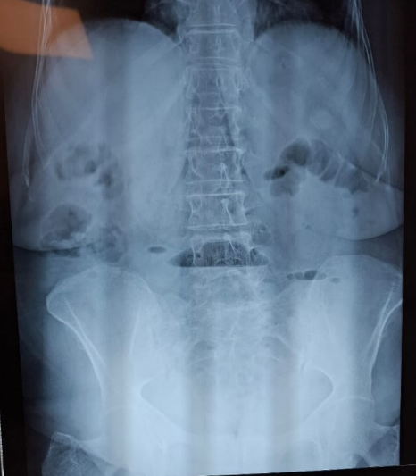

**Fig. 1:** plain abdominal X-ray showing bowel-type air-fluid levels

Patient installed a hypotension (75/43 mmHg) a few hours within admission, which prompted the decision to perform an urgent exploratory laparotomy.

Exploratory laparotomy revealed a suspicious small bowel mass located 1.80 meters distal to the first jejunal loop, responsible for the intestinal obstruction. The mass measured approximately 3 × 4 cm macroscopically. Associated with the mass was a suspicious mesenteric lymph node measuring 1 × 2 cm. **[Fig. 2]** A decision was made to perform an oncologic resection of the mass and the lymph node. A manual end-to-end resection-anastomosis was carried out. **[Fig.3]**

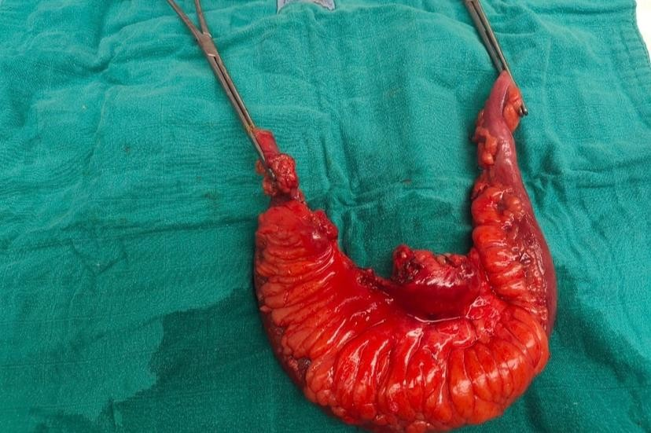

**B**

**A**

**Vascular blush**

**D**

**C**

**Fig. 2: Macroscopic view of the resected specimen (arrow: mesenteric lymph node)**

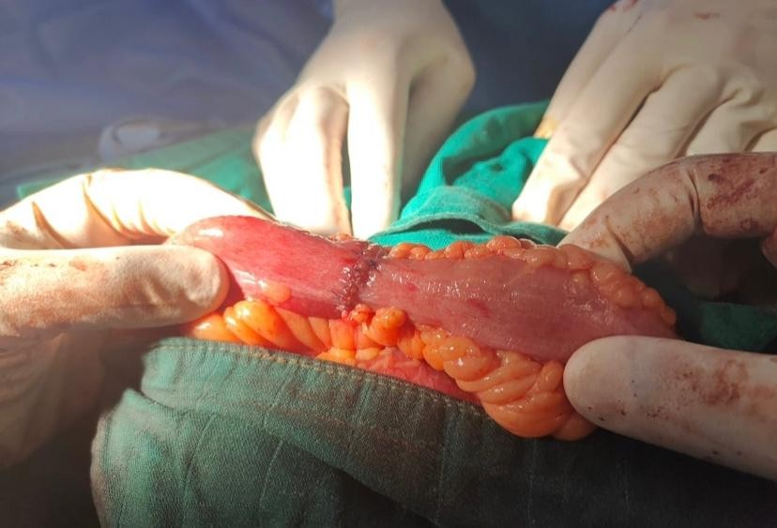

.

**Fig. 3** End-to-end manual resection anastomosis

The postoperative course was uncomplicated. To our great surprise, histopathological analysis revealed a nonspecific inflammatory thickening of the small bowel wall. Postoperative investigations were unremarkable

3. DISCUSSION

Small bowel obstruction (SBO) in elderly patients is a common but challenging clinical scenario, often caused by postoperative adhesions, hernias, or neoplasms. Tumors are a significant concern in this population due to their relatively high prevalence and potential severity [7,8]. However, as illustrated by this case, not all masses causing SBO are malignant; some may represent non-neoplastic inflammatory lesions that mimic tumors both clinically and radiologically [9]. This pseudo-tumoral presentation can complicate diagnosis and management, particularly in elderly patients.[1]

Elderly patients frequently present with atypical or subtle symptoms, which can delay diagnosis and treatment. In this case, the patient exhibited classic obstructive symptoms—epigastric pain, vomiting, and radiological signs of obstruction—but imaging initially suggested adhesions as the cause. Intraoperatively, a suspicious small bowel mass and an adjacent mesenteric lymph node were found, raising concern for malignancy and leading to an oncologic resection.

In such situations, surgeons often opt for wide resection to ensure oncologic safety, especially in elderly patients where a malignant etiology is strongly suspected. Nevertheless, histopathological analysis revealed only nonspecific inflammatory thickening without evidence of tumor, highlighting the diagnostic challenges of differentiating between inflammatory pseudotumors and true neoplasms based on imaging and gross appearance alone [10]. Inflammatory pseudotumors may arise from chronic inflammatory reactions, infections, or autoimmune processes, though in this case, no specific underlying cause was identified.[2]

The management of these pseudo-tumoral lesions is complex. The primary challenge lies in the preoperative diagnosis, as imaging modalities, although advanced, may not reliably distinguish inflammatory masses from malignancies. Thus, exploratory laparotomy remains the definitive diagnostic and therapeutic approach, especially in cases with clinical deterioration or hemodynamic instability, as seen here with the patient’s hypotension. [3]

This case underscores the importance of multidisciplinary collaboration between surgeons, radiologists, and pathologists to optimize patient management and avoid unnecessary oncologic treatments. Histological confirmation is crucial before initiating further oncologic therapies, particularly in elderly and frail patients where the risk-benefit ratio must be carefully considered.

**4. CONCLUSION**

In conclusion, although clinical and radiological findings may suggest malignancy in cases of SBO with mass formation, non-neoplastic inflammatory lesions must be considered in the differential diagnosis. Awareness of such entities can prevent overtreatment and guide appropriate management based on definitive pathology.

Consent

As per international standard or university standard, patient written consent has been collected and preserved by the authors.

Ethical approval

As per international standard or university standard written ethical approval has been collected and preserved by the authors.

References

1. Ahmed M, Buti YJ, Bawahab A, Ghaly H, Elsayed R. Small Bowel Obstruction as a Result of Inflammatory Pseudotumor. Cureus. 2022 Sep 2;14(9):e28707. doi: 10.7759/cureus.28707. PMID: 36204020; PMCID: PMC9527131.
2. Abdominal inflammatory myofibroblastic tumor. Groenveld RL, Raber MH, Oosterhof-Berktas R, Eijken E, Klaase JM. Case Rep Gastroenterol. 2014;8:67–71.
3. Fever of unknown origin as a presentation of gastric inflammatory myofibroblastic tumor in a two-year-old boy. Cho MY, Min YK, Kim NR, et al. J Korean Med Sci. 2002;17:699–703. - PMC – PubMed
4. Hwang, F., Crandall, M., Smith, A., Parry, N., & Liepert, A. E. (2023). Small bowel obstruction in older patients: challenges in surgical management. *Surgical Endoscopy*, *37*(1), 638-644.
5. Rosa, F., Covino, M., Fransvea, P., Quero, G., Pacini, G., Fiorillo, C., ... & Alfieri, S. (2022). Management of Small Bowel Obstruction (SBO) in older adults (> 80 years): a propensity scorematched analysis on predictive factors for a (un) successful non-operative management (NOM). *European Review for Medical & Pharmacological Sciences*, *26*(19).
6. Perrone, G., Giuffrida, M., Papagni, V., Pattonieri, V., Tarasconi, A., & Catena, F. (2021). Management of acute large bowel obstruction in elderly patients. In *Emergency General Surgery in Geriatrics* (pp. 349-360). Cham: Springer International Publishing.
7. Li, R., Quintana, M. T., Lee, J., Sarani, B., & Kartiko, S. (2024). Timing to surgery in elderly patients with small bowel obstruction: an insight on frailty. *Journal of Trauma and Acute Care Surgery*, *97*(4), 623-630.
8. Perrone, G., Papagni, V., Giuffrida, M., Pattonieri, V., Tarasconi, A., & Catena, F. (2021). Small Bowel Obstructions in the Elderly. In *Emergency General Surgery in Geriatrics* (pp. 285-297). Cham: Springer International Publishing.
9. Hussein, A., Arena, A., Yu, C., Cirilli, A., & Kurkowski, E. (2021). Abdominal Pain in the Elderly Patient: Point-of-care Ultrasound Diagnosis of Small Bowel Obstruction. *Clinical Practice and Cases in Emergency Medicine*, *5*(1), 127.
10. González-Arestizábal, T., Morales, Á., Avayú-Zaliasnik, T., Csendes, A., Korn, O., & Figueroa-Giralt, M. (2024). Clinical and surgical dilemmas in octogenarian patients with small bowel obstruction. *ABCD. Arquivos Brasileiros de Cirurgia Digestiva (São Paulo)*, *37*, e1801.