Case report
ACUTE APPENDICITIS DURING PREGNANCY: A CASE REPORT

.
ABSTRACT

Aim:
Appendicitis during pregnancy is a rare but serious condition, often presenting atypically and posing diagnostic challenges
Presentation of case:
We report a 20-year-old pregnant patient at 15 weeks gestation with right iliac fossa pain, fever, and elevated inflammatory markers. Ultrasound showed a right lateral and retro-uterine collection, but differentiation between tubal and appendiceal abscess was unclear. MRI without gadolinium confirmed an appendiceal abscess
Discussion:
MRI is a valuable diagnostic tool in pregnancy when ultrasound is inconclusive, facilitating accurate diagnosis and timely surgical intervention. Early appendicectomy with drainage prevented complications and ensured maternal and fetal well-being
Conclusion:
High suspicion and prompt MRI-based diagnosis followed by early surgery are essential for favorable outcomes in pregnant patients with suspected appendicitis.

Keywords: Appendicitis, Pregnancy, MRI, Appendiceal abscess

1. INTRODUCTION

Appendicitis during pregnancy is a rare but serious condition that can pose risks to both mother and fetus. It often presents with atypical symptoms, making diagnosis challenging. Prompt recognition and treatment are essential to avoid complications. Understanding its signs and management is crucial for ensuring maternal and fetal health. [1]

2. PRESENTATION OF CASE

We present here the case of 20-years-old patient with no past medical history. Patient is G1P0, current pregnancy estimated at 15 weeks + 5 days of gestation. History of present illness dates back to 3 days prior to consultation in the emergency department in the Maternity’s Emergency department with the onset of right iliac fossa pain radiating to the hypogastric region, associated with dysuria and fever.
Physical exam revealed a guarding in the right iliac fossa as well as fever measured at 38.3 ֯C. We performed biological tests that showed a WBC at 21,000 /mm³ as well as a CRP level at 171 UI/L. Rest of biological exams were within the normal range.

Patient performed a pelvic ultrasound that showed a right lateral and retro-uterine collection. On one hand, this collection envelops the right adnexa, with a thickened appearance of the tubal wall containing echogenic material, while the ovary retains a normal morphology. On the other hand, the tip of the appendix is in contact with the collection, but its proximal portion remains of normal size. Additionally, the examination reveals a gravid uterus containing a single, viable fetus estimated at 15 weeks of gestation, with a positive cardiac activity. [Fig.1,2,3]

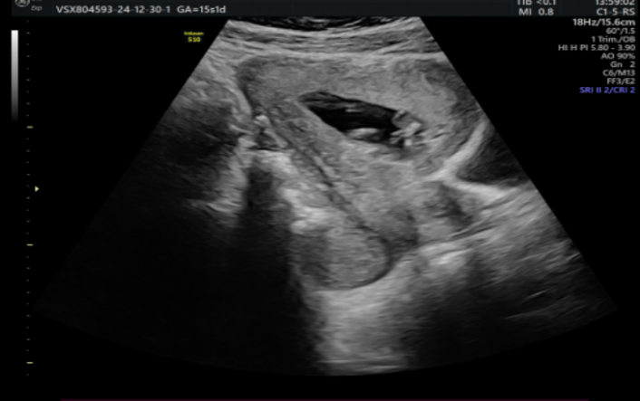
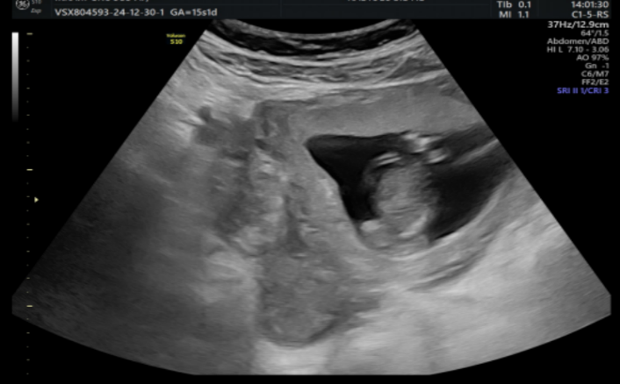

Fig. 1: Axial and coronal views demonstrating a right lateral and retro-uterine collection, as well as a gravid uterus containing a viable pregnancy.
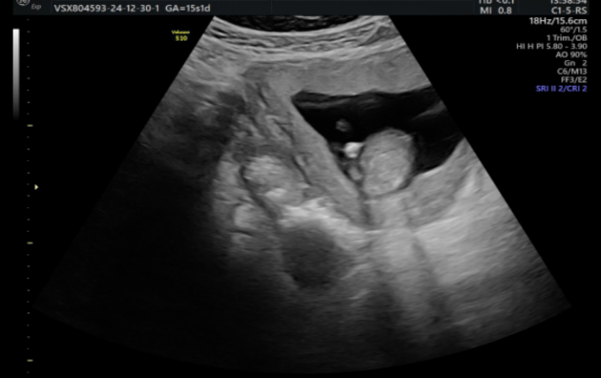
Vascular blush

D

Fig. 2: Axial view showing the tip of the appendix in contact with the collection. (arrow)

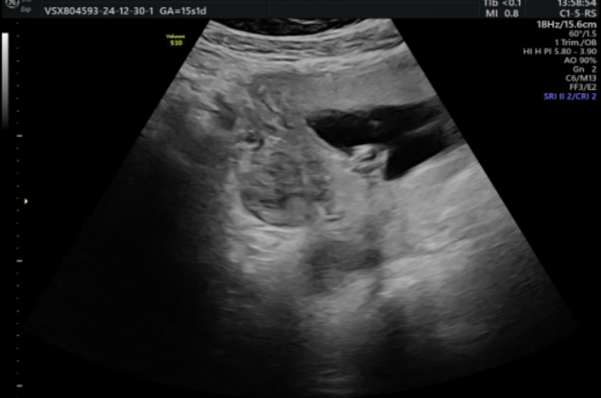

Fig. 3: Ultrasound view showing the right adnexa with a thickened tubal wall and echogenic content.

Due to the difficulty in establishing a definitive diagnosis between a tubal abscess and an appendiceal abscess, it was decided to perform an MRI.

An MRI was performed without Gadolinium injection, revealing a right lateral uterine collection extending posteriorly and inferiorly toward the pouch of Douglas. This collection displays a heterogeneous content, with low T1 signal and high T2 signal intensity, containing areas of low T2 signal. It shows restricted diffusion with low ADC values and includes a blind-ended structure within it.
The appendix is lateral to the cecum, with a descending pelvic course. Its proximal portion retains a normal caliber, measuring up to 6 mm, while its distal tip is swollen, reaching a caliber of up to 18 mm and coming into contact with the right lateral uterine collection. This collection is adjacent to the right ovary, the fallopian tube, and some adjacent small bowel loops.
Additionally, there is significant pelvic fat infiltration associated with reactive lymph nodes which orientated the diagnosis of appendiceal abscess. [Fig. 4,5]
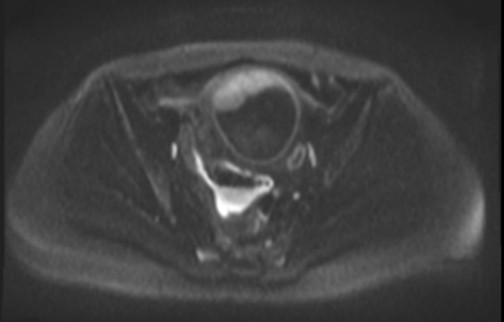
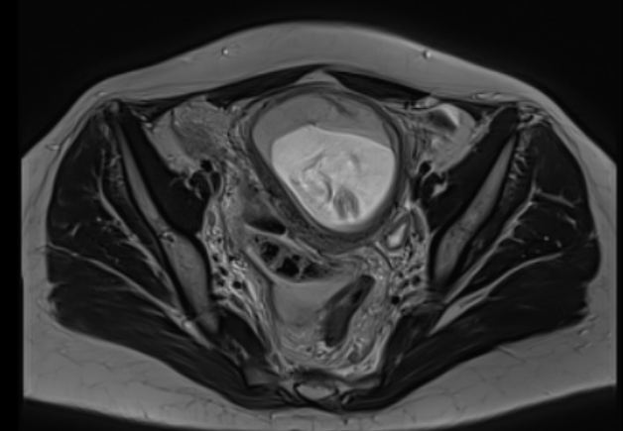

Fig. 4: Axial T2- and restricted diffusion images showing a lateral and retro-uterine collection with heterogeneous content, appearing to contain a blind-ended digestive structure.

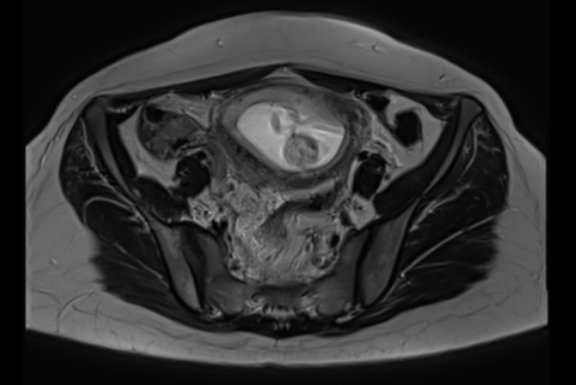

Fig. 5: Axial T2-weighted image showing the proximal portion of the appendix. (arrow)

Patient benefited from large spectrum antibiotics.
Decision for surgical appendicectomy was made. After a Mcburney incision, surgical exploration revealed appendicitis with a suppurative tip, and the associated abscess was located in the recto-uterine pouch. Appendicectomy as wel as Irrigation and drainage were performed. Post-surgery echography revealed a viable fetus. [Fig. 6]

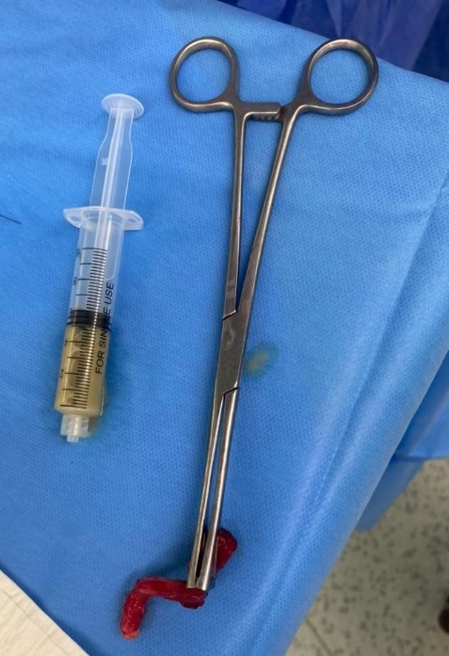

Fig. 6: Macroscopic view of the resected appendix and pus aspirated

The patient was discharged on the fifth day post-surgery with no further complications.

3. DISCUSSION

Acute appendicitis during pregnancy is the most common non-obstetric surgical emergency, though it remains rare, particularly in the second trimester. Diagnosis is often delayed due to overlapping symptoms with normal pregnancy and anatomical changes that shift the appendix upward as the uterus enlarges. [2]

In this case, the patient presented with right iliac fossa pain, fever, and elevated inflammatory markers, which raised suspicion for an intra-abdominal infection. However, imaging findings suggested both a possible tubal abscess and an appendiceal abscess, complicating the diagnosis.

Ultrasound, though non-invasive and first-line in pregnancy, had limited specificity in differentiating between tubo-ovarian pathology and appendicitis. MRI, which is safe during pregnancy when performed without gadolinium, proved to be crucial for confirming the diagnosis by demonstrating a distended, inflamed appendiceal tip in contact with the collection, consistent with an appendiceal abscess. [3,4]

Prompt surgical intervention is critical to reduce the risk of rupture, peritonitis, and fetal loss.[5]
This case highlights the importance of maintaining a high index of suspicion for appendicitis in pregnant patients with abdominal pain, and underscores the utility of MRI when ultrasound findings are inconclusive. Early diagnosis and appropriate surgical management allowed for a favorable maternal and fetal outcome.

4. Conclusion

Appendicitis during pregnancy requires a high index of suspicion due to atypical presentations. MRI is a valuable diagnostic tool when ultrasound is inconclusive, enabling accurate diagnosis without radiation risk. Early surgical management is essential to prevent complications and ensure favorable maternal and fetal outcomes.

Consent (where ever applicable)

As per international standard or university standard, patient written consent has been collected and preserved by the authors.

Ethical approval (where ever applicable)

As per international standard or university standard written ethical approval has been collected and preserved by the authors.

References

- Silva, H. R. Kumar, & Soma, M. (2023). Acute Appendicitis in Pregnancy – Current Management (Review Article). Asian Journal of Medicine and Health, 21(10), 69–75. https://doi.org/10.9734/ajmah/2023/v21i10879Gluszek
- Courtney A. Woodfield, Elizabeth Lazarus, Karen C. Chen, and William W. Mayo-Smith, Abdominal Pain in Pregnancy: Diagnoses and Imaging Unique to Pregnancy—Review, Volume 194, Issue 6_supplement, https://doi.org/10.2214/AJR.07.7139
- Konrad J, Grand D, Lourenco A. MRI: first-line imaging modality for pregnant patients with suspected appendicitis. Abdom Imaging. 2015 Oct;40(8):3359-64. doi: 10.1007/s00261-015-0540-7. PMID: 26338256.JA
- Israel GM, Malguria N, McCarthy S, Copel J, Weinreb J. MRI vs. ultrasound for suspected appendicitis during pregnancy. J Magn Reson Imaging. 2008 Aug;28(2):428-33. doi: 10.1002/jmri.21456. PMID: 18666160.
- Management of Complicated Appendicitis during Pregnancy: A Nationwide Analysis. Scientific Forum, American College of Surgeons Clinical Congress 2020, October 3-7, 2020.

