Case report
Post-cholecystectomy enormous hepatic hematoma

.
ABSTRACT

Aims:
We present a rare case of intrahepatic subcapsular hematoma (ISH) following laparoscopic cholecystectomy (LC) and discuss its management.
Presentation of Case:
A 59-year-old male presented with severe abdominal pain 10 days post-LC. Imaging revealed a large right-sided hepatic hematoma and a ruptured pseudoaneurysm. He was treated successfully with endovascular embolization and supportive care.
Discussion:
ISH is a rare but potentially life-threatening LC complication. Causes include iatrogenic injury or vascular anomalies. Management depends on hemodynamic stability and hematoma size.
Conclusion:
Early diagnosis and tailored treatment, including embolization, can prevent complications and avoid surgical intervention in selected ISH cases.

Keywords: Intra-hepatic subcapsular hematoma, Laparoscopic cholecystectomy, complication, management

1. INTRODUCTION

The actual preferred treatment for symptomatic gallstones is laparoscopic cholecystectomy (LC). Intra-hepatic subcapsular hematoma (ISH) is a rare but life-threatening complication following LC occurring in less than 1% of cases. [1-2]
Other complications described are post-operative bleeding, bowel injuries, iatrogenic bile duct injuries and infections. [3]
Overall morbidity is less than 7%. [4]

2. PRESENTATION OF CASE

We present the case of a 59-year-old male, with no medical history, who underwent a laparoscopic cholecystectomy 10 days before the admission in our emergency care unit. The patient was discharged at post-operative day one and presents severe abdominal pain since post-operative day seven. Physical examination revealed a pale patient, tachycardia at 130 bpm, tenderness in the right hypochondrium.

We performed biological tests, that showed an anemia with hemoglobin levels at 7 g/dl (pre-operative hemoglobin level was at 11g/dl). Rest of biological exams were within the normal range.

Patient underwent an abdominopelvic CT scan which revealed a large subcapsular hematoma of the liver measuring 21x10x8 cm as well as a rupture of a false aneurysm of segment VIII 8x8 mm.
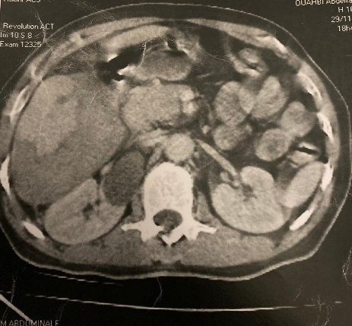
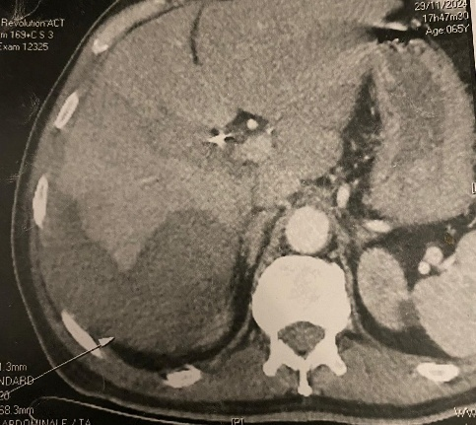
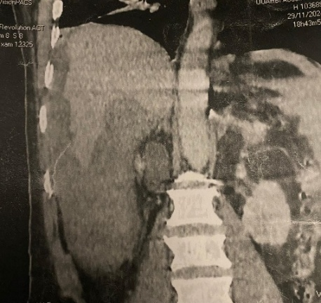

B
A

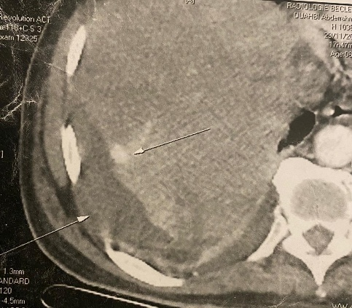

Vascular blush

Hematoma
D
C

Fig. 1: post-operative CT scan showing a subcapsular hematoma surrounding the lateral and inferior surface of the right hemi liver (A,B,C) with an active bleeding in the VIII segment.
After hospitalisation, patient benefited from an arterial embolization due to the active bleeding.

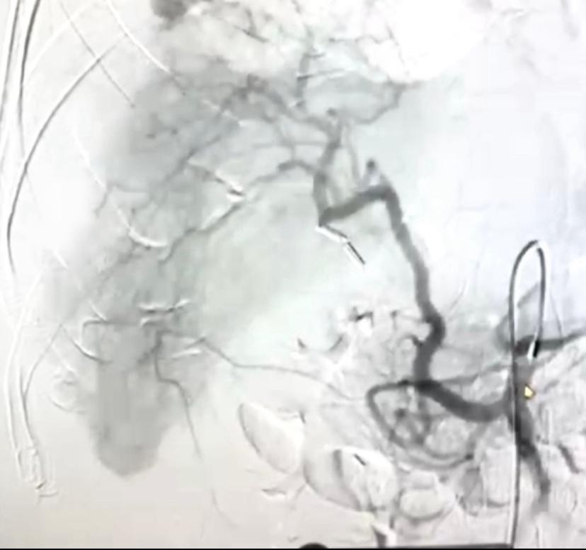
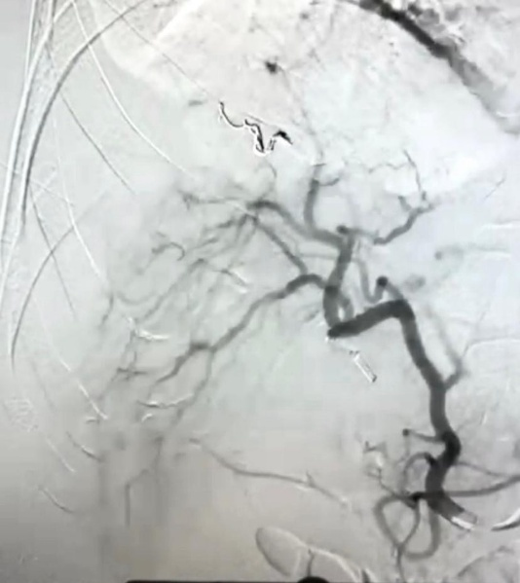

Fig. 2: Arterial embolization of the ruptured pseudo-anevrysm

After the embolization patient benefited from close monitoring in our department, and after being transfused, patient stabilized which prompted surgical abstention.
The patient was discharged on the fourth day upon stabilization with no further complications.

3. DISCUSSION

Large cohort studies have shown that LC is a safe procedure, with an overall morbidity rate of less than 7%. Even more, bleeding is observed in fewer than 1% of cases. The most common sites of bleeding following LC are the gallbladder bed, the falciform ligament, the trocar insertion site and the cystic artery. Bleeding can also occur from tears in the liver capsule. However, even though the occurrence of ISH following LC is rare, it represents a life-threatening complication due to haemodynamic instability from possible rupture. Hematomas are usually located on the right side of the liver (in 75% of cases) and can occur from 24h to several weeks after LC. [5-6]

Some contributing factors have been identified. These include iatrogenic injuries to the liver parenchyma and capsular tears during gallbladder traction or trocar placement. Other factors include the presence of a preoperative pseudoaneurysm or hepatic hemangioma, which could be injured during the procedure. The perioperative administration of non-steroidal anti-inflammatory drugs (NSAIDs) has been reported in several cases of ISH following LC, with a particular focus on the use of ketorolac, as this has been associated with the greatest estimated risk of bleeding. Consumption of NSAIDs in the postoperative period has also been proposed as an associated cause, since ketorolac (up to 58.8%) or parecoxib was used by several patients in this period. ISH has also been associated with anticoagulant therapy. [7-8]
Our patient, had no specific underlying cause, as she had no coagulation disorders, nor she was taking anticoagulants or antiplatelet therapy. However the iatrogenic rupture of a pre-existent pseudo-aneurysm cannot be eliminated to the lack of pre-operative imagery (particularly CT-Scan).
When the ISH is small, it is usually asymptomatic. However, if it continues to grow, serious complications may arise. Depending on the symptoms and the patient's condition, various therapies may be employed, ranging from expectant management to emergency surgery
The management of large ISHs is unclear, but several strategies have been proposed: conservative management with strict clinical observation; surgical management, either laparotomy or laparoscopy; percutaneous drainage; and endovascular embolisation. The choice of strategy is mainly determined by the patient's clinical condition, the size of the haematoma, and its cause. [3-5]

4. Conclusion

In conclusion, laparoscopic cholecystectomy (LC) is a generally safe procedure with low morbidity and rare bleeding complications. However, intrahepatic subcapsular hematoma (ISH), though uncommon, remains a serious and potentially life-threatening event. Its management varies depending on the patient’s clinical stability and hematoma characteristics. Early recognition and individualized treatment are crucial for optimal outcomes. Our patient benefited from endovascular embolization upon diagnosis of vascular rupture which allowed rapid stabilization of the patient as well as surgical abstention.

Consent (where ever applicable)

As per international standard or university standard, patient written consent has been collected and preserved by the authors.

Ethical approval (where ever applicable)

As per international standard or university standard written ethical approval has been collected and preserved by the authors.

References

Reference to a journal:
- E Saad, L O'Connell, AM Browne, et al.: Giant Intrahepatic Subcapsular Haematoma: A Rare Complication following Laparoscopic Cholecystectomy—A. Case Report and Literature Review. Case Reports in Surgery. 2020, 10.1155/2020/6410790
- Gluszek S, Kot M, Nawacki L, et al.: Subcapsular liver haematoma as a complication of laparoscopic cholecystectomy. Videosurgery and Other Miniinvasive Techniques. Videosurgery and Other Miniinvasive Techniques,, 15. 10.5114/wiitm.2015.52059
- S Duca, O Bãlã, N Al‐Hajjar, et al.: Laparoscopic cholecystectomy: incidents and complications. A retrospective analysis of 9542 consecutive laparoscopic operations. HPB. Romanian Journal of Emergency Surgery, 2003. 10.1080/13651820310015293
- Qiao-fei Liu, Ling-ling Bian, Meng-qing Sun, et al.: A rare intrahepatic subcapsular hematoma (ISH) after laparoscopic cholecystectomy: a case report and literature review. BMC surgery. BMC surgery, 2019. 10.1186/s12893-018-0453-9
- JA Shea, MJ Healey, JA Berlin, et al.: Mortality and complications associated with laparoscopic cholecystectomy. A meta-analysis. Ann Surg. 1996,
- R Badea, L Chiorean, C Mitre, et al.: Spontaneous retroperitoneal and subcapsular liver hematoma. The diagnostic contribution of CT, US, and CEUS. Case report. Med Ultrason. Medical ultrasonography, 2013. 10.11152/mu.2013.2066.152.rb1lc2
- BM Moloney, N Hennessy, EO Malley, et al.: Subcapsular haematoma following laparoscopic cholecystectomy. BJR Case. BJR| case reports, 2016. 10.1259/bjrcr.20160118
- MC Barrios, J Sotomayor, JM Lozano, et al.: Hepatic subcapsular hematoma following laparoscopic cholecystectomy: a case report.. Annals of Mediterranean Surgery, 2023. 10.22307/2603.8706.2023.01.005

