***Case report***

**Congenital Sternal Cleft: A Case report and brief review of literature**.

**Abstract:**

Background: Congenital sternal clefts (SC) are rare idiopathic anomalies of thoracic cage. The incidence of congenital sternal cleft is 0.15% of all chest wall malformations.

Case report: a male infant born to third gravid mother by normal vaginal delivery who cried immediately after birth had a thin defective skin layer over upper part chest. On palpation there was no feel of sternum in the upper part. The cardiac contractions were visible over the skin defect. This infant was diagnosed to have congenital sternal defect. Primary closure was done which was uneventful. The infant did not have post-operative complications.

Conclusion: the congenital SC is rare anomaly of chest wall which cannot be detected by routine antenatal ultrasound examination. The traumatic injury to visceral organs is a major complication. Hence the diagnosis should be made at the earliest in suspected cases and treated.

Key words: congenital, sternum, anomaly, infant

Introduction :

Congenital sternal clefts (SC) are rare idiopathic anomalies of thoracic cage. There is a limited number of cases reported in the literature. The incidence of congenital sternal cleft is 0.15% of all chest wall malformations.1

The defect was first reported in 1739.2 There is currently no evidence of a familial inheritance to sternal cleft. The pathogenesis is unclear, but it is more commonly found in girls. There is a hypothesis that sternal cleft may be related to abnormality in HoxB gene expression, based on murine models which could be a reason for preponderance in girl infants.3

Antenatal diagnosis is difficult due to limited ultrasound image resolution to detect anomaly by antenatal ultrasound. Postnatally these infants usually do not have manifestations as the defect is covered by skin. In symptomatic infants paradoxical respiratory movements are seen at birth when the defect is covered with thin layer of skin. Other features include skin defect, skin tag or skin raphe. In older infants respiratory difficulty and recurrent respiratory infection is possible. On clinical examination these infants have no palpable sternum. The underlying viscera especially the heart is at risk of traumatic injury. Hence early detection and treatment of these cases is important. The treatment of choice for these cases is primary sternal closure during the infantile period. Congenital SC are associated with other malformations, of which the pentalogy of Cantrell is most common. Here, we present a case report of a newborn boy baby having an isolated congenital sternal cleft, affecting the superior portion of sternum and also discuss the clinical features and management options available for this condition.

**Case report:**

A day 1 male infant born to 29year old 4th gravida mother by normal vaginal delivery (NVD). Her first pregnancy was a spontaneous abortion at 2 months of gestation. 2nd pregnancy was an ectopic pregnancy. Third conception was a live male baby born by NVD with a birth weight of 3kgs. Baby is alive and healthy. In the present pregnancy mother had uneventful antenatal history. Her antenatal scans were normal with no anomalies detected during antenatal period. Her growth scans did not show any growth lag. Mother had spontaneous onset of labour pain at 38+3 weeks of gestation, which progressed without complications and delivered by NVD. Baby cried immediately after birth with APGAR score of 8 and 9 and a birth weight of 3.350kgs.

On examination baby was having thin defective skin layer over the upper part of the sternum. On palpation of the upper part of sternum was soft with no underlying bony structure. The contractions of the heart were easily seen over the chest, which was covered just by a thin layer of subcutaneous tissue. A small skin ulcer was present at the upper portion of sternum. There were no other external congenital anomalies. The infant was active and hemodynamically stable. The infant was started on exclusive breast feeding soon after birth and the infant was feeding well. On echocardiography, cardiac anatomy was normal. Ultrasound cranium had no abnormalities. Computed tomography (CT) of the chest showed ‘U’ shaped defect in the upper portion of sternum with widely placed clavicles. This baby was diagnosed to have primary defect in the formation of sternum in the superior portion.

Pediatric surgery consultation was taken and was decided to go for primary closure of defect. Preoperative investigations were normal. Baby was operated on day 13 of life. Vertical midline incision encircling skin ulcer from suprasternal to xiphoid was taken. Skin flap raised. Pericardium and pleura separated from split sternal edges posteriorly. Stitches taken from full thickness of both split sternal cleft region. Stitches crossed over and sutures were approximated. Cardio respiratory compromise was looked for, which was not there. Post operatively course was uneventful. Baby was discharged on day 23 of life. On follow up at 3 months, infant did not have any complications. Infant’s developmental and anthropometric measurements were normal for the age.

**Discussion:**

DISCUSSION

The sternum is formed from bilateral sternal plates which

chondrify and begin to fuse with the ribs at about 10

weeks’ gestation. During the 6th week, it appears as a pair

of parallel bands of condensed mesenchyme. The right and

left vertical sternal bars of mesenchymal origin (somatic

mesoderm) are responsible for the formation of the ster-

num by a ventrolateral and craniocaudal union of the two

layers. They begin to chondrify almost at once. At about

the same time, a median cranial rudiment, the presternum,

appears, associated with the developing shoulder girdle.

Much later (the 6th month), the paired suprasternal carti-

lages appear cranially and laterally to the presternum. They

usually fuse with the presternum to form part of the

manubrial articulation with the clavicle.

DISCUSSION

The sternum is formed from bilateral sternal plates which

chondrify and begin to fuse with the ribs at about 10

weeks’ gestation. During the 6th week, it appears as a pair

of parallel bands of condensed mesenchyme. The right and

left vertical sternal bars of mesenchymal origin (somatic

mesoderm) are responsible for the formation of the ster-

num by a ventrolateral and craniocaudal union of the two

layers. They begin to chondrify almost at once. At about

the same time, a median cranial rudiment, the presternum,

appears, associated with the developing shoulder girdle.

Much later (the 6th month), the paired suprasternal carti-

lages appear cranially and laterally to the presternum. They

usually fuse with the presternum to form part of the

manubrial articulation with the clavicle.

DISCUSSION

The sternum is formed from bilateral sternal plates which

chondrify and begin to fuse with the ribs at about 10

weeks’ gestation. During the 6th week, it appears as a pair

of parallel bands of condensed mesenchyme. The right and

left vertical sternal bars of mesenchymal origin (somatic

mesoderm) are responsible for the formation of the ster-

num by a ventrolateral and craniocaudal union of the two

layers. They begin to chondrify almost at once. At about

the same time, a median cranial rudiment, the presternum,

appears, associated with the developing shoulder girdle.

Much later (the 6th month), the paired suprasternal carti-

lages appear cranially and laterally to the presternum. They

usually fuse with the presternum to form part of the

manubrial articulation with the clavicle.

**Embryology**:

The sternum is formed by the ventrolateral and craniocaudal union of the two layers of the right and left vertical sternal bars, which are of mesenchymal origin. Around the sixth week of pregnancy, the mesenchymal condensation gives rise to the sternum. At around 6th months of gestation, the paired suprasternal cartilages appear cranially and laterally to the presternum. They usually fuse with the presternum to form part of the manubrial articulation with the clavicle. During the 7th week, the sternal bands join at their cephalic ends and gradually fuse in the midline, throughout their length. The fusion progresses and completes by 9th or 10th week of gestation.

The process of ossification begins in the manubrium and the upper section of the sternal body during the sixth month of gestation, progresses to the middle section of the body by the seventh month, occurs in the lower body within the first year after birth. The xiphoid process ossifies between the ages 5 to 18 years. The merging of these ossification centers occurs only after puberty.4

**Clinical features:**

SC makes up less than 1% of all CWMs, making it an uncommon outlier.1 It is more common in female infant and has a higher prevalence of partial superior type SC.5 Hinchkliff et al6 in their systematic review identified 71 studies from 1970 to 2019, reporting a total of 115 patients with congenital sternal cleft. The most common variant was superior partial sternal cleft, comprising 65.2% of the cases.

Clinically, sternal clefts are divided into 3 types according to the location and degree of the ﬁssure, superior sternal cleft, total sternal cleft, and inferior cleft.7 Sternal clefts can also be classified based on shape as “V”- or “U”-shaped defects which can be a complete separation of sternal halves till the xiphisternum.8

Individuals are largely asymptomatic during the newborn period; nonetheless, upon physical examination, all individuals exhibit a paradoxical midline thoracic bulge and protrusion of the mediastinal viscera after expiration. SC may experience recurring chest infections, respiratory symptoms as coughing and dyspnea which could be due to poor gas exchange secondary to impaired lung mechanics. 9

It is possible for the sternal cleft to occur alone or in conjunction with other congenital abnormalities. In particular, cervicofacial hemangiomas, midline raphe from the tip of the sternal cleft to the umbilicus, and PHASES (posterior fossa malformations, facial hemangiomas, arterial anomalies with coarctation of the aorta, cardiac defects, eye abnormalities, sternal cleft, and supraumbilical raphe) syndrome are abnormalities that are typically associated with the superior sternal cleft.10

# Diagnosis:

Imaging is the primary method used to diagnose cleft sternum since it can assess the severity of the deformity. In particular, the size of the lesion is assessed by thoracic CT and DR. The location of the defect and whether the associated ribs and spine are aberrant are ascertained using three-dimensional reconstruction CT.6

Sternal clefts can be identified prenatally on mid-trimester ultrasonography.11 However, image resolution is a constraint on ultrasonography imaging, and the accuracy of ultrasound is also impacted by maternal obesity, an unfavorable fetal position, and multiple pregnancies.12

Although there are few instances of prenatal ultrasound diagnosis, Twomey and colleagues have thought that a sunken and flattened midline anterior chest wall with intact skin covering but no discernible cartilaginous sternum is indicative of this abnormality.13 MRI is an eﬀective means of prenatal screening for sternal clefts. MRI is not yet used as a routine for prenatal examination, due to the high cost of MRI14. MRI is used for further evaluation only if the ultrasonography is abnormal14, 15

**Treatment:**

The surgical correction of SC was first proposed in 188816, but was successfully performed only in 1947.17 Surgical treatment for the sternal cleft is necessary depending on the magnitude of the defect, with early surgery preferred due to the elasticity of the thoracic cage. Surgery is indicated to improve respiratory dynamics, protect mediastinal structures from direct damage, and for cosmetic purposes.18 Primary repair surgery should be performed as soon as feasible, preferably during the newborn period, when the sternum is more flexible and the surgical methods required are simpler.10

In an institutional series for the management of SC described that the Primary closure resulted the most preferred treatment, with or without chondrotomies, periosteal ﬂaps, or cartilage resections. Alternative procedures included bone graft interposition, prosthetic closure, and muscle flap interposition.19

Nevertheless, if corrective surgery is not performed during the neonatal period, as age increases, sternal cartilage ossification will cause sternal reconstruction to become complicated, and the requirements for surgical techniques are greatly increased, which may include sliding or rotating cartilage incision, sliding chondrotomy, partial or total thymectomy, clavicle dislocation, bone or cartilage graft insertion, and muscle flap insertion19,20

**Complications**:

The untreated cases of SC can have the risk of insensible water loss, infections, and traumatic injury to the thoracic viscera. During the sternal repair pleural and pericardial tears were possible complications. Postoperative complications were found in 17% of cases, mostly represented by retrosternal seromas and pneumothorax. Long term complication of SC repair is pectus excavutum which is seen in 10% of cases.19

**Prognosi**s:

Isolated SC have favourable prognosis. The SC which are associated with cardiac anomalies prognosis is guarded. No risk of recurrence.21

**Conclusion**:

Sternal cleft are rare anomalies of chest wall. Most of the SC are asymptomatic in newborns except for paradoxical respiratory movements. SC should be identified at the earliest either prenatally by anomaly scan or postnatally at birth to prevent the life threatening complications like injury to thoracic viscera. Primary repair in the infantile period is the preferred treatment for SC.

**References**:

1. Acastello E, Majluf R, Garrido P, Barbosa LM, Peredo A. Sternal cleft: a surgical opportunity. J Pediatr Surg. 2003 Feb; 38(2):178-83. doi: 10.1053/jpsu.2003.50038. PMID: 12596098.
2. Chappius JP, Takuorian P, Philibert M, et al. A propos de deux cas de ﬁssure sternale congenitale. Pédiatrie 1984; 39:195.
3. Francesco f, piers E F Daubney, Susan M White. Midline raphe, sternal cleft and other abnormalities:a new dominant syndrome?.Am J Med Genet A.2005; 135(1):9-12.
4. Skindalakis JE, Gray SW, Ricketts R. The anterior body wall. Skindalakis JE, Gray SW, editors. Embryology for Surgeons. 1994; 540–93.
5. Durusoy C, Mihci E, Tacoy S, Ozaydin E, Alpsoy E. PHACES syndrome presenting as hemangiomas, sternal clefting and congenital ulcerations on the helices. J Dermatol 2006; 219–22.
6. Hinchcliﬀ K, Xue Y, Wong G. Reconstruction of congenital sternal cleft: A systematic review of the literature. Ann Plast Surg. 2021; 86:S418-21.
7. Engum SA: Embryology, sternal clefts, ectopia cordis, and Cantrell’s pentalogy. Semin Pediatr Surg. 2008;17:154-60
8. Spitz L, Bloom R, Milner S, et al. Combined anterior abdominal wall, sternal, diaphragmatic, pericardial, and intracardiac defects: a report of ﬁve cases and their management. J Pediatr Surg 1975;10: 491-6
9. Ravitch MM. Disorders of the sternum and thoracic wall. In: Sabiston Jr DC, Spencer FC, editors. Gibbon’s surgery of the chest. 4th ed., Philadelphia: W.B. Saunders; 1983, 318–60.
10. Nichols JH, Nasr VG. Sternal malformations and anesthetic management. Paediatr Anaesth. 2017; 27:1084-90
11. Sha Y, Deng Y, Ou M. Congenital Superior Sternal Cleft Isolated in a Newborn: Report of a Rare Case and a Literature Review. Am J Case Rep. 2022 Oct 21; 23:e937443.
12. Torres US, Portela-Oliveira E, Braga Fdel C, et al. When closure fails: What the radiologist needs to know about the embryology, anatomy, and prenatal imaging of ventral body wall defects. Semin Ultrasound CT MR. 2015;36:522-36
13. Twomey EL, Moore AM, Ein S, et al. Prenatal ultrasounography and neonatal imaging of complete cleft sternum: a case report. Ultrasound Obstet Gynecol 2005; 25:599-601.
14. Kovler ML, Jelin EB. Fetal intervention for congenital diaphragmatic hernia. Semin Pediatr Surg. 2019;28:150818
15. Van der Veeken L, Russo FM, De Catte L, et al. Fetoscopic endoluminal tracheal occlusion and reestablishment of fetal airways for congenital diaphragmatic hernia. Gynecol Surg. 2018;15:9
16. Ravitch M. Congenital deformities of the chest wall and their operative correction. 1977; 23—25.
17. Burton JF. Method of correction of ectopic cordis: two cases. Arch Surg 1947;54:79—81
18. Firmin RK, Fragomeni LS, and Lenox SC. Complete cleft sternum. Thorax 1980; 35:303—6.
19. Torre M, Rapuzzi G, Carlucci M, Pio L, Jasonni V. Phenotypic spectrum and management of sternal cleft: literature review and presentation of a new series. Eur J Cardiothorac Surg. 2012 Jan; 41(1):4-9. doi: 10.1016/j.ejcts.2011.05.049. PMID: 21737294; PMCID: PMC3241094.
20. Alshomer F, Aldaghri F, Alohaideb N, et al. Reconstruction of congenital sternal clefts: Surgical experience and literature review. Plast Reconstr Surg Glob Open. 2017;5:e1567
21. José-Ribas Milanez de Campos at al. Twenty seven-year experience with sternal cleft repair; European Journal of Cardio-Thoracic Surgery, March 2009

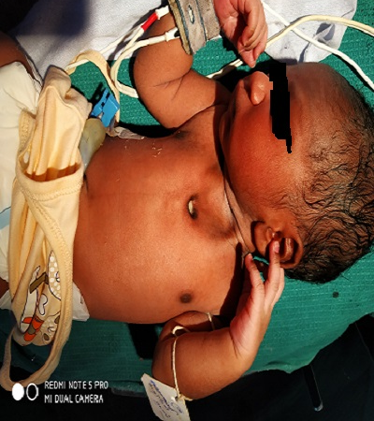

Figure 1: Newborn with Congenital Sternal Cleft

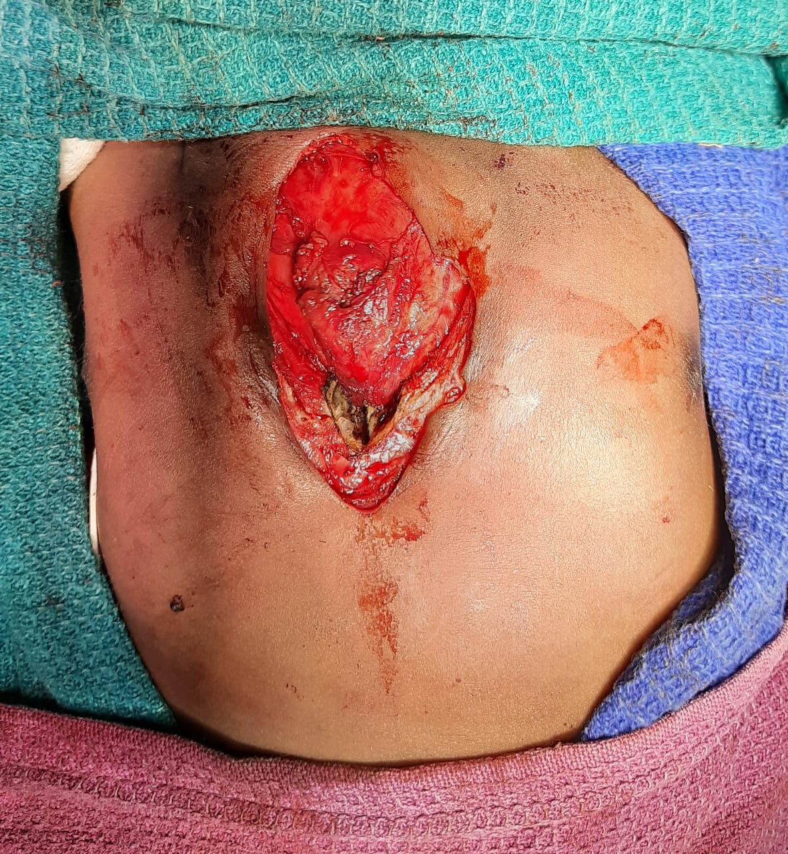 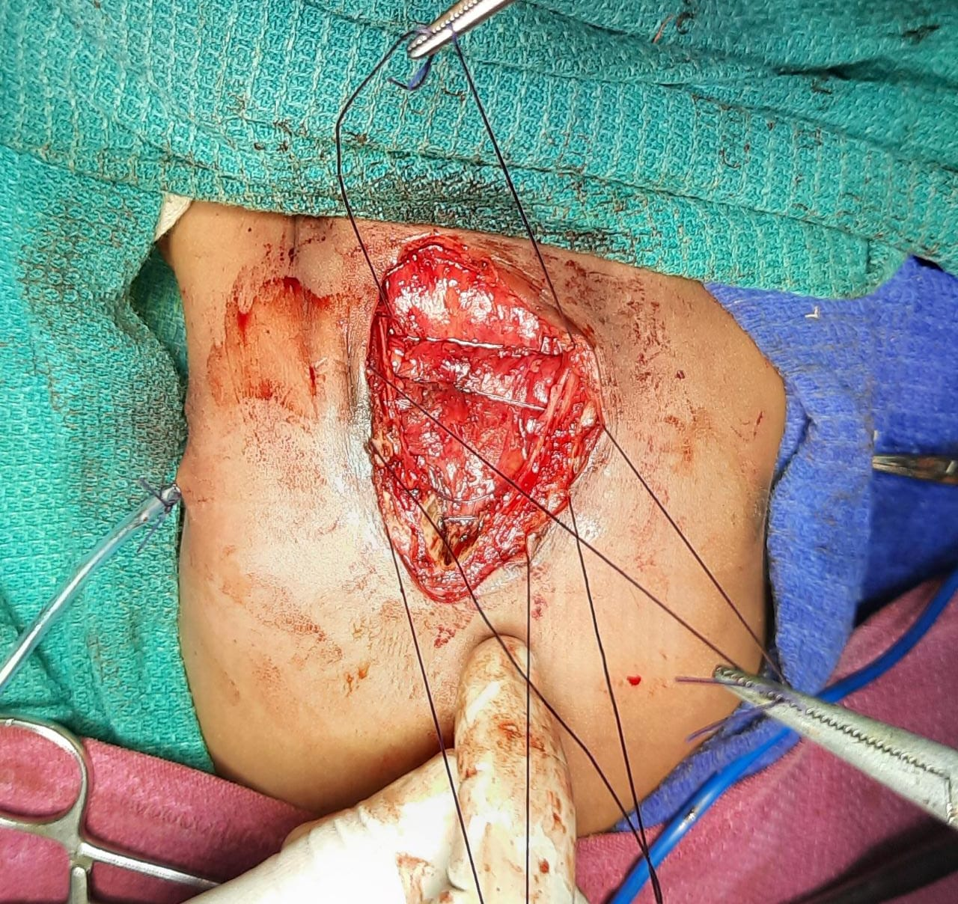 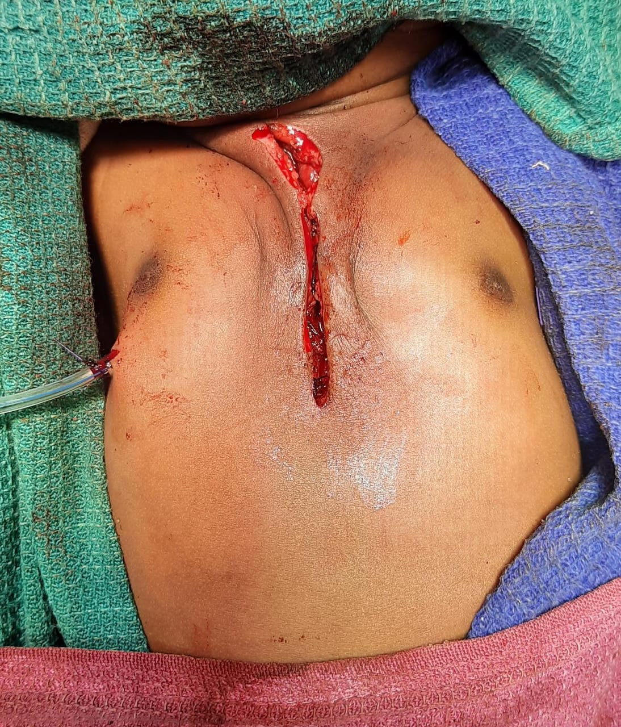

Figure 2: Intraoperative images of congenital sternal cleft

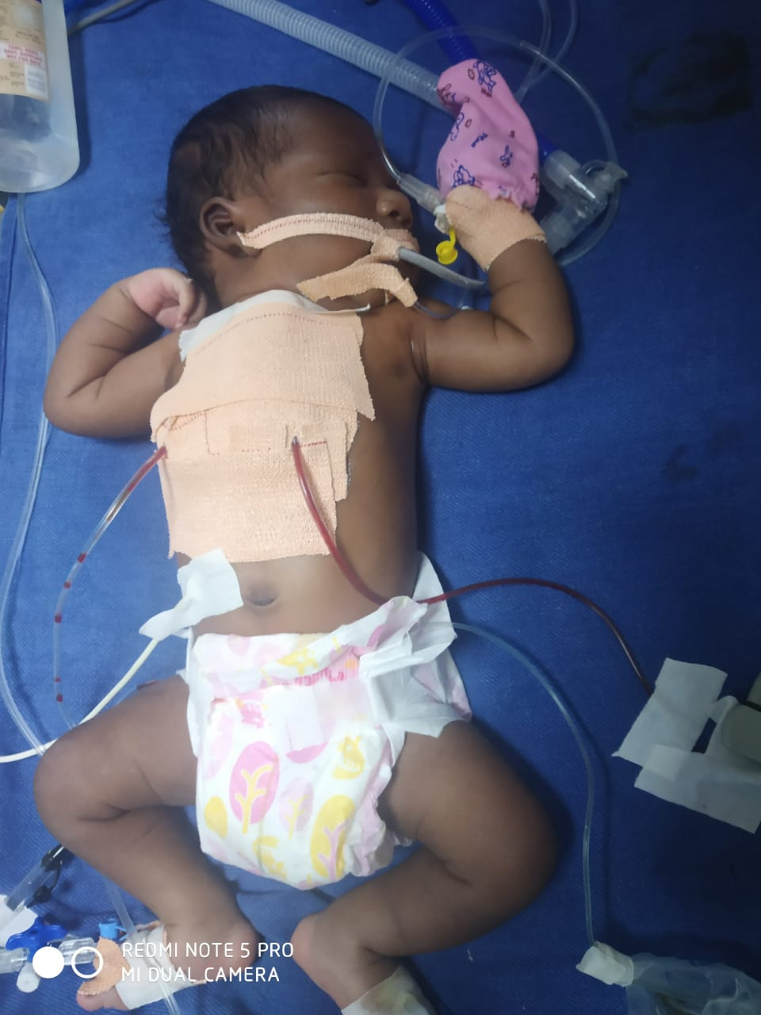

Figure 3: Post-operative image of congenital sternal cleft