Case report

Bouveret syndrome: Gastric Outlet Obstruction Secondary to Cholecysto-duodenal Fistula

Abstract

Background:
Gastric outlet obstruction (GOO) due to gallstone disease, known as Bouveret syndrome, is a rare but serious complication typically seen in elderly patients. Early recognition and appropriate management are crucial to prevent morbidity.
Methods:
A 29-year-old female presented with a 15-day history of recurrent mild upper abdominal pain, nausea, and non-bilious vomiting. Imaging and endoscopy revealed chronic cholecystitis with a large gallbladder calculus causing GOO via a cholecysto-duodenal fistula. Endoscopic retrieval attempts were unsuccessful.

Results:
The patient underwent open cholecystectomy, duodenotomy for stone removal, and gastrojejunostomy. Postoperative recovery was uneventful, with complete resolution of symptoms.
Conclusions:
Bouveret syndrome, though uncommon, should be considered in cases of gastric outlet obstruction and a history of Gallstone disease. In younger patients, surgical management with definitive fistula closure is advisable to prevent recurrence and long-term complications. In elderly or high-risk patients, endoscopic extraction with conservative management of the fistula may be appropriate when stone clearance is complete.
Keywords: Bouveret Syndrome, Gastric Outlet Obstruction, Cholecysto-duodenal Fistula

Introduction
Gastric outlet obstruction (GOO) is an uncommon complication of gallstone disease, often resulting from gallstone migration through a cholecysto-duodenal fistula. This rare condition, known as gallstone ileus, typically occurs in elderly patients and is associated with significant morbidity. Diagnosis is often delayed due to nonspecific symptoms, and management ranges from endoscopic retrieval to definitive surgical repair. Herein, we present an unusual case in a young patient and discuss the rationale for definitive fistula closure in this demographic.

Case Report
Patient History
A 29-year-old lady came with complaints of recurrent mild pain in the upper abdomen for 15 days. Pain was accompanied by multiple episodes of postprandial nausea and non-bilious vomiting. She denied fever, jaundice, or other abdominal symptoms.
Clinical Examination
On examination, the patient was afebrile with stable vital signs. Abdominal examination revealed mild tenderness in the epigastrium and right hypochondrium. Her routine investigations were within normal limits.
Imaging Studies
Abdominal ultrasonography revealed a collapsed, thick-walled gallbladder with calculi in the lumen.
Endoscopic Findings
Upper gastrointestinal endoscopy demonstrated a large black-pigmented gallstone (>2 cm) lodged at the pylorus, causing complete GOO.(Figure. 1)

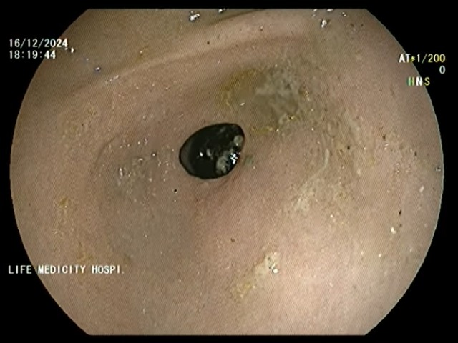
Figure. 1. Endoscopic image showing a black foreign object (likely a stone or pill) in the stomach lining.
Management
Endoscopic Interventions
Endoscopic stone retrieval with a conventional basket, polyp extraction mesh and laser lithotripsy, but all attempts to remove or fragment the calculus failed.(Figure. 2)
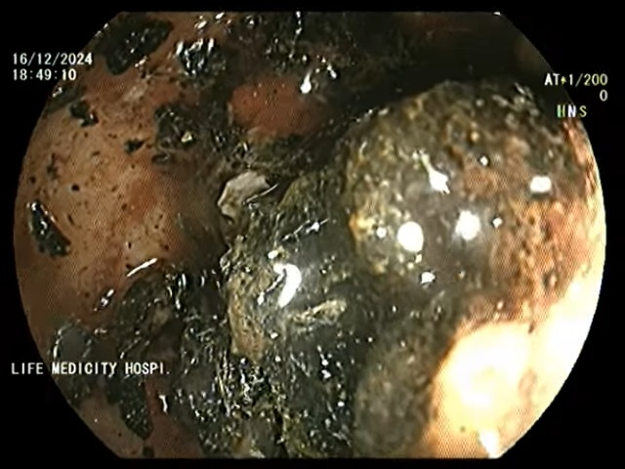.
Figure. 2. Surgical Approach
Given the failure of endoscopic management, the patient was scheduled for exploratory laparotomy, during which a chole cysto-duodenal fistula was identified, with a large gallbladder calculus obstructing the fistula.

Surgical Procedure
- Duodenotomy and Stone Extraction: A duodenotomy was performed at the fistula site, allowing the extraction of two large gallbladder calculi (Figure. 3 -4).
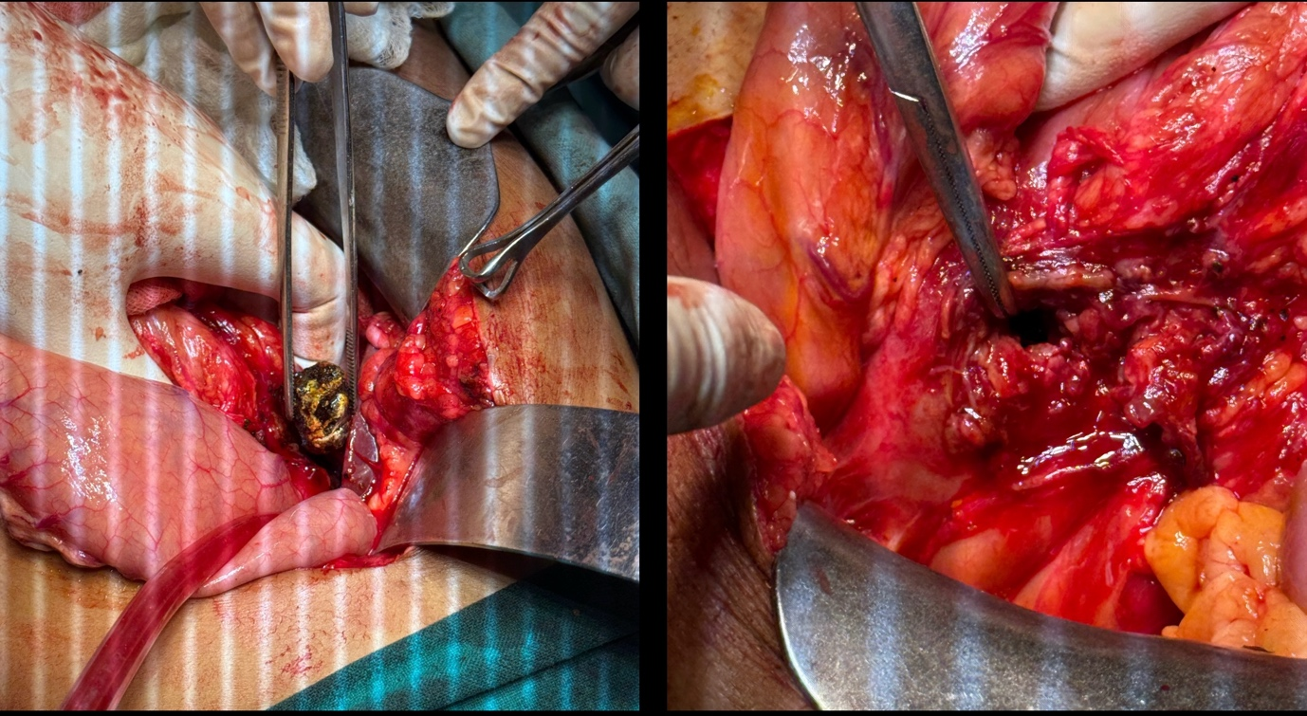
Fig. 3 Fig. 4
Fig. 3 . Surgical removal of a stone from the intestine
Fig. 4. After the stone removal from the intestine

- Cholecystectomy: The gallbladder was removed to prevent recurrence and further complications.
- Primary Duodenotomy Repair: The duodenotomy was closed primarily to restore the integrity of the duodenal wall.
- Gastrojejunostomy: To bypass the obstructed gastric outlet and ensure adequate gastric emptying, a gastrojejunostomy was created.
Postoperative Course
The patient’s recovery was uneventful. Follow-up at 2 months showed complete resolution of symptoms with no evidence of recurrence or complications.
Discussion
Pathophysiology
Gallstone-related GOO, also known as Bouveret’s syndrome, is a rare manifestation of chronic cholecystitis. Persistent inflammation can lead to the formation of a fistula between the gallbladder and adjacent structures, It complicates around 3-5% of cholelithiasis cases and most commonly the duodenum harbour the fistula. Large calculi may migrate through the fistula, causing mechanical obstruction [1, 3],most commonly obstruction occur at distal ileum. Its incidence peaks in elderly females, making our young patient’s presentation particularly noteworthy.
Clinical Presentation
The classic presentation includes symptoms of GOO, such as nausea, vomiting, and epigastric pain[2, 4]. In our case, the absence of systemic signs and normal laboratory findings initially obscured the diagnosis, emphasizing the importance of detailed imaging and endoscopy.
Diagnostic Challenges
Ultrasonography is a valuable initial tool for identifying gallstones and gallbladder pathology [5]. Endoscopy is essential for diagnosing GOO and visualizing impacted stones. Cross-sectional imaging, such as computed tomography (CT), classical Rigler's triad of a dilated stomach, pneumobilia and a radio-opaque shadow in the region of the duodenum, although it was not performed in this case due to clear endoscopic findings [4].
Management Strategies
The treatment of gallstone-related GOO involves relieving the obstruction and addressing the underlying pathology [6]. Endoscopic techniques, including lithotripsy and basket retrieval, are often attempted first. However, surgical intervention remains the definitive treatment in cases of failed endoscopic management or complex anatomy [7].
Surgical Considerations
Open surgery is preferred for large calculi and fistula repair. In our case, the combination of duodenotomy, cholecystectomy, and gastrojejunostomy ensured complete resolution of the obstruction and prevention of recurrence [1, 8]. Elderly or high-risk patients may be managed with stone extraction alone if endoscopic clearance is achieved, and the fistula can be left intact without significant morbidity [9,10].
Prognosis and Follow-Up
The prognosis for gallstone-related GOO is generally favourable with timely intervention. Long-term follow-up is necessary to monitor for complications, such as recurrent fistula formation or adhesive bowel obstruction [3, 5].
CONCULSION
Gallstone-related GOO is a rare but serious complication of chronic cholecystitis. Early diagnosis and prompt management are essential for preventing significant morbidity. Endoscopy is useful for diagnosis and initial management; however, surgery remains the gold standard in cases of endoscopic failure. Our case underscores the importance of a multidisciplinary approach: prompt imaging, judicious endoscopic attempts, and timely conversion to surgery with definitive fistula closure in a young patient to optimize outcomes.

References
- Van Hillo M, van der Vliet JA, van Rijswijk JE, et al. Gallstone ileus: diagnosis and treatment. Arch Surg. 1987;122(5):497-501.
- Bouveret L. Stenosis du pylore adherent a la vesicule. Rev Med (Paris). 1896;16:1-16.
- Reisner RM, Cohen JR. Gallstone ileus: a review of 1001 reported cases. Am Surg. 1994;60(6):441-446.
- Lassandro F, Romano S, Ragozzino A, et al. Role of imaging in the diagnosis of gallstone ileus and related conditions. AJR Am J Roentgenol. 2005;185(5):1159-1165.
- Glenn F, Reed C, Grafe WR. Biliary enteric fistula. Surg Gynecol Obstet. 1981;153(4):497-502.
- Rigler LG, Borman CN, Noble JF. Gallstone obstruction: pathogenesis and roentgen manifestations. JAMA. 1941;117(21):1753-1759.
- Malik AA, Ul-Haq I, Wani KA, et al. Gallstone ileus: a review. Saudi J Gastroenterol. 2007;13(2):78-82.
- Clavien PA, Baillie J. Gallstone ileus: a review of the literature. Br J Surg. 1990;77(7):727-729.
- Ayantunde AA, Agrawal A. Gallstone ileus: diagnosis and management. World J Surg. 2007;31(6):1292–1297.
- 10. Nuño-Guzmán CM, Marín-Contreras ME, Figueroa-Sánchez M, Corona JL. Gallstone ileus, clinical presentation, diagnostic and treatment approach. World J Gastrointest Surg. 2016;8(1):65–76.

