Case report

Retained fractured Foley catheter: A rare case report

ABSTRACT
Removing a Foley catheter could sometimes be problematic. When difficulty is encountered during removal of a Foley catheter, force should never be applied because of the dangers of traumatizing the bladder neck and the urethra resulting in severe bleeding and stricture subsequently. This case report is about a 72-year old man who had retained Foley catheter caused by non-deflation of the catheter balloon. Force was applied in an attempt to remove the catheter which resulted in pulling the catheter into the urethra and also fracturing the catheter, leaving a part of it with the balloon in the urethra. Catheter balloon was located by transperineal ultrasound which also guided catheter balloon puncture. Retained catheter was removed by milking it out which was enhanced by adequate analgesia and generous urethral lubrication. This report highlights the importance of ultrasonography in the management of a retained fractured catheter.
INTRODUCTION
Urethral catheterization is a routine medical procedure that facilitates direct drainage of the urinary bladder¹. It is usually performed for therapeutic, diagnostic and monitoring purposes. Although the procedure is simple and commonly performed by all cadres of doctors, it could lead to various complications such as urinary tract infection, bleeding, injury to the urethra or bladder and catheter malfunction². The most common complications related to Foley catheter passage particularly in males are urethral trauma and retention of catheter balloon³.
A retained Foley catheter occurs when it cannot be easily removed or its balloon fails to deflate. This can be due to various reasons including catheter valve malfunction, encrustation or adherence to the bladder or urethra.
Retained Foley catheter is considered a rare experience in clinical practice⁴⁻⁵. Adebamowo et al⁶ reported an incidence of 3.4% (18 out of 528 patients)
Retained catheter, though uncommon in clinical practice can cause problem when it occurs. Therefore, knowledge of the possibilities and their management is essential.
The purpose of this article is to report an unusual case of a retained fractured Foley catheter in the urethra due to the malfunctioning of the catheter balloon.
CASE PRESENTATION
A 72-year old man referred from a private hospital to the emergency room with 8 hour history of retained urethral catheter and 6 months history of lower urinary tract symptoms (LUTS). LUTS include nocturia, poor stream and feeling of incomplete voiding. He went into acute urinary retention a week prior to presentation which was relieved by urethral catheterization in the referring hospital. On the day of presentation to the emergency room, he had gone to the referring hospital for catheter removal. The medical staff on duty had difficulty removing the catheter; hence she applied force resulting in fracturing of the catheter. The proximal fractured part came out while she was pulling whereas the distal part was retained. There was no urethral bleeding and pain. He was unable to void,a few hours later he developed suprapubic swelling and pain, hence he was referred to the teaching hospital emergency room. He had no comorbidity
He was in painful distress, afebrile, not pale, anicteric, no pedal edema
The suprapubic region of the abdomen was distended up to the umbilicus and tender. There was no blood at the tip of the penis. A soft long object was palpable in the urethra mainly in the bulbar and proximal penile urethral.
The prostate was markedly enlarged with benign features.
A diagnosis of acute urinary retention secondary to retained fractured urethral catheter on a background of Benign Prostatic Hyperplasia was made
He had a suprapubic cystostomy to relieve urinary retention with drainage of 700mls of blood- stained urine.
Suprapubic ultrasonography showed the bulb of the suprapubic catheter without visualization of the bulb of the urethral catheter. Prostate was 84gm in size and had median lobe prominence. Complimentary transperineal ultrasonography was done which showed the fractured catheter stump with an intact balloon lodged in the bulbar urethra (fig1). The balloon was ruptured under ultrasound guidance with the needle of size 18G cannula which was associated with mild urethral bleeding.
The urethra lumen was instilled with 20mls of xylocaine jelly, followed by milking out of the catheter stump (fig2). The patient was covered with intravenous ciprofloxacin and metronidazole for 48 hours and afterwards discharged home for further evaluation of prostate enlargement at the urology outpatient department.
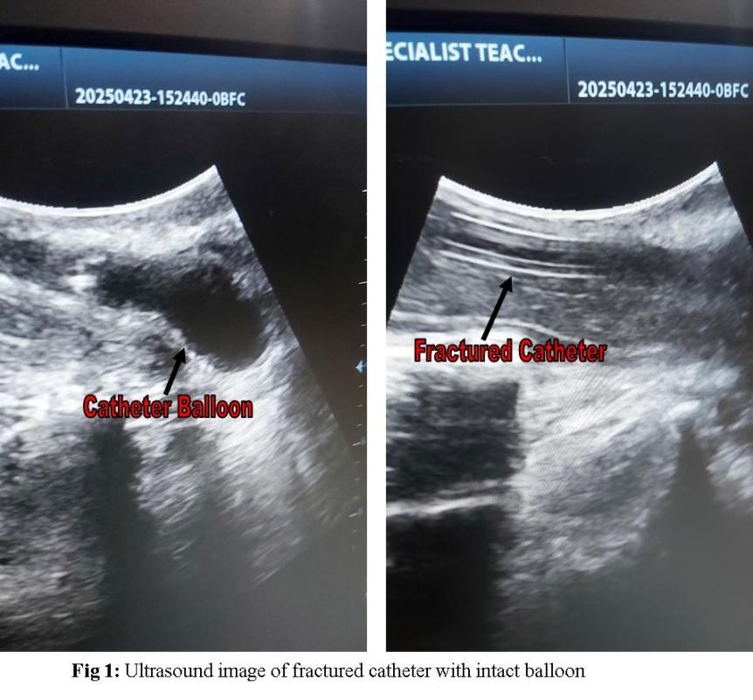
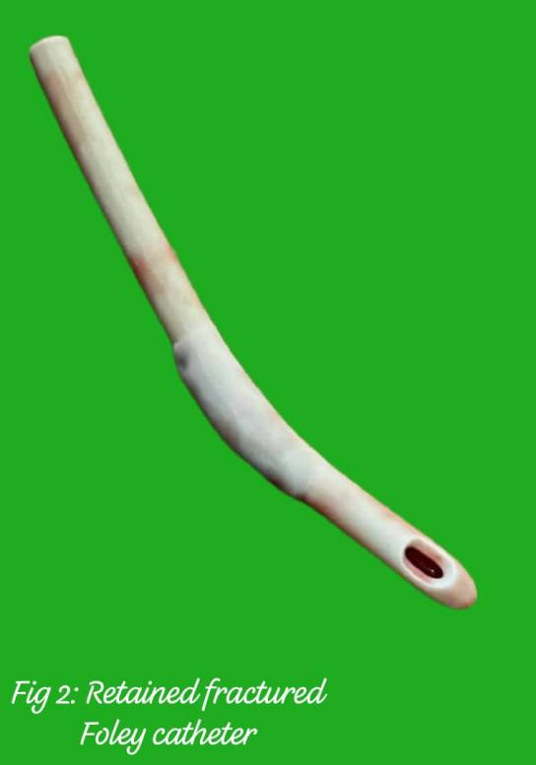

DISCUSSION
Approximately 10 -15% of patients admitted to the hospital receive a Foley catheter⁷.After they have served their purpose, indwelling urethral catheters can be removed by deflating their balloons. Removal of the Foley catheter is usually easy and straightforward but occasionally could be difficult resulting in catheter retention. The commonest cause of retained catheter is non-deflation of catheter balloon^{8, 9}. Other causes include pericatheter encrustation¹⁰and stone formation over the tip or balloon of the catheter^{11, 12}, cuffing effect of the deflated balloon¹³ and spontaneous knotting of the catheter on itself¹⁴. The possible reasons a catheter cannot be deflated include manufacturing defect, malfunctioning of the inflation valve caused by external clamping, crushing or kinking of the inflation channel, obstruction of the valve by either encrustation or crystallization when non -sterile fluid is used to fill the balloon⁷.
Diagnosing a retained catheter often involves a combination of clinical assessment and imaging techniques. If the balloon inflation valve is intact, but the balloon won’t deflate, it suggests a problem with the valve or blockage. In the index case, there was no opportunity of knowing the status of the catheter balloon or catheter balloon deflation since the catheter had been fractured and the part bearing the valve channel removed. The peculiarity of the index case meant that any hope of knowing the status of catheter balloon and its location relied much on clinical examination and ultrasonography. The balloon of a retained urethral catheter could be located in the bladder, urethra and rarely in the ureter¹⁵. Retained catheter balloon lodged in the urethra has the highest chance of being located by examination of the perineum because of the anatomical closeness of the urethra to the perineal skin. In the case being reported, the retained catheter fragment was clinically palpable along the course of the urethra. The retained catheter balloon wasn’t evident on examination hence the need for ultrasonography. Abdominal sonography is quick to diagnose the status and location of the Foley catheter balloon with added benefit of guiding needle puncture of the balloon for removal¹⁰. The balloon of a retained catheter may get accidentally pulled into the urethra as was the case in the index patient. This is best demonstrated by the absence of intravesical balloon on sonography.
The management of a non-deflating Foley catheter balloon is stepwise, graduating from non-invasive to invasive techniques. Shapiro⁸ and colleagues described a sequence of techniques used to manage retained Foley catheter caused by balloon that will not deflate. The first in the sequence is to cut the balloon port proximal to the inflation valve to allow the water drain spontaneously. If it fails, the next maneuver is to pass a lubricated guide wire through the inflation channel. The guide wire should allow fluid to drain along the wire itself. But if it doesn’t work, a 22 – gauge central venous line catheter can be passed over the guide wire. When the catheter tip is into the balloon, the wire can be removed, and the balloon should drain. If the above techniques are unsuccessful, the balloon can be hyperinflated with fluid or air, or dissolved chemically. In the index patient, the techniques above were not applied as their applicability depended on intact inflation valve which was part of the proximal fragment pulled out. Serious literature search shows no similar case has been documented. In index case, active rupture of the Foley balloon with a sharp instrument under transperineal ultrasound guidance was done enabling removal of the retained catheter fragment. The transperineal ultrasound - guided puncture is a bedside procedure that is safe, simple and quick in removing a non - deflatable catheter balloon in the urethra¹⁶.This method should be considered when the retained catheter balloon lies distal to the prostate gland.
CONCLUSION
Urethral catheterization is an invaluable procedure that is commonly performed in clinical practice for therapeutic, diagnostic and monitoring purposes. Being a commonly performed procedure by all cadres of health care givers, it is expected that challenges with removing a urethra catheter could occur. Knowledgeable stepwise application of the documented techniques for removal of a retained catheter is required in order to be successful when faced with the challenge of a retained catheter. Transperineal ultrasound - guided balloon puncture is a proven and effective method of removing a non - deflatable catheter balloon in the urethra.
REFERENCES
- Thomsen TW, Setnik GS. Videos in Clinical Medicine. Male Urethral Catheterization. N Engl. J Med 2006;354: e22
- Lowthein P. An Uncommon Complication of Urethral Catheterization. Br. J Urol. 1996;78: 805
- St. Luce S, Niran AC, Hall JA, Kimber IJ, Petros JA, Issa MM. Role of Transrectal Ultrasonography in Diagnosis and Treatment of Retained Foley Catheter. Urology 2005;65:1001
- JT Hamdi, JR Coll. Management of Retained Foley Catheter. Surg. Edinb. 1995;40:290 – 291
- Morgarita Hollingsworth et al. The Management of Retained Foley Catheters. Can J. Urol. 2004;11;2165 – 2166
- C.A Adebamowo et al. The Retained Urinary Catheter. Trop. Geogr. Med. 1993;45: 186 – 188
- Jeffery T, Kirchner DO. Methods for Removing a Non-deflating Foley Catheter. Am Fam Physician. 2005;62: 1397 – 1398
- Shapiro AJ, Soderdahl DW, Stack RS, et al. Managing the Non-deflating Urethral Catheter. J Am Board Fam Pracl. 2000;13: 116 – 119
- Obi AO. Management of Non-deflating Foley Suprapubic Catheters: A Novel Technique. J Coll of Med. Univ of Nigeria. 2004;9; 36 – 37
- Rath S, Mishra TS, Sasmal PR, Meher S. Pericatheter Encrustation: An Unusual Cause of a Retained Foley Catheter. BMJ Case Rep. 2016;14.doi:10.1136/bcr-2015-212379
- Nakano M, Lida T, Ohnishi M, Kurokawa K, Takahashi A, Tsukamoto T, Yasunaga T, Honda T. Association of the Urease Gene with Enterohaemorrhagic Eschericha Coli Strains Irrespective of their Serotypes. J. Clin. Microbiol. 2006;39: 4541 – 4543
- Hukins DWL, Hickey DS, Kenedy AP. Catheter Encrustation by Struvites. Br. J Urol 1983;55: 305 – 305
- Robinson J. Suprapubic Catheterization: Challenges in Changing Catheters. Br J Community Nurs 2005;10; 461 – 464
- Sithasanan N, Kihne M, Naidu RR, Ramanujam TM. Twisted Fate of Bladder Catheter. Med J Malaysia 2006;61; 369 – 370
- Thomas B McGregor, Rajau Sharta. Retained Urethral Catheter Secondary to Placement in Proximal Ureter. Case Reports in Urology 2016;1: 9178645
- F. Georgiades, R. Bakewell, A. Tsiotras. A Simple and Quick Solution to the Retained Traumatic Catheter. Urology 2020;141; e39 – e40

