Case report
Meningeal Metastases Presenting as Extra-Axial Hematoma: A Diagnostic Pitfall

.

ABSTRACT

Aims: To illustrate a significant diagnostic pitfall where meningeal metastases mimic benign extra-axial hematomas, and to highlight the crucial role of contrast-enhanced magnetic resonance imaging (MRI) in achieving the correct diagnosis.
Presentation of Case: We report two cases. The first is a 44-year-old female with breast carcinoma whose dural metastases, associated with osteolytic lesions, presented on computed tomography (CT) as an enhancing dural-based mass. The second is a 38-year-old male with colorectal cancer whose dural metastasis appeared on CT as a hyperdense collection suggestive of a subacute hematoma, with MRI being crucial in rectifying the diagnosis.
Discussion: The radiological presentation of meningeal metastases can be deceptive, leading to potential misdiagnosis and delayed oncologic management. This mimicry is a recognized challenge, particularly on initial CT scans. Key MRI findings that argue for a neoplastic process include marked diffusion restriction, nodular dural enhancement, and associated findings such as sinus thrombosis.
Conclusion: The possibility of meningeal metastases should be considered in the differential diagnosis of any new extra-axial collection in patients with a known history of malignancy. Contrast-enhanced MRI is the imaging modality of choice to differentiate these lesions and guide appropriate management.

Keywords: Meningeal metastases; Dural metastases; Extra-axial hematoma; Diagnostic pitfall; Breast cancer; Magnetic Resonance Imaging (MRI).

1. INTRODUCTION

Meningeal metastasis, encompassing both dural and leptomeningeal carcinomatosis, is a recognized and severe complication of systemic cancer, often associated with a poor prognosis. Meningeal metastasis encompasses two distinct entities: dural metastases, which often present as solid extra-axial masses, and leptomeningeal carcinomatosis, characterized by a more diffuse spread within the cerebrospinal fluid pathways. While a wide variety of malignancies can be implicated, this phenomenon is most frequently associated with primary tumors of the breast, lung, and prostate, particularly for dural-based lesions (Knippenberg et al., 2021). The clinical presentation is typically non-specific, including headaches, cranial nerve palsies, or other focal neurological deficits. Radiologically, the diagnosis is most often confirmed by contrast-enhanced magnetic resonance imaging (MRI). However, a significant diagnostic pitfall exists wherein these metastases can present with imaging features that closely resemble benign extra-axial hematomas, such as subdural or epidural collections. This mimicry is particularly challenging on initial computed tomography (CT) scans, where dural metastases can appear as isodense or hyperdense crescent-shaped collections, leading to potential misdiagnosis and delayed oncologic management. This report aims to illustrate this important diagnostic challenge through a presentation of two cases involving different primary tumors—breast and colorectal carcinoma—where meningeal metastases presented as an extra-axial hematoma. We will discuss the key CT and MRI findings that help orient toward the correct diagnosis.

2. PRESENTATION OF CASE
2.1 Case 1

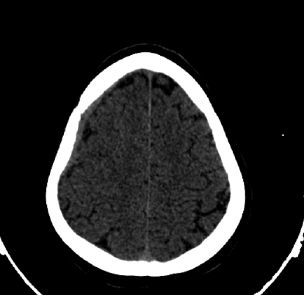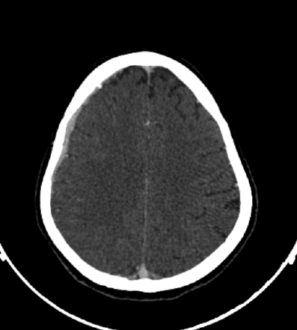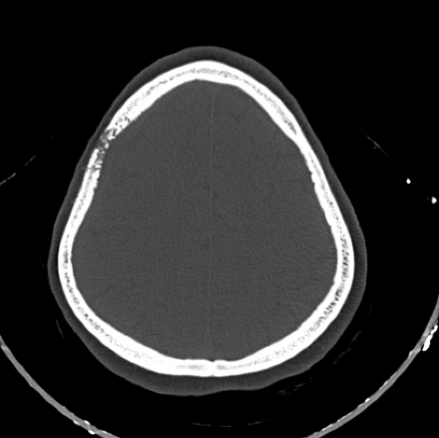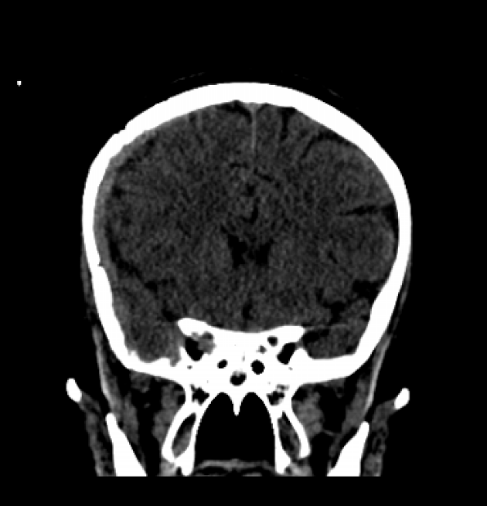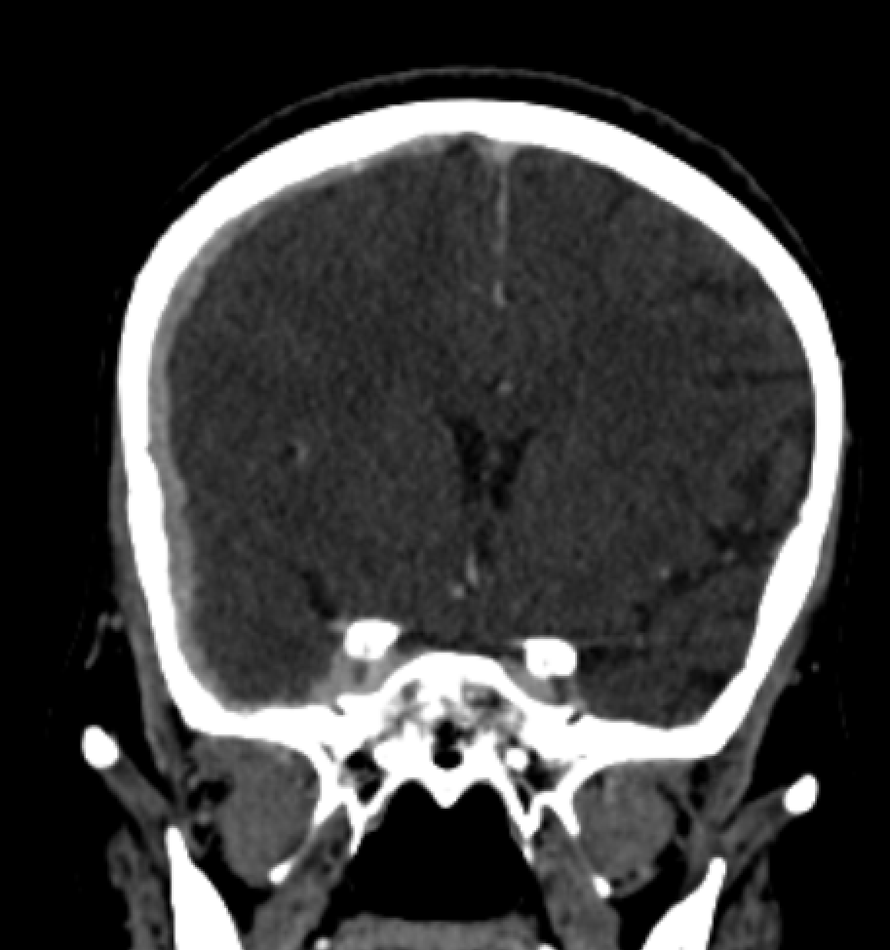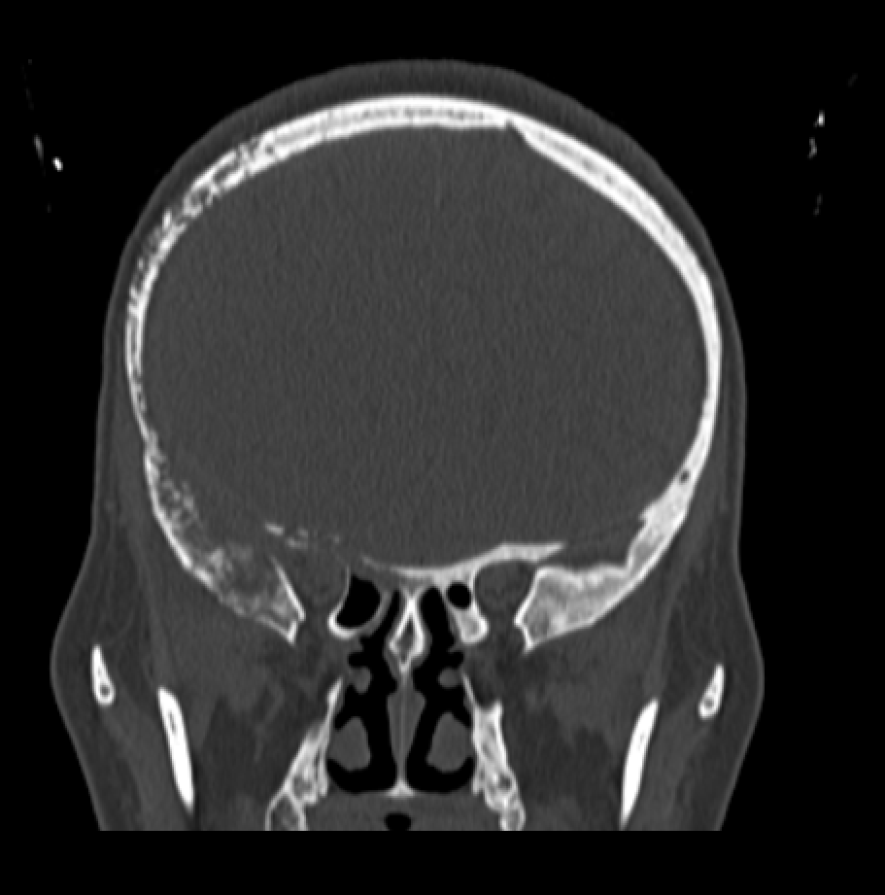A 44-year-old female presented with a marked deterioration in her general health. The workup diagnosed a grade III invasive ductal carcinoma (IDC) of the right breast, with an immunoprofile that was hormone receptor-positive (HR+) and human epidermal growth factor receptor 2-positive (HER2+). A comprehensive staging CT revealed a large primary retro-areolar mass measuring 52 x 50 x 59 mm, with local invasion of the skin and pectoral muscle. The scan also confirmed a significant systemic disease burden, with metastases in the lungs, multiple lymph node chains, and skeleton. Cranial imaging revealed the diagnostic challenge: lytic destruction of the right sphenoid and fronto-temporal bones, from which a contiguous, dural-based mass extended into the intracranial space (Figure 1). In light of the complete clinical picture, the dural-based mass was considered a manifestation of carcinomatosis, and the patient was directed toward palliative radiotherapy.
Fig. 1. Dural Metastasis Mimicking an Extra-Axial Hematoma (Case 1). A right fronto-temporal, spontaneously dense extra-axial lesion on non-contrast CT (A, D) mimics a hematoma. Its intense post-contrast enhancement (B, E) is highly suggestive of a neoplastic process. The extensive underlying osteolytic lesion, revealed on the bone windows (C, F), is a hallmark of a malignant origin (Axial findings: blue arrows; Coronal findings: orange arrows).
A
B
C
D
E
F

2.2 Case 2

A 38-year-old male with a history of surgically treated rectal adenocarcinoma presented with acute neurological symptoms, including headache, vomiting, confusion, and a spastic left hemiparesis. An initial non-contrast CT scan revealed a hyperdense, extra-axial collection with an appearance suggestive of a subacute epidural hematoma (Figure 2A). For further characterization of this lesion, a multi-parametric MRI was performed. This advanced imaging provided findings that contradicted the initial hypothesis. While the lesion was iso-intense on T1 and T2-weighted sequences (Figure 2B), it exhibited profound diffusion restriction on diffusion-weighted imaging (DWI)—a hallmark of hypercellularity—(Figure 2C) and intense, heterogeneous enhancement post-gadolinium administration (Figure 2D). Furthermore, the process was complicated by a tumoral invasion and thrombosis of the right sigmoid sinus. This combination of features was inconsistent with a simple hematoma. The definitive diagnosis of leptomeningeal carcinomatosis was established via the cytological identification of malignant cells in the cerebrospinal fluid.

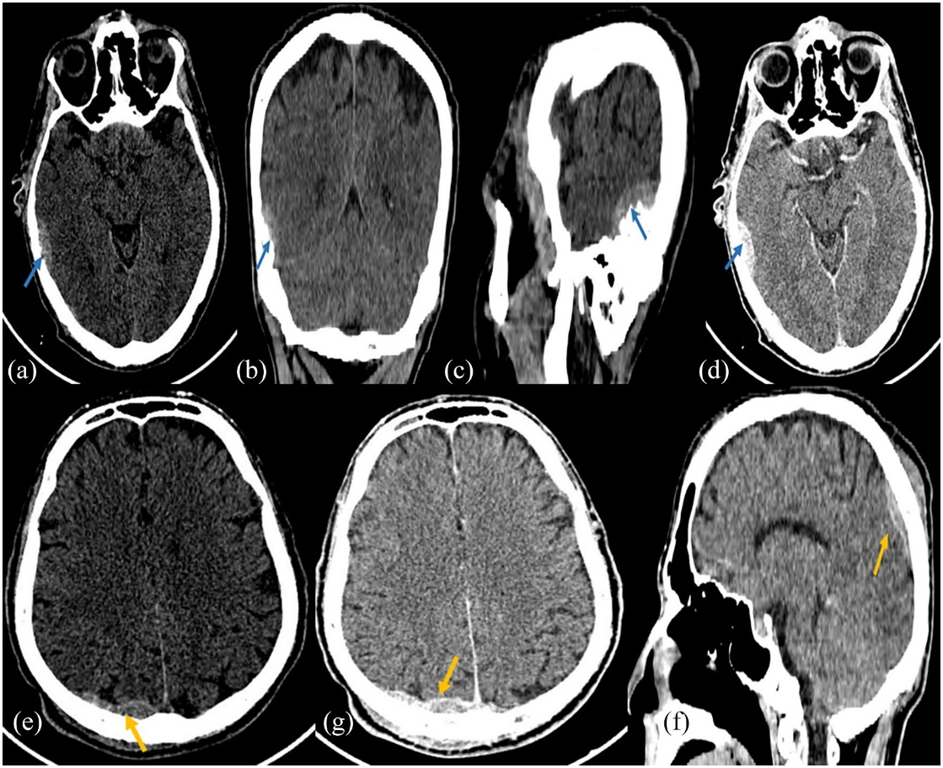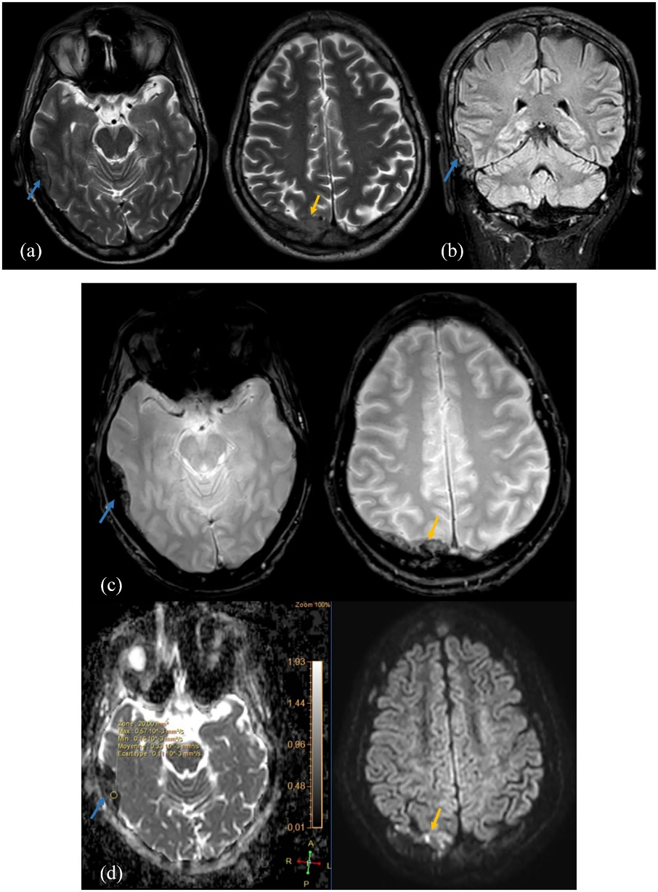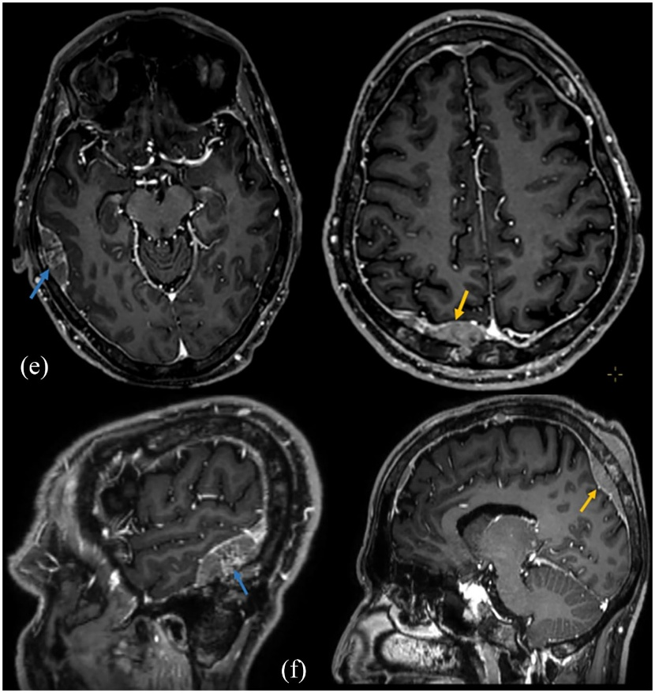
Fig. 2. Hematoma-Mimicking Dural Metastasis (Case 2). Non-contrast CT (A) demonstrates a hyperdense extra-axial lesion in the temporal region, simulating a subacute hematoma. On MRI, this portion of the lesion shows an iso-intense T2 signal (B) and profound diffusion restriction (C) (ADC low at 0.33×10⁻³ mm²/s), indicating high cellularity. The post-contrast T1-weighted MRI (D) demonstrates intense and heterogeneous enhancement, a defining feature of a vascularized neoplasm. (Images courtesy of Lahfidi et al. [5] and used with permission).
A
B
C
D

3. Discussion

This report highlights a critical diagnostic pitfall through two distinct cases where meningeal metastases presented with features of an extra-axial hematoma. This phenomenon is a well-documented entity in the literature, a phenomenon that is thought to be underdiagnosed (Knippenberg et al., 2021). Misdiagnosis can have significant consequences, potentially leading to unnecessary surgical interventions and delays in appropriate oncologic therapy.
Our first case, a dural metastasis from breast cancer, aligns with findings from several reports identifying breast cancer as one of the most common primaries to present in this manner (Fukui et al., 2021; Nagahide et al., 2020; Marhold et al., 2022). The presentation can be remarkably subtle, at times perfectly mimicking a chronic subdural hematoma even on initial MRI studies (Fukui et al., 2021). Our second case, originating from a colorectal adenocarcinoma (Lahfidi et al., 2022), illustrates that this pitfall is not exclusive to breast cancer. Other reports have confirmed similar presentations in patients with colon cancer (Han et al., 2022) and other malignancies such as lung adenocarcinoma (Lu et al., 2021), which underscores the need for a high index of suspicion in any patient with a known history of cancer.

The crucial role of advanced imaging, particularly contrast-enhanced MRI, cannot be overstated in resolving this diagnostic dilemma. As demonstrated in our second case, MRI provides superior characterization compared to CT (Mitu et al., 2023). Key findings that argue against a simple hematoma and for a neoplastic process include marked diffusion restriction, nodular or thick linear dural enhancement, and associated findings such as sinus thrombosis or direct parenchymal invasion (Lahfidi et al., 2022; Mitu et al., 2023). The potential pathophysiological mechanism for this hematoma-like appearance may involve microhemorrhages from fragile tumor neovessels or venous congestion secondary to dural venous sinus infiltration by the tumor (Broggini et al., 2023).
In the second illustrative case, although the primary imaging finding was a solid dural metastasis, the positive cerebrospinal fluid cytology suggests a concomitant microscopic involvement of the leptomeninges, a phenomenon that highlights the complexity of meningeal dissemination.

4. Conclusion

Meningeal metastases can present a formidable diagnostic challenge by deceptively resembling extra-axial hematomas on initial imaging. A high index of suspicion should be maintained in any oncologic patient presenting with such findings. Contrast-enhanced MRI, with careful attention to DWI sequences and enhancement patterns, is indispensable for accurate characterization. Distinguishing this neoplastic mimicry from a true hematoma is essential for ensuring timely and appropriate patient management and avoiding potentially harmful diagnostic and therapeutic errors.

Consent

All authors declare that ‘written informed consent was obtained from the patient (or other approved parties) for publication of this case report and accompanying images. A copy of the written consent is available for review by the Editorial office/Chief Editor/Editorial Board members of this journal.

Ethical approval

All authors hereby declare that all experiments have been examined and approved by the appropriate ethics committee and have therefore been performed in accordance with the ethical standards laid down in the 1964 Declaration of Helsinki.

References

Broggini, T., Nidecker, A., H-Augustine, V., et al. (2023). Pathophysiology and Imaging of Dural Venous Sinus Thrombosis in Oncologic Patients. Cancers (Basel), 15(11), 3001.
Fukui, A., Inaba, A., Kobayashi, T., et al. (2021). Dural metastasis of breast cancer mimicking chronic subdural hematoma: A case report and literature review. Surg Case Rep, 7(1), 168.
Han, M., Kim, Y. J., Lee, S. H., & Kim, D. Y. (2022). Dural Metastasis From Colon Cancer Mimicking Subdural Hematoma. J Korean Neurosurg Soc, 65(3), 421-425.
Knippenberg, R., Knippenberg, D., D'Andrea, G., et al. (2021). Dural Metastases Mimicking Subdural Hematoma: A Systematic Review. World Neurosurg, 149, e794-e803.
Lahfidi, A., Traore, W-YM., Imrani, K., Jerguigue, H., Latib, R., & Omor, Y. (2022). Leptomeningeal Metastasis Mimicking a Subacute Epidural Hematoma: Case Report. Clin Med Insights Case Rep, 15, 11795476221121315.
Lu, M., Zhang, J., Wang, T., & Zhang, T. (2021). Dural metastasis from lung adenocarcinoma mimicking chronic subdural hematoma: a case report. Ann Palliat Med, 10(5), 5935-5940.
Marhold, F., Koinig, H., Gatterbauer, B., et al. (2022). Dural metastases: a retrospective study of 23 patients. Cancers (Basel), 14(15), 3768.
Mitu, H., Jain, A., Doddamani, R., et al. (2023). The Role of Contrast-Enhanced MRI in the Diagnosis of Dural Metastases: A Pictorial Review. Neurol India, 71(4), 706-714.
Nagahide, T., Kameyama, M., Ogasawara, J., et al. (2020). Dural Metastasis from Breast Cancer Mimicking Subdural Hematoma: Three Case Reports and a Review of the Literature. Kurume Med J, 65(4), 145-150.

