Case report
Progressive Disseminated Histoplasmosis Presenting as Unmasking IRIS in a Patient With Advanced HIV Disease

Abstract :
Immune reconstitution inflammatory syndromes (IRIS) are well documented but it presents challenges in diagnosis and management. IRIS in patients with acquired immune deficiency syndrome (AIDS) can be characterized by unusual manifestations of Opportunistic Infections. This case aims to explore Progressive Disseminated Histoplasmosis Presenting as Unmasking IRIS in a Patient With Advanced HIV Disease. A 23-year-old Male patient presented to the hospital with a 7-day history of fever, cough with expectoration, shortness of breath, and progressive weight loss for the past 2 months. The patient also complained of a 2-day history of night sweats, chills and 1 episode of Epistaxis a day before presentation. He was a known case of HIV since birth and had stopped taking Anti-retroviral Therapy Medications for the past 7 years. On examination, he was febrile (104 °F), normal Blood Pressure (110/80mm Hg), Tachycardic (143 bpm), requiring 4L/minute of Oxygen supplementation by the help of nasal prongs. This case illustrates the potential for progressive disseminated histoplasmosis to emerge as an unmasking IRIS phenomenon in a patient with advanced HIV disease shortly after the initiation of antiretroviral therapy.
Introduction
Immune reconstitution inflammatory syndromes (IRIS) in patients with acquired immune deficiency syndrome (AIDS) can be characterized by unusual manifestations of Opportunistic Infections. These occur in patients who experience an improvement in CD4 cell counts following initiation of Highly Active Anti-Retroviral Therapy (HAART). Even though IRIS is well documented [1], it presents challenges in diagnosis and management. In this case we see the progressive dissemination of histoplasmosis with presentation of miliary mottling, fungal lymphadenitis, facial papules and fungal granuloma of the brain. Routine Screening for Opportunistic Infections will help in picking the infections earlier which helps treating infections at an earlier stage. [2]

Case Presentation
A 23-year-old Male patient presented to the hospital with a 7-day history of fever, cough with expectoration, shortness of breath, and progressive weight loss for the past 2 months. The patient also complained of a 2-day history of night sweats, chills and 1 episode of Epistaxis a day before presentation. He was a known case of HIV since birth and had stopped taking Anti-retroviral Therapy Medications for the past 7 years. The patient used to reside in the Chikkamagaluru region in Karnataka, who then later moved to Mysuru, Karnataka around 2 years before the presentation. The patient’s social history was collected, and it was found that the patient was a current smoker with an average of two packs per day. The patient had no history of hospitalization.
On examination, he was febrile (104 °F), normal Blood Pressure (110/80mm Hg), Tachycardic (143 bpm), requiring 4L/minute of Oxygen supplementation by the help of nasal prongs. Lymphadenitis was observed, bilateral crepitations were heard on examination
Laboratory Investigations revealed bicytopenia, White Cell Count was 3400 cells/cubic mm, Hemoglobin was 7.9g/dL, elevated SGOT 52U/L and SGPT 47U/L, Bilirubin levels were normal. Urine Histoplasma Antigen test was positive for the patient. Serum Cryptococcal Antigen was negative. Plain radiography of the chest revealed multiple small, fluffy nodular opacities in both the lung fields with prominent hila. FNAC was performed, and the clinical details suggested swelling. Macroscopy impressions were white material aspirated from the left cervical nodes. Microscopy smear studies showed sheets of small lymphocytes, follicle center cells and many macrophages. Many intracellular and extracellular encapsulated small fungal bodies were observed, which was consistent with Histoplasma with no evidence of malignancy. Periodic Acid-Schiff staining showed the presence of Fungal spores. The treatment was started with oral Itraconazole 200mg thrice a day initially, which was followed by Oral Itraconazole bid for a period of 12 months.
After 4 weeks, the patient presented back to the hospital with history of Convulsions 4 episodes a day. On Examination, he was afebrile (96 F), with normal vesicular breath sounds, Per Abdomen was soft, and tenderness was present. LFT and RFT levels were normal. Brain magnetic resonance imagng (T2 screening) was performed and the findings was focal altered signal intensity lesions in the right caudate nucleus and parietal cortex lesion with perilesional oedema as described. This finding was suggestive of features of granuloma. The diagnosis was made as progressive disseminated histoplasmosis presenting as miliary mottling, fungal lymphadenitis, pulmonary histoplasmosis and fungal granuloma.
The patient was started on ATT empirically, as the patient showed all clinical features of tuberculosis, even though there was no objective evidence. The treatment was also started on levetiracetam 750 mg bid and lacosamide 100 mg bid for the treatment of focal seizures, Tab. ATT DOTS OD (Isoniazid, Rifampicin, Pyrazinamide, ethambutol) for the empirical treatment of suspected tuberculosis, pyridoxine 50mg OD for preventing peripheral neuropathy for a period of 12 months and requested for follow up every 30 days once and a request was sent to his ART center is made to test for their current CD4 Counts and Viral load. The Patient was symptomatically better on follow-up after 6 weeks.

Discussion
This case report emphasizes a patient who had initially presented as a loss to follow up in HIV who was diagnosed as disseminated histoplasmosis for which they were treated and discharged and then visited the hospital with a second presentation with convulsive episodes.
Progressive disseminated histoplasmosis is a life-threatening opportunistic infection that can emerge in patients with advanced HIV disease. This case presented here illustrates the potential for disseminated histoplasmosis to manifest as unmasking IRIS (immune reconstitution inflammatory syndrome) in an individual with AIDS who initiated antiretroviral therapy. Immune reconstitution inflammatory syndrome is a well-documented phenomenon that can arise in HIV-infected individuals as their immune system begins to recover with the initiation of antiretroviral therapy, particularly in those with profound immunosuppression at baseline. [1] As the restored immune response works to combat previously subclinical opportunistic infections, it can sometimes trigger an exaggerated inflammatory reaction, leading to the clinical manifestation or worsening of these latent infections. [3]
There have been two types of IRIS observed clinically; 1. Paradoxical IRIS: A form which is characterized by the recurrence, worsening or a new onset of clinical symptoms related to a previously treated infection following the initiation of ART. Irrespective whether the treatment is ongoing or completed, immune function shows exaggerated symptoms of inflammatory symptoms, resulting in exacerbation/reappearance of the symptoms 2. Unmasking IRIS: Similar to this presentation, the IRIS makes its emergence through clinical signs and symptoms of an undiagnosed or a subclinical infection that might become apparent after initiation of ART. The improved immune function, indicated by a rise in CD4 cell counts and absolute neutrophil count, instigating a heightened response against pathogens that had been present earlier but asymptomatic due to immunosuppression. [4]
IRIS was unmasked upon initiation of Tenofovir+ Lamivudine+ Dolutegravir (TLD) regimen of HAART. TLD is a first line HAART regimen which has shown satisfactory viral suppression rates (>95%) without correlation with age, health status, sex and duration of anti-retroviral therapy. [5] Additionally, studies have revealed that dolutegravir based regimens have lately gained popularity. Tegegne et al. conducted a study on drug use evaluation of TLD regimen which revealed a significant decrease in viral load and increase in CD4 counts upon initiation or transition to TLD regimen. [6]
This patient had a presentation of granuloma for which drugs to manage focal seizures- levetiracetam and lacosamide were prescribed. Additionally, anti-tubercular drugs (Tab HRZE) were also prescribed along with Tab. Pyrazinamide 50 mg OD for prevention of peripheral neuropathy following treatment with isoniazid.
In this case, the abrupt appearance of disseminated histoplasmosis shortly after ART initiation was likely the result of an unmasking IRIS reaction, where the reconstituted immune system reacted vigorously to the previously occult histoplasma infection. This case highlights the critical importance for clinicians to maintain a high level of vigilance for the potential development of opportunistic infections, including disseminated histoplasmosis, in patients with advanced HIV disease who are initiated with antiretroviral therapy.

Conclusion
This case illustrates the potential for progressive disseminated histoplasmosis to emerge as an unmasking IRIS phenomenon in a patient with advanced HIV disease shortly after the initiation of antiretroviral therapy. The Clinician should be vigilant of viral, bacterial and fungal Infections while managing an advanced HIV disease which can cause unexpected complications. The diagnosis of this case presents with its complexities as progressive disseminated histoplasmosis is seen to mimic the symptoms of tuberculosis which further complicates the diagnosis. Timely Diagnosis of IRIS is needed to avoid further complications. Increased awareness of the disease condition and its associated factors might improve a clinician’s index towards the suspicion of the disease which could lead to a better treatment outcome also reducing the patients’ healthcare costs.

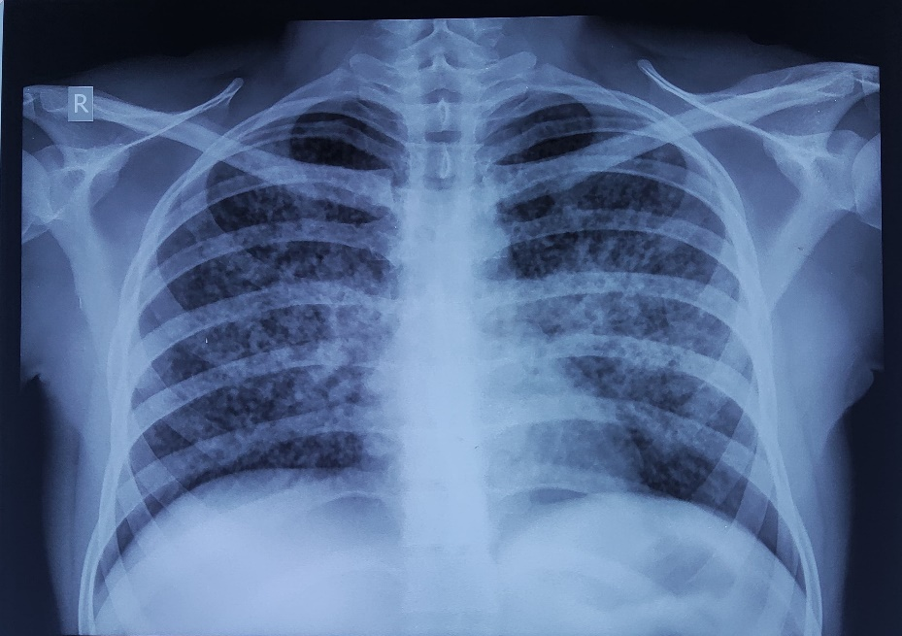
Fig 1 : Chest Radiography showing the presence of miliary nodules

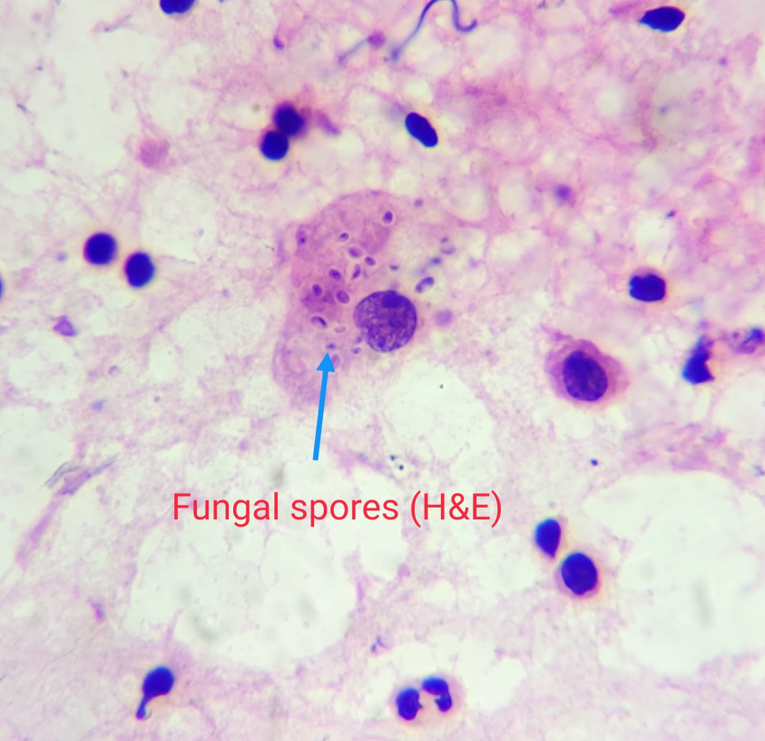

Fig 2 : Left Cervical Lymph Node Biopsy confirming presence of White material and fungal spores are present (x400 magnification)

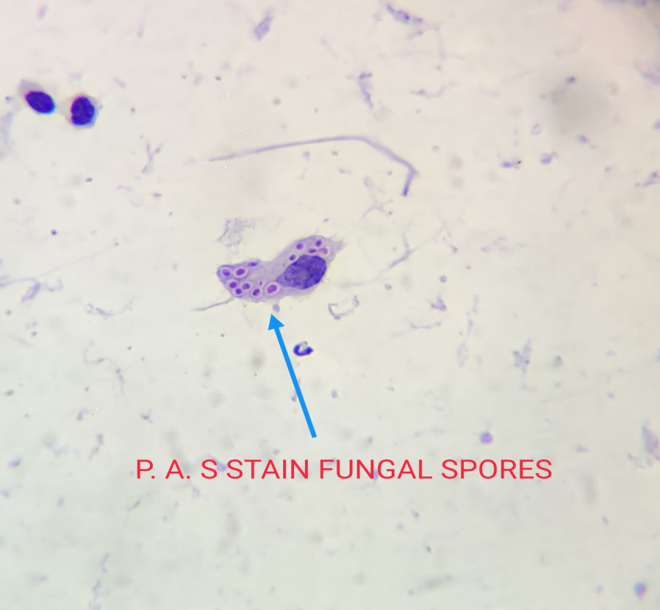

Fig 3 : P.A.S Staining showing Intracellular and extracellular spores consistent with Histoplasma (x400 magnification)
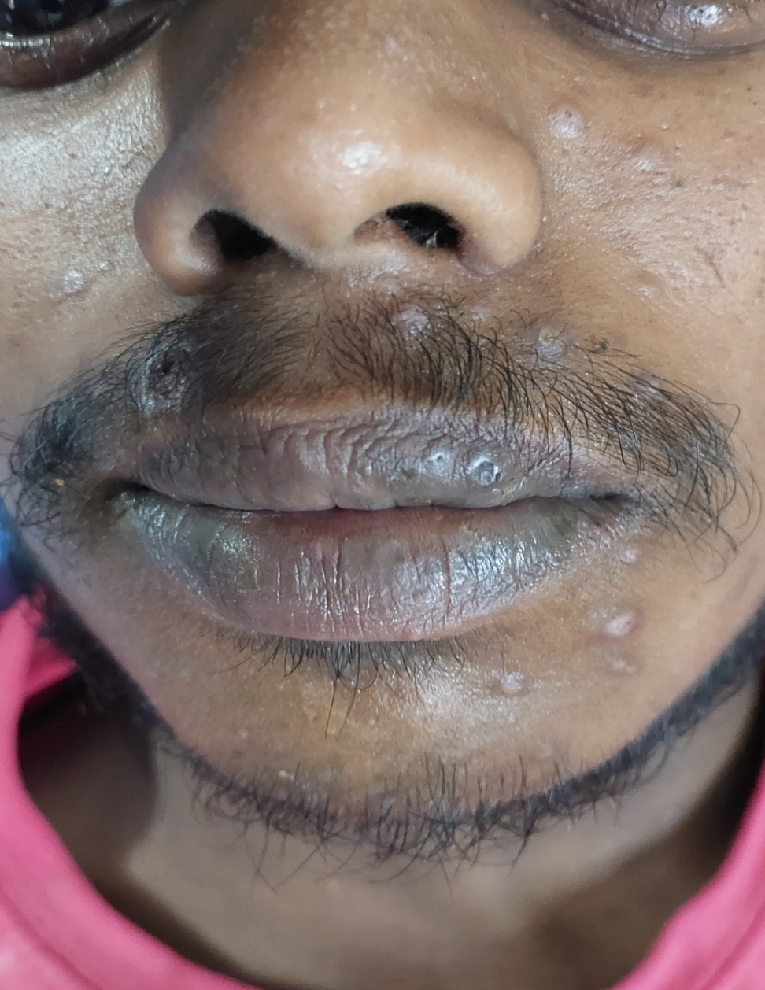
Fig 4 : Presence of facial papules

Informed Consent
The authors have obtained written consent from the participating subject for writing and publishing this case report.
Competing Interests/Conflicts of Interest:
The authors declare no competing interests
Ethics Approval
Not Applicable
Data Availability
Data sharing is not applicable to this article as no datasets were generated or analyzed during the current study.
Statement about the use of AI
The authors would like to state that there was no involvement of any AI tools for writing this manuscript.

References:

- SHELBURNE, SAMUEL A. III; HAMILL, RICHARD J.; RODRIGUEZ-BARRADAS, MARIA C.; GREENBERG: STEPHEN B.; ATMAR, ROBERT L.; MUSHER, DANIEL M.; GATHE, JOSEPH C. JR.; VISNEGARWALA, FEHMIDA; TRAUTNER, BARBARA W.. Immune Reconstitution Inflammatory Syndrome: Emergence of a Unique Syndrome During Highly Active Antiretroviral Therapy. Medicine 81(3): p 213-227, May. 2002, 10.1097/00005792-200205000-00005
- Sadiq U, Shrestha U, Guzman N: Prevention of Opportunistic Infections in HIV/AIDS. [Updated 2023 May 22]. In. StatPearls [Internet, Treasure Island (FL): StatPearls Publishing; 2025.
- Bosamiya SS: The immune reconstitution inflammatory syndrome. Indian J Dermatol. 2011, 56:476-9. 10.4103/0019-5154.87114
- Thapa S, Shrestha U: Immune Reconstitution Inflammatory Syndrome [Internet]. PubMed. Treasure Island (FL). StatPearls Publishing; 2022.
- Semengue ENJ, Fokam J, Etame NK, et al.: Dolutegravir-Based Regimen Ensures High Virological Success despite Prior Exposure to Efavirenz-Based First-LINE ART in Cameroon: An Evidence of a Successful Transition Model. Viruses. 2022:18-2022. 10.3390/v15010018
- Tegegne BA, Alehegn AA, Kassahun M: Drug Use Evaluation of Tenofovir/Lamivudine/Dolutegravir (TLD) Fixed-Dose Combination for Initiation and Transition Among HIV-Infected Individuals Attending Lumame Primary Hospital, North West Ethiopia. Integr Pharm Res Pract. 2024, 18:31-42. 10.2147/IPRP.S455351

