Case report

Mediastinal hydatid cyst: A Case Report with Diagnostic Approach and Imaging Review

ABSTRACT
Hydatidosis is a zoonosis caused by Echinococcus granulosus, and remains a significant public health issue in Mediterranean countries. Mediastinal hydatid cyst is an extremely rare manifestation and poses a diagnostic challenge when based solely on clinical presentation. While many cases are incidentally discovered, complications may occur in some patients. Nevertheless, hydatid disease should be considered in the differential diagnosis of mediastinal masses in endemic regions. We report the case of a 36-year-old female farmer with no notable medical history, but with regular exposure to dogs. She presented with progressively worsening back pain. Radiological investigations, including plain chest X-ray and cervico-dorsal MRI, revealed a posterior mediastinal hydatid cyst appearing hyperintense on T2 and hypointense on T1, with a bilayered wall containing daughter vesicles and extension into the spinal canal with visible compression. This case underscores the importance of considering echinococcosis in the differential diagnosis of mediastinal masses, even in the absence of typical symptoms.
Keywords: Posterior mediastinal hydatid cyst, rare case, radiology, MRI

INTRODUCTION
Hydatid disease, caused by the parasite Echinococcus granulosus, is a parasitic infection that mainly affects the liver and lungs. However, in rare cases, the disease can involve other organs such as the mediastinum, the central compartment of the thorax. Mediastinal hydatid cysts are extremely uncommon, representing only 0.1% to 4% of all hydatid cases [1][2]. This rarity is due to the parasite needing to bypass both the liver and lungs before reaching the mediastinum [3][4]. When they do occur, these cysts can cause various symptoms by compressing nearby structures such as the lungs, heart, spine, or nerves. With the help of modern imaging techniques like CT and MRI, diagnosis has become more accurate, and recent reports have described unusual cases with serious complications such as spinal cord compression and vascular involvement [14][16][18][19]. This paper discusses the clinical, radiological, and therapeutic aspects of mediastinal hydatid cysts, with a focus on recently published cases and complications

CASE PRESENTATION
We report a case of a 36-year-old female farmer with a history of dog exposure and no other significant medical background. She presented with progressive dorsal pain evolving over several months. Clinical examination revealed no palpable mass or local skin changes, but showed marked tenderness in the mid-dorsal region.
Chest radiography revealed a posterior mediastinal opacity with dorsal projection, without visible calcifications.
Cervico-dorsal MRI(figure 1): showed a cystic lesion with T2 hyperintensity and T1 hypointensity, characterized by a bilaminar wall and internal daughter vesicles. The lesion extended into the spinal canal, causing visible spinal cord compression .

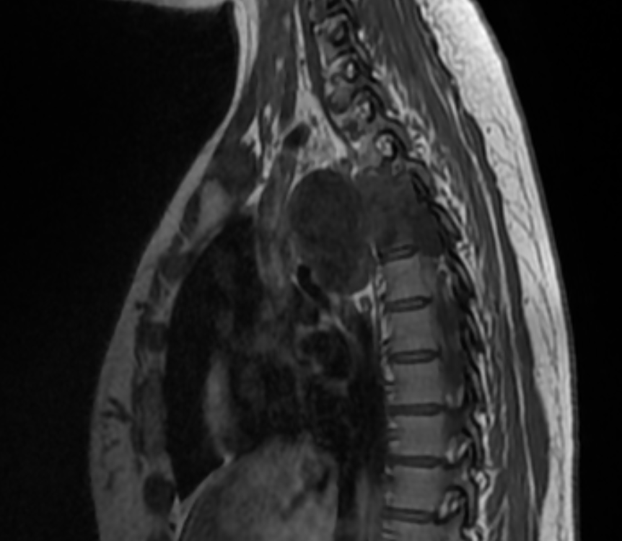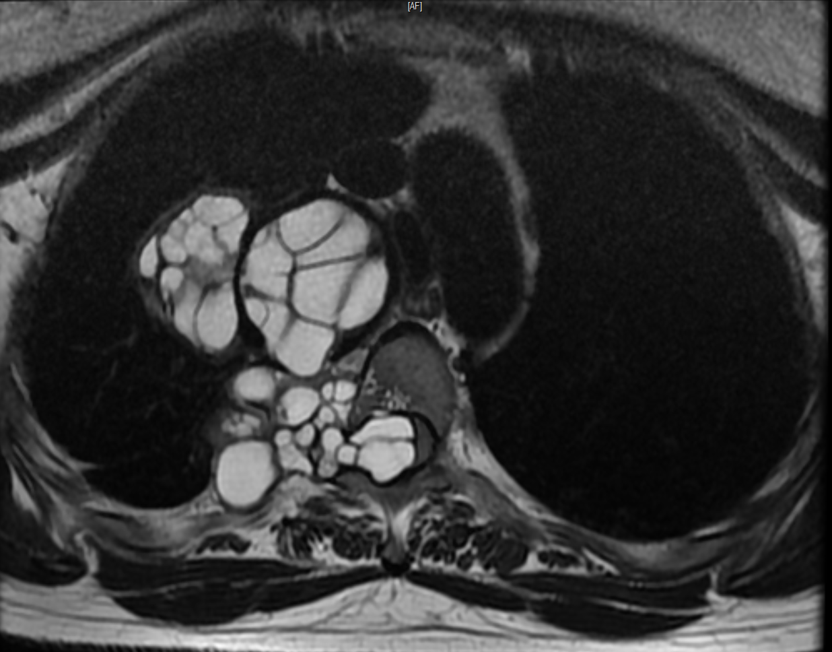
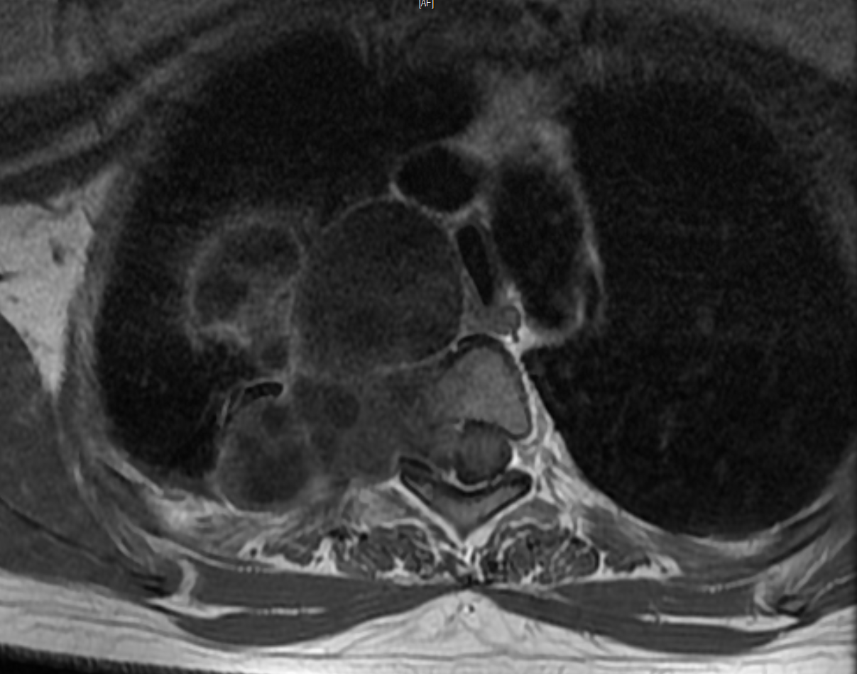
FIGURE 1: showed a cystic lesion with T2 hyperintensity and T1 hypointensity, characterized by a bilaminar wall and internal daughter vesicles. The lesion extended into the spinal canal, causing visible spinal cord compression.

Additional Investigations
CT-guided biopsy revealed a paucicellular sample with translucent eosinophilic material, showing a “comb-like” histologic appearance, pathognomonic of hydatid disease.

DISCUSSION
Mediastinal hydatid cysts remain exceptionally rare, accounting for only 0.1% to 4% of all echinococcosis cases [1][2]. This uncommon location is explained by the parasite's need to bypass both hepatic and pulmonary filters before reaching the mediastinum [3]. Two primary mechanisms have been proposed for this localization: hematogenous dissemination through systemic circulation that avoids hepatic and pulmonary filtration, and lymphatic spread via thoracic or chylous lymphatic pathways [4]. The posterior mediastinum is the most frequently affected site, likely due to its rich vascular and lymphatic network [5]. Clinical manifestations range from asymptomatic presentations to compressive symptoms such as chest pain, dyspnea, neurological deficits (especially when the spinal canal is involved), and vascular compression syndromes [2][6][7]. Recent reports highlight spinal cord involvement via dumbbell-shaped cysts extending through neural foramina [18]. Radiologically, chest X-rays may reveal mediastinal widening, well-defined water-density opacities, and occasional calcifications [8]. Ultrasound, although limited to superficial lesions, may show rosette or honeycomb patterns [7][9]. CT is the gold standard, identifying fluid-density lesions (0–20 HU), thin-walled cysts, daughter cysts, and the classic "serpent sign" [10][11]. MRI provides superior soft-tissue contrast and is particularly useful for evaluating extension into the spine or aorta, showing T1 hypointensity, T2 hyperintensity of cystic fluid, a T2-hypointense rim, and daughter cysts [12][13]. Recently reported imaging cases include a posterior mediastinal cyst with chest wall and spinal extension confirmed by CT [14], and a middle mediastinal cyst fistulating into the ascending aorta, identified by CT and MRI and requiring vascular surgical planning [16]. The differential diagnosis includes bronchogenic or pleuropericardial cysts, lymphangiomas, teratomas, neurogenic tumors, and mediastinal abscesses [9][11], with imaging differentiation based on wall characteristics, internal content, and enhancement patterns. Complications can include cyst rupture with bronchial or pleural spread (risking anaphylaxis), compression of vital structures, secondary infection with increased wall enhancement, and calcification suggesting chronicity [13]. New complications include diaphragmatic palsy due to phrenic nerve compression by a primary mediastinal cyst [19], and fistulation into major vessels like the ascending aorta, which may lead to life-threatening events [16]. Surgical cystectomy remains the treatment of choice, preferably through complete resection [11]. In cases involving the spine or major vessels, a multidisciplinary surgical approach is essential. Adjuvant albendazole therapy before and after surgery is widely recommended to reduce recurrence rates [15], and follow-up imaging (CT/MRI) is crucial; ultrasound remains useful for superficial residuals [7]. A 2023 case series of eight intrathoracic extrapulmonary hydatid cysts, including mediastinal forms, demonstrated favorable surgical outcomes and low recurrence with combined medical and surgical therapy [17]. Moreover, a 2024 literature review identified fewer than ten reported cases of mediastinal cysts with spinal canal extension, underscoring their rarity but emphasizing the need for clinical vigilance [18]

CONCLUSION
Mediastinal hydatid cysts are a rare but important differential diagnosis for cystic masses in the thorax. Their unusual location is explained by either hematogenous or lymphatic spread of Echinococcus granulosus, bypassing the liver and lungs. Although often asymptomatic, these cysts can cause serious complications through compression of nearby structures such as the trachea, spinal cord, or blood vessels.
Imaging plays a key role in diagnosis. CT scans typically show well-defined, water-density lesions with daughter cysts or detached membranes. MRI adds value in cases of suspected spinal or soft tissue involvement. Radiological features such as the "serpent sign" and "rim sign" are highly suggestive of hydatid disease. In some cases, biopsy may reveal characteristic histologic features, including translucent eosinophilic material with a "comb-like" appearance.
The mainstay of treatment is surgical removal, ideally a complete cystectomy. Albendazole may be used pre- and post-operatively to reduce recurrence. Postoperative follow-up with CT or MRI is essential to detect potential recurrences or complications.
Although rare, mediastinal hydatid cysts must be considered, especially in endemic regions. Early recognition, accurate imaging, and proper surgical management offer excellent outcomes and help prevent serious complications.

REFERENCES
1. El Abaissi Skalli A, El Amraoui F, Chikhaoui N. Mediastinal hydatid cyst: a case report. J Radiol. 2000 Feb;81(2):154-7.
2. Msougar Y, Afandi O, Ihfa N, et al. Mediastinal hydatid cyst: a case report. J Med Case Rep, 2013, 7, 236.
3. Benjelloun H, Bakhatar A, El Biaze M, Yassine N, Alaoui-Yazidi A, El Meziane A &amp; Bahlaoui A. Multivesicular mediastinal hydatid cyst. Respiratory Diseases Review. 2006;23:98.
4. Ali D, Gorur Y, Cardos B. Image of the month - Mediastinal hydatid cyst. Rev Med
Liege, 2019; 74(1)
5. Gasmi M, Fitouri F, Sahli S, et al.— Primary mediastinal hydatidosis in children: report of two cases. Rev Pneumol Clin, 2010, 7, 351-354.
6. Khannous M, Ferreti G, Ranchoup Y, Thony F, Robert F, Coulomb M. Intrathoracic hydatidosis: Contribution of CT (25 observations). J Radiol. 1993 Nov; 74(11): 541-8.
7. Akkari K, Chnitir S, Miled M, Mardassi A, Setthom A, Hachicha S & Chebbi M. Cervical mediastinal hydatid cyst: report of a case. Tunisian Journal of ENT and Head and Neck Surgery. 2007;19(1).
8. Zidi A, Zannad-Hantous S, Mestiri I, Ghrairi H, Baccouche I, Djilani H, Ben Miled
Mrad K. Primary hydatid cyst of the mediastinum: 14 cases. J Radiol. 2006 Dec;87(12)Pt 1:1869-74.
9. Charon P, Hamwi A, Beroud P, Dauptain J, Lefort JF & Cazal J. Hydatid cyst of the mediastinum: relevance of current medical imaging methods. La
Semaine des hôpitaux de Paris. 1993;69(4):100-103.
10. Msaad S, Fouzi S, Ketata W, et al.— An anterior mediastinal mass of rare aetiology. Rev Mal Respir, 2009, 7, 324-328.
11. Souhi H, Zegmout A, Janah H, et al.— A rare cause of posterior mediastinal tumors: mediastinal hydatid cyst. Pan Afr Med J, 2016, 25, 122.
12. Benzarti M, Jerray M, Khirouni S et al. Primary compressive calcified mediastinal hydatid cyst. Rev Mal Respir. 1997 Jan;14(1):53-4.
13. Janah H, Souhi H. Massive hydatid pulmonary embolism. Pan Afr Med J. 2014
Sep 9; 19:20.
14. Tadasa et al., 2023 – Posterior mediastinal hydatid cyst with chest wall and spinal involvement pmc.ncbi.nlm.nih.gov+8pubmed.ncbi.nlm.nih.gov+8edoriumjournalofdentistry.com+8
15. Caushi et al., 2023 – Intrapericardial hydatidosis case highlighting multidisciplinary surgical planning cardiothoracicsurgery.biomedcentral.com+1link.springer.com+1
16. Mehri et al., 2023 – Mediastinal cyst fistulating into the ascending aorta pmc.ncbi.nlm.nih.gov
17. Machboua et al., 2023 – Prognosis of intrathoracic extrapulmonary hydatidosis pmc.ncbi.nlm.nih.gov+4cardiothoracicsurgery.biomedcentral.com+4link.springer.com+4
18. Tadele et al., 2023–24 – Mediastinal dumbbell cyst with spinal compression, literature review pubmed.ncbi.nlm.nih.gov+2edoriumjournalofdentistry.com+2edoriumjournalofdentistry.com+2
19. Case of diaphragmatic palsy due to primary mediastinal cyst, 2024

