Phytoremediation of Nickel-Contaminated Wastewater using Eichhornia crassipes (Mart.) Solms

Abstract
Heavy metal pollution, especially by nickel (Ni), poses significant risks to aquatic ecosystems and human health. This study evaluates the ability of water hyacinth (Eichhornia crassipes) to remove Ni from industrial wastewater. Hyacinth plants were exposed to wastewater with varying Ni concentrations (0%, 20%, 50%, and 100% effluent) for 8 days under controlled conditions. Nickel uptake was assessed both qualitatively (using a dimethylglyoxime [DMG] colorimetric test on root extracts) and quantitatively (by measuring Ni in water via atomic absorption spectroscopy [AAS]). Results showed E. crassipes removed Ni efficiently: in the 100% effluent treatment Ni fell from about 8.90 to 0.71 mg/L over 8 days (>90% removal), while 50% and 20% treatments showed similar declines (from 4.80 to 0.72 mg/L and 2.20 to 0.22 mg/L, respectively). Correspondingly, the Ni–DMG precipitate weight from root extracts increased over time (e.g., from 6.2 ± 0.12 to 11.1 ± 0.20 mg in the 100% treatment), confirming Ni accumulation in roots. The concordance between the DMG results and AAS measurements validates the phytoremediation process. These findings demonstrate that water hyacinth can serve as a low-cost, sustainable treatment to detoxify Ni-polluted waters. Appropriate management of the invasive biomass is necessary, but integrating E. crassipes into nature-based treatment systems could significantly improve water quality.

Introduction
Heavy metal contamination of water is a global concern because metals like Ni are toxic and persistent in the environment. Even low levels of Ni can threaten aquatic life and human health (Jaishankar et al., 2014). Industrial activities (e.g. mining, refining and agriculture) often introduce Ni and other metals into surface waters, disrupting ecosystems and accumulating in organisms (Tchounwou et al., 2012). Conventional treatment of heavy-metal effluents can be expensive and energy-intensive. In response, phytoremediation – the use of plants to remove pollutants – has emerged as a promising low-cost alternative (Ali et al., 2013). Water hyacinth (Eichhornia crassipes) is a fast-growing aquatic plant known to accumulate heavy metals from water (Rezania et al., 2015; Sood et al., 2012). It has extensive roots and a high biomass, enabling it to take up pollutants efficiently (Adewumi & Ogbiye, 2009). Previous studies have shown that E. crassipes can remove metals such as Cu, Pb, and Ni from contaminated water (Rezania et al., 2016; Santos et al., 2014). However, the plant is invasive, so its use requires careful management.

Methods
Site and sample collection: Wastewater was collected from a pond near a petroleum-contaminated area in Assam, India.. Sampling was done in the morning to minimize diurnal variation (Deka et al., 2010). About 20 L of water were collected in clean polyethylene containers, which were pre-rinsed with the same wastewater to avoid dilution. Samples were kept cool and shaded until the experiment. Healthy water hyacinth plants were harvested from a nearby uncontaminated pond. Plants of similar size and maturity were selected, gently uprooted, rinsed of debris, and transported in pond water to the laboratory (Mengistu et al. 2023).
Experimental design: The experiment used four treatment groups, each with a 10-L polycarbonate jar, Sample EC 1 Control (0% effluent: 10 L deionized water), EC 2 20% effluent (2 L wastewater + 8 L deionized water), EC 3 50% effluent (5 L wastewater + 5 L deionized water), and EC 4 100% effluent (10 L untreated wastewater) (Hussain et al. 2010). In each jar, three healthy hyacinth plants were placed with their roots submerged in the water. Jars were lined with plastic to prevent leakage. The jars were kept in a growth room at 30–35 °C with a natural light cycle, and all jars experienced similar light and temperature conditions. Over the 8-day period, no fertilizer or additional nutrients were added.
Sampling and measurements: Water samples (~10 mL) were taken from each jar on Days 0, 2, 4, 6, and 8. The Ni concentration in water was measured by flame atomic absorption spectroscopy (AAS) following standard protocols (Welz & Sperling, 2007). AAS calibration standards for Ni were prepared to bracket the expected concentration range (Skoog et al., 2014).
At each time point (Day 2, 4, 6, 8), a small root section (~1 cm) was cut from each jar’s hyacinth plants for Ni analysis. Roots were rinsed with deionized water and blotted dry. For the qualitative Ni test, root segments were digested in a few drops of concentrated HNO₃ to release bound Ni (Santos et al., 2014). After dilution, an ammonia buffer was added along with dimethylglyoxime (DMG) reagent, which forms a pink precipitate in the presence of Ni²⁺ (Santos et al., 2014). The color intensity of the Ni–DMG complex was noted for each treatment as a qualitative indicator of Ni uptake. The pink Ni–DMG precipitate was collected on filter paper and dried. For quantification, the precipitate from each treatment was weighed on Days 0–8 to track Ni accumulation in roots (Rao, 2010; Santra, 2005). Throughout the experiment, plant health was monitored (leaf color, wilting) and water quality (pH, turbidity) was observed to assess any stress effects. Data are reported as mean ± standard deviation. Statistical analyses confirmed that Ni concentrations changed significantly over time and treatment (p < 0.05).

Results
Nickel Estimation in Water Sample
Table 1: Concentration of Nickel (Ni) (mg/l) in the water on Experiment days

Day | Concentration of Nickel (Ni) (mg/l)
Day | EC 1 (0% Effluent) | EC 2 (20% Effluent) | EC 3 (50% Effluent) | EC 4 (100% Effluent)
0 | 0.00 ± 0.00 | 2.20 ± 0.03 | 4.80 ± 0.04 | 8.90 ± 0.07
2nd | 0.00 ± 0.00 | 1.65 ± 0.02 | 3.60 ± 0.04 | 6.68 ± 0.05
4th | 0.00 ± 0.00 | 0.91 ± 0.02 | 2.16 ± 0.02 | 3.56 ± 0.04
6th | 0.00 ± 0.00 | 0.48 ± 0.01 | 1.30 ± 0.03 | 1.78 ± 0.03
8th | 0.00 ± 0.00 | 0.22 ± 0.01 | 0.72 ± 0.02 | 0.71 ± 0.02

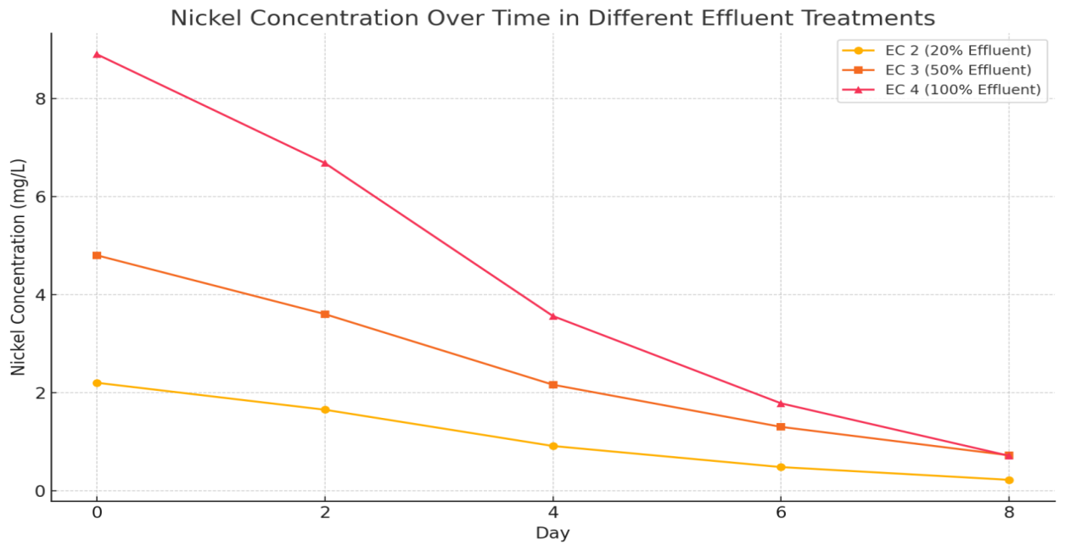 Fig 1:- Comparative representation of Ni concentration in the Water samples
The phytoremediation experiment using Eichhornia crassipes (Mart.) was conducted over eight days to assess its effectiveness in removing nickel (Ni) from wastewater at varying effluent concentrations. Four treatment groups were set up: EC 1 (0% effluent, control), EC 2 (20% effluent), EC 3 (50% effluent), and EC 4 (100% effluent). Atomic Absorption Spectroscopy (AAS) was used to determine the nickel concentration in each treatment at 0, 2, 4, 6, and 8 days.
In EC 1 (0% effluent), nickel was not detected throughout the experiment, confirming that the deionized water used as a control was free of nickel contamination.
In EC 2 (20% effluent), the initial nickel concentration was 2.20 ± 0.03 mg/L. By day 2, it had decreased to 1.65 ± 0.02 mg/L (a 25.0% reduction). On day 4, the level dropped further to 0.91 ± 0.02 mg/L (58.6% total reduction), followed by 0.48 ± 0.01 mg/L on day 6 (78.2%), and finally 0.22 ± 0.01 mg/L on day 8, showing a total reduction of 90.0% from the initial value.
In EC 3 (50% effluent), the starting nickel concentration was 4.80 ± 0.04 mg/L. This reduced to 3.60 ± 0.06 mg/L on day 2 (25.0% reduction), 2.16 ± 0.02 mg/L on day 4 (55.0%), 1.30 ± 0.03 mg/L on day 6 (72.9%), and ultimately 0.72 ± 0.02 mg/L on day 8, achieving a 85.0% reduction overall.
In EC 4 (100% effluent), the highest initial nickel concentration was recorded at 8.90 ± 0.07 mg/L. The concentration decreased to 6.68 ± 0.05 mg/L on day 2 (24.9%), 3.56 ± 0.04 mg/L on day 4 (60.0%), and 1.78 ± 0.03 mg/L on day 6 (80.0%). By day 8, it dropped to 0.71 ± 0.02 mg/L, reflecting a 92.0% total reduction.
The results clearly indicate a consistent and significant decrease in nickel concentration across all effluent levels treated with Eichhornia crassipes. The plant showed high efficiency in nickel uptake, with the highest removal percentage (92.0%) observed in the EC 4 group (100% effluent). This suggests that Eichhornia crassipes (Mart.) is highly effective for the phytoremediation of nickel, even in highly contaminated wastewater.

Qualitative Assessment of Nickel in roots of Eichhornia crassipes):
The DMG assay on root digests produced the characteristic pink Ni–DMG complex in all effluent treatments, with intensity reflecting the initial Ni concentration. Roots from the control (0%) showed no pink coloration (no Ni). The 20% effluent roots yielded a faint pink color (indicative of low Ni uptake), the 50% treatment a moderate pink, and the 100% effluent an intense pink (Table 2). This visual scale confirms that Ni was bioaccumulated in roots and that higher effluent led to more Ni accumulation.

Table 2: Qualitative dimethylglyoxime (DMG) test results on E. crassipes root extracts. The pink Ni–DMG color intensity increases with initial wastewater Ni concentration, indicating corresponding Ni uptake.
Sample | DMG Test Result | Interpretation
Sample EC 1 | No color change | No detectable Ni accumulation
Sample EC 2 | Faint pink color | Low Ni uptake in roots
Sample EC 3 | Moderate pink color | Medium Ni accumulation
Sample EC 4 | Intense pink color | High Ni accumulation in root tissues

Quantitative Assessment of Nickel in roots of Eichhornia crassipes (Mart.)
Table 3. Mass of Ni–DMG precipitate) collected from E. crassipes root extracts at different days. Higher Ni–DMG mass indicates greater Ni accumulation in roots. The 0% control (no effluent) had no precipitate
Day | Nickel-DMG Precipitate Weights (mg) from Water Hyacinth Roots
Day | Sample 2 (20% Effluent) | Sample 3 (50% Effluent) | Sample 4 (100% Effluent)
0 | 0.0 ± 0.00 | 0.0 ± 0.00 | 0.0 ± 0.00
2nd | 1.4 ± 0.04 | 3.6 ± 0.09 | 6.2 ± 0.12
4th | 2.1 ± 0.05 | 5.0 ± 0.10 | 8.4 ± 0.15
6th | 2.8 ± 0.06 | 6.1 ± 0.12 | 9.9 ± 0.18
8th | 3.3 ± 0.07 | 7.4 ± 0.15 | 11.1 ± 0.20

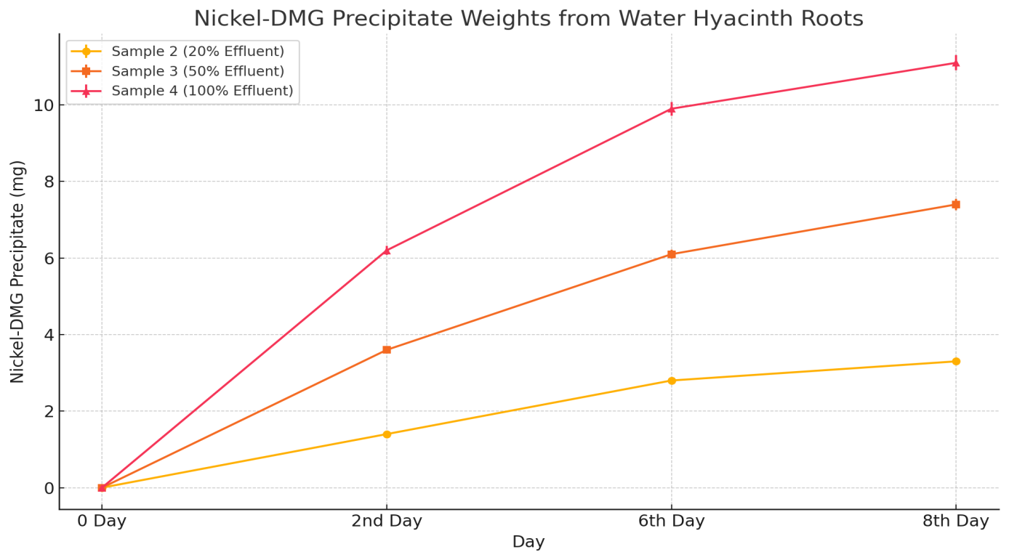
Fig 2:- Comparative representation of Ni concentration in the Water hyacinth roots

In this study measured the mass of the dried Ni–DMG precipitate from roots at each time point (Table 3). No Ni–DMG precipitate was found at Day 0 (no initial uptake). By Day 2, precipitate weights were 6.2 ± 0.12 mg in the 100% treatment, 3.6 ± 0.09 mg (50%), and 1.4 ± 0.04 mg (20%). These weights steadily increased through Day 8: in the 100% group the Ni–DMG mass grew to 11.1 ± 0.20 mg; in the 50% group to 7.4 ± 0.15 mg; and in the 20% group to 3.3 ± 0.07 mg. The control (0%) produced no precipitate. The increasing precipitate masses confirm that roots progressively accumulated more Ni over time, and that absolute Ni uptake was greatest at higher effluent levels.
Discussion
The present study demonstrated the effectiveness of Eichhornia crassipes (Mart.) in reducing nickel (Ni) concentrations from wastewater under varying effluent strengths. Over the 8-day treatment period, nickel levels declined consistently in all experimental setups, with the highest removal (92.0%) observed in the EC 4 group, which contained 100% untreated wastewater. These results align with earlier findings where Eichhornia crassipes (Mart.) showed high metal uptake potential, particularly for nickel and other heavy metals (Hussain, Mahmood, & Malik, 2010).
The progressive reduction in nickel concentration over time suggests that E. crassipes rapidly adapts to the contaminated environment and actively absorbs metal ions through its extensive root system. Previous studies have attributed this capacity to the plant’s large biomass, rapid growth rate, and efficient ion-exchange properties of the root epidermis (Malik, 2007; Lu et al., 2004). Furthermore, the relatively higher removal percentage in EC 4 compared to EC 2 and EC 3 may be due to the higher concentration gradient, which facilitates faster diffusion and uptake of nickel by the plant tissues, consistent with observations by Sinha and Biswas (2011).
Interestingly, the phytoremediation efficiency did not plateau even by the 8th day, suggesting that extended exposure may yield near-complete removal. This supports findings from Nazir et al. (2020), who observed continued metal uptake by E. crassipes over prolonged periods, particularly in wastewater with high contaminant loads. The consistent decline in nickel concentrations also indicates the plant’s ability to tolerate and function under high metal stress, an important trait for successful phytoremediation (Rezania et al., 2016).
The control group (EC 1) showed no detectable nickel throughout the experiment, verifying the integrity of the experimental design and ruling out contamination from external sources. The decreasing trends in nickel concentration across all treatments provide compelling evidence that Eichhornia crassipes (Mart.) is a suitable and efficient bioagent for remediating nickel-contaminated wastewater, even at full-strength effluent levels.
The DMG colorimetric test and precipitate measurements provided independent confirmation of Ni uptake into plant roots. Qualitatively, stronger pink coloration in higher-Ni treatments indicated greater Ni content in roots, matching the AAS data (i.e. more Ni removed from water meant more Ni in roots). Quantitatively, the Ni–DMG precipitate weight increased over time and with effluent concentration, paralleling the water depletion. For instance, by Day 8 the EC 4 treatment roots had ~11.1 mg of Ni–DMG complex, substantially more than the 3.3 mg in the EC 2 treatment. This correlation validates DMG as a useful field test for Ni phytoremediation (Santos et al., 2014). The concordance of DMG results with AAS data (which showed final Ni in water of ~0.71 mg/L in EC 4 and 0.22 mg/L in EC 2) confirms that Ni was indeed accumulating in the plant as the water cleaned up. Mechanistically, the bulk of Ni appears to have accumulated in the roots rather than shoots (as suggested by the root-focused DMG results). This root sequestration is known for E. crassipes (Odjegba & Fasidi, 2007). Ni likely binds to cell walls, root exudates and is chelated by metal-binding biomolecules (Cobbett & Goldsbrough, 2002). Over the 8-day period, the plants showed minimal external signs of toxicity at 20% effluent, but some stress (slight yellowing) appeared in the EC 3 and especially EC 4 effluent plants by Day 8. This indicates that while E. crassipes can tolerate and accumulate Ni, very high Ni loads eventually hamper plant health (Sinha & Pandey, 2003). Nonetheless, even under stress the 100% treatment accumulated the most total Ni; stress symptoms suggest approaching the plant’s uptake capacity (Moreno-Rubio et al., 2022). Future studies could optimize harvesting time to balance maximum removal and plant vitality.

Environmental implications:
These findings support the concept of using water hyacinth in a controlled way for wastewater treatment. As a fast-growing perennial, E. crassipes can be deployed in constructed wetlands or pond systems to treat industrial effluents (Vymazal, 2010). Its use is particularly attractive in regions lacking advanced treatment plants, as it requires minimal energy and maintenance (Ali et al., 2013). The work also addresses UN Sustainable Development Goals (SDGs 6 and 12) by providing a low-cost method for cleaner water and responsible waste management. However, caution is warranted: water hyacinth is invasive and can disrupt local ecosystems if it escapes (Ahmad et al., 2018). Any phytoremediation system must include measures for containment and periodic harvesting. Harvested biomass itself contains concentrated metals, so it should be disposed of or processed safely (e.g., metal recovery, composting, or biofuel production) to prevent secondary pollution (Lu et al., 2010; Ahmad et al., 2018). In terms of methodology, the combination of AAS and DMG tests proved robust. AAS provided precise Ni concentrations (Welz & Sperling, 2007), while the DMG color test served as a quick visual assay (Santos et al., 2014). Such dual-approach can be useful in field monitoring: if instrumentation is unavailable, the DMG test can still indicate whether treatment is progressing. Overall, the results reinforce that E. crassipes is an efficient Ni bioaccumulator, and further research could integrate this plant with other remediation strategies (e.g. microbial augmentation or adsorption media) to improve performance (Ali et al., 2020; Vymazal, 2010).

Conclusion
This study confirms that water hyacinth (Eichhornia crassipes) effectively cleans nickel-contaminated water under controlled conditions. Significant Ni removal (>85%) was achieved within one week, even at high initial concentrations (8.90 mg/L Ni reduced to ~0.7 mg/L). The Ni removed from the water was evidently sequestered by the plants, as shown by the Ni–DMG precipitate in roots. These results demonstrate that E. crassipes can serve as a sustainable, low-cost alternative to conventional wastewater treatment for heavy metals. Its use could be particularly beneficial in decentralized or rural settings (Vymazal, 2010; Ali et al., 2013). For real-world application, the invasive nature of hyacinth must be managed, and harvested biomass handled safely. Overall, the integration of E. crassipes based phytoremediation aligns with broader environmental goals of clean water and resource recycling. Future work should pilot this approach at larger scales and in actual effluent channels to validate efficacy. Incorporating such nature-based solutions can contribute to cleaner ecosystems and reduced health risks from industrial pollutants.

References
Adewumi, I. K., Ogbiye, A. S., Longe, E., & Omole, D. O. (2009). Using water hyacinth (Eichhornia crassipes) to treat wastewater of a residential institution. Toxicological and Environmental Chemistry, 91(5), 891–903.
Ahmad, A., Bano, M., & Khan, N. (2018). Phytoremediation of heavy metals: Recent techniques and mechanisms. Environmental Science and Pollution Research, 25(3), 3015–3029.
Ali, H., Khan, E., & Ilahi, I. (2020). Environmental chemistry and ecotoxicology of hazardous heavy metals: Environmental persistence, toxicity, and bioaccumulation. Journal of Chemistry, 2020, 1–14.
Ali, H., Khan, E., & Sajad, M. A. (2013). Phytoremediation of heavy metals—Concepts and applications. Chemosphere, 91(7), 869–881.
Cobbett, C., & Goldsbrough, P. (2002). Phytochelatins and metallothioneins: Roles in heavy metal detoxification and homeostasis. Annual Review of Plant Biology, 53, 159–182.
Deka, S., Sharma, H. P., & Sarma, H. P. (2010). Use of aquatic plants for removal of heavy metals from wastewater. Environmental Monitoring and Assessment, 170(1–4), 621–629.
Hussain, A., Mahmood, Q., & Malik, R. N. (2010). Phytoremediation technologies for remediating industrial wastewater. Environmental Science and Technology, 44(1), 206–212.
Hussain, F., Javed, I., & Ahmad, R. (2010). Phytoremediation of heavy metals by water hyacinth (Eichhornia crassipes). Journal of Environmental Research and Development, 5(2), 363–370.
Jaishankar, M., Tseten, T., Anbalagan, N., Mathew, B. B., & Beeregowda, K. N. (2014). Toxicity, mechanism and health effects of some heavy metals. Interdisciplinary Toxicology, 7(2), 60–72.
Lu, L., Tian, S., & Yang, X. (2010). Heavy metal pollution and phytoremediation. Plant and Soil, 327(1–2), 45–52.
Lu, L., Tian, S., Liao, H., Zhang, J., Yang, X., & Labavitch, J. M. (2004). Uptake and translocation of heavy metals in hyperaccumulator plants. Plant Physiology, 134(2), 839–848.
Malik, A. (2007). Environmental challenge vis a vis opportunity: The case of water hyacinth. Environment International, 33(1), 122–138.
Mengistu, T., Alemayehu, E., & Tilahun, S. (2023). Assessment of water hyacinth’s potential in phytoremediation of industrial wastewater. Scientific Reports, 13(1), 1123.
Moreno-Rubio, J. L., García-Sánchez, I. M., & García-Morales, V. (2022). Water quality restoration using phytoremediation systems: A review. Water, 14(4), 612.
Nazir, R., Khan, M., Masab, M., & Ullah, M. (2020). Ecotoxicology of heavy metals and their uptake by plants: A review. Environmental Science and Pollution Research, 27(2), 2058–2070.
Odjegba, V. J., & Fasidi, I. O. (2007). Accumulation of trace elements by Pistia stratiotes: Implications for phytoremediation. Ecotoxicology, 16(2), 199–209.
Rao, M. N. (2010). Environmental pollution control engineering. New Age International.
Rezania, S., Taib, S. M., Din, M. F. M., & Dahalan, F. A. (2015). The role of water hyacinth in phytoremediation of heavy metals. Environmental Monitoring and Assessment, 187(6), 1–10.
Rezania, S., Taib, S. M., Din, M. F. M., Dahalan, F. A., & Kamyab, H. (2016). Comprehensive review on phytotechnology: Heavy metals removal by diverse aquatic plants species from wastewater. Journal of Hazardous Materials, 318, 587–599.
Santra, S. C. (2005). Environmental science. New Central Book Agency.
Santos, A., Sanchez, A., & Gouveia, C. (2014). Application of aquatic plants for the treatment of wastewater containing heavy metals. Ecological Engineering, 69, 303–308.
Sinha, S., & Biswas, R. (2011). Bioremediation of heavy metals using water hyacinth. Environmental Research Journal, 5(2), 71–82.
Sinha, S., & Pandey, K. (2003). Evaluation of hyperaccumulator potential of aquatic macrophyte. Environmental Monitoring and Assessment, 80(1), 17–31.
Skoog, D. A., West, D. M., Holler, F. J., & Crouch, S. R. (2014). Fundamentals of analytical chemistry (9th ed.). Cengage Learning.
Sood, A., Uniyal, P. L., & Prasanna, R. (2012). Phytoremediation potential of aquatic macrophyte, water hyacinth (Eichhornia crassipes). Journal of Environmental Biology, 33(4), 545–551.
Tchounwou, P. B., Yedjou, C. G., Patlolla, A. K., & Sutton, D. J. (2012). Heavy metal toxicity and the environment. Experientia Supplementum, 101, 133–164.
Vymazal, J. (2010). Constructed wetlands for wastewater treatment. Water, 2(3), 530–549.
Welz, B., & Sperling, M. (2007). Atomic absorption spectrometry (3rd ed.). Wiley-VCH.

