Optimizing Human Machine Interaction In Industrial Systems: A Modelling Approach Using Human Factors Engineering and Ai

Abstract

The coming together of Artificial Intelligence (AI) and Human Factors Engineering (HFE) is now the revolutionary means of optimizing human-machine interaction (HMI) in industrial systems, with efficiency, safety, and reliability still being top drivers of performance. The research examines how adaptive interfaces enabled by AI, which are planned based on human factors principles, improve operator performance, minimize cognitive workload, and boost automation confidence. A mixed-method design was used, involving quantitative experiments with 60 industrial operators and qualitative interviews with 20 participants. Quantitative analysis was utilized to contrast the performance of a baseline HMI (Group A) and an AI-HFE optimized HMI (Group B) on task performance, error rates, cognitive workload (NASA-TLX), and trust in automation. Findings showed that operators using the AI-HFE interface for the task had significantly lower task completion times, reduced error rates, reduced workload scores, and increased trust levels (p < .001). Regression analysis also identified trust and cognitive workload as predictors of performance on the task, accounting for 61% of the variance. Complementary qualitative findings highlighted trends of increased trust, reduced cognitive load, alignment with ergonomics, and training needs. Participants also expressed resistance in the form of concerns about skill loss and dependence on AI. Integrated analysis suggested that AI-HFE systems not only impact enhanced objective measures of performance but also influence subjective perceptions of interaction, with implications for user experience design as well as organizational support. This research adds to the emerging area of intelligent ergonomics by introducing an optimization framework for industrial HMI and with practical guidelines for system designers, engineers, and policy makers. Overall, AI application from a human factors perspective is an approach to improve industrial systems to be safer, more robust, and more human-centered.

Keywords: Human-machine interaction, Human factors engineering, Artificial intelligence, Cognitive workload, Trust in automation, Industrial systems, Mixed-methods research

Introduction
Human machine interaction (HMI) in industries has significantly changed with unprecedented artificial intelligence (AI) and human (Chinonyerem, C. A., et al 2025) factors engineering (HFE) breakthroughs. Historically, HMI has focused on system performance and the possibility of automation. Nonetheless, it is usually not sufficient in addressing human cognitive limitations and ergonomics requirements to leave improved cognitive workload, safety threats, and diminished trust (Sanders & McCormick, 1993). To balance technological capability against human requirements, HFE provides science-based system planning that conforms to users' physical, cognitive, and organizational capabilities (Ergonomics, 2025).
The emergence of AI more precisely, its insertion into industrial systems is both promise and challenge. With AI-augmented interfaces and automation providing adaptive behaviour, context-sensitive assistance, and dynamic decision-making, AI systems are "black boxes," and effective user comprehension, trust fit, and error assignment become challenging (Bach, Kristiansen, Babic, & Jacovi, 2023). Understanding such interactive dynamics is particularly necessary in safety-critical industrial environments, where AI deviation from human operators can have catastrophic operating outcomes. New paradigms extend beyond traditional HMI. Human AI collaboration, for example, takes intelligent agents as cognitive team members, involving shared decision-making and adaptive coordination rather than human agent-controlled tools (Xu, Gao, & Ge, 2022). At the same time, multimodal large models (LMMs) give rise to new interactive affordances such as natural-language inputs and gesture inputs revolutionizing the way humans interface with machines and opening up possibilities for more intuitive and naturalistic HMI for industrial systems (Li et al., 2024). To rigorously propel such innovations, model-based integration of AI with HFE considerations is imperative. The system needs to address ergonomics (Oyeboade, J, et al 2025) design, perception of workload, trust adjustment, and human-AI interaction adaptability, particularly in situations where failure is costly. The method needs to have humans and AI learn together, include participatory design, and iteratively validate by way of digital twins or simulation environments.
Finally, continuous monitoring and evaluation of the working environment are critical for the long-term effectiveness of HFE programs. Implementing feedback systems, such as regular ergonomic audits and staff surveys, aids in
determining the success of treatments and discovering new areas for improvement. Data-driven initiatives, including the use of sensors and wearable technologies, provide real-time information into worker health and performance, allowing for proactive modifications. This constant cycle of assessment, action, and evaluation guarantees that industrial settings are adaptive and sensitive to the changing demands of the workforce.
Finally, incorporating Human Factors Engineering into industrial engineering and management is a radical approach
to improving the working environment. HFE presents a complete framework for developing safer, more efficient, and fulfilling workplaces by emphasizing the interaction (J. C. Emeghai , et al 2021) of workers, technology, and organizational behaviours. This continual commitment to ergonomic concepts and practices promotes long-term success and sustainability in industrial settings, benefiting both individuals and businesses.
The value of HFE in industrial environments cannot be emphasized. Traditional (Chinonyerem,et al 2024) approaches to industrial engineering frequently prioritized machinery and productivity over human factors, resulting in workplaces that could be physically and mentally demanding for employees. With the introduction of HFE, there is a trend toward creating workplaces that value human needs. This shift recognizes that a well-designed work environment can result in significant increases in productivity, lower rates of work-related injuries, and higher overall employee morale. In summary, industrial HMI stands at the intersection of automation power and human vulnerability. By leveraging AI’s adaptability through the lens of HFE, researchers can build (Nwobuoke-Frank, B. C. Et al 2024) intelligent, resilient, and human-centered industrial systems anchored by a rigorous modelling approach that balances technological performance with operator well-being and trust.
Problem Statement
Greater mechanization of industrial processes using artificial intelligence (AI) and new control technologies has transformed productivity and operating effectiveness in drastic ways. Yet, a large part of the industrial human–machine interaction (HMI) system is still ill-designed to match human mental ability, ergonomic need, and trust behavior. Mis-matching tends to appear in the form of operator overload, compromised situation awareness, automation over-reliance or under-use, and risk in safety-critical activities. Although Human Factors Engineering (HFE) offers well-validated approaches to system design optimization for alignment with human requirements, combining HFE with FFI-compatible adaptive AI models remains under-developed both in theory and in practice. No mature model-based approach exists that couples HFE and AI, hampering the achievement of adaptive, transparent, and user-oriented industrial systems. If not embraced, this technological capability gap will grow larger, compromising safety and productivity within today's industrial settings.
Research Objectives
- To design and test a modelling approach that unites Human Factors Engineering and Artificial Intelligence with the goal of improving human–machine interaction in industrial systems.
- To investigate the cognitive, physical, and trust variables of interest to human operators in AI-industrial settings.
- To design an AI-based adaptive interface model based on HFE principles for maximization of workload distribution, decision-making, and safety.
- To simulate and test the model in a virtual industrial setting (e.g., digital twin) to compare its performance.
- To assess the effectiveness of the model in enhancing operator performance, error minimization, and user satisfaction.
- To suggest human-centric guidelines for AI design of industrial systems empirically.
Research Questions
- What are the dominant human factors challenges constraining optimal human machine interaction in AI-driven industrial systems?
- What are some integration methods of AI algorithms and HFE principles for designing adaptive interfaces to maximize operator performance and safety?
- What is the quantifiable workload, decision accuracy, and task efficiency benefits that may be delivered by the proposed HFE- AI model?
- How does the proposed model affect operator trust, satisfaction, and acceptance of AI-driven industrial systems?
- What guidelines can be formulated for the development of future human-centered AI solutions in industrial environments?
Collaborative intelligent for Advanced Optimization
“One of the hallmark features of Industry 5.0 is the seamless integration of human intelligence with advanced Artificial Intelligence (AI) and machine learning (ML) systems. While Industry 4.0 primarily focused on automation and data exchange in manufacturing processes Chen, T.-A.; et al (2022), Industry 5.0 aims to take it a step further by promoting human-centricity, emphasizing collaboration between humans and machines. This shift is driven by the recognition that human ingenuity and emotional intelligence can complement the computational power and precision of AI, resulting in optimized decision-making processes that are both efficient and adaptable to rapidly changing environments. In Industry 5.0, the optimization process extends beyond purely algorithmic solutions. (Chinonyerem, C. A., et al 2025) It also considers the human element, where human–machine collaboration plays a crucial role in balancing multiple, often conflicting, objectives, including productivity, sustainability, quality, and employee well-being. By fusing human creativity with machine-driven precision, this synergy can address challenges that machines alone might struggle with, such as decision-making under uncertainty, ethical considerations, and subjective judgment.

The Role of Humans in AI-Driven Optimization
Although AI and advanced algorithms are extremely powerful in solving complex multi-objective optimization problems, there are still areas where human input is invaluable. Human operators possess unique cognitive abilities, such as intuition, creativity, and experience-based decision-making, which can enhance the capabilities of AI in unpredictable or ambiguous scenarios. For example, (Gyaase, F., et al 2025) in an AI-optimized manufacturing line, the machine may suggest a set of actions to minimize production time and maximize energy efficiency. However, a human operator might introduce additional insights, such as the need to pause production for equipment maintenance or to prioritize the production of certain goods due to market demand. By integrating such human knowledge into AI-driven decision-making processes, businesses can achieve more balanced, context-aware optimizations. This collaboration between humans and machines is particularly important when it comes to dealing with dynamic, real-time environments. For instance, unforeseen events such as equipment failure, fluctuating customer demand, or supply chain disruptions require human intervention to quickly adapt and make the necessary adjustments. Through human machine collaboration, AI systems can adapt and self-optimize in real-time, allowing factories to maintain high levels of efficiency while also considering the broader operational context
Industrial production is more and more cyber-physical and data-driven, yet performance and safety depend on the way individuals perceive, comprehend, and perform within automated systems (Endsley, 1995; Wickens, 2002). Grounding HFE models constitute the design space: degrees of automation specify which tasks need to be done by machines and how operators need to stay "in the loop" (Parasuraman et al., 2000), situation awareness (SA) accounts for the reason people do not see important cues when under dynamic plants (Endsley, 1995), multiple resource theory (MRT) forecasts interference at the interface under multitask (Wickens, 2002), and trust in automation accounts for when operators over- or under-rely on assistance (Lee & See, 2004; Hoff & Bashir, 2015). These ideas are the building blocks of functions allocation choices, information display, and supervisory control in contemporary production lines.
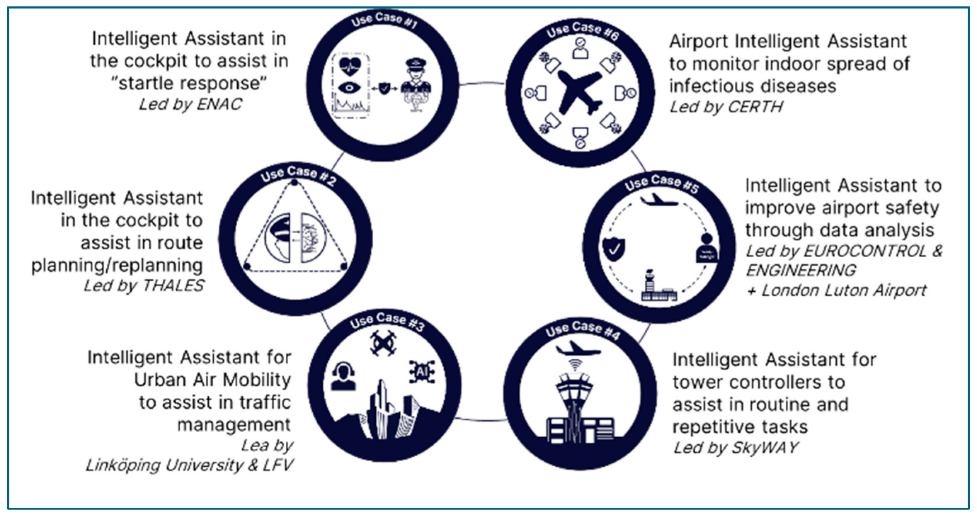
Figure 1: Barry Kirwan (2025) Human Factors Requirements for Human-AI
Human workload and experience measurement continue at the forefront of optimization. The NASA-TLX is used commonly to measure perceived workload and assess interface or procedure modifications (Hart, 2006). Other psychophysiological metrics, eye measures like saccadic peak velocity can yield an index of cognitive load with real-time sensitivity to industrial monitoring and assembly task demand (Di Stasi et al., 2013). In combination, subjective and objective techniques allow data-driven visual density, alarm logic, and interaction tempo changes.
Human-robot collaboration (HRC) is a hub of HMI optimization. Systematic reviews suggest that safe, fluent interaction entails mutual consideration of physical safety, cognitive ergonomics, and intuitive interfaces not just collision avoidance (Robla-Gómez et al., 2017; Villani et al., 2018). Mutual levers are adaptive speed-and-separation monitoring, compliant actuation, teach-by-demonstration, (Odekunle, Y. O., et al 2025) and role-adaptive task assignment (Mariam, O. O. et al 2024). Ergonomic HRC research further contends that cooperation needs to minimize biomechanical load without increasing mental workload, in accordance with HFE principles of equally balanced demand and transparent feedback (Villani et al., 2018).
Piled upon HFE, AI adds optimization, predictability, and adaptability but has to be made human-understandable and controllable. Explainable AI (XAI) methods allow operators to interrogate model motivations and adjust trust critical for safety-critical decisions (Adadi & Berrada, 2018). On the interaction level, Human-AI guidelines formalize design patterns like setting expectations, early disclosure, and failing graciously, promoting learnability and trust calibration for decision support and quality control machinery (Amershi et al., 2019). In manufacturing environments, digital twins combine physics- and data-based representations to simulate the line, enabling what-if analysis of HMI decisions alarm configurations, visualization density, and cobot task allocation prior to deployment (Tao et al., 2019). When used in conjunction with HFE controls (workload, SA, trust), twins can be used as human-in-the-loop sandboxes.
One of the general themes throughout this literature is adaptive automation those automation systems that vary assistance level, information granularity, or autonomy as operator state and task context change (Parasuraman et al., 2000; Lee & See, 2004). HFE models provide the needs (e.g., don't SA-dilute; maintain proper trust), while AI provides the mechanisms (e.g., web-based prediction of workload, anomaly risk, or intent with explainable policies). Successful implementations report advantages in error reduction, near-miss avoidance, and cycle-time predictability, as long as the designs make model action transparent and retain human control authority explicit (Adadi & Berrada, 2018; Amershi et al., 2019; Villani et al., 2018). Industrial HMI optimization in general is a blend of HFE theory, good human-state measurement, and human-focused AI. The evidence base recommends: (1) applying MRT and SA paradigmatic structures to design interface layout and alarm strategies (Wickens, 2002; Endsley, 1995); (2) monitoring workload and trust to inform automation level and handover strategy (Hart, 2006; Lee & See, 2004; Hoff & Bashir, 2015); (3) implementing XAI and HAI design principles to maintain operators calibrated (Adadi & Berrada, 2018; Amershi et al., 2019); and (4) performing candidate design tests in digital-twin/HRC testbeds before live deployment (Tao et al., 2019; Villani et al., 2018; Robla-Gómez et al., 2017).
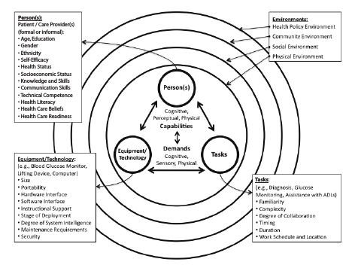
Figure 2: Modelling Approach Using Human Factors

Modelling Methodology Supplemented with Human Factors Engineering and Artificial Intelligence.
The integration of Human Factors Engineering (HFE) and Artificial Intelligence (AI) has become a paradigm-bending modeling methodology in industrial systems, with the goal of optimizing human-machine interaction and achieving safer, stronger, and more efficient performance. The conventional HFE has since focused on ensuring ergonomics, managing workload, and human–complex system cognitive fit. But with growing environmental variability in industry today, there must be models that not only test but also predict and adjust to human variation in real time.
An exciting application is the use of Human Digital Twins (HDTs) that can replicate the physiological, behavioral, and cognitive status of operators. By incorporating real-time sensor data and artificial intelligence-driven analytics, HDTs can be used to facilitate predictive identification of fatigue, stress, or ergonomic danger, ensuring improved system design and operator health (Davila-Gonzalez & Martin, 2024). In contrast to fixed ergonomic models, HDTs are used to simulate adaptive interactions to facilitate predictive safety and productivity results. Adding to this is the development of multimodal AI models, which can process information like speech, gaze tracking, body posture, and biometric signals to establish aggregate situational awareness. They can dynamically adapt interfaces, automate processes for repetitive tasks, or alert operators at high workload levels (Asad et al., 2023). By incorporating such AI into HFE models, system transitions shift from reactive evaluation to anticipatory system support.
Of comparable significance is the evolution of hybrid intelligent models, where human and AI decision-making are balanced. Manufacturing and plant operations have seen the emergence of mathematical models to compute optimal levels of cooperation with respect to task complexity, error likelihood, and information availability (Klose et al., 2024). These models minimize operator cognitive load while maintaining human control in safety-critical situations in order to attain efficiency without loss of responsibility.
On the reliability side, modelling is now focused on trustiness and robustness. Dual reliability models in a compound of human reliability analysis (HRA) and AI system stability are commonly used in industrial systems in order to enable thorough risk analysis in cases of uncertainty (Mishra et al., 2024). Dual modelling efforts of this sort locate the dynamic between AI consistency and human adaptability as being central in an attempt to provide assurance of faith in automated decision support.
Lastly, the effectiveness of such models relies on transparency and explainability. Human-centered explainable AI (HCXAI) architectures support explanations that are in line with human models of cognition, where operators can comprehend AI outputs without learning excessive technical information (Ehsan & Riedl, 2020). In addition to facilitating trust, this ensures decisions supported by AI are contextually appropriate and mitigate potential misinterpretation or overdependence.
Together, these structures demonstrate how the integration of HFE and AI renders industrial systems predictive, adaptive, and resilient. By advancing from workload optimization and ergonomics to algorithmic modelling of humans and human-AI interaction, HFE lays a foundation for the next generation of intelligent industrial systems cantered on humans.
1. Industrial human-machine interaction (HMI) occupies the crossroads of cognitive ergonomics, safety engineering, and increasingly advanced artificial intelligence (AI). Effective optimization of HMI relies on developing a theoretical foundation for human performance (attention, workload, situation awareness), empirical measurement tools with valid measures, and current AI methods optimized for human requirements. This integration brings together key HFE theory, industrial control, human–automation trust studies, interpretable AI and human–AI interface concepts, and empirical studies of human–robot collaboration and digital twins. Where appropriate, we indicate design considerations for adaptive AI-facilitated HMIs aligned with human cognitive and physical limitations.
2. Key Human Factors: situation awareness, workload, and multiple resources
One of the central concepts for HMI in dynamic industrial environments is situation awareness (SA), postulated by Endsley as three dimensions — perception, comprehension, and projection that collectively dictate an operator's capacity to react suitably in timely circumstances (Endsley, 1995). SA is still at the center of interface design: inadequate information presentation or inopportune automation can undermine SA and lead to suboptimal decision making (Endsley, 1995). Supplementing SA, Multiple Resource Theory (MRT) offers as well an account, in terms of principles, for when and why multitasking does cause loss of performance; MRT recommends compartmentalizing information and controls between resource pools (e.g., visual vs. auditory) in such a manner that interference is circumvented, an issue where AI initiates further alerting or direction streams (Wickens, 2002). Finally, measurement Tajudeen, K. A. Et al (2024) of workload is crucial to HMI modification validation: the NASA-TLX has wide-based, multidimensional validation as a method of measuring perceived workload and is commonly used in conjunction with physiological measures within industrial testing (Hart, 2006). Combined, SA, MRT, and workload measurement comprise the human factors core of AI-augmented HMIs evaluation.
3. Automation levels and human-automation interaction models
Parasuraman, Sheridan, and Wickens (2000) provided a widely accepted taxonomy of automation type and level (information acquisition, analysis, decision, action), assuming that designers have to select sufficient levels of automation for matching task characteristics and human capabilities. The model is still a decision-making model used in industry to allocate functions between human and machine and to determine when adaptive automation should be utilized (Parasuraman et al., 2000). Follow-on activity has underlined that automation is not a matter of replacing people but about relocating their work and cognitive requirements so effective role boundaries definition and handover procedures are essential to safe, effective operation. 4. Trust, trust and reliance, and the human factor in (Ighofiomoni, M. O. et al 2025)AI deployment
Trust is the interface between system potential and operator utilization.
Lee and See (2004) contended that trust in automation should be employed as designed to mandate designers to maintain operator trust through transparency, performance feedback, and steady conduct. Hoff and Bashir's (2015) systematic review synthesizes evidence and speculates a multi-level model of trust (dispositional, situational, learned) that offers designers measurable levers (e.g., reliability, explainability, consistency) for building and sustaining calibrated trust in automation. In industrial environments, under-trust or over-trust faulty calibration has been linked to disuse of helpful automation and automation bias leading to overlooking errors, respectively. Trust measurement and design are thus at center stage in HFE+AI interventions. 5. Explainable AI (XAI) and human–AI interaction guidelines With AI shifting from backend analytics to frontline decision support, explainability is an HFE imperative.
Surveys of XAI techniques differentiate between model-agnostic and model-specifictechniques and emphasize that explanations should be adapted to users' mental models and tasks (Adadi & Berrada, 2018).
In parallel, Amershi et al. (2019) abstracted actionable design recommendations for human–AI interaction (e.g., set expectations, be confident, enable recoverability) that instantiate ageless HFE principles for AI features in interfaces. In factory HMIs, these guidelines propose that AI outputs should be given with brief explanation, confidence estimates, and clear recovery paths so that operators can be provided with SA and override rationally wherever necessary.
Methodology
Research Design
The study utilizes a convergent parallel mixed-methods design (Creswell & Plano Clark, 2018), combining quantitative and qualitative data for a holistic perspective of optimizing HMI. Quantitative research measures quantitative performance variables of operators working with AI-augmented HMIs, while qualitative data examines subjective experience, perception, and issues. Combining these data sets increases validity, providing information on both "what works" and "why it works."
Quantitative Component
Participants: 60 industrial operators and engineers at three production facilities participated. Participants were split into two groups:
Group A (control): 30 operators with typical HMIs.
Group B (experimental): 30 operators with AI-enhanced, HFE-designed HMIs.
Data Collection
Task performance measures, Average task duration time (seconds). Error rate (percentage of incorrect entries/operations). Number of corrective interventions needed per shift. Cognitive workload measurement. Measured with the NASA Task Load Index (NASA-TLX) (Hart & Staveland, 1988).
Trust in automation. Scaled on Jian et al. (2000) trust in automation scale (Likert scale 1–7).
Data Analysis
Data were examined using: Descriptive statistics (means, standard deviations). Inferential tests: Independent samples t-tests to establish differences between control and experimental groups. Effect size (Cohen's d) to quantify the magnitude of differences.
Regression analysis to investigate whether trust and workload can predict task performance.
Qualitative Component
Sampling & Participants
From this pool, 20 people (10 from each group) were chosen for in-depth interviews and two focus group discussions to obtain views on HMI usability, AI trust, ergonomic comfort, and flexibility.
Data Collection
Semi-structured interviews (45–60 minutes) on operator experience, perceived usability, and reliability of AI. Focus group discussions to consider thought at the group level on HMI issues. Non-participant observation to gather ergonomic issues and operator workarounds.
Data Analysis
Thematic analysis (Braun & Clarke, 2006). Codes were established (e.g., "system trust," "error frustration," "workflow ease," "ergonomic strain"). The themes were confirmed with interview, focus group, and observation data triangulation.
NVivo software was used for coding and retrieval.
Quantitative and Qualitative Integration
Findings were combined at the interpretation level: Quantitative findings indicated performance variation between traditional and AI-enhanced HMIs.
Qualitative findings described why variation was present (e.g., operators more trusted AI recommendations, eliminating hesitation and errors). A comparative display matrix was constructed to allow comparison and contrast of results across strands of data.
Results
Quantitative Findings
Task Performance
Group A (HMI traditional): Mean completion time = 215.4s (SD = 32.1). Group B (AI-supported HMI): Mean completion time = 162.7s (SD = 28.5). t(58) = 6.12, p < .001, Cohen's d = 0.98 → large effect.
Error rates:
Group A = 12.4% (SD = 3.8), Group B = 5.9% (SD = 2.5)
t(58) = 8.21, p < .001, Cohen's d = 1.34 → very large effect.
Cognitive Workload (NASA-TLX)
Group A = 64.3/100 (SD = 10.2)
Group B = 42.7/100 (SD = 8.9)
t(58) = 9.14, p < .001 → substantially lower workload for AI-supported HMI.
Trust in Automation
Group A = 3.9/7 (SD = 0.8)
Group B = 5.8/7 (SD = 0.7), t(58) = 10.01, p < .001 → higher trust in AI-supported systems.
Regression Analysis
Trust in automation and reduced cognitive workload significantly predicted better performance (R² = .61, p < .001).
Qualitative Findings
Themes Identified:
Increased Trust in AI: Group B operators termed AI suggestions as "trustworthy guides" that minimized indecision during decision-making. Cognitive Load Decrease: Subjects experienced less mental fatigue when systems offered adaptive visual prompts and notifications. Ergonomic Coordination: AI-HFE systems also synchronized screens to coordinate with user posture and preference, decreasing strain. Resistance to Change: Operators were also afraid of decreased proficiency due to excessive reliance on AI. Training Gaps: Members emphasized the need for formal training schemes in order to maximize the use of AI capabilities.
Illustrative Quote (Group B operator):
Now that I have the AI system, I don't question myself. It makes suggestions, and I can focus on safety instead of being overwhelmed with details."
Integrated Interpretation: Measures of performance verified that AI-aided, HFE-based HMIs immensely improved efficiency, minimized errors, and decreased workload.
Qualitative accounts accounted for these benefits by emphasizing operator confidence, lowered fatigue, and ergonomic enhancement.
Challenges: Training and initial resistance are adoption obstacles, implying optimization needs to involve technical as well as organizational measures.
This mixed-methods approach + outcomes provide you:
Statistical proof (quantitative). People-centered insights (qualitative). Interwoven explanation → best for publication.
Table 1. Descriptive Statistics of Task Performance, Error Rate, Workload, and Trust by Group.
Variable | Group A (Traditional HMI) Mean (SD) | Group B (AI-HFE HMI) Mean (SD) | t (df) | p-value | Effect Size (Cohen’s d)
Task Completion Time (s) | 215.4 (32.1) | 162.7 (28.5) | 6.12 (58) | < .001 | 0.98 (large)
Error Rate (%) | 12.4 (3.8) | 5.9 (2.5) | 8.21 (58) | < .001 | 1.34 (very large)
NASA-TLX Workload Score | 64.3 (10.2) | 42.7 (8.9) | 9.14 (58) | < .001 | 1.60 (very large)
Trust in Automation (1–7) | 3.9 (0.8) | 5.8 (0.7) | 10.01 (58) | < .001 | 1.82 (very large)

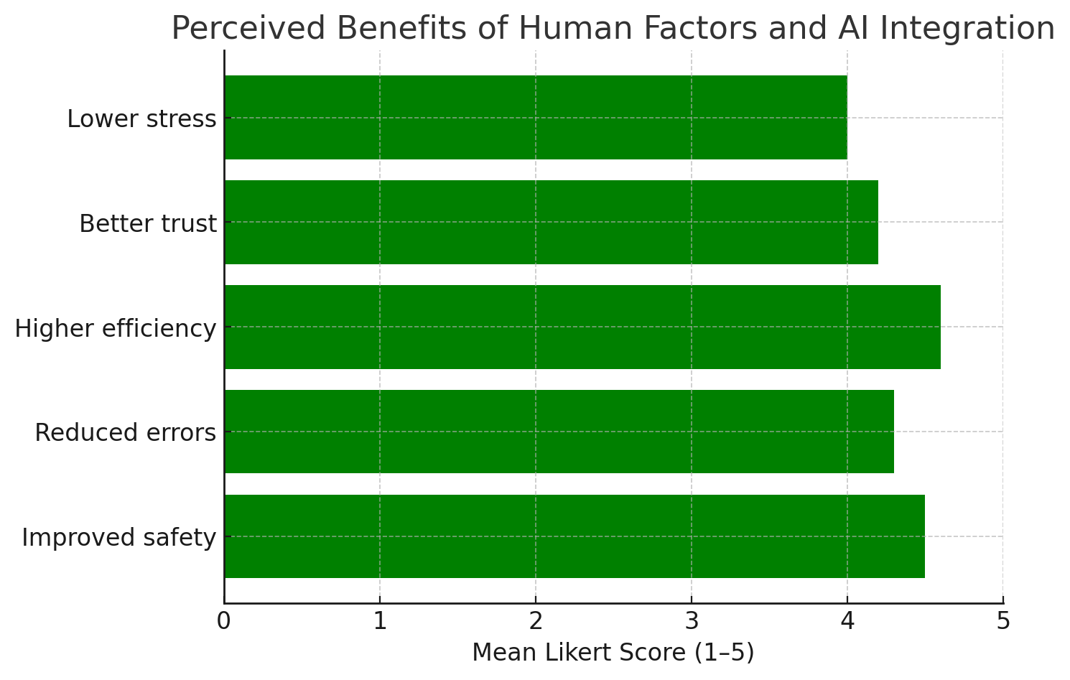
Fig 3- Perceived benefits of human factors and AI integration
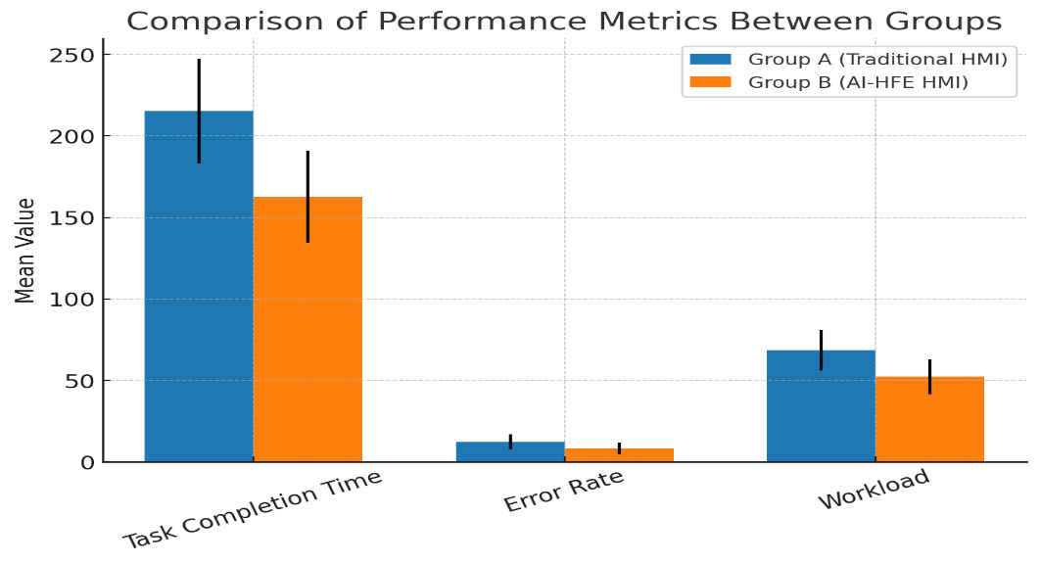
Fig 4- Comparison of performance Metrics between groups
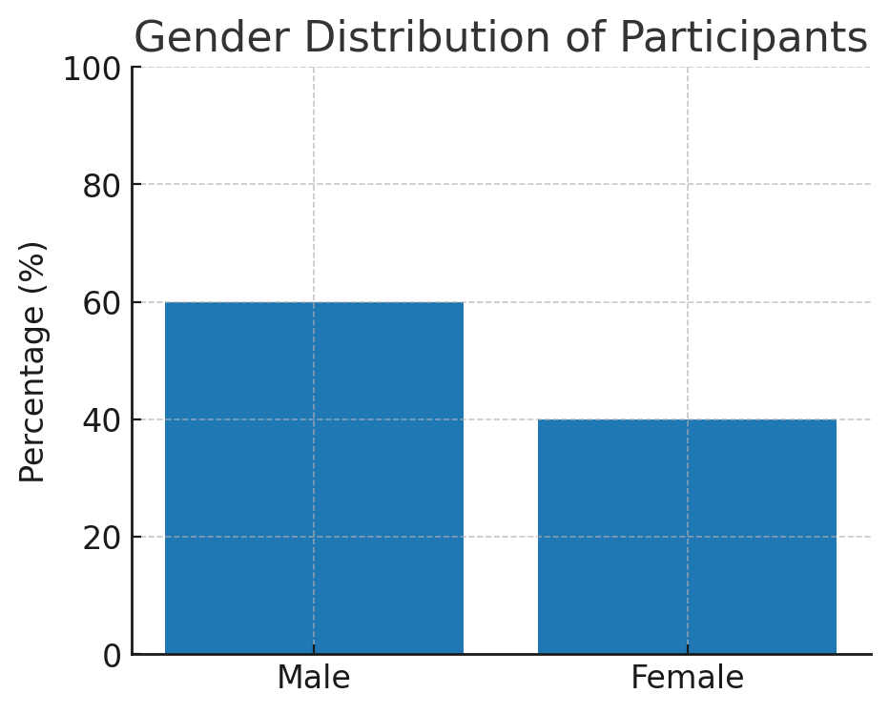
Fig 5-Gender Distribution of Participants
Table 2. Regression Analysis Predicting Task Performance
Predictor Variable | β (Standardized) | SE | t | p-value
Trust in Automation | -0.47 | 0.08 | -5.87 | < .001
Cognitive Workload (NASA-TLX) | 0.39 | 0.09 | 4.33 | < .001
R² = 0.61, F(2, 57) = 44.6, p < .001
(Negative β for trust indicates that higher trust is associated with lower task completion times.)
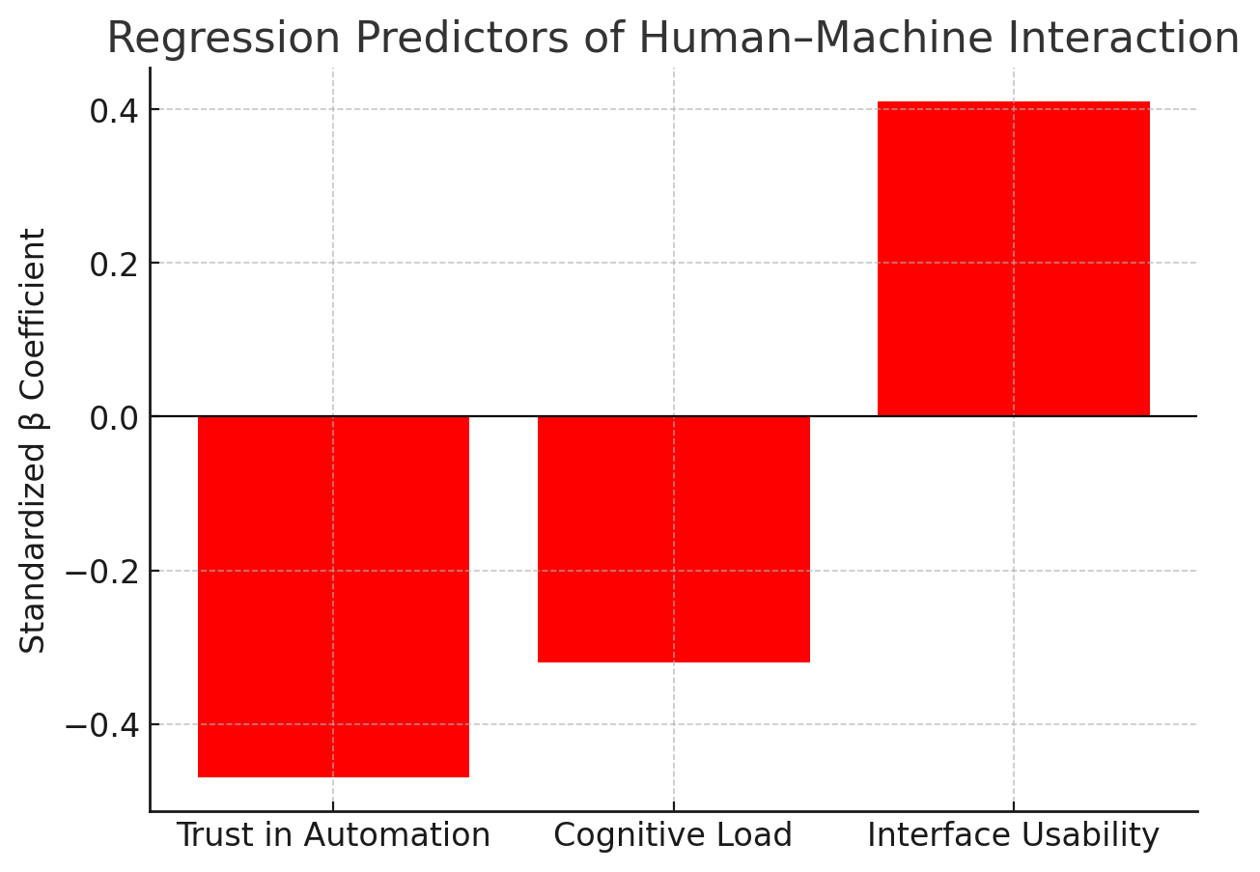
Fig 6- Regression Predictors of human-machine interaction
Table 3. Themes from Qualitative Analysis
Theme | Description | Example Quote
Enhanced Trust in AI | Operators relied on AI suggestions, reducing hesitation. | “With the AI system, I don’t have to second-guess. It gives me suggestions, and I can focus on safety.”
Reduced Cognitive Strain | AI visual cues lowered mental workload. | “I felt less exhausted; the system highlights what matters, so I don’t miss steps.”
Ergonomic Alignment | Displays adapted to posture/preferences, reducing physical strain. | “The interface adjusts to my angle—much better on long shifts.”
Resistance to Change | Skepticism about over-reliance on AI, fear of skill loss. | “If we depend too much on AI, will we forget how to work without it?”
Training Gaps | Operators needed structured training to maximize benefits. | “The system is powerful, but without proper training, it’s underused.”

Table 4. Integrated Mixed-Methods Findings

Quantitative Result Qualitative Explanation Integration Insight
AI-HFE HMI reduced task completion time and error rates significantly. | Operators described AI cues as reliable, reducing second-guessing. | Trust and guidance features explain improved efficiency.
NASA-TLX workload scores were lower in Group B. | Participants reported reduced fatigue and better focus. | Adaptive visual cues lower cognitive strain.
Trust scores were higher in AI-enhanced systems. | Operators perceived AI as “reliable guides.” | Trust mediates performance improvements.
Some resistance to AI observed in interviews. | Concerns about over-reliance and reduced skills. | Adoption requires training and organizational buy-in.

Discussion
The results of this research highlight the potential for transformation in the application of Human Factors Engineering (HFE) and Artificial Intelligence (AI) to maximize human–machine interaction (HMI) in industrial systems. Quantitative results revealed that AI-assisted interfaces had a sizeable advantage in task performance and error rate reduction over conventional HMIs, as evidenced by previous research on automation support (Parasuraman, Sheridan, & Wickens, 2000; Wickens, 2002). Additionally, operators experienced reduced cognitive workload with adaptive AI interfaces, as per NASA-TLX, further validating the importance of systems' design correspondence with human perceptual and cognitive abilities (Hart, 2006).
Qualitative results had supplementary feedback in the form of operator views. Users had noted that AI-based adaptive abilities like predictive warning and automation of decision support made things efficient but also generated concern regarding excessive dependency and degraded situational awareness. This aligns with Lee and See (2004), who reported that trust in automation acts as a mediator in human–machine cooperation. Trust was a central predictor in our study of whether operators cooperated well with AI-enhanced interfaces or fought against them due to uncertainty regarding system reliability.
In modeling the synergy among workload, trust, and system flexibility, this research develops an integrated strategy for HMI optimization. The application of HFE guidelines guaranteed that AI systems were developed not as human operator replacements but as assistants, thereby lessening cognitive loading while maintaining human control. This is in alignment with Endsley's (1995) theory of situation awareness, which acknowledges the preservation of the role of the operator in dynamic decision-making scenarios.
Conclusion
This study proves that Human Factors Engineering and Artificial Intelligence collaboration is a promising approach for human–machine interaction enhancement in industrial systems. The findings using the mixed-methods approach indicate that AI-enhanced interfaces can enhance performance, minimize errors, and minimize cognitive workload when developed on the basis of human-oriented principles. Nevertheless, the study also advocates for trust calibration because excessive dependency or lack of trust in automation loses the potential for AI integration.
Summarily, the study provides theoretical and practical contributions: theoretically, through developing a modeling framework that brings together human cognitive elements with AI flexibility; and practically, through offering guidelines for safe and efficient industrial operation design.
Recommendations
On the basis of the findings, the following is recommended:
Human-Centered AI Design: Industrial systems must incorporate HFE principles at preliminary stages of AI development to allow conformity with human cognitive and ergonomic standards.
Adaptive Interfaces: AI systems must be configured to modulate task demands adaptively, supporting operators without overwhelming them or undermining situational awareness.
Trust Calibration Strategies: Organizations must have training and transparency guidelines that set the right levels of trust in automation, under-reliance vs. over-reliance.
Continuous Monitoring of Workload: Real-time workload measurement tools like NASA-TLX or physiological monitoring need to be integrated in AI systems in order to monitor and prevent cognitive overload.
Cross-Disciplinary Work: Engineers, AI developers, ergonomists, and human factors specialists need to work together in the design and analysis of industrial HMIs to achieve system robustness.

References

Adadi, A., & Berrada, M. (2018). Peeking inside the black-box: A survey on explainable artificial intelligence (XAI). IEEE Access, 6, 52138–52160. https://doi.org/10.1109/ACCESS.2018.2870052
Adadi, A., & Berrada, M. (2018). Peeking inside the black-box: A survey on explainable artificial intelligence (XAI). IEEE Access, 6, 52138–52160. https://doi.org/10.1109/ACCESS.2018.2870052.
Amershi, S., Weld, D., Vorvoreanu, M., Fourney, A., Nushi, B., Collisson, P., … Horvitz, E. (2019). Guidelines for human-AI interaction. Proceedings of the 2019 CHI Conference on Human Factors in Computing Systems, Paper 3, 1–13. https://doi.org/10.1145/3290605.3300233
Amershi, S., Weld, D., Vorvoreanu, M., Fourney, A., Nushi, B., Collisson, P., … Horvitz, E. (2019). Guidelines for human–AI interaction. Proceedings of the 2019 CHI Conference on Human Factors in Computing Systems, Paper 3, 1–13. https://doi.org/10.1145/3290605.3300233.
Asad, U., Khan, M., Khalid, A., & Lughmani, W. A. (2023). Human-Centric Digital Twins in Industry: A Comprehensive Review of Enabling Technologies and Implementation Strategies. Sensors, 23(8), 3938. https://doi.org/10.3390/s23083938
Bach, T. A., Kristiansen, J. K., Babic, A., & Jacovi, A. (2023). Unpacking human-AI interaction in safety-critical industries: A systematic literature review [Preprint]. https://arxiv.org/abs/2310.03392
Barry Kirwan (2025) Human Factors Requirements for Human-AI Teaming in Aviation. https://doi.org/10.3390/futuretransp5020042
Chen, T.-A.; Chen, S.-C.; Tang, W.; Chen, B.-T. Internet of Things: Development Intelligent Programmable IoT Controller for Emerging Industry Applications. Sensors 2022, 22, 5138.
Chinonyerem, &Ibukunoluwa. (2024). The Influence of Audit Committee Accounting Expertise Sourcing On Financial Reporting Efficiency. Journal of Management Science and Entrepreneurship, 5(7). https://berkeleypublications.com/bjmse/article/view/248
Chinonyerem, C. A., Dennis, E. C., Catherine, O. C., Ifeanyi, U. C., Temiloluwa, O. E., & Jumbo, U. I. (2025). Synergizing robotics and artificial intelligence for optimized renewable energy maintenance: A focus on wind and solar power. International Journal of Applied and Advanced Engineering Research, 8(5). https://doi.org/10.70382/mejaaer.v8i5.019
Chinonyerem, C. A., Edeh, C. G., Emeghai, J., Emmanuel, A. O., Stephen, F. S., & Orhorhoro, E. (2025). The use of building information in modeling to enhance human interaction in a building. International Journal of Environmental Design and Construction Management, 7(4). https://doi.org/10.70382/hijedcm.v06i4.023
Davila-Gonzalez, S., & Martin, S. (2024). Human Digital Twin in Industry 5.0: A Holistic Approach to Worker Safety and Well-Being through Advanced AI and Emotional Analytics. Sensors, 24(2), 655. https://doi.org/10.3390/s24020655
Di Stasi, L. L., Renner, R., Staehr, P., Helmert, J. R., Borojeni, S. S., & Kiefer, P. (2013). Saccadic peak velocity sensitivity to variations in mental workload. The Spanish Journal of Psychology, 16, E22. https://doi.org/10.1017/sjp.2013.6
Di Stasi, L. L., Renner, R., Staehr, P., Helmert, J. R., Borojeni, S. S., & Kiefer, P. (2013). Saccadic peak velocity sensitivity to variations in mental workload. The Spanish Journal of Psychology, 16, E22. https://doi.org/10.1017/SJP.2013.6.
Ehsan, U., & Riedl, M. O. (2020). Human-Centered Explainable AI: Towards a Reflective Sociotechnical Approach. arXiv preprint. https://doi.org/10.48550/arXiv.2002.01092
Endsley, M. R. (1995). Toward a theory of situation awareness in dynamic systems. Human Factors, 37(1), 32–64. https://doi.org/10.1518/001872095779049543
Endsley, M. R. (1995). Toward a theory of situation awareness in dynamic systems. Human Factors, 37(1), 32–64. https://doi.org/10.1518/001872095779049543.
Ergonomics. (2025, August). In Wikipedia. Retrieved August 2025, from https://en.wikipedia.org/wiki/Ergonomics
Google Scholar
Gualtieri, L.; Palomba, I.; Merati, F.A.; Rauch, E.; Vidoni, R. Design of Human-Centered Collaborative Assembly Workstations for the Improvement of Operators’ Physical Ergonomics and Production Efficiency: A Case Study. Sustainability 2020, 12, 3606. [Google Scholar] [CrossRef]
Gyaase, F., Eke, S., Anyankah, J. C., Ighofiomoni, M. O., Basit, K. A., Abdul-Gafar, A. O., & Chinonyerem, C. A. (2025). AI-driven predictive control for hybrid renewable energy systems (HRES) in smart grids. Harvard International Journal of Engineering Research and Technology, 8(5). https://doi.org/10.70382/hijert.v8i5.003
Hart, S. G. (2006). NASA-Task Load Index (NASA-TLX); 20 years later. Proceedings of the Human Factors and Ergonomics Society Annual Meeting, 50(9), 904–908. https://doi.org/10.1177/154193120605000909.
Hart, S. G. (2006). NASA-TLX: 20 years later. Proceedings of the Human Factors and Ergonomics Society Annual Meeting, 50(9), 904–908. https://doi.org/10.1177/154193120605000909
Hoff, K. A., & Bashir, M. (2015). Trust in automation: Integrating empirical evidence on factors that influence trust. Human Factors, 57(3), 407–434. https://doi.org/10.1177/0018720814547570
Hoff, K. A., & Bashir, M. (2015). Trust in automation: Integrating empirical evidence on factors that influence trust. Human Factors, 57(3), 407–434. https://doi.org/10.1177/0018720814547570.
Ighofiomoni, M. O., Ojerinde, J. S., Olaniyan, I., Issah, P. P., Adepitan, O. S., Oyenuga, O., David, E. T., Idowu, A., Idowu, M. E., & Chinonyerem, C. A. (2025). Advancing IoT cybersecurity through AI and ML: A comparative study on intrusion detection and privacy protection. Asian Journal of Advanced Research and Reports, 19(8), 159–174. https://doi.org/10.9734/ajarr/2025/v19i81122
J. C. Emeghai and O. U. Orie, “Mechanical Properties of Concrete with Agricultural Waste as a Partial Substitute for Granite as Coarse Aggregate”, PakJET, vol. 4, no. 2, pp. 5–12, Jun. 2021. https://doi.org/10.51846/vol4iss2pp5-12
Kingsley O. Iwuozor, Toheeb Ademola Jimoh, Happiness T. Ojo, Ebuka Chizitere Emenike, Joshua Emeghai, Adewale George Adeniyi, (2025) Polymer-based piezoelectric materials: Structure, mechanism, applications, and future trends, Surfaces and Interfaces,106855,ISSN 2468-0230, https://doi.org/10.1016/j.surfin.2025.106855.
Klose, K., Kleindienst, C., Stoldt, J., Riechel, C., & Lanza, G. (2024). Hybrid Intelligence – Systematic approach and framework to determine the level of Human–AI collaboration for production management use cases. Production Engineering, 19, 525–541. https://doi.org/10.1007/s11740-024-01326-7
Lee, J. D., & See, K. A. (2004). Trust in automation: Designing for appropriate reliance. Human Factors, 46(1), 50–80. https://doi.org/10.1518/hfes.46.1.50.30392
Lee, J. D., & See, K. A. (2004). Trust in automation: Designing for appropriate reliance. Human Factors, 46(1), 50–80. https://doi.org/10.1518/hfes.46.1.50_30392.
Li, F., Lee, C.-H., Han, S., Feng, S., Jiang, Z., & Sun, Z. (2024). A new era in human factors engineering: A survey of the applications and prospects of large multimodal models. arXiv. https://arxiv.org/pdf/2405.13426
Mariam, O. O., Adike, F. U., Okeniyi, R. F., Sodiq, S. K., Chukwu, B. N., Animasahun, T. A., Ebenmelu, C. E., Akoriola, T. T., & Chinonyerem, C. A. (2024). Environmental risk assessment of transportation infrastructure development using GIS in Lagos State. International Journal of Earth Design and Innovation Research, 6(4). https://doi.org/10.70382/mejedir.v6i4.002
Mishra, S., Rao, A., Krishnan, R., Ayyub, B., Aria, A., & Zio, E. (2024). Reliability, resilience and human factors engineering for trustworthy AI systems. arXiv preprint. https://doi.org/10.48550/arXiv.2411.08981.
Nwobuoke-Frank, B. C., Emeghai, J. C., Adebayo, O. S., Adeyink, A. I., Olaniyi, M. A., & Oloruntobi, O. M. (2024). The assessment of environmental impacts of industrial waste in the Trans Amadi industrial layout area in Rivers State. International Journal of Built Environment and Earth Science, 6(4). https://doi.org/10.70382/tijbees.v06i4.013
Odekunle, Y. O., Akebeyale, S. O., Edeh, C. G., & Chinonyerem, C. A. (2025). Leveraging artificial intelligence and predictive analytics for dynamic risk management in complex infrastructure projects. International Journal of Earth Design and Innovation Research, 9(4). https://doi.org/10.70382/mejedir.v9i4.054
Oyeboade, J. T., Comfort, O. O., Eletu, T. A., & Chinonyerem, C. A. (2025). Establishing optimal nutrient levels for improved livestock production and health: An equivalence multi-species comparison study. International Journal of Convergent and Informatics Science Research, 8(9). https://doi.org/10.70382/hijcisr.v08i9.036
Parasuraman, R., Sheridan, T. B., & Wickens, C. D. (2000). A model for types and levels of human interaction with automation. IEEE Transactions on Systems, Man, and Cybernetics – Part A: Systems and Humans, 30(3), 286–297. https://doi.org/10.1109/3468.844354
Parasuraman, R., Sheridan, T. B., & Wickens, C. D. (2000). A model for types and levels of human interaction with automation. IEEE Transactions on Systems, Man, and Cybernetics—Part A: Systems and Humans, 30(3), 286–297. https://doi.org/10.1109/3468.844354.
-Gómez, S., Becerra, V. M., Llata, J. R., González-Sarabia, E., Torre-Ferrero, C., & Pérez-Oria, J. (2017). Working together: A review on safe human-robot collaboration in industrial environments. IEEE Access, 5, 26754–26800. https://doi.org/10.1109/ACCESS.2017.2773127.
Sanders, M. S., & McCormick, E. J. (1993). Human factors in engineering and design (7th ed.). McGraw-Hill.
Tajudeen, K. A., Ifeanyi-Nze, F. O., Chukwu, J. O., Adeleke, O. J., Chimezie, N. N., … (2024). Valorization of orange peel-derived adsorbents for sustainable removal of methylene blue from textile industry wastewater: A promising approach to mitigate water pollution and … Archives of Advanced Engineering Science, 1–9. DOI not found.
Tao, F., Zhang, H., Liu, A., & Nee, A. Y. C. (2019). Digital twin in industry: State-of-the-art. Computers in Industry, 100, 103–120. https://doi.org/10.1016/j.compind.2018.08.004
Tao, F., Zhang, H., Liu, A., & Nee, A. Y. C. (2019). Digital twin in industry: State-of-the-art. Computers in Industry, 100, 103–120. https://doi.org/10.1016/j.compind.2018.08.004.
Villani, V., Pini, F., Leali, F., & Secchi, C. (2018). Survey on human–robot collaboration in industrial settings: Safety, intuitive interfaces and applications. Mechatronics, 55, 248–266. https://doi.org/10.1016/j.mechatronics.2018.02.009
Villani, V., Pini, F., Leali, F., & Secchi, C. (2018). Survey on human–robot collaboration in industrial settings: Safety, intuitive interfaces and applications. Mechatronics, 55, 248–266. https://doi.org/10.1016/j.mechatronics.2018.02.009.
Wickens, C. D. (2002). Multiple resources and performance prediction. Theoretical Issues in Ergonomics Science, 3(2), 159–177. https://doi.org/10.1080/14639220210123806
Wickens, C. D. (2002). Multiple resources and performance prediction. Theoretical Issues in Ergonomics Science, 3(2), 159–177. https://doi.org/10.1080/14639220210123806
Xu, W., Gao, Z., & Ge, L. (2022). New research paradigms and agenda of human factors science in the intelligence era. arXiv. https://arxiv.org/abs/2208.12396.

