Case Report

Bardet-Biedl syndrome in a 10-year-old child: clinical observation and literature review

ABSTRACT

Aims: To report a pediatric case of Bardet-Biedl syndrome and discuss clinical, diagnostic, and therapeutic aspects in light of the current literature.
Study Design : Case report and literature review.
Place and Duration of Study : Department of Pediatrics, Hôpital Militaire d’Instruction Mohammed V, Rabat, Morocco, 2024.
Methodology : We describe a 10-year-old boy born from a consanguineous marriage, presenting with growth retardation, obesity, facial dysmorphism, polydactyly, brachydactyly, micro-penis, learning difficulties, and decreased visual acuity. Clinical, radiological, ophthalmological, renal, and genetic investigations were performed.
Results: The patient exhibited typical features of Bardet-Biedl syndrome, including polydactyly, obesity, retinal dystrophy, renal anomalies (horseshoe kidney with asymmetric renal function), and learning disabilities. Genetic study and karyotype were ongoing at the time of report.
Conclusion: Bardet-Biedl syndrome is a rare multisystem disorder requiring early diagnosis and multidisciplinary management. Renal and visual impairment largely determine the prognosis.

Keywords: Bardet-Biedl syndrome, ciliopathy, polydactyly, obesity, renal anomalies, retinal dystrophy, case report

1. INTRODUCTION

Bardet-Biedl syndrome (BBS) is a rare autosomal recessive ciliopathy characterized by multisystem involvement. Its cardinal features include retinal dystrophy, obesity, polydactyly, hypogonadism, renal anomalies, and variable intellectual disability. The prevalence is estimated at 1/140,000 in Europe and North America but is higher in consanguineous populations. Diagnosis is challenging because of phenotypic variability and progressive onset of symptoms. Early recognition is crucial to prevent renal and visual complications. This report describes a pediatric case of BBS and reviews the main clinical and diagnostic aspects in light of the literature.

2. CASE PRESENTATION

A 10-year-old boy, born from first-degree consanguineous parents, was referred for evaluation of growth retardation, obesity, and visual impairment. He measured 122 cm (−3 SD) and weighed 34 kg (BMI 22.47, >97th percentile). Clinical examination revealed facial dysmorphism, post-axial polydactyly of both hands and feet, brachydactyly, micro-penis, learning difficulties, and poor school performance. Parents reported progressive night blindness over two years.
Investigations showed normal laboratory results. Radiographs confirmed polydactyly and brachydactyly. Ophthalmological assessment revealed retinal dystrophy with extinguished electroretinogram. Abdominal ultrasound demonstrated hepatomegaly and horseshoe kidney with asymmetric function. Cervical spine imaging showed straightening without malformation. Genetic studies were initiated but pending.
Family history was negative for similar anomalies. Siblings were healthy. No teratogenic exposure was reported.

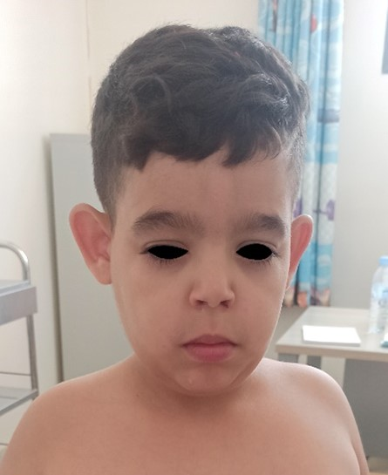
Figure 1. Dysmorphic face.

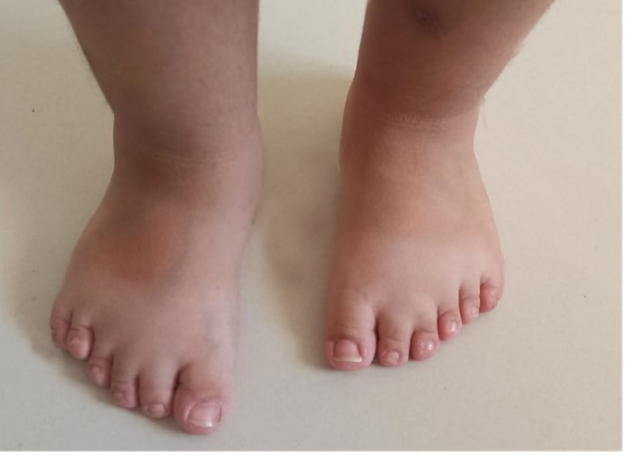
Figure 2. Polydactyly of foot.

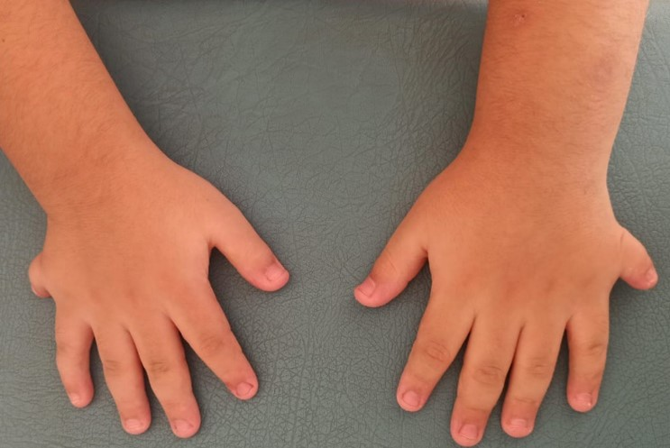
Figure 3. Polydactyly of hand.


Figure 4. Micro-penis.

3. discussion

The clinical features in this child fulfill the major diagnostic criteria of BBS: obesity, retinal dystrophy, post-axial polydactyly, learning difficulties, renal anomalies, and hypogonadism. Our patient’s phenotype is consistent with the criteria proposed by Beales et al. (1999).
Retinal dystrophy, almost universal in adolescence, was confirmed by an abnormal electroretinogram. This is a key feature leading to progressive visual loss. Polydactyly, present in both hands and feet, is a frequent early diagnostic clue. Renal anomalies, as in our case, are the leading cause of morbidity and mortality. Horseshoe kidney with impaired function illustrates the variability of renal involvement reported in up to 80% of cases.
Genetically, more than 20 BBS genes (BBS1–BBS21) have been identified, all related to ciliary dysfunction. Although molecular confirmation was not yet available for our patient, clinical features alone were sufficient to strongly suggest BBS.
This observation underlines the importance of early recognition in high-consanguinity populations, where prevalence is increased. Early diagnosis allows closer monitoring of renal and visual status and supports a multidisciplinary approach to improve prognosis.

4. Conclusion

Bardet-Biedl syndrome is a rare multisystem disorder. Our case illustrates the diagnostic value of polydactyly, obesity, retinal dystrophy, and renal anomalies. Early recognition and multidisciplinary care are essential to reduce morbidity, particularly from renal and visual complications.

Consent (where ever applicable)

Written informed consent was obtained from the patient’s parents for the publication of this case report and any accompanying images. A copy of the written consent is available for review by the Editorial Office/Chief Editor/Editorial Board members of this journal.

Ethical approval (where ever applicable)
Not applicable. Written informed consent for publication was obtained from the patient’s parents.

Definitions, Acronyms, Abbreviations
BBS: Bardet-Biedl Syndrome
BMI: Body Mass Index
ERG: Electroretinogram
PNDS: Protocole National de Diagnostic et de Soins
SD: Standard Deviation

References

Badano, J. L., Ansley, S. J., Leitch, C. C., Lewis, R. A., Lupski, J. R., & Katsanis, N. (2003). Identification of a novel Bardet-Biedl syndrome protein, BBS7, that shares structural features with BBS1 and BBS2. American Journal of Human Genetics, 72(3), 650–658.

Barnett, S., Reilly, S., Carr, L., O’Brien, S., Beales, P. L., & Green, J. (2002). Behavioural phenotype of Bardet-Biedl syndrome. Journal of Medical Genetics, 39(12), e76.

Beales, P. L., Elcioglu, N., Woolf, A. S., Parker, D., & Flinter, F. A. (1999). New criteria for improved diagnosis of Bardet–Biedl syndrome: Results of a population survey. Journal of Medical Genetics, 36(6), 437–446.

Beales, P. L., Warner, A. M., Hitman, G. A., Thakker, R., Flinter, F. A., & Trembath, R. C. (2000). Renal cancer and malformations in relatives of patients with Bardet‐Biedl syndrome. American Journal of Medical Genetics, 15(12), 1977–1985.

Beales, P. L., Badano, J. L., Ross, A. J., Ansley, S. J., Hoskins, B. E., Kirsten, B., et al. (2001). Genetic and mutational analyses of a large multiethnic Bardet-Biedl cohort reveal a minor involvement of BBS6 and delineate the critical intervals of other loci. American Journal of Human Genetics, 68(3), 606–616.

Cox, G. F., Hansen, R. M., Quinn, N., Flaherty, M., & Fulton, A. B. (2003). Retinal function in carriers of Bardet-Biedl syndrome. American Journal of Ophthalmology, 121(6), 804–810.

David, A., Bitoun, P., Lacombe, D., Lambert, J. C., Nivelon, A., Vigneron, J., et al. (1999). Hydrometrocolpos and polydactyly: A common neonatal presentation of Bardet-Biedl and McKusick-Kaufman syndromes. Clinical Genetics, 36(8), 599–603.

Ghadami, M., Majidzadeh, K., Shokrpour, M., Bagherizadeh, I., Zeinali, S., & Lupski, J. R. (2000). Bardet-Biedl syndrome type 3 in an Iranian family: Clinical study and confirmation of disease localization. American Journal of Medical Genetics, 94(5), 433–437.

Green, J. S., Parfrey, P. S., Harnett, J. D., Farid, N. R., Cramer, B. C., Johnson, G., et al. (1989). The cardinal manifestations of Bardet–Biedl syndrome, a form of Laurence–Moon–Biedl syndrome. New England Journal of Medicine, 321(15), 1002–1009.

Katsanis, N., Ansley, S. J., Badano, J. L., Eichers, E. R., Lewis, R. A., Hoskins, B. E., et al. (2001). Triallelic inheritance in Bardet-Biedl syndrome, a Mendelian recessive disorder. Science, 293(5538), 2256–2259.

Katsanis, N., Beales, P. L., Woods, M. O., Lewis, R. A., Green, J. S., Parfrey, P. S., et al. (2000). Mutations in MKKS cause obesity, retinal dystrophy and renal malformations associated with Bardet-Biedl syndrome. Nature Genetics, 26(1), 67–70.

Katsanis, N., Lupski, J. R., & Beales, P. L. (2001). Delineation of the critical interval of Bardet-Biedl syndrome 1 (BBS1) to a small region of 11q13, through linkage and haplotype analysis of 91 pedigrees. American Journal of Human Genetics, 65(6), 1672–1679.

Li, J. B., Gerdes, J. M., Haycraft, C. J., Fan, Y., Teslovich, T. M., May-Simera, H., et al. (2004). Comparative genomics identifies a flagellar and basal body proteome that includes the BBS5 human disease gene. Cell, 117(4), 541–552.

Mykytyn, K., Braun, T., Carmi, R., Haider, N. B., Shen, J., & Stone, D. L. (2002). Identification of the gene (BBS1) most commonly involved in Bardet-Biedl syndrome, a complex human obesity syndrome. American Journal of Human Genetics, 31(4), 435–438.

Mykytyn, K., Nishimura, D. Y., Searby, C. C., Shastri, M., Yen, H. J., Beck, J. S., et al. (2003). Evaluation of complex inheritance involving the most common Bardet-Biedl syndrome locus (BBS1). American Journal of Human Genetics, 72(2), 429–437.

Nishimura, D. Y., Searby, C. C., Carmi, R., Elbedour, K., Van Maldergem, L., Fulton, A. B., et al. (2001). Positional cloning of a novel gene on chromosome 16q causing Bardet–Biedl syndrome (BBS2). American Journal of Human Genetics, 10(8), 865–874.

Putoux, A. (2020). Syndrome de Bardet-Biedl et apparentés. In J. Bacchetta & O. Boyer (Eds.), Nephrologie de l’enfant (pp. 235–238). Paris: Elsevier Masson.

Riise, R. (1987). Visual function in Laurence-Moon-Bardet-Biedl syndrome: A survey of 26 cases. Acta Ophthalmologica, 65(S182), 128–131.

Slavotinek, A. M., Stone, E. M., Mykytyn, K., Heckenlively, J. R., Green, J. S., Parfrey, P. S., et al. (2000). Mutations in MKKS cause Bardet-Biedl syndrome. Nature Genetics, 26(1), 15–16.

Stone, D. L., Slavotinek, A. M., Bouffard, G. G., Bannykh, S., Cheadle, J. P., & Collins, F. S. (2000). Mutation of a gene encoding a putative chaperonin causes McKusick-Kaufman syndrome. Nature Genetics, 25(1), 79–82.

