A Review of Soil Erosion Risks in Somalia

Abstract:
Soil erosion represent critical environmental and agricultural challenges in Somalia, where climate variability, recurrent droughts, and unsustainable land-use practices exacerbate vulnerability. This review synthesizes findings from published and unpublished studies, reports, and geospatial assessments to evaluate rainfall erosivity, soil loss, and land degradation dynamics across different regions of Somalia. Data were collected from 2000 to 2024 and analyzed using established frameworks, including the Modified Fournier Index (MFI), Bagnouls–Gaussen Index (BGI), the Revised Universal Soil Loss Equation (RUSLE), and the CORINE methodology. The evidence indicates that high rainfall erosivity affects nearly 40% of Somalia, particularly in southern regions, where alternating drought and intense rainfall events increase erosion susceptibility. Soil loss estimations in Hirshabelle and Bay regions highlight moderate to high erosion risks, influenced by rainfall intensity, slope steepness, and land management practices. The Actual Soil Erosion Risk (ASER) assessment in Waqooyi Galbeed shows that 99% of the landscape faces moderate erosion risk, with localized hotspots of high vulnerability. Furthermore, widespread land degradation, driven by deforestation, overgrazing, and climate change, is diminishing soil fertility and undermining agricultural productivity, thereby worsening food insecurity. The findings underscore the urgent need for integrated soil and water conservation strategies, including water harvesting, vegetative cover restoration, and sustainable land management practices. By consolidating secondary data and modeling evidence, this review provides a comprehensive understanding of erosion dynamics in Somalia and offers decision-support for policymakers, land managers, and development partners seeking to strengthen resilience and promote sustainable food systems.
Keywords: Erosion, soil loss models, Somalia

Introduction
Soil erosion influences environmental change by causing land degradation (Oldeman et al., 1991; Lal et al., 1998). Soil erosion diminishes the land's ability to regulate ambient temperature, agricultural productivity, surface water quality, and visual appeal by modifying the soil profile (Feddema, 1998; FAO, 2003; Gisladottir and Stocking, 2005). Land managers endeavour to reduce soil erosion by pinpointing eroded areas or sites displaying preliminary signs of erosion and executing specific control strategies. The severity of soil erosion is contingent upon soil erodibility and the erosive agent. Precipitation and runoff serve as the principal sources of energy for soil disaggregation and transport in water erosion processes. Erosivity denotes the potential ability of precipitation to cause erosion. It depends on the physical characteristics of precipitation, including raindrop size, drop size distribution, kinetic energy, and velocity. Rainfall erosivity, similar to other rainfall attributes, is determined by the rainfall drop size distribution (DSD) (Ahmed Mohamed Abd Elbasit, 2013). Given the qualitative characteristics of the rainfall DSD, numerous markers have been suggested to measure rainfall erosivity. Soil erosion arises from the interplay between soil erodibility and erosivity (Kertesz and Gergely, 2011). Rainfall erosivity has been analysed worldwide, employing characteristics such as intensity, velocity, size, and kinetic energy of raindrops to develop erosivity indexes. Rainfall erosivity substantially contributes to global sediment and nutrient loss, potentially leading to crop failures for farmers and creating unstable equilibrium states in landscapes. The exposure of the Earth's surface to severe rainfall significantly affects water erosion in terrestrial ecosystems and contributes to adverse hydrological events, such as floods and flash floods. Hydrological extremes and the consequent sediment loss during rainfall events are critical components of the global climate system, as variations in temperature and precipitation patterns lead to similar changes in the occurrence of natural disasters. It is believed that extreme storms and rainfall-runoff erosivity are becoming more frequent due to climate change (Gianni Bellocchi and Nazzareno Diodato 2020). Erosion presents a substantial global issue, leading to adverse economic and environmental effects, such as the depletion of land resources and reduced land productivity, primarily through the movement of nutrient-rich sediments that exacerbate eutrophication and diminish the storage capacity and longevity of reservoirs (Eroglu et al. 2010). In Africa, especially in sub-Saharan countries with considerable rainfall, water erosion is a major problem to agriculture and the environment. Water erosion was the principal cause of soil degradation in the North. Wind erosion caused substantial soil loss along the northwestern coast of the Indian Ocean in Somalia (FAO SWALIM, 2009). The soil of Somalia primarily consists of well-developed and extensively weathered material, with exceptions in degraded areas and recent alluvial and sand dune deposits. The WRB suggests that Somali soils demonstrate considerable heterogeneity in relation to their parent rock.
Soil erosion constitutes a substantial environmental and public health issue for humanity globally. Annually, almost 10 million hectares of arable land are lost due to soil erosion, reducing the land accessible for food production. The decline of arable land is a significant issue, with the World Health Organisation indicating that over 3.7 billion people worldwide are afflicted by malnutrition. The cumulative soil erosion from terrestrial regions is 10 to 40 times greater than the rate of soil regeneration, threatening future environmental integrity and food security for humans (Pimentel D, 2006). East Africa is particularly vulnerable to soil erosion because of its high terrain, fragile soils, and significant precipitation (Wynants M, 2019). Soil erosion poses a considerable challenge for land managers in Somalia due to its impact on biomass production, surface water quality, and the aesthetic value of the landscape. The removal of vegetation, poor land management practices, and the detrimental effects of urbanisation all exacerbate the risk of soil erosion. Currently, studies on soil erosion appear to focus on improving the accuracy of its evaluation (Lim et al., 2005). As a result, there is an expanding disparity between research objectives and the necessity to address soil erosion. It is imperative to integrate contemporary research approaches for predicting the extent and rate of soil degradation and apply them to alleviate rapid soil erosion. The project seeks to assess erosion risk and predict soil losses in Somalia, providing essential insights for sustainable land management and resource planning. Soil erosion represents a significant challenge to worldwide agriculture. It presents a considerable threat to soil resources, productivity, and ultimately the production of food and fibre, especially in agricultural and rangeland areas. The issue has existed since the inception of settled agriculture, however its scale and effect on human wellbeing and the global environment have intensified considerably over time. Persistent elevated levels of soil erosion, coupled with the application of fertilisers and other inputs, will ultimately lead to a reduction in crop production, notwithstanding the transient yield enhancement they frequently provide. These difficulties are referred to as the secondary effects of erosion. Soil erosion additionally contributes to environmental contamination. Erosion downstream results in flooding, sediment accumulation in water reservoirs, and deterioration of water quality. A decline in soil quality invariably correlates with a reduction in water and often air quality. These are the off-site effects of erosion (Lakew and Belayneh, 2012).
Soil erosion by water is influenced by anthropogenic activities and physiographical elements, such as rainfall intensity, topography, soil texture, and discharge. The importance of this topic has led to extensive global research aimed at understanding water-induced soil erosion. Diverse approaches have been employed to assess soil erosion, ranging from small agricultural plots to larger regional scales. Recently, the utilisation of numerical models for assessing soil erosion has garnered substantial attention and interest from scholars worldwide, demonstrating a notable increase. The use of numerical models in assessing soil erosion has several advantages. It aids scholars in understanding and linking the processes of sediment generation, transport, and deposition, hence enhancing their comprehension of erosion dynamics (Ding and Richards, 2009).
METHODOLOGY
This study employed a secondary data review and geospatial analysis to assess soil erosion, rainfall erosivity, and land degradation in Somalia. The methodology combined published literature, reports, and empirical modeling approaches (RUSLE and CORINE) to provide a comprehensive understanding of erosion risk and its implications for agricultural sustainability. Relevant datasets and secondary sources were collected between January 2025 and julay 2025 from academic journals, institutional reports (e.g., FAO, UNEP), books, and national publications. Searches were conducted using Google Scholar, Scopus, and Google with keywords such as “soil erosion in Somalia,” “rainfall erosivity,” “RUSLE model,” “CORINE erosion risk,” and “soil conservation strategies.” Only materials published between 2000 and 2024 were considered. Out of 84 documents initially gathered, 31 studies were selected based on relevance, credibility, and alignment with the research objectives.
REVIEW OF MAJOR FINDINGS, DISCUSSION AND REPORTS

1: Rainfall Erosivity in Somalia
Rainfall erosivity is a critical determinant of soil erosion, as it reflects the capacity of rainfall to detach and transport soil particles. The erosivity analysis in Somalia, based on the Modified Fournier Index (MFI) and the Bagnouls–Gaussen Index (BGI), reveals significant spatial variations in the risk of soil erosion (Fig. 1).
1.2 Distribution of erosivity classes

Figure. 1. Erosivity classes Source (Nur et al, 2024)

1.3 Spatial Distribution of Erosivity

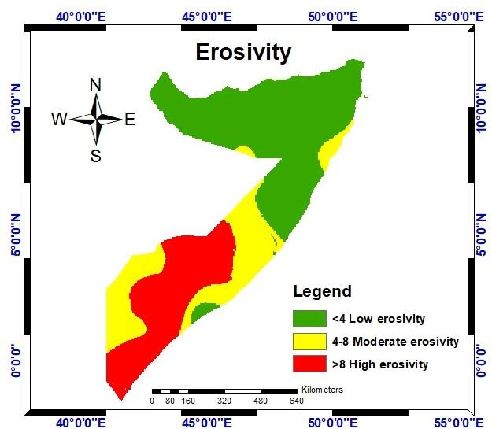
Fig. 2. Erosivity map Source (Nur et al, 2024)

Moderate erosivity covers about 180,539.67 km² (28.30%), largely distributed across transitional zones with intermediate rainfall regimes. Meanwhile, low erosivity accounts for 32.14% of the area, typically associated with the northern and northeastern regions, where annual rainfall is limited and less erosive.
2. Soil Loss Estimation in Hirshabelle State
The final soil loss estimation, derived from the multiplicative interaction of rainfall erosivity (R), soil erodibility (K), slope length and steepness (LS), cover management (C), and support practice (P) factors, provides a comprehensive spatial representation of erosion risk within Hirshabelle State (Fig. 8). This methodology, grounded in the Revised Universal Soil Loss Equation (RUSLE), enables the categorization of soil loss into five severity classes—very low, low, moderate, high, and very high—thus offering a nuanced understanding of the extent and distribution of erosion risk across the landscape (Yesuph et al., 2021).
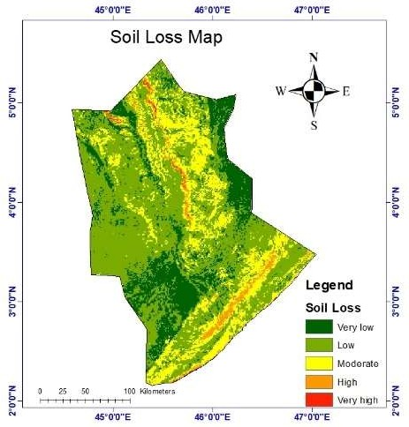
Figure3: Soil Loss Estimation in Hirshabelle State Source (Nur et al, 2025)

The results indicate that soil erosion in northwest Somalia is predominantly moderate, though notable spatial variations exist across agro-ecological zones. In the northern region, particularly around Bossaso and adjacent weather stations, erosivity risk is relatively low, primarily due to reduced annual precipitation. In contrast, the southern parts of Hirshabelle, where slopes are steeper, exhibit higher erosion risks despite receiving comparatively greater rainfall. This pattern highlights the critical interplay between precipitation regimes and topographic gradients in shaping erosion processes within the state (Nur et al., 2024). From a management perspective, these insights underscore the need for targeted soil and water conservation strategies. Identifying erosion-prone areas allows land managers and policymakers to prioritize interventions such as slope stabilization, reforestation, agroforestry, contour farming, and improved land-use practices. Such measures are essential to mitigate ongoing soil degradation and strengthen the resilience of agroecosystems in Hirshabelle State.
3. Actual Soil Erosion Risk (ASER) in Waqooyi Galbeed, Somalia
Soil erosion is one of the most pressing environmental challenges in arid and semi-arid regions, with significant implications for agricultural productivity, ecosystem stability, and sustainable land management. The assessment of actual soil erosion risk (ASER) provides an essential basis for identifying vulnerable areas and implementing effective soil conservation strategies. Within this context, the CORINE (Co-Ordination of Information on the Environment) methodology offers a systematic approach to estimating erosion risk by integrating multiple biophysical and land-use factors.
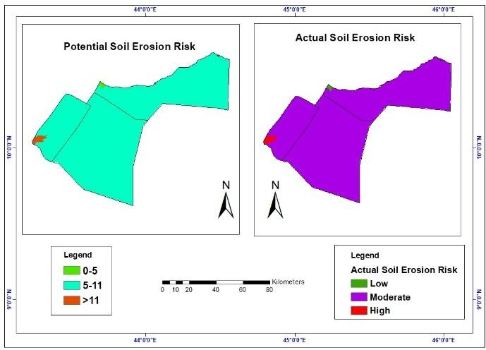
Figure 4: Map of potential and acutual soil erosion risk og waqooyi Galeed
Source (Nur et al, 2024)

The CORINE actual soil erosion risk map combines two primary datasets: potential erosion risk and land cover information. Land cover data reflect the type and distribution of vegetation, which plays a pivotal role in regulating soil erosion. Vegetation reduces erosion by intercepting rainfall, minimizing surface runoff, and stabilizing soil with root systems. Thus, areas with dense vegetation generally exhibit a lower erosion risk compared to sparsely vegetated or barren areas. Potential soil erosion risk is derived from inherent physical factors such as soil erodibility, rainfall erosivity, and slope gradient, which indicate the natural susceptibility of an area to erosion processes. By overlaying land cover with potential erosion risk, the CORINE ASER map provides a more realistic and spatially explicit understanding of soil erosion vulnerability. The application of this methodology in the Waqooyi Galbeed region of Somalia (2011–2019) revealed that the overall soil erosion risk is predominantly moderate. The quantitative assessment (Table 1) shows that:
Table 1: Actual Soil Erosion Risk (ASER)
Risk Class | Area (km²) | Area (%)
Low | 59.3 | 0.21%
Moderate | 28,001.2 | 99.17%
High | 176.3 | 0.62%
Total 28,236.8 100.00%This distribution underscores that while most of the region experiences moderate erosion risk, localized hotspots of high vulnerability exist and warrant targeted management.

4: Soil Loss Estimation in Bay Region
Soil loss in Bay Regionwas quantified using the Revised Universal Soil Loss Equation (RUSLE), a widely applied empirical model that integrates climatic, edaphic, topographic, vegetative, and management factors. The final soil loss was derived by multiplying the five factors—rainfall erosivity (R), soil erodibility (K), slope length and steepness (LS), cover management (C), and support practice (P). The mean values of these parameters are summarized in Table 2.
Table 2. Mean values of the RUSLE model
Parameters | Mean R Factor | Mean K Factor | Mean LS Factor | Mean C Factor | Mean P Factor | Mean Soil Loss
Mean Values | 520.34 | 0.03 | 2.35 | 0.58 | 0.80 | 17.65
Source (Nur et al, 2025)
The average soil loss rate of 17.65 t ha⁻¹ yr⁻¹ suggests a moderate level of erosion within the study area. However, considerable spatial variation exists, reflecting the combined influence of rainfall intensity, soil properties, topography, land cover, and management practices.
The results of the soil loss assessment were classified into five erosion severity classes—very low, low, moderate, high, and very high following the framework of Housseyn et al. (2021). Figure 5 illustrates the distribution of areas across these classes, while Figure 6 presents the corresponding spatial soil loss map for Bay Region.
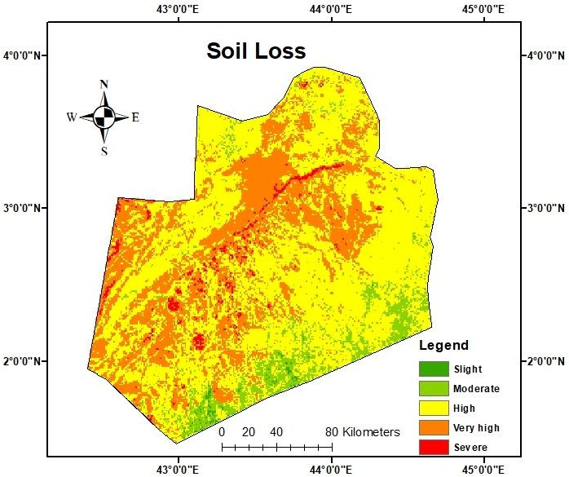
Figure 5: Soil loss map of Bay Region Source (Nur et al, 2025)

4.1 Distribution of Soil Loss Classes
The chart (Fig. 6) provides a quantitative overview of the extent of land affected by each erosion severity class. Most areas of Bay region fall within the moderate to high erosion risk categories, with only limited portions exhibiting very low or very high soil loss rates. This distribution indicates that while widespread catastrophic erosion is not dominant, a substantial share of the landscape remains vulnerable and requires proactive soil conservation measures.

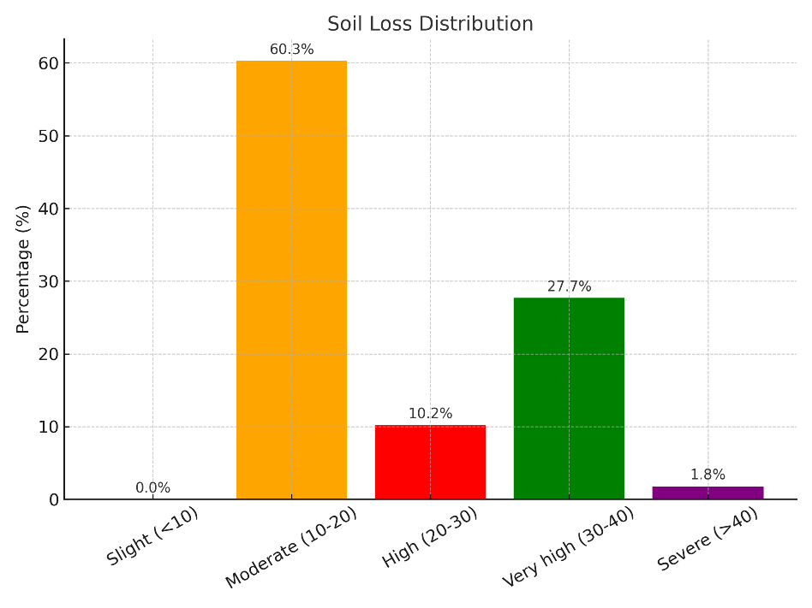
Figure 6 : Soil Loss Classes Source (Nur et al, 2025)

5. Modelling of topsoil erosion

Estimates of soil loss from the three models indicated a greater rate of soil loss in 2007 compared to 2008. The average topsoil loss rate was projected at 15.48 tons/ha/year (with a standard deviation of 9.11 tons/ha/year) in 2008 and 21.46 tons/ha/year (with a standard deviation of 4.7 tons/ha/year) in 2007. Figure 7 illustrates the regional distribution of soil loss estimates derived from the MUSLE model for the years 2007 and 2008.

Despite the three soil erosion models yielding varying magnitudes of topsoil loss, all exhibited a roughly identical spatial pattern of topsoil depletion in 2007 and 2008: significant soil loss rates in the western, northwestern, and northeastern regions of the study area, as well as along the Indian Ocean coastline. The presents the soil loss estimates for the regions between Luuq and Bardheere, as well as between Belet Weyne and Bulo Burti stations. On average, the three models indicated that the regions between Luuq and Bardheere saw greater soil loss than those between Belet Weyne and Bulo Burti stations during 2007-2008. This may create the perception of more silt deposition in the Juba River compared to the Shabelle River.

Table 3: Soil loss estimates between sediment measuring stations

Soil loss estimates (million tons)
Between stations | Year | MUSLE | RUSLE | Thornes
Belet Weyne and Bulo Burti | 2007 | 436.1 | 674.3 | 515.3
 | 2008 | 260.0 | 157.0 | 168.4
Total |  | 696.1 | 831.3 | 683.8
Luuq and Bardheere | 2007 | 436.6 | 302.8 | 451.4
 | 2008 | 770.5 | 536.6 | 211.3
Total |  | 1207.1 | 839.3 | 662.8
Source. (Omuto, et al 2009)

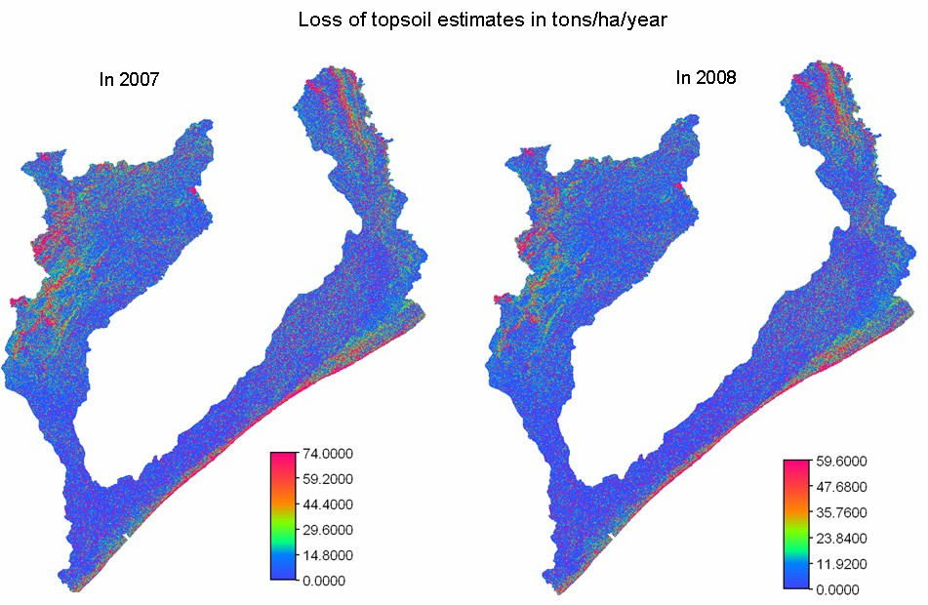
Fig 9- Comparison of loss of topsoil estimates in tons/ha/year in 2007 and 2008 Source 7 . (Omuto, et al 2009)

Conclusion
This study demonstrates that soil erosion and land degradation in Somalia are highly variable across regions, shaped by the interaction of rainfall intensity, soil properties, topography, vegetation cover, and land management practices. While erosion risk is predominantly moderate, southern and central Somalia experience higher losses due to stronger rainfall erosivity and steeper slopes, whereas northern areas face lower but still significant risks, especially where vegetation has been depleted. The findings highlight that moderate to high soil erosion is widespread, posing long-term threats to agricultural productivity, food security, and ecosystem stability. Climate variability, unsustainable land use, deforestation, and overgrazing are accelerating these processes, making soil degradation one of the most pressing environmental challenges in Somalia
To address this, integrated land management strategies are needed. Priority actions include adopting soil and water conservation measures, restoring vegetative cover through agroforestry and reforestation, implementing slope stabilization in erosion-prone areas, and promoting sustainable farming practices. These interventions, combined with institutional support and community engagement, can significantly reduce erosion risks. Ultimately, combating soil erosion in Somalia requires linking scientific evidence with policy and practice. By identifying erosion hotspots and understanding spatial patterns of risk, decision-makers can prioritize interventions that enhance resilience, protect livelihoods, and secure the long-term sustainability of Somalia’s fragile landscapes.
REFERENCES
Oldeman LR, Hakkeling RTA, Sombroek WG. 1991.World Map of the Status of Human-Induced Degradation: An Explanatory Note.ISRIC-UNEP: Wageningen, The Netherlands, Nairobi, Kenya.
Lal R, Blum WH, Valentine C, Stewart BA. 1998. Methods for assessment of soil degradation.Advances in Soil Science. CRC Press: Boca Raton,Florida.
Feddema JJ. 1998. Estimated impacts of soil degradation on the African water balance and climate.Climate Research10: 127–141.
FAO. 2003.Data Sets, Indicators and Methods to Assess Land Degradation in Drylands. FAO, Rome.
Gisladottir G, Stocking M. 2005. Land degradation control and its global environmental benefits.Land Degradation & Development16:99–112.
Abd Elbasit, A. M. (2013). The role of rainfall drop size distribution in rainfall erosivity. Journal of Soil and Water Conservation, 68(5), 353-359. https://doi.org/10.2489/jswc.68.5.353
Kertesz, Z., & Gergely, I. (2011). Quantification of rainfall erosivity indices based on raindrop size distribution. Catena, 85(2), 155-163. https://doi.org/10.1016/j.catena.2011.01.004
Mohamed, A. (2013). Soil erosion in Somalia: Impact of rainfall erosivity. Somali Journal of Science and Engineering, 10(4), 123-135.
Bellocchi, G., & Diodato, N. (2020). The impact of climate change on rainfall erosivity and hydrological extremes: A global perspective. Hydrological Sciences Journal, 65(6), 857-870. https://doi.org/10.1080/02626667.2020.1821109
Eroglu, H., Arslan, H., & Yildirim, K. (2010). Environmental and economic impacts of soil erosion: A case study of Mediterranean region. Environmental Monitoring and Assessment, 166(1-4), 467-475. https://doi.org/10.1007/s10661-009-1087-3
FAO SWALIM. (2009). Soil erosion and its impacts in Somalia: An overview. FAO-SWALIM Technical Report.
Pimentel D. Soil erosion: a food and environmental threat. Environment, development and sustainability (2006): 119-37.
Wynants M. Drivers of increased soil erosion in East Africa's agropastoral systems: changing interactions between the social, economic and natural domains. Reg Environ Change 19 (2019):1909-1921.
Lim KJ, Sagong M, Engel BA, Tang Z, Choi J, Kim K. 2005. GIS-based sediment assessment tool.Catena64: 61–80.
Lakew, D & Belayneh, A (2012). Nile Basin Initiative: A Field Guide on Gully Prevention and Control.
Ding, J. and Richards, K. (2009) Preliminary modelling of sediment production and delivery in the Xihanshui River basin, Gansu, China. Catena, 79(3): 277– 287. Nur, A. H., Ahmed, A. H., Mohamed, A. A., Hasan, M. F., & Sarmin, S. (2024). Geospatial assessment of Aridity and Erosivity Indices in Northwest Somalia using the CORINE Model. Journal of Environmental and Science Education, 4(1), 1-11.
Nur, Abdiaziz Hassan, Abdinasir Abdullahi Mohamed, and Ali Hussein Ahmed. 2024. “Spatial Assessment of Soil Erosion and Aridity in Somalia Using the CORINE Model”. Asian Soil Research Journal 8 (4):111-23. https://doi.org/10.9734/asrj/2024/v8i4167.
Nur, A. H., Ibrahim, A. A., Warsame, A. A., & Farah, A. H. (2024). Estimation of soil erosion and risk assessment in Somalia. International Journal of Agricultural Research, Innovation and Technology (IJARIT), 14(2), 111-121.
Nur, A. H., Mohamed, J. A., Hussein, A. S., & Orchy, N. S. (2025). GIS-Based on Assessment of Soil Erosion in Bay Region of Somalia. International Congresses of Turkish Science and Technology Publishing, 1210-1210.
Nur, A. H., Faruq Hasan, M., Sarmin, S., Shahin, A., Mohamed, A. A., & Ahmed, A. H. (2025). Geospatial Assessment of Soil Erosion Using Revised Universal Soil Loss Equation in Hirshabelle State of Somalia. Nature Environment & Pollution Technology, 24.
Omuto, C., Vargas, R. R., & Paron, P. (2009). Soil erosion and sedimentation modelling and monitoring of the areas between rivers Juba and Shabelle in Southern Somalia. Somalia Water and Land Information Management.

