FINANCIAL LITERACY AND SPENDING HABITS AMONG FOURTH YEAR STUDENTS IN THE UNIVERSITY OF EASTERN PHILIPPINES COLLEGE OF EDUCATION

ABSTRACT

This study aimed to examine the financial literacy and spending habits of fourth-year students from the College of Education at the University of Eastern Philippines – Main Campus and to determine the correlation between the two variables. A descriptive-correlational research design was utilized, employing a standardized 21-item questionnaire divided into three sections: Spending Habits, Saving Habits, and Financial Knowledge. The study surveyed 359 students selected through simple random sampling from a total population of 423. Data were collected through both printed and online questionnaires and analyzed using descriptive statistics and correlational analysis with Excel’s Data Analysis Toolpak. Findings revealed that students exhibited moderate financial literacy and a combination of prudent and impulsive spending behaviors. While most respondents practiced basic budgeting and saving, few engaged in structured financial planning. A significant negative correlation (r = -0.12, p = 0.03) was found between financial literacy and spending habits, indicating that higher financial literacy is linked to more responsible spending. Among the demographic factors examined, only sex showed a significant relationship with financial literacy. The study concludes that while students demonstrate a general awareness of financial management, there remains a need to strengthen structured budgeting practices and deepen their understanding of financial tools to further improve financial literacy and decision-making.

___________________________________________________________________________

Keywords: Financial literacy, spending habits, fourth-year students.
INTRODUCTION
Financial literacy is all about being able to navigate personal experience which means being able to handle their own financial situations. For instance, budgeting their allowance to cover daily needs since most of the students have a limited amount of money and making ends meet with their allowance thus, they decide how much to spend on non-essential items like snacks, clothing, or leisure. Conversely, a lack of financial literacy can lead to poor financial management, increased debt, and financial stress. Especially, in a university life where a financial crisis is one of the common problems where lack of knowledge in managing their finances and skills to make sound financial decisions can trigger these problems.
However, finding ways to save money despite limited financial resources and how they cope with financial stress when their budget falls short. Saving and budgeting habits is only a choice to ease financial burdens even to monitor our spending habits. Tracking spending makes sense so students become aware of where their money goes, encouraging them to prioritize and balance their needs over wants and develop responsible spending habits.

Aspiring educators, after graduating in college and passing the Board exam work in a public school then start borrowing money then burden comes in. Teachers went to loans and suddenly it became a problem if they didn't manage properly. It costs a lot of money. According to Casingal & Ancho (2021) teachers unconsciously practice informal debt, which causes uncontrolled debt. Without proper knowledge and education to financial literacy, borrowing money becomes a lifestyle of every teacher in the country. Researchers believe that this way can help the young minds of the students as they graduate in college they are already equipped with those skills and financially literate.
Moreover, in the Philippines, inflation rates are very high. The country’s inflation rate in February 2024 was higher at 4.2 percent Baring (2025). With these it can also affect the students' studies and may even force students to work part-time jobs that interfere with their studies or lead to drop out of their subjects due to financial constraints. This can have a significant impact on their ability to afford an education and can make it more difficult for them to graduate Team Asia (2025). That's why financial literacy is important to manage money efficiently. According to the Australian Securities and Investments Commission (ASIC), Financial literacy is a combination of financial knowledge, skills, attitudes, and behaviors necessary to make sound financial decisions, based on personal circumstances, to improve financial wellbeing Australian Securities and Investments Commission (2022). These skills are important to every teen out there which equip certain knowledge and skills in today's world real life challenges. However, problems arise that currently our educational system still has a gap. For example, at the higher education level financial literacy is typically taught within business courses like Business Administration in every University. With these, students in other fields often receive little or no formal knowledge about financial management. This is a reason why many young Filipinos are unprepared to handle real-world financial challenges. One of the main reasons why financial education in every school is still limited is the overcrowding of the curriculum which makes it difficult for financial literacy to gain a foothold, even though the benefits are clear Cobb global outreach (2024). Alongside with the many challenges in schools is the lack of resources, time, or staff to implement an additional course and to teach these subjects effectively. In the context of thi In 2022, Bangko Sentral ng Pilipinas cited a global financial literacy study by Standard & Poor’s (S&P Global Ratings) and revealed that the Philippines ranked in the bottom 30 of 144 countries, with only 25% of Filipino adults considered financially literate, this means that 75% of Filipino are not financially literate Nicolas (2024).s study, the limited knowledge among the youth on how they handle their finances has become a common problem in today's world, especially in university students. College life is often regarded as a period of newfound independence, especially in financial responsibilities. Among these, managing finances becomes one of the most significant challenges.
In 2023, Northern Samar's poverty incidence worsened, rising from 19.3% to 21.8%, with Catarman, the capital, being part of this trend, Meniano (2024). Poverty can only bring financial problems and a limited budget struggles the students not only with their studies but also with the budget left in their pocket, the burden of the financial crisis tends them to become a working student, balancing their work and study to meet their needs. In University, survival skills are only a key to win academically and financially. Managing our spending habits is very important to always monitor, think before spending and learn to control ourselves not to lavishly spend our allowance. In other words, choosing first our needs over our wants. Moreover, the Low Enrollment Rate (26.9%) in region VIII Eastern Visayas indicates that only about 1 in 4 college-age individuals in Eastern Visayas were enrolled in higher education in 2020 Magsambol (2025). This is lower compared to other regions, suggesting potential barriers to access, such as financial difficulties, lack of higher education institutions, or personal reasons.
A study in the University of Eastern Philippines (UEP) revealed that the respondents tend to be academically prepared but receive lesser guidance in terms of financial literacy. The result showed that parental guidance has a very strong influence on financial literacy Lalosa (2020). Even though our government is trying their best to instill financial literacy in every school it remains until now a problem especially for the students who belong to marginalized families where limited budget in their allowances lacks knowledge in managing their finances. Therefore, we need strong policies in response to these issues while helping them to improve and develop their own money management and to fix their mindset when it comes to spending habits and financial literacy make them better individual and responsible consumers. All of these will benefit us through financial education.
This study was intended to explore how financial literacy and spending habits affect the financial well-being of fourth-year students at the University of Eastern Philippines College of Education.
Specifically, the study aims to answer the following objectives:
1. Describe the demographic profile of College of Education students in terms of:
1.1 Age
1.2 Sex
1.3 Field of Specialization
1.4 Commuter or Non-Commuter Status
1.5 Scholarship Status
1.6Boarding Status (Staying in a dormitory or boarding house)
1.7 Employment Status (Working student or not)
1.8 Estimated Monthly Allowance.

2. To Determine the level of financial literacy of a college of Education in the following areas:
2.1 spending habits
2.2 saving or budgeting practice
2.3 financial knowledge

3. To find out the relationship between demographic profiles towards Financial Literacy among students.

4. To assess the relationship between financial literacy and spending habits among students.

MATERIALS AND METHODS
This study was conducted at the College of Education, University of Eastern Philippines (UEP) – Main Campus, located in the University Town, Catarman, Northern Samar.
This study used a Descriptive-correlational method of research which employed the analysis of data by correlating the variables in this study where the questionnaire was the principal instrument in the data gathering.
In determining the target population of the respondents for this research, the researcher used simple random probability sampling. The target population consisted of 423 fourth-year students from the College of Education. A sample size of 359 was determined by taking 85% of the total population. Using a random selection process, each student had an equal chance of being chosen. All 359 selected students were included as respondents in the study. This method was used to ensure fairness, reduce bias, and increase the representativeness of the sample.
For data collection, this study used a survey questionnaire, both printed and online through Google Forms. The completion of the form will be taken as consent in pursuant to Republic Act (R.A.) 10173 otherwise known as the Data Privacy Act of 2012. The researcher used the survey questionnaire in gathering the data. The questionnaire was taken from Binobo et.al, (2019) titled "Level of Financial Literacy of Senior High School Students from Private Schools of Bacolod City". The questionnaire was standardized, and it comprised three sections entirely, where each segment consists of seven (7) questions thus totaling to a twenty-one (21) item questionnaire. The sections are classified as the following accordingly: Spending Habits, Saving Habits, and Financial Knowledge. The interpretation of the data of their responses used a 5-point Likert scale.
Prior to data collection, a formal request letter was sent to the Dean of the College of Education to secure permission to conduct the study and to access the list of fourth-year students. Additionally, approval was sought from subject professors to administer the questionnaires after their class hours.
Data gathered were encoded, tallied, and analyzed using the Data Analysis Toolpak in Excel. Also, the Descriptive statistics such as frequency counts, percentages, and weighted means were used to summarize the data. Furthermore, correlational analyses were employed to address the study’s objectives and test the research hypotheses.
RESULTS AND DISCUSSION
This section presents the findings and discussions based on the data gathered. Table 1,2,3,4, presentation is the demographic profile of the respondents and another Table 5,6,7 is organized into three sections; first, the spending habits of the students; second, the level of the saving habits and budgeting practice; and third, the financial knowledge practice of the students while the Table 5 and 6 the results of correlation Analysis on the Demographic profile of students towards financial literacy and financial literacy towards spending habits.
Fig 1- Age distribution
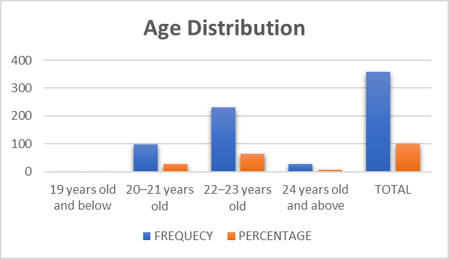
Table 1 showed the distribution of the Demographic Profile of the respondents. From the study, it presents the age of the respondents. Most of the Fourth-year students, out of 359 the 232 or 64.63% of the respondents were shown to be between 22-23 years old; 99 out of 359 or 27.58% of the respondents were 20-21 years old; 27 out 359 or 7.53% of the respondents were between 24 and above years old. While the fewest number of students, one (1) below out of 359 or 0.28% of the respondents were found to be between 19 and below years old. This indicated that most fourth-year students at College of Education belong to the average-group, while fewer students belong to the youngest age group.
This confirms the study of Bugheanu and Străchinaru (2020) where there is a positive correlation between spending behavior and respondents' age; as you get older, spending behavior tends to occupy a more prominent role in adult life. This means that, as individuals grow older, spending behavior tends to play a more significant role in their daily lives, influenced by increased financial responsibilities and decision-making maturity. However, several studies have confirmed that the lowest level of financial literacy was among the youngest and the oldest Nguyen et al. (2022). These findings are relevant to the present study, as they help explain the observed differences in spending behavior and financial literacy among fourth-year students in terms of their age.
Fig 2- Sex distribution

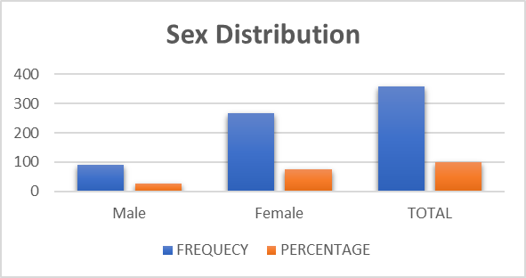
Furthermore, the data revealed that most of the respondents were female, with a total of 268 individuals for 74.66% of the population. In contrast, male respondents numbered only 91, making up 25.35% of the total.
In contrast, according to Bağcı and ahraman, (2020) their study about the effect of gender on financial literacy. Financial literacy varies according to gender and the financial literacy level of men is higher than women. According to their study, the reason is that men are more skillful in making financial decisions and more eager to learn than women. In this study, their findings may help in interpreting the disparities in financial literacy and spending behaviors across gender lines and provide an underlying basis to understand that gender as a potential influencing factor.
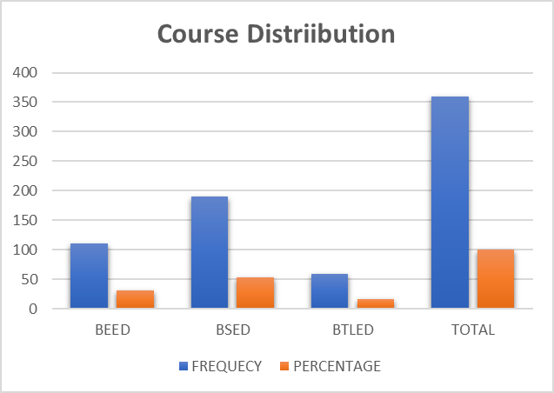
Fig 3- Course distribution
Likewise, among the academic programs, the Bachelor of Secondary Education (BSED) accounted for the largest proportion of respondents were 190, or 52.93%, followed by the Bachelor of Elementary Education (BEED) 110 or 30.65% and the Bachelor of Technology and Livelihood Education (BTLED) which is 59 or 16.44%. These figures demonstrate that BSED is the most populated program among the fourth-year students in the College. Likewise, with respect to the field of specialization, the most common major was Physical Education where 63 or 25.72%. Other majors with few representations included Science and Mathematics where 25 response or 10.21%, English and BTLED-HE with 23 each or 9.39%, Social Studies and BTLED-AFA a same total of 21 or 8.58%, followed by Values Education with 17 respond or 6.94%, and Filipino with 16 or 6.54%, and BTLED-IA with 11 or 4.49%. The results indicate a diverse range of specializations pursued by the respondents, with notable concentrations in Physical Education, Math, and Sciences. The results, in accordance with the study of Elomina and Buama (2021) found that there was no significant difference in financial literacy when respondents were classified according to their demographic profile. Similarly, in the present study involving fourth-year students from the College of Education, results showed that financial literacy levels did not significantly differ across demographic categories. This means, it suggests that financial literacy is not inherently gained through academic exposure in teaching education programs. In contrast, the study highlights that business majors tend to demonstrate greater knowledge in areas like finance, not surprising because the curriculum requirements for business degrees often provide more opportunities to take courses in finance and related subjects Chen and Volpe (2024). Likewise, the research by Okicic et al. (2021) found a positive association between financial knowledge and financial behaviors (such as saving, investing, insurance) among business administration students at the KNUST (Kwame Nkrumah University of Science and Technology) School of Business. This is consistent with the study by Aydin and Akben Selcuk (2019) who found that positive financial attitudes and behaviors among students are significantly related.
Fig 4- Commuting distribution
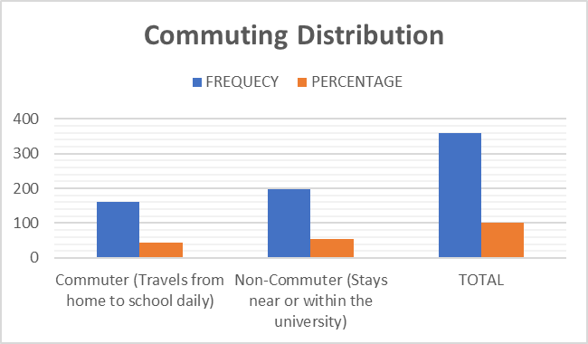
Furthermore, A slight majority of respondents where 198 or 55.16% identified as non-commuters, indicating that they reside either on or near the university campus. Conversely, 44.85% or 161 were classified as commuters, reflecting a nearly balanced distribution between commuting and non-commuting students. In terms of financial support, more than half of the respondents 191 or 53.21% reported having no scholarship, while a substantial number of 159 or 44.29% were government-funded scholars. A minimal portion of 9 or 2.51% received private scholarship assistance. This suggests that while a significant number of students benefit from government assistance, a majority rely on personal or familial financial resources.
Fig 5- Scholarship distribution
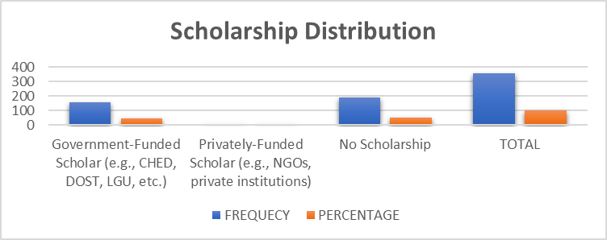
However, from the study of Biggs (2023) having a scholarship can help individuals to ease their burden financially and they learn to manage effectively. According to this article, Scholarships can teach you financial management skills such as budgeting, saving, and investing by giving you a sum of money that you are responsible for allocating towards your education and living expenses. Which means, although in this study there are most respondents who have limited to avail scholarship programs once they provide adequate financial support it can boost their financial literacy and full potential.
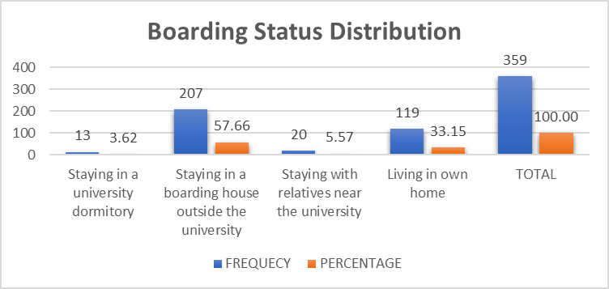
Fig 6- Boarding status distribution
Regarding their place of residence, most respondents total of 207 or 57.67% resided in boarding houses outside the university premises, while 33.15% or 119 lived in their own homes. A small percentage stayed with relatives near the university where 20 or 5.58%, and only a few of 13 or 3.63% resided in university dormitories. These findings imply that most students live independently off-campus, which may have implications for their daily routines and financial management. This confirms the study of Lubiyansyah (2020), Students who live in boarding houses spend more on daily food needs compared to students who live with their parents. This means that needs such as eating and drinking are indemnified by the parents. In this study, consumption or spending habits vary according to the student's type of living. Like, living in a boarding house outside their own home depends on the students how to strategically manage their allowance and control their cost of spending. Generally, those students who lived in cheaper dormitories tended to spend less than those in the more expensive ones Aseng (2020). Thus, it depends on the students on financial management skills.
Fig 7- Employment status distribution
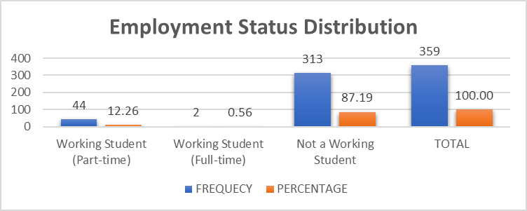
Moreover, the employment status of respondents revealed that the majority of 313 or 87.19% were not working, suggesting that they are focused primarily on academic responsibilities. Meanwhile, a small portion 44 or 12.26% were employed as part-time working students, while only 2 respondents 0.56% reported being full-time working students. Conversely, employed students can provide them an extra source of income compared to non-working students.
A study indicated that part-time students are more financially literate and demonstrate financial responsibility than those who are not working students in a group. Anupriya and Moorthy (2024), this study explores the spending patterns of college students in Sivakasi who have engaged themselves in part-time jobs. The study reveals that most respondents spend the income they earn from part-time jobs primarily on personal needs such as transportation and college fees. A significant portion also uses their earnings to settle family debts and make small investments for future security. This means, being financially responsible and learning to have healthy spending habits helps them to shape how students manage their money well.
Fig 8- Estimated Monthly allowance distribution
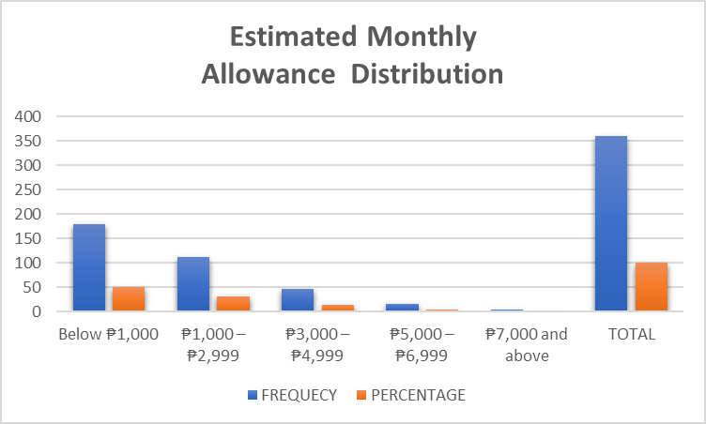
Lastly, half of the respondents which is 180 or 50.14% reported having an estimated monthly allowance of below 1,000, indicating limited financial capacity. Meanwhile, 112 students or 31.20% had a monthly allowance ranging from 1,000 to 2,999, and 47 students 13.10% received 3,000 to 4,999. Only a few respondents reported higher monthly allowances: 15 or 4.18% had 5,000 to 6,999, and 5 or 1.40% received 7,000 and above. These figures underscore the financial limitations experienced by a majority of students.
Whereas, from the study of Hassan and Wahid (2023), their study concluded there is no significant relationship between the monthly allowance and their daily spending. Likewise, they found out that most of the students received monthly allowances from their parents and spent most of their allowances on food and transportation. About my study, this indicates that there is no significant association between the amount of allowance received and the way students manage their spending habits.
Further analysis was done by grouping and calculating individual Frequency count, percentage, mean scores, and standard deviation to determine the level of financial literacy in terms of their spending habits, saving or budgeting practice and financial knowledge this was illustrated in Table 5 to 7.

Table 5 Spending Habits by Fourth Year Students

ITEMS | SD | D | N | A | SA | MEAN | Std. Deviation
I tend to buy things on impulse. | 39 (10.9%) | 98 (27.3%) | 152 (24.3%) | 59 (16.4) | 11  (3.1%) | 2.74 | .96
The money I spend is greater when I have just received my allowance or any source of cash. | 40 (11.1%) | 113 (31.5%) | 117 (32.6%) | 73 (20.3%) | 16 (4.5%) | 2.75 | 1.04
I treat people often/ I spend money on others. | 62 (17.3%) | 146 (40.7%) | 115 (32%) | 33 (9.2%) | 3 (0.8%) | 2.36 | 0.9
I spend more on my wants compared to needs. | 94 (26.2%) | 151 (42.1%) | 83 (23.1%) | 28 (7.8%) | 3 (0.8%) | 2.15 | 0.93
I wait for sales before I buy my wants. | 12 (3.3%) | 30 (8.4%) | 112 (31.2%) | 160 (44.6%) | 45 (12.5%) | 3.55 | 0.93
I spend money using a card. | 197 (54.9%) | 129 (35.9%) | 24 (6.7%) | 5 (1.4%) | 4 (1.1%) | 1.58 | 0.77
I spend more on branded items compared to non-branded ones. | 148 (41.2%) | 120 (33.45) | 67 (18.7%) | 17 (4.7%) | 7 (1.9%) | 1.93 | 0.98
Average | 2.44  Disagree.  Low spending habits
Legend of Mean Scores (Likert Scale Interpretation):
4.24–5.04 – Strongly Agree 3.43–4.23 – Agree 2.62–3.42 – Neutral 1.81–2.61 – Disagree 1.00–1.80 – Strongly Disagree

Table 5 describes the spending habits of the fourth-year students which are interpreted using a Likert scale of their means scores and frequency percentage. The data reveal varied spending behaviors among fourth-year students.
The data show that 152 or 24.3% of the students expressed neutrality, suggesting a degree of uncertainty or situational impulsivity in their spending behavior. On the other hand, a smaller portion disagreed (16.4%) or strongly disagreed (3.1%), indicating fewer students who consistently avoid impulse buying. The mean score of 2.74, with a standard deviation of 0.96, further supports the tendency toward moderate impulsivity among the respondents. This finding implies that impulse buying is a prevalent behavior among fourth-year education students. Conversely, the higher a student's financial literacy, the lower the impulse buying behavior Anisa (2020). Whereas, the lower a student's financial literacy, the higher impulse buying behavior. In this study, this inverse relationship highlights the significant role that financial literacy plays in shaping students’ spending habits.
A significant portion of respondents 117 or 32.6% remained neutral when asked if their spending increased after receiving their allowance while 73 or 20.3% agree this means that not everyone spends more money after receiving cash. Some choose to save or spend carefully, showing different financial habits. Meanwhile, the Mean = 2.75 (Neutral) Standard Deviation = 1.04 indicated that respondents were neutral on whether their spending increases after receiving money. On treating others, 40.7% or 146 students disagreed and 32% or 115 remained neutral, suggesting that most students are cautious in spending money on others. Mean scores = 2.36 (Disagree) and Standard Deviation 0.9 where it was interpreted students tend to disagree with this statement, suggesting that most of them do not frequently spend money on others, likely prioritizing personal expenses. The findings above support the study of Yoganandham (2025), that urge to integrate a financial planning that saves from debt or burden these basic concepts can transform individuals into financial stability and independence. His research suggests education and awareness in mastering financial sources where it tackled budgeting, savings, early investing, debt management, and the transformative power of financial planning. In relation to my study, it is important that those students who are uncertain about the way they spend their allowance with the help of these can make sound economic decisions in terms of financial and knowledge to manage the money effectively.
When it comes to prioritizing wants over needs, the majority also disagreed 151 or 42.1% or strongly disagreed 94 or 26.2%, showing a tendency to spend more wisely. Mean = 2.15 (Disagree) with standard deviation 0.93 where majority of respondents disagree, meaning that students generally prioritize needs over wants. This suggests a level of financial discipline among the group.
Interestingly, 44.6% or 160 agreed that they wait for sales before buying wants, demonstrating a strategic and budget-conscious approach to spending. Meanwhile, 31.2% or 112 participants expressed uncertainty regarding this behavior. Mean = 3.55 (Agree) with standard deviation 0.93 where it interpreted Students agree with waiting for sales, indicating a tendency toward being strategic and practical in spending, especially when it comes to non-essential items. The findings above are anchored in the theory of Hierarchy of needs by Abraham Maslow. Maslow's theory is often presented as a pyramid with the first level, the physiological needs, at the foundation a person must meet on their journey to be a complete, happy, and satisfied individual Jones and Hartzell (2023). In the context of this study, this hierarchy of needs relates to how the students spend money based on their priorities where they most likely focus on the basic needs like their foods, transportation in school and shelter but without financial knowledge they may struggle to manage their money. In other words, Maslow’s Hierarchy of Needs helps explain how students manage their money based on their priorities and they can avoid financial crises and secure a better future. Further findings support this theory.
In terms of payment method, a majority 54.9% or 197 strongly disagreed and 35.9% or 129 disagreed with the use of cards, implying that cash is still the primary mode of transaction among students with this it implies that Mean = 1.58 and standard deviation 0.77 a strongly disagree, meaning they rarely use credit or cards for purchases. This could be due to limited access or preference for cash-based transactions. Ludlum et al., (2012), “Financial Literacy and Credit Cards: A Multi Campus Survey” the study revealed that many college students did not have enough knowledge about how to properly use credit cards, which often led them to debt.
When asked about preference for branded items, 148 or 41.2% strongly disagreed and 120 or 33.45% disagreed, showing that most students choose practicality and affordability rather than brand items. The results confirm the Mean = 1.93 which is (Disagree). These findings support the study of Fernandez et.al (2021), 116 respondents from PHINMA Araullo University at Barangay Bitas, Cabanatuan City, Nueva Ecija, Philippines. Results revealed that the respondents have good financial literacy. Likewise, they were good spenders of their money as to their food, personal and academic needs. This indicates that students are more practical, preferring non-branded or more affordable items over branded products.
Overall, the findings suggest that the fourth-year students display financially aware and prudent spending behaviors, often prioritizing needs over wants and choosing to spend wisely.
Analysis of the level of Financial Literacy in terms of saving Habits or Budgeting practice was analyzed as captured in Table 6.

Table 6 Saving Habits or Budgeting Practice by Fourth year Students

ITEMS | SD | D | N | A | SA | MEAN | Std. Deviation
I am able to allocate my budget to match with my budget to match with my spendings. | 10 (2.8%) | 12  (3.3%) | 102 (28.4%) | 191 (53.2%) | 44  (12.3%) | 3.69 | 0.83
I see to it that I would always have weekly or monthly savings | 5 (1.4%) | 2 7  (7.5%) | 119 (33.1%) | 171 (47.6%) | 37 (10.3%) | 3.58 | 0.83
I am able to determine what should be prioritized before and during buying an item/s. | 9 (2.5%) | 3  (0.8) | 58 (16.250 | 180 (50.1%) | 109 (30.4%) | 4.05 | 0.85
I do written or electronic budget planning/preparation. | 1 5  (4.2%) | 59 (16.4%) | 144 (40.15) | 115 (32%) | 26 (7.2%) | 3.22 | 0.95
I keep receipts and bills to be conscious of my spendings. | 14 (3.9%) | 52 (14.5%) | 104 (29%) | 14 (41.5%) | 40 (11.1%) | 3.42 | 1
I use my personal money (savings) for my wants and needs. | 6 (1.7%) | 2 4 (6.7%) | 106 (29.5%) | 179 (49.9%) | 4 4  (12.3%) | 3.64 | 0.84
I set aside money for the Lord before budgeting for my needs and wants. | 8  (2.2%) | 25  (7%) | 160 (44.6%) | 143 (39.8%) | 23 (6.4%) | 3.41 | 0.8
Average | 3.43  Agree or  High Saving habits
Legend of Mean Scores (Likert Scale Interpretation):
4.24–5.04 – Strongly Agree 3.43–4.23 – Agree 2.62–3.42 – Neutral 1.81–2.61 – Disagree 1.00–1.80 – Strongly Disagree

Table 6 indicates that most fourth-year College of Education students exhibit responsible saving and budgeting behaviors. A large percentage, 53.2% or 191, agreed that they can allocate their budget according to their spending, showing a high level of financial self-management. But several students, a total of 102 or 28.4%, are undecided. Overall, mean = 3.69 (Agree) and standard deviation 0.83 reflects a strong sense of budget awareness and financial control. Similarly, nearly half 47.6% or 171 agreed that they maintain weekly or monthly savings, reflecting a conscious effort to build financial reserves. This confirms to the Mean scores = 3.58 (Agree) practicing regular saving. This indicates a good saving habit and financial literacy among many of the respondents. However, the study of Fiergbor (2020) indicates that the majority of college students do not save as a result of certain contributory factors such as meager salaries and economic hardships. This is consistent with the study of Sridhar (2023), According to the study's findings, college students struggle to manage their finances and have a low degree of financial literacy. In my study, students must develop effective money management skills and strong financial habits. By creating a budget and monitoring their expenses, college students can manage their finances more efficiently and avoid costly mistakes.
Notably, 180 or 50.1% agreed and 109 or 30.4% strongly agreed that they can identify priorities before making purchases, highlighting strong financial decision-making skills. A Mean score = 4.05 (Agree) this item received one of the highest scores. Students show strong financial decision-making skills, demonstrating maturity in knowing priorities when spending. On the other hand, when it comes to formal budgeting through written or electronic planning, only 115 or 32% agreed and 26 or 7.2% strongly agreed, while 144 or 40.15% remained neutral. This suggests that while many students budget mentally or informally, fewer engage in written or electronic financial planning. This reflects on the Mean scores = 3.22 (Neutral) and standard deviation 0.95 indicate many remain neutral or do not engage in it. This suggests room for improvement in developing systematic budgeting habits. There are a lot of studies that support electronic financial planning which is an innovative way to track our spending, budgeting, and saving. Besides from the study of Koskelainen et al., (2023), proposing a framework for digital financial literacy and financial capability. A positive digital innovation for transforming financial services and resulting changes in consumer behavior and personal money management. In this study, students can use electronic financial planning since most of the students are knowledgeable enough about technology.
When asked about keeping receipts and bills, 14 or 41.5% agreed and 40 or 11.1% strongly agreed, yet a notable number were neutral 104 or 29% or 52 or 14.5% disagreed, a Mean = 3.42 (Neutral) and standard deviation of 1 indicating that this habit is not consistently practiced. It is very important to keep our receipts or bills organized because it can help you see how much money is being spent on certain items and how often, which can be useful when budgeting or saving for future purchases Garcia (2022).
Furthermore, most students 179 or 49.9% agreed, 44 or 12.3% strongly agreed, reported using their savings for both needs and wants, demonstrating an active use of their personal funds. Meanwhile, 106 students or 29.5% undecided in this statement. Overall, Mean scores= 3.64 (Agree) and standard deviation 0.84 a positive relationship showing that personal savings serve as a primary financial resource. Lastly, when asked if they set aside money for the Lord before budgeting for other expenses, responses were more varied 160 or 44.6% undecided, and a sizable portion 25 or 7% disagreed and 8 or 2.2% strongly disagreed remained less committed to this practice, reflecting personal or religious differences. Meanwhile, a total of 143 or 39.8 % agree with this statement. But this confirms the mean scores 3.41 (Neutral). Generally, the students demonstrate positive saving and budgeting practices however some areas such as formal budget tracking, receipt-keeping and personal or religious financial commitments are less consistently practiced. By this, a need for further financial education or encouragement to develop more structured money management strategies. The above-mentioned concur with the article from College of Southern Maryland (2025) budgeting allows you to cover the costs of living, to afford the things that are important to you, and to plan toward short- and long-term goals. This means in this study, being able to budget effectively you can learn how to prioritize money on what to spend on and what to set aside either in personal needs or our faith services. Another, the published articles author by Henson (2020) budgeting emerges as a spiritual discipline, an exercise that helps us to live in the present and transforming reality of the kingdom of God. Moreover, financial literacy and financial behavior moderated by religiosity simultaneously have a significant effect on investment decisions, meaning that the higher the student's religiosity, the stronger the religiosity in moderating financial literacy and financial behavior on investment decisions. This is consistent with the study of Al Hakim et al., (2023). In this study, it implies that financial literacy and responsible spending habits can be guided and strengthened by spiritual and moral values. Contrastingly, to the findings above that majority of the students are uncertain when it comes to balancing the budget between religious financial commitments.
Analysis of the level of Financial Literacy in terms of financial knowledge practice was analyzed as captured in Table 7.

Table 7 Financial Knowledge Practice By Fourth Year Students

ITEMS | SD | D | N | A | SA | MEAN |  | Std. Deviation
I feel confident in my knowledge and ability to manage my own finances. | 3  (0.8%) | 18  (5%) | 118 (32.9) | 18 0  (50.1%) | 40 (11.1) | 3.66 | 0.77
I consider myself to be financially literate (able to maximize present money in order to gain financial stability). | 4  (1.1%) | 14  (3.9%) | 112 (31.2%) | 194  (54%) | 35  (9.7%) | 3.67 | 0.75
I am aware of the exchange rate of peso. | 6  (1.7%) | 18  (5%) | 97  (27%) | 191  (53.2%) | 47  (13.1%) | 3.71 | 0.82
I am aware of the of inflation rate in the Philippines | 5  (1.4%) | 13  (3.6%) | 79  (22%) | 179  (49.9%) | 83 (23.1%) | 3.92 | 0.84
I read and understand a contract/s especially involving money before signing. | 4  (1.1%) | 5  (1.4%) | 59 (16.4) | 202  (56.3%) | 89 (24.8) | 4.02 | 0.75
I learn financial management and obtain financial knowledge through my parents. | 5  (1.4%) | 6  (1.7%) | 75  (209%) | 200  (55.7%) | 73  (20.3%) | 3.92 | 0.77
I obtain financial knowledge and learn financial management on my own. | 4  (1.1%) | 13  (3.6%) | 104  (29%) | 188  (52.4%) | 50  (13.9%) | 3.74 | 0.78
Average | 3.81  Agree or  High Financial Knowledge
Legend of Mean Scores (Likert Scale Interpretation):
4.24–5.04 – Strongly Agree 3.43–4.23 – Agree 2.62–3.42 – Neutral 1.81–2.61 – Disagree 1.00–1.80 – Strongly Disagree

The findings show that a majority of fourth-year students exhibit strong confidence and awareness regarding their financial knowledge and practices. Half of the respondents 180 or 50.1% agreed and 40 or 11.1% strongly agreed that they feel confident managing their own finances, but a percentage tend to be neutral 118 or 32.9%. Similarly, 194 or 54% agreed and 35 or 9.7% strongly agreed that they consider themselves financially literate capable of maximizing money for financial stability indicating a generally high level of self-assessed financial capability. The mean score of 3.66 and 3.67 falls within the range of 3.43–4.23, which corresponds to "Agree" on the Likert scale. This indicates that the respondents generally agree that they consider themselves financially literate and manage their own money correctly, wherein they believe they can maximize their current financial resources to work toward financial stability. However, it is contrasting to the study of Montalbo et al. (2017) from their study about “Financial Literacy of Professional and Pre-Service Teachers in the Philippines” where findings revealed that both professional and pre-service teachers have very low basic and sophisticated financial literacy skills. Thus, financial illiteracy is common among educators which reflect their students’ financial literacy skills and the economic condition of most of the Filipino people. This is supported by the study of Barotilla et al. (2024) Pre-service teachers often face challenges in managing their finances, especially as they juggle various obligations. According to this, they felt tension because of the responsibilities they had to do before going to their respective school where they are employed. In the international context, Individuals in the U.S., on average, have relatively large amounts of money about which they must make decisions, but they do not have commensurate levels of financial literacy Faulkner (2021). This indicates that many individuals in the U.S. possess considerable financial resources yet lack adequate financial literacy is both concerning and thought-provoking. In this study, although they perceive themselves as financially literate and capable, contrasting studies indicate that many educators, and potentially students, lack essential financial skills.
Awareness of economic concepts such as the peso exchange rate and inflation rate also appear strong. More than half 191 or 53.2% agreed and 47 or 13.1% strongly agreed that they are aware of the exchange rate, while 179 or 49.9% agreed and 83 or 23.1% strongly agreed that they are familiar with inflation trends in the Philippines. This confirms to their Means scores 3.71 and 3.9 standard deviation 0.82 and 0.84 (Agree) positive response which suggest a solid awareness of broader financial contexts in the present economic conditions in our country. Moreover, most students (56.3% agree; 24.8% strongly agree) reported that they read and understand contracts involving money before signing, reflecting a sound judgement in financial decisions. A study found a positive correlation between inflation crisis awareness and financial literacy, The results indicate that the level of inflation crisis awareness among the respondents was high, while the level of financial literacy was moderately high Balgo et al. (2025). In this study, students' awareness of the trends in today's issue is a sign that they are already aware and prudent to spend and manage their budget effectively.
Furthermore, the role of parents in financial education is evident, with 55.7% agreeing and 20.3% strongly agree that they learn financial management through their parents. Additionally, a large portion (52.4% agreed; 13.9% strongly agreed) also indicated that they gain financial knowledge through self-learning, which reflects initiative and independence in understanding financial matters. On average across OECD (The Organization for Economic Co-operation and Development) countries and economies, 83% of students reported talking to their parents at least once a month about money for things they want to buy, and 76% about their own spending decisions Baron (2025). The claims support another study where this study found that parents’ financial teaching positively influences their children’s financial attitude and behavior by increasing their self-esteem Noh (2022). In this study, these insights suggest that early and consistent parental guidance not only enhances students' financial decision-making but also builds their confidence in handling personal finances.
Overall, positive results of mean scores 4.02 and standard deviation 0.75, 3.92, 0.77, 3.74 and standard deviation 0.78. These scores indicate a positive outlook and behavior toward financial awareness and education among the respondents.
Table 8 shows the results of correlation Analysis on the Demographic Profile of Students Towards Financial Literacy.

Table 8 Correlation Analysis on the Demographic Profile of Students Towards Financial Literacy
Variable | Pearson r | P-value  (2-tailed) | Decision on Ho | Interpretation
Age | -0.10 | P =.07 | Fail to reject Ho | Insignificant
Sex | 0.13 | P =.01 | Reject Ho | Significant
Course | 0.07 | P =.19 | Fail to reject Ho | Insignificant
Commuting Status | -0.02 | P =.78 | Fail to reject Ho | Insignificant
Scholarship Status | 0.00 | P =.99 | Fail to reject Ho | Insignificant
Boarding Status | -0.08 | P =.13 | Fail to reject Ho | Insignificant
Employment Status | 0.04 | P =.45 | Fail to reject Ho | Insignificant
Estimated Monthly Allowance | 0.07 | P =.21 | Fail to reject Ho | Insignificant
NOTE ONLY: (If the p-value is less than or equal to the significance level (α), we reject the null hypothesis (Ho). This means there is a statistically significant relationship).

Table 8 At α = 0.05 level of significance, the result shows that there was no significant relationship between demographic characteristics such as Age, Course, Commuting status, Scholarship status, Boarding status, Employment and Estimated monthly allowance with a correlation coefficient of (Age r = - 0.10 and .07 Course r = 0.07 and .19 Commuting status r = -0.02 and .78 Scholarship status r = 0.00 and .99 Boarding status r = -0.08 and .13 Employment status r = 0.04 and .45 Estimated monthly allowance r= 0.07 and .21) respectively. The evidence above failed to reject the null hypothesis of no significant relationship between students' demographic characteristics towards Financial Literacy. However, the results found that only one of the demographic profiles has a significant relationship which is the sex (r = 0.13 and .01) of the respondents towards financial literacy where it suggests that male and female students may exhibit different levels of financial understanding, which could influence their financial decision-making and spending behaviors. This is confirmed by the study of Lusardi and Hasler (2017) many papers show that women display lower financial literacy and confidence than men, leaving them at a potential disadvantage. In my study, this can reflect that young female students tend to display lower financial literacy due to limited real-world practice and lower financial self-confidence since the majority of them do not have jobs and currently focus on their academic responsibilities. However, this claim is contrary to the article published which suggested in a 2021 study by the Global Financial Literacy Excellence Center, that a large portion of the financial knowledge gap comes down to a lack of confidence rather than a lack of knowledge Rhoades (2024). In relation to my study, this suggests that financial literacy is not necessarily determined by gender; rather, it is influenced by individual experiences, exposure, and self-confidence, regardless of whether the student is male or female.
Table 9 shows the results of correlation Analysis on the Financial Literacy Towards Spending Habits.

Table 9 Correlation Analysis on the Financial Literacy Towards Spending Habits
Variable | Pearson’s r | P value (2-tailed) | Decision on Ho | Interpretation
Spending Habits | -0.12 | P = .03 | Reject | Significant
NOTE ONLY: (If the p-value is less than or equal to the significance level (α), we reject the null hypothesis (Ho). This means there is a statistically significant relationship)

The results of the correlation analysis in Table 9 reveal a statistically significant relationship between financial literacy and spending habits, as indicated by a Pearson’s r value of -0.12 and a p-value of 0.03. Since the p-value is less than the significance level (α = 0.05), the null hypothesis is rejected, meaning that there is a significant, though weak, negative correlation between the two variables. This suggests that as students' financial literacy increases, their spending habits tend to become more cautious or responsible implying that students with better financial knowledge may be more mindful of how they manage their money. The results above support the study of Ahmad et al. (2024) test the relationship shows there is a positive relationship between students' habits of spending and financial literacy, implying that when students learn more about money, they are more likely to make good financial choices. Furthermore, Saripada et al. (2024) the results showed a high level of significant relationship between financial literacy and spending habits, this means when the students' financial literacy increases, the spending habits will become more informed and responsible. These studies support the findings of the present research, highlighting the importance of financial knowledge in helping students manage their money better.

CONCLUSION

In conclusion, the study reveals that fourth-year College of Education students possess a moderate to high level of financial literacy, characterized by a combination of responsible and impulsive spending behaviors. While many students demonstrate an awareness of basic financial management concepts, there is a notable need for improvement in areas such as structured budgeting and the effective use of financial tools like credit cards. The findings also underscore the influence of gender on financial literacy, with female students exhibiting comparatively lower financial knowledge than their male counterparts.
To address these gaps, it is recommended that educational institutions incorporate more structured and practical financial management training into the curriculum, particularly focusing on budgeting, saving, and the responsible use of financial instruments. Moreover, promoting financial literacy workshops and peer-based learning activities could help bridge the knowledge gap, especially among female students, and foster more responsible financial behaviors.
While the findings of this study provide valuable insights, they are limited in scope as they focus solely on students from the College of Education. Future research should aim to include a more diverse group of respondents from other colleges to enhance the generalizability of the results. Employing a qualitative or mixed-methods approach may also yield deeper insights into students’ financial attitudes, behaviors, and the underlying reasons for their financial decision-making.

References
1. Ahmad, N., Hamat, M., Astifar Alias, F., Mohamed, S. A., & Afizi Shuaib, N. (2024). Understanding the Relationship Between Financial Literacy and Spending Habits in University Students. International Journal of Academic Research in Business and Social Sciences, 14(9). Accessed 01 April 2025. Available: https://doi.org/10.6007/ijarbss/v14-i9/22785
2.Anisa, N. A., Arifin, S., Setyowati, L., Hidayah, N., & Megasari, A. D. (2020). Financial Literacy on Impulsive Buying Behavior in Y Generation. Quantitative Economics and Management Studies, 1(1), 70–75. Accessed 09 April 2025.Available: https://doi.org/10.35877/454ri.qems80
3.Anupriya, C., & Ganesha Moorthy, K. (2024). Spending Pattern Of Part Time Job Goers Among College Students In Sivakasi. International Journal of Creative Research Thoughts, 12(2320-2882), 2320–2882. Accessed 15 April 2025.Available: https://www.ijcrt.org/papers/IJCRT2408396.pdf
4.Aseng, A. C. (2020). Consumption Patterns of Dormitory Students in a Private University. ResearchGate, 21(1), 93–101. Accessed 12 April 2025. Available:https://www.researchgate.net/publication/340778044_Consumption_Patterns_of_Dormitory_Students_in_a_Private_University.
5.Asia, T. (2023). How Does Inflation Affect Students in the Philippines? Https://Shoeboxcampaign.teamasia.com/How-Inflation-Affects-Students-In-The-Philippines/; TeamAsia.com. Accessed 20 April 2025. Available:https://shoeboxcampaign.teamasia.com/how-inflation-affects-students-in-the-philippines/
6.Australian Securities and Investments Commission . (2022). What is Financial Literacy? Financialeducatorscouncil.org/What-Is-Financial-Literacy/. Accessed 20 April 2025. Available:https://www.financialeducatorscouncil.org/what-is-financial-literacy/
7.Aydin, A. E., & Akben Selcuk, E. (2019). An investigation of financial literacy, money ethics and time preferences among college students. International Journal of Bank Marketing, 37(3), 880–900. Accessed 12 April 2025. Available: https://doi.org/10.1108/ijbm-05-2018-0120
8.BAĞCI, H., & KAHRAMAN, Y. E. (2020). THE EFFECT OF GENDER ON FINANCIAL LITERACY. Finans Ekonomi ve Sosyal Araştırmalar Dergisi, 2602 – 2486. Accessed 13 April 2025. Available: https://doi.org/10.29106/fesa.615866
9. Baring, E. (2025). Summary Inflation Report in Negros Oriental Consumer Price Index for Bottom 30% Income Households (2018=100) February 2025 | Philippine Statistics Authority - Central Visayas. Psa.gov.ph. Accessed 13 April 2025. Available:https://rsso07.psa.gov.ph/content/summary-inflation-report-negros-oriental-consumer-price-index-bottom-30-income-households-0
10.Barotilla, H., Barotilla, J., Bermudez, M., Daub, M., Roy, K., Torres, A., & Pugado, R. (2024). MONEY CRISIS: THE CRY OF PRE-SERVICE TEACHERS IN HANDLING FINANCES PSYCHOLOGY AND EDUCATION: A MULTIDISCIPLINARY JOURNAL Money Crisis: The Cry of Pre-service Teachers in Handling Finances. Psych Educ, 2024(8), 893–898. Accessed 20 April 2025. Available:https://doi.org/10.5281/zenodo.12689446
11.Biggs, C. (2023). How Scholarships Boost Financial Literacy Among Students - Cody Biggs STEM Scholarship. Cody Biggs STEM Scholarship. Accessed 15 April 2025. Available:https://codybiggsstemscholarship.com/how-scholarships-boost-financial-literacy-among-students/
12.Bonz Magsambol. (2025). 4 in 10 Filipino college students dropping out despite free tuition law. RAPPLER. Accessed 12 April 2025. Available:https://www.rappler.com/philippines/rate-college-students-dropping-out-edcom-2-report/
13.Bugheanu, A.-M., & Străchinaru, A. (2020). Financial Spending Behavior Patterns Based on Education, Gender and Age. Studies in Business and Economics, 15(2), 62–68.Accessed 20 April 2025. Available:https://doi.org/10.2478/sbe-2020-0025
14.Casingal, C., & Ancho, I. (2021). FINANCIAL LITERACY CHALLENGES: THE CASE OF FILIPINO PUBLIC-SCHOOL TEACHERS20. Accessed 23 April 2025. Available:https://www.researchgate.net/publication/356893174_FINANCIAL_LITERACY_CHALLENGES_THE_CASE_OF_FILIPINO_PUBLIC-SCHOOL_TEACHERS
15.CHEN, H., & Volpe, R. (1998). An analysis of personal financial literacy among college students. Financial Services Review, 7(2), 107–128. Accessed 24 April 2025. Available:https://doi.org/10.1016/s1057-0810(99)80006-7
16.Cobb, C. global outreach. (2024). Why Financial Literacy Is Not Taught In Schools (And How We Can Change That) - Cobb Global Outreach, Inc. Cobb Global Outreach, Inc. Accessed 17 April 2025. Available: https://cobbglobaloutreachinc.com/why-financial-literacy-is-not-taught-in-schools-and-how-we-can-change-that/
17.College of Southern Maryland. (2025). Financial Literacy and Budgeting. Www.csmd.edu. Accessed 15 April 2025. Available: https://www.csmd.edu/costs-aid/financial-literacy/index.html
18.Cook, A. (2020). Why is budgeting important for christians? Christian Wealth. Accessed 09 May 2025. Available: https://christianwealth.com/why-is-budgeting-important-for-christians/
19.Elomina, J. B., & Buama, C. (2021). Financial Literacy, Management Practices of Public Elementary School Teachers: An Input to Teacher Financial Management Plan. Turkish Journal of Computer and Mathematics Education (TURCOMAT), 12(10), 4323–4325. Accessed 15 May 2025. Available:https://doi.org/10.17762/turcomat.v12i10.5165

20.Faulkner, A. (2021). Financial literacy around the world: What we can learn from the national strategies and contexts of the top ten most financially literate nations. The Reference Librarian, 63(1-2), 1–28. Accessed 20 May 2025. Available:https://doi.org/10.1080/02763877.2021.2009955
21.Fernandez, R., Ignacio, A. J., Cruz, J. M. M. G., Santarina, A. L., Canlapan, M., & Simangan, R. (2021). Financial literacy and spending habits of Bachelor of Science in Accounting Information System (BSAIS) students. International Journal of Advanced Engineering, Management and Science, 7(6), 81–84. Accessed 20 May 2025. Available:https://doi.org/10.22161/ijaems.76.10
22.Fiergbor, D. (2022). The Habit of Savings among College students. ResearchGate. Accessed 17 April 2025. Available: https://www.researchgate.net/search?context=publicSearchHeader&q=
23.Garcia, A. (2022). 4 reasons you should Always Keep Your Receipts. Www.dvphilippines.com. Accessed 05 May 2025. Available:https://www.dvphilippines.com/blog/reasons-you-should-always-keep-your-receipts
24. Hartzell, S., & Jones, J. (2023, November 21). The Needs Theory: Motivating Employees with Maslow’s Hierarchy of Needs - Video & Lesson Transcript | Study.com. Study.com. https://study.com/academy/lesson/the-needs-theory-motivating-employees-with-maslows-hierarchy-of-needs.html
25. Hasler, A., & Lusardi, A. (2017). The Gender Gap in Financial Literacy: A Global Perspective | 1 The Gender Gap in Financial Literacy: A Global Perspective Introduction 2. In https://gflec.org/wp-content/uploads/2017/07/The-Gender-Gap-in-Financial-Literacy-A-Global-Perspective-Report.pdf. https://gflec.org/wp-content/uploads/2017/07/The-Gender-Gap-in-Financial-Literacy-A-Global-Perspective-Report.pdf
26.Koskelainen, T., Kalmi, P., Scornavacca, E., & Vartiainen, T. (2023). Financial literacy in the digital age—A research agenda. Journal of Consumer Affairs, 57(1), 507–528. https://doi.org/10.1111/joca.12510
27. Lalosa, D. A. A. (2020). Contributing Factors of Student’s Financial Literacy in a State University in Eastern Philippines. Zenodo, Journal of Social Studies Education Research, 187, 1-9. https://doi.org/10.5281/zenodo.4454545
28.Lionelle Rei Balgos, FLAUTA, A. A., LOBO, G., PHIA MARIELLE TALADOC, & RIC LAURENCE DELCANO. (2025). INFLATION CRISIS AWARENESS AND FINANCIAL LITERACY OF SENIOR HIGH SCHOOL ABM STUDENTS . SSRN Electronic Journal. https://doi.org/10.2139/ssrn.5161123

29.Lubiyansyah, R. A. (2020, June). Consumption patterns of boarding students. Researchgate.net; Indonesian Journal of Social Sciences. https://www.researchgate.net/publication/346705636_Consumption_patterns_of_boarding_students

30.Ludlum, M., Tilker, K., Ritter, D., Cowart, T. W., Xu, W., & Smith, B. C. (2017). Financial Literacy and Credit Cards: A Multi-Campus Survey. Scholar Works at UT Tyler. https://scholarworks.uttyler.edu/accounting_fac/2/

31. Meniano, S. (2024). Eastern visayas logs 1.9% drop in poverty incidence | philippine news agency. Pna.gov.ph. https://www.pna.gov.ph/articles/1235482

32.Montalbo Calapre Imelda, Angeline Mag-aso Pogoy, Gwendelina Av, & Genalen MP. (2017). Financial literacy of professional and pre-service teachers in the philippines. ResearchGate; Unknown. Accessed 19 April 2025. Available:
https://www.researchgate.net/publication/3223756

33.Mughni Al Hakim, I. S., Jihadi, M., & Warsono. (2023). The Effect of Financial Literacy and Financial Behavior on Religiosity Moderated by Investment Decisions. Jamanika (Jurnal Manajemen Bisnis Dan Kewirausahaan), 3(02), 186–195. Accessed 28 April 2025. Available:
https://doi.org/10.22219/jamanika.v3i02.27365

34. Nicolas, J. (2024). Improved financial literacy still needed among Filipinos. BusinessWorld Online. Accessed 12 May 2025. Available:
https://www.bworldonline.com/economy/2024/05/16/595655/improved-financial-literacy-still-needed-among-filipinos/

35.Noh, M. (2022). Effect of parental financial teaching on college students’ financial attitude and behavior: The mediating role of self-esteem. Journal of Business Research, 143, 298–304. Accessed 20 May 2025. Available:
https://doi.org/10.1016/j.jbusres.2022.01.054

36.OECD. (2023). Shaping students’ financial literacy: The role of parents and socio-economic backgrounds.Https://Www.oecd.org/Content/Dam/Oecd/En/Publications/Reports/2024/06/Shaping-Students-Financial-Literacy_197a8f87/C3f3dc74-En. pdf. PISA 2022 Results (Volume I): The State of Learning and Equity in Education, PISA, OECD Publishing, Paris, Accessed 17 May 2025. Available:
https://doi.org/10.1787/53f23881-en.

37.Okicic, J., Kokorovic Jukan, M., & Heric, M. (2021). Some Insights Into Financial Literacy Among Undergraduate Students: A Case of Bosnia and Herzegovina. International Journal of Financial Research, 12(3), 103.Accessed 01 April 2025. Available:
https://doi.org/10.5430/ijfr.v12n3p103

38.Pondang, K., Nor-Ain Saripada, Fatmah Alnirah Balindong, & May Blossom Tuazon. (2024, May 5). Financial literacy and spending habits among senior high school students. ResearchGate; International Research Journal of Modernization in Engineering Technology and Science. Accessed 20 May 2025. Available:
https://www.researchgate.net/publication/383206321_Financial_Literacy_and_Spending_Habits_among_Senior_High_School_Students

39.Rhoades, A. (2024). There’s a financial literacy gender gap. Here’s how to combat it. N26.com. Accessed 16 May 2025. Available:
https://n26.com/en-eu/blog/women-and-financial-literacy-closing-the-gender-gap

40.Sridhar, S. (2023). Saving Habits and Financial Management among College students -A Study. International Journal of Creative Research Thoughts (IJCRT), 11(2320-2882), 2320–2882. Accessed 02 May 2025. Available:
https://ijcrt.org/papers/IJCRT2305500.pdf

41.Van Nguyen, H., Ha, G. H., Nguyen, D. N., Doan, A. H., & Phan, H. T. (2022). Understanding financial literacy and associated factors among adult population in a low-middle income country. Heliyon, 8(6), e09638. Accessed 19 May 2025. Available:
https://doi.org/10.1016/j.heliyon.2022.e09638

42.Yoganandham Govindharaj. (2025). MASTERING ECONOMIC AND FINANCIAL SOURCES WITH REFERENCE TO BUDGETING, SAVINGS, EARLY INVESTING, DEBT MANAGEMENT AND THE POWER OF FINANCIAL PLANNING -A COMPREHENSIVE ANALYSIS. Degrees Journal, 10(01), 19–33. Accessed 20 April 2025. Available:
https://www.researchgate.net/publication/387799240_MASTERING_ECONOMIC_AND_FINANCIAL_SOURCES_WITH_REFERENCE_TO_BUDGETING_SAVINGS_EARLY_INVESTING_DEBT_MANAGEMENT_AND_THE_POWER_OF_FINANCIAL_PLANNING_-A_COMPREHENSIVE_ANALYSIS

