Soil Salinity Problem and Remediation Methods: Integration of Traditional and Technological Approaches

Abstract
Soil salinity is a complex environmental problem widely observed, particularly in arid and semi-arid regions, posing serious threats to agricultural productivity and soil health. Both natural processes (geological formations, climate) and human-induced activities (improper irrigation, inadequate drainage, use of low-quality irrigation water) contribute to its formation. This review comprehensively addresses the causes, types (primary, secondary, sodic, etc.), classification criteria, and global-spatial distribution of soil salinity, while comparatively evaluating physical (drainage, land leveling, leaching), chemical (gypsum, sulfuric acid), and biological (organic matter, halophytic plants) remediation methods. Additionally, the use of remote sensing technologies and Geographic Information Systems (GIS) provides opportunities for large-scale monitoring, mapping, and modeling of salinity, thereby improving management strategies. The study emphasizes the necessity of multidisciplinary and integrated approaches for sustainable land use and effective soil management, offering strategic recommendations for researchers, practitioners, and policymakers.

Keywords: Soil salinity, remediation methods, remote sensing, sodic soils, sustainable agriculture, spectral indices, Geographic Information Systems

- Introduction
Soil degradation due to salinity represents a critical environmental problem that negatively affects soil health and agricultural productivity, threatening global food production and security (FAO, 2023; Leogrande and Vitti, 2019). Salinity and sodicity, especially prevalent in low-lying irrigated areas, disrupt soil structure and are major stressors that significantly reduce yield potential (Hassan et al., 2011; Ghafoor et al., 2012). According to FAO (2015), approximately 20% of irrigated agricultural lands worldwide are affected by these issues. It is estimated that, on average, 10 hectares of agricultural land are lost every minute, with about one-third of this loss directly attributable to salt and sodium accumulation (Leogrande and Vitti, 2019).
Poor drainage systems, improper irrigation practices, and the use of low-quality irrigation water exacerbate surface salt accumulation and accelerate salinization (Farid et al., 2020). Continuous use of saline groundwater or poor-quality irrigation water increases salt concentrations in the topsoil, creating adverse conditions that limit plant growth (Ghafoor et al., 2012).
One of the main reasons for declining soil productivity is the progressive accumulation of salts over time (FAO, 2023). Increasing salt concentrations disrupt soil structure, impede nutrient uptake by plants, restrict growth, and reduce yields; in severe cases, they may contribute to desertification (Shahid et al., 2018; Daba and Qureshi, 2021). Key factors accelerating this process include irrigation mismanagement, fertilizer imbalances, and land-use changes (Kaya et al., 2022). Climate change further exacerbates the issue by promoting salt accumulation in the root zone, thereby limiting plant growth (Shrivastava and Kumar, 2015; Okur and Orcen, 2020). These effects are more pronounced in areas with shallow groundwater and poor water quality (Corwin, 2020). Therefore, regular monitoring of soil salinity is critical both for sustainable agricultural practices and for the development of effective soil management strategies (Hussain et al., 2019; Hassani et al., 2021).
Salt accumulation negatively affects both the physical and chemical properties of soils, suppressing microbial activity and directly limiting plant growth (Mao et al., 2016; Murtaza et al., 2017; Luo et al., 2018). In highly saline areas, restricted access to water and nutrients not only hampers crop production but can indirectly threaten human health and livestock (Hopmans et al., 2021; Kebede et al., 2023). Salinity results in economic and social consequences such as yield reductions, loss of arable land, decreased farmer incomes, and deteriorating living conditions (Wondim et al., 2020), contributing further to income inequality and diminished livelihoods.
Developing effective strategies for the sustainable production of salinity-affected lands is therefore essential (Abebe et al., 2015). Farmers operating in these areas often face resource constraints, necessitating both technical knowledge and economic support (Qureshi et al., 2019). Recommended interventions include gypsum application for sodic soils, development of salt-tolerant crop varieties, appropriate irrigation management, and afforestation of saline lands (Helmy et al., 2013). Numerous studies report successful applications of chemical, biological, and physical remediation methods (Leogrande and Vitti, 2019; Murtaza et al., 2017; Wang et al., 2019).
Recently, remote sensing technologies have emerged as effective tools for monitoring and mapping salinity over large areas with diverse climates and agricultural systems (Wu, 2019; Corwin and Scudiero, 2019). Data obtained from satellite imagery and aerial sensors enable the assessment of multiple environmental parameters associated with salinity, including vegetation status, soil moisture, and soil properties (Metternicht and Zinck, 2003). Analysis of these data allows the generation of maps and models depicting the spatial distribution of soil salinity, improving land management decisions and risk assessments (Xu et al., 2016; Singh, 2022).
Understanding the impacts of salinity on agricultural lands and evaluating existing mitigation strategies has become increasingly important. When traditional approaches prove insufficient, new technologies such as remote sensing and digital mapping provide significant advantages for monitoring and managing salinity. This review aims to examine the causes and effects of soil salinity, present current mitigation strategies, and evaluate the role of remote sensing–based approaches in this field.

2. Types and Distribution of Soil Salinity
2.1. Concept of Salinity
Soil salinity refers to the accumulation of soluble salts in the soil to levels that inhibit plant growth. These salts typically include ions such as sodium (Na⁺), calcium (Ca²⁺), magnesium (Mg²⁺), chloride (Cl⁻), and sulfate (SO₄²⁻). Increased salt concentration in the soil elevates osmotic pressure, limiting water and nutrient uptake by plants. From an agricultural perspective, a critical threshold is reached when soil electrical conductivity (EC) exceeds 4 dS/m, above which the soil is considered saline (FAO, 2023). Salinity can also lead to soil structure degradation, reduced infiltration, and altered microbial balance.

2.2. Primary (Natural) Salinity
Primary or natural salinity develops without human intervention, arising from factors such as topography, parent material, and climate. This type of salinity is commonly observed in arid and semi-arid regions, where high evaporation rates and low precipitation prevent the leaching of salts to lower soil layers. Additionally, mineral-rich groundwater close to the surface can transport salts upward through capillarity (Shahid et al., 2018). Although geologically slow, this process can gradually render extensive agricultural areas naturally saline.

2.3. Secondary (Anthropogenic) Salinity
Secondary salinity is an environmental problem that results directly from human activities. Improper irrigation, inadequate drainage, and the use of low-quality irrigation water lead to salt accumulation in soils. Excessive irrigation raises the groundwater table, allowing saline water to move upward via capillarity, where evaporation concentrates salts at the surface (Ghafoor et al., 2012). In addition, water retention on low-permeability soils exacerbates salinity, particularly in irrigated agricultural areas, resulting in significant yield losses (Leogrande and Vitti, 2019).

2.4. Sodic (Alkaline) Soils
Sodic or alkaline soils are structurally degraded soils with an exchangeable sodium percentage (ESP) exceeding 15%, exhibiting alkaline characteristics. High sodium content disperses soil particles, reducing permeability and impairing water-holding capacity. This leads to physical problems such as surface crusting, reduced infiltration, and limited aeration (Murtaza et al., 2017). Sodic soils typically have a pH above 8.5. They inhibit root development and decrease crop yields, making amelioration interventions, such as gypsum application, often necessary.

2.5. Geographic Distribution of Salinity
Soil salinity is widespread globally, particularly in arid and semi-arid climatic zones. According to FAO (2015), approximately 20% of irrigated agricultural lands worldwide are affected by salinity. Highly impacted regions include Central Asia, India, China, Pakistan, Iran, Australia, and parts of Africa. In Turkey, critical areas include the Konya Closed Basin, Harran Plain, and the Büyük Menderes and Gediz Basins (Kaya et al., 2022). This distribution reflects a combination of natural conditions and human-induced activities.

2.6. Salinity Classification
Soil salinity is commonly classified using indicators such as electrical conductivity (EC), exchangeable sodium percentage (ESP), and sodium adsorption ratio (SAR). Soils with EC values above 4 dS/m are considered saline, while those with ESP above 15% are classified as sodic. Soils are further categorized into three main types: saline soils (high EC, low ESP), sodic soils (low EC, high ESP), and saline-sodic soils (both high EC and high ESP) (Corwin, 2020). This classification serves as a fundamental tool for managing saline soils and determining appropriate remediation strategies.

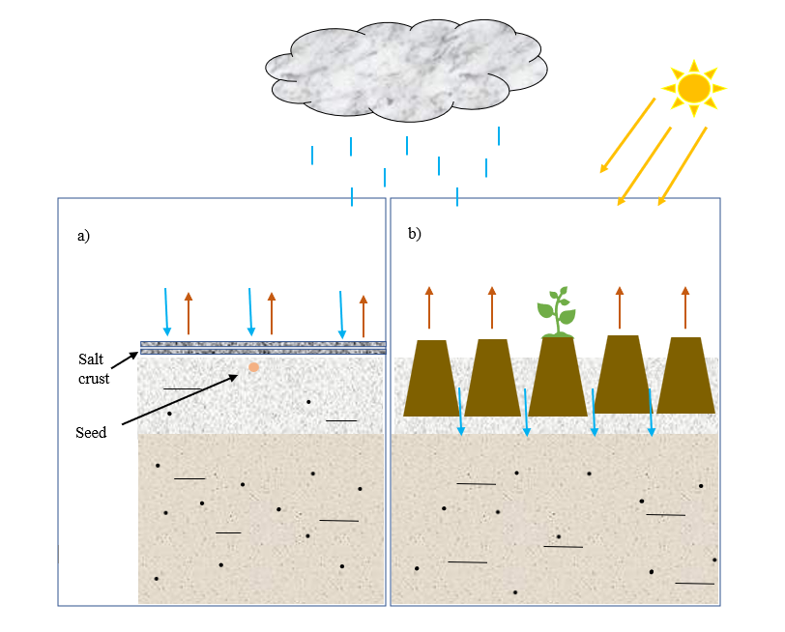
Figure 1. Conceptual model of the reclamation process in a salinity-affected area, a) Pre-reclamation: Conditions in which salinity problems persist, soil structure is degraded, and plant growth is adversely affected, b) Post-reclamation: Conditions following the implementation of amelioration techniques, where salinity is reduced, soil physical and chemical properties are improved, and plant cultivation becomes feasible
Table 1. Classification of Soils Based on Chemical Indicators of Salinity and Sodicity
Soil Type | ECe (dS/m) | ESP (%) | pH | Description
Non-saline, non-sodic | < 4 | < 15 | 6.0–8.0 | No salinity or sodicity that limits plant growth..
Saline soils | > 4 | < 15 | < 8.5 | High salt concentration, but low sodicity.
Sodic (alkaline) soils | < 4 | > 15 | 8.5–10 | Low salt levels, but high exchangeable sodium percentage..
Saline-sodic soils | > 4 | > 15 | < 8.5 | Both salinity and sodicity problems are present, but pH is relatively low.

The classification of soils based on salinity and sodium content is of critical importance, particularly for determining appropriate management strategies in agricultural practices. This classification is generally based on three key chemical parameters: saturated paste electrical conductivity (ECe), exchangeable sodium percentage (ESP), and pH. The different soil types are described according to these criteria below:
Non-saline and Non-sodic Soils: These soils have an ECe value below 4 dS/m, an ESP below 15%, and a pH range of 6.0–8.0. They do not pose any agricultural problems related to salt or sodium accumulation.
Saline Soils: Although ECe exceeds 4 dS/m, ESP remains below 15%, and pH is generally below 8.5. High salt concentrations in these soils may limit plant growth, but sodicity is not a dominant issue.
Sodic (Alkaline) Soils: In this category, ECe is low (< 4 dS/m), but ESP exceeds 15%. The pH typically ranges between 8.5 and 10. High sodium content disrupts soil structure and reduces permeability.
Saline-Sodic Soils: Both ECe and ESP exceed threshold levels (ECe > 4 dS/m, ESP > 15%), while pH is usually below 8.5. These soils face severe physical and chemical problems due to excessive salt and sodium content. This classification was developed by the United States Salinity Laboratory Staff (1954) and remains a fundamental reference for soil salinity management today.

- Physical Reclamation Methods
Physical reclamation methods aim to remove excess salts from the soil mechanically and improve water movement. Common practices include the installation of drainage systems, deep plowing, land leveling, and leaching applications. Rising groundwater levels and capillary movement of salts to the surface exacerbate soil salinity, particularly in irrigated agricultural areas (Ayers and Westcot, 1985). Therefore, establishing an effective drainage system is critical for removing excess water and associated salts from the soil. Subsurface drainage allows controlled removal of saline water accumulated in lower soil layers (Hopmans, 2021). Deep plowing can mix surface salts into deeper layers, temporarily reducing surface salt concentrations. However, this method provides only a short-term solution and may be ineffective if not supported by proper drainage (Qadir et al., 2007). Leaching involves applying an adequate amount of fresh water to wash salts from the root zone to deeper soil layers. This method should be coupled with a drainage system; otherwise, water retention may exacerbate salt accumulation (United States Salinity Laboratory Staff, 1954).

- Chemical Reclamation Methods
Chemical reclamation methods are primarily used to improve soil structure and restore ionic balance, particularly in sodic soils. In sodic soils, sodium ions adhere to soil particles, disrupting structure and reducing permeability (Abrol et al., 1988). The most commonly applied amendment is calcium sulfate dihydrate (gypsum). Gypsum application replaces sodium ions in the soil with calcium ions, thereby improving structural binding between soil particles and enhancing permeability (Qadir et al., 2007). The gypsum dosage is determined based on the soil’s exchangeable sodium percentage (ESP). Other amendments, such as calcium chloride and sulfuric acid, are also used to correct pH and ionic imbalance in sodic soils. Sulfuric acid reacts with lime in the soil, releasing calcium ions and helping reduce alkalinity (Minhas and Sharma, 2006). Chemical reclamation is more effective when combined with physical methods for controlling soil salinity and sodicity (Hopmans, 2021).

- Biological and Ecological Reclamation
Biological and ecological reclamation methods provide organic and plant-based solutions to improve soil health, mitigate salt stress, and promote sustainable land use. Salt-tolerant plants (halophytes) can reduce soil salinity by accumulating salts in their tissues (Kumar et al., 2019). The addition of organic materials such as compost and farmyard manure increases water-holding capacity and buffers the harmful effects of salts. Furthermore, organic matter improves soil physical structure, enhances microbial activity, and increases plant tolerance to salt stress (Sabah et al., 2020). Biological reclamation yields better results when integrated with chemical and physical methods. Additionally, these approaches support environmental sustainability and contribute to the preservation of soil ecosystems (Sharma and Singh, 2019).

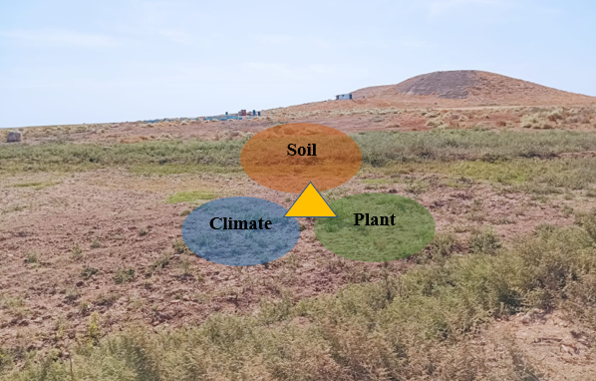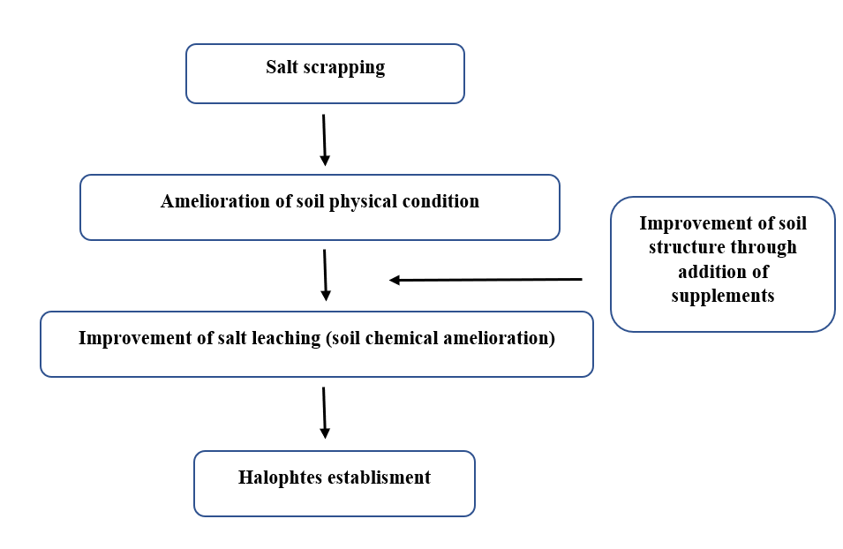
b)
a)
Figure 2. a) The small triangle in the figure represents the intersection of soil, plant, and climate factors, highlighting the essential information required to determine an appropriate and effective reclamation method for the land, b) Diagram illustrating the techniques necessary for the reclamation of salinity-affected lands.

- Guidance through Remote Sensing and Modeling
Recent advances in remote sensing technologies have enabled the acquisition of high-accuracy data across various spatial and spectral resolutions (Taghadosi et al., 2018; Kasim et al., 2020). The development of multispectral imaging systems has particularly facilitated reliable monitoring of environmental parameters by capturing information across broad wavelength ranges (Azabdaftari and Sunar, 2016; Abuelgasim and Ammad, 2019). Measurement of electromagnetic energy reflected from the surface allows indirect estimation of several soil properties, including soil moisture, organic matter content, and salt accumulation (Avdan et al., 2022; Sahbeni, 2021).

Spectral indices are widely used tools for detecting soil salinity. These indices are derived from mathematical combinations of reflectance data across multiple wavelengths and capture variations in reflectance behavior associated with salinity (Aceves et al., 2019; Merembayev et al., 2022; Smanov et al., 2023). Particularly, spectral responses in the visible (VIS), near-infrared (NIR), and shortwave-infrared (SWIR) bands are effective indicators of soil salt content (Khan et al., 2005).
In addition to optical systems, Synthetic Aperture Radar (SAR) technology plays a significant role in soil salinity monitoring. SAR systems can operate independently of weather conditions and provide subsurface information (Ouchi, 2013). These microwave-based systems generate data on soil moisture (Barrett et al., 2009) and structural properties (Beale et al., 2019). Moreover, the backscatter coefficient (sigma-0), representing the amount of microwave reflection, is closely correlated with soil electrical conductivity (EC) and is frequently used in salinity mapping (Muhetaer et al., 2022; Wu and Lambot, 2022; Hoa et al., 2019).

Combining optical sensor data with SAR imagery has significantly improved the accuracy of salinity detection maps (Dehni and Lounis, 2012). While optical data can capture surface characteristics such as vegetation, reflectance, and moisture distribution, SAR data provide insights into deeper soil physical structures (Sahbeni and Székely, 2022). Additionally, integrating remote sensing outputs with environmental variables such as land cover, land use, and topography enhances the reliability of modeling efforts (Kaya et al., 2022; Shahrayini and Noroozi, 2022). This data fusion approach leverages the strengths of different sensing platforms, enabling more comprehensive evaluations.

With the increasing volume of remote sensing data, machine learning techniques have become widely applied for processing and analysis. These methods improve the performance of soil salinity prediction models by recognizing complex patterns (Sarker, 2021). Methods such as Random Forest (Breiman, 2001) and Support Vector Machines (SVM) (Vapnik et al., 1997) allow highly accurate predictions using multivariate remote sensing data (Vermeulen and Van Niekerk, 2017; Wang et al., 2019).

Nevertheless, certain limitations remain in the application of current remote sensing-based approaches. Constraints in data resolution, gaps in time series, high costs, and technical complexity of analysis are notable challenges. Therefore, holistic approaches that critically assess both the potential and limitations of existing technologies are essential for both academic research and practical agricultural and environmental management strategies.

- Sustainability and Economic Analyses
Soil salinity not only limits agricultural production but also poses significant sustainability challenges at environmental, social, and economic levels. The methods used to mitigate salinity must be ecologically and economically sustainable.

Although physical and chemical reclamation methods can provide short-term effectiveness, their implementation over large areas often involves substantial labor, equipment, and cost considerations. Physical methods, such as soil leaching, drainage system installation, or deep tillage, require direct intervention on the land, leading to costs that increase proportionally with the treated area. Similarly, chemical reclamation (e.g., gypsum application) improves soil permeability, but incorrect dosages may create new imbalances and pose environmental risks (Abrol et al., 1988).

Remote sensing technologies allow reclamation strategies to be planned and implemented more efficiently and sustainably. Multispectral and hyperspectral imagery enable the remote assessment of salinity levels across different areas, facilitating prioritization of intervention zones based on salinity severity (Taghadosi et al., 2018). Spectral indices provide rapid information on surface salinity, reducing the need for extensive in-situ measurements and optimizing intervention areas (Smanov et al., 2023).

Furthermore, integrating remote sensing data with GIS supports the establishment of long-term monitoring systems. These systems enable the observation of reclamation impacts over time and provide objective evaluations of intervention effectiveness. Such feedback mechanisms enhance resource efficiency and adaptive management, particularly in repeated or staged interventions. Additionally, SAR technology allows analysis of subsurface dynamics, such as moisture and salt movement (Ouchi, 2013; Muhetaer et al., 2022), directly informing physical reclamation designs, including drainage effectiveness and underground salt accumulation.

In conclusion, remote sensing and data analytics-based monitoring models provide strategic advantages for salinity reclamation, including prioritization of intervention areas, post-reclamation impact assessment, reduction of unnecessary input use, and enhancement of economic and environmental sustainability (Sarker, 2021; Kaya et al., 2022). Consequently, remote sensing systems have become an integral and guiding component of salinity reclamation processes.

- Future Perspectives
Emerging approaches for combating soil salinity are expected to increasingly rely on holistic management strategies integrated with technological innovations. In particular, artificial intelligence (AI)-supported decision support systems, when combined with real-time remote sensing data and soil sensors, have the potential to make land management more dynamic and effective. The application of machine learning and big data analytics in salinity prediction and early warning systems is becoming increasingly prevalent (Wang et al., 2019). These technologies can analyze data from diverse sources-including climate, soil, and land use-to provide agricultural managers with actionable insights for risk assessment, intervention timing, and resource allocation. Additionally, long-term strategies such as the development of genetically salt-tolerant crops and the protection of vulnerable areas through agroecological planning are expected to play a crucial role in future management. Successful implementation of these approaches will require multi-stakeholder collaboration involving policymakers, academic institutions, private sector actors, and farmers.

- Conclusions and Recommendations
Soil salinity represents a significant environmental challenge, arising from both natural processes and human activities, that threatens agricultural productivity and ecosystem health. This review addressed the primary factors contributing to salinity in agricultural soils, its classification, impacts, and mitigation methods, while also evaluating the potential role of remote sensing technologies and Geographic Information Systems (GIS) in this domain.

Key conclusions are as follows:
Multifaceted impacts: Salinity not only directly impedes plant growth but also induces physical and chemical degradation of soil structure, adversely affecting infiltration, aeration, and microbial activity.
Classification is critical for management: Categorizing soils based on parameters such as EC, SAR, and ESP provides a foundation for selecting appropriate reclamation strategies.
Reclamation methods are diverse but limited: Physical, chemical, and biological techniques can be applied on a case-specific basis, yet challenges related to cost, technical complexity, and environmental effects limit their universal sustainability.
Remote sensing technologies are increasingly important: The use of multispectral imagery, spectral indices, and SAR data enables cost-effective mapping and monitoring of soil salinity over large areas. These technologies complement rather than replace traditional methods.

Based on these findings, the following recommendations are proposed:
Adopt integrated management approaches: Physical, chemical, and biological interventions should be assessed together, considering site-specific conditions, and multidisciplinary applications should be prioritized.
Expand remote sensing and GIS-based monitoring systems: Particularly through early warning systems and spatiotemporal analyses, interventions can be implemented more efficiently and effectively.
Develop salt-tolerant agricultural systems: Breeding crops with enhanced salinity tolerance can form the foundation of long-term resilient agricultural practices.
Increase education and capacity-building programs: Awareness and knowledge transfer initiatives should target farmers, technical experts, and decision-makers.
Strengthen policy and incentive mechanisms: Providing financial support to farmers for salinity management can promote the adoption of sustainable land management practices.
In conclusion, effective reduction and management of soil salinity require sustainable solutions that integrate technological, ecological, economic, and policy dimensions. Future research in this area will support the development and implementation of strategies tailored to local conditions, contributing to resilient and productive agricultural systems.

References

Abebe, F., Alamirew, T., & Abegaz, F. (2015). Appraisal and mapping of soil salinity problem in Amibara irrigation farms, middle Awash basin, Ethiopia. International Journal of In Sc Research, 13(1), 298–314.
Abrol, I. P., Yadav, J. S. P., & Massoud, F. I. (1988). Salt-affected soils and their management. FAO Soils Bulletin 39.
Abuelgasim, A. A., & Ammad, R. (2019). Mapping soil salinity in arid and semi-arid regions using Landsat 8 OLI satellite data. Remote Sensing Applications: Society and Environment, 13, 415–425.
Aceves, E. Á., Guevara, H. J. P., Enríquez, A. C., Sánchez, M. F., & Mora, E. M. (2019). Determining salinity and ion soil using satellite image processing. Polish Journal of Environmental Studies, 28, 1549–1560.
Ayers, R. S., & Westcot, D. W. (1985). Water quality for agriculture. FAO Irrigation and Drainage Paper 29 Rev.1.
Azabdaftari, A., & Sunar, F. (2016). Soil salinity mapping using multitemporal Landsat data. International Archives of Photogrammetry, Remote Sensing and Spatial Information Sciences, XLI-B7, 3–9.
Avdan, U., Kaplan, G., Küçük Matcı, D., Yigit Avdan, Z., Erdem, F., & Mizik, E. T. (2022). Soil salinity prediction models constructed by different remote sensors. Physics and Chemistry of the Earth, 128, 103230.
Barrett, B., Dwyer, E., & Whelan, P. (2009). Soil moisture retrieval from active spaceborne microwave observations: An evaluation of current techniques. Remote Sensing, 1, 210–242.
Beale, J., Snapir, B., Waine, T., Evans, J., & Corstanje, R. (2019). The significance of soil properties to the estimation of soil moisture from C-band synthetic aperture radar. Hydrology and Earth System Sciences Discussions, 1–28.
Breiman, L. (2001). Random forests. Machine Learning, 45, 5–32.
Corwin, D. L. (2020). Climate change impacts on soil salinity in agricultural areas. European Journal of Soil Science, 72, 842–862.
Corwin, D. L., & Scudiero, E. (2019). Review of soil salinity assessment for agriculture across multiple scales using proximal and/or remote sensors. Advances in Agronomy, 158, 1–130.
Daba, A. W., & Qureshi, A. S. (2021). Review of soil salinity and sodicity challenges to crop production in the lowland irrigated areas of Ethiopia and its management strategies. Land, 10, 1377.
Dehni, A., & Lounis, M. (2012). Remote sensing techniques for salt-affected soil mapping: Application to the Oran region of Algeria. Procedia Engineering, 33, 188–198.
FAO. (2015). Status of the world’s soil resources (SWSR)–main report. Rome, Italy: Food and Agriculture Organization of the United Nations.
FAO. Soil Salinization as a Global Major Challenge|ITPS Soil Letter #3. Available online: https://www.fao.org/global-soilpartnership/resources/highlights/detail/en/c/1412475/ (accessed on 7 March 2023).
Farid, I., Hashem, A., El-Aty, A., Esraa, A., Abbas, M., & Ali, M. (2020). Integrated approaches towards ameliorating a saline sodic soil and increasing the dry weight of barley plants grown thereon. Environmental Biodiversity and Soil Security, 4, 31–46.
Ghafoor, A., Murtaza, G., Rehman, M. Z., & Sabir, M. (2012). Reclamation and salt leaching efficiency for tile drained saline-sodic soil using marginal quality water for irrigating rice and wheat crops. Land Degradation & Development, 23(1), 1–9.
Hassan, W., Saqib, Z., & Ghafoor, A. (2011). Efficiency of Ca²⁺ application for the reclamation of saline-sodic soils with different soil textures. Pakistan Journal of Agricultural Sciences, 48(4), 277–281.
Helmy, A., Shaban, K., & El-Galad, M. (2013). Effect of gypsum and sulphur application in amelioration of saline soil and enhancing rice productivity. Journal of Soil Science and Agricultural Engineering, 4(10), 1037–1051.
Hopmans, A., Qureshi, A., Kisekka, I., Munns, R., Grattan, S., Rengasamy, P., Ben-Gal, A., Assouline, S., Javaux, M., Minhas, S., & Raats, P. (2021). Critical knowledge gaps and research priorities in global soil salinity. Advances in Agronomy, 169, 1–191.
Hussain, S., Shaukat, M., Ashraf, M., Zhu, C., Jin, Q., & Zhang, J. (2019). Salinity stress in arid and semi-arid climates: Effects and management in field crops. In Climate Change and Agriculture. London, UK: IntechOpen.
Kasim, N., Maihemuti, B., Sawut, R., Abliz, A., Dong, C., & Abdumutallip, M. (2020). Quantitative estimation of soil salinization in an arid region of the Keriya Oasis based on multidimensional modeling. Water, 12, 880.
Kebede, F. (2023). Status, drivers, and suggested management scenarios of salt-affected soils in Africa. In Biosaline Agriculture as a Climate Change Adaptation for Food Security (pp. 259–284). Cham: Springer.
Kumar, A., Kumar, A., Mann, A., Devi, G., Sharma, H., Singh, R., & Sanwal, S. K. (2019). Phytoamelioration of the salt-affected soils through halophytes. In Ecophysiology, Abiotic Stress Responses and Utilization of Halophytes (pp. 313–326). Singapore: Springer Singapore.
Leogrande, R., & Vitti, C. (2019). Use of organic amendments to reclaim saline and sodic soils: A review. Arid Land Research and Management, 33(1), 1–21.
Minhas, P. S., & Sharma, S. K. (2006). Managing soil salinity with chemical amendments. Irrigation Science, 25(3), 279–284.
Merembayev, T., Amirgaliyev, Y., Saurov, S., & Wójcik, W. (2022). Soil salinity classification using machine learning algorithms and radar data in the case from the south of Kazakhstan. Journal of Ecological Engineering, 23, 61–67.
Murtaza, B., Murtaza, G., Imran, M., Amjad, M., Naeem, A., & Shah, G. M. (2017). Yield and nitrogen use efficiency of rice-wheat cropping system in gypsum amended saline-sodic soil. Journal of Soil Science and Plant Nutrition, 17(3), 686–701.
Ouchi, K. (2013). Recent trend and advance of synthetic aperture radar with selected topics. Remote Sensing, 5, 716–807.
Okur, B., & Orcen, N. (2020). Soil salinization and climate change. In M. N. V. Prasad & M. Pietrzykowski (Eds.), Climate change and soil interactions (pp. 331–350). Amsterdam, The Netherlands: Elsevier.
Qadir, M., Oster, J. D., Schubert, S., Noble, A. D., & Sahrawat, K. L. (2007). Phytoremediation of sodic and saline‐sodic soils. Advances in Agronomy, 96, 197–247.
Qureshi, A., Tesfaye, E., & Melese, M. (2019). Extent characterization and management strategies for the salt-affected soils in Ethiopia. Dubai: ICBARAMSAP.
Sabah, N. U., Tahir, M. A., Sarwar, G., & Muhammad, S. (2020). Role of organic amendments to enhance soil fertility status and wheat growth in salt-affected soil. Pakistan Journal of Agricultural Research, 33(2), 228–233.
Sahbeni, G. (2021). A PLSR model to predict soil salinity using Sentinel-2 MSI data. Open Geosciences, 13, 977–987.
Sahbeni, G., & Székely, B. (2022). Salinity levels discrimination using ERS-1/2 and Sentinel-1 SAR time series data in Hortobágyi National Park, Hungary. In Proceedings of the 2022 IEEE Mediterranean and Middle East Geoscience and Remote Sensing Symposium (M2GARSS) (pp. 194–197).
Shahid, S. A., Zaman, M., & Heng, L. (2018). Introduction to soil salinity, sodicity and diagnostics techniques. In Guideline for Salinity Assessment, Mitigation, and Adaptation Using Nuclear and Related Techniques (pp. 1–25). Cham, Switzerland: Springer.
Sharma, P. C., & Singh, A. (2019). Managing dryland salinity for food and environmental security: Issues and options. In O. P. Yadav & N. R. Panwar (Eds.), 2019.
Singh, A. (2022). Soil salinity: A global threat to sustainable development. Soil Use and Management, 38, 39–67.
Staff, U. S. L. (1954). Diagnosis and improvement of saline and alkali soils. Agriculture Handbook, 60, 83–100.
Taghadosi, M. M., Hasanlou, M., & Eftekhari, K. (2018). Soil salinity mapping using dual-polarized SAR Sentinel-1 imagery. International Journal of Remote Sensing, 40, 237–252.
Vapnik, V., Golowich, S., & Smola, A. (1997). Support vector method for function approximation, regression estimation, and signal processing. In M. C. Mozer, M. I. Jordan, & T. Petsche (Eds.), Advances in Neural Information Processing Systems 9 (pp. 281–287). Cambridge, MA: MIT Press.
Vermeulen, D., & Van Niekerk, A. (2017). Machine learning performance for predicting soil salinity using different combinations of geomorphometric covariates. Geoderma, 299, 1–12.

