Phytochemical analysis and identification of bio-active components from n-hexane extract of Plagiochasma intermedium Lindenb. & Gottsche (A-Liverwort) using UV, FT-IR and GC-MS techniques.

ABSTRACT:
It is well known that liverworts generate distinct classes of secondary metabolites with a range of pharmacological characteristics. Using spectroscopic and chromatographic methods, the current study was conducted to determine the phytochemical profile of the n-hexane extract of Plagiochasma intermedium (Liverwort). FT-IR analysis verified the presence of aliphatic hydrocarbons, fatty acids, alcohols, esters, and terpenoids through distinctive functional group vibrations, while UV-visible spectroscopy showed strong absorption peaks in the 200–250 nm region, suggesting the presence of conjugated systems and aromatic compounds. Thirty-nine compounds were found using gas chromatography–mass spectrometry (GC–MS) analysis, with hydrocarbons being the most common class. The main constituents of these were pentane, 2,4-dimethyl- (65.30%), n-hexane (18.87%), pentane, 2-methyl- (4.31%), and pentane, 3-methyl- (2.75%), less quantity but biologically important chemical constituents like caryophyllene oxide, neophytadiene, phytol, and palmitic acid were also present. The identified secondary metabolites of P. intermedium are pharmacolocally important and known for their antimicrobial, antioxidant, anti-inflammatory and cytotoxic potency.
Keywords: Plagiochasma intermedium, n-Hexane extract, Phytochemicals, Metabolites UV, FT-IR, GC-MS.
- Introduction
For centuries, medicinal plants have been an essential source of therapeutic agents, and they still have a significant impact on drug development and the study of natural products (Napagoda and Wijesundara, 2022). As members of the Bryophyte group, liverworts are among the oldest land plant lineages and are renowned for generating a wide variety of distinctive secondary metabolites that are uncommon in higher plants (Pfeifer et al., 2022). Because of the antimicrobial, antioxidant, anti-inflammatory, and cytotoxic properties of these bioactive substances, which include terpenoids, aromatic derivatives, fatty acids, and phenolics, liverworts are becoming a more valuable tool in pharmacognostic research (Pfeifer et al., 2022).
The thalloid liverwort Plagiochasma intermedium Lehm. & Lindenb. is a member of the Aytoniaceae family and is typically found in tropical and subtropical areas near water bodies, damp soil, and rocky surfaces. The thallus has a distinct midrib and dorsal air chambers that aid in photosynthesis. It is dorsiventral, ribbon-like, and dark green to brownish in color. Gemmae are used for asexual reproduction, while antheridiophores and archegoniophores are used for sexual reproduction (Kashid, 2012). Similar to the other liverworts, P. intermedium generates a diverse range of secondary metabolites, such as fatty acids, aromatic compounds, and terpenoids, which serve ecological purposes in protecting against microbial pathogens and herbivores. Pharmacological research has become interested in it because of its distinct phytochemical composition, especially because of its potential antimicrobial, antioxidant, and anti-inflammatory properties (Sharma et al., 2022).
The presence of volatile oils, sesquiterpenes, bibenzyls, and fatty acids has been identified by phytochemical studies of liverworts. These compounds are in charge of the plants' defence mechanisms and therapeutic potentia(Ludwiczuk and Asakawa, 2020).Numerous pharmacological uses, including antibacterial, antifungal, insecticidal, and anticancer properties, have been connected to the phytoconstituents found in liverworts. Even though their significance is becoming more widely acknowledged, very few studies have examined phytochemistry of P. intermedium, which leaves a significant knowledge gap regarding its bioactive potential. Non-polar solvents like n-hexane are essential for isolating lipophilic compounds like hydrocarbons, fatty acids, terpenoids, and sterols because the extraction solvent selection frequently affects the phytochemical composition.
Fourier-transform infrared (FT-IR) spectroscopy, ultraviolet-visible (UV-Vis) spectroscopy, and gas chromatography–mass spectrometry (GC–MS) are commonly used analytical techniques for characterizing plant extracts. These techniques offer important new information about the structural characteristics, functional groups, and qualitative and quantitative makeup of bioactive substances. Such sophisticated analytical profiling of P. intermedium is anticipated to reveal a broad range of compounds that could be involved in its pharmacological significance. Additionally, the identification of bioactive phytochemicals using contemporary analytical techniques and n-hexane extraction offers a scientific foundation for confirming its traditional applications and investigating its potential in drug development based on natural products (Ikeh et al., 2025).
Thus, the goal of the current study was to use GC-MS, FT-IR, and UV-Vis analyses to ascertain the phytochemical profile of the n-hexane extract of P. intermedium. The aim was to provide a thorough chemical characterization of the studied species, identify the main classes of compounds present in it, and interpret their potential biological activities. The therapeutic potential of P. intermedium as a viable candidate for upcoming pharmacological and biotechnological applications is highlighted by this work, which also contributes to the expanding phytochemical database of liverworts.
2. MATERIALS AND METHODS
2.1 Plant collection and extract preparation of plant material
For phytochemical analysis of Plagiochasma intermedium powder was extracted with Soxhlet extraction method in n-hexane for 6 hours then these extracts were filtered, evaporated to dryness and weighed (Harborne, 1998).
2.3 UV and FT-IR analysis
The non-polar crude extract was diluted with hexane solvent (1 mg/mL) and then scanned using a "UV-visible true double-beam spectrophotometer (Motras Scientific, India)" to identify a variety of chemical compounds that manifest as absorption bands in the hexane extract of P. intermedium. The wavelength range of 200 to 700 nm was used to record the qualitative UV-visible spectrum and its peak values.
The functional groups were interpreted from the FT-IR-spectra by comparing them with standard reference spectra, which were obtained using "FTIR spectroscopy (Bruker alpha Eco-ATR)" in the scan range of 4000 to 600 cm-1 (Nandiyanto et al., 2019).
2.3 GC-MS conditions
"GC-MS-QP2010 Ultra Shimadzu, Japan" was used to analyze the chemical composition. The carrier gas was helium, which flowed at a steady 16.3 mL/min. The oven was set to reach temperatures between 70°C and 300°C at a rate of 10°C per minute. A 260°C injector temperature and a 1 µL injector volume were set. Based on their mass spectra and chromatograms, the structure, molecular weight, and name of unknown bioactive substances were documented. The results were compared with the NISTM1 library.

3. RESULTS AND DISCUSSION
UV-visible spectrum of n-hexane extract of Plagiochasma intermedium revealed strong absorption peaks in the lower wavelength range (200–250 nm), with maximum absorbance values ranging from 3.5 to 4.2. These peaks suggested the presence of chromophoric groups, aromatic compounds, and conjugated double bonds. The gradual decrease in absorbance beyond 300 nm indicates fewer extended conjugated systems in the extract, whereas the sharp peaks in the UV region correspond to π→π* transitions of unsaturated hydrocarbons and aromatic systems. The lack of strongly pigmented compounds is indicated by the weak absorbance signals in the visible region (400–700 nm), which suggests that terpenoids, fatty acids, and simple aromatics are the main phytoconstituents. The presence of secondary metabolites is supported by these spectral features (Muhamad et al., 2017; Alamgir, 2018). (Fig.1).

Figure 1: UV-Visible Spectra of n-hexane extract of P. intermedium

FT-IR spectrum showed distinctive absorption peaks that corresponded to various functional groups. Long-chain aliphatic hydrocarbons and fatty acid derivatives were confirmed by the presence of prominent peaks at 2954.41, 2922.74, and 2863.21 cm⁻¹, which were ascribed to the C–H asymmetric and symmetric stretching vibrations of alkanes (Bobroff et al., 2016). While the band at 1378.72 cm⁻¹ showed methyl group bending, indicating the presence of aliphatic chains and terpenoids, the peak at 1460.49 cm⁻¹ correlated with C–H bending vibrations of –CH₂ and –CH₃ groups (Verma et al., 2023).
The presence of terpenoid alcohols and fatty acid esters was indicated by a sharp band at 1062.32 cm⁻¹ that represented C–O stretching vibrations, which can be attributed to alcohols, esters, and ethers (Selvam et al., 2022). Additionally, the band at 725.22 cm⁻¹ was caused by (CH₂)_{n} rocking vibrations of long-chain alkanes, whereas the absorption at 892.92 cm⁻¹ was attributed to out-of-plane bending of =C–H bonds, indicating the presence of alkenes (Jesse, 2020). These findings imply that aliphatic hydrocarbons, fatty acids (including palmitic acid), esters, sterols, and terpenoids, all of which are known to have a variety of biological activities make up the majority of the n-hexane extract (Fig.2, Table1).
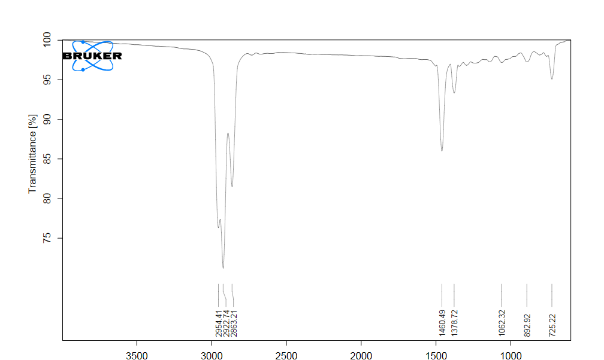
Figure 2: FT-IR Spectra of n-hexane extract of P. intermedium

Table 1: FT-IR peak values and functional groups in n-hexane extract of Plagiochasma intermedium.
S. No. | Frequency peak  values (cm−1) | Vibration/bond Specific | functional group | Chemical compound
1 | 2954.41 | C–H asymmetric stretching | Alkanes (–CH₃, –CH₂) | Aliphatic hydrocarbons, fatty acids
2 | 2922.74 | C–H asymmetric stretching | Alkanes (–CH₂) | Long-chain fatty acids, terpenoids
3 | 2863.21 | C–H symmetric stretching | Alkanes (–CH₃) | Alkanes, fatty esters
4 | 1460.49 | C–H bending (scissoring) | Alkanes (–CH₂, –CH₃) | Fatty acids, terpenoids
5 | 1378.72 | C–H bending (wagging) | Methyl groups (–CH₃) | Aliphatic chains, sterols
6 | 1062.32 | C–O stretching | Alcohols, esters, ethers | Terpenoid alcohols, fatty acid esters
7 | 892.92 | =C–H bending (out-of-plane) | Alkenes (cis-disubstituted) | Terpenoids, phytosterols
8 | 725.22 | (CH₂)n rocking | Long-chain alkanes | Palmitic acid, hydrocarbons

n-hexane extract of Plagiochasma intermedium, as determined by GC–MS analysis, contained a complex mixture of terpenoids, fatty acids, aromatic compounds, and aliphatic hydrocarbons with different biological activities. Aliphatic hydrocarbons, specifically pentane, 2,4-dimethyl (65.30% area), and n-hexane (18.87% area), dominated the chromatogram, suggesting that volatile branched alkanes make up the majority of the extract. In smaller amounts, methylated pentanes, cyclopentane derivatives, cyclohexane, and toluene were among the other noteworthy hydrocarbons found. The extract included a variety of physiologically active terpenoids, including caryophyllene oxide, neophytadiene, phytol, and calamenene, in addition to hydrocarbons. These terpenoids are known to have antimicrobial, antioxidant, anti-inflammatory, and anticancer effects (Salminen et al., 2008).
The antioxidant and hypocholesterolemic properties of the extract were enhanced by the identification of fatty acids like n-hexadecanoic acid (palmitic acid) and glyceride derivatives like octadecenoic acid and 1,2,3-propanetriyl ester (triolein) (Onyegeme and Essien, 2021; Shawer et al., 2022). A wide range of metabolic products were suggested by the presence of minor constituents such as aldehydes (7-hexadecenal), ketones (2-pentadecanone), and aromatic derivatives (ethylbenzene, xylene). The n-hexane extract of P. intermedium is rich in volatile hydrocarbons, with notable fractions of bioactive terpenoids and fatty acids, according to the GC–MS profile (Sianipar et al., 2021). These compounds may together be responsible for the pharmacological actions of the extract (Fig.3, Table 2).

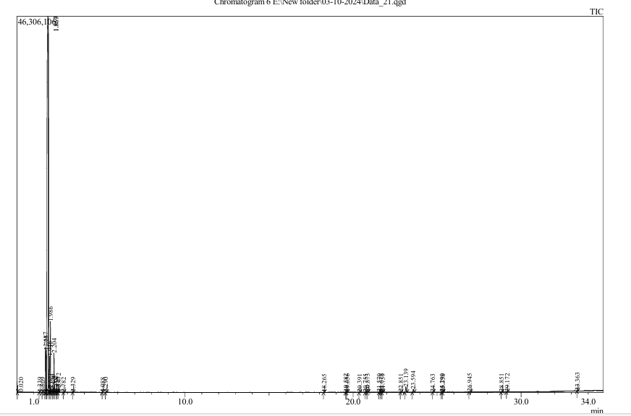
Figure 3: GC-MS Spectra of n-hexane extract of P. intermedium

Table 2: Details of compounds identified in n-hexane extract of P. intermedium.
Peak# | R.Time | Area% | Height% | A/H | Name | Nature | Biological potential
1 | 0.020 | 0.00 | 0.01 | 0.85 | 7-Hexadecenal, (Z)- | Unsaturated aldehyde (fatty aldehyde) | Antimicrobial, pheromonal, signaling molecule
2 | 1.339 | 0.01 | 0.02 | 1.15 | l-Alanine ethylamide, (S)- | Amino acid derivative | Neuroactive, metabolic intermediate
3 | 1.509 | 0.01 | 0.02 | 1.48 | Acetone | Simple ketone | Solvent, antimicrobial at higher concentration
4 | 1.687 | 4.31 | 4.49 | 2.74 | Pentane, 2-methyl- | Branched alkane | Volatile hydrocarbon, fuel-related, weak bioactivity
5 | 1.725 | 2.75 | 4.13 | 1.90 | Pentane, 3-methyl- | Branched alkane | Volatile hydrocarbon, limited biological role
6 | 1.837 | 65.30 | 37.20 | 5.00 | Pentane, 2,4-dimethyl- | Branched alkane | Volatile compound, hydrocarbon marker
7 | 1.869 | 18.87 | 36.98 | 1.45 | n-Hexane | Straight-chain alkane | Industrial solvent, neurotoxic at high doses
8 | 1.946 | 1.52 | 3.57 | 1.21 | Pentane, 2,2-dimethyl- | Branched alkane | Hydrocarbon, limited direct bioactivity
9 | 1.986 | 3.65 | 7.00 | 1.48 | Cyclopentane, methyl- | Cycloalkane | Volatile hydrocarbon, weak biological effect
10 | 2.021 | 0.21 | 0.42 | 1.40 | Pentane, 2,2-dimethyl- | Branched alkane | Volatile hydrocarbon
11 | 2.136 | 0.12 | 0.29 | 1.21 | Pentane, 3,3-dimethyl- | Cycloalkane | Industrial solvent, narcotic effects at high conc.
12 | 2.204 | 1.81 | 3.87 | 1.33 | Cyclohexane | Branched alkane | Volatile hydrocarbon
13 | 2.265 | 0.08 | 0.14 | 1.52 | Hexane, 3-methyl- | Unsaturated hydrocarbon | Component of volatile oils, weak antimicrobial
14 | 2.358 | 0.01 | 0.02 | 1.79 | Octane, 3-methyl-6-methylene- | Cycloalkane | Hydrocarbon, limited direct activity
15 | 2.415 | 0.01 | 0.01 | 2.78 | Cyclopentane, 1,2-dimethyl-, trans- | Cycloalkane derivative | Hydrocarbon, weak narcotic effect
16 | 2.472 | 0.18 | 0.44 | 1.19 | Hexane, 3-methyl- | Aromatic hydrocarbon | Solvent, CNS depressant, toxic at high exposure
17 | 2.782 | 0.01 | 0.02 | 1.22 | Cyclohexane, methyl- | Aromatic hydrocarbon | Solvent, mild irritant, weak antimicrobial
18 | 3.329 | 0.02 | 0.04 | 1.48 | Toluene | Aromatic hydrocarbon | Solvent, potential irritant
19 | 5.088 | 0.01 | 0.01 | 1.49 | Ethylbenzene | Long-chain alkane | Antimicrobial, antioxidant, insecticidal
20 | 5.290 | 0.03 | 0.03 | 2.41 | Benzene, 1,3-dimethyl- | Polycyclic hydrocarbon | Bioactive component in essential oils, antimicrobial
21 | 18.265 | 0.00 | 0.01 | 1.47 | Pentadecane | Sesquiterpene derivative | Antimicrobial, anti-inflammatory
22 | 19.582 | 0.04 | 0.05 | 2.15 | 1H-Cyclopenta[1,3]cyclopropa[1,2]benzene, o | Aromatic terpenoid | Antioxidant, antimicrobial
23 | 19.656 | 0.03 | 0.03 | 2.36 | (1R,4R,5S)-1,8-Dimethyl-4-(prop-1-en-2-yl)sp | Sesquiterpene (aromatic) | Anti-inflammatory, antibacterial, anticancer
24 | 20.391 | 0.01 | 0.02 | 2.06 | Benzene, 1-methyl-4-(1,2,2-trimethylcyclopen | Sesquiterpene hydrocarbon | Antioxidant, antimicrobial
25 | 20.755 | 0.01 | 0.02 | 2.00 | cis-Calamenene | Sesquiterpene hydrocarbon | Anti-inflammatory, antimicrobial
26 | 20.873 | 0.04 | 0.05 | 2.17 | (1S,2E,6E,10R)-3,7,11,11-Tetramethylbicyclo | Sesquiterpene oxide | Antifungal, antibacterial, anticancer, anti-inflammatory
27 | 21.570 | 0.02 | 0.03 | 2.12 | 1H-Cycloprop[e]azulen-7-ol, decahydro-1,1,7 | Sesquiterpene oxide | Same as above
28 | 21.673 | 0.02 | 0.03 | 2.32 | Caryophyllene oxide | Sesquiterpene | Antimicrobial, antioxidant
29 | 21.759 | 0.02 | 0.03 | 2.29 | Caryophyllene oxide | Sesquiterpene alcohol | Anti-inflammatory, antimicrobial
30 | 22.851 | 0.02 | 0.03 | 2.12 | (4aS,8R)-4a,8-Dimethyl-4,4a,5,6,7,8-hexahyd | Sesquiterpene hydrocarbon | Antioxidant, antibacterial
31 | 23.139 | 0.48 | 0.52 | 2.63 | (1R,2R,4S,6S,7S,8S)-8-Isopropyl-1-methyl-3- | Sesquiterpene | Antimicrobial, antioxidant
32 | 23.594 | 0.25 | 0.30 | 2.38 | 4-Methyl-1-(1,2,2-trimethylcyclopentyl)cycloh | Sesquiterpene hydrocarbon | Antioxidant, antibacterial
33 | 24.763 | 0.01 | 0.01 | 2.30 | 3,3-Dimethyl-4-phenyl-4-penten-2-one | Aromatic ketone | Flavor compound, antimicrobial
34 | 25.290 | 0.02 | 0.02 | 2.08 | Neophytadiene | Diterpene hydrocarbon | Anti-inflammatory, antioxidant, antimicrobial
35 | 25.358 | 0.01 | 0.01 | 2.02 | 2-Pentadecanone, 6,10,14-trimethyl- | Ketone (iso-prenoid type) | Insecticidal, antimicrobial
36 | 26.945 | 0.06 | 0.06 | 2.50 | n-Hexadecanoic acid | Saturated fatty acid | Antioxidant, antibacterial, hypocholesterolemic
37 | 28.851 | 0.02 | 0.02 | 2.40 | Phytol | Diterpene alcohol | Antimicrobial, antioxidant, anticancer, precursor of Vit. E/K
38 | 29.172 | 0.02 | 0.02 | 2.23 9- | Octadecenoic acid, 1,2,3-propanetriyl ester, | Glyceride (lipid) | Energy source, antioxidant, anti-inflammatory
39 | 33.363 | 0.01 | 0.02 | 2.23 3',8,8'- | Trimethoxy-3-piperidyl-2,2'-binaphthale | Alkaloid-like naphthalene derivative | Potential antimicrobial, antioxidant, cytotoxic
 |  | 100.00 | 100.00

4. CONCLUSION
GC-MS, FT-IR, and UV-Vis analyses of the n-hexane extract of Plagiochasma intermedium showed that the plant is a rich source of a variety of phytoconstituents, such as hydrocarbons, fatty acids, terpenoids, esters, and aromatic derivatives. The identification of bioactive substances like palmitic acid, caryophyllene oxide, phytol, and neophytadiene emphasizes the plant's possible pharmacological significance, especially in demonstrating cytotoxic, antimicrobial, antioxidant, and anti-inflammatory qualities. These results support P. intermedium's therapeutic significance and offer a solid basis for future research into drug development and biotechnological uses.
DISCLAIMER
Authors hereby declare that no generative AI technologies such as Large Language Models generators have been used during the writing or editing of this manuscript.
COMPETING INTERESTS
Authors have declared that no competing interests exists.
REFERENCES:
Alamgir, A. N. M. (2018). Phytoconstituents—active and inert constituents, metabolic pathways, chemistry and application of phytoconstituents, primary metabolic products, and bioactive compounds of primary metabolic origin. In Therapeutic use of medicinal plants and their extracts: Volume 2: Phytochemistry and bioactive compounds (pp. 25-164). Cham: Springer International Publishing.
Bobroff, V., Rubio, C., Vigier, V., & Petibois, C. (2016). FTIR spectroscopy characterization of fatty-acyl-chain conjugates. Analytical and bioanalytical chemistry, 408(1), 319-326.
Commisso, M., Guarino, F., Marchi, L., Muto, A., Piro, A., & Degola, F. (2021). Bryo-activities: a review on how bryophytes are contributing to the arsenal of natural bioactive compounds against fungi. Plants, 10(2), 203.
Harborne, A. J. (1998). Phytochemical methods a guide to modern techniques of plant analysis. springer science & business media.
Ikeh, G. O., Ani, N. I., Ude, V. U., Onyia, J. K., Diovu, C. C., & Okpoto, R. C. (2025). Molecular Spectroscopic (FTIR and UV-Vis) and Hyphenated Chromatographic (GC–MS) Characterization of Bioactive Compounds Present in Different Solvent Fractions of Extract of Leaf of Cola hispida Brenan & Keay Sterculiaceae. South Asian Research Journal of Natural Products, 8(2), 229-252.
Jesse, A. O. (2020). Fourier transform infrared spectroscopy analysis of Allium sativum L. and Nymphaea lotus L. Asian J. Appl. Chem. Res, 6, 7-24.
Kashid, J. K. (2012). Studies On The Antimicrobial Properties Of Thalloid Liverworts From Western Ghats Of Maharashtra (Doctoral dissertation, University of Pune).
Ludwiczuk, A., & Asakawa, Y. (2020). Essential Oils and Volatiles in Bryophytes. Handbook of Essential Oils, 581-612.
Muhamad, I. I., Hassan, N. D., Mamat, S. N., Nawi, N. M., Rashid, W. A., & Tan, N. A. (2017). Extraction technologies and solvents of phytocompounds from plant materials: physicochemical characterization and identification of ingredients and bioactive compounds from plant extract using various instrumentations. In Ingredients extraction by physicochemical methods in food (pp. 523-560). Academic Press.
Nandiyanto, A. B. D., Oktiani, R., & Ragadhita, R. (2019). How to read and interpret FTIR spectroscope of organic material. Indonesian Journal of Science and Technology, 4(1), 97-118.
Napagoda, M., & Wijesundara, D. (2022). Medicinal plants as sources of novel therapeutics: The history, present, and future. Chem. Nat. Prod. Phytochem. Pharm. Med. Plants, 3, 4-18.
Onyegeme-Okerenta, B., & Essien, E. (2021). Analysis of bioactive compounds present in the leaf extracts of Senna alata, Dennettia tripetalla and Delonix regia. Asian J. Emerging Res, 3, 59-64.
Pfeifer, L., Mueller, K. K., & Classen, B. (2022). The cell wall of hornworts and liverworts: innovations in early land plant evolution?. Journal of Experimental Botany, 73(13), 4454-4472.
Salminen, A., Lehtonen, M., Suuronen, T., Kaarniranta, K., & Huuskonen, J. (2008). Terpenoids: natural inhibitors of NF-κB signaling with anti-inflammatory and anticancer potential. Cellular and Molecular Life Sciences, 65(19), 2979-2999.
Selvam, M. S., Tresina, P. S., Benjamin, J., & Mohan, V. R. (2022). Assessment of phytochemical, FT-IR and GC-MS fingerprint profiling of marine angiosperms Enhalus acoroides (Lf) Royle and Syringodium isoetifolium (Asch) Dandy, Gulf of mannar Biosphere Reserve, Tamil nadu. Asian J. Biol. Life Sci., 11(2), 469.
Sharma, R., Singh, S., Joshi, S., Nagaraju, G. P., Vats, S., & Alam, A. (2022). Phyto-chemical profiling and bioactive potential of Plagiochasma rupstre (JR Frost. And G. Frost) Steph., A Thalloid Liverwort. Ann Phytomed, 11(1), 43-48.
Shawer, E. E. S., Sabae, S. Z., El-Gamal, A. D., & Elsaied, H. E. (2022). Characterization of Bioactive Compounds with Antioxidant Activity and Antimicrobial Activity from Freshwater Cyanobacteria. Egyptian Journal of Chemistry, 65(9), 723-735.
Sianipar, N. F., Assidqi, K., Hadisaputri, Y. E., Salam, S., Tarigan, R., & Purnamaningsih, R. (2021, July). Determination of bioactive compounds of superior mutant rodent tuber (Typhonium flagelliforme) in various fractions using GC-MS. In IOP Conference Series: Earth and Environmental Science (Vol. 794, No. 1, p. 012144). IOP Publishing.
Verma, R., Akanksha, K., Jha, S. K., & Rani, L. (2023). Comparative studies of functional groups present in invasive and economically important plant leaf methanolic extracts by using FTIR spectroscopic analysis. GSC Biological and Pharmaceutical Sciences, 23(3), 184-191.

