Commentary / Opinion Article
A Review of Explainable Artificial Intelligence

ABSTRACT: In recent years, artificial intelligence (AI) has demonstrated exceptional performance across multiple domains; however, its complex internal mechanisms have limited its applications in critical fields and user trust. This paper presents a systematic review of the recent research progress in explainable artificial intelligence (XAI). The mainstream explanation methods are classified into two categories: a priori interpretability (characterized by inherent transparency) and post hoc interpretability (based on ex-post analysis). Furthermore, the latter is further refined into two paradigms, namely global model explanation and local decision explanation. Subsequently, the core contradictions of different methods in terms of theoretical completeness, computational efficiency, and explanation validity are discussed in depth. Finally, from the perspective of interdisciplinary integration, we propose key directions for future research, providing theoretical support and practical pathways for the development of trustworthy AI systems.
Keywords:Explainable Artificial Intelligence ;Interpretability Methods;Pre-hoc Interpretability; Post-hoc Interpretability.
- Introduction
Artificial intelligence (AI) originated in the 1950s. In the 21st century, breakthroughs in big data technology and innovations in deep learning algorithms have driven the rapid development of AI[1].However, the opacity of its decision-making process has triggered an urgent demand from stakeholders for model transparency and interpretability[2][3].Currently, AI research is shifting from a sole focus on performance toward a focus on interpretability.
Explainable artificial intelligence (XAI) helps users understand the working principles of models by providing explanations for the decision-making process [4][5][6],and the methodological principles thereof are illustrated in Fig. 1. By generating additional information or in-depth explanations, XAI aims to achieve specific goals [7][8], and the correlations between these goals are presented in the knowledge graph shown in Fig. 2.
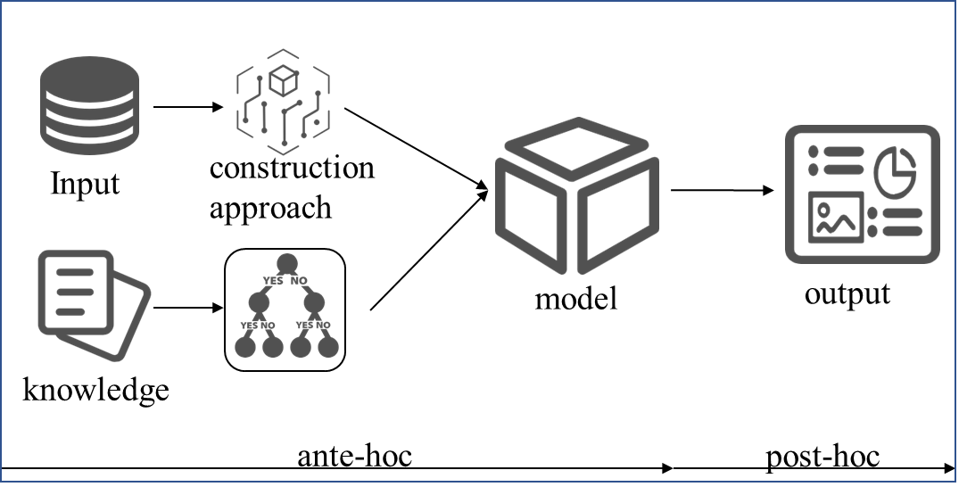
Fig. 1 Principle of interpretability method.

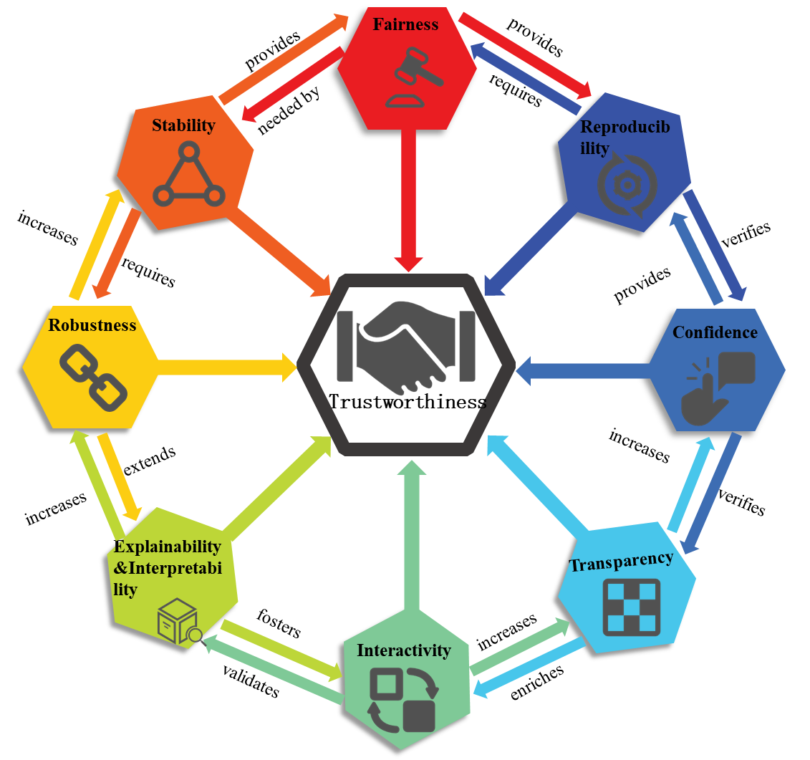
Figure 2. Interconnectedness of individual goal concepts through interpretability to achieve multiple goals. Inspired by[8].
- Different scopes of AI interpretability: a categorization of approaches
Interpretability lacks a unified definition [3],with different researchers emphasizing different aspects. In this paper, interpretability is defined as "the ability of users to understand and trace the process by which a model generates output results from input data." Based on processing methods and temporal nodes, this paper classifies interpretability methods into a pre-hoc interpretability and post-hoc interpretability. Among these, post-hoc interpretability is further divided into perturbation-based methods and backpropagation-based methods according to the attribution of decision characteristics. The attributes of these methods are presented in Table 1.
Table 1. Properties of various interpretation methods.
Interpretation Methods | Pre-hoc | Post-hoc | Perturbation | Backpropagation | Global | Local
Bayesian Rule Lists[9]
Generalized Additive Model[10][11]
neural additive models[12]
Prediction Difference Analysis[13]
Randomized Input Sampling for Explanation[14]
Influence Function[15][16]
Activation Maximization[17]
Class Activation Mapping[18] [19]
Gradient-weighted Class Activation Mapping[20]
2.1 Pre-hoc interpretability
Pre-hoc interpretability refers to the integration of comprehensible designs into the model construction and training phases, which endows the model itself with interpretability.
The decision tree model partitions data based on a tree-like structure and generates predictions from the root node to leaf nodes through hierarchical decision-making. It features fast computation speed, easy-to-understand results, and robustness. The Bayesian rule lists(BRL) proposed by Letham et al. [9] generate "If…Then…" decision lists by sampling pre-mined rules. Although they exhibit excellent interpretability, their parameter selection requires manual adjustment.
The generalized additive model (GAM) is a nonparametric regression model that typically uses spline functions to fit the relationships between independent variables and the dependent variable [10], while accounting for the interactive effects among multiple independent variables. Its form is expressed as follows:
(1)
Herein, ${\text{f}}_{\text{i} }$denotes a univariate function that satisfies the condition $\text{E}{\text{(}\text{f}}_{\text{i}}\text{)=0}$.To enhance accuracy, pairwise interactions (between independent variables) are integrated into the GAM, leading to the formation of the GA²M (Generalized Additive Model with Pairwise Interactions). The form of GA²M is expressed as follows:
(2)
Caruana et al. [11] applied GA²M (Generalized Additive Model with Pairwise Interactions) to pneumonia risk prediction, achieving state-of-the-art accuracy while maintaining interpretability. Traditional GAM models typically use smooth low-order splines to fit shape functions; to address this limitation, Agarwal et al. [12] proposed Neural Additive Models (NAM). NAMs retain the inherent interpretability of GAMs while leveraging the expressive power of deep neural networks to learn shape functions. Table 2 summarizes the relevant studies on a priori interpretability methods.
Table 2. Overview of pre-hoc interpretability methods.
Method | Methods of interpretation | Advantages and disadvantages | Evaluation criteria
BRL | Combine a priori knowledge and data to obtain a posteriori probabilities to estimate the unknown parameters | Has the ability to analyze a priori knowledge in conjunction with new data, but requires the data to conform to some distribution | Highly accurate Interpretable
GAM | Predictor variables are transformed by a nonparametric smooth function before summing the function values | Can fit nonparametric relationships, but is computationally intensive | Robust and highly interpretable
NAM | Prediction by learning linear combinations of neural networks | Capable of handling nonlinear problems, but more parameters need to be adjusted | Accuracy  Flexibility
2.2 Post-hoc interpretability
Post-hoc interpretability refers to the use of external methods to explain a model’s reasoning process and results after model training, where these methods are not embedded within the model itself. In this section, explanation methods are classified into perturbation-based methods and backpropagation-based methods according to the attribution of decision characteristics.
2.2.1 Interpretation methods based on perturbations
Perturbation-based interpretability methods explore a model’s sensitivity to and dependence on different features by perturbing inputs, thereby revealing its working principles and decision-making bases.
Prediction Difference Analysis (PDA) [13] assesses the impact of input features on the model by systematically altering these features:
(3)
This method calculates the weight of feature i by comparing class probabilities and ,significantly enhancing the interpretability of deep neural network decisions. Building on PDA, the Randomized Input Sampling for Explanation (RISE) method proposed by Retsiuk et al. [14]expands the scope of explanation. The formula for calculating the saliency score in the RISE algorithm is as follows:
(4)
The RISE method exhibits high computational complexity due to the generation of numerous random masks and the calculation of model outputs. In contrast, the influence function [15] improves computational efficiency by calculating the inverse of the Hessian matrix via efficient numerical methods, and it does not require model retraining. Koh et al. [16] utilized the influence function to measure the impact of training instances on model parameters and predictions:
(5)
Herein,denotes the optimal parameters; L(·) represents the loss function;and is a positive definite Hessian matrix.Table 3 summarizes the the relevant studies on perturbation-based explanation methods.
Table 3. Overview of perturbation-based explanation methods.
Method | Global / Local | Methods of interpretation | Advantages and disadvantages | Evaluation criteria
PDA | L | By quantifying the contribution of features to category prediction, presented in a visual way. | Can consider multiple features simultaneously, but accuracy depends on the classifier itself. | Predictive Accuracy
RISE | L | The extent to which each pixel contributes to the model is estimated by randomly masking the pixels of the input image and recording the response of the model. | The concept hierarchy and semantic network can be updated at any time, but the matching accuracy is too demanding. | Generalizability, Interpretability
Influence function | G | Identify the most responsible training points by learning algorithms back to the training data. | High accuracy but high data quality requirements. | Systematic

2.2.2 Interpretation methods based on backpropagation
Backpropagation is an algorithm based on gradient descent in deep learning, which updates network parameters by propagating the gradient of the loss function through the chain rule.
Erhan et al. [17] proposed the Activation Maximization (AM) method, which searches the input space via gradient ascent to visualize the response features of high-level units in the network. Erhan formulated an optimization problem: given $\text{θ}$ as the model parameters and ${\text{z}}_{\text{ij}}\text{(}\text{θ}\text{,}\text{x}\text{)}$ as the activation j of a specific unit i in a layer, assuming the parameters $\text{θ}$ are fixed, the activation map can be defined as follows:
(6)
Compared with the AM (Activation Maximization) method, which requires multiple forward propagations, the Class Activation Mapping (CAM) method [18] can generate a class activation map and localize discriminative regions with only a single forward propagation. The CAM method replaces the fully connected layers (except for the final softmax layer) in traditional CNN models with a global average pooling layer. By projecting the weights ${\text{w}}_{\text{k}}^{\text{c}}$ of the output layer onto the output feature maps ${\text{F}}^{\text{k}}$ of the last convolutional layer, it generates a class saliency map with the same size as the input image to localize the important regions in the input sample that distinguish classes. The finally calculated class saliency map is denoted as ${\text{L}}^{\text{c}}$[19]:
${\text{L}}_{\text{ij}}^{\text{c}}\text{=}\sum_{\text{k}}{{\text{ω}}_{\text{k}}^{\text{c}}{\text{F}}_{\text{ij}}^{\text{k}}}$ （7）
To apply the CAM algorithm to general networks, Gradient-Weighted Class Activation Mapping (Grad-CAM) was proposed [20]. This method integrates gradient information with feature maps: by calculating the gradients of the target class with respect to each feature map in the last convolutional layer, and performing global average pooling on these gradients, the importance weights of each feature map are obtained:
(8)
Here, Z denotes the number of pixels in the feature map, used to derive the importance weight of each feature map, and $y^{c}$ represents the score for class c. Table 4 summarizes the relevant studies on backpropagation-based explanation methods.
Table 4. Overview of backpropagation-based methods.
Method | Global / Local | Methods of interpretation | Advantages and disadvantages | Evaluation criteria
AM | L | Maximize the activation value of a cell by optimizing the input pattern to obtain a "visual" representation of the cell. | It is widely applicable, but requires iterative optimization, making it more computationally expensive. | Explainability  Stability
CAM | L | Map the categorization layer weights back to the feature map to generate the category activation map. | Better able to determine the overall scope of the target object, but has some limitations on the network structure. | Explainability
Grad-CAM | L | Using the gradient output from the model in the last convolutional layer, the class activation map is obtained by weighted summation | Computationally efficient, but does not reflect the behavior of the model as a whole. | Model fidelity
This paper has provided a systematic review and comparison of model explanation methods, encompassing both a pre-hoc interpretability and post-hoc interpretability. The research community is currently dedicated to designing models with superior performance,enhanced reliability,and higher efficiency [21].By integrating human knowledge to improve data annotation and decision-making processes [22][23],and incorporating external knowledge in human-computer interaction frameworks [24][25],these approaches significantly enhance model adaptability and robustness in complex scenarios—even though such methods may potentially slow down the learning process [26].Collectively,these studies are driving a fundamental shift from pure performance optimization to an interpretability-driven research paradigm in artificial intelligence.

3.Discussion and outlook
To analyze the research status of XAI, this study explores XAI interpretability through a literature review. The review discusses the conceptual definition of interpretability and reclassifies existing interpretability methods, noting that despite their abundance, these methods vary in interpretive perspectives and effectiveness. They lack multi-dimensional interpretive capabilities, highlighting that XAI remains in an early stage in constructing fully transparent AI systems and is still far from achieving comprehensive and effective applications. Based on this, we propose key future research directions:
- Enhancing Explanation Fidelity to Align with Actual Decision Processes;
- Enabling Real-Time Interpretability for Time-Critical Domains;
- Developing Multimodal Explanation Technologies for Diverse User Groups.

4.Conclusion
As artificial intelligence technologies increasingly shape user decision-making, the demand for trust in these systems has reached critical importance. This paper presents an overview of XAI, encompassing its fundamental concepts and methodological classifications (including evaluation frameworks), while identifying future development trends in XAI. By analyzing research directions in XAI, this work aims to provide theoretical support for the sustainable advancement of AI technologies. Notably, reliability, interpretability, and trustworthiness have emerged as pivotal metrics for evaluating AI's value. Constructing trustworthy AI systems necessitates collaborative efforts across diverse sectors to drive their research, development, and widespread adoption.

Declaration of Competing Interest
The authors declare that they have no known competing financial interests or personal relationships that could have appeared to influence the work reported in this paper.

Reference
- Lei, T.; Barzilay, R.; Jaakkola, T.S. Rationalizing Neural Predictions. In Proceedings of the 2016 Conference on Empirical Methods in Natural Language Processing, EMNLP 2016, Austin, TX, USA, 1–4 November 2016; The Association for Computational Linguistics: Stroudsburg, PA, USA, 2016; pp. 107–117.
- A. Preece, D. Harborne, D. Braines, R. Tomsett, S.Chakraborty, Stakeholders in Explainable AI, 2018.

- Lipton Z C. The mythos of model interpretability: In machine learning, the concept of interpretability is both important and slippery[J]. Queue, 2018, 16(3): 31-57
- Riccardo Guidotti, Anna Monreale, Salvatore Ruggieri, Franco Turini, Fosca Giannotti, and Dino Pedreschi. 2019. A survey of methods for explaining black box models. ACM computing surveys (CSUR) 51, 5 (2019), 93.
- Zachary C Lipton. 2016. The mythos of model interpretability. arXiv preprint arXiv:1606.03490 (2016).
- Marco Tulio Ribeiro, Sameer Singh, and Carlos Guestrin. 2016. Why should i trust you?: Explaining the predictions of any classifier. In Proceedings of the 22nd ACM SIGKDD international conference on knowledge discovery and data mining. ACM, 1135–1144.

- Gunning D, Stefik M, Choi J, et al. XAI—Explainable artificial intelligence[J]. Science robotics, 2019, 4(37): eaay7120.

- T. Rojat, R. Puget, D. Filliat, J. Del Ser, R. Gelin, N. Díaz-Rodríguez, Explainable Artificial Intelligence on timeseries data: A survey, 2021, arXiv preprint arXiv:2104.00950
- B. Letham, C. Rudin, T. H. McCormick, and D. Madigan, “Interpretable classifiers using rules and Bayesian analysis: Building a better stroke prediction model,” The Annals of Applied Statistics, vol. 9, no. 3, pp. 1350–1371, Sep 2015.
- T. Hastie and R. Tibshirani, “Generalized additive models,” Stat. Sci., vol. 1, no. 3, pp. 297–310, Aug. 1986.
- R. Caruana, Y. Lou, J. Gehrke, P. Koch, M. Sturm, and N. Elhadad, “Intelligible models for healthcare: Predicting pneumonia risk and hospital 30-day readmission,” in Proceedings of the ACM SIGKDD International Conference on Knowledge Discovery and Data Mining, 2015, pp. 1721–1730.
- R. Caruana, Y. Lou, J. Gehrke, P. Koch, M. Sturm, and N. Elhadad, “Intelligible models for healthcare: Predicting pneumonia risk and hospital 30-day readmission,” in Proceedings of the ACM SIGKDD International Conference on Knowledge Discovery and Data Mining, 2015, pp. 1721–1730.
- V. Petsiuk, A. Das, and K. Saenko, “RISE: Randomized Input Sampling for Explanation of Black-box Models,” British Machine Vision Conference 2018, BMVC 2018, Jun 2018.
- Dennis Cook and Sanford Weisberg. Characterizations of an empirical influence function for detecting influential cases in regression. Technometrics, 22(4):495–508, 1980. ISSN 0040-1706. doi: 10.1080/00401706.1980.10486199.
- Basu S, Pope P, Feizi S. Influence Functions in Deep Learning Are Fragile[C]//International Conference on Learning Representations (ICLR). 2021.
- Arras L,Horn F,Montavon G, et al.What is relevant in a text document?:An interpretable machine learning approach[J].PloS One,2017,12(8):e0181142.
- Linder, J., Seelig, G. Fast activation maximization for molecular sequence design. BMC Bioinformatics 22, 510 (2021). https://doi.org/10.1186/s12859-021-04437-5.
- Zhou BL, Khosla A, Lapedriza A, Oliva A, Torralba A. Learning deep features for discriminative localization. In: Proc. of the IEEEConf. on Computer Vision and Pattern Recognition. Las Vegas: IEEE, 2016. 2921–2929. [doi: 10.1109/CVPR.2016.319].
- R. R. Selvaraju, A. Das, R. Vedantam, M. Cogswell, D. Parikh, and D. Batra, “Grad-CAM: Why did you say that? Visual explanations from deep networks via gradient-based localization,” CoRR, vol. abs/1610.02391, pp. 1–21, Oct. 2016.
- Selvaraju, R.R.; Cogswell, M.; Das, A.; Vedantam, R.; Parikh, D.; Batra, D. Grad-cam: Visual explanations from deep networks via gradient-based localization. In Proceedings of the IEEE International Conference on Computer Vision, Venice, Italy, 22–29 October 2017; pp. 618–626.
- O. Zaidan, J. Eisner, C.D. Piatko, Using ‘‘annotator rationales’’ to improve machine learning for text categorization, in: Human Language Technology Conference of the North American Chapter of the Association of Computational Linguistics, Proceedings, April 22–27, 2007, Rochester, New York, USA, The Association for Computational Linguistics, 2007, pp. 260–267.
- L.A. Hendricks, K. Burns, K. Saenko, T. Darrell, A. Rohrbach, Women also snowboard: Overcoming bias in captioning models, in: Computer Vision - ECCV 2018 - 15th European Conference, Munich, Germany, September 8–14, 2018, Proceedings, Part III, in: Lecture Notes in Computer Science, vol. 11207, Springer, 2018, pp. 793–811.
- Y. Zhang, I.J. Marshall, B.C. Wallace, Rationale-augmented convolutional neural networks for text classification, in: Proceedings of the 2016 Conference on Empirical Methods in Natural Language Processing, EMNLP 2016, Austin, Texas, USA, November 1-4, 2016, The Association for Computational Linguistics, 2016, pp. 795–804.
- K.Judah, A.P. Fern, T.G. Dietterich, Active imitation learning via reduction to I.I.D. active learning, in: Robots Learning Interactively from Human Teachers, Papers from the 2012 AAAI Fall Symposium, Arlington, Virginia, USA, November 2–4, 2012 Y. Gal, R. Islam, Z. Ghahramani, Deep Bayesian active learning with image data, in: Proceedings of the 34th International Conference on Machine Learning, ICML 2017, Sydney, NSW, Australia, 6–11 August 2017, in: Proceedings of Machine Learning Research, vol. 70, PMLR, 2017, pp. 1183–1192.
- AAAI Technical Report, FS-12-07, AAAI, 2012.
- Song Z, Jiang A, Jiang Z. Back analysis of geomechanical parameters using hybrid algorithm based on difference evolution and extreme learning machine[J]. Mathematical Problems in Engineering, 2015, 2015(1): 821534.

