Original Research Article

Experimental study on the characteristics of cement improved loess

Abstract
In order to study the influence of cement on the mechanical properties of remolded loess. Incorporating 3 %, 4 %, 5 %, 6 %, and 7 % cement into the remolded loess, the consolidation and direct shear tests were performed on the remolded soil samples to analyze the relationship between different amounts of cement and the mechanical indexes of the remolded loess. The test results show that the incorporation of cement improves the deformation resistance and shear strength of remolded loess. The compression modulus of remolded loess increases with the increase of loess content, but the compression coefficient decreases gradually. The cohesion and internal friction angle of remolded loess increase with the increase of cement content, but the cohesion increases more obviously, while the internal friction angle is not obvious. The incorporation of cement can greatly improve the anti-disintegration ability of loess. With the increase of cement content, the anti-disintegration effect is more obvious. When the cement content is 3 %, the cumulative disintegration component is almost 0. Finally, the research shows that the anti-deformation performance, shear strength and anti-disintegration ability are greatly improved when the cement ratio is 3 %, which is the optimal ratio economically. The research results can provide theoretical support and reference for the future foundation engineering construction in loess area.

Keywords : remolded loess ; cement improvement ; consolidation test ; compression test ; the best ratio.
1 Introduction
Loess is widely distributed in the Loess Plateau and its surrounding areas [ 1 ]. The loess has small particles and high porosity, and is easily affected by water and temperature changes. Therefore, the loess generally cannot meet the engineering requirements and must be improved before use.
Engineering often uses cement, lime and other modifiers to improve loess to obtain excellent engineering properties. As a commonly used improved material, cement can effectively improve the mechanical properties of loess [ 2 ]. The reinforcement of soil by cement is mainly through the hydration reaction between cement and soil [ 3-5 ]. Through the incorporation of cement, the deformation resistance and shear strength of loess can be significantly improved, thereby improving its performance in engineering applications. The interaction between cement and loess not only changes the physical structure of soil, but also affects its water characteristics and mechanical behavior.
The research on cement-improved loess started late in China, but it has developed rapidly. In the late 1970 s, with the large-scale development of domestic infrastructure construction, scientific research and design units began to pay attention to and study the application of cement improved soil materials [ 6-7 ].
As early as the early eighteenth century, the United States began to try to use cement, asphalt and chemical products to improve the soil, and achieved remarkable results [ 8 ].Japanese ' architectural design standards ' refer to the use of cement or lime modifiers to improve the national volcanic ash clay. [ 9 ].In Germany, the ' Code for Design of Railway Engineering ' also requires the use of cement, lime powder and other modifiers in high-speed railway subgrade filling. [ 10 ]. With the deepening of research, cement and other materials have been widely used in civil engineering, including building construction, roadbed construction, airport construction and other fields. Cheng et al. [ 11 ] through the indoor compressive strength test of cement-improved soil and the field test of cement-improved soil, the test results show that the cement-improved soil reinforcement method can better improve the strength of collapsible loess. Li Zhiqing et al. [ 12 ] studied the compaction characteristics, shear strength characteristics and disintegration characteristics of typical loess in Shuozhou, Shanxi Province by using plain loess, lime fly ash, lime cement and cement fly ash to improve loess, and put forward the best scheme for loess improvement. ZHU [ 13 ] developed a new stabilizer ( seu-2 ). Through unconfined compression and shrinkage tests, it was proved that the new stabilizer can significantly improve the strength and water stability of the sludge, reduce the shrinkage strain of the sludge, and thus improve the soil characteristics. TREMBLAY et al. [ 14 ].Thirteen kinds of organic consolidation agents were used to study the improvement effect of various consolidation agents on loess. Wang [ 15 ] analyzed the mechanical properties of cement-improved loess, and studied the influence of different cement content and curing time on soil strength. The test proved that the physical and mechanical properties of Q3 loess increased with the increase of mixing ratio. Liang Renwang et al. [ 16 ] took the silt on the west bank of the Fenhe River as the research object, and mixed the cement into the soil according to 6 different proportions. The unconfined compression test was carried out on the improved soil samples with different cement mix ratios. The test results show that the best cement mix ratio with the best reliability and economy can be obtained under the condition that the cement content is not higher than 15 %, and it can meet the design strength requirements.
In this paper, the physical and mechanical tests of cement remolded loess with different contents were carried out to study the improvement effect of cement on the mechanical properties of remolded loess.

2 Experimental materials and methods
2.1 Soil sample collection and preparation
The soil sample used in the test is from western Henan. The soil sample is yellowish brown, slightly humid, slightly dense soil is more uniform, mixed with plant roots, and is not easy to compress under load. As a modifier, ordinary Portland cement was selected.
Wet density  /g·cm⁻³ | Water content  /% | void ratio  /% | Dry density  /g·cm⁻³ | Specific gravity /g·cm ⁻³
1.9952 | 16 | 0.63 | 1.72 |  | 2.63
Table 1. Soil Properties Summary
The preparation of improved soil samples was prepared by artificial compaction method, that is, three kinds of cement mix proportion samples of 3 %, 4 %, 5 %, 6 % and 7 % were prepared, and the optimal moisture content was 16 %. First, the collected soil samples are broken into powder, and the impurities such as doped branches and small gravels that affect the test results are removed. According to the geotechnical test standard, the amount of water added to the weighing soil to achieve the optimal water content is calculated, and then the amount of cement to be mixed into the weighing soil is calculated. The mixer is used to evenly mix the cement with the loess to ensure the uniform distribution of each component. After the preparation is completed, because the sample is not easy to compress, the sample is prepared by jack as shown in figure 1. According to the size of the dry density of the undisturbed loess, the preparation of the remolded soil sample also tries to meet the same dry density as the undisturbed soil. The dry density measured in the experiment is 1.75g / cm3 ± 0.05g / cm3.
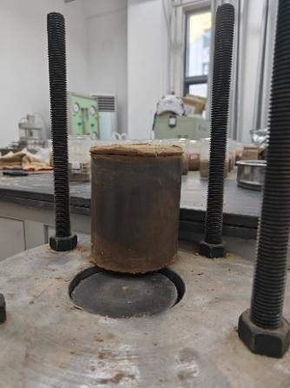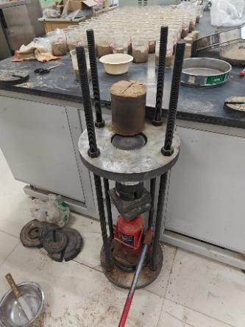
Fig. 1 Remodeling soil samples
2.2 Experimental design
Standard compression test and shear test were used. The compression test measures the relationship between pressure and sample deformation or void ratio, and the relationship between deformation and time by gradually applying pressure, so as to calculate the compression coefficient and compression modulus of soil. In the shear test, the shear strength of the sample is measured by increasing different loads at the same shear rate. Each test needs to be repeated many times to ensure the reliability and accuracy of the data.
The data were processed by statistical analysis method to analyze the influence of different cement content on the mechanical properties of loess. By comparing the test results of different samples, the best ratio and improvement effect of cement improved loess were discussed. The rigor and systematicness of the experimental design will provide a solid foundation for subsequent research.
2.2.1 Consolidation compression test
A certain amount of disturbed loess was prepared into 4 %, 5 %, 6 % and 7 % cement ratio samples. The water content of the sample was the optimal water content of the cement ratio loess. The compaction coefficient K = 0.95, the sample size is φ79.8 mm × h20 mm, and the test is carried out after 7 days of standard curing. The test was carried out in a standard consolidation apparatus with rapid consolidation method, and the loading levels were 50 kPa, 100 kPa, 200 kPa and 400 kPa, respectively.
2.2.2 Direct shear test
The direct shear test used a semi-automatic direct shear apparatus with a shear rate of 4 r / min. The test process is carried out in accordance with the steps specified in the ' Standard for Soil Test Methods '.
2.2.3 Disintegration experiment
At present, the disintegration experiments of improved loess mainly include balance method and buoy method. The buoy method is a simple instrument for soil disintegration based on the principle of buoy buoyancy. The soil is placed on the iron net suspended in the lower part of the buoy and soaked in water. The soil is disintegrated in water. The soil mass on the iron net decreases, the volume becomes smaller, and the buoy floats. The buoy reading during the disintegration process can intuitively reflect the change of the volume of the soil with the disintegration time, and then calculate the amount of soil disintegration according to the formula, so as to judge its anti-disintegration. The balance method [ 8 ] uses the mass method to test. Although it solves the influence of air in the soil sample of the buoy method on the experiment, the assembly of the instrument is cumbersome. Therefore, the buoy method is selected as the research method of this experiment. At the beginning of the experiment, 11 large buckets were prepared and injected into the water level line, as shown in the figure. The fresh-keeping film was used to seal the mouth to avoid water volatilization. The square sample was placed in the middle of the iron net and hung to the bottom of the buoy to quickly put into the water for disintegration experiment, as shown in the figure. During the experiment, the readings of the scales on the buoy were recorded at 1min, 3min, 10min, 30min, 1h, 2h, 3h, 4h, 5h and 6h respectively. In order to ensure the accuracy of the experiment, two parallel experiments were carried out for each dosage.
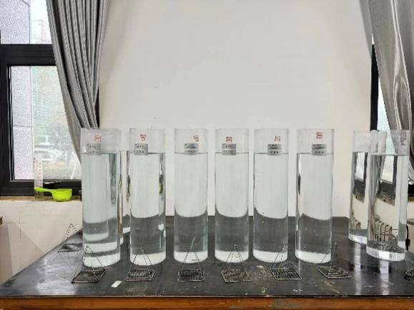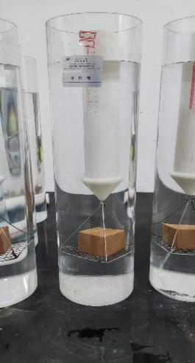
fig 2 Collapsing experimental equipment fig 3 disintegration test

3 test result & analysis
3.1 Analysis of consolidation compression test results
The soil is compressed under the action of external force, and the gradual discharge of air and water causes the soil volume to shrink. It can be said that the soil compression is mainly caused by the decrease of pore volume. The pore water and gas are discharged, and the external load is transmitted to the soil particles, and the compression deformation of the soil is gradually stabilized from time to time. The compaction and consolidation of soil have an important influence on the engineering properties. For example, the strength of soil compression dense soil will increase and the permeability will decrease. Soil compression will lead to foundation deformation, which will cause safety hazards to the use of superstructure. The soil compaction test can determine the compression characteristics of soil samples and obtain the relationship curve between unit compression value and pressure and the relationship curve between void ratio and pressure. In this test, the standard consolidation instrument was used to test the soil samples from different cement ratios by means of rapid consolidation. The pressure load needed to be applied is : 50 kPa, 100 kPa, 200 kPa, 400 kPa to apply this pressure step by step.

proportion of cement | 0% | 3% | 4% | 5% | 6% | 7%
Compression coefficient MPa-1 | 0.171 | 0.11 | 0.093 | 0.081 | 0.075 | 0.052
Compression modulus  MPa | 8.591 | 14.864 | 16.340 | 20.160 | 24.520 | 31.365
Table 2 Effect of Cement Content on Soil Compression
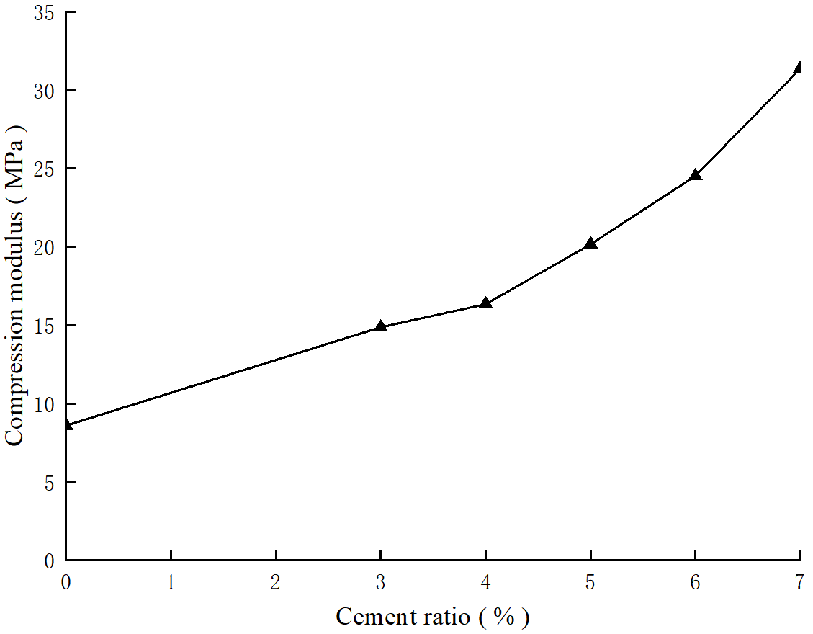
fig 4 Compression coefficient and cement mix ratio

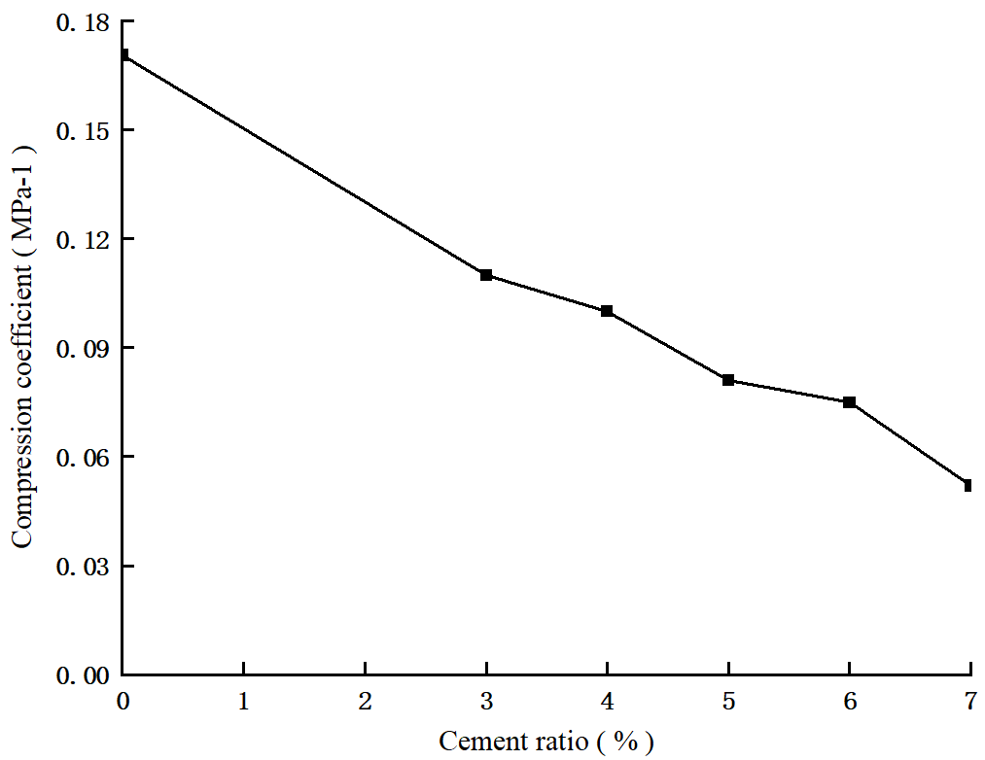

Fig.5 Compression modulus and cement mix ratio

The consolidation test results of loess after cement improvement are shown in Table 2. It can be seen from the table that the compressibility coefficient of loess after cement improvement is less than 0.12MPa − 1, which has a significant effect with the unimproved remolded loess ( 0.171MPa − 1 ). Therefore, the loess has the characteristics of low compression after cement improvement, and meets the design requirements of subgrade filling. At the same time, the compression modulus of the soil after cement improvement is significantly improved compared with the unmodified ( 8.591MPa ). This is because the hydration products generated by the reaction of cement with water and mineral particles in the soil adsorb the soil particles and form a network framework to effectively make up for the voids between the soil particles. [ 17 ] Therefore, adding a certain amount of cement to the soil can not only effectively improve its compression coefficient, but also greatly reduce the settlement deformation of the subgrade, which is helpful for the safe and reliable operation of the high-speed passenger dedicated line. In order to further explore the relationship between the improvement of the compression deformation characteristics of cement-modified loess and the cement content, the relationship curves between the compression coefficient and compression modulus of cement-modified loess and the cement content can be seen in Fig.5.
It can be seen from Fig.4 that when the cement content gradually increases, the compressibility coefficient of the loess after cement improvement shows a downward trend. In the small range of 4 % ~ 6 % cement content, the change degree of compression coefficient and compression modulus is relatively small. In the range of 0 % ~ 3 % and 6 % ~ 7 % cement content, the change degree is more obvious, and the effect of improving compression characteristics is the most obvious. Therefore, under the premise of meeting the standard conditions of subgrade filling, the cement modifier has an optimal cement content to improve the compression performance of this kind of loess. The cement mix ratio corresponding to the cement content value has the best effect on improving the compression characteristics. Therefore, after this test, it is recommended to use the mix ratio of more than 6 % cement content to chemically improve this kind of loess, but in terms of economy, 3 % optimization improvement effect is the most economical.
3.2 Analysis of direct shear test results
The direct shear test was used to study the variation of shear strength of remolded loess under different cement ratios. The test results are shown in the figure. The figure is the shear strength table of remolded loess under different cement ratios.
proportion of cement | 0% | 3% | 4% | 5% | 6% | 7%
aggregation force  c/kPa | 114.8 | 161.27 | 195 | 261.72 | 306.82 | 375.15
angle of internal friction  /° | 20.254 | 24.275 | 46.736 | 50.889 | 51.58 | 53.532
Table 3 Impact of Cement on Shear Strength
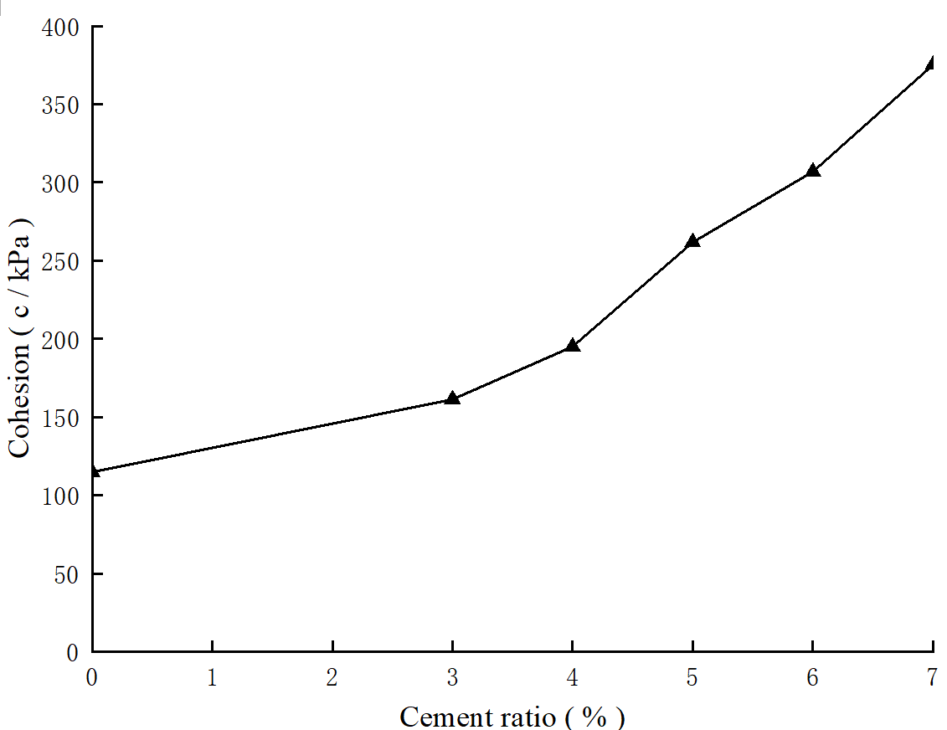

Fig.6 Cohesion and cement ratio
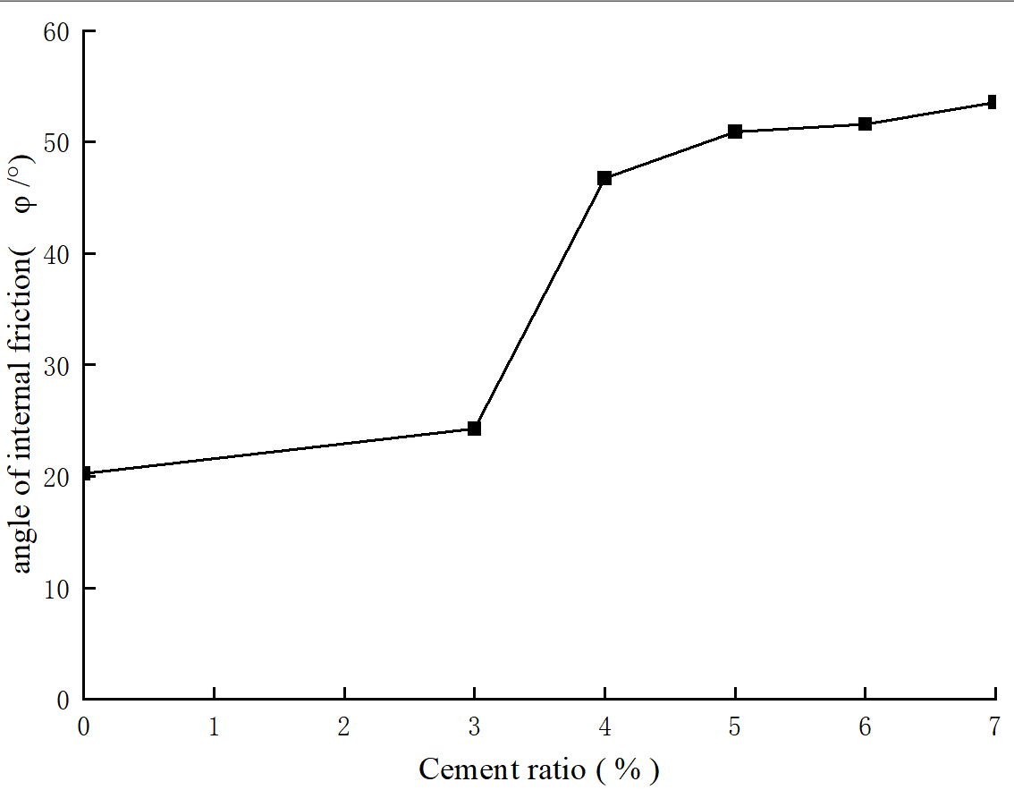
Fig.7 Internal friction angle and cement mix ratio

The addition of cement modifier to loess can improve the internal cohesion and internal friction angle of soil, and both of them are significantly improved compared with those before improvement. The growth trend of internal cohesion in a certain range is the most significant and relatively large. The cohesion of the improved loess will gradually increase with the increase of cement content, as shown in Fig.6.In the range of 0 % ~ 7 %, the cohesion and the cement ratio generally show a linear relationship. With the increase of mixing ratio from 3 % to 7 %, the increase of cohesion is very obvious. The internal friction angle of the cement-modified loess will be relatively improved compared with the previous remolded soil. As shown in figure 7, the increase in the range of 4 % to 7 % of the mix ratio is relatively gentle and the change is weak. When the cement content increases from 0 % to 7 %, the cohesion increases obviously. The internal friction angle is not obvious.
It can be proved that the incorporation of cement modifier into loess can improve the internal cohesion and internal friction angle, and the effect on cohesion is very obvious, but the effect on internal friction angle is weak. For the improvement of loess cement, the shear strength of soil is mainly improved by increasing cohesion, while the effect of internal friction angle on improving shear strength is relatively weak.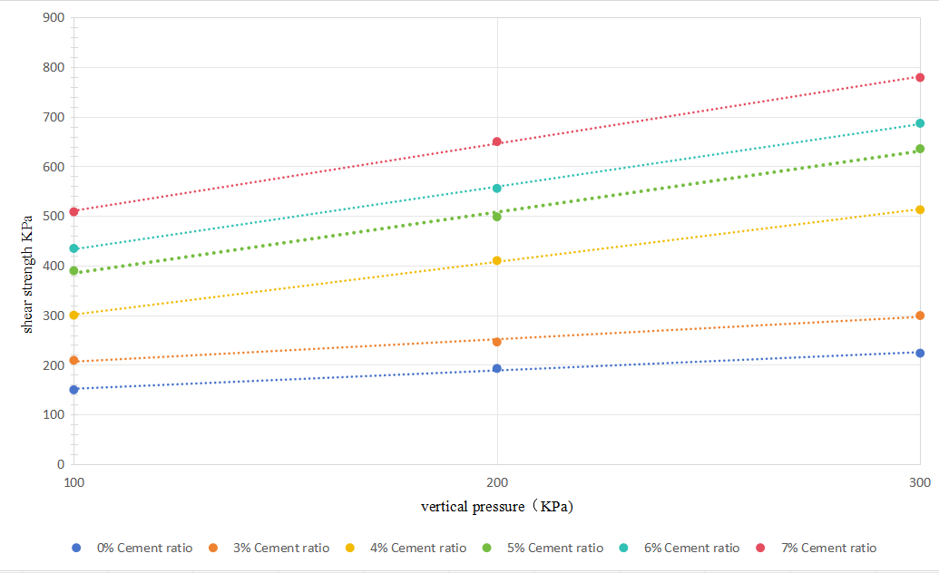
Fig. 8 The relationship curve between shear strength and vertical pressure

The shear strength values of improved loess with different cement mix ratios under different vertical loads reflect the relationship between shear strength and vertical load, which can be seen in Fig.8. It can be seen that when the cement mix ratio is 6 % or even continues to increase, the increase of shear strength is more obvious.

3.3 Analysis of disintegration test results
The disintegration process of the improved soil is after soaking, disintegration, and end. The disintegration of the improved soil with different cement content is also very different over time. The soil with 0 % cement content disintegrated rapidly in water, a large number of bubbles emerged, the edges and corners gradually fell off and scattered at the bottom of the measuring cylinder, and the buoy scale gradually increased until the soil disintegrated completely. When the cement content is greater than or equal to 3 %, the buoy scale is reduced, there are a small number of bubbles on the surface, and the soil is always intact without disintegration.
During the experiment, the readings on the buoy are used to determine whether the soil has disintegrated. Among them, it can be seen that the soil with 0 % cement content disintegrates rapidly after encountering water until it disintegrates completely. The improved soil with more than or equal to 3 % cement content not only did not disintegrate, but even the buoy reading gradually decreased. This is because the cement with this ratio and above solidified the soil, so that it did not disintegrate, so that the soil absorbed water. Therefore, it can be seen that the improved loess with 3 % cement content can achieve the purpose of improving the strength of railway subgrade.
cement dosage（%） | 1min | 3min | 10min | 30min | 60min | 2h | 3h | 4h | 5h | 6h
0% | 4 | 20 | 42.67 | 100
3% | 0 | 0 | 0 | 0 | 0 | 0 | 0 | 0 | 0 | 0
4% | 0 | 0 | 0 | 0 | 0 | 0 | 0 | 0 | 0 | 0
5% | 0 | 0 | 0 | 0 | 0 | 0 | 0 | 0 | 0 | 0
6% | 0 | 0 | 0 | 0 | 0 | 0 | 0 | 0 | 0 | 0
7% | 0 | 0 | 0 | 0 | 0 | 0 | 0 | 0 | 0 | 0

Table 4 Effect of Cement Dosage on Disintegration Time
The disintegration behavior of undisturbed soil and improved soil is shown in the figure. The disintegration phenomenon of loess samples before and after improvement varies significantly with time. After the undisturbed soil is immersed in water, a large number of bubbles can be seen, and the soil particles are separated from the parent body, falling in a cloudy, scattered block, and scattered into the water until the disintegration is over. When the cement content is greater than or equal to 3 %, the soil sample remains intact, so the disintegration process is incomplete.

4.Conclusions and recommendations
The experimental study on the mechanical properties of cement-improved loess provides an important theoretical basis and practical guidance for the field of civil engineering. The experimental results show that the incorporation of cement significantly improves the deformation resistance and shear strength of loess, especially when 3 % and 7 % cement are mixed, the improvement of mechanical properties is particularly obvious. This discovery provides a feasible improvement scheme for the infrastructure construction in the loess area, which can effectively improve the stability and bearing capacity of the soil. The results show that :
( 1 ) The effect of adding cement modifier to loess on cohesion is very obvious, but the effect on internal friction angle is obvious. Weaker. For the improvement of this kind of loess cement, the shear strength of the soil is mainly improved by increasing the internal cohesion.
( 2 ) After the remolded loess is improved by cement, its compressive strength will gradually increase with the increase of cement content. And the increase is also increasing, and the compressive strength value is greater than 0.5MPa ;
( 3 ) Adding a certain amount of cement to the soil can not only improve its compression coefficient, but also greatly reduce the settlement. deformation ; the compressibility coefficient of cement after improvement is less than 0.12MPa − 1, which has a significant improvement effect with the unmodified remolded loess ( 0.171MPa − 1 ). Therefore, after cement improvement, it has low compressibility and meets the design standard requirements of roadbed fillers. At the same time, the compression modulus of the soil after cement improvement is significantly improved compared with that without improvement ( 8.591MPa ).
( 4 ) It is obtained from the test that the use of cement to improve loess meets the standard requirements of the railway for roadbed fillers, and when 3 % of cement is added to the soil, the optimization and improvement of the engineering characteristics of the soil is the most economical. However, in order to ensure the maximum reliability and be able to cooperate with the actual project, the cement mix ratio of 7 % is selected as the cement mix ratio for the construction of roadbed fillers in railway sections.
( 5 ) The remolded loess collapses in a very short time after soaking. Cement incorporation can effectively improve the disintegration of loess.
Future research can further explore the mechanical properties of cement-modified loess under different humidity, temperature and load conditions in order to understand its behavior more comprehensively. In addition, considering the needs of environmental protection, it will also be an important direction to study the application of cement alternative materials. The introduction of renewable materials or other environmentally friendly additives may reduce the impact on the environment while maintaining mechanical properties.

COMPETING INTERESTS DISCLAIMER:
Authors have declared that they have no known competing financial interests OR non-financial interests OR personal relationships that could have appeared to influence the work reported in this paper.

Reference

[ 1 ] Xu Zhangjian, Lin Zaiguan, Zhang Mao province. Loess and loess landslides in China [ J ]. Journal of Rock Mechanics and Engineering, 2007, ( 07 ) : 1297-1312.
[ 2 ] Zhang Xiaofeng.X214 line ( Peizhai section ) Lime treatment of loess roadbed application research [ D ].Chang 'an University, 2018
[3] Yamashita E, Cikmit A A, Tsuchida T, et al. Strength estimation of cement-treated marine clay with wide ranges of sand and initial water contents[J]. Soils and Foundations, 2020, 60(5): 1065-1083.
[ 4 ] Nie Shihui.Development and application of cement soil [ J ].Shanghai Building Materials, 2001 ( 2 ) : 34-35.
[ 5 ] Leaves. Experimental study on mechanical properties of unsaturated cohesive soil solidified by fiber reinforced lime [ D ].Nanjing University, 2014.
[ 6 ] Zhang Yingying, Liu Fei.Summarization of cement curing agent commonly used in bad subgrade soil of highway engineering [ J ].Value Engineering, 2015,34 ( 18 ) : 110-112.
[ 7 ] Li Juncai, Zhou Xianxiang, Liang Yongjing.Effect of water content of soft soil on the reinforcement effect of powder spray method [ J ].Journal of Chengdu University of Technology, 1998 ( 3 ) : 66-70.
[ 8 ] Qian Yeyu.Experimental study on mechanical properties of frozen cement modified weak expansive soil [ D ].Huainan : Anhui University of Science and Technology, 2019
[ 9 ] Japan Railway Construction Association. Interpretation of Building Design Standards ( Soil Structures ) [ M ]. 1978.
[ 10 ] Institute of Standards and Metrology, Ministry of Railways. Compilation of foreign standards and codes for high-speed railways / Code for Geotechnical Buildings of German Railways
( DS836 ), 1995.
[11]K. Yuan, Y. Jiang, L. Cai, J. Fan, C. Deng, J. Xue, Influencing Factors and Prediction Model for the Antierosion Performance of Cement-Improved Loess Compacted Using Different Compaction Methods, Advances in Materials Science and Engineering 2021 (2021)
[12] Ma Wenjie, Wang Bolin, Wang Xu, et al. Experimental study on mechanical properties of modified loess [ J ].Water conservancy and hydropower technology, 2018,49 ( 10 ) : 150-156.DOI : 10.13928 / j.cnki.wrahe.2018.10.02..
[15] Wang Yimin, Liang Bo, Ma Xuening, et al. Experimental study on cement-improved loess in high-speed railway subgrade [ J ]. Journal of Lanzhou Jiaotong University, 2005,24 ( 4 ) : 28-31. DOI : 10.3969 / j.issn.1001-4373.2005.04.008.
[16] Liang Renwang, Zhang Ming, Bai Xiaohong.Experimental study on mechanical properties of cement soil [ J ].Geotechnical mechanics, 2001,02 : 211-213.
[17] Yu Xiang. Experimental study on the characteristics of cement-improved loess railway subgrade filler for Baolan passenger dedicated line [ D ].Xi 'an University of Science and Technology, 2017

