Optimization of formulation for production of nutrient enhanced noodles containing sorghum and cowpea

ABSTRACT

Aim: The demand and consumption of noodles has increased globally and is attributable to the rising demand for affordable, convenient and shelf stable foods. Nevertheless, most noodles available on the market are low in nutritional value, consisting mainly of starch. This study aimed to develop an optimal formulation for production of nutrient enhanced noodles with sorghum and cowpea as ingredients. Methodology: Response Surface Methodology (RSM) was used to determine the optimal formulation for production of noodles. Independent variables included content of wheat flour, sorghum and cowpea whereas the response variables included protein content and acid detergent fiber.
Results: The relationship between the independent and response variables followed a linear model (for acid detergent fiber) and reduced cubic model (for protein content), with respective R² values of 0.5593 and 0.7111. Both models had an insignificant lack of fit (P > 0.05). With the use of numerical optimization, the optimal formulation was found to comprise 55% wheat, 36 sorghum% and 9% cowpea flour. Noodles produced using this optimal formulation contained 16.01% protein and 2.08% acid detergent fiber with a desirability function of 0.811. On validation of results, there was no significant difference (P <0.05) between the predicted and observed values. The nutrient enriched noodles had significantly higher protein, crude fiber and crude fat in comparison to wheat-only noodles. The developed noodles were found acceptable (overall acceptability of 6.17 on a 9-point hedonic scale).
Conclusion: The findings of the study show the potential of using sorghum and cowpea as major ingredients for nutritious noodles.

Keywords: Composite flour, nutrient-enriched noodles, response surface methodology, sensory evaluation

1. INTRODUCTION

Noodles are such an important food throughout the world with origins from China (Adejuwon et al., 2020). Noodles have gained great global popularity due to their desirable attributes including convenience, affordability (Chepkosgei & Orina, 2021), sensory appeal and long shelf life (Ginting & Yulifianti, 2015).

The production process for noodles involves mixing wheat (and in some cases non-wheat flour), water, salt and other additives (Akajiaku et al., 2017). Additionally, demand for noodles is increasing due to urbanization, changing lifestyle and rise in income levels (Dolislager et al., 2022). Several recent studies have aimed at improving nutritional value of noodles through substitution of wheat flour with various inexpensive locally grown foods like sorghum (Akajiaku et al., 2017), mung bean (Wahjuningsih et al., 2022), and yam (Sun et al., 2019) in an effort to improve nutritional value and to lower wheat importation (Adejuwon et al., 2020; Zula et al., 2021). These crops are good sources of protein, starch, dietary fiber, minerals (Pakhare et al., 2016) and in some cases are high in antioxidants (Adejuwon et al., 2020).

Despite crops like sorghum and cowpea being locally produced and abundant in Uganda and many other countries, they are largely underutilized (Mabhaudhi et al., 2019) and there is a dearth of information on their utilization in noodle production. Utilization of sorghum in production of noodles confers functional benefits for example high nutritive value, antioxidant, anti-obesity, and anti-diabetic activity (Serna-Saldivar & Espinosa-Ramírez, 2019). Likewise, cowpea is rich in protein and essential amino acids especially lysine making it a magnificent enhancer of protein quality thus improving nutritional quality of products (Ritika et al., 2016).
This study sought to obtain an optimum composite formulation for production of nutrient-rich noodles comprising sorghum and cowpea as major ingredients.
2. MATERIALS AND METHODS
2.1 Selection of raw materials in the study

Grains of NAROSORG-4 sorghum variety and seeds of SECOW 2W cowpea variety were obtained from National Semi-Arid Resources Research Institute (NaSSARI), Serere in Uganda. Both varieties were chosen due to their high availability. Wheat flour, salt and eggs were purchased from Wandegeya market, Kampala.
2.2 Preparation of raw materials

Sorghum grains were cleaned manually to remove foreign matter and damaged grains and milled into flour using a powder grinder (Silver Crest SC-7880, Neckarsulm, Germany) before passing in a 0.5 mm sieve for uniformity. Cowpea seeds were sorted manually to remove foreign matter as well as damaged and broken seeds; soaked for 72 hours while washing daily (Kesselly et al., 2023), followed by removal of seed coat by hand. The seeds were dried in a solar drier for 48 hours to less than 10% moisture content, milled using a powder grinder (Silver Crest SC-7880, Neckarsulm, Germany) and passed through a 0.5 mm sieve. After sieving, the two flours were separately packaged in zipper bags made of polyethylene (PE).
2.3 Design of experiment

I optimal of Design Expert-13 software (Stat-Ease, Inc., Minneapolis, USA) was used to develop the experimental runs for conducting the optimization study. Independent variables included wheat flour, sorghum flour, and cow pea flour while the dependent variables included crude protein and acid detergent fiber. The levels of the independent variables (Table 1) were decided using results from preliminary investigations. A number of 20 experimental runs were generated using mixture design (Table 2). An empirical model (Equation 1) below was used to show the relationship between the independent and dependent variables.
Y = B₀ + ∑ (B_{i} X_{i}) + ∑ (B_{ii} X_{i}²) + ∑ (B_{ij} X_{i} X_{j}) + 𝜀 (1)
Where Y indicates the response output (protein and acid detergent fiber content), B₀ is the independent constant, B_{i} is the linear effect, B_{ij} is the interaction effect (i = A, B, C and j = A, B, C), B_{ii} is the squared effect and X_{i} is the independent experimental components (i = A, B, C)

Table 1: Independent variables and their levels in mixture designs

 |  | Codes and levels (g/100g)
Variables | Symbol | -1 | 0 | 1
Wheat | X₁ | 40 | 55 | 70  40  20
Sorghum | X₂ | 25 | 32.5 | 70  40  20
Cowpea | X₃ | 5 | 12.5 | 70  40  20
2.4 Production of noodles
Noodle were produced based on the experimental runs shown in Table 2 in accordance with the method described by Akajiaku et al. (2017) with a few modifications. For each 100 g of the flours mixed according to formulations in Table 2, water (100 ml), eggs (46 g), carboxy methylcellulose (15 g) and iodized salt (1 g) were added, the mixture kneaded by hand and dough placed in a pasta maker (Marcato Design Atlas 150 Oasta Machine, Italy). Thickness of the dough maker was set to produce strands of thickness 2 mm. The noodle strands were steamed for 10 minutes and transferred into a hot air oven (Gallenkamp, Loughborough, UK) for drying at 50°C for 5 hours followed by cooling and packaging in polyethylene zipper bags for later analysis (Natocho et al., 2024).

2.5 Analytical methods

Protein content (N×6.25) was determined using the official method of 954.10 (AOAC, 2016) whereas acid detergent fiber was determined using the official method of 942.05 (AOAC, 2016).

2.6 Optimization and validation

Acid detergent fiber and protein contents (response variables) were measured and separately expressed as a function of the different independent variables as indicated in equations 2 and 3. Numerical multi-response optimization was carried out using Design-Expert Version 13 software whereby the ingredients were optimized through the desirability function approach (Nansereko et al., 2022). Noodles were produced using the predicted values from optimization and the experimental values of response variables were determined and then compared with the theoretical values via a t-test (P < .05) in Statistical Package for Social Scientists 20.0 software program (SPSS software, release 20.0, SPSS Inc.), to ascertain validity of the predictions.

2.7 Sensory evaluation

Thirty un-trained panelists comprised of Makerere University students and staff evaluated coded samples of noodles. Samples were prepared by following the method described by (FoodNetwork, 2022) with modifications. Each sample was prepared by adding dried noodles into boiling water with salt (2%) until the noodles were fully submerged while stirring occasionally and allowing them to cook for 15 minutes. The cooked noodles were then drained and mixed with sauce made of a 1:3 ratio of fried onions and tomatoes. The mixture was made of 2 parts sauce and 5 parts cooked noodles. The control sample that was made from wheat only was compared to noodles made from an optimized wheat-sorghum-cowpea formulation. Panelists scored cooked noodles for color, appearance, taste, aroma, flavor, mouth feel, and overall acceptability, using a 9-point hedonic scale, where 1=disliked extremely, and 9=liked extremely (Akajiaku et al., 2017).

2.8 Proximate analysis

The noodles samples were analyzed for moisture, ash, protein, crude fibre and crude fat according to the methods 925.10, 923.03, 954.10, 962.09 and 922.06 respectively as described by the Association of Official Analytical Chemist (AOAC, 2016). Carbohydrate content was estimated by difference, that is to say, 100 - (% Moisture + % Crude protein + % Crude fat + % Crude fibre + % Ash). Tests were done in triplicate.

2.8 Statistical analysis

Design Expert software-version 13 was used for analysis of data. Response surface methodology (RSM) was performed for optimization of independent process parameters using Design Expert software version 13. Analysis of variance (ANOVA) was used to determine the significance of model terms. The lack of fit and coefficient of determination R² analyses were done to test the adequacy of the developed model. Optimized conditions predicted by the software and experimental values of the response variables were compared using t-test (P < .05). Experiments for validation of results and proximate analysis were carried out in triplicate. Statistical analyses for the quality properties were carried out using SPSS version 20.0. Data were subjected to an independent T-test. Significant difference was at α level of 5%. Values are presented as means ± standard deviation.

3. RESULTS AND DISCUSSION
3.1 Effect of ingredients on each of the response variables
3.1.1 Acid detergent fiber

The acid detergent fiber of noodles from the experimental runs ranged from 0.75 to 3.18%, with fiber content rising with percentage of wheat substituted (Table 2). The increase in acid detergent fiber is attributable to an increase in sorghum incorporated in the formulation for production of the noodles. Sorghum has a high (3%) fiber content crude fiber (Tanwar et al., 2023) and its utilization in dough increases the fiber content of noodles produced. Agomuo et al. (2024) reported that dietary fiber was essential in reduction of blood sugar levels, prevention of constipation, lowering risks of Hiv and heart disease. This provides justification for the interest in the increase of fiber content of processed food products. Figure 1 presents the 3D surface plot showing the effect of ingredients on acid detergent fiber.

3.1.2 Protein content

The protein content of noodles from the experimental runs ranged from 9.21 to 16.17%, with levels rising with increase in levels of wheat substitution (Table 2). High protein content is attributable to the high protein content of cowpea. These findings are in line with those of Udeogu et al. (2014) who reported an increased protein content in noodles produced from cowpea-wheat composite flours. Cowpea is a rich source of protein and its’ use in products has potential of reducing protein-energy malnutrition thus underscoring inclusion of protein-rich ingredients in processed foods (Affrifah et al., 2022). Figure 2 presents the 3D surface plot showing the effect of ingredients on protein content.

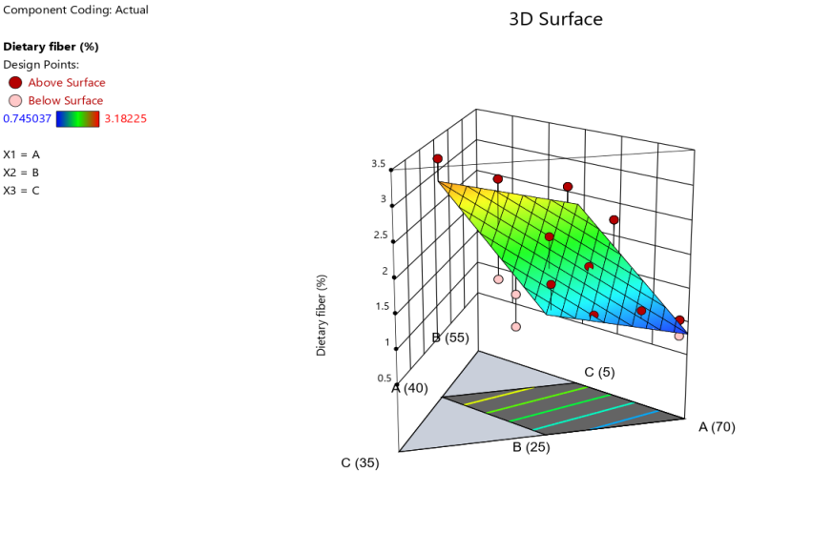
Figure 1: 3D Surface plot showing the effect of the ingredients on acid detergent fiber
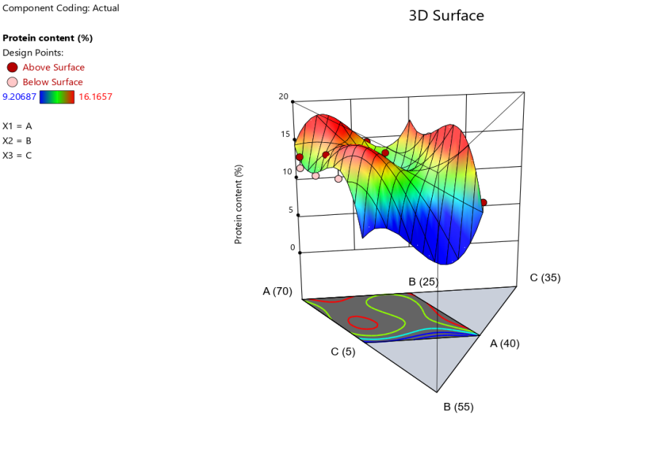
Figure 2: 3D Surface plot showing the effect of the ingredients on protein content

Table 2: Experimental runs for optimization and corresponding values of response variables
Run | A: Wheat (g) | B: Sorghum (g) | C: Cowpea (g) | Acid detergent fiber (%) | Protein (%)
1 | 68.92 | 26.08 | 5 | 0.75 | 11.82
2 | 58.23 | 30.6 | 11.17 | 1.23 | 14.75
3 | 47.6 | 35 | 17.4 | 1.49 | 11.71
4 | 53.99 | 30.66 | 15.35 | 2.22 | 11.78
5 | 55.49 | 25 | 19.51 | 1.74 | 14.53
6 | 58.23 | 30.6 | 11.17 | 1.24 | 13.25
7 | 64.94 | 25 | 10.06 | 1.23 | 16.17
8 | 54.12 | 35 | 10.88 | 1.24 | 16.12
9 | 68.92 | 26.08 | 5 | 0.99 | 13.27
10 | 58.23 | 30.6 | 11.17 | 1.73 | 11.75
11 | 63.72 | 30.03 | 6.25 | 1.23 | 14.64
12 | 47.6 | 35 | 17.4 | 2.98 | 11.84
13 | 60 | 35 | 5 | 2.24 | 13.17
14 | 50.92 | 29.08 | 20 | 1.47 | 16.09
15 | 50.92 | 29.08 | 20 | 0.99 | 16.04
16 | 59.94 | 25 | 15.06 | 1.23 | 13.14
17 | 59.06 | 28.77 | 12.17 | 1.26 | 15.65
18 | 40 | 40 | 20 | 3.18 | 11.01
19 | 53.87 | 40 | 6.13 | 2.63 | 9.21
20 | 65.26 | 29.74 | 5 | 1.15 | 11.95

3.2 Model fitting

The linear model (Equation 2) was found to fir the data for acid detergent fibre while and results for protein content fitted reduced cubic model (Equation 3). Both models were significant (P < .05) and lack-of-fit was insignificant (P > .05). This indicated that the models sufficiently explained the data. The coefficient of determination (R²) were above 0.5 (Table 3) hence the models made sufficient predictions of the response variables

Acid detergent fiber (%) = 0.814743A + 3.89425B + 1.8029C --------- (2)

Protein content (%) = 14.51A + -200.05B + 205.92C + 400.02AB + -372.47AC + -235.27AB(A-B) + 249.99AC(A-C) + 390.47BC(B-C) ------- (3)

Where A, B, and C are wheat, sorghum and cowpea components respectively of the produced noodles.

Table 3: Statistical evaluation of model adequacy

ANOVA and Fit statistics | Response variable
ANOVA and Fit statistics | Acid detergent fiber (%) | Protein (%)
Model P-value | 0.0014 | 0.0227
Lack-of-fit P-value | 0.7355 | 0.2222
R² | 0.5593 | 0.7111
Adjusted R² | 0.5042 | 0.52273
3.3 Optimization of the ingredients

Numerical optimization results (Table 4) showed that formulation consisting 55% wheat flour, 36% sorghum flour and 9% cowpea flour had the highest desirability (0.811). The predicted response variables for the formulation with highest desirability was 16.01% protein and 2.08% acid detergent fiber. Validation test found no significant difference (P > .05) between the experimental and predicted values for response variables (Table 5). This implies that the models used adequately predicted the response variables.

Table 4: Optimized formulation for making noodles obtained from Design Expert software

No. | Ingredients (g/100 g) |  |  | Responses (%) |  |  | Desirability |  | Comment
 | Wheat | Sorghum | Cowpea | Protein | Acid detergent fiber
1 | 55 | 35.9917 | 9.00825 | 16.0118 |  | 2.07507 |  | 0.811 | Selected
2 | 49.3336 | 31.2802 | 19.3862 | 16.1657 |  | 1.93327 |  | 0.672
3 | 50.25 | 29.75 | 20 | 16.7497 |  | 1.79641 |  | 0.666

Table 5: Results obtained from validation the optimized formulation of noodles
 | Protein (%) | Acid detergent fiber (%)
Observed values | 15.99ª ± 0.21¹ | 2.1ª ± 0.16¹
Predicted values | 16.01ª | 2.08ª
Values in the same column with different superscripts are significantly different (P < .05).

3.4 Sensory evaluation of noodles produced from the composite flour

The average scores for sensory acceptance of the noodles ranged between 4.8 and 8.0 for all the attributes evaluated (Table 6). Scores for the overall acceptance, appearance, color and mouth feel were significantly higher for the control than for the nutrient enriched noodles, implying that panelists generally preferred the control sample and overall lower acceptance of nutrient enhanced noodles could be due to their appearance and texture. The lower score for appearance of the nutrient enriched noodles may be attributed to the difference in color between the study samples and noodles on the market that panelists are familiar with. The reddish color of the study samples can be attributed to presence of anthocyanins (Devi et al., 2011) in the sorghum flour that was incorporated in the nutrient enriched sample hence lowering their lightness. To address the low appearance acceptance, it may be necessary to consider using lighter sorghum varieties for future studies. If the darker varieties are to be used, consumer education may be necessary to enhance acceptability. To address the inferior mouth feel scores, it is necessary to undertake further assessment to understand the specific mouth feel problems that consumers experienced and to find ways of improving the underlying causes. (Akajiaku et al., 2017) in their study of containing sorghum reported a negative relation between percentage of sorghum and sensory acceptability. Despite the lower scores for the nutrient enriched noodles for some attributes, their overall acceptability score (6.17), corresponding to liked slightly indicated that the substitution of wheat flour with sorghum and cowpea produced acceptable noodles.

Table 6: Sensory evaluation of the produced noodles

Sample | Appearance | Aroma | Mouth feel | Taste | Aftertaste | Overall acceptability
Control | 7.83^{b} ± 0.92 | 7.0ª ± 1.15 | 6.93^{b} ± 1.68 | 7.1ª ± 1.35 | 6.47ª ± 1.43 | 7.43^{b} ± 1.04
Enriched noodles | 5.07ª ± 2.13 | 6.67ª ± 1.21 | 5.57ª ± 1.52 | 6.73ª ± 1.23 | 6.53ª ± 1.22 | 6.17ª ± 1.46
Values are means±standard deviation (n=30). Means in each column with different superscripts are significantly different (P < .05).

3.5 Proximate composition of the produced noodles

The proximate composition of the noodles produced is summarized as shown in table 7. Nutrient enhancement using sorghum and cowpea flour resulted in increase in crude fiber, crude protein and crude fat of the produced noodles. It was also observed that there was no significant difference in moisture and ash content of the noodles. The high fat content was attributed to high sorghum flour content in the noodles produced. High crude fiber was attributed to sorghum flour, that is to say, the higher the sorghum flour incorporated in noodles production, the higher the crude fiber of the noodles. Akajiaku et al. (2017) reported that crude fiber plays a role in the health of gastrointestinal and metabolic systems in humans. Improved fiber content can contribute to health benefits including lower risk of cardiovascular diseases, lower risk of cancer and improved gut health (Pakhare et al., 2016). High crude protein of the nutrient-enriched noodles was due to increased cowpea content of the optimal formulation used. Affrifah et al. (2022) stated that cowpea is an important protein-rich legume and its utilization has potential in combating the persistent protein-energy malnutrition.

Table 7: Proximate composition of the sorghum and cowpea enriched noodles
Sample | Composition (%)
 | Moisture | Ash | Crude fat | Crude fiber | Protein | Carbohydrates
Enriched noodles | 9.45ª ± 0.26 | 0.89ª ± 0.33 | 0.94^{b} ± 0.03 | 1.6^{b} ± 0.05 | 15.99^{b} ± 0.21 | 71.15ª ± 0.26
Control | 8.68ª ± 2.73 | 0.83ª ± 0.15 | 0.53ª ± 0.05 | 0.48ª ± 0.02 | 12.40ª ± 0.21 | 77.09ª ± 2.7

The data are means ± standard deviation of three determinations (n=3). Means in each column with different superscripts are significantly different (P < .05).

4. CONCLUSION

This study sought to develop an optimal formulation for noodles made from sorghum and cowpea as partial substitutes of wheat and to assess the sensory acceptability of the noodles developed. With the use of response surface methodology, an optimal noodles formulation, consisting 55% wheat, 36% sorghum and 9% cowpea was obtained, and this included of wheat, sorghum and cowpea. The optimal formulation contained markedly higher protein and acid detergent fiber than noodles made without wheat substitution. The noodles produced from the optimal formulation were acceptable with an average overall acceptability score of 6.17 on the 9-point hedonic scale. The noodles made using the developed optimal formulation had significantly higher protein and fiber content compared to the control. The findings of this study showed the potential of sorghum and cowpea as ingredients in noodle production, but also indicated the necessity of improvement of certain sensory attributes of the developed noodles. Utilization of sorghum and cowpea for commercial production of noodles could contribute to the socio-economic benefits by creating a new market for these crops. It would also contribute to improvement in nutrient intake among consumers of noodles.

COMPETING INTERESTS
Authors declare that no competing interests exist.

COMPETING INTERESTS DISCLAIMER:
Authors have declared that they have no known competing financial interests OR non-financial interests OR personal relationships that could have appeared to influence the work reported in this paper.

REFERENCES
Adejuwon, O. H., Jideani, A. I., & Falade, K. O. (2020). Quality and public health concerns of instant noodles as influenced by raw materials and processing technology. Food Reviews International, 36(3), 276-317.
Affrifah, N. S., Phillips, R. D., & Saalia, F. K. (2022). Cowpeas: Nutritional profile, processing methods and products—A review. Legume Science, 4(3), e131.
Agomuo, J., Ifeka, C., & Ibilaye, R. (2024). Quality Evaluation of Noodles Produced from Wheat Flour (Triticum spp.), Sorghum Flour (Sorghum bicolar) and Pumpkin Seed Flour (Cucurbita pepo) Enriched with Eggyolk Powder. Nigeria Agricultural Journal, 55(1), 295-301.
Akajiaku, L., Nwosu, J., Kabuo, N., Odimegwu, E., Umelo, M., & Unegbu, V. (2017). Using Sorghum Flour as Part Substitute of Wheat Flour in Noodles Making. MOJ Food Processing & Technology, 5(2), 1-9. https://doi.org/10.15406/mojfpt.2017.05.00120
AOAC. (2016). Official Methods of Analysis RESEARCH BLVD Rockville, Maryland, USA, 20th ed(300), 2275.
Chepkosgei, T. M., & Orina, I. (2021). Quality and sensory properties of instant fried noodles made with soybean and carrot pomace flour. African Journal of Food Science, 15(3), 92-99.
Devi, P. S., Saravanakumar, M., & Mohandas, S. (2011). Identification of 3-deoxyanthocyanins from red sorghum (Sorghum bicolor) bran and its biological properties. African Journal of Pure and Applied Chemistry, 5(7), 181-193.
Dolislager, M., Liverpool‐Tasie, L. S. O., Mason, N. M., Reardon, T., & Tschirley, D. (2022). Consumption of healthy and unhealthy foods by the African poor: Evidence from Nigeria, Tanzania, and Uganda. Agricultural Economics, 53(6), 870-894.
FoodNetwork. (2022). How to Cook Pasta. https://www.foodnetwork.com/how-to/articles/howto-cook-italian-pasta-a-step-by-step-guide
Ginting, E., & Yulifianti, R. (2015). Characteristics of noodle prepared from orange-fleshed sweet potato, and domestic wheat flour. Procedia Food Science, 3, 289-302.
Kesselly, S. R., Mugabi, R., & Byaruhanga, Y. B. (2023). Effect of soaking and extrusion on functional and pasting properties of cowpeas flour. Scientific African, 19, e01532.
Mabhaudhi, T., Chibarabada, T. P., Chimonyo, V., Murugani, V., Pereira, L., Sobratee, N., Govender, L., Slotow, R., & Modi, A. (2019). Mainstreaming Underutilized Indigenous and Traditional Crops into Food Systems: A South African Perspective. Sustainability, 11, 72, 1-22. https://doi.org/10.3390/su11010172
Nansereko, S., Muyonga, J., & Byaruhanga, Y. B. (2022). Optimization of drying conditions for jackfruit pulp using refractance window drying technology. Food Science & Nutrition, 10(5), 1333-1343.
Natocho, J., Mugabi, R., & Muyonga, J. H. (2024). Optimization of formulation and processing conditions for the production of functional noodles containing orange‐fleshed sweet potatoes and biofortified beans. Food Science & Nutrition.
Pakhare, K., Dagadkhair, A., Udachan, I., & Andhale, R. (2016). Studies on preparation and quality of nutritious noodles by incorporation of defatted rice bran and soy flour.
Ritika, B., Baljeet, S., Mahima, S., & Roshanlal, Y. (2016). Suitability of wheat flour blends with malted and fermented cowpea flour for noodle making. International Food Research Journal, 23(5).
Serna-Saldivar, S. O., & Espinosa-Ramírez, J. (2019). Grain structure and grain chemical composition. In Sorghum and millets (pp. 85-129). Elsevier.
Sun, K.-N., Liao, A.-M., Zhang, F., Thakur, K., Zhang, J.-G., Huang, J.-H., & Wei, Z.-J. (2019). Microstructural, textural, sensory properties and quality of wheat–yam composite flour noodles. Foods, 8(10), 519.
Tanwar, R., Panghal, A., Chaudhary, G., Kumari, A., & Chhikara, N. (2023). Nutritional, Phytochemical and Functional Potential of Sorghum: A Review. Food Chemistry Advances, 100501.
Udeogu, E., Onyeka, E., & Umelo, M. (2014). Potentials of using cowpea-wheat composite flour in noodles products. European international Journal of Applied Science and Technology, 1.
Wahjuningsih, S., Azkia, M., & Kusumaningtyas, R. (2022). Physicochemical, functional and sensory properties of wheat noodles substituted by sorghum and mung bean flours. Food Research, 6(5), 84-90.
Zula, A. T., Ayele, D. A., & Egigayhu, W. A. (2021). Proximate composition, antinutritional content, microbial load, and sensory acceptability of noodles formulated from moringa (Moringa oleifera) leaf powder and wheat flour blend. International Journal of Food Science, 2021.

