**Original Research Article**

**Spray Drying of Passion Fruit Juice: Process Optimization and Quality Assessment**

**Abstract**

Passion fruit contains a satisfactory amount of juice, characterized by its acidic nature, pleasant flavour and aroma. In this study, spray drying was employed to produce passion fruit juice powder. Fresh, matured yellow passion fruits were used to extract the juice, which was then subjected to spray drying under varying process conditions. A maltodextrin-corn starch ratio of 3:2 was used as the wall material. Seventeen experimental trials were conducted to evaluate the effects of wall material concentration (15%, 17.5%, and 20% w/v), inlet air temperature (150°C, 160°C, and 170°C) and feed pump speed (8, 10, and 12 rpm) on quality parameters of spray dried powder. The process was optimized using the Box-Behnken design of response surface methodology (RSM). The optimal process conditions for obtaining high-quality passion fruit juice powder were determined as 12% maltodextrin, 8% corn starch, an inlet air temperature of 165°C, a feed pump speed of 12 rpm (0.83 ml/h), an outlet air temperature of 75°C, a blower speed of 1700 rpm and an atomizer pressure of 2.5 kg/cm². Under these conditions, the product yield was 61.23%, with a low moisture content of 1.62%, indicating good drying efficiency. The resulting powder exhibited excellent dispersibility (89.32%), low wettability time (12.42 s) and a total colour difference of 20.37. These results provide a comprehensive basis for producing high-quality, stable and reconstitutable spray-dried passion fruit juice powder through process optimization.

**Keywords:** Yellow passion fruit, Spray drying, Juice powder, Response surface methodology, Wall material optimization

1. **Introduction**

Yellow passion fruit (Passiflora edulis f. flavicarpa) is widely consumed for its distinct aroma, tangy flavour, and high nutritional value (Fonseca et al., 2022). It is a rich source of bioactive compounds, including vitamin C, carotenoids and polyphenols, which contribute to its antioxidant properties and potential health benefits (Ruxton & Myers, 2021). Due to its high moisture content and water activity, fresh yellow passion fruit juice is highly perishable, limiting its shelf life and commercial viability (da Silva et al., 2024). The production and commercialization of passion fruit juice face several challenges, including its limited shelf life, low consumer awareness, weak market linkages, the need for processing facilities, inadequate infrastructure, low production and productivity, insufficient post-harvest management, and complex transportation logistics. Due to its highly perishable nature, the fruit must be processed and marketed before it dehydrates. Therefore, transforming the juice into a powder form offers an effective solution to enhance its stability, ease of transportation and application in food formulations.

Spray drying is a widely used technique for producing fruit juice powders while preserving their sensory and nutritional properties. This process involves atomizing liquid juice into fine droplets and rapidly drying them with hot air, resulting in powdered particles. However, the direct spray drying of passion fruit juice is challenging due to its high sugar and acid content, which can lead to stickiness, low powder yield and poor flowability. To overcome these challenges, the addition of wall materials, such as maltodextrin and corn starch, is necessary to improve the drying process, prevent particle agglomeration, and enhance powder properties.

Despite the advantages of spray drying, optimizing the process conditions is crucial to achieving high-quality fruit juice powder. Parameters such as wall material concentration, inlet air temperature, and feed pump speed significantly influence the physical and functional properties of the final product. Although previous studies have explored spray drying for various tropical fruit juices, limited research has been conducted on optimizing spray drying parameters specifically for yellow passion fruit juice powder.

This study aims to optimize the spray drying conditions for yellow passion fruit juice powder using response surface methodology (RSM). The effects of wall material concentration, inlet air temperature and feed pump speed on powder characteristics, such as bulk density, flow properties, and moisture content were analysed. The findings from this study will contribute to the development of a high-quality yellow passion fruit juice powder with improved shelf stability and industrial applications.

1. **Materials and methods**
   1. **Raw materials**

Fresh yellow passion fruits (*Passiflora edulis f. flavicarpa*) were procured from M/s. Riya Farms, Wayanad, Kerala, India. The carrier materials used for spray drying, including maltodextrin (DE 20) and corn starch, were obtained from M/s. Chemind, Thrissur, Kerala, India. All other chemicals and reagents utilized in this study were of analytical grade.

* 1. **Sample preparation and spray drying**

Fresh yellow passion fruits were washed thoroughly and well drained. The fruits were halved, and the pulp was extracted manually using a stainless steel spoon. The extracted pulp was then filtered through a muslin cloth to remove seeds. The seed-free pulp was stored in an air blast freezer at -20°C until further processing. Spray drying experiments were conducted using a lab-scale vertical co-current tall-type spray dryer (M/s. S. M. Scientech, Kolkata, India). Fluid flow pattern followed in this spray dryer is co-current type having an evaporation rate of 1000 ml/h. The feed solution was prepared and the spray dryer was set to the desired inlet temperature and feed rate. The atomizer pressure was maintained at 2.5 kg/cm² with a blower speed of 1700 rpm. Distilled water was initially pumped to stabilize the outlet air temperature at 75 °C, after which it was replaced with the feed solution. The feed was sprayed into the drying chamber, where moisture was removed, and the powder was collected at the outlet. After cooling, the powder was packed in 150 µm aluminium-laminated pouches for further analysis. The process flow chart for the production of spray dried passion fruit powder is shown in Figure1.

**Figure 1. Process flow chart for the spray drying of passion fruit juice**

* 1. **Design of experiment**

In this study, Response Surface Methodology (RSM) was employed for the experimental design. RSM is a collection of statistical and mathematical techniques used for developing, improving and optimizing processes. It explores the relationships between multiple explanatory variables and one or more response variables, particularly in cases where limited prior knowledge about the process is available. By carefully designing experiments, RSM facilitates the optimization of responses influenced by various independent variables, ultimately maximizing the production of the desired product. A three-factor, three-level Box-Behnken design (BBD) was used to evaluate the effects of independent variables on the spray drying process. Maltodextrin (DE 20) and corn starch were used as carrier materials in a 3:2 ratio at three different concentrations: C1 (15%), C2 (17.5%), and C3 (20%). The spray drying process was performed under varying operating conditions, including inlet air temperatures of T1 (150°C), T2 (160°C), and T3 (170°C) and feed rates of F1 (8 rpm), F2 (10 rpm), and F3 (12 rpm). The process parameters were optimized based on the quality attributes of the resulting passion fruit juice powder. The experimental design corresponds to seventeen experimental trials are presented in Table 1. Carrier concentration, inlet temperature, and feed rate are the independent variables used to optimize and analyse the flow properties of spray-dried powder, based on responses like bulk density, tapped density, Carr’s index, and Hausner ratio. `

**Table 1. Factors and levels tested for experimental design**

|  |  |  |  |  |
| --- | --- | --- | --- | --- |
| **Independent variables** | **Factor** | **Levels in coded form** | | |
| **1** | **0** | **+1** |
| Carrier concentration (%) | A | 15 | 17.5 | 20 |
| Inlet temperature (°C) | B | 150 | 160 | 170 |
| Feed rate (rpm) | C | 8 | 10 | 12 |

* 1. **Properties of spray dried powder**
     1. **Product Yield**

Product yield is a key indicator of process efficiency, defined as the percentage ratio of the mass of powder collected after drying to the total mass of solids in the feed solution, including both fruit juice solids and carrier material. High product yield is essential for economic feasibility in industrial production. As noted by Karaca et al. (2016), low yield is often attributed to stickiness of certain food components, while Bhandari et al. (1997) suggested that a successful spray drying process should achieve yields above 50%. The product yield (%) was calculated using the following equation 1.

…………. (1)

* + 1. **Moisture Content**

The amount of moisture present in spray dried passion fruit juice powder was estimated using the method by Horwitz and Latimer (2005) methodology. Percentage wet basis moisture was found by using the following equation:

$Moisture content\left(\% wb\right)=\frac{Wi-Wf}{Wi}×100$…………………. (2)

where,

Wi – initial weight of raw tomato, g

Wf – dry weight of raw tomato, g

* + 1. **Wettability**

Wettability was determined by measuring the time required for complete wetting of the powder. A 1.5 g sample was gently placed on the surface of 100 ml of water maintained at 30 °C in a beaker. The time taken for all powder particles to fully immerse from the surface to the bottom was recorded using a stopwatch, following the method described by Atomizer et al. (1978).

* + 1. **Dispersibility**

Dispersibility was evaluated following the method described by Jinapong et al. (2008). A 1 g powder sample was added to 10 ml of distilled water at 25 °C in a 50 ml beaker. Using a spoon, 25 circular movements were made both clockwise and counterclockwise for 20 seconds to aid dispersion. The mixture was then filtered through a 150 µm sieve. To determine the solid content of the filtrate, 1 ml was transferred to a drying vessel and dried in a vacuum oven at 65 °C until a constant weight was achieved, or at 105 °C for 4 hours. Dispersibility (%) was calculated using the equation 3.

$Dispersibility \left(\%\right)=\frac{(100+a)×b}{a×(100-c)}×100$…………………… (3)

Where:

a = Amount of powder used (g)

b = % Dry matter in the filtrate

c = % Moisture content of the powder

* + 1. **Total colour difference**

The colour properties of food powders are typically evaluated using Hunter L*, a*, and b* values. However, interpreting these values in isolation can be challenging. Therefore, the analysis was extended to include the total colour difference (ΔE), which provides a more comprehensive assessment of colour changes. The ΔE was calculated relative to the raw feed solution, as a reference, using the appropriate equation 4. A lower ΔE value indicates minimal colour deviation, which is desirable for producing a high-quality spray-dried product.

Total color difference = $\sqrt{{(L-L_{0})}^{2} + {(a-a_{0})}^{2}+{(b-b_{0})}^{2}}$............ (4)

Where;

L0, a0, and b0 = Colour parameters for the feed

L, a, and b= Colour parameters of the product

* + 1. **Statistical analysis**

A statistical software package Design expert 12 from a private company Stat-Ease Inc. specifically designed to perform the design of experiments was used in the optimisation of various process parameters. The procedure of optimisation was conducted using Box-Behnken design which is a most efficient and economical way to estimate the first and second order coefficients of mathematical model (Bezerra et al., 2008). Besides providing optimised treatments response surface plots are also obtained using Design Expert software

**3. Results and Discussions**

**3.1.** **Optimization of process parameters on spray drying**

The influence of three independent process variables on the spray drying process was individually analysed using Design-Expert software to identify the optimal treatment conditions. The effects of the spray drying process parameters on the respective response variables are summarized in Table 2. To assess the statistical significance of these effects, an Analysis of Variance (ANOVA) was performed for each response parameter.

**3.1.1. Effect of Process Parameters on product yield**

The influence of spray drying parameters on the product yield of passion fruit powder is presented in Table 2, while the 3D response surface plots are shown in Fig.1. The ANOVA results indicated that the quadratic model was highly significant (p = 0.0007, p ≤ 0.01), with a high coefficient of determination (R² = 0.95), confirming a good fit between experimental and predicted values. Carrier concentration, inlet temperature, and feed rate significantly influenced product yield (p ≤ 0.01), with a notable interaction observed between feed rate and yield. The fitted second-order regression model describing the effect of independent variables on product yield is as follows:

ProductYield (%)=8.13+0.48A-0.37B-0.54C-0.011AB-0.085AC+0.027BC+0.054A2+0.25B2-0.56C2 ………………(5)

Where,

A = carrier concentration (%)

B = inlet temperature (°C)

C = feed rate (rpm)

Product yield ranged from **45.32% to 84.49%** (Figure 2), with the **highest yield (84.49%)** achieved at a carrier concentration of 20%, inlet temperature of 150 °C and feed rate of 10 rpm. Carrier concentration significantly influenced yield, showing a positive correlation; values increased from 45.99% to 84.49% as the concentration rose from 15% to 20%. In contrast, an increase in inlet temperature led to a significant decrease in yield. This reduction, also observed in sugar-rich products like sugarcane juice and raisin extract (Avila et al., 2015; Papadakis et al., 2006), is primarily attributed to caramelization or thermal degradation of sugars at elevated temperatures, resulting in powder loss. Similar trends were reported for other fruit juices (Cynthia et al., 2015; Fazaeli et al., 2012). Feed rate exhibited a negative correlation with product yield; increasing feed rate from 8 to 12 rpm reduced the yield. Higher feed rates result in larger droplets and reduced heat and mass transfer efficiency, leading to incomplete drying (Muzaffar and Kumar, 2015).

|  |  |  |  |  |  |  |  |  |  |
| --- | --- | --- | --- | --- | --- | --- | --- | --- | --- |
| Experiment No. | Concentration  (%) | Temperature  (°C) | Feed rate  (rpm) | Product yield  (%) | Moisture content  (%) | Ascorbic Acid  (mg/100g) | Dispersibility  (%) | Wettability  (Sec) | Overall colour difference value (ΔE) |
| 1 | 20.0 | 150 | 10 | 84.49±0.67 | 2.50±0.02 | 15.91±0.43 | 60.93±0.48 | 24.93±0.02 | 18.17±0.85 |
| 2 | 15.0 | 150 | 10 | 70.07±0.47 | 4.73±0.03 | 27.27±0.59 | 63.37±0.62 | 47.19±0.13 | 07.58±0.76 |
| 3 | 17.5 | 160 | 10 | 65.75±1.01 | 3.73±0.01 | 20.45±0.72 | 79.71±0.71 | 13.34±0.34 | 13.01±0.66 |
| 4 | 17.5 | 170 | 12 | 45.32±0.62 | 3.48±0.02 | 18.18±0.63 | 94.90±0.65 | 12.72±0.36 | 22.24±0.45 |
| 5 | 20.0 | 160 | 12 | 60.02±0.48 | 1.55±0.06 | 22.73±0.58 | 84.16±0.46 | 10.09±0.63 | 21.42±0.58 |
| 6 | 17.5 | 150 | 08 | 80.19±0.83 | 3.44±0.02 | 18.18±0.78 | 70.91±0.37 | 24.93±0.74 | 21.19±0.82 |
| 7 | 20.0 | 160 | 08 | 74.55±0.58 | 1.47±0.04 | 20.45±0.62 | 84.47±0.4 | 10.27±0.08 | 29.00±0.87 |
| 8 | 15.0 | 160 | 08 | 53.69±0.54 | 3.97±0.02 | 25.00±0.82 | 94.83±0.83 | 22.65±0.43 | 09.83±0.48 |
| 9 | 17.5 | 160 | 10 | 65.75±0.87 | 3.33±0.06 | 18.18±0.44 | 75.90±0.67 | 14.23±0.68 | 16.72±0.86 |
| 10 | 17.5 | 160 | 10 | 66.66±0.68 | 3.33±0.02 | 18.18±0.48 | 75.12±0.37 | 20.34±0.46 | 13.82±0.48 |
| 11 | 17.5 | 160 | 10 | 65.75±0.43 | 3.33±0.02 | 20.45±0.63 | 76.21±0.84 | 21.67±0.84 | 20.12±0.68 |
| 12 | 20.0 | 170 | 10 | 71.84±1.32 | 1.50±0.04 | 20.45±0.37 | 88.01±0.66 | 15.96±0.48 | 29.24±0.79 |
| 13 | 17.5 | 170 | 08 | 66.01±0.89 | 2.80±0.02 | 15.90±0.42 | 95.01±0.48 | 10.06±0.64 | 22.00±0.72 |
| 14 | 17.5 | 160 | 10 | 66.67±0.73 | 2.33±0.04 | 18.18±0.64 | 78.31±0.63 | 08.45±0.86 | 10.05±0.89 |
| 15 | 17.5 | 150 | 12 | 55.58±0.62 | 3.88±0.05 | 20.45±0.48 | 68.66±0.64 | 24.93±0.42 | 13.48±0.54 |
| 16 | 15.0 | 160 | 12 | 45.99±0.72 | 4.60±0.02 | 25.00±0.74 | 84.61±0.48 | 15.51±0.67 | 13.15±0.84 |
| 17 | 15.0 | 170 | 10 | 59.27±0.82 | 3.88±0.02 | 24.99±0.53 | 96.27±0.52 | 12.20±0.82 | 21.25±0.78 |

**Table 2. The experimental data for response surface analysis of the effect of processing conditions on the quality of passion fruit juice powder**

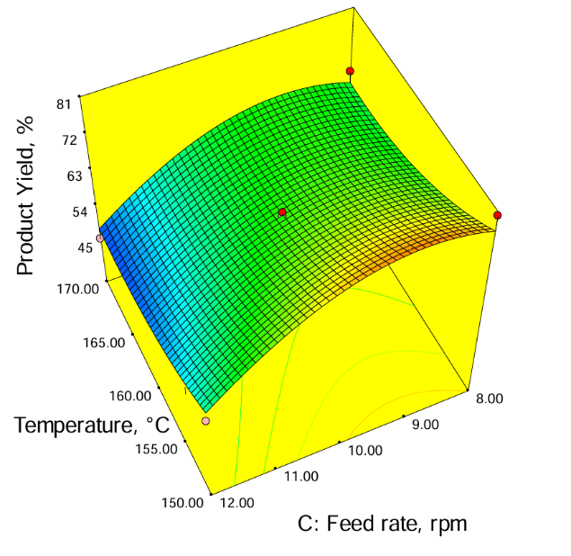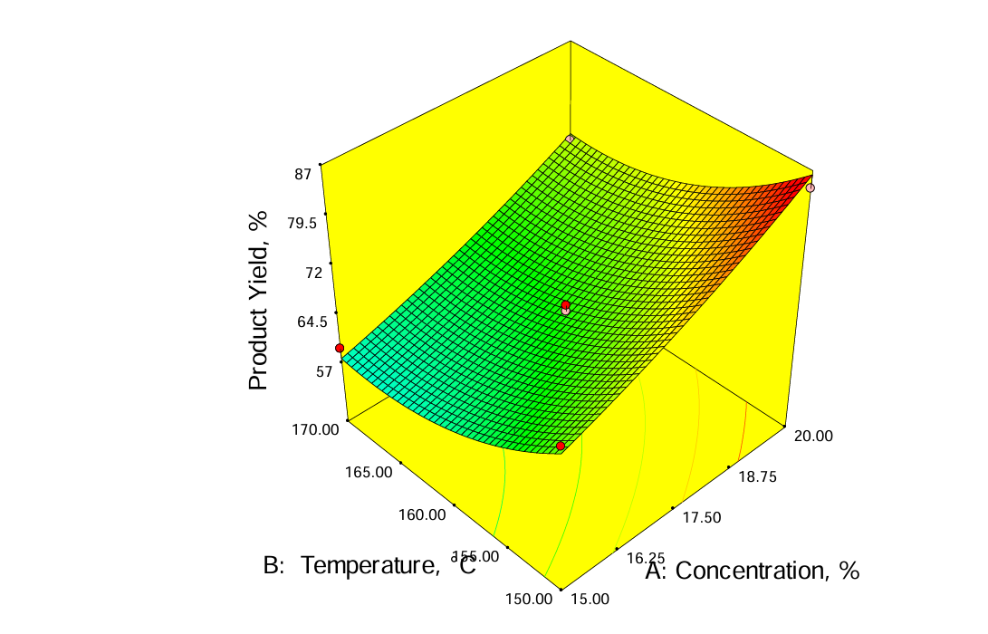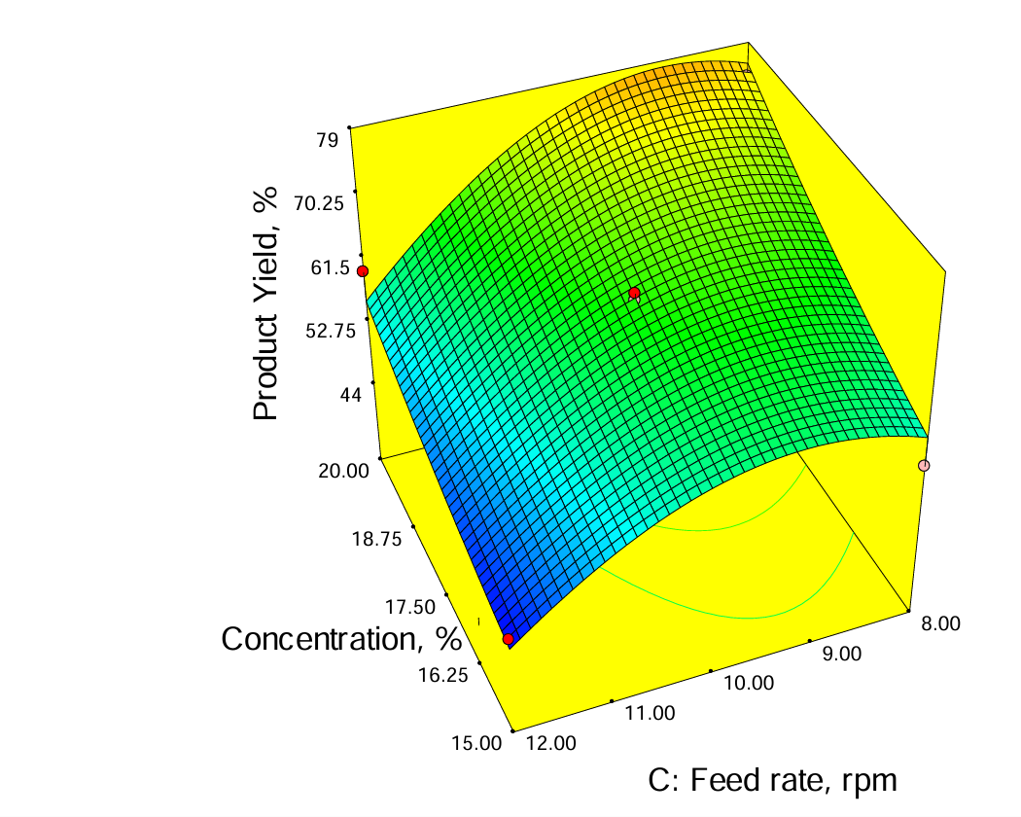

**Figure 2. Response surface plot for product yield**

**3.1.2. Effect of Process Parameters on moisture content**

The moisture content of the spray-dried passion fruit powder across seventeen trials is presented in Table 2. Statistical analysis revealed that the process variables significantly influenced moisture content, with carrier concentration (A) showing the highest significance (p < 0.0001). The fitted model demonstrated good predictive ability (R² = 0.9191), and the regression equation is as follows:

Moisture Content (%)=1.79−0.38A−0.11B+0.062C−0.038AB−0.030AC+0.019BC−0.12A2+0.072B2−0.017C2 …………………….. (5)

Where,

A = carrier concentration (%)

B = inlet temperature (°C)

C = feed rate (rpm).

Moisture content ranged from 1.47% to 4.60% (wb), with the lowest value was observed at 20% carrier concentration, 160 °C, and 8 rpm feed rate. The highest value occurred at 15% concentration, 160 °C, and 12 rpm. Response surface plots (Figure 3) demonstrated that **moisture content decreased with increasing carrier concentration and temperature,** while **feed rate showed a positive linear effect.** These trends align with previous studies on pomegranate, acai, pineapple, and watermelon juice powders (Thirugnanasambandham & Sivakumar, 2017; Tonon et al., 2008; Abadio et al., 2004; Queck et al., 2007). Higher carrier concentrations reduce available free moisture, thereby enhancing drying efficiency. Similarly, elevated temperatures accelerate water evaporation; however, they may also cause crust formation, which can limit rehydration. Hence, careful control of inlet and outlet temperatures is essential (Moghaddam et al., 2017). Conversely, increased feed rates lead to larger droplets with reduced surface area and contact time, consequently lowering heat transfer efficiency and increasing moisture retention, consistent with findings in acai and guava juice powders (Tonon et al., 2011; Mahendran, 2010; Siacor et al., 2020).

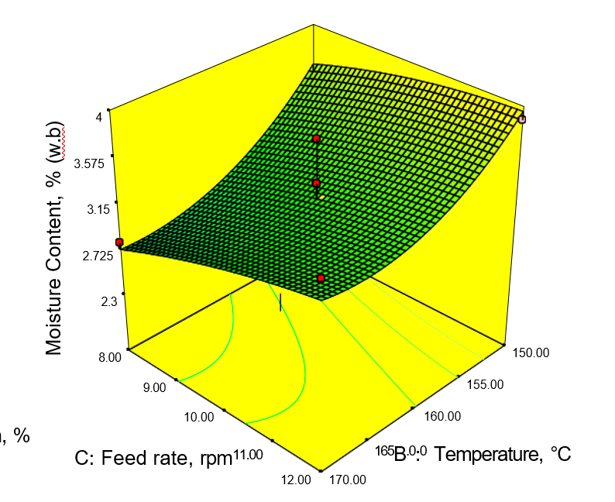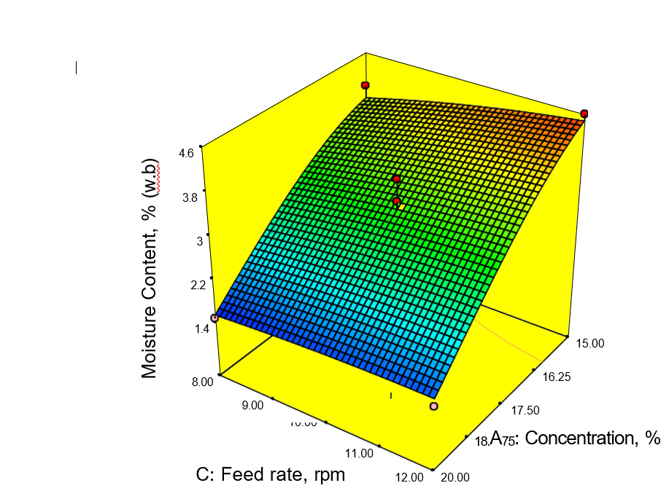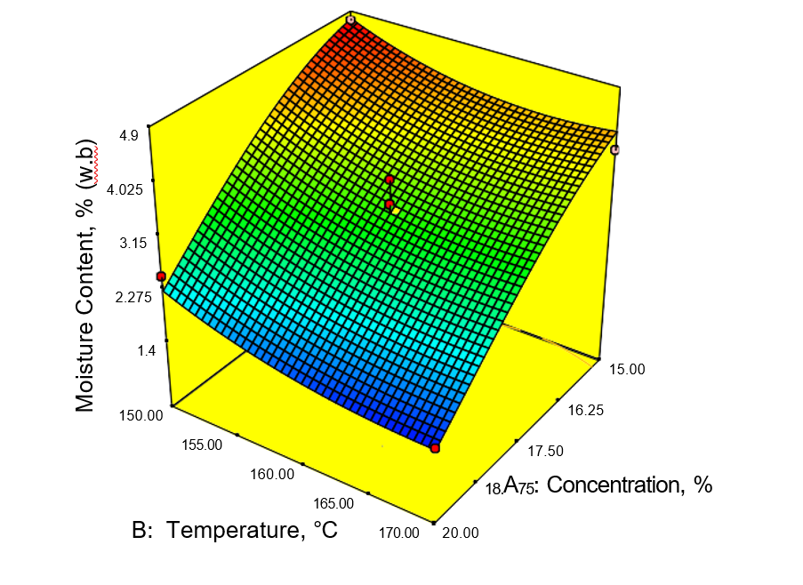

**Figure 3. Response surface plot for moisture content**

**3.1.3. Effect of Process Parameters on ascorbic acid**

Table 2 presents the variation in ascorbic acid content across different spray drying conditions, while Fig. 4 illustrates the response surface plots. ANOVA results confirmed that carrier concentration significantly affected vitamin C retention (p ≤ 0.01), along with a significant third-level interaction. The model showed good fit with an R² value of 0.8571. The regression model (Equation 7) predicting ascorbic acid content is:

Vitamin C = 4.37-0.30A-0.028B+0.097C+0.19AB+0.061AC+4.185BC+0.44A2-0.12B2 + 0.016C2 …………………. (7)

Where,

A = carrier concentration (%)

B = inlet temperature (°C)

C = feed rate (rpm)

Ascorbic acid content ranged from 15.90 to 27.27 mg/100 g. The maximum retention (27.27 mg/100 g) was observed at 150 °C, 15% carrier concentration, and 10 rpm feed rate. The lowest (15.90 mg/100 g) occurred at 170 °C, 17.5% concentration, and 8 rpm. Response surface graph clearly showed that there was a better retention of ascorbic acid at lowest temperature and lowest carrier concentration. Temperature and carrier concentration negatively impacted vitamin C content due to thermal and oxidative degradation, aligning with findings in spray-dried guava, gac aril, seabuckthorn, and other juices (Shishir & Chen, 2017; Kha et al., 2010; Patil et al., 2014; Selvamuthukumaran & Khanum, 2014). Conversely, feed rate had a positive effect. Higher feed rates led to faster drying and reduced thermal exposure, minimizing nutrient loss, consistent with studies on passion fruit, orange, and blackberry juices (Angel et al., 2009; Chegni et al., 2005; Ferrari et al., 2012).

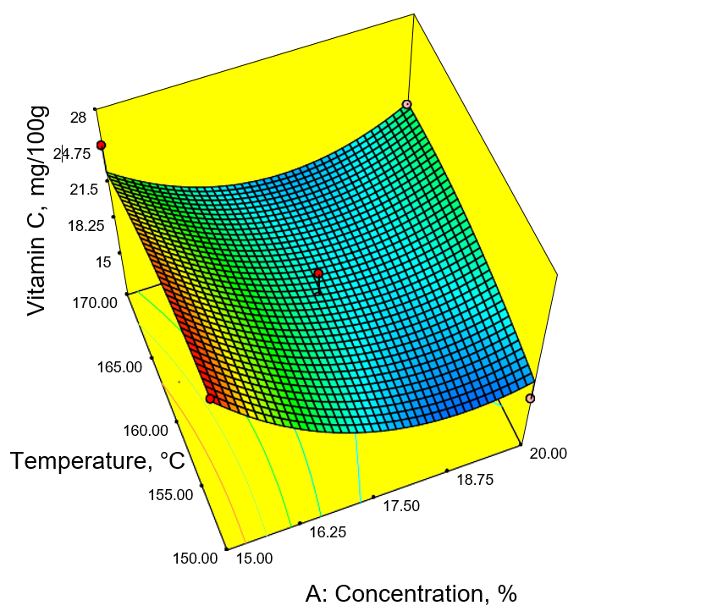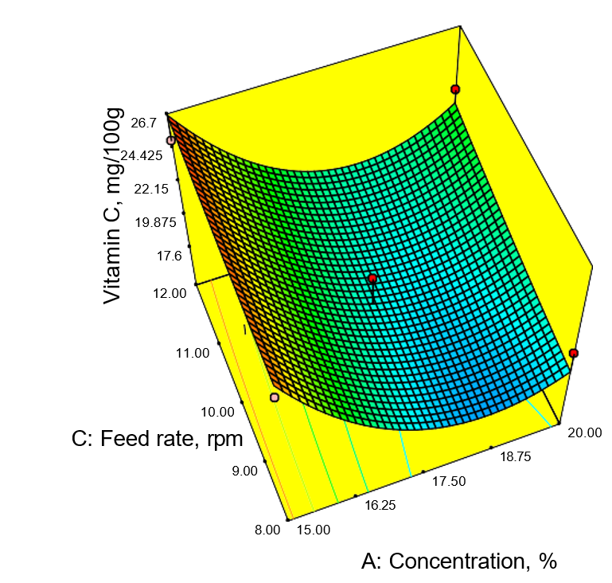

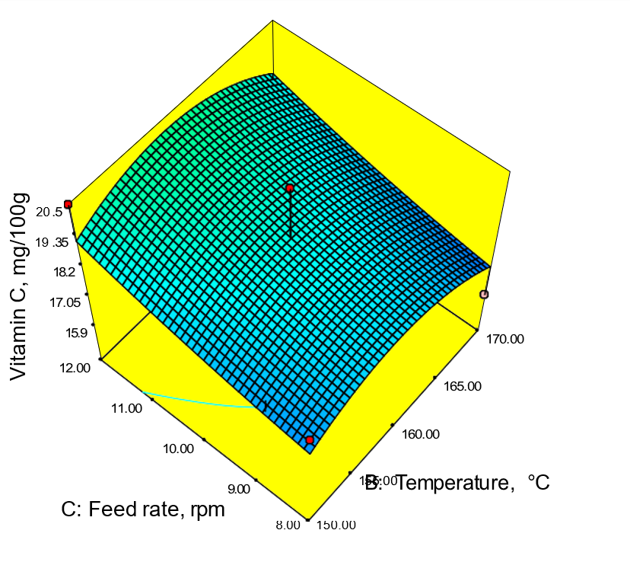

**Figure 4. Response surface plot for ascorbic acid**

**3.1.4. Effect of Process Parameters on Dispersibility**

Dispersibility, a key indicator of reconstitution quality, was significantly influenced by processing parameters (Table 2). ANOVA results revealed that inlet air temperature (p < 0.0001) and carrier concentration (p ≤ 0.05) had significant effects, with temperature-feed rate interactions also showing significance. The model had excellent fit (R² = 0.9806). The regression model (Equation 8) was

Dispersibilty=8.78-0.14A+0.78B-0.087C-0.069AB+0.13AC+0.032BC+0.12A2-0.16B2 +0.43C2……………………. (8)

Where,

A = carrier concentration (%)

B = temperature (°C)

C = feed rate (rpm)

Dispersibility ranged from 60.93% to 96.27%. The highest value was observed at 15% carrier, 170 °C, and 10 rpm, while the lowest occurred at 20% carrier, 150 °C, and 10 rpm. Dispersibility of spray dried passion fruit juice powder increased linearly with increasing temperature (Figure 5). Temperature positively influenced dispersibility, as higher inlet temperatures promoted better particle formation, consistent with findings in jamun, goat milk, and sugarcane juice powders (Santhalakshmy et al., 2015; Reddy et al., 2014; Khuenpet et al., 2016). Carrier concentration had minimal impact, aligning with Bhusari et al. (2014) for tamarind powder. Feed rate negatively influenced dispersibility, with lower feed rates producing finer particles and higher dispersibility, corroborating results from studies on tomato paste and date powder (Banat et al., 2002; Manickavasagan et al., 2015).

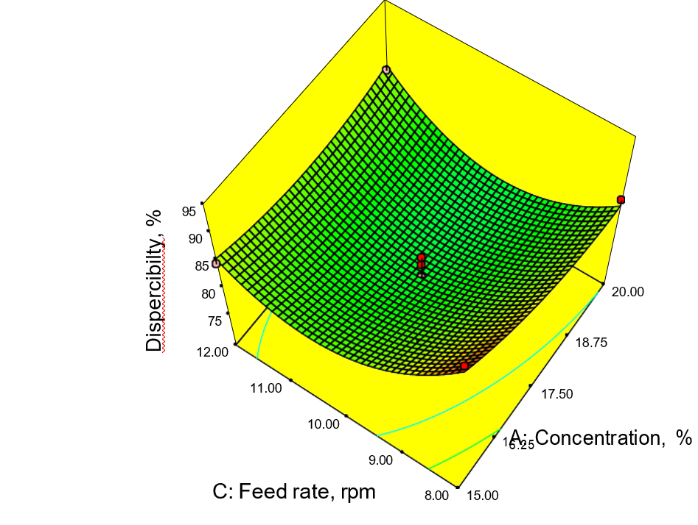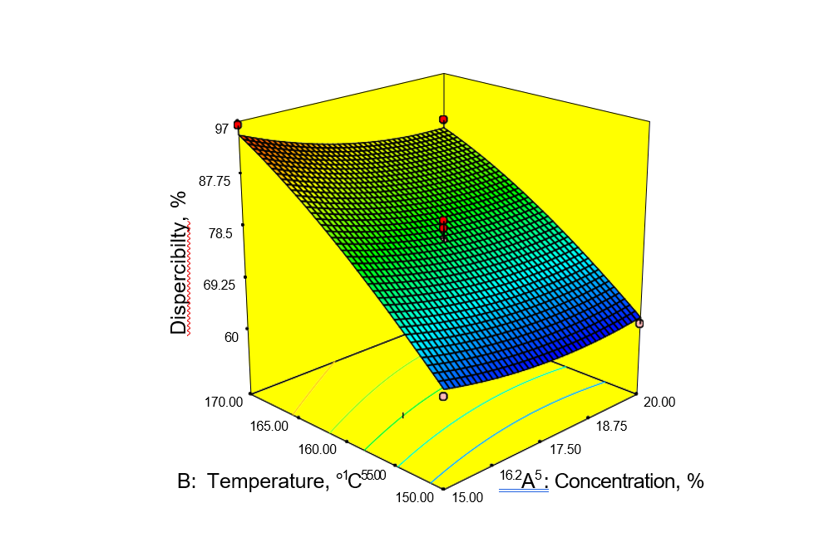

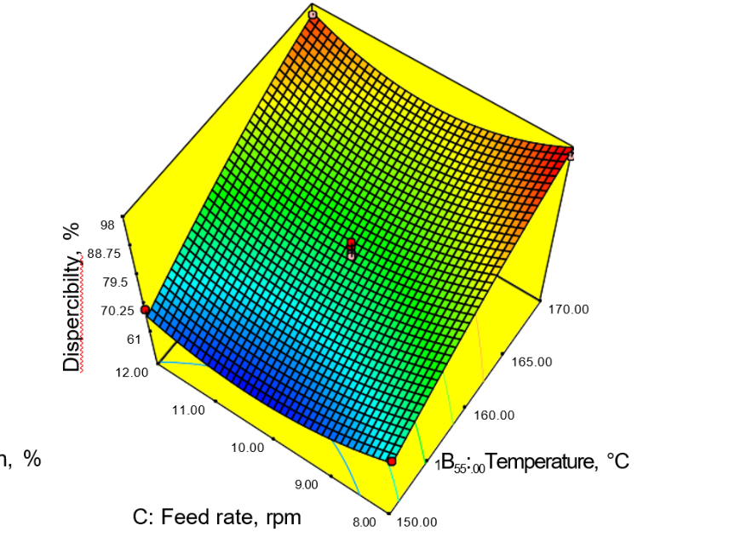

**Figure 5. Response surface plot for dispersibility**

**3.1.5. Effect of Process Parameters on wettability**

Wettability, an indicator of powder's reconstitution behaviour, was significantly influenced by inlet air temperature. The highest wettability (47.19 s) was observed at 15% carrier, 150 °C, and 10 rpm, while the lowest (8.45 s) occurred at 17.5% carrier, 160 °C, and 10 rpm (Table 2). The regression model had good fit (R² = 0.844), and the predicted equation was

Wettability (sec) = 3.90-0.46A-0.95B-0.057C+0.59AB+0.20AC+0.099BC+0.26A2+0.67B2-0.39C2………………………… (9)

Where,

A = carrier concentration (%)

B = temperature (°C)

C = feed rate (rpm).

From response surface plots (Figure 6) it is observed that the increased inlet air temperature negatively influenced on wettability of spray dried powder, while concentration and feed rate had no considerable effect. Inlet temperature had a highly significant negative effect (p ≤ 0.01), while concentration and feed rate showed no significant influence. The inverse relation between temperature and wettability may be due to the formation of coarser particles at higher temperatures, which resist water penetration. This aligns with findings from Santhalakshmy et al. (2015) and Cynthia et al. (2014), where lower wettability was associated with larger particle sizes. Fine powders exhibited better wettability due to faster water absorption.

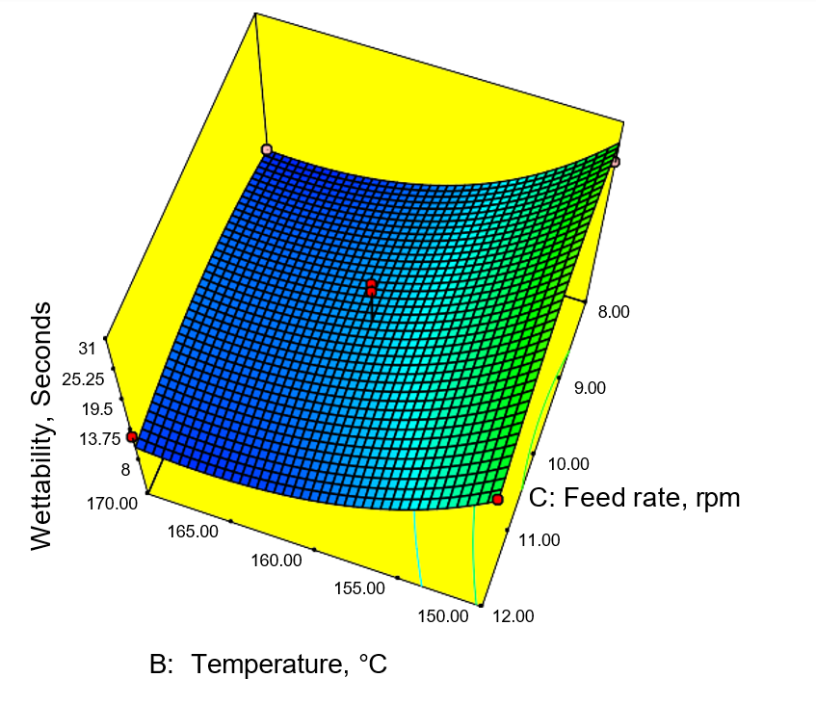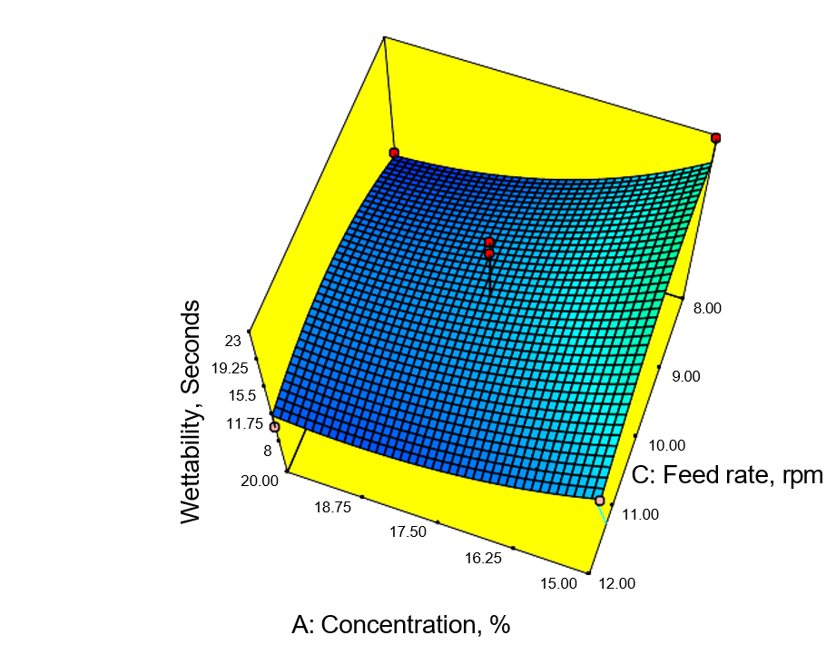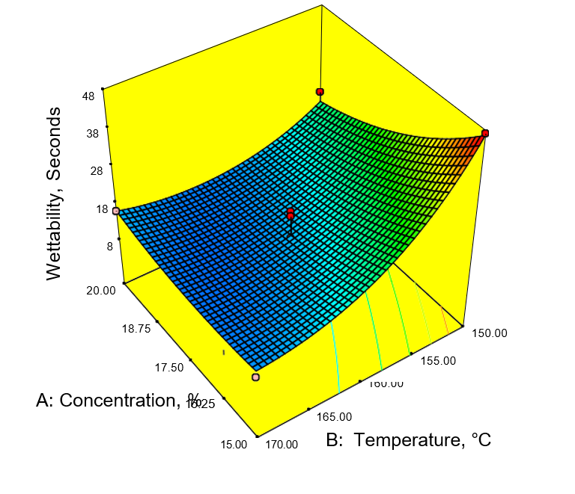

**Figure 6. Response surface plot for wettability**

**3.1.6. Effect of Process Parameters on total colour difference**

The total colour difference (∆E) of spray-dried passion fruit juice powder was significantly influenced by carrier concentration (p ≤ 0.01) and inlet air temperature (p ≤ 0.05), while feed rate showed no significant effect. The model showed good fit (R² = 0.8309), and the second-order regression equation is given as:

Total Colour Difference = 3.81+0.69A+0.52B-0.15C-0.18AB-0.31AC+0.24BC+0.11A2+ 0.34B2+0.27C2…………………………(10)

Where,

A = carrier concentration (%)

B = temperature (°C)

C = feed rate (rpm)

From the response surface plots (Fig.7) identified the variation in colour with respect to processing parameters. The temperature and carrier agent concentration exhibited positive effect on total colour difference. As temperature and concentration of carrier material increased the colour difference also increased linearly. The ∆E ranged from 7.58 to 29.24. Minimum colour deviation (7.58) was observed at 15% carrier, 150 °C, and 10 rpm, while maximum deviation (29.24) occurred at 20% carrier, 170 °C, and 10 rpm. Higher inlet temperatures and carrier concentrations increased ∆E due to intensified browning reactions such as Maillard and caramelization (Chen et al., 2014; Lee et al., 2017). Similar findings were reported for seabuckthorn and tamarind juice powders (Selvamuthukumaran & Khanum, 2014; Kha et al., 2010). Interactions between feed rate and other parameters were statistically insignificant, though variation in ∆E was observed across combinations. Maltodextrin in combination with corn starch significantly impacted colour change more than maltodextrin alone (Tontul & Topuz, 2017).

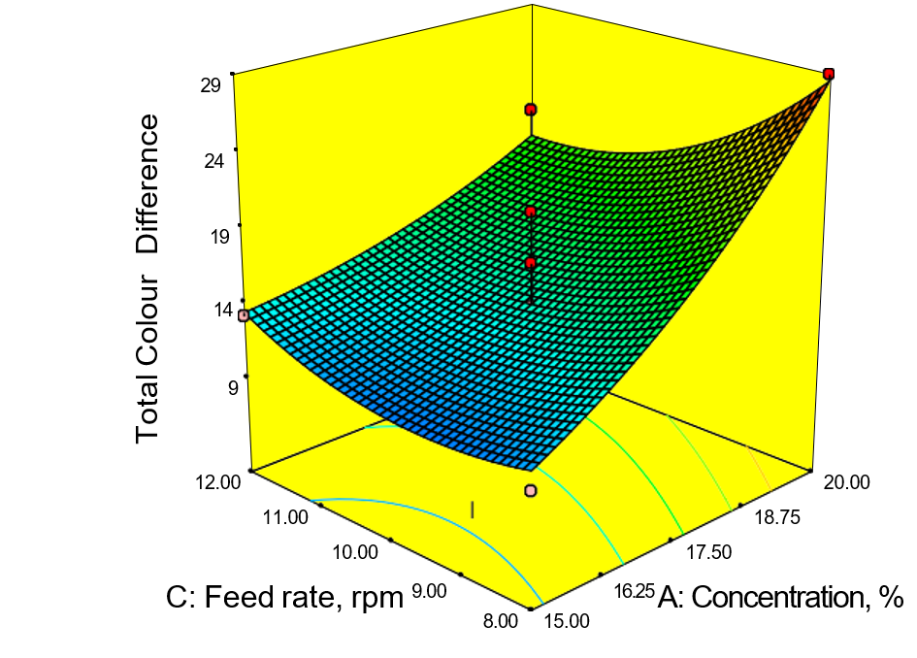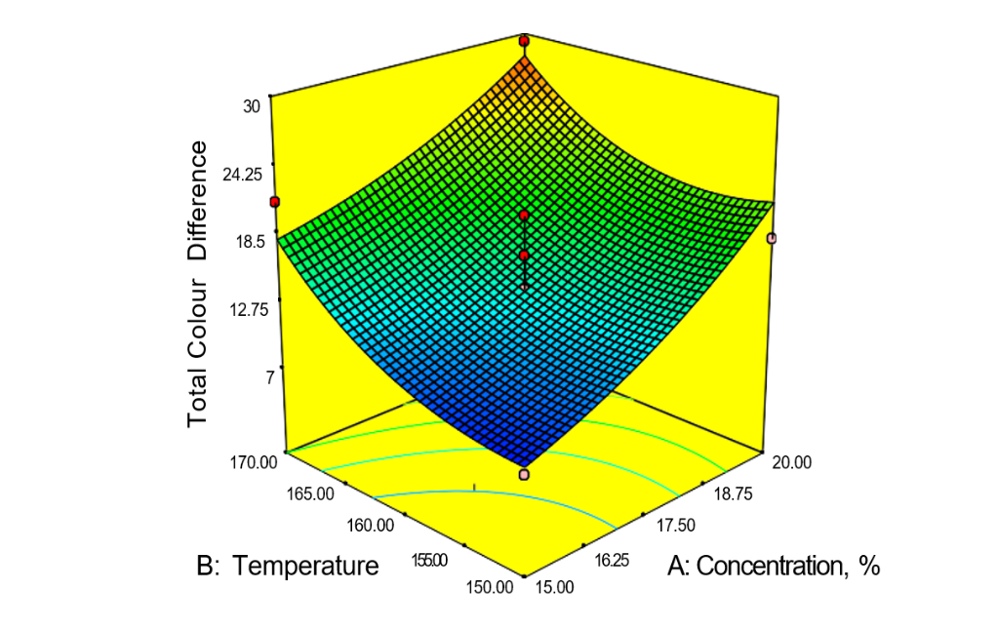

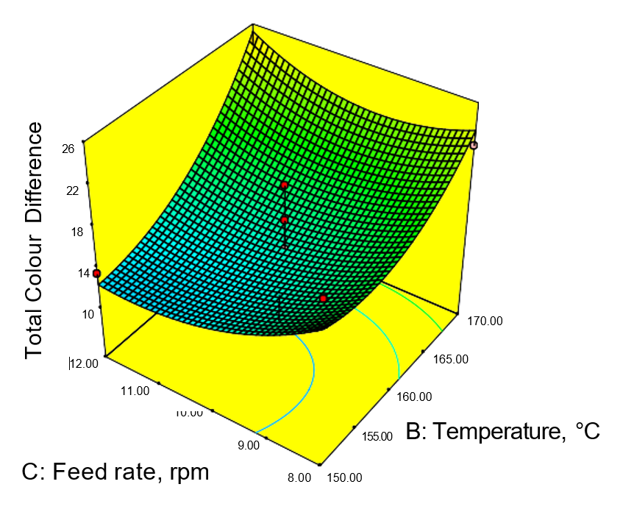

**Figure 7. Response surface plot for total colour difference**

The spray drying of passion fruit juice was optimized using a carrier combination of maltodextrin and corn starch in the ratio 3:2, with a total carrier concentration of 20%. The optimized process parameters included an inlet air temperature of 165 °C, outlet air temperature of 72–75 °C, feed pump speed of 12 rpm (0.83 L/h), blower speed of 1700 rpm, and atomizer pressure of 2.5 kg/cm². Under these conditions, the resulting powder exhibited desirable physicochemical characteristics. A product yield of 61.23 ± 0.034% was achieved, indicating efficient juice-to-powder conversion. The low moisture content (1.62 ± 0.002%) suggests good shelf stability, while the high dispersibility (89.32 ± 0.821%) reflects excellent reconstitution ability. The powder also demonstrated fast wetting behaviour, with a wettability value of 12.42±0.34 seconds, making it an advantageous trait for instant beverage applications.

1. **Conclusion**

This study successfully optimized the spray drying process to produce high-quality passion fruit juice powder. Using maltodextrin and corn starch (3:2 ratio) as carrier agents at a 20% concentration, an inlet air temperature of 165 °C, and a feed rate of 12 rpm, the researchers achieved a powder with desirable functional and physicochemical properties. The resulting powder exhibited a yield of 61.23%, low moisture content (1.62% wb), high dispersibility (89.32%), and rapid wettability (12.42 s). The inlet air temperature and carrier concentration significantly influenced the dispersibility, wettability, and total color difference of the powder. The study's regression models demonstrated strong predictive ability with high R2 values. Overall, this optimized spray drying process offers an efficient method for creating passion fruit juice powder with improved reconstitution characteristics and overall quality, making it suitable for commercial food and beverage applications.

**Data Availability Statement:**

The data that support the findings of this study are available from the corresponding author upon reasonable request.

**References**

Altendorf, S. 2019. *Major Tropical Fruits Market Review 2018.* Published by Food and Agricultural Organization, Rome, Italy, 18p.

Angel, R. C. M., Munoz, L. C. E., Aviles1, C. A., García1, R. G., Santillan, M. M., Lagunes, A. G., and Archila, M. A.2009. Spray-Drying of Passion Fruit Juice Using Lactose- Maltodextrin Blends as the Support Material. *Brazilian Archives of Boil. and Technol*. 52 (4) : 1011-1018. ISSN 1516-8913.

Atomizer. N. A. S. 1978. Determination of wettability. In: Sorensen, I.H., Krag. J., Pisecky, J., and Westergaard, V. (eds.), .*Analytical methods for dry milk product* (4th Ed.). De Forenede Trykkerier A/S, Cph. Denmark. pp. 26-27.

Bezerra, M. A. Santelli, R. E. Oliveira, E. P. Villar, L. S and Escaleira, L. A. 2008.

Response surface methodology (RSM) as a tool for optimization in analytical

chemistry. Talanta. 76(5), 965–977.

Bhandari, B. R., Dumoulin, H. M. J., Richard, H. M. J., Noleau, I., and Lebert. A. M. 1992. Flavour encapsulation by spray drying: application to critical and linalyl acetate. *J. Food Scie.* 57: 217-221.

Bhandari, B. R., Datta, N., and Howes, T.1997. Problems associated with spray drying of sugar rich foods. *Drying Technol.* 15: 671-684.

Bicudo, M. O. P., Jo, J., Oliveira, G. A. D., Chaimsohn, F. P., Sierakowski, M. R., and Freitas, R. A. D. 2015. Microencapsulation of juçara (Euterpe edulis M.) pulp by spray drying using different carriers and drying temperatures. *Drying Technol.* 33: 153-161.

Deliza, R., MacFie, H. J. H., and Hedderley, D. 2004. The consumer sensory perception of passion-fruit juice using free-choice profiling. *J. Sensory Studies.* 19(1): 577−587.

FAOSTAT [Food and Agricultural Organisation Statistics]. 2018. Production Statistics. *Rome, Italy, Minor Tropical fruits 2015- 2017* [on-line]. Available: [http://www.fao.org/docrep/006/ y5143e/y5143e1a.html](http://www.fao.org/docrep/006/%20y5143e/y5143e1a.html).

Fazaeli, M., Emam-Djomeh, Z., and Yarmand, M. S. 2016. Influence of black mulberry juice addition and spray drying conditions on some physical properties of ice cream powder. *Int. J. Food Eng.* 12: 277-285.

GEA Niro. 1978. *Milk powder technology evaporation and spray drying.* In: Sorensen, I.H., Krag. J., Pisecky, J., and Westergaard, V. (eds.) 4th Edition. GEA Niro Research Laboratory Procees Engineering. Cph. Denmark, pp. 199-219.

Goula, A. M., and Adamopoulos, K. G. 2010. A new technique for spray drying orange juice concentrate. *Innovative Food Sci. and Emerging Technol.* 11: 342-351.

Jinapong, N., Suphantharika, M. and Jamnong, P. 2008. Production of instant soymilk powders by ultra filtration, spray drying and fluidized bed agglomeration. *J. Food Eng.* 84(2): 194-205.

Joy, P. P. 2016. Status and prospectus of passion fruit cultivation in kerala. Technical report, Kerala Agricultural University, pp. 2-7.

Karaca, A. C., Guzel, O., and Mehmet, M. A. 2016. Effect of processing conditions and formulation on spary drying of sour cherry juice concentrate. *J. the Scie. Food and Agric.* 96(2): DOI: 10.1002/jsfa.7110.

Khuwijitjaru, P., and Klinchongkon, K. 2020. Passion fruit. In: Galanakis, C. M (ed.),

*Valorization of Fruit Processing Byproducts*. pp. 183-201.

Morton, J. F. 1987. *Fruits of warm climates*. Creative Resources Systems Inc*.* pp.

320–328.

Sagar, V. R., Kumar, P. S. 2010*.* Recent advances in drying and dehydration of fruits and vegetables: a review*. J. Food Sci. Technol.* Association of Food Scientists and Technologists, Mysore, India, 47(1):15–26.

Santhalakshmy, S., Bosco, S. J. D., Francis, S., and Sabeena, M. 2015. Effect of inlet temperature on physicochemical properties of spray-dried jamun fruit juice powder. *Powder Technol.* 274 (1): 37–43.

Shishir, M. R. I., and Chen, W. 2017. Trends of spray drying: a critical review on drying of fruit and vegetable juices. *Trends in Food Sci. and Technol.* Elsevier Ltd, 65 (5): 49-67.

Shishir, M. R. I., Taip, F. S., Aziz, N. A.,. Talib, R. A. 2014. Physical properties of spray-dried pink guava (psidium guajava) powder. *Agric. and Agric. Sci. Proc.* 2 : 74- 81.

Teixeira, C. G., de Castro, J. V., Tocchini, R. P., Nisida, A. L. A. C., Hashizume, T., and Medina, J. C. 1994. Maracuja: cultura, materia-prima, processamento e aspectos economicos. Campinas: *ITAL Série Frutas Tropicais* 9.

Wijeratnam, S. W. 2016. Passion fruit. In: Cabellero, B., Finglas, P. M. and Toldra,

F. (eds), *Encyclopedia of Food and Health.* Elsevier Ltd, pp. 230-234.

William, Horwitz, and George W. Latimer. 2005. Official Methods of Analysis of AOAC International. 18th ed. Gaithersburg, Md, USA: AOAC International.