Ameliorative effect of alfa-lipoic acid on cadmium-intoxicated developing chicken embryo

ABSTRACT
Exposure to heavy metals has increased due to recent industrial activities. The bioaccumulation of heavy metals, such as cadmium, has numerous negative effects on various organs. Cadmium interferes with biological functions like growth, proliferation, and differentiation of cells. Alfa-lipoic acid acts as a metal-chelating supplement that can help with vascular disease, hypertension, inflammation and fatty liver disease. A total of 48 fertilised chicken eggs were divided into four groups having 12 eggs. On day 1 of incubation, group-I eggs were kept as controls, group-II eggs were intoxicated with cadmium (3μg/egg), group-III eggs were treated with cadmium (3μg/egg) and alfa-lipoic acid (5μg/egg), and group-IV eggs were treated with cadmium (3μg/egg) and alfa-lipoic acid (10μg/egg) in-ovo inoculation. Six eggs from each group were carefully opened in a Petri dish on the seventh day to assess the degree of vascularisation and embryonic deformity. Six eggs from each treatment group were opened on the fourteen days to gather liver and heart tissue samples, which were stained with Hematoxylin & Eosin and Masson's trichrome stain to document histopathological changes. Cadmium inhibited vascularization in chicken embryos at the 7th day. Amplified vascularization and arbourization of chief and small blood vessels were clearly apparent because of alfa-lipoic acid’s enriching impact. At the 14th day, cadmium-intoxicated chicken embryos showed significant necrosis, congestion, fibrosis, haemorrhage and hypertrophy of cells in hepatic and cardiac tissues. These pathological changes were reversed significantly by alfa-lipoic acid as seen in histology. Thus, alfa-lipoic acid can reduce the severity of cadmium intoxication.
Keywords: Chicken embryo, Cadmium, Alfa-lipoic acid, Histopathology

- INTRODUCTION
Industrial and anthropogenic activities, as well as modern industrialisation, have increased exposure to heavy metals, resulting in negative health consequences (Luo et al. 2020). Cadmium and other heavy metals have a variety of immediate and long-term negative effects on different body organs, which can lead to consequences like neurological issues, gastrointestinal and renal dysfunction, lesions of the skin, damage to blood vessels, immune system collapse, and birth defects (Gazwiet al.2021).
In addition to the electroplating industry, cadmium exposure can also happen in the alloy, battery, and glass manufacturing industries. They may frequently react with biological systems, releasing one or more electrons and producing metal cations that are attracted to significant macromolecules' nucleophilic sites (Balali-Mood et al. 2021). Cadmium has been linked to hepatotoxicity. Acute toxicity can manifest as necrosis or apoptosis, depending on the circumstances of exposure (Pi et al. 2015). Cadmium poisoning has been linked to an increase in mortality due to cardiovascular damage (Pradhan et al., 2023). Cadmium's involvement in cardiovascular disease and myocardial infarction is demonstrated by endothelial dysfunction at the beginning of the condition, loss of endothelial cell structure leading to cell death, and thrombogenic events (Rafati et al. 2017). Due to increased risk of nephrotoxicity, BAL (British Anti Lewisite) treatment is not administered in cadmium poisoning.
Cadmium reduces antioxidant enzymes, produces reactive oxygen species, and oxidises lipids. Cadmium causes oxidative stress through formation of reactive oxygen species (ROS) causingorgan toxicity, carcinogenicity, and apoptotic cell death (Brancaet al., 2020). Antioxidants like vitamin C and E have been shown to protect experimental mice from cadmium poisoning. By reducing lipid peroxidation and increasing glutathione levels in rats, a blend of alpha-tocopherol, ascorbic acid, and selenium is helpful against cadmium poisoning (Koyuturket al., 2006).
Alpha-lipoic acid (thioctic acid) is a natural chemical present in plant and animal cell membranes and cytoplasm (Tripathi et al., 2023). Because it is inadequate in the human diet, the body spontaneously synthesises it in the liver, heart, and testis to produce the needed alfa-lipoic acid. It also preserves cellular membranes by interacting with vitamin C and glutathione, recycling vitamin E in the process (Jan et al., 2015). It is also present in Solanum tuberosum (potato), Spinacia oleracea(spinach), Solanum lycopersicum (tomato), Beta vulgaris (beet), Daucus carrota (carrot), Brassica oleracea (broccoli), Pisum sativum (Peas) (Markiewicz-Górkaet al. 2019) and organ meats of liver, kidney, spleen, brain, testis, etc (Fig. 1).
Figure 1: Sources of Alpha-lipoic acid
The therapeutic role of alfa-lipoic acid against lead is due to chelation, antioxidative, anti-inflammatory, and antiapoptotic activities (Deoreet al. 2021). Considering the potential of alfa-lipoic acid as protectant, we aimed to assess the protective effect of alfa-lipoic acid in cadmium intoxicated chicken embryos.
- MATERIALS AND METHODS
Chemicals
Cadmium was employed @ 3μg/egg, which is the lethal dose (LD)₅₀ (Khandia et al., 2017). Cadmium and alfa-lipoic acid, were obtained from MP Biomedicals, France and kept at 2–8°C. Both cadmium and alfa-lipoic acid stock solutions were prepared in Millipore water and serially diluted up to the required dosage before inoculation in liquid form.
Fertilised chicken eggs
48 fertilised chicken eggs weighing around 55.0 ± 2.0 g and 0 day old were bought from the Central Poultry Development Organization, Bhubaneswar, Odisha. Candling was performed to determine whether the eggs had been fertilised. The research was carried out at CVSc & AH, OUAT, Bhubaneswar. As per the CPCSEA, experiments involving avian embryos and chicken CAM models do not necessitate ethical approval (Fauzia et al., 2018). This is because chick embryos lack nociception and do not experience pain until day 14 (Ribatti, 2016, Buhr et al., 2020, Kundeková et al., 2021, Mishra et al., 2021). Nevertheless, all necessary precautions were taken to ensure the experiment was conducted ethically.
Experimental protocol
The total numbers of eggs were divided into four groups, each with 12 eggs. On day 1 of incubation, group-I eggs were kept as controls, while group-II eggs were cadmium (3μg/egg) intoxicated, group-III eggs were cadmium (3μg/egg) and alfa-lipoic acid (5μg/egg) treated, and group-IV eggs were cadmium (3μg/egg) and alfa-lipoic acid (10μg/egg) treated through in-ovo inoculation. Using a dental drill, a tiny hole was bored into each egg on the side opposite the air sac, i.e., into egg albumin, as per Dzugan et al. (2011). After administration of cadmium and alfa-lipoic acid with an insulin syringe, the pores in the eggs were closed with parafilm and incubation was done at 37°C and 65–75 % relative humidity.
Gross examination
On the seventh day, six eggs from each group were gently cracked open in a Petri plate (after angiogenesis was complete) to assess the level of vascularization, angiogenesis, and macroscopically the embryonic malformation in the chorioallantoic membrane of treated eggs (Khandia et al. 2017).
Histological Evaluation
Six eggs from each treatment group were opened on the fourteenth day (after organogenesis was complete) to collect liver andheart tissue samples in 10% BNF. After 72 hours of fixation, routine processing of the samples was done to obtain 6 µm thick serial paraffin slices. Hematoxylin and Eosin staining was performed for histoarchitecture, and Masson's trichrome stain was employed to demonstrate collagen fibres (Bancroft and Stevens, 1996). The histopathological alterations were documented using a trinocular research microscope (Leica, DM 2500, Digital camera system DFC 290).
- RESULTS AND DISCUSSION
The chick's chorioallantoic membrane (CAM) is an extra-embryonic membrane that is packed with capillaries, lymphatic channels, and blood vessels. The avian embryo's chorioallantoic membrane (CAM) is an inherently fascinating organ for gas exchange and osmoregulation that has an impact on the development of the heart and central arteries (Burggren, and Rojas Antich, 2020). It is frequently utilised to investigate in vivo angiogenesis and anti-angiogenesis of biomolecules and medications. The CAM tests use in-ovo techniques with restricted access to the CAM and better viability of the embryo (Naik, et al., 2018). The chicken egg CAM assay can record response of blood vessels to a variety of agonists (Nowak-Sliwinska et al., 2014), evaluate efficacy of anticancer drug delivery (Vu, et al., 2018), study CAM tumor model of adenoviral vectors (Duruptet al., 2012) and perform cardiovascular research (Burggren, and Rojas Antich, 2020). It is an upcoming model for fields of bioengineering, developmental biology, morphology, vascular biology, biochemistry and transplant biology (Nowak-Sliwinska et al., 2014).
Figure 2: Alfa-lipoic acid recovers cadmium-intoxicated developing chicken embryo

Following treatment, the four groups of resealed fertilised chicken eggs were examined and loosened on the seventh and fourteenth day of incubation. It was observed that the cadmium at a concentration of 3µg/egg reduced vascularization in 7-day fertilised chicken eggs (Figure 3a). Our findings proved that cadmium has an angiostatic effect on endothelial cells. According to Woods et al. (2008), cadmium may prevent angiogenesis by interfering with cadherin-mediated cell-cell adhesion and changing the location and functionality of VE-cadherin, a molecule necessary for angiogenesis. In the course of the regular angiogenic process, it inhibits endothelial cell migration, proliferation, and tube creation. Additionally, Prozialeck et al. (2008) found that VE-cadherin inhibits tube formation by being sequestered from the endothelial cell surface. It can target molecules such as metal ion transporters, protein kinase signalling pathways, and cell adhesion molecules that are present in vascular endothelial cells (Prozialeck et al., 2006, Oliveira-Paula et al., 2024).
The effects of cadmium toxicity on the embryo could not be reversed by alfa-lipoic acid at 5 µg/egg; however, at 10 µg/egg, cadmium-induced altered vascularization, angiogenesis, and embryonic malformation—all indicators of the growth and development of fertilised chicken eggs—could almost completely be reversed. Significant development of major and minor blood vessels in the cardiac and hepatic tissues was indicative of the reduced neo-vascularization brought on by cadmium and its reversal by alfa-lipoic acid (Figure 3b and 3c). Alfa-lipoic acid’s ability to restore vascular architecture in cadmium-intoxicated chicken embryos may be due to its antioxidant effect. Alfa-lipoic acid shows noticeable enhancement in antioxidant enzymes in rat erythrocytes and biomarkers of oxidative stress proving its cytoprotective and antioxidant effect in combating free radical-induced tissue injury and oxidative stress in cadmium toxicity (Hussein et al., 2014).
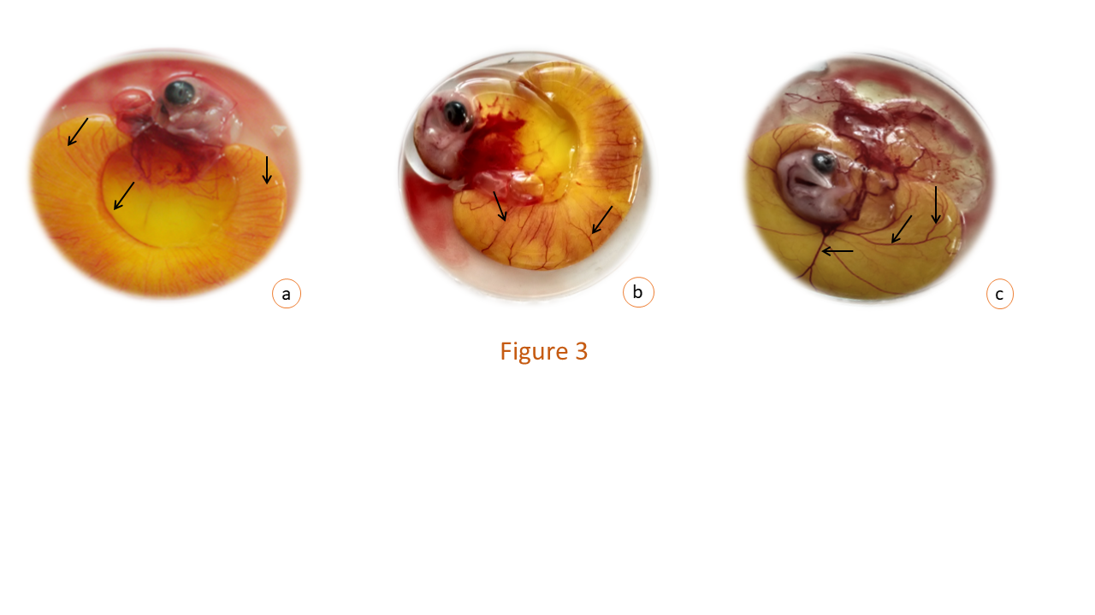
Figure 3 : Gross examination of 7 day old developing chicken embryo
Figure 3 a: Group II: Cadmium(3µg) treated embryonated egg opened at 7th day showing faintly appearing blood vessels (arrow).
Figure 3 b: Group III: Cadmium (3µg) + dl-α-lipoic acid (5µg) treated embryonated egg opened at 7th day showing appreciable blood vessels (arrow) but not in the appropriate pattern.
Figure 3 c: Group IV: Cadmium (3µg) + dl-α-lipoic acid (10µg) treated embryonated egg opened at 7th day showing very prominent blood vessels (arrow) arborized (primary, secondary and tertiary blood vessels) in a definite pattern.

The cadmium intoxicated liver and heart tissue from 14-day fertilised chicken eggs displayed pathological changes of hepatic and cardiac parenchyma respectively. The liver tissue showed hypertrophied hepatocytes with pyknotic nuclei and vacuolated cytoplasm, dilated sinusoids (Fig 4a), moderate fibrosis, focal necrosis, degeneration, and haemorrhage. Moderate hyperplasia and hypertrophy of Kupffer cells and inflammatory cells infiltration as perivascular cuff were also observed. At some locations the hepatic capsule was also found to be discontinuous and disrupted. The cadmium intoxicated heart tissue revealed severe interstitial inflammation of the myocardial fibers with loss of characteristic cross-striation pattern. There was moderate cytoplasmic vacuolation arranged irregularly as a syncytium (Fig 4b). Aggregation of mononuclear cells in between the myofibers, desquamation of endothelial lining of the endocardium, and moderate haemorrhage were noted. Both the ventricular walls of the heart were thickened. Pawlak et al. (2013) observed alike histopathological changes due to cadmium toxicity but in case of heart only thickening of the right ventricle wall were recorded. Acute and/or high cadmium exposures could negatively affect organ morphology and physiology in a non-compensated, irreversible and detrimental manner (Lee and Thévenod, 2020).
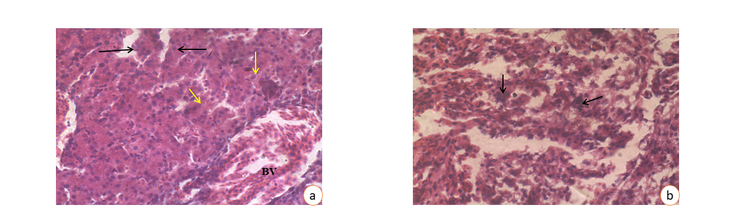
Figure 4: Photomicrograph of liver (a) and heart (b) of chick embryo at 14th day of incubation period treated with Cadmium (3µg/egg)
a: Hypertrophied hepatic sinusoids (black arrow). The nuclear condensation (yellow arrow) of the hypertrophied Kupffer cells and highly enlarged blood vessels (BV) are noted.
H & E- staining × 400
b: Condensation of chromatin material within nuclei of myocardiocytes (arrow). The atrophied and pycnotic nuclei as well as fragmented nuclei are noted.
H & E - staining × 400
The hepatic parenchyma of cadmium intoxicated chicken embryo treated with alfa-lipoic acid @ 5µg/egg exhibited near normal histoarchitecture with minor pathological alterations (Fig 5 a, b). Some of the hepatocytes had a moderate vacuolization in the cytoplasm. Necrosis and haemorrhage were apparently absent. There was mild sinusoidal dilatation and mononuclear cell infiltration. The histomorphology of the cadmium intoxicated liver tissue treated with alfa-lipoic acid (@ 10µg/egg was very close to normal. The hepatocytes had vesicular central nucleus, normal sinusoids, Kupffer cells and negligible infiltration of inflammatory cells (Fig 5c, d). .The ameliorative effect of alfa-lipoic acid against cadmium toxicity related histopathology reveals that alfa-lipoic acid treatment triggered the repair of damaged histoarchitecture in the liver, which was more apparent at the dose rate of alfa-lipoic acid @10µg/egg. Shi et al. (2021) found a reduced level of damage in chicken liver exposed to cadmium treated with alfa-lipoic acid, suggesting that its protective effect is exerted by stabilizing the cell membrane of hepatocytes.
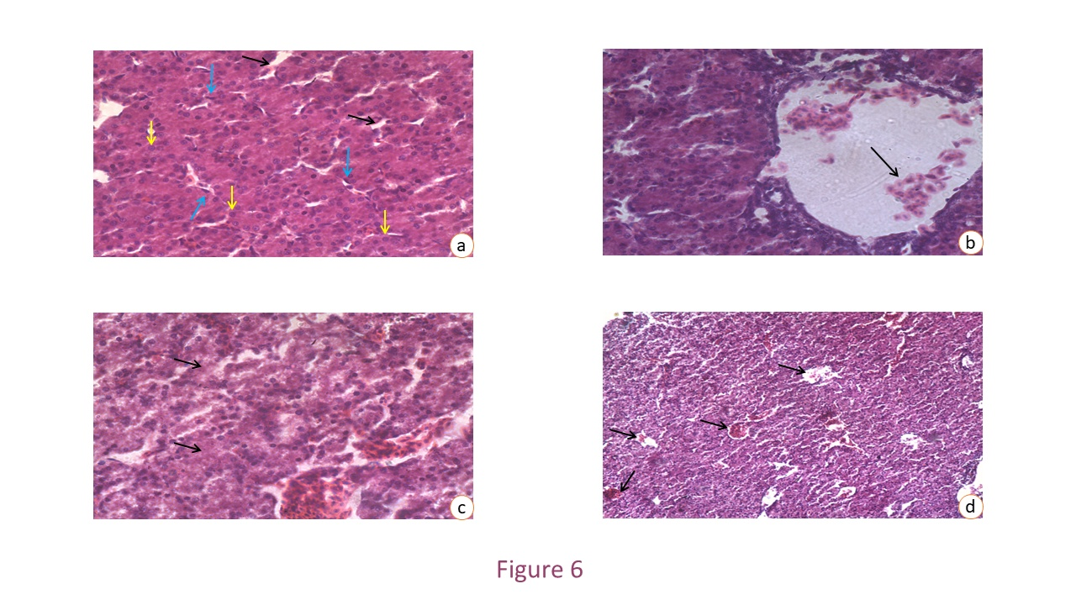
Figure 5 : Photomicrograph of liver of chick embryo at 14th day of incubation period
Figure 5 a: Group III: Cadmium (3µg) + dl-α-lipoic acid (5µg) showing the euchromatic circular nucleus (yellow arrow) in most of the hepatocytes and moderately enlarged sinusoids (black arrow). The normal morphology and frequency of kupffer cells (blue arrow) on the sinusoidal walls are noted.
H & E - staining × 400
Figure 5 b: Group III: Cadmium (3µg) + dl-α-lipoic acid (5µg) showing loose scatters of RBC (arrow) in the lumen of blood vessels of the hepatic parenchyma. Strongly eosinophilic and granular cytoplasm of the hepatocytes are noted.
H & E - staining × 400
Figure 5 c: Group IV: Cadmium (3µg) + dl-α-lipoic acid (10µg) showing the highly eosinophilic and granular cytoplasm of the hepatocytes (arrow). The slight degree of vacuolation in the cytoplasm of hepatocytes are noted.
H & E- staining × 400
Figure 5 d: Group IV: Cadmium (3µg) + dl-α-lipoic acid (10µg) showing the extensive proliferation of blood vessels (arrow) in the hepatic parenchyma.
H & E- staining × 100
The heart of cadmium intoxicated chicken embryo treated with alfa-lipoic acid @ 5µg manifested a diffuse cross striation pattern of myocardial fibres, moderate myocardial inflammation and necrosis, rare mononuclear cell infiltration along with a continuous endocardium. The tissue section of cadmium intoxicated heart treated with alfa-lipoic acid @ 10µg exhibited almost normal histomorphology. Myocardial fibers had distinct cross-striations, no myocarditis, fibrosis, and congestion with an intact endocardium (Fig 6 a,b,c). Myocardiocytes contained euchromatic nucleus and uniformly eosinophilic cytoplasm. Alpha-lipoic acid supplement amplified antioxidative potential and partly normalized the liver and kidney function by decreasing oxidative stress and inflammatory marker levels (Markiewicz-Górka et al., 2019). Mukherjee et al. (2011) reported that alpha lipoic acid significantly prevented cardiac damage, marker enzymes leakage, reduced cardiac free radicals’ generation, antioxidant status, structural changes and increased metallothionein induction when co-administrated with melatonin showing efficacy in protection against oxidative cardiac damage induced by cadmium (Dosoky et al., 2023). Following cadmium exposure, alfa-lipoic acid upregulated Nrf2 and GPx1 gene expression and downregulated Keap1 in the rabbits' brain showing its effectiveness in protection against cadmium-induced oxidative stress and the depletion of cellular antioxidants due to its free radical scavenging antioxidant, and chelating effects (Saleh et al., 2017). Alfa-lipoic acid acts as an enzymatic cofactor for metabolism regulation, energy production and has epigenetic genes regulation of inflammatory mediators, like PGE2, IL-1β, TNF-α, iNOS, COX-2, and IL-6 (Famurewa et al., 2023). Also, its antioxidant capacity prevents excess free radical formation, improves mitochondrial performance (Correia et al., 2021).
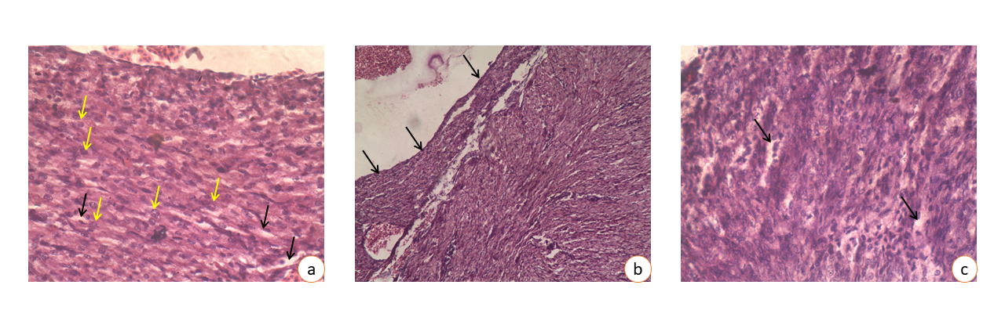
Figure 6: Photomicrograph of heart of chick embryo at 14th day of incubation period
Figure 6 a: Group III: Cadmium (3µg) + dl-α-lipoic acid (5µg) showing the vacuolation (black arrow) between myocardial fibres. The euchromatic nuclei (yellow arrow) are more frequent than the heterochromatic nuclei of myocardiocytes are noted.
H & E- staining × 400
Figure 6 b: Group III: Cadmium (3µg) + dl-α-lipoic acid (5µg) showing the normal endocardium (arrow) of heart with slight degree of desquamation.
H & E- staining × 100
Figure 6 c: Group IV: Cadmium (3µg) + dl-α-lipoic acid (10µg) showing a mild degree of vacuolation (arrow) between the myocardial fibres.
H & E - staining × 400
- CONCLUSION
Cadmium inhibited neovascularization in the CAM of chick embryo and altered the cell construction of the liver and heart. Alpha-lipoic acid protects cadmium-intoxicated developing chicken embryos by ameliorating decreased neovascularisation in the CAM and restoring normal cellular architecture of liver and heart. Thus, alfa-lipoic acid can be proposed as a possible remedy for cadmium toxicity.

REFERENCES
Balali-Mood M, Naseri K, Tahergorabi Z, Khazdair MR, Sadeghi M, 2021. Toxic mechanisms of five heavy metals: Mercury, Lead, Chromium, Cadmium, and Arsenic. Frontiers in pharmacology. 12.
Bancroft JD and Stevens A, 1996. Wiley-Liss. Theory and practice of histological techniques, 4th ed. Churchill Livingstone, New York/London/San Francisco/Tokyo.

Branca JJ, Fiorillo C, Carrino D, Paternostro F, Taddei N, Gulisano M, Becatti M, et al,. 2020. Cadmium-induced oxidative stress: focus on the central nervous system. Antioxidants. 9(6):492.
Buhr CR, Wiesmann N, Tanner RC, Brieger J, Eckrich J, 2020. The chorioallantoic membrane assay in nanotoxicological research—an alternative for In vivo experimentation. Nanomaterials.10(12):2328.

Burggren W & Rojas Antich M, 2020. Angiogenesis in the Avian Embryo Chorioallantoic Membrane: A Perspective on Research Trends and a Case Study on Toxicant Vascular Effects. Journal of Cardiovascular Development and Disease. 7(4):56.
Correia Y, Scheel J, Gupta S, & Wang K, 2021. Placental mitochondrial function as a driver of angiogenesis and placental dysfunction. Biological Chemistry
Deore MS, Naqvi S, Kumar A, Flora SJ, 2021. Alpha-Lipoic acid protects co-exposure to Lead and Zinc oxide nanoparticles induced neuro, immuno and male reproductive toxicity in rats. Frontiers in Pharmacology. 12:1210.
Dosoky WM, Farag SA, Almuraee AA, Youssef IM, Awlya OF, Abusudah WF, Qadhi A, Arbaeen AF, Moustafa M, Hassan H, & Tellez-Isaias G. 2024. Vitamin C and/or garlic can antagonize the toxic effects of cadmium on growth performance, hematological, and immunological parameters of growing Japanese quail. Poultry Science. 103(3):103457
Durupt F, Koppers-Lalic D, Balme B, et al,. 2012. The chicken chorioallantoic membrane tumor assay as model for qualitative testing of oncolytic adenoviruses. Cancer Gene Ther. 19:58–68 https://doi.org/10.1038/cgt.2011.68)
Famurewa A C, Hamdi H, & Sedky A 2023. Lipoic acid abates testis lead accumulation, sperm-endocrine deficits, testicular oxidative inflammation and apoptosis and modulates gene expression of Bax and Bcl-2 in rats. Scientific African. 21: e01842
Fauzia E, Barbhuyan TK, Shrivastava AK, Kumar M, Garg P, Khan MA, Raza SS, et al,. 2018. Chick embryo: a preclinical model for understanding ischemia-reperfusion mechanism. Frontiers in pharmacology. 9:1034.
Gazwi HS, Yassie EE, Hassan HM, 2020. Mitigation of lead neurotoxicity by the ethanolic extract of Laurus leaf in rats. Ecotoxicology and environmental safety. 192:110297.
Hussein SA, Omnia M & Fayed AM, 2014. Protective effects of alpha-lipoic acid and melatonin against cadmium-induced oxidative stress in erythrocytes of rats. J. Pharmacol. Toxicol. 9: 1-24.
Jan AT, Azam M, Siddiqui K, Ali A, Choi I, Haq QM, et al,. 2015. Heavy metals and human health: mechanistic insight into toxicity and counter defense system of antioxidants. International journal of molecular sciences. 16(12):29592-29630.
Khandia RA, Dwivedi A, Sahu P, Vishwakarma A, Kumar K, Dhama Munjal A, et al,. 2017. Anti-angiogenic Effects of Cadmium Chloride on the Process of Neovascularization. Journal of Biological Sciences. 17(1):42-46.
Koyuturk M, Yanardag R, Bolkent S, Tunali S, 2006. Influence of combined antioxidants against cadmium induced testicular damage. Environmental toxicology and pharmacology. 21(3):235-240.
Kundekova B, Macajova M, Meta M, Cavarga I, Bilcik B, 2021. Chorioallantoic Membrane Models of Various Avian Species: Differences and Applications. Biology. 10(4):301.
Lee WK, & Thevenod F, 2020. Cell organelles as targets of mammalian cadmium toxicity. Archives of toxicology. 94(4):1017-1049.
Luo L, Wang B, Jiang J, Huang Q, Yu Z, Li H, et al,.2020. Heavy metal contaminations in herbal medicines: determination. comprehensive risk assessments. Front. Pharmacol, 11:595335. doi:10.3389/fphar.2020.595335
Markiewicz-Gorka I, Pawlas K, Jaremkow A, Januszewska L, Pawłowski P, & Pawlas N, 2019. Alleviating Effect of α-Lipoic Acid and Magnesium on Cadmium-Induced Inflammatory Processes, Oxidative Stress and Bone Metabolism Disorders in Wistar Rats. International journal of environmental research and public health. 16(22): 4483. https://doi.org/10.3390/ijerph16224483
Mishra, C. B., Dash, J. R., Patra, R., Mishra, U. K., Parija, S. C., & Palai, S. (2021). Protective effect of morin against cadmium induced toxicity in the developing chicken embryo. Annals of Phytomedicine, 10(2), 376-383.
Mukherjee R, Banerjee S, Joshi N, Singh PK, Baxi D, & Ramachandran AV, 2011. A combination of melatonin and alpha lipoic acid has greater cardioprotective effect than either of them singly against cadmium-induced oxidative damage. Cardiovascular toxicology. 11(1): 78-88.
Naik M, Brahma P, & Dixit M, 2018. A cost-effective and efficient chick ex-ovo CAM assay protocol to assess angiogenesis. Methods and protocols. 1(2):19.
Nowak-Sliwinska P, Segura T, & Iruela-Arispe ML, 2014. The chicken chorioallantoic membrane model in biology, medicine and bioengineering. Angiogenesis. 17(4):779–804. https://doi.org/10.1007/s10456-014-9440-7.
Oliveira-Paula G H, Martins A C, Ferrer B, Tinkov A A, Skalny A V, & Aschner M, 2024. The impact of manganese on vascular endothelium. Toxicological Research. 1-17.
Pi H, Xu S, Reiter RJ, Guo P, Zhang L, Li Y, Zhou Z, et al,. 2015. SIRT3-SOD2-mROS-dependent autophagy in cadmium-induced hepatotoxicity and salvage by melatonin. Autophagy. 11(7):1037-1051.
Pradhan S, Palai S, Dash J R, Patra R, Sahoo P R, Behera P C, & Parija S C, 2023. Characterisation of selenium nanoparticles and Phyllanthus niruri Hook. f. selenium nanoparticles with histopathological investigation of their effects on cadmium-induced gastric toxicity in wistar rats. Annals of Phytomedicine. 12(1):367-375.
Prozialeck WC, Edwards JR, Nebert DW, Woods JM, Barchowsky A & Atchison WD, 2008. The vascular system as a target of metal toxicity. Toxicological Sciences. 102(2):207-218.
Prozialeck WC, Edwards JR, Woods JM, 2006. The vascular endothelium as a target of cadmium toxicity. Life Sci. 2006 Sep 13;79(16):1493-506. doi: 10.1016/j.lfs.2006.05.007. Epub 2006 May 17. PMID: 16765992.
Rafati-Rahimzadeh M., RafatiRahimzadeh M, Kazemi S, Moghadamnia, AA, 2017. Cadmium toxicity and treatment: An update. Caspian journal of internal medicine. 8(3):135–145. https://doi.org/10.22088/cjim.8.3.135
Ribatti D, 2016. The chick embryo chorioallantoic membrane (CAM). A multifaceted experimental model. Mechanisms of development. 141:70-77.

Saleh HM, El-Sayed YS, Naser SM, Eltahawy AS, Onoda A & Umezawa M, 2017. Efficacy of α-lipoic acid against cadmium toxicity on metal ion and oxidative imbalance, and expression of metallothionein and antioxidant genes in rabbit brain. Environmental Science and Pollution Research. 24(31):24593-24601.
Tripathi A K, Ray A K, Mishra S K, Bishen S M, Mishra H, & Khurana A 2023. Molecular and therapeutic insights of alpha-lipoic acid as a potential molecule for disease prevention. Revista Brasileira de Farmacognosia. 33(2):272-287.
Vu BT, Shahin SA, Croissant J, Fatieiev Y, Matsumoto K, Doan TLH, & Tamanoi F, 2018. Chick chorioallantoic membrane assay as an in vivo model to study the effect of nanoparticle-based anticancer drugs in ovarian cancer. Scientific reports. 8(1):1-10.
Woods JM, Leone M, Klosowska K, Lamar PC, Shaknovsky TJ, & Prozialeck WC, 2008. Direct antiangiogenic actions of cadmium on human vascular endothelial cells. Toxicology in vitro. 22(3):643-651.

