Invasive Acacia tortilis and Soil Organic Carbon Dynamics in Jorbeer Conservation Reserve, Bikaner, Rajasthan, India

Abstract: Soil organic carbon (SOC) is widely recognized as a critical indicator of soil health, productivity, and climate change mitigation potential, particularly in fragile arid ecosystems where organic matter is naturally low. The present study examines the effect of Acacia tortilis, a hardy leguminous tree species with invasive tendencies in the Thar Desert, on SOC levels within the Jorbeer Conservation Reserve, Bikaner, Rajasthan. Soil samples were systematically collected from three distinct land-use categories—dumping site, grassland, and adjacent non-vegetated open areas (controls)—under A. tortilis canopy and across four seasonal periods (summer, rainy, winter, and spring). SOC content was quantified at two soil depths (0–15 cm and 15–30 cm) using standardized methodologies. Results revealed that soils under A. tortilis exhibited significantly higher SOC concentrations than open control sites, with the most pronounced enhancement recorded during the winter season. This increase can be attributed to increased litter deposition, moderated soil temperature fluctuations, and improved microclimatic conditions that are conducive to organic matter accumulation and microbial activity beneath the tree canopy. Among all land-use categories, the dumping zone recorded the highest SOC levels, followed by grassland and open land. The findings highlight the ecological role of A. tortilis in enhancing SOC and improving soil quality in arid ecosystems, while simultaneously raising concerns about its invasive spread and impact on native grassland biodiversity. The study underscores the importance of balancing carbon sequestration benefits with biodiversity conservation when evaluating the role of exotic leguminous trees in arid land management and ecological restoration.
Keywords: - Soil organic carbon; Acacia tortilis; Jorbeer Conservation Reserve; carbon sequestration.
Introduction: -
Arid and semi-arid ecosystems, such as the Thar Desert in northwestern India, are recognized worldwide as fragile ecological systems. Even small changes in vegetation can greatly impact biodiversity, soil health, and how these ecosystems work. These landscapes have low and unpredictable rainfall, high rates of evapotranspiration, poor soils, and frequent droughts.Under these conditions, the presence of perennial vegetation, especially woody species, significantly shapes ecosystem processes (Stavi et al., 2023). Trees stabilize soils, reduce wind erosion, and help with nutrient cycling, microclimate improvement, and storing soil organic carbon (SOC). SOC is vital for soil fertility and plays a key role in fighting climate change (Devi, 2021; Shi et al., 2018).
In recent decades, large-scale tree planting and sand dune stabilization projects have taken place across Rajasthan. These efforts aim to counter desertification, improve rural livelihoods, and boost ecosystem services (Yadav et al., 2021). Typically, hardy exotic tree species have been favored due to their fast growth, drought resistance, and usefulness for fuelwood, fodder, and shelter (Yadav et al., 2022). One notable example is Acacia tortilis, also known as the umbrella thorn, which is native to Africa and the Middle East. This species was widely planted in the Thar Desert during the 1960s and 1970s. Its deep root system, ability to fix nitrogen from the air, and durability in extreme dryness initially made it a popular choice for ecological restoration (Cheruto et al., 2025; Andersen and Krzywinski, 2007; Asaye, 2016). Over time, however, Acacia tortilis has shown invasive tendencies in several areas of the Thar Desert, including the Jorbeer Conservation Reserve in Bikaner. Jorbeer was once an open arid grassland mixed with native shrubs like Capparis decidua and Calligonum polygonoides, along with grasses such as Cenchrus ciliaris and Lasiurus sindicus. This area is ecologically unique because it supports large groups of raptors, especially migratory vultures, eagles, and harriers. The open landscape offers critical foraging and roosting sites for these birds, many of which are globally at risk. The spread of A. tortilis into these habitats is changing both the structure and function of the ecosystem (Stave et al., 2006).
Dense thickets of A. tortilis, due to their sharp thorns and robust coppicing, block movement. These thickets limit visibility and the ability of large scavenging birds to maneuver in the air (Gowda, 1996; Ross and Burt, 2015). Moreover, the heavy shade from its canopy, combined with high litter fall and possible negative effects on other plants, limits the growth and renewal of native grasses and herbs. This reduction impacts food availability for herbivores, decreases the numbers of insects and small animals, and weakens the ecological foundations that support higher-level predators. From a water perspective, the deep roots of A. tortilis compete for limited soil moisture, putting native plant species at a disadvantage. Additionally, its thorny barriers hinder the movement of livestock and wild ungulates, creating new problems for reserve management and communities that depend on grazing. The spread of Acacia tortilis in Jorbeer highlights the conflict of introduced species in managing arid areas. While these species were first valued for helping to fight desertification, they often turn into ecological disruptors, changing fire patterns, reducing biodiversity, and displacing native plants. The invasion of A. tortilis has consequences for both biodiversity conservation and the ecosystem services that support human life. Of particular concern is its effect on soil organic carbon (SOC) (Ksiksi, 2012; Singh et al., 2002). Its woody biomass, nitrogen-fixing capabilities, and litter contribution may improve SOC levels and soil health, supporting climate change efforts (Yadav and Yadav, 2023). However, by suppressing native grasses, which significantly contribute to belowground biomass and soil carbon through root turnover, it may undermine the stability and strength of SOC reserves. The balance between these conflicting dynamics is not well understood in the dry landscapes of Rajasthan.
In this setting, evaluating how Acacia tortilis affects SOC is both ecologically and practically important. SOC is increasingly seen as a key measure of soil health, ecosystem resilience, and the long-term sustainability of land-use practices. In dry regions, where organic matter breaks down slowly and carbon storage is closely linked to plant cover, shifts in plant community composition can have long-lasting effects on SOC patterns. For conservation managers at Jorbeer, knowing whether A. tortilis aids in carbon storage or if its invasive spread hinders native carbon pathways is essential for creating effective management strategies. For policymakers, this understanding helps weigh the benefits of promoting exotic species for quick greening against the need to restore native grass and shrub systems that preserve ecological balance.
Thus, this study aims to assess the role of Acacia tortilis in affecting soil organic carbon in the Jorbeer Conservation Reserve. By conducting the analysis in a landscape experiencing invasion, the research offers critical insights into the ecological trade-offs of introducing exotic trees into arid ecosystems. Specifically, the study will explore whether the SOC advantages of A. tortilis outweigh the biodiversity and habitat costs related to its spread, and how these findings can inform future ecological restoration efforts and conservation planning in Rajasthan’s arid region.
Material and Methods: -
Study area: The Jorbeer Conservation Reserve is situated approximately 12 km southeast of Bikaner city in Rajasthan, India (Fig. 1). Geographically, Jorbeer lies at 28.3° N latitude and 73.5° E longitude. Recognized as a conservation reserve, it holds significant ecological value as a prominent grassland ecosystem. The region serves as a suitable habitat for herbivorous animals and various grassland bird species, and it is particularly important for sustaining populations of vultures and migratory birds (Rajasthan Forest Department (2023)). The area is characterized by an arid climate, marked by extreme heat and low rainfall. Covering an expanse of approximately 56.26 square kilometres, Jorbeer is considered a vital site for vulture conservation efforts.

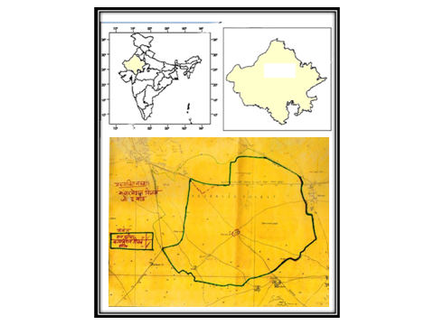Fig 1: Map of study area (not on scale)

The vegetation of Jorbeer conservation reserve is well adapted to arid environments, enduring water deficiency and harsh temperatures. Jorbeer is recognized as a site for the disposal of animal carcasses on the periphery of Bikaner, where several vultures and eagles may be seen scavenging on dead cattle or perching. The soil of Bikaner is mostly light-textured, ranging from sand to sandy loam with clay concentration. The district’s vegetation is classified as tropical forest. The terrain has vegetation consisting of grasslands and arid flora, with few trees scattered throughout. The flora mostly consists of “Sewan” (Lassiurussindicus), “Bui” (Aervatomentosa), “Kair” (Capparis decidua), “Kheep” (Leptadeniapyrotechnica), and “Phog” (Calligonumpolygonoides), among others. The scattered trees of Prosopis cineraria, Salvadora, Acacia nilotica,and Ziziphusnumularia, together with the pervasive Prosopisjuliflora, disrupt the uniformity of grasses.
Jorbeer Conservation Reserve in Bikaner was selected as the study area due to its typical arid environment and its ecological relevance within the broader landscape of western Rajasthan. The region is marked by harsh climatic conditions, including limited rainfall, high temperatures, and low natural soil fertility—all of which make sustainable land use particularly challenging. In this setting, Acacia tortilis stands out as a hardy, drought-tolerant species with the potential to influence soil quality positively. Studying its effect on soil organic carbon (SOC) within such a degraded ecosystem is important for restoring soil health and enhancing sustainability in arid zones. The research involved sampling soils from beneath A. tortilis canopies as well as from nearby unvegetated control plots, allowing for a meaningful comparison of SOC dynamics.
Site selection: Soil samples for the study were collected from three distinct sites within the Jorbeer Conservation Reserve, Bikaner:
- Site A: Grassland areas with established Acacia tortilis plantations.
- Site B: Dumping areas (carcass dump or carcass disposal site) with naturally growing or planted Acacia tortilis.
- Site C: Adjacent non-vegetated open lands or fallow fields without Acacia tortilis cover, serving as control plots.
These sites were carefully selected to ensure comparable soil types, land-use history, and climatic conditions across all sampling locations.
Soil Sampling: Soil samples were collected seasonally from all selected sites to assess variations in soil organic carbon (SOC) across different climatic periods. Sampling was conducted quarterly during December (winter), March (spring), June (summer), and September (rainy season) to capture the temporal dynamics of SOC.
- Sampling Depth: Soil samples were obtained from two depth intervals: 0–15 cm (topsoil) and 15–30 cm (subsoil) — to examine the vertical distribution of SOC.
- Sampling Technique: For each depth at each site, five soil cores were collected randomly using a soil auger. These cores were homogenized to form a single composite sample per depth. This resulted in two composite samples per site per season, totalling six composite samples per season across all sites.
- Sample Preservation: All soil samples were immediately sealed in labelled containers and stored at 4 °C to prevent microbial degradation until pretreatment and subsequent laboratory analysis, following the protocol described by Lyu et al. (2021).
Soil Preparation and Analysis: The collected soil samples from all three study sites were processed and analysed in the laboratory using the following procedures:
- Air-Drying and Sieving: All soil samples were first air-dried at room temperature. Once dried, they were passed through a 2 mm sieve to remove stones, roots, and large debris, ensuring uniformity in texture and composition for analysis.
- Soil Organic Carbon (SOC) Determination: SOC was quantified using a combination of the core sampler technique for bulk density estimation (Blake and Hartge, 1986) and the modified Walkley and Black wet oxidation method (Walkley and Black, 1934). This method involves the oxidation of soil organic matter using a mixture of potassium dichromate (K₂Cr₂O₇) and concentrated sulfuric acid (H₂SO₄). The amount of dichromate reduced during the reaction is used to calculate the SOC content.
Statistical Analysis: Statistical analysis, tabulation, and graphical representation of data were performed using SPSS and Microsoft Excel. Mean and ANOVA test were used to assess seasonal and spatial variations in Soil Organic Carbon (SOC) across sites and depths.
Result and Discussion: -
The SOC content in the studied site is according to Table 1 and Figure 2. At site A, top soil SOC was recorded as 0.170%, whereas at site C (adjacent control area) showed a lower value of 0.110%. In the subsoil, SOC under site A was 0.195% compared to 0.120% in the control site.
Table 1: Annual average SOC in the A. tortilis ecosystem with the control site
Site | Soil Depth | Average SOC± SE (in percent)
Site A | 0-15cm | 0.170 ± 0.013
Site A | 15-30cm | 0.195 ± 0.021
Site B | 0-15cm | 0.201 ± 0.018
Site B | 15-30cm | 0.231 ± 0.020
Site C (Control) | 0-15cm | 0.110 ± 0.012
Site C (Control) | 15-30cm | 0.120 ± 0.012

A similar trend is observed in Site B, where 0.201% SOC in the top soil is recorded in contrast to 0.110% in the nearby control site. At the 15–30 cm depth, the values were 0.231% whereas 0.120% in the control plot. These consistent differences highlight the positive impact of A. tortilis on SOC enrichment across both topsoil and subsoil layers in multiple land-use systems.
These results clearly indicate that soils under Acacia tortilis canopies (Sites A and B) accumulated greater SOC compared to the open control, with the effect being most pronounced at the carcass dumping site. The elevated SOC levels in Site B may be attributed to the combined influence of organic matter inputs from decomposed carcasses and enhanced litter deposition from A. tortilis, creating favourable microclimatic and microbial conditions for carbon accumulation. In contrast, the control site, lacking tree cover and additional organic inputs, exhibited the lowest SOC at both depths. This finding aligns with the general trend reported in earlier studies, where dumping sites typically showed higher soil organic carbon and nutrient levels compared to control sites.For instance, Kumar et al. (2019) also reported that municipal solid waste dumping sites across Himachal Pradesh exhibited higher soil parameter values than control sites, confirming that waste deposition significantly alters soil properties. Their study specifically found differences in the relationships between organic carbon and available phosphorus in dumping versus control sites, which supports the idea that waste input modifies nutrient dynamics. Similarly, Negi and Meena (2024) found that dump sites had higher levels of SOC, nitrogen, phosphorus, and potassium, with strong positive correlations among these parameters, reinforcing the nutrient enrichment effect observed in our study. Furthermore, Ajibade et al. (2021) provided further evidence from Nigeria, where dumpsites showed elevated organic matter and organic carbon contents compared to controls, along with higher microbial activity. While their study highlighted that dumpsites were often acidic and sometimes posed environmental risks due to contamination, the observed increase in organic carbon mirrors our findings of SOC enrichment in dumping areas.Overall, the findings highlight the significant role of Acacia tortilis in enhancing SOC concentrations in arid ecosystems, with site-specific variations linked to land-use type and organic matter availability.
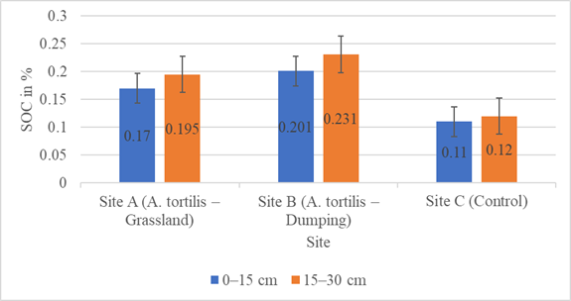
Fig 2: Soil organic carbon content at Top Soil and Sub-soil under A. tortilis Ecosystem
The details of seasonal variations along both depth in SOC across three sites are given in Table 2 and Figure 3. The Seasonal variations in soil organic carbon (SOC) were more evident under Acacia tortilis at Site A. In the top soil, SOC levels were highest during winter (0.196%), followed by spring (0.184%), summer (0.160%), and reached their lowest point in the rainy season (0.138%). In contrast, the sub-soil layer showed peak SOC during the summer (0.240%), likely due to accelerated decomposition of organic material under favourable temperature and moisture conditions. This was followed by a gradual decline in the rainy (0.198%), winter (0.184%), and spring (0.158%) seasons. Interestingly, SOC in the subsoil surpassed that in the topsoil during summer and rainy seasons, while the topsoil showed higher values in spring and winter. Additionally, SOC tended to decrease with increasing soil depth, and this pattern was consistent across all the sites. In comparison, control plots (Site C) recorded uniformly lower SOC values ranging from 0.080% to 0.150%, with minimal seasonal changes, highlighting the lack of substantial organic carbon inputs in the absence of A. tortilis vegetation.
Table 2: Seasonal and depth-wise variation in soil organic carbon content (%)
Condition | Soil Depth | Spring | Summer | Rainy | Winter
Site A | 0-15cm | 0.184 | 0.16 | 0.138 | 0.196
Site A | 15-30cm | 0.158 | 0.24 | 0.198 | 0.184
Site B | 0-15cm | 0.216 | 0.198 | 0.16 | 0.228
Site B | 15-30cm | 0.176 | 0.284 | 0.252 | 0.21
Control (Site C) | 0-15cm | 0.120 | 0.100 | 0.080 | 0.140
Control (Site C) | 15-30cm | 0.090 | 0.130 | 0.110 | 0.150

The trend-line analysis at the grassland site provides further insight into these seasonal dynamics. At Site A, which is located under the canopy of A. tortilis, the SOC levels in the topsoil display a distinct seasonal fluctuation, best represented by a quadratic trend with a high correlation coefficient (R² = 0.8475). In contrast, the SOC in the subsoil also follows a seasonal trend, though with a moderately strong fit (R² = 0.6722). These patterns indicate that topsoil SOC tends to reach its highest levels during spring and winter, while subsoil SOC remains lower during these times. Conversely, during the summer and monsoon seasons, the subsoil SOC surpasses that of the topsoil.
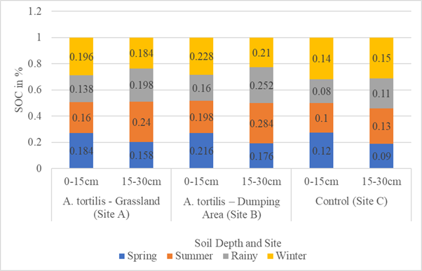
Fig 3: Seasonal variation of soil organic carbon (%) across different soil depths
Across all sites, SOC was generally higher during the winter season, with the most pronounced enrichment occurring at the carcass dumping site. Conversely, the rainy season recorded the lowest SOC in surface soils, especially at the control site.
These findings highlight that the presence of Acacia tortilis, particularly in combination with organic inputs from carcass decomposition at the dumping site, substantially enhances SOC relative to open control areas. Seasonal variation further suggests that cooler winter conditions promote SOC accumulation, likely due to reduced decomposition rates and favourable microclimatic conditions beneath the tree canopy.

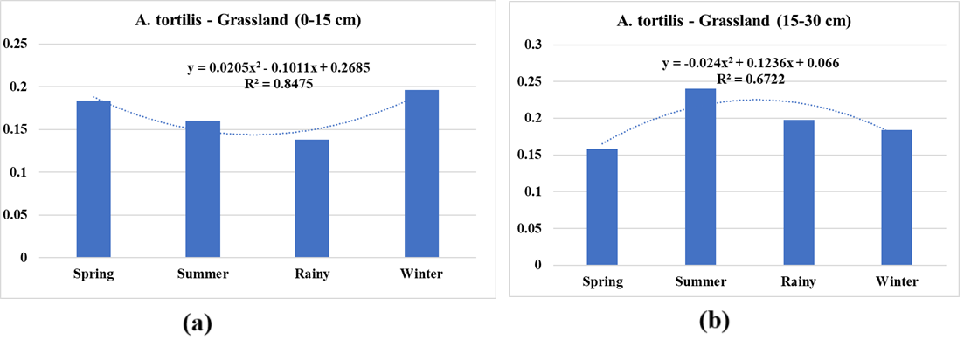
Fig 4: SOC trend in Site A (A. tortilis-Grassland) (a) top soil; (b) subsoil
At Site A, the top soil shows a distinct seasonal fluctuation, with a polynomial (Fig. 4(a)) trend with R² value of 0.8475, whereas the R² value for subsurface soil was recorded only 0.6722 (Fig. 4 (b)). In the site B (dumping zone), the surface soil layer (0–15 cm) beneath the Acacia tortilis canopy shows distinct seasonal fluctuations (Fig.5), with a polynomial trend exhibiting a coefficient of determination (R²) of 0.6997. SOC levels are elevated during spring and winter but decline noticeably during the rainy season. Conversely, the sub-surface layer (15–30 cm) demonstrates an even stronger correlation with seasonal changes (R² = 0.8742), with peak SOC levels observed during the summer and rainy seasons and lower values in spring and winter. These results suggest an alternating seasonal pattern, where increases in SOC in one soil layer correspond to decreases in the other, reflecting a complementary redistribution of carbon across soil depths throughout the year.
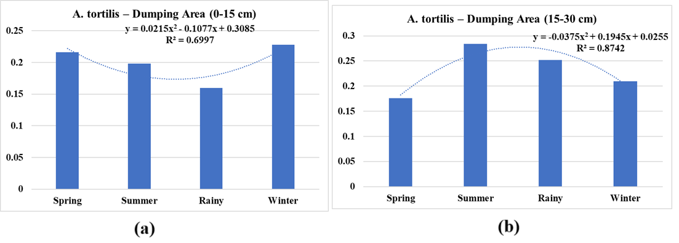
Fig 5: SOC trend in site B (A. tortilis-Dumping area) (a) top soil; (b) sub soil

A two-way Analysis of Variance (ANOVA) was conducted to evaluate differences in Soil Organic Carbon (SOC) between A.tortilis plots and control plots across various seasons. The analysis yielded a p-value of 4.08 × 10⁻⁴ for the condition factor, signifying a highly significant variation in SOC between areas with A.tortilis and control sites. This notably low p-value indicates that the presence of A.tortilis exerts a statistically significant positive influence on SOC levels, regardless of seasonal variation. In contrast, the seasonal variation in SOC levels showed a p-value of 3.47 × 10⁻¹, which is not statistically significant, indicating that seasonal changes did not contribute significantly to SOC variation. Despite this, observable trends indicate that SOC levels were highest in winter under A.tortilis, especially in the topsoil, supporting the ecological importance of this species in enhancing soil carbon content. This analysis emphasizes the potential of A.tortilis in improving soil organic carbon content, thus contributing to better soil health and sustainable land use practices in arid regions like Bikaner, Rajasthan.
The results of this study underscore the significant role of tree species like Acacia tortilis in enhancing SOC levels in arid and semi-arid regions. Across different land-use conditions—such as grassland, dumping sites, and control plots—and varying soil depths and seasons, tree-covered areas consistently showed higher SOC concentrations compared to control plots with no tree cover. The two-way ANOVA results confirmed that the presence of vegetation (condition) had a statistically significant effect (p < 0.001) on SOC levels, while seasonal variations were not statistically significant. These findings demonstrate that vegetation cover, particularly by deep-rooted and drought-resistant species like A. tortilis, is a critical driver of carbon sequestration in degraded and low-carbon soils. This has important implications for land restoration, climate change mitigation, and soil fertility improvement in dryland ecosystems like Bikaner, Rajasthan, and similar environments globally.
Seasonal variations in land use type, vegetation cover, and soil texture, in conjunction with the presence of native leguminous trees, significantlyinfluence the organic carbon dynamics in arid soils. The current findings are partially in line with other studies. According to Abdallah et al. (2008), soils under Acacia tortilis in the arid zone of South Tunisia exhibited higher organic matter and nutrient content compared to adjacent open areas, particularly under light grazing conditions. This aligns with the present findings, where significantly higher SOC levels were observed under A. tortilis, especially in dumping and grassland sites, indicating the role of tree canopy in improving soil fertility. Similarly, Ksiksi (2012) reported that A. tortilis-dominated sites had significantly more soil organic matter than areas dominated by Calotropisprocera, suggesting that tree species selection plays a key role in soil restoration in desert ecosystems. In the current study, A. tortilis contributed to improved SOC levels in both topsoil and subsoil layers, possibly due to higher biomass, slower litter decomposition, and enhanced nutrient cycling under its canopy. The work of Tasisa and Nemomissa (2019) further supports these findings, demonstrating that Acacia shade, especially within protected enclosures, results in increased SOC and organic matter, which are positively correlated with higher plant species richness. This supports the observed pattern in the present study, where A. tortilis consistently enhanced SOC levels across all seasons, with the highest values often recorded in winter due to greater litter fall, reduced decomposition rates, and more stable soil microenvironments. Tiruneh (2017) highlighted a gradient effect under A. tortilis, with SOC and fertility declining with increasing distance from the tree base. This is consistent with the current observations of A. tortilis forming “fertility islands” under their canopy zones. The trees’ ability to stabilize temperature, enrich soil through organic inputs, and support microbial diversity is crucial for maintaining SOC pools in otherwise nutrient-poor arid environments. Taken together, these findings emphasize that native leguminous trees such as A. tortilis play a significant role in enhancing soil organic carbon, especially under harsh climatic conditions. Their contributions—through litter fall, root biomass, and nitrogen fixation—are vital to improving soil structure, nutrient retention, and long-term ecosystem resilience.
While the findings highlight the role of A. tortilis in enhancing SOC and improving soil quality, they also bring attention to its invasive nature and potential ecological trade-offs(Swensen et al., 2024; Poudel et al., 2020). Originally introduced to Rajasthan for sand dune stabilization and afforestation, A. tortilis has now spread aggressively, replacing native grasses (Cenchrusciliaris, Lasiurussindicus) and shrubs (Capparis decidua, Calligonumpolygonoides). Its dense, thorny thickets suppress understory vegetation through shading (Greiner, 2010), litter accumulation, and competition for soil moisture. This reduction in grass cover not only undermines forage availability for herbivores but also alters the primary pathways of SOC accumulation, shifting the system from grass-root dominated carbon inputs to tree-litter dominated carbon pools (Qian et al., 2024). Such a shift may reduce the long-term stability of SOC, as grass-derived carbon is often more resistant to decomposition and contributes significantly to soil aggregation in arid systems.
Furthermore, the structural transformation of open grasslands into tree-dominated stands has direct consequences for biodiversity. Jorbeer is globally significant as a congregation site for vultures and raptors, species that rely on open habitats for foraging and flight maneuverability. The spread of A. tortilis reduces habitat openness, obstructs access to carcasses, and creates barriers to animal movement. Thus, while A. tortilis promotes local SOC enrichment; it simultaneously degrades the habitat quality essential for grassland specialists and scavenger guilds.
These findings underline the double-edged nature of A. tortilis invasion: on one hand, it contributes positively to soil carbon sequestration, particularly in disturbed areas like carcass dumping sites; on the other, it threatens the ecological integrity of arid grasslands through biodiversity loss and habitat homogenization. Management of A. tortilis in Jorbeer, therefore, requires a nuanced approach—recognizing its role in carbon enrichment while controlling its spread to safeguard native grassland structure and associated faunal communities. Long-term monitoring of SOC pools under different vegetation types, combined with restoration of native grasses, will be critical for balancing carbon sequestration benefits with biodiversity conservation in arid landscapes.
Conclusion: -
A. tortilis contributes positively to soil carbon storage and localized soil health improvements, its invasive nature poses ecological trade-offs by threatening native grassland biodiversity and altering ecosystem structure. The dual role of this species—as both a contributor to soil carbon sequestration and a driver of habitat homogenization—emphasizes the need for balanced management strategies.
Overall, this study underscores the ecological paradox of A. tortilis in arid landscapes: it enhances SOC and microclimatic conditions, yet simultaneously risks undermining the conservation value of open grassland habitats critical for native flora and fauna. Effective management of A. tortilis in reserves like Jorbeer should therefore carefully weigh its soil-improving potential against its invasive impacts, ensuring that conservation and soil health objectives are addressed in an integrated manner.

Limitations of the Study: -
Although this study offers important insights into the contribution of Acacia tortilis to soil organic carbon (SOC) enhancement in arid environments.The invasive impact of A. tortilis on native flora and fauna, particularly grassland species and raptor foraging behavior, was discussed but not quantified through field surveys. This limits the ability to directly link SOC benefits with biodiversity costs.At the carcass dumping site, elevated SOC values likely reflect inputs from decomposing carcasses in addition to A. tortilis litter. The combined effects of these inputs could not be separated, which may confound interpretation of tree-specific contributions to SOC.
References: -
- Abdallah, F.; Noumi, Z.; Touzard, B.; Belgacem, A. O.; Neffati, M.; Chaieb, M. The Influence of Acacia tortilis (Forssk.) Subsp. raddiana (Savi) and Livestock Grazing on Grass Species Composition, Yield and Soil Nutrients in Arid Environments of South Tunisia. Flora. 2008, 203 (2), 116–125.
- Ajibade, F.; Adelodun, B.; Ajibade, T.; Lasisi, K.; Abiola, C.; Adewumi, J.; Akinbile, C. The Threatening Effects of Open Dumping on Soil at Waste Disposal Sites of Akure City, Nigeria. Int. J. Environ. Waste Manage.2021, 27 (2), 127–146. https://doi.org/10.1504/IJEWM.2021.10030610.
- Andersen, G. L.; Krzywinski, K. Longevity and Growth of Acacia tortilis: Insights from 14C Content and Anatomy of Wood. BMC Ecol.2007, 7 (4). https://doi.org/10.1186/1472-6785-7-4.
- Asaye, Z. Effects of Scattered Acacia tortilis (Forssk) Hayne on Soil Properties in Different Land Uses in Central Rift Valley of Ethiopia. J. Sustainable For.2016, 36, 1–13. https://doi.org/10.1080/10549811.2016.1270835.
- Blake, G. R.; Hartge, K. H. Methods of Soil Analysis; American Society of Agronomy, Inc.: Madison, USA, 1986.
- Cheruto, G.; Nungula, E.; Nyawira, L.; Chappa, L.; Kahuthia-Gathu, R.; Gitari, H.; Mwadalu, R.; Dlamini, J.; Ranjan, S.; Sow, S.; Maitra, S.; Nasar, J. Agroforestry Tree Species: Acacia tortilis, Biology, Importance, Agroforestry Production, and Biotechnology Application. In Agroforestry Systems and Food Security; Springer, 2025. https://doi.org/10.1007/978-981-96-0002-1_10.
- Devi, A. S. Influence of Trees and Associated Variables on Soil Organic Carbon: A Review. J. Ecol. Environ.2021, 45 (5). https://doi.org/10.1186/s41610-021-00180-3.
- Gowda, J. Spines of Acacia tortilis: What Do They Defend and How? Oikos1996, 77 (2), 279–284. https://doi.org/10.2307/3546066.
- Greiner R. Improving the Net Benefits from Tourism for People Living in Remote Northern Australia. Sustainability. 2010; 2(7):2197-2218. https://doi.org/10.3390/su2072197
- Ksiksi, T. Acacia tortilis and Calotropisprocera: Do They Substantially Promote Soil Carbon Sequestration? Open J. Soil Sci.2012, 2, 116–122.
- Kumar, R.; Singh; Thakur, S. Assessment of Physico-Chemical Properties of Soil in the Dumping Sites of Himachal Pradesh, India. Int. J. Basic Appl. Sci.2019, 1–6.
- Lyu, M.; Noormets, A.; Ukonmaanaho, L.; Li, Y.; Yang, Y.; Xie, J. Stability of Soil Organic Carbon during Forest Conservation Is More Sensitive in Deep Soil Than in Topsoil in Subtropical Forest. Pedobiologia2021, 84, 150708.
- Management plan of Jorbeer Conservation Reserve.
- Negi, A.; Meena, A. K. Impact of Landfill Proximity on Soil Quality: A Comparative Study of Dumping and Non-Dumping Sites Near Srinagar, Garhwal, Uttarakhand. Nature Environ. Pollut. Technol.2025, 24 (2), B4259. https://doi.org/10.46488/nept.2025.v24i02.b4259.
- Pareek, L., Yadav. V. K.,Tripathi, S. L. and Yadav, S. Impact of Prosopis cineraria on Soil organic carbon: Implication for arid agroforestry with a case study of Sardarshahar, Rajasthan. 2024, 9(6), 23-29.
- Poudel, A.S., Shrestha, B.B., Joshi, M.D., Muniappan, R., Adiga, A., Venkatramanan, S. and Jha, P.K., 2020. Predicting the current and future distribution of the invasive weed Ageratinaadenophora in the Chitwan–Annapurna Landscape, Nepal. Mountain Research and Development, 40(2), p.R61.
- Qian, J., Ji, C., Yang, J., Zhao, H., Wang, Y., Fu, L. and Liu, Q., 2024. The advantage of afforestation using native tree species to enhance soil quality in degraded forest ecosystems. Scientific Reports, 14(1), p.20022.
- Rajasthan Forest Department (2023). Management Plan of Jorbeer Conservation Reserve, Bikaner. Government of Rajasthan.
- Ross, Z.; Burt, J. Unusual Canopy Architecture in the Umbrella Thorn Acacia, Vachelliatortilis (= Acacia tortilis), in the United Arab Emirates. J. Arid Environ.2015, 115, 43–49. https://doi.org/10.1016/j.jaridenv.2015.01.004.
- Shi, W.; Zhu, X.; Zhang, F.; Wang, K.; Deng, L.; Ma, M. Soil Carbon Biogeochemistry in Arid and Semiarid Forests. IntechOpen eBooks2019. https://doi.org/10.5772/intechopen.87951.
- Singh, G.; Singh, B.; Kuppusamy, V.; Bala, N. Variations in Foliage and Soil Nutrient Composition in Acacia tortilis Plantation of Different Ages in North-Western Rajasthan. J. Arid Environ.2002, 128, 514–521.
- Stave, J.; Oba, G.; Nordal, I.; Stenseth, N. C. Seedling Establishment of Acacia tortilis and Hyphaenecompressa in the Turkwel Riverine Forest, Kenya. Afr. J. Ecol.2006, 44 (2), 178–185. https://doi.org/10.1111/j.1365-2028.2006.00614.x.
- Stavi, I.; Xu, C.; Argaman, E. Climate-Smart Forestry in the World’s Drylands: A Review of Challenges and Opportunities. Anthropocene Rev.2023, 11 (1), 67–90. https://doi.org/10.1177/20530196231182354.
- Swensen, S.M., Gomez, A.M., Piasecki-Masters, C., Chime, N., Wine, A.R., Rodriguez, N.C., Conklin, J. and Melcher, P.J., 2024. Minimal impacts of invasive Scaevolataccada on Scaevolaplumieri via pollinator competition in Puerto Rico. Frontiers in Plant Science, 15, p.1281797.
- Tasisa, B. Y.; Nemomissa, S. Patch Enclosure and Localized Effects of Selected Acacia Species on Herbaceous Richness and Soil Properties of Rangelands in Somali Regional State in Ethiopia. J. Rangeland Sci.2019, 9 (4), 319–332.
- TirunehAsaye, Z. Effects of Scattered Acacia tortilis (Forssk) Hayne on Soil Properties in Different Land Uses in Central Rift Valley of Ethiopia. J. Sustain. For.2017, 36 (2), 164–176.
- Walkley, A.; Black, I. A. An Examination of the Degtjareff Method for Determining Soil Organic Matter and a Proposed Modification of the Chromic Acid Titration Method. Soil Sci.1934, 37, 29–38.
- Yadav, S and Yadav V. K. Green Economy Challenges and Feasible Opportunities of the Mountainous state Uttrakhand in India. IJAEB, 2023, 16(02): 73-76, DOI: 10.30954/0974-1712.02.2023.3
- Yadav, V. K., Yadav, S., Adhikari, B. S. and Rawat, L. Forest Provisioning Services Use Pattern: A Case Study from Renuka Forest Division, Western Himalaya. Small-scale Forestry. 2022, 21, 55–70.
- Yadav, V.K., Yadav, S., Rawat, L. and Adhikari, B.S. Food Provision Indicators of Renuka Forest Division, Himachal Pradesh, Western Himalaya. Indian Forester,2021, 147(4), 395-399

