Case report

Evaluating The Efficacy Of Advanced Depression Rehabilitation Through Movement And Relaxation Combined With Pharmacological Treatment, On Brain-Derived Neurotrophic Factor (BDNF) Levels In An Individual Suffering From Depression: A Case Report

.
ABSTRACT

Background and Aims: Depression is a common mental illness that affects people globally and has a big influence on individuals and society. Pharmacological approaches are essential and frequently utilized, although they come with notable adverse effects. This case report examines how an ADR-MR Intervention and medicine work together to treat depression. The outcomes are validated by changes in Brain-Derived Neurotrophic Factor (BDNF) levels and clinical evaluations.
Case Description: The Neuro Physiotherapy Outpatient Department received a referral for a 21-year-old male patient, who was diagnosed with depression. Upon obtaining informed consent, he was enrolled in the report after undergoing a comprehensive psychiatric evaluation that included the Montgomery–Åsberg Depression Rating Scale (MADRS). The intervention plan included five days a week ADR-MR session in addition to medication for 4 weeks. On Day 0 the recording of pre-test BDNF levels, Hamilton Depression Rating Scale values were taken. On days 14 and 21, the CGI Scale was used to track progress. The BDNF levels, MADRS, and HDRS scores were assessed on day 28 following the intervention.
Result: The efficacy of ADR-MR in conjunction with pharmacological treatment was demonstrated by the significant improvements in the BDNF levels, MADRS score, and HDRS score. The CGI-S score, which went from 3 to 1, the CGI-G score, which went from 1 to 2, and the CGI-E from minimal to moderate.
Conclusion: The ADR-MR regimen can improve BDNF levels in a depressed individual in addition to the pharmacological treatment, which will decrease depression symptoms, enhance therapeutic results, and improve the patient's quality of life.

Keywords: Depression, Brain-Derived Neurotrophic Factor, Exercise, Respiration, Relaxation, Rehabilitation

- INTRODUCTION

The term "mental health" refers to the state of cognitive and emotional well-being influencing relationships, thoughts, feelings, behaviours, and overall QoL^{[1]}. The WHO states that it enables individuals to manage stress, work efficiently, and contribute to society^{[2]}. Depression is the fourth biggest cause of disability globally^{[3]}. Millions of individuals throughout the world suffer from depression. This prevalent and dangerous medical disorder impairs their QoL^{[4]}. The classification includes postpartum, dysthymic, severe depression, premenstrual, and atypical depression^{[5]}.

The 2015–16 National Mental Health Survey indicates that 5% of Indian adults suffer from depression, with 15% needing active intervention. Women are more affected than men, with lifetime prevalence between 10% and 20%. Globally, 3.8% of people experience depression, affecting 4% of men and 6% of women, and rising to 5.7% for those aged 60 and above ². Unipolar depression is predicted to rank as the second largest cause of the world's disease burden by 2030^{[6]}.

Depression has both psychological and physical signs. Physical symptoms include changes in appetite and sleep difficulties, while psychological symptoms involve feelings of worthlessness and prolonged unhappiness^{[5]}. The DSM-5 and ICD-11 require that symptoms of Major Depressive Disorder (MDD) last at least two weeks. According to ICD-11, a depressive episode involves at least five out of ten symptoms occurring most of the day, nearly every day, for two weeks. Depression is associated with anatomical and functional changes in brain regions like the hippocampus, thalamus, striatum, and frontal and parietal cortices^{[7]}. Depression is influenced by factors like monoamine imbalances, chronic stress affecting the HPA axis, and inflammatory cytokines that impact neuroplasticity and neurotransmission. Irregular sleep and light exposure disrupt circadian rhythms and serotonin function. First-line treatments include cognitive behavioural therapy (CBT), antidepressants, or a combination of both. Electroconvulsive therapy (ECT) is used for severe, treatment-resistant depression or related symptoms^{[8]}. However, pharmacotherapy alone may not be sufficient for all patients, and combining medication with psychotherapy, cognitive-behavioural therapy (CBT), or Physiotherapy interventions such as physical exercises^{[9]}, relaxation techniques^{[10]}, breathing exercises, rhythmic aerobic exercises^{[11],} and Cranial Electrical Stimulation (CES)^{[12]} may yield better outcomes. Physiotherapy is a reliable adjuvant treatment for depression that reduces recurrence rates and addresses the limitations of medication and psychotherapy^{[13]}. Decreased levels of BDNF have been consistently associated with depression, and treatment strategies are essential to elevating BDNF levels^{[14]}.

This case report explores the changes in BDNF levels and depression severity in a patient undergoing an ADR-MR physiotherapy protocol in conjunction with pharmacological treatment.

2. CASE PRESENTATION
This prospective case report was conducted between January 2025 to March 2025, following institutional ethical guidelines and with written informed consent from the participant. A 21-year-old male student was referred by the psychiatry department to the physiotherapy OPD at JNU Hospital with a primary diagnosis of major depressive disorder. The patient presented with a two-month history of insomnia, decreased appetite, social withdrawal, mood lability, anhedonia, and gastrointestinal disturbances. There was no significant personal or family psychiatric history reported. The participant was selected based on confirmed psychiatric diagnosis, voluntary participation, and absence of contraindications related to physiotherapy. Initial clinical evaluation revealed a Montgomery-Åsberg Depression Rating Scale (MADRS) score of 19 (moderate depression), Hamilton Depression Rating Scale (HDRS) score of 23 (moderate-severe depression), and serum brain-derived neurotrophic factor (sBDNF) levels of 13.8 ng/ml. Following a comprehensive baseline assessment, the participant underwent a 4-week ADR-MR (Aerobic exercise, Deep breathing, Relaxation, and Muscle Relaxation) protocol administered five times weekly. The intervention timeline included pre-intervention sBDNF levels and HDRS assessment on Day 1, Clinical Global Impression (CGI) scale monitoring on Days 14 and 21, and post-intervention assessments including sBDNF levels, HDRS, and MADRS scores on Day 28.
The ADR-MR protocol used in this study is a rehabilitation framework designed by the authors. The protocol has been registered with The Indian Copyright Society (ROC No- LD-20250168304).

3. DISCUSSION:

This case report highlights that the ADMR-MR protocol, combined with medication, improved BDNF levels and reduced symptoms as measured by MADRS, HDRS, and CGI scales in a depressed individual. Compared to baseline, the patient's Brain-Derived Neurotrophic Factor (BDNF) level increased (Table & Graph 1). Clinically, the patient demonstrated significant improvement in depressive symptoms. The MADRS score decreased (Table & Graph 2), while the HDRS also decreased (Table & Graph 3). Additionally, CGI efficacy index improved from “minimal” to “moderate,” reflecting marked clinical progress (Table & Graph 4).
Outcome Measure | Day 0 | After 4 weeks
Serum Brain-Derived Neurotrophic Factor(sBDNF) | 13.8ng/ml | 16.3 ng/ml

(Table 1). Brain-Derived Neurotrophic Factor (BDNF) Levels in tabular form

(Graph 1). Showing improvement in sBDNF test score for both pre-test reading (13.8ng/ml) and post-test reading (16.3 ng/ml) in graphical form

Outcome Measure | Day 0 | After 4 weeks
MADRS Scale | 19(mild) | 8(mild)
(Table 2) . Montgomery–Åsberg Depression Rating Scale (MADRS) in tabular form

(Graph 2). Showing Significant improvement in MADRS score for both pre-test reading (19) and post-test reading (8), in graphical form

Outcome Measure | Day 0 | After 4 weeks
HDRS Scale | 23 | 14
(Table 3) Hamilton depression rating scale (HDRS), in tabular form

(Graph 3) Hamilton depression rating scale (HDRS) shows a Significant improvement in the HDRS scale score for both pre-test reading (23) and post-test reading (14), in graphical form.

Outcome Measure | Day 14 | Day 21
CGI Scale  - Severity of illness  - Global Improvement  - Efficacy Index | 3  1  Minimal | 1  2  Moderate
(Table 4) Hamilton depression rating scale (HDRS) in tabular form

(Graph 4) Hamilton depression rating scale (HDRS) shows improvement in CGI scores for both day 14 and readings on day 21 in graphical form.

This case report highlights that the ADMR-MR protocol, combined with medication, improved BDNF levels and reduced symptoms While depression is associated with reduced hippocampal capacity, exercise promotes neurogenesis through pathways involving BDNF, serotonin, endorphins, and vascular endothelial growth factor. Chest expansion and respiratory muscle function are improved by respiratory workouts, including resistance band exercises and deep diaphragmatic breathing ¹⁰. Furthermore, relaxation methods improve self-esteem and self-awareness by triggering physiological and neurological processes, which makes them useful for treating depression. According to reports, cranial electrical stimulation (CES), which uses a small, portable electrical device to give a low-intensity electrical current, is an effective treatment for depression with few side effects ¹². In the existing literature, there is a lack of evidence of a specific physiotherapy protocol for depression and its impact on BDNF levels and depression symptoms in combination with pharmacological treatment; however, a few studies revealed the benefits of physical exercise on depression patients. According to an RCT conducted by Anna J.T. Smit in 2024 determined that although BDNF in the central nervous system is probably involved in the effectiveness of antidepressants and in some elements of the pathophysiology of MDD, its representation in serum BDNF levels has diagnostic or predictive value ¹⁴. An RCT conducted by Elisa Calisgan in 2020 showed that, in comparison to normal treatment alone, physiotherapy techniques combined with respiratory and relaxation exercises increase mood and reduce pain in depression ¹⁰. Kristin L. Szuhany in 2020, concluded, Acute exercise significantly raises BDNF levels in sedentary people with depression, but this rise is not associated with a reduction in depressive symptoms, according to the study. This implies that while exercise has a good impact on BDNF, it is yet unknown how BDNF and the reduction of depressive symptoms are related ⁷.

4. Conclusion

In this Report, the ADR-MR protocol and pharmacotherapy were associated with improved BDNF levels. While medication effects cannot be excluded, a structured physiotherapy protocol supports a synergistic approach. Further trials are needed to evaluate the efficacy of each modality; however, this report highlights the clinical value of including targeted physiotherapy protocols alongside pharmacological management in the treatment of depression.

Consent

All authors declare that ‘written informed consent was obtained from the patient (or other approved parties) for publication of this case report and accompanying images.

Ethical approval

All authors hereby declare that all experiments have been examined and approved by the appropriate ethics committee and have therefore been performed in accordance with the ethical standards laid down in the 1964 Declaration of Helsinki.

References

- Maurer, D. M., Raymond, T. J., & Davis, B. N. (2018). Diagnostic and statistical manual of mental disorders: DSM-5. American Family Physician, 98(8), 508–515. Retrieved from https://www.aafp.org/pubs/afp/issues/2018/1015/p508.html
- World Health Organization. (2024, March 14). Clinical descriptions and diagnostic requirements for ICD-11: Mental, behavioural and neurodevelopmental disorders. World Health Organization.
- Murawska-Ciałowicz, E., Wiatr, M., Ciałowicz, M., de Assis, G. G., Borowicz, W., Rocha-Rodrigues, S., et al. (2021). BDNF impact on biological markers of depression: Role of physical exercise and training. International Journal of Environmental Research and Public Health, 18(14), 7561.
- Gourgouvelis, J., Yielder, P., Clarke, S. T., Behbahani, H., & Murphy, B. A. (2018). Exercise leads to better clinical outcomes in those receiving medication plus cognitive behavioral therapy for major depressive disorder. Frontiers in Psychiatry, 9, 37.
- Paykel, E. S. (2008). Basic concepts of depression. Dialogues in Clinical Neuroscience, 10(3), 279–289.
- Arvind, B. A., Gururaj, G., Loganathan, S., Amudhan, S., Varghese, M., Benegal, V., et al. (2019). Prevalence and socioeconomic impact of depressive disorders in India: A multisite population-based cross-sectional study. BMJ Open, 9(6), e027250.
- Szuhany, K. L., & Otto, M. W. (2020). Assessing BDNF as a mediator of the effects of exercise on depression. Journal of Psychiatric Research, 123, 114–121.
- Liu, H. L., Sun, J., Meng, S. F., & Sun, N. (2024). Physiotherapy for patients with depression: Recent research progress. World Journal of Psychiatry, 14(5), 635–643.
- Iriarte-Yoller, N., Etxaniz-Oses, J., Pavón-Navajas, C., Tous-Espelosin, M., Sánchez-Gómez, P. M., Maldonado-Martín, S., et al. (2024). Treatment with combined exercise in patients with resistant major depression (TRACE-RMD): Study protocol for a randomised controlled trial. Trials, 25(1), 1–19.
- Caliskan, E., Cumurcu, H., Talu, B., Zayman, E., & Aydin, Y. (2020). The effects of physiotherapy methods combined with respiratory and relaxation exercises on patients with major depression. Medical Science International Medical Journal, 9(4), 837–843.
- Kwon, I. H., Song, J. Y., Kim, D. Y., Son, J. Y., Shim, Y. J., & Shin, W. S. (2017). Comparison of rhythmic and non-rhythmic aerobic exercises on depression and balance in the elderly. Physical Therapy Rehabilitation Science, 6(3), 146–151.
- Feusner, J. D., Madsen, S., Moody, T. D., Bohon, C., Hembacher, E., Bookheimer, S. Y., & Bystritsky, A. (2012). Effects of cranial electrotherapy stimulation on resting state brain activity. Brain and Behavior, 2(3), 211–220.
- Carneiro, L., Afonso, J., Ramirez-Campillo, R., Murawska-Ciałowicz, E., Marques, A., & Clemente, F. M. (2020). The effects of exclusively resistance training-based supervised programs in people with depression: A systematic review and meta-analysis of randomized controlled trials. International Journal of Environmental Research and Public Health, 17(18), 6715.
- Smit, A. J., Wu, G. W., Rampersaud, R., Reus, V. I., Wolkowitz, O. M., & Mellon, S. H. (2024). Serum brain-derived neurotrophic factor, Val66Met polymorphism and open-label SSRI treatment response in major depressive disorder. Psychoneuroendocrinology, 165, 107045.

FIGURES LEGENDS:

- Fig 1. Diaphragmatic breathing
- Fig 2. Jumping Jacks
- Fig 3. Cycling
- Fig 4. Treadmill walking
- Fig 5 & 6 (Clapping with rhythmic music)
- Fig 7. Application of Cranial Electrical Stimulation
- FFig.8 & 9 Relaxation

Written informed consent was obtained from the patient for publication of this case and accompanying images. The participant provided written informed consent and was informed that anonymized demographic data and outcome measures would be included in this case report for potential publication. The study protocol adhered to the Declaration of Helsinki principles, with all clinical data collected and stored by institutional guidelines for patient confidentiality and data protection.

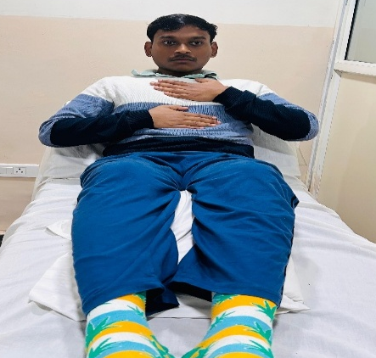  Fig 1. Diaphragmatic Breathing | 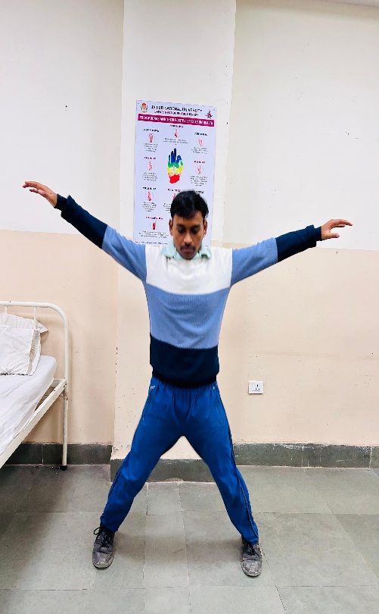  Fig 2. Jumping Jacks
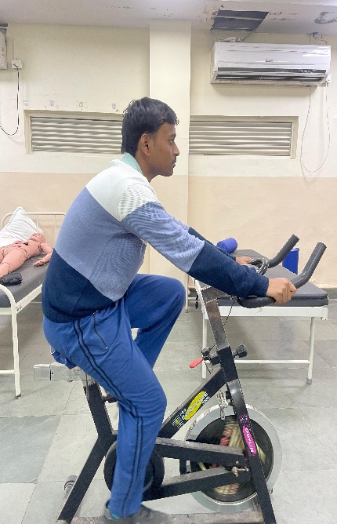  Fig 3. Cycling | 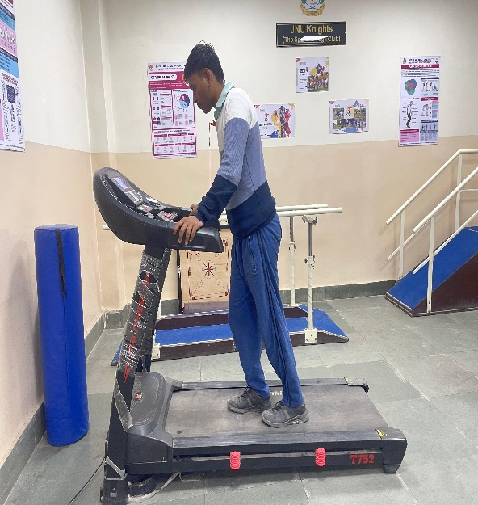  Fig 4. Treadmill walking
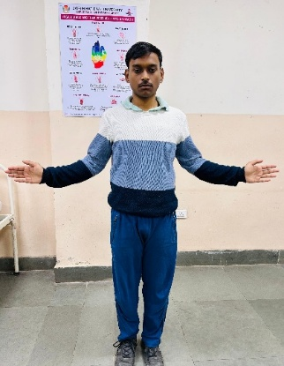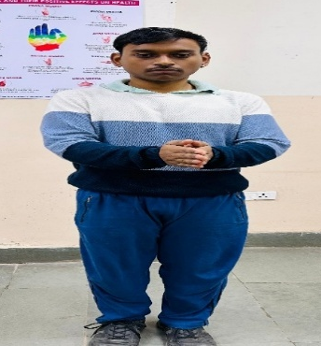
Fig 5 & 6 (Clapping with rhythmic music)



Fig 7. Application of Cranial Electrical Stimulation

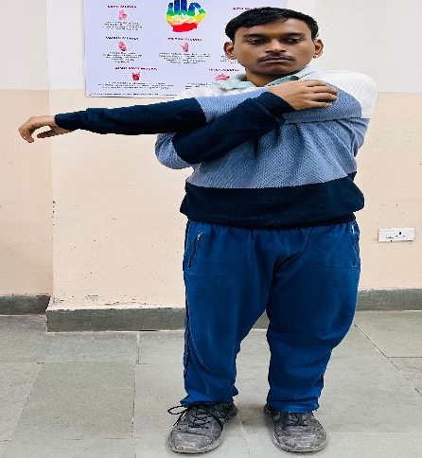

(Fig 8 & 9 Relaxation)
