Assessment of economic impact of pressure variation in drip irrigation systems for maize production

.
ABSTRACT

Irrigation is crucial for optimizing crop yields, with drip irrigation serving as an efficient method for delivering precise water quantities directly to plants. Evaluating the economic implications of pressure variations within drip systems is essential for enhancing productivity and profitability. This study was conducted at Sokoine University of Agriculture (SUA) in the Morogoro Region of Tanzania. A randomized complete block design was employed, featuring three inlet pressure treatments – 1.0 bar, 1.5 bars, and 2.0 bars – each replicated three times. Uncompensated drippers were used to supply water efficiently, and volumetric measurements determined emitter flow rates. During the first cropping season, maize evapotranspiration was measured at 271.2 mm, while the second season recorded 212.3 mm. Results showed slight variations in yields across the pressure treatments: in the first season, yields were 2,340.9 kg/ha (T1), 2,432.7 kg/ha (T2), and 2,708.1 kg/ha (T3). In the second season, yields were 2,203.2 kg/ha (T1), 2,233.8 kg/ha (T2), and 2,646.9 kg/ha (T3). The net profit per hectare over the system's long lifespan was estimated at $1,103 (T1), $1,139 (T2), and $1,250 (T3) in the first season and $993 (T1), $1,005 (T2), and $1,170 (T3) in the second season. The Benefit-Cost Ratios (BCRs) were notably favourable, with values of 16.53 (T1), 17.63 (T2), and 20.93 (T3) during the first season. In the second season, the BCRs ranged from 14.88 (T1) and 15.25 (T2) to 20.20 (T3), indicating strong economic viability for long-term investment. These findings underscore drip irrigation as a sustainable water management strategy in agriculture. Based on the results, adoption of drip irrigation systems is recommended for long-term use. Additionally, utilizing a pressure of 2 bars is suggested to enhance water use efficiency (WUE) and profitability, especially for maize farmers in water-scarce regions.

Keywords: Drip Irrigation, Economic Benefit, Pressure Variation, Maize Production

1. INTRODUCTION

Maize is one of the world's most vital cereal crops, serving as a staple food for millions and as a key component in animal feed. Globally, it ranks third in importance after rice and wheat, playing a crucial role in agriculture and food security. In 2008, the global maize sowing area reached 159.5 million hectares, yielding 817.1 million tons with an average productivity of 5.12 tons per hectare (El-Wahed and Ali, 2013). Cultivated across diverse continents and climatic zones, maize significantly contributes to global food security and agricultural economics (Ranum et al., 2014).
In recent years, maize production has experienced steady growth. In 2021, global maize output exceeded 1.2 billion metric tons, according to the Food and Agriculture Organization (FAO, 2021). This upward trend highlights maize's adaptability to diverse environmental conditions and its versatility across multiple applications, including human consumption, livestock feed, and industrial use.
Tanzania, a key maize-producing nation, relies heavily on this crop to achieve its agricultural and food security goals, as it provides a significant portion of the daily caloric intake for much of the population. As the most widely cultivated cereal in the country, maize plays a critical role in ensuring food security and alleviating poverty. Its cultivation is primarily undertaken by smallholder farmers, for whom maize serves as a cornerstone crop, supporting both livelihoods and household incomes.
Acknowledging maize's significance, the Tanzanian government has introduced various initiatives and policies to boost production and promote food self-sufficiency (Nkonya et al., 1998). However, achieving optimal maize growth and maximizing yields are highly dependent on consistent and precise irrigation practices.
In this context, the adoption of drip irrigation systems has brought significant advantages to maize production. Drip irrigation offers an efficient and sustainable approach to water management, particularly suited for maize cultivation. By delivering water directly to plant roots, this method enables precise and efficient water distribution, making it a cornerstone of precision agriculture. Compared to traditional surface irrigation techniques, such as basin or furrow irrigation, drip irrigation has the potential to increase crop yields while minimizing water loss and conserving valuable water resources (Yang et al., 2023) and (Windows, 2012).To ensure the effectiveness of drip irrigation systems, maintaining consistent and controlled pressure levels and water flow throughout the network is essential. Pressure variations can occur due to factors such as fluctuations in water supply, system design flaws, or operational challenges. These variations often result in uneven water distribution, leading to under- or over-irrigation across the field. Such irregularities can decrease crop yields, increase water consumption, and cause economic losses (Sharma et al., 2016). In maize production, non-uniform irrigation can significantly affect crop growth, development, and yield potential (Sui et al., 2015).
The economic implications of pressure variation in drip irrigation systems are complex and far-reaching. Uneven water distribution directly impacts crop yields, as both water stress and excess moisture hinder maize growth and development, ultimately reducing productivity per hectare (Wambua, 2025). Additionally, to compensate for non-uniform distribution, farmers often need to apply more water, leading to increased water consumption and higher operational costs (Lamm et al., 2010). These inefficiencies are further compounded by energy waste, as additional pumping is often required to sustain the desired pressure levels (Soboyejo et al., 2019).
Narayanamoorthy (2004) demonstrated that drip irrigation is economically viable even without subsidies, highlighting its long-term sustainability. Similarly, (Wahid et al., 2020) found that drip irrigation offers the highest net benefits and marginal rate of return compared to alternative irrigation methods. Although the initial investment costs are higher, the system's ability to ensure sustainable yields justifies the expense. Narayanamoorthy et al., (2018) further emphasized that drip irrigation significantly improves crop productivity compared to flood irrigation, making it a compelling choice for farmers. Additionally, (Guo & Li, 2024) and (Whittlesey, 2003) concluded that drip irrigation is notably more efficient in water use, reinforcing its value in resource conservation.
The success of any irrigation investment depends on the cost-effectiveness and overall performance of the chosen system. (Mukherjee et al., 2023) evaluated the economic impact of integrating pressure gauges (regulators) into drip irrigation systems on a commercial tomato farm in California. Their findings revealed a 20% reduction in water consumption and a 15% increase in crop yield compared to systems without pressure gauges. These improvements led to significant water cost savings and increased revenue from higher yields, achieving a return on investment (ROI) within two years. Similarly, (Liu et al., 2023) Comparing drip irrigation to border irrigation method (BI) in northwest China, the net return and benefit/cost ratio rose by 60.90% and 22.88%, respectively. These findings show that drip irrigation can significantly increase maize's growth, yield, WUE, and economic benefits.
The lack of a comprehensive evaluation of the economic implications of pressure variation, water use efficiency, and crop yields in drip irrigation systems limits the development of effective strategies for promoting sustainable agriculture and economic prosperity in water-scarce regions. Understanding the economic impact of pressure fluctuations in these systems is crucial for enhancing efficiency, optimizing resource use, and ensuring the sustainability of maize production. This study aimed to thoroughly assess the economic consequences of pressure variations in drip irrigation systems for maize cultivation, offering valuable insights for farmers, policymakers, and agricultural stakeholders.

2.0. MATERIALs AND Methods

2.1 Description of the Study Area
A field experiment was conducted at a research site of a School of Engineering and Technology (SoET) within Sokoine University of Agriculture (SUA). The site is located approximately 3 km from Morogoro town, Tanzania, at coordinates 6°51'30"S and 37°39'0"E, with an elevation of 533 meters above sea level. Figure 1 presents the map showing the location of the study area.
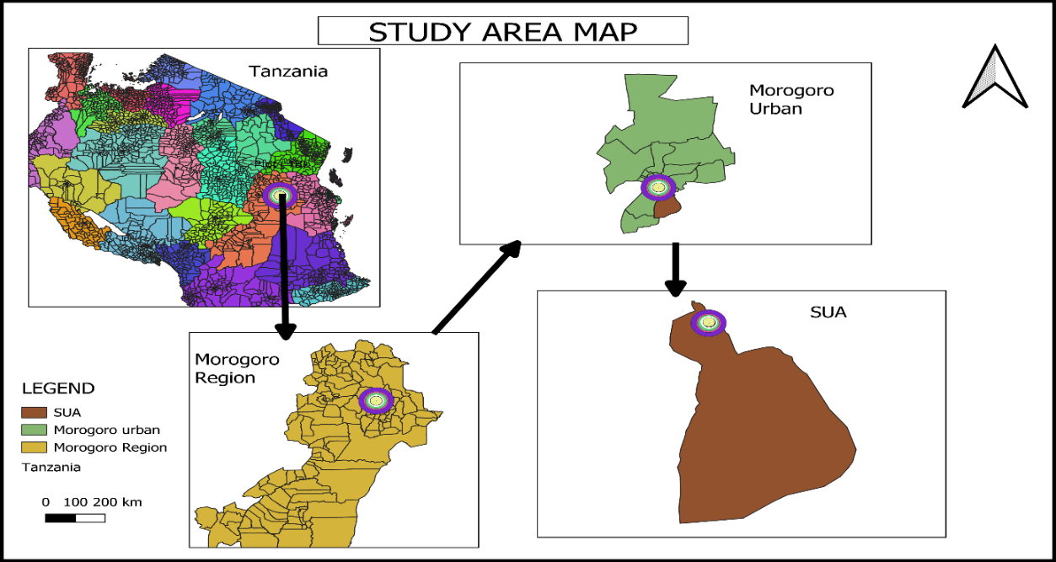
Figure 1: Location map of the study area
2.2 Experimental Design and Layout
The experiment was laid out in a randomized complete block design with three treatments, i.e., 1.0 bar, 1.5 bar, and 2.0 bar pressure at the head of the lateral. These were replicated three times with a total of 9 individual plots as shown in Figure 2.
A conventional drip irrigation system was installed on each plot to assess its technical performance. The system components - including operating pressure head, pipe diameter, pipe length, emitter type, and emitter spacing – were selected in accordance with standard drip irrigation practices. Each component was critical to ensure the model accurately simulated the functionality of the actual installed system. A non-pressure compensating emitter was used throughout the system. Each plot measured 6 m by 17 m, with a 2-meter buffer zone surrounding it. The maize variety DK777 was planted at a spacing of 30 cm between plants within the row and 1 m between rows, on raised beds with drip lines positioned alongside. The emitter spacing on the lateral lines matched the within-row plant spacing, ensuring that each plant received water from a single emitter. Each plot was fitted with three drip lines, as illustrated in Figure 2.
The setup comprised a 1-horsepower (hp) centrifugal pump, a 10,000-liter water tank elevated on a platform 1 m above ground level, and a filter attached to the tank's outlet. Water was discharged from the tank into a mainline made of high-density polyethylene (HDPE), 32 mm in diameter and 50 m in length. This mainline branched into a sub-main line of the same diameter. From the sub-main, water was metered to the manifold, also 32 mm in diameter, located at the head of each plot (Figure 2). Each manifold supplied three lateral lines, each 16 mm in diameter and 15 m long. Additionally, a control valve and a pressure gauge were installed at the head of each manifold to facilitate effective pressure regulation.

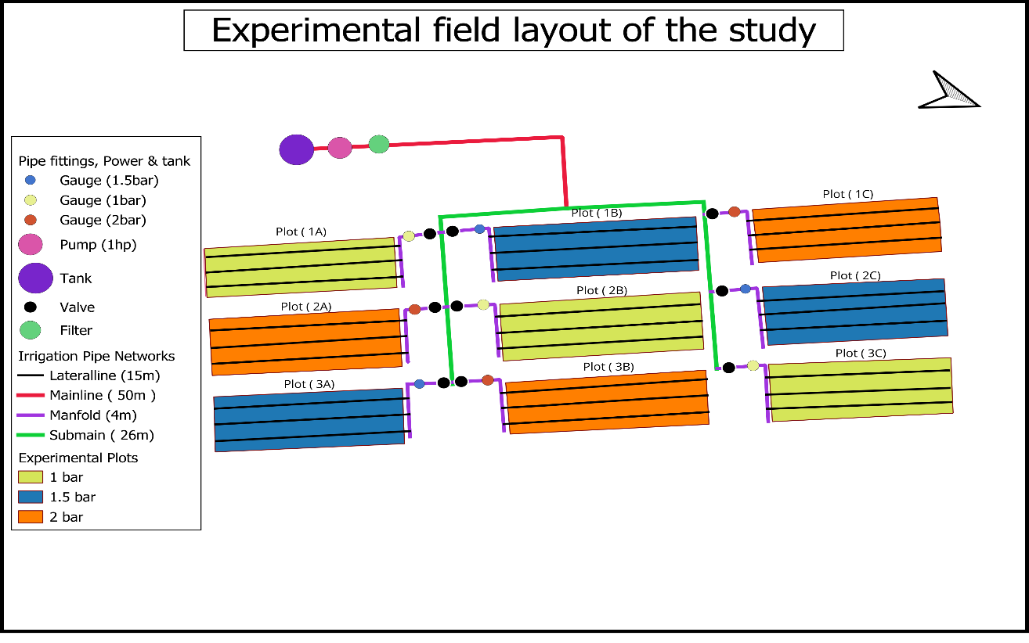Figure 2: Experimental field layout of the study
2.3. Data Collection
2.3.1 Determination of crop water requirements
Rainfall —a critical climatic factor influencing crop growth —was monitored using the manual rain gauge method throughout the growing seasons of the experiment. The collected data were then used to calculate dependable effective rainfall using CROPWAT version 8.0 software (Smith and Nations, 1992).
The reference crop evapotranspiration (ET_{o}) was computed using the Penman-Monteith method with the aid of INSTAT-plus (v3.6) software (Stern et al., 2006).
The crop water requirement (ET_{c}) was determined by multiplying daily reference evapotranspiration (ET_{o}) with the crop coefficient (K_{c}) value. The ET_{c} was determined using CROPWAT 8.0 software, along with monthly ET_{o} values using ClimWat 2.0 (Allen et al., 1998).
$ET_{c}=ET_{o}×K_{c}$................................................................................................................(1)
Where ET_{c} = Crop evapotranspiration (mm/day)
ET_{o} = References evapotranspiration (mm/day)
ET_{o} = References evapotranspiration (mm/day)
The daily ET_{c} values calculated were aggregated for the different growth stages of the crop – initial, developmental, mid-season, and late-season – to determine the seasonal crop water requirement.
2.3.2 Estimation of crop coefficients for different stages
Crop coefficient values provided by the FAO (Allen, Richard G., PEREIRA, Luis S., RAES, Dirk and SMITH, 1998) were utilized following the single crop coefficient approach to calculate ET_{c}. Specifically, K_{c} values of 0.30 for the initial stage, 1.20 for the mid-season stage, and 0.35 for the late season stage were assigned for the maize crop. Additionally, the respective durations of the growth stages were taken as 13, 21, 25, and 16 days for both seasons, the first and second. This approach facilitated the determination of crop evapotranspiration (ET_{c}) for maize in accordance with the FAO guidelines (FAO et al., 2015).

2.3.3 Determination of irrigation requirement
The first step in determining irrigation requirements is to calculate the net irrigation (I_{n}). This was done according to (Smajstrla and Zazueta, 2011).
$I_{g}=ET_{c}-P_{e}$....................................................................................................................(2)
Where,
P_{e} = dependable effective rainfall (mm).
Next, the gross irrigation requirement (I_{g}) was determined as follows (Savva et al., 2002) Where field application efficiency expressed as a fraction with an E_{a} of 94% was employed in this study.
2.3.4 Yield parameter measurements
At the maturity stage, maize samples from the different treatment plots were harvested manually. Subsequently, the number of plants and ears was counted, and the ears per plant were recorded. Kernels from 15 representative ears per treatment plot were oven-dried at 70°C and weighed using a scale (Figure 4), with measurements recorded in kilograms. A moisture meter was used to determine the grain moisture content. Grain yield was calculated at a standard moisture content of 14% and was used for statistical analysis and the computation of water use efficiency (WUE).
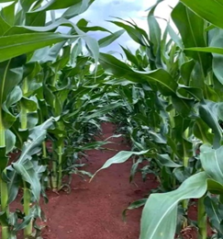 | 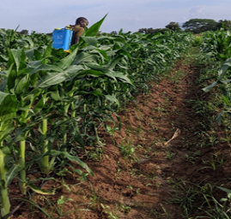 | 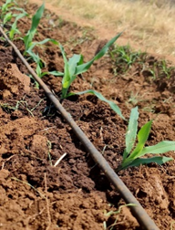
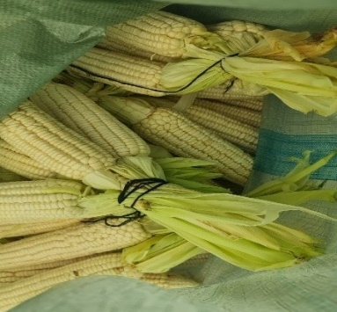 | 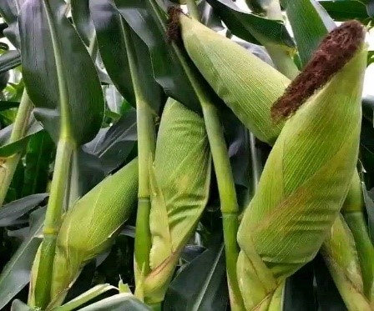 | 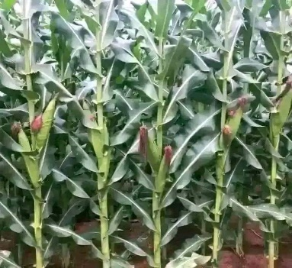

Figure 3: Appearance of the maize crop at various stages of development

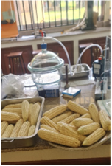 | 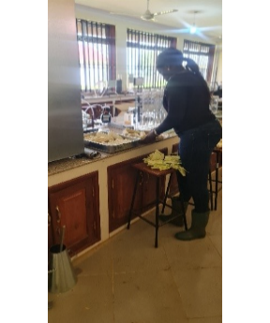 |  | 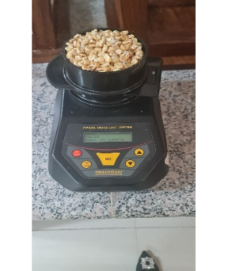
Figure 4: Laboratory preparations of the harvested maize to obtain dry weight

2.3.5 WATER PRODUCTIVITY
- Water use and irrigation water use efficiency
- Following the crop harvest, water use efficiency (WUE) and irrigation water use efficiency (IWUE) values, measured in kg of grain per cubic meter (kg m⁻³), were calculated for various treatments using the equations provided by Gheysari et al., 2015.
- Water use efficiency
Water use efficiency was computed by dividing the grain yield by the total evapotranspiration over the entire season.
$WUE=grain \frac{yield\left(kg ha^{-1}\right)}{ET_{c}\left(m^{3} ha^{-1}\right)}$.....................................................................................(3)
- Irrigation Water Use Efficiency
Irrigation water use efficiency was computed by dividing the grain yield by the total water applied.
$IWUE=grain \frac{yield\left(kg ha^{-1}\right)}{total water applied\left(m^{3} ha^{-1}\right)}$......................................................(4)
2.3.6 Economic analysis
Economic analysis was conducted following the guidelines outlined by Scott & Farquharson (2004). The benefit-cost (B-C) ratio, which is a measure of project worth, was used to evaluate the economic viability of the drip irrigation system in maize production, calculated as the present value of benefits divided by the present value of costs. When the ratio is greater than or equal to 1, the project is considered acceptable because benefits outweigh costs. The total cost of maize production encompasses expenses related to land preparation, irrigation system installation, labor, fertilizers, and pest control for a long-term period (10 years lifespan). The benefit-cost ratio (BCR) can be expressed as:
$BCR=\frac{\sum_{t=1}^{t=n}{\frac{B_{t}}{{\left(1+r\right)}^{t}}}}{\sum_{t=1}^{t=n}{\frac{C_{t}}{{\left(1+r\right)}^{t}}}}$.........................................................................................................(5)
Where:
B_{t} = Benefit at time t
C_{t} = Cost at time t
r = Interest (discount) rate
t = time (1, 2… n)
n = time horizon (years)

2.4. Statistical Analysis
The collected data were systematically organized, and mean values were calculated using Microsoft Excel. Data analysis was performed with R software, employing ANOVA to compare the treatment means. Furthermore, a Least Significant Difference (LSD) test at the 5% significance level was conducted to identify significant differences among treatments regarding plant growth and yield.

3. RESULTS AND DISCUSSION
3.1 Soil Physical Properties of the Study Area
The results of the soil physical analysis of samples taken from the experimental site are as shown in table 1.
Table 1: Showing the physical properties of the soil
Physical properties | Values
Bulk density (g cm⁻³) | 1.46
Porosity (% by vol.) | 45
Field capacity (% by vol.) | 17.9
Wilting point (% by vol.) | 8.1
Organic matter (%) | 2.5
Particle size distribution | (%)
Sand | 65
Silt | 25
Clay | 10

The analysis indicates that the soil texture is sandy loam, with a total available soil moisture (difference between field capacity and wilting point) of 98.0 mm/m. This value represents the lower end of the water-holding capacity for sandy loam soils, which influences the selection of an appropriate irrigation method considering the available water resources. Based on site conditions, implementing drip irrigation is recommended, as it aligns well with the observed maximum rain infiltration rate of 6 mm/day. The maximum rooting depth for maize in the study area was determined to be 100 cm. The initial available soil moisture at the site was taken as 98.0 mm/m.

3.2. Climatic Characteristics of the Study Area
Table 2 shows the mean monthly values of climatic variables for the study area, including the reference evapotranspiration (ET₀) calculated using the Penman-Monteith method (Stern et al., 2006). The region experiences a warm, sub-humid climate throughout the year, characterized by moderate winds. As a tropical climate, it receives annual precipitation ranging from 450 to 1,300 mm, with an average of approximately 870 mm (Table 3), reflecting considerable variability. Precipitation is predominantly concentrated from March to May (the long rains) and, to a lesser extent, from October to December (the short rains), indicating a bimodal rainfall pattern (Figure 4). The humid period – when precipitation exceeds potential evapotranspiration – lasts approximately three months, from March to May (Figure 5). This rainfall distribution plays a significant role in determining suitable crop choices and management practices in the area. Water availability is a critical concern, given the limited duration of the humid period, highlighting the need for supplemental irrigation and effective water conservation strategies (Kihupi et al., 2015).

Table 2: Mean monthly values of climatic variables for Morogoro station
Month | Minimum  Temperature ⁰C | Maximum Temperature  ⁰C | Relative Humidity % | Wind  km/day | Sun  hours | Radiation  MJ/m²/day | ET_{o}  mm/day
January | 21.0 | 31.5 | 71 | 130 | 5.7 | 18.6 | 4.38
February | 20.8 | 31.7 | 73 | 121 | 5.9 | 19.1 | 4.40
March | 20.8 | 31.5 | 76 | 121 | 6.0 | 18.8 | 4.27
April | 20.4 | 29.6 | 83 | 104 | 4.6 | 15.7 | 3.40
May | 18.8 | 28.2 | 82 | 112 | 4.2 | 13.9 | 3.00
June | 15.9 | 27.3 | 78 | 130 | 4.5 | 13.5 | 2.93
July | 15.0 | 27.2 | 74 | 130 | 4.4 | 13.7 | 3.00
August | 15.8 | 28.3 | 69 | 130 | 4.4 | 14.8 | 3.39
September | 16.6 | 29.8 | 67 | 156 | 4.9 | 16.7 | 4.03
October | 18.0 | 31.2 | 65 | 190 | 5.8 | 18.6 | 4.74
November | 19.5 | 31.8 | 68 | 173 | 6.1 | 19.2 | 4.73
December | 21.1 | 32.0 | 69 | 173 | 5.7 | 18.4 | 4.64
Average | 18.6 | 30.0 | 73 | 139 | 5.2 | 16.8 | 3.91

Table 3: Mean monthly rainfall data (1961 – 2020) for Morogoro station
Month | Jan | Feb | Mar | Apr | May | June | July | Aug | Sept | Oct | Nov | Dec | Total
Rainfall (mm) | 104.5 | 82.6 | 140.9 | 207.5 | 81.9 | 17.9 | 13.6 | 9.5 | 10.6 | 38.0 | 68.6 | 103.1 | 878.8
Effective Rainfall (mm) | 87.0 | 71.7 | 109.1 | 138.6 | 71.2 | 17.4 | 13.3 | 9.4 | 10.4 | 35.7 | 61.1 | 86.1 | 711.0

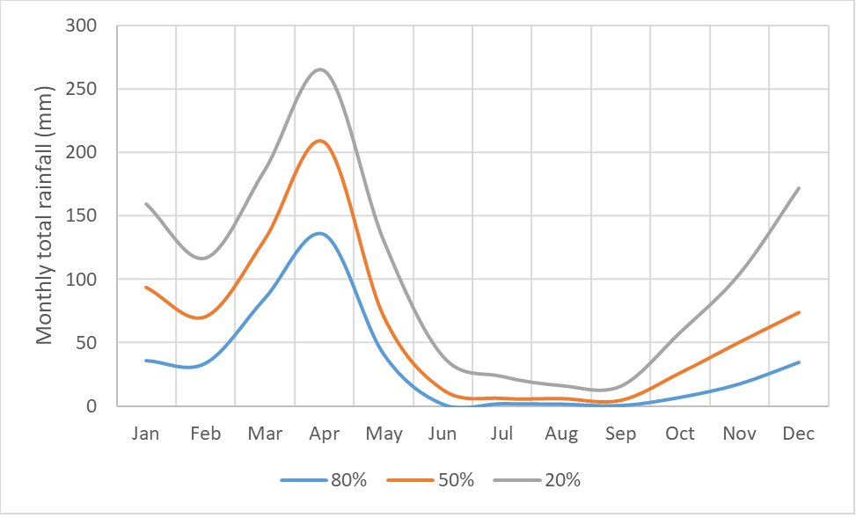
Figure 5: Expected rainfall amounts for each month at Morogoro, with a 20, 50 and 80% probability of exceedance representing a wet, normal and dry period respectively

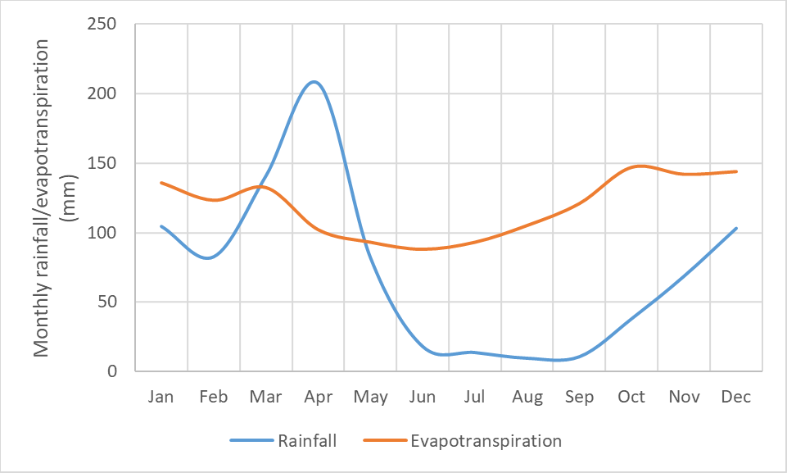
Figure 6: Mean monthly rainfall and evapotranspiration for Morogoro

3.3 Crop Water Requirements
The evapotranspiration (ET) of maize was recorded at 271.2 mm during the first season (November, December, and January) and 212.3 mm during the second season (February, March, and April). Notably, crop evapotranspiration was higher during the dry months compared to the rainy months, as crops require more water for replenishment during dry periods. Additionally, crop water consumptive use (ET_{c}) varies significantly depending on the crop's developmental stage and is predominantly influenced by climatic factors, with rainfall being the most impactful.
Rainfall in the second season was higher (159.2 mm) than in the first season (101.5 mm). Conversely, water applied was lower in the second season (53.1 mm) compared to the first season (169.7 mm), as shown in Table 4. The duration of water application differed among treatments according to the crop's growth stages. In the first season, application intervals were every 5 days with durations of 1.30 hours at the initial stage, 7 days with 3 hours at the development stage, 10 days with 5 hours at the mid-stage, and 10 days with 4 hours at the late stage. Similarly, in the second season, intervals were every 5 days with 1 hour at the initial stage, 7 days with 2 hours at the development stage, 10 days with 4 hours at the mid-stage, and 10 days with 3 hours at the late stage. The higher rainfall in the second season significantly influenced yield outcomes, as detailed in Table 5.

Table 4 Crop water and irrigation requirements for the first and second season, for all four growth stages
Month | Decade | Stage | K_{c}  Coeff | ET_{c}  mm/day | ET_{c}  mm/dec | Eff rain  mm/dec | Irr. Req.  mm/dec
First Season
Nov | 3 | Init | 0.30 | 1.41 | 14.1 | 3.2 | 10.9
Nov | 1 | Dev | 0.41 | 1.93 | 19.3 | 7.1 | 12.2
Nov | 2 | Dev | 0.81 | 3.75 | 37.5 | 10.4 | 27.1
Dec | 3 | Mid | 1.13 | 5.68 | 56.8 | 29.2 | 27.6
Dec | 1 | Mid | 1.16 | 5.16 | 51.6 | 25.7 | 25.9
Dec | 2 | Mid | 1.14 | 5.00 | 50.0 | 11.9 | 38.1
Jan | 3 | Late | 0.75 | 3.63 | 36.3 | 10.3 | 26.3
Jan | 1 | Late | 0.40 | 1.76 | 5.3 | 10.3 | 1.6
Total |  |  |  |  | 271.2 | 101.5 | 169.7
Second Season
Feb | 3 | Init | 0.30 | 1.31 | 1.3 | 0.0 | 1.3
Mar | 1 | Init | 0.30 | 1.30 | 13.0 | 10.7 | 2.3
Mar | 2 | Dev | 0.44 | 1.89 | 18.9 | 15.6 | 3.3
Mar | 3 | Dev | 0.85 | 3.39 | 37.3 | 25.5 | 11.8
Apr | 1 | Mid | 1.12 | 4.15 | 41.5 | 27.6 | 13.9
Apr | 2 | Mid | 1.13 | 3.84 | 38.4 | 31.0 | 7.4
Apr | 3 | Late | 1.10 | 3.59 | 35.9 | 30.2 | 5.7
May | 1 | Late | 0.17 | 2.24 | 22.4 | 17.2 | 5.2
May | 2 | Late | 0.40 | 1.19 | 3.6 | 1.4 | 2.2
Total |  |  |  |  | 212.3 | 159.2 | 53.1
3.4 Crop yield parameters
The results for crop yield, including grain weight, water use, and water use efficiency, are summarized in Table 5 for both growing seasons. The application rates were 271.2 mm in the first season and 212.3 mm in the second season. The discharge rates from the emitters varied depending on the operating pressure.
As shown in Table 5, in the first season, the yields were 2,340.9 kg/ha for T1, 2,432.7 kg/ha for T2, and 2,708.1 kg/ha for T3. In the second season, with a slight decrease attributable to rainfall, the yields were 2,203.2 kg/ha for T1, 2,233.8 kg/ha for T2, and 2,646.9 kg/ha for T3. Statistical analysis indicated no significant differences (p > 0.05) among the treatments in terms of yield.
Table 5: Comparison of yield, water use, and water use efficiency among treatments
TREATMENT | FIRST SEASON
 | Pressure | Yield (kg/ha) | Water applied  (mm) | Water use efficiency (kg/m³) | Irrigation water use efficiency (m³)
T1 | 1 bar | 2,340.9 | 271.2 | 8.632 | 27.638
T2 | 1.5 bar | 2,432.7 | 271.2 | 8.970 | 28.721
T3 | 2 bar | 2,708.1 | 271.2 | 9.986 | 31.973
SECOND SEASON
T1 | 1 Bar | 2203.2 | 212.3 | 10.378 | 26.012
T2 | 1.5 Bar | 2233.8 | 212.3 | 10.522 | 26.373
T3 | 2 Bar | 2646.9 | 212.3 | 12.468 | 31.250
There are no significant differences (p > 0.05) among treatments in yield.
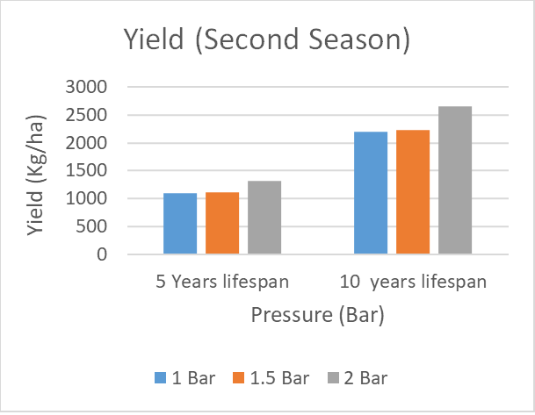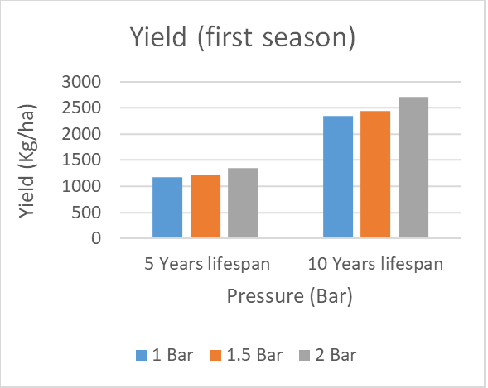
Figure 7: Effect of different operating pressures on yield

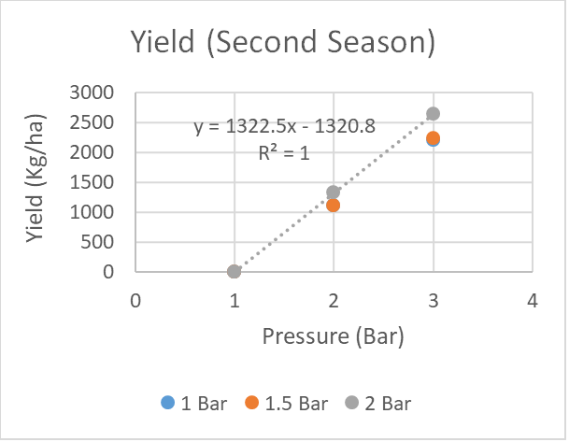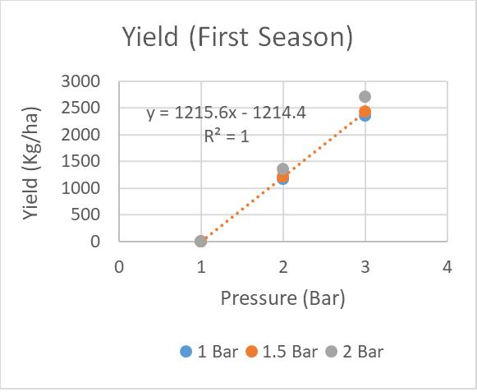
Figure 8: Regression relationship between different operating pressures on yield

4. ECONOMIC ANALYSIS
4.1. Cost of Cultivation
An interesting observation is that the substantial profits derived from cultivating a single crop allow farmers to offset both the capital expenditure on the drip irrigation system and the operational costs, which amount to $262 per hectare, as detailed in Table 6.

Table 6: Overall Cost of cultivation for maize production under drip irrigation for season one and season two (USD)
 | Agricultural Inputs | First Season |  |  | Second  Season
 |  | T1 | T2 | T3 | T1 T2 |  | T3
Cost of cultivation per hectare for maize production under drip irrigation
1 | Ploughing and Harrowing | $ 20 | $ 20 | $ 20 | $ 20 | $ 20 | $ 20
2 | Maize Seed (DK777) | $ 10 | $ 10 | $ 10 | $ 10 | $ 10 | $10
3 | Fertilizer (DAP ) | $ 15 | $ 15 | $ 15 | $ 15 | $ 15 | $ 15
4 | Fertilizer (Urea) | $ 15 | $ 15 | $ 15 | $ 15 | $ 15 | $ 15
5 | Pesticides | $ 12 | $ 12 | $ 12 | $ 12 | $ 12 | $ 12
6 | Herbicides | $ 12 | $ 12 | $ 12 | $ 12 | $ 12 | $ 12
7 | Weeding (Hand and Hoes) | $ 12 | $ 12 | $ 12 | $ 12 | $ 12 | $ 12
8 | Harvesting (Manual) | $ 9 | $ 9 | $ 9 | $ 9 | $ 9 | $ 9
Investment cost of the drip irrigation in maize cultivation
9 | Material Purchase (Drip Irrigation System) | $ 107 | $ 107 | $ 107 | $ 107 | $ 107 | $ 107
10 | Water Pump (1 Horsepower) | $ 20 | $ 20 | $ 20 | $ 20 | $ 20 | $ 20
11 | Drip Installation (HDPE Pipes 32mm & 16mm) | $ 17 | $ 17 | $ 17 | $ 17 | $ 17 | $ 17
12 | Maintenance | $ 13 | $ 13 | $ 13 | $ 13 | $ 13 | $ 13
 | TOTAL | $ 262 | $ 262 | $ 262 | $ 262 | $ 262 | $ 262

4.2 Profit
The analysis of cost reduction and yield benefits clearly demonstrates that the installed drip irrigation system is both technically and economically advantageous across different cultivation seasons and operating pressures (treatments). Table 7 shows the net returns from maize cultivation, with gross returns calculated by multiplying the yield by the market prices received by farmers. Net returns, or profit, are derived by subtracting the variable cultivation costs from the gross returns, consistent with the methodology outlined by (Mufunda et al., 2021)
The estimated net returns per hectare for maize grown under three different operating pressures are detailed in Table 7. Results indicate that maize cultivated using drip irrigation yields profits approximately 75% higher than those achieved through conventional irrigation methods. This finding corroborates the study by (Narayanamoorthy et al., 2018), which emphasizes the effectiveness of drip irrigation in addressing water scarcity.
Although the initial cost of implementing drip irrigation is substantial, amounting to $262 per hectare, the system offers long-term benefits. Over a 10-year investment horizon, maize farms utilizing drip irrigation experienced notable yield increases: T1 2,340.9 kg/ha, T2 2,432.7 kg/ha, and T3 2,708.1 kg/ha in the first season. In the subsequent season, yields slightly declined to T1 2,203.2 kg/ha, T2 2,233.8 kg/ha, and T3 2,646.9 kg/ha, respectively.
Table 7: Profit from maize cultivation for each season
Seasons | First Season |  |  |  |  | Second Season
Treatments | T1 | T2 | T3 | T1 | T2 |  | T3
Production Cost (USD/ha) | $ 262 | $ 262 | $262 | $ 262 | $ 262 |  | $ 262
Yield in Kg/ha (5 years)  (10 years) | 1170.45  2340.9 | 1216.35  2432.7 | 1354.05  2708.1 | 1101.6  2203.2 | 1116.9  2233.8 |  | 1323.45  2646.9
Yield in ton/ha (5 years)  (10 years)  Total Income (5 Years)  (10 Years) | 1.17045  2.3409  $584  $1,169 | 1.21635  2.4327  $621  $1,213 | 1.35405  2.7081  $731  $1,345 | 1.1016  2.2032  $529  $1,059 | 1.1169  2.2338  $542  $1,082 |  | 1.3235  2.6469  $707  $1,413
Net Returns (5 years)  (10 years) | $518  $1,103 | $554  $1,139 | $665  $1,250 | $463  $993 | $475  $1,005 |  | $640  $1,170

4.3 Economic Viability of Investing in Drip Irrigation
The Benefit-Cost Ratio (BCR) was evaluated across various operating pressures, as summarized in Table 8. This analysis assessed the cost-effectiveness of the installed drip irrigation system at different pressures - 1.0 bar, 1.5 bars, and 2.0 bars - specifically for maize cultivation, yielding encouraging results.
During the dry season, BCR values for the three treatments were as follows: Treatment T1 at 1.0 bar achieved a BCR of 7.765, while increasing the pressure to 1.5 bars (T2) resulted in a slight improvement, with a BCR of 8.316. The most significant enhancement was observed at 2.0 bars (T3), which attained a BCR of 9.968, indicating optimal cost-effectiveness at this pressure. Although T2 performed well, the increase was less pronounced compared to T3, suggesting diminishing returns at intermediate pressures.
In the wet season, Treatment T3 at 2.0 bars continued to outperform the other options, recording the highest BCR of 9.601 - affirming its status as the most cost-effective choice across both seasons. Treatment T2 at 1.5 bars maintained solid performance with a BCR of 7.122, though this represented a slight decline from its dry season result, indicating consistent returns despite seasonal variations. Conversely, Treatment T1 at 1.0 bar experienced a decline in efficiency, with a BCR of 6.939, making it the least economically viable - likely due to the adverse effects of increased rainfall on production during the wet season.
A seasonal comparison reveals that BCR values are generally higher during the dry season, implying that drip irrigation is more cost-efficient under drier conditions. Overall, Treatment T3 demonstrated the greatest resilience and profitability across both seasons, whereas the consistently lower performance of T1 suggests a need for further optimization.
The net profit and BCR are also significantly influenced by the lifespan of the drip irrigation system. While a five-year lifespan is considered optimal, extending the system’s operational period to ten years - assuming proper maintenance - can substantially increase net profits and improve BCR values, thereby enhancing overall economic returns, see table 8.

Table 8: Benefit Cost Ratio (BCR) for maize cultivation across seasons and lifespan
Treatment | Lifespan (years) | BCR
 |  | Season 1 | Season 2
T1 (1 BAR) | 5  10 | 7.7654  16.5308 | 6.9392  14.8784
T2 (1.5 BAR) | 5  10 | 8.3162  17.6324 | 7.1228  15.2456
T3 (2 BAR) | 5  10 | 9.9686  20.9372 | 9.6014  20.2028

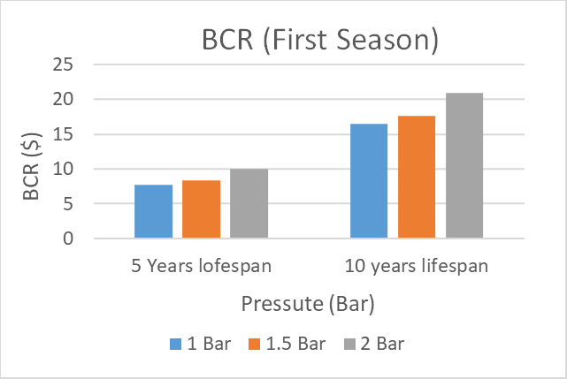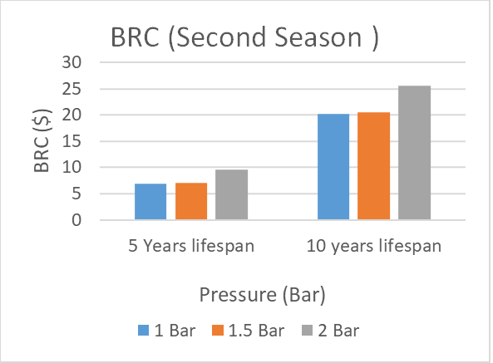

Figure 9: BCR under different operating pressures

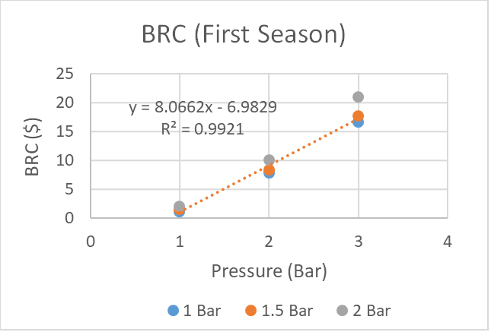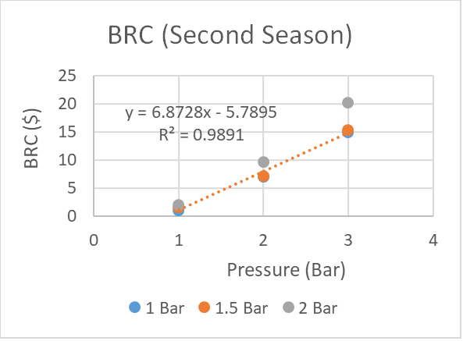

Figure 10: Regression between BCR and yield across varying operating pressures

5. Conclusion and Recommendations
5.1. Conclusion
This study demonstrates that the adoption of drip irrigation systems in maize cultivation can yield a favorable benefit-cost ratio (BCR) and enhance crop productivity, making it a viable strategy for farmers seeking to improve both sustainability and profitability. Specifically, the research evaluated the economic impact of pressure variations in drip irrigation for maize, with net water applications of 217.2 mm in the first season and 212.3 mm in the second season. Results indicated no significant differences (p>0.05) in yield attributes and BCR among the three tested operating pressures (1.0, 1.5, and 2.0 bars). However, all treatments demonstrated a notable increase in water use efficiency (WUE), primarily due to an 18.2% reduction in water consumption.
Yield outcomes were comparable between treatments T1 (1.0 bar) and T2 (1.5 bars), with yields of approximately 2,340.9 kg/ha and 2,432.7 kg/ha in the first season, respectively. Treatment T3 (2.0 bars) achieved the highest yields at 2,708.1 kg/ha in the first season and 2,646.9 kg/ha in the second season. Economic analysis revealed that all systems performed well, with T3 exhibiting the highest BCRs – 16.53 and 17.63 in the first and second seasons, respectively – indicating strong potential for long-term investment (over 10 years). The most cost-effective operating pressure was identified as 2.0 bars, achieving BCRs of 20.93 and 20.20 across the two seasons for a ten-year lifespan under the conditions in Morogoro, Tanzania.
Beyond its economic benefits, drip irrigation offers significant environmental advantages by conserving water, reducing losses, minimizing leaching, and supporting higher crop yields.
5.2. Recommendations
Based on the findings, it is recommended that maize farmers adopt drip irrigation systems for medium- to long-term use, as they are economically advantageous despite higher initial costs. Specifically, operating at a pressure of 2.0 bars is advised to maximize water use efficiency and profitability in water-scarce regions like Morogoro, Tanzania.
Effective water management is critical; therefore, proper irrigation scheduling– considering the timing and quantity of water application – is essential to optimize yields and prevent inefficient water use. Implementing precise irrigation practices will enhance the benefits of drip systems, ensuring sustainable and profitable maize production in regions facing water constraints.
Competing interests
Authors have declared that no competing interests exist.

REFERENCES
Allen, Richard G., PEREIRA, Luis S., RAES, Dirk and SMITH, M. (1998). FAO Irrigation and Drainage Paper Crop by. Irrigation and Drainage, 300(56), 300. http://www.kimberly.uidaho.edu/water/fao56/fao56.pdf
El-Wahed, M. H. A., & Ali, E. A. (2013). Effect of irrigation systems, amounts of irrigation water and mulching on corn yield, water use efficiency and net profit. Agricultural Water Management, 120(1), 64–71. https://doi.org/10.1016/j.agwat.2012.06.017
FAO. (2021). FAOSTAT ANALYTICAL BRIEF 60 Agricultural production statistics 2000-2021 FAOSTAT Analytical Brief 60 FAOSTAT CROPS AND LIVESTOCK PRODUCTION INTRODUCTION. Agricultural Production Statistics 2000-2021, 60, 1–17.
FAO, D. P., Allen, R. G., Pereira, L. S., Raes, D., & Smith, M. (2015). FAO . 1998 . Crop Evapotranspiration : Guidelines FAO Irrigation and Drainage Paper Crop Evapotranspiration. Irrigation and Drainage, 300(November), 300. http://www.kimberly.uidaho.edu/water/fao56/fao56.pdf
Gheysari, M., Loescher, H. W., Sadeghi, S. H., Mirlatifi, S. M., Zareian, M. J., & Hoogenboom, G. (2015). Water-yield relations and water use efficiency of maize under nitrogen fertigation for semiarid environments: Experiment and synthesis. Advances in Agronomy, 130, 175–229. https://doi.org/10.1016/bs.agron.2014.12.001
Guo, H., & Li, S. (2024). A Review of Drip Irrigation’s Effect on Water, Carbon Fluxes, and Crop Growth in Farmland. Water (Switzerland), 16(15). https://doi.org/10.3390/w16152206
Kihupi, M. L., Chingonikaya, E. E., Mahonge, C., Mwalimu, T., & Memorial, N. (2015). Smallholder Farmers ’ Perception of Climate Change Versus Meteorological Data in Semi-arid Areas of Iringa District ,. 5(2), 137–148.
Liu, M., Liang, F., Li, Q., Wang, G., Tian, Y., & Jia, H. (2023). Enhancement growth, water use efficiency and economic benefit for maize by drip irrigation in Northwest China. Scientific Reports, 13(1), 1–12. https://doi.org/10.1038/s41598-023-35611-9
Mufunda, A., Mupaso, N., Maparara, T., & Chipunza, N. (2021). Evaluation of Financial Performance of Center Pivot Versus Furrow Irrigation Systems in Sugarcane Production At Green Fuel Estate in Chipinge, Zimbabwe. Big Data in Water Resources Engineering (BDWRE), 2(1), 01–04. https://doi.org/10.26480/bdwre.01.2021.01.04
Mukherjee, S., Dash, P. K., Das, D., & Das, S. (2023). Growth, Yield and Water Productivity of Tomato as Influenced by Deficit Irrigation Water Management. Environmental Processes, 10(1). https://doi.org/10.1007/s40710-023-00624-z
Narayanamoorthy, A. (2004). Impact assessment of drip irrigation in India: The case of sugarcane. Development Policy Review, 22(4), 443–462. https://doi.org/10.1111/j.1467-7679.2004.00259.x
Narayanamoorthy, A., Bhattarai, M., & Jothi, P. (2018). An assessment of the economic impact of drip irrigation in vegetable production in India. Agricultural Economics Research Review, 31(1), 105. https://doi.org/10.5958/0974-0279.2018.00010.1
Nkonya, E., Xavery, P., Akonaay, H., Mwangi, W., Anandajayasekeram, P., Verkuijl, H., Martella, D., & Moshi, A. (1998). Maize Production Adoption of Maize. October.
Ranum, P., Peña-Rosas, J. P., & Garcia-Casal, M. N. (2014). Global maize production, utilization, and consumption. Annals of the New York Academy of Sciences, 1312(1), 105–112. https://doi.org/10.1111/nyas.12396
Savva, A. P., Frenken, K., Patel, N. H., Chintan Rajnikant Prajapati, Monitoring, D., Agriculture, I., Participation, F., Iv, V., Ighrakpata, U., Chouikha, M., Ejofodomi, tega A., Ofualagba, G., Gates, P., Gates, P., Gravatt, L., Mellos, T., Miller, A., Turjanski, D., Brier, J., & Jayanti, lia dwi. (2002). Irrigation Manual Module 9 Localized Localized Irrigation Systems Planning, Design,Operation and Maintenance. In Planning, Development Monitoring and Evaluation of Irrigated Agriculture with Farmer Participation (Vol. 21, Issue 1). http://journal.um-surabaya.ac.id/index.php/JKM/article/view/2203%0Ahttps://sswm.info/sites/default/files/reference_attachments/FAO 1992 Irrigation manual.pdf
Scott, F. J., & Farquharson, R. J. (2004). An Assessment of the Economic Impacts of NSW Agriculture Research and Extension - Conservation Farming and Reduced Tillage in Northern NSW. 19, 53.
Smajstrla, A. G., & Zazueta, F. (2011). Estimating crop irrigation requirements for irrigation system design and consumptive use permitting. Design, 1–4. http://edis.ifas.ufl.edu/ae078
Smith, M., & Nations, F. and A. O. of the U. (1992). CROPWAT: A Computer Program for Irrigation Planning and Management. Food and Agriculture Organization of the United Nations. https://books.google.co.tz/books?id=p9tB2ht47NAC
Stern, Roger Derk Rijks, Ian Dale, J. K. (2006). Instant Climatic Guide. January, 1–330. https://www.researchgate.net/profile/Roger_Stern/publication/264879427_Instat_Climatic_Guide/links/566532fb08ae4931cd60a556/Instat-Climatic-Guide.pdf
Sui, R., Fisher, D. K., & Reddy, K. N. (2015). Yield Response to Variable Rate Irrigation in Corn. Journal of Agricultural Science, 7(11), 11–18. https://doi.org/10.5539/jas.v7n11p11
Wahid, J., Saleh, B., Arar, M. S. A., & Awad, J. (2020). International Transaction Journal of Engineering , Management , & Applied Sciences & Technologies URBANISATION IN AJMAN PUSHING. Journal of Engineering, Management, & Applied Sciences & Technologies International, 11(7), 1–11. https://doi.org/10.14456/ITJEMAST.2020.151
Wambua, N. L. (2025). Optimizing Irrigation and Water Productivity for Maize Based on Soil Moisture Deficit and Crop Water Stress. 67(1), 59–76.
Whittlesey, N. (2003). Improving irrigation efficiency through technology adoption: When will it Conserve water? Developments in Water Science, 50(C), 53–62. https://doi.org/10.1016/S0167-5648(03)80007-2
windows. (2012). TB 15-Drip irrigation and water scarcity. June.
Yang, P., Wu, L., Cheng, M., Fan, J., Li, S., Wang, H., & Qian, L. (2023). Review on Drip Irrigation: Impact on Crop Yield, Quality, and Water Productivity in China. Water (Switzerland), 15(9). https://doi.org/10.3390/w15091733

