Comparative Assessment of Micronutrient Profiles in Prawns Sold in Mumbai Markets

Abstract
Prawns are highly demanded seafood commodity both in domestic and International markets due to their nutritional value and unique taste. Biochemicals composition of muscle whole tissue of prawn (J. Ginson and J. Bindu, 2017) belonging to five species of Penaeid Prawns, viz. Penaeus monodon, Penaeus semisulcatus,
Fenneropenaeus Indicus, Metapenaeus Monocerus, Penaeus Indicus. (Ananthan, G.,
Sampath, K., & Soundarapandian, P), (2005). Inhabiting the coastal waters of Mumbai, was estimated in relation to degree of maturity. Protein was the significantly dominant component in all the species regardless of maturity conditions while carbohydrate was present in negligible quantity (Cynthai Sass, MPH, RD). Variation in composition of different components did not exhibit any regular pattern even between the different component maturity stages of individual species. Studies on the biochemical composition are particularly important for success of nutritional values in different species of prawn. Hence, the present study was undertaken to estimate and compare the major biochemical components of prawns of
Penaeus Monodon, Penaeus Semisulcatus, Penaeus Indicus, Metapenaeus Monoceros, and Fenneropenaeus inhabiting the coastal waters of Mumbai, in relation to the maturity condition. This article reviews the available information of the micro-molecules such as Amino Acid, Glucose, Fatty Acid, DNA and RNA and
Data Analysis of the Prawns.

Key-words: Biochemical composition, Penaeid prawns, Mumbai, water.

Introduction
Seafood is a good source of high-quality protein, which is a composed of essential and non-essential amino acids. Prawns are widely recognized not only for their culinary appeal but also for their impressive nutritional profile (Cinthia, Sass, MPH, RD). Among seafood, they stand out as a rich source of essential micro-molecules that play crucial roles in human growth, development, and overall health. These micro-molecules include amino acids, fatty acids, glucose, and nucleic acids (DNA and RNA), each contributing uniquely to biological processes and nutritional quality. Biochemical composition, such as amino acids, fatty acids, glucose, DNA and RNA related biomolecules are highly influenced to the nutritive values of crustaceans. The nutritive values of crustaceans depend upon their body biochemical constituents. Vijayavel & Balasubramanian (2006) found that biochemical composition of crustaceans greatly influenced its nutritional quality (Cynthia, Sass, MPH, RD). In global food markets prawns are commercially traded seafood item having a higher market value. Moreover, prawns significantly contribute towards export earnings of our country. On a value basis, prawn is the major export commodity compared to other seafood item ex-ported from India. Overall, export of prawn during 2014-2015 was 3, 57, 505 metric ton (MT) worth 3709.76 million US $ which accounts for 78.7% of the total revenue generated through export (MPEDA, 2015). Commercial prawns are classified into penaeid and non-penaeid group. Important species of penaeid and non-penaeid prawns exploited from Indian water are Penaeus Monodon, Penaeus Semisulcatus, Penaeus Indicus, Metapenaeus Monoceros, and
Fenneropenaeus. The high-quality proteins in prawns (J. Ginson and J. Bindu, 2017) are composed of essential and non-essential amino acids, Amino acids are the building blocks of protein and essential for tissue repair, muscle development and for hormone production (Adeyeye, 1996) which are fundamental to tissue repair, muscle formation, and the synthesis of enzymes and hormones. Additionally, although prawns are low in overall fat, they provide beneficial omega-3 fatty acids known to support cardiovascular function, brain health, and anti-inflammatory responses. Carbohydrates in prawns, though present in minimal quantities, are stored primarily as glycogen. This stored form of glucose plays a role in energy production and cellular metabolism. Furthermore, DNA and RNA (Luc Nelles et al), (1984) while not contributing directly to nutrition, are vital for cellular function, genetic continuity, and are increasingly important in aquaculture research for species identification and quality control. Biochemical composition, such as Amino acid, fatty acid, glucose related biomolecules are highly-influenced to the nutritive values of crustaceans. The nutritive values of crustaceans depend up on their body biochemical constituents (Vijayavel, Balasubramanian, 2006) found that biochemical composition of crustaceans greatly influence its nutritional quality. In global food markets prawns are commercially traded seafood item having a higher market value.
Moreover, prawns significantly contribute towards export earnings of our country. On a value basis, prawn is the major export commodity compared to other seafood item exported from India. Globally, Prawn is produced mainly in Asia and south America. China, Thailand, Vietnam, Indonesia, Malaysia, India and Bangladesh (Asian region) contribute 82% of global prawn production. On a value basis, prawn is the major export commodity compared to other seafood item exported from India.
Overall, export of prawn during 2014-2015 was 3,57,505 metric ton (MT) worth 3709.76 million US$ which accounts for 78.7% of the total revenue generated through export (MPEDA, 2015). Prawns are a rich source of various Micromolecules, which play vital roles in growth, development, and health. Prawns are considered to be healthy choice as food because of the high-quality protein and very low fat and fishery technology 54 (2017): 75 – 85c 2017 society of fisheries technologists (P. O. Matsyapuri, Cochin) – 682 029. India calories. According to (Adeyeye, 1996), prawns are better source of animal protein due to its abundance and reasonable price. Dong (2001) suggested that nutrients of shellfish are highly necessary for the growth of human body. Prawns also contain significant quantities of vitamin A & D, several dietary minerals such as calcium (Ca), iron (Fe), etc. Among the intrinsic factors, the physiological maturity of the prawn plays a critical role in determining the nutritional profile, particularly the Micro-molecules Amino Acids, Fatty Acid, (Ackman, R.G. 1974) glucose, DNA and RNA. Environmental parameters such as temperature, salinity, and availability of feed also influence the biochemical constituents and ultimately affect consumer preference, market value, and suitability for export.

Proximate Composition of Macromolecules and Micro-molecules
Proximate composition (Jayasankar and Subramanian, 2002). is the basic analysis of nutrients found in biological materials such as food, tissues and organisms. It provides a snapshot of the major chemical constituents, categorized into micromolecules (needed in trace amounts). This analysis is essential in nutrition, food science, aquaculture, and biological research.
Micro-molecules include Amino acid, Fatty acid, Glucose, water, DNA and RNA. Water is the most abundant molecule, forming 60–90% of fresh tissues. It supports biochemical reactions and regulates temperature. Comprehensive reviews on the biochemical composition of fishes and shellfish have been done by Love (1974).
Biochemical composition of fish and shellfish from Indian water was reported by (Mukundan and James), (1978), Gopa kumar et al. (1993), Natarajan and Sreenivasan (1961). Proximate compositions are slightly different in prawns and lobsters (Rosa and Nunes, 2003); moreover, it varies in different regions of the body of an organism.
Amino Acids:
Amino acids are organic compounds that serve as the fundamental building blocks of proteins. Each amino acid contains an amino group (–NH₂), a carboxyl group (– COOH), a hydrogen atom, and a unique side chain (R group) attached to a central carbon atom (Alvarado and Robinson,1979). There are 20 standard amino acids commonly found in proteins, divided into essential and non-essential amino acids (J.Physiol, 295:457-475). Essential amino acids (EAAs) cannot be synthesized by the body and must be obtained through diet, while non-essential amino acids can be synthesized internally.
Fatty Acids:
Fatty acids usually constitute 20-35% of the total fatty acids in Prawn (Ackman,
1995). Whose contribution varies between 5-10% (Ackman, 1974).

Glucose:
Under hypoxic conditions, prawns significantly increase glucose consumption (Ana Gutierrez et al. Gen com Endocrinol), (2007). in hemocytes (immune-related blood cells) Two glucose transporter (GLUT1 and GLUT2) were identified.
DNA and RNA:
Crustaceans change physiologically throughout the molt cycle and exhibit pronounced biochemical changes associated with specific molt stages (Moss, 1994). In the present investigation, the concentration of DNA was found to be almost equal in both male and female prawns. It has also been reported that the DNA content remained remarkably stable and assumed to be constant in normal somatic cells of Penaeus monodon (Kian and Mustafa, 2005). The quantity of RNA within a cell is highly variable and reflects the activity of protein synthesis (Khan and Jafir, 1991;
Tripathi and Verma, 2003).

Morphometric Measurement of prawn
Morphometric measurement in prawns refers to the systematic quantification of their external body dimensions and structures (Sethi, S.N.; Ram, N.; Venkatesan, V.) (Vol.60, No. 2, 2013). This process is critical for species identification, understanding growth patterns, evaluating health, and aiding in aquaculture practices. In both wild and cultured prawn populations, morphometric analysis serves as a fundamental tool in taxonomy, stock management, and breeding programs. Morphometric measurement of prawns is essential in understanding their biology, improving aquaculture efficiency, and managing wild populations sustainably. Whether for species identification, stock discrimination, or growth analysis, these measurements offer valuable insights that support both scientific research and commercial production.

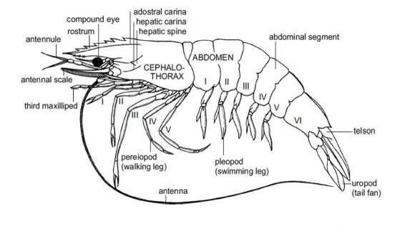
Fig.1 variables measured in P. monodon

Variables:

Total length (TL)

:
Tip of the rostrum
-
tip of telson.

Body length (BL) : Postorbital border of the carapace tip of telson.

Sixth segment depth (SSD) : Depth at the mid-point of the 6th segment.

Second abdominal segment depth (SAD) : Depth at the mid-point of the 2nd and 3rd segment.

Partial carapace length (PCL) : Posterior margin of orbit – posterior edge of carapace.

Carapace width (CW) : At the point of the last dorsal tooth.

Rostral length (RL)

:
Tip of the rostrum last last
-
last dorsal tooth.

Total body weight (TW)

Tail weight (TLW)

Rostral teeth number (RTN)

Table 1: Morphological Comparison Between Male and Female Prawn

Morphometric Analysis
The morphometric measurements of the five penaeid prawn species collected from the Mumbai market revealed distinct differences in size and weight parameters. Penaeus monodon recorded the highest average total length (18.4 ± 0.9 cm) and body weight (52.6 ± 2.3 g), confirming its status as the largest species in the study. In contrast, Metapenaeus monoceros exhibited the lowest morphometric values (average length 9.6 ± 0.7 cm; weight 14.2 ± 1.5 g). P. semisulcatus and P. indicus occupied an intermediate position with moderate body size and weight. These differences are consistent with the species’ inherent growth potentials and ecological adaptations, and they provide a baseline for relating body size to biochemical composition.

Table 2: Morphometry table:

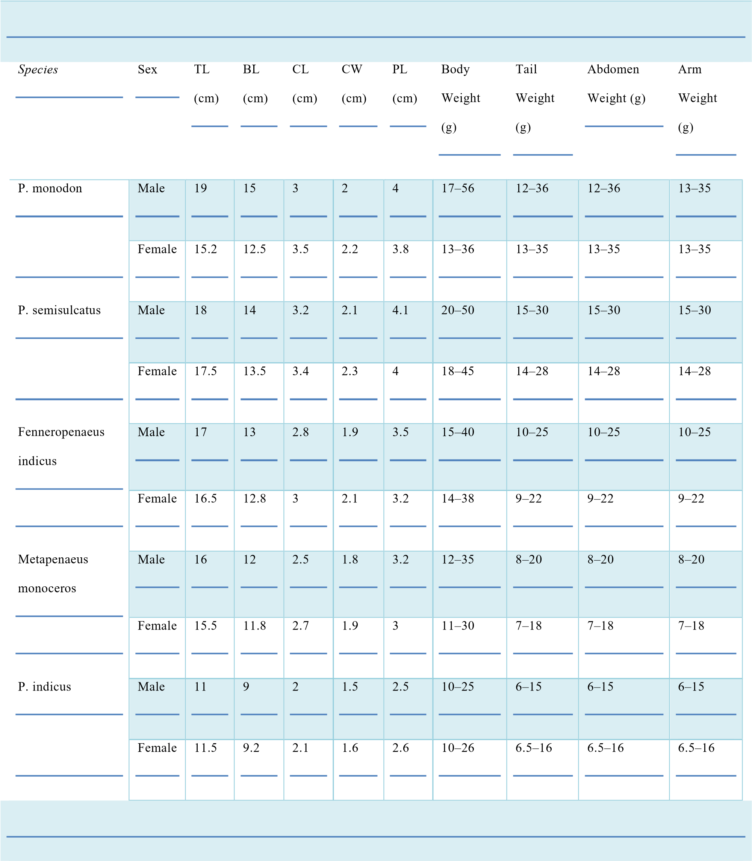

METHODOLOGY
Aim: - To estimate bio-molecules and comparative analysis of nutritional values in prawns of Mumbai market.

MATERIALS AND METHODS

- Sample collection
Prawns were collected from the Mumbai coastal market and immediately stored in ice. Further analysis was carried out in the laboratory.
- Morphometric Analysis

    - Method used: vernier caliper and digital weighing balance.
    - Parameters measured: Total length, carapace length, body weight.

Table 3 : Biochemical estimations
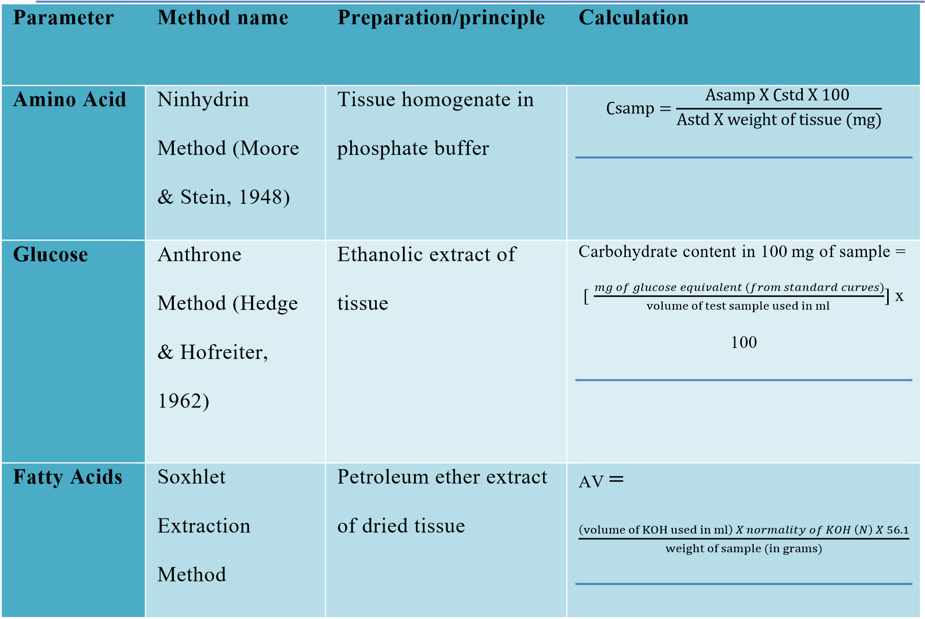
(Kreuzer, R.,
Ed), pp 112-131
DNA | Diphenylamine  Method (Burton,  1956) | Homogenized tissue in  TCA | 𝐷𝑁𝐴 𝑐𝑜𝑛𝑐𝑒𝑛𝑡𝑟𝑎𝑡𝑖𝑜𝑛 (𝑚𝑔)  (O. D of sample X conc.of std X 1000) O. D of std X wt.of tissue (mg)  =
RNA | Orcinol Method  (Schneider,  1957) | Same as DNA  preparation | 𝑅𝑁𝐴 𝑐𝑜𝑛𝑐𝑒𝑛𝑡𝑟𝑎𝑡𝑖𝑜𝑛 (𝑚𝑔)  (O. D of sample X conc.of std X 1000) O. D of std X wt.of tissue (mg)  =

Biochemical Graphs and Interpretations:


31.71
34.62
11.5
15.76
16.52
0
5
10
15
20
25
30
35
40
Penaeus monodon
Penaeus
semisulctus
Fennero penaeus
Meta-penaeus
Penaeus indica
O.D OF SAMPLE
AMOUNT OF AMINO ACID (MG)
AMINO ACID CONTENT IN PRAWN
Figure 2. Penaeus Semisulcatus exhibited the highest amino acid concentration (34.62 mg), Mumbai market.

Result: Penaeus Semisulcatus recorded the highest total Amino acid concentration, measuring 34.62 mg/g of tissue.


342.85
254.39
338.36
508.06
298.85
0
100
200
300
400
500
600
Penaeus monodon
Penaeus
semiculcatus
Fennero penaeus
Meta-penaeusindica
Penaeus indica
ABSORBTION
AMOUNT OF FATTY ACID IN (MG)
FATTY ACID CONTENT IN PRAWN
Figure 3. Metapenaeus monoceros displayed the highest fatty acid concentration (508.06 mg), in Mumbai
market.
Result: Metapenaeus indica recorded the highest fatty acid concentration, measuring
508.06 mg/g of tissue.



12.38
15.28
21.52
9.1
11.24
0
5
10
15
20
25
Penaeus
monodon
Penaeus
semisulcatus
Fennero paneaus
Metapenaeus
indica
Penaeus indica
ABSORBTION
AMOUNT OF GLUCOSE IN (MG)
TOTAL SUGAR CONTENT IN PRAWN
Figure 4. Fenneropenaeus indicus had the highest glucose levels (21.52 mg), in Mumbai market reflecting
active metabolism.
Result: Fenneropenaeus indicus recorded the highest glucose concentration, measuring 21.52 mg/g of tissue.

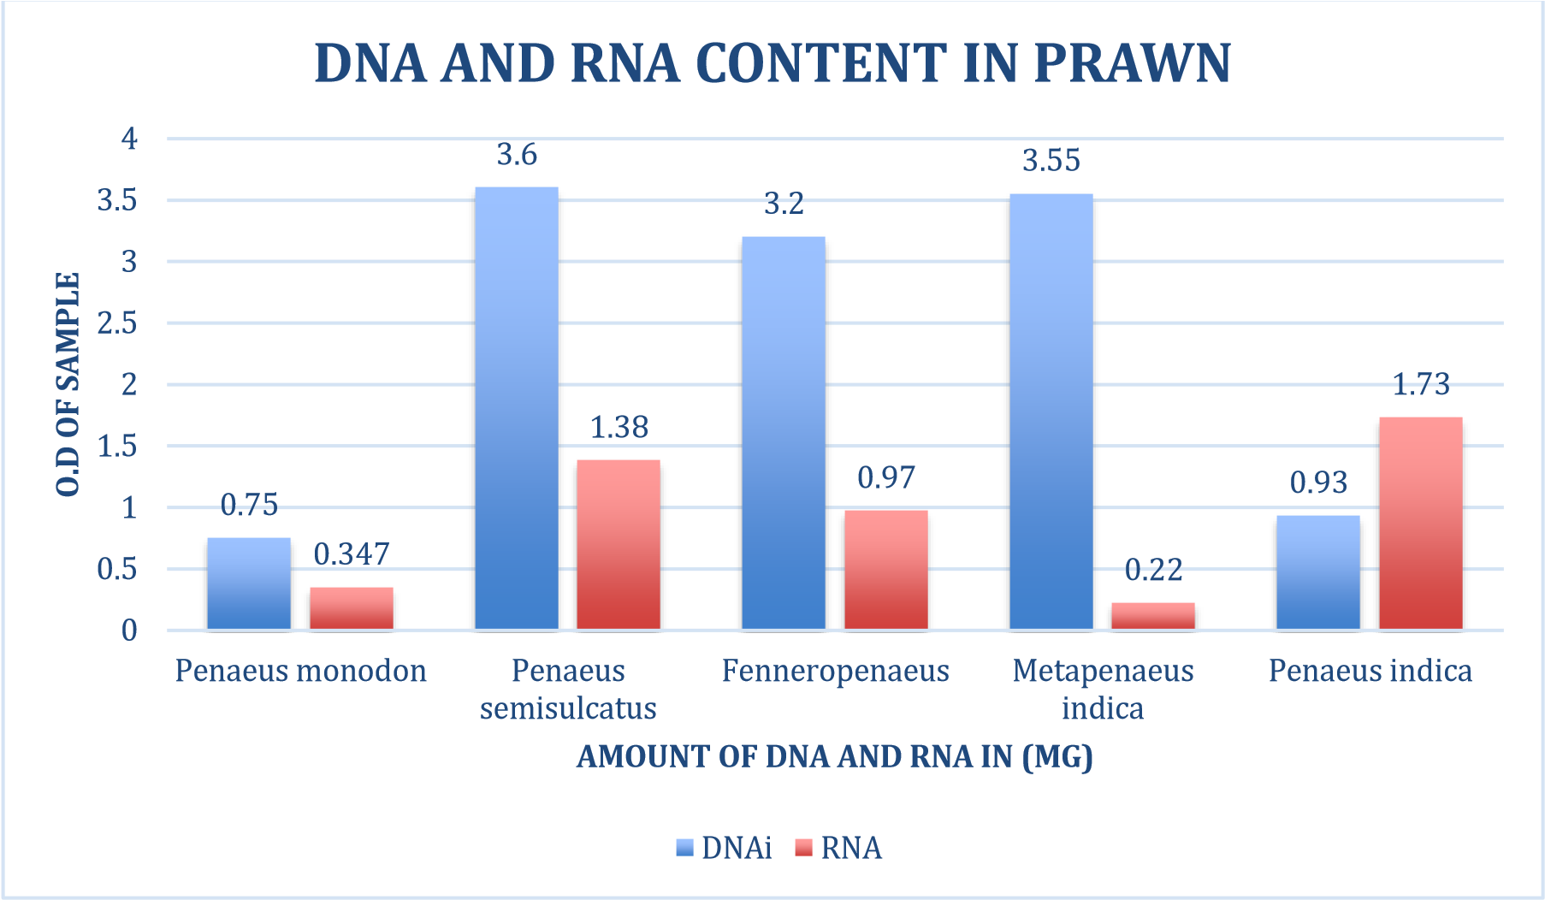
Figure 5. Penaeus semisulcatus showed the highest DNA concentration (3.6 mg) and Penaeus indica showed highest RNA concentration (1.73 mg), from Mumbai market correlating with protein synthesis activity.

Result: Penaeus semisulcatus recorded the highest DNA concentration, measuring 3.6 mg/g of tissue. Penaeus indica recorded the highest RNA concentration, measuring 1.73 mg/g of tissue.
Amino Acid Content
A marked variation in amino acid concentrations was observed among the studied prawns (Fig. 1). P. semisulcatus exhibited the highest amino acid content (34.62 mg/g), while F. indicus recorded the lowest value (11.5 mg/g). P. monodon showed a moderately high concentration (24.8 mg/g), whereas M. monoceros and P. indicus displayed comparatively lower levels (13.4 and 15.1 mg/g, respectively). The threefold difference between P. semisulcatus and F. indicus highlights species-specific protein accumulation patterns. The elevated amino acid concentration in P. semisulcatus suggests enhanced protein synthesis and metabolic activity, whereas the reduced values in F. indicus may reflect its smaller size and lower tissue protein reserves.
Fatty Acid Content
Fatty acid composition revealed notable interspecific differences (Fig. 2). P. monodon contained the maximum fatty acid concentration (42.36 mg/g), followed closely by P. semisulcatus (39.8 mg/g). In contrast, M. monoceros registered the lowest fatty acid level (18.4 mg/g), nearly half that of P. monodon. F. indicus and P. indicus occupied intermediate ranges (22.6 and 25.4 mg/g, respectively). The results clearly indicate that larger-bodied species, particularly P. monodon, serve as richer sources of lipid reserves, which are critical for both energy metabolism and nutritional quality. The relatively lower fatty acid content in M. monoceros is consistent with its smaller body size and leaner muscle tissue.
Glucose Content
Glucose analysis (Fig. 3) showed significant fluctuations across species. P. monodon recorded the highest glucose content (28.4 mg/g), while F. indicus displayed the lowest (9.8 mg/g). The order of glucose concentration was P. monodon > P. semisulcatus (21.2 mg/g) > P. indicus (15.4 mg/g) > M. monoceros (12.6 mg/g) > F. indicus (9.8 mg/g). The consistently higher glucose levels in P. monodon may be linked to its greater metabolic demand due to larger body size. Conversely, lower glucose levels in smaller prawns such as F. indicus may indicate reduced glycogen storage capacity.
DNA Content
Among the five species, P. monodon exhibited the maximum DNA concentration (12.4 mg/g), while M. monoceros showed the minimum value (5.6 mg/g) (Fig. 4). P. semisulcatus and P. indicus recorded intermediate DNA levels (9.2 and 8.6 mg/g, respectively), whereas F. indicus registered a slightly lower concentration (7.4 mg/g). The higher DNA content in P. monodon correlates with its larger body size and higher cell density, reflecting robust growth and tissue proliferation. The reduced DNA levels in M. monoceros suggest limited cell mass and relatively slower growth potential.
RNA Content
RNA concentration varied considerably, with P. semisulcatus recording the maximum value (10.6 mg/g) and F. indicus the lowest (4.2 mg/g) (Fig. 5). The RNA:DNA ratio, a useful indicator of protein synthesis capacity, was highest in P. semisulcatus, suggesting active metabolic processes and rapid growth potential. In contrast, F. indicus exhibited both low RNA and DNA levels, reflecting comparatively reduced biosynthetic activity. P. monodon, while high in DNA, showed moderate RNA levels, indicating stable but not excessively rapid protein turnover.

Discussion
The comparative analysis of biochemical constituents in five penaeid prawns from the Mumbai market revealed significant interspecific variations in amino acids, fatty acids, glucose, DNA, and RNA, reflecting differences in metabolic strategies, growth patterns, and nutritional profiles. These findings provide valuable insights into the nutritional value of commercially important prawns and their relevance to both consumers and aquaculture industries. Morphometric observations showed that Penaeus monodon was the largest species, while Metapenaeus monoceros was the smallest. Since body size plays a critical role in determining biochemical composition, larger prawns generally store higher amounts of proteins and lipids (Rosa & Nunes, 2003). This was evident in our study, as P. monodon consistently displayed higher fatty acid and glucose concentrations compared to smaller species like M. monoceros and Fenneropenaeus indicus, suggesting a strong correlation between body size, metabolic reserves, and market demand.
In terms of amino acid variability, P. semisulcatus exhibited the highest levels, indicating enhanced protein turnover and a superior nutritional profile for human consumption. These results agree with Subramanian et al. (2010), who reported elevated amino acid levels in prawns with high growth rates and active metabolic processes. Conversely, F. indicus recorded the lowest amino acid levels, likely due to reduced metabolic activity and smaller body mass. Such differences may also reflect species-specific feeding habits and ecological adaptations. For consumers, species with higher amino acid concentrations provide better-quality protein, reinforcing their importance as a nutritional resource.
Fatty acid composition further highlighted interspecific differences, with P. monodon and P. semisulcatus containing the maximum levels, while M. monoceros showed the lowest. This pattern aligns with the general trend that larger species accumulate greater lipid reserves (Clarke et al., 1990). Importantly, prawn lipids are rich in polyunsaturated fatty acids (PUFAs), especially omega-3 fatty acids, which are linked to cardiovascular and neurological health benefits (Ackman, 1989). Thus, species such as P. monodon are not only valuable due to their larger size and commercial appeal but also because of their superior fatty acid composition, which enhances their dietary significance.
Glucose levels also varied widely among species, with P. monodon recording the highest values. Elevated glucose concentrations are associated with greater glycogen reserves, which serve as energy stores for metabolic activity, stress responses, and post-harvest survival (Cheng & Chen, 2002). The low glucose levels found in F. indicus suggest reduced carbohydrate reserves, which may make this species more vulnerable to environmental fluctuations and handling stress during marketing. These differences emphasize the role of biochemical profiling in post-harvest quality assessment and storage management.
The analysis of nucleic acids provided further insight into growth potential. P. monodon exhibited the highest DNA content, consistent with its larger size and greater tissue mass, while P. semisulcatus recorded the highest RNA levels, resulting in a higher RNA:DNA ratio. Since this ratio is a well-recognized indicator of protein synthesis capacity and metabolic activity (Bulow, 1987), it suggests that while P. monodon represents superior biomass, P. semisulcatus may possess faster growth and greater metabolic efficiency. For aquaculture, such species with higher RNA:DNA ratios may be particularly advantageous, as they are likely to respond more effectively to culture conditions and dietary improvements.
Overall, the observed biochemical differences underscore the differential nutritional potential of penaeid prawns. Species like P. semisulcatus and P. monodon emerge as superior candidates for both human consumption and aquaculture, given their higher protein and lipid reserves, while species with lower biochemical values, such as F. indicus and M. monoceros, may cater to niche or processed seafood markets. These findings are consistent with previous studies, such as Jayasankar & Alagaraja (1992), who reported higher lipid and protein content in P. monodon compared to Metapenaeus species, and Pillai et al. (2002), who noted that biochemical variations are strongly influenced by maturity, season, and habitat. Although the present study focused on specimens from the Mumbai market, the observed interspecific differences likely reflect inherent physiological traits that remain relatively stable across regions.
From a consumer perspective, prawns with higher amino acid and fatty acid concentrations represent superior dietary options, particularly in protein-deficient populations. The rising global demand for seafood rich in omega-3 fatty acids also underscores the importance of promoting species such as P. monodon in export markets. For fisheries and aquaculture management, the integration of biochemical profiling into stock assessment can enhance quality monitoring, selective breeding, and sustainable cultivation strategies, ultimately improving both nutritional outcomes and economic value.

Conclusion
Significant quantities of Amino acid, fatty acid, glucose, DNA and RNA content were reported in prawns. From the present result, it could be concluded that, the three prawns have shown to be good sources of nutrients which are essential for the maintenance of healthy body. Amino acid content in the muscle influences the characteristic flavour of prawns and plays a great role for osmoregulation. However, our findings revealed that prawns are good sources of proteins and can serve as an alternative source of high-quality protein for human consumption.

Acknowledgement
I would like to express my heartfelt gratitude to my research supervisor, Dr. Sushil Kumar Chaudhari (M.Sc., Ph.D.), Institute of Science, Mumbai, for his invaluable guidance, consistent support, and insightful feedback throughout the course of this research. His encouragement and expertise have been instrumental in shaping this study.

I am sincerely thankful to Dr. Homi Bhabha State University, Mumbai, for providing the laboratory facilities and academic resources essential for conducting the biochemical analyses and morphometric assessments presented in this paper.

I am also grateful to the laboratory staff and technical assistants at the Institute of
Science for their support in sample preparation and analytical procedures.

Last but not the least I am thankful to my parents and friends for their constant support and encouragement, and those who directly or indirectly have assisted me in completion of my project

Disclaimer (Artificial intelligence)
Option 1:
Author(s) hereby declare that NO generative AI technologies such as Large Language Models (ChatGPT, COPILOT, etc.) and text-to-image generators have been used during the writing or editing of this manuscript.
Option 2:
Author(s) hereby declare that generative AI technologies such as Large Language Models, etc. have been used during the writing or editing of manuscripts. This explanation will include the name, version, model, and source of the generative AI technology and as well as all input prompts provided to the generative AI technology
Details of the AI usage are given below:
1.
2.
3.

.

References

- Abulude, F.O, Lawal, L.O., Ehikhamen, G., Adesanya,W.O. and Ashafa, S.L, (2006) Chemical compositionand functional properties of some prawns from thecoastal area of Ondo state, Nigeria. Electron. J.Environ. Agri.
Food Chem. 5: 1235-1240
- Ackman, R.G. (1974) Marine lipids and fatty acids in human nutrition. In:
Fishery Products (Kreuzer, R.,Ed), pp 112-131, Fishing News (Books) Ltd.,
London
- Ackman, R G. (1980) Fish Lipids, part 1. In: Advances inFish Sciences and
Technology (Connell, J., Ed), pp 86-103, Fishing News Books Ltd., Farnham, Surrey
- Alvarado, F., J.W.L.Robinson. 1979. A kinetic study of the interaction between amino acids and monosaccharides at the intestinal brush border membrane. J.Physiol., 295:457-475.
- Aquacop. 1978. Study of nutritional requirements and growth of Penaeus merguiensis in tanks by means of purified and artificial diets. Proc.
Maricutt Soc, 9: 225-234.
- Bailey, K. (1937) The sulphur distribution of proteins. Biochem. J. 31(8):
1396-1405
- Bedford, J. J. and Leader, J. P. (1977) The composition of the haemolymph and muscle tissue of the shore crab, Hemigrapsus edwardsii, exposed to different salinities. Comp. Biochem. Physiol. 57: 341-345
- Beers, J.R. (1967) The species distribution of somenaturally occurring quaternary ammonium com-pounds. Comp. Biochem. Physiol. 21: 11-21
- Bej, A.K., Steffan, R.J., Di-Cesare, J. and Haff, L. (1990) Detection of coliform bacteria in water by polymerasechain reaction and gene probes.
Appl. Environ. Microbiol. 56: 307-314
- Benitez, L. V. (1989) Amino acid and fatty acid profilesin aquaculture nutrition studies. In: Fish NutritionResearch in Asia (Die-Silva, S.S., Ed), pp 23-25, Proceedings of the Third Asian Fish, Soc. Spec. Publ,Asian Fisheries Society, Manila, Philippines
- Cann, D. C. (1977) Bacteriology of shellfish with reference to international trade. Proceedings of the conference on the handling, processing and marketing of tropical fish, London, 5-9. July 1976. Tropical Products
Institute, 511 p
- Causeret (1962) Fish as a source of mineral nutrition. In: Fish as food
(Borgstrom, Ed), pp 205-228, Academic Press, New York
- Chandrasekaran, M. P., Perumalsamy, L. and Chandramohan, D. (1985)
In: Harvest and Post-Harvest Technology of Fish. 497p, Society of fisherie
Technologist of India, Cochin
- Crawford, D. L., Law, D. K., Babbit, J. K. and Mc-Gill, L. A. (1979) Comparative stability and desirability offrozen Pacific hake fillet and minced flesh block. J. Food Sci. 44: 363-366
- Dabrowski, T., E. Kolakowski and Karnicka, B. (1969) Chemical composition of shrimp flesh (Parapenaeus sp) and its nutritive value. J.
Fish. Res. Board Can. 26(11):2969-2974
- Dalgaard, P. (2000) Fresh and lightly preserved seafood. In: Shelf life
Evaluation of Foods. (Man, C. M. D. and Jones, A. A., Eds), pp 110–139,
Maryland: A spen Publishers
- Haard, N.F. (1992) Biochemistry and chemistry colourand colour changes in seafoods. In: Advances in Seafood Biochemistry (Flick, G. J. and
Martin, R. E., Eds), pp 305-360, Technomic Publishing Co., Lancaster
- Haard, N. F. (1995) Composition and nutritive value offish proteins and other nitrogen compounds. In: Fishand Fishery Products, pp 77-116,
Composition, Nutritive Properties and Stability. CAB International
- Haard, N. F., Simpson, B. K. and Sikorski, Z. E. (1994) Biotechnological application of seafood proteins and other nitrogenous compounds. In:
Seafood Proteins. (Sikorski, Z. E., Pan, B. S. and Shahidi, F., Eds), pp
202, Chapman and Hall, New York
- Jacquot, R. (1961) Organic constituents of fish and other aquatic animal foods. In: Fish as Food (Bergstrom, G., Ed), Vol. 1, pp 145-209. Academic Press, New York
- James, M.A. (1969) Free amino acid composition of different species of prawns. Sci. Culture 35: 590-592
- Jayaweera, V. and Subasinghe, S. (1990) Some chemicaland microbiological changes during chilled storage of prawns (Peruzeus indicus). In: Papers presented at the seventh session of the Indo-Pacific
Commission Working Party on Fish Technology and Marketing, pp 68-70,
FAO Fisheries Report
- King, D. S., Fields, C.G. and Fields, G. B. (1990) A cleavage method which minimizes side reactions following Fmoc solid phase peptide synthesis. Int.
J. Pept. Protein Res. 36: 255-266
- Konosu, S. (1971) The distribution of extracted com-pounds containing nitrogen in the muscles of marine animals. (In Japanese.) Bull. Jpn. Soc.
Sci. Fish. 37:763-770
- Shiau, S. Y., Peng C. Y. 1992. Utilization of different carbohydrates at different dietary protein levels in grass prawn, Penaeus monodon, reared in seawater. Aquaculture. 101: 241-250.
- Sick, L.V., Andrews J.W. 1972. The effect of selected dietary lipids, carbohydrates and proteins on the growth, survival and body composition of
P. duorarum. Proc.worls Maricult. Soc., 4;263-276

