Original Research Article

Deciphering Salt Adaptation Mechanisms: Morphological, Biochemical, and Genotypical Contrasts between Salt-Tolerant and Salt-Sensitive Rice Genotypes under Salinity Stress

Shweta Singh¹, Prerona Boruah¹*, Pranita Thakur^{1*}, Mala Parab¹, Sneha Patil¹, Shravankumar Nachula¹, Pramodkumar P Gupta¹

¹School of Biotechnology and Bioinformatics, DY Patil Deemed to be University, Navi Mumbai, India

Shweta Singh: shwetamanojsingh@gmail.com
Prerona Boruah: boruahprerona@yahoo.com , Pranita Thakur: pranitat03@gmail.com
Mala Parab: malaparab@gmail.com , Sneha Patil: sne.pat.bt22@dypatil.edu , Shravankumar Nachula:
nachulla73@gmail.com
Pramodkumar P Gupta:
pramodkumar785@gmail.com
boruahprerona@yahoo.com
*Prerona Boruah Tel.: +917678012436; boruahprerona@yahoo.com
*Pranita Thakur Tel: +919529965447, pranita.thakur@dypatil.edu

.
ABSTRACT

Aims: This study aims to elucidate the morphological and gene expression patterns of salt stress induced rice crop of two different varieties, Improved Samba Mahsuri (ISM) (salt sensitive) and FL-478 (salt resistant).
Place and Duration of Study: School of Biotechnology and Bioinformatics, DY Patil Deemed to be University, Navi Mumbai, India, June 2024- January 2025
Methodology: In this study different rice genotypes were selected viz., FL478 and Improved Samba Mahsuri (ISM) were used, and there phenotypic and genotypic differences including gene expressions were studies post saline stress.
Results: Phenotypic evaluation revealed marked differences in salt tolerance, with FL478 demonstrating superior resilience, minimal leaf damage, and sustained growth under salt stress conditions compared to ISM. Biochemical analyses provided insights into FL478's higher salt tolerance, highlighting dynamic changes in ionic composition and an increase in osmolytes, indicative of robust adaptive mechanisms to mitigate salt-induced osmotic stress. Genotypic assessment uncovered molecular mechanisms underlying FL478's salt tolerance, particularly the up-regulation of stress-responsive genes HAK1 and HAK5, emphasizing its genetic adaptability to salinity.
Conclusion: These findings enhance our understanding of the mechanisms underpinning rice resistance to salt stress and offer valuable data for breeding programs aimed at developing salt-tolerant cultivars.

Keywords: ISM, FL478, Salt stress, Osmolytes, Osmotic stress.

1. INTRODUCTION

To sustain global food supply, staple crops are grown in specific agro-ecological regions, providing food for billions of people. As the major staple food grain, rice (Oryza sativa) is consumed by more than 3.5 billion people in Asia, Africa, and Latin America.(Fukagawa & Ziska, 2019) India is endowed with vast population and rich agricultural heritage that grows diversified staple cereals including rice, wheat, maize, and pulses. States like Andhra Pradesh, Assam, and Odisha, being major rice consumers grow substantial quantities of rice. (Atta et al., 2023)Despite its significance, rice production is beset with various pests and diseases, causing enormous losses in terms of quantity, quality, and sustainability. Abiotic constraints such as drought, salinity, and flooding further, make rice highly vulnerable to pests and diseases, eventually resulting in yield loss and poor quality. Particularly, the impact of abiotic stresses like salinity, is on reduction of crop yield since the accumulation of salts in the irrigated agricultural lands leads to decrease crop productivity.(Pathak et al., 2021) Major challenge in achieving best rice yields in many countries of the world is salinity in irrigated soils, however, the mechanisms of rice's tolerance to salinity is largely unknown.
In plants, salinity stress results in osmotic, ionic, and oxidative stress, which alter plant physiology and growth in different ways. Characterizing rice phenotype under salt stress involves assessing osmotic adjustment, root growth, leaf health, and shoot morphology. Salt stress not only affects chlorophyll synthesis but also causes degradation of the available chlorophyll resulting in reduction of photosynthesis efficiency and overall plant health.(Ashraf & Foolad, 2007)Rice varieties that are more tolerant to high salinity have less chlorophyll damage, underlining the importance of this feature in salt tolerance. In addition to this, anthocyanins, pigments giving blue, purple, and red hues, are also involved in plant response to salt stress.(Hoang et al., 2016)
In response to salt stress, rice plants have naturally developed biochemical and physiological mechanisms to help them cope, including ion transporter modifications, osmolyte accumulation and stress responsive gene activation. (Zhao et al., 2021) These mechanisms crucially depend on the regulation of ion transport, specifically the maintenance of an appropriate ratio of sodium (Na+) to potassium (K+) ions. Soils with high salinity disturb this balance leading to the harmful over accumulation of sodium that is in turn perilous to the plant. Maintaining a good Na+/K+ ratio is indispensable for normal cellular functions.(Balasubramaniam et al., 2023) To meet this goal, rice plants employ diverse mechanisms of ion transport regulation and ion balance maintenance specifically, ions are compartmentalized in vacuoles using certain ion transporters.
Ion transport pumps and channels are key to governing the flow of chloride and sodium ions across cell membranes to preserve ion balance and reduce salt stress. An imbalance in the Na+/K+ ratio leads to decreased enzyme activity and poor plasma membrane protein synthesis, impairing the plant's ability to cope with salt stress.(Assaha et al., 2017)To Adjust to this very saline environment, genetic regulation in the developing rice plant is crucial. For instance, the overexpression of the SOS1 gene helps remove sodium ions from the cytoplasm, while the HKT1 transporter gene regulates potassium and sodium ion absorption and transport in plant roots, mitigating the adverse effects of salt stress. (Dave et al., 2022; Ponce et al., 2021)
OsMYB6, OsHAK5, and OsHAK1 are all examples of crucial rice salt stress responsive genes. OsMYB6 is a transcription factor that regulates osmotic adjustment, antioxidation stress, and ion homeostasis in rice under salt stress conditions (Tang et al., 2019) OsHAK5, which up-regulates significantly in salt-tolerant rice, enhances high-affinity potassium uptake from the soil and improves salt stress, particularly ion balance, by reduced Na+ accumulation. OsHAK1, a stress salt tolerance gene associated with potassium uptake, regulates more solid osmotic regulation by controlling rice enzyme activity, turgor, and stomatal function (G. Chen et al., 2015; Yang et al., 2014), improving overall salt tolerance.
This study focuses on two distinct rice varieties: Improved Samba Mahsuri (ISM), a salt-sensitive variety, and FL-478, a salt-resistant inbred variety developed from the resilient Pokkali rice crossed with IR-29 (Cotsaftis et al., 2011)While the Pokkali variety has been extensively studied, both FL-478 and ISM are relatively new and less characterized. Examining these two phenotypically opposite varieties in terms of their salt tolerance abilities offers a clearer understanding of the mechanisms involved in salt tolerance, providing valuable insights into breeding and agricultural practices. In this research, we aim to understand the morphological and genetic differences between these varieties under salt stress. The phenotypic evaluations were conducted to assess morphological, physiological, and agronomic traits. Moreover, the expression analysis of key genes involved in homeostasis was performed to unravel the molecular mechanisms that underlie salt tolerance. Besides, the specific markers within the SALTOL QTL region were used to profile the selected rice varieties which will provide the insights about the genetic variation of these varieties and their response to salt stress.(Rekha et al., 2022)
While progress has been made, there are still significant gaps in our knowledge of the regulatory networks of salt tolerance that require investigation. This work seeks to address these open questions by conducting detailed morphological assessments, investigating the roles of osmolytes, and bridging them with changes in gene expression. The purpose of this study is to deepen our understanding of the morphological and genetic differences between salt-sensitive and salt-resistant rice varieties under salt stress. By conducting comprehensive phenotypic evaluations, analyzing gene expressions, and profiling genetic markers within the SALTOL QTL region, this research seeks to unravel the molecular mechanisms that underlie salt tolerance. The insights gained from this study will inform breeding programs and agricultural practices, fostering the development of resilient rice varieties capable of thriving in saline environments and contributing to global food security and sustainable agriculture.

2. material and methods

2.1. Germination, Salt stress, and Sampling
In this investigation different rice genotypes were selected viz., FL478 and Improved Samba Mahsuri (ISM) due to their contrasting salt tolerance scores as reported in prior studies. (Yadav et al., 2020; Ye et al., 2022) The seeds were obtained from ICAR-Directorate of Rice Research, Hyderabad. The seeds were grown in Petri dishes on top of moist filter papers with a pinch of fungicide until proper germination was observed and on the ninth day after exhibited onset of the shoot and root growth, the seedlings were transferred to a hydroponic setup. The seeds of both the varieties were divided into two groups: control and treated. Salt stress was induced to these seedlings from 15th day onwards with 125 Mm NaCl.(Zhao et al., 2021) After 19 days of germination the samples were harvested with liquid nitrogen and stored at -20 ºC.
2.2. Phenotypic evaluation
The visual salt injuries were evaluated using a modified Standard Evaluation System (SES) at the seedling stage following the method proposed by Gregoria et al.(Gregorio & Senadhira, 1993) Various growth parameters viz. the growth percentage, seedling weight, seedling height, root length, shoot length, root fresh weight, shoot fresh weight, were recorded for both control and salt treated plants just prior to the samples being crushed for biochemical trait analysis. Using an analytical weighing balance. The data was analyzed using 2-WAY ANOVA and the Tukey-Kramer test, was employed to compare population means and for finding the significance between the test and the control varieties.

2.3. Biochemical evaluation
2.3.1. Quantitative analysis of Total Chlorophyll and Total Anthocyanin content
To find the Total Chlorophyll (TC) content, a method provided by Lichtenthal (1987) (Vanisri, Sreedhar, Jeevan, Pavani, Chaturvedi, Aparna, Pavan Kumar, et al., 2017) was employed. The leaf tissue was ground in a pre-chilled mortar with calcium carbonate at a ratio of 1gram of tissue to 2 grams of CaCO3, along with 1 ml of 80% acetone(v/v). The sample extracts were then filtered using Whatman No. 1 filter paper, washed with 1 ml of acetone, and further diluted to make up the final volume of 5 ml using acetone. The resulting extracts were then subjected to UV-VIS spectrophotometric determination at 646 nm and 663 nm.
For Total Anthocyanin (TA) content, a modified procedure of Abdel-Aal and Hucl (1999) was used. Approximately, 0.1 gram of fresh leaf was soaked in 10 ml of acidified ethanol (ethanol: 1 N HCl, 85:15 v/v) for 72 hours. The suspension was then filtered through Whatman No. 1 filter paper, and the absorbance of the filtrate was measured at 535 nm.(Garriga et al., 2014)
The chlorophyll a (Ca) and chlorophyll b (Cb) content in milligram per litre was determined according to the formulae given below (Ashraf & Foolad, 2007) (written using MathType) and further expressed in milligram per gram of fresh weight of plant material.
Chlorophyll a,
Chlorophyll b,
Total chlorophyll,
2.3.2. Analysis of Sucrose and Glucose
Sucrose and Glucose analysis is integral to understanding plant tissue response to salt stress. Glucose is a simple sugar and serves as a primary source of energy for plants. Sucrose, a disaccharide composed of glucose and fructose, plays a crucial role in carbohydrate transport and storage in plants. After harvesting, 0.1 g of each sample was weighed and mixed with 4 mL of Anthrone solution. Vortex mixing ensured thorough interaction between the solution and plant material. Spectrophotometric analysis was then conducted to quantify Sucrose and Glucose concentration at 565 nm. (Jeandet et al., 2022)
2.3.3. Analysis of Proline
The most common endogenous osmolyte that responds to salinity by increasing its accumulation in plants is proline, and there is evidence that its overexpression in rice plants leads to improved salinity tolerance (Koc et al., 2024). Proline content was analyzed using a modified procedure provided by Bates et al (Bates et al., 1973) Accordingly, 0.1 gram of the fresh leaf tissue was homogenized in 5 mL of 3% aqueous sulfosalicylic acid. Subsequently, 2 mL of the resultant extract was mixed with 2 mL of acid ninhydrin along with 2 mL glacial acetic acid, followed by boiling at 96℃ for an hour. The reaction was then quenched by keeping the tube on ice at once. The solutions were further extracted using toluene and the absorbance of the toluene fraction was then measured at 520 nm spectrophotometrically. A calibration curve was plotted using known proline standards.
2.3.4. Analysis of Glycine betaine
Glycine betaine (GB), an osmolyte, which accumulates in cells, protects organisms from abiotic stresses. (Giri, 2011) We analyzed the endogenous levels of GB in the two phenotypically distinct rice varieties to gain insights into the inherent salt tolerance mechanisms in FL478. Lyophilized plant material was ground and mixed with 2 N H2SO4 for 10 minutes at 60°C to extract quaternary ammonium compounds, including glycine betaine. After centrifugation, the supernatant was mixed with cold KI-I2, incubated, and centrifuged again. The resulting precipitate was dissolved in 1,2-dichloromethane, and its absorbance at 265 nm was measured using a spectrophotometer after 48 hours. Glycine betaine levels were quantified using a standard curve prepared from stock solutions with concentrations of 5, 10, 15, 20, 25, 30 µL.(Valadez-Bustos et al., 2016)
2.4. Measurement of Ion content
Leaf Samples were evaluated for the concentrations of Na+ and K+ ions using atomic absorption spectroscopy. Approximately 0.5 grams of the sample were digested with 7 ml of nitric acid and 3 ml of hydrochloric acid in a microwave digester system under pressure at 250℃ for an hour. After cooling, the samples were then filtered and further diluted to 50 ml with water. Consequently, the digested samples were aspirated against known standards in Inductively Coupled Plasma Optical Emission Spectroscopy (ICP-OES) instrument. The final concentrations of the analytes in the samples were calculated using a dedicated software for the same. (Choi & Gilroy, 2015)
2.5. Quantitative Real-Time PCR Analysis
RNA was extracted from the leaf samples after 0, 8, 24, and 48 hours using the CTAB method.(Rogers & Bendich, 1994) Subsequently, cDNA conversion was conducted using Aura cDNA synthesis kit as per the manufacturer's instructions. It was followed by Real-Time PCR (using the SYBR green method) based gene expression analysis for stress-resistant/tolerant genes against their controls. It was performed using three genes MYB6, HAK1, and HAK5. GAPDH was used as a housekeeping gene. The primers for these genes were designed using Batch3 primer software. The primer sequences used are given in Table 2. The data obtained was assessed using the ddCt method for calculations. (Mirdar Mansuri et al., 2019). Table 1 summarizes the thermal profile for the amplification.
Segment | Plateau | Temperature | Duration | Cycle
Hot Start | 1 | 95 | 00:02:00 | 1
Amplification | 1 | 95 | 00:00:10 | 40
Amplification | 2 | 60 | 00:00:20 | 40
Amplification | 3 | 72 | 00:00:15 | 40
RT | 1 | 25 | 00:05:00 | 1

Table 1: Thermal Profile parameters used for qRT-PCR
2.6. DNA Extraction and SSR Genotyping
With a few adjustments, the CTAB technique was used to isolate genomic DNA from leaf samples.(Rogers & Bendich, 1994) Its quantity was calculated using spectrophotometry, and its quality was assessed using 0.8% agarose gel electrophoresis in 1X TBE buffer stained with ethidium bromide. In this study, PCR analysis was conducted using the following markers: RM10720, RM8094, and RM1287. Details on the markers were obtained from the GRAMENE database, and their sequences are provided in Table 2. The selection of this STMS marker is based on its proximity to the Saltol QTL on Chromosome 1, which is commonly used for the recombinant selection of lines that exhibit a salt tolerance response.(Karmakar et al., 2012) The isolated DNA was used for PCR amplification using the primers mentioned in table 2. The thermal parameters of the PCR reaction is summarized in table 3. The DNA ladder (excel BioSolutions) and the amplification products were combined with loading buffer, resolved on a 3% agarose gel in 1x TBE buffer, and monitored by the gel documentation system for 90 minutes at a constant voltage of 80 V. The 100 bp DNA ladder was used as a molecular size benchmark to compare the PCR products' sizes.(Kumari et al., 2019)
Name of gene | Primer type | Primer Sequence (5’-3’)
OsMYB6 | Forward Primer | CAAAGGCGACTGGAGGAGTA
OsMYB6 | Reverse Primer | CTGGCTGTCCAATTGTCGTA
OsHAK1 | Forward Primer | CGCTCTACTCGCTGATCTCC
OsHAK1 | Reverse Primer | TGCGTCTGAGTCAAGTTTGG
OsHAK5 | Forward Primer | AGGCTGCCAGGAATAGGTTT
OsHAK5 | Reverse Primer | ATTCCTCGTGGATGAATTGC
Name of STMS marker
RM10720 | Forward Primer | GCAAACGTCTACGTGAGAAACAAGC
RM10720 | Reverse Primer | GCATGTGGTGCCTTAACATTTGG
RM8094 | Forward Primer | AAGTTTGTACACATCGTATACA
RM8094 | Reverse Primer | CGCGACCAGTACTACTACTA
RM1287 | Forward Primer | GTGAAGAAAGCATGGTAAATG
RM1287 | Reverse Primer | CTCAGCTTGCTTGTGGTTAG
Table 2. List of designed gene specific primer and selected STMS marker flanking to Saltol QTLs and their sequences
Temperature | Time
94℃ | 5 Mins
94℃ | 40 Secs
65℃ | 30 Secs
72℃ | 1 Min
72℃ | 5 Mins
CYCLES | 30
HOLD | Infinite At 4℃
Table 3: Thermal Profile parameters used for PCR
2.7. Statistical analysis
GraphPad Prism version 8.0 was employed for statistical analysis, including the implementation of a Two-way ANOVA was performed to verify statistical significance.
2.8. Use of large language model
Quill Bot- Inbuilt in MS word was used as a paraphrasing tool in some parts of the introduction section of the manuscript.

3. results and discussion
3.1 Phenotypic evaluation
FL478 plants exhibited superior health compared to the ISM variety following salt treatment. The percentage of viable leaves was significantly lower in the ISM variety after exposure to saline stress, whereas the FL478 variety-maintained leaf integrity. Moreover, distinct morphological differences were observed between the two varieties: ISM plants developed long, lateral roots, while FL478 plants predominantly featured crown roots. Visual salt injury was rated based on specific criteria, ranging from 1 (highly tolerant) to 9 (highly susceptible). The results reveal that ISM and FL478 control and test seedlings exhibit similar trends in response to salt stress, albeit with some distinctions. FL478 control seedlings demonstrated superior initial growth parameters like number of leaves and rate of shoot growth . Following salt stress, ISM and FL478 test seedlings diverge in their responses. FL478 test seedlings exhibit lower growth percentage but maintain better growth performance and leaf health compared to ISM. Notably, FL478 test seedlings maintain 100% leaf survival, indicating minimal salt-induced leaf damage, whereas ISM test seedlings show moderate leaf damage with 50% leaf survival. ISM test plants display a score of 7, indicating complete growth cessation with dried lower leaves and wilting of the two youngest leaves, while FL478 test plants receive a score of 3, suggesting nearly normal growth with slight leaf symptoms. FL478 also demonstrated higher shoot length compared to ISM, the difference however was not statistically significant. There was a significant decrease in total plant weight in ISM treated plants compared to ISM control plants, contrastingly the plant weight remained comparable in FL478 pre and post salt treatment. ANOVA results for hydroponic-based studies are represented in graphical form in Fig. 2. A visual representation of all plant leaves is given below in Fig. 1, offering the evidence of salt injury and leaf symptoms observed in ISM and FL478 under salt stress conditions.
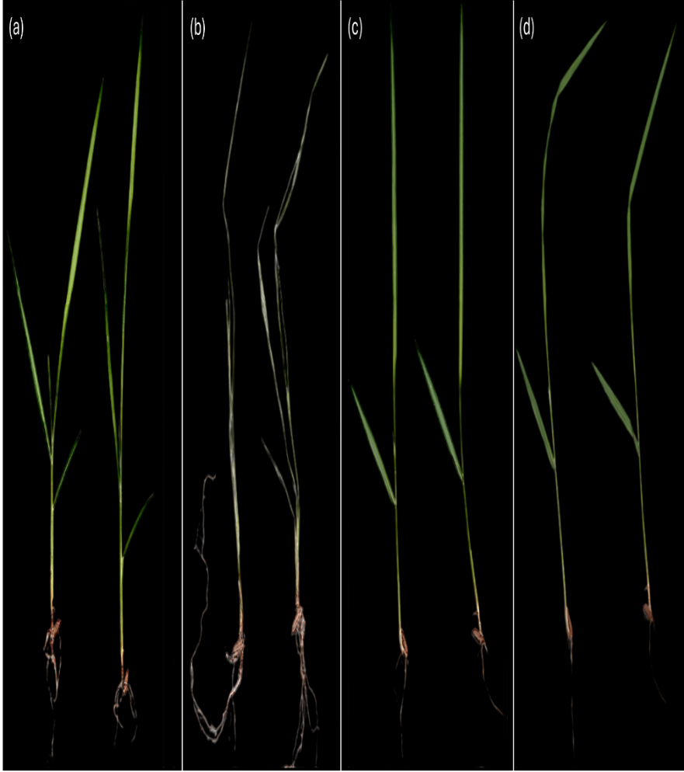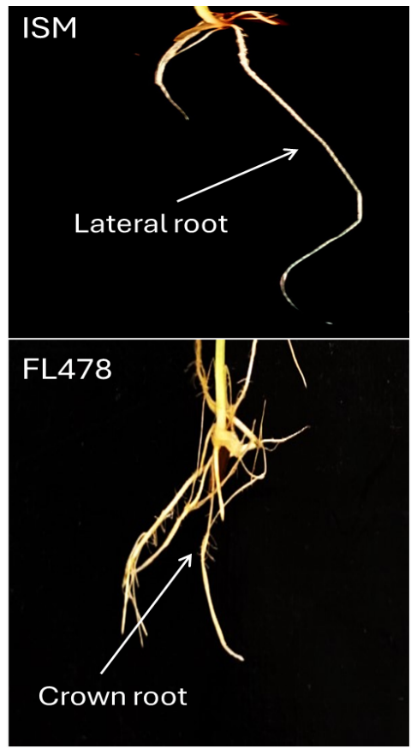
Fig.1 Leave samples of ISM and FL478 before and after stress(left) a, b: ISM, c, d: FL478; difference in the root structure of ISM and FL478(right).
3.2 Biochemical evaluation
3.2.1. Quantitative analysis of TC and TA content
The chlorophyll analysis showed significant differences between ISM and FL478 control and test seedlings. ISM control seedlings exhibited Ca levels of 7.78 mg/g, Cb at 6.64 mg/g, and TC at 14.43 mg/g. In contrast, ISM test seedlings displayed significantly reduced levels: Ca at 2.86 mg/g, Cb at 1.11 mg/g, and TC at 3.97 mg/g post saline treatment. FL478 control seedlings had higher chlorophyll levels: Ca at 17.35 mg/g, Cb at 5.16 mg/g, and TC at 22.51 mg/g. Remarkably, FL478 test seedlings showed even higher chlorophyll content: Ca at 22.52 mg/g, Cb at 9.27 mg/g, and TC at 31.79 mg/g, ANOVA revealed that this increase was statistically significant.
The analysis of total anthocyanin content revealed variations among the rice varieties. ISM control had TA levels of 0.258 mg/g, slightly increasing to 0.304 mg/g in the test group. Similarly, FL478 control had TA content of 0.293 mg/g, while the test group showed a notable increase to 0.590 mg/g. Graphical representation for both TC and TA contents is as given in Fig. 3.
3.2.2. Analysis of Sucrose and Glucose
The baseline glucose and sucrose content data highlights significant metabolic differences between the ISM and FL478 rice varieties even prior to saline stress. FL478 consistently demonstrates higher levels of both glucose and sucrose compared to ISM. (Fig. 3) FL478 exhibits a glucose concentration of 118.04 mg/ml, notably surpassing ISM's concentration of 90.04 mg/ml. Similarly, FL478 showcases elevated sucrose levels, with a concentration of 144.74 mg/ml, compared to ISM's concentration of 97.37 mg/ml.
3.2.3. Analysis of proline
The proline analysis data reveals significant differences in proline levels between the ISM and FL478 rice varieties under control and test conditions. In the control group, FL478 exhibits notably higher proline levels compared to ISM, with a concentration of 82.15 µg/g compared to ISM's concentration of 14.78 µg/g. In the test group, there is a notable decrease in proline levels for ISM, with a concentration of 1.15 µg/g compared to the control group's concentration of 14.78 µg/g. In contrast, FL478 continues to exhibit high proline levels even in the test group, with a concentration of 97.20 µg/g compared to the control group's concentration of 82.15 µg/g. (Fig. 3)
3.2.4. Quantification of Glycine Betaine
The quantification of glycine betaine levels in ISM and FL478 rice varieties showed distinct concentrations under both control and test conditions. In the control group, ISM exhibited a concentration of 4.05 micrograms per milligram, whereas FL478 displayed a higher concentration of 12.01 micrograms per milligram. Under salt stress conditions, ISM showed a significant increase in glycine betaine levels, reaching 23.71 micrograms per milligram, while FL478 exhibited increasing concentration of 18.09 micrograms per milligram, however the increase was not statistically significant. (Fig. 3)
3.2.5. Measurement of ion concentration
The ion content measurements revealed significant distinctions between the ISM and FL478 samples. FL478 control samples exhibited sodium and potassium levels of 42.7, 2.41 ppm respectively which were found to be comparable to ISM control samples that is 46.685 ppm Na⁺ and 2.135 K⁺ , with no statistical significance, indicating similar baseline sodium content in both the varieties. However, post salt stress ISM treated samples displayed statistically significant higher levels of sodium, 305.905 ppm compared to FL 478 test samples, which amounted to 148.505 ppm. Potassium levels post saline stress were comparable in both ISM and FL478 with 2.94, 3.075 ppm respectively. The significant higher Na⁺/K⁺ ratio in ISM compared to FL478 (Fig. 3) indicates better homeostatic mechanism employed by FL478 under saline stress.
3.2.6. Quantitative Real-Time PCR Analysis
For the MYB6 gene, there was a marginal increase observed in ISM control vs saline treated samples, whereas FL478 had a significant 1.15-fold increase in expression of MYB6 gene expression post salt treatment compared to control as seen in Fig. 4. Further, the expression of the HAK1 and HAK 5 also had a significant increase in FL478 saline treated samples compared to control samples, (2.5, 1.5) fold increase respectively in case of ISM, HAK 1 expression levels remained unaltered in saline treated samples. HAK 5 expression was slightly increased in ISM treated samples compared to control, however, the increase was not found to be statistically significant.

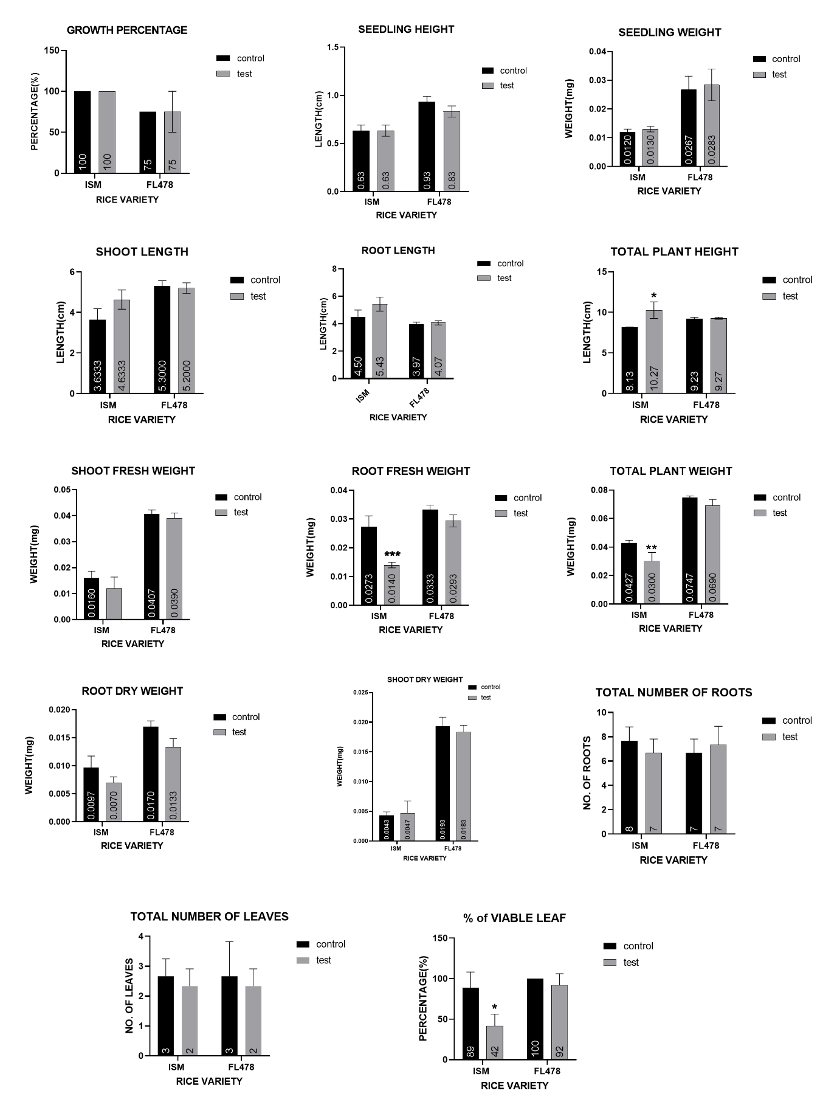
Fig.2 Morphological characteristics differences between FL478 and ISM rice varieties pre and post salt treatment. Data represented as mean ±SEM, (N=3) p≤0.05 is considered significant. *, **, ***, **** denotes p values of 0.05,0.01,0.001,0.0001 respectively

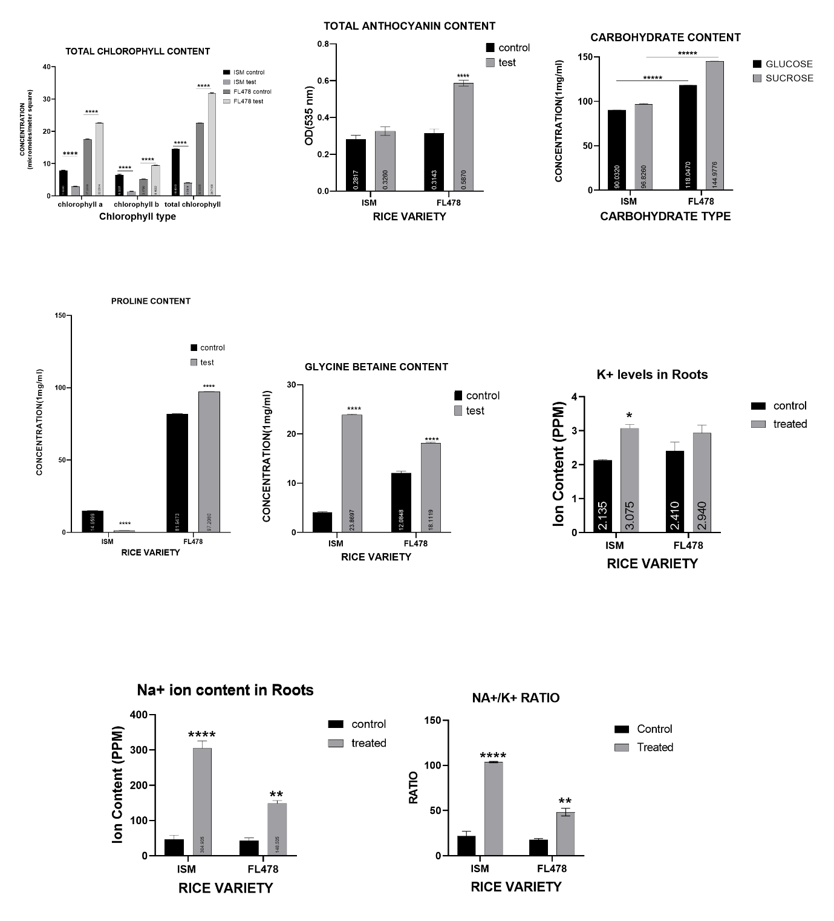
Fig. 3 Biochemical characterization differences between FL478 and ISM rice varieties pre and post salt treatment. Data represented as mean ±SEM, (N=3) p≤0.05 is considered significant. *, **, ***, **** denotes p values of 0.05,0.01,0.001,0.0001 respectively

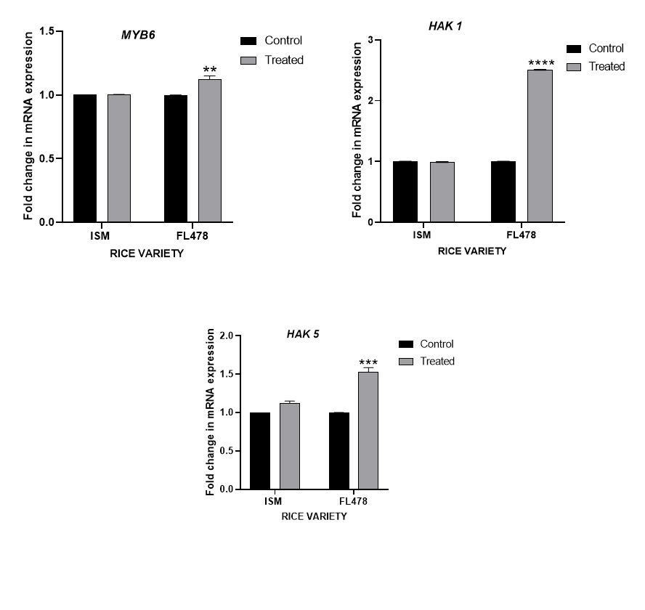
Fig.4 Gene expression analysis Data represented as mean ±SEM, (N=2) p≤0.05 is considered significant. *, **, ***, **** denotes p values of 0.05,0.01,0.001,0.0001 respectively.

3.2.7. DNA Extraction and SSR Genotyping
DNA extraction was successfully conducted using the CTAB method, followed by PCR amplification for SSR analysis. The extracted DNA was run for quality and quantity estimation and the representative image for the same is as seen in supplementary file 1. The precision of PCR product size was rigorously validated by aligning band positions with a standard ladder of 100 base pairs (bp). RM10720 exhibited a PCR product size of about 70 bp for both the markers. Subsequently, marker RM8094 revealed two bands with product sizes of approximately 190 and 110 bp for ISM and 200 bp for FL478.(Chowdhury et al., 2016) Finally, marker RM1287 showed product sizes around 180 bp for both ISM and FL478. This band size alignment for all three markers with the expected size indicates the successful amplification of the target SSR region. The precision of the PCR product size was confirmed by the consistency of the band position relative to the standard ladder. Since the markers were specifically selected only for rice varieties, the presence of both bands confirms that both plant samples used were of Rice. A visual representation of the markers is as given in Fig. 5.
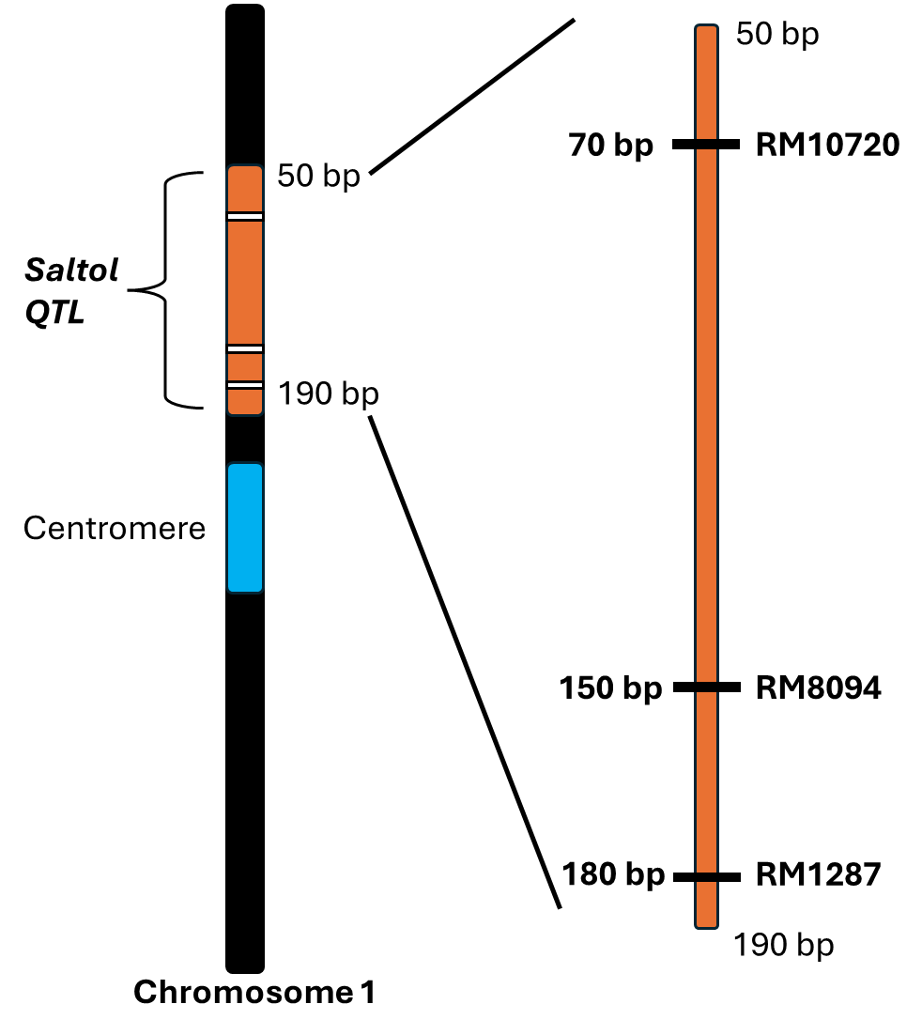
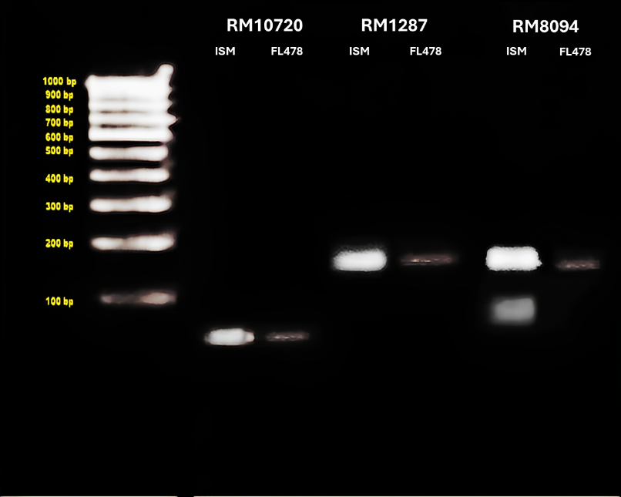
Fig.5 SSR Profile of the markers with 100 bp ladder (left),and a representation of the markers at chromosome 1. (right)

Phenotypic evaluation of salt tolerance in ISM and FL478 rice varieties revealed significant differences in their response to salt stress. Our S.E.S. evaluations showed clear distinctions between the two varieties, with FL478 faring much better in terms of leaf damage and overall growth. Our finding mirrors previous research that has credibly argued FL478's enhanced tolerance, attributed to its genetic background derived from the Pokkali strain, known for its salinity resilience.(SENGUPTA & MAJUMDER, 2010) In our study, FL478 maintained better growth and leaf health under salt stress conditions compared to ISM, further highlighting its advantage in salt tolerance. The contrasting root structures of ISM and FL478, with ISM exhibiting lateral roots and FL478 displaying crown roots, that significantly influence their response to salt stress. Lateral roots, as observed in ISM, primarily grow horizontally from the main root, and spread widely. While lateral roots can aid in nutrient absorption and provide stability to the plant, they may also increase the surface area exposed to salt stress, potentially leading to higher salt uptake and subsequent damage to the plant. In contrast, FL478's crown roots, which grow vertically from the base of the stem, may offer advantages under salt stress conditions. In a study carried out by Lyzenga et. al. crown roots tend to grow deeper into the soil, allowing the plant to access water and nutrients from deeper soil layers where salt concentrations are lower. (Lyzenga et al., 2023)Additionally, the vertical orientation of crown roots may help minimize salt exposure compared to lateral roots, reducing the risk of salt accumulation in the root system.
Quantitative analysis of TC and TA contents in ISM and FL478 rice varieties revealed significant differences in their responses to salt stress. FL478 consistently exhibited higher TC levels compared to ISM, suggesting a genetic advantage in chlorophyll production. This higher TC content in FL478 implies a greater capacity for photosynthesis, enabling sustained growth and stress tolerance, particularly under salt stress conditions. On the other hand, FL478 also showed higher TA levels compared to ISM, indicating a potential genetic predisposition towards greater anthocyanin accumulation. Anthocyanins are known to minimize oxidative damage and act as antioxidants, potentially contributing to FL478's superior performance and stress tolerance, our findings were found to be consistent to previous studies conducted by Vanisri et. al(Vanisri, Sreedhar, Jeevan, Pavani, Chaturvedi, Aparna, Kumar, et al., 2017) The observed differences in TC and TA contents between ISM and FL478 underscore FL478's genetic advantage in coping with environmental stressors like salinity, highlighting its potential for cultivation in saline-prone areas.
Further evaluation of osmolytes revealed higher glucose content in FL478 suggesting it may have a more efficient carbohydrate metabolism or greater capacity for glucose synthesis compared to ISM potentially enabling better coping with stress conditions like salinity. Elevated sucrose levels in FL478 indicate a higher capacity for carbohydrate accumulation and transport, suggesting enhanced mechanisms for sucrose synthesis or transport compared to ISM.(Ghosh et al., 2021) These metabolic differences may contribute to FL478's superior performance and stress tolerance.
The proline analysis data reveals significant differences in proline levels between the ISM and FL478 rice varieties under control and test conditions. FL478 exhibits notably higher proline levels compared to ISM in the control group, which in turn has been studied to impart stress tolerance by maintaining cell turgor or osmotic balance; stabilizing membranes thereby preventing electrolyte leakage. (Hayat et al., 2012)However, in the test group, while FL478 maintains high proline levels even under stress conditions, ISM shows a notable decrease in proline levels. This decrease indicates potential modulation of proline metabolism in ISM under stress conditions, reflecting a different stress response mechanism compared to FL478. These differences in proline accumulation patterns between ISM and FL478 may reflect variations in stress tolerance mechanisms, highlighting the potential for targeted genetic modulation strategies in rice varieties.(Chunthaburee et al., 2016)
The quantification of glycine betaine levels in ISM and FL478 rice varieties sheds light on their osmotic stress response mechanisms. Both varieties showed increased glycine betaine levels under salt stress compared to controls, indicating active accumulation as a protective response. FL478 displayed higher basal glycine betaine levels than ISM under control conditions, suggesting a pre-existing adaptive mechanism contributing to its salt tolerance.(Rhodes & Hanson, 1993) The slower increase in glycine betaine levels in FL478 compared to ISM under salt stress may be due to pre-existing stress coping mechanisms or genetic factors favouring a gradual response. Despite this, both varieties demonstrated significant increases in glycine betaine levels under salt stress, indicating a common stress response mechanism.
Ion content measurements revealed distinct differences in sodium (Na+) and potassium (K+) levels between the varieties. FL478 exhibited lower Na+ and K+ levels than ISM post salt stress, suggesting mechanisms for maintaining ion balance under salt stress, thereby contributing to improved tolerance. (Munns & Tester, 2008)The lower Na+/K+ ratio in FL478 indicates a better ability to maintain ion homeostasis, further enhancing its salt stress tolerance (Blumwald, 2000; Farooq et al., 2021)

The gene expression analysis revealed intriguing patterns in the response of FL-478 and ISM rice varieties under the tested conditions. All the genes considered for the study viz. MYB6, HAK1and HAK5 , showed a marginal increase in ISM test samples, suggesting little to no modulation in response to salt stress. In contrast, the expression of the MYB 6, HAK1and HAK5 gene showed a significant increase in FL-478 test samples. These findings indicate a more pronounced response in upregulating gene expression in FL-478 compared to ISM under the saline stress conditions. (van Zelm et al., 2020) Earlier investigations have hinted the role of upregulation of MYB 6 in response to salt and drought stress suggesting that the transcription factor has role in modulating osmolyte accumulations [11]. The osmolyte concentrations we obtained in our rice varieties confirms and bridges the function of gene upregulation with respect to salinity stress. The upregulation of HAK1 and HAK5 gene expression, particularly under salt stress, is pivotal for potassium transport and balance in plants encountering saline conditions.(Nieves-Cordones et al., 2014) HAK1 plays a critical role in potassium uptake from the soil when external potassium is scarce, while HAK5 assists in potassium absorption in roots. Through enhancing the expression of these genes, FL-478 exhibits a superior capacity to regulate potassium uptake and sustain balance compared to ISM, potentially augmenting its salt tolerance. Studies have indicated that under salt stress, plants activate high-affinity potassium transporters to facilitate potassium uptake and restore cellular sodium and potassium equilibrium, underscoring the significance of genes like HAK1 and HAK5 in maintaining ion homeostasis. (M. Chen et al., 2018) Overall, these results highlight the differential gene expression responses between FL-478 and ISM rice varieties, with FL-478 showing a more significant increase in the expression of stress-responsive genes HAK1 and HAK5.
The successful amplification of the target SSR region, as indicated by the observed band on the agarose gel, confirms the reliability of the CTAB-based DNA extraction method and the specificity of the PCR amplification using the three markers for SSR analysis in the rice samples. For RM8094, the resulting PCR products differed in size between the two varieties, with ISM sensitive yielding approximately 190base pairs (bp) and 110 bp bands and FL478 producing 170 bp fragments.(Chowdhury et al., 2016) These distinct product sizes hint at potential locus heterozygosity in the variety used for this study. Another possible reason could be that the primer used for RM 8094 might not be strictly specific. However, markers RM1287 and RM1072 exhibited monomorphic banding patterns, indicating uniformity in genetic composition, and validating the genotypes used belonged to Oryza sativa. (Thomson et al., 2010)
4. Conclusion

In conclusion, our comprehensive study on two phenotypically distinct rice varieties, ISM and FL478 under salt stress conditions has provided valuable insights into their adaptive mechanisms and potential applications in agriculture. Attributing to its distinct root structure, higher chlorophyll, and anthocyanin contents, efficient osmolyte accumulation, better ion homeostasis, and specific gene expression patterns. These findings align with previous research and underscore the potential for genetic manipulation to enhance salt stress tolerance in rice.
Overall, our findings position FL478 as a promising candidate for cultivation in saline-affected regions, offering sustainable solutions to global food security challenges. Further research into the underlying genetic and biochemical mechanisms driving FL478's superior traits could unlock new avenues for crop improvement and the development of salt-tolerant rice varieties, ensuring resilient agricultural systems capable of withstanding environmental stressors and ensuring food security for future generations

Competing interests

The authors declare that they have no known competing financial interests or personal relationships that could have appeared to influence the work reported in this paper.

Authors’ Contributions

Prerona BORUAH: Conceptualization, Data curation, Formal analysis. Shweta Singh: Investigation, first draft preparation. Pranita thakur: Seed material acquisition, first draft review. Mala Parab: First draft review, methodology. Sneha Patil & Shravankumar Nachula: Experimentation, Pramodkumar P Gupta: methodology,

COMPETING INTERESTS DISCLAIMER:
Authors have declared that they have no known competing financial interests OR non-financial interests OR personal relationships that could have appeared to influence the work reported in this paper.

References

Ashraf, M., & Foolad, M. R. (2007). Roles of glycine betaine and proline in improving plant abiotic stress resistance. Environmental and Experimental Botany, 59(2), 206–216. https://doi.org/10.1016/j.envexpbot.2005.12.006
Assaha, D. V. M., Ueda, A., Saneoka, H., Al-Yahyai, R., & Yaish, M. W. (2017). The Role of Na+ and K+ Transporters in Salt Stress Adaptation in Glycophytes. Frontiers in Physiology, 8. https://doi.org/10.3389/fphys.2017.00509
Atta, K., Mondal, S., Gorai, S., Singh, A. P., Kumari, A., Ghosh, T., Roy, A., Hembram, S., Gaikwad, D. J., Mondal, S., Bhattacharya, S., Jha, U. C., & Jespersen, D. (2023). Impacts of salinity stress on crop plants: improving salt tolerance through genetic and molecular dissection. Frontiers in Plant Science, 14. https://doi.org/10.3389/fpls.2023.1241736
Balasubramaniam, T., Shen, G., Esmaeili, N., & Zhang, H. (2023). Plants’ Response Mechanisms to Salinity Stress. Plants, 12(12), 2253. https://doi.org/10.3390/plants12122253
Bates, L. S., Waldren, R. P., & Teare, I. D. (1973). Rapid determination of free proline for water-stress studies. Plant and Soil, 39(1), 205–207. https://doi.org/10.1007/BF00018060
Blumwald, E. (2000). Sodium transport and salt tolerance in plants. Current Opinion in Cell Biology, 12(4), 431–434. https://doi.org/10.1016/S0955-0674(00)00112-5
Chen, G., Hu, Q., Luo, L., Yang, T., Zhang, S., Hu, Y., Yu, L., & Xu, G. (2015). Rice potassium transporter <scp>O</scp> s <scp>HAK</scp> 1 is essential for maintaining potassium‐mediated growth and functions in salt tolerance over low and high potassium concentration ranges. Plant, Cell & Environment, 38(12), 2747–2765. https://doi.org/10.1111/pce.12585
Chen, M., Yang, Z., Liu, J., Zhu, T., Wei, X., Fan, H., & Wang, B. (2018). Adaptation Mechanism of Salt Excluders under Saline Conditions and Its Applications. International Journal of Molecular Sciences, 19(11), 3668. https://doi.org/10.3390/ijms19113668
Choi, W.-G., & Gilroy, S. (2015). Quantification of Sodium Accumulation in Arabidopsis thaliana Using Inductively Coupled Plasma Optical Emission Spectrometery (ICP-OES). BIO-PROTOCOL, 5(16). https://doi.org/10.21769/BioProtoc.1570
Chowdhury, A. D., Haritha, G., Sunitha, T., Krishnamurthy, S. L., Divya, B., Padmavathi, G., Ram, T., & Sarla, N. (2016). Haplotyping of Rice Genotypes Using Simple Sequence Repeat Markers Associated with Salt Tolerance. Rice Science, 23(6), 317–325. https://doi.org/10.1016/j.rsci.2016.05.003
Chunthaburee, S., Dongsansuk, A., Sanitchon, J., Pattanagul, W., & Theerakulpisut, P. (2016). Physiological and biochemical parameters for evaluation and clustering of rice cultivars differing in salt tolerance at seedling stage. Saudi Journal of Biological Sciences, 23(4), 467–477. https://doi.org/10.1016/j.sjbs.2015.05.013
Cotsaftis, O., Plett, D., Johnson, A. A. T., Walia, H., Wilson, C., Ismail, A. M., Close, T. J., Tester, M., & Baumann, U. (2011). Root-Specific Transcript Profiling of Contrasting Rice Genotypes in Response to Salinity Stress. Molecular Plant, 4(1), 25–41. https://doi.org/10.1093/mp/ssq056
Dave, A., Agarwal, P., & Agarwal, P. K. (2022). Mechanism of high affinity potassium transporter (HKT) towards improved crop productivity in saline agricultural lands. 3 Biotech, 12(2), 51. https://doi.org/10.1007/s13205-021-03092-0
Farooq, M., Park, J. R., Jang, Y. H., Kim, E. G., & Kim, K. M. (2021). Rice Cultivars Under Salt Stress Show Differential Expression of Genes Related to the Regulation of Na+/K+ Balance. Frontiers in Plant Science, 12. https://doi.org/10.3389/fpls.2021.680131
Fukagawa, N. K., & Ziska, L. H. (2019). Rice: Importance for Global Nutrition. In J Nutr Sci Vitaminol (Vol. 65). http://www.riceassociation.org.uk/content/1/18/types-
Garriga, M., Retamales, J. B., Romero‐Bravo, S., Caligari, P. D. S., & Lobos, G. A. (2014). Chlorophyll, anthocyanin, and gas exchange changes assessed by spectroradiometry in Fragaria chiloensis under salt stress. Journal of Integrative Plant Biology, 56(5), 505–515. https://doi.org/10.1111/jipb.12193
Ghosh, U. K., Islam, Md. N., Siddiqui, Md. N., & Khan, Md. A. R. (2021). Understanding the roles of osmolytes for acclimatizing plants to changing environment: a review of potential mechanism. Plant Signaling & Behavior, 16(8). https://doi.org/10.1080/15592324.2021.1913306
Giri, J. (2011). Glycinebetaine and abiotic stress tolerance in plants. Plant Signaling & Behavior, 6(11), 1746–1751. https://doi.org/10.4161/psb.6.11.17801
Gregorio, G. B., & Senadhira, D. (1993). Genetic analysis of salinity tolerance in rice (Oryza sativa L.). Theoretical and Applied Genetics, 86(2–3), 333–338. https://doi.org/10.1007/BF00222098
Hayat, S., Hayat, Q., Alyemeni, M. N., Wani, A. S., Pichtel, J., & Ahmad, A. (2012). Role of proline under changing environments. Plant Signaling & Behavior, 7(11), 1456–1466. https://doi.org/10.4161/psb.21949
Hoang, T., Tran, T., Nguyen, T., Williams, B., Wurm, P., Bellairs, S., & Mundree, S. (2016). Improvement of Salinity Stress Tolerance in Rice: Challenges and Opportunities. Agronomy, 6(4), 54. https://doi.org/10.3390/agronomy6040054
Jeandet, P., Formela-Luboińska, M., Labudda, M., & Morkunas, I. (2022). The Role of Sugars in Plant Responses to Stress and Their Regulatory Function during Development. In International Journal of Molecular Sciences (Vol. 23, Issue 9). MDPI. https://doi.org/10.3390/ijms23095161
Karmakar, J., Roychowdhury, R., Kar, R. K., Deb, D., & Dey, N. (2012). Profiling of selected indigenous rice (Oryza sativa L.) landraces of Rarh Bengal in relation to osmotic stress tolerance. Physiology and Molecular Biology of Plants, 18(2), 125–132. https://doi.org/10.1007/s12298-012-0110-1
Koc, Y. E., Aycan, M., & Mitsui, T. (2024). Self-Defense Mechanism in Rice to Salinity: Proline. J, 7(1), 103–115. https://doi.org/10.3390/j7010006
Kumari, R., Kumar, P., Sharma, V. K., & Kumar, H. (2019). Seedling stage salt stress response specific characterization of genetic polymorphism and validation of SSR markers in rice. Physiology and Molecular Biology of Plants, 25(2), 407–419. https://doi.org/10.1007/s12298-018-0623-3
Lyzenga, W. J., Liu, Z., Olukayode, T., Zhao, Y., Kochian, L. V, & Ham, B.-K. (2023). Getting to the roots of N, P, and K uptake. Journal of Experimental Botany, 74(6), 1784–1805. https://doi.org/10.1093/jxb/erad035
Mirdar Mansuri, R., Shobbar, Z. S., Babaeian Jelodar, N., Ghaffari, M. R., Nematzadeh, G. A., & Asari, S. (2019). Dissecting molecular mechanisms underlying salt tolerance in rice: a comparative transcriptional profiling of the contrasting genotypes. Rice, 12(1). https://doi.org/10.1186/s12284-019-0273-2
Munns, R., & Tester, M. (2008). Mechanisms of Salinity Tolerance. Annual Review of Plant Biology, 59(1), 651–681. https://doi.org/10.1146/annurev.arplant.59.032607.092911
Nieves-Cordones, M., Alemán, F., Martínez, V., & Rubio, F. (2014). K+ uptake in plant roots. The systems involved, their regulation and parallels in other organisms. Journal of Plant Physiology, 171(9), 688–695. https://doi.org/10.1016/j.jplph.2013.09.021
Pathak, H., Kumar, M., A Molla, K., & Chakraborty, K. (2021). Abiotic stresses in rice production: Impacts and management. Oryza-An International Journal on Rice, 58(Special), 103–125. https://doi.org/10.35709/ory.2021.58.spl.4
Ponce, K. S., Guo, L., Leng, Y., Meng, L., & Ye, G. (2021). Advances in Sensing, Response and Regulation Mechanism of Salt Tolerance in Rice. International Journal of Molecular Sciences, 22(5), 2254. https://doi.org/10.3390/ijms22052254
Rekha, G., Abhilash Kumar, V., Gokulan, C. G., Koushik, M. B. V. N., Laxmi Prasanna, B., Kulkarni, S., Aleena, D., Harika, G., Hajira, S. K., Pranathi, K., Punniakoti, E., Kale, R. R., Dilip Kumar, T., Ayyappa, D., Anila, M., Sinha, P., Manohara, K. K., Padmavathi, G., Subba Rao, L. V., … Sundaram, R. M. (2022). DRR Dhan 58, a Seedling Stage Salinity Tolerant NIL of Improved Samba Mahsuri Shows Superior Performance in Multi-location Trials. Rice, 15(1). https://doi.org/10.1186/s12284-022-00591-3
Rhodes, D., & Hanson, A. D. (1993). Quaternary Ammonium and Tertiary Sulfonium Compounds in Higher Plants. Annual Review of Plant Physiology and Plant Molecular Biology, 44(1), 357–384. https://doi.org/10.1146/annurev.pp.44.060193.002041
Rogers, S. O., & Bendich, A. J. (1994). Extraction of total cellular DNA from plants, algae and fungi. In Plant Molecular Biology Manual (pp. 183–190). Springer Netherlands. https://doi.org/10.1007/978-94-011-0511-8_12
SENGUPTA, S., & MAJUMDER, A. L. (2010). Porteresia coarctata (Roxb.) Tateoka, a wild rice: a potential model for studying salt‐stress biology in rice. Plant, Cell & Environment, 33(4), 526–542. https://doi.org/10.1111/j.1365-3040.2009.02054.x
Tang, Y., Bao, X., Zhi, Y., Wu, Q., Guo, Y., Yin, X., Zeng, L., Li, J., Zhang, J., He, W., Liu, W., Wang, Q., Jia, C., Li, Z., & Liu, K. (2019). Overexpression of a MYB Family Gene, OsMYB6, Increases Drought and Salinity Stress Tolerance in Transgenic Rice. Frontiers in Plant Science, 10. https://doi.org/10.3389/fpls.2019.00168
Thomson, M. J., de Ocampo, M., Egdane, J., Rahman, M. A., Sajise, A. G., Adorada, D. L., Tumimbang-Raiz, E., Blumwald, E., Seraj, Z. I., Singh, R. K., Gregorio, G. B., & Ismail, A. M. (2010). Characterizing the Saltol Quantitative Trait Locus for Salinity Tolerance in Rice. Rice, 3(2–3), 148–160. https://doi.org/10.1007/s12284-010-9053-8
Valadez-Bustos, M. G., Aguado-Santacruz, G. A., Tiessen-Favier, A., Robledo-Paz, A., Muñoz-Orozco, A., Rascón-Cruz, Q., & Santacruz-Varela, A. (2016). A reliable method for spectrophotometric determination of glycine betaine in cell suspension and other systems. Analytical Biochemistry, 498, 47–52. https://doi.org/10.1016/j.ab.2015.12.015
Vanisri, S., Sreedhar, M., Jeevan, L., Pavani, A., Chaturvedi, A., Aparna, M., Kumar, D. P., Sunitha, T., Aruna, K., Venkata, V. G. N. T., Raju, Ch. S., & Jagadeeswar, R. (2017). Evaluation of Rice Genotypes for Chlorophyll Content and Scavenging Enzyme Activity under the Influence of Mannitol Stress towards Drought Tolerance. International Journal of Current Microbiology and Applied Sciences, 6(12), 2907–2917. https://doi.org/10.20546/ijcmas.2017.612.338
Vanisri, S., Sreedhar, M., Jeevan, L., Pavani, A., Chaturvedi, A., Aparna, M., Pavan Kumar, D., Sunitha, T., Aruna, K., Tripura Venkata, V. G. N., Surender Raju, Ch., & Jagadeeswar, R. (2017). Evaluation of Rice Genotypes for Chlorophyll Content and Scavenging Enzyme Activity under the Influence of Mannitol Stress towards Drought Tolerance. International Journal of Current Microbiology and Applied Sciences, 6(12), 2907–2917. https://doi.org/10.20546/ijcmas.2017.612.338
van Zelm, E., Zhang, Y., & Testerink, C. (2020). Salt Tolerance Mechanisms of Plants. Annual Review of Plant Biology, 71(1), 403–433. https://doi.org/10.1146/annurev-arplant-050718-100005
Yadav, A. K., Kumar, A., Grover, N., Ellur, R. K., Krishnan, S. G., Bollinedi, H., Bhowmick, P. K., Vinod, K. K., Nagarajan, M., Krishnamurthy, S. L., & Singh, A. K. (2020). Marker aided introgression of ‘Saltol’, a major QTL for seedling stage salinity tolerance into an elite Basmati rice variety ‘Pusa Basmati 1509.’ Scientific Reports, 10(1), 13877. https://doi.org/10.1038/s41598-020-70664-0
Yang, T., Zhang, S., Hu, Y., Wu, F., Hu, Q., Chen, G., Cai, J., Wu, T., Moran, N., Yu, L., & Xu, G. (2014). The Role of a Potassium Transporter OsHAK5 in Potassium Acquisition and Transport from Roots to Shoots in Rice at Low Potassium Supply Levels . Plant Physiology, 166(2), 945–959. https://doi.org/10.1104/pp.114.246520
Ye, X., Tie, W., Xu, J., Ding, Z., & Hu, W. (2022). Comparative Transcriptional Analysis of Two Contrasting Rice Genotypes in Response to Salt Stress. Agronomy, 12(5), 1163. https://doi.org/10.3390/agronomy12051163
Zhao, S., Zhang, Q., Liu, M., Zhou, H., Ma, C., & Wang, P. (2021). Regulation of Plant Responses to Salt Stress. International Journal of Molecular Sciences, 22(9), 4609. https://doi.org/10.3390/ijms22094609

