How Digital Transformation Drives New Quality Productivity in Manufacturing

Abstract: Under the Fifth Industrial Revolution, digital technologies are deeply integrating into industry. Major industrial nations have adopted development strategies. These strategies center on digital-physical integration. China is known as the "world factory." Its manufacturing sector faces challenges. It is large but not strong. It is comprehensive but not optimal. Digital transformation is urgently needed. It can overcome development bottlenecks. It can foster new competitive advantages. This study draws on the resource-based view and dynamic capabilities theory. It systematically examines how digital transformation drives new-quality productive forces in manufacturing firms. Empirical analysis reveals the following findings:(1) Drivers of digital transformation include internal and external factors. A linked internal-external driving system is required. It enables dual-directional momentum. (2) Digital transformation reshapes value creation in manufacturing. It does so through three paths: technological innovation, model innovation, and managerial innovation. Based on these findings, a stepwise transformation path model is proposed. A differentiated policy intervention framework is also proposed. These provide theoretical support and practical guidance. They support the strategic transition from "Made in China" to "Intelligent Manufacturing in China."
Keywords: Digital transformation; New quality productivity; Manufacturing industry

- Introduction.
The 20th National Congress of the Communist Party of China proposed to "accelerate the building of a manufacturing power." It is also called to "promote manufacturing toward high-end, intelligent, and green development." Digital transformation is identified as the core path. It is key to cultivating new, productive forces in manufacturing. A new round of technological and industrial change is accelerating. Next-generation digital technologies are deeply integrating into manufacturing. Examples include artificial intelligence and 5G. These technologies affect the entire manufacturing value chain. According to IDC, 67% of the world's top 1,000 firms have included digital transformation in their core strategies (Xu et al., 2019). This shows it has become a critical strategic choice for manufacturers. In June 2020, the General Office of the State Council issued guidelines. These are titled "Guiding Opinions on Integrating New-Generation Information Technology with Manufacturing." They call for accelerating changes in production models and enterprise forms. Technological integration is the means. This provides support for developing new productive forces. Despite this clear trend, the manufacturing sector still faces deep-seated challenges.
Manufacturing enterprises face complex domestic and international conditions. Developing new-quality productive forces has become essential. It is a key focus for achieving high-end transformation. It also supports high-quality development. In January 2024, General Secretary Xi Jinping addressed the 11th group study session of the Political Bureau of the CPC Central Committee. He defined new-quality productive forces as an advanced form of productivity. It is characterized by high technology, high efficiency, and high quality. Innovation is the primary driver. It moves beyond traditional economic growth models and productivity paths. It aligns with the new development philosophy. The background, mechanisms, and pathways of new-quality productive forces have become a research priority. Their emergence results from multiple factors. Digitalization plays a crucial role in their formation and development. In the manufacturing sector, digital transformation is particularly important. It drives the continuous emergence of new-quality productive forces. This occurs through cross-sector integration, tool innovation, technological change, and data value discovery.
Then, how can manufacturing enterprises use digital transformation to enable new-quality productive forces? Current academic research mainly focuses on the drivers of enterprise digital transformation. Few studies examine how digital transformation in manufacturing enables new-quality productive forces. This study addresses that gap. It draws on dynamic capabilities theory and the resource-based view. It explores the mechanisms through which digital transformation influences new-quality productive forces in manufacturing. The findings can deepen theoretical understanding. They help manufacturing enterprises. They also provide theoretical support. They offer practical implementation pathways. These help enterprises adapt to technological and market changes. They support the cultivation of new-quality productive forces.
- Literature Review.
  - Digital transformation
Traditional views define digital transformation in two core ways: first, by formulating an information technology strategy that covers all business areas of a firm; second, by using digital technologies to improve the efficiency of organizational processes. Another definition highlights its role in business model innovation, suggesting that digital transformation means optimizing products and services, improving processes, and enhancing relationships with customers and suppliers through digital technologies. In the manufacturing context, Pan and Zhao propose that digital transformation involves the deep integration of the internet with development concepts, production models, business models, and profit models. It creates combined economic effects by blurring industry boundaries and reshaping competitive and cooperative relationships. This is specifically reflected in integrated innovation activities by manufacturing firms at the technological, operational, and market levels. Zhao and Peng define it from a value chain perspective as "a symbiotic phenomenon of deconstructing the physical value chain and cross-chain reorganization of the virtual value chain." In terms of evolution, Yan Zichun et al. (2021) divide digital transformation into three stages: the period of digital technology innovation and development, the period of creating business value and industrial growth through digital technologies, and the period of rapid development driven by deep integration between industries and digitalization. The conceptual framework of digital transformation is shown in Figure 1.
Based on definitions in the literature and the focus of this study, digital transformation in manufacturing enterprises is defined as the process of transforming value-creation activities—such as production, R&D, sales, and services—through integration of internal and external resources, enabled by new-generation information technologies like mobile internet, cloud computing, the Internet of Things (IoT), and big data, aiming for intelligence, sustainability, and innovation.
As shown in Figure 1, the drivers of digital transformation fall into two broad categories: external and internal. External drivers include multiple dimensions such as environment, technology, and policy. An Xiaopeng (2019) pointed out that the evolution of internet technologies has created new supply-demand mismatches for enterprises. Internal drivers relate to enterprise development needs. Wang Zhitao et al. (2022) argued that strategic transformation becomes necessary when a firm’s current strategy does not align with its internal conditions or when resource utilization is suboptimal, to achieve optimal resource allocation.
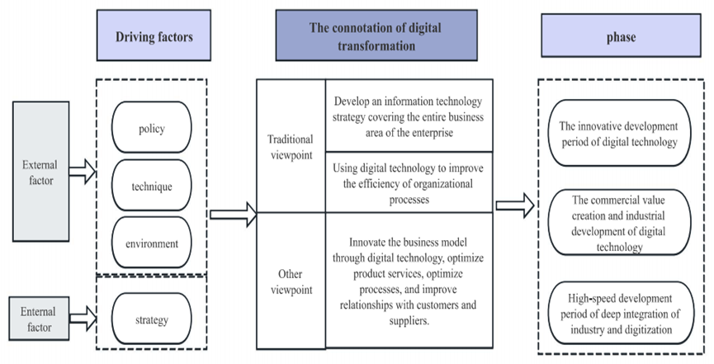
Fig.1 The connotation of digital transformation
  - New mass productivity
New quality productivity, as an advanced form of productivity emerging in the new era, requires a clear understanding of its theoretical foundations and development trajectory to grasp its essential characteristics. Since President Xi Jinping introduced the important concept of "new quality productivity," scholars have conducted systematic explorations into its meaning. Among them, Lu Jiang et al. (2024), responding to this issue of the times, constructed a multidimensional comprehensive evaluation framework. They clearly defined new quality productivity as an integrated system shaped by the interaction and joint support of three core dimensions: technological empowerment, green transformation, and digital integration. This highlights the symbiotic relationship among technological innovation, ecological orientation, and digital transformation in upgrading productivity.
In terms of characteristic analysis, scholars have reached a multi-perspective consensus. Li Xiaohua (2023) focuses on how technological change reshapes production methods. He points out that digitization and green development are clear markers distinguishing new quality productivity from traditional forms. Its core driving force comes from continuous innovation and breakthroughs in high-tech fields. Jiang Yongmu and Xue Weiran (2024) approach from the perspective of value orientation. They emphasize that high-quality development is both the core goal and direct purpose of new quality productivity, reflecting the intrinsic alignment between productivity advancement and economic transformation. Su Xijian and Sun Jiuyun shift the focus to industrial carriers. They argue that strategic emerging industries and future industries are key areas for new quality productivity. This highlights the supporting role and forward-looking nature of industrial structure upgrading in driving productivity leaps.
Compared to traditional forms of productivity, the advancement of new quality productivity is not limited to partial optimization of production factors or simple iterative application of a single technology. Instead, it is a systemic transformation driven by the joint effect of three elements: revolutionary technological breakthroughs that guide the direction, innovative allocation of production factors that provide support, and deep transformation and upgrading of industrial systems that inject momentum. This represents an advanced and higher-level direction for productivity development.
- Theoretical basis.
  - Dynamic capability theory
Teece's dynamic capabilities theory suggests that organizations need the strategic ability to quickly integrate internal and external resources and seize market opportunities to achieve sustained competitive advantage. In short, this theory emphasizes that firms must adapt to external changes through resource reconfiguration and strategic decision-making. The core elements of the theory are threefold. First, environmental adaptability, which means responding quickly and flexibly to market trends and technological changes. Second, organizational flexibility requires efficient internal change through process reengineering, resource reallocation, and workforce adjustments. Third, innovation drive, which focuses on continuous improvement of products, services, and processes to maintain a competitive advantage.
  - Resource-based theory
The Resource-Based View (RBV) was established by Birger Wernerfelt in his seminal 1984 paper "A Resource-Based View of the Firm," published in the Strategic Management Journal. This theory broke from traditional competitive analysis by proposing that differences in firm performance stem from internal resource endowments. Barney made a key contribution to this theory by developing a framework (VRIN/VRIO) to identify strategic resources and define the conditions for sustainable competitive advantage. The core argument is that only resources that are valuable, rare, inimitable, and non-substitutable (or organizationally supported to exploit these traits) can serve as the source of a firm's competitive advantage.
In summary, the theoretical framework of the digital transformation of manufacturing enterprises is shown in Figure 2. Dynamic capability theory and resource-based view theory work together on the digital transformation of manufacturing enterprises.
- Mechanism analysis.
Digital transformation has a significant positive impact on the development of new quality productivity in firms, and scholars have reached multidimensional conclusions. Li Yating (2024) and Zhang Huiheng with Zhang Weicheng (2024) both confirm this positive effect. The latter further indicates that the mechanism lies in enhancing managerial capability and improving information transparency. Based on dynamic capabilities theory, Yang Yin and Chen Feier (2024) find that digital transformation drives new quality productivity by strengthening firms’ abilities in digital sensing, resource integration, and organizational change. Li Zicheng, Wang Jue, and colleagues (2024) highlight the critical role of data as a production factor in advancing new quality productivity. At the supply chain level, Wang Ying and Hu Hanhui (2024) show that digital transformation boosts new quality productivity by improving supply chain efficiency and increasing supply chain influence. Shi Jin, Xu Minghao, and colleagues (2024) further reveal a positive spillover effect: the digital progress of customer firms positively impacts the new quality productivity of their suppliers. In addition, Fu Dongping and colleagues (2025) point out that improving digital infrastructure, advancing digital finance, and fostering digital industrial clusters through urban data trading platforms can help firms achieve a qualitative leap in productivity.
Overall, enterprise digital transformation drives the development of strategic emerging industries and future industries through three synergistic pathways—technological innovation, business model innovation, and management innovation—thereby fostering the emergence of new quality productivity. Specifically, digital transformation can improve operational efficiency, enhance performance and green innovation output, and promote the upgrading of human capital toward higher-end and more specialized profiles. Its impact extends beyond the firm, generating external spillovers through supply chain networks and peer effects. In terms of mechanisms, digital transformation supports the cultivation of new quality productivity by increasing investment in innovation factors, advancing talent ecosystems, and strengthening strategic alignment. This aligns with the qualitative changes required in workers, means of labor, objects of labor, and their configurations under new quality productivity. In turn, new quality productivity promotes high-quality economic development through technological application, reshaping of growth drivers, and industrial advancement, driving transformations in quality, efficiency, and momentum. As shown in Figure 3, for manufacturing firms, an evaluation system for new quality productivity can be constructed along the dimensions of intelligence, green development, and innovation. The heterogeneous characteristics of this new quality development hold significant practical implications for high-quality industrial advancement.
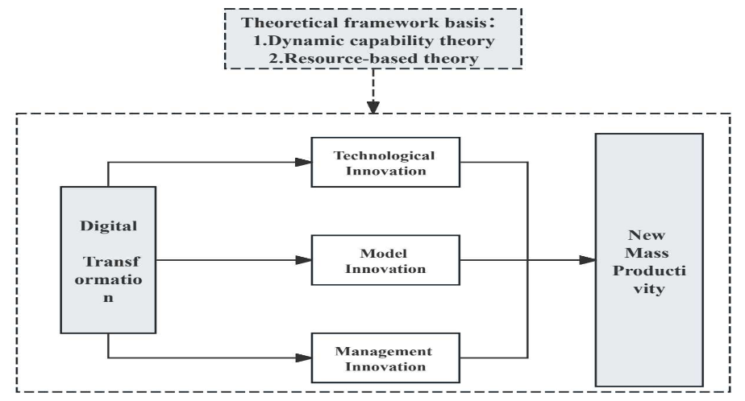

Fig.2 Theoretical framework basis
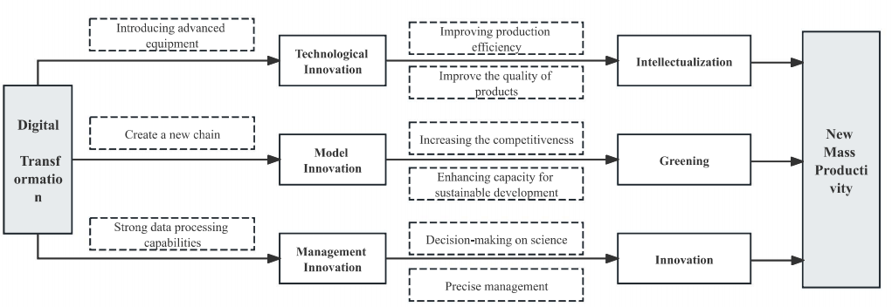
Fig.3 The mechanism of digital transformation on new productivity
- Conclusions.
Firstly, Manufacturing firms need a dual-driven system for digital transformation. This system integrates internal and external drivers. External drivers require coordinated support. The environment, technology, and policy must be optimized continuously. Industrial digital infrastructure should be strengthened. Cross-regional technology sharing platforms need development. Key technologies like 5G and industrial internet should be applied in real scenarios. These actions will lower the technology adoption barrier for firms. Policy support must be refined. Targeted subsidies and tax incentives can encourage digital investment. An evaluation mechanism for transformation outcomes should be established. This creates a positive policy feedback loop. Internal drivers focus on firm-specific needs. Transformation paths must be planned precisely. Firms should prioritize efficiency gains, cost reduction, and faster market response. These core goals define transformation priorities and implementation steps.
Secondly, digital transformation drives the formation and development of new, high-quality productive forces. This occurs through three synergism pathways: technological innovation, model innovation, and managerial innovation. Based on this mechanism, a systematic policy framework can be built. This framework promotes the leap of new-quality productive forces across the three dimensions.
- Firms should strengthen technological innovation. They can build intelligent production systems. These systems rely on core technologies like IoT, big data analytics, and cloud computing. Such systems provide the core momentum for new-quality productive forces.
- Digital-physical integration and digital-green synergy are critical. In the supply chain dimension, digital transformation offers key technological support. It enables the construction of green supply chains in manufacturing. This forms an important dimension of digital transformation's role.
3) Firms must enhance data processing capabilities. They should establish full lifecycle data management mechanisms. Data empowerment can overcome the limits of experience-based decision-making. This injects sustained momentum into cultivating innovative, new-quality productive forces.

Disclaimer (Artificial intelligence)
I hereby declare that NO generative AI technologies such as Large Language Models (ChatGPT, COPILOT, etc.) and text-to-image generators have been used during the writing or editing of this manuscript.

- References.
[1] Kraus, S., Jones, P., Kailer, N., Weinmann, A., Chaparro-Banegas, N., & Roig-Tierno, N. (2021). Digital transformation: An overview of the current state of the art of research. Sage Open, 11(3), 21582440211047576.
[2] Zaoui, F., & Souissi, N. (2020). Roadmap for digital transformation: A literature review. Procedia Computer Science, 175, 621-628.
[3] Matt, C., Hess, T., & Benlian, A. (2015). Digital transformation strategies. Business & information systems engineering, 57(5), 339-343.
[4] Tabrizi, B., Lam, E., Girard, K., & Irvin, V. (2019). Digital transformation is not about technology. Harvard business review, 13(March), 1-6.
[5] Henriette, E., Feki, M., & Boughzala, I. (2016). Digital transformation challenges.
[6] Gong, C., & Ribiere, V. (2021). Develo** a unified definition of digital transformation. Technovation, 102, 102217.
[7] Oliveira, K. K. D. S., & De Souza, R. A. (2022). Digital transformation towards education 4.0. Informatics in Education, 21(2), 283-309.
[8] Istvan, R. L. (1992). A new productivity paradigm for competitive advantage. Strategic Management Journal, 13(7), 525-537.
[9] Lieberman, M. B., & Asaba, S. (2006). Why do firms imitate each other?. Academy of management review, 31(2), 366-385.
[10] Yin, Z., Gong, X., Guo, P., & Wu, T. (2019). What drives entrepreneurship in digital economy? Evidence from China. Economic Modelling, 82, 66-73.
[11] Małkowska, A., Urbaniec, M., & Kosała, M. (2021). The impact of digital transformation on European countries: Insights from a comparative analysis. Equilibrium. Quarterly Journal of Economics and Economic Policy, 16(2), 325-355.
[12] Lida, J. (2020). Digital transformation vs. COVID-19: The case of Japan. Digital LJ, 1, 8.
[13] Pramanik, H. S., Kirtania, M., & Pani, A. K. (2019). Essence of digital transformation—Manifestations at large financial institutions from North America. Future Generation Computer Systems, 95, 323-343.

