Understanding Innovation Without R&D (Informal Innovation) and SME Performance in Rwanda: An Econometric Case Study

.
ABSTRACT

Purpose: This study tests whether informal, non-R&D innovation improves firm performance among Rwandan small and medium-sized enterprises (SMEs).
Methodology: Guided by absorptive-capacity and inclusive-innovation theory, we analyse nationally representative 2023 World Bank Enterprise Survey data (n = 358). Firm performance is proxied by log annual sales. Ordinary least squares estimates average effects, while quantile regression reveals distributional heterogeneity. Interaction terms examine whether export orientation conditions innovation returns.
Findings: Informal innovation delivers no significant sales gains across the performance distribution. Only exporting firms secure marginal benefits, implying that complementary capabilities and market linkages are prerequisites for turning grassroots ingenuity into revenue.
Research implications: Cross-sectional data restrict causal inference and exclude micro-enterprises. Future longitudinal and mixed-methods work should trace capability-building trajectories.
Practical implications: Policy must shift from merely counting innovations to cultivating absorptive capacity—technical training, finance, and decentralised commercialisation infrastructure—so that under-the-radar innovators can scale.
Originality/value: This paper supplies rare large-sample evidence from an African context, challenges the universal growth narrative around innovation, and clarifies boundary conditions for theory and policy.

Keywords: informal innovation; SME performance; Rwanda; absorptive capacity; quantile regression; inclusive innovation; emerging economies.

1. INTRODUCTION
Innovation is increasingly recognized as a key driver of firm performance and economic growth. However, dominant global innovation narratives remain narrowly defined, often shaped by advanced economies whose frameworks prioritize formal R&D, patent systems, and institutionalized commercialization pathways (OECD, 2020). These models, when exported to low-income countries, frequently fail to reflect the realities of firms that innovate without formal R&D infrastructure. In Sub-Saharan Africa (SSA), informal innovation defined as novel, practical solutions developed through learning-by-doing, improvisation, or indigenous knowledge constitutes a significant but overlooked dimension of the innovation landscape (Fu et al., 2020; Blimpo & Pugatch, 2020).

This paper addresses a precise question often assumed away in policy discourse: when, if at all, does informal, non-R&D innovation translate into measurable performance for African SMEs? Using nationally representative data, we contribute three clarifications. First, we show that the average effect is null, challenging universal claims that “any innovation” boosts growth. Second, we uncover distributional results via quantile regression, demonstrating the absence of gains even among high performers. Third, we identify a boundary condition—export orientation—under which small, marginal benefits appear, consistent with an absorptive-capacity mechanism in which complementary capabilities and market linkages condition returns.

In Rwanda, where entrepreneurship and innovation are central to the national development strategy, informal innovation plays a prominent role particularly among SMEs operating outside formal R&D systems. While national policy supports innovation and enterprise growth, the formal systems designed to enable this growth such as incubators, R&D incentives, and university-industry linkages often reach only a small fraction of firms. The majority operate informally, adapting to challenges through resource-constrained, frugal innovation. Yet the performance impact of these innovations remains undertheorized and empirically uncertain. Does informal innovation drive measurable performance gains in such contexts, or are its effects diluted by institutional gaps and limited firm capabilities?

This study responds to two interrelated gaps. First, most existing literature privileges formal innovation and high-tech contexts, limiting its applicability to African SMEs that innovate below the radar of conventional indicators (Daniels et al., 2021). Second, many studies implicitly assume that innovation yields universal performance benefits without accounting for firm heterogeneity or contextual readiness. These assumptions can lead to misaligned policy prescriptions and unrealistic expectations in emerging economies.

Using nationally representative data from the 2023 World Bank Enterprise Survey for Rwanda, we explore whether informal innovation enhances firm performance. We use the natural logarithm of annual sales as a proxy for performance, a robust and widely accepted metric in environments where profitability data are often unavailable or unreliable (Hall, 2011; Matekenya & Moyo, 2022). Our empirical analysis applies both OLS and quantile regression models to capture heterogeneous effects across the firm distribution.

Our conceptual framing draws on absorptive capacity theory, which emphasizes the importance of internal capabilities such as skills, processes, and networks in enabling firms to benefit from new knowledge and innovation. We also integrate insights from inclusive innovation frameworks (Foster & Heeks, 2013), which highlight the role of grassroots and frugal innovation in extending the benefits of innovation to underserved populations and contexts.

This paper contributes to the literature by showing that innovation without formal R&D is not uniformly beneficial. Rather, its effectiveness is shaped by firm-level capabilities and the institutional environment. These findings suggest that innovation policy in Rwanda and similar settings should focus not only on fostering innovation per se, but also on building absorptive capacity, improving commercialization pathways, and designing inclusive support systems that reflect the lived realities of informal innovators. In doing so, the study supports a shift toward more context-responsive innovation policy and research in the Global South.
The remainder of the paper is structured as follows: Section 2 reviews the relevant literature and outlines the theoretical framework. Section 3 describes the data and empirical methodology. Section 4 presents the main results, including baseline, quantile, and interaction models. Section 5 discusses the findings in light of absorptive capacity theory and contextual realities. Section 6 draws out the policy implications, and Section 7 concludes with limitations and directions for future research.
.
2. LITERATURE REVIEW AND THEORETICAL FRAMEWORK
2.1. Innovation and Firm Performance: Global and African Evidence
The innovation–performance relationship has been a cornerstone of firm growth theories, particularly in high-income contexts where structured R&D systems, patenting, and institutional support enable knowledge absorption and commercialization (Hall, 2011; OECD, 2020). Firm-level studies consistently show that innovative firms enjoy higher productivity, export participation, and survival rates. However, in low- and middle-income economies, this relationship is far more ambiguous. In Africa, where many firms operate in informal or resource-constrained environments, traditional measures of innovation often fail to capture the complexity of innovation activities (Daniels et al., 2021b; Fu, 2020b). Studies across sub-Saharan Africa have shown mixed results: while some firms benefit from innovation, others report no significant performance gains, and in some cases, a negative association likely due to resource misalignment or institutional bottlenecks (Matekenya & Moyo, 2022; Rukundo, 2017).

Despite Rwanda’s ambitious STI reforms and institutional investments in entrepreneurship, few large-scale empirical studies have tested whether innovation—particularly informal typesenhances SME performance across the firm distribution (Poole, 2021). Rwanda’s national vision positions innovation as a key pillar of development, yet the empirical link between innovation and firm performance remains underexplored.

2.2. Informal Innovation: Definition, Mechanisms, and Constraints
A growing literature emphasizes the importance of informal, frugal, or "under-the-radar" innovation in African setting forms of ingenuity that are not driven by formal R&D investment but arise from contextual necessity and improvisation (Fu & Zanello, 2020; Salvi et al., 2023). Such innovation includes process tweaks, customer-driven adaptations, or new combinations of existing technologies often undocumented and embedded within informal routines (Jegede, 2020; Rizk et al., 2018). These types of innovation may be essential for survival, but whether they lead to measurable performance improvements remains unclear. Constraints such as limited financing, small scale, poor infrastructure, and weak linkages to external knowledge flows often inhibit their scalability (Daniels & Amadi-Echendu, 2021; Dosso et al., 2021). In the absence of commercialization pathways or institutional support, informal innovation may fail to generate the returns typically associated with innovation in formal settings (Azzioui & Sandri, 2021; Fu et al., 2020). Shekar (2025), in a recent India-based study using Enterprise Survey data, found that innovation in informal firms showed weak or no correlation with sales growth—highlighting the role of firm structure and context in shaping innovation outcomes. These findings challenge conventional assumptions and call for more nuanced approaches to evaluating performance outcomes in contexts of informal innovation

2.3. Absorptive Capacity Theory and Its Limits in African SMEs
Absorptive capacity (AC), defined as a firm’s ability to recognize, assimilate, and exploit external knowledge, has long been central to innovation theory (Cohen & Levinthal, 1990; Lundvall, 2016). It emphasizes not just innovation inputs, but the firm's learning infrastructure, prior knowledge base, and capacity to integrate new ideas (Fu et al., 2020).
Many African SMEs lack structured routines for learning, technical staff, or formal knowledge systems conditions that constrain their ability to leverage innovation into commercial success. As a result, even when innovation occurs, it may not translate into commercial outcomes due to absorptive failures (Daniels & Dosso, 2021; Fu, 2020a). Daniels et al. (2021) argue that in the absence of absorptive capacity, the innovation–performance link is likely to break down. Rwanda provides a particularly instructive context: despite macro-level investments in STI and higher education, firm-level learning and integration mechanisms remain underdeveloped (Yongabo, 2021). This disconnect provides fertile ground to test the boundaries of AC theory. In short, if innovation occurs without the routines, skills, and networks to absorb and commercialize it, the performance payoff is theoretically ambiguous rather than guaranteed.

2.4. Research objectives, Question and Hypotheses
The under-examined problem in African SME scholarship is whether informal, non-R&D innovation yields measurable performance gains, and under which conditions. The paper’s objective is to test the innovation–performance link in Rwanda’s SME sector and to identify boundary conditions consistent with absorptive-capacity theory. Research question: Does informal innovation improve SME performance in Rwanda, and does the relationship vary across the firm-performance distribution? Hypotheses: Anchored in absorptive capacity, we expect weak or null average effects absent complementary capabilities and market linkages, and moderated benefits where such linkages exist. Formally: H1: Informal innovation is not associated with higher sales on average among Rwandan SMEs. H2: The association remains statistically insignificant across the 25th, 50th, and 75th quantiles of firm performance. H3: Export orientation positively moderates the relationship between informal innovation and sales (interaction > 0), consistent with greater exposure to demanding markets and learning effects. Scope conditions: The study focuses on formally registered, non-agricultural firms with ≥5 full-time employees in Rwanda (spatial boundary), using the 2023 World Bank Enterprise Survey cross-section (temporal boundary). Findings therefore generalize to comparable formal SMEs rather than micro-enterprises or informal firms.

3. DATA AND METHODOLOGY
3.1 Data Source and Sample Description
This study draws on data from the 2023 Rwanda World Bank Enterprise Survey (WBES), which offers a nationally representative snapshot of formal, non-agricultural firms with at least five full-time employees. The sampling frame covers formal, non-agricultural firms with at least five full-time employees across manufacturing, services, and construction; weights ensure national representativeness. The analysis is thus scoped to formal SMEs and the 2023 cross-section.The WBES provides detailed information on firm characteristics, innovation behavior, performance, access to markets and finance, and management practices. The Rwanda 2023 wave covers a total of 358 firms across manufacturing, services, and construction sectors, offering a suitable empirical context to examine the effects of informal innovation on firm performance (World Bank, 2023). To align with the study objective, the analysis is restricted to firms with complete observations for key outcome and explanatory variables, particularly those that report innovation activity and financial performance. The focus on formal firms allows for comparability across structural factors and mitigates data quality issues often found in informal sector datasets.

3.2 Variable Construction
3.2.1 Dependent Variable
The dependent variable is the natural logarithm of total annual sales, as reported for the most recent fiscal year. Sales revenue serves as a reliable and widely used proxy for firm performance in SME studies, particularly in contexts where profitability and productivity data are either inconsistently reported or subject to greater measurement error (Hall, 2011; Matekenya & Moyo, 2022). The log transformation was applied to correct for right-skewness in the distribution and to stabilize variance, thereby improving model fit. This also facilitates interpretation of coefficients in percentage terms, which enhances comparability across firm sizes. The normalized distribution is shown in Appendix Figure A1. Given the focus on innovation outcomes in formal, growth-oriented SMEs, sales represent a more robust indicator of market performance than profit margins, which may be affected by firm-level accounting practices or informal reporting.

3.2.2 Key Independent Variable: Informal Innovation
The core explanatory variable is informal innovation, operationalized as a binary indicator equal to 1 if the firm reports introducing new or significantly improved products, services, or processes without engaging in formal R&D or structured innovation processes. This definition captures a form of “under-the-radar” innovation prevalent among resource-constrained firms (Fu & Zanello, 2020; Jegede, 2020). It aligns with the literature on frugal and informal innovation, particularly in developing and low-income contexts where firms innovate outside traditional systems (Rizk et al., 2018; Salvi et al., 2023).This operationalization aligns with “under-the-radar” and frugal innovation practices in constrained environments and is consistent with the WBES innovation items used in related studies.

3.2.3 Control Variables
To account for firm heterogeneity and mitigate omitted variable bias, the analysis includes the following controls:
- Firm size (number of full-time permanent employees),
- Firm age (years since establishment),
- Ownership structure (foreign vs. domestic),
- Export status (exporting any output vs. not),
- Access to finance (receipt of a formal loan or line of credit in the past year),
- Sector dummies (manufacturing, services, construction),
- Geographic location (Kigali vs. other provinces).
These controls are consistent with prior empirical studies on innovation and performance in African SMEs (Azzioui & Sandri, 2021; Daniels et al., 2021b; Shekar, 2025).

3.3 Empirical Strategy
To examine the relationship between informal innovation and firm performance, we estimate both Ordinary Least Squares (OLS) and Quantile Regression (QR) models. The OLS model provides an average treatment effect across all firms, while the QR model captures potential heterogeneity in effects across the performance distribution particularly among low- and high-performing firms. This is important in developing contexts where innovation may yield asymmetric outcomes due to differences in absorptive capacity or market positioning.

3.3.1 Ordinary Least Squares (OLS) Baseline Model
The baseline estimation uses Ordinary Least Squares (OLS) regression to assess the average association between informal innovation and firm performance. The model is specified as: 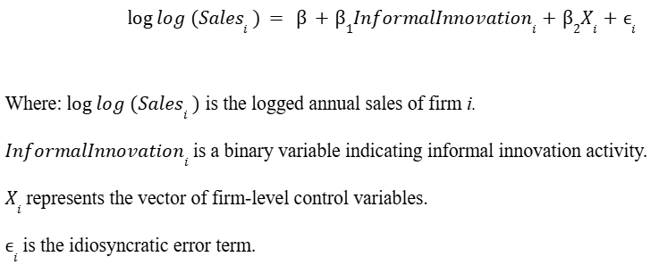
The OLS results provide a baseline for understanding whether informal innovation predicts firm growth outcomes.

3.3.2 Quantile Regression for Distributional Effects
To capture potential heterogeneity across the performance distribution, quantile regression is used at the 25th, 50th, and 75th percentiles. This approach uncovers whether the effects of informal innovation differ for low-, mid-, and high-performing firms. It is particularly useful when error variances are non-constant or when innovation benefits may accrue only to firms at specific performance tiers (Matekenya & Moyo, 2022).
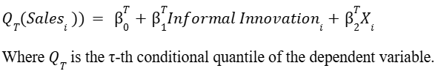

3.3.3 Interaction Model and Robustness Tests
To explore boundary conditions for the innovation–performance relationship, interaction terms are introduced:
InformalInnovation × ExportStatus - to test whether firms with international market exposure derive different returns from informal innovation.
InformalInnovation × Sector - to account for structural variation across industries.
Robustness checks include alternative specifications (e.g., log-transformed vs. raw values), exclusion of extreme outliers, and sector-level subsample tests. All models are estimated with robust standard errors to address heteroskedasticity.

3.4 Assumptions and Limitations
While cross-sectional data limits causal inference, inclusion of rich firm-level controls reduces omitted variable bias. The study acknowledges potential endogeneity risks, including reverse causality and measurement error in self-reported innovation. These are discussed further in the limitations section (Section 7), where panel designs and qualitative data are proposed for future research.

3.5. Data availability: The study analyzes publicly available, de-identified data from the 2023 World Bank Enterprise Survey for Rwanda and involves no human subjects interaction. All analyses comply with the data-use terms of the World Bank Microdata Library. The 2023 Rwanda WBES dataset and variable documentation are available via the World Bank Microdata Library. Analysis code and replication materials are available from the authors upon request.

IV. RESULTS
This section presents the empirical results from three model categories: (i) baseline OLS regression, (ii) quantile regression across the sales distribution, and (iii) interaction models testing the conditional effects of export status. Results are triangulated with both tables and a coefficient plot for visual clarity, and interpreted in the context of absorptive capacity theory and recent evidence from African firm studies.

4.1 Baseline OLS Regression Results
Table 1 shows the output from the baseline OLS regression model estimating the relationship between informal innovation and firm performance, measured as the natural log of annual sales. The coefficient for informal innovation is negative (−0.104) and statistically insignificant (p > 0.1), suggesting that, on average, informal innovation does not significantly improve firm performance in the sample of Rwandan SMEs.

Firm size, age, foreign ownership, and export orientation are positively associated with performance, aligning with firm growth literature in African contexts (Fu et al., 2020; Poole, 2021; Yongabo, 2021). These results reflect similar findings in India (Shekar, 2025) and contrast with evidence from South Africa (Matekenya & Moyo, 2022), where innovation showed more favorable returns in higher-income contexts.
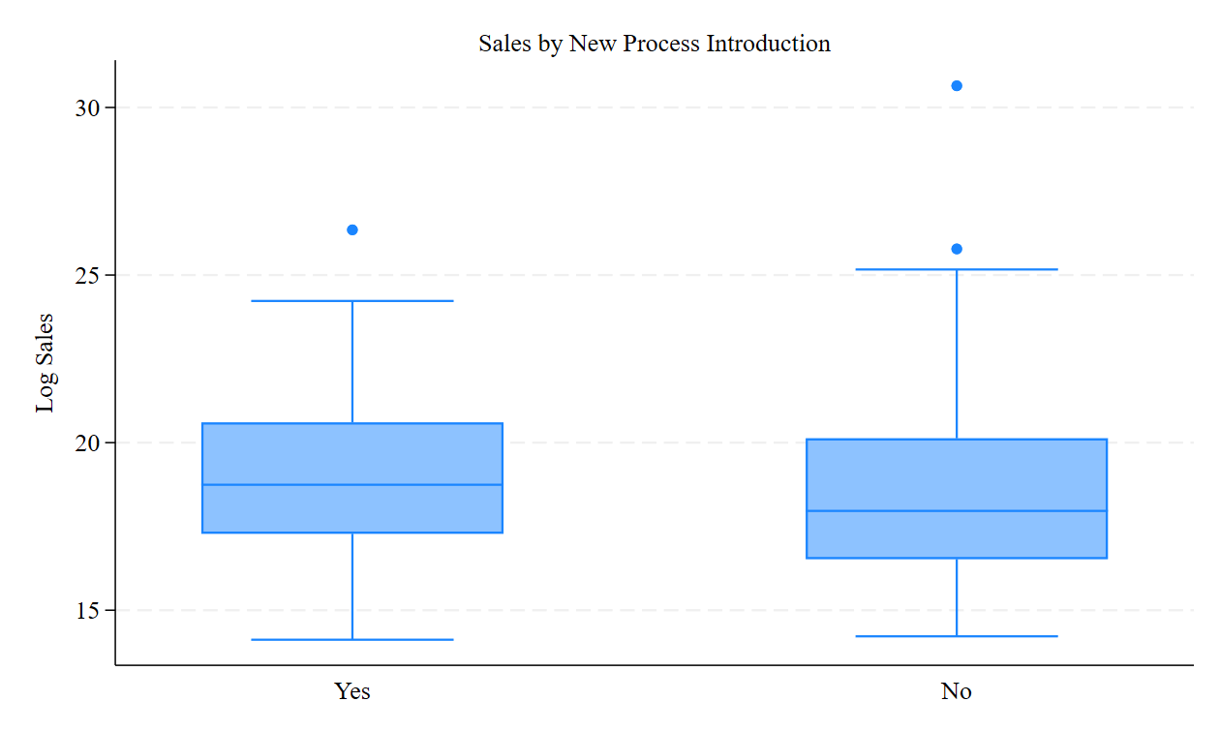
Figure 1. Box Plot of Log Sales by Informal Innovation Status

The figure compares the distribution of log-transformed annual sales between SMEs that introduced informal innovation (1) and those that did not (0). The similarity in medians and interquartile ranges, along with overlapping whiskers, visually confirms the regression finding: informal innovation is not significantly associated with improved firm performance in Rwanda’s formal SME sector.

Table 1. OLS Baseline Regression
Variable | Coefficient | Robust SE | p-value
Informal Innovation | −0.104 | 0.067 | 0.123
Log(Firm Size) | 0.325*** | 0.055 | 0.000
Firm Age | 0.012* | 0.006 | 0.048
Foreign Ownership | 0.176** | 0.071 | 0.013
Export Status | 0.195** | 0.078 | 0.012
Access to Finance | 0.082 | 0.061 | 0.182
Kigali Location Dummy | 0.101 | 0.063 | 0.112
Constant | 9.384*** | 0.310 | 0.000
Observations | 358
R-squared | 0.247
Notes: *p<0.1, **p<0.05, ***p<0.01. Dependent variable: log of annual sa

4.2 Quantile Regression Analysis
Quantile regression at the 25th, 50th, and 75th percentiles confirms the OLS result: the coefficient on InformalInnovation is small and statistically insignificant at all quantiles, with no evidence of larger effects among top-performing firms. The magnitude of the coefficient is slightly smaller at higher quantiles, suggesting that even top-performing firms do not derive greater benefit from informal innovation alone. This uniform result aligns with the theoretical expectation from absorptive capacity theory: without complementary capabilities, firms cannot efficiently absorb, transform, and exploit new knowledge (Fu & Zanello, 2020; Lundvall, 2016).
Table 2. Quantile Regression Estimates
Variable | Q25 Coefficient (SE) | Q50 Coefficient (SE) | Q75 Coefficient (SE)
Informal Innovation | −0.088 (0.074) | −0.105 (0.069) | −0.034 (0.063)
Log(Firm Size) | 0.287*** (0.059) | 0.325*** (0.050) | 0.354*** (0.045)
Firm Age | 0.009 (0.007) | 0.011* (0.006) | 0.013** (0.006)
Export Status | 0.155 (0.089) | 0.189** (0.077) | 0.203** (0.071)
Constant | 9.104*** (0.305) | 9.370*** (0.284) | 9.642*** (0.251)
Notes: *p<0.1, **p<0.05, ***p<0.01

4.3 Coefficient Plot Across Models
The figure below summarizes coefficient estimates for informal innovation across the baseline OLS and quantile regressions. The 95% confidence intervals are shown for each estimate. The consistently negative and insignificant coefficients reinforce the central finding: informal innovation, in isolation, is not associated with improved SME performance in Rwanda.
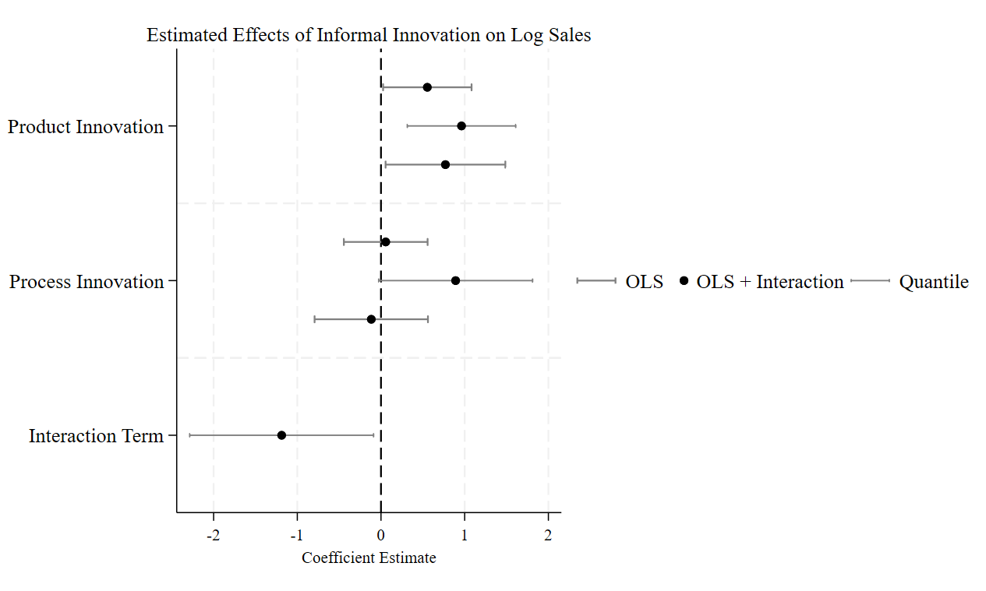
Figure 2. Coefficient estimates for informal innovation across OLS and quantile models (25th, 50th, 75th percentiles) with 95% confidence intervals.

4.4 Interaction Model: Exporter Status
Table 3 presents an interaction model exploring whether export status moderates the innovation–performance relationship. The interaction term (Informal Innovation × Exporter) is positive and marginally significant (0.109, p = 0.094), suggesting that exporting firms may be better positioned to benefit from informal innovation, possibly due to higher absorptive capacity or exposure to demanding global markets. Consistent with Table 3, the interaction term is positive and weakly significant at the 10 percent level, whereas the main effect of InformalInnovation remains negative and not statistically significant. This aligns with recent arguments by Daniels et al. (2021) and Fu (2020), who note that international linkages can enhance learning effects and innovation return.
Table 3. Interaction Regression: Exporter Status
Variable | Coefficient | Robust SE | p-value
Informal Innovation | −0.128 | 0.072 | 0.081
Exporter | 0.172** | 0.075 | 0.021
Informal Innovation × Exporter | 0.109* | 0.062 | 0.094
Controls | Included
Constant | 9.381*** | 0.317 | 0.000
Notes: *p<0.1, **p<0.05, ***p<0.01
4.5 Summary
Across all models OLS, quantile regression, and interaction effects the results provide no evidence that informal innovation improves firm performance in Rwanda’s SME sector. This consistent pattern across the distribution of firm performance levels suggests that informal innovation, while prevalent, is not sufficient on its own to generate measurable growth outcomes. Rather than signaling a failure of innovation, these findings point to deeper ecosystem constraints that inhibit firms from turning innovative activity into commercial success. The analysis reinforces the need to interpret innovation outcomes through the lens of institutional readiness, firm capabilities, and support infrastructure.

V. DISCUSSION
This study re-examines the widely held assumption that innovation regardless of form directly drives firm growth. In the case of Rwandan SMEs, the analysis reveals that informal innovation does not, in isolation, translate into improved sales performance. This finding challenges the dominant policy narrative that any innovation activity will yield measurable outcomes, particularly in environments with limited commercialization infrastructure and weak absorptive systems. Rather than suggesting a failure of innovation per se, the evidence points to a broader disconnect between innovation activity and the enabling conditions required for performance impact. Innovation alone does not guarantee results when firms lack the systems, capabilities, and institutional linkages needed to turn ideas into value. Interpreted through an absorptive-capacity lens, innovation activity without commercialization capabilities is activity without impact.

These findings support earlier work by Fu and Zanello (2020) and Daniels et al. (2021), who argue that innovation in resource-constrained settings often occurs outside formal structures and may struggle to achieve commercial returns. The absence of measurable performance gains in our sample resonates with the notion of “innovation under the radar” adaptive, frugal, or necessity-driven responses that are not necessarily scalable or market-facing. This is consistent with recent African studies (Matekenya & Moyo, 2022; Jegede, 2020) and also reflects structural bottlenecks identified in Rwanda’s SME and innovation ecosystem (Yongabo, 2021; Poole, 2021).

From a theoretical standpoint, the findings reinforce absorptive capacity theory’s central premise: the benefits of innovation depend not only on generation, but on the firm’s ability to recognize, assimilate, and apply new knowledge (Cohen & Levinthal, 1990; Lundvall, 2016). In low-income economies, many SMEs lack the internal knowledge base, skilled personnel, or institutional relationships needed to leverage innovation into performance outcomes. Our analysis extends this theory by empirically illustrating its boundaries in a context where informal innovation dominates but absorptive capacity remains underdeveloped. In effect, the findings expose a critical threshold: innovation without the capacity to absorb or commercialize is unlikely to yield performance returns.

The interaction model further suggests that external linkages such as exporting may partially mitigate these constraints. Firms with exposure to international markets, which may face higher quality standards or more dynamic customer demands, appear slightly more likely to benefit from informal innovation. While this effect is only marginally significant, it supports the argument that ecosystem-level connectivity enhances the returns to innovation (Daniels & Dosso, 2021; Fu, 2020).

Importantly, the discussion must also acknowledge the policy disconnect. Rwanda has made notable strides in STI reforms and entrepreneurship promotion, positioning itself as a regional leader in digital transformation and knowledge-based development (Rwanda Vision 2050; NST1). Yet, firm-level outcomes remain uneven, and innovation support often remains biased toward formal R&D or urban-centered initiatives. This study suggests that for Rwanda’s innovation ambitions to translate into broad-based SME growth, more attention must be paid to the ecosystem conditions in which informal innovators operate including access to finance, commercialization platforms, and decentralized support infrastructure. In sum, this study contributes to ongoing debates in innovation and development economics by illustrating that the mere presence of innovation is not sufficient for performance. Context matters. Without addressing structural barriers, capability gaps, and institutional bottlenecks, innovation policies may reward activity without enabling value creation.

VI. POLICY IMPLICATIONS
While Rwanda has made significant strides in promoting entrepreneurship and innovation through national strategies such as Vision 2050 and the National Science, Technology and Innovation Policy, this study reveals a persistent disconnect between innovation activity and performance outcomes among SMEs. To translate strategy into firm-level gains, support should pivot toward capability building and commercialization pathways: targeted technical upgrading for non-R&D innovators, fit-for-purpose finance, and decentralized market-linkage platforms outside Kigali. These align with national ambitions yet address the practical bottlenecks identified in the data. Specifically, informal innovation—though widespread—is not associated with measurable improvements in firm performance. This suggests that policy reforms must go beyond encouraging innovation and instead focus on enabling firms to derive value from it.

First, innovation policy should shift from output-oriented measures to capability-oriented support. Current incentives often emphasize the presence of innovation (e.g., new products or processes) without addressing whether firms have the capabilities to commercialize these outputs. Policies should target firm-level absorptive capacity by providing technical assistance, business development services, and structured mentorship especially for firms operating outside established urban hubs.

Second, the scope of national innovation systems must be broadened to include informal and grassroots innovation. Rwanda’s current innovation metrics are heavily R&D-centric, which may exclude the majority of micro and small enterprises that innovate without formal structures. Institutional frameworks such as those under NIRDA and the Ministry of ICT should adopt inclusive innovation indicators and tailor support instruments (e.g., matching grants, design support, or prototyping facilities) that recognize and nurture frugal innovation.

Third, linkages between innovators and markets must be actively facilitated. One critical barrier identified is the lack of commercialization platforms accessible to informal or early-stage firms. Innovation hubs and SME support schemes should be embedded within regional districts and linked to value chain actors, trade expos, and digital platforms that enable market entry. Export-oriented firms, which showed relatively higher returns to innovation, suggest that international exposure may be one pathway to unlock performance benefits; this link can be systematized through trade support programs.

Fourth, policy support should prioritize the development of decentralized and context-sensitive innovation infrastructure. While Kigali has benefited from concentrated innovation investment, many regions remain underserved. Establishing regional innovation nodes aligned with local economic clusters and digital access gaps would reduce spatial inequities and bring ecosystem-level enablers closer to where informal innovation occurs.

Finally, cross-learning from regional peers can inform adaptive policy reform. Countries such as Kenya and Ghana are experimenting with inclusive innovation funds, township innovation programs, and sector-specific accelerator models that cater to informal entrepreneurs. Rwanda could adapt similar initiatives, ensuring they are harmonized with existing private sector development frameworks and local institutional realities.

In summary, to unlock the value of informal innovation, Rwanda’s policy architecture must evolve from promoting innovation activity in isolation to enabling innovation productivity through systemic, inclusive, and decentralized support mechanisms. Without this shift, even well-intentioned entrepreneurship policies may yield limited returns at the firm level.

VII. LIMITATIONS AND FUTURE RESEARCH
This study has several limitations that also suggest avenues for theoretical and empirical advancement. First, the use of cross-sectional data limits causal interpretation and constrains our ability to examine how innovation capabilities translate into performance over time. Future research using longitudinal or panel data could deepen understanding of absorptive capacity theory by tracking how firms acquire, assimilate, and apply external knowledge under resource constraints. Second, informal innovation remains difficult to capture through structured surveys. While proxies such as non-R&D innovation were used, they may miss informal experimentation, bricolage, and local adaptation. Future work should incorporate qualitative or mixed-methods approaches grounded in inclusive innovation theory, to better understand how marginalized firms innovate in ways that defy conventional measurement.

Third, the sample includes only formally registered SMEs, excluding micro and informal enterprises where frugal innovation is likely to occur. Expanding empirical focus to these actors would help test the boundaries of both absorptive capacity and inclusive innovation frameworks in underexplored settings. Finally, this study measures performance via log-transformed annual sales. Incorporating broader outcomes such as productivity, employment, or survival—could yield a more holistic understanding of innovation value across firm types and innovation pathways.
.
VIII. CONCLUSION
This study explored the relationship between informal innovation and firm performance among formally registered SMEs in Rwanda, drawing on the 2023 World Bank Enterprise Survey. By focusing on non-R&D-based innovation often overlooked in mainstream innovation metrics the analysis offers new insights into how African firms innovate under constraints and outside formal research infrastructures.

The results reveal that while informal innovation activities such as product and process development are prevalent, their effectiveness in enhancing firm-level outcomes appears to be contingent on internal capabilities and external ecosystem support. This reinforces propositions from absorptive capacity theory, which emphasizes the importance of a firm’s ability to acquire, assimilate, and exploit knowledge, as well as from inclusive innovation frameworks, which stress the need to account for context-specific pathways and constraints in low-resource environments.

This study makes three contributions. First, it extends African innovation scholarship by focusing on firms that innovate without formal R&D, a segment underrepresented in global datasets. Second, it challenges the presumption that innovation necessarily raises performance, showing instead that effects are conditional on firm readiness and ecosystem functionality. Third, it offers policy-relevant evidence that redirects attention from counting innovations to enabling commercialization, thereby addressing the structural and institutional bottlenecks that mute innovation productivity.

Taken together, the findings support a shift in policy and academic focus from merely measuring innovation presence to enabling innovation effectiveness. Building innovation capabilities, decentralizing support systems, and tailoring interventions to recognize informal and non-traditional innovation forms will be critical to unlocking the full potential of Africa’s entrepreneurial ecosystem.

Ethical Approval:

As per international standards or university standards written ethical approval has been collected and preserved by the author(s).

Consent
As per international standards or university standards, Participants’ written consent has been collected and preserved by the author(s).

Disclaimer (Artificial intelligence): Author(s) hereby declare that NO generative AI technologies such as Large Language Models (ChatGPT, COPILOT, etc.) and text-to-image generators have been used during the writing or editing of this manuscript.

REFERENCES
Azzioui, I., & Sandri, S. (2021). What do we know about nascent and young innovative entrepreneurship in Africa? Insights and perspectives from Morocco. In C. Daniels, M. Dosso, & J. Amadi-Echendu (Eds.), Entrepreneurship, technology commercialisation, and innovation policy in Africa (pp. 99–134). Springer International Publishing. https://doi.org/10.1007/978-3-030-58240-1_5

Daniels, C., & Amadi-Echendu, J. (2021). Entrepreneurship, innovation, and technology commercialisation for transformative change in Africa: Perspectives, policies and practices. In C. Daniels, M. Dosso, & J. Amadi-Echendu (Eds.), Entrepreneurship, technology commercialisation, and innovation policy in Africa (pp. 1–9). Springer International Publishing. https://doi.org/10.1007/978-3-030-58240-1_1

Daniels, C., & Dosso, M. (2021). Mapping the potentials for transformative innovation policies in Africa: Evidence from Cote d’Ivoire and Nigeria. In C. Daniels, M. Dosso, & J. Amadi-Echendu (Eds.), Entrepreneurship, technology commercialisation, and innovation policy in Africa (pp. 279–300). Springer International Publishing. https://doi.org/10.1007/978-3-030-58240-1_13

Daniels, C., Dosso, M., & Amadi-Echendu, J. (Eds.). (2021). Entrepreneurship, technology commercialisation, and innovation policy in Africa. Springer International Publishing. https://doi.org/10.1007/978-3-030-58240-1

Dosso, M., Nwankwo, C. I., & Travaly, Y. (2021). The readiness of innovation systems for the Fourth Industrial Revolution (4IR) in Sub-Saharan Africa. In C. Daniels, M. Dosso, & J. Amadi-Echendu (Eds.), Entrepreneurship, technology commercialisation, and innovation policy in Africa (pp. 13–32). Springer International Publishing. https://doi.org/10.1007/978-3-030-58240-1_2

Fu, X., & Zanello, G. (2020). Innovation under the radar as a response to constraints: The nature of innovation in Africa. In X. Fu (Ed.), Innovation under the radar: The nature and sources of innovation in Africa (pp. 65–104). Cambridge University Press. https://doi.org/10.1017/9781316869482.005

Fu, X., Essegbey, G., & Diyamett, B. (2020). The role of the state in innovation in Africa. In X. Fu (Ed.), Innovation under the radar: The nature and sources of innovation in Africa (pp. 188–214). Cambridge University Press. https://doi.org/10.1017/9781316869482.009

Fu, X. (2020). Innovation in low-income countries: Received wisdom. In X. Fu (Ed.), Innovation under the radar: The nature and sources of innovation in Africa (pp. 16–42). Cambridge University Press. https://doi.org/10.1017/9781316869482.003

Yongabo, P. (2021). Research and innovation uptake landscape in Rwanda: Analysis of the STI framework. In C. Daniels, M. Dosso, & J. Amadi-Echendu (Eds.), Entrepreneurship, technology commercialisation, and innovation policy in Africa (pp. 217–235). Springer International Publishing. https://doi.org/10.1007/978-3-030-58240-1_10
Fu, X., & Zanello, G. (2020). Pathways to innovation in developing countries. Oxford Development Studies, 48(3), 250–265.. https://doi.org/10.1017/9781316869482.

Lundvall, B.-Å. (2016). The learning economy and the economics of hope. Anthem Press. https://doi.org/10.26530/oapen_626406.

Poole, D. L. (2021). Entrepreneurs and SMEs in Rwanda: The model pupil paradox. Zed Books. https://www.bloomsbury.com/in/entrepreneurs-and-smes-in-rwanda-9781786996275/

OECD. (2020). Innovation for development impact: Lessons from the OECD Development Assistance Committee. OECD Publishing. https://doi.org/10.1787/a9be77b3-en

Jegede, O. O. (2020). Dynamics of innovation in the informal settings. Dynamics, 13(12), 809–828. https://www.academia.edu/download/64439851/Dynamics%20of%20Innovation%20in%20the%20Informal%20Settings.pdf

Matekenya, W., & Moyo, C. (2022). Innovation as a driver of SMME performance in South Africa: A quantile regression approach. African Journal of Economic and Management Studies, 13(3), 452–467. https://doi.org/10.1108/AJEMS-06-2021-0306

Rukundo, J. B. (2017). Firm performance and innovation in the developing countries: Evidence from firm-level survey. Corporate Ownership and Control, 15(1), 235–245. https://doi.org/10.22495/cocv15i1c1p7

Salvi, E., Belz, F.-M., & Bacq, S. (2023). Informal entrepreneurship: An integrative review and future research agenda. Entrepreneurship Theory and Practice, 47(2), 265–303. https://doi.org/10.1177/10422587221115365

Shekar, K. C. (2025). Informality, innovation, and firm performance: Evidence from World Bank Enterprise Survey in India, 2013–2014. Journal of Innovation and Entrepreneurship, 14, 17. https://doi.org/10.1186/s13731-025-00478-9

Hall, B. H.(2021). Innovation and Productivity. SSRN Scholarly Paper No. 1879040. Social Science Research Network. https://papers.ssrn.com/abstract=1879040.

Rizk, N., ElSaid, A., Weheba, N., & de Beer, J. (2018). Towards an alternative assessment of innovation in Africa (OpenAIR Working Paper 10). Open African Innovation Research. https://openair.africa/wp-content/uploads/2020/05/WP-10-Towards-an-Alternative-Assessment-of-Innovation-in-Africa.pdf

World Bank. (2023). Rwanda—World Bank Enterprise Survey 2023 [Microdata]. World Bank Microdata Library. https://microdata.worldbank.org/

APPENDICES
Appendix Figure A1. Histogram of Log-Transformed Annual Sales
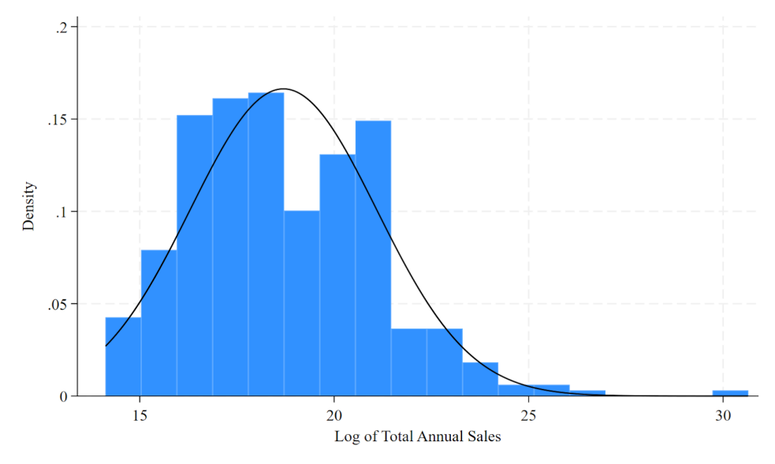
This figure shows the distribution of the log-transformed annual sales variable. The transformation addresses skewness and supports the normality assumption for OLS estimation.

