**Beyond the spicules: Atypical Retinitis Pigmentosa in Bardet-Biedl Syndrome**

**ABSTRACT**

Bardet-Biedl Syndrome (BBS) is a rare autosomal recessive ciliopathy with multisystem involvement. We present the case of a 7-year-old boy who presented with photophobia and difficulty seeing in dim light. Examination revealed central obesity, bilateral post-axial polydactyly of the feet, crowded teeth, and micropenis. His best-corrected visual acuity was 6/9 in both eyes. Fundus examination showed pale optic discs and attenuated arterioles without classical bone spicule pigmentation, suggestive of retinitis pigmentosa sine pigmento. A clinical diagnosis of BBS was established based on the presence of multiple primary diagnostic features. The presence of dental and genital anomalies highlights the need for a multidisciplinary approach to diagnosis and care. This report contributes to the limited literature on BBS from India and reinforces the significance of recognizing atypical phenotypes, especially in resource-limited settings.

*Keywords: Bardet-Biedl Syndrome, Retinal Dystrophies, Ciliopathies Paediatric Genetic Disorders, photophobia*

**INTRODUCTION**

Bardet–Biedl syndrome (BBS) is a rare, pleiotropic ciliopathy with substantial clinical and genetic heterogeneity. Classically, it is inherited in an autosomal recessive manner, though instances of oligogenic inheritance have also been described [1,2]. The clinical diagnosis relies on a constellation of features, with six primary manifestations: rod–cone dystrophy, postaxial polydactyly, central obesity, hypogonadism, learning difficulties, and renal abnormalities [1]. Secondary findings include developmental and speech delay, gait abnormalities, diabetes mellitus, cardiovascular malformations, and dental anomalies such as microdontia and hypodontia [3].

Although uncommon in the general population, with an estimated prevalence of 1 in 150,000–160,000 in Europe and North America, higher rates have been reported in regions with high consanguinity, such as Kuwait (1 in 13,500) and Newfoundland (1 in 17,000) [4,5]. In India, population-based prevalence is unknown, but hospital-based studies have described BBS-associated retinitis pigmentosa, particularly in consanguineous communities, suggesting probable underdiagnosis [6].

Ocular involvement is often the earliest clue to diagnosis. Most patients develop early-onset rod–cone dystrophy with markedly reduced or extinguished electroretinogram responses [1,7]. Fundus findings typically include optic atrophy, vessel attenuation, and retinitis pigmentosa, which may sometimes present sine pigmento. Progressive visual loss generally culminates in blindness by the third decade [6,7]. Over 20 BBS genes have been identified, with BBS1 and BBS10 most frequently implicated; these genes encode proteins essential for ciliary function [2,8].

BBS belongs to a broader group of ciliopathies that share overlapping phenotypes and genotypes. For example, Meckel syndrome represents the severe end of this spectrum, often lethal in utero due to multi-organ malformations, and is associated with truncating CEP290 variants. Hypomorphic mutations in the same gene can cause BBS, while milder variants may present as nephronophthisis [9,10]. Other related conditions include Joubert syndrome, Leber congenital amaurosis, and Senior–Løken syndrome, which may also involve CEP290 [11,12]. Alström syndrome, another ciliopathy caused by ALMS1 variants, resembles BBS with features such as retinal dystrophy, obesity, hypogonadism, and renal dysfunction, but can be distinguished by the presence of neurosensory hearing loss and cardiomyopathy, and absence of polydactyly or cognitive impairment [13].

Given its systemic manifestations, early recognition of BBS is crucial. Renal disease is a major determinant of morbidity and mortality, making multidisciplinary evaluation and genetic counselling essential [1]. Herein, we present a case of Bardet–Biedl syndrome with ocular features, highlighting the importance of early ophthalmic findings in guiding diagnosis.

**PRESENTATION OF CASE**

A 7-year-old boy was brought to the ophthalmology outpatient department with complaints of photophobia and difficulty seeing in dim light for the past one year. There was no history of eye pain or floaters. His parents also reported that he struggled academically and had poor attention in school. He was the youngest of four siblings; the other three siblings were healthy with no ocular or systemic complaints. There was no history of parental consanguinity.

On general examination, the child had central truncal obesity [Fig 1a], with weight and BMI above the 95th percentile for age. Bilateral post-axial polydactyly was noted on both feet [Fig 1b]. Oral examination revealed crowded and crooked teeth [Fig 1d]. Genital examination showed micropenis [Fig 1e].   
  
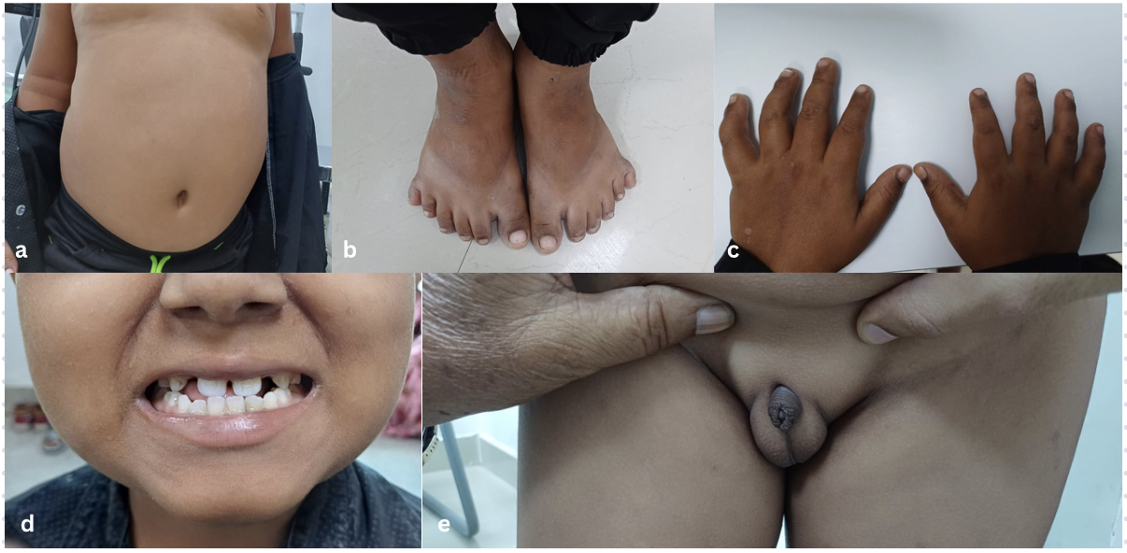

**Figure 1: Clinical features of Bardet-Biedl Syndrome in the patient. (a)** Central truncal obesity with abdominal fat accumulation. **(b)** Bilateral post-axial polydactyly of the feet. **(c)** Normal fingers without polydactyly of the hands. **(d)** Dental anomalies showing crowded, crooked, and malaligned teeth. **(e)** Genital hypoplasia with micropenis and underdeveloped scrotum.

Best-corrected visual acuity was 6/9 in both eyes. Slit-lamp examination of the anterior segment was normal. Fundus examination revealed pale optic discs and attenuated arterioles without characteristic bone spicule pigmentation, suggestive of retinitis pigmentosa sine pigmento [Fig 2]. Renal function was normal, and abdominal ultrasound showed no structural abnormalities in the kidneys.

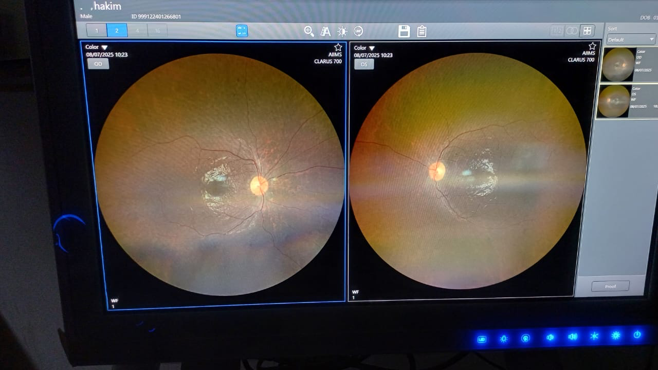

**FIGURE 2: Fundus photographs of both eyes showing atypical retinal features in Bardet-Biedl Syndrome.**

Based on the combination of retinal dystrophy, central obesity, polydactyly, learning difficulties, and genital hypoplasia, a clinical diagnosis of Bardet-Biedl syndrome was made. The child was referred for genetic evaluation and multidisciplinary care. His parents were counselled regarding the risk of progressive visual loss and the importance of ongoing systemic monitoring, especially for renal and metabolic complications.

**DISCUSSION**

Bardet–Biedl syndrome (BBS) is a rare ciliopathy characterised by multisystem involvement. The hallmark ocular feature is rod–cone dystrophy, typically manifesting as nyctalopia and progressive constriction of peripheral vision in childhood, eventually leading to legal blindness. Fundus examination classically reveals attenuated arterioles, waxy optic disc pallor, and bone spicule pigmentation. However, atypical presentations such as retinitis pigmentosa sine pigmento have also been documented, as observed in this case [1,2].

Our patient’s presentation is notable for preserved visual acuity (6/9 OU) despite clear evidence of retinal dystrophy. RP sine pigmento, as described here, represents an early or atypical form where photoreceptor degeneration precedes pigmentary deposition [2]. This underscores the importance of electrophysiology, OCT, and autofluorescence imaging in confirming diagnosis when fundus features are subtle.

The systemic features in our case—including truncal obesity, polydactyly, learning difficulties, dental crowding, and genital hypoplasia—support the diagnosis of BBS and distinguish it from other syndromic retinal dystrophies. For example, Usher syndrome is associated with hearing loss but not polydactyly or obesity, while Laurence–Moon syndrome overlaps with obesity and hypogonadism but lacks polydactyly [3,4]. Similarly, Alström syndrome presents with retinal dystrophy, obesity, and insulin resistance but is differentiated by sensorineural hearing loss, cardiomyopathy, and absence of polydactyly [13].

This case is clinically significant because it illustrates a diagnostic window before renal or metabolic complications develop, which are the major causes of morbidity and mortality in BBS [5,7]. Regular renal monitoring is imperative, as nephropathy may be silent initially but progresses insidiously [7]. Similarly, addressing obesity and endocrine dysfunction early can reduce long-term cardiovascular and metabolic risk.

From a genetic standpoint, BBS demonstrates marked heterogeneity, with mutations identified in at least 22 genes involved in ciliary transport and function [8]. Notably, CEP290 mutations can also cause Joubert syndrome and Leber congenital amaurosis, highlighting overlapping phenotypes among ciliopathies [9–12]. Thus, molecular testing not only confirms the diagnosis but also informs prognosis and family counselling.

The importance of this case lies in its emphasis on recognising RP sine pigmento as a presenting feature of BBS. Without classical pigmentary changes, diagnosis may be delayed. Early identification facilitates comprehensive systemic evaluation, timely interventions, and genetic counselling for families, ultimately improving quality of life and long-term outcomes [5,7].

**CONCLUSION**

Bardet-Biedl Syndrome is a multisystemic ciliopathy that often goes unrecognized due to its phenotypic variability and overlap with other genetic syndromes. This case highlights the importance of considering BBS in children presenting with early retinal dystrophy—especially RP sine pigmento—alongside systemic features such as obesity, polydactyly, dental anomalies, and genital hypoplasia. Timely diagnosis is essential for initiating appropriate visual rehabilitation, systemic monitoring, and genetic counselling. In resource-limited settings where advanced diagnostics like genetic testing or ERG may not be feasible, clinical acumen and a multidisciplinary approach remain the cornerstone of effective diagnosis and management. Early recognition and awareness of atypical presentations can help improve long-term outcomes and reduce morbidity in patients with BBS.

Consent: All authors declare that ‘written informed consent was obtained from the parent of patient (or other approved parties) for publication of this case report and accompanying images.

ETHICAL APPROVAL: As per international standard or university standard written ethical approval has been collected and preserved by the author(s).

**Disclaimer (Artificial intelligence)**

Option 1:

Author(s) hereby declare that NO generative AI technologies such as Large Language Models (ChatGPT, COPILOT, etc.) and text-to-image generators have been used during the writing or editing of this manuscript.

**References**

1.     Forsythe E, Beales PL. Bardet–Biedl syndrome. *Eur J Hum Genet*. 2013;21(1):8–13. PMID: 22713813

2.     Moore SJ, Green JS, Fan Y, et al. Clinical and genetic epidemiology of Bardet–Biedl syndrome in Newfoundland: a 22-year prospective, population-based, cohort study. *Am J Med Genet A*. 2005;132A(4):352–60. PMID: 15637713

3.     Farag TI, Teebi AS. High incidence of Bardet–Biedl syndrome among the Bedouin. *Clin Genet*. 1989;36(6):463–4. PMID: 2589922

4.     Daniels AB, Sandberg MA, Chen J, et al. Genotype–phenotype correlations in Bardet–Biedl syndrome. *Arch Ophthalmol*. 2012;130(3):346–52. PMID: 22411677

5. Forsythe, E., Sparks, K., Best, S., Borrows, S., Hoskins, B., Sabir, A., ... & Beales, P. L. (2017). Risk factors for severe renal disease in Bardet–Biedl syndrome. Journal of the American Society of Nephrology, 28(3), 963-970.

6. Paranjpe, G., & Shetty, N. (2021). Bardet-Biedl Syndrome with Familial Retinitis Pigmentosa--A Case Report. Journal of Evolution of Medical and Dental Sciences, 10(1), 62-65.

7.     Forsythe E, Sparks K, Hoskins B, et al. Risk factors for severe renal disease in Bardet–Biedl syndrome. *J Am Soc Nephrol*. 2017;28(3):963–70. PMID: 27659102

8. Billingsley, G., Bin, J., Fieggen, K. J., Duncan, J. L., Gerth, C., Ogata, K., ... & Héon, E. (2010). Mutations in chaperonin-like BBS genes are a major contributor to disease development in a multiethnic Bardet–Biedl syndrome patient population. Journal of medical genetics, 47(7), 453-463.

9.     Valente, E. M., Silhavy, J. L., Brancati, F., Barrano, G., Krishnaswami, S. R., Castori, M., ... & Gleeson, J. G. (2006). Mutations in CEP290, which encodes a centrosomal protein, cause pleiotropic forms of Joubert syndrome. Nature genetics, 38(6), 623-625.

10.  Coppieters F, Lefever S, Leroy BP, De Baere E. CEP290, a gene with many faces: mutation overview and presentation of CEP290base. *Hum Mutat*. 2010;31(10):1097–108. PMID: 20052762

11.  Bachmann-Gagescu, R., Dempsey, J. C., Phelps, I. G., O'roak, B. J., Knutzen, D. M., Rue, T. C., ... & University of Washington Center for Mendelian Genomics. (2015). Joubert syndrome: a model for untangling recessive disorders with extreme genetic heterogeneity. Journal of medical genetics, 52(8), 514-522.

12.  den Hollander AI, Koenekoop RK, Yzer S, et al. Mutations in the CEP290 gene are a frequent cause of Leber congenital amaurosis. *Am J Hum Genet*. 2006;79(3):556–61. PMID: 16826527

13.  Marshall JD, Maffei P, Collin GB, Naggert JK. Alström syndrome: genetics and clinical overview. *Curr Genomics*. 2011;12(3):225–35. PMID: 22043170