Original Research Article
Molecular Phylogenetic and Risk Factors of Klebsiella aerogenes in Diabetic Foot Ulcers: A First Study from Iraq

ABSTRACT

Aims: Molecular phylogenetic profiling of Klebsiella aerogenes in diabetic foot ulcers and estimating the relationship of infection to some related risk factors.
Study design: The current study designed to indicate the implication of K. aerogenes in foot ulcers of diabetic patients.
Place and Duration of Study: Swab samples were collected from foot ulcer of an overall 143 diabetic patients at Al-Qadisiyah province (Iraq) between February 2025 and April 2025.
Methodology: Swab samples of all study individuals were examined molecularly by conventional PCR assay, and some of positive study isolates were sequenced. The received sequence data were submitted to the NCBI-GenBank database, and then analysed phylogenetically using the MEGA-11 software. Information related to age and sex of study patients as well as type of diabetes and glycemic control had been recorded as risk factors.
Results: Totally, 13.29% of foot ulcers were positive to K. aerogenes infection. Sequencing data and pahylogenetic analysis of 10 study K. aerogenes isolates with the global GenBank-BLAST K. aerogenes isolates / strains revealed an identity and substitution / mutation at range of 99.25-99.86% and 0.0001-0.0014%, respectively with Polish K. aerogenes strain (ID: OM250432.1). For risk factors, positive K. aerogenes infection was observed significantly in patients aged 30-50 (11.86%) and >50 (14.63%) years more than <30 (0%) years; males (14.66%) more than females (7.41%); type 2 diabetes (14.17%) more than type 1 (6.25%); and glycemic uncontrolled (17.07%) more than glycemic controlled (8.2%) patients. Subsequently, the risk of K. aerogenes infection was elevated significantly in patients aged >50 years more than 30-50 years and <30 years; males more than females; type 2 diabetes more than type 1; and glycemic uncontrolled more than controlled patients.
Conclusion: This represents the first Iraqi study demonstrates the presence of K. aerogenes in diabetic foot ulcers indicating the need for moreover studies.

Keywords: Enterobacteriaceae, Diabetes mellitus, Polymerase chain reaction (PCR), Phylogenetic analysis, Iraq

1. INTRODUCTION

The genus of Klebsiella encompasses a diverse group of Gram-Negative bacterial species that widely distributed in natural environments and as a commensal within the human microbiota (Dong et al., 2022; Madhi et al., 2024). Among these species, K. aerogenes, previously known Enterobacter aerogenes, has garnered significant attention as a major opportunistic pathogen, which increasingly recognized for its role in nosocomial infections and propensity to multi-drug resistance (Vali et al., 2015; Wesevich et al., 2020). Also, the bacterium characterized by presence of large polysaccharide capsule as a key virulence factor contributing to its pathogenicity and enables the bacterium to evade phagocytosis and contributes to biofilm formation that enhancing its survival and persistence within various hosts (Ibraheim et al., 2024; Liu et al., 2025). The intrinsic resistance of K. aerogenes to certain antimicrobial agents combined with its capacity to form biofilms significantly complicates the treatment strategies particularly in infections associated with indwelling medical devices (Russo et al., 2023; Almatroudi, 2025).

Diabetes mellitus is a harmful metabolic and chronic illness characterized by persistently high blood glucose levels due to inadequate insulin production or when the body fails to utilize the produced insulin (Al-Shaeli et al., 2022a, b). This persistent hyperglycemia is associated with long-term damage, dysfunction, and eventual failure of various organs including the eyes, kidneys, nerves, heart, and blood vessels (Mezil and Abed, 2021). Subsequently, the pervasive condition significantly impacts global health leading to serious macrovascular and microvascular complications that diminish quality of life and increase mortality rate (Zakir et al., 2023). Globally, diabetes mellitus affects a substantial portion of the population, with type 2 alone impacting approximately 462 million individuals and contributing to over one million deaths in 2017, underscoring its significant public health burden (Erhunmwunse et al., 2025). Diabetic foot ulcer represents a multifactorial complication in patients with diabetes mellitus, which is often leading to severe morbidity and mortality due to impaired wound healing and rapidly progressing to deeper tissues, necessitating surgical intervention or amputation if not promptly and appropriately managed (Chen et al., 2023; Yachmaneni et al., 2023). Given the poly-microbial nature often characterizing these infections, identifying the role of each specific pathogen is crucial for guiding effective therapeutic strategies (Chang and Nguyen, 2021; Jaber et al., 2025).

In Iraq, although Gram-positive bacteria such as Staphylococcus aureus (Hussein and Saleh, 2024; Aifari, 2025), Streptococcus spp. (Habeeb et al., 2021; Matar and Saleh, 2024), and Enterococcus spp. (Habeeb et al., 2021; Turkei and Al-Dulaimi, 2024) in diabetic foot ulcers were analyzed extensively, few available data were identified which focused on traditional isolation of Gram-negative bacteria like Pseudomonas aeruginosa (Alkhudhairy et al., 2020; Abd Khader and Raad, 2025) and K. pneumonia (Habeeb et al., 2021; Matar and Saleh, 2024). Hence, this might represent the first study in Iraq aims to molecular phylogenetic profiling of K. aerogenes in diabetic foot ulcers with documenting of study isolates in the NCBI-GenBank database and estimating the relationship of infection to some related risk factors including age, sex, type of diabetes, and glycemic control.

2. methodology

2.1 Samples

Totally, 143 diabetic patients with foot ulcer of different ages (17-81 years) and sexes who attended to the private medical clinics in Al-Qadisiyah province were selected to the present study, and subjected to obtaining of swab samples from February 2025 to April 2025. Then, the collected swabs were transported using labeled plastic tubes containing 1ml of tryptone (15%) to be kept frozen (-20°C) for later testing by molecular tool. Data related to study patients including age, sex, type of diabetes, and glycemic control were recorded to estimated their relationships to positive infections.

2.2 Molecular testing

After preparation of swab samples, DNAs were extracted following the manufacturer instructions of the PrestoTM Mini gDNA Bacteria Kit (Geneaid, Taiwan) and examined then by the Nanodrop system (Thermo-Scientific, UK) to evaluate the concentration and purity of extracted DNAs. Targeting 16S rRNA gene, one set of primers was designed based on the NCBI-GenBank isolate (ID: NR_102493.2) and provided (F: 5ʹ-TAC TCG CAG AAG AAG CAC CG-ʹ3 and R: 5ʹ-AGT TGC AGA CTC CAA TCC GG-ʹ3) to be served for preparing the MasterMix tubes following the manufacturer instructions of the Accupower® PCR PreMix (Bioneer, Korea) at a final volume of 25μL for DNAs amplification in the Thermal Cycler system (BioRad, USA). Electrophoresis of agarose-gel (1.5%) stained with ethidium bromide was done at 100V and 80Am for 90min, and the positive bands were detected at an approximately 836bp using the UV transilluminator system (Clinx Science, China).
The DNAs of some positive isolates were sequenced, and submitted in NCBI-GenBank database. For phylogeny, MEGA-11 software and NCBI-Multiple Sequence Alignment (MSA) Viewer were served to analyzing the study K. aerogenes isolates by the ClustralW Alignment, Homology Sequence Identity and Phylogenetic Tree Analysis to indicate identity between the study K. aerogenes isolates and NCB-BLAST K. aerogenes isolates / strains.

2.3 Statistical analysis

GraphPad Prism Software was applied using the t-test, One-Way ANOVA in addition to Odds-Ratio (OR) and Relative Risk (RR) to detect significant differences between the obtained results at p<0.05. The confidence interval (95%CI) was calculated between the obtained data of various age groups (Al-Ethafa et al., 2025; Al-Shaeli et al., 2025).

3. results and discussion

3.1 Molecular results

Among totally 143 diabetic patients, 19 (13.29%) swabs of foot ulcers were positively infected by K. aerogenes using the conventional PCR assay (Figure 1).

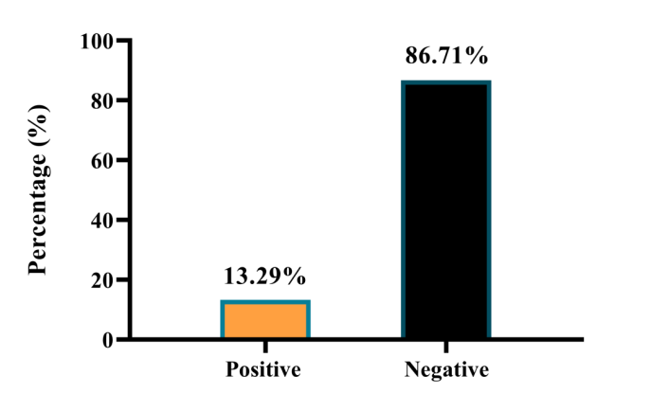
Fig. 1. Total results for testing 143 swab ulcers by PCR
Among the species of Klebsiella genus, though K. aerogenes is historically considered less virulent than K. pneumoniae, it is increasingly recognized for its involvement in opportunistic infections, particularly in immunocompromised individuals and those with chronic conditions such as diabetes, where it can acquire resistance to multiple antibiotics (Rajagopalan, 2005; Rossi et al., 2023; Morgado et al., 2024). In this study, 13.29% of diabetic foot ulcers were positive to K. aerogenes molecularly by the PCR assay as identified in Nigeria by Orji et al. (2009) who found that the prevalence rate of K. aerogenes in diabetic foot ulcers was 12.3%. In a number of studies, distribution of K. aerogenes had been investigated previously in the West of Scotland neurosurgical unit (Price and Sleigh, 1970), as well as in the ward environments of a hospital and hands of nursing staff (Cooke et al., 1979). In last study, authors have been suggested that there is large reservoir of K. aerogenes both in the bowel of patients and the environment. In recent studies, K. aerogenes was detected in 31.2% of 285 patients with bacteraemia (Álvarez-Marín et al., 2021) as well as in 6.9% of hospitalized patients with blood stream infections (Guedes et al., 2024).

3.2 Phylogenetic analysis

The sequencing data of 10 study K. aerogenes isolates were recorded in the NCBI-GenBank under the names of Klebsiella aerogenes isolate RAH1 to RHA10. Then, phylogenetic analysis of study K. aerogenes isolates revealed the presence of similarity (*) at range of 99.25-99.86% and substitution / mutation at range of 0.0001-0.0014% with the global GenBank-BLAST K. aerogenes isolates / strains. Comparative homology identity, phylogenetic tree analysis and MSA had shown an identity between the study K. aerogenes isolates and Polish K. aerogenes strain (ID: OM250432.1), (Table 1, Figures 2-4).

Table 1. Homology sequence identity for study and NCBI K. aerogenes isolate / strain
Local isolate |  | NCBI-BLAST strain |  |  |  | Identity (%)
Name | Access. No. | Strain | Source | Country | Access. No. | Identity (%)
RAH1 | PV953396.1 | AF3II1 | Soil | Poland | OM250432.1 | 99.86
RAH2 | PV953397.1 | AF3II1 | Soil | Poland | OM250432.1 | 99.73
RAH3 | PV953398.1 | AF3II1 | Soil | Poland | OM250432.1 | 99.55
RAH4 | PV953399.1 | AF3II1 | Soil | Poland | OM250432.1 | 99.79
RAH5 | PV953400.1 | AF3II1 | Soil | Poland | OM250432.1 | 99.84
RAH6 | PV953401.1 | AF3II1 | Soil | Poland | OM250432.1 | 99.25
RAH7 | PV953402.1 | AF3II1 | Soil | Poland | OM250432.1 | 99.46
RAH8 | PV953403.1 | AF3II1 | Soil | Poland | OM250432.1 | 99.51
RAH9 | PV953404.1 | AF3II1 | Soil | Poland | OM250432.1 | 99.80
RAH10 | PV953405.1 | AF3II1 | Soil | Poland | OM250432.1 | 99.43

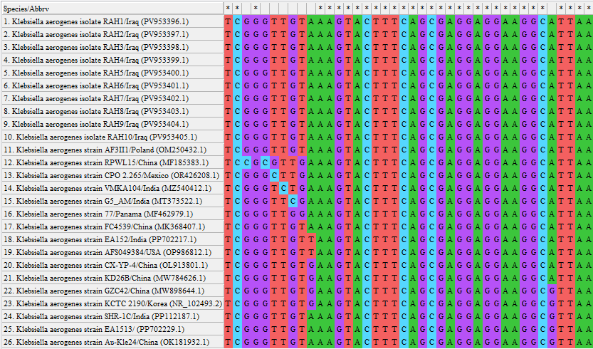
Fig. 2. MSA for the study and global NCBI-GenBank K. aerogenes isolates / strains using the MEGA-11 Software
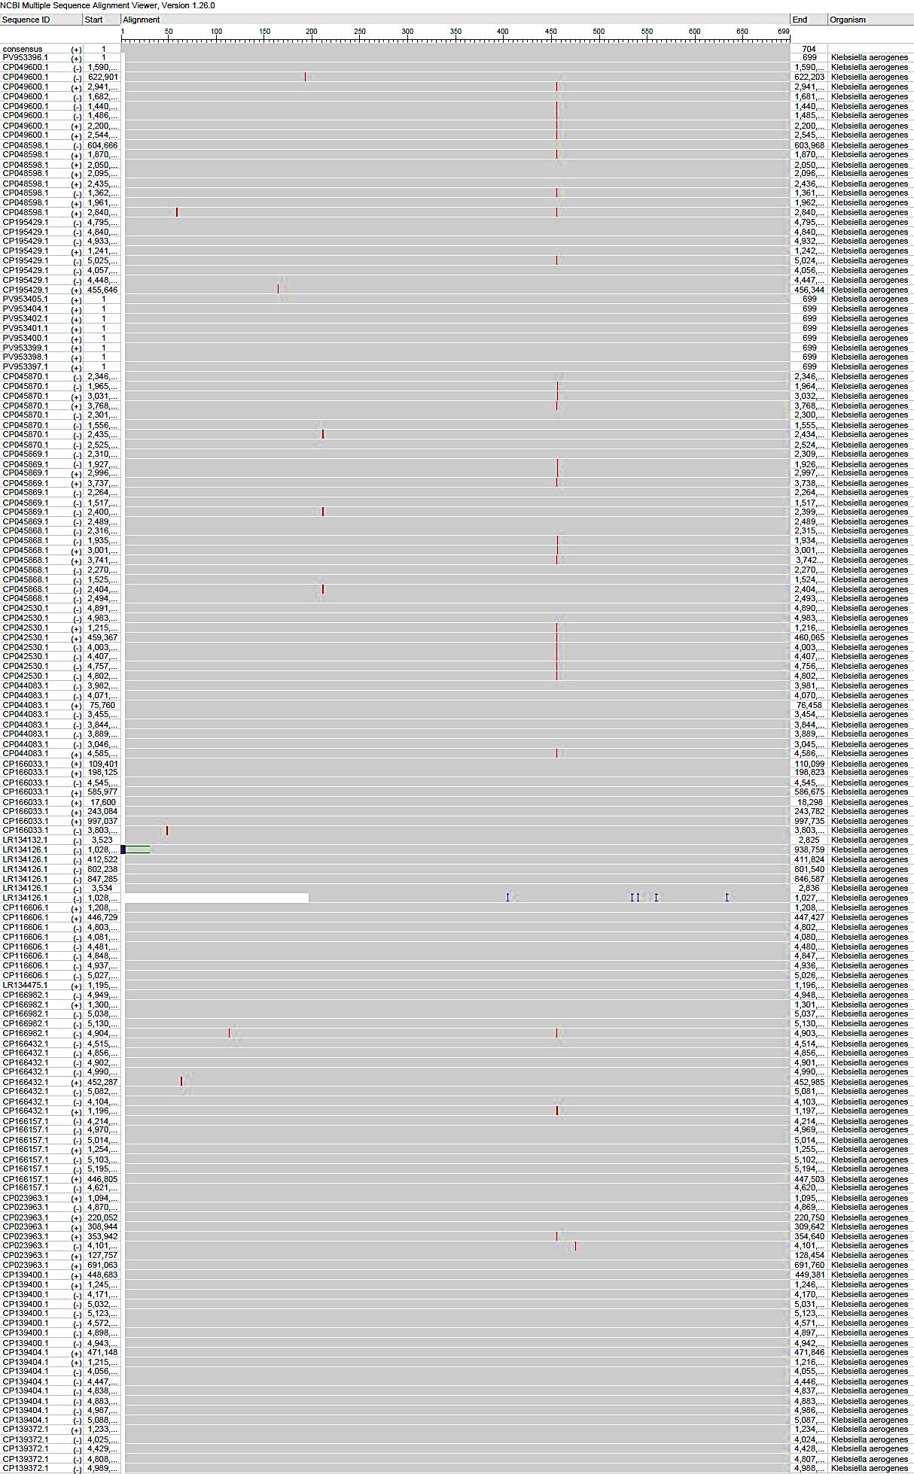
Fig.3. MSA for the study and global NCBI-GenBank K. aerogenes isolates / strains using the NCBI-MSA Viewer
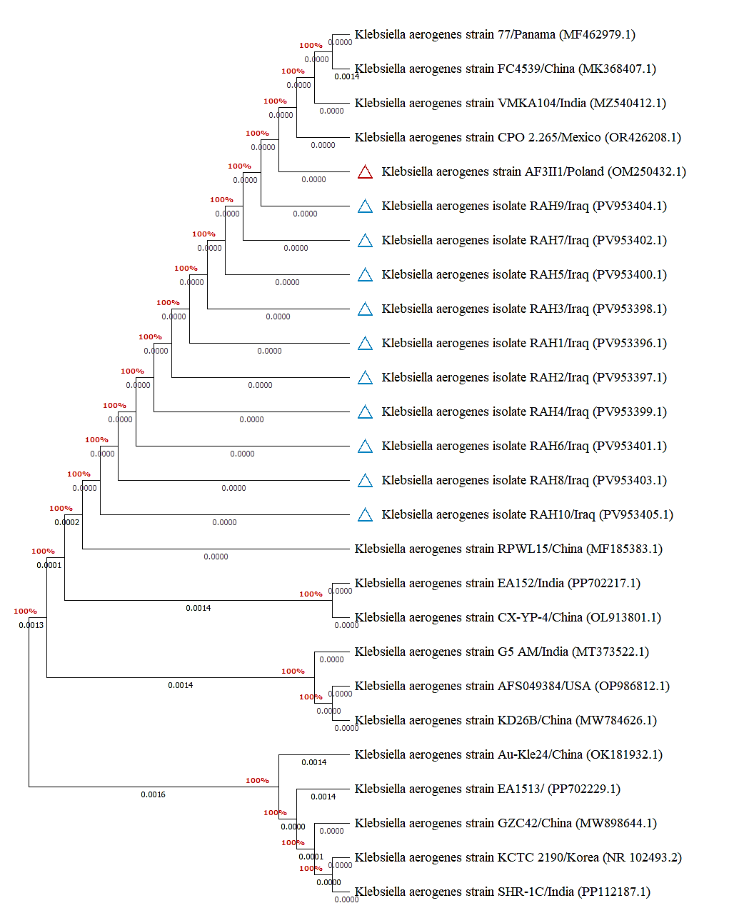
Fig. 4. Phylogenetic tree analysis of study local and NCBI-BLAST K. aerogenes isolates / strains

Phylogenetic analysis of study isolates demonstrated its identity with Polish K. aerogenes strain that isolated from the soil. Although, many studies have mentioned to the capability of this organism for persisting in various environments including soil, no specify exact causes for this ability (Glushakova et al., 2022; Rong et al., 2022, 2024). However, the presence of K. aerogenes in soil could be attributed to its ability to thrive in diverse conditions, in addition to the role of soil to act as potential reservoir for its spread.

3.3 Risk factors

For risk factors, significant elevation (p<0.0313; 95%CI: 10.48 to 28.14) in percentage of K. aerogenes infection among the study groups of age factor was observed in 30-50 years [11.86% (7/59)] and >50 years [14.63% (12/82)] when compared to <30 years [0% (0/2), (Figure 5).
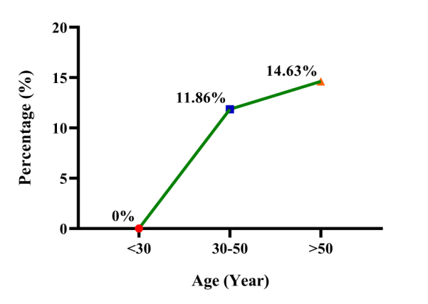
Fig. 5. Total results of positive K. aerogenes among study groups of age factor

However, the risk of K. aerogenes infection (OR and RR) was elevated significantly (p<0.0001; 95%CI: 0.9399 to 23.55; and 95%CI: 0.9019 to 23.03, respectively) patients aged >50 years (1.315 and 1.27, respectively) when compared to 30-50 (0.808 and 0.832, respectively) as well as <30 years (0 and 0, respectively), (Figure 6).

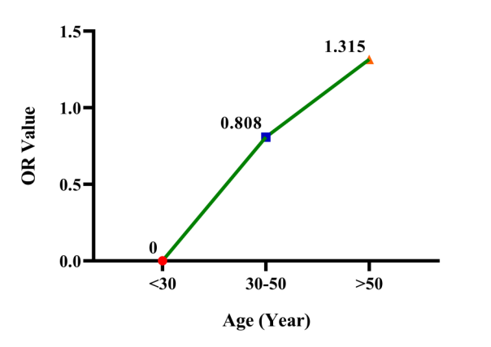
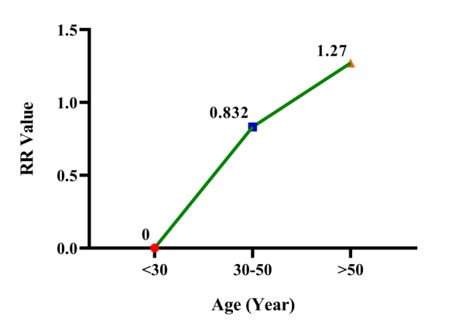
Fig. 6. Results of infection risk (OR; RR) among the study groups of age factor

Significantly (p<0.0402; 95%CI: 35.02 to 57.09), positive K. aerogenes infections were higher in males [14.66% (17/116)] than females [7.41% (2/27)], (Figure 7). In addition, the risk of infection (OR; RR) was elevated significantly (p<0.0001; 95%CI: 0.9397 to 12.01; and 95%CI: 0.8183 to 10.67, respectively) in males (2.15 and 1.987, respectively) than females (0.465 and 0.503, respectively), (Figure 8).

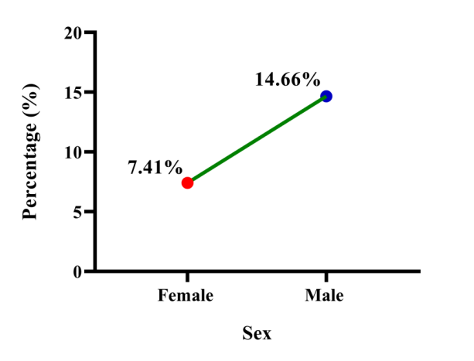
Fig.7. Total results of positive K. aerogenes among study groups of sex factor
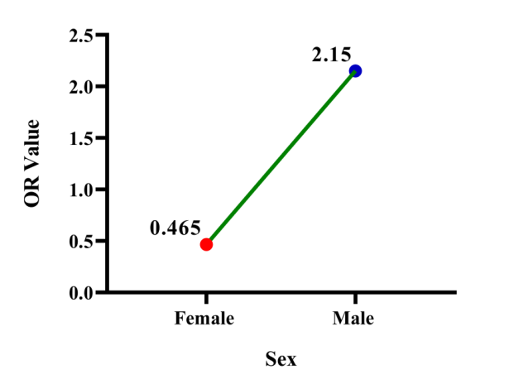
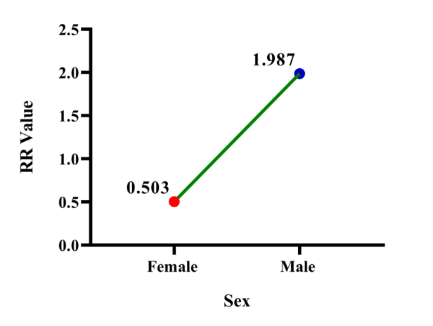
Fig. 8. Results of infection risk (OR; RR) among the study groups of sex factor

According to type of diabetes mellitus, the findings were seen a significant association (p<0.0355; 95%CI: 40.11 to 60.53) of positive K. aerogenes infections to type 2 diabetes [14.17% (18/127)] more than type 1 [6.25% (1/16)] (Figure 9). Also, the risk K. aerogenes (OR; RR) was noticed significantly (p<0.0001; 95%CI: 0.9163 to 14.50; and 95%CI: 0.9280 to 12.99, respectively) in type 2 (2.463 and 2.272, respectively) more than type 1 (0.406 and 0.44, respectively), (Figure 10).
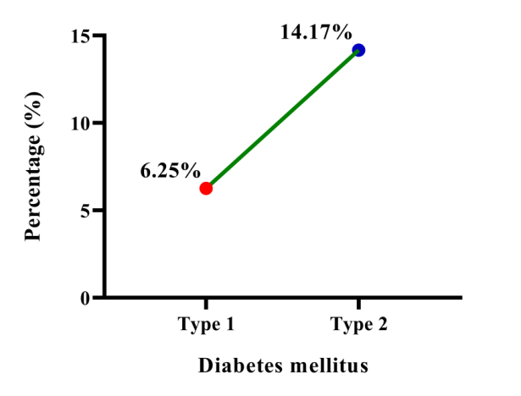
Fig. 9. Total results of positive K. aerogenes according to type of diabetes mellitus
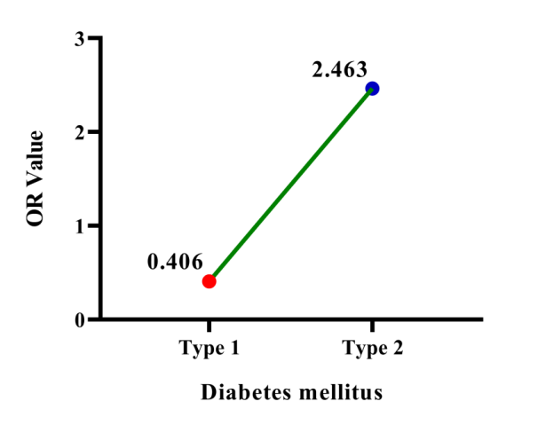
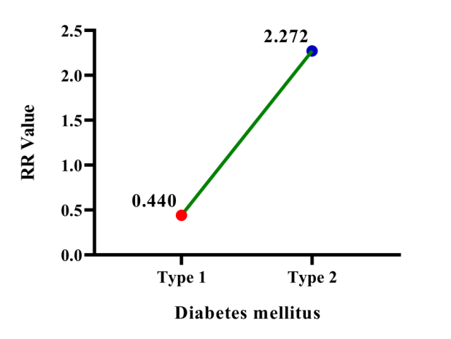
Fig.10. Results of infection risk (OR; RR) according to type of diabetes mellitus

Relation to glycemic control, positive K. aerogenes infections were increased significantly (p<0.0296; 95%CI: 43.72 to 68.99) in diabetes mellitus patients of uncontrolled [17.07% (14/82)] more than those of controlled [8.2% (5/61)] diabetes mellitus (Figure 11). Also, the risk of K. aerogenes infection was significantly higher (p<0.0001; 95%CI: 0.9509 to 13.34; and 95%CI: 0.8914 to 11.48, respectively) in glycemic uncontrolled patients (2.315 and 2.085, respectively) more than glycemic controlled individuals (0.432 and 0.48, respectively) (Figure 12).
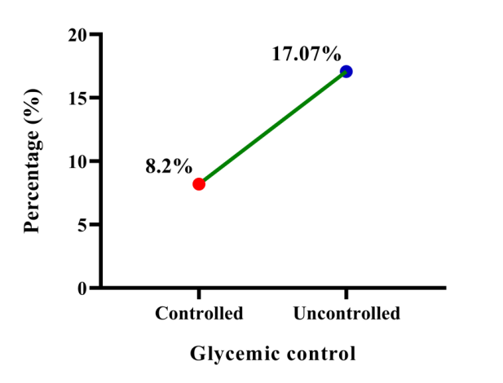
Fig. 11. Total results of positive K. aerogenes according to glycemic control
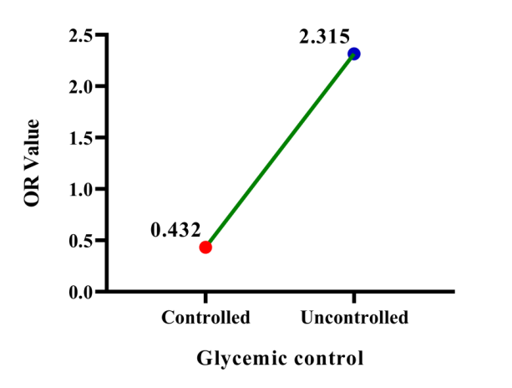
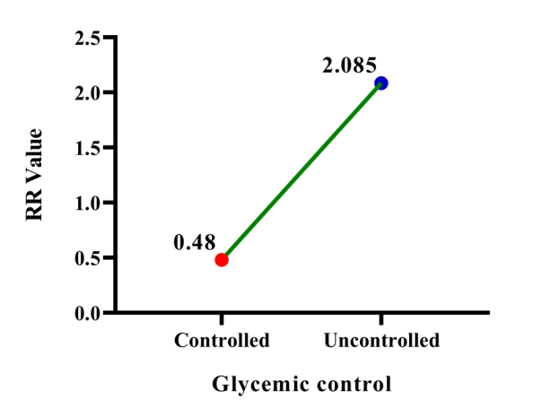
Fig.12. Results of infection risk (OR; RR) according to glycemic control

Although, no national or international studies have investigated the association of K. aerogenes infection to risk factors of patients with diabetic ulcers, several studies have been conducted to estimate the relationship between diabetic foot ulcers and multiple risk factors. In a previous study on 725 diabetic subjects, the risk of diabetic ulcers was greater in patient with mean age 65.9 years suggesting that foot ulcer and lower extremity vascular disease are related to a higher risk of death in diabetic subjects (Boyko et al., 1996). In another study performed on 194 diabetic patients with new foot ulcers, the findings shown the majority of ulcers were neuropathic and present on the forefoot but without any effect for age, sex, duration/type of diabetes on outcome (Oyibo et al., 2001). Orji et al. (2009) found that diabetic foot ulcers were increased significantly in males and females aged 30-49 years (24% and 25%, respectively) when compared to other age groups; 10-29 years (0%), 50-69 years (14% and 8%, respectively), and 70-89 years (18% and 105, respectively). In the later study, males were reported a higher rate of diabetic foot ulcers than females at age groups of 50-69 years (14% and 8%, respectively) and 70-89 years (18% and 10%, respectively). Costa et al. (2017) reported that the mean age of 654 diabetic patients was 63.1 years, and peripheral arterial disease was present in 24.5% concluding that diabetic foot ulcers is associated with old age and high mortality rates.

In a systemic review and meta-analysis study, difference in risk and sequelae of diabetic foot ulcers in males and females remains inconclusive; however almost studies have demonstrated that higher risk of disease was in males (Akinci et al., 2011; Sayiner et al., 2019; Gandhi et al., 2020) but some studies found the absence of significance between females and males (Lin et al., 2010; Tabur et al., 2015).

Hangaard et al. (2019) mentioned that the screening information can be used for the risk assessment of foot ulcers among patients with type and type 2. In contrast, Schofield et al. (2021) detected that foot ulcer is an independent factor in type 1 and type 2 diabetes; however, authors recorded that the incidence rate of type 2 was higher (82.65%) than type 1 (17.35%) diabetes mellitus.

Xiang et al. (2019) investigated the role of glycemic control in healing of diabetic foot ulcers, and found that the wound healing rate was higher after the level of HbA1c was controlled between 7-8% but not at less than 7%. In a systemic review and meta-analysis of observational study, Lane et al. (2020) indicated that the higher HbA1c and fasting glucose are associated with increased amputation risk in patients with diabetic foot ulcers but neither HbA1c nor glucose levels were related with wound healing. Dutta et al. (2023) concluded that the early and intensive glycemic control in the first 4 weeks of treatment initiation is associated with greater healing of diabetic foot ulcers of initial ulcer area. Mustamu et al. (2024) found that the poor glycemic control with mean HbA1c of 8.3±1.4 and vascular complications such as peripheral artery disease and neuropathy were the most significant predictor of diabetic foot ulcer recurrence suggesting that controlling blood-sugar level, managing vascular issue, and promoting healthy behaviors can prevent diabetic foot ulcer recurrence.

4. Conclusion

This represents the first Iraqi molecular phylogenetic study implicates K. aerogenes in diabetic foot ulcers indicating the need for moreover studies. However, the growing concern remain underscores the necessity of distinguishing between Klebsiella species in clinical diagnostics to tailor appropriate antimicrobial therapies effectively. Also, the nuanced interplay between bacterial virulence factors, host immune responses and the development of antimicrobial resistance necessitates a re-evaluation of current diagnostic and therapeutic paradigms for diabetic foot ulcers

Ethical approval

The Scientific Committee in the Department of Pathological Analyses (College of Science, University of Al-Qadisiyah) was licensed this work.

Definitions, Acronyms, Abbreviations

PCR: Polymerase chain reaction
NCBI: National Center for Biotechnology Information

Disclaimer

Author declares that NO generative AI technologies have been used during the writing or editing of this manuscript.

References

Abd Khader, K., and Raad, A. (2025). The Prevalence of Pseudomonas aeruginosa and antibiotic resistance in diabetic foot ulcer patients in Erbil\Iraq. The Medical Journal of Tikrit University, 31(1), 7-13.

Aifari, S. A. G. (2025). A Molecular Investigation for Staphylococcus aureus in Diabetic Foot Ulcers. International Journal of Medical and Health Research, 3(1), 22-32.

Akinci, B., Yener, S., Yesil, S., Yapar, N., Kucukyavas, Y., and Bayraktar, F. (2011). Acute phase reactants predict the risk of amputation in diabetic foot infection. Journal of the American Podiatric Medical Association, 101(1), 1-6.

Al-Ethafa, L. F., Almialy, A. J., Gharban, H. A., Essa, I. A. M., and Al-Eqabi, S. R. (2025). First molecular phylogenetic and serological insights into Listeria monocytogenes infection in aborted ewes in Iraq: A cross-border comparative analysis. Veterinary World, 18(7): 1899-1910.

Alkhudhairy, M. K., and Al-Shammari, M. M. M. (2020). Prevalence of metallo-β-lactamase–producing Pseudomonas aeruginosa isolated from diabetic foot infections in Iraq. New microbes and new infections, 35, 100661.

Almatroudi, A. (2025). Biofilm resilience: Molecular mechanisms driving antibiotic resistance in clinical contexts. Biology, 14(2), 165-176.

Al-Shaeli, S. J. J., Ethaeb, A. M., and Al-Zaidi, E. A. N. (2022a). Serological and histological evaluation of the effect of honeybee venom on pancreas and liver in diabetic mice. Archives of Razi Institute, 77(3), 11-25.

Al-Shaeli, S. J., Hussen, T. J., and Ethaeb, A. M. (2022b). Effect of honey bee venom on the histological changes of testes and hormonal disturbance in diabetic mice. Veterinary World, 15(9), 2357.

Al-Shaeli, S. J., Almialy, A. J., Ethaeb, A. M., and Gharban, H. A. (2025). Molecular, Histopathological, and Immunohistochemical Investigation of Peste des Petits Ruminants in Clinically Suspected Sheep in Wasit Province, Iraq. Veterinary Medicine International, 2025(1), 2702787.

Álvarez-Marín, R., Lepe, J. A., Gasch-Blasi, O., Rodríguez-Martínez, J. M., Calvo-Montes, J., Lara-Contreras, R., and Spanish Network for Research in Infectious Diseases. (2021). Clinical characteristics and outcome of bacteraemia caused by Enterobacter cloacae and Klebsiella aerogenes: more similarities than differences. Journal of Global Antimicrobial Resistance, 25, 351-358.

Boyko, E. J., Ahroni, J. H., Smith, D. G., and Davignon, D. (1996). Increased mortality associated with diabetic foot ulcer. Diabetic medicine, 13(11), 967-972.

Chang, M., and Nguyen, T. T. (2021). Strategy for treatment of infected diabetic foot ulcers. Accounts of chemical research, 54(5), 1080-1093.

Chen, L., Sun, S., Gao, Y., and Ran, X. (2023). Global mortality of diabetic foot ulcer: a systematic review and meta‐analysis of observational studies. Diabetes, Obesity and Metabolism, 25(1), 36-45.

Cooke, E. M., Pool, R., Brayson, J. C., Edmondson, A. S., Munro, M. E., and Shinebaum, R. (1979). Further studies on the sources of Klebsiella aerogenes in hospital patients. Epidemiology and Infection, 83(3), 391-395.

Costa, R. H. R., Cardoso, N. A., Procópio, R. J., Navarro, T. P., Dardik, A., and de Loiola Cisneros, L. (2017). Diabetic foot ulcer carries high amputation and mortality rates, particularly in the presence of advanced age, peripheral artery disease and anemia. Diabetes and Metabolic Syndrome: Clinical Research and Reviews, 11, S583-S587.

Dong, N., Yang, X., Chan, E. W. C., Zhang, R., and Chen, S. (2022). Klebsiella species: taxonomy, hypervirulence and multidrug resistance. EBioMedicine, 79, 1-11.

Dutta, A., Bhansali, A., and Rastogi, A. (2023). Early and intensive glycemic control for diabetic foot ulcer healing: a prospective observational nested cohort study. The International Journal of Lower Extremity Wounds, 22(3), 578-587.

Erhunmwunse, R. U., Ogbodo, E. C., and Muoneke, G. I. (2025). Complications Associated with Type 2 Diabetes Mellitus, Pathophysiology, Diagnosis and Management: A Concise Review of Current Literature. Saudi J Biomed Res, 10(7), 201-244.

Gandhi, S. K., Waschbusch, M., Michael, M., Zhang, M., Li, X., Juhaeri, J., and Wu, C. (2020). Age-and sex-specific incidence of non-traumatic lower limb amputation in patients with type 2 diabetes mellitus in a US claims database. Diabetes Research and Clinical Practice, 169, 108452.

Glushakova, А. М., Kachalkin, А. V., Prokof'eva, T. V., and Lysak, L. V. (2022). Enterobacteriaceae in soils and atmospheric dust aerosol accumulations of Moscow city. Current Research in Microbial Sciences, 3, 100124.

Guedes, M., Gathara, D., López-Hernández, I., Pérez-Crespo, P. M. M., Pérez-Rodríguez, M. T., Sousa, A., and Rodríguez-Baño, J. (2024). Differences in clinical outcomes of bloodstream infections caused by Klebsiella aerogenes, Klebsiella pneumoniae and Enterobacter cloacae: a multicentre cohort study. Annals of Clinical Microbiology and Antimicrobials, 23(1), 42-59.

Habeeb, T. A., Shaebth, L. J., and Abdulameer, N. A. (2021). Isolation of Bacteria from Diabetic Foot Patients in Hospital of Al-Dewaniyah City, Iraq. Annals of the Romanian Society for Cell Biology, 25(5), 187-192.

Hangaard, S., Rasmussen, A., Almdal, T., Nielsen, A. A., Nielsen, K. E., Siersma, V., and Holstein, P. (2019). Standard complication screening information can be used for risk assessment for first time foot ulcer among patients with type 1 and type 2 diabetes. Diabetes research and clinical practice, 151, 177-186.

Hussein, S. Z., and Saleh, G. M. (2024). Molecular Detection of Virulence Factors Genes for Staphylococcus aureus in Diabetic Foot Ulcers in Iraq. Ibn AL-Haitham Journal For Pure and Applied Sciences, 37(3), 98-105.

Ibraheim, H. K., Madhi, K. S., Jasim, A. S., and Gharban, H. A. (2024). Molecular identification of Klebsiella species from pneumonic goats, Iraq. Open Veterinary Journal, 14(11), 29-40.

Jaber, D., Younes, N., Khalil, E., Albsoul-Younes, A., Zawiah, M., and Al-Bakri, A. G. (2025). Studying microbial ecology of diabetic foot infections: significance of PCR analysis for prudent antimicrobial stewardship. The International Journal of Lower Extremity Wounds, 24(2), 497-505.

Lane, K. L., Abusamaan, M. S., Voss, B. F., Thurber, E. G., Al-Hajri, N., Gopakumar, S., and Mathioudakis, N. N. (2020). Glycemic control and diabetic foot ulcer outcomes: A systematic review and meta-analysis of observational studies. Journal of Diabetes and its Complications, 34(10), 107638.

Lin, C. W., Hsu, L. A., Chen, C. C., Yeh, J. T., Sun, J. H., Lin, C. H., and Huang, Y. Y. (2010). C-reactive protein as an outcome predictor for percutaneous transluminal angioplasty in diabetic patients with peripheral arterial disease and infected foot ulcers. Diabetes research and clinical practice, 90(2), 167-172.

Liu, X., Xu, Q., Yang, X., Heng, H., Yang, C., Yang, G., and Chen, S. (2025). Capsular polysaccharide enables Klebsiella pneumoniae to evade phagocytosis by blocking host-bacteria interactions. MBio, 16(3), e03838-24.

Madhi, K. S., Jasim, A. S., Nasear, H. A., Ibraheim, H. K., and Gharban, H. A. (2024). Phylogenetic analysis of Klebsiella pneumoniae isolates of respiratory tract infections in humans and sheep. Open Veterinary Journal, 14(9), 2325.

Matar, T. A., and Saleh, N. I. (2024). Detection of Multidrug Resistant Bacterial Infections Isolated from Patients with Diabetics Foot Ulcers in Iraq. Central Asian Journal of Medical and Natural Science, 5(4), 410-418.

Mezil, S. A., and Abed, B. A. (2021). Complication of diabetes mellitus. Annals of the Romanian Society for Cell Biology, 25(3), 1546-1556.

Morgado, S., Fonseca, É., Freitas, F., Caldart, R., and Vicente, A. C. (2024). In-depth analysis of Klebsiella aerogenes resistome, virulome and plasmidome worldwide. Scientific Reports, 14(1), 65-83.

Mustamu, A. C., Samaran, E., and Bistara, D. N. (2024). Impact of Poor Glycemic Control and Vascular Complications on Diabetic Foot Ulcer Recurrence. Integrative Biomedical Research, 8(8), 1-14.

Orji, F. A., Nwachukwu, N. C., and Udora, E. C. (2009). Bacteriological evaluation of diabetic ulcers in Nigeria. African Journal of Diabetes Medicine, 15(11), 19-21.

Oyibo, S. O., Jude, E. B., Tarawneh, I., Nguyen, H. C., Armstrong, D. G., Harkless, L. B., and Boulton, A. J. M. (2001). The effects of ulcer size and site, patient's age, sex and type and duration of diabetes on the outcome of diabetic foot ulcers. Diabetic Medicine, 18(2), 133-138.

Price, D. J. E., and Sleigh, J. D. (1970). Control of infection due to Klebsiella aerogenes in a neurosurgical unit by withdrawal of all antibiotics. The Lancet, 296(7685), 1213-1215.

Rajagopalan, S. (2005). Serious infections in elderly patients with diabetes mellitus. Clinical infectious diseases, 40(7), 990-996.

Rong, Q., Ling, C., Lu, D., Zhang, C., Zhao, H., Zhong, K., and Qin, X. (2022). Sb (III) resistance mechanism and oxidation characteristics of Klebsiella aerogenes X. Chemosphere, 293, 133453.
Rong, Q., Lu, D., Zhong, K., Yang, S., Li, Z., and Zhang, C. (2024). Mechanism of antimony oxidation and adsorption using immobilized Klebsiella aerogenes HC10 in soil. Science of The Total Environment, 956, 177404.

Rossi, F., Santonicola, S., Amadoro, C., Marino, L., and Colavita, G. (2023). Recent records on bacterial opportunistic infections via the dietary route. Microorganisms, 12(1), 69-78.

Russo, A., Fusco, P., Morrone, H. L., Trecarichi, E. M., and Torti, C. (2023). New advances in management and treatment of multidrug-resistant Klebsiella pneumoniae. Expert Review of Anti-infective Therapy, 21(1), 41-55.

Sayiner, Z. A., Can, F. I., and Akarsu, E. (2019). Patients’ clinical charecteristics and predictors for diabetic foot amputation. Primary care diabetes, 13(3), 247-251.

Schofield, H., Haycocks, S., Robinson, A., Edmonds, M., Anderson, S. G., and Heald, A. H. (2021). Mortality in 98 type 1 diabetes mellitus and type 2 diabetes mellitus: Foot ulcer location is an independent risk determinant. Diabetic Medicine, 38(10), e14568.

Tabur, S., Eren, M. A., Çelik, Y., Dağ, O. F., Sabuncu, T., Sayiner, Z. A., and Savas, E. (2015). The major predictors of amputation and length of stay in diabetic patients with acute foot ulceration. Wiener Klinische Wochenschrift, 127(1), 45-50.

Turkei, M. R., and Al-Dulaimi, T. H. (2024). Identification of bacterial species isolated from diabetic foot ulcer in Iraq. Microbial Biosystems, 9(2), 115-120.

Wesevich, A., Sutton, G., Ruffin, F., Park, L. P., Fouts, D. E., Fowler Jr, V. G., and Thaden, J. T. (2020). Newly named Klebsiella aerogenes (formerly Enterobacter aerogenes) is associated with poor clinical outcomes relative to other Enterobacter species in patients with bloodstream infection. Journal of clinical microbiology, 58(9), 1110-1128.

Vali, L., Dashti, A. A., El-Shazly, S., and Jadaon, M. M. (2015). Klebsiella oxytoca with reduced sensitivity to chlorhexidine isolated from a diabetic foot ulcer. International Journal of Infectious Diseases, 34, 112-116.

Xiang, J., Wang, S., He, Y., Xu, L., Zhang, S., and Tang, Z. (2019). Reasonable glycemic control would help wound healing during the treatment of diabetic foot ulcers. Diabetes Therapy, 10(1), 95-105.

Yachmaneni Jr, A., Jajoo, S., Mahakalkar, C., Kshirsagar, S., and Dhole, S. (2023). A comprehensive review of the vascular consequences of diabetes in the lower extremities: current approaches to management and evaluation of clinical outcomes. Cureus, 15(10), 1-19.

Zakir, M., Ahuja, N., Surksha, M. A., Sachdev, R., Kalariya, Y., Nasir, M., and Ali, M. (2023). Cardiovascular complications of diabetes: from microvascular to macrovascular pathways. Cureus, 15(9), e45835.

