Original Research Article
IN VITRO EVALUATION OF SOYBEAN NODULES ASSOCIATED BACTERIA FOR THEIR PLANT GROWTH PROMOTING ABILITY ON AGRICULTURAL SOILS IN CENTER OF COTE D'IVOIRE

ABSTRACT
The overuse of chemical fertilizers poses significant risks to preserving the environment, food safety and human health. As sustainable alternatives, plant growth-promoting rhizobacteria offer a ecological approach to improving plant productivity and soil fertility. This study aims to assess the plant growth promoting (PGP) traits of 10 bacterial isolates derived from soybean nodule in order to select the most efficient ones and use them as biofertilizers. These bacterial isolates were tested for their PGP characteristics such as AIA and ammonia production, phosphate, potassium and calcium solubilization.
AS results, 60% of isolates produced IAA, 100% ammonia, 60% solubilized phosphate and 40% solubilized potassium and calcium. Two (02) isolates (RSC323, RSC325) showed several characteristics of plant growth promoting. But, one isolate (RSC323) was fund to be most efficient. It shown the higest solubilization indices, PSI (381.48±16.97 %), KSI (211.11±19.24 %) and CaSI (220.00±40.00 %) and produced more IAA and Ammonia
These results suggest that the selected rhizobacterial strains have significant potential as biofertilizers to support sustainable agriculture in tropical ecosystems.
Future work should focus on the identification of 16S rRNA genes and field trials to confirm their effectiveness in promoting plant growth under natural conditions.

Key words: PGPR, Biofertilizers, Bacteria, Soybean, In vitro

- INTRODUCTION
Food security is a major concern on a global scale, particularly in developing countries where crop production is often insufficient to meet the needs of a constantly growing population (Daszkiewicz, 2022). To solve this problem, intensive agriculture is highly dependent on chemical fertilizers which are widely used as a source of nutrients to promote plant growth. However, the excessive use of chemical fertilizers poses a serious threat to the environment and human health, hardens the soil, reduces its fertility, limits microbial growth, and pollutes ecosystems (Pahalvi et al., 2021). In addition, they contain heavy metals such as mercury, cadmium, and lead that are absorbed by the roots of plants and successively enter the food chain causing various complications, including renal dysfunction, nervous system disorders, blood-related diseases and cancer (Balali-Mood et al., 2021). It therefore seems urgent to find other ways to increase agricultural production without compromising the balance of the ecosystem and human health
This is why the use of PGPR bacteria represents an interesting solution for a sustainable and environmentally friendly approach in agriculture, in order to naturally increase soil fertility.
PGPRs (plant growth-promoting rhizobacteria) are soil microorganisms that can colonize the surface of a plant’s root system (and sometimes the tissues inside the root), promoting plant growth and well-being (Sharma et al., 2023; Vocciante et al., 2022). Rhizobacteria improve crop yield, soil fertility, increase biodiversity and association with other beneficial microorganisms, and limit pathogen growth and infections (Vázquez et al., 2020). They improve the biological characteristics of the soil, promote the absorption of mineral nutrients such as nitrogen, phosphate or potassium and facilitate their assimilation by plants (Elhaissoufi et al., 2022), play a crucial role in plant growth and confer host tolerance to biotic and abiotic stresses and survival in stressful environments and also contribute indirectly to soil nutrient stabilization and maintenance (Abdelkrim et al. 2020, Taha et al. 2022).
Thus, the general objective is to evaluate the plant growth-promoting trait of bacteria isolated from soybean nodules in order to select the most efficient ones and use them as biofertilizers.

2. MATERIEL ET METHODES
2.1. Baterial strains
Ten (10) bacteria (RSC115, RSC119, RSC309, RSC323, RSC324, RSC325, RSC502, RSC504, RSC506 and RSC508) isolated from soybean nodules at the Jean Lorougnon Guédé University in Daloa, Côte d'Ivoire were used in this study. These bacteria were stocked at -80 °C in the the Laboratory of Agrovalorization of Jean Lorougnon Guede University in Daloa (Côte d’Ivoire).
2.2. Reactivation and verification of strain purity
The strains stored in 20% (v /v) of glycerol at -80°C were removed from the freezer and their purity was checked by streaking technique according to the Jordan method (1984).
2.3. Evaluation of PGPR activities in vitro
2.3.1. IAA production
AIA production was tested according to the Ehmann method (1977). The qualitative test of the root growth-promoting hormone auxin (indole-3-acetic acid) was realized on the YEM agar medium supplemented with 0,5 mg/ml of L-tryptophan. 10 µL of each rhizobial isolate was pread on culture medium and incubated at 28 °C. Three (03) days after incubation, sterile filter paper washers impregnated with Salkowski’s reagent had deposited onto the Petri dish containing the culture medium to highlight IAA production. The importance of production was assessed according to the intensity of pink coloration.The appearance of colonies with a pink-red hue after a duration of 30-60 minutes in darkness indicates the production of IAA.
2.3.2. Ammonia production
The ability of bacterial isolates to Ammonia production was carried out according to the method of Cappucino and Sherman (1992). A quantity of 2ml of the specific culture medium BK131 was distributed in test tubes, which were then inoculated with freshly prepared bacterial precultures at a rate of 10µl per tube. After incubation at 28°C under agitation at 150 rpm for 48 h, 0.5 ml of Nessler reagent (1.75 g KI +2.5 g HgCl₂ +4 g NaOH +25 ml H₂O) is added to each test tube. The importance of the Ammonia production was evaluated in comparison with the color of the control. Ammonia production and accumulation are indicated by yellow, orange to brown coloration of the medium.
2.3.3 Phosphate solubilization
The phosphorus solubilization capacity of isolates was tested on Pikovskaya agar medium containing tricalcium phosphate [Ca₃(PO₄)₂] as the sole source of phosphorus according to the method of Pikovskaya (1948). a sample of 10 μL from each culture was spotted on Pikovskaya’s (PVK) agar medium and incubated at 28 °C for 3 days. After incubation, bacterial isolates which were able to solubilize the tri-calcium phosphate establish clear halo surrounded the bacterial spot. Bacteria phosphorus solubilisation was evaluated for phosphorus solubilization index( PSI) determination. It was obtained with the halo diameter and colony diameter for each colony: measuring
PSI (%) = ((halo diameter - colony diameter)/colony diameter) *100)
2.3.4. Potassium solubilization
The qualitative analysis of K solubilization was carried out using Aleksandrov medium (pH 7.2 0.2), containing 5.0 g/L Glucose (C₆H₁₂O₆), 0.5 g/L Magnesium sulfate (MgSO₄), 0.005 g/L Ferric chloride (FeCl₃), 0.1 g/L calcium carbonate (CaCO₃), 2 g/L calcium phosphate (CaHPO₄), and 2 g/L added to a mineral source containing potassium (white mica). 10 μL from each culture was spotted on Aleksandrov agar medium and incubated at 28 °C during 72 hours. The presence of a clear area around the colony of bacteria indicating their ability to solubilize potassium (Meena et al., 2013).
The potassium solubilization index was estimated by measuring the halo diameter and colony diameter for each colony:
KSI (%) = ((halo diameter - colony diameter)/colony diameter) *100)
2.3.5. Calcium solubilization
The ability of bacterial strains to solubilize calcium was demonstrated on a modified Aleksandrov culture medium (Meena et al., 2013). This medium contain 5g/L Glucose; 2g/L K₂HPO₄; 2g/L CaCO₃; 0.5g/L MgSO₄; 0,005g/L FeCl₃; 20g/L agar and 1000 ml of distilled water. The calcium solubilization index was estimated by measuring the halo diameter and colony diameter for each colony:
CaSI (%) = ((halo diameter - colony diameter)/colony diameter) *100)
2.3. Statistical analysis
The collected data were entered with the Excel spreadsheet and then processed using R edition software version 4.3.3 through single-factor analysis of variance (ANOVA) assumptions for normality and of distribution and homogeneity of variance. They were secondly verified Fisher’s Least Significant Difference test (LSD) to compare the performance of isolates (mean) at a significance level of 5%.
3. RESULTS
3.1. Reactivated and purified isolates
After reactivation and purification, the colonies obtained on each Petri dish show identical morphological characters, which translates the purity of these isolates. Indeed, well-isolated colonies of the same chromogen, shape, contour, opacity, elevation, and appearance were observed on each analyzed Petri dish. (Figure 1).
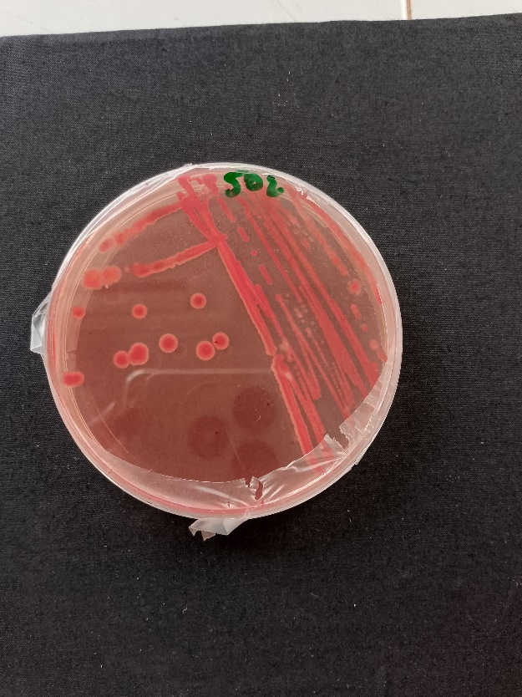
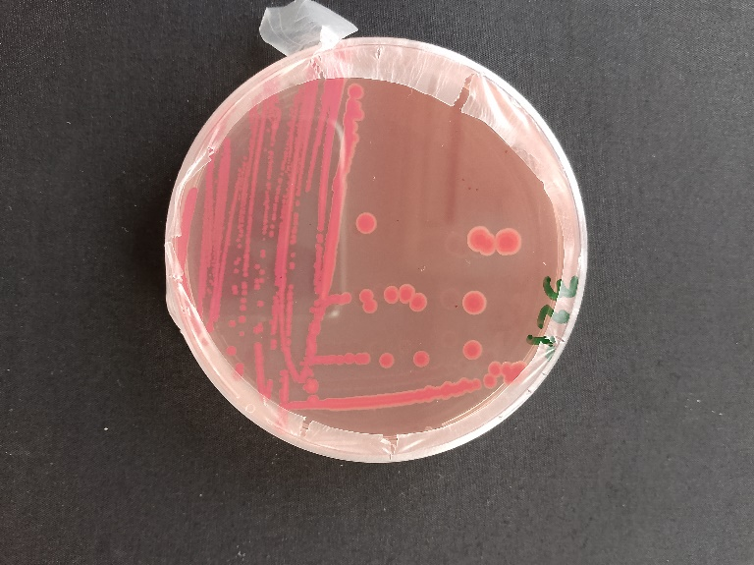
Figure 1: Macroscopic aspect of bacterial colonies after purification on solid YEM Agar medium

3.2. IAA production
The ability of bacterial isolates to produce IAA was detected by the appearance of a pink-reddish color after adding Salkowski reagent to the culture. The results obtained show variability in the production of AIA by bacteria. Indeed, the different shades of pink (very dark pink, dark pink and pale pink) observed on the petri dishes reflect a difference in production and each shade is based on the intensity of production of each isolate (Figure 2). The production range is from low to very high intensity (Table I). Of all the isolates tested, 60% show production of Indole Acetic Acid. The strong production of IAA is observed with bacterial isolates RSC323, RSC325 and RSC506. Among these bacteria, RSC323 produced the highest quantity of IAA according to his production intensity
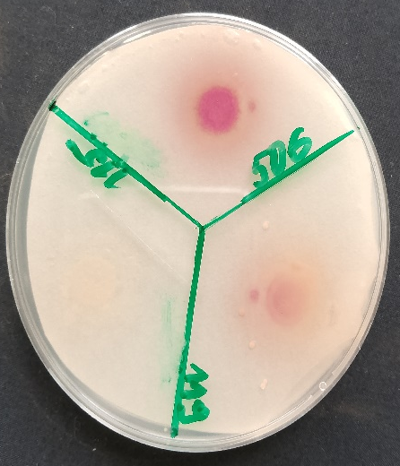
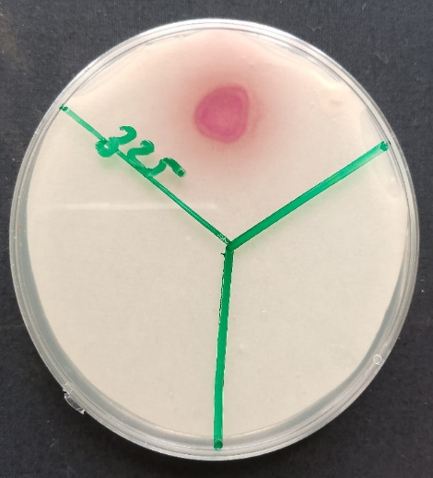
Pale pink
Absence of staining
Dark pink
Very dark pink

Figure 2: Indole-3-acetic acid (IAA) production test of soybean nodules bacteria on YEM Agar medium supplemented with L-tryptophan
3.3. Ammonia production
Ammonia production is detected by the change in coloration after adding Nessler reagent compared to the control (yellow). All isolates (100%) produced ammonia with varied intensities, confirming their metabolic versatility and potential to improve nitrogen supply. (Figure 3). The production range is from low to high intensity (Table 1). The high production of ammonia was obtained with the bacterial isolate RSC323.
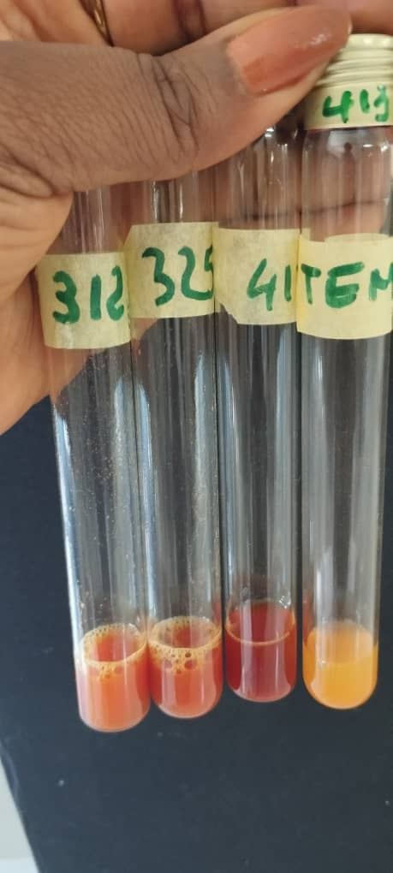
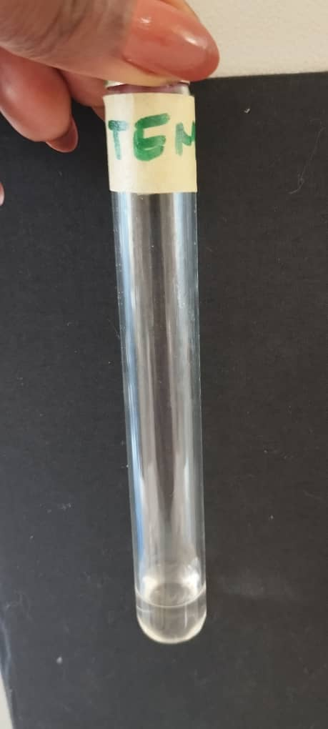
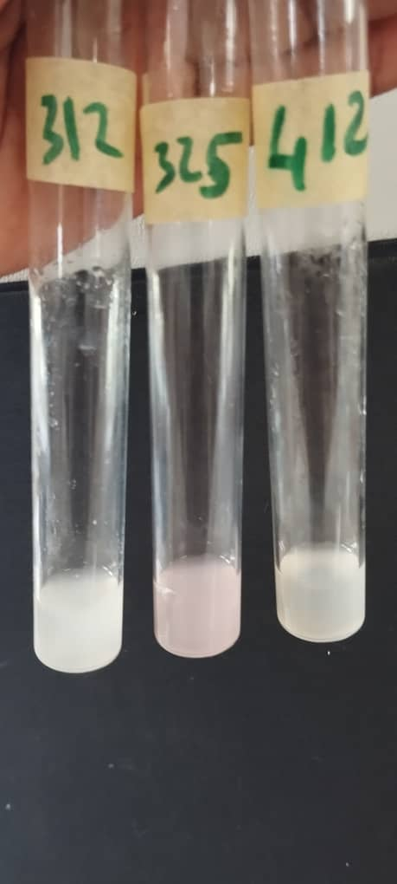
Control
B
A
Very High production

Control
Average production
High production

A: Before adding the Nessler reagent B: After adding the Nessler reagent
Figure 3: Ammonia production test of soybean nodules bacteria in Nessler reagent based medium
3.4. Phosphate Solubilization
The ability of the strains to solubilize phosphate was determined on Pikovskaya medium (PVK).
In our study, 60% of our bacterial strains showed the ability to solubilize phosphate. These bacteria produced a clear zone around the bacterial colony (Table I). Also, a significant difference (P=0.0001) was observed between the PSIs ranging from 0% to 382%. The higher production was obtained with bacteria RSC508, RSC504, RSC325, RSC506, RSC119, and RSC323 producing respectively 366.67±19.24%, 368.52±27.40%, %, 374.07±6.41%, 374.08±23.12, 378.24±30 and 381.48±16.97.
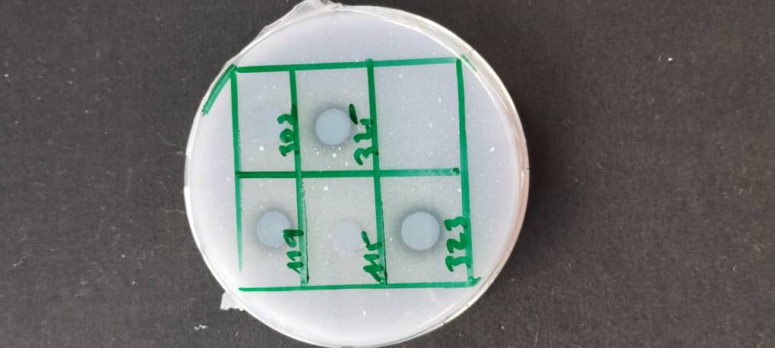
Colony
Halo

Figure 4: Phosphate solubilization testof soybean nodules bacteria on Pikovskaya (PVK) medium
3.5. Potassium solubilization
The ability of strains to solubilize potassium was determined by the production of a clear zone around bacterial colonies. Only 40 % of tested bacteria presented a clear halo. However, a significant difference (p=0.0001) was observed between the potassium solubilization indices which ranged from 129.91 to 211.11%. The best. solubilization index (211.11±19.24%) was observed with bacterial isolate RSC323 (Table I).

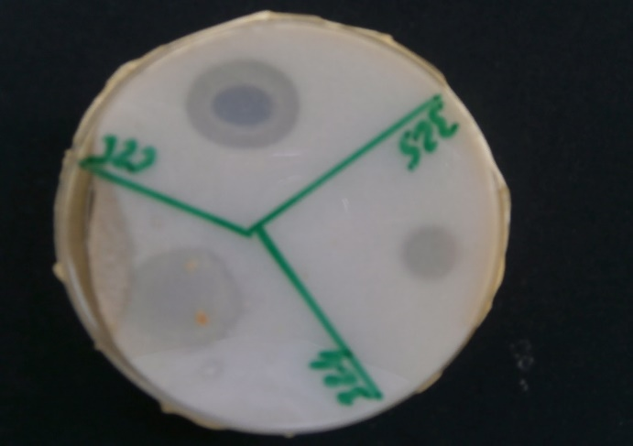
Colony
Halo

Figure 5: Potassium solubilization test of soybean nodules bacteria on Aleksandrov medium
3.6. Calcium solubilization
The ability of the the bacterial isolates to solubilize calcium was determined by producing a clear halo around the colonies. Statistical analysis reveals a significant difference (P=0.0001) between potassium solubilization indices. Calcium solubilization indices range from 129 to 210%. Bacteria RSC119, RSC325; RSC323 and RSC324 have a strong capacity for calcium solubilization. The greatest production was observed in strain RSC323 with an ISca (=220.00±40.00), (Table I).
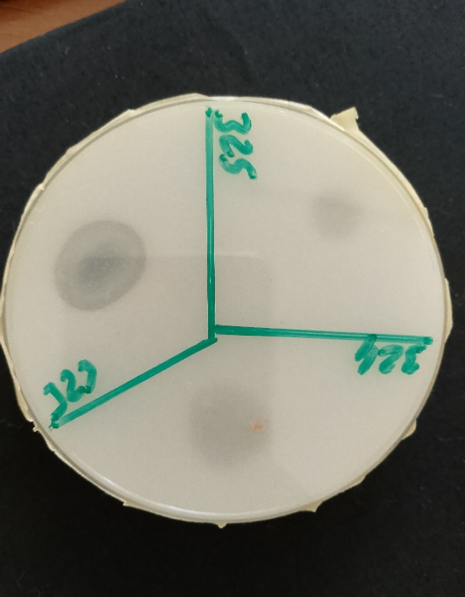
Halo
Colony

Figure 6: Calcium solubilization test of soybean nodules bacteria on modified Aleksandrov medium
Table I: Plant growth promoting characteristics of rhizobacteria isolated from soybean nodules
Isolates | PSI (%) | KSI (%) | CaSI (%) | AIA | NH₃
RSC115 | 0.00±0.00b | 0.00±0.00b | 0.00±0.00b | - | 2+
RSC119 | 378.24±30.1a | 129.91±7.64a | 0.00±0.00b | 2+ | 1+
RSC309 | 0.00±0.00b | 0.00±0.00b | 0.00±0.00b | - | 1+
RSC323 | 381.48±16.97a | 211.11±19.24a | 220.00±40.00a | 4+ | 4+
RSC324 | 0.00±0.00b | 159.26±7a | 206.66±90.18a | - | 2+
RSC325 | 374.07±6.41a | 176.29±56.27a | 160.84±43.07a | 3+ | 3+
RSC502 | 0.00±0.00b | 0.00±0.00b | 0.00±0.00b | - | 3+
RSC504 | 368.52±27.40a | 0.00±0.00b | 0.00±0.00b | 1+ | 2+
RSC506 | 374.08±23.12a | 0.00±0.00b | 133.00±25.85a | 3+ | 2+
RSC508 | 366.67±19.24a | 0.00±0.00b | 0.00±0.00b | 2+ | 3+
Residuals | 5792 | 17150 | 24513
Pr | 2e-16 *** | 0.00000000196 *** | 0.0000000139 ***
For each mean, the values with the same letters (a, b) on the same column are statistically identical at the 5% threshold according to the Fisher LSD test. 4+: Very high intensity AIA/NH3 productio_{n;}3+: high intensity AIA/NH₃ production; 2+: average production of AIA/NH₃; 1+: low production AIA/NH₃ et (-): no production of AIA. PSI: Phosphate Solubilization Index; KSI: Potassium solubilization index and CaSI: Calcium solubilization index.

Third part: RESULTS AND DISCUSSION

4. DISCUSSION
In the framework of sustainable agriculture and environmental preservation, there are numerous issues that need to be resolved, including alternative strategies to decrease the use of synthetic fertilizers in order to increase plant productivity without compromising soil fertility, environmental balance, and public health. Therefore, this study is a research avenue for a solution to increase agricultural yields, guarantee food security,, and assure sustainable soil management.
In the present study, bacteria isolated from soybean nodules in the soil of Côte d’Ivoire were selected to evaluate their plant growth-promoting (PGP) traits such as IAA production and ammonia production ,phosphate, potassium , calcium solubilization
The majority of nodule bacteria used in this study had potential for promoting plant growth by the production of IAA, production of Potassium, production of Calcium, production of Ammonia and solubilization of phosphate. the capacities of these strains would be linked to their intrinsic characteristics. This is suggested by the work of Guei et al (2024) who explain that the capacities of the Bambara pea endophytic bacteria studied were linked to their genetic lineage. Kuklinsky-Sobral et al. (2004) which studied nodule endophyte isolated from soybean have revealed that bacteria with PGP traits were generally affiliated with the genera Bacillus, Pseudomonas, Paenibacillus, Rahnella, Rhizobium etc.. included within Firmicutes and Proteobacteria phyla
The ability of rhizosphere bacterial strains to produce auxin is a promising tool to study the profound effect of these strains on plant growth (Marfungah et al, 2023). IAA is widely regarded as the most significant phytohormone that regulates several plant developmental processes (Kunkel and Johnson, 2021). These include cell-cell signaling, regulation of plant development, and induction of plant defense systems (Gravel et al., 2007)
Based on tests, 60% of the bacteria isolated from soybean nodules produced measurable levels of IAA, with the strength of production ranging from low to very high.
The ability of the tested strains to produce IAA may be attributed to the substantial presence of AIA in the nodules of leguminous plants. Indeed, this phytohormone may be involved in the development of legume-rhizobia symbiosis, a phenomenon that is the foundation for the formation of nodules (Duca et al., 2014). Mengstie et al. (2024) found that eight isolates the Bacteria from the faba bean rhizosphere, seven were able to produce IAA.
The observed constant ammonia production is characteristic of an efficient PGPR. Ammonia not only contributes to nitrogen supply, but also inhibits phytopathogens by altering soil pH (Cochard et al., 2022). The result of this study clearly shows that all the isolates tested were able to produce ammonia. These results are confirmed by those of Capuccino and Sherman (1992) and those of Ahmed et al., (2008) who studied endophytic bacteria that were capable of producing ammonia. Ahmed et al. (2021) reported similar metabolic characteristics in tomato and corn PGMPs.
Phosphorus, an essential macronutrient, plays a key role in plant growth and development. However, its availability of phosphate is a major limiting factor in tropical soils.
In this study, in total, 60% of the strains tested showed the ability to solubilize phosphorus. These results corroborate those obtained by Djuuna et al. (2022), who worked on bacterial strains that recorded a high phosphorus production The ability of isolates to mobilize phosphate is explained by the work of Afzal et al. (2023) and Bashir et al. (2023), where Bacillus and Rhizobium species significantly increased P uptake and plant yield. The wide range of PSI observed could be understood by the fact that prolonged incubation improves solubilization efficiency (Tariq et al., 2022).
The use of phosphate-solubilizing bacteria (PSB) as biofertilizers for crop production is one solution to the problem of plant phosphate inadequacy.
Potassium and calcium solubilization by PGPRs is increasingly recognized as a crucial factor in nutrient cycling. In this work, 40% of the isolates tested were able to solubilize potassium (K) and calcium (Ca). Isolate RSC323 demonstrated dual efficacy in solubilizing potassium and calcium, suggesting potential for the development of multi-nutrient biofertilizers. According to the work of Fatharami & Rahayu (2018), certain bacteria isolated from rice roots were able to solubilize K (mica). Research by Ahmed et al (2021) has also shown that certain bacterial genera are capable of solubilizing Calcium. This ability would be linked to the production of organic acid by PGPR, which would facilitate the solubilization of (Wang et al., 2020; Verma et al., 2017).
Isolates RSC325 and RSC323 performed well in all the PGP activities tested. The effectiveness of PGPR is directly related to the presence of multiple plant growth-promoting mechanisms in the microorganisms (Mengstie et al. 2024). The use of these bacteria as biofertilizers for crop production is one solution to f the problem of soil infertility and the decline in crop production. Consequently, our isolates could be of interest for future inoculant production.

5. CONCLUSION
This study demonstrated that PGPR isolated from soybean nodules had multiple beneficial characteristics for plants, including hormone production and nutrient solubilization. Two (02) isolates(RSC323, RSC325) showed particularly promising potential for the development of biofertilizers. Future work should focus on the identification of 16S rRNA genes and field trials to confirm their effectiveness in promoting plant growth under natural conditions.

Disclaimer (Artificial intelligence)
Option 1:
Author(s) hereby declare that NO generative AI technologies such as Large Language Models (ChatGPT, COPILOT, etc.) and text-to-image generators have been used during the writing or editing of this manuscript.

REFERENCES

Abdelkrim, S., Jebara, S. H., Saadani, O., Abid, G., Taamalli, W., Zemni, H., Mannai, K., Louati, F., & Jebara, M. (2020). In situ effects of Lathyrus sativus- PGPR to remediate and restore quality and fertility of Pb and Cd polluted soils. Ecotoxicology and Environmental Safety, 192, 110260.
Afzal, A., Bahader, S., Ul Hassan, T., Naz I., & Din, A. U. (2023). Rock phosphate solubilization by plant growth-promoting Bacillus velezensis and its impact on wheat growth and yield. Geomicrobiology Journal, 40 (2), 131-142.
Ahmed, O.H., Aminuddin, H.; & Husni, M. H. A. (2008). Ammonia volatilization and ammonium accumulation from urea mixed with zeolite and triple superphosphate. Acta Agriculturae. Scandinavicia section B-Soil and Plant Science, 58: 182-186.
Ahmed, Z., Kihombo, S., & Chen, S. (2021). Linking financial development, economic growth, and ecological footprint : what is the role of technological innovation ? Environmental Science and pollution Research 28 (43), 61235-61245.
Balali-Mood, M., Naseri, K., Tahergorabi, Z., Khazdair, MR, Sadeghi, M. (2021) : Mécanismes toxiques de cinq métaux lourds : mercure, plomb, chrome, cadmium et arsenic. – Frontiers in Pharmacology 12, 643972.
Bashir, T., Iqbal, M., Javed, S., Riaz, J., Bukhari, N. T., Nisa, I., & Khan, N. (2023). Isolation and characterization of plant growth promoting bacteria (PGPR) from rhizosphere of Okra. Journal of Population Therapeutics and Clinical Pharmacology, 30(18), 1257-1268.
Cappuccino J.C. and Sherman N. (1992) Ammonia production, In Cappuccino J.C. and Sherman N., eds., Microbiology: A Laboratory Manual, third ed., Benjamin, Cummings Pub Co., Redwood City, 125-179
Cochard, B., Giroud, B., Crovadore, J., Chablais, R., Arminjon, L., & Lefort, F. (2022) : Endophytic PGPR from Tomato Roots : In Vitro Characterization and in Vivo Evaluation of Teated Tomatoes (Solanum lycopersicum L.). Microorganisms 10, 765.
Daszkiewicz, T. (2022) : Food Production in the Context of Global Developmental Challenges Agriculture 12 : 832.
Djuuna, I. A. F., Prabawardani, S., & Massora, M. (2022). Population distribution of phosphate-solubilizing microorganisms in agricultural soil. Microbes and environments, 37 (1), ME21041.
Duca, D., Lorv, J., Patten, C. L., Rose, D., & Glick, B. R. (2014). Indole-3-acetic acid in plant–microbe interactions. Antonie Van Leeuwenhoek,106, 85-125. https://doi.org/10.1007/s10482-013-0095-y
Ehmann A. (1977). The van Urk-Salkowski Reagent--a Sensitive and Specific Chromogenic Reagent for Silica Gel Thin-Layer Chromatographic Detection and Identification of Indole Derivatives. Journal of Chromatography 132 (2): 267-76.
Elhaissoufi, W., Ghoulam, C., Barakat, A., Zeroual, Y., & Bargaz, A., (2022). Phosphate bacterial solubilization: A key rhizosphere driving force enabling higher P use efficiency and crop productivity. Journal of Advanced Research 38, 13–28. https://doi.org/10.1016/j.jare.2021.08.014
Fatharani R. & Rahayu Y S. (2018). Isolation and characterization of potassium-solubilizing bacteria from paddy rhizosphere (Oryza sativa L.). Journal of Physics : Conference Series, 1108 (1) : 012105.
Gravel, V., Antoun, H., & Tweddell, R. J. (2007). Growth stimulation and fruit yield improvement of greenhouse tomato plants by inoculation with Pseudomonas putida or Trichoderma atroviride: possible role of indole acetic acid (IAA). Soil biology and Biochemistry, 39(8), 1968-1977.
Jordan, D. C. (1984). Family III, Rhizobiaceae. Bergey's manual of systematic bacteriology, 1, 235-244.
Kuklinsky-Sobral, A.J., Mendes, W.L., Geraldi, R., Pizzirani-kleiner, I.O., & Azevedo, A.J.L. (2004). Isolation and characterization of soybean-associated bacteria and their potential for plant growth promotion. Environnement Microbiology 6, 1244-1251. DOI: 10.1111/j.1462-2920.2004.00658.x
Kunkel, BN., & Johnson, JMB. (2021) : Auxin ¨Plays Multiple Roles during Plant-Pathogen Interctions. Cold Spring Harb Perspect in Biology 13: a040022. https://doi: 10.1101/cshperspect. a 040022
Marfungah S., F. Puspita, B. Tjahjono, B. Siregar, A. Gafur, (2023): Potential of indigenous rhizobacteria as biocontrol agents of Xanthomonas sp, Philippine Journal of Science. 152 (5) 1539–1548
Meena, O. P., Maurya, B. R., Meena, V. S. M. (2013). Influence of k- solubilizing bacteria on release of potassium from Waste mica, Agriculture for Sustainable Development 1(1):53-56.
Mehmood, A., Khan, N., Irshad, M., Hamayun, M., Husna, I., Javed, A., & Hussain, A. (2018). IAA producing endopytic fungus Fusariun oxysporum wlw colonize maize roots and promoted maize growth under hydroponic condition. European Journal of Experimental Biology, 8(4), 24.
Mengstie, G. Y., Awlachew, Z. T., & Degefa, A. M. (2024). Screening of rhizobacteria for multi-trait plant growth-promoting ability and antagonism against B. fabae, the causative agent of chocolate spot disease of faba bean. Heliyon, 10(3).
Pahalvi, HN, Rafiya, L., Rashid, S., Nisar, B., & Kamili, AN. (2021): Chemical Fertilizers and Their Impact on Soil Health. Microbiota and Biofertilizers, Vol 2 : Springer International Publishing. https:// doi.org/10.1007/978-3-030-61010_1
Pikovskaya, R. I. (1948). Mobilization of phosphorus in soil in connection with vital activity of some microbial species. Microbiologia, 1948, 17 édition.
Raïssa, GUEI Nassé Kaéda, KOUADIO Loukou Edouard, ZRO Bi Gohi Ferdinand, TAHA Kaoutar, KOFFI Mathurin, SORO Dogniméton, FILALI-MALTOUF Abdelkarim, and KONATE Ibrahim. 2024. “In Vitro Evaluation of Plant Growth Promoting Endophytes from Bambara Groundnut Nodules in Côte d’Ivoire”. Journal of Advances in Microbiology 24 (12):233-243. https://doi.org/10.9734/jamb/2024/v24i12886.
Sharma, M., Bhardwaj, R., Saran, M., Prajapat, RK, Sharma, D., & Mathur, M. (2023). Secondary Metabolites and Bioprospecting. In : Mawar, R., sayyed, RZ, Sharma, SK, Sattiraju, KS (eds) Plant Growth Promoting Microorganisms of Arid Region. Springer, Singapour. https:// doi.org/10.1007/978-981-19-4124-5_12.
Taha, K., El, I., Hnini, M., Raif, A., Gilles, B., Aurag, J., & Berraho, E. B. (2022). Rhizosphere Beneficial effect of Rhizobium laguerreae co-inoculated with native Bacillus sp. and Enterobacter aerogenes on lentil growth under drought stress, Rhizosphere, 22, 100523.
Tariq, M. R., Shaheen, F., Mustafa, S., Sajid, A. L. I., Fatima, A., Shafiq, M., & Nasir, M. A. (2022). Phosphate solubilizing microorganisms isolated from medicinal plants improve growth of mint. PeerJ, 10, e13782.
Vázquez, IT., Cruz, R.S., Domínguez, M. A., Ruan, V. L., Reyes, A. S., María del Rayo, S. C., Chacón, D. P, García, R. A. B., & Mallol, J. L. F. (2020). Isolation and characterization of psychrophilic and psychrotolerant plantgrowth promoting microorganisms from a high-altitude volcano crater in Mexico. Microbiological Research, 232,126394.
Verma, P., Yadav, A. N., Khannam, K. S., Saxena, A. K., & Suman, A. (2017). Potassium-solubilizing microbes: diversity, distribution, and role in plant growth promotion. In Microorganisms for green revolution: Volume 1: Microbes for sustainable crop production (pp. 125-149). Singapore: Springer Singapor
Vocciante, M., Grifoni, M., Fusini, D., Petruzzelli, G., & Franchi, E. (2022). The role of plant growth-promoting rhizobacteria (PGPR) in mitigating plant’s environmental stresses. Applied sciences, 12(3), 1231.
Wang, F., Zhang, X., Zhang, S., Zhang, S., & Sun, Y. (2020). Interactions of microplastics and cadmium on plant growth and arbuscular mycorrhizal fungal communities in an agricultural soil. Chemosphere, 254, 126791.

