***Short Research Article***

**Prevalence and antibiotic resistance profiles of *Enterobacteriaceae* isolated from street dèguè in Abidjan district, Côte d’Ivoire**

**ABSTRACT**

**[Background and Objective**]: Foods of animal origin are considered a major source of foodborne illness. Resistant *Enterobacteriaceae* strains pose a serious threat to public health due to the consumption of feed contaminated with antibiotics used to treat various bacterial infections in livestock. This study aimed to determine the prevalence and antibiotic resistance profil of *Enterobacteriaceae* strains isolated from dèguè (drink made from millet couscous and curdled milk) sold on the streets of the Abidjan district. **[Methods**]: A total of 160 samples of traditional dèguè were analyzed. The isolated strains were identified by classical bacteriology and identification method. They were subjected to an antibiogram by the Mueller-Hinton agar diffusion method according to the EUCAST-CASFM 2024_V1.0 recommendations and the resistance phenotype was based on their behavior in relation to the tested antibiotics. [**Results]:** On average, 54.4% of dairy product (dèguè) samples (87/160) were found contaminated with *Klebsiella pneumoniae* (25/87), *Escherichia coli* (21/87), *Citrobacter koseri* (21/87), *Enterobacter aerogenes* (19/87) and *Salmonella* spp (01/87) in almost all sampling areas of the Abidjan district. Antibiotic susceptibility testing showed the highest rates of resistance of isolates to amoxicillin-clavulanic acid (69.4%), piperacillin (61.2%) (Yopougon), cefepime (34.2%), and pefloxacin (40%) in the Songon commune, and the lowest rates of resistance to ciprofloxacin and amikacin, all at a rate of 2%, and levofloxacin (4%), gentamicin (5.7%). A 3% rate of extended-spectrum beta-lactamase production was detected. [**Conclusion and perspective]:** The high level of contamination caused by multidrug-resistant *Enterobacteriaceae* strains poses a risk to public health and highlights the need for further research on the surveillance and control of pathogens present in dairy products.

**Keywords:** Dèguè, *Enterobacteriaceae*, Antibiotic resistance, Côte d'Ivoire

**1. INTRODUCTION**

Foodborne diseases are a major global public health problem (Bedasa *et al.,* 2018). In industrialized countries, their incidence rate is estimated at 30%, while up to two million deaths are reported annually in developing countries (Abebe *et al.,* 2020). Among the main pathogens responsible for these diseases is *Escherichia coli*, some variants of which can cause severe gastrointestinal disorders (CDC, 2011). Although its presence is naturally low (approximately 0.1%) in the gut microbiome of humans and warm-blooded animals, some pathogenic strains represent a significant health risk (Farrokh *et al.,* 2013; Canizalez-Roman *et al.,* 2013; Pendleton *et al.*, 2013).

Foods of animal origin, particularly milk and its derivatives, are particularly susceptible to microbial contamination due to poor sanitation, inappropriate storage conditions, and careless handling by personnel (Farrokh *et al.*, 2013; García-Heredia *et al*., 2016). Bacteria commonly isolated from these products include *Enterobacteriaceae*, known for their ability to produce toxins and their high prevalence of antibiotic resistance (Dhaka *et al*., 2016; Farshad *et al.,* 2012). Studies have demonstrated multidrug resistance of STEC strains to various antibiotics, including aminoglycosides, fluoroquinolones, tetracyclines, cephalosporins, sulfonamides, and chloramphenicol (Momtaz *et al.,* 2012; Abdi *et al.,* 2014).

The transmission of these pathogens through dairy products poses a serious public health threat, particularly in resource-poor countries such as Côte d'Ivoire, where data on antibiotic resistance in *Enterobacteriaceae* remain limited. Although several studies have studied the microbiological quality of local dairy products, few have explored the resistance of the pathogenic bacteria that contaminate them (Coulibaly *et al.,* 2015 ; N’Goran-Aw *et al*., 2018 ; Maïwore *et al.,* 2018).

This study aimed to determine the prevalence and antibiotic resistant profiles of *Enterobacteriaceae* isolated from dèguè, a traditional dairy product sold on the streets of the Abidjan district. The results obtained will help strengthen microbiological surveillance systems and guide policies to combat foodborne zoonoses in Côte d'Ivoire.

**2. MATERIALS AND METHODS**

**2.1. Study Setting**

This study was conducted at the National Reference Center for Antibiotics of the Pasteur Institute of Côte d'Ivoire, where the isolation of suspect bacteria, their identification, and antibiotic susceptibility testing took place.

**2.2. Selection of Study Sites**

The samples were collected in the autonomous district of Abidjan, located in southern Côte d'Ivoire, bordering the Atlantic Ocean in the Gulf of Guinea. This district covers an area of 2,119 km², or approximately 0.7% of the national territory, and includes thirteen (13) communes (including Yopougon and Songon) as well as four (04) sub-prefectures (Anyama, Songon, Bingerville, and Brofodoumé). The total projected population for 2024 is estimated at 6,865,306 inhabitants (ANStat, 2024).

The sampling sites were chosen in the communes of Yopougon and Songon due to their high population density and commercial dynamics. These areas are home to an active population composed mainly of traders, transporters, and small artisans, fostering intense street food activity, particularly around the sale of dèguè. This socioeconomic and demographic context makes these sites particularly relevant for assessing microbiological risks associated with informally marketed dairy products.

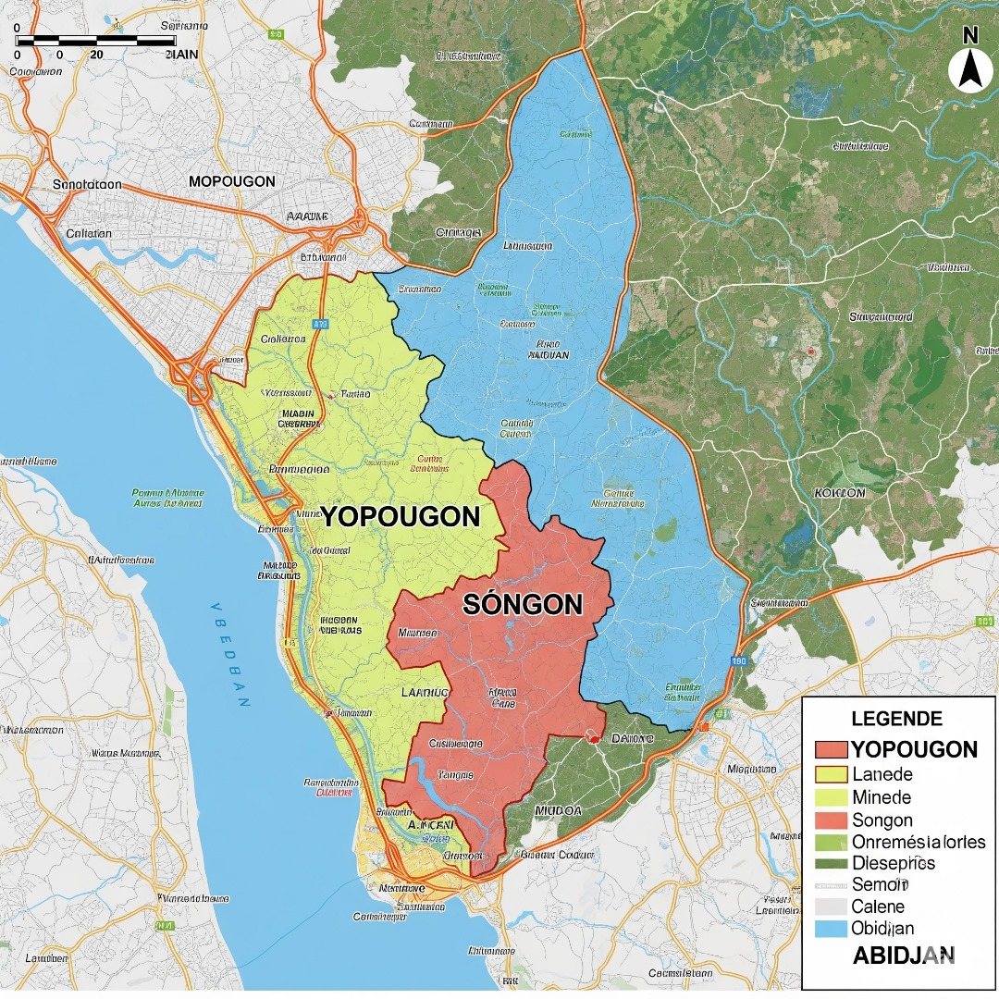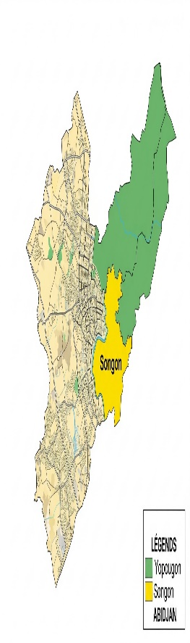

**Figure 1 :** Autonomous District of Abidjan, Côte d’Ivoire

**2.3. Study Type and Period**

This was a descriptive cross-sectional study conducted between December 2024 and April 2025, focusing on dèguè, a traditional dairy product prepared locally from fermented, sweetened, and flavored millet couscous. This product is widely consumed and sold on the streets of the autonomous district of Abidjan, often under variable hygiene conditions, making it a potential vector of microbiological risks.

**2.4. Sampling**

The samples were purchased on the streets of two municipalities in the district of Abidjan: Yopougon and Songon. Each sample consisted of approximately 300 mL of dairy product packaged in plastic or in a 500 mL bottle, previously used to package mineral water. The samples were collected in bulk.

**2.5. Sample Size**

The sample size for the dèguè was 160, including 59 collected in Songon and 101 in Yopougon.

**2.6. Sample Transportation**

All samples were promptly transported to the National Reference Center for Antibiotics at the Pasteur Institute of Côte d'Ivoire. Transport was carried out in an insulated container equipped with ice packs, ensuring the temperature chain was maintained. Microbiological analyses were performed within 24 hours of collection, in accordance with microbiological quality standards.

**2.7. Culture and identification of enterobacteria**

Approximately 25 mL of liquid dairy products were mixed with 225 mL of phosphate-buffered saline (pH = 7.2; Merck, Darmstadt, Germany), followed by vigorous stirring for at least 1 minute. Then, 1 mL of the homogenized solution was inoculated into a liquid medium, buffered peptone water, and incubated for 24 hours at 37°C. After incubation, 15 μL of the resulting solution was streaked onto Eosin Methylene Blue (EMB) agar (HiMedia, Mumbai, India) and incubated at 37°C for 24 hours. The colonies obtained were characterized by macroscopic examination, which consisted of describing the cultural characteristics of the bacterial colonies on their isolation media. Microscopic examination of the fresh bacterial cells, Gram staining, and catalase and oxidase tests were then performed. This characterization was followed by biochemical tests on Api 20E slides. The strains were identified by comparing their characteristics with those of known taxa as described in the Mérieux SA bio manual. The identified strains were selected and stored at -20°C in brain heart infusion broth with glycerol (20% v/v) for antibiotic susceptibility testing.

**2.8. Antibiotic Susceptibility Testing**

The antibiotic susceptibility of all isolates was assessed using the Kirby-Bauer disk diffusion method on Mueller-Hinton agar plates (Oxoid™), following the EUCAST-CASFM guidelines, latest version 2024. In this study, bacterial suspension densities measured at 0.5 McFarland (5x105CFU/mL) were prepared. The following antibiotic discs (BioMérieux) were used: amikacin (AKM, 30μg), gentamicin (GNM, 10μg), amoxicillin/clavulanic acid (AMC, 20/10μg), cefotaxime (CTX, 5μg), cefepime (FEP, 30μg), ciprofloxacin (CIP, 5μg), levofloxacin (LVX, 5μg), pefloxacin (PEF, 5μg), imipenem (IPM, 10μg), piperacillin (PIP, 30μg) and tigecycline (TGC, 15μg). Plates inoculated were incubated aerobically at 37°C for 18 to 24 hours. Additionally, *Escherichia coli* ATCC 25922 was used as a quality control strain. Finally, multidrug-resistant bacteria (MDB) are characterized by bacteria that exhibit acquired resistance to at least 3 classes of antibiotics (Magiorakos *et al.,* 2012). To calculate the prevalence of Enterobacteriaceae and the resistance rate, the following formulas were used:

Resistance rate =

Number of bacteria resistant to antibiotics x 100

Total number of antibiotics tested

Prevalence of Enterobacteriaceae =

Number of positive samples x 100

Total number of samples

**2.9. Detection of Enzyme Production, Extended-Spectrum Beta-Lactamases**

All isolates were tested for extended-spectrum beta-lactamase production using the double synergy test. This test was performed under standard antibiogram conditions. Ceftazidime and cefepime discs were placed around an amoxicillin/clavulanic acid disc on Mueller-Hinton agar (approximately 30 mm) and incubated at 37°C for 24 hours. The appearance of a "champagne cork" pattern indicates the production of an extended-spectrum beta-lactamase by the strain tested (Drieux *et al.,* 2008).

**3. Statistical Data Analysis**

All recorded parameters were used to generate an Excel database from which prevalence and resistance rates were calculated.

**4. RESULTS**

**4.1. Prevalence of Isolated *Enterobacteriaceae***

Of the 160 dèguè samples analyzed in this study, *Enterobacteriaceae* were isolated from 87 samples (54.4%) based on their morphological and biochemical characteristics. The *Enterobacteriaceae* identified were: *Klebsiella pneumoniae* (28.73%; 25/87), *Escherichia coli* (24.13%; 21/87), *Citrobacter koseri* (24.13%; 21/87), *Enterobacter aerogenes* (21.83%; 19/87), and *Salmonella* spp (1.14%; 1/87) (Figure 1).

**Figure 2:** Distribution of enterobacteria isolated from dèguè sold in the streets of the district of Abidjan

**4.2. Distribution of Isolated Strains by Sampling Site**

The distribution of *Enterobacteriaceae* strains isolated from purchased samples at the two study sites (Yopougon and Songon) is shown in Figure 3. During the study period, 87 *Enterobacteriaceae* strains were isolated from the dèguè samples, including 56% from the commune of Yopougon and 44% from the commune of Songon.

**Figure 3:** Distribution of *Enterobacteriaceae* strains isolated at the two sampling sites

**4.3. Antibiotic resistance profiles of *Enterobacteriaceae* isolated in the municipality of Yopougon**

Analysis of antibiotic resistance among *Enterobacteriaceae* isolated in the municipality of Yopougon revealed worrying levels of resistance to several commonly used antibiotics. The observed rates were: 69.4% for the amoxicillin-clavulanic acid combination, 61.2% for piperacillin, 42.8% for cefotaxime, and 32.6% for cefepime and pefloxacin. In contrast, resistance rates to ciprofloxacin and amikacin remained relatively low, at 2%. These data are illustrated in Figure 4.

**Figure 4 :** Antibiotic resistance profiles of 49 strains of enterobacteria isolated from dèguè in the commune of Yopougon (Abidjan, Côte d’Ivoire)

**AMC** : Amoxicilline acide clavulanique, **PIP** : Pipéracilline, **AKM** : amikacine, **GMN** : gentamicine, **FEP** : Céfépime, **CTX** : cefotaxime, **CAZ** : ceftazidime, **LVX** : levofloxacine, **PEF**: péfloxacine, **CIP** : ciprofloxacine, **IPM** : imipenème

**4.4. Antibiotic resistance profiles of *Enterobacteriaceae* isolated in the commune of Songon**

The study revealed variable rates of antibiotic resistance among *Enterobacteriaceae* isolated in the commune of Songon. The highest resistance was observed with pefloxacin (40%), cefepime (34.2%), piperacillin (28.9%), and cefotaxime (21.6%). In contrast, resistance rates to ciprofloxacin, gentamicin, and levofloxacin remained relatively low, at 8%, 5.7%, and 4%, respectively. These data are summarized in Figure 5.

**Figure 5 :** Antibiotic resistance profiles of 38 strains of enterobacteria isolated from dèguè in the commune of Songon (Abidjan, Côte d’Ivoire)

**AMC** : Amoxicilline acide clavulanique, **PIP** : Pipéracilline, **AKM** : amikacine, **GMN** : gentamicine, **FEP** : Céfépime, **CTX** : cefotaxime, **CAZ** : ceftazidime, **LVX** : levofloxacine, **PEF**: péfloxacine, **CIP** : ciprofloxacine, **IPM** : imipenème

**4.5. Prevalence of Resistance Phenotypes**

The distribution of Enterobacteriaceae strains isolated from the dèguè showed variable resistance phenotypes. Resistance phenotypes were determined through their resistance phenotype analyzed by the ADAGIO® system (Antibiogram Reading and Interpretation System). One strain of *Enterobacter aerogenes* from the commune of Songon produced an extended-spectrum beta-lactamase (3%). A proportion of 33.3% of *Enterobacteriaceae* were resistant to fluoroquinolones (Songon), 32.8% of these strains produced hyperproduced cephalosporinases (Yopougon), and 26.2% of strains were suspected of producing carbapenemases (Yopougon) (Table I).

**Table I:** Resistance Phenotype of *Enterobacteriaceae* Isolated from the dèguè

|  |  |  |
| --- | --- | --- |
| Resistance phenotype | Proportion of strains by locality (%) | |
| **Songon** | **Yopougon** |
| Extended Spectrum Beta-Lactamases | 3 | 0 |
| Overproduced cephalosporinase | 18,2 | 32,8 |
| Resistance to fluoroquinolones | 33,3 | 13,1 |
| Suspicion of carbapenemase production | 21,2 | 26,2 |
| Combination of resistance phenotypes | 24,2 | 27,9 |

**5. DISCUSSION**

This study revealed significant contamination of dèguè by *Enterobacteriaceae*, with a positivity rate of 54.4%. This result is higher than the prevalence reported in Iran (30.2%, Ranjbar *et al.,* 2018) and Ethiopia (33.9%, Disassa *et al.,* 2017), similar to that observed in China (52.4%), but lower than other more recent Iranian data (68.7%, Fallah *et al.,* 2021). This variability could be explained by differences in hygiene practices, storage conditions, and artisanal manufacturing protocols. Indeed, inadequate management of livestock, milking equipment, or HACCP standards increases the microbiological risk (Bedasa *et al.,* 2018; Ombarak *et al.,* 2016). In terms of antibiotic resistance, the results confirmed the scale of the phenomenon and the associated health emergency. In Yopougon, *Enterobacteriaceae* showed high rates of resistance to amoxicillin-clavulanic acid (69.4%), piperacillin (61.2%), and several 3rd and 4th generation cephalosporins. In Songon, similar levels of resistance were observed, although slightly lower. These results are consistent with data reported in Senegal (Dia *et al.,* 2015), while highlighting an evolutionary dynamic in the resistance profile. Conversely, certain molecules such as ciprofloxacin, gentamicin and amikacin retained significant activity, with resistance rates below 10%, in contrast to data from Benin (Anago *et al.,* 2015). The presence of ESBL-producing strains remained moderate in this study (3% in Songon), but the increase in hyperproduced cephalosporinases (up to 32.8% in Yopougon) and the suspicion of carbapenemase production (up to 26.2%) were worrying. These mechanisms, observed in particular in *Escherichia coli, Klebsiella* spp. and *Enterobacter* spp., indicate potentially uncontrolled community spread (Poirel *et al.,* 2013; EFSA, 2025). The differences in resistance profiles between this study and those conducted in other countries (Morocco, Algeria, Nigeria, China) could be attributed to the variability of veterinary practices, the availability of antibiotics in pharmacies and the behavior of prescribers (Ranjbar *et al*., 2018; Sanders *et al*., 2017). Thus, our results support the implementation of a strengthened surveillance system for antimicrobial resistance in traditional dairy products.

**6. CONCLUSION**

This study revealed significant microbiological contamination of traditional dèguè sold on the streets of the autonomous district of Abidjan, with a marked prevalence of *Enterobacteriaceae*, particularly in the communes of Yopougon and Songon. Although only one strain of *Salmonella* spp. was detected, the presence of antibiotic-resistant *Enterobacteriaceae* strains represents a serious threat to food safety and the public health of consumers.

Strains isolated in Yopougon showed high resistance rates to amoxicillin-clavulanic acid and piperacillin, while in the commune of Songon, these rates remained below 40%. The most active antibiotics were ciprofloxacin, amikacin, gentamicin, and levofloxacin, suggesting their therapeutic potential against multidrug-resistant *Enterobacteriaceae*. The detection of a strain producing extended-spectrum beta-lactamases *(Enterobacter aerogenes*), hyperproduced cephalosporinases, fluoroquinolone-resistant phenotypes, and suspected carbapenemase production highlights the diversity and complexity of the resistance mechanisms present. The inappropriate use of antibiotics in the livestock industry could contribute to this emergence, justifying the urgent implementation of control measures, continuous microbiological surveillance, and antibiotic resistance policies adapted to the Ivorian context.

**Disclaimer (Artificial intelligence)**

Author(s) hereby declare that NO generative AI technologies such as Large Language Models (ChatGPT, COPILOT, etc.) and text-to-image generators have been used during the writing or editing of this manuscript.

**REFERENCE**

Abdel-Rahman , M.A.A. , Hamed , E.A. , Abdelaty , M.F. , Sorour , H.K. , Badr , H. , Hassan , W.M. , Shalaby , A.G. , Halem , A.A.E. , Soliman , M.A. and Roshdy , H. ( 2023 ) Distribution pattern of antibiotic resistance genes in *Escherichia coli* isolated from colibacillosis cases in broiler farms of Egypt. *Veterinary World*, 16(1): 1–11.

Abdi, S., Ranjbar R., Vala, M.H., Jonaidi N., Bejestany O.B., Bejestany F.B. (2014). Frequency of bla TEM, bla SHV, bla CTX-M and qnrA in *Escherichia coli* isolated from a urinary tract infection. *Archives of Clinical Infectious Diseases*, 9:e18690.

Abebe, E.; Gugsa, G.; Ahmed, M. (2020). Review on the main zoonotic bacterial pathogens of food origin. *Journal of Tropical Medicine*, 4674235.

Anago E., Ayi-Fanou L., Akpovi C.D., Hounkpe W.B., Agassounon-Lake Tchibozo M., Bankole HS et al. (2015). Antibiotic resistance and genotype of beta lactamase producing Escherichia coli in nosocomial infections in Cotonou, Benin. *Annals of Clinical Microbiology and Antimicrobials*; 14(1):

European Food Safety Authority (2008). Antimicrobial resistance of food origin: a biological hazard. Scientific Opinion of the Scientific Group on Biological Risks. AND J., 6,

Bedasa, S., Shiferaw D., Abraham, A., Moges, T. (2018). Occurrence and antimicrobial susceptibility profile of *Escherichia coli* O157: H7 from foods of animal origin in Bishoftu city, Central Ethiopia. *International Journal of Food Contamination*. 5,

Bendjebbara M. Benmoumene N.M., Benidiri C.L. (2024). Prevalence and antibioresistance of *Escherichia coli* strains isolated from raw milk in the Ain Témouchent region. Final Project For the degree of Master of Applied Microbiology, Field: Biology, Branch: Biological Sciences, Specialty: Applied Microbiology. Ain Temouchent University- Belhadj Bouchaib Faculty of Science and Technology Department of Natural and Life Sciences. P71.

Bhardwaj, D.K. Taneja, N.K., Shivaprasad, D.P., Chakotiya, A., Patel, P., Taneja , P., Sachdev , D., Gupta, S., Sanal , M.G. (2021). Phenotypic and genotypic characterization of pathogenic, antimicrobial-resistant and biofilm-forming *Escherichia coli* isolated from Indian dairy and meat products. *International Journal of Food Microbiology*. 336, 108899.

Canizalez-Roman, A.; Gonzalez-Nunez, E.; Vidal, J.E.; Flowers-Villasenor, H.; Leon-Sicairos, N. (2013). Prevalence and antibiotic resistance profiles of diarrheal *Escherichia coli* strains isolated from food in northwestern Mexico. *International Journal of Food Microbiology*. 164, 36 to 45

Centers for Disease Control and Prevention (CDC) (2011). CDC Estimates of Foodborne Illness in the United States: Centers for Disease Control and Prevention Estimates.

Cissé, H.K., (2020). Beta-lactam Resistance Phenotypes of Enterobacteriaceae Strains Isolated from Pus, Blood Cultures, and Stool at Point G University Hospital. Thesis, Faculty of Pharmacy, University of Sciences, Techniques and Technologies of Bamako. P99

Coulibaly K.J., Kouamé Elogne C, Yeo A, Koffi C, Dosso M. (2015). Qualité microbiologique des produits laitiers industriels vendus à Abidjan de 2009 à 2012. *Revue Bio-Africa -* N° 14 - 2015, pp. 44-52

Dhaka, P., Vijay, D., Vergis, J., Negi, M., Kumar, M., Mohan, V., Doijad, S., Poharkar, K.V., Malik S.S., Barbuddhe, S.B., (2016). Genetic diversity and antimicrobial susceptibility profile of diarrheagenic *Escherichia coli* pathotypes isolated from human, animal, food, and associated environmental sources. *Infection Ecology & Epidemiology*. 6:31055.

Dia, M.L., Chabouny, H., Diagne, R., Ka R., et al. (2015). Antibiotic profile of uropathogenic bacteria isolated at Dakar University Hospital. *Uro-Andro*. 1(4): 212-217.

Disassa, N.; Sibhat, B.; Mengistu, S.; Muktar, Y.; Belina, D. (2017). Prevalence and antimicrobial susceptibility pattern of *E. coli* O157:H7 isolated from traditionally marketed raw cow's milk in and around Asosa town, western Ethiopia. *Veterinary Medicine International*. 7581531.

Drieux L., Brossier F., Sougakoff W. & Jarlier V. (2008). Phenotypic detection of extended-spectrum b-lactamase production in Enterobacteriaceae: review and bench guide. *Clinical Microbiology and Infection*, 14: 90-103.

EFSA (2025). Carbapenem resistance in the food chain. Carbapenem resistance in the food chain | EFSA

European Committee on Antimicrobial Susceptibility Testing and Comité de l’antibiogramme de la Société Française de Microbiologie (EUCAST-CASFM V1.0) (2024). <https://www.sfm-microbiologie.org/wp-content/uploads/2024/06/CASFM2024_V1.0.pdf>

Fallah, N.; Ghaemi, M.; Ghazvini, K.; Rad, M.; Jamshidi, A. (2021). Presence, pathotypes, and antimicrobial resistance profiles of diarrheagenic *Escherichia coli* strains in food products of animal origin from public markets in Mashhad, *Iran. Food Control*, 121, 107640.

Farrokh, C.; Jordan, K.; Auvray, F.; Glass, K.; Oppegaard, H.; Raynaud, S.; Thevenot, D.; Condron, R.; De Reu, K.; Govaris, A. (2013). Review of Shiga toxin-producing *Escherichia coli* (STEC) and their importance in dairy production. *International Journal of Food Microbiology*. 162, 190–212.

Farshad, S., Ranijbar, R., Japoni, A., Hosseini, M., Anvarinejad, M., Mohammadzadegan, R. (2012). Microbial susceptibility, virulence factors, and plasmid profiles of uropathogenic Escherichia coli strains isolated from children in Jahrom, *Iran. Archives of Iranian Medicine*. 15:312–6.

García-Heredia, A.; García, S.; Merino-Mascorro, J.Á.; Feng, P. (2016). Natural plant products inhibit growth and alter swarming motility, biofilm formation, and virulence gene expression in enteroaggregative and enterohemorrhagic *Escherichia coli. Food Microbiol*. 59, 124–132.

Magiorakos, A.P., Srinivasan, A., Carey, R.B., Carmeli, Y., Falagas, M.E., Giske, C.G., Harbarth, S., Hindler, J.F., Kahlmeter, G., Olsson-Liljequist, B., Paterson, D.L., Rice, L.B., Stelling, J., Struelens, M.J., Vatopoulos, A., Weber, J.T., Monnet, D.L. (2012). Multidrug-resistant, extensively drug-resistant and pandrug-resistant bacteria: an international expert proposal for interim standard definitions for acquired resistance. *Clinical Microbiology and Infection* 18:268–81

Maïwore J, Baane M. P, Tatsadjieu Ngoune L., Fadila J. A., Yaouba Yero M. et Montet D. (2018). Qualité microbiologique et physico-chimique des laits fermentés consommés à Maroua (Cameroun). *International Journal of Biological and Chemical Sciences*. 12(3): 1234-1246

Momtaz H, Farzan R, Rahimi E, Safarpoor Dehkordi F, Souod N. (2012). Molecular Characterization of Shiga Toxin-Producing Escherichia coli Isolated from Raw Ruminant and Donkey Milk Samples and Traditional Dairy Products in Iran. *Scientific World Journal*. 1-13.

N’Goran-AW, J. K. Coulibaly, E. N. Assidjo, C. N’Gatta (2018). Qualité microbiologique des farines de maïs commercialisées sur les marchés de la ville d’Abidjan. *Revue marocaine des Sciences Agronomiques et Vétérinaires*. 6 (4): 476-482

Ogunleye, A.O., Okunlade, A.O., Jeminlehin, F.O, Ajuwape, A.T.P. (2013). Antibiotic Resistance in Escherichia Coli Isolated from Healthy Cattle at a Major Cattle Market in Ibadan, Oyo State, South Western, Nigeria. *African Journal of Microbiology Research*, 7: 4572-4575.

Ombarak, R.A., Hinenoya, A., Awasthi, S.P., Iguchi, A., Shima, A., Elbagory, A.R.M., Yamasaki, S. (2016). Prevalence and pathogenic potential of Escherichia coli isolates from raw milk and cheese in Egypt. *International Journal of Food Microbiology*. 221, 69-76.

Paterson, D.L. (2006). Resistance in Gram-negative bacteria: Enterobacteriaceae. *American Journal of Medicine*. 119 (6 Suppl. 1): S20–8; discussion S62–70.

Pendleton, J.N.; Gorman, S.P.; Gilmore, B.F. (2013). Clinical relevance of ESKAPE pathogens. *Expert Review of Anti-Infective Therapy*. 11, 297 to 308.

Poirel, L., Dortel, L. and Nordmann, P. (2013). Epidemiology of carbapenemases. *The letter from the infectious disease specialist*. 28(4): 124-127.

Putra, A.R., Effendi, M.H., Koesdarto, S., Suwarno, S., Tyasningsih, W. and Estoepangestie, A.T. (2020) Detection of the extended spectrum β-lactamase produced by Escherichia coli from dairy cows by using the Vitek-2 method in Tulungagung regency, Indonesia. *Iraqi Journal of Veterinary Sciences*, 34(1): 203–207.

Ranjbar, R.; Dehkordi, FS; Shahreza, MHS; Rahimi, E. (2018). Prevalence, identification of virulence factors, O serogroups, and antibiotic resistance properties of Shiga toxin-producing Escherichia coli strains isolated from raw milk and traditional dairy products. *Antimicrobial Resistance and Infection Control*, 7, 53.

Sanders, P., Perrin-Guyomard, A. & Moulin, G. (2017). -Evolution of antibiotic use in animal production. *Cahiers de Nutrition et de Diététique*, 52: 301-311.

Siboney, P., Marlen, B., Patricio, R. (2021). Detection of antimicrobial-resistant Salmonella enterica strains in samples from hedgehogs (Atelerix albiventris) raised as pets in urban Santiago, Chile. Austral *Journal of Veterinary Sciences*. 53:1-6.

Yassin A.K., Gong, J., Kelly, P., Lu, G., Guardabassi, L., Wei, L., Han, X., Qiu, H., Price, S., Cheng, D., Wang, C. ((2017)). Antimicrobial resistance in clinical Escherichia coli isolates from poultry and livestock, China. *PloS One*, 12:e0185326. [https://doi.org/10.1371/journal.pone.01 85326](https://doi.org/10.1371/journal.pone.01%2085326)