**Evaluation of Fungicides Against Sheath Rot Disease of Rice: An *In Vitro* Study**

**Abstract**

Rice (*Oryza sativa* L.) belongs to the grass Poaceae family known as the Gramineae, is the second most important cereal crop grown throughout the world. Sheath rot, caused by *Sarocladium oryzae* (Sawada) Gams and Hawksworth (1968) has achieved the status of a major disease of rice and yield loss reported up to 3 to 85%. Efficacies of fungicides were tested against the sheath rot pathogen *S. oryzae* under *in vitro* condition. Ten fungicides were tested for their anti-fungal activity against the pathogen, among the fungicide treatments Tebuconazole 25 EC, Tebuconazole 50% + Trifloxystrobin 25% WG, Propiconazole 25% EC, Isopyrazam 12.5% w/v EC, Flusilazole 12.5% + Carbendazim 25% EC were completely (100%) inhibiting the mean mycelial growth (00.00 mm) are followed by the treatment of Kresoxim methyl 40% + Hexaconazole 8% WG (12.66 mm), at 1000ppm.

**Keywords:** Rice, Sheath rot, *Sarocladium oryzae,* Fungicides, *In vitro*, Pathogen.

**Introduction**

“Rice is a versatile crop which is cultivated for its grain and used as staple food in most parts of the world. Sheath blight is the most important rice disease in the U.S. and is the second most important rice disease worldwide after blast. Symptoms usually develop in the later tillering or early internode elongation stage of growth as oval-to-elliptical, green-gray, water-soaked lesions on the sheaths of lower leaves near the waterline. Eventually these lesions expand and the center of the lesions may become bleached with irregular tan to brown borders. Under favorable conditions, infection spreads rapidly to the upper plant parts. Heavy infection results in reductions in grain yield, quality and increased lodging of plants. Disease severity depends on the amount of inoculum, crop growth stage, environment, and variety susceptibility” (Uppala and Zhou, 2018).

“About 90 percent of the world’s rice is grown and consumed in Asia and 60 percent of the world’s population depends on rice for their half of the calorie intake” (Anon, 2021). “It serves as the primary staple food, feeds more than half of the world's population and is harvested over an area of 163 million hectares in over 100 countries to meet the needs of the world's 3.5 billion people” (FAO, 2021). “The potential yield of rice suffers major setback by natural calamities like flood, dry spell and biotic factors like disease. Rice suffers from 50 diseases including 21 fungal, 6 bacterial, 12 viral, 4 nematodes and 7 miscellaneous diseases and disorders Rice crop suffers from a large number of fungal, bacterial, and viral diseases. Among all the fungal diseases, sheath rot caused by *Sarocladium oryzae* (Sawada) Gams and Hawksworth, has a major problem in most the country’s rice-growing regions including India and Chhattisgarh region. Agnihothrudu, (1973) first time reported this disease in India. Sheath rot is one such example which has emerged as of a major threat during the panicle initiation or booting stage. The yield losses have been reported to be 20-85 per cent” (Peeters *et al.,* 2021).

**Materials and Methods**

The efficacy of fungicides was test tested against sheath rot disease under *in vitro* condition. The sheath rot pathogen *Sarocladium oryzae* was isolated from experimental rice fields department of Plant Pathology, IGKV, Raipur, (C.G.).

***In vitro* evaluation of fungicides**

The efficacy of different fungicides was tested by using poisoned food technique. The required concentration of fungicides were mixed with PDA medium then poured 20 ml into each petri dishes dish and allowed to solidify at room temperature. Ten days old culture of *S. oryzae* cut 8mm mycelial disc by using of sterilized cork-borer and placed in the centre of culture medium. The untreated control PDA plates maintain without fungicides. Three replications of each treatment were maintained and incubated at 28±2°C. The observations of mycelial growth were recorded by using the formula given by Vincent (1927).

$$I=\frac{C-T}{C} ×100$$

Where,

I = Per cent inhibition of mycelial growth

C = Radial growth in control

T = Radial growth in treatment

**Table 1: *In vitro* evaluation of fungicides against *Sarocldium oryzae***

|  |  |  |
| --- | --- | --- |
| **Treatment** | **fungicides** | **Dose** |
| **T1** | Tebuconazole 25 EC | 500ppm, 1000ppm |
| **T2** | Azoxystrobin 23% SC |
| **T3** | Kresoxim methyl 40% + Hexaconazole 8% WG |
| **T4** | Tebuconazole 50% + Trifloxystrobin 25% WG |
| **T5** | Validamycin 3% L |
| **T6** | Propiconazole 25% EC |
| **T7** | Hexaconazole 0.5% GR |
| **T8** | Kresoxim-methyl (44.3% SC) |
| **T9** | Isopyrazam 12.5% w/v EC |
| **T10** | Flusilazole 12.5% + Carbendazim 25% EC |
| **T11** | Control |  |

**Results and Discussion:**

The experimental result of *in vitro* condition the fungicides treatment Tebuconazole 25 EC, Tebuconazole 50% + Trifloxystrobin 25% WG, Propiconazole 25% EC, Isopyrazam 12.5% w/v EC, Flusilazole 12.5% + Carbendazim 25% EC were significantly complete (100%) inhibited the mean mycelial growth (00.00 mm) of *S. oryzae* over control treatment are followed by the treatment of Kresoxim methyl 40% + Hexaconazole 8% WG (13.65 mm), Kresoxim-methyl 44.3% SC (15.33 mm), Hexaconazole 0.5% GR (17.65 mm), Azoxystrobin 23% SC (18.92 mm), and Validamycin 3% L (22.08 mm), whereas the maximum mycelial growth was recorded with control treatment (46.87 mm). (Table-2, Plate-2) Fig.1. The fungicide Tebuconazole is effective against pathogen by inhibiting the biosynthesis process of ergosterol, an essential component of fungal cell membranes. Without adequate ergosterol, fungal cells are rendered structurally compromised and incapable of maintaining their integrity. (Hewitt, 2000). *In vitro* evaluation of fungicides is useful to know the primary information about its efficacy against a pathogen within the short time of period and thus serves as a guide for further testing.

The present findings supported by Kindo *et al.,* (2015) the fungicides were tested against *S. oryzae*, maximum inhibition of radial growth was recorded at 500 ppm of hexaconazole, tebuconazole, tricyclazole and propiconazole. Sunil kumar and Patibanda, (2015) tested the fungicides were *in vitro* condition hexaconazole, carbendazim, tebuconazole-trifloxistrobin, carbendazim and mancozeb recorded 100 percent inhibition in the growth of *Sarocladium oryzae*. Kalaiselvi *et al.,* (2015) test the fungicides *viz.,* Carbendazim (Bavistin 50% wp), Captaf (Captan-50 wp), Mancozeb (Dithane-75), Copperoxychloride (Blitox -50wp), Ethanol and Methanol. All the fungicides were significantly proved effective. Among them, Carbendazim at 0.20% showed 85.2% inhibition of the mycelial growth of the pathogen.

Shamsi and Chowdhury, (2016) evaluated the ten fungicides *i.e.,* Bavistin, Dithane M-45, Greengel, Ridomil and Indofil were systemic while Capvit, Hayvit, Salcox, Sulphur and Tall 25EC were protective fungicides. Tall 25 EC completely inhibited the radial growth of *S. oryzae* at all the concentrations used. Bavistin and Salcox showed complete inhibition of radial growth at 300, 400 and 500 ppm concentrations. Capvit showed 100% inhibition of radial growth at 400 and 500 ppm concentrations. Naveenkumar and Mohanpriya, (2017) found the fungicides *in vitro* condition inhibited the myceliam mycelium growth at 300 ppm.

Titaria, (2020) also reported the various fungicides, trifloxystrobin 50% + tebuconazole 25 % WG, mancozeb 63 % + carbendazim 12 % WP, carbendazim 50 WP) and tebuconazole 25EC completely inhibit the mycelial growth of the pathogen.

Nayak *et al.,* (2022) found the maximum inhibition of radial growth (100%) was recorded at 0.05% of Propiconazole fungicide. Nayak *et al.,* (2023) also confirm the fungicides, carbendazim 50% WP, tebuconazole 60 FS, carboxin 75% WP, carbendazim 50% + mancozeb 25%, flusilazole 12.5% + carbendazim 25% SE and carboxin 37.5% + thiram 37.5% WP exhibited 100 percent inhibition of mycelial growth.

**Table 2:** **Evaluation of fungicides against *S. oryzae* under *in vitro* condition**

|  |  |  |  |  |  |  |  |
| --- | --- | --- | --- | --- | --- | --- | --- |
| **Treatments** | **fungicides** | **Radial growth (mm)**\* | | **Mean**  **Radial growth (mm)** | **(%) ** inhibition of mycelial growth in different concentration** | | **(%) Mean inhibition** |
|  |  | **500ppm** | **1000ppm** |  | **500ppm** | **1000ppm** |  |
| **T1** | Tebuconazole 25 EC | 00.00 | 00.00 | 00 | 100 | 100 | 100 |
| **T2** | Azoxystrobin 23% SC | 20.35 | 17.50 | 18.92 | 56.58 | 62.66 | 59.62 |
| **T3** | Kresoxim methyl 40% + Hexaconazole 8% WG | 14.65 | 12.66 | 13.65 | 68.72 | 72.98 | 70.85 |
| **T4** | Tebuconazole 50% + Trifloxystrobin 25% WG | 00.00 | 00.00 | 00 | 100 | 100 | 100 |
| **T5** | Validamycin 3% L | 25.00 | 19.16 | 22.08 | 46.66 | 59.12 | 52.89 |
| **T6** | Propiconazole 25% EC | 00.00 | 00.00 | 00 | 100 | 100 | 100 |
| **T7** | Hexaconazole 0.5% GR | 20.66 | 14.65 | 17.65 | 55.92 | 68.72 | 62.32 |
| **T8** | Kresoxim-methyl (44.3% SC) | 15.66 | 15.00 | 15.33 | 66.58 | 67.99 | 67.28 |
| **T9** | Isopyrazam 12.5% w/v EC | 00.00 | 00.00 | 00 | 100 | 100 | 100 |
| **T10** | Flusilazole 12.5% + Carbendazim 25% EC | 00.00 | 00.00 | 00 | 100 | 100 | 100 |
| **T11** | Control | 46.87 | 46.87 | 46.87 |  |  |  |
| **SE(m)±** |  | **0.90** | **0.96** | **0.93** |  |  |  |
| **CD at 1%** |  | **2.60** | **2.65** | **2.62** |  |  |  |
| **CV** |  | **7.76** | **9.20** | **8.48** |  |  |  |

* Average three replication days after inoculation

** Percent growth inhibition

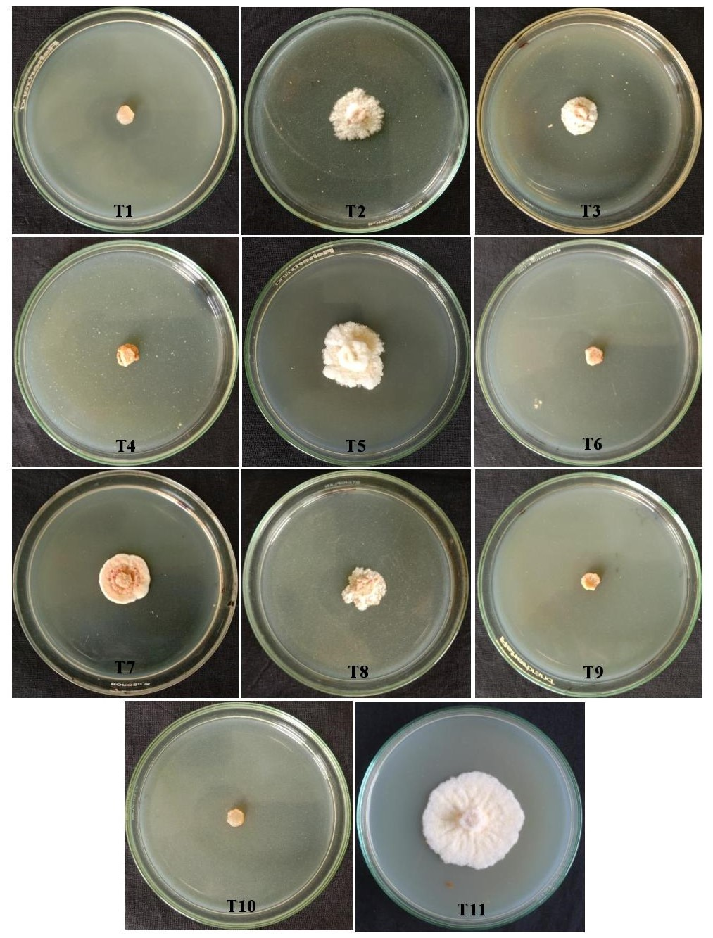

**Plate 1:** **Evaluation of fungicides against *S. oryzae* under *in vitro* condition (500ppm)**

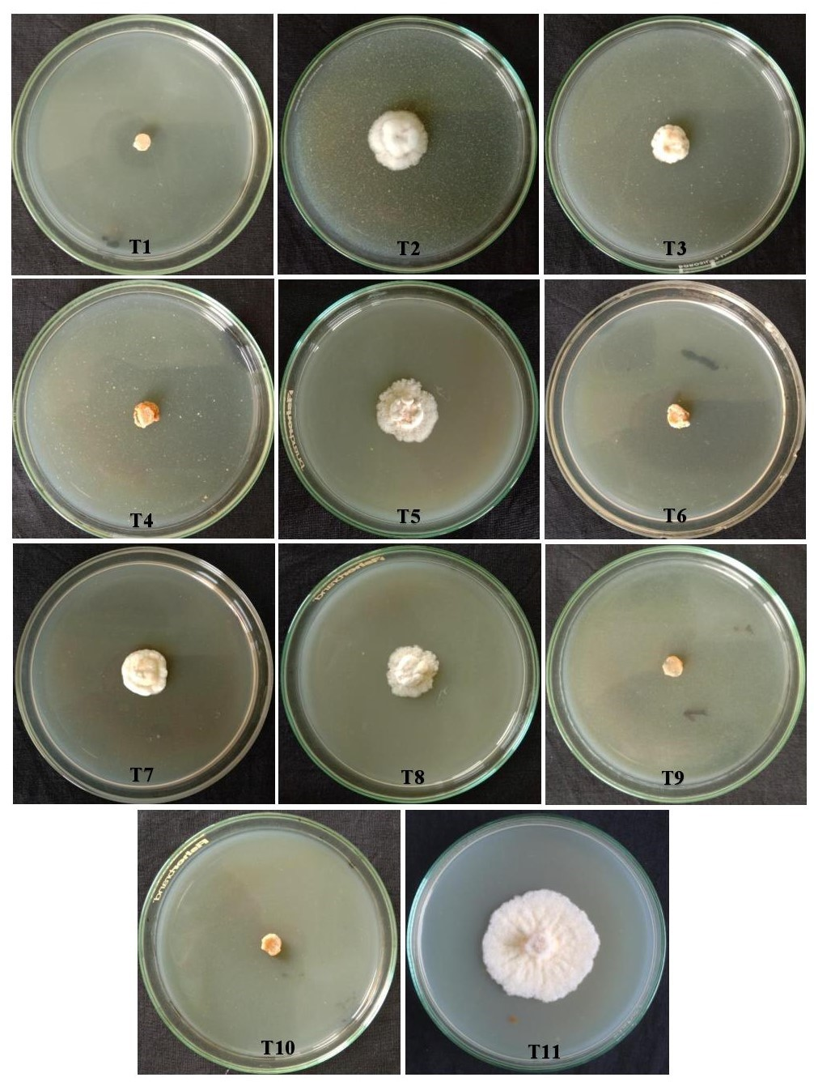

**Plate 2:** **Evaluation of fungicides against *S. oryzae* under *in vitro* condition (1000ppm)**

**Fig. 1:** **Evaluation of fungicides against *S. oryzae* under *in vitro* condition**

**Conclusion:**

Sheath rot of rice caused by *Sarocladium oryzae* is an important disease of rice. The present study was conducted to evaluate the efficacy of fungicides for the management of sheath rot disease of rice. The results were concluded that all the treatments significantly reduced the radial mycelial growth of *S. oryzae.* The fungicides treatment Tebuconazole 25 EC, Tebuconazole 50% + Trifloxystrobin 25% WG, Propiconazole 25% EC, Isopyrazam 12.5% w/v EC, Flusilazole 12.5% + Carbendazim 25% EC were completely (100%) inhibiting the mean mycelial growth (00.00 mm) of *S. oryzae* over control treatment.

**Disclaimer (Artificial intelligence)**

Option 1:

Author(s) hereby declare that NO generative AI technologies such as Large Language Models (ChatGPT, COPILOT, etc.) and text-to-image generators have been used during the writing or editing of this manuscript.

Option 2:

Author(s) hereby declare that generative AI technologies such as Large Language Models, etc. have been used during the writing or editing of manuscripts. This explanation will include the name, version, model, and source of the generative AI technology and as well as all input prompts provided to the generative AI technology

Details of the AI usage are given below:

1.Not used

2. Not used

3.

**References**

1. Agnihothrudu, V. 1973. *Acrocylindrium oryzae* Sawada - sheath rot on paddy. *Kavaka*.1: 69-71.
2. Anonymus 2021. www.fao.org, 2021.
3. Arun, A., Ranjan, R. K., Choudhary, C. S., Rai, D., Kumar, M., Jaiswal, A., ... & Rai, B. 2024. Effect of essential oils, medicinal plants, bio agents and chemicals on sheath rot incidence and yield of rice. *International Journal of Advanced Biochemistry Research,* 8(2): 202-204.
4. Berhan, M., Yalew, D., & Zeleke, T. 2020. Evaluation of fungicides efficacy against rice sheath rot Disease (*Sarocladium oryzae*) in rain fed low land rice (*Oryzae sativa* L.) in *fogera hub*.221-225
5. Gams, W. and Hawksworth, D. L. 1975. The identity of *Acrocylindrium oryzae* Sawada and a similar fungus causing sheath rot of rice. *Kavaka*. 3: 57-61.
6. Hewitt G. New modes of action of fungicides. Pestic. Outlook. 2000;11(1):28-32.
7. Johnson M, Madhuri V, Chandrika V, Sreenivasa Chari M. 2023. Management of sheath rot (*Sarocladium oryzae* (Sawada)) disease in Rice under aberrant weather field conditions. *The Pharma Innovation Journal* 12(12): 3078-3081.
8. K. B, Bharathi, Sanath Kumar V. B, Denesh G. R, Kitturmath M. S, and Pallavi K. N. 2024. “Host Plant Resistance Studies on Rice Cultivars Against Sheath Rot Caused by *Sarocladium oryzae* (Sawada) Gams and Hawksworth”. *Journal of Advances in Biology & Biotechnology* 27 (10):295-311.
9. Kindo and Tiwari. 2015. Efficacy of fungicides for the management of sheath rot in rice under field. *Plant achives*. 15(1): 119-120.
10. Kumar, Y. S. and Patibanda, A. K. 2015. Bioefficacy of fungicides, botanicals and biocontrol agents against *Sarocladium oryzae*, incitant of rice sheath rot. *J. Agri. Vet. Sci.* 8(12): 52-56.
11. Naveenkumar, R. and Mohanpriya, R. 2017. Survey and evaluation of efficacy of some fungicides against virulence of *Sarocladium oryzae* inciting sheath rot disease of rice. *Oryza*. 53(4): 464-469.
12. Nayak, M. S., Hosagoudar, G. N., Naik, G., Gangadhar Naik, B., Kumar, D. and Thippeshappa, G. N. 2022 b. *In vitro* and *in vivo* efficacy of botanicals, bioagents and fungicides against sheath rot of rice incited by *Sarocladium oryzae*. *Pharma Innovation*. 11(12): 1881-1889.
13. Nayak, S., Gowdar, S. B., Ashwathanarayana, D. S., Amaresh, Y. S. and Badariprasad, P. R. 2023. Evaluation of fungicides against *Sarocladium oryzae*. *Pharma Innovation*. 12(10): 1021-1025.
14. Peeters, K. J., Audenaert, K. and Höfte, M. 2021. Survival of the fittest: How the rice microbial community forces *Sarocladium oryzae* into pathogenicity. *FEMS Microbiology Ecology,* 97: 2.
15. Raju, M. R. B. and Visalakshmi, V. 2020. Effective scheduling of fungicide and insecticide combination for the management of rice sheath rot caused by *Sarocladium oryzae* (Sawada) W. Gams & D. Hawksw. *Int. J. Chem. Stud.* 8(4): 3782-3785.
16. Sanjeev Kumar, Vinod Kumar and Mandal, D.K. 2015. Efficacy of fungicides and plant extracts for management of sheath rot disease in Rice. *Ann. Pl. Protec. Sci.* 23(1): 94-97.
17. Selvaraj, K., & Annamalai, P. 2015. *In vitro* evaluation of fungicides and two species of Trichoderma against *Sarocladium oryzae* causing sheath rot of paddy (Oryza sativa L.). *World Journal of Pharmaceutical Research*, *4*, 1200-1206.
18. Shamsi, S., & Chowdhury, P. 2016. *In vitro* evaluation of fungicides and some plant extracts against rice sheath rot pathogen *Sarocladium oryzae*. *Bangladesh Journal of Scientific Research*, *29*(1), 47-54.
19. Sharma, A. B., SarbjitKaur, & Lore, J. S. 2023. Prevalence of pathogens causing sheath rot of rice in North India and its management. *Indian Phytopathology*, *76*(3), 727-741.
20. Sreekanth B, Surendran M, Radhakrishnan NV. 2023. Biological and chemical Management of sheath rot disease in rice. *The Pharma Journal.* 12(6):4925-4926.
21. Sunil Kumar, Y. and Patibanda, A.K. 2015. Bioefficacy of Fungicides, Botanicals and Biocontrol Agents Against *Sarocladium Oryzae*, Incitant of Rice Sheath Rot. *Journal of Agriculture and Veterinary Science.* 8(12): 52-56.
22. Titaria .2020. Studies on sheath rot of rice caused by *Sarocladium oryzae*. M.Sc. (Agri.) thesis submitted to Chaudhary Sarwan Kumar Himachal Pradesh Krishi Vishvavidyalaya, Palampur.
23. Vincent JM. 1927. Distortion of fungal hyphae in the presence of certain inhibitors. *Nature,* 59:850.
24. Yongxiang H, Yuelian L, Zhihao X. 2022. First report of *Sarocladium oryzae* causing sheath rot of *Oryza rufipogon* in Zhanjiang, China. *Journal of Plant Pathology,* 104:887.
25. Uppala S, Zhou XG. Field efficacy of fungicides for management of sheath blight and narrow brown leaf spot of rice. Crop Protection. 2018 Feb 1;104:72-7.