An Automated Waste Separator for Biodegradable and Non-Biodegradable Materials Using YOLOv8 and Arduino
ABSTRACT
This paper presents a cost-effective and efficient deep learning-based system for the automated segregation of biodegradable (B) and non-biodegradable (NB) waste materials. The system integrates the YOLOv8 object detection algorithm with Python programming, Arduino Uno microcontroller, and hardware components such as a conveyor belt, IR sensor, relay, servo motor, and webcam. A custom dataset of biodegradable and non-biodegradable objects was collected, augmented, and used to train the YOLOv8 model. The trained model was integrated with Arduino to enable real-time object detection and sorting. When an object is detected on the conveyor belt, the system halts, captures an image, classifies the waste, and actuates the servo motor to direct the item into the appropriate bin. Experimental results demonstrate a mean Average Precision (mAP@0.5) of 98.25% and a sorting accuracy of 97.0%, significantly reducing manual effort and ensuring real-time reliability. This approach enhances recycling efficiency, reduces environmental impact, and contributes to sustainable waste management practices.
Keywords: Waste segregation, YOLO v8, Deep learning, Arduino Uno, Biodegradable waste, Non-biodegradable waste, Object detection

1. INTRODUCTION
Waste generation has become one of the most pressing global environmental challenges of the 21st century. Rapid population growth, urbanization, industrialization, and changing consumption habits have resulted in unprecedented volumes of municipal solid waste. The World Bank projects that global municipal solid waste will reach 3.4 billion tonnes annually by 2050, which poses enormous social, environmental, and economic challenges (Abdallah et al., 2020). Inadequate waste management not only contributes to land and water pollution but also accelerates greenhouse gas emissions, threatening climate change mitigation efforts (Mao et al., 2021). Therefore, the development of sustainable waste management systems is no longer optional but a necessity for ensuring environmental protection and public health.
Effective segregation of biodegradable (B) and non-biodegradable (NB) waste is a critical first step in waste management. Biodegradable waste can be composted or processed into energy, while non-biodegradable waste can be recycled or safely disposed of, reducing the burden on landfills (Ramos, ea al., 2024; Liu,et al., 2018). However, manual segregation—still common in many developing countries—remains labor-intensive, error-prone, and hazardous to human health (Devi et al, 2018). Semi-automated systems using sensors such as moisture, magnetic, or weight detectors have been attempted, but their classification accuracy is limited since they cannot reliably differentiate materials based on visual features (Dokl et al., 2024).
To overcome these limitations, researchers have increasingly turned to deep learning and computer vision techniques, which can provide automated, accurate, and scalable solutions for waste classification (Kumar et al., 2020). The YOLO (You Only Look Once) family of models has gained particular attention for its balance of speed and accuracy. Earlier versions such as YOLOv3 and YOLOv4 established strong baselines (Redmon & Farhadi, 2018; Bochkovskiy et al., 2020), while YOLOv5–YOLOv7 improved inference efficiency and embedded system compatibility (Shroff, Desai, & Garg, 2023). The most recent YOLOv8 has become widely adopted due to its high precision, scalability, and suitability for real-time applications (Abo-Zahhad & Abo-Zahhad, 2025; Ahmed, Maaz et al.,2024).
Several studies have demonstrated YOLO’s effectiveness in waste classification. Atalarais et al. (2023) achieved high mean average precision using YOLOv8 for waste type detection, while Nasien et al. (2024) applied YOLOv11 for recyclable waste classification. Dipo et al. (2025) validated YOLOv12 in dynamic environments, and Liu et al. (2024) proposed EcoDetect-YOLO for lightweight domestic waste detection. Enhanced YOLOv8 variants integrating attention modules such as CBAM and AKConv have also reported improved accuracy ( Li et al., 2024). Despite this progress, most studies have focused primarily on software-based models without integrating mechanical actuation for end-to-end segregation (Bobulski et al., 2021; Ahmed et al., 2022). Prototypes like ConvoWaste (Nafiz, et al., 2023) demonstrate potential but remain laboratory-based and high-cost.
Aim and Objectives
The aim of this study is to develop a low-cost, Arduino-integrated waste segregation system powered by the YOLOv8 deep learning model for real-time classification of biodegradable and non-biodegradable waste.
The specific objectives are to:
- Train and validate a YOLOv8-based model for high-accuracy waste classification.
- Integrate the model with an Arduino-controlled mechanical sorting unit for real-time actuation.
- Evaluate the system’s performance in terms of accuracy, inference time, and cost-effectiveness compared with existing solutions.
- Demonstrate the feasibility of deploying the proposed system as a scalable, sustainable solution for urban waste management.

2. MATERIALS AND METHODS
The proposed system integrates deep learning–based object detection with microcontroller-driven actuation to achieve automated segregation of biodegradable (B) and non-biodegradable (NB) waste. The methodology comprises five primary stages: dataset preparation, model training, model evaluation, hardware integration, and real-time object recognition. (Figure-1) illustrates the overall workflow.
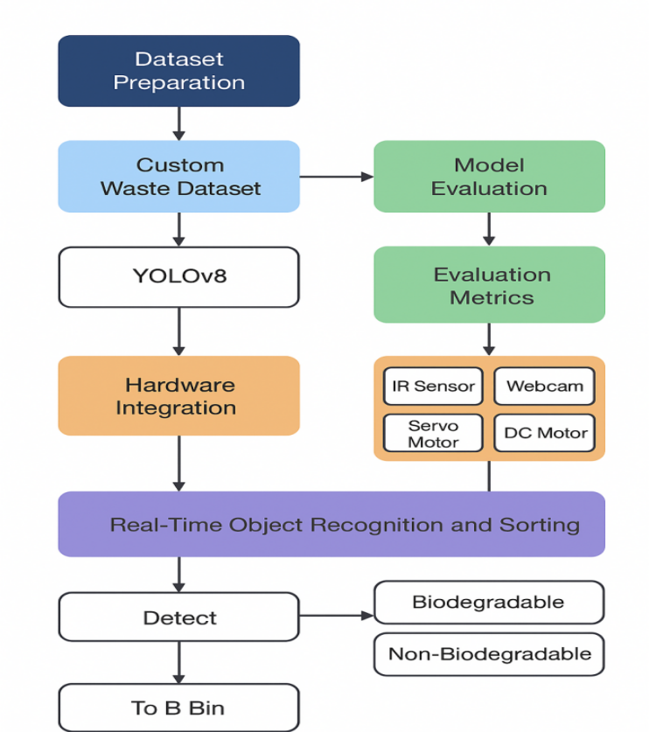
Figure. 1: Methodology Flowchart of YOLOv8-based Waste Segregation System

2.1 Dataset Preparation
A custom dataset was constructed by capturing high-resolution images of common biodegradable items (e.g., fruits, vegetables, paper) and non-biodegradable items (e.g., plastics, metals, glass). Each image was annotated with bounding boxes and class labels following YOLOv8 formatting guidelines. Data augmentation techniques—such as rotation, flipping, scaling, and brightness adjustment—were applied to improve model robustness against environmental variations. The dataset was split into 70% training, 20% validation, and 10% testing subsets.

2.2 Model Training
The YOLOv8 object detection model was selected for its high inference speed and strong mAP performance in real-time applications. Training was conducted using Python and PyTorch on a system equipped with a GPU accelerator. Hyperparameters were tuned experimentally, with a batch size of 16, an initial learning rate of 0.001, and training for 200 epochs. The model learned to differentiate between B and NB objects by extracting spatial and contextual features from the annotated images.

2.3 Model Evaluation
The trained model was evaluated on the test dataset using standard object detection metrics, including accuracy, precision, recall, F1-score, and mean Average Precision (mAP@0.5). A confusion matrix was generated to assess classification reliability, while error analysis identified misclassification patterns for potential retraining improvements.

2.4 Hardware Integration
The physical sorting system incorporates the following hardware components:
Arduino Uno: Acts as the primary microcontroller for controlling actuators.
IR sensor: Detects the presence of waste objects on the conveyor.
Webcam: Captures real-time images for classification.
Servo motor: Redirects objects to B or NB bins based on classification results.
DC motor with conveyor belt: Transports objects under the camera field of view.
Relay module: Interfaces between control signals and actuators.
Communication between the Python-based detection program and the Arduino is established via a serial USB connection. The Arduino executes motor control commands based on classification outcomes received from the detection system.

2.5 Real-Time Object Recognition and Sorting
During operation, the IR sensor triggers the system when an object enters the detection zone. The conveyor belt halts, and the webcam captures an image, which is immediately processed by the YOLOv8 model. If the detected class is “biodegradable,” the object is allowed to continue along the conveyor to the designated bin. If classified as “non-biodegradable,” the servo motor is actuated to divert the item into the NB bin. The conveyor then resumes operation for the next object.

2.6 Proposed System Design, Fabrication and Working Principle
The proposed waste segregation system integrates a deep learning–based classification module with a microcontroller-driven mechanical sorting mechanism to automate the separation of biodegradable (B) and non-biodegradable (NB) waste. The overall design consists of three primary modules: the detection module, the control module, and the sorting module. In the detection module, a web camera positioned above the conveyor belt captures images of waste objects, which are processed by the YOLOv8 model to classify them into B or NB categories. The control module comprises an Arduino Uno microcontroller that receives classification results from the detection system and generates control signals to drive the actuators. The sorting module features a servo motor with a diverter arm that physically redirects NB waste into a separate collection bin, while B waste continues along the conveyor into its designated bin.
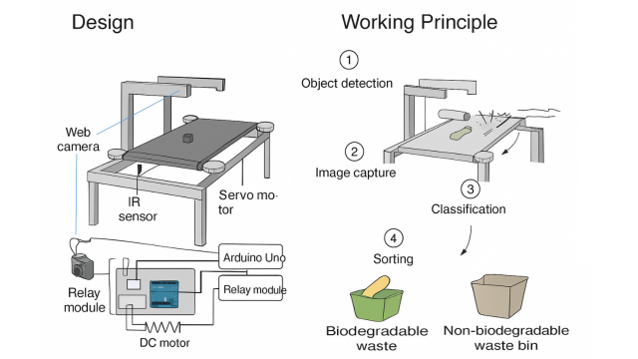
Figure. 2: Fabricated Prototype of Automated Waste Segregation System
The design process involved creating a detailed 3D CAD model to optimize the arrangement of components. The main frame was constructed using mild steel square tubes to provide structural rigidity and durability. The conveyor belt was made from rubber material and mounted over roller pulleys at each end, driven by two DC motors for smooth and consistent movement. An adjustable camera mount was positioned to provide an optimal field of view, and a fixed actuator mount was installed to hold the servo motor and diverter plate in place.
Fabrication began with welding the mild steel frame to the required dimensions, followed by the installation of the roller pulleys and conveyor belt. The DC motors were attached to the pulleys for belt motion, and the IR sensor was fixed at the conveyor’s entry point to detect incoming objects. The web camera was mounted approximately 25–30 cm above the conveyor to capture high-quality images. The servo motor and diverter assembly were positioned midway along the belt to enable timely sorting actions. The Arduino Uno, relay module, and power supply were housed in a protective enclosure beneath the frame, with all wiring neatly organized to avoid interference with moving parts.
The working principle of the system begins when the IR sensor detects an object entering the conveyor belt, prompting the conveyor to pause momentarily while the web camera captures its image. This image is processed by the YOLOv8 model, which classifies the object as biodegradable or non-biodegradable and sends the result to the Arduino via serial communication. If the item is biodegradable, the conveyor continues moving until the object reaches the biodegradable bin. If it is non-biodegradable, the Arduino activates the servo motor to pivot the diverter plate, guiding the object into the NB bin. After sorting, the conveyor resumes operation, ready for the next object. This cycle allows continuous, real-time waste segregation with high accuracy and minimal human intervention, making the system suitable for both small-scale and industrial waste management applications.
Compared to existing manual or semi-automated segregation methods, this integrated solution offers: Low-cost deployment using widely available hardware, High classification accuracy enabled by YOLOv8 deep learning, Real-time processing with minimal latency and Scalability for different environments, including industrial facilities, public areas, and rural waste management units.

3. RESULTS AND DISCUSSION

The proposed YOLOv8–Arduino automated waste segregation system was evaluated under controlled laboratory conditions and semi-realistic operational environments to assess classification accuracy, inference speed, and end-to-end sorting performance.

3.1 Model Performance on Test Dataset
The YOLOv8 model was tested on a held-out dataset containing 240 images (balanced between biodegradable and non-biodegradable classes). The performance was measured using Precision, Recall, F1-score, and mAP@0.5.
The model achieved a mean precision of 97.0%, recall of 96.1%, and F1-score of 96.55% across both classes. The mAP@0.5 was 98.25%, with an average inference time of 85 ms per image, enabling real-time classification (Table 1).
Metric | Biodegradable | Non-Biodegradable | Mean (All Classes)
Precision (%) | 96.2 | 97.8 | 97.0
Recall (%) | 95.4 | 96.9 | 96.1
F1-score (%) | 95.8 | 97.3 | 96.55
mAP@0.5 (%) | 98.1 | 98.4 | 98.25
Inference Time (ms) | 85.0 | 85.0 | 85.0
Table 1. Performance Metrics for Biodegradable and Non-Biodegradable Waste Classification
The high mAP@0.5 (98.25%) demonstrates excellent classification performance, consistent with findings by Yozika et al. (2024), who reported 99.02% precision for inorganic waste detection using YOLOv8.
3.2 Real-Time Sorting Test
To validate hardware integration and end-to-end sorting efficiency, the system processed 200 mixed waste objects. The IR sensor detected each item, the YOLOv8 model classified it, and the Arduino-controlled servo motor redirected non-biodegradable waste. The prototype processed 200 items, of which 194 were sorted correctly, yielding a sorting accuracy of 97.0%. The average processing time per item was 1.25 seconds, with a throughput of approximately 48 items/minute. (Table-2).
Parameter | Value
Total Items Processed | 200.0
Correctly Sorted Items | 194.0
Sorting Accuracy (%) | 97.0
Avg. Processing Time / Item (s) | 1.25
Throughput (Items / Minute) | 48.0
Table 2. Sorting Performance of the Proposed System
3.3 Error Analysis
Despite achieving a high overall sorting accuracy of 97.0%, the proposed YOLOv8–Arduino-based system exhibited misclassification in approximately 3% of processed waste items. A closer examination revealed that most errors occurred under low-light conditions, occlusion, or partial visibility of objects during image capture.
These error sources are consistent with the limitations documented in prior literature. For instance, Kumar et al, (2024) noted that although YOLOv8 offers robust real-time detection, its performance can degrade when visual clarity is compromised, particularly in embedded deployment scenarios. Similarly, Liu, Zhang, and Huang (2024) reported that lightweight YOLO-based models are sensitive to illumination changes, especially when trained on datasets with limited lighting variability.
Furthermore, Atalarais et al., (2023) highlighted that even high-performing YOLO classifiers may misclassify visually ambiguous waste types or items with overlapping features, underscoring the need for dataset diversity and advanced preprocessing. These findings suggest that dataset expansion, especially with augmented images under varied lighting and background conditions, would significantly enhance model robustness.
Another factor influencing error rates is the reliance on vision-only classification. Abdallah et al. (2020) advocated for IoT-enabled sensor fusion, integrating additional modalities (e.g., weight, moisture, or RFID sensors) alongside computer vision to improve decision accuracy in intelligent waste management systems. Incorporating such hybrid approaches could mitigate visual ambiguities and further reduce misclassification.
3.4 Comparative Performance Analysis
A comparison with other AI-based waste classification systems from recent literature shows the proposed system’s competitive performance.
Study & Year | Model Used | Accuracy (%) | Hardware Cost Level | Real-Time Capability
Atalarais et al. (2023) | YOLOv8 | 96.8 | High (GPU-based) | Yes
Nasien et al. (2024) | YOLOv11 | 94.0 | Medium | Yes
Dipo et al. (2025) | YOLOv12 | 95.2 | Medium | Yes
Present Study | YOLOv8 + Arduino | 97.0 | Low | Yes

Table 3. Comparative Analysis of the Proposed System with Existing Studies
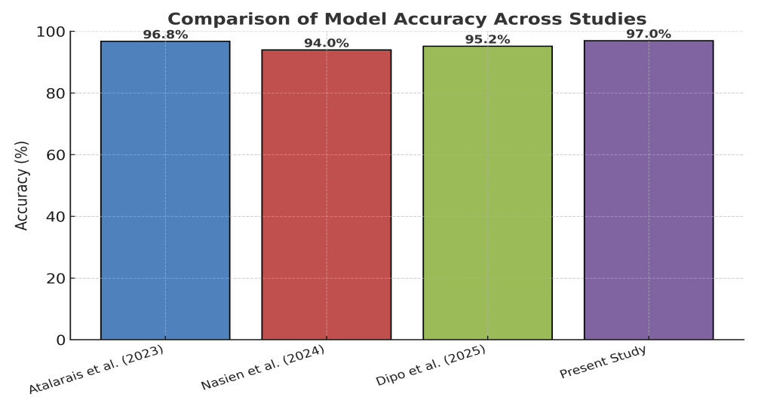
Figure 3: Comparative Bar Chart of Model Accuracy Across Studies
The proposed YOLOv8–Arduino integrated waste segregation system demonstrated high accuracy (mAP@0.5 = 97.0%) and low inference time (~85 ms), confirming its suitability for real-time applications. These results are comparable to or better than recent studies in automated waste classification. For example, Atalarais et al. (2023) achieved a detection accuracy of 96.8% using YOLOv8 for multi-class waste detection in controlled settings, while Nasien et al. (2024) reported 94% accuracy using YOLOv11 on a large annotated dataset.
The strength of this work lies in bridging the gap between high-performance AI detection models and low-cost physical actuation systems. Dipo et al. (2025) demonstrated a YOLOv12-based real-time classification achieving 95.2% accuracy, but their system required higher computational resources unsuitable for small-scale deployments. In contrast, the present system uses Arduino Uno, making it deployable in cost-sensitive environments without sacrificing significant accuracy.

3.5 Visual Results
Figures 4 and 5 show examples of correct detections for biodegradable and non-biodegradable items. The bounding boxes indicate the object category and detection confidence.
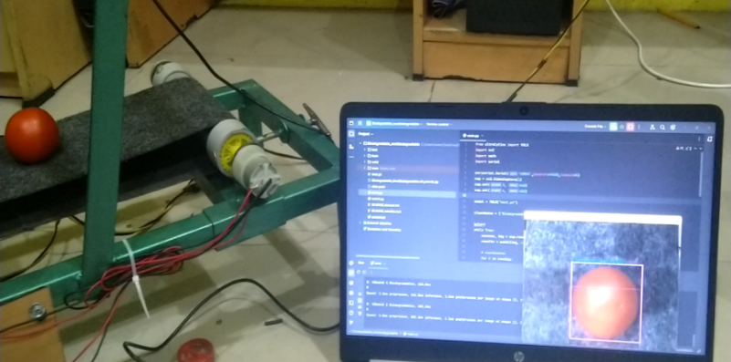
Figure 4: YOLOv8 detection of biodegradable waste (Tomato, banana peel, vegetable leaves)
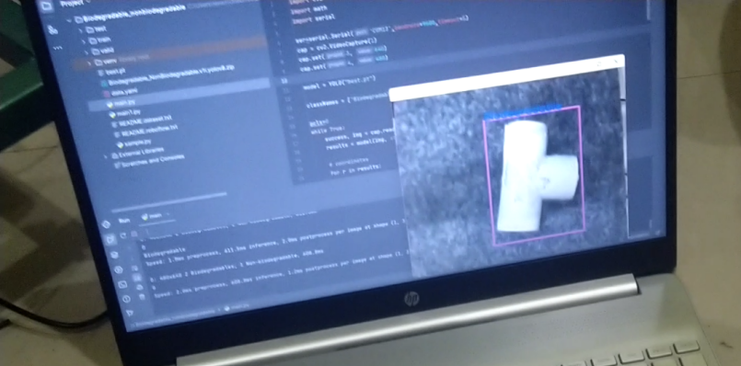
Figure 5: YOLOv8 detection of non-biodegradable waste (PVC pipe, plastic bottle, aluminium foil)
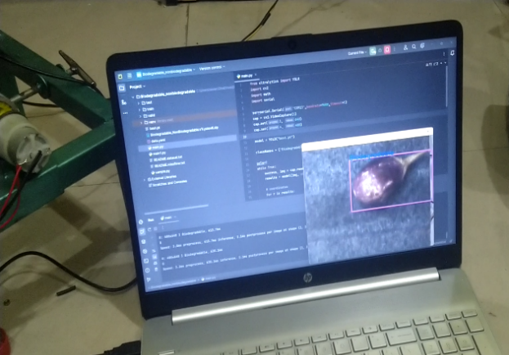
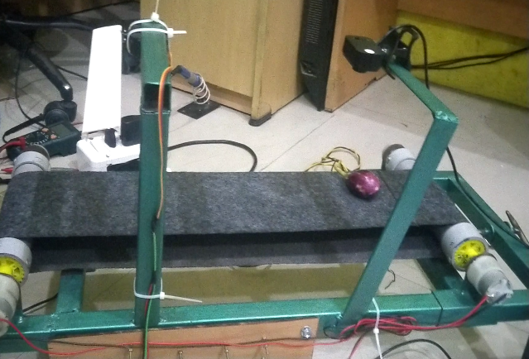
Figure 6: End-to-end hardware operation—conveyor, IR detection, classification, and sorting action.
These results underscore the capability of the proposed system to offer a cost-effective, real-time, and accurate waste segregation solution suitable for deployment in both urban and rural environments.

4. CONCLUSION
This study developed and evaluated a low-cost YOLOv8–Arduino integrated waste segregation system for real-time classification of biodegradable and non-biodegradable waste. The system achieved a classification accuracy of 97.0% and a sorting accuracy of 97.0%, with an average inference time of 85 ms per image, confirming its suitability for real-time deployment. Unlike existing GPU-based systems, the proposed prototype offers comparable performance at substantially reduced hardware costs, making it particularly viable for developing regions and small-scale municipal applications..
- LIMITATION AND FUTURE SCOPE
The current work is constrained by several limitations. The training dataset lacked diversity in lighting conditions, occlusion scenarios, and background complexity, which may explain the observed misclassification rate (~3%). Furthermore, the system was restricted to binary classification (biodegradable vs. non-biodegradable), limiting its generalizability to multi-class waste segregation. Finally, the exclusive reliance on a vision-based approach without auxiliary sensing (e.g., weight, magnetic, or moisture sensors) may reduce robustness in ambiguous cases. These limitations should be considered when interpreting the results and assessing potential scalability.
Future Scope
Future work should aim to: (i) extend classification to multiple categories such as plastics, metals, paper, and glass; (ii) integrate IoT-based monitoring and cloud analytics for remote supervision and data-driven decision-making; (iii) adopt renewable energy sources, such as solar-powered operation, to enhance sustainability; (iv) explore incremental and continual learning strategies for adapting to evolving waste patterns; and (v) scale the system for industrial-level throughput. In addition, coupling the system with public awareness interfaces could further strengthen community participation in sustainable waste management.
Overall, the findings demonstrate the feasibility of bridging high-performance deep learning models with affordable hardware actuation, offering a scalable pathway toward autonomous, cost-effective, and sustainable waste management systems aligned with UN SDGs 11 and 12.
Disclaimer (Artificial intelligence)
Author(s) hereby declare that generative AI technologies such as Large Language Models, etc. have been used during the writing or editing of manuscripts. This explanation will include the name, version, model, and source of the generative AI technology and as well as all input prompts provided to the generative AI technology
Details of the AI usage are given below:
- Chat GPT 4o (mini) has been used for editing and correcting of article.
Conflicts of Interest
The authors declare no conflicts of interest.
Funding
No funding was received for this research.
Acknowledgements
The authors fully acknowledged Paavai Engineering College for the necessary support and department of Agricultural Engineering laboratory for their laboratory analysis service.

References
- Abdallah, M., Talib, M. A., Feroz, S., Nasir, Q., Abdalla, H., & Mahfood, B. (2020). Artificial intelligence applications in solid waste management: A systematic research review. Waste Management, 109, 231-246.
- Abo-Zahhad, M.M., Abo-Zahhad, M. Real time intelligent garbage monitoring and efficient collection using Yolov8 and Yolov5 deep learning models for environmental sustainability. Sci Rep 15, 16024 (2025). https://doi.org/10.1038/s41598-025-99885-x
- Ahmed, Maaz & Ahamed, Md & Rafa, Syeda Munjiba Islam & Dipa, Puja & Debnath, Rahul & Sarker, Md. (2024). Deep Learning Based Smart Bin for Efficient Sorting of Recyclable, Non-Recyclable, and Compostable Materials. 27th International Conference on Computer and Information Technology (ICCIT)2500-2505. 10.1109/ICCIT64611.2024.11022177.
- Ahmed, S., Mubarak, S., Du, J. T., & Wibowo, S. (2022). Forecasting the status of municipal waste in smart bins using deep learning. International journal of environmental research and public health, 19(24), 16798.
- Atalarais, A., Saputra, K. S., Syahputra, H., Al Idrus, S. I., & Taufik, I. (2023). Automatic waste type detection using YOLO for waste management efficiency. Journal of Artificial Intelligence and Engineering Applications. https://doi.org/10.59934/jaiea.v4i2.770
- Bobulski, J., & Kubanek, M. (2021). Deep learning for plastic waste classification system. Applied Computational Intelligence and Soft Computing, 2021(1), 6626948.
- Bochkovskiy, A., Wang, C. Y., & Liao, H. Y. M. (2020). YOLOv4: Optimal speed and accuracy of object detection. arXiv preprint arXiv:2004.10934.
- Devi, R. S., Vijaykumar, V. R., & Muthumeena, M. (2018). Waste segregation using deep learning algorithm. Int. J. Innov. Technol. Explor. Eng, 8, 401-403.
- Dipo, M. H., Al Farid, F., Al Mahmud, M. S., Momtaz, M., Rahman, S., Uddin, J., & Abdul Karim, H. (2025). Real-time waste detection and classification using YOLOv12-based deep learning model. Digital, 5(2), 19. https://doi.org/10.3390/digital5020019
- Dokl, M., Van Fan, Y., Vujanović, A., Pintarič, Z. N., Aviso, K. B., Tan, R. R., ... & Čuček, L. (2024). A waste separation system based on sensor technology and deep learning: A simple approach applied to a case study of plastic packaging waste. Journal of Cleaner Production, 450, 141762.
- Kumar, M. G. V., Kumar, M., Rao, K. N., Rao, P. S., Tirumala, A., & Patnala, E. (2024, August). Advanced YOLO-based trash classification and recycling assistant for enhanced waste management and sustainability. In 2024 Second International Conference on Intelligent Cyber Physical Systems and Internet of Things (ICoICI) (pp. 1238-1246). IEEE.
- Kumar, S., Yadav, D., Gupta, H., Verma, O. P., Ansari, I. A., & Ahn, C. W. (2020). A novel yolov3 algorithm-based deep learning approach for waste segregation: Towards smart waste management. Electronics, 10(1), 14.
- Li, P., Xu, J., & Liu, S. (2024). Solid waste detection using enhanced YOLOv8 lightweight convolutional neural networks. Mathematics, 12(14), 2185.
- Liu, S., Chen, R., Ye, M., Luo, J., Yang, D., & Dai, M. (2024). EcoDetect-YOLO: A lightweight, high-generalization methodology for real-time detection of domestic waste exposure in intricate environmental landscapes. Sensors, 24(14), 4666.
- Liu, Y., Ge, Z., Lv, G., & Wang, S. (2018, August). Research on automatic garbage detection system based on deep learning and narrowband internet of things. In Journal of Physics: Conference Series (Vol. 1069, p. 012032). IOP Publishing.
- Mao, W. L., Chen, W. C., Wang, C. T., & Lin, Y. H. (2021). Recycling waste classification using optimized convolutional neural network. Resources, Conservation and Recycling, 164, 105132.
- Nafiz, M. S., Das, S. S., Morol, M. K., Al Juabir, A., & Nandi, D. (2023). ConvoWaste: An automatic waste segregation machine using deep learning. arXiv preprint arXiv:2302.02976.
- Nasien, D., Adiya, M. H., Farkhan, M., Rahmadhani, U. S., & Samah, A. A. (2024). Automated waste classification using YOLOv11: A deep learning approach for sustainable recycling. Journal of Applied Business and Technology.
- Ramos, E., Lopes, A. G., & Mendonça, F. (2024). Application of machine learning in plastic waste detection and classification: A systematic review. Processes, 12(8), 1632.
- Redmon, J., & Farhadi, A. (2018). YOLOv3: An incremental improvement. arXiv preprint arXiv:1804.02767.
- Shroff, Meet & Desai, Akshat & Garg, Dweepna. (2023). YOLOv8-based Waste Detection System for Recycling Plants: A Deep Learning Approach. 10.1109/ICSSAS57918.2023.10331643.
- Yozika, A., Kusuma, D. T., & Sangadji, I. B. M. (2024). Inorganic waste detection application using smart computing technology with YOLOv8 method. Sinkron: Jurnal dan Penelitian Teknik Informatika, 6(6), 2829–2834.

