Occurrence of Albinism in wild ungulates of Rajasthan, India

Abstract
Colour aberration, in particular albinism is characterized by the total absence or partial absence of skin pigmentation due to absence of active Tyrosinase enzymes in pigment cells. Absence of pigment cells affects skin and hair coloration, resulting in a total white fur or skin coat colour with red eyes. Present observations deal with the colour aberration of three species of wild ungulates, namely Nilgai (Boselaphus tragocamelus), Blackbuck (Antilope cervicapra) and Indian Gazelle (Gazella bennettii) from the different districts of Rajasthan state, India. Boselaphus tragocamelus individual was observed in Udaipur district, Antilope cervicapra from Jodhpur district and Gazella bennettii from Jalore district. During behavioral observation, all three species individuals performed normal behavioral activities. This kind of occurrence is rarely observed in field. Several activities of three albinism wild ungulate were also recorded.
Keywords: Albinism, Ungulates, Nilgai, Blackbuck, Indian Gazelle, Rajasthan.
Introduction
Albinism primarily affects integumentary coloration and epidermal features in most animals, including humans, due to a lack of melanin pigment. It is characterized by abnormal coloration of the skin, hair, feathers, scales or eyes. Mammalian skin is typically covered with fur or hair, and its ability to blend in can be affect by the colour and pattern of coat. Usually changes in coat colour occur due to seasonal climatic conditions and the geographic region where the animal resides (Menon, 2003; Caro, 2005). Furthermore, coat colouration is affected by various factors such as age, sex, health and amount of nutrient availability in animal body largely influenced the body colouration of animals. Mammals can exhibit individual difference in their coat or pelage, particularly in cases of genetic mutations like albinism, melanism (Menon, 2003); leucism, piebaldism, hypomelanism and blue eyed white morph (Mahabal et al., 2019). Albinism is a condition characterized by a complete lack of melanin pigment in hair, eyes and skin due to the inherited absence of functional Tyrosinase enzymes in pigment cells. This affects skin and hair coloration and results in entirely white fur or plumage and red eye colour (Smielowski, 1987).
Albinism is controlled by inheritance of autosomal recessive genes in all animal species, including mammals (Hale et al., 2005; Van-Grow, 2006 & 2013). According to Sage (1962), complete or partial albinism may be present at birth, emerge later in life, or diminish with age. Other possible causes of albinism include diet, senility, shock, infection and injury. The occurrence of albinism in wild ungulates species which belongs to subfamily Bovinae and Antilopinae. The subfamily Antilopinae represents Antilopini tribes, which includes Gazella, Antilope, Antidorcas, Litocranius and Ammodorcas but tribe Neotragini represent the Dik-Dik and other small antelopes like Raphicerus, Dorcatragus, Neotragus and Madoqua etc. Whereas, the subfamily Bovidae has three tribe namely Tribe Tragelaphini, Boselaphini and Bovini (Gentry, 1992). According to Castello (2016) Antilopinane family consisted total nine tribes including Caprini, Antilopini, Oreotragini, Reduncini, Hippotragini, Neotragini, Cephalophini, Alcelaphini and Aepycerotini. Hassanin et al. (2012) devised new names for the Antilopini tribe Antilopina, which is based on the genus Antilopes and includes Gazella spp., and Antilope cervicapra. This classification supports a close relationship among the Antilopini subgroup, Antilopina, which includes Gazelles, Blackbuck, Springbok, Saiga and Gerenuk and the dwarf antelopes (Ourebia). Furthermore, according to a recent classification, the subfamily Antilopinae consists of several tribes, among which one is the Antilopini tribes with four sub-tribes, whereas Oreotargini is a district tribe within this subfamily. Additionally, the Neotragini tribe is now recognized as polyphyletic, because Oreotargus and Neotragus are not closely related to Antelopes (Bärmann et al., 2013).
Rajasthan is home to a wide range of ungulate species and major species includes Nilgai or Blue Bull (Boselaphus tragocamelus), Chousingha or Four-horned antelope (Tetracerus quadricornis), Chinkara or Indian Gazelle (Gazella bennettii) and Blackbuck (Antilope cervicapra) among others. Commonly, the Blackbuck and Nilgai are called antelopes, whereas the Chinkara is called Indian gazelle. Blackbuck and Nilgai have distinct sexual dimorphs in adulthood. Male Nilgai are gray-blue in color and have short, stout, conical, and smooth horns, and females are brown in color with white patches under the lower jaw. Indian gazelles are characterized by their coloring and distinctive white streaks on each side of the face. While an adult male Blackbuck has a black skin coat, it has a brownish color in the sub- adult age. At the age of three years, the dorsal coat of the male begins to turn black, including the outer flanks of the hind- and fore-legs, and the face and neck. The females are light brownish on the upper parts of the body, tail, outer flanks of hind- and fore-legs, face and neck, while the under parts of the body and inner flank of the legs are white, with a similar coloured patch around each eye (Gehlot, 2006). This paper aims to document albinism in wild ungulates of Rajasthan, providing insights into color aberration in three ungulate species, Boselaphus tragocamelus, Antilope cervicapra and Gazella bennettii.
Material and Methods
Albinism or colour aberration patterns among three species of wild ungulates from different areas of Rajasthan were identified by sightings. Photographs and behavioral activities of these individuals were captured using a Nikon P1000 and Canon D series DSLR cameras. Direct visual observation, focal and scan sampling methods (Altmann, 1974) and ad-libitum sampling methods were used to observe behavioral and daily activity patterns of ungulates in their natural habitats. Antilope cervicapra and Gazella bennettii exhibiting albinism were then further observed in wildlife rescue centers after their relocations.
Result and Discussion
Occurrence of albinism in three wild ungulate species of Rajasthan and was observed in different regions of Rajasthan state. The specific details of these three ungulate species are summarized below.
1. Nilgai or Blue Bull (Boselaphus tragocamelus): The Nilgai or Blue Bull, is the largest Asian antelope. The body is usually ranges between approximately 190 to 230 cm in height and long, tail measures between 45 to 55 cm in length. The height of the shoulder is ranges up to 130 to 150 cm and the maximum weight reaches up to 190 to 210 kg (Sheffield et al., 1983). Males have horns, whereas females have no horns (Figures 1, 2). The horn of the male reach up to 15 to 20 cm, while a tuft of black hair hang below the throat, which is approximately 13 cm in length in males (Sheffield et al., 1983).
On April 28, 2018, at 8:30 AM during a field visit, we recorded a male albino Boselaphus tragocamelus grazing on Typha grass (Typha angustifolia) at the Sarjana Dam, Vallabhnagar tehsil of the Udaipur district. The Sarjana dam is located at 24°39'34.61"N Latitude and 73°59'26.45"E Longitude. In normal cases, males typically exhibit bluish-grey coat coloration. But in this case, we observed that the partial albino Boselaphus tragocamelus exhibited piebaldism and it has white-body coloration across various parts of the body. White pigmentation was notably present around the mouth, under the neck, on both the fore and hind limbs, as well as along the back and tail regions of the body (Figure 3). The surrounding habitat around the Sarjana dam encompasses dominant wetland, terrestrial and agricultural landscapes. The dam serves as a significant water source, which promotes the growth of aquatic plants and tall grasses, such as Typha angustifolia, and provides favourable foraging and feeding habitats for Boselaphus tragocamelus in this region.
2. Blackbuck (Antilope cervicapra): During study, we observed many Blackbuck herds and recorded their morphology and average body measurements. A well-grown Blackbuck is typically approximately 80 to 90 cm at the shoulder and weighs approximately 44 to 45 kg on average. The body measures approximately 100 to 130 cm and the tail was 13 to 17 cm. Long and spirally twisted horns that occur only in males seldom exceed up to 50 to 55 cm. The coat colour in the dorsal and lateral parts of the male is blackish-brown, with white patches on the muzzle and white rings around the eyes (Figure 4). The dorsal and lateral coats of the females are fawn coloured. The under parts of both males and females are always white or off-white (Figure 5). Young Blackbuck individuals usually exhibit yellowish coat colour, but at maturity, or three-year-old male individuals, coat colour turns black in colour. The dark black coloration is a secondary sexual characteristic of the Blackbuck and generally coincides with major sexual and aggressive display (Gehlot, 2006).
On May 20, 2021, at 3:30 pm during a field survey, we observed an albino male Blackbuck feeding on the dry pods and dry leaves of Khejri trees (Prosopis cineraria) in an agricultural field at Salavas-Kanakni road, Jodhpur district (Latitude: 26° 4'36.77" N and Longitude: 73° 3'16.62" E). The body coloration of the albino adult male was completely white, except for the horns. We monitored it for more than five days in the wild, after which the forest department rescued the Blackbuck and kept it in captivity in a Machia Biological Park. During captive conditions, it performed normal daily activity patterns similar to those of other Blackbuck individuals (Figure 6).
3. Chinkara or Indian Gazelle (Gazella bennettii): Throughout the study period, we encountered multiple Chinkara herds and documented their physical characteristics along with the mean body measurements. A fully grown male Chinkara typically measured approximately 65 cm long and was approximately 23 kg to 25 kg in weight. The dorsal and lateral coat coloration of Chinkara is a light chestnut colour, which intensifies at the junction with the white under parts on the flank and buttocks. A distinctive white streak is present on each side of the face, which is a characteristic feature of gazelles, accompanied by a dusky patch above the nose. Both male and female Chinkara have horns. When viewed from the front, the horns of the male appear almost straight; in the lateral profile they exhibit a slight curvature. Horns usually range between 10 cm to 13 cm in female and up to 40 cm in male (Prater, 1971) (Figures 7, 8).
On October 30, 2022, at 8:15 AM in the early morning, we observed an albino male Indian gazelle (or Chinkara) resting under the shade of a Jaal tree (Salvodora persica) in the village of Siwara village, Sanchor tehsil of Jalore district (Latitude: 24°53'55.36"N and Longitude: 71°43'16.28" E). In the male albino Chinkara, the body coloration is completely white. After this report, the individual was rescued by a local NGO and kept in Amrita Devi Udhyan, Dhamana Ka Goliya. Moreover, the albino male performed normal behavioural activity (Figure 9 A &B).
Patterns of colour variation or aberrations is referred to by different terms, such as colour variation (Hofreiter & Schoneberg, 2010), anomalous colouration (Abreu et al., 2013), chromatic disorder (Lucati & Lopez-Baucells, 2016) and atypical coloration (Zalapa et al., 2016) but in partial albinism or piebaldism, the eyes generally consist of normal or natural colors, but white patches are present on the entire fur or skin. Piebaldism usually occurs owing to the complete absence of melanin in certain areas of the skin or hair follicles because of the genetic lack of melanocytes in these specific areas (Mahabal et al., 2019). In mammalian taxa, colouration is primarily determined by the presence or absence of melanin pigments in the skin, hair and eyes. Melanin is synthesized through a step-by-step biochemical pathway in which the tyrosine amino acid is converted to a melanin pigment.
Tyrosinase plays an important role in the synthesis and production of melanin pigments in the body. Any alteration or mutation in the tyrosinase gene can lead to an enzyme that cannot synthesize or produce melanin pigments or only produces a small quantity of melanin. Melanin is the most prominent colour pigment found in birds and mammals, and is largely responsible for the coloration of bird feathers and mammalian hairs and skins (Fox and Vevers, 1960; Lubnow, 1963; Van Grouw, 2013). Melanin is primarily found in two forms or types: eumelanin and phaeomelanin (Lubnow, 1963; Mahabal et al., 2019). Among these, the concentrations and distributions of eumelanin is largely responsible for the black, gray, and dark brown colouration of skin and feather colour, while phaeomelanin contributes to warm, reddish-brown to pale buff shades (Mahabal et al., 2019). Combination of eumelanin and phaeomelanin produces a wide range of grayish-brown colouration of the skin and feathers (Lubnow, 1963; Van Grouw, 2013).
Melanin is produced by a biochemical pathway known as melanin synthesis, and occurs in melanocytes. Melanin synthesis pathway requires tyrosine amino acids and tyrosinase enzymes. Furthermore, any disruption, alteration or genetic mutation at any point during melanin synthesis pathways can lead to alterations in the concentration and distribution of melanin pigments and can lead to unusual colouration of the skin, such as albinism, melanism, leucism, piebaldism, hypomelanim, and blue-eyed white morph (Menon, 2003; Van Grouw, 2006 & 2013; Mahabal et al., 2016 & 2019; Chishty et al., 2021).
Variations in body colouration in mammalian taxa have been described in different terms, such as albinism (pure/complete), partial albinism, melanism, and erythrism (Mahabal et al., 2019). Individuals with albinism were more conspicuous than those without albinism. Moreover, this unusual colour pattern, due to albinism, significantly decreases the survival rate because of increased visibility to predators (Samson et al., 2017). For this reason, both antelopes, Indian Gazelle and Blackbuck, were kept in captivity to ensure protection from potential predators and other possible threats. Moreover, albino organisms are linked to visual problems due to the decreased melanin levels in the body, which cause eye-related problems because melanin plays a crucial role in the development of the retina of eyes (Grant et al., 2001; Garipis & Hoffmann, 2003). Furthermore, albinism poses a direct disadvantage to the survival of organisms, with only a few albinos managing to avoid predators and survives to reach sexual maturity (Mahabal et al., 2019). Therefore; reports of albino individuals are rare and infrequent. A few instances were not documented, possibly due to collectors and collection managers lacking awareness of this important phenomenon in skin colour aberration (Samson et al., 2017; Samson et al., 2021). We captured the photographs of these albino and colour aberration Blue bull, Blackbuck and Indian Gazelle. During observation, it was found that albino performed normal daily activity, including grazing, drinking water, and residing in a group of other normal individuals.
Mahabal et al. (2019) conducted a review study on colour aberration in mammals from 1886 to 2017 and observed 239 instances of colour aberration belonging to 56 mammalian species belonging to eight orders and 19 families. Occurrence of albinism in Chinkara was previously recorded also from three localities of Rajasthan: Dhava-Doli conservation reserve area, Jodhpur (Mehra et al., 2010); Viratra Mata Oran (sacred land) of Chohtan, Barmer (Kumar et al., 2016); and Siyaho-ka-tala, Village post Kheda, Dhanau area of Barmer district (Kumar & Gharu, 2025) and albinism has been observed in Chinkara at central India by Divyabhanusinh (1987) and Smielowski (1987). But this current report is record of albinism found in Blackbuck and Blue bull from the Rajasthan state. Similarly, Akash et al. (2024) recorded albinism in Blue bull from Mahan village, Katepurna Wildlife Sanctuary of Maharashtra, India.
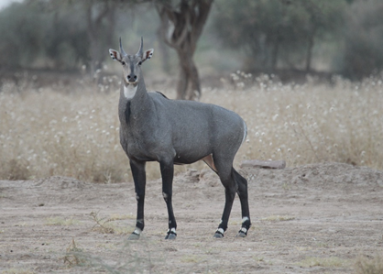
Figure 1: Male Blue Bull
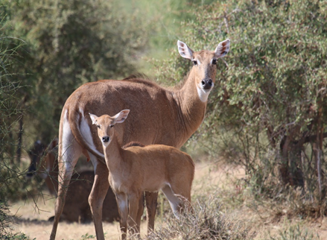
Figure 2: Female Blue Bull
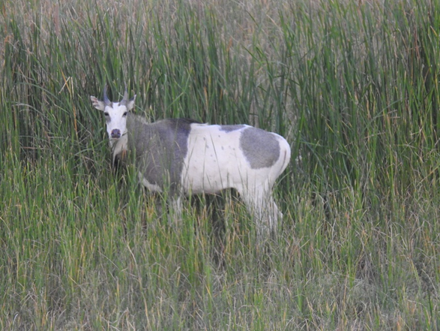
Figure 3: Piebaldism in Blue Bull
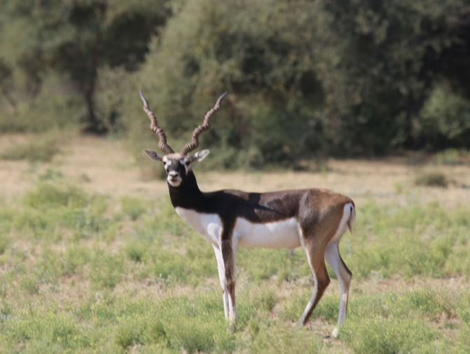
Figure 4: Male Blackbuck
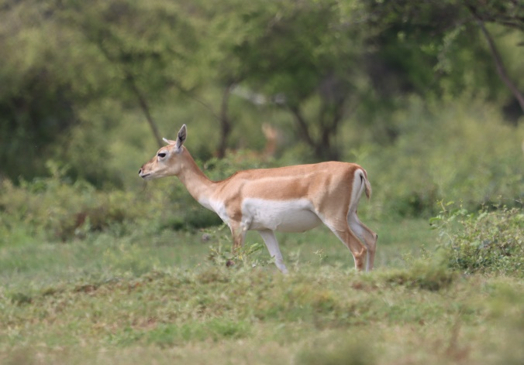
Figure 5: Blackbuck (Female)
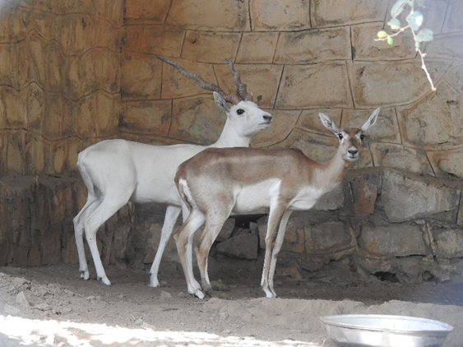
Figure 6: Albinism in Male Blackbuck
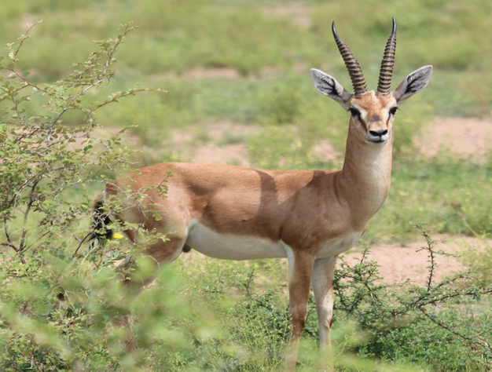
Figure 7: Male Chinkara
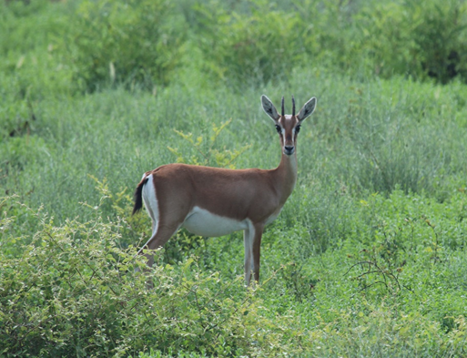
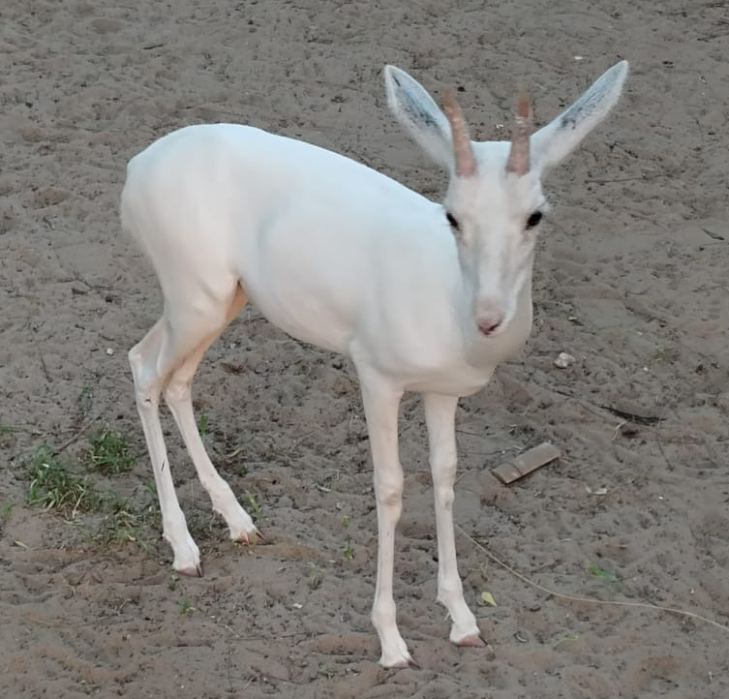
Figure 8: Female Chinkara
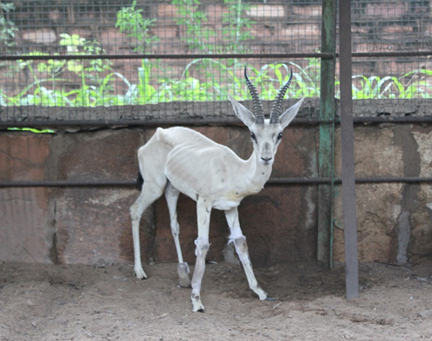
Figure 9 A&B: Albinism in Chinkara (Male & Fawn)
Conclusions
Photography of the wild animals and nature is an invaluable tool for documenting the habitat, ecology and behavioral biology of particular species by providing visual evidence of unique phenomenon and characteristics such as albinism and rare behavior. Photographic records of unusual organisms, such as albinos, are crucial for the analyses and comparison of colour abnormalities across different species, populations and geographical regions. In this paper, we describe the occurrence of albinism in three wild ungulate species: partial albinism or piebaldism in Boselaphus tragocamelus and complete albinism in Antilope cervicapra and Gazella bennettii in Rajasthan, India.
Disclaimer (Artificial intelligence):
Authors hereby declare that NO generative AI technologies such as Large Language Models (ChatGPT, COPILOT, etc.) and text-to-image generators have been used during the writing or editing of this manuscript.
Conflict of Interest:
Authors declare no conflict of interest.
References
- Abreu, M.S.L., Machado, R., Barbieri, F., Freitas, N.S., & Oliveira, L.R. (2013). Anomalous colour in Neotropical mammals: a review with new records for Didelphis sp. (Didelphidae, Didelphimorphia) and Arctocephalus australis (Otariidae, Carnivora). Brazilian Journal of Biology, 73, 185-194. doi: 10.1590/s1519-69842013000100020.
- Akash, A., Munna, S., & Nisha, P. Record of the Albino Blue Bull (Boselaphus tragocamelus) from Katepurna Wildlife Sanctuary, Akola District, Maharashtra. Prithivya, 4 (1), 12-16.
- Altmann, J. (1974). Observational study of behavior: sampling methods. Behaviour, 49(3), 227-266. doi: 10.1163/156853974x00534.
- Bärmann, E.V., Rössner, G.F., & Wörheide, G. (2013). A revised phylogeny of Antilopini (Bovidae, Artiodactyla) using combined mitochondrial and nuclear genes. Molecular Phylogenetics and Evolution, 67(2):484-493. https://doi.org/10.1016/j.ympev.2013.02.015
- Caro, T. (2005). The Adaptive Significance of Coloration in Mammals. BioScience 55(2);125–136. https://doi.org/10.1641/0006-3568(2005)055[0125:TASOCI]2.0.CO;2
- Castelló, J. R. (2016). Bovids of the world: Antelopes, Gazelles, Cattle, Goats, Sheep, and Relatives. Princeton, New Jersey, Princeton University Press 664 pp.
- Chishty, N., Choudhary, N.L., Parveen, R., Bano, H., Patel, P. and Kumawat, P. A. (2021). Chronicle on Pycnonotus cafer the Red vented bulbul. Booksclinic Publishing, 1-191.
- Divyabhanusinh (1987). The earliest record of a white tiger (Panthera tigris). Journal of the Bombay Natural History Society, 83:163–165.
- Fox, H.M. & Vevers, G. (1960). The Nature of Animal Colours. Sidgwick & Jackson, London, 246pp.
- Garipis, N., & Hoffmann, K. P. (2003). Visual field defects in albino ferrets (Mustela putorius furo). Vision Research, 43(7):793-800. https://doi.org/10.1016/S0042-6989(03)00015-4
- Gehlot, H.S. (2006). Social Organization, behavioural and Resources selection patterns in Antelope cervicapra and Gazelle bennetti of Thar Desert. Ph.D Thesis, Jai Narain Vyas University, Jodhpur (Rajasthan), 195p.
- Gentry, W.A. (1992): The subfamilies and tribes of the family Bovidae, Mammal Review, 22(1): l-32. https://doi.org/10.1111/j.1365-2907.1992.tb00116.x
- Grant, S., Patel, N. N., Philp, A. R., Grey, C. N., Lucas, R. D., Foster, R. G., ... & Jeffery, G. (2001). Rod photopigment deficits in albinos are specific to mammals and arise during retinal development. Visual Neuroscience, 18(2):245-251. DOI: https://doi.org/10.1017/S095252380118209X
- Hale, W.G., Saunders, V.A., & Margham, J.P. (2005). Collins Dictionary of Biology, 3rd ed. Available at https://medical dictionary.thefreedictionary.com/. Accessed on 10 May, 2017.
- Hassanin, A., Delsuc, F., Ropiquet, A., Hammer, C., Jansen-van-vuuren, B., Matthee ,C., Ruiz-Garcia, M., Catzeflis, F., Areskoug, V., Nguyen, T.T., & Couloux, A. (2012). Pattern and timing of diversification of Cetartiodactyla (Mammalia, Laurasiatheria), as revealed by a comprehensive analysis of mitochondrial genomes. Comptes Rendus Biologies, 335:32–50.
- Hofreiter, M. & T. Schoneberg (2010). The genetic and evolutionary basis of colour variation in vertebrates. Cellular and Molecular Life Science, 67:2591–2603. https://doi.org/10.1007/s00018-010-0333-7
- Kumar, K., & Gharu, C.P. (2025). First Record of Leucism in Albino Gazella bennettii from the Western Thar Desert, Barmer, Rajasthan, India. International Journal of Environmental & Agriculture Research (IJOEAR), 11 (2):69-74.
- Kumar, K., Vaishnav, V., Ojha, A. P., Parihar, P., Barmera, R., & Parihar, G. R. (2016). Occurrence of Albino Gazella bennetti in Viratra mata Oran (Sacred land) of Chohtan, Barmer (Thar Desert of Rajasthan) India. International Journal of Agriculture and Environmental Research, 2(11):87-90.
- Lubnow, E. (1963). Melanine bei Vögel und säugetieren. Journal für Ornithologie 104(1):69–81.
- Lucati, F. & A. López-Baucells (2016). Chromatic disorders in bats: a review of pigmentation anomalies and the misuse of terms to describe them. Mammal Review 47(2):112–123. https://doi.org/10.1111/mam.12083
- Mahabal, A., Sharma, R. M., Patil, R. N., & Jadhav, S. (2019). Colour aberration in Indian mammals: a review from 1886 to 2017. Journal of Threatened Taxa, 11(6):13690-13719. DOI: https://doi.org/10.11609/jott.3843.11.6.13690-13719
- Mahabal, A., Van Grouw, H., Sharma, R.M., & Thakur, S. (2016). How common is albinism really? Colour aberrations in Indian birds reviewed. Dutch Birding, 38:301–309.
- Mehra, S.P., N.S. Kharwar & P. Singh (2010). Field Notes on albinism in Five-striped Palm Squirrel Funambulus pennanti Wroughton from Udaipur, Rajasthan, India. Small Mammal Mail, 2(1): 18.
- Menon, V. (2003). Variations within species, pp14–15. In: A Field Guide to Indian Mammals. Dorling Kindersley (India) Pvt. Ltd. and Penguin Book of India Pvt. Ltd., Delhi, 201pp.
- Prater, S. H. (1971). The book of Indian animals. Bombay Natural History Society, Bombay. Pp. 324.
- Sage, B. L. (1962). Albinism and melanism in birds. British birds, 55(6):201-225.
- Samson, A., Krishnakumar, N., Ramakrishnan, B., & Princy, J. L. (2021). Albino wild boar (Sus scrofa) in Tamil Nadu, Southern India. Therya Notes, 2:109-111.
- Samson, A., Ramakrishnan, B., & Bargavi, S. (2017). Leucism in the three-striped palm squirrel (Funambulus palmarum) at Gudalur Forest Division, Tamil Nadu, Southern India. Therya, 8(3):261-262.
- Sheffield, W.J., Fall, B.A. and Brown, B.A. 1983. The Nilgal Antelope. The Caesar Kleberg Program in Wildlife Ecology and Department of Wildlife and Fisheries Sciences. The Texas A&M Univ. 100 Pp.
- Smielowski, J. (1987). Albinism in the blue bull or nilgai, Bose laphus tragocamelus (Pallas, 1766). Journal of the Bombay Natural History Society, 84:427-429.
- Van Grouw, H. (2006). Not every white bird is an albino: sense and nonsense about colour aberrations in birds. Dutch Birding, 28:79-89.
- Van Grouw, H. (2013). What colour is that bird? The causes and recognition of common colour aberrations in birds. British Birds, 106:17-29.
- Zalapa, S.S., S. Guerrero, M.L. Romero–Almaraz & C. Sánchez Hernández (2016). Coloración atípica en murciélagos: frecuencia y fenotipos en Norte y Centroamérica e islas del Caribe y nuevos casos para México y Costa Rica [Atypical coloration in bats: frequency and phenotypes in North and Central America, and the Caribbean islands, and new cases from Mexico and Costa Rica]. Revista Mexicana de Biodiversidad, 87: 474–482.

