Review Article

Climate Change and Food Systems: Exploring the Nexus of Diet Quality, Nutrition and Health - A Comprehensive Review

ABSTRACT
The profound interplay between climate change, food systems, diet quality and human health outcomes is a critical concern of our time. This narrative review delves into the multifaceted repercussions of climate change on global food systems, and their cascading effects on food security, dietary diversity and nutritional well-being. Climate change exerts its influence on food systems across various dimensions, encompassing alterations in soil fertility, crop yields, nutrient profiles of foods, pest resilience, and the risk of malnutrition. The imperative of fostering sustainable and resilient food systems, in conjunction with climate-smart agricultural practices, is emphasized as the pathway to ensure diets that are both ecologically sound and nutritionally robust. As we explore this intricate interplay, it becomes evident that robust tools and indicators are urgently needed to assess the reciprocal interaction between food systems and climate change, exacerbated by pandemics, and to elucidate their impact on human health. Unsustainable food systems characterized by mass monoculture farming, excessive fertilizer use, intensive livestock production, and deforestation contribute to elevated greenhouse gas emissions and biodiversity loss. This review contemplates the prospects of mitigating environmental footprints associated with food systems by embracing more sustainable dietary patterns that concurrently fulfil nutritional requirements and safeguard the environment. Strategies such as dietary diversification, fortification, biofortification, and the integration of alternative protein sources are explored as alternative options. Cross-cutting issues like gender, urbanization and food wastage, as well as potential health consequences of interventions targeting micronutrient deficiencies, warrant thorough assessment. In essence, this review underscores the urgency of developing robust tools and indicators to comprehensively evaluate the complex interactions between climate change, food systems, and their impact on diet and nutrition outcomes.

Keywords: Food Security, Dietary Diversity, Climate-Smart Agriculture, Biofortification, Climate Change

- INTRODUCTION
Climate change, an unprecedented global challenge, continues to exert far-reaching impacts on our planet's ecological systems, with dire consequences for humanity's health and well-being. Among its myriad effects, climate change profoundly influences the world's food systems, altering the very fabric of what we eat, how it's produced, and, subsequently, the nutritional quality of our diets (Upadhyay, 2020). The intersection of climate change and food systems has evolved into a complex nexus with profound implications for diet quality, nutrition, and, ultimately, public health (Moscatelli et al., 2016). The intricate relationship between climate change and food systems is characterized by a multitude of pathways and feedback loops, each contributing to a dynamic and evolving landscape. Climate change affects the productivity of agricultural lands, diminishing crop yields, altering the nutrient content of our foods, and triggering the emergence of pests and diseases that imperil global food security (Shankar, 2018). These shifts, in turn, challenge our capacity to ensure that diets are diverse, nutritious, and sustainable, resonating throughout the intricate web of environmental and human health.
This review paper embarks on a comprehensive exploration of the intricate connections between climate change and food systems, delving into the profound consequences for diet quality, nutrition, and health outcomes. It elucidates the multifaceted dimensions of this challenge, while also acknowledging the added complexities introduced by global crises such as the COVID-19 pandemic. As we journey through this terrain, we will uncover the role of sustainable and resilient food systems, grounded in climate-smart agricultural practices, as a means to secure diets that harmonize with the Earth's ecosystems and safeguard human health. Moreover, we will underscore the urgency of developing robust tools and indicators to gauge the reciprocal interactions between food systems and climate change, recognizing their multifaceted and interconnected nature (Forster & Escudero, 2014). The importance of embracing transformative measures to mitigate the environmental footprints of food systems will also be explored (Daher et al., 2021). This journey will traverse dietary diversification, fortification, biofortification, and innovative approaches like edible insects as alternative protein sources.
Numerous repercussions of climate change pose a threat to food security and the quality of diets, thereby exposing susceptible populations across continents to various forms of malnutrition. Inadequate nutrition is a significant contributor to both mortality and morbidity, as indicated by research by (Afshin et al., 2019) and (Micha et al., 2020). At present, approximately 690 million individuals are experiencing hunger, and this number is projected to rise to over 840 million by 2030, according to the (FAO 2020 report). In 2020, 149.2 million children under the age of 5 suffered from stunting, and 45.4 million were affected by wasting, largely attributable to insufficient dietary intake. Concurrently, in 2020, 38.9 million children under the age of 5 were dealing with overweight issues, as per the World Health Organization's 2021 statistics (WHO, 2022). These patterns are partially fuelled by disparities and unsustainable food systems that are unable to meet the food security and nutritional needs of all individuals. Besides climate change, other external shocks that negatively affect food systems encompass pandemics, such as the ongoing COVID-19 pandemic, which was forecasted to push an additional 83-132 million individuals into the undernourished category by 2020, according to the (WHO, 2022).
Climate change exacerbates the issues surrounding unsustainable food systems by directly impacting soil fertility, precipitation patterns, crop yields, food production, the composition of food nutrients and anti-nutrients, and the availability of nutrients (Karavolias et al., 2021). These shifts lead to a reduction in both macro and micronutrient content in the global food supply. Additional complications arise from indirect effects, including increased pest activity, resulting in a higher occurrence of food spoilage and safety concerns at various stages of the food supply chain, spanning from primary production to post-harvest handling through to consumption. Each of these factors can have adverse consequences on human nutrition, as observed in studies by (Parfitt et al., 2010) and (Hodges et al., 2011). Measuring the intricate and interconnected relationship between food systems and climate change, further complicated by pandemics, remains a substantial challenge, particularly with regard to its impact on human health.
As the global population burgeons, urbanization accelerates, and dietary preferences evolve, this intricate tapestry is further complicated. We will navigate this complex landscape to discern the strategies and tools needed to navigate these challenges effectively, and we will consider how recent global initiatives and recommendations might shape the future of food systems in response to climate change (Barrett et al., 2020). This embarks on a journey to decipher the ever-evolving landscape of climate change and food systems and the profound impacts they have on diet quality, nutrition, and health outcomes. It underscores the imperative of fostering resilient food systems and innovative solutions to safeguard our collective well-being in the face of this unprecedented global challenge (Tufford et al., 2020).

- CLIMATE CHANGE, FOOD SYSTEMS AND BIODIVERSITY
Food systems encompass a wide range of activities that encompass everything from food production to postharvest storage, transportation, processing, distribution, trade, marketing, regulatory processes, consumption of food, and the resulting impacts on aspects such as nutrition, health, socioeconomic factors, and the environment. These food systems form the initial focal point of the Decade of Action on Nutrition, as designated by the World Health Organization in 2017, as well as emphasized by (Demaio and Branca, 2018) and (Turner et al., 2020).
Within the broader scope of food systems, the food environment plays a pivotal role and comprises both an external dimension, which includes elements like food availability, product attributes, pricing, marketing strategies, and regulatory measures, and a personal dimension, which encompasses factors like accessibility, affordability, convenience, and desirability. These domains, both external and personal, significantly influence how people obtain food, their consumption patterns, and, ultimately, the resulting nutritional and health outcomes, as outlined by (Turner et al., 2018 and 2020), and recognized by UNSCN in 2019.
The intricate interplay between climate change, food systems, and biodiversity is the subject of considerable scrutiny in the realm of environmental and agricultural research. Climate change, with its associated effects like altered weather patterns and extreme events, exerts a profound impact on agriculture and the entire food supply chain (Panwar et al., 2023). These disruptions can result in food scarcity, fluctuating prices, and challenges in predicting optimal planting and harvesting times. Biodiversity plays a pivotal role in the resilience and adaptability of food systems. It maintains genetic diversity in crops and livestock, supports essential pollinators, and provides ecosystem services critical to agriculture. The relationship between these elements is critical to food security and necessitates adaptive strategies (Gregory et al., 2005). Ensuring the preservation of biodiversity, alongside ecosystem-based adaptation strategies, represents a promising approach to addressing the challenges posed by climate change to food systems. This holistic understanding underscores the significance of adopting sustainable and biodiversity-friendly practices within food systems to ensure long-term food security and environmental sustainability. A review paper exploring these intricate connections is essential to comprehensively address this critical nexus of climate change, food systems, and biodiversity. Conceptual Framework of Food Systems for Diet and Nutrition shown in Fig. 1. Certainly, the intricate interplay between climate change, food systems, and biodiversity is a subject of paramount importance that has garnered extensive attention in scientific research and policy discussions. Climate change, driven by various factors such as greenhouse gas emissions and deforestation, has a multifaceted impact on food systems across the globe. Alterations in temperature, precipitation patterns, and the increased occurrence of extreme weather events disrupt agricultural practices, leading to diminished crop yields and an increased risk of food supply instability (Reddy et al., 2015). This poses significant challenges for food security, exacerbating hunger, and creating economic uncertainties.
Concurrently, biodiversity, which encompasses the vast variety of life on Earth, plays a vital role in ensuring the robustness of food systems. This wealth of genetic resources underpins agricultural diversity, enabling the development of new crop varieties and animal breeds that are more resilient to changing environmental conditions. Furthermore, biodiversity in the form of pollinators, soil microorganisms and other organisms supports ecosystem services that are indispensable for sustainable agriculture, including natural pest control, nutrient cycling, and enhanced soil fertility (Attwood et al., 2017). Understanding the relationship between climate change, food systems, and biodiversity is essential for both mitigating the adverse effects of climate change on agriculture and safeguarding biodiversity for the future. The conservation of biodiversity is intricately linked to the sustainability and resilience of food systems, as it offers a genetic reservoir for breeding and adaptation efforts. Furthermore, as climate change escalates, preserving biodiversity becomes increasingly crucial in maintaining the provision of ecosystem services vital for agriculture (Gliessman, 2021).
In the context of a review paper, a comprehensive examination of this intricate relationship is essential. Such a paper can serve as a valuable resource for policymakers, scientists, and practitioners, providing insights into strategies that can enhance the sustainability and resilience of food systems in the face of climate change. By integrating knowledge from various disciplines and exploring successful case studies, it can offer a roadmap for fostering biodiversity-friendly and climate-resilient food systems, ultimately contributing to global food security and the preservation of Earth's precious biodiversity (Nyekwere & Ole, 2022). Additionally, it can play a pivotal role in raising awareness among the wider public about the critical link between our food choices, climate, and the health of our planet, inspiring positive change and responsible consumption practices for a sustainable future.

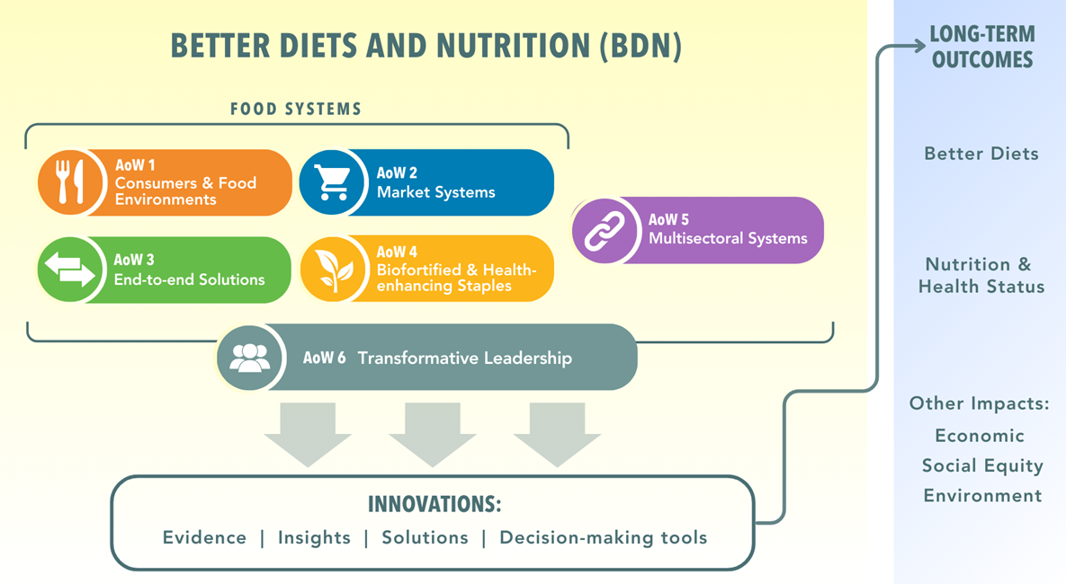
Fig. 1: Conceptual Framework of Food Systems for Diet and Nutrition

Moreover, the introduction of science and technology brought about a revolution in food production, processing, preservation, and transportation (Hueston and McLeod, 2012), leading to a transition towards the consumption of energy-dense and macronutrient-rich processed foods (Vermeulen et al., 2020).
The global demand for meat, particularly in Low and Middle-Income Countries (LMICs), is steadily increasing, driven by factors such as urbanization, education, and rising affluence (Headey et al., 2018) and (Adesogan et al., 2020). For example, per capita meat consumption escalated by 20 kg from 1961 to 2014, primarily in Asia and Africa (Vermeulen et al., 2020), while it decreased in many Western countries. High-income nations consume nearly six times more dairy products and nine times more eggs per capita compared to low-income countries (Herforth et al., 2019). Projections indicate that the global demand for livestock and dairy is expected to rise by 70% and 60%, respectively, from 2010 to 2050.
The intricate and cyclical relationship between food systems and climate change is evident. In the past four decades, agricultural production has doubled, and food supply chains have become globalized (Niles et al., 2017; Von Braun, 2018). Mass production practices in agriculture, including increased fertilizer use and expanded crop and livestock production, along with deforestation, have contributed to elevated greenhouse gas emissions and subsequent climate change effects. These effects, such as droughts, floods, heat waves, reduced soil fertility, disrupted rain patterns, and acid rain from extensive fertilizer application, have impacted food systems and led to reduced food production (Niles et al., 2017). This cycle results in food insecurity, malnutrition in various forms, environmental degradation, water scarcity, and the emergence of new human, plant, and animal diseases (Popkin et al., 2020).
The evolution of food systems has been a dynamic process, shaped by a multitude of historical, cultural, and technological influences. The transition from hunter-gatherer societies to agriculture during the Neolithic revolution was a seminal moment in human history, marking a shift towards plant-based diets as communities began cultivating crops and domesticating animals for a more stable food supply (Abbo et al., 2022). With the rise of agriculture, food systems evolved further with the growth of city-states and governance structures, enabling more organized food production, storage, and distribution. The establishment of trade networks and evolving consumer demands spurred the development of food supply chains. The Industrial Revolution brought about mechanization and improved transportation, leading to increased food production and distribution (Rasmussen, 1982). This period laid the foundation for modern food systems by introducing technologies that significantly enhanced productivity. The Green Revolution of the mid-20th century introduced high-yielding crop varieties, synthetic fertilizers, and pesticides, boosting agricultural output but also raising concerns about environmental sustainability (Fischer & Connor, 2018).
Globalization in the late 20th century further transformed food systems, enabling the international exchange of diverse food products. Technological advances continued to revolutionize food production, with an increasing shift towards processed and nutrient-dense foods, driven by changing dietary preferences and consumer demand for convenience. In parallel, the global demand for meat has been rising, particularly in Low and Middle-Income Countries (LMICs), driven by factors like urbanization, increasing education, and growing affluence (Drewnowski & Monsivais, 2020). The contrasting patterns of meat and dairy consumption between high-income and low-income countries underline the disparities in dietary habits and nutritional access. The relationship between food systems and climate change is characterized by a vicious cycle. Modern agricultural practices, such as high fertilizer use and deforestation, contribute to increased greenhouse gas emissions and climate change. In turn, climate change leads to adverse weather events like droughts, floods, and heatwaves, disrupting food systems and reducing food production. These impacts have far-reaching consequences, from food insecurity and malnutrition to environmental damage and the emergence of new diseases, highlighting the intricate connections between our food systems and the changing climate (Shen et al., 2020).
This complex interplay between food systems and their historical evolution, meat consumption trends, and their interactions with climate change underscores the need for sustainable and resilient food systems that can adapt to the challenges posed by a changing world (Gil et al., 2019). Further research and policy initiatives are crucial for addressing these multifaceted issues to ensure food security, environmental sustainability, and public health in a rapidly evolving global landscape.

- CLIMATE CHANGE, NUTRIENT SUFFICIENCY AND THEIR EFFECTS ON NUTRITION AND HEALTH
The intricate nexus of climate change, nutrient adequacy, and nutrition and health outcomes represents a vital subject for review, shedding light on the profound consequences of environmental shifts on human well-being. Climate change, spurred by various factors, including greenhouse gas emissions and deforestation, exerts far-reaching effects on the nutritional adequacy of diets and the overall health of populations (Friel, 2019). Climate-induced disruptions in agriculture, such as extreme weather events and altered weather patterns, can lead to diminished crop yields and a potential reduction in nutrient content in food, thereby jeopardizing the nutritional adequacy of diets. Furthermore, the altered availability and affordability of certain foods, caused by climate-induced shifts, can have a direct bearing on nutrient adequacy, as well as food quality.
The impact of climate change on food quality is exemplified by rising temperatures and changing CO2 levels, which can influence the nutritional content of food, possibly leading to deficiencies in vital nutrients (Redden et al., 2014). Concurrently, climate change raises concerns about food safety, contributing to the proliferation of foodborne diseases. The consequences of these nutritional inadequacies are far-reaching, encompassing a spectrum of health issues, including malnutrition, stunting in children, and an increased susceptibility to diseases. Water scarcity, exacerbated by climate change, is a significant concern, as it affects both food production and the availability of clean water for consumption, compromising food security and nutrition. The changing climate can also influence the distribution of disease vectors, such as mosquitoes, leading to the spread of vector-borne diseases, which have detrimental effects on health and nutrition (De Laurentiis et al., 2016). Additionally, climate-induced events like natural disasters can affect mental health, leading to displacement, loss of livelihoods, and trauma, ultimately influencing dietary patterns and nutrition.
A comprehensive understanding of the interplay between climate change, nutrient adequacy, and nutrition and health outcomes is pivotal for the development of effective strategies to mitigate these impacts. Sustainable agricultural practices, dietary diversity, food fortification, and resilient health systems are key initiatives that can help address the nutritional and health challenges posed by climate change (Vijayalakshmi et al., 2021). Furthermore, advocating for climate mitigation and adaptation measures is essential for ensuring long-term food security and the well-being of populations in a rapidly changing climate. This review paper delves into these complex relationships, aiming to provide insights and recommendations for policymakers, researchers, and practitioners concerned with the intersection of climate change, nutrition, and health outcomes.
Climate change has profound implications for food systems and, consequently, global food production. It exerts its influence through changes in crop yields, alterations in biomass, shifts in food composition, and variations in nutritional quality. These impacts directly affect human nutrition and health (Glopan, 2020). Furthermore, climate change can disrupt food supply chains and transportation networks, resulting in food price fluctuations and jeopardizing food security, nutrition, and human well-being (FAO, 2020). Vulnerable and disadvantaged populations, often less resilient to such environmental shocks, bear a disproportionate burden of these consequences (Tirado et al., 2013; Niles et al., 2017). Addressing these challenges requires a concerted effort to develop food systems that are both climate-smart and nutrition-sensitive, spanning from food production to consumption (Bryan et al., 2019). The integration of sustainability criteria into food-based dietary guidelines can play a pivotal role in promoting diets that benefit both human health and the environment, thus fostering the well-being of both people and the planet.

- THE IMPACT OF CLIMATE CHANGE ON THE NUTRIENT CONTENT OF FOOD
The impact of climate change on the nutrient content of food has emerged as a topic of significant concern and scientific investigation. Climate change, characterized by rising global temperatures, shifting precipitation patterns, and increased atmospheric carbon dioxide levels, can exert various profound effects on the nutrient content of crops and food products (Srivastav et al., 2019). One of the most striking findings suggests that elevated carbon dioxide levels in the atmosphere may lead to reduced nutrient density in staple crops like wheat, rice, and maize, with lower levels of essential nutrients such as iron, zinc, and protein (Suganya et al., 2020). This, in turn, has implications for human nutrition and health. Climate change can also influence the availability of micronutrients in crops, as alterations in soil pH and composition affect the bioavailability of minerals, potentially leading to variations in the micronutrient content of food. Furthermore, shifts in weather patterns, including prolonged droughts and severe storms, can significantly impact crop yields, potentially resulting in food scarcity and diminished access to diverse and nutritious foods. Climate-related extreme weather events, such as floods or storms, may compromise the safety of food products by allowing contaminants, pathogens, and chemicals to infiltrate the food supply, raising concerns about food safety and its impact on nutrition and health (Prats, 2020). Changes in agricultural practices and crop choices driven by climate-induced shifts can lead to altered dietary patterns, potentially causing nutritional imbalances. Moreover, the nutritional composition of animal-derived foods, including meat and dairy, can be influenced by climate change, affecting the quality and availability of these essential dietary components (Westhoek et al., 2014). Understanding these complex dynamics is pivotal for addressing the consequences of climate change on food and nutrition. It underscores the urgent need for adopting sustainable agricultural practices, enhancing soil management, and developing climate-resilient crop varieties to mitigate potential negative impacts on the nutrient content of food.
Alternative dietary protein sources, such as plant proteins, edible insects, seaweed, microalgae, and cell-culture based proteins (e.g., cultured milk and eggs, lab-grown meats), have gained attention as potential replacements for animal source foods, offering the advantage of a lower environmental footprint (Thavamani et al., 2020; Tso et al., 2020). Edible insects, in particular, have experienced a resurgence of interest as a sustainable protein source. While more than 2,000 species of edible insects from wild sources have been identified in traditional diets globally, a select few have gained prominence in the last decade for farming and mass production (Halloran et al., 2018). Impact of Climate Change on Nutrient Content of Food and Alternative Protein Sources tabulated in Table 1.
One of the notable advantages of edible insects is their remarkable efficiency in converting organic feed substrates into animal tissue, comprising protein, fat, and other essential compounds. Insect farming requires less space, reduced water and feed inputs, and generates lower greenhouse gas emissions compared to traditional livestock, making it an appealing choice from an environmental sustainability perspective (Halloran et al., 2016, 2017). This research should include a specific focus on the composition and bioavailability of protein, amino acids, essential fatty acids, vitamin B12, zinc, iron, and the concentration of anti-nutrient compounds that can hinder bioavailability. This assessment is crucial to ensure that these alternative protein sources can provide a nutritionally balanced and sustainable alternative to traditional animal-based protein sources while addressing both environmental and health considerations. Fig. 2 illustrated food value chain encompasses a series of interconnected stages that transform agricultural inputs into consumable products, linking input suppliers, farmers, traders, food companies, retailers, and consumers. Input companies provide essential resources such as seeds, fertilizers, crop protection products, and animal health solutions. Farmers convert these inputs into primary commodities like crops, meat, and dairy, which are then traded in domestic and global markets. Traders facilitate the movement of raw and semi-processed goods, including biofuel feedstocks, to food companies, which process them into value-added products such as bakery goods, snacks, and beverages. Retailers distribute these products through various outlets, from hypermarkets to local shops, ultimately reaching urban and rural consumers. This integrated chain plays a crucial role in ensuring food availability, quality, and sustainability, while also influencing economic development and environmental impacts.
Table 1: Impact of Climate Change on Nutrient Content of Food and Alternative Protein Sources
Aspect | Key Impacts/Findings | References
Elevated CO₂ Levels | Leads to reduced nutrient density in staple crops (wheat, rice, maize) with lower levels of protein, iron, and zinc. | Srivastav et al., 2019; Suganya et al., 2020
Soil Changes | Altered soil pH and composition affect mineral bioavailability, leading to variations in micronutrient content of crops. | Srivastav et al., 2019
Weather Pattern Shifts | Droughts, storms, and floods reduce yields, affect crop nutrient quality, and increase risk of contaminants and food safety issues. | Prats, 2020
Animal-Derived Foods | Climate stress alters quality and availability of meat and dairy, influencing protein and micronutrient intake. | Westhoek et al., 2014
Dietary Shifts | Climate-driven crop changes may alter food availability, leading to imbalanced diets. | Srivastav et al., 2019
Alternative Protein Sources | Plant proteins, seaweed, microalgae, edible insects, and cell-cultured foods provide sustainable replacements for animal protein with lower environmental footprint. | Thavamani et al., 2020; Tso et al., 2020
Edible Insects | >2,000 species identified globally; efficient feed-to-protein conversion; high in protein, fats, vitamin B12, iron, and zinc; lower land, water, and GHG requirements. | Halloran et al., 2016, 2017, 2018

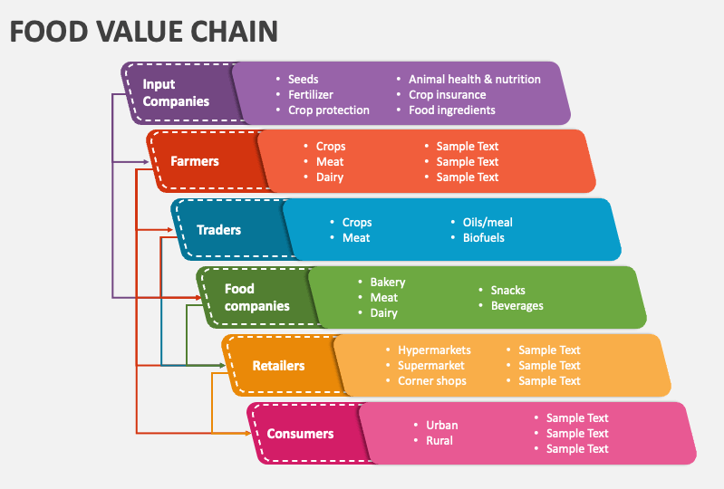
Fig. 2: From Inputs to Consumers: The Food Value Chain Framework

- CLIMATE CHANGE AND FOOD SYSTEMS: AN IN-DEPTH EXPLORATION
Food systems exhibit a range of strengths, resilience factors, and vulnerabilities in the face of dynamic and often anthropogenic shocks (Tendall et al., 2015). While climate change is typically considered an environmental factor, it has widespread impacts on food systems, including increased disease transmission. Food systems are susceptible to disruptions caused by a variety of factors, from disease outbreaks to economic and trade issues (Béné, 2020). For instance, the Ebola outbreaks in West Africa disrupted the movement of workers, leading to inhibited food production and disrupted food supply chains in the region. Similarly, the ongoing COVID-19 pandemic has had a global impact by impeding the movement of labor and affecting various aspects of food systems.
International trade plays a crucial role in many food systems but is susceptible to disruption when countries implement trade restrictions, such as export bans, to safeguard their domestic consumption. Food systems that rely on local institutions, knowledge, and farmers tend to exhibit higher levels of resilience. Resilient food systems are characterized by diversification in production and distribution channels, reduced waste, and cumulative enhancements in food and nutrition security (Dixon et al., 2021). Moreover, food systems that promote biodiversity contribute to more sustainable food production. Social factors, particularly gender dynamics, are critical elements in determining the resilience of food systems. Women are significant stakeholders in food systems, yet there are often significant gender-based disparities in access to opportunities that ensure sustainable and healthy diets for women (Lemke & Bellows, 2015). Elements of Food system chain illustrated in Fig. 3.

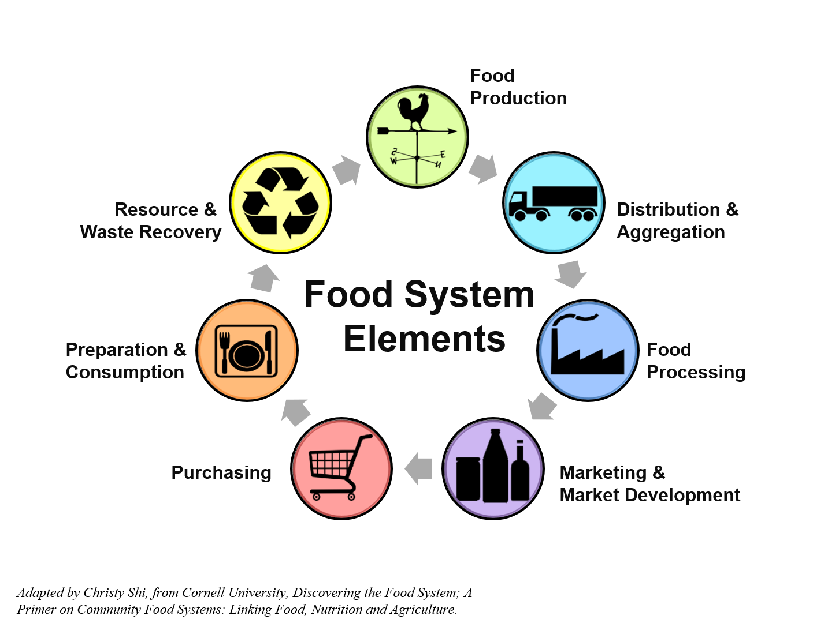
Fig. 3: Elements of Food system chain

Understanding these strengths, resilience factors, and vulnerabilities within food systems is crucial for developing strategies and policies that enhance food security, improve resilience, and address the challenges posed by various shocks and disruptions, both short-term and chronic, in our ever-evolving world (Eakin et al., 2017). The exploration of climate change's intricate relationship with food systems encompasses a multitude of strengths and weaknesses, along with a repertoire of interventions and the development of pertinent metrics. These aspects are instrumental in understanding the profound and multifaceted impact of climate change on global food systems. The first notable strength in this realm is the heightened awareness and urgency surrounding climate change's effects on food systems. This heightened awareness has galvanized a global commitment to addressing the issue, fostering a collective sense of responsibility (Méndez, 2020). Furthermore, researchers and policymakers have adopted an interdisciplinary approach, integrating the expertise of various fields, including climate science, agriculture, nutrition, and economics. This multidisciplinary lens allows for a more comprehensive understanding of the complexities at play. Additionally, technological advancements in areas such as agriculture, data analysis, and communication technology have empowered interventions and data collection efforts, enabling more targeted and effective responses. Lastly, a range of policy initiatives, both at the national and international levels, have been established to provide a framework for mitigating the impact of climate change on food systems.
While the strengths are evident, there are also notable weaknesses that must be addressed. Data gaps, despite technological advances, remain a significant hurdle. These gaps hinder the accurate assessment and modelling of climate change's effects on food systems, impeding the development of informed interventions (Bahn et al., 2021). Another weakness lies in the adaptive capacity of vulnerable and low-resource regions, which often lacks the necessary resources to effectively cope with the challenges posed by climate change on food security and nutrition. Furthermore, interventions to mitigate climate change's impact on food systems may have trade-offs, such as potential impacts on land use and economic costs (Meyfroidt, P. (2018). Finally, climate change exacerbates inequalities in food systems, with marginalized communities suffering disproportionately from its effects.
A range of interventions can address these weaknesses and enhance the strengths of climate change's interaction with food systems. Promoting sustainable agriculture, including practices like crop diversification and reduced pesticide use, can significantly enhance food system resilience. Additionally, the development and adoption of climate-resilient crop varieties play a pivotal role in ensuring food security in the face of changing climatic conditions (Gobu et al., 2020). Efforts to reduce food waste in the supply chain and at the consumer level can improve food system efficiency and sustainability. Encouraging dietary diversity is another critical intervention, as it enhances individual nutrition and reduces reliance on resource-intensive food sources.
To assess the effectiveness of these interventions and track the impact of climate change on food systems, specific metrics are indispensable. Measuring greenhouse gas emissions from agriculture and food transportation is vital for assessing the environmental impact of food systems. Monitoring crop yields and production changes offers valuable insights into the impact of climate change on food availability (Abdullah et al., 2023). Metrics that evaluate dietary patterns and the consumption of diverse food groups can gauge the nutritional quality of diets, providing critical information for intervention design. The Global Food Security Index and similar metrics offer a comprehensive view of food system strength by assessing food security on a global scale (Tucker, 2010). In summation, the multifaceted approach to understanding the impact of climate change on food systems requires a concerted effort involving in-depth research, collaboration, and policy implementation (Dinesh et al., 2018). This collective endeavor is vital for securing global food security and environmental sustainability in the face of a changing climate.
Recent advancements in the sphere of nutrition and food systems represent substantial progress in addressing the intricate challenges of our contemporary world (Béné et al., 2019). Endeavors such as the resource guide aimed at fortifying nutrition initiatives, which draws from the policy recommendations of the Second International Conference on Nutrition (ICN2), as well as the endorsement of the voluntary guidelines for food systems and nutrition by the Committee on World Food Security (CFS), mark an auspicious initial step toward the transformative overhaul of our food systems. These initiatives underscore the global acknowledgment of the urgency and significance surrounding the issues of nutrition and food systems. Nevertheless, this journey is far from its conclusion, and the path ahead is beset with critical requisites. To genuinely assess the impact of these recommendations and to craft solutions that are climate-smart, we necessitate indispensable tools to steer our efforts. These tools should be conceived with a profound understanding of the intricate trade-offs that characterize the intricate web of food systems (Altamirano et al., 2018). This involves finding equilibrium in matters related to crop yield as opposed to nutrient content and bioavailability, carefully evaluating the nutritional advantages of augmented consumption of animal-derived foods versus their environmental footprint and effects on biodiversity, and actively seeking scenarios where dietary patterns offer the dual benefit of being both healthier and more sustainable (Singh et al., 2021).
Additionally, it is imperative that we do not overlook the health repercussions stemming from altered dietary behavior or the intersections of gender, urbanization, and food wastage. These elements stand as pivotal components in the equation of reshaping our food systems. As we peer into the future, it is unequivocally evident that the food systems of tomorrow must chart a course that not only furnishes sufficient nourishment but does so without incurring harmful environmental trade-offs. Striking a balance between nutrition, health, sustainability, and equity stands as the formidable challenge before us. This challenge necessitates innovation, collaborative endeavors, and unwavering dedication to a world where food systems not only sustain the human body but also the planet. In this endeavor, the harmonious coexistence of nutrition and environmental stewardship emerges as the ultimate aspiration, promising a healthier and more sustainable future for all.

- FUTURE PROSPECTS OF CLIMATE CHANGE AND FOOD SYSTEMS
The future prospects of the intersection between climate change and food systems, with a specific focus on diet quality, nutrition, and health, are poised to play a pivotal role in shaping our global response to the multifaceted challenges we face. Key considerations and areas of exploration will undoubtedly guide the trajectory of this critical discourse. First and foremost, the urgency of building sustainable food systems resilient to climate change will continue to gain momentum (Hinrichs, 2014). Researchers, policymakers, and practitioners will increasingly concentrate their efforts on designing food production and distribution systems that not only minimize their environmental footprint but also actively contribute to reducing greenhouse gas emissions and fostering biodiversity.
Dietary shifts are set to be a central theme in the future of food systems. As climate change necessitates a reevaluation of our food production practices, there will be a growing emphasis on promoting dietary transitions toward more plant-based diets (El Bilali et al., 2019). These shifts are not just ecologically responsible but also hold the potential to improve diet quality and public health outcomes. Resilience and adaptation will be paramount in a changing climate. Future efforts will focus on developing strategies to mitigate the impact of climate change on food production and create adaptive mechanisms capable of coping with evolving agricultural landscapes (Yaro, 2013). Maintaining the nutritional adequacy of diets in the face of climate change-induced alterations in crop yields and nutrient content will continue to be a key concern. Future research will delve into innovative solutions, including fortification, supplementation, and dietary diversification, to safeguard diet quality and human health (Newman et al., 2023). Food security, inextricably linked to climate change, will remain at the forefront of policy initiatives. Future strategies will revolve around ensuring access to safe, nutritious food for all, with particular attention to the most vulnerable regions. Technological advancements will play a transformative role in the future of food systems. Precision agriculture, genetically modified crops, and innovative food production methods, such as lab-grown meats, offer promising avenues for addressing the challenges posed by climate change (Karunathilake et al., 2023).
Responsible consumption patterns and food waste reduction will be central to building sustainable food systems. Future research will explore creative approaches to minimize food waste and promote responsible food consumption. Effective policy and governance structures will be imperative for aligning national and international efforts with the goals of sustainable food systems and climate change mitigation (Caron et al., 2018). Future research will concentrate on developing and implementing policies that facilitate this alignment. Education and awareness initiatives will underpin the future of food systems. Raising awareness about the interconnectedness of climate change, diet quality, and health, and educating individuals about sustainable food choices, will be pivotal in fostering behavioral changes. The future of "Climate Change and Food Systems: Exploring the Nexus of Diet Quality, Nutrition, and Health" is intrinsically tied to our ability to adapt and innovate. As climate change continues to impact food systems, multidisciplinary collaboration among scientists, policymakers, and stakeholders will be central in navigating these complex challenges (Foran et al., 2014). The objective is to create a more sustainable and resilient future for global food systems and, in turn, enhance the well-being of humanity (Elechi et al., 2022). This comprehensive perspective encapsulates the core themes that will shape the path forward in addressing this critical intersection of climate change, nutrition, and food systems.

- CONCLUSION
Exploration of "Climate Change and Food Systems: Exploring the Nexus of Diet Quality, Nutrition, and Health" has unveiled a complex and dynamic landscape at the intersection of climate change, food systems, and human well-being. This comprehensive review has touched upon various key aspects, from the intricate relationship between climate change and food production to the implications for diet quality, nutrition, and health. We have examined the profound impact of climate change on food systems, from altered crop yields and nutrient content to disruptions in food supply chains and the exacerbation of food insecurity. Climate change presents both opportunities and challenges, encouraging a shift toward sustainable, plant-based diets, while also demanding resilient food systems that can adapt to the evolving environmental conditions. Furthermore, we have explored alternative protein sources, food security, and the role of technology in shaping the future of food systems. As we peer into the future, the prospects of climate change and food systems are marked by urgency and opportunity. We must continue to innovate, adapt, and promote sustainable practices to ensure that our food systems are not only resilient in the face of climate change but also aligned with the broader goals of environmental conservation, improved nutrition, and enhanced public health. The complexities and challenges we face at the nexus of climate change, diet quality, nutrition, and health are substantial, but they are not insurmountable. Through collective efforts, informed decision-making, and a commitment to sustainable practices, we can work toward a future where food systems are not only resilient in the face of climate change but also nourishing and equitable, ensuring a healthier and more sustainable world for all.

COMPETING INTERESTS DISCLAIMER
Authors have declared that they have no known competing financial interests OR non-financial interests OR personal relationships that could have appeared to influence the work reported in this paper.

DISCLAIMER (ARTIFICIAL INTELLIGENCE)
Author(s) hereby declare that NO generative AI technologies such as Large Language Models (ChatGPT, COPILOT, etc.) and text-to-image generators have been used during the writing or editing of this manuscript.

REFERENCES
Abbo, S., Gopher, A., & Bar-Gal, G. K. (2022). The origins of agriculture in the ancient near East. Cambridge University Press.
Abdullah, A. F., Wayayok, A., Kassim, M. S. M., & Jamaluddin, A. (2023). Smart Farming for Sustainable Rice Production: An Insight into Applications, Challenges and Future Prospects. Rice Science.
Adesogan, A. T., Havelaar, A. H., Mckune, S. L., Eilitt,ä, M., and Dahl, G. E. (2020). Animal source foods: sustainability problem or malnutrition and sustainability solution? Perspective matters. Glob. Food Secur. 25:100325. doi: 10.1016/j.gfs.2019.100325
Afshin, A., Sur, P. J., Fay, K. A., Cornaby, L., Ferrara, G., Salama, J. S., et al. (2019). Health effects of dietary risks in 195 countries. 1990–2017: a systematic analysis for the Global Burden of Disease Study 2017. Lancet. 393, 1958–1972. doi: 10.1016/S0140-6736(19)30041-8
Altamirano, M. A., van Bodegom, A. J., van der Linden, N., de Rijke, H., Verhagen, A., Bucx, T., ... & van der Zwaan, B. (2018). Operationalizing the WEF nexus: quantifying the trade-offs and synergies between the water, energy and food sectors: Dutch Climate Solutions research programme (No. E--18-036). ECN.
Attwood, S., Estrada-Carmona, N., DeClerck, F. A., Wood, S., Beggi, F., Gauchan, D., ... & Zonneveld, M. V. (2017). Using biodiversity to provide multiple services in sustainable farming systems.
Bahn, R. A., Yehya, A. A. K., & Zurayk, R. (2021). Digitalization for sustainable agri-food systems: potential, status, and risks for the MENA region. Sustainability, 13(6), 3223.
Barrett, C. B., Benton, T. G., Fanzo, J., Herrero, M. T., Nelson, R., Bageant, E., ... & Wood, S. A. (2020). Socio-technical innovation bundles for agri-food systems transformation.
Béné, C. (2020). Resilience of local food systems and links to food security–A review of some important concepts in the context of COVID-19 and other shocks. Food security, 12(4), 805-822.
Béné, C., Oosterveer, P., Lamotte, L., Brouwer, I. D., de Haan, S., Prager, S. D., ... & Khoury, C. K. (2019). When food systems meet sustainability–Current narratives and implications for actions. World Development, 113, 116-130.
Bryan, E., Chase, C., and Schulte, M. (2019). Nutrition-Sensitive Irrigation and Water Management. World Bank.
Caron, P., Ferrero y de Loma-Osorio, G., Nabarro, D., Hainzelin, E., Guillou, M., Andersen, I., ... & Verburg, G. (2018). Food systems for sustainable development: proposals for a profound four-part transformation. Agronomy for sustainable development, 38, 1-12.
De Laurentiis, V., Hunt, D. V., & Rogers, C. D. (2016). Overcoming food security challenges within an energy/water/food nexus (EWFN) approach. Sustainability, 8(1), 95.
Demaio, A. R., and Branca, F. (2018). Decade of action on nutrition: our window to act on the double burden of malnutrition. BMJ Glob. Health 3:e000492. doi: 10.1136/bmjgh-2017-000492
Dinesh, D., Zougmore, R. B., Vervoort, J., Totin, E., Thornton, P. K., Solomon, D., ... & Campbell, B. M. (2018). Facilitating change for climate-smart agriculture through science-policy engagement. Sustainability, 10(8), 2616.
Dixon, J. M., Weerahewa, J., Hellin, J., Rola-Rubzen, M. F., Huang, J., Kumar, S., ... & Timsina, J. (2021). Response and resilience of Asian agrifood systems to COVID-19: An assessment across twenty-five countries and four regional farming and food systems. Agricultural Systems, 193, 103168.
Drewnowski, A., & Monsivais, P. (2020). Taste, cost, convenience, and food choices. In Present knowledge in nutrition (pp. 185-200). Academic Press.
Drewnowski, A., Finley, J., Hess, J. M., Ingram, J., Miller, G., & Peters, C. (2020). Toward healthy diets from sustainable food systems. Current Developments in Nutrition, 4(6), nzaa083.
Eakin, H., Connors, J. P., Wharton, C., Bertmann, F., Xiong, A., & Stoltzfus, J. (2017). Identifying attributes of food system sustainability: emerging themes and consensus. Agriculture and human values, 34, 757-773.
El Bilali, H., Callenius, C., Strassner, C., & Probst, L. (2019). Food and nutrition security and sustainability transitions in food systems. Food and energy security, 8(2), e00154.
Elechi, J. O. G., Nwiyi, I. U., & Adamu, C. S. (2022). Global food system transformation for resilience.
FAO. Food loss and food waste [Internet]. Available from: http://www.fao.org/food-loss-and-food-waste/en/.
Fischer, R. A., & Connor, D. J. (2018). Issues for cropping and agricultural science in the next 20 years. Field Crops Research, 222, 121-142.
Foran, T., Butler, J. R., Williams, L. J., Wanjura, W. J., Hall, A., Carter, L., & Carberry, P. S. (2014). Taking complexity in food systems seriously: An interdisciplinary analysis. World development, 61, 85-101.
Forster, T., & Escudero, A. G. (2014). City Regions as Landscapes for People Food and Nature (p. 62). Washington, USA: EcoAgriculture Partners.
Friel, S. (2019). Climate change and the people's health (Vol. 2). Small Books Big Ideas in Popul.
Gil, J. D., Daioglou, V., van Ittersum, M., Reidsma, P., Doelman, J. C., van Middelaar, C. E., & van Vuuren, D. P. (2019). Reconciling global sustainability targets and local action for food production and climate change mitigation. Global Environmental Change, 59, 101983.
Gliessman, S. R. (2021). Package price agroecology: The ecology of sustainable food systems. CRC press.
Glopan (2020). Global Panel on Agriculture Food Systems for Nutrition: Future Food Systems: for People, Our Planet and Prosperity. Global Panel London.
Gobu, R., Shiv, A., Kumar, C. A., Basavaraj, P. S., Harish, D., Adhikari, S., ... & Sujatha, M. (2020). Accelerated crop breeding towards development of climate resilient varieties. Climate change and Indian Agriculture: Challenges and Adaptation Strategies. Not Available.
Gregory, P. J., Ingram, J. S., & Brklacich, M. (2005). Climate change and food security. Philosophical Transactions of the Royal Society B: Biological Sciences, 360(1463), 2139-2148.
Halloran, A., Flore, R., Vantomme, P., and Roos, N. (2018). Edible Insects in Sustainable Food Systems. Cham: Springer.
Halloran, A., Hanboonsong, Y., Roos, N., and Bruun, S. (2017). Life cycle assessment of cricket farming in north-eastern Thailand. J. Clean. Prod. 156, 83–94. doi: 10.1016/j.jclepro.2017.04.017
Halloran, A., Roos, N., Eilenberg, J., Cerutti, A., and Bruun, S. (2016). Life cycle assessment of edible insects for food protein: a review. Agron. Sustain. Dev. 36, 1–13. doi: 10.1007/s13593-016-0392-8
Headey, D., Hirvonen, K., and Hoddinott, J. (2018). Animal sourced foods and child stunting. Am. J. Agric. Econ. 100, 1302–1319. doi: 10.1093/ajae/aay053
Herforth, A., Arimond,M., Álvarez-Sánchez, C., Coates, J., Christianson, K., and Muehlhoff, E. (2019). A global review of food-based dietary guidelines. Adv. Nutr. 10, 590–605. doi: 10.1093/advances/nmy130
Hinrichs, C. C. (2014). Transitions to sustainability: a change in thinking about food systems change?. Agriculture and human values, 31, 143-155.
Hodges, R. J., Buzby, J. C., and Bennett, B. (2011). Postharvest losses and waste in developed and less developed countries: opportunities to improve resource use. J. Agric. Sci. 149:37. doi: 10.1017/S0021859610000936
Karavolias, N. G., Horner, W., Abugu, M. N., & Evanega, S. N. (2021). Application of gene editing for climate change in agriculture. Frontiers in Sustainable Food Systems, 5, 685801.
Karunathilake, E. M. B. M., Le, A. T., Heo, S., Chung, Y. S., & Mansoor, S. (2023). The Path to Smart Farming: Innovations and Opportunities in Precision Agriculture. Agriculture, 13(8), 1593.
Lemke, S., & Bellows, A. C. (2015). Sustainable food systems, gender, and participation: Foregrounding women in the context of the right to adequate food and nutrition. In Gender, nutrition, and the human right to adequate food (pp. 296-382). Routledge.
Méndez, M. (2020). Climate change from the streets: How conflict and collaboration strengthen the environmental justice movement. Yale University Press.
Meyfroidt, P. (2018). Trade-offs between environment and livelihoods: Bridging the global land use and food security discussions. Global food security, 16, 9-16.
Micha, R., Mannar, V., Afshin, A., Allemandi, L., Baker, P., Battersby, J., et al. (2020). 2020 Global Nutrition Report: Action on Equity to EndMalnutrition. Global Nutrition Report.
Moscatelli, S., El Bilali, H., Gamboni, M., & Capone, R. (2016). Towards sustainable food systems: A holistic, interdisciplinary and systemic approach. Agrofor, 1(1).
Newman, L., Fraser, E., Newell, R., Bowness, E., Newman, K., & Glaros, A. (2023). Cellular agriculture and the sustainable development goals. In Genomics and the global bioeconomy (pp. 3-23). Academic Press.
Niles, M. T., Ahuja, R., Esquivel, J. M., Mango, N., Duncan, M., Heller, M., et al. (2017). Climate change and food systems: Assessing impacts and opportunities. Washington, DC: Meridian Institute.
Nyekwere, E. H., & Ole, N. C. (2022). Tackling the Global Environmental Problem of Climate Change through COVID-19 Economic Recovery Stimulus Packages: Some Suggested Legal Strategies. JL Pol'y & Globalization, 123, 45.
Panwar, R., Ober, H., & Pinkse, J. (2023). The uncomfortable relationship between business and biodiversity: Advancing research on business strategies for biodiversity protection. Business Strategy and the Environment, 32(5), 2554-2566.
Parfitt, J., Barthel, M., and Macnaughton, S. (2010). Food waste within food supply chains: quantification and potential for change to 2050. Philos. Trans. R. Soc. B Biol. Sci. 365, 3065–3081. doi: 10.1098/rstb.2010.012
Popkin, B. M., Corvalan, C., and Grummer-Strawn, L. M. (2020). Dynamics of the double burden of malnutrition and the changing nutrition reality. Lancet 395, 65–74. doi: 10.1016/S0140-6736(19)32497-3
Prats, E. V. (2020). WHO guidance for climate-resilient and environmentally sustainable health care facilities. World Health Organization.
Rasmussen, W. D. (1982). The mechanization of agriculture. Scientific American, 247(3), 76-89.
Redden, R. J., Hatfield, J. L., Vara Prasad, P. V., Ebert, A. W., Yadav, S. S., & O'Leary, G. J. (2014). Temperature, climate change, and global food security. Temperature and Plant Development, 181-202.
Reddy, P. P., & Reddy, P. P. (2015). Impacts of climate change on agriculture. Climate resilient agriculture for ensuring food security, 43-90.
Shankar, S. (2018). Impacts of climate change on agriculture and food security. In Biotechnology for Sustainable Agriculture (pp. 207-234). Woodhead Publishing.
Shen, M., Huang, W., Chen, M., Song, B., Zeng, G., & Zhang, Y. (2020). (Micro) plastic crisis: un-ignorable contribution to global greenhouse gas emissions and climate change. Journal of Cleaner Production, 254, 120138.
Singh, M., Trivedi, N., Enamala, M. K., Kuppam, C., Parikh, P., Nikolova, M. P., & Chavali, M. (2021). Plant-based meat analogue (PBMA) as a sustainable food: A concise review. European Food Research and Technology, 247, 2499-2526.
Srivastav, A., Srivastav, N., & Nishida. (2019). The science and impact of climate change. Singapore: Springer.
Suganya, A., Saravanan, A., & Manivannan, N. (2020). Role of zinc nutrition for increasing zinc availability, uptake, yield, and quality of maize (Zea mays L.) grains: An overview. Commun. Soil Sci. Plant Anal, 51(15), 2001-2021.
Tendall, D. M., Joerin, J., Kopainsky, B., Edwards, P., Shreck, A., Le, Q. B., ... & Six, J. (2015). Food system resilience: Defining the concept. Global Food Security, 6, 17-23.
Thavamani, A., Sferra, T. J., and Sankararaman, S. (2020). Meet the meat alternatives: the value of alternative protein sources. Curr. Nutr. Rep. 9, 346–355. doi: 10.1007/s13668-020-00341
Tirado,M. C., Crahay, P.,Mahy, L., Zanev, C., Neira,M.,Msangi, S., et al. (2013). Climate change and nutrition: creating a climate for nutrition security. Food Nutr. Bull. 34, 533–547. doi: 10.1177/156482651303400415
Tso, R., Lim, A. J., and Forde, C. G. (2020). A critical appraisal of the evidence supporting consumer motivations for alternative proteins. Foods 10:24. doi: 10.3390/foods10010024
Tucker, K. L. (2010). Dietary patterns, approaches, and multicultural perspective. Applied physiology, nutrition, and metabolism, 35(2), 211-218.
Tufford, A. R., Calder, P. C., Van’t Veer, P., Feskens, E. F., Ockhuizen, T., Kraneveld, A. D., ... & de Vries, J. (2020). Is nutrition science ready for the twenty-first century? Moving towards transdisciplinary impacts in a changing world. European journal of nutrition, 59, 1-10.
Turner, C., Aggarwal, A., Walls, H., Herforth, A., Drewnowski, A., Coates, J., et al. (2018). Concepts and critical perspectives for food environment research: a global framework with implications for action in low-and middle-income countries. Glob. Food Secur. 18, 93–101. doi: 10.1016/j.gfs.2018.08.003
Turner, C., Kalamatianou, S., Drewnowski, A., Kulkarni, B., Kinra, S., and Kadiyala, S. (2020). Food environment research in low-and middleincome countries: a systematic scoping review. Adv. Nutr. 11, 387–397. doi: 10.1093/advances/nmz031
Upadhyay, R. K. (2020). Markers for global climate change and its impact on social, biological and ecological systems: A review. American Journal of Climate Change, 9(03), 159.
Vermeulen, S. J., Park, T., Khoury, C. K., and Béné, C. (2020). Changing diets and the transformation of the global food system. Ann. N. Y. Acad. Sci. 1478:3. doi: 10.1111/nyas.14446
Vijayalakshmi, D., & Barbhai, M. D. (2021). Resilient measures in face of climate change to strengthen food and nutritional security. Climate Change and Resilient Food Systems: Issues, Challenges, and Way Forward, 113-140.
Von Braun, J. (2018). Economic and for political innovation nutritional improvement.World Rev. Nutr. Diet. 118, 1–9. doi: 10.1159/000484513
Westhoek, H., Lesschen, J. P., Rood, T., Wagner, S., De Marco, A., Murphy-Bokern, D., ... & Oenema, O. (2014). Food choices, health and environment: Effects of cutting Europe's meat and dairy intake. Global Environmental Change, 26, 196-205.
World Health Organization. (2022). Fiscal policies to promote healthy diets: policy brief.
Yaro, J. A. (2013). Building resilience and reducing vulnerability to climate change: Implications for food security in Ghana. Accra, Ghana: Friedrich-Ebert-Stiftung, Ghana Office.

