Review Article

Application of Sensors and Instrumentation in Precision Agriculture

Abstract
Precision agriculture is a modern farming method that maximizes agricultural productivity and resource efficiency by utilizing state-of-the-art technologies. Using sensors and instrumentation systems that allow for real-time monitoring and data-driven decision-making throughout different stages of crop production is essential to this approach. Application of several sensor technologies, including temperature, nutrient, and soil moisture sensors, in conjunction with remote sensing instruments like satellites and drones, to gather vital agronomic and environmental data. By integrating these sensing devices with wireless communication networks, GPS, GIS, site-specific field management is made possible, which lowers input costs and improves sustainability. Additionally, predictive modelling and automated farming operation control are made possible by the convergence of data analytics and the internet of things IoT, significantly enhancing precision agriculture's potential. This paper highlights the potential of sensor-based systems in transforming contemporary agriculture and promoting long-term food security and environmental stewardship by analysing current trends, technological developments, implementation problems, and future opportunities.
Keywords: Sensors, Instrumentation, Precision agriculture, GIS, GPS, Drones

Introduction
As the backbone of the world's food production system, agriculture provides crucial food, fiber, and raw materials that are indispensable to the survival of both human and livestock populations (Tiwari et al., 2019a). In many parts of the world, agriculture is not only essential for supplying nutritional needs but also makes a substantial contribution to jobs and the economy. However, because of a number of interconnected issues, the agricultural sector is coming under more and more strain. While climate change continues to produce unpredictable weather patterns, upsetting traditional farming cycles and increasing the frequency of extreme weather events, the world's rapidly growing population has caused a spike in demand for food. Adopting more sustainable and efficient farming practices is also essential because freshwater supplies and arable land are becoming less available (Sahni et al., 2018b; Singh and Sahni, 2019; Tiwari et al., 2019b; Padhiary and Roy, 2024).
Agriculture has changed over the years to meet these issues, mostly due to the use of cutting-edge technologies. Thanks to these technical developments, farmers are now able to increase output, reduce environmental damage, and improve global food security. The use of sensors and instrumentation, which have drastically changed the way farming operations are carried out, is one of the most significant improvements (Sahni et al., 2018c).
Sensors are advanced instruments made to identify, quantify, and react to variations in the physical, chemical, or biological aspects of their environment (Shafi et al., 2019). Sensors are used in agriculture to collect accurate, real-time data on a variety of crop-related and environmental variables. These consist of light intensity, nutrient concentrations, relative humidity, ambient and soil temperature, soil moisture levels, and markers of plant stress and health. Sensors let farmers make better judgments, apply fertilizer and water more effectively, and react proactively to shifting field conditions by continuously monitoring these variables (Xie et al., 2022; Hoque et al., 2025).
As the technology becomes more widely available and affordable, sensor adoption in agriculture is gradually accelerating. Sensor performance has been greatly enhanced while their size and manufacturing cost have decreased thanks to developments in microelectronics, wireless communication, and the internet of things (IoT) (Ullo et al., 2021). The application of sensor-based technology is therefore anticipated to grow even more, opening the door for a new era of precision agriculture that prioritizes resource optimization, data-driven methods, and sustainable growth (Kayad et al., 2020).

Importance of Sensors in Agriculture
Sensors are essential to modern agriculture because they give farmers access to real-time data that enables them to make fast, accurate, and well-informed decisions (Thakur et al., 2019). Sensor- based technologies offer a scientific and measurable way to controlling agricultural activities, in contrast to conventional farming approaches that frequently rely on gut feeling, historical knowledge, and visual evaluations (Xu et al., 2022). Numerous issues in farming, such as wasteful resource usage, irregular yields, and environmental degradation, are addressed by this move from guesswork to data-driven decision-making (Tiwari et al., 2017).
Several environmental and soil factors that are essential to crop health and productivity can be tracked using sensors. These consist of nutrient concentrations, pH levels, light intensity, temperature, humidity, and soil moisture (Soussi et al., 2024). Farmers may better grasp their field conditions and react quickly and precisely to changing conditions by consistently gathering and evaluating this data. Soil moisture sensors, for instance, can help with irrigation scheduling so that water is only used where and when it is needed, saving money and water (Morchid et al., 2024). In a similar vein, temperature and humidity sensors can be used to improve greenhouse climates or predict disease outbreaks, improving crop development and protection.
Furthermore, farmers may better apply fertilizer or pesticides, modify planting dates, and prevent losses from unfavorable weather events by using weather sensors to forecast rainfall, wind speeds, or frost conditions (Abbasi et al., 2022). By using nutrient sensors to detect soil nutrient deficiency, fertilizers can be applied precisely, increasing crop yields while lowering the danger of nutrient runoff and contamination (Jawad et al., 2017).
All things considered, the incorporation of sensors into farming systems promotes precision agriculture, a contemporary farming method that leverages technology to improve sustainability, productivity, and efficiency (Elbasi et al., 2022). Farmers may increase yields, lower operating costs, and lessen their environmental impact by using sensor data to inform their decisions about when to plant, irrigate, fertilize, and harvest (Abdollahi et al., 2021). The application of sensors in agriculture is anticipated to advance further as technology develops, becoming more crucial in providing food for the world's expanding population while protecting the environment.

Basics of Sensor
A sensor is a device or component that detects and measures physical properties or changes in the environment and converts this information into a signal or data that can be interpreted, displayed, or used for various purposes (Farooq et al., 2020). Sensors play a crucial role in various fields, including agriculture, science, engineering, industry, and everyday life. They are essential for collecting data and information about the world around us. Human beings are equipped with five different types of sensors (Fig. 1). Eyes detect light energy, ears detect acoustic energy, tongue and nose detect certain chemicals, and skin detects pressures and temperatures. The eyes, ears, tongue, nose, and skin receive these signals then send messages to the brain which outputs a

response. For example, when you touch a hot plate, it is your brain that tells you it is hot, not your skin.
In real world example there are several sensor sensors which are commonly used in agriculture or diverse field (Fig. 2) such as temperature sensor, proximity sensor, accelerometer, Infrared (IR) sensor, pressure sensor, light sensor, ultrasonic sensor, smoke, gas and alcohol sensor, touch sensor, color sensor, humidity sensor, position sensor, magnetic sensor (hall effect sensor), microphone (sound sensor), tilt sensor, flow and level sensor, passive infrared (PIR) sensor, strain and weight sensor etc. These sensors in combination or alone used in agriculture for diverse applications (Lakhiar et al., 2018).
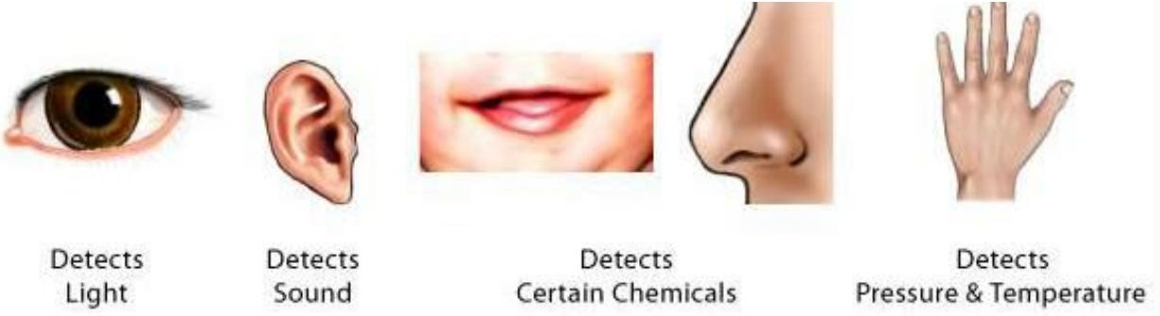
Fig.1. Sensors of human beings.
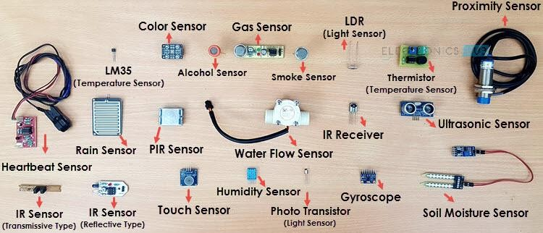
Fig. 2. Different sensors used in agriculture or diverse field.

Types of Sensors used in Agriculture
Agricultural sensors come in various forms, each tailored to specific needs. Some of the most common types include:
- Soil Sensors: These sensors measure soil parameters such as moisture content, pH levels, soil compaction and nutrient concentrations (Kumar et al., 2019). They help farmers determine when and how much water and fertilizer should be applied, preventing over-irrigation and nutrient wastage. Figure 3 shows on-the-go soil EC and pH measurement device developed at ICAR-CIAE, Bhopal.
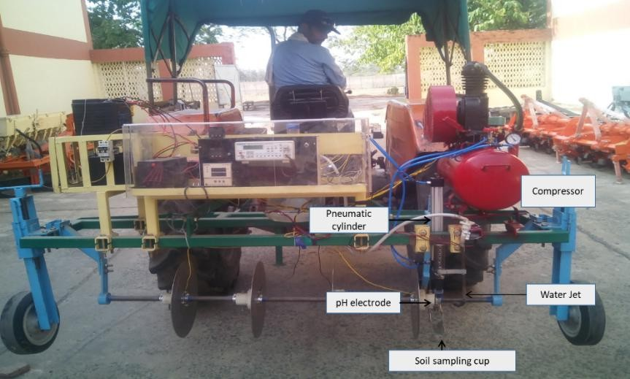
Fig. 3. On-the-go soil EC and pH measurement device.
- Weather Sensors: Weather sensors monitor atmospheric conditions like temperature, humidity, wind speed, and rainfall. Farmers use this data to predict weather patterns and make decisions regarding planting, harvesting, and pest control. Figure 4 depicts an all-in-one weather station (model: ATMOS 41, METER Group, Pullman, WA, USA) mounted in the vineyard to monitor different weather parameters (Sahni et al., 2022).

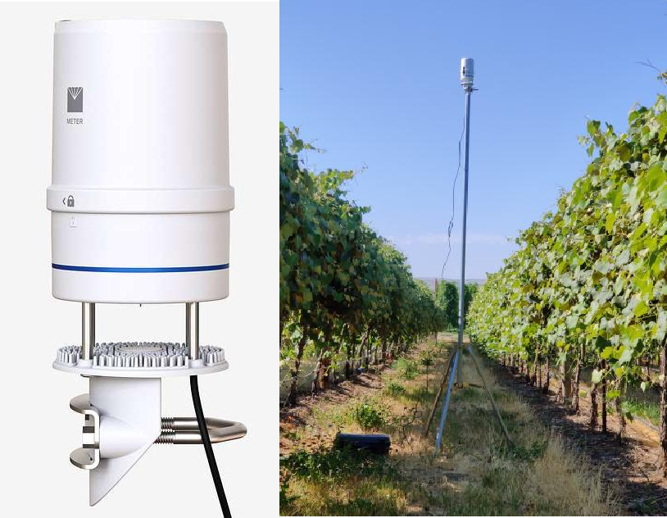
(a) (b)
Fig. 4. (a) All-in-one weather sensor for measuring weather parameters, (b) weather sensor installed in the vineyard to monitor weather parameters.
- Crop Sensors: Crop sensors assess the health and growth of plants by measuring factors like chlorophyll content, lightwave reflectance and canopy temperature. This information guides precision application of pesticides and fertilizers, minimizing chemical use and maximizing crop yield (Rathnayake et al., 2022). Figure 5 shows SPAD meter and green seeker respectively measuring chlorophyll content and NDVI.
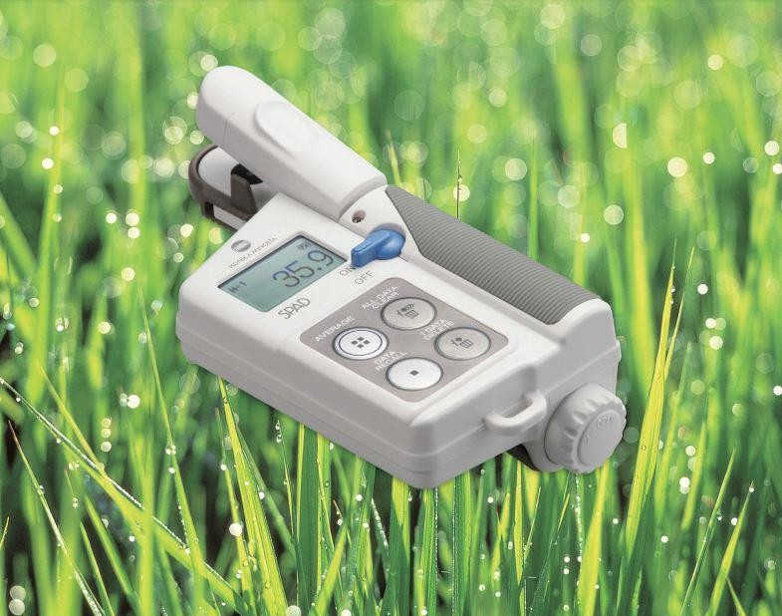
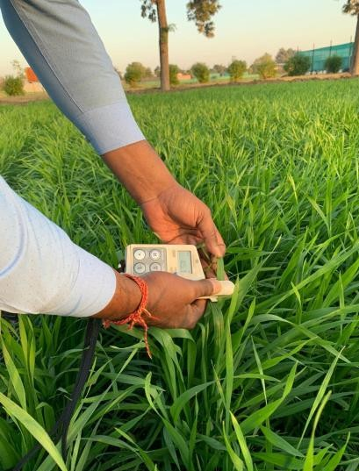
(a)

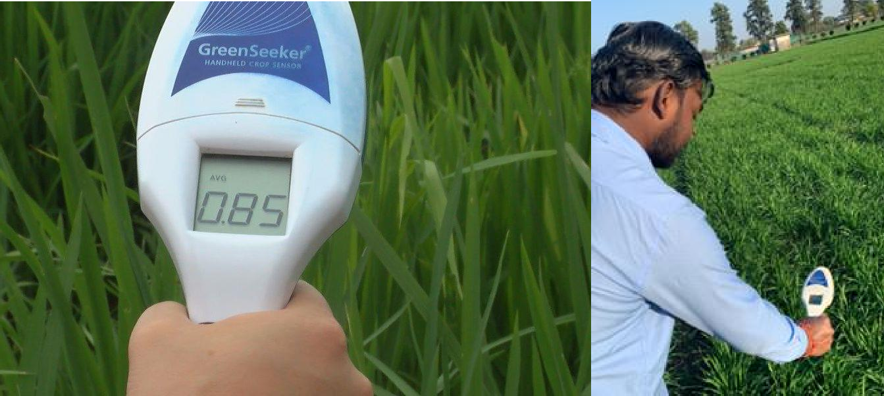
(b)
Fig. 5. Crop sensors (a) SPAD meter measuring chlorophyll content, and (b) Green seeker measuring NDVI to monitor crop health and growth.

- Animal Health Sensors: In livestock farming, sensors can monitor the health and well-being of animals by tracking vital signs such as body temperature, heart rate, and feeding behavior. Early detection of health issues can prevent disease outbreaks and improve animal welfare (Neethirajan et al., 2017). Figure 6 shows the health monitoring sensor.
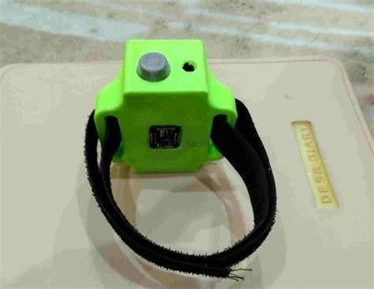 | 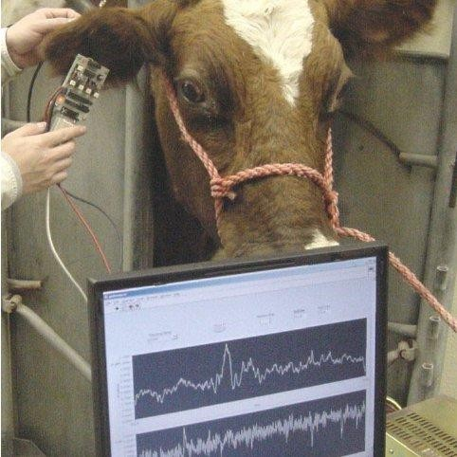
(a) | (b)
Fig. 6. Animal health sensors (a) wearable sensor (b) monitoring of animal health using sensor

- GPS and Drone Sensors: Global Positioning System (GPS) and drone-based sensors provide spatial data that aids in precise field mapping, crop monitoring, and yield estimation (El-Sharkawy et al., 2016; Anand et al., 2023; Ashraf et al., 2023; Padhiary et al., 2025). They enhance the overall efficiency of farm management. Figure 7 shows different sensors which can be mounted on drones to measure different crop parameters such as yield estimation, disease detection and irrigation and others.

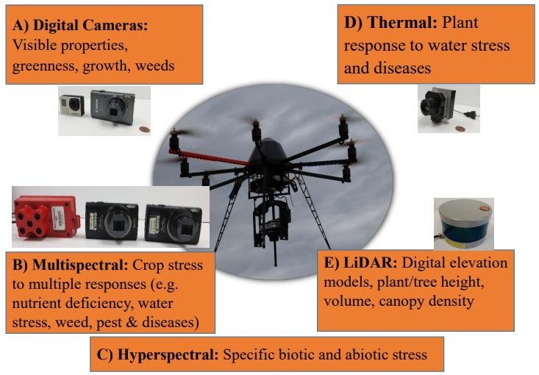
Fig. 7. Different optical sensors used on drones to monitor crop health and yield estimation.
In conclusion, these sensors play an essential role in enhancing precision farming by providing real-time, accurate data on soil, weather, crops, livestock, and field conditions. Their integration enables informed decision-making, optimizing resource use, improving productivity, and promoting sustainable agricultural practices.

Considerations for using sensors in agriculture
The integration of sensors in agricultural practices necessitates careful consideration of several critical factors to ensure their effective deployment and utility (Fig. 8). Key considerations include the selection of appropriate sensor types based on the specific agricultural application, such as soil moisture monitoring, crop health assessment, or climate data collection. The environmental durability and accuracy of sensors are paramount, given the often harsh and variable field conditions. Additionally, issues related to data management, including data volume, transmission reliability, and cybersecurity, must be addressed to enable seamless integration into broader farm management systems. Economic factors, such as initial investment costs, maintenance requirements, and potential return on investment, also play a significant role in adoption decisions. Furthermore, user-friendliness and the need for technical training are crucial to ensure widespread acceptance among farmers. Below are some major considerations for using sensors in agriculture:
- Selection of the Right Sensors: Choose sensors that are suitable for the specific needs of your farm. This might include soil moisture sensors, weather sensors, nutrient sensors, or even drones equipped with various sensors (Saranya et al., 2023).
- Accuracy and Calibration: Ensure that the sensors are accurate and properly calibrated. Regular maintenance and calibration are essential to ensure the data they provide is reliable.
- Placement and Installation: Proper sensor placement is crucial. Sensors should be strategically located to collect representative data. For example, soil moisture sensors should be placed at different depths to monitor soil conditions accurately.
- Data Integration: Integrate sensor data with other farm management systems, such as GPS, GIS, and farm management software, to provide a comprehensive view of your operations (Hussain and Kumar, 2025).
- Data Management, Storage and Security: Consider how you will store and manage the large volume of data generated by sensors. Cloud-based solutions are often used for data storage and accessibility. Ensure that the data collected by sensors is protected from unauthorized access and cyber threats. Data security is crucial to protect sensitive farm information (Peladarinos et al., 2023).
- Power and Connectivity: Ensure that sensors have a reliable power source, whether through batteries, solar panels, or other means. Also, consider connectivity options such as cellular, Wi-Fi, or LoRa to transmit data.
- Scalability and Interoperability: Plan for scalability in case you want to expand your sensor network in the future. Ensure that your system can accommodate additional sensors without major disruptions. Choose sensors and systems that are compatible with each other to facilitate data exchange and analysis.
- Data Analysis and Interpretation: Implement algorithms and analytics tools to process and interpret the sensor data. This can provide actionable insights for decision-making (Alahmad et al., 2023).
- Alerts and Notifications: Set up alerts and notifications so that you can receive real-time information about critical conditions or events on your farm, such as sudden weather changes or irrigation system failures.
- Cost-Benefit Analysis: Evaluate the costs associated with purchasing, installing, and maintaining sensors against the potential benefits, such as increased yield, reduced resource usage, and improved efficiency.
- Regulatory Compliance: Be aware of any regulations or standards related to sensor use in agriculture, especially if you are using sensors for monitoring purposes in areas like water quality or pesticide application.
- Environmental Impact: Consider the environmental impact of sensor deployment, including the disposal of sensor components and their energy consumption. Sustainable sensor choices can align with eco-friendly farming practices (Yin et al., 2021).
- Farm Specificity: Keep in mind that each farm is unique, so tailor your sensor deployment and data analysis to suit your specific crops, climate, and farming goals.
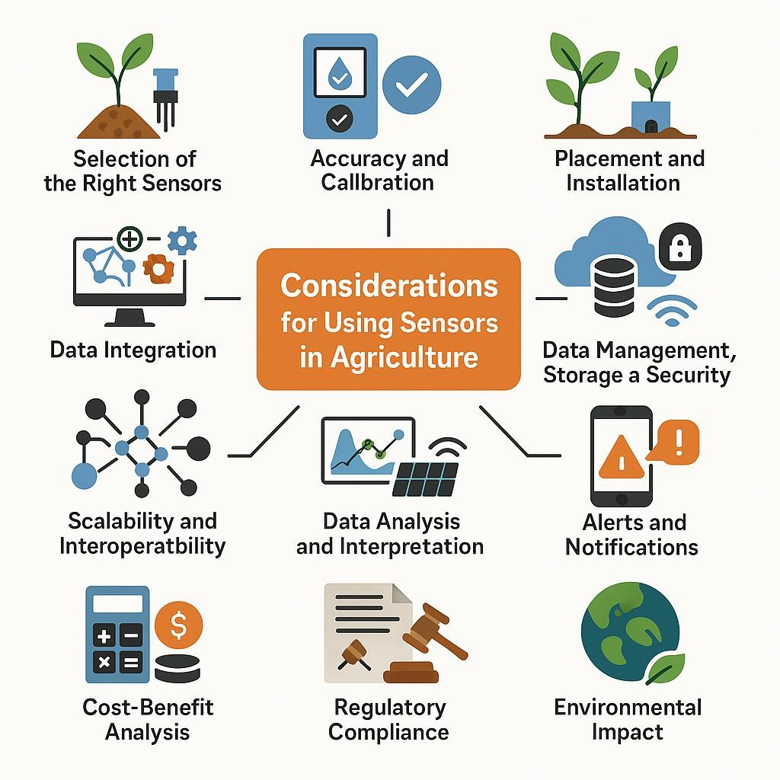
Fig. 8. Considerations for using agricultural sensors

Benefits of Sensors and Instrumentation in Precision Agriculture
Sensors and instrumentation play a pivotal role in advancing precision agriculture by enabling real-time monitoring, accurate data collection, and informed decision-making. These technologies optimize resource utilization, enhance crop productivity, and minimize environmental impact. Furthermore, they facilitate predictive analysis, promote sustainable farming practices, and contribute significantly to the efficiency and profitability of agricultural operations (Fig. 9). Below are some of the key benefits of sensors and instrumentation in precision agriculture:

Enhanced Resource Management:
  - Optimized Water Usage: Soil moisture sensors allow farmers to monitor soil moisture levels in real-time. This information helps them schedule irrigation precisely, reducing water wastage and energy consumption (Kumar et al., 2018 a,b).
  - Efficient Fertilizer Application: Nutrient sensors can measure soil nutrient levels and plant requirements, enabling farmers to apply fertilizers only where and when needed. This reduces over-fertilization, minimizes nutrient runoff, and saves costs (Sahni et al., 2018a).
  - Improved Pest and Disease Management: Sensors can detect early signs of pest infestations and diseases, enabling targeted interventions. This reduces the need for broad-spectrum pesticides, lowering environmental impact and costs (El-Ghany et al., 2020).

Increased Crop Yields:
  - Precision Planting: GPS-guided planters equipped with sensors ensure accurate seed placement and spacing, optimizing crop establishment and yield potential.
  - Crop Monitoring: Crop sensors and drones equipped with multispectral cameras monitor plant health and growth throughout the season, allowing timely adjustments in irrigation, fertilization, and pest control to maximize yields (Muruganantham et al., 2022).

Environmental Sustainability:
  - Reduced Environmental Impact: Precision agriculture minimizes the overuse of resources such as water, fertilizer, and pesticides, reducing the environmental footprint of farming operations (Joshi et al., 2023).
  - Preservation of Natural Habitats: By using sensors to target inputs precisely, farmers can reduce the need to expand agricultural land into natural habitats, helping to preserve biodiversity.

Data-Driven Decision Making: .

Real-Time Data: Sensors provide real-time data on various environmental factors, enabling farmers to respond quickly to changing conditions and make data-driven decisions (Wang et al., 2022).
      - Historical Data: Sensors collect data over time, allowing farmers to analyze trends, make long-term plans, and continuously improve their practices.

Cost Savings:
  - Optimized Inputs: Precision agriculture helps farmers use inputs such as seeds, fertilizers, and pesticides more efficiently, resulting in cost savings (Awais et al., 2022).
  - Labor Efficiency: Automation and sensor-driven equipment reduce the need for manual labor, further reducing operational costs.

Improved Livestock Management:
  - Animal Health Monitoring: Sensors can track the health and well-being of livestock, allowing early detection of diseases and optimizing feeding practices (Akhigbe et al., 2021).
  - Livestock Tracking: GPS and RFID sensors help farmers keep track of the location and behavior of animals, improving overall management.

Market Access and Traceability:
  - Quality Control: Sensors can monitor crop and livestock quality parameters, ensuring that products meet market standards and enhancing market access.
  - Traceability: Sensor data can be used to trace the origin and production history of agricultural products, providing transparency to consumers concerned about food safety and sustainability.

Risk Mitigation:
  - Weather Monitoring: Weather sensors provide valuable data for assessing climate- related risks, allowing farmers to implement strategies to mitigate the impact of extreme weather events.
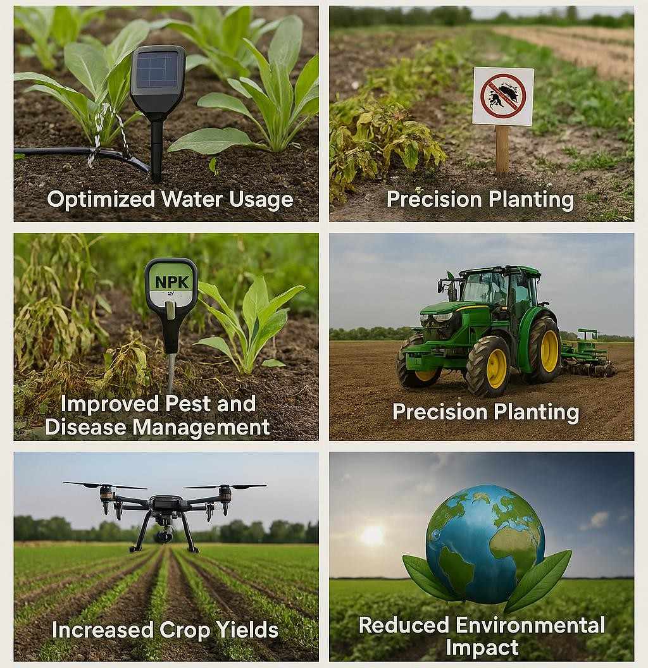
Fig. 9. Benefits of using sensors in agriculture
Sensors and instrumentation are integral components of precision agriculture, offering a wide range of benefits to farmers and the environment. By harnessing the power of real-time data and automation, precision agriculture not only increases agricultural productivity but also contributes to sustainable and environmentally responsible farming practices. As technology continues to advance, the potential for sensors and instrumentation to further revolutionize agriculture and address global food security challenges is substantial.

Challenges in Using Sensors and Instrumentation in Agriculture
The application of sensors and instrumentation in agriculture has the potential to significantly improve crop yields, resource efficiency, and overall farm management. However, there are several challenges associated with their implementation:
- Cost: High-quality sensors and instrumentation can be expensive to purchase, install, and maintain. Many farmers, especially small-scale ones, may find it challenging to justify the initial investment (Guebsi et al., 2024).
- Data Management: Sensors generate large volumes of data, which can be overwhelming for farmers to manage and analyze. Data storage, processing, and interpretation can be complex and require specialized skills and tools (Chin et al., 2023).
- Compatibility: Integrating various sensors and instrumentation from different manufacturers can be challenging due to compatibility issues. Farmers may face difficulties in creating a seamless and interconnected sensor network on their farms.
- Power Supply: Many farms, especially in remote areas, may lack reliable and continuous power sources. Sensors often require a stable power supply, and the lack of it can hinder their operation.
- Calibration and Maintenance: Sensors and instrumentation need regular calibration and maintenance to ensure accurate measurements. Farmers may lack the necessary knowledge or resources to perform these tasks, leading to inaccurate data.
- Environmental Conditions: Agricultural environments can be harsh, with exposure to extreme temperatures, moisture, and dust. This can affect the durability and performance of sensors and instrumentation, necessitating protective measures.
- Data Privacy and Security: The collection of farm data, including sensitive information such as crop yield and resource usage, raises concerns about data privacy and security. Farmers need to ensure that their data is protected from unauthorized access and potential breaches (Basri et al., 2021).
- Education and Training: Farmers and farmworkers may require training to effectively use and interpret data from sensors and instrumentation. A lack of knowledge and skills can hinder the adoption of these technologies (Edulakanti et al., 2023).
- Scalability: Adapting sensor systems to different types of crops, farm sizes, and agricultural practices can be challenging. A one-size-fits-all approach may not work, and customization may be required.
- Return on Investment (ROI): Demonstrating a clear and substantial ROI can be challenging for some farmers, making it difficult to convince them to invest in sensor technology, especially if they have limited access to credit or financial resources.
- Adoption Barriers: Resistance to change and traditional farming practices can act as significant barriers to the widespread adoption of sensor technology in agriculture (Kumar et al., 2024).
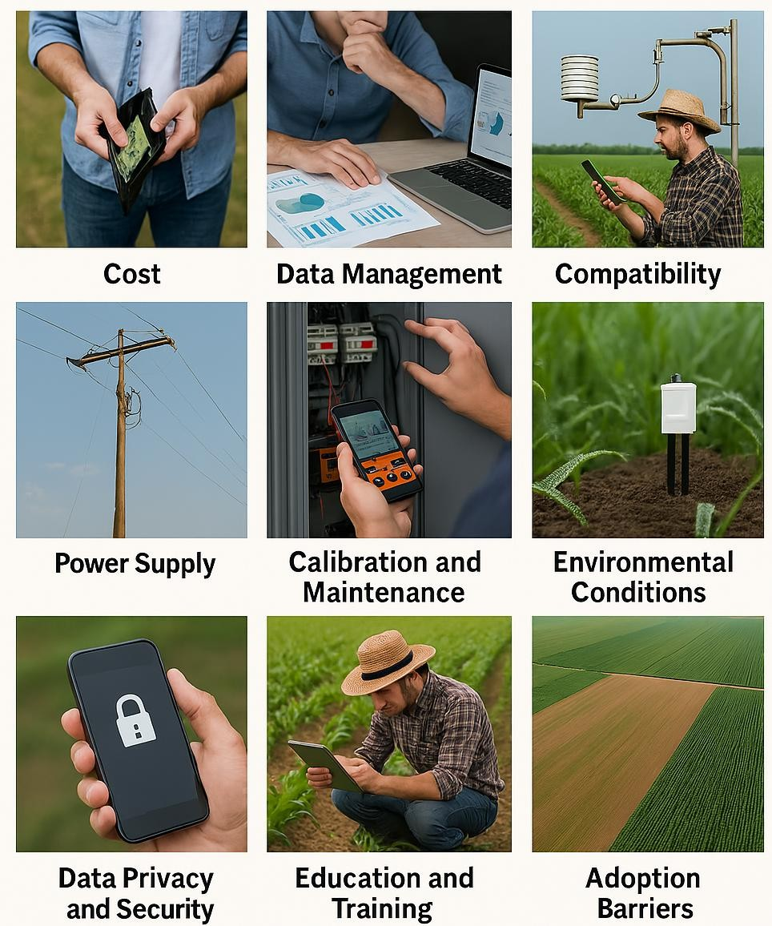
Fig. 10. Various challenges and barriers in using agricultural sensors

Conclusions

A new era in farming has begun with the use of sensors and instrumentation in precision agriculture, which has completely changed the way agricultural operations are run. By allowing for the optimization of both inputs and outputs, these cutting-edge technologies have greatly improved farming operations' sustainability, accuracy, and efficiency. Sensor systems enable farmers to make well-informed, data-driven decisions that increase output while preserving precious resources by providing real-time data on important variables including crop health, weather patterns, soil conditions, and equipment performance. In order to meet the twin challenges of feeding the world's rapidly expanding population and reducing the environmental impact of agricultural operations, precision agriculture technology integration is essential. These technologies help reduce waste, maintain soil health, and increase overall farm resilience through resource-efficient tactics and site-specific management. Future developments in sensor technology, data analytics, artificial intelligence, and connectivity hold the promise of unleashing even more potential, further transforming farming methods and advancing the development of a more resilient, secure, and sustainable global food system.
Disclaimer (Artificial intelligence)

Author(s) hereby declare that NO generative AI technologies such as Large Language Models (ChatGPT, COPILOT, etc.) and text-to-image generators have been used during the writing or editing of this manuscript.
References
Abbasi, R., Martinez, P., & Ahmad, R. (2022). The digitization of agricultural industry–a systematic literature review on agriculture 4.0. Smart Agricultural Technology, 2, 100042.
Abdollahi, A., Rejeb, K., Rejeb, A., Mostafa, M. M., & Zailani, S. (2021). Wireless sensor networks in agriculture: Insights from bibliometric analysis. Sustainability, 13(21), 12011.
Akhigbe, B. I., Munir, K., Akinade, O., Akanbi, L., & Oyedele, L. O. (2021). IoT technologies for livestock management: a review of present status, opportunities, and future trends. Big data and cognitive computing, 5(1), 10.
Alahmad, T., Neményi, M., & Nyéki, A. (2023). Applying IoT sensors and big data to improve precision crop production: a review. Agronomy, 13(10), 2603.
Anand, R., Sahni, R. K., Kumar, S. P., Thorat, D. S. and Kumar A. K. (2023). Advancement in Agricultural Practices with Use of Drones in the context of Precision Farming. Global Journal of Engineering Sciences, 11 (2), 1-7.
Ashraf, A., Ahmad , L., Ferooz , K., Ramzan, S., Ashraf , I., Khan , J. N., Shehnaz, E., Ul-Shafiq, M., Akhter , S., Nabi , A., Rasool , R., & Nazir , S. (2023). Remote Sensing as a Management and Monitoring Tool for Agriculture: Potential Applications. International Journal of Environment and Climate Change, 13(8), 324–343. https://doi.org/10.9734/ijecc/2023/v13i81957
Awais, M., Li, W., Cheema, M. J. M., Zaman, Q. U., Shaheen, A., Aslam, B., ... & Liu, C. (2022). UAV-based remote sensing in plant stress imagine using high-resolution thermal sensor for digital agriculture practices: A meta-review. International Journal of Environmental Science and Technology, 1-18.
Basri, R., Islam, F., Shorif, S. B., & Uddin, M. S. (2021). Robots and drones in agriculture— a survey. Computer vision and machine learning in agriculture, 9-29.
Chin, R., Catal, C., & Kassahun, A. (2023). Plant disease detection using drones in precision agriculture. Precision Agriculture, 24(5), 1663-1682.
Edulakanti, S. R., & Ganguly, S. (2023). The emerging drone technology and the advancement of the Indian drone business industry. The Journal of High Technology Management Research, 34(2), 100464.
Elbasi, E., Mostafa, N., AlArnaout, Z., Zreikat, A. I., Cina, E., Varghese, G., ... & Zaki, C. (2022). Artificial intelligence technology in the agricultural sector: A systematic literature review. IEEE access, 11, 171-202.
El-Ghany, N. M., El-Aziz, S. E., & Marei, S. S. (2020). A review: application of remote sensing as a promising strategy for insect pests and diseases management. Environmental Science and Pollution Research, 27(27), 33503-33515.
El-Sharkawy, M. M., Sheta, A. S., Abd El-Wahed, M. S., Arafat, S. M., & Behiery, O. M. E. (2016). Precision Agriculture Using Remote Sensing and GIS for Peanut Crop Production in Arid Land. International Journal of Plant & Soil Science, 10(3), 1–9. https://doi.org/10.9734/IJPSS/2016/20539
Farooq, M. S., Riaz, S., Abid, A., Umer, T., & Zikria, Y. B. (2020). Role of IoT technology in agriculture: A systematic literature review. Electronics, 9(2), 319.
Guebsi, R., Mami, S., & Chokmani, K. (2024). Drones in precision agriculture: A comprehensive review of applications, technologies, and challenges. Drones, 8(11), 686.
Hoque, A., Padhiary, M., Prasad, G., & Kumar, K. (2025). Real-Time Data Processing in Agricultural Robotics. In Computer Vision Techniques for Agricultural Advancements (pp. 431–468). IGI Global. https://doi.org/10.4018/979-8-3693-8019-2.ch014
Jawad, H. M., Nordin, R., Gharghan, S. K., Jawad, A. M., & Ismail, M. (2017). Energy- efficient wireless sensor networks for precision agriculture: A review. Sensors, 17(8), 1781.
Joshi, A., Pradhan, B., Gite, S., & Chakraborty, S. (2023). Remote-sensing data and deep- learning techniques in crop mapping and yield prediction: A systematic review. Remote Sensing, 15(8), 2014.
Kayad, A., Paraforos, D. S., Marinello, F., & Fountas, S. (2020). Latest advances in sensor applications in agriculture. Agriculture, 10(8), 362.
Kumar M, Sahni RK, Waghaye AM and Nayak AK. 2018a. Precision Irrigation Technologies: A Present Need to Save for Future. Published on www.biotecharticles.com. https://biotecharticles.com/Agriculture-Article/Precision-Irrigation-Technologies-A-Present- Need-to-Save-for-Future-4382.html.
Kumar, M., Sahni, R.K., Waghaye, A.M., Nayak, A.K. and Kumar, D., 2018b. Automated Irrigation System for Rice: A Review. The Andhra Agriculture Journal, 65: 324-329.
Kumar, V., Kumar, P., Sahni, R.K. and Thomas, E., 2019. Design of tractor mounted hydraulically operated soil compaction measurement system. Multilogic in Science, 8(28): 53- 56.
Kumar, V., Sharma, K. V., Kedam, N., Patel, A., Kate, T. R., & Rathnayake, U. (2024). A comprehensive review on smart and sustainable agriculture using IoT technologies. Smart Agricultural Technology, 100487.
Lakhiar, I. A., Jianmin, G., Syed, T. N., Chandio, F. A., Buttar, N. A., & Qureshi, W. A. (2018). Monitoring and control systems in agriculture using intelligent sensor techniques: A review of the aeroponic system. Journal of sensors, 2018(1), 8672769.
Morchid, A., El Alami, R., Raezah, A. A., & Sabbar, Y. (2024). Applications of internet of things (IoT) and sensors technology to increase food security and agricultural Sustainability: Benefits and challenges. Ain Shams Engineering Journal, 15(3), 102509.
Muruganantham, P., Wibowo, S., Grandhi, S., Samrat, N. H., & Islam, N. (2022). A systematic literature review on crop yield prediction with deep learning and remote sensing. Remote Sensing, 14(9), 1990.
Neethirajan, S. (2017). Recent advances in wearable sensors for animal health management. Sensing and Bio-Sensing Research, 12, 15-29.
P. (2023). Enhancing smart agriculture by implementing digital twins: A comprehensive review. Sensors, 23(16), 7128.
Padhiary, M., & Roy, P. (2024). Collaborative Marketing Strategies in Agriculture for Global Reach and Local Impact: In S. C. Pant, V. G. Venkatesh, P. Panday, G. P. Shukla, & S. Parhi (Eds.), Emerging Trends in Food and Agribusiness Marketing (pp. 219–252). IGI Global. https://doi.org/10.4018/979-8-3693-6715-5.ch008
Padhiary, M., Saikia, P., Roy, P., Hussain, N., Kumar, K., Padhiary, M., Saikia, P., Roy, P., Hussain, N., & Kumar, K. (2025). A Review on Advancing Agricultural Efficiency through Geographic Information Systems, Remote Sensing, and Automated Systems. Cureus Journals, 2(1). https://doi.org/10.7759/s44388-024-00559-7
Peladarinos, N., Piromalis, D., Cheimaras, V., Tserepas, E., Munteanu, R. A., & Papageorgas,
Rathnayake, A.P., Sahni, R.K., Khot, L.R., Hoheisel, G.A. and Zhu, H., (2022). Intelligent sprayer spray rates optimization to efficiently apply chemicals in modern apple orchards. Journal of the ASABE, 65(6), 1411-1420.
Roy, P., Padhiary, M., Hoque, A., Sahu, B., Roy, D., & Kumar, K. (2025). Machine Learning for Precision Agriculture and Crop Yield Optimization: Techniques and Applications. In The Role of Artificial Intelligence in Advancing Applied Life Sciences (pp. 189–234). IGI Global. https://doi.org/10.4018/979-8-3693-9208-9.ch007
Sahni RK, Kumar V, SP Kumar, NS Chandel, PS Tiwari. 2018a. Precision Agriculture Technologies, Published on www.biotecharticles.com. https://biotecharticles.com/Agriculture-Article/Precision-Agriculture-Technologies- 4383.html.
Sahni RK, Patel A, Kumar M, Thorat DS, Kumar V. 2018b. Status of farm mechanization in indian agriculture. Biotech Articles. https://www.biotecharticles.com/Agriculture- Article/Status-of-Farm-Mechanization-in-Indian-Agriculture-4468.html.
Sahni, R.K., Kumar, D., Tiwari, P.S., Kumar, V., Kumar, S.P. and Chandel, N.S., 2018c. DGPS based on-the-go soil nutrient mapping system: A Review. The Andhra Agriculture Journal 65: 1-6.
Sahni, R.K., Ranjan, R., Khot, L.R., Hoheisel, G.A. and Grieshop, M.J., 2022. Reservoir Units Optimization in Pneumatic Spray Delivery-Based Fixed Spray System for Large-Scale Commercial Adaptation. Sustainability, 14(17), 10843.
Saranya, T., Deisy, C., Sridevi, S., & Anbananthen, K. S. M. (2023). A comparative study of deep learning and Internet of Things for precision agriculture. Engineering Applications of Artificial Intelligence, 122, 106034.
Shafi, U., Mumtaz, R., García-Nieto, J., Hassan, S. A., Zaidi, S. A. R., & Iqbal, N. (2019). Precision agriculture techniques and practices: From considerations to applications. Sensors, 19(17), 3796.
Singh RS and Sahni RK. 2019. Transformation of Indian agriculture through mechanization. Economic Affairs, 64(2), 297-303.
Soussi, A., Zero, E., Sacile, R., Trinchero, D., & Fossa, M. (2024). Smart sensors and smart data for precision agriculture: a review. Sensors, 24(8), 2647.
Thakur, D., Kumar, Y., Kumar, A., & Singh, P. K. (2019). Applicability of wireless sensor networks in precision agriculture: A review. Wireless Personal Communications, 107, 471- 512.
Tiwari PS, Gurung TR, Sahni RK, Kumar V. Agricultural mechanization trends in SAARC region. 2017. In Gurung, T. R., Kabir, W & Bokhtiar, S. M. (Eds.) Mechanization for Sustainable Agricultural Intensification in SAARC, Agriculture Centre, Dhaka, Bangladesh.; 302:1–45.
Tiwari PS, Sahni RK, Kumar SP, Kumar V and Chandel NS. 2019b. Precision agriculture applications in horticulture. Pantnagar Journal of Research, 17(1), 1-10.
Tiwari PS, Singh KK, Sahni RK, Kumar V. 2019a. Farm mechanization–trends and policy for its promotion in India. Indian Journal of Agricultural Sciences, 89(10), 1555-1562.
Ullo, S. L., & Sinha, G. R. (2021). Advances in IoT and smart sensors for remote sensing and agriculture applications. Remote Sensing, 13(13), 2585.
Wang, D., Cao, W., Zhang, F., Li, Z., Xu, S., & Wu, X. (2022). A review of deep learning in multiscale agricultural sensing. Remote Sensing, 14(3), 559.
Xie, D., Chen, L., Liu, L., Chen, L., & Wang, H. (2022). Actuators and sensors for application in agricultural robots: A review. Machines, 10(10), 913.
Xu, J., Gu, B., & Tian, G. (2022). Review of agricultural IoT technology. Artificial Intelligence in Agriculture, 6, 10-22.
Yin, H., Cao, Y., Marelli, B., Zeng, X., Mason, A. J., & Cao, C. (2021). Soil sensors and plant wearables for smart and precision agriculture. Advanced Materials, 33(20), 2007764.

