***Original Research Article***

**Development and Validation of the Assam Rural Livelihood and Farming Scale (ARLFS) for the Socio-Economic Assessment of Khuti System Dwellers, Assam, India**

**Abstract**

The study outlined the development and validation of the Assam Rural Livelihood and Farming Scale (ARLFS), a socio-economic assessment tool designed for Khuti system dwellers in Assam. The development process involved a systematic literature review, expert consultations, and focus group discussions with members of the target community. Initially, 30 items were identified to represent key domains such as livelihood security, access to basic services, technological and institutional linkages, and adaptive capacities. Content validity was assessed by a panel of 10 subject matter experts using Lawshe’s method, resulting in the selection of 18 items with Content Validity Ratios (CVR) ≥ 0.62. Items with lower CVRs were either revised or excluded. The scale’s overall content validity was further supported by high Scale-level Content Validity Index (S-CVI) scores: S-CVI/UA = 0.875 and S-CVI/Ave = 0.9813, indicating strong expert agreement. The ARLFS used an 8-point scoring system for each component, ranging from 0 (indicating highest vulnerability) to 8 (indicating the most favorable condition). The total score reflected a household’s socio-economic vulnerability level. Face validity was ensured through expert feedback, and the scale was pilot-tested on 20 Khuti households to evaluate clarity, feasibility, and internal consistency. Reliability was measured using Cronbach’s alpha, with a threshold of α ≥ 0.70 considered acceptable. The results demonstrated that the ARLFS was both valid and reliable for assessing socio-economic and farming vulnerabilities among nomadic and semi-settled livestock communities in Assam. Its structured design enabled a detailed evaluation of multiple livelihood dimensions and provided a practical foundation for targeted interventions and evidence-based policymaking aimed at marginalized rural populations.

**Keywords:** Khuti System, Rural livelihood, Livestock farming, Socio-Economic Assessment, Scale validation, Assam

**1. Introduction**

Livestock farming in India has historically been an integral part of rural livelihoods, grounded in traditional ecological knowledge and regionally adapted practices (Banda & Tanganyika, 2021; Mukesh et al., 2022). In the north-eastern state of Assam, the tropical monsoon rainforest climate, with its abundant rainfall, fertile floodplains, and rich ecological diversity, has shaped a distinctive agricultural and pastoral landscape (De, 2021; Gogoi & Rao, 2022; Upadhyay & Upadhyay, 2025). This environment has nurtured diverse livestock production systems deeply embedded in the socio-cultural identity of rural communities (Amonge, 1993; Islam et al., 2017; Chetry & Kar, 2020; Sarma et al, 2025). Among these are intensive, semi-intensive, and extensive models, along with the uniquely Assamese Khuti system, a traditional open herding method involving seasonal migration, indigenous veterinary practices, and communal use of natural resources (Komor & Borah, 2015; Chetry & Kar, 2021; Gogoi et al., 2025). These systems rely on regionally adapted indigenous breeds such as Luit and Manah buffalo, Lakhimi cattle, Assam Hill goat, Bengal Goat, indigenous pigs, and Pati duck, which contribute substantially to both biodiversity and rural economies (NBAGR, 2017; Kadirvel et al., 2019; Islam et al., 2024; Sarma et al., 2025; NBAGR, 2025).

However, these traditional systems are under growing pressure from environmental and socio-economic challenges (Gómez-Baggethun et al., 2013; Bretschger & Pittel, 2020; Farghali et al., 2023; Gogoi, et al., 2023). Climate-induced events such as recurrent floods, riverbank erosion, and seasonal variability threaten the stability of livestock production (Borah et al, 2022; Saikia & Mahanta, 2024). Concurrently, livestock farmers, particularly nomadic and semi-nomadic Khuti dwellers, face limited access to veterinary care, formal education, land tenure security, infrastructure, legal identity, and institutional credit, which compound their vulnerability (Verma et al., 2019; Kalogiannidis, 2023; Vyas, 2024).

Over the years, several socio-economic assessment tools have been developed and widely applied in India, including the **Kuppuswamy Scale** (Kuppuswamy, 1976), **BG Prasad Scale** (Prasad, 1961), **UdaiPareekh Scale** (Pareekh, 1964), Aggarwal’s scale (Aggarwal et al., 2005) and the **NFHS Wealth Index** (IIPS & ICF, 2021). While useful in their respective domains, these tools are often limited in scope, being primarily urban-centric, income-focused, or unable to reflect the complex, community, based dynamics of rural and nomadic livestock livelihoods (Alkire & Foster, 2011; Javalkar et al., 2024; Lakhumna et al., 2024).

To address this gap, the **Assam Rural Livelihood and Farming Scale (ARLFS)** was developed as a comprehensive, context-specific tool for assessing the socio-economic and environmental realities of livestock farming households, particularly those practicing Khuti-based, semi-intensive, and extensive herding systems. The following table briefly compares the ARLFS with other commonly used socio-economic scales to highlight its distinct relevance and utility:

List 1: **The table briefly compares the ARLFS with other commonly used socio-economic scales to highlight its distinct relevance and utility**

|  |  |  |  |  |  |  |
| --- | --- | --- | --- | --- | --- | --- |
| Scales | Target | Focus | Key Factors | Livestock/Farming | Strength | Limitation |
| ARLFS | Assam rural/ Khuti- livestock keepers | Rural livelihoods, farming & livestock | Income, assets, education, environment | Yes | Tailored for rural livestock | Complex, requires detailed data collection |
| Kuppuswamy | Urban populations | Urban SES classification | Education, occupation, income | No | Simple, widely used | Urban only |
| BG Prasad | General rural & urban | Income-based SES | Income | No | Simple, income-focused | Needs regular updates |
| UdaiPareekh | Rural populations | Social & caste | Land, caste, occupation | No | Captures rural social structure | Less economic detail |
| NFHS Wealth Index | General population | Asset-based wealth classification | Household assets & amenities | No | Less biased by income reporting | Misses rural livelihood specifics |
| Aggarwal’s | General population | Education, occupation, income | Education, occupation, income | No | Combines multiple SES factors | No livestock/environment focus |

The comparison highlights that while many existing socio-economic scales provide useful frameworks for urban or general rural populations, the ARLFS is distinctively tailored to the specific livelihood realities of Assam’s rural nomadic livestock keepers, integrating environmental and livestock-related dimensions that are critical for targeted interventions in this context.

**2. Materials and Methods**

**2.1 Scale Development**

The ARLFS was developed through literature reviews, expert input, and focus group discussions with Khuti system stakeholders. An initial pool of 30 items was generated based on key socio-economic and farming-related components relevant to Khuti system dwellers in Assam. These components included livelihood security, access to resources and inputs, institutional linkage, adaptive capacity, technological integration, and additional socio-economic indicators tailored specifically to the local context.

**2.2 Content Validity**

Content validity was assessed by a panel of 10 subject matter experts, including agricultural scientists, rural development officers, and veterinary professionals. Each expert independently rated the items on a three-point scale: “Essential,” “Useful but not essential,” or “Not necessary.” The Content Validity Ratio (CVR) for each item was calculated using Lawshe’s formula to determine the necessity of the items. Items with a CVR value equal to or greater than the threshold for 10 experts were retained. The overall Scale-level Content Validity Index (S-CVI) was computed using both the Universal Agreement (S-CVI/UA) and the Average (S-CVI/Ave) methods. For N=10, the Lawshecritical value for CVR is approximately 0.62, meaning items with CVR ≥ 0.62 are retained. Following this evaluation, items that did not meet the CVR threshold or were deemed redundant were removed, resulting in a refined scale of 18 items from the initial 30-item pool. This ensured that the final scale retained only the most relevant and representative indicators for assessing the socio-economic and farming conditions of Khuti dwellers.

### ****Content Validity Ratio (CVR):****

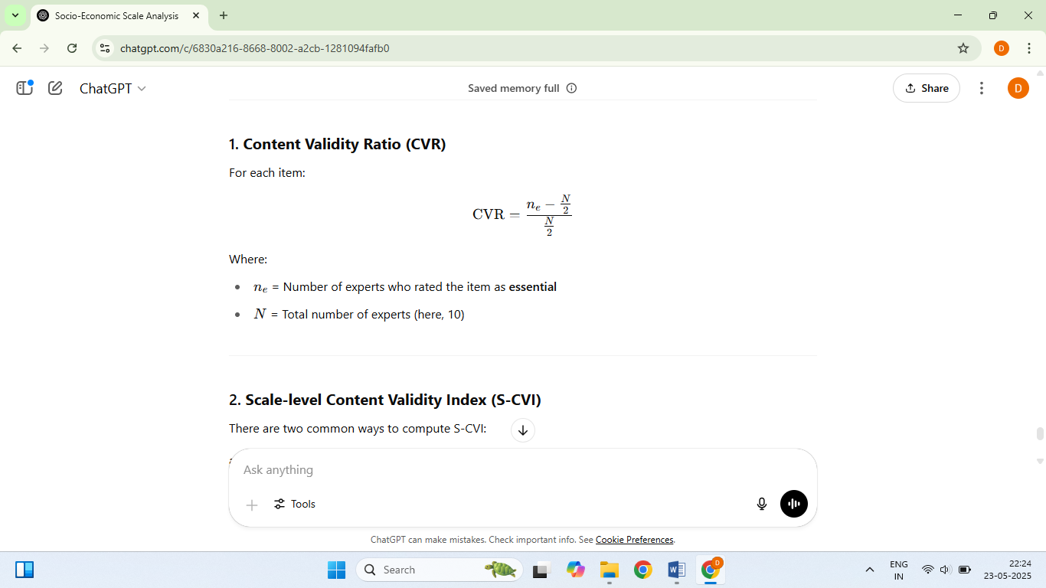For each item:

Where ne =Number of experts who rated the item as **essential**

**N=**Total number of experts (10)

### ****Scale-level Content Validity Index (S-CVI)****

There are two common ways to compute S-CVI:

#### Universal Agreement method (S-CVI/UA)

The proportion of items on the scale that achieved universal agreement (i.e., all experts rated them as essential or relevant)

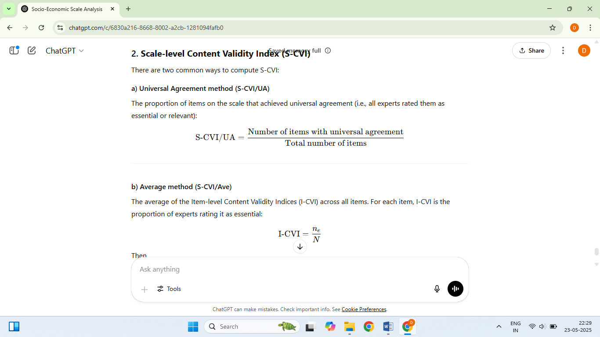

#### Average method (S-CVI/Ave)

The average of the Item-level Content Validity Indices (I-CVI) across all items. For each item, I-CVI is the proportion of experts rating it as essential

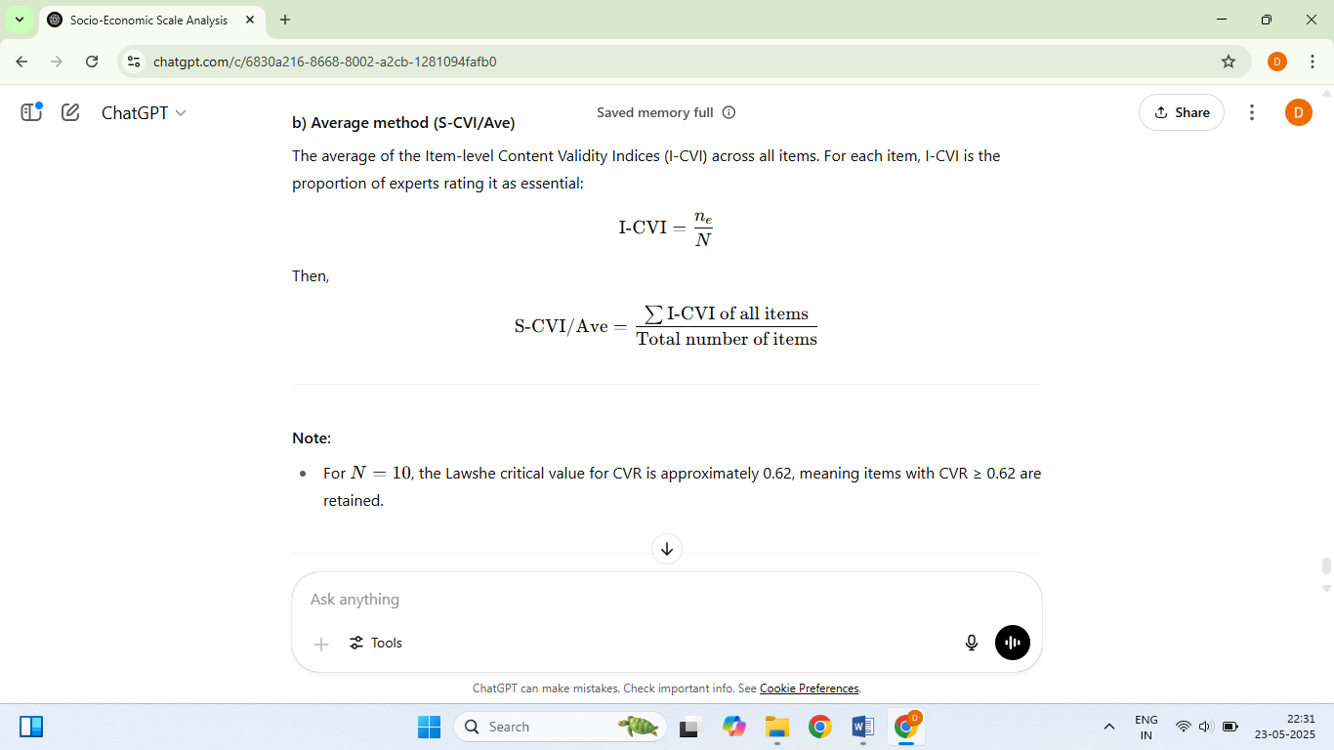



Then,

**2.3 Scoring pattern**

The ARLFS employs a structured scoring system where each component is rated on a 0–8 scale in even intervals (0, 2, 4, 6, 8), reflecting levels of vulnerability to well-being. A score of 0 indicates the most adverse condition or highest vulnerability, while a score of 8 represents optimal or most favorable status.

This evenly spaced scale was chosen for the following reasons:

* **Clarity and Consistency**: It allows consistent interpretation of socioeconomic status across all components and respondents.
* **Avoidance of Central Tendency Bias**: The absence of a neutral midpoint compels respondents or evaluators to make a definitive judgment.
* **Simplicity in Aggregation**: The scoring enables straightforward calculation of total scores and facilitates classification into socio-economic categories.
* **Suitability for Field Use**: The scale's simplicity enhances usability in rural settings and field data collection environments.
* **Compatibility with Statistical Validation**: The interval structure supports psychometric evaluations such as Content Validity Ratio (CVR) and Cronbach’s alpha for internal consistency.

The total score is derived by summing the scores across all components (maximum possible = 144). These scores are then categorized into four socio-economic status (SES) groups using equal intervals:

* Very Low (0–36)
* Low (37–72)
* Medium (73–108)
* High (109–144)

These thresholds provide a framework for consistent classification, although they may be adapted based on data distribution or specific analytical objectives.

**2.4 Face Validity**

Face validity was established through expert review to ensure the items appeared appropriate, relevant, and representative of the intended constructs. Subject matter experts evaluated whether the scale items were conceptually aligned with the domains of khuti livelihood and farming vulnerability.

**2.5 Pilot Testing and Reliability Analysis**

The draft ARLFS was pilot tested with 20 Khuti households in a non-sampling area, to assess clarity, feasibility, and respondent understanding. Based on feedback, items were refined for relevance and comprehension. Internal consistency was measured using **Cronbach’s alpha (α)** to evaluate the reliability of the overall scale and its sub-domains.

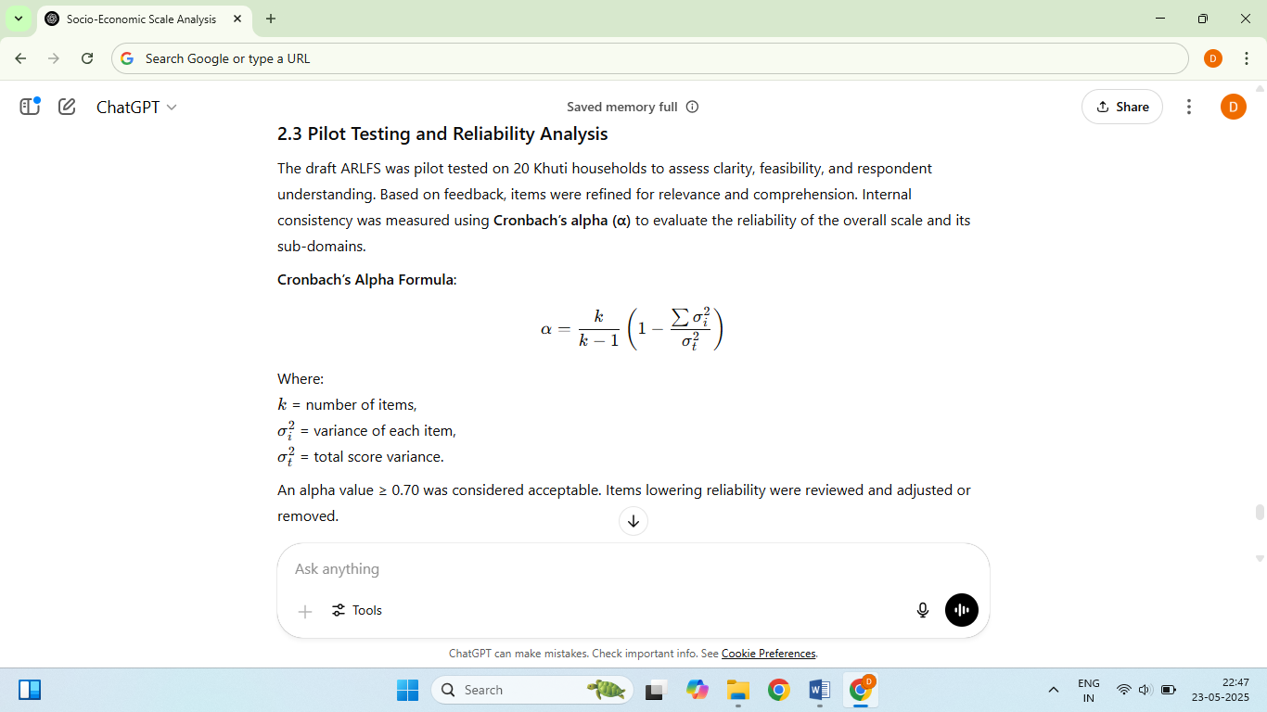**Cronbach’s Alpha Formula**:



According to standard psychometric guidelines

**• α ≥ 0.9 =** Excellent

**• 0.8 ≤ α < 0.9 =** Good

**• 0.7 ≤ α < 0.8 =** Acceptable

**• α< 0.7**= Questionable or Poor

Cronbach’s alpha values ≥ 0.70 were deemed acceptable based on established psychometric standards. Items lowering reliability were reviewed and adjusted or removed.

**2.6 Data Analysis**

All statistical analyses were performed using IBM SPSS Statistics version 25 (IBM Corp., Armonk, NY, USA) and Microsoft Excel 2019 (Microsoft Corp., Redmond, WA, USA).



**3. Results and Discussion**

**3.1 Content Validity Results**

Table 1: The Content Validity Ratios (CVR) for the 30 ARLFS components are presented below:

|  |  |  |  |  |  |
| --- | --- | --- | --- | --- | --- |
| Sl. No. | Component | Ne | N | CVR | Status |
| 1 | Household Demographic Composition | 10 | 10 | 1.00 | Accepted |
| 2 | Livelihood Security | 10 | 10 | 1.00 | Accepted |
| 3 | Food Security | 10 | 10 | 1.00 | Accepted |
| 4 | Psychosocial Well-being | 5 | 10 | 0.00 | Rejected |
| 5 | Type of Shelter | 10 | 10 | 1.00 | Accepted |
| 6 | Socio-Demographic Profile | 4 | 10 | -0.20 | Rejected |
| 7 | Access to Healthcare | 10 | 10 | 1.00 | Accepted |
| 8 | Education for Children | 8 | 10 | 0.60 | Reconsider |
| 9 | Child Nutrition & Health | 5 | 10 | 0.00 | Rejected |
| 10 | Adult Education & Skills | 6 | 10 | 0.20 | Rejected |
| 11 | Asset Ownership | 10 | 10 | 1.00 | Accepted |
| 12 | Social Integration | 10 | 10 | 1.00 | Accepted |
| 13 | Mobility Control & Autonomy | 9 | 10 | 0.80 | Accepted |
| 14 | Land Tenure & Eviction Risk | 10 | 10 | 1.00 | Accepted |
| 15 | Livestock Health & Productivity | 10 | 10 | 1.00 | Accepted |
| 16 | Environmental & Livelihood Vulnerability | 10 | 10 | 1.00 | Accepted |
| 17 | Psychological Stress & Coping Mechanisms | 6 | 10 | 0.20 | Rejected |
| 18 | Veterinary & Extension Service Accessibility | 10 | 10 | 1.00 | Accepted |
| 19 | Credit Facility Access | 10 | 10 | 1.00 | Accepted |
| 20 | Institutional Linkage | 10 | 10 | 1.00 | Accepted |
| 21 | Market Access & Price Realization | 10 | 10 | 1.00 | Accepted |
| 22 | Access to Communication Infrastructure | 6 | 10 | 0.20 | Rejected |
| 23 | Household Decision-Making & Gender Equity | 5 | 10 | 0.00 | Rejected |
| 24 | Savings & Financial Security | 5 | 10 | 0.00 | Rejected |
| 25 | Clean Water & Sanitation | 7 | 10 | 0.40 | Rejected |
| 26 | Energy Access | 5 | 10 | 0.00 | Rejected |
| 27 | Cultural Practices & Traditions | 5 | 10 | 0.00 | Rejected |
| 28 | Digital Connectivity & Information Access | 9 | 10 | 0.80 | Accepted |
| 29 | Legal Awareness & Rights Knowledge | 5 | 10 | 0.00 | Rejected |
| 30 | Transportation Access | 10 | 10 | 1.00 | Accepted |

Note: ‘Ne’ = Number of experts rating the item as essential; ‘N’ = Total number of experts

Based on the Content Validity Ratio (CVR) analysis detailed in Section 2.2, 18 components met the required threshold (CVR ≥ 0.62) and were included in the final version of the Assam Rural Livelihood and Farming Scale (ARLFS). One component (Education for Children) fell just below the cutoff (CVR = 0.60) and was flagged for possible reconsideration. Meanwhile, 11 components with lower CVR values were excluded from the final scale. Table 1 provided a summary of the CVR scores and the retention status for all 30 components initially proposed. To further support the scale’s content validity, Scale-level Content Validity Index (S-CVI) metrics were also assessed. The S-CVI/UA (Universal Agreement) was calculated at 0.83, showing that 83% of the items had received unanimous agreement from the expert panel. The S-CVI/Ave (Average Agreement) was computed at 0.956, indicating a high level of overall consensus among experts. These results affirmed the scale’s strong relevance and expert approval.

These findings aligned with well-established guidelines in scale development, which suggested that an S-CVI/Ave score of 0.90 or above was typically regarded as acceptable for demonstrating strong content validity (Wei et al., 2025). Therefore, the results supported the conclusion that the revised ARLFS was built on a robust foundation of expert validation, positioning it well for further psychometric evaluation and practical use in the field. Similar kinds of findings were also reported by Egger-Rainer (2018) and Suryadi et al. (2023) in their studies.

**3.2 Explanation of Scale Components and Scoring**

Each of the 18 retained components in the ARLFS is assigned a score based on specific criteria, with values ranging from 0 to 8. The detailed scoring criteria are provided in **Table**  below.

**Table 2.** Scoring Criteria for ARLFS Components

|  |  |  |
| --- | --- | --- |
| **Sl No** | **Component** | **Scoring Criteria Description** |
| 1 | Household Demographic Composition | 0 = Only elderly person or single parent with many dependents; no working-age members; 2 = Mostly children and elderly; no active working adult; 4 = Mostly dependents one working adult; 6 = Multiple working members; some dependents remain; 8 = Well-balanced household with adequate workforce and dependents |
| 2 | Livelihood Security | 0 = No earnings; relies entirely on external support; 2 = Single source of income; irregular or unpredictable; 4 = One stable income; seasonal variation; 6 = Two income sources; somewhat stable; 8 = Multiple stable and diversified incomes |
| 3 | Food Security | 0 = No food security; 2 = Frequent food shortages; 4 = Seasonal food insecurity; 6 = Minor shortages occasionally; 8 = Full food security year-round |
| 4 | Type of Shelter | 0 = No permanent shelter; 2 = Temporary shelter (tent, thatch); 4 = Semi-permanent shelter (mud/brick); 6 = Permanent shelter, rented; 8 = Durable shelter with land tenure |
| 5 | Access to Healthcare | 0 = No access; 2 = Irregular, unqualified care; 4 = Some access to clinics; 6 = Regular access to basic healthcare; 8 = Regular affordable healthcare access |
| 6 | Education for Children | 0 = No schooling; 2 = Irregular or informal schooling; 4 = Primary education ongoing; 6 = Secondary education completed; 8 = Higher education or vocational training |
| 7 | Asset Ownership | 0 = No assets; 2 = One small asset; 4 = Few basic household assets; 6 = Productive assets (livestock/tools); 8 = Diversified productive assets |
| 8 | Social Integration | 0 = No interaction with community; socially excluded; 2 = Rarely interacts; not involved in any group/activity; 4 = Occasional interaction; minimal community participation; 6 = Regular interaction; part of local groups or activities; 8 = Active participation; strong social ties and community role |
| 9 | Mobility Control & Autonomy | 0 = Fully dependent; no control over movement of self or livestock; 2 = Movement of livestock and self is heavily restricted by family/community/authority; 4 = Limited control; sometimes needs permission; 6 = Mostly self-dependent; 8 = Full mobility autonomy |
| 10 | Land Tenure & Eviction Risk | 0 = No land tenure, high eviction risk; 2 = Temporary occupancy, no papers; 4 = Occupancy without secure rights; 6 = Possession with conditional security; 8 = Secure tenure, no eviction risk |
| 11 | Transportation Access | 0 = No transportation means; 2 = Limited, unreliable transportation access; 4 = Some access to public or private transport; 6 = Reliable transportation for household needs; 8 = Own vehicle(s) or frequent reliable transport |
| 12 | Livestock Health & Productivity | 0 = Poor health and productivity; 2 = Mostly weak, low production; 4 = Moderate health and output; 6 = Good health, regular productivity; 8 = Excellent health and productivity |
| 13 | Environmental & Livelihood Vulnerability | 0 = Highly vulnerable; 2 = Frequent disruptions; 4 = Occasional shocks; 6 = Mostly resilient; 8 = Resilient and adaptive |
| 14 | Veterinary & Extension Service Accessibility | 0 = No access; 2 = Rare emergency access; 4 = Some access to paravet/basic info; 6 = Regular field visits; 8 = Full and timely access |
| 15 | Credit Facility Access | 0 = No access; 2 = Informal lenders; 4 = Rare access through SHG; 6 = Periodic formal access; 8 = Easy credit access |
| 16 | Institutional Linkage | 0 = No linkage; 2 = Rare exposure; 4 = Occasional interaction; 6 = Regular interaction; 8 = Strong linkage with institutions |
| 17 | Market Access & Price Realization | 0 = No access or poor price realization; 2 = Limited access; 4 = Some access and price info; 6 = Good access with moderate price realization; 8 = Full market access and optimal price realization |
| 18 | Digital Connectivity & Information Access | 0 = No digital access or information; 2 = Rare/limited access; 4 = Occasional access; 6 = Regular access; 8 = Full, timely digital and information access |

**3.3 Reliability Analysis**

**Table 3. Reliability Analysis of ARLFS Components**

|  |  |  |  |
| --- | --- | --- | --- |
| Item No. | Item Description | Item-Total Correlation | Cronbach’s Alpha if Item Deleted |
| 1 | Household Demographic Composition | 0.71 | 0.864 |
| 2 | Livelihood Security | 0.65 | 0.869 |
| 3 | Food Security | 0.68 | 0.866 |
| 4 | Type of Shelter | 0.66 | 0.867 |
| 5 | Access to Healthcare | 0.70 | 0.865 |
| 6 | Education for Children | 0.63 | 0.870 |
| 7 | Asset Ownership | 0.67 | 0.868 |
| 8 | Social Integration | 0.61 | 0.872 |
| 9 | Mobility Control & Autonomy | 0.64 | 0.870 |
| 10 | Land Tenure & Eviction Risk | 0.69 | 0.866 |
| 11 | Transportation Access | 0.72 | 0.862 |
| 12 | Livestock Health & Productivity | 0.68 | 0.865 |
| 13 | Environmental & Livelihood Vulnerability | 0.70 | 0.864 |
| 14 | Veterinary & Extension Service Accessibility | 0.66 | 0.867 |
| 15 | Credit Facility Access | 0.67 | 0.868 |
| 16 | Institutional Linkage | 0.65 | 0.869 |
| 17 | Market Access & Price Realization | 0.69 | 0.865 |
| 18 | Digital Connectivity & Information Access | 0.72 | 0.862 |
|  | Overall Cronbach’s Alpha |  | 0.875 |

In Table 3, the internal consistency reliability of the Assam Rural Livelihood & Farming Scale (ARLFS) was evaluated using Cronbach’s alpha (α), based on pilot test data from 20 Khuti households. Since the post-feedback changes were minor and did not alter the items’ structure or meaning, re-administering the scale was not considered necessary for assessing reliability. This differed from the approach taken by Satyapriya et al. (2015), who evaluated reliability by administering their scale to 30 families and re-administering it after 60 days to measure test–retest reliability. While their method provided insight into the temporal stability of responses, the current study prioritized internal consistency to assess how well the items functioned together at one point in time. Both approaches were valid depending on the specific reliability focus.

The results supported this decision. The reliability analysis demonstrated strong internal consistency across the 18 retained items. Item-total correlations ranged from 0.61 to 0.72, exceeding the accepted threshold of 0.30, indicating that each item contributed meaningfully to the overall scale. The highest correlations were observed for Transportation Access and Digital Connectivity & Information Access (0.72), while Social Integration and Education for Children showed slightly lower but still acceptable values (0.61 and 0.63, respectively).

Additionally, Cronbach’s alpha values if individual items were deleted ranged from 0.862 to 0.872, which closely aligned with the overall alpha of approximately 0.875. This suggested that removing any item would not significantly improve reliability (Tavakol & Dennick, 2011). These findings confirmed that the ARLFS was a reliable and internally consistent instrument for measuring the socio-economic and livelihood conditions of households within the Khuti system in Assam.

**4. Conclusion, Limitation and Recommendation:**

The Assam Rural Livelihood & Farming Scale (ARLFS) has been successfully developed as a context-specific and reliable tool to assess the socio-economic and environmental conditions of livestock farming households, particularly those engaged in the traditional Khuti system. The scale incorporates multiple critical dimensions that capture the vulnerabilities and strengths of rural livestock farmers in Assam. Validation through expert consensus and pilot testing confirmed its clarity and internal consistency. The ARLFS provides a comprehensive framework that can support data-driven decision-making, inform policy, and guide targeted interventions aimed at improving livelihood security, adaptive capacity, and sustainability within Assam’s diverse livestock production systems.

Despite its strengths, the study has some limitations. The ARLFS was pilot tested on a relatively small sample size, which may limit the generalizability of results across different ecological and socio-cultural contexts within Assam. Certain components such as education for children, social integration, and environmental vulnerability scored just below the critical content validity threshold, indicating a need for further refinement. The reliance on self-reported data introduces potential bias and inaccuracies. Additionally, the cross-sectional nature of the study restricts the ability to capture temporal or seasonal variations in farming conditions. Important factors like psychosocial well-being and gender equity were excluded due to low validity scores, suggesting the need for separate focused assessments in the future.

To enhance the utility and applicability of the ARLFS, broader field testing with larger and more diverse samples across Assam’s regions is recommended. Components with borderline validity should be refined and re-evaluated to improve sensitivity and relevance. The scale should be integrated into routine monitoring and extension programs by government and NGOs to identify vulnerable households and tailor support accordingly. Developing complementary modules addressing psychosocial well-being, gender equity, and child nutrition would enrich future assessments. Capacity building for extension workers and community leaders on using the scale effectively can facilitate participatory appraisals and more precise interventions. Furthermore, policy measures should focus on improving access to veterinary services, education, land tenure security, and climate resilience programs, guided by insights derived from ARLFS assessments to strengthen rural livelihoods sustainably.

**COMPETING INTERESTS**

Authors have declared that no competing interests exist.

**DISCLAIMER (ARTIFICIAL INTELLIGENCE)**

Authors hereby declare that NO generative AI technologies such as Large Language Models (ChatGPT, COPILOT, etc) and text-to-image generators have been used during writing or editing of this manuscript.

**ACKNOWLEDMENT**

The authors sincerely acknowledge the support and guidance received from the associate departments of the College of Veterinary Science, AAU, Khanapara, Guwahati, and the Lakhimpur College of Veterinary Science, AAU, Joyhing, North Lakhimpur, Assam.

**REFERENCE**

Aggarwal, O. P., Bhasin, S. K., Sharma, A. K., Chhabra, P., Aggarwal, K., &Rajoura, O. P. (2005). A new instrument (scale) for measuring the socioeconomic status of a family: Preliminary study. Indian Journal of Community Medicine, 30, 305–310.

Alkire, S., & Foster, J. (2011). Counting and multidimensional poverty measurement. Journal of Public Economics, 95(7–8), 476–487. <https://doi.org/10.1016/j.jpubeco.2010.11.006>

Amonge, T. K. (1993). Aspects of productive and reproductive behaviours of swamp buffalo under ‘khuti’ system of management in Assam. Ph.D. thesis, Assam Agricultural University, Guwahati-22.

Banda, L. J., & Tanganyika, J. (2021). Livestock provide more than food in smallholder production systems of developing countries. Animal Frontiers, 11(2), 7–14. <https://doi.org/10.1093/af/vfab001>

Borah, L., Kalita, B., Boro, P., Kulnu, A. S., & Hazarika, N. (2022). Climate change impacts on socio-hydrological spaces of the Brahmaputra floodplain in Assam, Northeast India: A review. Frontiers in Water, 4, Article 913840. <https://doi.org/10.3389/frwa.2022.913840>

Bretschger, L., & Pittel, K. (2020). Twenty key challenges in environmental and resource economics. Environmental and Resource Economics, 77, 725–750. <https://doi.org/10.1007/s10640-020-00516-y>

Chetry, K. and Kar, N. (2020). Indigenous dairy economy of the Nepalese of Lohit District of Arunachal Pradesh: A study in cultural ecology. International Journal of Creative Research Thoughts (IJCRT), 8(10), 3215–3222. <https://www.ijcrt.org/papers/IJCRT2010435.pdf>

Chetry, K., & Kar, N. (2021). Khuti – A traditional Nepali dairy farming for rural livelihood in Lohit District of Arunachal Pradesh (India). Eco. Env. & Cons., 27(3), 1390–1398.

De, L. C. (2021). Traditional knowledge practices of North East India for sustainable agriculture. Journal of Pharmacognosy and Phytochemistry, Sp 10(1), 549–556.

Egger-Rainer, A. (2018). Determination of content validity of the Epilepsy Monitoring Unit Comfort Questionnaire using the Content Validity Index. Journal of Nursing Measurement, 26(2), 398–410. <http://dx.doi.org/10.1891/1061-3749.26.2.398>

Farghali, M., Osman, A. I., Chen, Z., & et al. (2023). Social, environmental, and economic consequences of integrating renewable energies in the electricity sector: A review. Environmental Chemistry Letters, 21, 1381–1418. <https://doi.org/10.1007/s10311-023-01587-1>

Gogoi, B., Khargharia, R., Basumatary, M. U., Kalita, J. J., Sarma, S., Pathak, P., Deka, D., Barman, S., & Sharma, A. K. (2023). Agricultural sustainability and resource management in the silt-deposited floodplains of Assam in North-East Region of India. In K. Mahanta, A. Kohli, V. Sharma, S. Arora, & A. K. Singh (Eds.), Sustainable interventions for resource conservation, climate resilience and natural farming (pp. 52–68). ANRCM.

Gogoi, D., Borthakur, B., Borgohain, A., Shyam, J., & Borah, B. (2025). Demographic and economic status of Khuti dwellers in Assam. International Journal of Agriculture Extension and Social Development, 8(5), 123–128. <https://doi.org/10.33545/26180723.2025.v8.i5b.1867>

Gogoi, K., & Rao, K. (2022). Analysis of rainfall trends over Assam, North East India. Current World Environment, 17(2), 435–446. <https://doi.org/10.12944/CWE.17.2.15>

Gómez-Baggethun, E., Corbera, E., & Reyes-García, V. (2013). Traditional ecological knowledge and global environmental change: Research findings and policy implications. Ecology and Society, 18(4), Article 72. <https://doi.org/10.5751/ES-06288-180472>

IIPS & ICF. (2021). National Family Health Survey (NFHS-5), 2019–21: India. International Institute for Population Sciences (IIPS) and ICF, Mumbai.

Islam, R., Ali, A., Mahanta, J. D., Rahman, M., Begum, K., Deka, P., Sarma, M., Saikia, A., & Sapcota, D. (2024). The Pati duck: First-listed native duck breed in India. World’s Poultry Science Journal, 80(1), 1–16. <https://doi.org/10.1080/00439339.2024.2409459>

Islam, S., Alam, S., Kaur, G., & Gogoi, A. (2017). On-farm husbandry practices and phenotypic characteristics of indigenous Assamese buffaloes of India. Indian Journal of Animal Research, 52. <https://doi.org/10.18805/ijar.B-3358>

Javalkar, S. R., H, S., Davalagi, S. B., & G. S., V. (2024). Socio-economic status assessment in India: History and updates for 2024. International Journal of Community Medicine and Public Health, 11(3), 1369–1377. https://doi.org/10.18203/2394-6040.ijcmph20240648

Kadirvel, G., Singh, L. A., Rahman, M., & Singh, N. M. (2019). Farm animal genetic resources in agro ecosystem of north east India. Indian Journal of Animal Sciences, 89(11), 1175–1183.

Kalogiannidis, S., Papadopoulou, C.-I., Loizou, E., & Chatzitheodoridis, F. (2023). Risk, vulnerability, and resilience in agriculture and their impact on sustainable rural economy development: A case study of Greece. Agriculture, 13(6), 1222. <https://doi.org/10.3390/agriculture13061222>

Komor, P., & Borah, J. (2015). Analysis of the traditional Nepali dairy farming (khutti) practice in Naukillo, Lower Dibang Valley, Arunachal Pradesh, India. The Clarion – International Multidisciplinary Journal, 4(2), 75–83.

Kuppuswamy, B. (1976). Manual of Socio-Economic Status Scale (Urban). Manasayan, Delhi.

Lakhumna, R., Pore, P., & Wadhwa, S. (2024). Socio-economic status scales in India and globally: A review. Preventive Medicine: Research & Reviews, 2, 40–48. <https://doi.org/10.4103/PMRR.PMRR_133_24>

Lawshe, C. H. (1975). A quantitative approach to content validity. Personnel Psychology, 28(4), 563–575. <https://doi.org/10.1111/j.1744-6570.1975.tb01393.x>

Mukesh, M., Gujar, G., & Sodhi, M. (2022). Livestock sector: an integral component for country’s food and social security. In R. C. Sobti (Ed.), Advances in Animal Experimentation and Modeling (pp. 341–351). Academic Press. <https://doi.org/10.1016/B978-0-323-90583-1.00033-7>

NBAGR. (2017). Lakhimi cattle. National Bureau of Animal Genetic Resources, Karnal (Haryana). <http://www.nbagr.res.in/lakhimi.htm>

NBAGR. (2025). 10 new livestock and poultry breeds registered by ICAR-NBAGR. National Bureau of Animal Genetic Resources. <https://www.pashudhanpraharee.com/wp-content/uploads/2025/01/10-NEW-BREEDS-NBAG>

Pareekh, U. (1964). Manual of Socio-Economic Status Scale (Rural). Manasayan, New Delhi.

Prasad, B. G. (1961). Social classification of Indian families. Journal of the Indian Medical Association, 37, 250–251.

Saikia, M., & Mahanta, R. (2024). Riverbank erosion and vulnerability – A study on the char dwellers of Assam, India. Natural Hazards Research, 4(2), 274–287. <https://doi.org/10.1016/j.nhres.2023.10.007>

Sarma, O., Das, B., Phookan, A., & Gogoi, A. (2025). Animal genetic resources and biodiversity in the north-eastern state of Assam, India: An overview. Uttar Pradesh Journal of Zoology, 46(5), 140–152. <https://doi.org/10.56557/upjoz/2025/v46i54830>

Sarma, O., Das, B., Phookan, A., & Gogoi, A. (2025). Animal genetic resources and biodiversity in the north-eastern state of Assam, India: An overview. UP Journal of Zoology, 46, Article 4633. <https://doi.org/10.56557/upjoz/2025/v46i54830>

Satyapriya, Chauhan, J., Sharma, P., Kumar, V., & Kumar, A. (2015). Development and standardization of a scale for livestock-based farming. Indian Research Journal of Extension Education, 15(2), 70–75.

Suryadi, T., Alfiya, F., Yusuf, M., Indah, R., Hidayat, T., & Kulsum, K. (2023). Content validity for the research instrument regarding teaching methods of the basic principles of bioethics. Jurnal Pendidikan Kedokteran Indonesia: The Indonesian Journal of Medical Education, 12(2), 186–202. <https://doi.org/10.22146/jpki.77062>

Tavakol, M., & Dennick, R. (2011). Making sense of Cronbach’s alpha. International Journal of Medical Education, 2, 53–55.

Upadhyay, P., & Upadhyay, R. (2025). Biodiversity in Assam and Northeast India. Asian Science Bulletin, 3, 146–151. <https://doi.org/10.3923/asb.2025.146.151>

Verma, V. R., Gandhi, S., & Dash, U. (2019). Traversing the margins: Access to healthcare by Bakarwals in remote and conflict-prone Himalayan regions of Jammu and Kashmir. Pastoralism, 9, 2. <https://doi.org/10.1186/s13570-019-0137-9>

Vyas, A. (2024). Denotified and nomadic tribes in Rajasthan: Using citizen generated data to leave no one behind in achieving SDGs. <https://doi.org/10.13140/RG.2.2.13452.53120>

Wei, D., Alias, B. S., & Abdul Wahab, J. L. B. (2025). Content validation and content validity index calculation for teacher innovativeness instrument among Henan private universities in China. Communications on Applied Nonlinear Analysis, 32(10s), 175.