**Population dynamics of gram pod borer (*Helicoverpa armigera* Hüb) on Birsa Chana-3 variety in Ranchi**

**Abstract**

The constantly rising demand for legume crop, it is imperative to maximise productivity and cultivate more land while reducing the amount of stress on the crop plant. An effort has been made to look at the frequency of pod borer infestations in chickpeas in relation to various meteorological conditions. The current study was conducted at Birsa Agricultural University's Pulses Research Plots in Kanke, Ranchi. The trial was scheduled for *Rabi* 2022–2023 and *Rabi* 2023–2024. The larval population peaked in the 8th standard week (4th week of February) (2.74 larva/plant), having been first observed in the 49th standard week (1st week of December) in 2022–2023 and in 2023–2024 (1.78 larva/plant). Relative humidity (7 AM) exhibited a negative and non-significant correlation (-0.118), (-0.301) in 2022-23 and 2023-24, respectively, while the mean larval population of *Helicoverpa armigera* on chickpea variety Birsa Chana-3 showed a positive correlation with maximum temperature (0.459), minimum temperature (0.414), (0.026), and relative humidity (2 PM) (0.256), (0.492) in two consecutive years (20222-23) and (2023-24). Rainfall and larval population were shown to be positively and non-significantly correlated (0.121, 0.232). both in *Rabi* 2022–2023 and *Rabi* 2023–2024.

**Keywords:** *Population dynamics, Gram pod borer, Chickpea, Temperature, Relative Humidity*

**Introduction**

The most significant pulse crop is the chickpea (*Cicer arietinum* L.), also referred to as "gram" or "Bengal gram." It is crucial for environmental sustainability, food security, nutritional security, and income security. In addition to its nutritional value, it improves soil fertility, which increases crop yields in the future (Srivastava *et al.,* 2010). 75 percent of the world's chickpeas are produced and consumed in India (Das *et al.,* 2017). According to Ahlawat and Om Prakash (1996) and Jukanti *et al.,* (2012), chickpeas are a great source of carbs (60.7%), protein (21.5%), and fat (6.0%). They also include important elements including niacin (B3), riboflavin (B2), pantothenic acid (B5), and vitamin C. About 10.91 million hectares of chickpeas were grown in India, yielding 10.12 quintals per hectare. The 101.65 lakh tonnes of chickpeas were supplied overall. With 75% of the world's production, India is the biggest producer of chickpeas. Madhya Pradesh, Maharashtra, Rajasthan, Uttar Pradesh, Karnataka, and Gujarat are among the major producing states.

Jharkhand produces 2.86 lakh tonnes of chickpeas on an area of around 2.39 lakh hectares, with a productivity of 1,172 kg per hectare (DES 2022-23). India still imports chickpeas from other nations despite being the world's greatest producer. Given the constantly rising demand for this legume crop, it is imperative to maximise productivity and cultivate more land while reducing the amount of stress on the crop plant.

More than 50 insect species harm it worldwide, with the most significant biotic constraint being the gramme pod borer, *Helicoverpa armigera* (Hübner) (Noctuidae: Lepidoptera). According to reports, this cosmopolitan, multi-voltine, and polyphagous pest feeds and breeds on 182 different kinds of host plants from 47 different families in India (Pawar, 1998). Because of its rapid rates of reproduction, broad genetic variety, and capacity to tolerate, metabolise, and evade harmful pesticides, *Helicoverpa armigera* is recognised as the primary pest and the primary limiting factor in the successful cultivation of chickpeas (Lateef, 1985; Reed *et al.,* 1987). According to Taggar and Singh (2012), a single larva can eat 30–40 pods over its lifetime. Gram pod borer can cause 70–95 percent of chickpea yield losses (Prakash *et al.*, 2007). Therefore, an effort has been made to look at the frequency of pod borer infestations in chickpeas in relation to various meteorological conditions.

**Materials and Methods**

The research was carried out at Birsa Agricultural University's Pulses Research Plots in Kanke, Ranchi, to examine the population dynamics of *Helicoverpa armigera* on chickpea varieties. The study will take place in *Rabi* in 2022–2023 and 2023–2024. In 2022 and 2023, the crop was planted on 17th November. With the exception of applying insecticides, all agronomic procedures were followed. Five randomly chosen plants from each quadrate were used to record the larvae population once a week on a regular basis. The Department of Agrometeorology and Environmental Science at BAU Ranchi provided the weather factor data, which included the maximum and minimum air temperatures, the maximum and minimum relative humidity, and the total amount of rainfall. Larval population and climatic parameter data were statistically evaluated using the methodology outlined by Pearson (1920).

$$r_{XY}=\frac{\sum{XY-\frac{\sum{X\sum{Y}}}{n}}}{\sqrt{\left(\sum{X^{2}-\frac{{\left(\sum{X}\right)}^{2}}{n}}\right) \left(\sum{Y^{2}-}\frac{{\left(\sum{Y}\right)}^{2}}{n}\right)}}$$

whereas,

rxy = Simple correlation coefficient

x = Variable, *i.e.* abiotic component.

(Maximum temperature, minimum temperature, relative humidity and total rainfall)

y = Variable, *i.e.* mean number of insect pests

n = Number of observations.

**Results and Discussion**

According to the information presented in Table 1 and illustrated in Figure 1, the pod borer pest population on Birsa Chana-3 varied throughout the season from 1.78 to 2.78 larvae per plant. Throughout the growth phase, the larval population was on chickpea, with a low population during the vegetative stage and a high population during the pod formation stage. In the eighth standard week of February, when there were 2.78 larvae per plant, the highest and lowest larval populations were observed. Data on *H. armigera* population trends collected during *Rabi* 2022–2023 and *Rabi* 2023–2024 are shown in Tables 1 and 2 (Fig. 1 & Fig. 2). The data makes it clear that the pest activity began with the first infestation and persisted until the crop's peak stages.

During the 49th standard meteorological week (SMW) of *Rabi*, 2022–23 and *Rabi*, 2023–24, the larvae were first observed. The temperatures were 31.6 °C and 27.8 °C at their highest, 2.5 °C and 3.9 °C at their lowest, 67.2 & 68.3 % relative humidity, and there were no rains during this time. The average number of larvae observed during the initial observation in the 49th SMW was 0.24 and 0.39 per plant. After that, *H. armigera* activity persisted during the crop season, though in varying numbers. During the 47th and 48th SMW during *Rabi*, 2022-23 and 2023-24, the larvae were recorded at a minimum temperature of 11.8 ºC and 14.1 ºC, a maximum temperature of 29.0 ºC and 30.3 ºC, a relative humidity of 67.4 & 71.2 percent, and no rainfall.

The current study was consistent with the population dynamics of *H. armigera* on chickpeas carried out by Choudhary *et al.,* (2024). The incident started between the first and second weeks of December, which correspond to the 49th and 50th SMW. which grew steadily and peaked in the third and second weeks of February (8th and 9th SMW) at 6.4 and 5.2 larvae/m row.   
The incidence of *H. armigera* was also noted by Shinde *et al.,* (2013), Patidar *et al.,* (2020), Bajya *et al.,* (2022), Yadav *et al.,* (2024), and Kumawat *et al.,* (2024) at various phases of crop growth. Depending on the weather, the population peaked between the second two weeks of February and the first two weeks of April, with a minimum during the second two weeks of December and the first two weeks of January.

Table 3 shows the correlation between the larval population and meteorological factors, including rainfall, relative humidity in the morning and evening, maximum and minimum temperatures, and so on. The data indicates that during *Rabi*, 2022–2023, the larval population exhibited a non-significant negative correlation with relative humidity morning and (-0.118), while a non-significant positive correlation with maximum temperature (0.459), minimum temperature (0.414), relative humidity evening (0.256), and rainfall (0.121). In *Rabi*, 2023–2024, the data clearly shows that the larval population exhibited a non-significant negative correlation with the maximum temperature (-0.106) and relative humidity morning (-0.301), while the minimum temperature (0.026), relative humidity evening (0.492), and rainfall (0.232) showed a non-significant positive correlation.

The current results also support the hypothesis that the larval population had a non-significant positive correlation with rainfall during *Rabi*, 2022–2023, and a non-significant negative correlation with morning and evening relative humidity (r = -0.278: p<.05, r = -0.314; p<.05), while there was a positive significant correlation with maximum and minimum temperatures (r = 0.528 and 0.572; p<.05). The population of *H. armigera* also showed a significant negative correlation with morning relative humidity (r = -0.578; p<.05) and a significant positive correlation with maximum and minimum temperatures (r = 0.539 and 0.562; p<.05). However, during *Rabi*, 2023–24, there was a non-significant negative correlation with evening relative humidity and a non-significant positive correlation with rainfall(Bajya *et al.,* 2025)

According to Patel (2015), there was a non-significant relationship between the larval population of H. armigera and maximum temperature and evening relative humidity, and a significant negative association between the larval population of H. armigera and evaporation (-0.551). When comparing the larval counts of *H. armigera* with abiotic parameters, Alok *et al.,* (2022) found that there was a negative, non-significant correlation with maximum and minimum temperatures, but a positive, non-significant correlation with morning relative humidity and a significant correlation with evening relative humidity. According to Kumar *et al.,* (2022), the maximum temperature was found to have a positive link with the larval incidence of *H. armigera* on chickpeas, whereas the minimum temperature and relative humidity showed a negative and non-significant correlation.

**Table 1: Seasonal incidence of *H. armigera* on chickpea (Birsa Chana-3) variety in relation to abiotic factors during *Rabi,* 2022-23**

|  |  |  |  |  |  |  |  |
| --- | --- | --- | --- | --- | --- | --- | --- |
|  |  |  | **Temperature(°C)** | | **R.H. (%)** | | **Rainfall (mm)** |
| **SMW** | **Date** | **Mean**  **Larval Population** | **Temp.**  **(Max)** | **Temp. (Min.)** | **7.00 AM** | **2.00 P.M** |
| 49 | 04/12/2022 | 1.78 | 24.3 | 4.7 | 88 | 69 | 0 |
| 50 | 11/12/2022 | 1.60 | 25.4 | 6.7 | 86 | 69 | 0 |
| 51 | 18/12/2022 | 1.40 | 23.7 | 3.9 | 86 | 69 | 0 |
| 52 | 25/12/2022 | 1.23 | 25.6 | 7.0 | 87 | 69 | 0 |
| 1 | 01/01/2023 | 1.54 | 22.8 | 5.4 | 86 | 69 | 0 |
| 2 | 08/01/2023 | 1.32 | 20.4 | **2.5** | 85 | 69 | 0 |
| 3 | 15/01/2023 | 2.40 | 24.2 | 5.2 | 86 | 70 | 0 |
| 4 | 22/01/2023 | 1.06 | 27.8 | 12.6 | 87 | 70 | 0 |
| 5 | 29/01/2023 | 1.57 | 26.5 | 8.4 | 87 | 70 | 0 |
| 6 | 05/02/2023 | 1.61 | 26.8 | 8.7 | 86 | 70 | 0 |
| 7 | 12/02/2023 | 1.93 | 26.4 | 9.1 | 86 | 69 | 0 |
| 8 | 19/02/2023 | **2.71** | 29.3 | 14.1 | 86 | 70 | 0 |
| 9 | 26/02/2023 | 2.27 | **31.6** | 13.2 | 86 | 70 | 0 |
| 10 | 05/03/2023 | 1.94 | 31.3 | 13.6 | 86 | 68 | 2 |

**#SMW – Standard Meteorological Weeks**

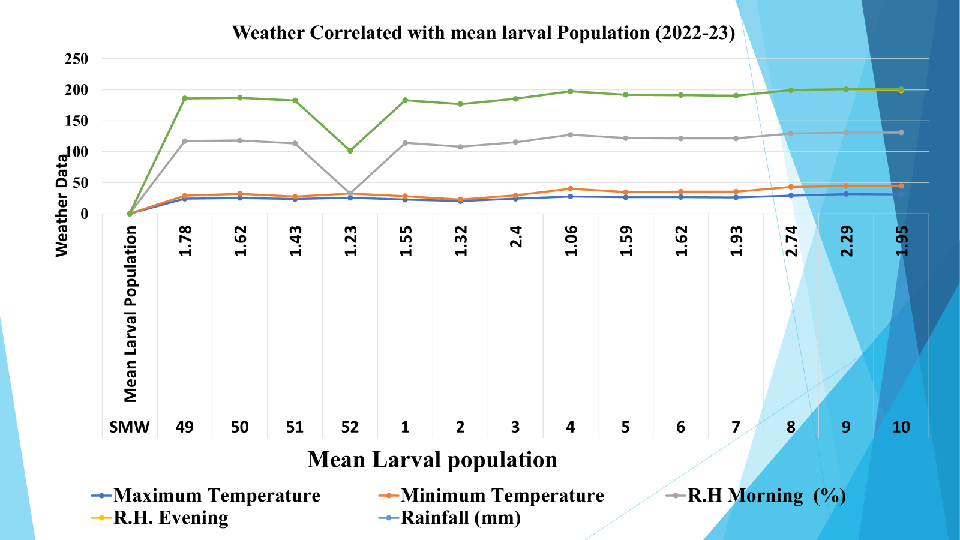

**Fig. 1. Population dynamics of *H. armigera* on chickpea in relation to abiotic factors during *Rabi* 2022-23.**

**Table 2: Seasonal incidence of *H. armigera* on chickpea (Birsa Chana-3) variety in relation to abiotic factors during *Rabi,* 2023-24**

|  |  |  |  |  |  |  |  |
| --- | --- | --- | --- | --- | --- | --- | --- |
|  |  |  | **Temperature(°C)** | | **R.H. (%)** | | **Rainfall (mm)** |
| **SMW** | **Date** | **Mean**  **Larval Population** | **Temp.**  **(Max)** | **Temp. (Min.)** | **7.00 AM** | **2.00 P.M** |
| **49** | 4/12/2023 | 1.95 | 25.0 | 15.6 | 86 | 70 | 38.8 |
| **50** | 11/12/2023 | 1.12 | 22.5 | 5.9 | 85 | 70 | 0 |
| **51** | 18/12/2023 | 1.56 | 21.7 | **3.9** | 85 | 70 | 0 |
| **52** | 25/12/2023 | 1.5 | 24.0 | 4.9 | 85 | 70 | 0 |
| **1** | 01/01/2024 | 1.67 | 24.2 | 5.3 | 85 | 70 | 3 |
| **2** | 08/01/2024 | 0 | 23.6 | 5.1 | 88 | 69 | 0 |
| **3** | 15/01/2024 | 0.4 | 21.4 | 4.4 | 84 | 70 | 0 |
| **4** | 22/01/2024 | 0.00 | 21.6 | 4.0 | 86 | 69 | 0 |
| **5** | 29/01/2024 | 0 .00 | 25.6 | 8.8 | 86 | 70 | 10.4 |
| **6** | 05/02/2024 | 0.62 | 25.0 | 8.4 | 84 | 70 | 0 |
| **7** | 12/02/2024 | 0.72 | 26.0 | 11.6 | 86 | 70 | 30.6 |
| **8** | 19/02/2024 | 0.43 | **27.8** | 13.2 | 87 | 70 | 0 |
| **9** | 26/02/2024 | 0.21 | 25.9 | 13.6 | 85 | 70 | 20.6 |
| **10** | 04/03/2024 | 0.74 | 25.3 | 13.4 | 87 | 70 | 2 |

**#SMW – Standard Meteorological Weeks;**

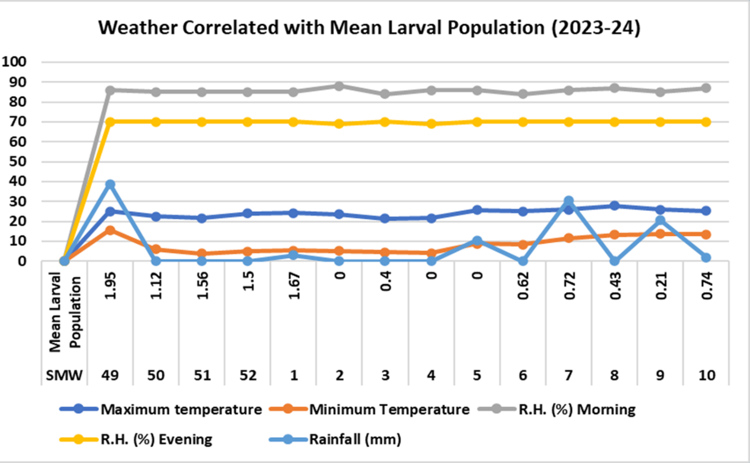

**Fig. 2. Population dynamics of *H. armigera* on chickpea in relation to abiotic factors during *Rabi* 2023-24.**

**Table 3: Correlation between Larval population of *H. armigera* (Hub.) and abiotic factors on chickpea during *Rabi*, 2022-23 and 2023-24**

|  |  |  |  |  |  |
| --- | --- | --- | --- | --- | --- |
| **Larval population** | **Temperature (ºC)** | | **R.H. (%)** | | **Rainfall (mm)** |
| **Maximum** | **Minimum** | **7 AM** | **2PM** |
| ***Rabi*, 2022-23** | 0.459 | 0.414 | -0.118 | 0.256 | 0.121 |
| ***Rabi*, 2023-24** | -0.106 | 0.026 | -0.301 | 0.492 | 0.232 |

**CONCLUSIONS**

In the chickpea study, the gram pod borer, *H. armigera*, peaked in mid-February after first appearing in early December. In 2022–2023 and 2023–2024, respectively, there were non-significant negative connections with morning relative humidity and non-significant positive correlations between the larval population and the maximum and minimum temperatures.

**Acknowledgement**

The Head and Major advisor, Department of Entomology, Birsa Agricultural University, Kanke Ranchi, Jharkhand allotted plot and issued chemicals for partial fulfillment and financial supports. The authors are thankful to all the faculty members of Entomology Department; Dean, Birsa Agricultural University, Kanke Ranchi, Jharkhand and the Director of Research for providing necessary facilities and encouragement**.**

**Conflict of Interest**

None.

**References**

Ahlawat, I. P. S. and Prakash, O. M. (1996) Nutritional value of chickpea grains. *Principles of agronomy and crops*, pp. 43.

Alok, N. K., Singh, S. K, Chandra, U. (2022) Population dynamics of gram pod borer*, Helicoverpa armigera* (Hübner) in relation to abiotic factors on chickpea. *Journal of Experimental Zoology,* India 1(1): 25.

Anonymous (2024) Agriculture Statistics. *Reports of Directorate of Economics and Statistics*, Department of Agriculture and Cooperation, Government of India, pp. 04.

Bajya, R., Bairwa, D. K., Jat, B.L., Bana, J.K., Hussain, A., Sharma, S.L., Saini, L. S., Bajya, D.R. and Choudhary, S. (2025) Seasonal Incidence of *Helicoverpa armigera* (Hub.) on Chickpea in Relation to Abiotic Factors Semi-arid Region of Rajasthan. *Biological Forum- An International Journal*, 17(1): 64-68

Bajya, R.., Patel, Y., Garg, V. K. and Kumar, N. (2022) Effect of Weather Factors on Population Dynamics of *Helicoverpa armigera* Hubner (Noctuidae: Lepidoptera) in Chickpea. *Biological Forum -* *An International Journal*, 14 (4a), 242-245.

Chatar, V. P., Raghvani, K. L., Joshi, M. D., Ghadge, S. M., Deshmukh, S. G. and Dalave, S. K. (2010) Population dynamics of pod borer, *H. armigera* (Hub.) infesting chickpea. *International Journal of Plant Protection*, 3 (1), 65-67.

Choudhary, S., Deshwal, H. L. and Bana, J. K. (2024) Population dynamics of pod borer *H. armigera* on chickpea. *Indian Journal of Entomology*, **10**, 55446.

Das, A., Datta, S., Thakur, S., Shukla, A., Chaturvedi, S. K., Kumar, P. A. and Singh, N. P. (2017) Expression of a chimeric gene encoding insecticidal crystal protein Cry1A abc of *Bacillus thuringiensis* in chickpea (*Cicer arietinum* L.) confers resistance to gram pod borer, *H. armigera* (Hub.). *Frontiers in Plant Science*, **8**, 1423.

Jukanti, A. K., Gaur, P. M., Gowda, C. L. and Chibbar, R. N. (2012) Nutritional quality and health benefits of chickpea (*Cicer arietinum* L.): a review. *British Journal of Nutrition*, 108, S11-S26.

Kumar, P., Mishra, D. N., Singh, D. V., Singh, R. and Mishra, P. (2022) Population fluctuation of pod borer, *Helicoverpa armigera* (Hübner) in relation with abiotic factors. *The Pharma Innovation Journal*, 11(6): 1471-1474.

Kumawat, S., Sharma, S., Kumari, H., Naga, B. L., Meena, R. K., Meena, S. K. and Arvind (2024). Population dynamics of *H. armigera* (Hubner) in chickpea. *Indian Journal of Entomology*, 10, 55446

Lateef, S. S, Bhagat, V. R, and Reed, W. (1985) Field screening of chickpea genotypes for resistance to *H. armigera*. *International Chickpea Newsletter*, 13:29-32.

Malik, R., Kumar, R., Prasad, C. S. and Rana, R. (2015) Seasonal dynamics of *H. armigera* (Hub.) on chickpea and relative abundance of larval parasitoid *Campoletis chlorideae* in correlation with weather parameters. *International Journal of Multidisciplinary Research and Advanced*, 1, 1-6.

Patel, S. R., Patel, K. G. and Ghetiya, L. V. (2015) Population dynamics of pod borer*, H. armigera* (Hub.) in relation to abiotic factors. *An International e-Journal*, 4(2), 163-170.

Patidar, D., Nayak, M. K., Jaiswal, S. K. and Patel, K. (2020). Seasonal variation of *H. armigera* (Hub.) population and their correlation with weather parameters under agro-climatic condition of Tikamgarh district, Madhya Pradesh. *International Archive of Applied Sciences and Technology*, 11, 53-56.

Pawar, V. M. (1998) Microbial control of *Helicoverpa armigera* sp. on pulses crops In: *IPM System in Agriculture* (Upadhyaya R.K., Mukarji K.G. and Rajak RL Eds.),New Delhi, India, Aditya books Private Ltd, 55-7811.

Pearson, K. (1920) Notes on the history of correlation. *Biometrika*,13(1), 25-45. Reprinted in E.S. Pearson & Kendall (1970).

Prakash, M.R, Ram, U, Tariq, A. (2006) Evaluation of chickpea (*Cicer arietinum* L.) germplasm for the resistance to gram pod borer, *Helicoverpa armigera* Hubner (Lepidoptera: Noctuidae). *Journal of Entomology Research*, **31**:215-218.

Reed, W., Cardona, C., Sithanantham. S, Lateef, S.S. (1987) The chickpea insect pests and their control. In: Saxena MC and Singh, K. B (Eds.). The Chickpea. *CAB International*, Wallington, UK. 283-318

Shinde, Y. A., Veeda, O. P. and Patel, B. R. (2013). Observed the larval population of *H. armigera* (Hub.) during *Rabi*, 2009-10 and 2010-11. *Current Biotica*, 7(3), 222-227.

Srivastava, S.K, Sivaramane, N. and Mathur, V.C. (2010) Diagnosis of pulses performance of India. *Agricultural Economics Research Review*, 23 (1):137-148.

Taggar, G. K. and Singh, R. (2012) Integrated management of insect pests of *Rabi* pulses. In: Arora R, Singh, B and Dhawan, A.K. (ed.) *Theory and practice of Integrated pest management*, Scientific Publishers, India.; 454-72.

Yadav, S. K., Singha, D. R., Umraoa, R. S., Yadav, A. and Yadav, V., Yadav, G. (2024). Studies on seasonal incidence of gram pod borer, *H. armigera* (Hub.) on chickpea crop. *International Journal of Environment and Climate Change*, 14(3), 349-354