**Melted Electronic Waste Plastic as an Alternative to Cement in Pavement Block Manufacture: A Study of Mechanical Properties**

**ABSTRACT**

The viability of using melted electronic waste (e-waste) plastic as a complete replacement for cement in the production of pavement blocks is examined in this study. The study compared the compressive strength, split tensile strength, water absorption, and heat resistance of pavement blocks made from e-waste plastic to those made from cement. The experimental procedure involved producing two different batches of pavement blocks. One batch used melted electronic waste (e-waste) as a binder, while the other used Portland cement at a ratio of 1:3. A total of 28 blocks were produced in each batch for the investigation. River sand was collected from a construction site near Windy’s Hostel at Windy Ridge in Takoradi. The particle size distribution of the sand used in this investigation was determined by a grading test procedure according to the British Standard method. In accordance with the British Standard method, the compressive strength test was done to determine the compressive strength of the pavement blocks. After 28 days of curing, the results of the compressive strength tests showed that the pavement blocks made from e-waste plastics achieved a compressive strength of 41.3 MPa, while the cement pavement blocks achieved a compressive strength of 39.2 MPa. The split tensile strength tests conducted after 28 days of curing revealed that the e-waste plastic pavement blocks achieved a tensile strength of 5.5 MPa, whilst the cement pavement blocks reported a tensile strength of 3.2 MPa. This suggests that the e-waste plastic pavement blocks are suitable for use in low-load-bearing applications. The study also revealed that e-waste plastic pavement blocks absorbed water at a rate of 0.46% whereas the cement pavement blocks absorbed water at a rate of 1.33% after 24 hours of full immersion. This demonstrates the resilience of e-waste plastic pavement blocks in wet conditions, reducing their susceptibility to degradation over time. Moreover, the heat resistance test conducted indicates that the e-waste plastic pavement blocks started to deform after 1 hour at a temperature of 150°C, whilst the cement pavement blocks showed no physical change up to 150 °C. The findings of this research suggest that the melted e-waste plastic may be a viable alternative to cement in the production of pavement blocks for use in areas with a temperature of <140°C. Further research may be necessary to investigate the heat resistance of e-waste plastic pavement blocks for usage in a wider range of environmental conditions.

**Keywords**: *Plastics, Concrete, E-waste, Pavement Blocks, Compressive Strength, Slump*

**1.0 INTRODUCTION**

The increase in population trends, which have necessitated the recent rapid advancement in technology, has resulted in overwhelming quantities of production of electronic waste (e-waste) [1]. Electronic waste comprises old or broken-down electrical or electronic gadgets, including computers, mobile phones, and television sets that have been abandoned. [2]. According to the United Nations report, e-waste generation has increased sharply, reaching 53.6 million metric tons in 2019, elevated by 21% from 2015, and is projected to reach nearly 120 million metric tons by 2050 as a global burden (Ghulam & Abushammala, 2023).

Apart from the rate of technological advancement and increasing consumer demand for electronic and electrical equipment, there is the problem of continuously decreasing product life time and use phase. It has resulted in voluminous amounts of electronic and electrical equipment becoming obsolete considerably in a short while [3]. The majority of these huge volumes of electronic waste may contain toxic elements, making them potentially environmentally invasive if not disposed of properly, making it a pressing global menace. [4]. Many factors contribute to this surge in e-waste. These include the short lifecycle of equipment, low recycling, and the continuous upgrading of electronic equipment as affluent societies demand the latest technology. E-waste has been described as one of the most difficult classes of waste to manage due to a constant change in its features and specificities (Abalansa et al., 2021; Bhatia & Laroiya, 2025). Poor recovery of metals from electronic wastes and the use of landfills for disposal have distorted the quality of the soil ecosystem, and eventually harmed such environment and human health. Especially in developing countries, as they continue to receive these used electrical and electronic gadgets from developed countries. [5] [6].

Given these, reducing the harmful effects of e-waste on the environment and human health is undoubtedly the best thing that can happen to the world through proper management and possibly recycling of electronic waste.

Apart from the nuisance of electronic waste in the environment, large volumes of cement are being exhausted as a result of the increasing demand for construction materials and infrastructural developments. This is evident from the global cement report that 4.08 billion tons of cement were used worldwide in the year 2019, which was a 2.8% increase from the previous year. [7]. Exhaustion of the earth’s non-renewable resources is a growing dilemma when the reason is that energy consumption has rapidly increased during the 21st century. As the quarrying and mining sector is widely active, at some point in the future, the reserves of non-renewable resources will inexorably be diminished as they are extracted from the environment and used for economic purposes (Mohamad et al., 2022).

Unfortunately, several setbacks accompany the production of cement, such as the high cost of production from the cost of raw materials, the release of excess CO2, which depletes the ozone layer, as well as high consumption of energy [8]. The need to address these setbacks escalated investigations, which include using recycled aggregates, fly ash, and granulated blast Furnace slag (GBFS), tundish powder, silica fume, rice husk ash, cocoa pod ash, corn cob ash, plantain peel ash, etc., as partial replacement of cement in concrete and other cement-based products.

Apart from the above-mentioned materials, crushed electronic waste plastic has been used as a replacement for coarse aggregates in the manufacture of lightweight concretes production in which the compressive strength of the e-waste aggregate concrete decreased with an increase in e-waste content. [9]. The strength of concrete and mortar with plastic aggregates has also shown a reduction in the compressive strength when fine aggregates were partially substituted with plastic waste.[10].

Because cement's binding properties are essential for construction, some researchers have incorporated melted plastic waste as an additive in concrete and as a binder in mortar. However, little attention has been paid to using melted electronic waste as a binding material for making pavement blocks. Electronic waste plastic has been utilised to create asphalt binder additives, and it was observed that untreated e-waste modified asphalt binders were stiffer and more elastic than the control binder. When the same e-waste plastic was first treated with cumene hydroperoxide, the increase in stiffness and elasticity was notably higher. [11, 12, 13].

The utilisation of melted electronic waste plastic as a replacement for cement in pavement block manufacturing would help to reduce the cost of manufacturing pavement blocks and serve as a means of controlling and recycling electronic waste plastics, thereby curbing their prohibited environmental footprints by keeping them out of landfills and open burning.

This study, therefore, attempts to evaluate the feasibility of replacing cement with melted e-waste plastics in pavement block production.

The effect of melted electronic waste plastic as a partial replacement of cement on the mechanical properties of pavement blocks prepared with cement and partially replaced with melted e-waste plastics was investigated in this study.

**2.0 EXPERIMENTAL METHOD**

The experimental procedure involved producing two different batches of pavement blocks. One batch used melted electronic waste (e-waste) as a binder, while the other used Portland cement at a ratio of 1:3. The dimensions of the blocks were 200mm x 100mm x 60mm. The mechanical properties of the pavement blocks with and without cement were compared. A total of 28 blocks were produced in each batch for the investigation.

**2.1 Material Source and Preparation**

**2.11 Electronic waste (e-waste)**

The electronic waste (e-waste) plastic, which was mostly plastic covers of spoilt televisions, desktop monitors, was purchased from scrap dealers at Kokompe, a suburb of Takoradi in the Western Region of Ghana. After breaking down and shredding the electronic waste into sizes passing through a 30mm sieve and retained on a 5mm sieve, they were cleaned to remove dirt. The total mass of e-waste plastic used was 30kg

**2.12 Cement**

The cement used for the production of the pavement blocks was Ghacem Portland cement, produced by Ghana Cement grade 42.5R, and was purchased from a local cement vendor at Newsite, a suburb of Takoradi in the Western Region of Ghana.

**2.13 Sand**

River sand was collected from a construction site near Windy’s Hostel at Windy Ridge in Takoradi and was air-dried for two days to allow the elimination of natural moisture. The mass of sand used was 200kg.

**2.2 Physical Properties of Sand**

**2.2.1. Particle size distribution**

The particle size distribution of the sand used in this investigation was determined by a grading test procedure according to the British Standard method. [14]. In this method, the sand particles were passed through a stack of sieves whose openings were known and shaken for about 10minutes with a mechanical sieve shaker. After the sieves were removed, the mass of samples retained on each sieve was noted and subtracted from the respective mass of each sieve and the mass of the sieve and content. The percentage passing was calculated by subtracting the cumulative percentage retained from 100%, in which a semi-logarithmic curve was plotted with the ordinate axis as percentage passing and the abscissa (logarithmic scale) as sieve sizes. Equations 1 and 2, respectively, depict how the percentage retained and the percentage passing were calculated.

% retained = (mass retained)/ (total mass retained) × 100 ……...…… Equation 1

% passing = (𝑡𝑜𝑡𝑎𝑙 % 𝑟𝑒𝑡𝑎𝑖𝑛𝑒𝑑 − % 𝑝𝑎𝑠𝑠𝑖𝑛𝑔) ……….……………. …..Equation 2

**2.2.2. Silt content test**

By the British Standard Method [15] The silt content of the sand was determined by pouring a salt solution of 1% salt into a 1000ml measuring cylinder to a level of 200ml. The sand sample was poured to make 400ml of water. After shaking until the mixture was uniform, some of the salt solution was used to wash the sand particles stuck on the walls of the measuring cylinder, making the water increase in volume to 500ml. After leaving the setup for 24hours, the sand settled down while the silt remained on top, forming a layer. The volume of the silt layer was measured and recorded as V1, and the volume of the whole sample was measured and noted as V2. The procedure was repeated for two other samples, and their average was determined. The percentage of silt content was calculated with the help of equation 3 below.

% silt content = $\frac{V1}{V2} × 100$…… Equation 3

**2.3 Batching, mixing, and moulding**

**2.3.1 Cement/sand pavement blocks**

A mix ratio of 1:3, signifying one part of cement to 3 parts of sand. The mass of 3000g of sand was poured on a clean platform, on which 1000g of the cement was added to the sand and mixed thoroughly until a uniform mixture was obtained. The required amount of water was sprinkled on the mixture and thoroughly mixed until a uniform paste was obtained. After oiling moulds of dimensions 200mm x 100mm x 60mm with dirty engine oil, the mixture was fetched with a hand trowel and placed into the mould and compacted with about 25 blows in three layers. The surface of the filled mould was trimmed with a foam and removed from the mould after an hour.

**2.32 Melted E-waste pavement blocks**

A mix ratio of 1:3, which signifies 1 part of the melted e-waste plastic to 3parts of the sand, was used for the melted e-waste plastic pavement blocks. After batching, the required mass of the shredded e-waste plastic was poured into a drum and set on fire. The setup was stirred while the plastics melted to ensure uniform burning.

After continuously stirring and obtaining a molten e-waste plastic, the mass of 3000g of sand was gradually added to the melted plastic in the drum and thoroughly stirred until a uniform mixture was obtained. The moulds were then oiled with dirty machine oil, and the mixture of the melted electronic waste and sand was fetched with a hand trowel and placed in the mould, whose dimensions were 200mm x 100mm x 60mm, and compacted with 25blows with a rod in three layers. The surface of the filled mould was trimmed with a foam and removed from the mould after an hour.

**2.4 Drying and Curing**

After the blocks were removed from the mould, they were left to dry in the open as shown in Figures 1 a-b below.

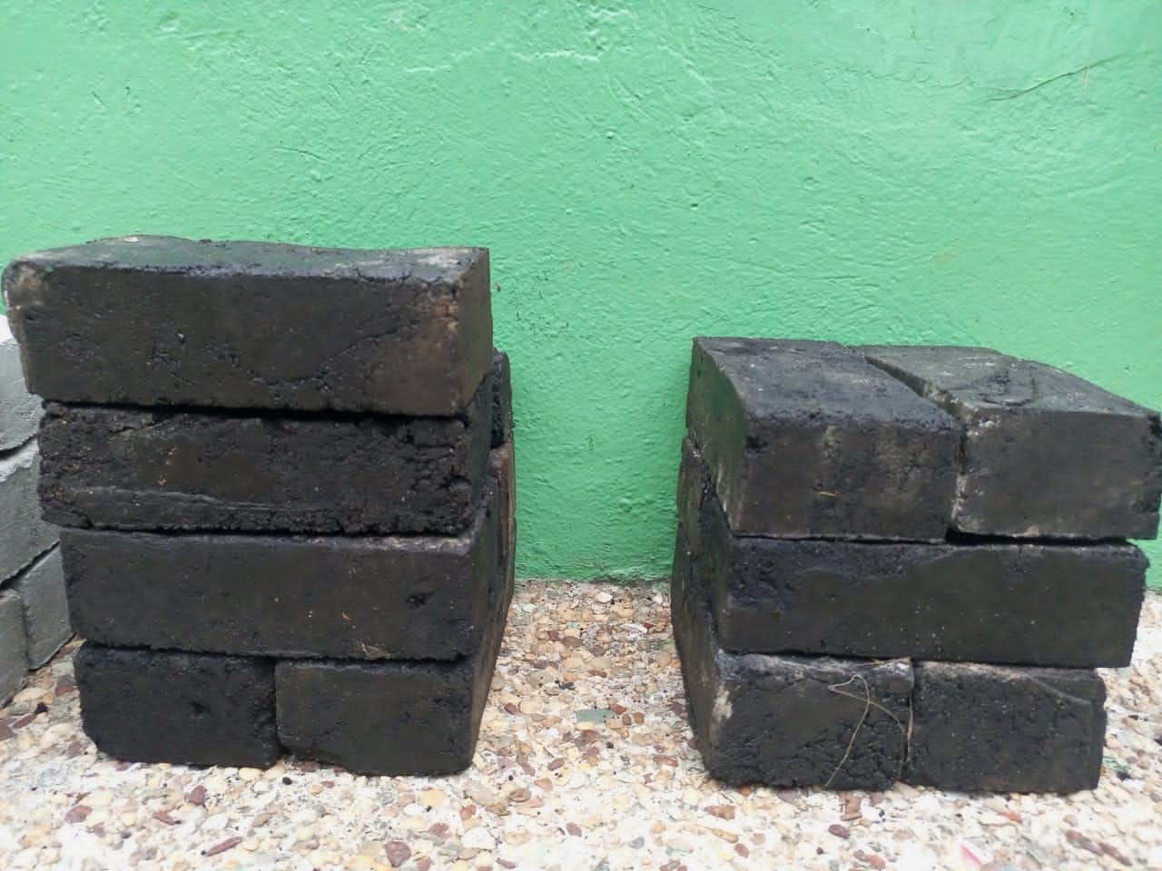 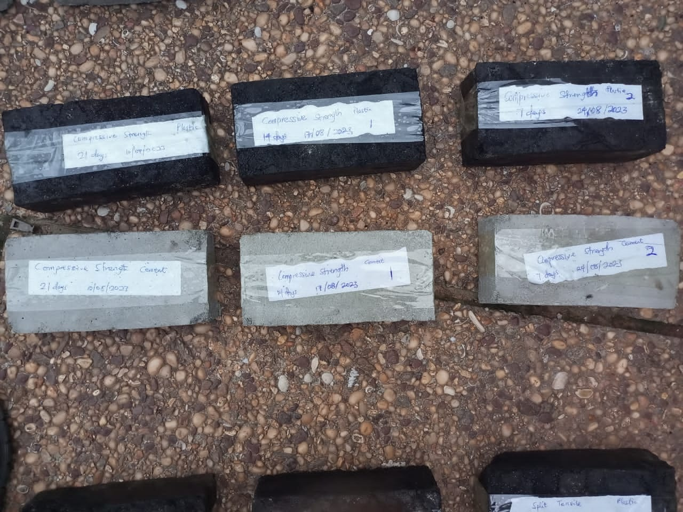

Figure 1a -waste plastic pavement blocks, Figure 1b cement-based pavement blocks.

**2.5 Compressive Strength Test**

In accordance with the British Standard method [15], the compressive strength test was done to determine the compressive strength of the pavement blocks. For each curing period of 7,14and 28 days, the pavement blocks were drained of excess water and their masses determined, placed on a metal plate in the compressive strength machine, and a load applied until the block crushed. The ultimate load at which the block crushed was recorded, and the value for the compressive strength of the block was calculated with the help of the cross-sectional area of the block, whose dimensions were 100mm x 60mm. Three blocks were tested for each set of curing days, and the average compressive strength was calculated in MPa.

**2.6 Split Tensile Strength Test**

The split tensile strength was determined to determine the tensile strength of the pavement blocks using the British Standard method. [16]. The prepared pavement blocks were weighed and placed into the split tensile strength machine with two plywood strips positioned on the centre lines at the top and bottom contact surfaces with the machine plates. The machine was started, and the load was applied to the block until the block split. The ultimate load at which the block split was generated, as well as the value of the split tensile strength of the pavement block. Similarly, three blocks were tested for each set of curing period, and their average split tensile strength was calculated, and a graph of split tensile strength was plotted against curing days for both melted e-waste plastic and cement-based pavement blocks, as shown in Figure 1.

**2.7 Water absorption test**

The water absorption of the e-waste block was obtained by the water absorption method specified in [17]. The e-waste pavement block was dried and weighed after casting. The blocks were immersed in water after some time and removed from the water, wiped, and reweighed to calculate the water absorption capacity with the aid of the formula:

% Water absorbed = (M1 -M0)/M0  ………………………………………..Equation 4

Where M1= Mass of block after immersing in water

M0 = Mass of block before immersing in water

**3.0 RESULTS AND DISCUSSION**

**3.1 Particle size distribution**

The results of the grading test are shown in Figure 2, indicating the variation of the cumulative % passing with sieve sizes for the sand used. It can be seen that the greater % of the sand particles were retained on the sieve sizes between 0.07mm and 4mm. This is evident that the sand used in this investigation was mostly made up of sandy particles with few dust particles, which fall within the standard of sand required for construction as specified by the British Standard Method. [14].

**Figure 2: Variation of cumulative % passing with sieve sizes for sand**

**3.2 Silt test**

The values of silt content of sand are presented in Table 1. It shows that the sand contains about 14.7% silt, which is below the specified limit of 15% silt content for sand as specified by the British standard method. [15].

**Table 1. Values of volumes and % silt content for sand**

|  |  |  |  |
| --- | --- | --- | --- |
| Silt Test Results | | | |
| Sample | 1 | 2 | 3 |
| Volume of Sample1 (V1), ml | 70 | 70 | 71 |
| Volume of Silt Content after 24hrs (V2), ml | 10 | 10 | 11 |
| Percentage of Silt Content | 14.3 | 14.3 | 15.5 |
| Average Percentage of Silt Content | 14.7 | | |

**3.3 Water absorption of pavement blocks**

Figure 3 shows the variation of % water absorption with pavement block type, in which the e-waste plastic pavement block and cement-sand pavement block showed 0.46% and 1.33% water absorption, respectively. The values indicate that the melted e-waste plastic pavement blocks absorbed less water as compared to the cement-sand-based pavement. The lower water absorption in the melted e-waste plastic pavement blocks may be attributed to the reduced porosity of the plastic material in the block than that of the porosity in the cement-sand based pavement block. That notwithstanding, the 0.46% water absorbed for the melted e-waste plastic and 6% water absorbed for the cement-sand pavement block satisfied the criteria specified in [17] For which the melted e-waste plastic may be used for medium-duty pavement. `

**Figure 3. Variation of water absorption with pavement block type**

**3.4 Compressive strength of pavement blocks**

The compressive strength of the melted e-waste plastic pavement blocks at 28days was 41.3MPa, whilst that of the cement-sand pavement blocks was 39.2MPa after 28days, as shown by Figure 4. The increase in the compressive strength of the melted e-waste may be attributed to the increased binding strength of the mixture than the cement-sand mixture. The value of 41.3MPa for the compressive strength of the melted e-waste plastic exceeds the standard requirement of 30MPa for a 60mm thickness pavement block for footpaths and bicycle lanes as prescribed by the Ministry of Transportation Specification for Road and Bridge construction in Ghana. Furthermore, the 28-day compressive strength of 41.3MPa for the melted e-waste plastic pavement block met the standard requirement for medium-duty pavement as prescribed by [15].

**Figure 4. Variation of compressive strength with curing days**

**3.5 Split Tensile strength**

Generally, the split tensile strength for both melted e-waste plastic pavement blocks and cement-sand pavement blocks increased with increasing curing days, as shown in Figure 5. The split tensile strength for the melted e-waste plastic was higher than the cement-sand pavement blocks for all the curing days, with the 28-day split tensile strength of the melted e-waste plastic being 2.3MPa more than the cement-based pavement block, indicating a 72% increase in split tensile strength.

**Figure 5. Variation of split tensile strength with curing days**

**3.6 Heat Resistance of pavement blocks**

The values of temperature at 1-hour intervals and the changes that occurred on pavement blocks during the heat resistance tests are shown in Table 2.

**Table 2: Values of temperature for cement-based and melted e-waste plastic pavements**

|  |  |  |  |  |  |  |
| --- | --- | --- | --- | --- | --- | --- |
| **Specimen** | **Increasing Temperature (⁰C) At 1-Hour Intervals** | | | | | |
| **100** | **110** | **120** | **130** | **140** | **150** |
| **Condition of Cement Pavement Block** | No change | No change | No change | No change | No change | No change |
| **Condition of E-Waste Plastic Pavement Block** | No change | No change | No change | No change | No change | Started to deform |

It was observed that both sets of pavement blocks showed no physical change from 100 oC to 140 oC, except at 150 oC where the melted e-waste plastic pavement blocks tend to soften and deform. This shows that the melted e-waste plastic pavement blocks have a lower heat resistance compared to the cement-based pavement blocks, which showed no deformity at 150 oC as investigated by [19]. As a result of the plasticity of the electronic waste plastics upon exposure to heat, the electronic waste plastic may not be suitable for high-temperature environment applications.

**4.0 CONCLUSION**

Based on the analysis of the results, the following conclusions were drawn:

* The water absorption of the melted e-waste plastic pavement blocks and cement-sand pavement blocks was 0.46% and 1.33% respectively. The lesser value of 0.46% for the melted e-waste plastic pavement block than 1.33% of the cement-sand pavement block implies that melted e-waste plastic pavement blocks absorbed less water as compared to the cement-sand-based pavement blocks.
* The compressive strength of the melted e-waste plastic pavement block at 28days was 41.3MPa, whilst that of the cement-sand pavement blocks was 39.2MPa, implying that the melted e-waste plastic pavement block is about 5% higher in compressive strength than the cement-sand pavement blocks.
* The split tensile strength of the melted e-waste plastic at 28days was 5.5Nmm-2, whilst that of the cement-based pavement blocks was 3.2Nmm-2 at 28days, implying that the split tensile strength of the melted e-waste plastic was about 42% more than that of the cement-sand pavement blocks.
* The melted e-waste plastic pavement blocks showed no physical change from 100 oC to 140 0C except at 150Oc where the melted e-waste plastic pavement blocks softened and deformed, but the cement-sand pavement blocks showed no change physically at 150Oc. This implies that the melted e-waste plastic pavement is less resistant to heat than the cement-sand pavement blocks.

These results indicate the feasibility of replacing cement with melted e-waste plastics as a binder in pavement block production.

Disclaimer (Artificial intelligence)

Option 1:

Author(s) hereby declare that NO generative AI technologies such as Large Language Models (ChatGPT, COPILOT, etc.) and text-to-image generators have been used during the writing or editing of this manuscript.

Option 2:

Author(s) hereby declare that generative AI technologies such as Large Language Models, etc. have been used during the writing or editing of manuscripts. This explanation will include the name, version, model, and source of the generative AI technology and as well as all input prompts provided to the generative AI technology

Details of the AI usage are given below:

1.

2.

3.

**REFERENCES**

|  |  |
| --- | --- |
| [1] | D. Dutta and G. Sudha, "Electronic waste Generation and Management," *Advances in Solid and Hazardous Waste Management,* pp. 249-266, 2017. |
| [2] | M. Jain, D. Kumar, J. Chaudhary, S. Kumar, S. Sharma, and A. S. Verma, "Review on E-waste Management and its impact on the environment and society," *Waste Management Bulletin,* vol. 1, no. 3, pp. 34-44, 2023. |
| [3] | A. Abhishek and L. Jinhui, "Management of Electrical & Electronic Waste, A comparative Evaluation of China and India," *Renewable and Sustainable Energy Reviews,* vol. 76, pp. 434-447, 2017. |
| [4] | H. Hu, X. Zeng, K. Zheng, Z. Zeng, C. Dai, and X. Huo, "Risk Assessment and Partitioning behavior of PFASs in Environmental Matrixes from an e-waste recycling area," *Science of The Total Environment,* vol. 5, 2023. |
| [5] | M. S., I. Dhinakarasamy, C. V. Nachiyar and K. R. Namasivayam S., "Towards sustainable metal recovery from e-waste: A mini Review," *Sustainable Chemistry for Environment,* vol. 2, 2023. |
| [6] | S. Marinelli, S. Marinello, F. Lolli, R. Gamberini, and A. M. Coruzzolo, "Waste Plastic and Rubber in Concrete and Cement Mortar: A Tertiary Literature Review," *Sustainability,* vol. 15, 2023. |
| [7] | C. Meyer, "Concrete and Sustainable Development," *ACI Special Publication,* vol. 206, pp. 501-512, 2002. |
| [8] | D. N.-L. Botchway, J. Bentil and C. Y. Henaku, "Effect of Partial Replacement of Coarse Aggregate with Electronic waste plastic in lightweigth concrete," *Journal of Management Science and Engineering Research,* vol. 5, no. 2, pp. 38-44, 2022. |
| [9] | O. Babatunde, H. S. Adebayo, and Q. A. Shaibu, "Effect of Partial Replacement of Fine Aggregate with Plastic Waste Aggregates on Workability and Strength of Concrete," *Uniport Journal of Engineering and Scientific Research,* vol. 6, no. 2, pp. 101-109, 2022. |
| [10] | J. Bentil and J. J. Nsiah, "Utilization of Plastic Waste bags as concrete additives," *International Journal of Scientific & Engineering Research,* vol. 7, no. 7, pp. 801-804, 2016. |
| [11] | M. Thiam, M. Fall, and M. S. Diarra, "Mechanical Properties of Mortar with melted plastic waste as the only binder: Influence of material composition and curing regime and application in Bamako," *Case Studies in Construction Materials,* vol. 15, 2021. |
| [12] | M. R. M. Hassan, B. Colbert, Z. You, A. Jamshidi, P. A. Heiden, and M. O. Hamza, "A simple treatment of electronic waste plastics to produce asphalt binder additives with improved properties," *Construction and Building Materials,* vol. 110, pp. 79-88, 2016. |
| [13] | "BS 812-103:1 Methods for determining Particle Size Distribution," British Standards, 1985. |
| [14] | "BS 812-103.2 Methods of masonry: Compressive strength determination," International British Standards, 1985. |
| [15] | "BS EN 12390-6 Methods for determining the split tensile strength of masonry units," International British Standards, 2023. |
| [16] | "BS EN 722-7:2022 Methods of determination of water absorption of masonry units," International British Standards, 2002.  [17] Ghulam, S. T., & Abushammala, H. (2023). Challenges and Opportunities in the Management of Electronic Waste and Its Impact on Human Health and Environment. Sustainability, 15(3), 1837.  [18] Abalansa, S., El Mahrad, B., Icely, J., & Newton, A. (2021). Electronic Waste, an Environmental Problem Exported to Developing Countries: The GOOD, the BAD and the UGLY. *Sustainability*, *13*(9), 5302.  [19] Mohamad, N., Muthusamy, K., Embong, R., Kusbiantoro, A., & Hashim, M. H. (2022). Environmental impact of cement production and Solutions: A review. *Materials Today: Proceedings*, *48*, 741-746.  [20] Bhatia, M. K., & Laroiya, C. (2025). Towards a Greener Future: Addressing Infrastructural Challenges in E-waste Management. *Asian Journal of Advanced Research and Reports*, *19*(6), 141–152. |