**Type of Article:** Original Research Article

**Revitalising the turmeric sector in Bihar: A Value Chain Perspective**

**Abstract**

Turmeric (*Curcuma longa L.*) is a high-value crop with significant health, culinary, and industrial importance, making it an integral part of India’s agricultural exports. While India dominates global turmeric production, Bihar despite its favorable agro-climatic conditions has witnessed stagnation in productivity, acreage, and value addition. This study analyzes the turmeric sector in Bihar through a comprehensive value chain perspective, integrating secondary data analysis (2011–2025) with primary field insights from Samastipur and East Champaran districts. The study combines secondary data from 2011 to 2025 on area, production, productivity, value of output, and price trends sourced from IndiaStat and various government reports, along with primary field data on value chain mapping in Samastipur and East Champaran districts. The findings of trend analysis reveal that despite favourable agro-climatic conditions, Bihar lags behind national averages in yield and output value due to low adoption of improved varieties, inadequate processing infrastructure, fragmented marketing systems and poor branding providing a scope data-driven foundation for the value chain analysis and proposed policy recommendations. Farmers receive only 23.4% of the final consumer price, with the largest value addition occurring at the processing and retail levels.

The study benchmarks successful value chain models from Telangana, Odisha, and Meghalaya to identify replicable strategies for Bihar. Policy recommendations emphasize promoting Farmer Producer Organizations (FPOs), investing in post-harvest infrastructure, facilitating organic and GI certification, and enhancing direct market access. The paper concludes that a multi-pronged intervention anchored in institutional support, branding, and export facilitation can revitalize Bihar’s turmeric economy. Future research should focus on FPO led innovation models, digital market integration, and sustainable production systems to ensure equitable and scalable growth across the turmeric value chain.

**Keywords:** Turmeric Value Chain, Turmeric Cultivation in Bihar, Turmeric Retail Price Trends, Value Addition, Processing & Marketing Inefficiencies, Best Practices, Challenges in Value Chain

**Introduction**

Turmeric (*Curcuma Longa L.*), has traditional importance in India owning to its health benefits and popularly known as natural antibiotic in every households in the country. The curcumin content in this spice possesses attributes such as antioxidant, anti-inflammatory and antimicrobial properties giving it the title of “golden spice of life” (Hewlings *et al*., 2017; Teow *et al*., 2016 &Sravani *et al*., 2023). Turmeric has significantly contributed to the country’s economy due to its global recognition. India is the largest producer of turmeric accounting for 80% of the global production. India is also the largest consumer and exporter of turmeric in the world accounting for 60% of the world’s turmeric exports because of the superior quality varieties with high curcumin content (Bishnoi *et al*., 2020; PMFME DPR, 2017). China occupies the second position (8%) followed by Myanmar (4%) (cgg.gov.in). Indian turmeric has high demand in the countries such as the United States, the Middle East, the European Union, and Southeast Asia.

The crop plays a crucial role in the livelihoods of millions of smallholder farmers, particularly in states like Telangana, Andhra Pradesh, Tamil Nadu, Maharashtra, Odisha (Sahoo and Sarangi, 2018) and Bihar. In Telangana, turmeric cultivation spans about 42,535 hectares, yielding 184,285 metric tons during the 2015-16 period (cgg.gov.in). Similarly, in Bihar, turmeric contributed over 244 million Indian rupees to the state's economy in the fiscal year 2021 (statista.com).

Bihar, with its fertile alluvial plains and favourable agro-climatic conditions, holds substantial potential for turmeric cultivation as part of its broader agricultural portfolio (Sahoo, 2020). Despite these favourable conditions, turmeric production in Bihar has shown limited growth. Samastipur district is one of the Bihar’s core turmeric growing regions where the average cost of cultivation is around Rs. 53,700 per acre in 2019 giving a reasonable net return of around Rs. 56,300 per acre. Farmers reported that fluctuating prices, inefficiencies in market, inadequate infrastructure limit the profit potential and crop adoption by the farmers (Bishnoi *et al*., 2018; Sravani *et al*., 2023).

Given the rising global demand for natural food additives, colorants, and curcumin-rich extracts from turmeric, improving production efficiency and market functioning in Bihar is critical (PMFME DPR, 2017; Mukherjee *et al*., 2024). Understanding the experiences of turmeric farmers with respect to cost structures, yield performance, and marketing strategies is therefore essential to inform value chain interventions and policy decisions.

There is increasing global demand for natural food additives and colorants due to rising health concerns in the current population. Given this demand, Bihar should critically work on its production efficiency and market functioning for competing in the global markets. (PMFME DPR, 2017; Mukherjee *et al*., 2024). Therefore a study addressing turmeric farmers’ experiences and expectations with reference to cost structures, yield performance and marketing strategies is necessary to find scope for value chain intervention and policy decisions.

This paper investigates the current state of turmeric cultivation in Bihar with the objective to analyze production economics and farmer-level returns, drawing on primary data fromSamastipur; examine marketing and value chain constraints such as price volatility, middlemen influence, and storage deficiencies; and propose evidence-based strategies to enhance incomes and integrate Bihar more fully into high-value turmeric markets.

By combining empirical field insights with secondary data, we aim to highlight critical leverage points in Bihar’s turmeric value chain and inform policy and organizational initiatives that can close productivity gaps, minimize market inefficiencies and strengthen farmer livelihoods.

**Methodology**

This study employs a mixed-methods approach combining both quantitative secondary data analysis and qualitative field-based value chain mapping to examine the constraints and opportunities within the turmeric sector in Bihar, particularly in the districts of Samastipur and East Champaran.

***Secondary Data Analysis:*** Quantitative data on area, production, productivity, value of output, and retail price trends (2011–2025) were sourced from authoritative national databases, including IndiaStat, Statista, and published government reports (e.g., PMFME DPR 2017). These datasets provided temporal insights into Bihar’s relative performance in turmeric cultivation and economic contribution compared to the national context.Key indicators analyzed includearea under cultivation;production volume and productivity (MT/ha); value of output at constant and current prices;monthly and annual retail price trends; Comparative analysis across states; Field Survey and Value Chain Mapping

***Primary data*** were collected through field visits and semi-structured interviews with turmeric farmers, traders, and processors in Samastipur and East Champaran during early 2025. Observations and discussions focused onvalue chain stages and marketing channels; processing practices and infrastructure availability; transportation and storage costs; local price realization and intermediary margins; farmer perspectives on institutional and policy support; based on these field insights, value chain diagrams were developed to visualize flow channels and stakeholder interactions. A cost-price spread table was constructed to analyze value addition and the share of the consumer rupee across different actors (farmers, traders, processors, wholesalers, and retailers).

***Case Study Benchmarking:*** To contextualize Bihar’s turmeric sector challenges, the study also undertook a comparative review of successful value chain models from Meghalaya (Lakadong turmeric), Odisha (Kandhamal turmeric), and Telangana. These cases were selected for their emphasis on GI-tagging, organic certification, and FPO-led marketing, offering policy and institutional lessons for Bihar.

**Turmeric Cultivation in Bihar and India: Trends from 2011 to 2025**

Turmeric cultivation in India has witnessed substantial growth over the past decade, whereas Bihar’s performance has remained relatively stagnant. A comparative review of area under cultivation, production, and productivity reveals significant gaps between Bihar and the national average.

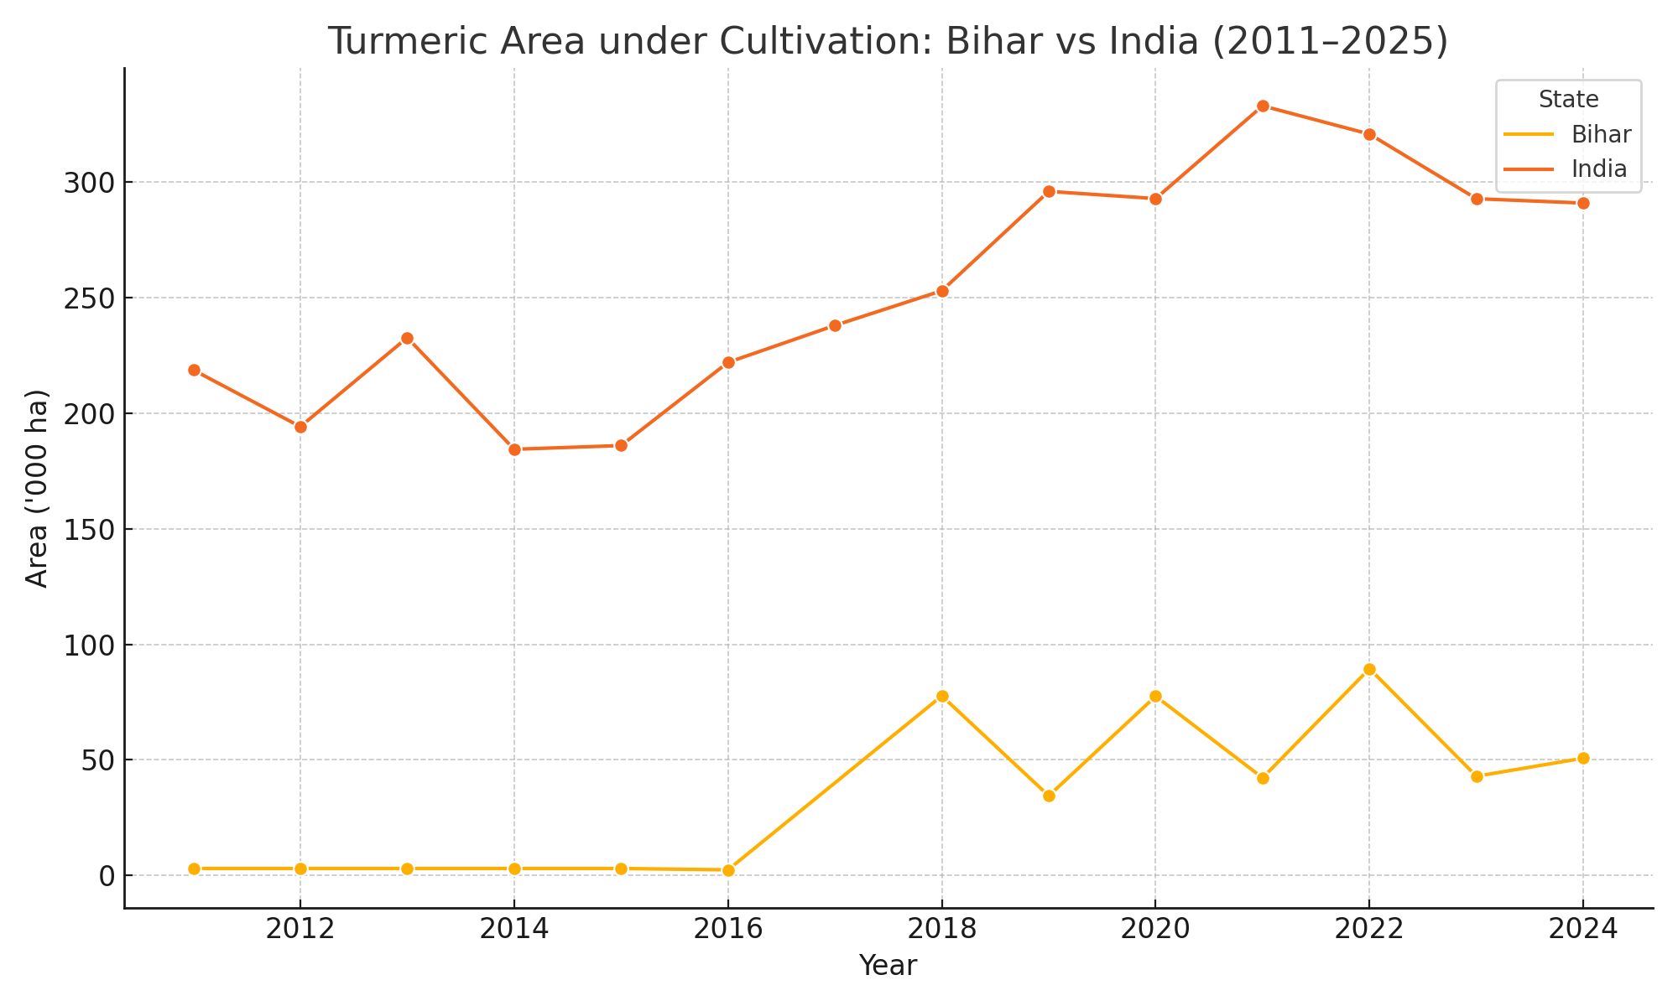

**Figure 1. Area under turmeric cultivation in Bihar compared to all India (2011-2025)**

*Source:* Data for Bihar sourced from IndiaStat’s*Area, Production and Productivity of Turmeric in Bihar dataset;* Comparative data for India sourced fromIndiaStat’s*Area, Production and Productivity of Turmeric in India dataset*

Figure 1 shows that Bihar’s area under turmeric cultivation has hovered around 3,000 hectares with minor fluctuations, while India overall shows a steady upward trend in cultivated area. The stagnation in Bihar’s turmeric acreage may be attributed to limited crop diversification incentives, weak market linkages and farmer preference for more remunerative crops.

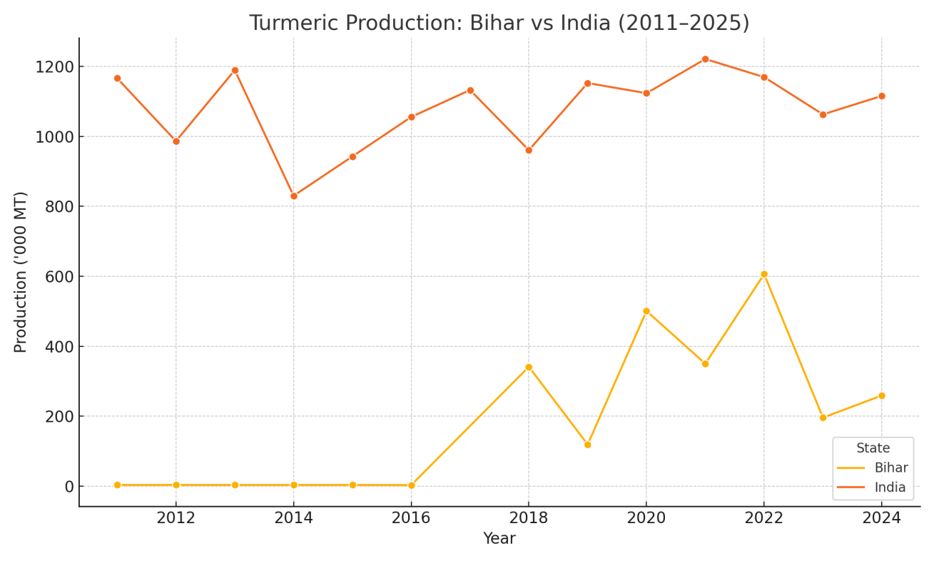

**Figure 2. Turmeric Production volumes in Bihar compared to all India (2011-2025)**

*Source:* Bihar production figures sourced from IndiaStat’s*Area, Production and Productivity of Turmeric in Bihar;* National production figures sourced from IndiaStats’s*Area, Production and Productivity of Turmeric in India.*

Production volumes in Bihar have shown minimal change over the period, remaining around 3,000 metric tonnes. In contrast, India’s national turmeric production displays robust expansion, particularly driven by states like Telangana, Andhra Pradesh, and Maharashtra. This divergence suggests that Bihar has not benefited from the technological and infrastructural advancements visible in leading turmeric producing states.

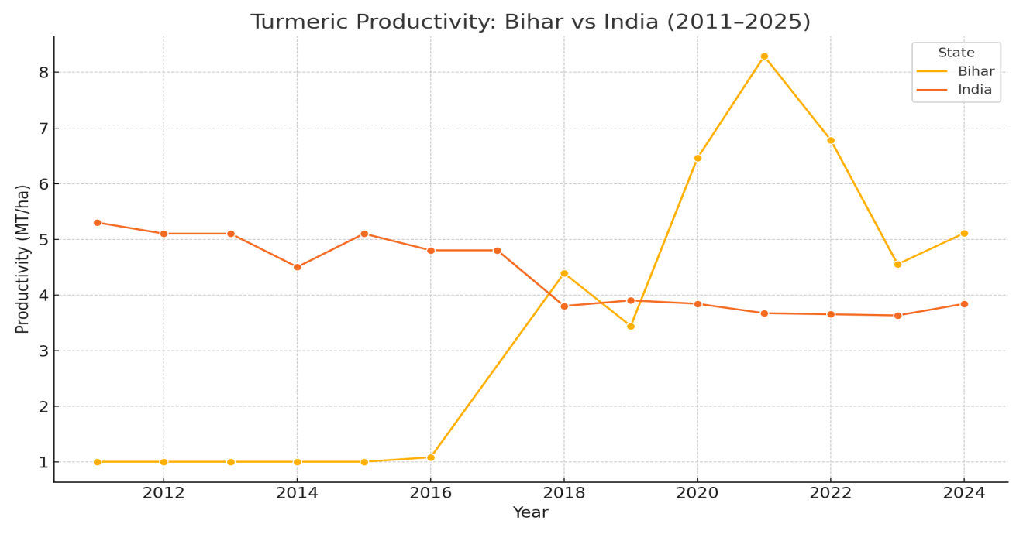

**Figure 3. Productivity of turmeric in Bihar versus all India averages (2011-2025)**

*Source: Bihar yield* data sourced from IndiaStats’s Bihar dataset on turmeric; *India wide productivity data* sourced from IndiaStat’s India dataset

Bihar consistently records around 1.0 metric tonne per hectare, significantly below the national average of 3.5-5.5. MT/ha. This wide gap underscores systematic challenges in Bihar’s turmeric sector such as poor adoption of high-yielding varieties, lack of irrigation infrastructure, and minimal use of scientific agronomic practices.

**Value of Output and Regional Contribution (2011-2022)**

The value of output from turmeric cultivation is a critical indicator of its economic contribution at both state and national levels. Between 2011 and 2022, India witnessed a steady rise in the gross value of turmeric output, particularly at current prices, reflecting the effects of inflation, rising market demand, and expansion in cultivated areas across major producing states. However, Bihar’s contribution to this national growth has remained stagnant, particularly when examined at constant 2011-12 prices, which offer a clearer picture or real growth excluding inflationary effects.

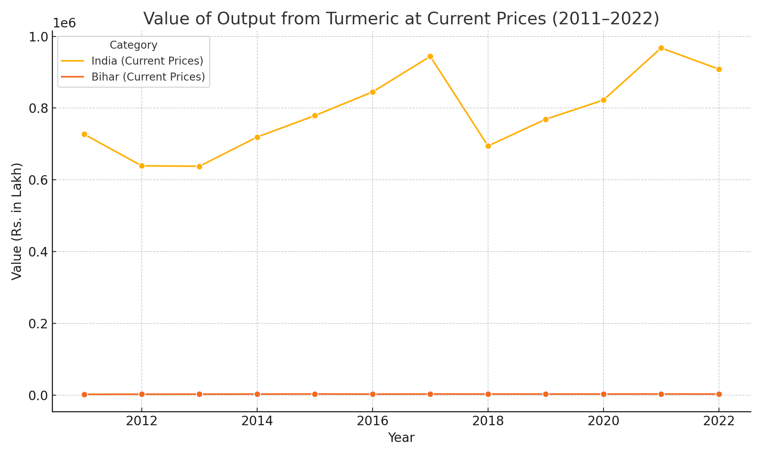

**Figure 4. Value of Output from turmeric at Current Prices in Bihar and India (2011-2022)**

*Source:*IndiaStat (2024).*Value of output from turmeric in India and Bihar (2011-2022).*

This figure illustrates that while India’s value of turmeric output has steadily increased over the years, peaking in 2021-22, Bihar shows only marginal improvement. The apparent increase at current prices in Bihar is largely a reflection of inflation rather than expansion in production or productivity.

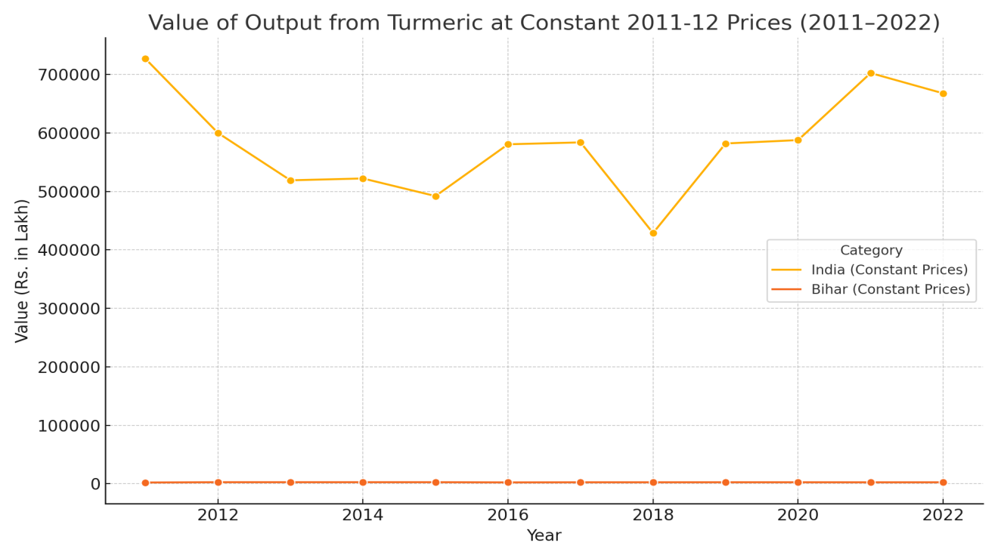

**Figure 5. Value of Output from Turmeric at Constant Prices in India & Bihar (2011-2022)**

*Source:*IndiaStat (2024).*Value of output from turmeric in India and Bihar (2011-2022).*

When adjusted for inflation, Bihar’s turmeric output value shows virtually no real growth. The output remained stagnant in the range of Rs. 2,400-Rs. 2,550 lakh over the entire period. This indicates that economic returns from turmeric cultivation in Bihar have not improved in real terms over the last decade.

The stagnant real output further reflects missed opportunities to align with national and global turmeric demand trends, which have surged due to the crop’s medicinal and culinary value. Bihar’s inability to capitalize in this growing market potential has resulted in its limited regional contribution to India’s turmeric economy.

The gap between nominal (current price) growth and real (constant price) stagnation highlights the need for strategic interventions in Bihar. Without structural changes, such as farmer training, investment in value chains and GI-based branding, the state will continue to contribute minimally to India’s expanding turmeric economy.

**Retail Price trends (2011-2023)**

An in-depth analysis of turmeric prices across Bihar and major Indian centers between 2011 and 2023 reveals significant fluctuations in both retail and wholesale markets. These price movements reflect a combination of supply chain bottlenecks, seasonal variations and demand-side shifts, especially during the post-COVID period.

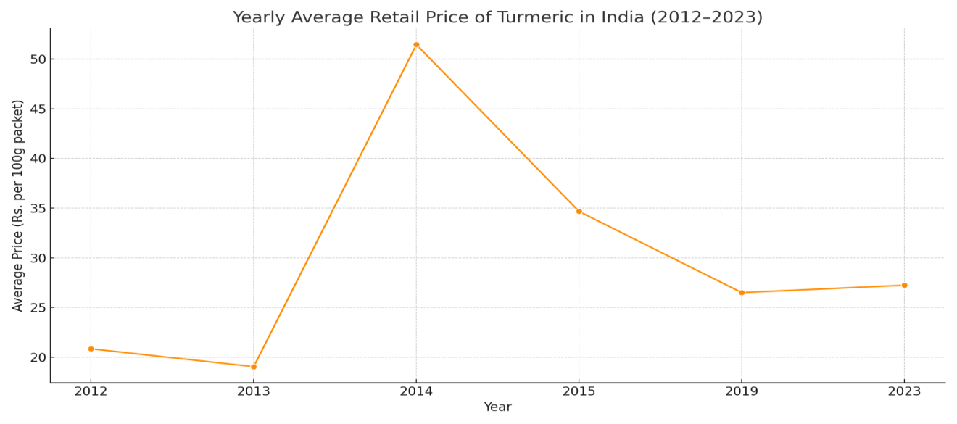

**Figure 6. Yearly Average Retail Price Trend of Turmeric in India (2012-13)**

*Source:*IndiaStat (2024).*State-wise monthly average retail prices of turmeric (powder) in India.*

Retail turmeric prices showed moderate and stable trends from 2012 to 2013, averaging Rs. 20-22 per 100g in many centers. However, sharp prices spikes occurred in 2014 and 2015, especially in Patna, where retail prices escalated to Rs. 78 and Rs. 86 respectively. These increases were likely driven by localized supply disruptions, speculative market behaviour, and transportation inefficiencies.

A second major uptrend was observed post 2020, coinciding with the COVID-19 pandemic, when global and domestic demand for turmeric rose sharply due to its perceived immunity boosting and health enhancing properties. This period saw persistent retail price increases across Bihar, Maharashtra, and Delhi, sustaining well into 2023.

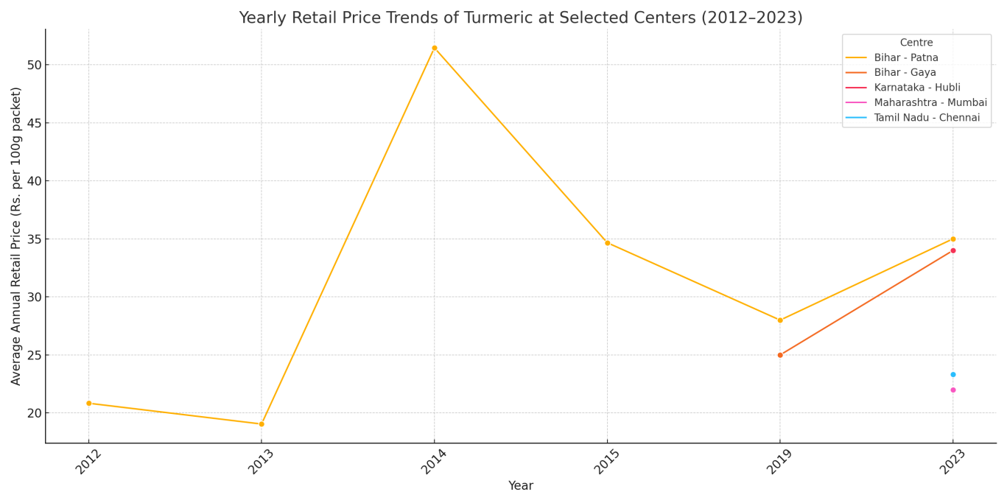

**Figure 7. Retail Price Trends at Selected Centers in Bihar (2012-2023)**

*Source:*IndiaStat (2024).*State-wise monthly average retail prices of turmeric (powder) in India.*

Patna exhibited the highest price volatility, with multiple peaks indicating unstable supply chain or market inefficiencies. In contrast, Gaya’s pricing was more stable and predictable, reflecting better procurement or buffer stock management. Urban centers like Mumbai and Delhi maintained consistently higher prices due to better branding, urban packing, and higher consumer willingness to pay.

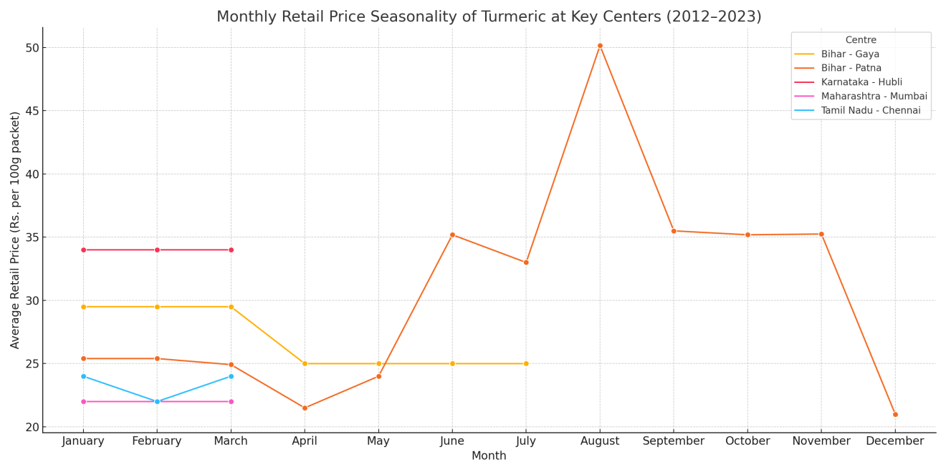

**Figure 8. Monthly Retail Price Seasonality of Turmeric (2012-2023)**

*Source:*IndiaStat (2024).*State-wise monthly average retail prices of turmeric (powder) in India.*

A clear seasonal pattern in visible, with peak prices between March and June, likely tied to lean supply phases and immediate post-harvest procurement. Prices soften during monsoon months (July to October), possibly due to lower market activity and improved supply. A second price increase is often noted in November to February, aligning with festive demand and winter stockpiling.

**Value Chain Analysis**

The turmeric value chain in Bihar, particularly in districts like Samastipur and East Champaran, is characterized by multiple marketing channels, varying degrees of processing, and a fragmented structure that often limits the income of primary producers. An indepth analysis reveals the stages through which turmeric moves from farm to market and highlights inefficiencies and value addition disparities.

In Samastipur, four primary channels are observed:

* **Channel 1:** Raw turmeric sold at the farm gate to local traders (baniya), who process and sell dried or powdered turmeric in local markets.
* **Channel 2:** Farmers transport turmeric directly to the Samastipur Bazaar Samiti, incurring transport costs but accessing better prices.
* **Channel 3:** On-farm processing by farmers (boiling and drying), with sales of dried turmeric at significantly higher prices.
* **Channel 4:** Interstate movement by traders to markets in Uttar Pradesh after purchasing processed turmeric.

In East Champaran, similar channels exist, but with more focus on home-based processing and milling. Farmers process turmeric and sell the powdered form in local markets (e.g., MadhubanMela) or even export to nearby districts or Nepal. However, despite the value addition, dependency on local traders and seasonal fairs limits market scale.

|  |  |
| --- | --- |
| **Channel 1** |  |
| **Channel 2** |  |
| **Channel 3** |  |
| **Channel 4** |  |

**Figure 9: Turmeric Value Chain Channels in Samastipur district, Bihar**

*Source:*Field Survey, 2025

|  |  |
| --- | --- |
| **Channel 1** |  |
| **Channel 2** |  |
| **Channel 3** |  |
| **Channel 4** |  |

**Figure 10: Turmeric Value Chain Channels in East Champaran district, Bihar**

*Source:*Field Survey, 2025

**Cost-Price Breakdown and Value Addition**

A stage-wise analysis of costs and value addition highlights critical insights:

**Table 1. Cost-price spread and share in consumer rupee across turmeric value chain actors**

(Rs/Kg)

|  |  |  |  |  |
| --- | --- | --- | --- | --- |
| **Stage** | **Cost Price** | **Selling Price** | **Value Addition** | **%Share in Consumer Rupee =(SP at stage/Consumer Price)*100** |
| Farmer | 45.00 | 55.76 | 10.76 | 23.4% |
| Trader | 55.76 | 64.00 | 8.24 | 13.8% |
| Processor | 64.00 | 129.00 | 65.00 | 34.2% |
| Wholesaler | 129.00 | 155.00 | 26.00 | 13.7% |
| Retailer | 155.00 | 190.00 | 35.00 | 14.9% |
| Consumer |  | 190.00 |  | 100% |

*The consumer price of Rs. 190/kg is an average based on recent market data (Commodity Online, 2025)*

*Source:*Commodity Online (2025, May 26) and Field Survey, 2025

It could be observed from Table 1 that, the processor stage contributes the most to value addition (44.8%), while farmers despite initiating the value chain receive only 23.4% of the consumer rupee. This points to an imbalance in value distribution.

**Processing and Marketing Inefficiencies**

Despite its potential, Bihar’s turmeric value chain suffers from several inefficiencies:

* *Lack of modern processing facilities:* Most farmers rely on traditional boiling and drying methods, leading to quality inconsistency.
* *High transport costs:* Farmers often incur Rs. 500-1000 per 10 bags just to reach the markets.
* *Risk of adulteration:* In the absence of regulatory oversight, turmeric powder sold in haats is sometimes mixed with rice flour, compromising quality. Booker *et al*. (2014) reports similar findings, where he found significant chemical inconsistencies in turmeric powder sold through informal value chains due to adulterations with cheaper materials like starch and rice flour especially in value chains where mechanisms to assure quality were absent.
* *Limited access to packaging and branding:* The absence of organized retail channels or cooperatives limits the ability to market turmeric under a unified identity.
* *Poor storage infrastructure:* Farmers and small traders lack cold or dry storage facilities, leading to losses or distress selling.

The value chain analysis demonstrates that while local processing adds significant value to turmeric, the lack of institutional support, aggregation models and organized marketing restricts farmers from maximizing returns. Strengthening processing infrastructure, farmer-producer collectives, and direct to market linkages are key to improving equity and efficiency in Bihar’s turmeric sector.

**Case studies and Best Practices**

An examination of successful turmeric producing regions across India provides valuable insights into how robust value chain development, institutional support, and quality branding can transform regional turmeric sectors. The experiences of Lakadong in Meghalaya, Kandhamal in Odisha, and selected districts in Telangana serve as instructive models for policy and practice that could be adapted to the context of Bihar

**Lakadong Turmeric in Meghalaya**

Lakadong turmeric, cultivated in the Jaintia Hills of Meghalaya, is distinguished bu its exceptionally high curcumin content (7-12%), making it highly sought after in both domestic and international markets (Lakadong Turmeric Action Plan, 2021). The government of Meghalaya made intervention in turmeric value chain in Meghalaya through Lakadong Turmeric Action Plan. It developed an integrated value chain by supporting with processing infrastructure in post harvest phase, GI certification for their unique variety in the country an extensive market branding thereby making the farmers more self reliant by enabling direct market access and minimizing the dependency on intermediaries. This not only augmented the farmers income, but also created a premium market positioning for the farmers produce. The Lakadong turmeric case shows the importance of product differentiation through GI tagging.

**Kandhamal Turmeric in Odisha**

Farmers in Kandhamal region of Odisha cultivate organic turmeric having both organic and GI certification, which offers opportunity to tap niche markets globally. The Kandhamal Apex Spices Association for Marketing (KASAM) plays an important role by providing advantage in collective marketing, capacity building and facilitation of direct export opportunity. They also have partnership with Control Union Certification that has enabled them to meet the stringent compliance mandates of European and North American organic standards (Sahoo & Sarangi, 2018). This case is a successful example of community based approach emphasizing the importance of collective institutions, certification compliance mechanisms, and public-private partnerships in augmenting value realization for marginal and small farmers.

**FPO-Led Model in Telangana**

Turmeric cultivation in Telangana in popular in districts such as Nizamabad, Jagtial, and Warangal. The formation of Farmer Producer Organizations has reduced middlemen intervention, helped farmers to realize per prices for their produce and access to advanced processing infrastructure, thereby empowering the turmeric farmers in collective input procurement, marketing, processing, packaging and branding (Singh *et al*., 2020). The support of the state further, in turmeric processing stages such as drying, polishing and curcumin extraction has improved and strengthened the value addition in Telangana (Ram Singh *et al*., 2020). Collective marketing approach aided farmers to collectively negotiate with bulk buyers, leading to better value addition and earnings. This model shows how collaborative and collective approach in negotiations and value addition can improve the farmers share in consumer rupee and reduce reliance on informal markets and information

**Implications for Bihar**

Bihar currently lacks in value addition facilities, adequate processing technology and infrastructure, farmer collectives and consolidated organized markets for turmeric. The learning’s from successful cases given above might offer replicable insights, given its moderate production capacity in the country. The key insights that can be applicable for Bihar’s turmeric scenario based on the successful cases include:

* Promoting GI-tagging and branding for Bihar-grown turmeric varieties (e.g., Rajendra Sonia) to capture premium markets;
* Establishing FPOsand cooperative marketing platforms to inform collective bargaining and reduce dependence on intermediaries;
* Investing in post harvest processing units and storage infrastructure (e.g.; solar dryers, polishing machines) to reduce losses and improve product quality;
* Facilitating organic and curcumin certification to enhance market access and export potential.

Adapting these proven models with localized policy support could significantly improve Bihar’s turmeric value chain, enhance farmer incomes, and elevate the state’s profile in national and global turmeric markets.

**Challenges in the Value Chain**

Despite its agro-climatic suitability and expanding national demand Bihar’s turmeric sector remains constrained by systemic inefficiencies across the value chain. A critical analysis of the economic, infrastructural, policy, technological and sustainability-related dimensions reveals several interlinked barriers that limit value realization for turmeric growers in the state.

Bihar has rich agro-climatic suitability for turmeric production and given the expanding national demand, Bihar’s turmeric market has opportunity to compete with other states popular for turmeric in the country. But yet the sector remains limited by the systematic inefficiencies across its turmeric value chain. Therefore a critical evaluation of the economic, technological, infrastructural and policy dimensions may help in identifying several barriers that limit value realization for turmeric farmers in the state.

***Economic Challenges***

Farmers in Bihar often realize a low share of the consumer rupee, with limited control over pricing due to the dominance of intermediaries. As the value chain analysis shows, farmers receive only 23.4% of the final consumer price, while the processor and retailer capture nearly 60% combined. Price volatility driven by seasonal gluts, weak procurement systems and limited access to storage, further exacerbates income instability. Farmers often resort to distress selling especially during the post harvest period when prices are typically at their lowest (Singh *et al*., 2020)

***Infrastructure Gaps***

The lack of modern post-harvest processing units, drying yards, and storage facilities severely impact product quality and shelf life. Traditional drying and polishing methods lead to inconsistencies, which reduce competitiveness in premium markets. Moreover, the absence of cold storage or warehouse receipt systems forces farmers to sell immediately after harvest,eliminating the possibility of timing the market for better returns (Sahoo&Srangi, 2018; Ram Singh *et al*., 2020).

***Policy and Institutional Barriers***

The absence of a Minimum Support Price (MSP) for turmeric leaves farmers vulnerable to market crashes, Especially during surplus production years. Additionally, the low penetration of Farmer Producer organizations (FPOs) in turmeric growing regions of Bihar weekens farmers bargaining power and hinders collective marketing efforts. In contrast to states like Telangana, where FPOs play a central role in aggregation and value addition, Bihar’s institutional ecosystem remains underdeveloped (Mukherjee *et al*., 2021).

***Technological and R&D Constraints***

Limited access to high-yielding, high-curcumin turmeric varieties and poor extension support contribute to Bihar’s low productivity, which averages around 1.0 MT/ha, well below the national average of 3.5 to 5.5 MT/ha (as per the data retrieved from IndiaStat, 2024). Mechanization of planting, harvesting and drying is also minimal. Moreover, public and private investment in turmeric-focused research and technology dissemination remains inadequate, particularly in developing region-specific economic packages (Timsia *et al*., 2012).

***Sustainability and Certification Issues***

Sustainability concerns are emerging due to the excessive use of chemical inputs, which affects soil health and export eligibility. The adoption of organic farming practices is limited by high certification costs, lack of training and minimal institutional support. While states like Odisha have advanced in organic certification through cooperative models (e.g.,Kandhamal turmeric), Bihar lacks the organized infrastructure and incentives necessary to promote eco-certified or GI tagged turmeric production (Sahoo & Sarangi, 2018).

Addressing these multi-faceted challenges will require an integrated strategy involving policy reforms, infrastructure investment, institutional strengthening, and farmer-centric technology dissemination. These interventions are necessary for Bihar’s turmeric sector to shine on par with other leading states in terms of productivity and market competitiveness.

**Policy Recommendations**

A multi-faceted policy strategy is needed to solve the systemic inefficiencies in the turmeric sector in Bihar. The recommendations based on a critical analysis of best successful practices from other parts of the country known for turmeric production, matched to Bihar’s limitations identified through the value chain study of turmeric is as follows:

**i. Strengthen Farmer Producer Organizations (FPOs), Warehousing and Price Monitoring**

Farmer Producer Organizations (FPOs) are one of the most effective ways to empower marginal and smallholder turmeric farmers. These collectives play a crucial role in aggregating farm produce, price negotiations, reduce margins paid to market intermediaries, and facilitate access to direct markets (Mukherjee *et al*., 2021). Policymakers should provide targeted capacity building support, working capital access, and digital training to FPOs in key turmeric producing districts of Bihar.

Furthermore, the establishment of modern warehousing infrastructure including dry storage units and solar-powered dryers can reduce post-harvest losses and allow farmers to time their sales to take advantage of favourable market prices. To further stabilize incomes, the government should implement real time price monitoring systems and explore the introduction of Minimum Support Price (MSP) mechanisms or price assurance schemes specific to turmeric, particularly in price volatile centers like Patna (Ram Singh *et al*., 2020; Singh *et al*., 2020).

**ii. Promote Branding based on Organic Farming and Geographical Indications (GI)**

The state should promote organic farming practices and GI certification for locally dominant varieties such as Rajendra Sonia in order to position Bihar’s turmeric competitively in high value domestic and export markets by providing financial assistance for organic certification costs, farmers training for sustainable practices, and extension services for disease and pest management.

Drawing on successful models like Lakadong in Meghalaya and Kandhamal in Odisha, Bihar can improve its market identity through GI-tagging initiatives that highlight curcumin content, traditional cultivation methods, and ecological advantages (Lakadong Turmeric Action Plan, 2021; Sahoo&Srangi, 2018). A dedicated branding strategy and public awareness campaign can help establish Bihar turmeric as a distinct, premium product in national and international markets.

**iii. Facilitate Export Promotion and Value Addition Infrastructure**

India’s dominance in global turmeric exports provides an opportunity for Bihar to enter high-margin export markets. However, this will require investment in value addition infrastructure, such as turmeric processing units, curcumin extraction plants, and packaging facilities complaint with international quality standards (Mukherjee *et al*., 2021). Similarly Sharangi and Pandit (2018) also emphasized that the Indian spice industry must be backed up with robust research and development, strong government support, and regulatory compliances to match globally approved and accepted safe and organic production and marketing standards to reach global competitiveness. These facilities can be developed through public-private partnerships (PPPs) or under centrally sponsored schemes like the Pradhan Mantri Formalization of Micro Food Processing Enterprises (PMFME).

Export promotion should also involve:

* Quality certification and residue monitoring systems to meet stringent EU and US standards
* Trade facilitation support for local exporters, including market intelligence and logistics linkages
* The formation of a dedicated turmeric export cell or board to support product positioning and compliance management (Singh *et al*., 2020)

Such efforts will not only improve Bihar’s turmeric export readiness but also enhance farm-level incomes by integrating the state into the higher ends of the value chain.

**Conclusion and Future Directions**

This study provides a comprehensive examination of Bihar’s turmeric sector through a value chain lens, highlighting persistent challenges in productivity, processing, marketing, and institutional support. Despite its agro-climatic potential, Bihar has yet to realize the full economic benefits of turmeric cultivation due to systemic inefficiencies and underdeveloped value chain infrastructure. Comparative insights from states like Meghalaya, Odisha, and Telangana underscore the transformative potential of collective marketing, GI-tagging, and value addition investments.

To fully integrate Bihar into national and global turmeric markets, coordinated policy action, farmer-centric institutional development, and strategic investments in post-harvest processing and certification systems are imperative. Empowering Farmer Producer Organizations, promoting organic practices, and enhancing export readiness can significantly improve farm-level returns and market competitiveness.

Future research should explore impact assessment of FPO-led interventions in turmeric-producing regions of Bihar; feasibility studies for curcumin extraction and organic certification in eastern India; value chain finance models tailored to smallholders and role of digital platforms in improving market linkages and traceability in turmeric trade.Addressing these gaps through empirical and participatory research can guide evidence-based policymaking and foster inclusive growth in Bihar’s spice economy.

**Disclaimer (Artificial intelligence)**

Author(s) hereby declare that NO generative AI technologies such as Large Language Models (ChatGPT, COPILOT, etc.) and text-to-image generators have been used during the writing or editing of this manuscript.

**References**

Bishnoi, R. K., Kate, S. S., &Guleria, A. (2020). Economics of turmeric production and farmers' perception on new marketing methods. International Journal of Current Microbiology and Applied Sciences, 9(10), 3042-3050. Retrieved from <https://www.ijcmas.com/9-10-2020/Rajesh%20Kumar%20Bishnoi,%20et%20al.pdf>

Booker, A., Frommenwiler, D., Johnston, D., Umealajekwu, C., Reich, E., & Heinrich, M. (2014). Chemical variability along the value chains of turmeric (Curcuma longa): A comparison of nuclear magnetic resonance spectroscopy and high performance thin layer chromatography. *Journal of Ethnopharmacology*, *152*(2), 292-301. Retrieved from <https://www.sciencedirect.com/science/article/pii/S0378874113009240>

Centre for Good Governance. (2017). *A study on turmeric with emphasis on value chain analysis in Telangana*. Retrieved from https://www.cgg.gov.in/research_project/a-study-on-turmeric-with-emphasis-on-value-chain-analysis-in-telangana/

Commodity Online. (2025, May 26). Turmeric market price today. Retrieved from <https://www.commodityonline.com/mandiprices/turmeric>

Hewlings, S. J., & Kalman, D. S. (2017). Curcumin: A review of its effects on human health. Foods, 6(10), 92. <https://doi.org/10.3390/foods6100092>

IndiaStat. (2024). *All-India turmeric statistics: Area, production, and productivity (2011–2025)*. Retrieved from <https://www.indiastat.com>

IndiaStat. (2024). *Turmeric cultivation statistics: Area, production, and productivity in Bihar (2011–2025)*. Retrieved from <https://www.indiastat.com>

IndiaStat. (2024). *Value of output from turmeric in India and Bihar (2011–2022)*. Retrieved July 18, 2025, from <https://www.indiastat.com>

IndiaStat. (2025). *State-wise monthly average retail prices of turmeric (powder) in India (up to April 2025)*. Retrieved from <https://www.indiastat.com/data/agriculture/state-wise-monthly-average-retail-prices-turmeric-/1480554>

Kannan, E., &Pohit, S. (2021). Agricultural growth diagnostics: identifying the binding constraints and policy remedies for Bihar, India. *arXiv*. <https://doi.org/10.48550/arXiv.2108.03912>

Lakadong Turmeric Action Plan. (2021). Action Plan for Development of Value Chain of Lakadong Turmeric in Meghalaya. Ministry of Food Processing Industries (MoFPI). Retrieved from https://www.mofpi.gov.in/sites/default/files/action_plan_for_development_of_value_chain_of_lakadong_turmeric_in_meghalaya_.pdf

Mukherjee, A., Dutta, S., Mukherjee, E., Gaikwad, K., Khanna, T., & Sen, N. (2024). *Making India the global hub for turmeric* (ICRIER Report 25‑R‑02). Indian Council for Research on International Economic Relations. Retrieved July 2025, from <https://icrier.org/pdf/Making-India-the-Global-Hub-for_Turmeric.pdf>

Mukherjee, A., Dutta, S., Mukherjee, E., Gaikwad, K., Khanna, T., & Sen, N. (2021). *Making India the global hub for turmeric.* Indian Council for Research on International Economic Relations (ICRIER). <https://icrier.org/pdf/Making-India-the-Global-Hub-for-Turmeric.pdf>

PMFME DPR. (2017). *Detailed project report: Processing of turmeric powder*. NIFTEM-T. Retrieved from <https://niftem-t.ac.in/pmfme/dpr-tpowder.pdf>

Ram Singh, R., Feroze, S. M., & Kumar, S. (2020). Production of Turmeric in North East Hill Region of India: A Value Chain Analysis. Indian Journal of Agricultural Economics, 75(4), 360-370. Retrieved from https://isaeindia.org/wp-content/uploads/2021/03/01-Article-Ram-Singh.pdf

Sahoo, P. (2020). Study of traditional Ahar‑Pyne system and community governance methods in Asarganj Block, Munger District, Bihar, India. *International Journal of Research in Engineering, Science and Management, 3*(3), 192–198. Retrieved July 2025, from <https://www.academia.edu/43909128/Study_of_Traditional_Ahar_Pyne_System>

Sahoo, P. P., & Sarangi, K. K. (2018). Value chain analysis of organic turmeric in Kandhamal district of Odisha. Journal of Pharmacognosy and Phytochemistry, 7(4), 1130-1137. Retrieved from <https://www.phytojournal.com/archives/2018/vol7issue4/PartS/7-3-712-203.pdf>

Sharangi, A. B., & Pandit, M. K. (2018). Supply chain and marketing of spices. In *Indian Spices: The Legacy, Production and Processing of India’s Treasured Export* (pp. 341-357). Cham: Springer International Publishing. Retrieved from <https://link.springer.com/chapter/10.1007/978-3-319-75016-3_12>

Singh, R., Sharma, S., & Patel, A. (2020). Analysis of turmeric value chain in India: Challenges and policy measures. Indian Journal of Agricultural Economics, 75(3), 245-263.

Sravani, S., et al. (2023). Problems encountered by the turmeric farmers and suggestions to overcome the problems in marketing the produce in Kadapa district of Andhra Pradesh. *Biological Forum – An International Journal, 15*(5), 225–229.

Statista. (2024). *Gross value added from turmeric in Bihar India FY 2012-2021*. Retrieved from <https://www.statista.com/statistics/1084189/india-economic-contribution-of-turmeric-bihar/>

Teow, S. Y., Liew, K., Ali, S. A., Khoo, A. S. B., &Peh, S. C. (2016). Anti-infective properties of the golden spice curcumin. *Frontiers in Microbiology, 7*, 912. <https://doi.org/10.3389/fmicb.2016.00912>

Timsina, K. P., Shrestha, K. P., Chapagain, T. R., & Pandey, S. (2012). Value Chain Analysis of Turmeric in Eastern Nepal. Nepal Agricultural Research Journal, 11, 70-82. Retrieved from https://www.cabidigitallibrary.org/doi/full/10.5555/20123287018