**RESEARCH PAPER**

**Genetic variability of Bael (*Aegle marmelos* Correa) genotypes in Mahasamund District of Chhattisgarh**

**ABSTRACT**

The investigation was conducted during the year 2022-23 and 2023-24 on already existed bael genotypes located at different villages of five blocks in Mahasamund district of Chhattisgarh and further analysis was done at Department of Fruit Science, College of Agriculture, Indira Gandhi Krishi Vishwavidyalaya, Raipur, Chhattisgarh. This study was conducted with the main objectives to characterize the available genotypes and genetic variability of bael. The significant variations were observed among all the Bael genotypes in relation to pomological characteristics under the present study. The genotypes Goma Yashi recorded the highest mean performance for fruit weight (959.79 g) and pulp weight (803.99 g), MB-28 for leaf length (14.50 cm), MB-37 for leaf width (8.95 cm), MB-2 for fruit diameter (136.44 mm) and fruit length (156.58 mm), MB-16 and MB-17 for specific gravity (1.09 g/cc), MB-21 for shell thickness (4.20 mm) and MB-31 for fruit yield (153.75 number of fruits/tree) under the present experiment. However, the minimum seed weight (6.50 g), shell weight (90.46 g) and total number of seeds (73.89) was confirmed in the genotypes Goma Yashi, MB-24 and MB-22 under the present trial.

**Key-words:** *Bael, Diversity, Pomological, Variability, Goma Yashi, MB and Mahasamund Bael.*

**INTRODUCTION**

Bael fruit (*Aegle marmelos Correa*) is a tropical fruit native to south-east Asia and belongs to family Rutaceae. It is an important indigenous fruit of India. It is also known as Bengal Quince. Aegle, the genous of bael is monotypic. It is a midsized, slender, aromatic, armed, gum-bearing tree growing up to 18 meter in height. It has a compound leaf with three leaflets. It has been known in India from prehistoric times and is more prized for its medicinal virtues than its edible quality. In Hinduism the tree is considered sacred. It is used for worship of lord Shiva, who is said to favour the leaves. The trifoliate leaves symbolize the trident the Shiva holds in his right hand. The fruit were used in place of Coconuts before large-scale rail transportation become available. The fruit is said to resemble a skull with a white, bone-like outer shell and a soft inner part (Singh *et al*., 2024). The tree grows wild in dry forests on hills and plains of central and southern India, Burma, Pakistan, Bangladesh, Sri Lanka, Northern Malaya, Java, and Philippine Islands. However, there were no organized orcharding of bael in India but now a days organized orchard are having planted it grows mainly wild and in temple gardens in early years. The fruit is available in almost all states of India, but most abundantly available in Uttar Pradesh, Bihar, West Bengal and Odisha, In Odisha the fruit is predominantly present in forests of Dhenkanal, Angul, Bolangir and Rayagada districts (Islam *et al*., 2012). It has a reputation in India for being able to grow in places where other trees cannot grow. The fruit is very hardy and can grow even under adverse agro-climatic conditions. Most of the tropical and subtropical condition fruits have a poor keeping quality but this let fruit can be kept for a longer period because of its hard outer shell and as, it can easily withstand transport and marketing hazards. It copes with a wide range of soil pH of 5-10 and a wide temperature tolerance from 7 degree to 48-degree C. It requires a pronounced dry season to give fruit (Deepti and Misra, 2005).

India is one of the countries where, Bael are grown on 8.43 thousand hectares area, with an annual production 81.88 thousand tonnes. Odisha is the leading producing Indian state, with a cultivated area of 7.28 thousand ha, an annual production of 45.29 thousand tonnes (Anon., 2021a). In Chhattisgarh, Bael are grown on an area of 0.06 thousand hectares, with an annual production of 0.43 thousand tonnes. Mahasamund district is the leading in area and production of bael in Chhattisgarh state with an area of 0.04 thousand ha and production of 0.33 thousand tonnes (Anon., 2021b).

The importance of bael lies in its curative properties, which makes it one of the important medicinal plants of India. All the parts of the tree (Stem, bark, leaves, roots and fruits) at some stages of maturity and ripening, has some important use in many Ayurveda and Unani patented drugs in India for treatment of a variety of diseases. The fruits and roots of bael possess antiamoebic and hypoglycemic activity. Research has found the essential oil of the bael tree to be effective against 21 types of bacteria (Singh *et al.,* 2024). It is prescribed for smooth bowel movement of patients suffering from constipation and other gastrointestinal problems. Unripe Bael fruit is also said to be effective in combating giardia and rotavirus. For medicinal use, the young fruits, while still tender, are commonly sliced horizontally and sun-dried and sold in local markets. Because of the astringency, especially of the wild fruits the unripe bael is most prized as a means of halting diarrhea and dysentery, which are prevalent in India in the summer months.

In India, some types have been named according to fruit shape and quality. Majumdar (1975) described six varieties from Uttar Pradesh and considered Mirjapuri as the most promising followed by Dagogaji, Ojha, Ranpure, Asamati and Rhamaria. Teaotia *et al.,* (1963) listed five promising varieties and reported that the Kagzi Gonda was the most promising with thin rind, soft yellow pulp and excellent flavor. Majumder (1975) presented the morphological and physic-chemical characteristics from the extensive survey in Uttar Pradesh and Bihar. They found that Etawah Kagzi, sewan large, Mirzapuri and Deoria were excellent in taste and quality. In West Bengal, working with five types of bael fruits, Majumder (1975) found that the spherical flattened once were usually the best on the basis of fruit weight and chemical composition. In India, various size of bael having good quality is available which are known after the locality. Ripe fruit is available mainly during the February to May. But immature fruit are sold in the month of August to mid-January, which are consumed after boiling or roasting. Dried chips of unripe fruit are also sold in the market. Considering the importance of bael fruits in there is need to evaluate the quantitative and yield attributing parameters of bael genotypes, keeping in view the present investigation has been work out.

**MATERIALS AND METHODS**

The experiment was conducted in Randomized Block Design consisted of forty genotypes along with check variety (Goma Yashi) and replicated fourth times, considering one plant as a unit. From the exploration of Mahasamund district of Chhattisgarh about 18 to 40 years old Forty Bael genotypes from 5 different block were randomly selected for the study with the help of local villagers. The blocks were Mahasamund, Baghbahra, Basna, Pithoura and Saraipali. Two villages were selected for each block *viz*. Machewa & Paraskol from Mahasamund block, Khamariya & Bakma from Baghbahra block, Bansula & Baraspur from Basna block, Kisanpur & Kotapara from Pithoura block and Sagarpali & Sajapali from Saraipali block. Four different Bael genotypes were selected from each village for further investigation as per key descriptor for *Aegle marmelos* Correa, CIAH, Godhra, Gujrat, 2015.

**Statistical analysis**

The replicated two years data obtained from the experiments has been subjected to suitable statistical analysis after transformation (if necessary) in Randomized Block Design using R-studio software.

**Analysis of Variance (ANOVA)**

The experimental data of all the parameters was subjected to statistical analysis for proper interpretation. The data obtained for different characters were statistically analyzed the mean values of the recorded characters were evaluated and analysis of variance was performed by the F-test. The significance of the genotypes was suggested by 5% level of probability (Gomez and Gomez, 1984).

**Table 1: Analysis of variance**

|  |  |  |  |  |  |  |
| --- | --- | --- | --- | --- | --- | --- |
| **S. No.** | **SV** | **D.F.** | **S.S.** | **M.S.S.** | **F. Cal.** | **F. Tab.** |
| 1 | Replication | r-1 | RSS | RMS | RMS/EMS |  |
| 2 | Treatment | t-1 | TrSS | TrMS | TrMS/EMS |  |
| 3 | Error | (r-1) (t-1) | ESS | EMS |  |  |
| 4 | Total | rt-1 | TSS |  |  |  |

**Methodology followed to record the observations**

**Leaf length (cm)**

The length of leaf was measured from the attachment of peduncle to tip of leaf with the help of scale and expressed in centimeter. The leaf length was categorized into small (<20cm) and large (>20cm).

**Leaf width (cm)**

The leaf width of bael was measured by scale from the centre of leaf and expressed in centimeter. The leaf width of bael genotypes were divided into two group *viz*. small (<18 cm) and large (>18 cm).

**Fruit weight (g)**

Four fully matured fruits were selected randomly from each direction of the tree *viz*. East, West, North and South and their individual weights were measured by electronic balance for each genotype. The mean weight of the fruits was calculated and expressed in grams. The fruit weight was categorized into low (<1000.00g), medium (1000.00-2000.00g) and high (>2000.00g).

**Fruit diameter (mm)**

Four fully matured fruits were randomly selected from each direction of the tree *viz*. East, West, North and South and diameter of the bael fruits were measured from the centre of the fruits in millimeter with the help of measuring tape.

**Fruit length (mm)**

Four fully matured fruits were selected randomly from each direction of the tree *viz*. East, West, North and South and the length of bael fruits were measured from stem end to styler end in centimeters with the help of measuring tape.

**Specific gravity (g/cc)**

The specific gravity of the fruits was calculated by applying the formula as given below:

Weight of fruits

**Specific gravity (g/cc)** = Volume of water displaced

**Shell thickness (mm)**

The shell thickness of the bael fruits were measured from the centre of the fruits in millimeter with the help of digital *vernier callipers*. The shell thickness of bael genotypes were divided into two group *viz*. thin (<2mm) and thick (>2mm).

**Total number of seeds**

From mature fruit, seeds were removed and computed. The total number of seeds in each genotype from randomly selected five fruits was recorded and the mean number of seeds per fruit was calculated. The total number of seeds of bael genotypes were divided into three group *viz*. low (<125), medium (126-175) and high (>175).

**Fruit yield (No. of fruits/tree)**

The fruit yield/tree was counted the fruits bear in tree from all the directions and expressed in number of fruits per tree.

**Pulp weight (g)**

Four fully matured fruits were selected at randomly from each direction of the bael tree *viz.* East, West, North, South and the pulp was separated from the shell of fruit along with seeds afterward the pulp was weighed and average values were calculated and expressed as pulp weight in grams.

**Seed weight (g)**

Total numbers of dried seeds per treatment from each replication were weighed on digital electric balance and the average value was calculated and expressed in grams.

**Shell weight (g)**

Four fully matured fruits were selected randomly from each direction of the bael tree *viz*. East, West, North, South and the separated shell from fruit was weighed with the help of electronic weighing balance and the average weight was calculated and then expressed as shell weight in grams.

**Table 2: Treatment details and geographical information of various villages of different Blocks of Mahasamund**

**District Chhattisgarh**

|  |  |  |  |  |  |
| --- | --- | --- | --- | --- | --- |
| **S. No.** | **Bael Genotypes** | **Blocks** | **Villages** | **Latitude** | **Longitude** |
| 1. | MB-1 | Mahasamund | Machewa | 21.101891⁰N | 82.085869⁰E |
| 2. | MB-2 | Mahasamund | Machewa | 21.101998⁰N | 82.086872⁰E |
| 3. | MB-3 | Mahasamund | Machewa | 21.094287⁰N | 82.062102⁰E |
| 4. | MB-4 | Mahasamund | Machewa | 21.097029⁰N | 82.064272⁰E |
| 5. | MB-5 | Mahasamund | Paraskol | 21.144906⁰N | 82.046205⁰E |
| 6. | MB-6 | Mahasamund | Paraskol | 21.144948⁰N | 82.046119⁰E |
| 7. | MB-7 | Mahasamund | Paraskol | 21.087310⁰N | 82.053261⁰E |
| 8. | MB-8 | Mahasamund | Paraskol | 21.090414⁰N | 82.062279⁰E |
| 9. | MB-9 | Baghbahra | Khamariya | 21.084245⁰N | 82.065516⁰E |
| 10. | MB-10 | Baghbahra | Khamariya | 21.094316⁰N | 82.065465⁰E |
| 11. | MB-11 | Baghbahra | Khamariya | 21.090892⁰N | 82.063012⁰E |
| 12. | MB-12 | Baghbahra | Khamariya | 21.090891⁰N | 82.06301⁰E |
| 13. | MB-13 | Baghbahra | Bakma | 21.102087⁰N | 82.081061⁰E |
| 14. | MB-14 | Baghbahra | Bakma | 21.105308⁰N | 82.082342⁰E |
| 15. | MB-15 | Baghbahra | Bakma | 21.094073⁰N | 82.072547⁰E |
| 16. | MB-16 | Baghbahra | Bakma | 21.091936⁰N | 82.069174⁰E |
| 17. | MB-17 | Basna | Bansula | 21.101469⁰N | 82.085968⁰E |
| 18. | MB-18 | Basna | Bansula | 21.104864⁰N | 82.082071⁰E |
| 19. | MB-19 | Basna | Bansula | 21.104755⁰N | 82.082088⁰E |
| 20. | MB-20 | Basna | Bansula | 21.104675⁰N | 82.081952⁰E |
| 21. | MB-21 | Basna | Baraspur | 21.105752⁰N | 82.082179⁰E |
| 22. | MB-22 | Basna | Baraspur | 21.106001⁰N | 82.082039⁰E |
| 23. | MB-23 | Basna | Baraspur | 21.106065⁰N | 82.082183⁰E |
| 24. | MB-24 | Basna | Baraspur | 21.106098⁰N | 82.082155⁰E |
| 25. | MB-25 | Pithoura | Kisanpur | 21.096045⁰N | 82.063769⁰E |
| 26. | MB-26 | Pithoura | Kisanpur | 21.096021⁰N | 82.063711⁰E |
| 27. | MB-27 | Pithoura | Kisanpur | 21.096189⁰N | 82.063696⁰E |
| 28. | MB-28 | Pithoura | Kisanpur | 21.096159⁰N | 82.063673⁰E |
| 29. | MB-29 | Pithoura | Kotapara | 21.105264⁰N | 82.082651⁰E |
| 30. | MB-30 | Pithoura | Kotapara | 21.097227⁰N | 82.064037⁰E |
| 31. | MB-31 | Pithoura | Kotapara | 21.092056⁰N | 82.062975⁰E |
| 32. | MB-32 | Pithoura | Kotapara | 21.103133⁰N | 82.081634⁰E |
| 33. | MB-33 | Saraipali | Sagarpali | 21.110803⁰N | 82.105708⁰E |
| 34. | MB-34 | Saraipali | Sagarpali | 21.111198⁰N | 82.106278⁰E |
| 35. | MB-35 | Saraipali | Sagarpali | 21.092121⁰N | 82.063175⁰E |
| 36. | MB-36 | Saraipali | Sagarpali | 21.102698⁰N | 82.085682⁰E |
| 37. | MB-37 | Saraipali | Sajapali | 21.092194⁰N | 82.063151⁰E |
| 38. | MB-38 | Saraipali | Sajapali | 21.104735⁰N | 82.082577⁰E |
| 39. | MB-39 | Saraipali | Sajapali | 21.104829⁰N | 82.082616⁰E |
| 40. | MB-40 | Saraipali | Sajapali | 21.104911⁰N | 82.083724⁰E |
| 41. | Goma Yashi | Dharsiwa | Jora | 21.231386⁰N | 81.711989⁰E |

**Note:** Bael genotypes were coded as Mahasamund Bael (MB) and MB-1 for Mahasamund Bael-1, MB-2 for Mahasamund Bael-2

and so on

**RESULT AND DISCUSSION**

Analysis of variance (ANOVA) is a useful tool to assess the diversity among genotypes. ANOVA helps to determine if there's a statistically significant difference between the means of multiple groups and in the context of genotype studies, these groups represent different genotypes. If the ANOVA results indicate significant differences between the groups (genotypes), it suggests that the genotypes are indeed diverse in their characteristics. Extreme diversity was observed under the present experiment based on the analysis of variance.

**Leaf length (cm)**

The data represent to average leaf length (cm) of bael genotypes showed significant variations among each other under the present trial. The maximum leaf length (14.50 cm) was recorded under the genotype MB-28, which was closely followed by MB-27, MB-38, MB-26, MB-31 & MB-29 with leaf length of 14.34, 14.35, 14.36, 14.48 & 14.49 cm. Moreover, the genotypes MB-7, MB-8, MB-18, MB-19 & MB-6 and MB-35, MB-4, MB-22, MB-9, MB-11, MB-5 & MB-10 and MB-3 & MB-1 having leaf length of 10.64, 10.72, 10.74, 10.75 & 10.82 and 11.56, 11.66, 11.72, 11.73, 11.76, 11.77 & 11.78 and 12.12 & 12.33 cm showed non-significant differences with each other. While, the minimum leaf length (10.64 cm) was registered under the genotype MB-7 as per the pooled mean.

**Leaf width (cm)**

Based on pooled mean, the observations pertaining to leaf width (cm) of bael genotypes showed significant differences among the various genotypes evaluated under present investigation. The maximum leaf width (8.95 cm) was recorded under the genotype MB-37, which was closely followed by MB-20, MB-35 & MB-36 with leaf width of 8.73, 8.80 & 8.94 cm. Besides, the genotypes MB-1, MB-4, MB-2, MB-10 & Goma Yashi and MB-9, MB-8, MB-5, MB-6 & MB-7 and MB-22, MB-21, MB-28, MB-39, MB-31, MB-29, MB-27 & MB-11 having leaf width of 6.66, 6.68, 6.69, 6.72 & 6.75 and 6.93, 6.94, 6.98, 7.13 & 7.18 and 7.58, 7.70, 7.71, 7.74, 7.75, 7.76, 7.76 & 7.80 cm showed statistically *at par* with each other under the present study. Whereas, the minimum leaf width (6.36 cm) was registered under the genotype MB-3.

**Fruit weight (g)**

As per the pooled mean, significant variations were observed between the bael genotypes evaluated under the current study based on data observed in relation to fruit weight (g). The maximum fruit weight (959.79 g) was recorded under the genotype Goma Yashi, which was followed by MB-39, MB-1 & MB-31 with respective fruit weight of 626.10, 625.90 & 625.00 g. Moreover, the genotypes MB-25, MB-12, MB-21 & MB-16 and MB-27, MB-15, MB-26 & MB-5 and MB-35, MB-30 & MB-23 and MB-18, MB-9, MB-14, MB-22 & MB-2 having fruit weight of 272.04, 273.22, 280.35 & 281.25 and 319.10, 322.79, 325.82 & 327.15 and 333.03, 341.07 & 343.10 and 352.90, 353.87, 356.06, 357.22 & 363.00 g, respectively showed non-significant differences with each other. However, the minimum fruit weight (258.09 g) was registered under the genotype MB-29 under the present investigation.

**Table 3: Variability in leaf length (cm), leaf width (cm) and fruit weight (g) of different Bael genotypes studied in Mahasamund District**

**of C.G**

**Cont….**

|  |  |  |  |  |  |  |  |  |  |
| --- | --- | --- | --- | --- | --- | --- | --- | --- | --- |
| **Genotypes** | **Leaf length (cm)** | | | **Leaf width (cm)** | | | **Fruit weight (g)** | | |
| **2022-23** | **2023-24** | **Pooled** | **2022-23** | **2023-24** | **Pooled** | **2022-23** | **2023-24** | **Pooled** |
| MB-1 | 12.32k | 12.34hi | 12.33hi | 6.67ab | 6.65b | 6.66b | 625.77t | 626.02t | 625.90t |
| MB-2 | 12.32k | 12.37ij | 12.35hij | 6.71bcd | 6.68bc | 6.69bc | 362.87h | 363.12h | 363.00h |
| MB-3 | 12.09j | 12.14h | 12.12h | 6.45a | 6.27a | 6.36a | 494.75o | 495.00o | 494.87o |
| MB-4 | 11.63fg | 11.68fg | 11.66fg | 6.69b | 6.66b | 6.68bc | 457.07m | 457.32m | 457.20m |
| MB-5 | 11.74ghi | 11.79fg | 11.77fg | 6.99ef | 6.97ef | 6.98de | 327.03de | 327.28de | 327.15de |
| MB-6 | 10.80bcd | 10.85abc | 10.82abc | 7.14ef | 7.11f | 7.13e | 376.79i | 377.04i | 376.91i |
| MB-7 | 10.61a | 10.66a | 10.64a | 7.19f | 7.16f | 7.18e | 602.75s | 603.00s | 602.87s |
| MB-8 | 10.69ab | 10.74a | 10.72ab | 6.96def | 6.93def | 6.94cde | 602.64s | 602.89s | 602.76s |
| MB-9 | 11.83hi | 11.63f | 11.73fg | 6.94cde | 6.92cdef | 6.93cde | 353.74gh | 353.99gh | 353.87gh |
| MB-10 | 11.88i | 11.68fg | 11.78fg | 6.73bcd | 6.71bcd | 6.72bcd | 427.85k | 428.10k | 427.97k |
| MB-11 | 11.73ghi | 11.78fg | 11.76fg | 7.81ghij | 7.79ghijk | 7.80fghij | 406.05j | 406.30j | 406.18j |
| MB-12 | 12.50lm | 12.55jkl | 12.52ijk | 8.06klm | 8.04lm | 8.05jkl | 273.10b | 273.35b | 273.22b |
| MB-13 | 12.33kl | 12.38ij | 12.36ij | 8.42nop | 8.39nopq | 8.41mno | 535.87q | 536.12q | 535.99q |
| MB-14 | 13.48op | 13.53no | 13.50mn | 8.67q | 8.65r | 8.66op | 355.93h | 356.18h | 356.06h |
| MB-15 | 13.36o | 13.41n | 13.39m | 8.59opq | 8.57opqr | 8.58nop | 322.67de | 322.92de | 322.79de |
| MB-16 | 13.61p | 13.66o | 13.64n | 8.26lmn | 8.24mn | 8.25klm | 281.13b | 281.38b | 281.25b |
| MB-17 | 13.38o | 13.43n | 13.40m | 8.65pq | 8.62pqr | 8.64op | 423.72k | 423.97k | 423.84k |
| MB-18 | 10.71ab | 10.76a | 10.74abc | 8.65pq | 8.63qr | 8.64op | 352.78gh | 353.03gh | 352.90gh |
| MB-19 | 10.72abc | 10.77ab | 10.75abc | 8.61opq | 8.59opqr | 8.60nop | 297.17c | 297.42c | 297.30c |
| MB-20 | 10.93d | 10.98c | 10.96bc | 8.74qr | 8.72rs | 8.73pq | 374.80i | 375.05i | 374.92i |
| MB-21 | 11.83hi | 11.88g | 11.86g | 7.72gh | 7.69gh | 7.70fg | 280.23b | 280.48b | 280.35b |
| MB-22 | 11.70fgh | 11.75fg | 11.72fg | 7.59g | 7.57g | 7.58f | 357.09h | 357.34h | 357.22h |
| MB-23 | 11.36e | 11.41de | 11.39de | 7.98ijk | 7.96ijkl | 7.97hij | 342.97fg | 343.22fg | 343.10fg |
| MB-24 | 12.91n | 12.96m | 12.93l | 8.05kl | 8.03klm | 8.04jkl | 396.94j | 397.19j | 397.07j |
| MB-25 | 12.58m | 12.63l | 12.60k | 8.01jk | 7.98jkl | 7.99ijk | 271.92b | 272.17b | 272.04b |
| MB-26 | 14.33rs | 14.38pq | 14.36op | 8.06klm | 8.03klm | 8.05jkl | 325.69de | 325.94de | 325.82de |
| MB-27 | 14.31qrs | 14.36pq | 14.34op | 7.78ghij | 7.75ghij | 7.76fghi | 318.98d | 319.23d | 319.10d |
| MB-28 | 14.47s | 14.52q | 14.50p | 7.72gh | 7.70gh | 7.71fgh | 473.13n | 473.38n | 473.25n |
| MB-29 | 14.46s | 14.51q | 14.49p | 7.78ghij | 7.75ghij | 7.76fghi | 257.97a | 258.22a | 258.09a |
| MB-30 | 14.14q | 14.19p | 14.17o | 8.00jk | 7.98jkl | 7.99ijk | 340.95f | 341.20f | 341.07f |
| MB-31 | 14.58t | 14.38pq | 14.48p | 7.76ghi | 7.73ghi | 7.75fghi | 624.88t | 625.13t | 625.00t |
| MB-32 | 13.32o | 13.37n | 13.34m | 8.41no | 8.38nop | 8.40mno | 549.05r | 549.30r | 549.17r |
| MB-33 | 14.17qr | 14.22p | 14.20o | 7.94hijk | 7.92hijkl | 7.93ghij | 401.36j | 401.61j | 401.48j |
| MB-34 | 12.36kl | 12.41ijk | 12.39ijk | 8.38no | 8.36no | 8.37mn | 397.91j | 398.16j | 398.03j |
| MB-35 | 11.54f | 11.59e | 11.56ef | 8.81qr | 8.78rs | 8.80pq | 332.91ef | 333.16ef | 333.03ef |
| MB-36 | 12.54m | 12.59kl | 12.57jk | 8.96r | 8.93s | 8.94q | 517.98p | 518.23p | 518.11p |
| MB-37 | 13.62p | 13.67o | 13.64n | 8.97r | 8.94s | 8.95q | 482.87n | 483.12n | 482.99n |
| MB-38 | 14.33rs | 14.38pq | 14.35op | 8.29mn | 8.27mn | 8.28lm | 439.99l | 440.24l | 440.11l |
| MB-39 | 14.20qr | 14.25p | 14.22o | 7.75ghi | 7.73ghi | 7.74fghi | 625.98t | 626.23t | 626.10t |
| MB-40 | 11.21e | 11.26d | 11.24d | 8.06klm | 8.04lm | 8.05jkl | 510.86p | 511.11p | 510.99p |
| Goma Yashi | 10.89cd | 10.97bc | 10.93c | 6.73bcd | 6.76bcde | 6.75bcd | 960.69u | 958.90u | 959.79u |
| **SE (m) ±** | **0.06** | **0.07** | **0.08** | **0.08** | **0.08** | **0.09** | **3.88** | **3.90** | **3.92** |
| **CD at 5%** | **0.17** | **0.20** | **0.23** | **0.23** | **0.24** | **0.26** | **11.64** | **11.68** | **11.75** |
| **CV** | **2.22** | **2.37** | **2.44** | **4.54** | **4.52** | **4.56** | **1.93** | **1.95** | **1.98** |

**Note:** (1)MB stand for Mahasamund Bael.

(2) The superscript letters signifies that the treatment means with similar letters are *at par* at 5% level of significance, while the means with

different letters are significantly different at 5% level of significance. These letters have been affixed based on CD-value comparison of

treatment means.

**Fruit diameter (mm)**

Based on pooled mean, the data represent to fruit diameter (mm) of bael genotypes showed significant variation among each other under the present trial. The maximum fruit diameter (136.44 mm) was recorded under the genotype MB-2, which was closely followed by MB-7, MB-34 & MB-1 with fruit diameter of 130.05, 129.56 & 129.48 mm, respectively. Moreover, the genotypes MB-8, MB-9 & MB-10 and MB-37 & MB-12 and MB-18, MB-19 & MB-20 and MB-40, MB-14, MB-22, MB-23 & MB-17 and MB-30, MB-31 & MB-32 having respective fruit diameter of 107.92, 108.39 & 108.49 and 109.09 & 109.67 and 111.35, 111.76 & 111.92 and 113.23, 113.38, 113.39, 113.50 & 113.67 and 119.24, 119.33 & 119.54 mm showed statistically parallel with each other. The minimum fruit diameter (107.29 mm) was registered under the genotype MB-13.

**Fruit length (mm)**

As per the pooled mean, the observations regarding fruit length (mm) of bael genotypes showed significant differences among the different genotypes observed under present investigation. The maximum fruit length (156.58 mm) was recorded under the genotype MB-2, which was found significantly superior from rest of the other genotypes tested under the study. Furthermore, the genotypes MB-9, MB-37 & MB-10 and MB-18, MB-19 & MB-20 and MB-40 & MB-21 and MB-17, MB-14, MB-22 & MB-23 and MB-16 & MB-15 and MB-6 & Goma Yashi having respective fruit length of 128.44, 128.77 & 128.79 and 131.63, 131.87 & 131.97 and 132.68 & 132.84 and 133.46, 133.54, 133.62 & 133.62 and 134.52 & 134.69 and 136.41 & 136.77 mm showed non-significant differences with each other. The minimum fruit length (126.49 mm) was registered under the genotype MB-8.

**Specific gravity (g/cc)**

Based on pooled mean, the bael genotypes were showed remarkable variations among each other under the present study. The maximum specific gravity (1.09 g/cc) was recorded under the genotype MB-16 & MB-17, which was observed statistically *at par* with the genotypes MB-38, MB-14, MB-8, MB-9, MB-18, MB-24, MB-25, MB-34, MB-27 & MB-15 with respective specific gravity of 1.05, 1.05, 1.05, 1.06, 1.06, 1.06, 1.06, 1.07, 1.07 & 1.07 g/cc under the present experiment. Besides, the genotypes MB-10, MB-26 & MB-9 having the respective specific gravity of 0.94, 1.00 & 1.06 g/cc was found significant differences among each other under the present investigation. The minimum specific gravity (0.94 g/cc) was registered under the genotype MB-10, MB-12 and MB-21.

**Table 4: Variability in fruit diameter (mm), fruit length (mm) and specific gravity (g/cc) of different Bael genotypes**

**Cont….**

**studied in Mahasamund District of C.G**

|  |  |  |  |  |  |  |  |  |  |
| --- | --- | --- | --- | --- | --- | --- | --- | --- | --- |
| **Genotypes** | **Fruit diameter (mm)** | | | **Fruit length (mm)** | | | **Specific gravity (g/cc)** | | |
| **2022-23** | **2023-24** | **Pooled** | **2022-23** | **2023-24** | **Pooled** | **2022-23** | **2023-24** | **Pooled** |
| MB-1 | 129.50vw | 129.47uv | 129.48vw | 149.73v | 149.78v | 149.75u | 0.97bcde | 0.98abcde | 0.97abc |
| MB-2 | 136.45x | 136.42w | 136.44x | 156.56x | 156.61x | 156.58w | 0.94ab | 0.95ab | 0.95ab |
| MB-3 | 122.41p | 122.39o | 122.40p | 142.55n | 142.60n | 142.58n | 1.03hijk | 1.04ghijk | 1.03def |
| MB-4 | 118.32l | 118.30k | 118.31l | 138.55k | 138.60k | 138.57k | 0.96abcd | 0.97abcd | 0.96ab |
| MB-5 | 122.81pq | 122.78op | 122.80pq | 142.74n | 142.79n | 142.77n | 0.95abc | 0.96abc | 0.95ab |
| MB-6 | 116.45k | 116.42j | 116.44k | 136.39j | 136.44j | 136.41j | 0.95abc | 0.96abc | 0.95ab |
| MB-7 | 130.06w | 130.04v | 130.05w | 151.45w | 151.50w | 151.47v | 0.95abc | 0.96abc | 0.95ab |
| MB-8 | 107.93b | 107.90b | 107.92b | 126.47a | 126.52a | 126.49a | 1.04ijkl | 1.05hijkl | 1.05efg |
| MB-9 | 108.41bc | 108.38bc | 108.39bc | 128.42c | 128.47c | 128.44c | 1.06klmn | 1.07jklm | 1.06fg |
| MB-10 | 108.50bc | 108.48bcd | 108.49bc | 128.77cd | 128.82cd | 128.79cd | 0.94ab | 0.95ab | 0.94a |
| MB-11 | 108.62cd | 108.61cd | 108.62cd | 128.87d | 128.92d | 128.89d | 0.95abc | 0.96abc | 0.95ab |
| MB-12 | 109.68e | 109.66e | 109.67e | 129.61e | 129.66e | 129.64e | 0.93a | 0.94a | 0.94a |
| MB-13 | 107.30a | 107.28a | 107.29a | 127.29b | 127.34b | 127.32b | 0.95abc | 0.96abc | 0.96ab |
| MB-14 | 113.40h | 113.37h | 113.38h | 133.51h | 133.56h | 133.54h | 1.05jklm | 1.06ijklm | 1.05efg |
| MB-15 | 114.32i | 114.30i | 114.31i | 134.67i | 134.72i | 134.69i | 1.06klmn | 1.07jklm | 1.07fg |
| MB-16 | 114.91j | 114.88i | 114.89j | 134.49i | 134.54i | 134.52i | 1.08mn | 1.09lm | 1.09g |
| MB-17 | 113.69h | 113.66h | 113.67h | 133.43h | 133.48h | 133.46h | 1.09n | 1.10m | 1.09g |
| MB-18 | 111.36f | 111.33f | 111.35f | 131.61f | 131.66f | 131.63f | 1.05jklm | 1.06ijklm | 1.06fg |
| MB-19 | 111.78f | 111.75f | 111.76f | 131.85f | 131.89f | 131.87f | 0.96abcd | 0.97abcd | 0.97abc |
| MB-20 | 111.94f | 111.91f | 111.92f | 131.94f | 131.99f | 131.97f | 0.94ab | 0.95ab | 0.95ab |
| MB-21 | 112.57g | 112.54g | 112.55g | 132.82g | 132.87g | 132.84g | 0.94ab | 0.95ab | 0.94a |
| MB-22 | 113.46h | 113.33h | 113.39h | 133.60h | 133.65h | 133.62h | 1.01fghi | 1.02efghi | 1.02cdef |
| MB-23 | 113.51h | 113.49h | 113.50h | 133.60h | 133.65h | 133.62h | 0.99defg | 1.00cdefg | 1.00bcde |
| MB-24 | 128.09u | 128.06t | 128.07u | 148.48u | 148.53u | 148.50t | 1.06klmn | 1.07jklm | 1.06fg |
| MB-25 | 127.51u | 127.49t | 127.50u | 147.79t | 147.84t | 147.82s | 1.05jklm | 1.06ijklm | 1.06fg |
| MB-26 | 126.17t | 126.16s | 126.16t | 146.78s | 146.83s | 146.80r | 1.00efgh | 1.01defgh | 1.00bcde |
| MB-27 | 124.28r | 124.26q | 124.27r | 144.55p | 144.60p | 144.58p | 1.06klmn | 1.07jklm | 1.07fg |
| MB-28 | 124.38r | 124.35q | 124.37r | 144.98q | 145.03q | 145.00p | 0.96abcd | 0.97abcd | 0.96ab |
| MB-29 | 123.22q | 123.19p | 123.21q | 143.44o | 143.49o | 143.47o | 0.95abc | 0.96abc | 0.95ab |
| MB-30 | 119.26m | 119.23l | 119.24m | 139.76l | 139.81l | 139.79l | 0.96abcd | 0.98abcde | 0.97abc |
| MB-31 | 119.34m | 119.32l | 119.33m | 139.74l | 139.77l | 139.75l | 1.02ghij | 1.03fghij | 1.02cdef |
| MB-32 | 119.55n | 119.52l | 119.54m | 140.02l | 140.07l | 140.04l | 0.98cdef | 0.99bcdef | 0.98abcd |
| MB-33 | 129.39v | 129.37u | 129.38v | 149.93v | 149.98v | 149.96u | 0.96abcd | 0.97abcd | 0.96ab |
| MB-34 | 129.58vw | 129.55uv | 129.56vw | 149.90v | 149.96v | 149.93u | 1.07lmn | 1.08klm | 1.07fg |
| MB-35 | 125.36s | 125.33r | 125.35s | 145.75r | 145.80r | 145.78q | 0.99defg | 1.00cdefg | 0.99abcd |
| MB-36 | 125.18s | 125.16r | 125.17s | 145.63r | 145.65r | 145.64q | 0.95abc | 0.97abcd | 0.96ab |
| MB-37 | 109.11de | 109.08de | 109.09de | 128.74cd | 128.79cd | 128.77cd | 1.01fghi | 1.02efghi | 1.02cdef |
| MB-38 | 121.22o | 121.18n | 121.20o | 141.54m | 141.56m | 141.55m | 1.04ijkl | 1.05hijkl | 1.05efg |
| MB-39 | 124.29r | 124.27q | 124.28r | 144.89pq | 144.94pq | 144.91p | 0.94ab | 0.95ab | 0.95ab |
| MB-40 | 113.24h | 113.22h | 113.23h | 132.66g | 132.70g | 132.68g | 0.97bcde | 0.98abcde | 0.98abcd |
| Goma Yashi | 120.36n | 120.47m | 120.41n | 136.75j | 136.78j | 136.77j | 0.96abcd | 0.96abc | 0.96ab |
| **SE (m) ±** | **0.20** | **0.22** | **0.21** | **0.13** | **0.12** | **0.15** | **0.01** | **0.02** | **0.02** |
| **CD at 5%** | **0.58** | **0.61** | **0.59** | **0.37** | **0.36** | **0.42** | **0.03** | **0.04** | **0.05** |
| **CV** | **0.35** | **0.33** | **0.39** | **0.19** | **0.18** | **0.26** | **2.83** | **2.84** | **2.89** |

**Note:** (1)MB stand for Mahasamund Bael.

(2) The superscript letters signifies that the treatment means with similar letters are *at par* at 5% level of significance, while the means with

different letters are significantly different at 5% level of significance. These letters have been affixed based on CD-value comparison of

treatment means.

**Shell thickness (mm)**

As per the findings the maximum shell thickness of bael (4.20 mm) was recorded under the genotype MB-21, which was found statistically *at par* with MB-39, MB-38, MB-13, MB-37, MB-35, MB-20, MB-23, MB-24, MB-36 & MB-19 having the shell thickness of 3.83, 3.92, 4.03, 4.03, 4.05, 4.13, 4.14, 4.15, 4.15 & 4.19 mm, respectively under the present trial. Additionally, the genotypes Goma Yashi, MB-2, MB-14, MB-9, MB-18 & MB-19 having the respective shell thickness of 2.01, 2.52, 2.94, 3.36, 3.80 & 4.19 mm were remarked significant differences between each other under the present exploration. Whereas, the minimum shell thickness (2.01 mm) was registered under the genotype Goma Yashi as per the pooled mean.

**Total number of seeds**

Based on pooled data, the different genotypes showed notable variations between each other tested under the present investigation. The minimum number of total seeds (73.89) was registered under the genotype MB-22, which was found significantly superior from rest of the other genotypes tested under the present study. Moreover, the genotypes MB-9 & MB-33 and Goma Yashi, MB-31 & MB-40 and MB-29 & MB-32 and MB-17 & MB-1 and MB-37 & MB-36 and MB-7, MB-16 & MB-4 having total number of seeds of 81.98 & 82.47 and 92.00, 92.19 & 95.36 and 103.84 & 104.96 and 114.03 & 115.02 and 119.75 & 122.78 and 124.28, 125.36 & 125.93, respectively showed non-significant differences with each other. The maximum number of total seeds (195.86) were recorded under the genotype MB-21.

**Fruit yield (No. of fruits per tree)**

As per the pooled mean, significant variations were registered under the different genotypes tested under the present investigation. The maximum fruit yield (153.75 number of fruits/tree) was demonstrated under the superiority of genotype MB-31, which was observed statistically superior from rest of the other genotypes tested under the present experiment. However, the genotypes MB-2, MB-23, MB-1 & MB-3 and MB-5 & MB-15 and MB-14, MB-24, MB-7 & MB-16 and MB-17, MB-39 & MB-25 and MB-8, MB-38 & MB-22 having respective fruit yield of 82.75, 83.25, 83.75 & 85.25 and 88.50 & 88.75 and 89.00, 89.00, 90.50 & 90.63 and 94.25, 95.50 & 96.25 and 102.00, 103.75 & 104.50 number of fruits/tree showed non-significant differences with each other. The genotype Goma Yashi recorded minimum fruit yield (58.63 number of fruits/tree) under the present trial.

**Table 5: Variability in shell thickness (mm), total number of seeds and fruit yield (No. of fruits per tree) of different Bael**

**genotypes studied in Mahasamund District of C.G**

**Cont….**

|  |  |  |  |  |  |  |  |  |  |
| --- | --- | --- | --- | --- | --- | --- | --- | --- | --- |
| **Genotypes** | **Shell thickness (mm)** | | | **Total number of seeds** | | | **Fruit yield (No. of fruits/tree)** | | |
| **2022-23** | **2023-24** | **Pooled** | **2022-23** | **2023-24** | **Pooled** | **2022-23** | **2023-24** | **Pooled** |
| MB-1 | 2.55bc | 2.58bc | 2.56bcd | 115.64h | 114.39i | 115.02h | 83.50b | 84.00b | 83.75b |
| MB-2 | 2.51bc | 2.53bc | 2.52bc | 110.22g | 108.97h | 109.59g | 82.50b | 83.00b | 82.75b |
| MB-3 | 2.68cd | 2.71cd | 2.69bcde | 77.07b | 78.07b | 77.57b | 85.00b | 85.50b | 85.25b |
| MB-4 | 2.69cd | 2.71cd | 2.70bcde | 125.76jk | 126.10l | 125.93j | 91.75de | 92.25de | 92.00de |
| MB-5 | 2.52bc | 2.54bc | 2.53bc | 129.10k | 130.32m | 129.71k | 88.25c | 88.75c | 88.50c |
| MB-6 | 3.45ghij | 3.48hijkl | 3.46ijkl | 139.57lmn | 138.23no | 138.90lm | 98.50g | 99.00g | 98.75g |
| MB-7 | 3.45ghij | 3.47hijk | 3.46ijkl | 123.95j | 124.62kl | 124.28j | 90.25cd | 90.75cd | 90.50cd |
| MB-8 | 3.35ghi | 3.38hij | 3.37hijk | 149.71pq | 148.26r | 148.99o | 101.75h | 102.25h | 102.00h |
| MB-9 | 3.35ghi | 3.38hij | 3.36hijk | 81.02c | 82.94c | 81.98c | 105.50i | 106.00i | 105.75i |
| MB-10 | 3.16efg | 3.19fgh | 3.18fghi | 143.34o | 144.07q | 143.71n | 113.00kl | 113.50kl | 113.25kl |
| MB-11 | 3.72jklm | 3.74klmn | 3.73klmn | 148.50p | 149.43rs | 148.97o | 125.75n | 126.25n | 126.00n |
| MB-12 | 3.29fgh | 3.31ghi | 3.30ghij | 151.63pq | 152.18st | 151.91op | 118.25m | 118.75m | 118.50m |
| MB-13 | 4.01mno | 4.04nopq | 4.03nop | 151.89pq | 151.65st | 151.77op | 109.25j | 109.75j | 109.50j |
| MB-14 | 2.93de | 2.95def | 2.94defg | 152.74qr | 153.16tu | 152.95pq | 88.75cd | 89.25cd | 89.00cd |
| MB-15 | 2.80cd | 2.82cd | 2.81cdef | 155.95r | 156.37u | 156.16q | 88.50c | 89.00c | 88.75c |
| MB-16 | 2.82cd | 2.84cde | 2.83cdef | 125.78jk | 124.95kl | 125.36j | 90.25cd | 91.00cd | 90.63cd |
| MB-17 | 2.98def | 3.00defg | 2.99efgh | 114.10h | 113.96i | 114.03h | 94.00ef | 94.50ef | 94.25ef |
| MB-18 | 3.78klm | 3.81lmno | 3.80lmno | 141.47mno | 141.72pq | 141.59mn | 124.25n | 124.75n | 124.50n |
| MB-19 | 4.17o | 4.20q | 4.19p | 138.82lm | 140.11op | 139.46lm | 136.50pq | 137.00pq | 136.75pq |
| MB-20 | 4.12no | 4.14opq | 4.13op | 142.70no | 143.71q | 143.20n | 113.50kl | 114.00kl | 113.75kl |
| MB-21 | 4.19o | 4.21q | 4.20p | 196.61v | 195.10y | 195.86u | 111.25jk | 111.75jk | 111.50jk |
| MB-22 | 3.78klm | 3.81lmno | 3.80lmno | 73.13a | 74.64a | 73.89a | 104.25hi | 104.75hi | 104.50hi |
| MB-23 | 4.13no | 4.15pq | 4.14op | 178.39u | 176.99x | 177.69t | 83.00b | 83.50b | 83.25b |
| MB-24 | 4.13no | 4.16pq | 4.15op | 170.93t | 169.47w | 170.20s | 88.75cd | 89.25cd | 89.00cd |
| MB-25 | 2.57bc | 2.59bc | 2.58bcd | 163.43s | 162.60v | 163.02r | 96.00fg | 96.50fg | 96.25fg |
| MB-26 | 2.74cd | 2.76cd | 2.75cde | 160.64s | 160.17v | 160.41r | 135.50pq | 136.00pq | 135.75pq |
| MB-27 | 2.93de | 2.95def | 2.94defg | 161.96s | 162.65v | 162.30r | 147.00st | 147.50st | 147.25st |
| MB-28 | 3.15efg | 3.17efgh | 3.16fghi | 161.88s | 160.51v | 161.19r | 118.50m | 119.00m | 118.75m |
| MB-29 | 2.34b | 2.36ab | 2.35ab | 104.05f | 103.63g | 103.84f | 129.50o | 130.00o | 129.75o |
| MB-30 | 2.34b | 2.37b | 2.35ab | 97.16e | 98.33f | 97.75e | 142.25r | 142.75r | 142.50r |
| MB-31 | 3.66ijkl | 3.68jklm | 3.67jklmn | 91.72d | 92.67de | 92.19d | 153.50u | 154.00u | 153.75u |
| MB-32 | 3.15efg | 3.17efgh | 3.16fghi | 104.85f | 105.08g | 104.96f | 138.50q | 139.00q | 138.75q |
| MB-33 | 3.31gh | 3.33ghi | 3.32ghij | 81.61c | 83.33c | 82.47c | 142.50r | 143.00r | 142.75r |
| MB-34 | 3.45ghij | 3.47hijk | 3.46ijkl | 152.91qr | 152.66st | 152.79pq | 144.25rs | 144.75rs | 144.50rs |
| MB-35 | 4.04mno | 4.06nopq | 4.05nop | 152.99qr | 153.24tu | 153.12pq | 115.75lm | 116.25lm | 116.00lm |
| MB-36 | 4.14no | 4.16pq | 4.15op | 122.98j | 122.58jk | 122.78ij | 147.75t | 148.25t | 148.00t |
| MB-37 | 4.02mno | 4.04nopq | 4.03nop | 119.45i | 120.04j | 119.75i | 134.50p | 135.00p | 134.75p |
| MB-38 | 3.90lmno | 3.93mnopq | 3.92mnop | 136.61l | 135.86n | 136.23l | 103.50hi | 104.00hi | 103.75hi |
| MB-39 | 3.82klmn | 3.84mnop | 3.83lmnop | 151.53pq | 151.28rst | 151.41op | 95.25f | 95.75f | 95.50f |
| MB-40 | 3.57hijk | 3.60ijklm | 3.59jklm | 94.99de | 95.73ef | 95.36de | 126.25n | 126.75n | 126.50n |
| Goma Yashi | 1.99a | 2.03a | 2.01a | 91.89d | 92.10d | 92.00d | 56.50a | 60.75a | 58.63a |
| **SE (m) ±** | **0.11** | **0.12** | **0.13** | **1.15** | **1.11** | **1.14** | **1.04** | **1.02** | **1.05** |
| **CD at 5%** | **0.32** | **0.33** | **0.38** | **3.42** | **3.31** | **3.41** | **3.09** | **3.06** | **3.12** |
| **CV** | **7.02** | **6.95** | **6.66** | **1.85** | **1.79** | **1.77** | **1.99** | **1.96** | **1.95** |

**Note:** (1)MB stand for Mahasamund Bael.

(2) The superscript letters signifies that the treatment means with similar letters are *at par* at 5% level of significance, while the means with

different letters are significantly different at 5% level of significance. These letters have been affixed based on CD-value comparison of

treatment means.

**Pulp weight (g)**

As per the pooled mean results significant variations were recorded among the different genotypes tested under the present investigation. The maximum pulp weight (803.99 g) was recorded under the genotype Goma Yashi, which was found superior from rest of the other genotypes studied under the present trial. Moreover, the genotypes MB-19 & MB-27 and MB-22 & MB-16 and MB-12, MB-25, MB-29 & MB-35 and MB-9 & MB-15 and MB-26, MB-20 & MB-30 and MB-23, MB-2, MB-33, MB-5 & MB-14 having pulp weight of 113.03 & 116.88 and 124.71 & 126.01 and 132.78, 134.96, 135.30 & 141.14 and 153.95 & 162.71 and 166.71, 170.11 & 174.59 and 186.60, 191.79, 193.50, 194.51 & 194.60 g, respectively showed non-significant differences with each other at 5% level of significance. Whereas, the minimum weight of pulp (93.50 g) was registered under the genotype MB-21.

**Seed weight (g)**

Based on pooled data, significant variations were noted under the different genotypes tested under the present investigation. The minimum seed weight (6.50 g) was recorded under the genotype Goma Yashi, which was found statistically equivalent with the genotypes MB-39 & MB-14 having seed weight of 9.11 & 9.28 g, respectively under the present experiment. Moreover, the genotypes MB-39, MB-14 & MB-24 and MB-34, MB-3, MB-18 & MB-30 and MB-13, MB-35, MB-17 & MB-5 and MB-6, MB-19, MB-28, MB-8 & MB-29 and MB-37, MB-23, MB-11 & MB-12 with respective seed weight of 9.11, 9.28 & 11.61 and 13.09, 14.01, 14.49 & 14.59 and 14.95, 15.01, 15.37 & 16.05 and 16.13, 16.30, 17.85, 18.10 & 18.83 and 19.35, 19.39, 19.71 & 19.80 g showed statistically *at par* with each other at 5% level of significance under the present investigation. The maximum seed weight (45.46 g) was inspected under the genotype MB-22.

**Shell weight (g)**

As per the pooled mean, the shell weight (g) in bael genotypes were significantly influenced under various treatments observed under the present trial. The minimum shell weight (90.46 g) was recorded under the genotype MB-24, which was statistically superior from rest of the other genotypes tested under the present experiment. Besides, the genotypes MB-1 & MB-38 and MB-29, MB-18, MB-6 & MB-11 and MB-25, MB-5 & MB-12 and MB-26, MB-15 & MB-16 and MB-40 & MB-23 and MB-10 & MB-2 and MB-7, MB-32, Goma Yashi & MB-4 having shell weight of 102.85 & 103.05 and 103.96, 104.02, 106.82 & 107.95 and 115.87, 116.59 & 120.64 and 128.32, 133.02 & 134.30 and 135.21 & 137.12 and 143.92 & 144.02 and 146.63, 147.38, 149.31 & 149.40 g, respectively were showed non-significant differences among each other at 5% level of significance. Whereas, the maximum shell weight (187.14 g) was detected under the genotype MB-33.

**Discussion**

The difference in leaf length and width among the genotypes might be due to genes play a crucial role in determining leaf size and shape. Different genotypes have variations in the genes that control cell division and expansion, which directly impacts leaf width. Mishra *et* *al.* (1999) also reported that the different Bael genotypes exhibited variations in their leaf length and leaf width characters under moist conditions of eastern India. The results from the present study are similar with the findings of Parihar (2015), Singh *et al*. (2015), Pavani *et al*. (2017), Amulya (2019), Pale *et al*. (2019), Singh *et al*. (2020) and Singh *et al.* (2024) in Bael genotypes. The Diversity in the fruit weight, fruit diameter, fruit length, specific gravity, shell thickness, total number of seeds, fruit yield, pulp weight, seed weight and shell weight characters of Bael genotypes are genetic in nature and vary according to different genotypes rather than due to edaphic or other environmental factors. Inherent genetic makeup, which influences various traits related to fruit production. These genetic differences can affect the number of flowers, fruit set, fruit size and fruit retention, all of which contribute to the overall yield. Additionally, environmental factors and their interaction with the genotype can also play a significant role in yield variation. Such kinds of differences in fruit weight, fruit diameter seems to be associated with the results as reported by Singh *et al.* (2000), Pathak *et al.* (2002) and Pandey *et al.* (2013), Parihar (2015), Singh *et al*. (2015), Pavani *et al*. (2017), Amulya (2019), Pale *et al*. (2019) and Singh *et al*. (2020) in Bael genotypes.

**Table 6: Variability in pulp weight (g), seed weight (g) and shell weight (g) of different Bael genotypes studied in Mahasamund**

**District of C.G**

**Cont….**

|  |  |  |  |  |  |  |  |  |  |
| --- | --- | --- | --- | --- | --- | --- | --- | --- | --- |
| **Genotypes** | **Pulp weight (g)** | | | **Seed weight (g)** | | | **Shell weight (g)** | | |
| **2022-23** | **2023-24** | **Pooled** | **2022-23** | **2023-24** | **Pooled** | **2022-23** | **2023-24** | **Pooled** |
| MB-1 | 486.53u | 486.28u | 486.41u | 36.52t | 36.77t | 36.65u | 102.72b | 102.97b | 102.85b |
| MB-2 | 191.91ij | 191.66ij | 191.79ij | 27.07no | 27.32no | 27.20op | 143.89h | 144.14h | 144.02h |
| MB-3 | 324.94p | 324.94p | 324.94p | 14.01cd | 14.01cd | 14.01cd | 155.80kl | 156.05kl | 155.92kl |
| MB-4 | 273.86m | 273.61m | 273.74m | 33.93rst | 34.18rst | 34.06stu | 149.28hij | 149.53hij | 149.40hij |
| MB-5 | 194.64ij | 194.39ij | 194.51ij | 15.93def | 16.18def | 16.05defg | 116.46e | 116.71e | 116.59e |
| MB-6 | 254.09l | 253.84l | 253.96l | 16.01defg | 16.26defg | 16.13defgh | 106.70bc | 106.95bc | 106.82bc |
| MB-7 | 432.87st | 432.51st | 432.69st | 23.43lm | 23.68lm | 23.55mn | 146.45hi | 146.81hi | 146.63hi |
| MB-8 | 424.92s | 424.67s | 424.80s | 17.97efghi | 18.22efghi | 18.10fghij | 159.74lm | 159.99lm | 159.87lm |
| MB-9 | 154.07f | 153.82f | 153.95f | 21.83jkl | 22.08jkl | 21.95klm | 177.85q | 178.10q | 177.97q |
| MB-10 | 253.92l | 253.61l | 253.76l | 30.16opq | 30.41opq | 30.29pqr | 143.76h | 144.08h | 143.92h |
| MB-11 | 278.70m | 278.34m | 278.52m | 19.58ijk | 19.83hijk | 19.71ijkl | 107.77bc | 108.13bc | 107.95bc |
| MB-12 | 132.91de | 132.66de | 132.78de | 19.68ijk | 19.93hijk | 19.80ijkl | 120.51e | 120.76e | 120.64e |
| MB-13 | 358.52q | 358.27q | 358.40q | 14.82de | 15.07de | 14.95def | 162.53mn | 162.78mn | 162.65mn |
| MB-14 | 194.72ij | 194.47ij | 194.60ij | 9.15ab | 9.40ab | 9.28ab | 152.06ijk | 152.31ijk | 152.18ijk |
| MB-15 | 162.83fg | 162.58fg | 162.71fg | 26.94no | 27.19no | 27.07op | 132.90fg | 133.15fg | 133.02fg |
| MB-16 | 126.14cd | 125.89cd | 126.01cd | 20.82ijkl | 21.07hijkl | 20.94ijklm | 134.18fg | 134.43fg | 134.30fg |
| MB-17 | 237.41k | 237.18k | 237.30k | 15.25de | 15.48de | 15.37def | 171.06op | 171.31op | 171.18op |
| MB-18 | 234.65k | 234.15k | 234.40k | 14.36cd | 14.61cd | 14.49cd | 103.77bc | 104.27bc | 104.02bc |
| MB-19 | 113.16b | 112.91b | 113.03b | 16.17defgh | 16.42defg | 16.30defgh | 167.85no | 168.10no | 167.97no |
| MB-20 | 170.32gh | 169.89gh | 170.11gh | 31.61pqr | 31.86pqr | 31.73qrs | 172.87opq | 173.30opq | 173.09opq |
| MB-21 | 93.62a | 93.37a | 93.50a | 32.64qrs | 32.89qrs | 32.76rst | 153.97jkl | 154.22jkl | 154.10jkl |
| MB-22 | 124.84cd | 124.59bcd | 124.71bcd | 45.33u | 45.58u | 45.46v | 186.92r | 187.17r | 187.05r |
| MB-23 | 186.72i | 186.47i | 186.60i | 19.26hij | 19.51ghij | 19.39hijk | 136.99g | 137.24g | 137.12g |
| MB-24 | 295.13n | 294.88n | 295.01n | 11.48bc | 11.73bc | 11.61bc | 90.33a | 90.58a | 90.46a |
| MB-25 | 135.09de | 134.84de | 134.96de | 21.09jkl | 21.34ijkl | 21.22jklm | 115.74de | 115.99de | 115.87de |
| MB-26 | 166.84gh | 166.59gh | 166.71gh | 30.66pq | 30.91pq | 30.78qrs | 128.20f | 128.45f | 128.32f |
| MB-27 | 117.00bc | 116.75bc | 116.88bc | 35.09st | 35.34st | 35.21tu | 166.89no | 167.14no | 167.01no |
| MB-28 | 292.66n | 292.41n | 292.54n | 17.72efghi | 17.97efgh | 17.85efghi | 162.75mn | 163.00mn | 162.87mn |
| MB-29 | 135.53de | 135.07de | 135.30de | 18.71fghij | 18.96fghij | 18.83ghijk | 103.73bc | 104.19bc | 103.96bc |
| MB-30 | 174.71h | 174.47h | 174.59h | 14.46cd | 14.71cd | 14.59cde | 151.78ijk | 152.02ijk | 151.90ijk |
| MB-31 | 494.16u | 493.91u | 494.03u | 20.81ijkl | 21.06hijkl | 20.93ijklm | 109.91cd | 110.16cd | 110.04cd |
| MB-32 | 380.93r | 380.68r | 380.80r | 20.86ijkl | 21.11hijkl | 20.99ijklm | 147.26hi | 147.51hi | 147.38hi |
| MB-33 | 193.64ij | 193.36ij | 193.50ij | 20.71ijkl | 20.99hijkl | 20.85ijklm | 187.01r | 187.26r | 187.14r |
| MB-34 | 199.73j | 199.48j | 199.61j | 12.96cd | 13.21cd | 13.09cd | 185.22r | 185.47r | 185.34r |
| MB-35 | 141.27e | 141.02e | 141.14e | 14.88de | 15.13de | 15.01def | 176.76pq | 177.01pq | 176.88pq |
| MB-36 | 323.33p | 323.08p | 323.20p | 22.80kl | 23.05kl | 22.93lm | 171.86opq | 172.11opq | 171.98opq |
| MB-37 | 290.97n | 290.72n | 290.85n | 19.22ghij | 19.47ghij | 19.35ghijk | 172.68opq | 172.93opq | 172.80opq |
| MB-38 | 308.67o | 308.42o | 308.55o | 28.39nop | 28.64nop | 28.52opq | 102.93b | 103.18b | 103.05b |
| MB-39 | 444.36t | 444.11t | 444.24t | 8.98ab | 9.23ab | 9.11ab | 172.64opq | 172.89opq | 172.76opq |
| MB-40 | 349.54q | 349.29q | 349.42q | 26.24mn | 26.49mn | 26.37no | 135.08g | 135.33g | 135.21g |
| Goma Yashi | 805.27v | 802.71v | 803.99v | 6.52a | 6.47a | 6.50a | 148.89hij | 149.72hij | 149.31hij |
| **SE (m) ±** | **3.89** | **3.90** | **3.92** | **1.08** | **1.09** | **1.11** | **2.12** | **2.10** | **2.15** |
| **CD at 5%** | **11.65** | **11.69** | **11.75** | **3.22** | **3.25** | **3.31** | **6.33** | **6.29** | **6.44** |
| **CV** | **3.20** | **3.21** | **3.83** | **6.73** | **6.69** | **6.15** | **0.77** | **0.98** | **1.09** |

**Note:** (1)MB stand for Mahasamund Bael.

(2) The superscript letters signifies that the treatment means with similar letters are *at par* at 5% level of significance, while the means with

different letters are significantly different at 5% level of significance. These letters have been affixed based on CD-value comparison of

treatment means.

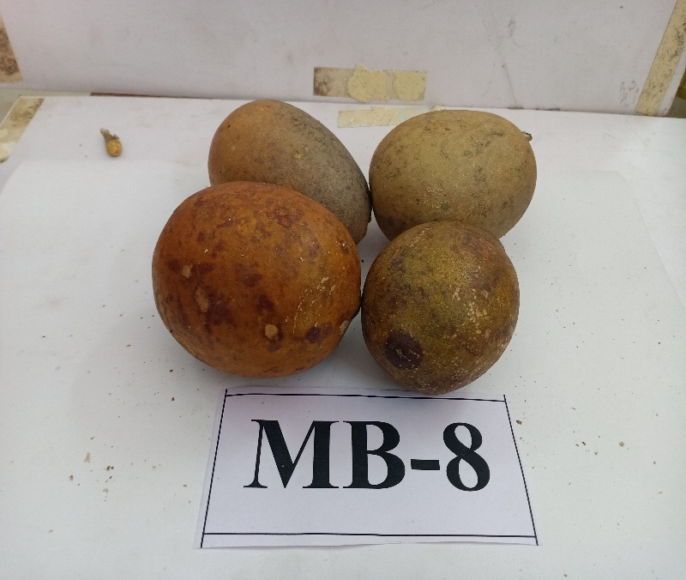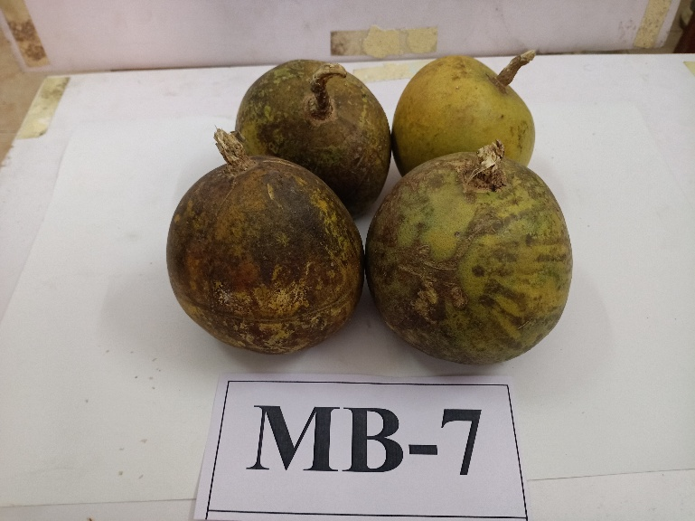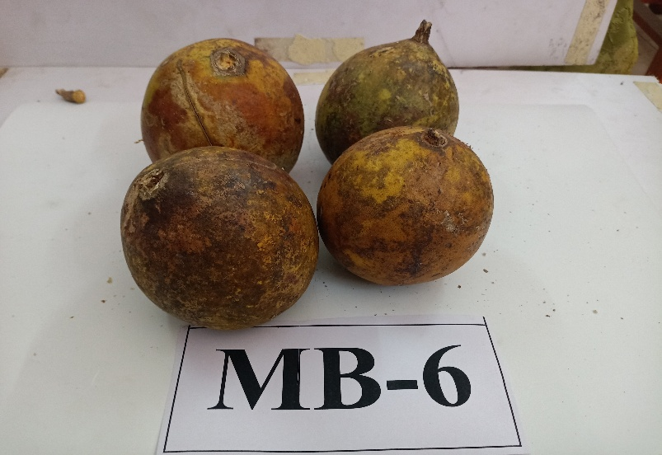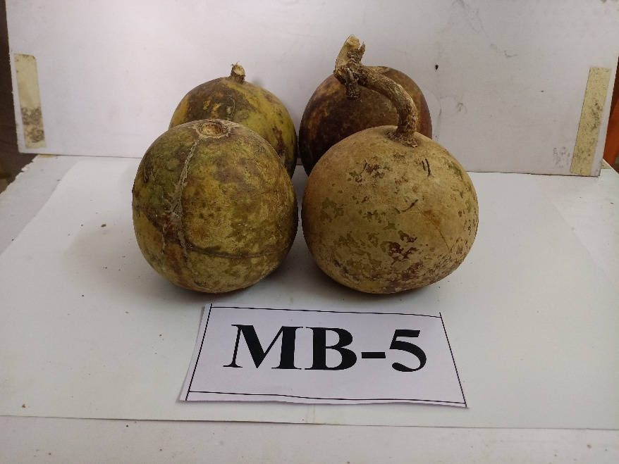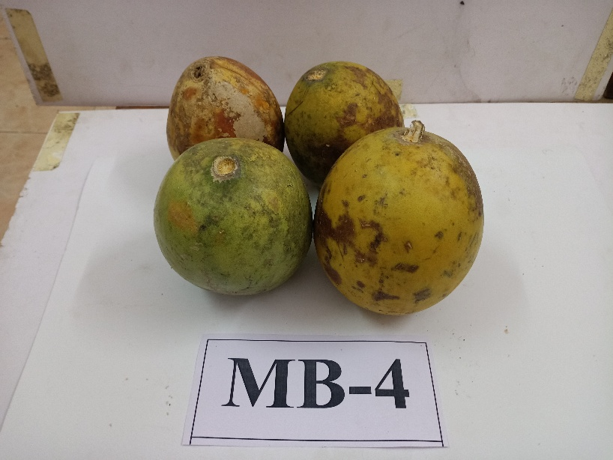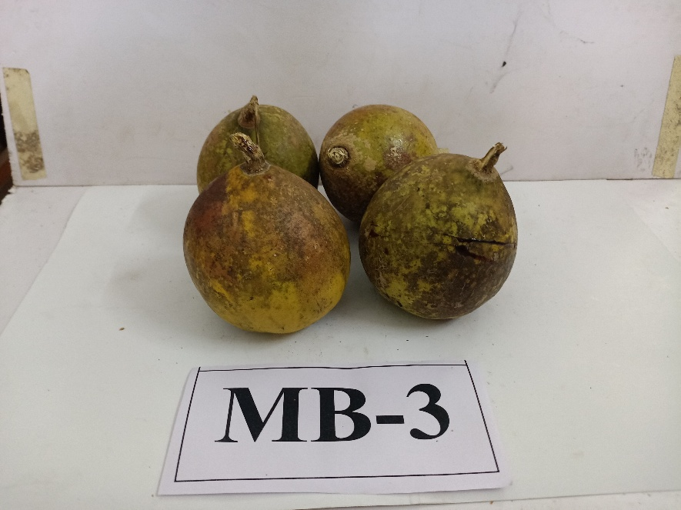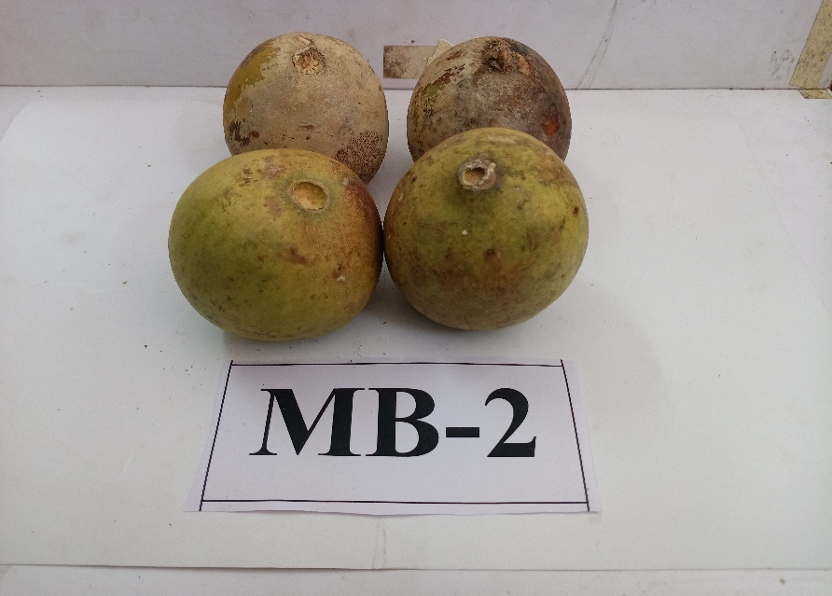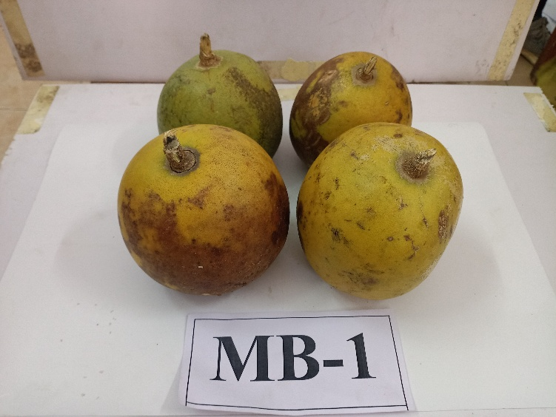

**Plate 4.1(a): Variability in fruits of different bael genotypes at Mahasamund District of Chhattisgarh**

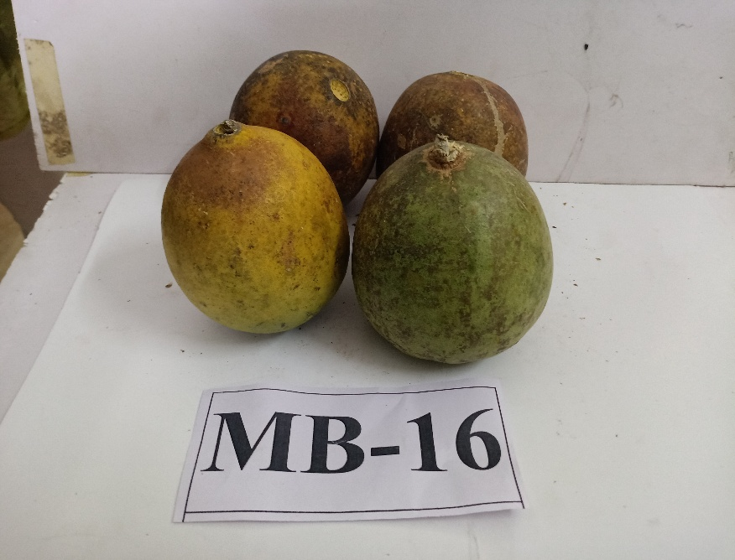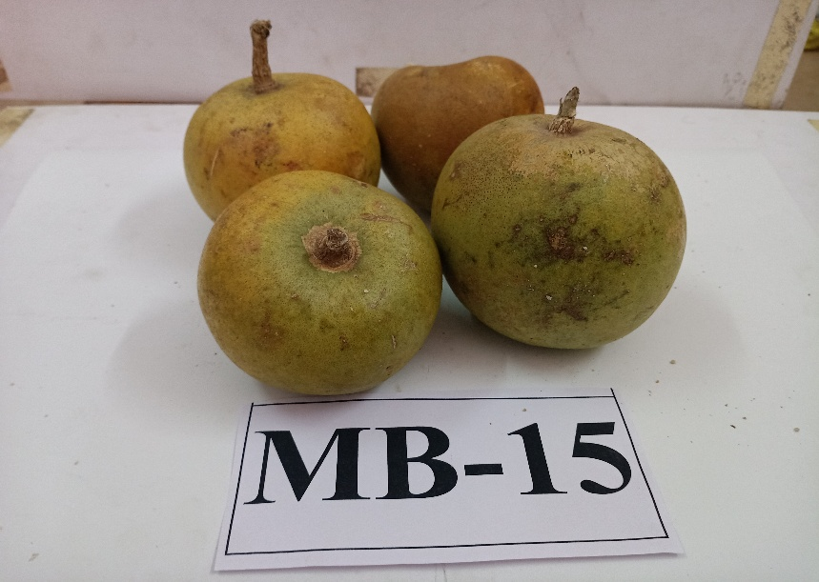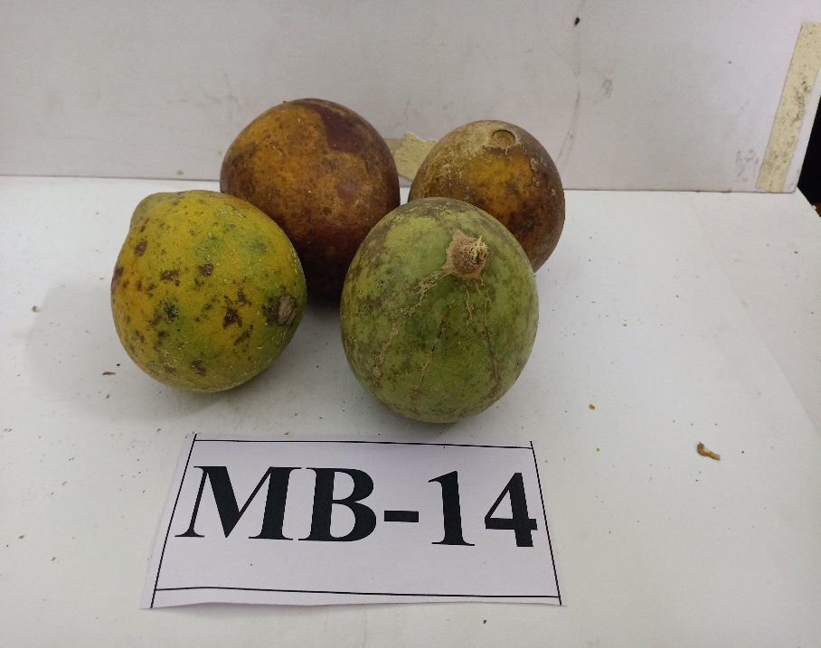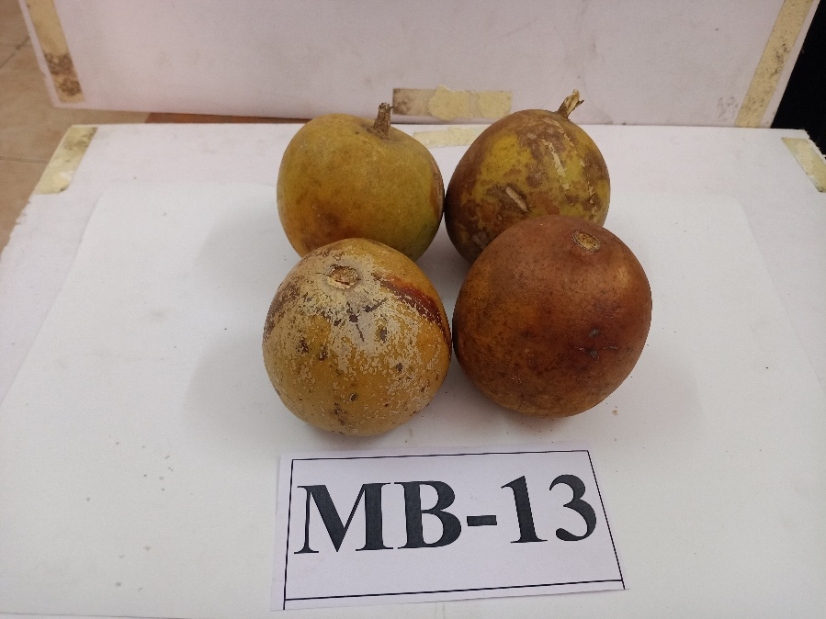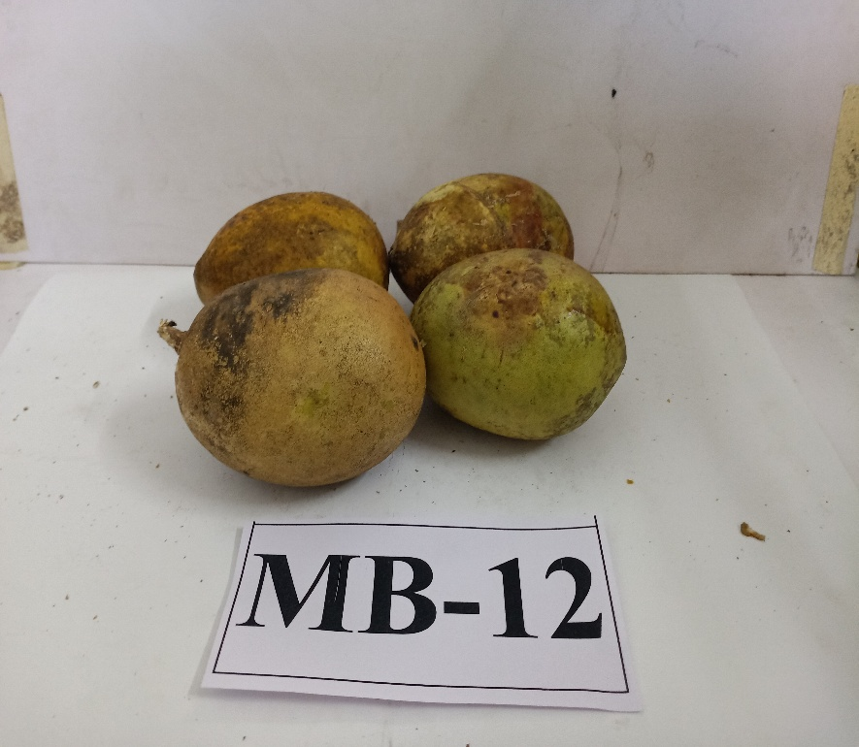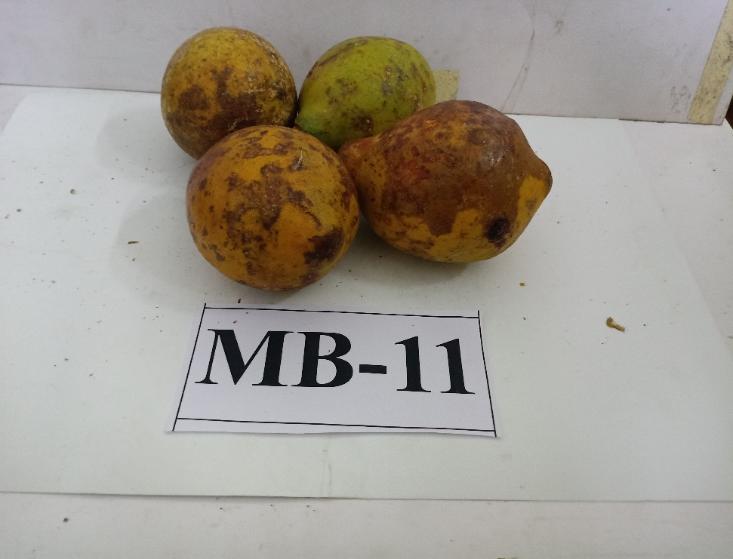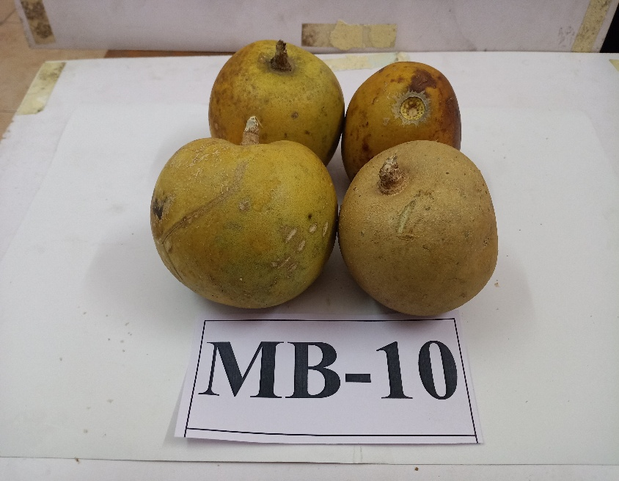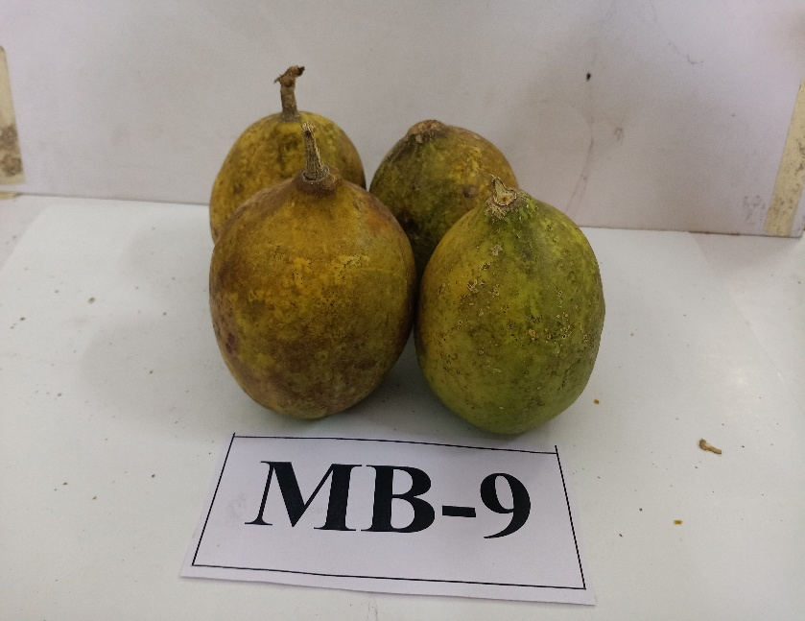

**Plate 4.1(b): Variability in fruits of different bael genotypes at Mahasamund District of Chhattisgarh**

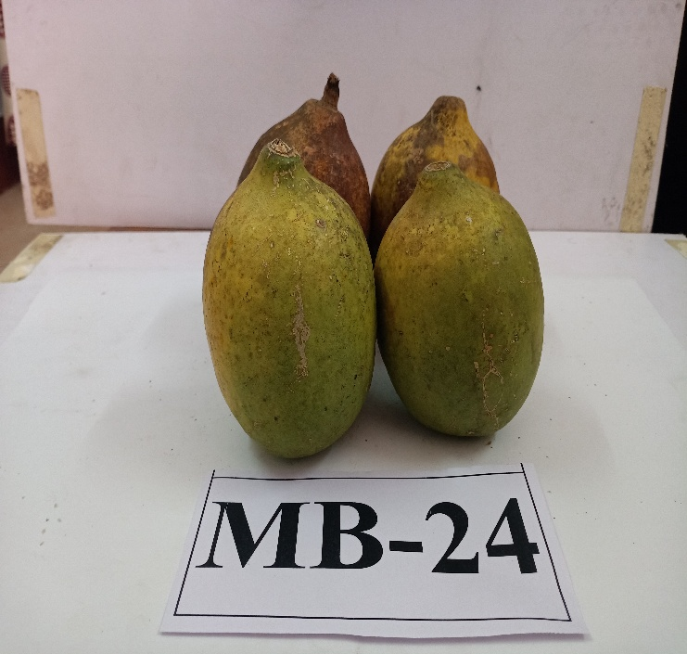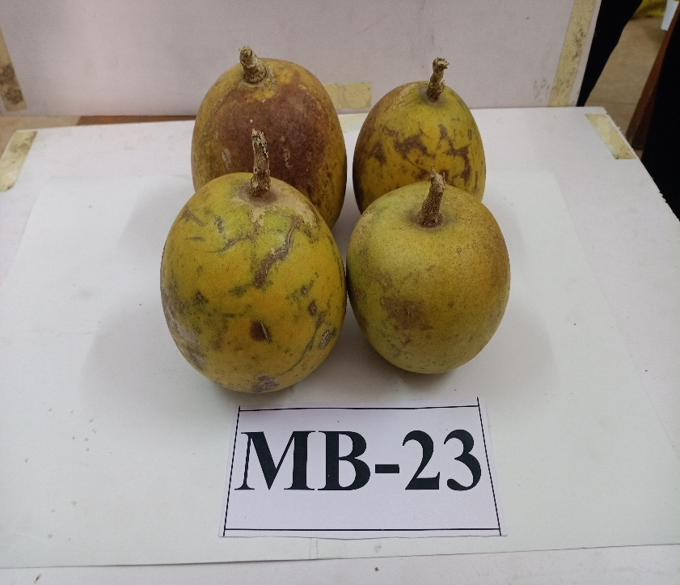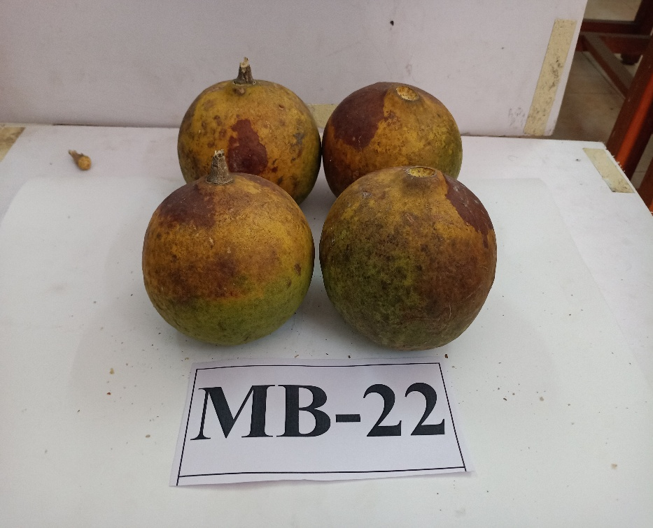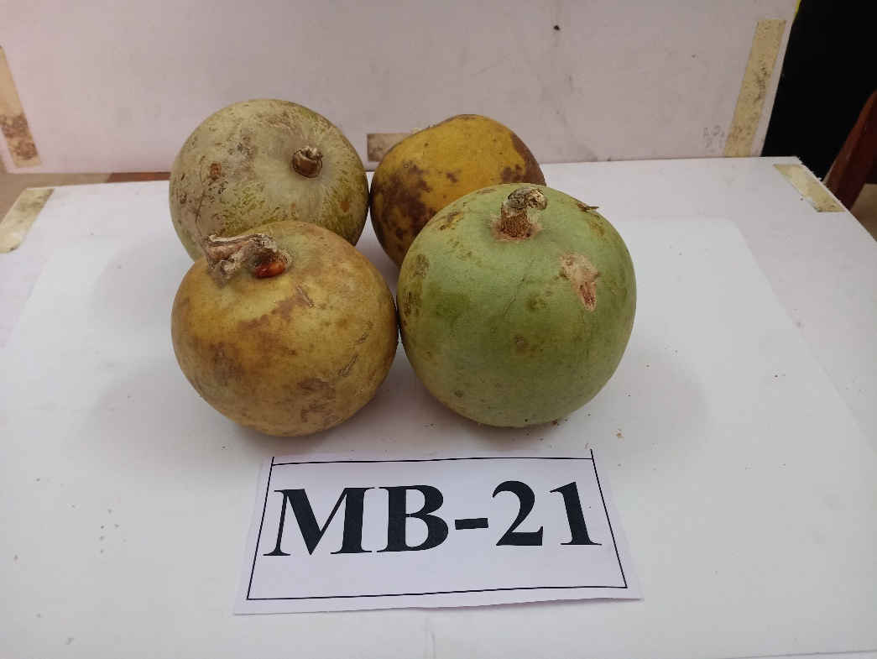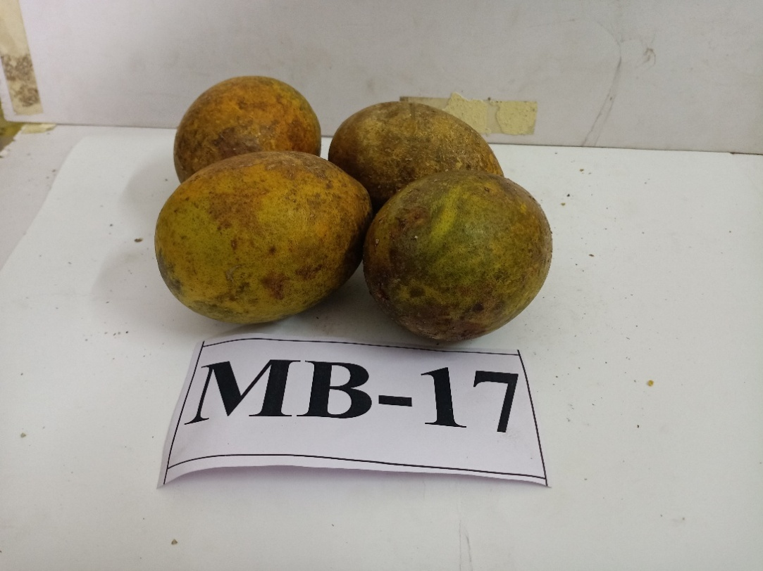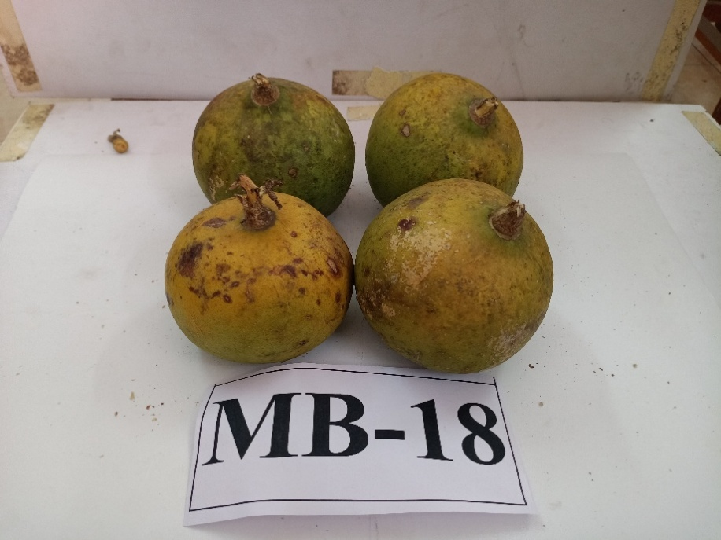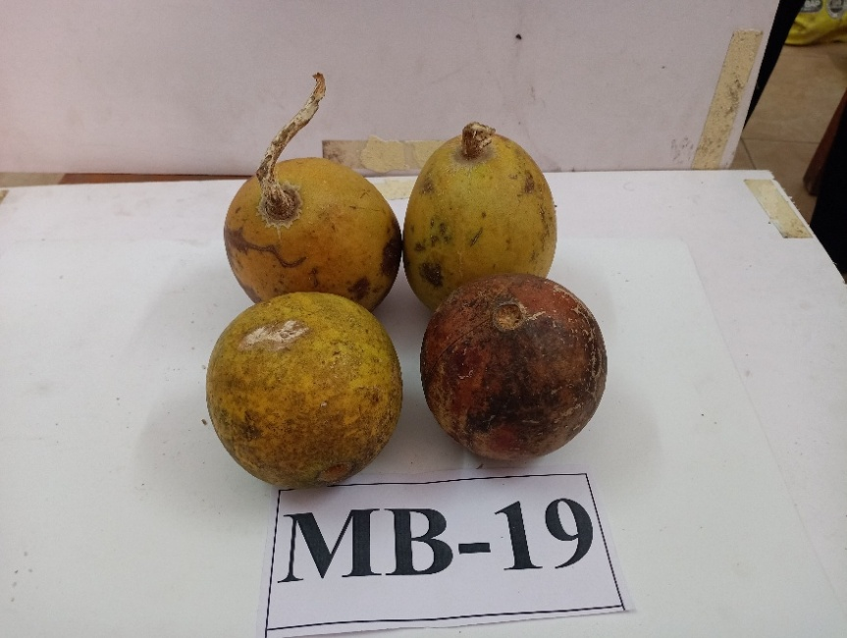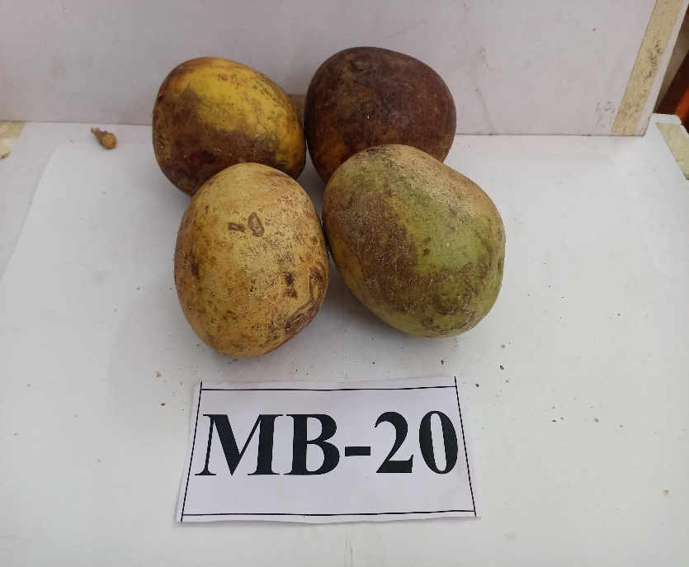

**Plate 4.1(c): Variability in fruits of different bael genotypes at Mahasamund District of Chhattisgarh**

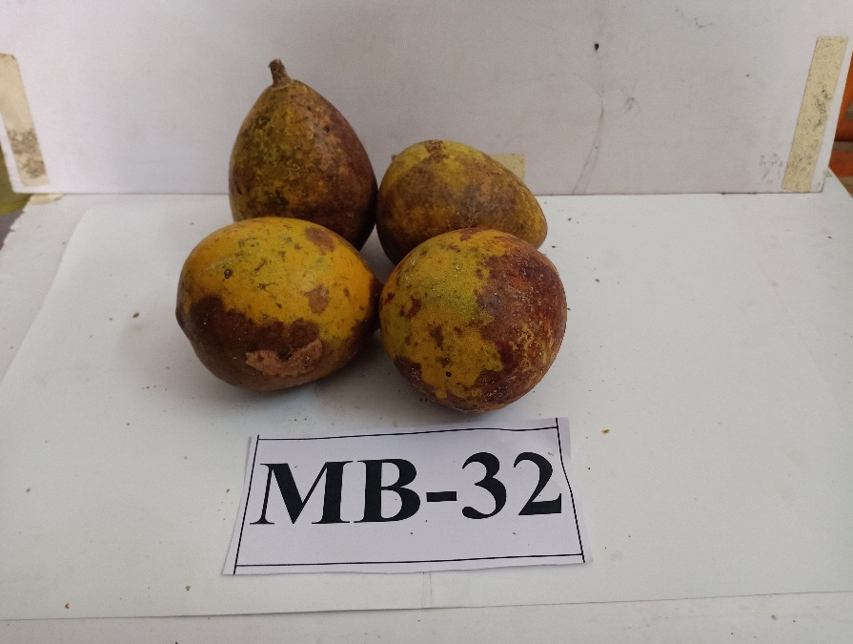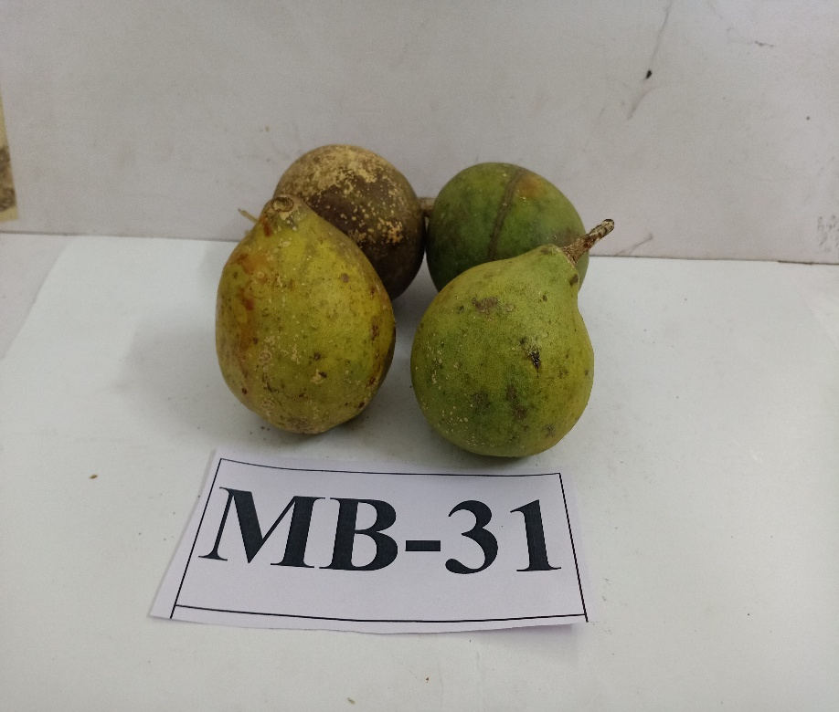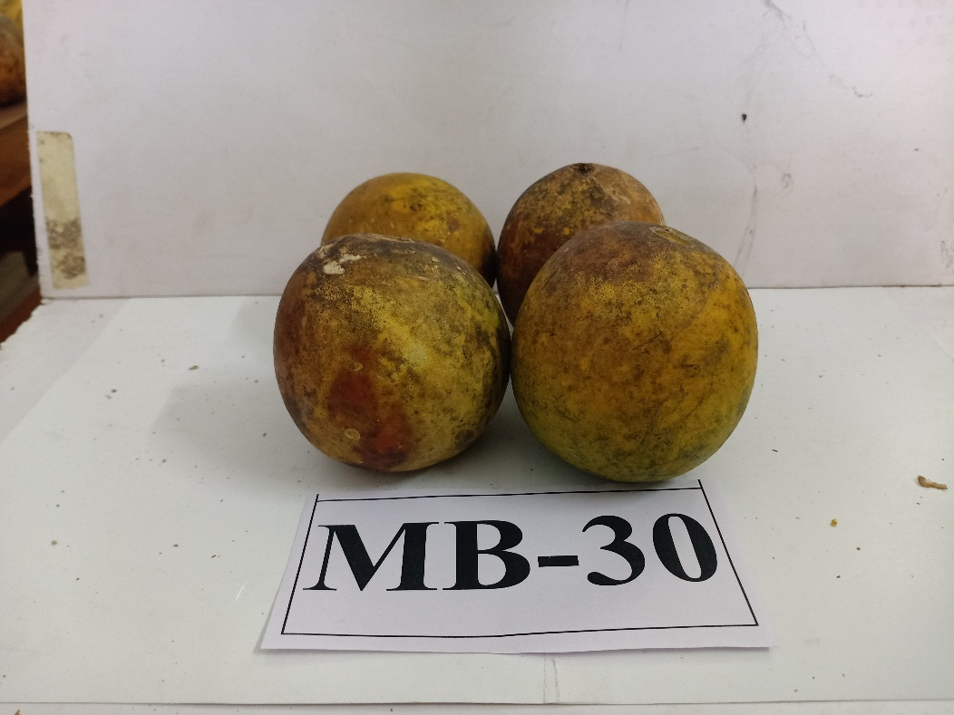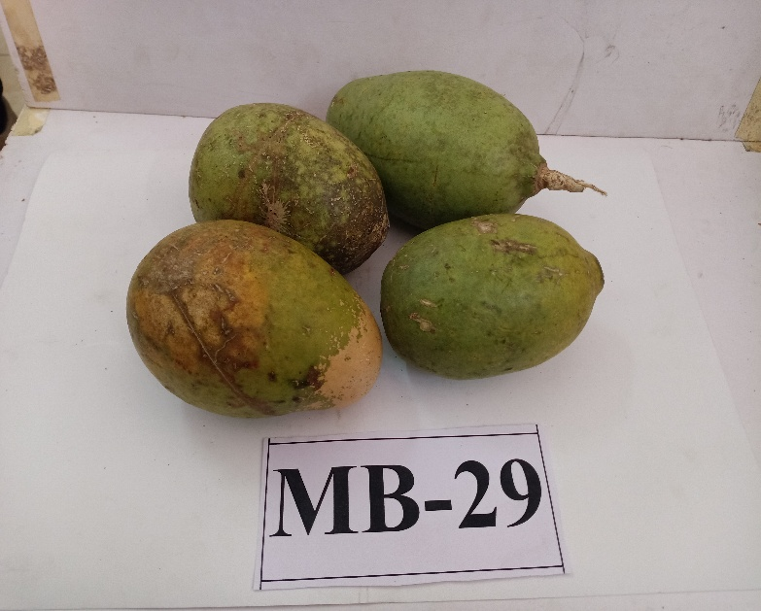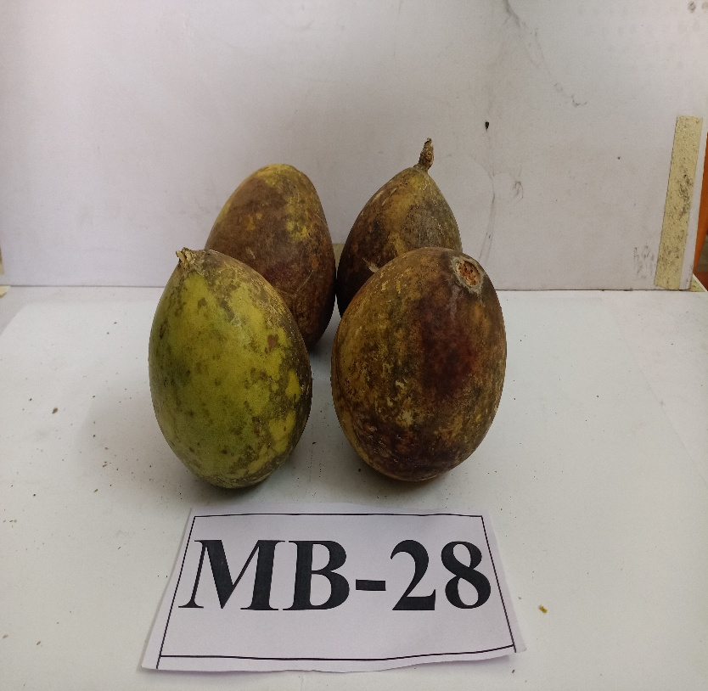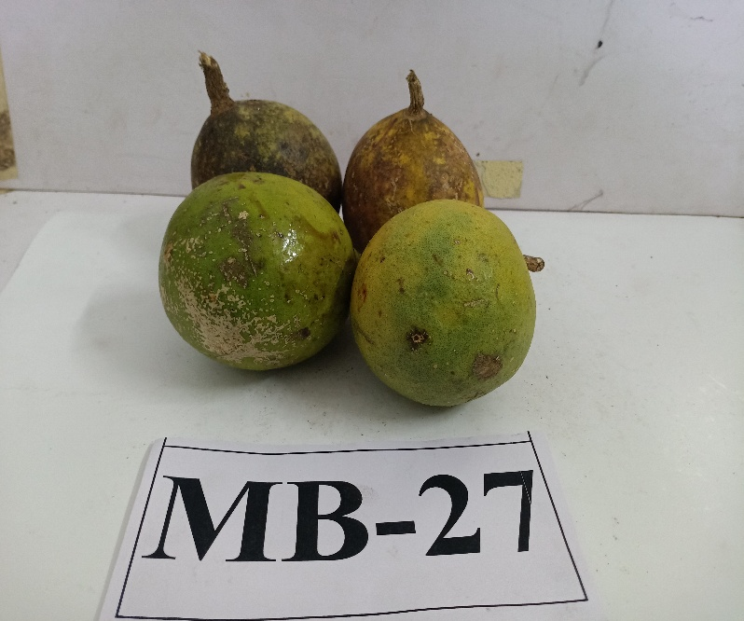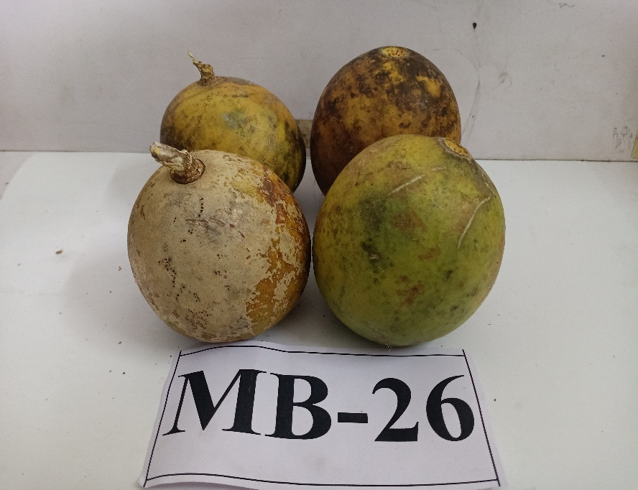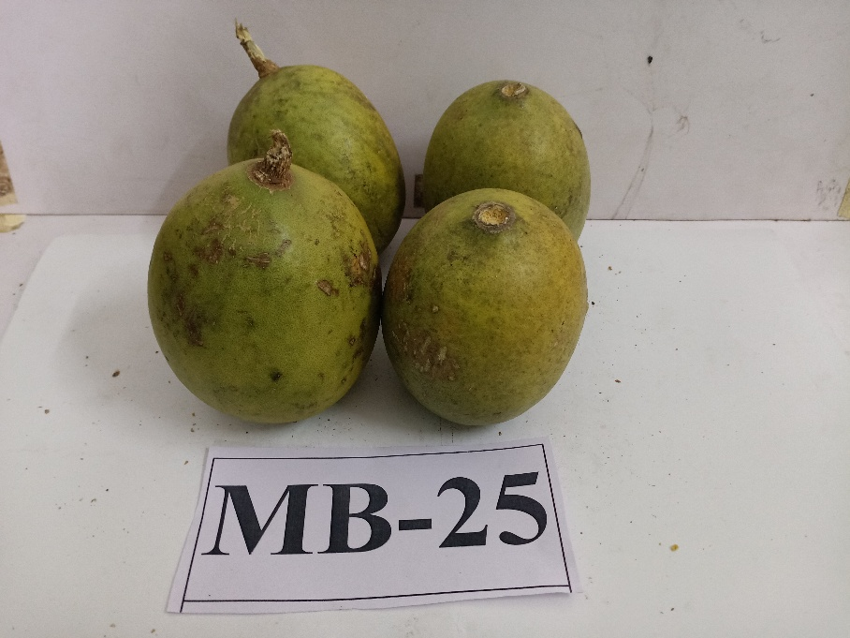

**Plate 4.1(d): Variability in fruits of different bael genotypes at Mahasamund District of Chhattisgarh**

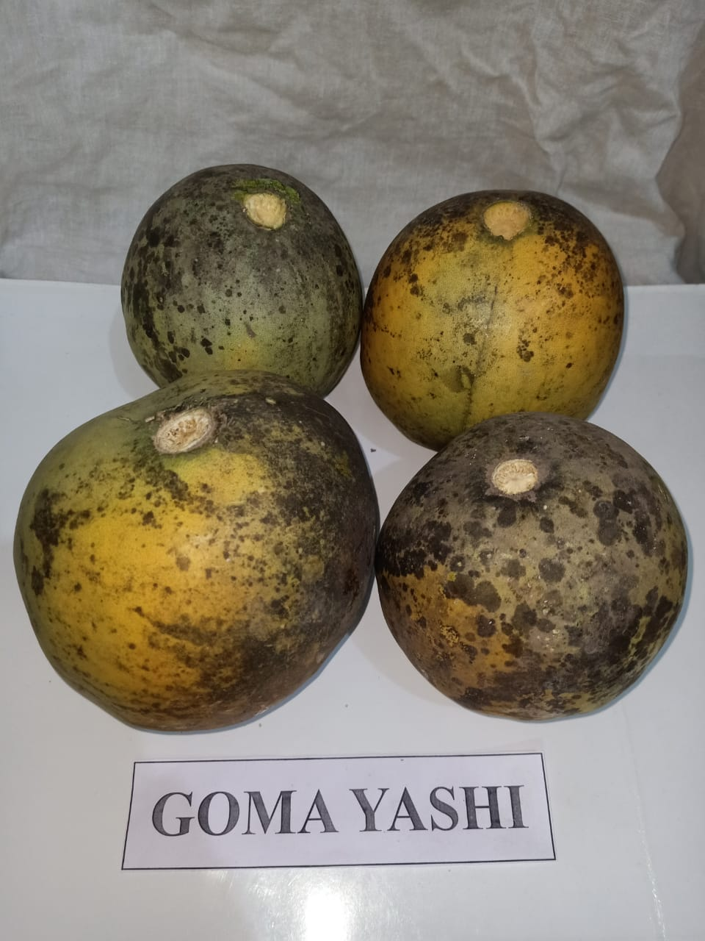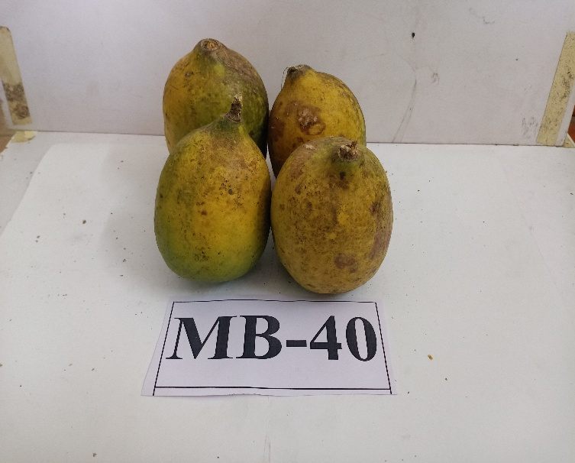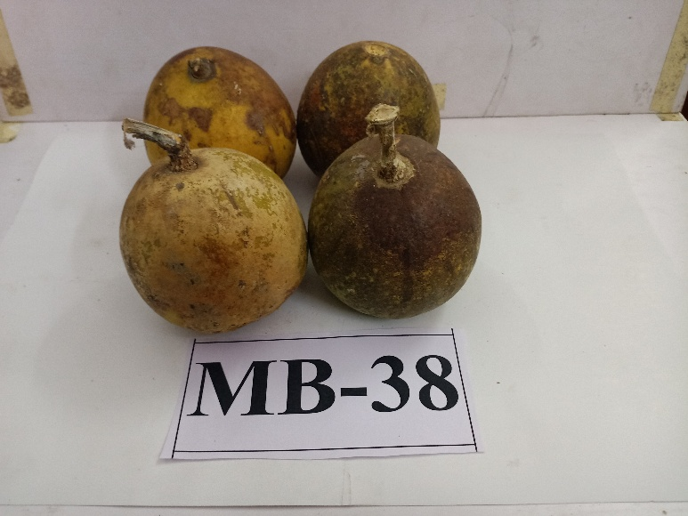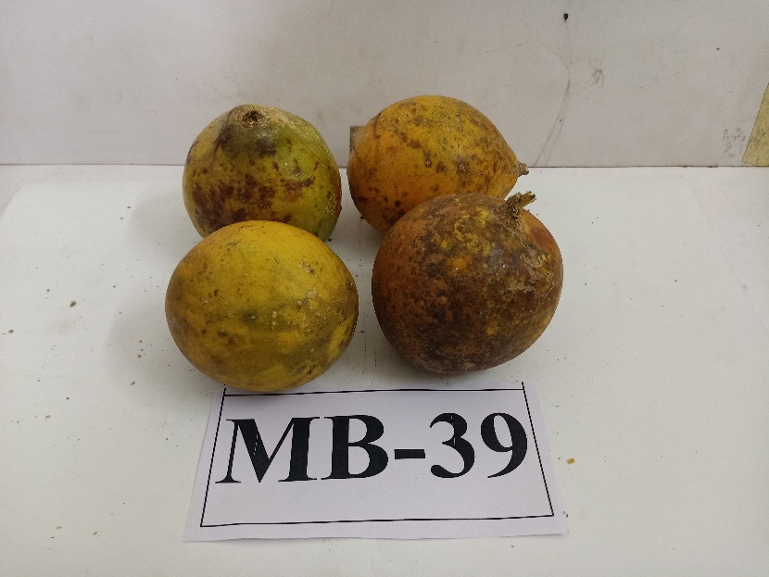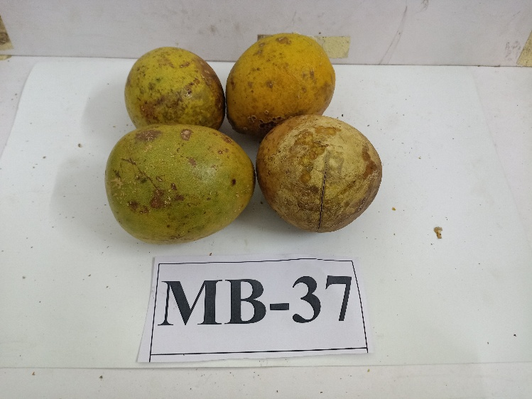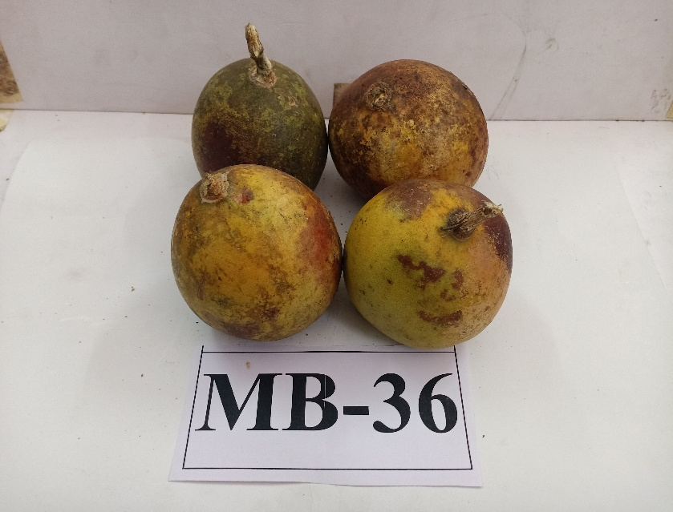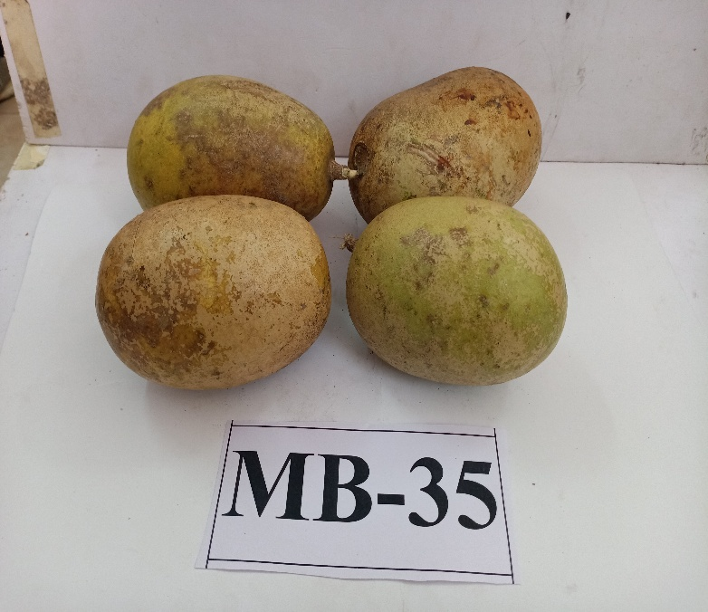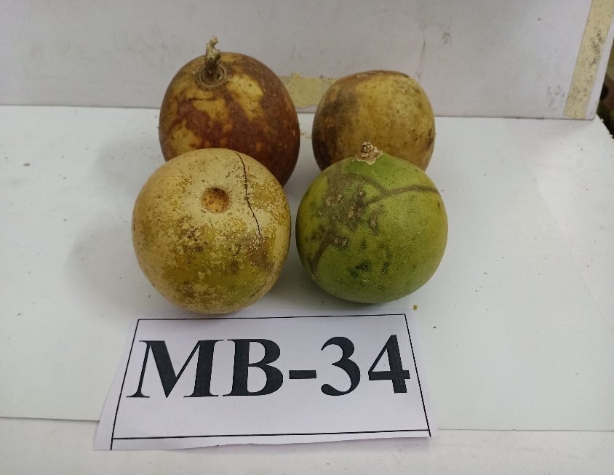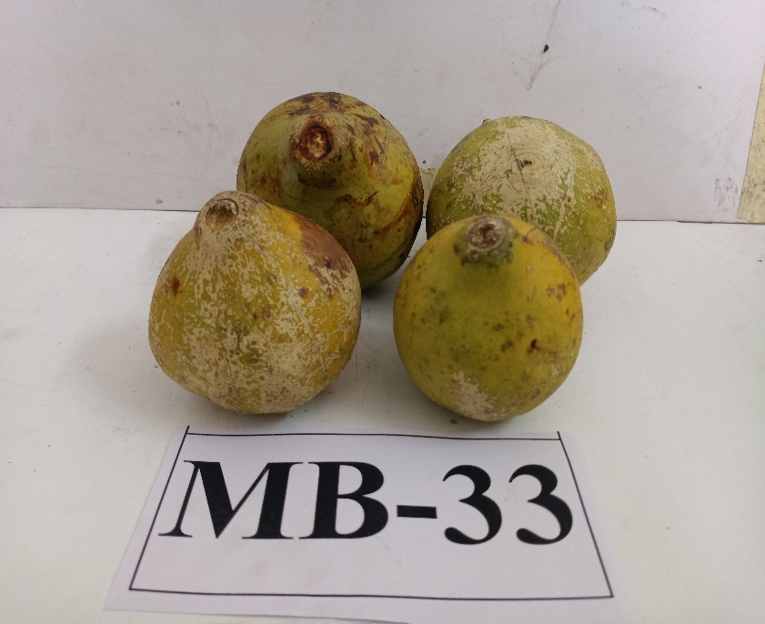

**Plate 4.1(e): Variability in fruits of different bael genotypes at Mahasamund District of Chhattisgarh**

**CONCLUSION**

After the evaluation of physical & yield attributes of different bael genotypes it can be concluded that the maximum fruit and pulp weight was recorded in the genotype Goma Yashi, fruit diameter and fruit length in the genotype MB-2, fruit yield in the genotype MB-31, specific gravity in MB-16 & MB-17 and shell thickness in the genotype MB-21, while the highest leaf length was observed in the genotype MB-28 and leaf width in the genotype MB-37 under the present exploration. Moreover, the total number of seeds, shell weight and seed weight were found minimum in the genotype MB-22, MB-24 and Goma Yashi, respectively. The outcome of the present experiment revealed existence of wide range of diversity for nearly all the physical and yield attributing characters suggesting the presence of large variability among the genotype. Identification and characterization of genotypes gave an idea for horticultural and crop morphology characters of Bael genotypes which is required in providing the helpful information of gene bank management and further evaluation of the existing genotypes for breeding program which are ultimate goal of the experiment.

**REFERENCES**

1. Amulya, R.N. 2019. Variability studies on Bael (*Aegle marmelos* Correa) genotypes of Sakharayapattana (Chickamagalur District). M.Sc. Thesis, University of Agricultural and Horticultural Sciences, Shivamogga, India.
2. Anonymous. 2021(a). Indian Horticultural Database. National Horticulture Board, Gurgaon.
3. Anonymous. 2021(b). Directorate Horticulture and Farm Forestry, Indravati Bhavan, Atal Nagar, Nava Raipur, Chhattisgarh.
4. Deepti, R. and Misra, K.K. 2005. Studies on genetic divergence in bael (*Aegle marmelos* Correa). *Indian Journal of Horticulture,* 62(2): 152-154.
5. Gomez, K.A. and Gomez, A. 1984. Statistical procedure for agricultural research. A wibey-International Science Publication John and Sons. Newyork, pp: 357-427.
6. Islam, M.S., Islam. M.S., Ibrahim, M., Hossain, M.M. and Kamal, A.M. 2012. Studies on morphological and fruit characters of bael. *International Journal of Sustainable Agricultural Technology*, 8(7): 24-27.
7. Majumder, B.C. 1975. Physico-chemical analysis of some types of Bael (*Aegle marmelos* Correa) fruit growing in West Bengal. *Indian Hort*.,19:295-298.
8. Misra, K.K., Singh, R. and Jaiswal, H.R. 1999. Performance of Bael (*Aegle marmelos* Corr.) trees under foot-hills region of Uttar Pradesh. *Indian Journal of Agricultural Sciences,* 70(10): 682-683.
9. Pale, J.P.L., Chetri, S., Suresh, C.P., Singh, Y.S., Chaurasiya, A. and Barman, A. 2019. Morphological and bio-chemical characterization of Bael (*Aegle marmelos* Correa) in West Garo Hills, Meghalaya, India. *International Journal of Current Microbiology & Applied Sciences*, 8(10): 2414-2420.
10. Pandey, D., Tandon, D.K., Hudedamani, U. and Tripathi, M. 2013. Variability in Bael (*Aegle marmelos* Corr.) trees from eastern Uttar Pradesh. *Indian Journal of Horticulture*, 70(2): 170-178.
11. Parihar, N. 2015. Variability studies in Bael (*Aegle marmelos* Correa) gene pool of Kymore Plateau and Satpura Hill Region. M.Sc. Thesis, Jawaharlal Nehru Krishi Vishwa Vidyalaya, Jabalpur, India.
12. Patel, A., Singh, P.K., Singh, A.K., Singh, S., Pandey, D., Acharya, S., Verma, L.R. and Prakash, R. 2015. Descriptor of bael (*Aegle marmelos* Correa). CIAH, Godhra, Gujrat, pp: 8-16.
13. Pathak, R.K., Pandey, D. and Pramanik, P.K. 2002 Diversity in Bael (*Aegle marmelos* Correa)-an under-utilized fruit of India. IPGRI Newsl.,37: 22 & 37.
14. Pavani, P., Kiranmayi, P. and Dash, S.N. 2017. Evaluation of Beal (*Aegle marmelos* Correa) genotypes for morphological, quality and yield related characters. *International Journal of Basic and Applied Biology,* 4(3): 164-167.
15. Singh, A.K., Singh, S. and Makwana, P. 2015. Inter-varietal morphological variability in Bael (*Aegle marmelos* Correa) under rainfed semi-arid hot ecosystem of western India. *Current Horticulture*, 3(2): 3-9.
16. Singh, P., Sharma, A., Jasrotia, A., Salgotra, R.K., Sharma, M. and Gupta, V. 2024. Diversity in morpho-pomological attributes and bio-chemical profiling of Bael (*Aegle marmelos* Correa) genotypes of North-Western India. *Heliyon*, 10(3): 1-13.
17. Singh, R., Mishra, K.K. and Jaiswal, H.R. 2000. Studies on physico-chemical characters in fruit of Bael genotypes. *Indian Journal of Horticulture*, 57(7): 314-317.
18. Singh, S., Sharma, J.R., Sehrawat, S.K., Jitarwal, O.P. and Gavri, A. 2020. Studies on the collection and evaluation of Bael cultivars. *International Journal of Chemical Studies*, 8(6): 212-214.
19. Singh, P., Sharma, A., Tandon, V., Salgotra, R.K., Sharma, M., Gupta, V. and Sharma, D. 2024. Genetic diversity and population structure of Bael [*Aegle marmelos* (L.) Correa] genotypes using molecular markers in the North-Western plains of India. *Scientific Reports*, 14(1), 18032.
20. Teaotia, S.S., Maurya, V.N. and Agnihotri, B.N. 1963. Some promising varieties of Bael (*Aegle marmelos* Correa) of eastern districts of Uttar Pradesh. *Indian J. Hort*., 20(7): 210-214.