Direct Immunofluorescence in Vasculitis: A Critical Tool in Diagnostic Dermatopathology

.

ABSTRACT

|  |
| --- |
| **Aims:** We assessed the significance of direct immunofiuorescence in the diagnosis of vasculitic lesions and to investigaie the hisiopathological characierises of vasculite iesions.  **Study design:** A cross-sectional study  **Place and Duration of Study:** The Cross-sectional research was conducted at the Blood Center and the Department of Pathology, Vinayaka Mission’s Kirupananda Variyar Medical College & Hospitals, Salem - 636308, Tamil Nadu, India, as a cross-sectional study carried out from January 2024 to December 2024, involving a sample size of 80 clinically diagnosed vasculitis lesions.  **Methodology:** This study included a sample size of 80 clinically diagnosed vasculitis patients selected based on the inclusion criteria of having complete clinical data, while excluding suspected cases and those with inadequate/incomplete data. Following informed consent, eligible patients were enrolled. Histopathological and Direct Immunofluorescence (DIF) findings were collected from the Department of Pathology, and clinico-epidemiological data were obtained. The primary outcome measures were the timing of biopsy with DIF positivity and the results of DIF studies.  **Results:** In our study of 80 clinically diagnosed vasculitis cases, the majority of patients were aged 31–40 years (31%), with a female predominance (58%). The lower limb was the most common biopsy site (41%). Direct immunofluorescence (DIF) revealed C3 as the most frequently detected component (25%), followed by fibrinogen (23%) and IgA (20%), while IgM (5%) and IgG (2%) were less common. Additionally 25% of patients showed negative results for all markers. DIF positivity was highest (93%) in patients biopsied within one week of symptom onset, decreasing to 50% in the second week, 22% in the third to fourth week, and 0% beyond four weeks, highlighting the importance of early biopsy for optimal detection  **Conclusion:** Direct immunofluorescence (DIF) is a valuable diagnostic tool in cutaneous vasculitis, with the highest yield seen in biopsies taken within one week of symptom onset. C3, fibrinogen, and IgA were the most commonly detected immune components. |

*Keywords: Direct immunofluorescence, Vasculitis, Early biopsy importance, Site involvement, C3, Fibrinogen, South Indian population*

INTRODUCTION

The inflammation of the vascular wall, known as vasculitis, can manifest clinically in a wide range of ways. Vasculitic processes frequently affect the skin. [1,2] Skin biopsies are frequently carried out when looking for vasculitides because of how simple they are to obtain. [3] Cutaneous vasculitis may be idiopathic, primary, or secondary to various illnesses, including neoplasms, infections, medications, inflammatory diseases, or a spectrum of systemic vasculitides. Vasculitis frequently involves small and/or medium-sized dermal vessels. [4,5]   
Due to its accessibility, cutaneous vasculitis is frequently identified and biopsied. Direct immunofluorescence (DIF) is also performed on the majority of biopsies, albeit the success rates differ. Verification and categorization of vasculitis depend on histopathologic analysis. [6, 7] Despite being considered sensitive, DIF has a varied yield and is affected by several factors. The majority of studies use a 48-hour cut-off period, and the positive rates are higher in early illness. [8, 9] We aim to assess the significance of direct immunofluorescence in the diagnosis of vasculitic lesions and to investigate the histopathological characteristics of vasculitic lesions in our hospital.

2. material and methods

This cross-sectional study was conducted at the Department of Pathology, Vinayaka Mission’s Kirupananda Variyar Medical College & Hospitals, Salem, Tamil Nadu, India, over a period from January 2024 to December 2024. A total of 80 patients with clinically diagnosed vasculitic lesions were included based on predefined inclusion criteria of complete clinical data. At the same time, suspected cases and those with inadequate or incomplete records were excluded. After obtaining informed consent, eligible participants were selected. Michel's transport media were used to carry the biopsies. Every biopsy was sectioned at 4 μm and frozen in a cryostat. IgG (1:30 diluted), IgA (1:30 diluted), IgM (1:30 diluted), complement C3 (1:30) (Dako), and fluorescein isothiocyanate (FITC) conjugated Fc-specific F (ab) 2 antisera were used to incubate the sections. If granular deposits of one or more immunoreactants were discovered in the walls of one or more vessels, the specimen was deemed positive. Histopathological examination characteristic of small vessel vasculitis typically reveals infiltration of vessel walls by neutrophils along with leucocytoclasis (nuclear dust), swollen endothelial cells, perivascular edema, extravasation of red blood cells, and thrombosis. (FIGURES 1-3) Histopathological and direct immunofluorescence (DIF) findings were obtained from the Department of Pathology, and relevant clinico-epidemiological data were obtained. The primary outcome measures were the timing of biopsy with DIF positivity and the DIF results themselves. Data entry and statistical analysis were performed using SPSS software, with p-values calculated to assess statistical significance in correlations and findings.

FIGURE 1: Perivascular infiltration of papillary dermis

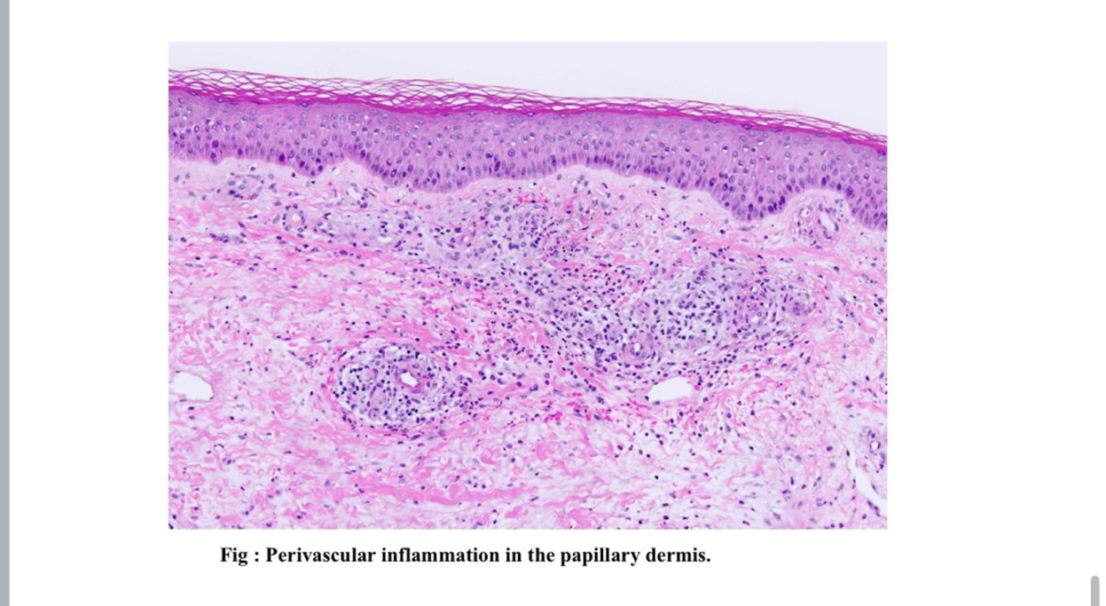

FIGURE 2: Perivascular inflammation showing neutrophils, fibrin deposits and nuclear dust

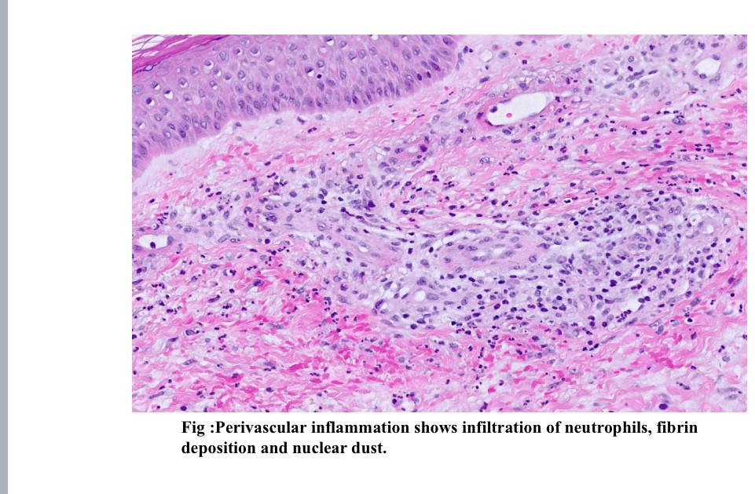

FIGURE 3: Endothelial swelling, perivascular inflammation of predominantly neutrophils & erythrocyte extravasation

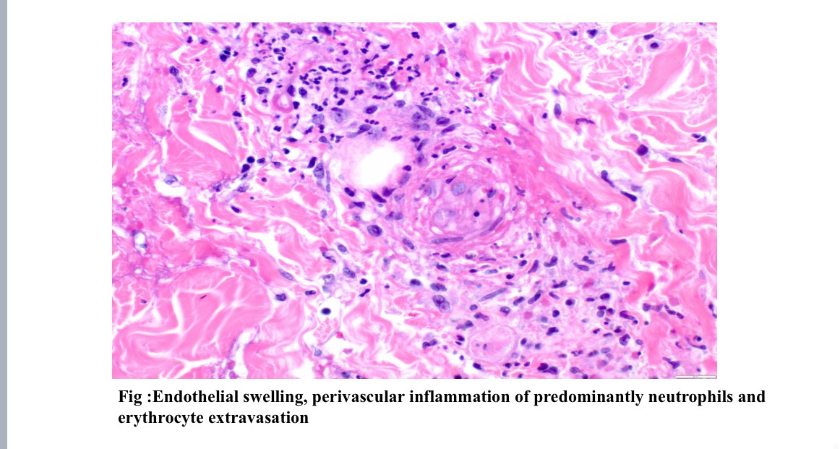

3. results and discussion

**AGE DISTRIBUTION**

In our study, individuals under 20 years of age accounted for 6% of the total, with 5 patients in this category. The 20–30 years age group comprised 15 patients, accounting for 19% of the total. The largest proportion was observed in the 31–40 years age group, comprising 25 patients or 31%. Both the 41–50 years and 51–60 years age groups had a similar number of patients—15 (19%) and 14 (17%), respectively. The 61–70 years group had 4 patients, representing 5%, while the 71–80 years group had the smallest count with just 2 patients, accounting for 3% of the total. (TABLE 1)

**TABLE 1: AGE DISTRIBUTION**

|  |  |  |
| --- | --- | --- |
| AGE GROUP | NO OF PATIENTS | PERCENTAGE |
| LESS THAN 20 YEARS | 5 | 6% |
| 20-30 YEARS | 15 | 19% |
| 31-40 YEARS | 25 | 31% |
| 41-50 YEARS | 15 | 19% |
| 51-60 YEARS | 14 | 17% |
| 61-70 YEARS | 4 | 5% |
| 71-80 YEARS | 2 | 3% |

**GENDER DISTRIBUTION**

In our study, 34 patients (42 %) were males and 46 patients (58%) were females (TABLE 2)

**TABLE 2: GENDER DISTRIBUTION**

|  |  |  |
| --- | --- | --- |
| GENDER | NO OF PATIENTS | PERCENTAGE |
| MALE | 34 | 42% |
| FEMALE | 46 | 58% |

**SITE DISTRIBUTION**

In our study, the most common site of biopsy was the lower limb, with 33 patients (41%) undergoing procedures in that area. This was followed by the upper limb, where 20 patients (25%) underwent biopsies. The back was the site of biopsy in 12 patients (15%), while the chest and abdomen accounted for 10 cases (13%). The least common biopsy site was the face and scalp, affecting only 5 patients (6%). (TABLE 3 & FIGURE 4)

**TABLE 3: SITE DISTRIBUTION**

|  |  |  |
| --- | --- | --- |
| SITE OF BIOPSY | NO OF PATIENTS | PERCENTAGE |
| LOWER LIMB | 33 | 41% |
| UPPER LIMB | 20 | 25% |
| BACK | 12 | 15% |
| CHEST & ABDOMEN | 10 | 13% |
| FACE & SCALP | 5 | 6% |

**FIGURE 4: SITE DISTRIBUTION**

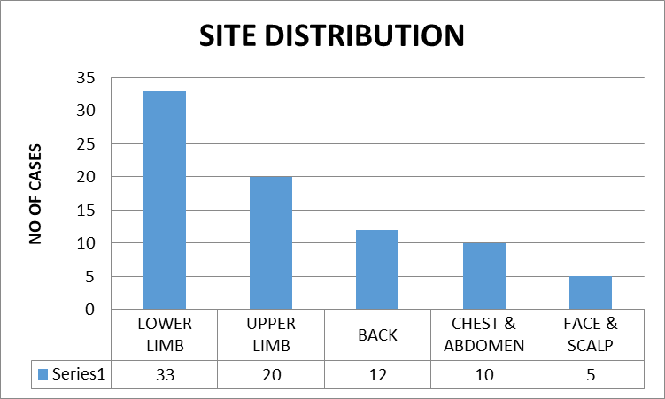

**SYMPTOMS**

The most frequently reported symptom was skin involvement, observed in 30 patients (37%). Joint pain was the next most common, reported by 25 patients (31%). Abdominal pain was present in 10 patients (13%), while 3 patients (4%) experienced neuropathy. Combined symptoms were also noted, with skin and joint involvement seen in 5 patients (6%), and skin and gastrointestinal involvement in another 5 patients (6%). Fever was the least common symptom, reported in only 2 patients (3%). (TABLE 4 & FIGURE 5)

**TABLE 4: SYMPTOMS**

|  |  |  |
| --- | --- | --- |
| **SYMPTOMS** | **FREQUENCY** | **%** |
| SKIN INVOLVEMENT | 30 | 37% |
| JOINT PAIN | 25 | 31 |
| ABDOMINAL PAIN | 10 | 13 |
| NEUROPATHY | 3 | 4 |
| SKIN & JOINT INVOLVEMENT | 5 | 6 |
| SKIN & GIT INVOLVEMENT | 5 | 6 |
| FEVER | 2 | 3 |

**FIGURE 5: SYMPTOMS**

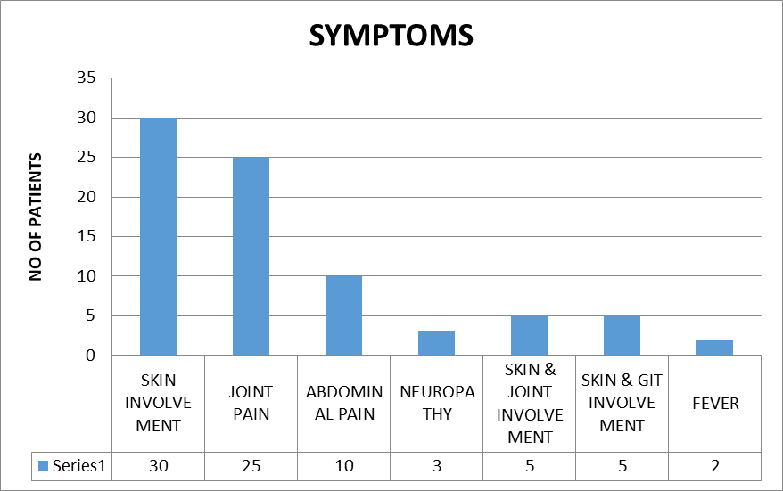

**RESULTS OF DIRECT IMMUNOFLUORESCENCE**

Direct immunofluorescence revealed the presence of C3 in 20 patients (25%), making it the most frequently detected component. Fibrinogen was found in 18 patients (23%), followed by IgA in 16 patients (20%). IgM and IgG were less commonly observed, with frequencies of 4 (5%) and 2 (2%) patients, respectively. Notably, 20 patients (25%) showed negative results for all tested immunoglobulins and complement components. (TABLE 5 & FIGURE 6)

**TABLE 5: RESULTS OF DIRECT IMMUNOFLUORESCENCE**

|  |  |  |
| --- | --- | --- |
| **IMMUNOGLOBULINS** | **FREQUENCY** | **%** |
| IgA | **16** | **20** |
| IgM | **4** | **5** |
| IgG | **2** | **2** |
| C3 | **20** | **25** |
| FIBRINOGEN | **18** | **23** |
| ALL NEGATIVE | **20** | **25** |

**FIGURE 6: RESULTS OF DIRECT IMMUNOFLUORESCENCE**

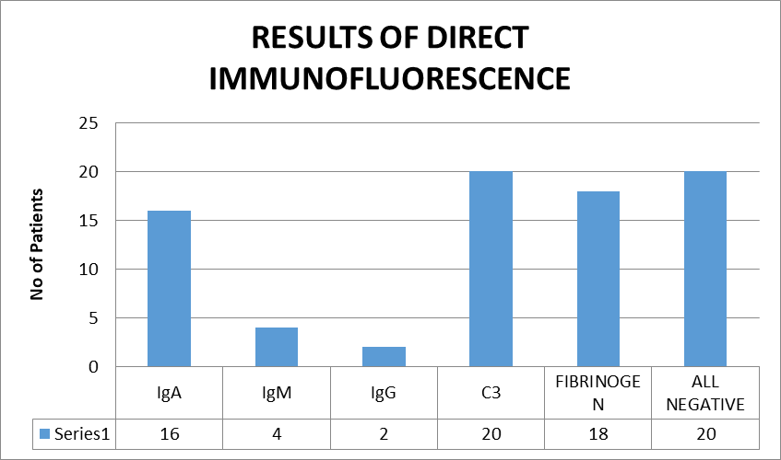

**TIMING OF BIOPSY AND DIF POSITIVITY**

In our study, the highest rate of DIF positivity was observed in patients who underwent biopsy within one week of symptom onset, with 52 out of 56 patients (93%) showing positive results. In those biopsied between the first and second week, DIF positivity dropped to 50%, with 6 out of 12 patients testing positive. The positivity rate further declined to 22% in patients biopsied between the second and fourth weeks (2 out of 9 patients). Notably, no DIF positivity was observed in patients biopsied after more than four weeks, indicating a clear decline in detection rates with delayed biopsy. (TABLE 6 & FIGURE 7)

**TABLE 6: TIMING OF BIOPSY AND DIF POSITIVITY**

|  |  |  |  |
| --- | --- | --- | --- |
| **TIMING OF BIOPSY** | **NO OF PATIENTS** | **DIF POSITIVITY** | **%** |
| LESS THAN 1 WEEK | 56 | 52 | 93% |
| 1ST TO 2ND WEEK | 12 | 6 | 50% |
| 2ND WEEK TO 4TH WEEK | 9 | 2 | 22% |
| MORE THAN 4TH WEEK | 3 | 0 | 0% |

**FIGURE 7: TIMING OF BIOPSY AND DIF POSITIVITY**

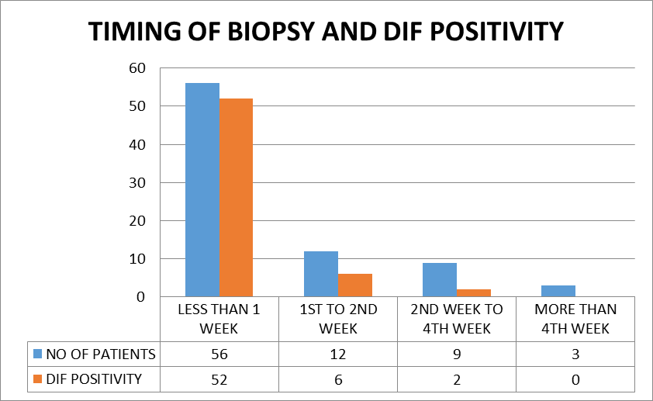

**DISCUSSION**

Small-vessel vasculitis is broadly divided into ANCA-associated and non-ANCA-associated forms. Among adults, ANCA-associated vasculitis represents the most prevalent type of primary systemic small-vessel inflammation, encompassing conditions such as microscopic polyangiitis, Wegener’s granulomatosis, Churg-Strauss syndrome, and vasculitis induced by certain drugs. In contrast, non-ANCA-associated vasculitis primarily includes Henoch-Schönlein purpura, which is the most frequently diagnosed small-vessel vasculitis in children. [10,11,12] Palpable purpura, which is mainly found on the lower extremities, is the clinical manifestation of cutaneous vasculitis, an inflammatory illness of the dermal blood vessels. Though they only produce a small number of histologic features of vascular inflammation, its causes are numerous. [13] The most frequent vasculitic manifestation seen in clinical practice is cutaneous vasculitis, which is also commonly biopsied. DIF gives the diagnosis more credibility, even though histology is necessary for confirmation and occasionally for determining the cause. However, a number of factors influence the DIF outcome. Despite being aware of these restrictions, DIF is used to the majority of biopsies. DIF's usefulness in these situations must be assessed, and cases where it could be helpful must be triaged. Numerous skin biopsies in the current investigation revealed no immune deposits on DIF, which is frequently done in the hopes of confirming vasculitis. [14]

In our study, the largest proportion was observed in the 31–40 years age group, comprising 25 patients or 31%. Both the 41–50 years and 51–60 years age groups had a similar number of patients—15 (19%) and 14 (17%), respectively. Nandeesh B et al [6] state that the age of the patients ranged from eight to 82 years with a mean age of 29.6 years. Seventy percent of the patients were below 40 years.

In our study, 34 patients (42 %) were males and 46 patients (58%) were females. Nandeesh B et al [6] state that women outnumbered men in a ratio of approximately 1.6:1 from their study. Poornimambaa M et al [15] state that among the total 35 patients, 18 were females and 17 males from their study. However, Lath K et al [16] state that there were 102 male and 96 female patients in their study.

In our study, most common site of biopsy was the lower limb, with 33 patients (41%) undergoing procedures in that area. This was followed by the upper limb, where 20 patients (25%) had biopsies performed. The back was the site of biopsy in 12 patients (15%), while the chest and abdomen accounted for 10 cases (13%). The least common biopsy site was the face and scalp, with only 5 patients (6%) affected. Nandeesh B et al [6] state that the commonest site was lower extremity followed by upper extremity from their study.

In our study, the most common symptom was skin involvement (37%), followed by joint pain (31%), abdominal pain (13%), and neuropathy (4%). Combined symptoms included skin and joint (6%) or skin and gastrointestinal involvement (6%). Fever was rare (3%). Nandeesh B et al [6] state that Palpable purpura was the main clinical finding seen in all the patients followed by multiple joint pain from their study. Lath K et al [16] state that skin involvement was present in all the cases and arthralgia in 30 patients (18.8%), pain in abdomen and/or malena in 16 patients (10%), and 10 cases (6.25%) showed simultaneous involvement of 3 organs, that is, skin, joint, and gastrointestinal tract.

Direct immunofluorescence revealed the presence of C3 in 20 patients (25%), making it the most frequently detected component. Fibrinogen was found in 18 patients (23%), followed by IgA in 16 patients (20%). IgM and IgG were less commonly observed, with frequencies of 4 (5%) and 2 (2%) patients, respectively. Notably, 20 patients (25%) showed negative results for all tested immunoglobulins and complement components. Nandeesh B et al [6] state that the C3 was most commonly found with 26% in 52 patients and followed by IgA in 46 patients with 23%. Poornimambaa M et al [15] state that C3 and fibrinogen were the common immune-reactants seen in DIF from their study. Lath K et al [16] state that IgA was the most common immunoreactant (35.3%) and other immunoreactant positivity seen in decreasing order of frequency were C3 (30.3%), IgM (24.7%), and IgG (18.6%). Positive DIF results alone should not be used to make a diagnosis of LCV, nor should a negative DIF test rule out the diagnosis. It is important to evaluate DIF results in conjunction with clinical, microscopic, and other laboratory results.

In our study, DIF positivity was highest (93%) in patients biopsied within one week of symptom onset (52/56). It dropped to 50% between weeks one and two (6/12), 22% between weeks two and four (2/9), and 0% after four weeks, highlighting decreased detection with delayed biopsy. Nandeesh B et al [6] state that DIF was positive in 85% of biopsies performed within seven days, followed by 14% positivity by 1st to 2nd week, 1% positivity by 2nd to 4th week and 0% positivity after 4th week. Poornimambaa M et al [15] state that in 14 patients who had lesions less than 2 days old DIF was positive in 13 (92%) and in 19 patients who had lesions of 3–5 days duration DIF was diagnostic in all of them. Because immune deposits break down quickly, a biopsy sample obtained too late (i.e., after 48 hours) may exhibit more pathology of repair than of the original damage and may have a negative DIF. Because patients often self-medicate in the early stages of the illness, or because primary level physicians may misdiagnose the ailment because they are not familiar with the presentation of cutaneous vasculitis, the diagnosis of cutaneous vasculitis may be slightly delayed.

The limitations of our study include small sample size and single-center design may limit the generalizability of the findings to broader populations. Our study also lacked long-term follow-up to correlate DIF findings with clinical outcomes or treatment response. Additionally, there was limited differentiation between various subtypes of vasculitis, particularly ANCA-associated and non-ANCA-associated forms.

4. Conclusion

This study emphasizes how important direct immunofluorescence (DIF) is for cutaneous vasculitis diagnosis, especially when samples are taken early in the illness. Biopsies obtained within a week of the onset of symptoms had the highest diagnostic yield, confirming that DIF sensitivity is time-sensitive. C3, fibrinogen, and IgA were the most commonly found immune components, indicating typical immunopathological patterns observed in vasculitic processes. Our results also corroborate previous research on the most common clinical characteristics, which are cutaneous manifestations, female preponderance, and lower limb involvement. Accurate classification and treatment of vasculitic illnesses depend on timely biopsy and clinical detection due to the diagnostic importance of DIF and histology, particularly in early lesions.

**RECOMMENDATION**

* Early Biopsy is Crucial: Clinicians should aim to perform skin biopsies within one week of symptom onset to maximize DIF positivity and diagnostic accuracy.
* Routine Use of DIF: Direct immunofluorescence should be routinely included in the evaluation of suspected cutaneous vasculitis for better immunopathological characterization.
* Site Selection Matters: The lower limb remains the most common and accessible site for biopsy and should be prioritized when appropriate.
* Integrated Clinical Approach: Clinical findings, histopathology, and DIF results should be interpreted together to ensure accurate diagnosis and appropriate management.
* Improve Awareness and Training: Enhanced clinician awareness and training on the importance of timing and technique in biopsy collection can improve diagnostic outcomes.

Consent

All authors declare that ‘written informed consent was obtained from the patient (or other approved parties) for publication of this study. A copy of the written consent is available for review by the Editorial office/Chief Editor/Editorial Board members of this journal.

Ethical approval

Before the study, all patients were informed about the contents & type of the study, and written informed consent was obtained from each of them. The study was approved by the Institutional ethical committee of Vinayaka Mission's Kirupananda Variyar Medical College & Hospitals. (Reference no: VMKVMC&H IEC/23/032). According to the ICMR guidelines on Biomedical research in human beings, and also adhering to the principles of Good Clinical Practice. All authors hereby declare that all experiments have been examined and approved by the appropriate ethics committee and have therefore been performed following the ethical standards laid down in the 1964 Declaration of Helsinki.”

Disclaimer (Artificial intelligence)

Option 1:

Author(s) hereby declare that NO generative AI technologies such as Large Language Models (ChatGPT, COPILOT, etc.) and text-to-image generators have been used during the writing or editing of this manuscript.

References

1. Watts RA, Scott DG. Recent developments in the classification and assessment of vasculitis. Best Pract Res Clin Rheumatol. 2009;23(3):429-443. doi:10.1016/j.berh.2008.12.004
2. Guillevin L. (2012). Vascularites : le temps des changements [Vasculitis: Time of changes]. *Presse medicale (Paris, France : 1983)*, *41*(10), 934–936. <https://doi.org/10.1016/j.lpm.2012.07.009>
3. Suresh E. Diagnostic approach to patients with suspected vasculitis. Postgrad Med J. 2006;82(970):483-488. doi:10.1136/pgmj.2005.042648
4. Cassisa A, Cima L. Cutaneous vasculitis: insights into pathogenesis and histopathological features. Pathologica. 2024;116(2):119-133. doi:10.32074/1591-951X-985
5. Saknite, I., Zhao, Z., Patrinely, J. R., Byrne, M., Jagasia, M., & Tkaczyk, E. R. (2020). Individual cell motion in healthy human skin microvasculature by reflectance confocal video microscopy. *Microcirculation (New York, N.Y. : 1994)*, *27*(6), e12621. <https://doi.org/10.1111/micc.12621>
6. Nandeesh B, Tirumalae R. Direct immunofluorescence in cutaneous vasculitis: experience from a referral hospital in India. Indian J Dermatol. 2013;58(1):22-25. doi:10.4103/0019-5154.105280
7. Feasel, P., Billings, S. D., Bergfeld, W. F., Piliang, M. P., Fernandez, A. P., & Ko, J. S. (2018). Direct immunofluorescence testing in vasculitis-A single institution experience with Henoch-Schönlein purpura. *Journal of cutaneous pathology*, *45*(1), 16–22. <https://doi.org/10.1111/cup.13054>
8. Palit A, Inamadar AC. Vasculitis: approach to diagnosis and therapy. Indian J Dermatol Venereol Leprol. 2006;72(5):334-345. doi:10.4103/0378-6323.27748
9. Cacoub P. (2011). Vascularites cryoglobulinémiques liées au virus de l'hépatite C: avancées thérapeutiques [Recent advances in the treatment of HCV cryoglobulinemia vasculitis]. *Presse medicale (Paris, France : 1983)*, *40*(11), 991–994. <https://doi.org/10.1016/j.lpm.2011.05.002>
10. Radzimski, C., Probst, C., Teegen, B., Rentzsch, K., Blöcker, I. M., Dähnrich, C., Schlumberger, W., Stöcker, W., Bogdanos, D. P., & Komorowski, L. (2013). Development of a recombinant cell-based indirect immunofluorescence assay for the determination of autoantibodies against soluble liver antigen in autoimmune hepatitis. *Clinical & developmental immunology*, *2013*, 572815. <https://doi.org/10.1155/2013/572815>
11. Kubaisi, B., Abu Samra, K., & Foster, C. S. (2016). Granulomatosis with polyangiitis (Wegener's disease): An updated review of ocular disease manifestations. *Intractable & rare diseases research*, *5*(2), 61–69. <https://doi.org/10.5582/irdr.2016.01014>
12. Greco, A., Marinelli, C., Fusconi, M., Macri, G. F., Gallo, A., De Virgilio, A., Zambetti, G., & de Vincentiis, M. (2016). Clinic manifestations in granulomatosis with polyangiitis. *International journal of immunopathology and pharmacology*, *29*(2), 151–159. <https://doi.org/10.1177/0394632015617063>
13. Baigrie D, Crane JS. Leukocytoclastic Vasculitis. [Updated 2023 Aug 8]. In: StatPearls [Internet]. Treasure Island (FL): StatPearls Publishing; 2025 Jan-. Available from: https://www.ncbi.nlm.nih.gov/books/NBK482159/
14. Alpsoy E. (2022). Cutaneous vasculitis; An algorithmic approach to diagnosis. Frontiers in medicine, 9, 1012554. https://doi.org/10.3389/fmed.2022.1012554
15. Poornimambaa M, Asokan N, Augustine J. Utility of Direct Immunofluorescence in the Diagnosis of Small Vessel Vasculitis of the Skin: A Cross-Sectional Study. *Indian Dermatol Online J*. 2017;8(6):515-517. doi:10.4103/idoj.IDOJ_298_16
16. Lath K, Chatterjee D, Saikia UN, et al. Role of Direct Immunofluorescence in Cutaneous Small-Vessel Vasculitis: Experience From a Tertiary Center. *Am J Dermatopathol*. 2018;40(9):661-666. doi:10.1097/DAD.0000000000001170