.**TOXICOLOGICAL EVALUATION OF CHRONIC ADMINISTRATION OF *Zea mays* HUSK EXTRACT ON FEMALE RATS**

**ABSTRACT**

*Zea mays L* (Family-Poaceae) husk locally use as a remedy for various diseases was investigated for effect on hematological indices, liver and kidney functions as well as lipid profile and organs histologies after chronic administration of *Zea mays* ethanol husk extract to female Wistar rats. The female rats were orally treated with husk extract (187, 374 and 561 mg/kg body weight) daily for 100 days and thereafter sacrificed under light diethyl ether anesthesia at the completion of the treatment period. Thehusk extract exerted insignificant (p>0.05) alteration of body and organ weights of rats relative to control. The blood indices of the rats were insignificantly (p>0.05) altered, but significant (p<0.001) reduction of bleeding time of rats treated with 374 mg/kg of the extract was recorded. No significant (p>0.05) effect on liver function parameters (total protein, albumin, AST,ALT, ALP, GGT, and combined bilirubin) of treated rats was recorded except significant (p<0.001) non-dose dependent increase in total bilirubin level only at middle dose (374 mg/kg) of the extract. Also, insignificant (p>0.05) effect on urea, creatinine, bicarbonate, potassium and sodium levels and a significant (p<0.001) increase in chloride level of the female rats at the highest dose of extract (561 mg/kg) were observed. The extract did not alter the rat’s lipid profile parameters except significant (p<0.05 - 0.001) lowering of total cholesterol levels of rats treated with extract (187 mg/kg) as well as VLDL levels of rats treated with low and highest dose (187 and 561 mg/kg) relative to control. The husk extract exerted mild to moderate effect on the histologies of brains, hearts, livers and kidneys of rats with serious effect on the ovary. The extract should be taken with caution and high dose should be avoided.

**Keywords:**  *Zea mays*, haematological parameters, kidney function, liver function

1. **INTRODUCTION**

Herbal preparations are in use world over in the therapyt of various diseases and ailments. The patronage of these herbal preparations which are believed and claimed to be natural and safe has increased over the years. Although the preparations are often assumed to be devoid of side effects and toxicities, there are indications and reports that attribute some toxicological manifestations such as organs dysfunctions and systemic toxicities to toxic potentials of the constituents of these preparations (Okokon et al., 2025). This is largely due to inadequate information on the toxic potentials of these plants and their preparations as most plants employed as food or medicine produce toxic effects in spite of their claimed safety.

*Zea mays* L.(Poacae) otherwise called maize or corn, is an annual plant which serves as food for humans and animals. The plant grows tall and bears ears inside a modified leaves referred to as husks (Simmonds, 1979). Though primarily use as food, the plant parts are also useful as herbal remedy for the treatment of various diseases as antidiabetic (Foster and Duke, 1990; Gill, 1992; Abo et al., 2008; Brobbeyet al., 2017;Okokonet al., 2017a), antitussive (Gill, 1992), anti-inflammatory (Okokonet al., 2016), antinociceptive and antiarthritis (Owoyele et al., 2010) and ulcer (Jadhav, 2016). The husk extract has pharmacological properties such as; antinociceptive, anti-inflammatory (Owoyele et al., 2010), free radical scavenging (Dong et al., 2014), antidepressant (Okokon et al., 2016), antimalarial and antiplasmodial (Okokon et al., 2017a), liverprotective (Okokon et al.*,* 2017b; Okokon et al., 2020; Udobang et al., 2019), antihyperglycemic and antihyperlipidemic (Okokon and Mandu, 2018) and renoprotective (Okokon et al., 2017c; Okokon et al., 2019), gastroprotective (Okokon et al., 2018), antiobesity (Okokon et al., 2021a), *in vivo* alpha amylase and alpha glucosidase inhibitory (Okokon et al., 2021b), genotoxic and cytotoxic (Akpan et al., 2024) activities.The husk extract has median lethal dose (LD50) of 1874.83 mg/kg (Okokon et al., 2016) and phytochemical compounds such as arabinoxylan (Ogawa et al., 2005), phenolic compounds (Dong et al.*,* 2014), anthocyannins (Li et al., 2008) and stigmasterol, stigmasteryl stearate and stigmasteryl palmitate (Okokonet al.,2021a). The effect of chronic administration of the husk extract of *Zea mays* on female rats is reported in this study.

1. **MATERIALS AND METHODS**

**2.1 Collection of Plant Materials**

Fresh *Zea mays* husks were collected from farmlands in Uruan LGA, Akwa Ibom State, Nigeria in August 2020. Identification and authentication of *Zea mays* was carried out by a taxonomist in the Department of Botany and Ecological Studies, University of Uyo, Uyo, Nigeria. Herbarium specimen (FPH, 614) was deposited at the Faculty of Pharmacy Herbarium, University of Uyo, Uyo.

**2.2 Extraction**

The collected *Zea mays* husks were washed, sliced to pieces, shade-dried for 2 weeks and pulverized to powder using electric grinder. The powdered husks (1.5 kg) was soaked in 50% ethanol (7.5 L) for 72 hours and thereafter filtered. Concentration of the liquid filtrate to remove the hydroethanol was done in *vacuo* 400C using a rotary evaporator (BuchiLab, Switzerland) and the extract stored in a refrigerator at -4°C, until used for the proposed experiments.

**2.3 Animals**

Swiss albino female rats (125 – 148 g) sourced from Animal house of Department of Pharmacology and Toxicology, University of Uyo were used for these experiments. They were housed in standard cages and maintained on a standard pelleted feed (Guinea feed) and water *ad libitum*. The study was approved by College of Health Sciences Animal Ethics Committee, University of Uyo.

**2.4 Chronic Toxicological Study**

Adult wistar female rats used in this experiment were weighed, randomly shared into groups of 5 rats each and treated as follows; groups I, II, and III were orally treated with 187, 374 and 561 mg/kg of the husk extract respectively on alternate days for 100 days. Distilled water (10 mL/kg) was given to rats in group IV for the same period of time. The weights of the animals in all the treatment groups were weighed periodically to monitor the weight increases. At the end of the treatment period (100 days), the animals were again weighed and sacrificed under light ethyl ether vapour. Blood samples were collected by cardiac puncture into EDTA-bottles and plain bottles. Haematological analyses such as bleeding time, clotting time, full blood counts etc were carried out on blood samples in EDTA bottles. Sera separated from the blood samples in plain bottles after centrifugation at 2500 rpm for 15 min at 10 °C were stored at -20˚C for biochemical determinations such as liver function test, kidney function test, and lipid profile parameters.

The effects of the extract on some organs were studied. The organs; liver, kidney, spleen, brain, ovary and heart of rats were removed surgically and fixed in 10% buffered formalin. The organs were weighed, processed, sectioned and stained using hematoxylin and eosin (H&E) according to standard procedures.

**2.5 Haematological Analysis**

Haematology analyser (Sysmex Haematology-Coagulation Systems®, Model KX-21N, Sysmex Incorporation, Kobe, Japan) was used to determine various haematological indices (RBC, HGB, PCV, platelets, WBC and differentials – neutrophils, eosinophils, basophils, lymphocytes and monocytes) in blood samples stored in EDTA bottles at the University of Uyo Teaching Hospital according to manufacturer’s protocols. Also, the bleeding and clotting times of each rat were also determined.

**2.6 Liver Function Test**

Liver function parameters such as aspartate aminotransferase (AST), alanine aminotransferase (ALT), total cholesterol, alkaline phosphatase (ALP), Total plasma protein, Total and combined bilirubin were determined spectrophotometrically using Randox analytical kits according to standard procedures of manufacturer’s protocols (Tietz, 1976) at the Chemical Pathology Department of University of Uyo Teaching Hospital.

**2.7 Kidney Function Test**

Kidney function parameters were determined as markers of kidney function using diagnostic kits at the Chemical Pathology Department of University of Uyo Teaching Hospital; Levels of electrolytes ( Na, K, Cl, and HCO3 ), creatinine, and urea.

**2.8 Effect on Lipid profile indices**

The various lipid profile indices such as serum cholesterol, triglyceride and high density lipoprotein (HDL) levels of the treated rats were enzymatically measured colorimetrically using Randox diagnostic kits. While the low and very low-density lipoprotein (LDL and VLDL) levels were estimated from the formula of Friedwald et al.*,* 1972) .

**2.10 Histopathological Examination**

The kidneys, livers, pancreas, hearts, brains and spleens of each extract treated rat animal were harvested and fixed in 10% formalin. Processing and staining of the organs with haematotoxylin and eosin (H&E) according to standard procedures were carried out at Department of Chemical Pathology, University of Uyo Teaching Hospital, Uyo. Morphological alteration were observed and recorded in the excised organs of the sacrificed animals. Histologic pictures were taken as micrographs.

**2.11 Statistical Analysis**

Data gotten from this experiment were analyzed statistically using Instat Graphpad (California, USA). ANOVA (one –way) followed by a post test (Tukey-Kramer multiple comparison test) were employed in the analysis. Differences between means were considered significant at 5% level of significance ie p≤ 0.05

1. **RESULTS**

**3.1 Body weight**

The effect of the extract on body weights of female rats treated chronically with *Zea mays* husk extract for 100 days is shown in Table 1 . The extract administration produced a non dose-dependent elevations in body weights of female rats and the highest dose (561 mg/kg) produced the most significant (p<0.001) weight gain relative to control statistically.

**3.2 Effect of extract on organs weights**

Treatment of female rats for 100 days with *Zea mays* husk extract (187-561 mg/kg) did not produce any significant (p>0.05) effect on the weights of heart, brain, liver, kidney, spleen, pancreas and ovary of the animals relative to control statistically (Table 2 ).

**3.3 Effect on haematological parameters**

The results of the effect of chronic treatment with *Zea mays* husk extract on haematological parameters of female rats are shown in Table 3. Chronic treatment of female rats with *Zea mays* husk extract for 100 days did not cause any significant (p>0.05) effect on the hematological parameters of female rats relative to control. However, neutrophils and PCV percentages in the female rats were insignificantly (p>0.05) decreased by the extract treatment when compared to control, while WBC count, lymphocytes and monocytes percentages were raised in the female rats insignificantly (p>0.05) relative to control.

Administration of husk extract (187-561mg/kg) to female rats for 100 days caused a slight but insignificant (p>0.05) increases in the clotting time of female rats at the extract’s higher doses (374 and 561 mg/kg) relative to control. Also, a significant (p<0.001) non dose-dependent reduction in bleeding time of the female rats was observed at the middle dose (374 mg/kg) relative to control (Figure 1).

Table 1: Effect of chronic administration of *Zea mays* husk extract on body weights of female rats

|  |  |  |  |  |
| --- | --- | --- | --- | --- |
| Treatment  R&G /Extract | Dose  (mg/kg) | Initial body weight (g) | Final body weight (g) | Weight gain (g) |
| Control | 10ml/kg | 112.33± 3.48 | 164.6± 6.66 | 52.27±2.44 |
| Husk extract | 187 | 108.0± 2.16 | 169.75±8.40 | 61.75±3.41 |
|  | 374 | 106.75± 3.54 | 159.5± 4.94 | 52.75±2.18 |
|  | 561 | 100.75± 2.25 | 172.0± 2.67 | 71.25±2.14c |

Data are expressed as mean ± SEM. Not significant when compared to control p>0.05.n = 5.

Table 2: Effect of chronic administration of *Zea mays* husk extract on organs weights of female rats

|  |  |  |  |  |  |  |  |  |
| --- | --- | --- | --- | --- | --- | --- | --- | --- |
| Treatment | DOSE(mg/ kg) | Heart (g) | Brain (g) | Liver (g) | Kidney  (g) | Spleen (g) | Pancreas (g) | Ovary (g) |
| Control | 10 mg/ml | 0.58± 0.02 | 1.31±0.12 | 5.47±0.38 | 1.00±0.06 | 0.53± 0.09 | 0.93± 0.11 | 0.09±0.01 |
| Husk extract | 187 | 0.60±0.01 | 1.44±0.03 | 5.61±0.20 | 1.07±0.04 | 0.69± 0.07 | 0.85± 0.04 | 0.10±0.01 |
|  | 374 | 0.52±0.02 | 1.35±0.06 | 6.11±0.34 | 1.00±0.06 | 0.63±0.12 | 0.77±0.05 | 0.10±0.02 |
|  | 561 | 0.61±0.03 | 1.35±0.06 | 4.98±0.23 | 1.02±0.03 | 0.51± 0.04 | 0.74± 0.06 | 0.11±0.04 |

Data are expressed as MEAN ± SEM, Significant at ap<0.05, bp< 0.01, cp< 0.001, when compared to control. (n=5).

**3.4 Effect of extract on liver function indices of rats**

Administration of husk extract of *Zea mays* (187 - 561 mg/kg) to female rats for 100 days did not cause any significant (p>0.05) effect on the levels of total protein and albumin, ALT, AST, ALP, GGT and combined bilirubin relative to control statistically (Table 4). However, the level of total bilirubin was increased non dose-dependently and was significant (p<0.001) in the group treated with the middle dose (374 mg/kg) when compared to control (Table 4).

**3.5 Effect on kidney function parameters of rats**

Treatment of female rats for 100 days with *Zea mays* husk extract (187-561 mg/kg) did not affect the levels of creatinine, urea, bicarbonate, potassium and chloride of female rats significantly (p>0.05) relative to control (Table 5), but caused non dose-dependent elevations of sodium levels at low and highest doses (187 and 561 mg/kg) of the extract which was only significant (p<0.001) in the group treated with the highest dose (561 mg/kg) relative to control (Table 5).

Table 3: Effect of chronic administration of *Zea mays* husk extract on heamatological parameters of female rats

|  |  |  |  |  |  |  |  |  |  |  |  |
| --- | --- | --- | --- | --- | --- | --- | --- | --- | --- | --- | --- |
| Treatment | Dose | WBC (x103/µL) | NEUT.  (%) | LYM  (%) | MONO (%) | ESINO  (%) | BASO  (%) | RBC (x106/µL) | HGB  (g/dL) | PCV  (%) | PLATELETS. (x103/µL) |
| Control  normal saline | 10 mg/ml | 11.27±0.14 | 39.83±1.27 | 57.66±1.42 | 0.86±0.17 | 0.93± 0.14 | 0.80±0.05 | 7.83±0.14 | 13..90±0.15 | 47.76±1.72 | 737.33± 91.25 |
| Crude extract | 187 | 12.86±0.51 | 34.72±3.45 | 62.22±3.65 | 0.97±0.07 | 1.15±0.06 | 0.92± 0.16 | 7.50 ± 0.32 | 13.47± 0.19 | 44.90±1.16 | 909.5± 87.56 |
| 374 | 12.28±2.31 | 33.60±3.05 | 61.37±2.35 | 2.22±0.67 | 1.50± 0.19 | 0.80± 0.14 | 7.30± 0.36 | 13.05± 0.42 | 43.70±2.60 | 700.25± 91.47 |
| 561 | 10.91±1.06 | 34.95±2.17 | 62.22±2.08 | 1.22±0.15 | 0.82± 0.18 | 0.77± 0.14 | 7.38± 0.18 | 13.37± 0.14 | 42.80±0.58 | 811.25± 62.19 |

Data are expressed as MEAN ± SEM, (n=5). MONO- monocytes, ESINO-esinophils, BASO-basophils, LYM- lymphocytes, NEUT- neutrophils, PCV-pack cell volume, HGB-hemoglobin, RBC-red blood cell, WBC-white blood cell

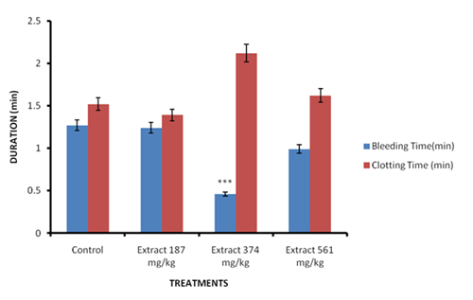

Figure 1: Effect of chronic administration of *Zea mays* husk extract on clotting and bleeding times of female rats.

Data are expressed as MEAN ± SEM, Significant at ***p<0.001, when compared to control. (n=5).

Table 4: Effect of chronic administration of *Zea mays* husk extract on liver function parameters of female rats

|  |  |  |  |  |  |  |  |  |  |
| --- | --- | --- | --- | --- | --- | --- | --- | --- | --- |
| TREATMENT | DOSE  (mg/ kg) | Total Protein  (mg/dL) | Albumin (mg/dL) | ALT (IU/L) | ALP (IU/L) | AST (IU/L) | Total Bilirubin (µmol/l ) | Combined  Bilirubin  (µmol/l) | GGT  (IU/L) |
| Control | 10 mg/ml | 69.33±3.28 | 44.0±2.08 | 16.66±1.20 | 33.0±1.15 | 56.66±2.84 | 7.80±3.02 | 6.56±0.44 | 1.83±0.20 |
| Crude extract | 187 | 73.5±1.32 | 43.5±0.64 | 19.0±0.70 | 42.0±5.16 | 53.50±2.36 | 10.50±0.29 | 5.70±0.63 | 1.52±0.22 |
|  | 374 | 71.5±0.64 | 45.0±0.81 | 19.5±1.04 | 30.0±1.58 | 55.25±4.95 | 11.20±0.99c | 7.15±1.27 | 2.00±0.12 |
|  | 561 | 70.0±1.29 | 42.5±1.04 | 17.75±1.31 | 24.5±1.32 | 51.0±4.34 | 10.17±0.95 | 5.72±0.79 | 1.62±0.25 |

Data is expressed as MEAN ± SEM, Significant at cp< 0.001, when compared to control. (n=5).

Table 5: Effect of chronic administration of *Zea mays* husk extract on kidney function parameters of female rats

|  |  |  |  |  |  |  |  |
| --- | --- | --- | --- | --- | --- | --- | --- |
| TREATMENT | DOSE (mg/kg) | CREATININE (mg/kg) | UREA  (mg/dl) | BICARBONATE (mMol/L) | SODIUM (mMol/L) | POTASSIUM (mMol/L) | CHLORIDE (mMol/L) |
| Control normal saline | 10 mg/ml | 116.0± 8.02 | 8.26± 0.41 | 26.0± 1.15 | 124.0±5.03 | 4.66± 0.12 | 63.33± 0.33 |
| Crude extract | 187 | 111.5± 8.19 | 7.72± 0.53 | 28.0± 0.81 | 141.0±14.40 | 9.47± 4.20 | 62.25± 1.03 |
| 374 | 127.5± 4.59 | 8.87± 0.20 | 27.0± 1.29 | 119.2± 4.71 | 4.25± 0.24 | 60.75± 1.25 |
| 561 | 102.7± 7.88 | 6.80± 0.21 | 25.5±1.70 | 166.2±6.86c | 5.97± 0.22 | 59.50± 2.10 |

Data is expressed as MEAN ± SEM, Significant at cp< 0.001, when compared to control. (n=5).

**3.6 Effect of husk extract on lipid profile indices of male and female rats**

Treatment of female rats for 100 days with husk extract (187-561 mg/kg) caused non dose-dependent lowering of total cholesterol, triglyceride, LDL and VLDL levels of the treated female rats. However, these decreases were only significant (p<0.05-0.001) in the total cholesterol level of the group treated with the low dose (187 mg/kg) and the VLDL levels of the groups treated with the low and highest doses (187 and 561 mg/kg) relative to control (Table 6).

**3.7 Effect on histology of organs**

Figures 2 – 7 show the effects of chronic treatment of female rats with *Zea mays* husk extract for 100 days on histology of some organs. The husk extract (187-561 mg/kg) caused varying defects on the histology of the organs of female rats. Moderate effect was observed on the cerebral cortex of female rats with abnormal presentation of the layer cells showing perinuclear vacoulatory astrocytes, shrinkage of neural cells and micro-cerebral blood vessels (Figure 2). The histo-structure of hearts of female rats was moderately affected by the extract’s treatment with abnormal cardiomyocytes array, well stained sarcoplasm, wide spread interstitial fibrocytes and fibroblast nuclei, vacoulatory myocyte nuclei, area of inflammatory infiltrates and degenerating myocyte nuclei within the cardiac tissue (Figure 3). Mild effects of the extract was observed on histo-structure of the renal tissue of female rats which showed slight abnormal histo-structure of the renal tissue with glomeruli, areas of occluding bowman’s space and widening bowman’s space (Figure 4). The female rats’ livers were mildly affected with the hepatic histo-structure showing areas of vacoulatory hepatocytes within the hepatic lobules (Figure 5). The ovaries were mildly affected with ovarian histo-architecture showing atrophying follicle, follicular artrophy, and vascular hemorrhage (Figure 6). The splenic histoarchitecture of the female rats was normal with no pathological signs and therefore, not affected by the extract’s treatment (Figure 7)

Table 6: Effect of chronic administration of *Zea mays* husk extract on lipid profile of female rats

|  |  |  |  |  |  |  |
| --- | --- | --- | --- | --- | --- | --- |
| TREATMENT | DOSE  mg/kg | TOTAL CHOLESTEROL (mMol/L) | TRIGLYCERIDE (mMol/L) | HDL-C (mMol/L) | LDL-C (mMol/L) | VLDL  (mMol/L) |
| Control | 10 mL/kg | 2.33± 0.08 | 0.99± 0.07 | 1.16± 0.21 | 1.61± 0.10 | 0.19± 0.01 |
| Crude extract | 187 | 1.85± 0.06b | 0.85± 0.08 | 1.05± 0.07 | 1.18± 0.11 | 0.09± 0.01c |
| 374 | 2.05± 0.10 | 0.90± 0.04 | 1.17± 0.06 | 1.37± 0.14 | 0.15± 0.01 |
| 561 | 2.12± 0.13 | 0.73± 0.11 | 1.14± 0.12 | 1.31± 0.07 | 0.13± 0.01b |

Data are expressed as MEAN ± SEM, Significant at ap<0.05, bPp< 0.01, cp< 0.001, when compared to control. (n=5).

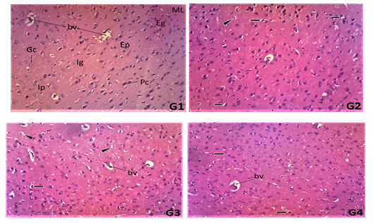

**Figure 2**: Photomicrograph of the transverse sections of cerebral cortex of female rats treated with distilled water (**G1**), husk extract of *Zea mays* at 187 mg/kg (**G2**), 374 mg/kg (**G3**) and 561 mg/kg (**G4**) liver tissue showing external pyramidal layer (EPL), external granular layer (Ep), internal granular layer (Ig), Pyramidal cells (Pc), blood vessels (bv), pyramidal cells (Pc) and granular cells (Gc), astrocytes (As), showing moderate effect on extract treated rats tissue with perinuclear vacoulatory astrocytes (arrow head), shrinkage of neural cells (arrow) and micro-cerebral blood vessels (bv). (x100).

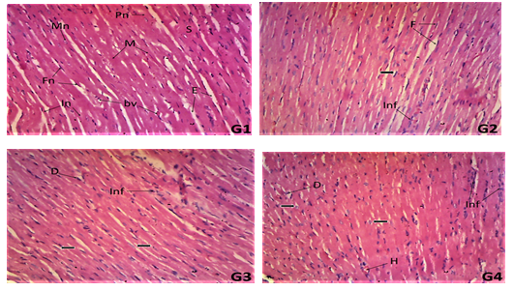

**Figure 3**: Photomicrograph of the transverse sections of hearts of female rats treated with distilled water (**G1**), husk extract of *Zea mays* at 187 mg/kg (**G2**), 374 mg/kg (**G3**) and 561 mg/kg (**G4**) liver tissue showingsarcoplasm (S), wide spread interstitial fibrocytes and fibroblast nuclei (Fn), well stained myocyte central nuclei (Mn), perinuclear sarcoplasm (Ps), interstitial endomysium (E),wide spread interstitial fibrocytes and fibroblast nuclei (F), vacoulatory myocyte nuclei (arrow), area of inflammatory infiltrates (Inf) and degenerating myocyte nuclei (D) within the cardiac tissue.

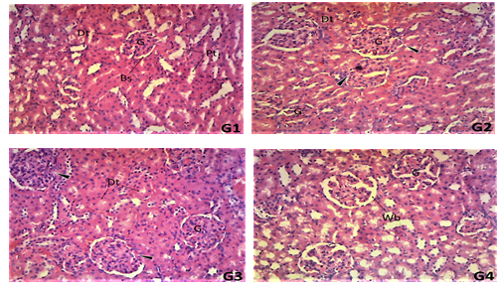

**Figure 4**: Photomicrograph of the transverse sections of kidneys of female rats treated with distilled water (**G1**), husk extract of *Zea mays* at 187 mg/kg (**G2**), 374 mg/kg (**G3**) and 561 mg/kg (**G4**) liver tissue showing glomeruli (G),Bowman’s space (Bs), proximal convulated tubules (Pt), distal convulated tubules (Dt) and infilterating interstitial connective tissues (Ic), widened bowman’s space (Wb), and widening bowman’s space (Wb), (x 100).

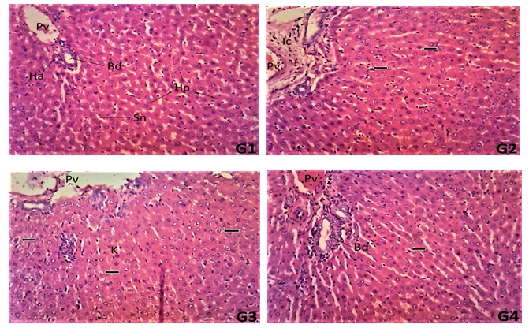

**Figure 5**: Photomicrograph of the transverse sections of livers of female rats treated with distilled water (**G1**), husk extract of *Zea mays* at 187 mg/kg (**G2**), 374 mg/kg (**G3**) and 561 mg/kg (**G4**) liver tissue showing portal vein (Pv), bile duct (Bd) and hepatic artery (Ha) within the connective tissue (Ct) of the portal area, well populated hepatocytes (Hp), kupffer cells (Kc) and arrays of sinusoidal spaces (Sn) ,areas of vacoulatory hepatocytes (arrow), Interstitial connective tissue (Ic) (x 100).

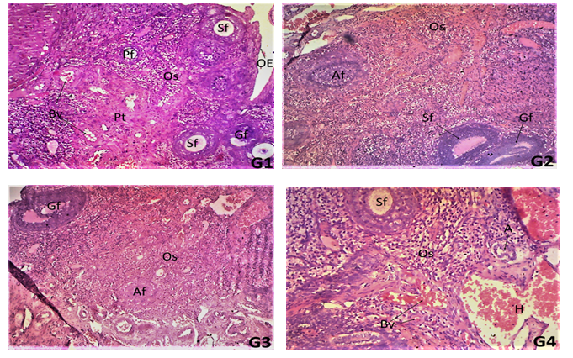

**Figure 6**: Photomicrograph of the transverse sections of ovaries of female rats treated with distilled water (**G1**), husk extract of *Z. mays* at 187 mg/kg (**G2**), 374 mg/kg (**G3**) and 561 mg/kg (**G4**) liver tissue showing different levels of developing follicles, primary follicle (Pf), secondary follicle (Sf), graffian follicle (Gf), blood vessels (Bv), and perivascular connective tissue (Pt) within the Ovarian Stroma (Os) and the ovarian epithelial lining (OE) follicular artrophy (A), and vascular hemorrhage (H),(x 100).

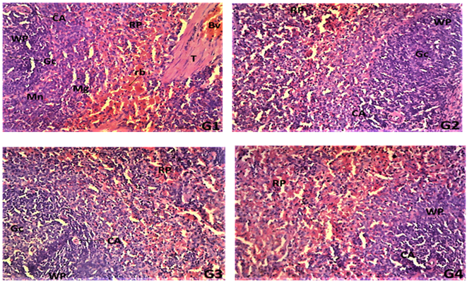

**Figure 7**: Photomicrograph of the transverse sections of spleens of female rats treated with distilled water (**G1**), husk extract of *Zea mays* at 187 mg/kg (**G2**), 374 mg/kg (**G3**) and 561 mg/kg (**G4**) liver tissue showingwhite pulp (WP), germinal center (Gc), central artery (C), central vein (Cv),ramified trabecula (T), mantle layer (Mn), marginal zone (Mz), the red pulp (RP), red blood cells (Rc) and tubercular tissue (Tb), degenerative immunal cells (black arrow) and the central vein (Cv).

1. **DISCUSSION**

In this study, chronic administration of the husk extract caused significant improvements in the body weights of female rats relative to untreated control, as observed in the weight gain by all the treated groups. Alterations in body weights are considered as serious indicators of adverse effects of drugs and significantly reduced body weight is regarded as severe consequences (Tepongning et al., 2018). In the present study, remarkable increases in body weights of female rats in all the extract treated groups were observed though only significant (p<0.05-0.01) at the highest dose (561 mg/kg). This finding indicates that extract treatment did not interfere with the feeding habit of the rats and probably must have increased appetite of the female rats. Furthermore, the administration of the extract did not exert adverse effects on the body growth processes of rats.

Treatment of rats with the husk extract (187-561 mg/kg) for 100 days did not cause any effect on the weights of heart, brain, liver, kidney, spleen, pancreas, testes and ovary when compared to control. Internal organs weights are used as as important parameter to assess injury and toxicities (Farah et al., 2013). Enlargement of organs portrays toxicity and damaged to the organ (Ping et al., 2013), which are consequences of inflammation of these organs, resulting in weight increases, though not observed in the present study.

Assessment of blood indices is commonly used to investigate the severity of effect of foreign compounds including plant extract on the blood (Lawal et al., 2015) as well as to correlate blood-relating functions of a chemical compounds contained in plant extracts (Bashir et al., 2015). Chronic administration of husk extract of *Zea mays* to female rats for 100 days did not affect RBC, WBC and platelets counts, hemoglobin concentration,PCV, neutrophils, lymphocytes, basophils, monocytes and eosinophils percentages significantly (p>0.05) when compared to control. Although there were non dose-dependent increases and decreases in the blood parameters, these were not significant relative to control, suggesting a lack of toxic effect on erythropoiesis (Berinyuy et al., 2015) as well as leucocytosis. This further indicates a non toxic potential on erythropoeitin (Shittu et al., 2015). The absent of significant effect (p> 0.05) on the RBC and Hb suggest no interference with the oxygen-carrying capacity of the blood. The extract did not exert any significant effect on platelets count perhaps due to adaptation of the animals to the effect of the extract. However, the bleeding time of female rats were observed to be significantly reduced in this study. This may be due to the extract ability to facilitate blood clotting mechanisms in the rats.

In this study, administration of husk extract for 100 days to female rats did not exert any significant (p>0.05) effect on all the liver function parameters except in the combined bilirubin level which was significantly (p<0.001) raised. This suggests that the husk extract did not cause any harm to the liver as both the synthetic and excretory functions indicated by total protein, albumin and bilirubin levels were seriously not affected at all doses (Kaplan et al.*,* 1979; Yakuba et al., 2003). Also, the fact that the levels of liver enzymes (AST, ALT and ALP) were not affected significantly further confirms the non hepatotoxic and/or hepatoprotective effect of the husk earlier reported (Okokon et al., 2017b; Okokon et al., 2020; Udobang et al., 2019). The significantly raised combined bilirubin in the female rats at middle dose signifies an effect on the excretory functions of the liver (Kaplan et al.*,* 1979; Yakuba et al., 2003). Severe hemolysis causes elevated levels of direct and total bilirubin (Nagana,1989), resulting in the release of more bilirubin into the blood. Since only the combined bilirubin level was elevated without any effect on the total bilirubin, this suggests inseverity of the effect. In this study, the administration of husk extract of *Zea mays* to female rats for 100 days did not cause any significant effect on any of the kidney function parameters (urea, creatinine, bicarbonate, potassium and chloride) except a slight elevation of sodium level in the female rats which was only significant at the highest dose (561 mg/kg). The significant effect on one of the electrolytes concentrations in this study suggest a slight effect on the glomerular filtration rate as was seen in the mild effect on the histo-structure of the renal tissues in this study. However, this does not portray a serious harmful effect as other parameters were not affected. Blood urea nitrogen (BUN) generated in the liver is excreted in the urine through the kidney. This accumulates in the serum during renal dysfunction as the rate of production exceeds that of excretion (Mayne, 1994). Serum creatinine is produced during metabolism (Mayne, 1994) and elevated urea and creatinine levels in the serum are indicators nephrotoxicity (Ali et al.*,* 2001; Flaoyen et al., 2001). In this study, there was no significant effect on creatinine and urea levels of rats exposed to repeated administration of the husk extract. This suggests that the extract does not exert a serious nephrotoxic effect and further support previously reported nephroprotective potentials of the husk extract (Okokon et al., 2017c; Okokon et al., 2019), .

In this study, administration of husk extract to female rats for 100 days was found to exert hypolipidemic effect on all major lipids in the female rats. Alterations in the concentrations of major lipids like total cholesterol, high-density lipoprotein cholesterol, low density lipoprotein cholesterol and triglycerides provide useful information on the lipid metabolism and its attendant effect on heart related diseases (Yakubu et al., 2008). High blood cholesterol concentrations are an important risk factor for cardiovascular disease (Abolaji *et al.,* 2007). Therefore, the reduced levels of serum cholesterol by the husk extract may be a beneficial effect to the animals as the extract is unlikely to be associated with cardiovascular risk. Decreased serum level of triacylglycerides by the extract may be explained as an inhibitory efffect on lipolysis (Yakubu et al.*,* 2008). The reduction in the levels of total cholesterol, tryglycerides, VLDL, LDL and HDL in this study further support the strong hypolipidemic and antiobesity potentials of the husk extract (Okokon et al., 2021a), which perhaps is due to inhibitory activity of its phytoconstituents on lipolysis.

On the histology, chronic administration of ethanol husk extract of *Zea mays* (187-561 mg/kg) to female rats for 100 days produced mild to moderate defects on the histology of the brain, heart, liver, kidney and spleen tissues but with serious effect to the ovary, indicating that chronic administration of the extract can produce toxic effect though not serious effect on these organs except ovary. These mild to moderate effects observed in this study corroborate the chemical pathology results observed as only the total bilirubin level and sodium concentration were observed to be increased significantly in the female rats, which suggest a high susceptibility of the female rats to the mild toxic effect of the extract. This is supported by the effect on the ovary, the female reproductive system. However, no mortality was recorded throughout the period of chronic study.

1. **CONCLUSION**

The results of this investigation suggests that the husk extract of *Zea may*s when taken for a long time could have mild to moderate effects on the brain, heart, liver and kidney in the female rats with serious effect to the ovary. However, the husk extract exerted no toxic effect on the spleen and provided hypolipidemic effect. It recommended that high doses should be avoided.

**EHTICAL APPROVAL**

Approval for the study was given by Faculty of Pharmacy Animal Ethics Committee, University

of Uyo.

**DISCLAIMER (ARTIFICIAL INTELLIGENCE)**

Author(s) hereby declare that NO generative AI technologies such as Large Language Models

(ChatGPT, COPILOT, etc.) and text-to-image generators have been used during the writing or

editing of this manuscript.

**REFERENCES**

Abo, K. A.*,* Fred-Ja­iyesimi, A. A. & Jaiyesimi, A. E. A. (2008). Ethnobotanical studies of medicinal plants used in the management of diabetes mellitus in South Western Nigeria. *Journal of Ethnopharmacology* IS: 67-71.

Abolaji, A. O., Adebayo, A. H. & Odesanmi OS (2007). Effect of ethanolic extract of *Parinari polyandra* (Rosaceae) on serum lipid profile and some electrolytes in pregnant rabbits. *Research Journal of Medicinal Plants* 1: 121- 127.

Akpan EE, Johnny II, Anagboso MO,Ebong OO,& Okokon JE. (2024). Genotoxic and cytotoxic potentials of cornhusk extracts of *Zea mays* and leaf extract of *Saccharum officinarum.* *Biology Medicine and Natural Product Chemistry* 13(2):531-540.

Ali, B.H., Ben, T.H. & Basheer, A.A. (2001). Sex related differences in the susceptibility of rat to gentamicin nephrontoxicity: influence of gonad-ectomy and hormonal replacement therapy. *Industrial Journal of Pharmacology* 33: 369-373.

Bashir, L., Shittu, O. K., Busari, M. B., Sani, S., & Aisha, M. I. (2015). Safety evaluation of giant African land snails (*Archachatina maginata*) haemolymph on hematological and biochemical parameters of albino rats. *Journal of Advances in Medical and Pharmaceutical Sci*ences, *3*(3), 122-30.

Berinyuy, E. B., Lawal, B., Olalekan, A. A., Olalekan, I. A., Yusuf, A. A., Sakpe, S., &Ossai, P. C. (2015). Hematological status and organs/body-weight parameters in Wister rats during chronic administration of *Cassia occidentalis*. *International Blood Research and Review*, *4*(3), 1-7.

Brobbey, A.A., Somuah-Asante, S., Asare-Nkansah, S., Boateng, F. O. & Ayensu, I. (2017). Preliminary phytochemical screening and scientific validation of the anti-diabetic effect of the dried husk of *Zea mays* L. (Corn, Poaceae) *International Journal of Phytopharmacy*. 7 (1): 01-05.

Dong, J., Cai, L., Zhu, X., Huang, X., Yin, T., Fang, H. & Ding, Z. (2014). Antioxidant activities and phenolic compounds of cornhusk, corncob and *Stigma Maydis. Journal of Brazilian Chemical Society.* 25: 1956-1964.

Farah, A. O., Nooraain H, Noriham A, Azizah AH, & Nurul HR. (2013). Acute and oral subacute toxicity study of ethanolic extract of *Cosmos caudatus* leaf in Sprague Dawley Rats. *International Journal of Biosciences, Biochemistry and Bioinformatics*. 3(4): 301-305.

Flaoyen, A., Hove, K.& Wilkins, A.L. (2001). Tolerance to nephrotoxic component of *Narthecium ossifragum* in sheep: The effects of repeated oral doses of plant extracts. *Veterinary Research Communication*. 25: 127-136.

Foster, S. & Duke, J. A. (1990). Field Guide 10 Medical Plants: Eastern and Central North America. Houghton MifAin, Boston.

Friedewald, W. T., Levy, R. I. & Fredrickson, D. S. (1972). Estimation of the concentration of low-density lipoprotein cholesterol in plasma, without use of the preparative ultracentrifuge. *Clinical Chemistry,* 18(6): 499 – 502.

Gill, L. S. (1992). Ethnomedical Uses of Plants in Nigeria*.* Uniben Press, Benin, Nigeria, p: 249.

Jadhav, S. M. (2016). Protective effect of *Zea mays* on experimentally induced gastric ulcer in rats. *Imperial Journal of Interdisciplinary Research,* 2: 8.

Kaplan, A., Szabo, L. V. L.& Opheim, K. E. (1979). Clinical Chemistry: Interpretation and Techniques: *Lea & Febiger Philadelphia*; 1979.

Lawal, I. O., Grierson, D. O. & Afolayan, A. I. (2015). Phytochemical and Antioxidant investigations of ma Clause a Aniston Hook; A South African medicinal plant. *African Journal of Traditional complimentary Alternative Medicine*. 12(1): 28-37.

[Li](http://pubs.acs.org/author/Li%2C+Chun-Ying), C.,  [Kim](http://pubs.acs.org/author/Kim%2C+Hee-Woong), H., [Won](http://pubs.acs.org/author/Won%2C+Se-Ra), S., [Min](http://pubs.acs.org/author/Min%2C+Hwang-Kee), H., [Park](http://pubs.acs.org/author/Park%2C+Ki-Jin), K.,  [Park](http://pubs.acs.org/author/Park%2C+Jong-Yeol), J.,  [Ahn](http://pubs.acs.org/author/Ahn%2C+Mun-Seob), M. & [Rhee](http://pubs.acs.org/author/Rhee%2C+Hae-Ik), H. (2008). Corn Husk as a Potential Source of Anthocyanins**.** *Journal of Agricultural Food and Chemistry*, 56 (23): 11413–11416.

Mayne, P.D. (1994). The kidneys and renal calculi. In: Clinical chemistry in diagnosis and treatment. 6th ed. London: Edward Arnold Publications, pp.2-24.

Naganna, B. (1989). Plasma proteins. In: Tawlar GP, Srivastava LM, Moudgil KD (Eds.).*Textbook of Biochemistry and Human Biology.* 2nd edn. India: Prentice-Hall of India Private Ltd. 1989. p. 172.

Ogawa K, Takeuchi M,& Nakamura N. 2005. Immunological effects of partially hydrolysed arabinoxylan from corn husk in mice. *Biosciences, Biotechnology and Biochemistry* 69:19-25.

Okokon, J. E, Udobang, J. A., Bassey, A. L., Edem, U. A. &Agu, C. E. (2020). Hepatoprotective and nephroprotective activities of *Zea mays* husk extract against paracetamol-induced liver and kidneys injuries in rats. *Tropical Journal of Natural Products Research.* 4(3): 69-76.

Okokon, J. E., Antia, B.S., Azare, B. A. & Okokon, P. J. (2017c). Antiplasmodial activity and cytotoxicity of ethanol extract of *Zea mays* root. *Avicenna Journal of Phytomedicine*, 7(3):275-284.

Okokon, J. E., Bassey, S., Dinesh, M. & Dinkar, S. (2017a). Antimalarial and anti-plasmodial activity of husk extract and fractions of *Zea mays*. *Pharmaceutical Biology,* 55(1): 1394 – 1400.

Okokon, J. E., Nelson, E. & Sunday, M. (2016). Antidepressant activity of ethanol husk extract of *Zea mays*. *Adv Herbal Med.* 2(4): 22 -28.

Okokon, J. E., Nyong, M. E., Essien, G. E. &Nyong, E. (2017b). Nephroprotective activity of husk extract and fractions of *Zea mays* against alloxan-induced oxidative stress in diabetic rats. *Journal of Basic Pharmacology and Toxicology*. 1(3):1-10.

Okokon, J. E., Nyong, M. E., Essien, G. E. & Nyong, E. (2017c). Hepatoprotective activity of husk extract and fractions of *Zea mays* against alloxan-induced oxidative stress in diabetic rats. *International Journal of Herbal Medicine*. 5(4):43-50.

Okokon JE, Nyong ME, Thomas P, Udobang JA, & Enin G. (2021). Antiobesity activities of extract, fractions and pure compounds from husk of *Zea mays*. *Tropical Journal of Natural Products Research* 5(10): 1868-1875.

Okokon JE, Obot J, &Amazu LU. (2018). Antiulcerogenic activity of husk extract of *Zea mays. African Journal of Pharmacology and Therapeutics* 7(2): 41-45.

Okokon JE, Udobang JA, Bassey AL, Edem UA, &Agu CE. (2020). Hepatoprotective and nephroprotective activities of *Zea mays* husk extract against paracetamol-induced liver and kidneys injuries in rats. *Tropical Journal of Natural Products Research* 4(3): 69-76.

Okokon JE, &Nyong M. (2018). Antidiabetic and hypolipidemic activities of *Zea mays* husk extract and fractions. *Journal of Herbs Spices and Medicinal Plants* 24(3):1-17.

Okokon JE, Udobang JA, Obot D, &Agu CE. (2019). Nephroprotective activity of *Zea mays* husk extract against gentimicin- induced kidney injury in rats. *Journal of Medicinal Plant Studies* 7(6): 156-160.

Okokon JE, Enin GU, Nyong ME, A**nyanwu BC. & Dick** GF. (2021b). Inhibitory effect of husk extract and fractions of *Zea mays* on alpha amylase and alpha glucosidase enzymes. *Advance Pharmaceutical Journal.* 6(6): 150-156.

Owoyele, B.V., Negedu, M. N., Olaniran, S.O., Onasanwo, S. A., Oguntoye, S. O., Sanya, J.O., Oyeleke, S. A., Ibidapo, A. J. & Soladoyel, A.O. (2010). Analgesic and anti-inflammatory effects of aqueous extract of *Zea mays* husk in male wistar rats. *Journal of Medicinal Foods,* 13:343-347.

Ping KY, Darah I, Chen Y, Sreeramanan S & Sasidharan S. (2013). Acute and subchronic toxicity study of *Euphorbia hirta* L. methanol extract in rats. *Biomedical Research International.* 2:1-14.

Shittu, O. K., Lawal, B., Alozieuwa, B. U., Haruna, G. M., Abubakar, A. N., &Berinyuy, E. B. (2015). Alteration in biochemical indices following chronic administration of methanolic extract of Nigeria bee propolis in Wistar rats. *Asian Pacific Journal of Tropical Disease*, *5*(8), 654-657.

Simmonds, N. W. (1979). *Evolution of Crop Plants.* Longmans, London, 339p..

Tepongning, R.N., Mbah, J.N., Avoulou, F.L., Jerme, M.M., Ndanga, E-K, K. & Fekam, F.B. (2018). Hydroethanolic extracts of *Erigeron floribundus* and *Azadirachta indica* reduced *Plasmodium berghei* parasitaemia in Balb/c Mice. *Evidence-based Complementary and Alternative Medicine*. 2018: 5156710. doi: 10.1155/2018/5156710.

Tietz, NW. (1976). *Fundamentals of Clinical Chemistry*. 2nd Edition. W. B. Saunders, Philadelphia, pp335-337.

Udobang, J. A., Okokon, J. E., Obot, D. & Agu, C. E. (2019). Hepatoprotective activity of *Zea mays* husk extract against carbon tetrachloride induced liver injury in rats. *Research Journal of Life Sciences, Bioinformatics, Pharmaceutical and Chemical Sciences*. 5(5):82-94.

Yakuba MT, Bilbis, L. S., Lawal, M. &Akanji, M. A. (2003). Evaluation of selected parameters of rat liver and kidney function following repeated administration of yohimbine. *Biokemistri* 15 (2): 50-6.

Yakubu, M. T, Akanji, M. A. & Oladiji, A. T. (2008). Alterations in serum lipid profile of male rats by oral administration of aqueous extract of *Fadogia argrestis* stem. *Res. J. Med. Plant.* 2: 66-73.