Review Article
The efficacy of Yoga therapy on risk reduction in high-risk Pregnancy. A narrative review.

Abstracts:
This review evaluates the impact of yoga intervention on pregnancy outcomes, Quality of life, and the mental and physical health of pregnant mothers in high-risk pregnancies. The objectives of this study are to understand the impact of Yoga on high-risk Pregnancy, to explore Yoga as an alternative and safe therapy during this period, and to investigate how Yoga improves the Quality of life and fetal outcomes, including APGAR scores and Fetal birth weights. A literature review was conducted from conception until February 2023, using the keywords Yoga and High-risk Pregnancy in the PubMed, Web of Science, and Embase databases. Using these keywords, we retrieved 138 articles. Only 17 studies were included in this trial, based on the inclusion criteria, which were all RCTs, review studies, and Articles, and excluded short communications, Single case and non-scientific studies. We observed that yoga intervention and various antenatal programs during Pregnancy help reduce the incidences of pregnancy-induced hypertension (PIH), pre-eclampsia (PE), intrauterine growth restriction (IUGR), and preterm birth (PTB), as well as improve the Quality of life and mental and physical health of expectant mothers in high-risk Pregnancy. According to this review, yoga interventions are an effective, non-pharmacological therapy for pregnant women with high-risk pregnancies in terms of all its complications, such as IUGR, preterm birth, Fetal parameters like APGAR Score, and Fetal Weight.

Introduction
The psycho-physiological processes of Pregnancy and labour can bring happiness to many families, yet unexpected anguish and suffering to some families. In 2020, approximately one maternal death occurred globally every two minutes, accounting for about 800 deaths daily (UNICEF, 2023). Pregnancies that pose a threat to the life of the mother or the fetus due to maternal and additional fetal disorders are classified as "high risk" even though there are no established standards to distinguish between high or low-risk pregnancies(1). Pregnancies with a higher risk of problems are frequently referred to as high-risk pregnancies(2). The most prevalent and dangerous risk factors for challenging conceptions include gestational diabetes mellitus (GDM), severe anaemia, intrauterine growth restriction (IUGR)(3), and high blood pressure linked to proteinuria (preeclamptic state)(4). Anaemia, GDM, and pre-eclampsia (Table 1) are the three disorders that have the most clinical impact on pregnancy outcomes, particularly in middle- and low-income nations where these conditions are known to be relatively common. Diabetes mellitus (GDM) is glucose intolerance leading to hyperglycemia of dynamic onset during Pregnancy (5). The prevalence of GDM has also been high, ranging from 3.8 to 41% in various regions globally(6). Although the pathogenesis of GDM is not fully known, pancreatic beta-cell dysfunction and hormonal abnormalities that influence insulin sensitivity have been associated with the disease (7). Because of pancreatic-cell malfunction, which results in glucose intolerance, GDM is characterised by enhanced insulin control of glucose homeostasis throughout Pregnancy (8). Hypertensive disorders of Pregnancy (HDP) affect 7-10% of pregnant women globally. Overall, pre-eclampsia and eclampsia are responsible for 10-15% of maternal mortality(9). Gestational hypertension (GH) is defined as a blood pressure (BP) level of at least 140/90 mmHg or higher measured on two independent occasions more than 4 hours apart and emerging de novo after the 20th week of Pregnancy in a previously normotensive woman. Maternal mortality in eclampsia is estimated at 20-33% in India(10). Because of concerns about the side effects on fetal growth and maturation and pregnant women's preference for alternative medicines, pharmacological interventions for maternal hypertension are commonly reserved for reducing maternal symptomology.

High-risk Pregnancy | Treatment | Medications | Side effects
Pre-eclampsia | Anti-hypertensive agents(7). prevention: The intrapartum and postpartum  administration of magnesium sulfate  anticonvulsants(8) | Methyldopa, labetalol, and nifedipine are widely accepted as safe in Pregnancy. | Labetalol - Common side effects include low blood pressure with standing, dizziness, feeling tired, and nausea (23)  Nifedipine - Common side effects include mild headache, fatigue, swelling of the leg, cough, and shortness of breath (24).  Methyldopa -The most common side effects include drowsiness. Serious side effects include red blood cell deficiency, liver problems, and allergies (25).
GDM | Anti-diabetic medication(9). | metformin | Common adverse effects include diarrhoea, nausea, and abdominal pain(10).
 | Aspirin |  | The common adverse effect is an upset stomach(11)
 | Weight-loss Surgery |  | Development of gallstones and increasing the pathogenicity of bile. Kidney side effects have been studied. Hyperoxaluria may lead to oxalate nephropathy and irreversible kidney failure (29).
Severe Anemia | Oral iron | Oral iron supplementation with ferrous sulfate, ferrous fumarate, or ferrous gluconate. | Side effects may include dark stools, constipation, and abdominal pain(12)

Table 1- Conditions of high-risk pregnancy and treatment regimen for these conditions, along with the possible side effects

Additionally, physical and mental stress is brought on by physiological changes during Pregnancy, and this stress increases if difficulties develop, especially in high-risk pregnancies. Stress and anxiety attacks are frequent, and they frequently make the problems worse while posing harm to the mother and fetus. Various pharmacological and non-pharmacological treatments are employed to prevent or treat these disorders. The safety of using pharmaceutical therapies while pregnant is not guaranteed because they may adversely affect the mother and fetus. At the same time, non-pharmacological treatments, such as Yoga, exercise, acupressure, and acupuncture, are proving useful throughout Pregnancy.
Yoga, which has been practised for over 5000 years, is a complete system for dealing with material, spiritual, and mental prosperity(11). Asanas, controlled breathing techniques, and meditation are all combined in Yoga, which is meant to improve practitioners' physical and psychological health and accelerate their spiritual development(12). Yoga is a more popular solution for pregnant women because it is non-invasive and has fewer adverse effects(13). Yoga is now recognised as a preventive and management therapy for chronic lifestyle-related disorders with much fewer consequences and adverse effects because of advancements in this field of research. Yoga is supported by research-based evidence to be an effective alternative treatment for medical conditions. This narrative review aims to evaluate the efficacy of Yoga on high-risk pregnancies.

Methodology
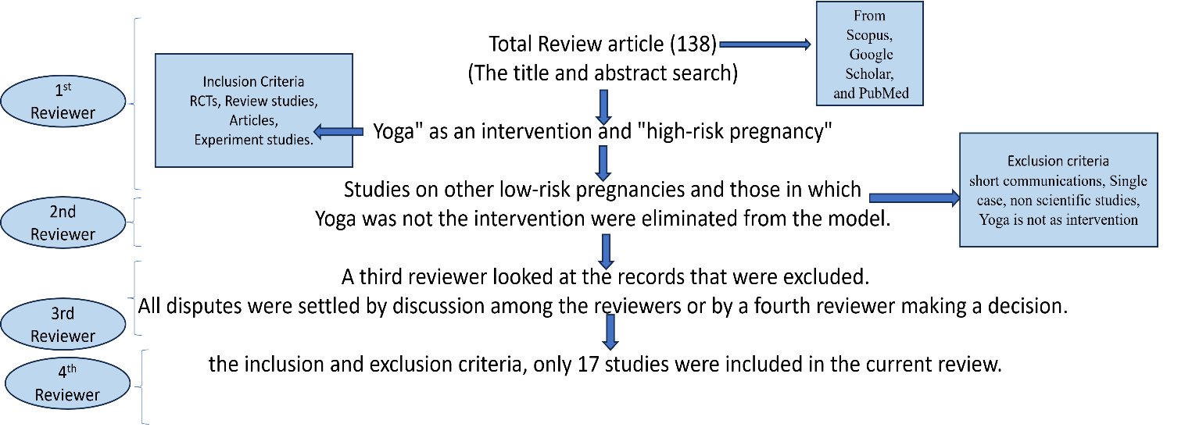
A search was conducted to identify all studies undertaken to examine how yoga practice impacted high-risk pregnancies. These studies were published in several databases, including Scopus, Google Scholar, and PubMed, between their inception in March 2023. Using the keywords "yoga," "high-risk pregnancy," "gestational diabetes mellitus," and "pre-eclampsia," articles were found in databases. Two independent review authors screened titles and abstracts before retrieving possibly eligible citations for full-text evaluation. Studies could also be uncovered by assessing the references of already discovered studies. To find additional papers that cited the previously located study, we also looked for articles by entering the citation for a study in Google Scholar and then selecting "as cited by." Clinical trial registrations, editorials, single-arm studies, conference proceedings, and abstracts were all excluded. To ensure a thorough analysis of the literature on the health benefits of Yoga for high-risk pregnancies, the search strategy included randomised controlled trials. Only English-language articles were included. A total of 138 studies were found using the title and abstract search. Studies using "yoga" as an intervention and "high-risk pregnancy" were the selection criteria for the review. Studies on other low-risk pregnancies and Thyogain, where Yoga was not the intervention, were eliminated from the model. A third reviewer looked at the records that were excluded. All disputes were settled by discussion among the reviewers or by a fourth reviewer making a decision. After the inclusion and exclusion criteria, only 17 studies were included in the current review.

Result & Discussion:
During antenatal, women experience physiological, psychosocial, mental, and physical stress, directly or indirectly associated with adverse conditions in Pregnancy. The prevalence of anxiety among the pregnant population is still unknown, as only a handful of research/ clinical trials explicitly target antenatal stress and associated outcomes(14). Usually, pressure is not measured in regular obstetrics practice. Still, according to the American College of Obstetricians & Gynaecologists (ACOG) committee, pregnant women should be screened for stress every trimester as it impacts their health and attentiveness to the mother and fetus.
Prolonged stress causes allostatic overload, which imbalances the physiological functions and ultimately affects maternal and fetal outcomes such as preterm births and low birth weight infants. These conditions also have a profound impact on sufferers and their families. According to a survey on the hospitalisation cost of infants in the United States, the cost of hospitalisation was higher for preterm infants (13).
Stress and psychiatric co-morbidities such as depression and anxiety during Pregnancy are prevalent. This may explain, in part, why pregnancy outcomes remain variable in the setting of more widespread adverse events. The sum of an individual's prior social experiences (both positive and negative) and their reaction to these experiences influences whether exposure to new acute or chronic stressors disrupts homeostasis and results in disease or adverse outcomes. Based on these data, the successful reduction of the biological effects of stress during Pregnancy has the potential for profound impacts on maternal health and pregnancy outcomes for specific populations. As medications during Pregnancy are not considered safe (Table 2), non-pharmacological interventions can be prescribed to reduce stress during Pregnancy to avoid its associated complications, with or without prescription.

Pre-eclampsia | Regular physical activity may protect against pre-eclampsia by intervening in three essential steps in the disease process: (16) enhanced placental growth and vascularity (protection from abnormal placenta development), (17) reducing oxidative stress and (18) conversion of endothelial dysfunction.
GDM | GDM can be reversed by lifestyle interventions such as exercise and diet control. Exercise is seen as a planned, repetitive movement with a specific goal (e.g., health improvement). It is a subset of physical activity, referring to any movement that involves the expenditure of energy and the use of skeletal muscle. Type of exercise can significantly reduce the incidence of GDM and pregnancy weight gain, which is associated with side effects such as high blood pressure in Pregnancy, and pre-eclampsia. In addition, exercise during Pregnancy is not associated with a decrease in gestational age during childbirth or an increase in the chances of having a caesarean section (19).
Anemia | Maternal mortality is closely related to anaemia. Pregnant women who participated in Yogabstetric Yoga weighed less than those who did not engage in Yogabstetric Yoga. In addition, they also had lower Hb levels with a consistent pattern than those who did not participate in Yogabstetric Yoga (20).
 |  | Table 2- High-risk pregnancy conditions and their characteristics.

Effect of Yoga on maternal mental health
During Pregnancy, women face several physical and psychological health challenges. Minor physical problems during Pregnancy significantly impact the Quality of life and well-being, which is also influenced by antenatal stress, anxiety, and depression. Women with high levels of anxiety and depression have a lower quality of life and are more likely to have a miscarriage. It also elevated the chances of developing anxiety and depression later in life. Physical activity has been shown to promote mental health in both pregnant and non-pregnant women. Prenatal Yoga has the potential to improve one's health and well-being significantly. A new systematic review and meta-analysis showed that Yoga positively impacts all significant psychological outcomes, including stress, anxiety, depression, and Quality of life.
A study published in 2014 by James Newhams et al. found that even a singlYogassion of Yoga reduced anxiety and cortisol levels significantly; however, there were no significant differences when baseline and follow-up were compared (21)conducted a randomised controlled trial in which 96 pregnant women were given an integrated approach to yoga therapy intervention for one hour every day from the 20th to the 36th week. Their findings revealed a reduction in state anxiety (doYoga5.65% in Yoga, up 13.76% in control), trait anxiety (dYoga8.97% in Yoga, up 5.02% in control), and depression (HADS) (doYoga0.67% in Yoga, up 3.57% in control)(22)(23)(24)confirmed similar findings in later investigations. Tiffany Field et al. recruited 92 depressed women for the intervention group. They provided Yoga and social support. Yoga and support groups. According to a study on Yoga, Yoga and support groups may be cost-effective therapies for lowering sadness, anxiety, and aggression and enhancing relationships. Two studies also assessed the perceived stress scale after offering Yoga to pregnant women; both found lower PSS scores after a yoga intervention. Another survey by Songporn Chuntharapat et al. suggests that 30 minutes of yoga practice at least three times per week for ten weeks is an effective complementary means for facilitating maternal comfort, decreasing pain during labour and two hours post-delivery, and shortening the Length of labor. The similarities in the pattern of subjective and physiological reactions show that women who use antenatal yoga practices can manage stress hormone elevations regardless of the endogenous height caused by increasing gestation. (Table: 3)

SL.  NO | TOPIC | AUTHOR &YEAR | SAMP  LE  SIZE | DESIGN | INTERVENTION | ASSESMENT | RESULT
1 | Yoga during  Pregnancy: The effects on labor pain and delivery outcomes(A Randomised Controlled Trial) | Complementary Therapies in  clinical Practice  2016  Fereshteh  Jahdi, Fatemeh  Sheikhan, Hamid  Haghani, Bahare  Sharifi, Azizeh  Ghaseminejad, Mah shad  Khodarahmian,Nic ole Rouhana | N=60 | A  Randomised Controlled Trial | Experimental  Group-Yoga and  Control group | Visual Analogue  Scale(VAS),  Cervical Dilatation,  Body Mass  Index(BMI) | Yoga during Pregnancy may contribute to a reduction in the pain of labor  and improved the Adequacy of childbirth.
2 | Effects of Antenatal Yoga on maternal anxiety and depression:  A Randomized  Controlled Trial | James  J.Newham, Anja Wittkowski, Clin, Ja nine Hurley, John D.Aplin and Melissa Westwood  . | N=59 | A  Randomised Controlled Trial | Experimental and control group. | State Trait Anxiety Inventory (STAI – state), WDEQ Questionnaire, EPDS  scal | Yogantenatal Yoga seems to be useful for reducing women's anxieties toward childbirth and preventing increases in depressive symptomatology.  Depression and  Anxiety
3. | The Yogafects of Yoga in  Prevention of Pregnancy Complications in high–risk pregnancies: A randomised controlled  trial | Preventive Medicine: A Rakhshani, R  Nagarathna, R  Mhaskar,A Thomas,S  Gunasheela. | N=68 | A  Randomised Controlled Trial | Experimental and control group (1 hr yoga session three times a week -12th to 28th week of gestation). | Age, Maternal weight, Maternal height,  Maternal BMI,  Maternal Systolic  BP, | The first randomised study of Yoga in high-risk Pregnancy has shown that Yoga can potentially be an effective therapy in reducing hypertension.

 |  |  |  |  |  | Maternal Diastolic BP. | Related complications of Pregnancy and improving fetal outcomes. Additional data is needed to confirm these results and better explain the mechanism of Yoga in this critical area.
4 | Effects of Yogaprenatal Yoga on women's stress and immune function across Pregnancy: A  Randomised controlled trial. | Complementary Therapies in Medicine.  Pao-Ju Chen,  Luke Yang,  Cheng Chen Chou,  Chia-chi Li, Yu–Cune Chang, Jen-Jiuan Liaw. | N=94 | A  Randomised controlled trial. | The 20-week intervention comprised two weekly (70-minute yoga sessions) and a control group, only prenatal care | Participants' salivary cortisol and immunoglobulin A levels immediately after yoga | practice showed significant reductions in stress and improvements in immune function among pregnant women. Clinicians should learn the  My Yogisms of Yoga  and its effects on pregnant women. Our findings  can guide clinicians to  help pregnant women alleviate their stress and enhance their immune function.
5 | Effect of Yoga on anxiety, depression & well-being in normal Pregnancy. | Complementary Therapies in Clinical Practice 2013.  M Satyapriya, R  Nagarathna, V  Padmalatha, H R | N=96 | Prospective  Randomised Control study. | The experimental group did an integrated yoga practice daily, and the control group did standard antenatal exercises  , one hour daily | Pregnancy Experience Questionnaire,  State trait anxiety  , Hospital Anxiety  Depression Scale | Yoga reduces anxiety, depression and pregnancy-related uncomfortable experiences.

 |  | Nagendra. |  |  | ,from 20th to 36th week of gestation.
6. | Yogafects of Yoga on UteroFetal-Placental  circulation in High–Risk  Pregnancy: A  Randomized Controlled  Trial. | Hindawi Publishing Corporation. Advances in preventive medicine.2015 Abbas Rakhshani,  Raghuram  Nagarathna,  Rita Mhaskar,  Arun Mhaskar,  Annamma Thomas and Sulochana Gunasheela | A  Randomised Control led  Trial. | N=59 | The yoga group received standard care plus yoga sessions (1 hour/day, 3 times/week). Control Group-  Standard care, conventional antenatal exercises  (walking) | Fetal Measurements,  Uteroplacental  Circulation, Fetoplacental circulation. | The results of this first randomised study of Yoga in high-risk Pregnancy suggest that guided yogic practices and visualisation can improve the intrauterine fetal growth and the uterofetal-placental circulation.
7. | Yoga for High-Risk Pregnancy: A  Randomized Controlled  Trial. | Annals of Medical and Health Sciences Research 2013.  Deshpande CS,  Rakshani A,  Nagarathna R,  Ganpat TS,  Kurpad A,  Maskar R,  Nagendra HR,  Sudheer DC,  Abbas R,  Raghuram N,  Anura K,  Rita M,  Ramarao NH | A  Randomised Control led  Trial. | N=68 | (38 in the control group with standard antenatal  care and 30 in the Yoga Therapy group) | PSS Score. | The present study suggests that the YT module can decrease the stress level during high‑risk pregnancy complications. Thus, practising YT during high‑risk Pregnancy is not only a cost‑effective option but also a feasible and safe option. Additional well‑designed studies are needed before a firm recommendation can be made.

8. | A Randomized  ControlYogatrail of Yoga for pregnant women with symptoms of depression and anxiety. | Complementary  therapies in clinical practice 2015.  Kyle Davis,  Sherryl H  Goodman,  Jenn Leiferman, Mary Taylor,  Sona Dimidjian. | A  Randomised controlled trial | N=46 | 8 weeks | EPDS,  PANAS-N,  STAI-S,  STAI- | YogaPrenatal Yoga was found to be a feasible and acceptable intervention and was associated with reductions in symptoms of anxiety and depression; however, Yogaprenatal Yoga  only significantly outperformed TAU on the decrease in negative affect.
9. | Yoga for high-risk Pregnancy: a randomised controlled trial | CS Deshpande, A  Rakshani and NH  Ramarao | 68 | Randomised controlled trial | Yoga therapy | Perceived stress scale(PSS) measured during 12th, 20th, and 20th weeks of Pregnancy. | There was a significant difference in the PSS level of the YT group, with significantly reduced scores at the second follow-up (28th week of Pregnancy) compared to the control group.
10Yoga | Effect of Yoga and Anxiety for High Risk | Angela Gallagher et al. | 79 | Randomised controlled trial | Yoga sessions | Hospital Anxiety and Depression Scale(HADS). | Yoga, even as little as three sessions, showed a significant impact in reducing anxiety and depression in high-risk pregnant women on hospitalised bed rest. Perceived anxiety and depression overall scores were lower in

 |  |  |  |  |  |  | The intervention group had a higher rate than the control group.
11 | Yogaffect of Yoga on the utero-fetal placental in  high-risk Pregnancy | Abbas Rakhshani et al. | 59 | Randomised controlled trial | The yoga group received standard care plus yoga sessions (1 hour/day, 3 times/week) from the 12th to the 28th week of gestation. The control group received standard care plus conventional antenatal exercises (walking). | Self-reported questionnaire, fetal measurements, uteroplacental circulation, fetoplacental circulation. | Guided yogic practices and visualisation can  improve the intrauterine fetal growth and the uterofetal-placental circulation.
12 | The Therapeutic Effects of Yoga in the prevention of pregnancy complications in highrisk pregnancies: A  randomised controlled trial | A Rakhshani et al. | 68 | Randomised controlled trial | The yoga group (n = 30) received standard care plus one-hour yoga sessions, three times a week, from the 12th to the 28th week of gestation. The control group (n = 38) received standard care plus conventional antenatal exercises (walking) during the same period. | Obstetrical outcomes(PIH,PE,G  DM, IUGR) | Yoga can potentially be an effective therapy in reducing hypertensive-related complications of Pregnancy and improving fetal outcomes.

13 | Yoga during Pregnancy: Effects on maternal comfort, labour pain and birth outcomes | SongpornChunthar  Apat et.al | RCT | N=74  Experimental group(n=37) Control group(n=37) Duration:10-  12 weeks |  | State-Trait Anxiety  Inventory, Visual  Analogue Scale  (VAS) for comfort, the maternal comfort questionnaire (MCQ), the visual analogue sensation of pain scale  (VASPS), The pain  Behavioural Observation Scale (PBOS), APGAR  score and the Length of labour. | The study findings suggest  that 30 min of yoga practice at least three times per week for 10  weeks  is an effective  complementary means  for facilitating maternal comfort, decreasing pain during labor  and 2 hours post-delivery, and shortening the Length of labour.
14. | Yoga and social support reduce prenatal depression, anxiety and Cortisol | Tiffany Field,phD  et.al | RCT | N=92 Yoga group(n=46) Social support group(n=46) Duration: 12 weeks |  | Structured Clinical  Interview  Depression (SCID),  The Centre for  Epidemiological  Studies Depression  Scale  (CES-D), Edinburgh  Postnatal Depression  Scale (EPDS),  Profile of Mood  States (POMS)  Depression scale,  State Anxiety  Inventory (STAI),  State Anger | Studies suggest that yoga and support groups may be cost-effective  therapies for reducing depression, anxiety, and anger, as well as improving relationships.

Inventory (STAXI),
The Relationship
Questionnaire, Cortisol, estriol, and progesterone levels.
15. | A randomised controlled trial to study the effect of Yoga on pregnancy outcomes in hypertensive disorders of Pregnancy | Amrita Makhija  et.al | RCT | N=67 Study group(n=35) Control group(n=32) Duration: 4 weeks |  | Blood pressure, A Vi-  sual Analog Scale  (VAS) for Total  Comfort | Yogategrated Yoga effectively reduced systolic and diastolic blood pressures and increased maternal comfort during labor in hypertensive disorder of Pregnancy.
16 | A randomised controlled trial of Yoga for pregnant women  women with  Symptoms of depression and anxiety | Kyle Davis, a Sherry  H.Goodman b  , Jenn Leiferman c  Mary Taylor d  , Sona Dimidjian a, | RCT | N=23 study group N=23 Control group | Yoga and  Treatment as usual  (TAU) | EPDS Edinburgh  Postnatal Depression  Scale; STAI-S State  Trait Anxiety,  Inventory State  Subscale; STAI-T  State Trait Anxiety  Inventory Trait  Subscale;  PANAS-N Positive and Negative Affect Scale-Negative Subscale. | Yoga was associated with high levels of credibility and satisfaction as an intervention for depression and anxiety during Pregnancy. Participants in both conditions reported  significant  Improvement in symptoms of depression and anxiety, Yogaime, and Yoga were associated with  significantly greater reduction  in negative affect as compared to TAU
17. | The effects of mindfulness eating and yoga exercise on the blood sugar levels of pregnant women with gestational diabetes mellitus | Sununta  Youngwanichsetha,  PhD, MSN,  Sasitorn  Phumdoung, PhD,  MSN  Thitiporn  Ingkathawornwong  , MSN, BA | RCT | N=180  Intervention group(N=90), Control  Group(N=90) | Study group: Mindfulness eating and yoga exercise in two 50-minute sessions.  The control group received standard diabetes care | fasting plasma glucose before taking a 100-g oral glucose tolerance test. | The intervention group showed significantly reduced fasting plasma glucose, 2-h postprandial blood glucose, and glycosylated  haemoglobin (HbA1c) in the intervention group (p < 0.05).
Table No. 3: Characteristics and Summary of Included Studies

Yoga on pregnancy outcomes
Yoga has been identified as a non-pharmacological strategy for increasing maternal strength and flexibility, while also improving the mother's ability to become more in tune with her body and labour reactions. An RCT of sixty primiparous women aged 18-35 years old found that when cervical Dilatation reached 3-4 cm (p=0.01), two hours after the first and second (p=0.000) measurements, labor pain scores in the yoga group were significantly lower than those in the control group. Increasing CSF circulation increases the availability of CSF endorphins and serotonin, substantially improving the mind-body pain threshold(25).
Infections, pregnancy problems such as pregnancy-induced hypertension (PIH) or diabetes, teratogens, and psychosomatic stress can all hurt the fetus's average growth and development(Figure: 2). Furthermore, normal Pregnancy is linked with physical changes, hormonal changes (typically associated with rapid mood changes), and concern about labor and fetal outcome, all of which may aggravate the stress response(28). A study examined the impact of IAYT beginning in mid-gestation and continuing until the delivery on pregnancy outcomes under unusual conditions (PIH, preterm labour, or maternal stress)(26). It revealed that yoga practice reduces the risk of pregnancy-induced hypertension (PIH), pre-eclampsia, gestational diabetes (GDM), and intrauterine growth restriction (IUGR) (p=0.018, 0.042, 0.049, 0.05, respectively)(figure: 1). It also reported a that the yoga group had newborns with low APGAR scores (p=0.006). Abas et al. reported that guided yogic practices and visualisation could improve intrauterine fetal growth and utero-fetal-placental circulation(27).
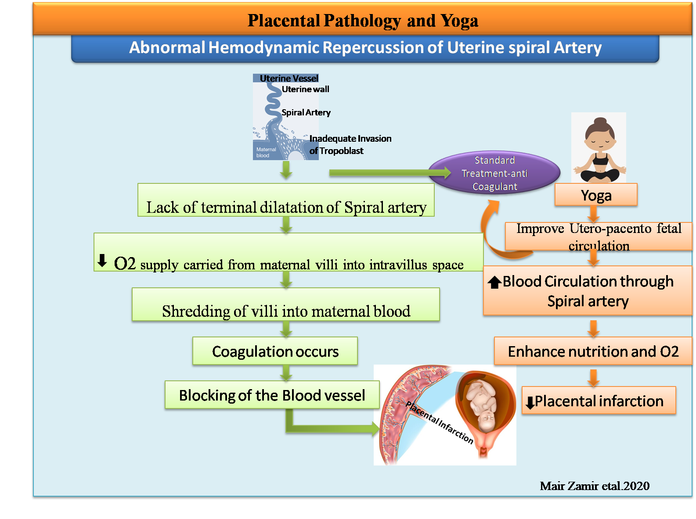

Figure 1: Impact of Yoga on Abnormal hemodynamic repercussions of the uterine spinal artery

Impact of Yoga Therapy on Hypertensive Disorders of Pregnancy:
Around 7-10% of all pregnancies are complicated by a hypertensive disorder of Pregnancy (HDP), which includes gestational hypertension, pre-eclampsia, and pre-eclampsia superimposed on chronic hypertension (28). Compared to women who had normal pregnancies, these women have a higher chance of developing essential hypertension, cardiovascular disease, diabetes mellitus, and kidney disease later in life(29)(30). As a result, there has always been a demand for an intervention to control Pregnancy without deteriorating the mother's health in Hypertensive Pregnancy Disorder. A recent systematic review and meta-analysis demonstrated the efficacy of mind-body medicine as an additional therapy for treating pregnant hypertension(31). Yoga, in particular, has been shown to lower both systolic and diastolic blood pressure significantly.
Makhija et al. recruited 79 primigravidae in the third trimester of Pregnancy with moderate hypertensive disease of Pregnancy to investigate the effect of Yoga on blood pressure.
(32). The study revealed that the group's mean systolic blood pressure dropped by 7.43±5.86 mmHg compared to 2.50±5.21 mmHg in the control group (p=0.002). Before delivery, the mean diastolic blood pressure was 88.00±3.71 mmHg in the study group and 92.20±5.02 mmHg in the control group (p=0.001). The yoga group also had shorter labour length and thus increased maternal comfort during labour. Another pilot pre-post trial(33) found similar outcomes in pregnant women with moderate pre-eclampsia. A recent mechanical trial also indicated that, besides reducing blood pressure, there was an improvement in HRV, BRS, and birth weight. They also observed reduced IL-6 levels and endothelial dysfunction in these women. Finally, they reported that after a 20-week intervention, 6.61% of women in the yoga group got hypertension compared to 38.1% in the control group, and there was a significant reduction in the risk of developing GH (RR, 2.65; CI 1.42–4.95) (34). Yoga for 40 minutes thrice a week for four weeks effectively decreased systolic and diastolic blood pressure in pregnant women with moderate hypertension. Yoga has no adverse side effects and can effectively prevent the disease or its progression, even when other therapy alternatives are limited (Figure 2).
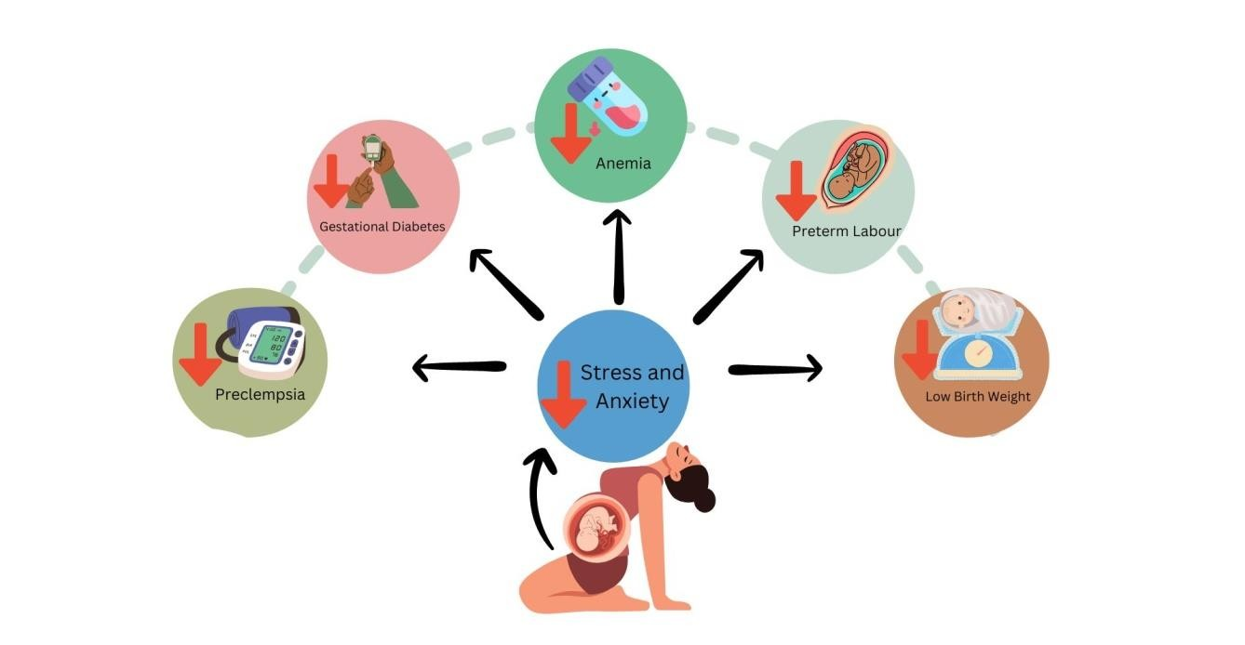

Figure: 2-Yoga in High-Risk Pregnancy
In high-risk pregnancies like GDM, anaemia, and pre-eclampsia, Yoga can be a useful adjunct therapy if practised safely. It has positive physiological, psychological, and emotional effects that can help both the mother and the fetus. However, it should be used in addition to, not in place of, medical care. Yoga earned recognition as a supportive intervention during Pregnancy, especially for high-risk situations. Here is a well-organised summary of Yoga: the way Yoga affects high-risk pregnancies, specifically those with pre-eclampsia, anaemia, and Gestational Diabetes Mellitus (GDM): Yoga reduces Cortisol and balances the autonomic nervous system, both of which impact glucose metabolism. Yoga boosts digestion and nutrient assimilation by activating the parasympathetic nervous system. Two key pre-eclampsia pathologies, inflammation and oxidative stress, are reduced by Yoga's mind-body activities(35).

The mechanisms by which Yoga exerts its antihypertensive effects are uncertain. However, it is hypothesised to improve overall vascular function by increasing parasympathetic activity, decreasing sympathetic nervous system activation, and promoting stress reduction. Lowering maternal stress may have also resulted in several good downstream consequences on the neuroendocrine pathway, metabolic function, and related inflammatory responses; (36)(37), possibly via lowering sympathoadrenal activation and reactivity and the hypothalamic-pituitary-adrenal (HPA) axis (38)

Yoga for Gestational diabetes mellitus
The prevalence of GDM ranges between 2% and 9% and is rapidly growing with the rise in obesity, as obese women are more susceptible to developing GDM during Pregnancy. GDM is characterised as glucose intolerance discovered or diagnosed during Pregnancy, particularly after 24 weeks. GDM pregnancies are more prone to develop gestational hypertension, pre-eclampsia, or preterm labor. Standard guidelines for glycemic management in pregnant women with GDM include insulin, medical nutrition therapy, and exercise. As a mind-body medicine, Yoga has been shown to enhance glycemic control in adults. Youngwanichsetha et al. investigated the effect of mindful eating and yoga movements on blood sugar levels in pregnant women with gestational diabetes mellitus in a study. The intervention group significantly reduced fasting plasma glucose, 2-hour postprandial blood glucose, and glycosylated haemoglobin (HbA1c). Similar effects were obtained in a single-arm study where 75 women with GDM received yoga training. These findings can be considered preliminary in this sector, and future studies will be undertaken with HOMA and insulin resistance in mind.
Yoga in pregnancy-related complications during COVID-19 as a self-care intervention:
COVID-19 can affect maternal mental health (Figure 3): First, there is a more significant concern about acquiring COVID-19, which can directly increase maternal anxiety. In addition, regular follow-ups and tests were temporarily cancelled. During the epidemic, women were also concerned about the availability of beds during labor. Second, social distancing restrictions prevented women from walking or exercising during the pandemic. In a US poll, nearly two-thirds of pregnant women (63.7%) expressed concern about losing a job or household income(39).
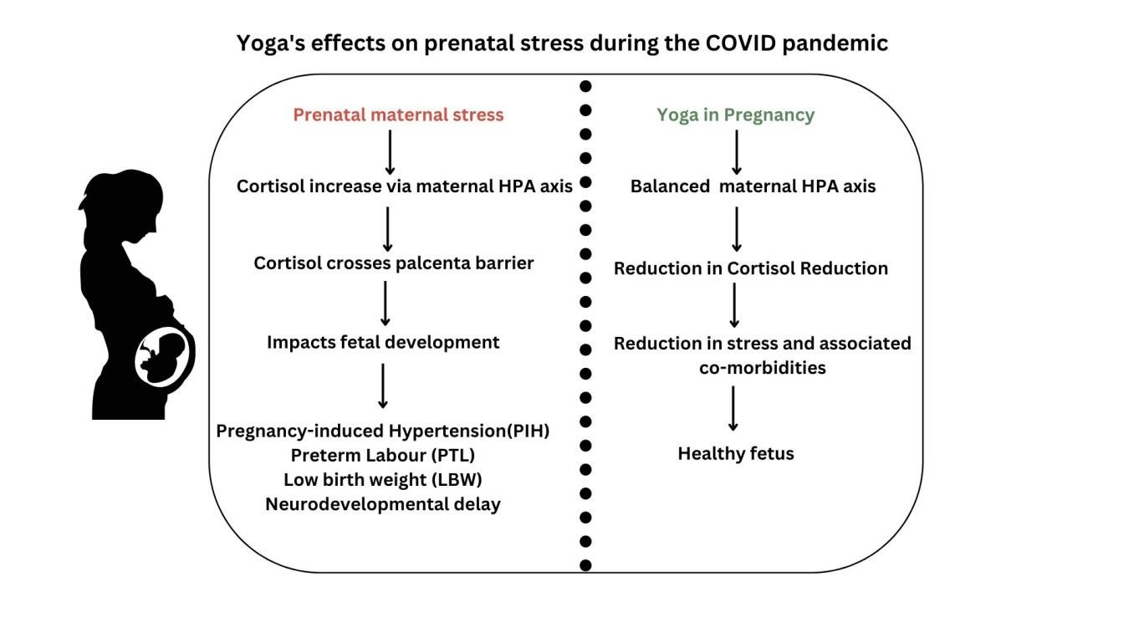

Figure 3: Impact of Yoga on prenatal stress during the COVID Pandemic

In comparison, in Israel, the proportion of pregnant women concerned about the possible economic impact of the pandemic was significantly lower (38.1%) (41). And as we know, maternal stress during Pregnancy is linked to pregnancy-related issues such as low birth weight (LBW), preterm labor (PTL), pregnancy-induced hypertension (PIH), and delayed cognitive development in afflicted 40 offspring. During the COVID-19 crisis, pregnant women can improve their mental health and well-being by engaging in home-based physical activity and mind-body therapy, such as Yoga, mindfulness, and relaxation exercises. According to a particular trial, pregnant (and postpartum) women who engaged in at least 150 minutes of moderate-intensity physical activity each week during the pandemic had significantly lower anxiety and sadness scores than those who did not (40). Prenatal stress affects the maternal hypothalamic-pituitary-adrenal (HPA) axis, raising cortisol levels in maternal blood that flows via the placenta to the fetus and influencing fetal development(41). This could lead to premature deliveries. Structured stress reduction programs such as Yoga, meditation, mindfulness, and appropriate prenatal care can reduce the likelihood of expected premature births (41). According to a randomised controlled trial conducted by DuchYoga et al., Yoga improves the psychological state of pregnant women. When compared to the control group, the yoga group showed lower anxiety (p=0.002), depression (p=0.032), and total mood disturbance (p=0.002) scores after ten weeks. Another recent study looked at the feasibility and usefulness of a yoga intervention on mental health amid the COVID-19 crisis. The researchers found no correlation between perceived stress, Quality of life, and C-reactive protein (44). Yoga and standard Treatment can help pregnant women enhance their Quality of life by lowering the unpleasant experiences, tension, anxiety, and sadness aggravated by the COVID-19 pandemic (42).

Conclusion
Yoga has the efficiency to reduce complications of high-risk Pregnancy and improve Quality of life. Yoga practice has been proven beneficial as a safe and productive non-pharmacological treatment during the gestational period.

COMPETING INTERESTS DISCLAIMER:
Authors have declared that they have no known competing financial interests, non-financial interests, OR personal relationships that could have appeared to influence the work reported in this paper.

Disclaimer (Artificial intelligence)
Option 1:
Author(s) hereby declare that NO generative AI technologies such as Large Language Models (ChatGPT, manuscript.

Reference :
- Alfirevic Z, Stampalija T, Dowswell T. Fetal and umbilical Doppler ultrasound in high‐risk pregnancies. Cochrane Database of systematic reviews. 2017(6).
- Holness N. High-risk pregnancy. Nursing Clinics. 2018 Jun 1;53(2):241-51.
- Alberry M, Soothill P. Management of fetal growth restriction. Archives of Disease in Childhood-Fetal and Neonatal Edition. 2007 Jan 1;92(1):F62-7.
- Rupani SN, Janagam SG. Risks a Mother Takes to Give Birth A Cross-Sectional Study of High-Risk Pregnancies and Preparedness of Public Health Facilities in Rural Karnataka. International Journal of Medicine and Public Health. 2021;11(1).
- Chandler K. The emerging field of yoga therapy. Hawaii medical journal. 2001;60(11).
- Guariguata L, Linnenkamp U, Beagley J, Whiting DR, Cho NH. Global estimates of the prevalence of hyperglycemia in Pregnancy. Diabetes research and clinical practice. 2014 Feb 1;103(2):176-85.
- Frank JB. The Limits of Biological Treatments for Psychological Distress: Comparisons with Psychotherapy and Placebo. The Journal of Nervous and Mental Disease. 1991 Dec 1;179(12):760-1.
- Jahdi F, Sheikhan F, Haghani H, Sharifi B, Ghaseminejad A, Khodarahmian M, Rouhana N. Yoga during Pregnancy: The effects on labor pain and delivery outcomes (A randomized controlled trial). Complementary therapies in clinical practice. 2017 May 1;27:1-4.
- Carty DM, Delles C, Dominiczak AF. Pre-eclampsia and future maternal health. Journal of hypertension. 2010 Jul 1;28(7):1349-55.
- Aabidha PM, Cherian AG, Paul E, Helan J. Maternal and fetal outcome in pre-eclampsia in a secondary care hospital in South India. Journal of family medicine and primary care. 2015 Apr;4(2):257.
- Bijlani RL. Yoga: an ancient tool in modern medicine. The National medical journal of India. 2008;21(5):215-6.
- Chandler K. The emerging field of yoga therapy. Hawaii medical journal. 2001;60(11).
- Fisher S, Greenberg RP. The limits of biological treatments for psychological distress: Comparisons with psychotherapy and placebo. Routledge; 2013 May 13.
- Satyapriya M, Nagarathna R, Padmalatha V, Nagendra HR. Effect of integrated Yoga on anxiety, depression & well-being in normal Pregnancy. Complementary therapies in clinical practice. 2013 Nov 1;19(4):230-6.
- Steegers EA, Von Dadelszen P, Duvekot JJ, Pijnenborg R. Pre-eclampsia. The Lancet. 2010 Aug 21;376(9741):631-44.
- Walker E, Flannery O, Mackillop L. Gestational diabetes and progression to type two diabetes mellitus: missed follow-up and prevention opportunities. Primary Care Diabetes. 2020 Dec 1;14(6):698-702.
- El-Sisi AE, Sokar SS, El-Sayad ME, Moussa EA, Salim EI. The anticancer effect of metformin against 2-amino-1-methyl-6-phenylimidazo [4, 5-b] pyridine-induced rat mammary carcinogenesis is through the AMPK pathway and modulation of oxidative stress markers. Human & Experimental Toxicology. 2019 Jun;38(6):703-12.
- Adeleye OO, Olayode JA, Ajamu MA, Odetola AA, Oyewo OO, Adeyinka OO, Ayanlade
JI. Effect of Simultaneous Administration of Alabukun and Ethanol on Hematological Parameters and Liver of Adult Wistar Rats (Rattus norvegicus). International Journal of Recent Innovations in Academic Research. 2019;3(1):199-208.
- Stuart MC, Kouimtzi M, Hill S, editors. WHO model formulary 2008. World Health Organization; 2009.
- Newham JJ, Wittkowski A, Hurley J, Aplin JD, Westwood M. Effects of antenatal Yoga on maternal anxiety and depression: a randomized controlled trial. Depression and anxiety. 2014 Aug;31(8):631-40..
- Satyapriya M, Nagarathna R, Padmalatha V, Nagendra HR. Effect of integrated Yoga on anxiety, depression & well-being in normal Pregnancy. Complementary therapies in clinical practice. 2013 Nov 1;19(4):230-6.
- Davis K, Goodman SH, Leiferman J, Taylor M, Dimidjian S. A randomized controlled trial of Yoga for pregnant women with symptoms of depression and anxiety. Complementary therapies in clinical practice. 2015 Aug 1;21(3):166-72.
- Gallagher A, Kring D, Whitley T. Effects of Yoga on anxiety and depression for high-risk mothers on hospital bedrest. Complementary Therapies in Clinical Practice. 2020 Feb 1;38:101079.
- Bouya S, Keikhaie LR, Hosseini S, Keikhaie KR. The effect of Yoga on uterine artery Doppler indices, maternal and fetal complications in pregnant women: A quasiexperimental study. Journal of Ayurveda and integrative medicine. 2021 Jan 1;12(1):70-4.
- Rakhshani A, Nagarathna R, Mhaskar R, Mhaskar A, Thomas A, Gunasheela S. The effects of Yoga in preventing pregnancy complications in high-risk pregnancies: a randomized controlled trial. Preventive medicine. 2012 Oct 1;55(4):333-40.
- Rakhshani A, Nagarathna R, Mhaskar R, Mhaskar A, Thomas A, Gunasheela S. Effects of Yoga on utero-fetal-placental circulation in high-risk Pregnancy: a randomized controlled trial. Advances in preventive medicine. 2015 Jan 20;2015.
- Davey DA, MacGillivray I. The classification and definition of the hypertensive disorders of Pregnancy. American Journal of Obstetrics and Gynecology. 1988 Apr 1;158(4):892-8.
- Wu P, Mamas MA, Gulati M. Pregnancy as a predictor of maternal cardiovascular disease: the era of CardioObstetrics. Journal of Women's Health. 2019 Aug 1;28(8):103750.
- Männistö T, Mendola P, Vääräsmäki M, Järvelin MR, Hartikainen AL, Pouta A, Suvanto E. Elevated blood pressure in Pregnancy and subsequent chronic disease risk. Circulation. 2013 Feb 12;127(6):681-90.
- Smith CA, Tuson A, Thornton C, Dahlen HG. The safety and effectiveness of mind-body interventions for women with pregnancy-induced hypertension and pre-eclampsia: a systematic review and meta-analysis. Complementary Therapies in Medicine. 2020 Aug 1;52:102469.
- Makhija A, Khatik N, Raghunandan C. A randomized control trial to study the effect of integrated Yoga on pregnancy outcome in the hypertensive disorder of Pregnancy. Complementary Therapies in Clinical Practice. 2021 May 1;43:101366.
- Hindun S, Franciska Y. Effect of yoga practice in reducing blood pressure, platelet blood count, and proteinuria in pregnant women with mild pre-eclampsia. Journal of Integrative Nursing. 2023 Jan 1;5(1):33.
- Karthiga K, Pal GK, Dasari P, Nanda N, Velkumary S, Chinnakali P, Renugasundari M, Harichandrakumar KT. Effects of Yoga on cardiometabolic risks and fetomaternal outcomes are associated with serum nitric oxide in gestational hypertension: a randomized control trial. Scientific Reports. 2022 Jul 12;12(1):1-23.
- Innes KE, Vincent HK, Taylor AG. CHRONIC STRESS AND INSULIN RESISTANCE-RELATED INDICES OF CARDIOVASCULAR DISEASE RISK, PART 2: A POTENTIAL ROLE FOR MIND-BODY THERAPIES. Alternative Therapies in Health & Medicine. 2007 Sep 1;13(5).
- Rakhshani A. Yoga and quality of life. Encyclopedia of quality of life research. 2013:7281-6.
- Ross A, Thomas S. The health benefits of Yoga and exercise: a review of comparison studies. The Journal of Alternative and complementary medicine. 2010 Jan 1;16(1):3-12.
- Liu X, Chen M, Wang Y, Sun L, Zhang J, Shi Y, Wang J, Zhang H, Sun G, Baker PN, Luo X. Prenatal anxiety and obstetric decisions among pregnant women in Wuhan and
Chongqing during the COVID‐19 outbreak: a cross‐sectional study. BJOG: An
International Journal of Obstetrics & Gynaecology. 2020 Sep;127(10):1229-40.
- Taubman–Ben-Ari O, Chasson M, Abu Sharkia S, Weiss E. Distress and anxiety associated with COVID-19 among Jewish and Arab pregnant women in Israel. Journal of reproductive and infant psychology. 2020 May 26;38(3):340-8.
- Davenport MH, Meyer S, Meah VL, Strynadka MC, Khurana R. Moms are not OK: COVID-19 and maternal mental health. Frontiers in global women's health. 2020:1.
- Madigan S, Oatley H, Racine N, Fearon RP, Schumacher L, Akbari E, Cooke JE, Tarabulsy GM. A meta-analysis of maternal prenatal depression and anxiety on child socio-emotional development. Journal of the American Academy of Child & Adolescent Psychiatry. 2018 Sep 1;57(9):645-57.
- Villalobos D, Pacios J, Vázquez C. Cognitive control, cognitive biases and emotion regulation in depression: a new proposal for an integrative interplay model. Frontiers in Psychology. 2021 Apr 30;12:628416.
- Shidhaye R, Bangal V, Bhargav H, Tilekar S, Thanage C, Gore S, Doifode A, Thete U, Game K, Hake V, Kunkulol R. Feasibility, acceptability, and preliminary efficacy of Yoga to improve maternal mental health and immune function during the COVID-19 crisis (Yoga-M2 trial): a pilot randomized controlled trial. Frontiers in Human Neuroscience. 2023;17.
- Nadholta P, Bali P, Singh A, Anand A. Potential benefits of Yoga in pregnancy-related complications during the COVID-19 pandemic and implications for working women. Work. 2020 Jan 1;67(2):269-79.

