Reversal of Chemical potentiated multiple end organ injuries by Citrus reticulata leaf Extract.

ABSTRACT
Background: The liver being the largest and central organ of nutrient metabolism is at a high risk of injury from the toxic metabolites of ingested materials. This invariably leads to rising incidence of chronic liver disease. This study investigated the ability of the aqueous extract of Citrus reticulata leaf to reverse carbon tetrachloride induced acute liver injury.
Methods: Mild, moderate and severe liver injuries were induced in three sets of animals with each consisting of three groups. Subsequently, low (200mg/kg) and high (400mg/kg) doses of the leaf extract were administered orally once daily to six of the groups for 28 days. At expiration, blood samples were collected for biochemical analyses. Liver and kidney were harvested from the animals for histopathological evaluation.
Results: The standardized weights of the liver as well as those of the kidney were similar across the groups.
The blood protein level was elevated in all the groups that had the extract but depressed in the liver injured groups that did not receive the extract. Low dose of the extract elevated the globulin level. The globulin: albumin ratio was greater than one in all the groups.
The alanine aminotransferase (ALT) level of the high extract dose with severe liver injury group was similar to that of the general control but remarkably lower than that of its counterpart control (ie the group with severe liver injury but did not receive the extract). The aspartate aminotransferase and alkaline phosphatase levels were similar in pattern to that of ALT. The histological architecture of both the liver and the kidney were preserved.
Conclusion: Oral administration of the aqueous extract of Citrus reticulata (tangerine) leaf reversed the organ damage potentiated by the administration of carbon tetrachloride (chemical). Low dose of C. reticulata leaf extract may improve immune status.
Key words: Acute liver injury, Citrus reticulata, Liver enzymes, Carbon tetrachloride.

INTRODUCTION
The phrase “End organ injury” refers to the organ that considerably bears the brunt of a chronic systemic disease. Such non-communicable diseases include hypertension, diabetes mellitus, dyslipidemia and sickle cell heamoglobinopathy. The ultimate consequence of hypertension includes chronic kidney failure and cerebrovascular accident. While that of diabetes mellitus include chronic non-healing foot ulcers and cataract. The sequelae of chronic alcoholism include hepatitis, fatty liver, liver cirrhosis and hepatocellular carcinoma. The three constituents of liver disease namely viral hepatitis, cirrhosis and cancer account for more than two million deaths worldwide annually. This translates to 4% of global mortality and ranks 11th [1,2]. Liver cancer accounts for 30-45% of liver related deaths. In the African continent, liver cirrhosis is the 10th cause of death. In people less than 50 years of age, liver disease is the 12th leading cause of disability-adjusted life-years [3] ‘The World Health Organization(WHO) Global Status Report on Alcohol and Health estimated that 2.3 billion people are current alcohol drinkers, who consume an average of 32.8 g of pure alcohol per day’[4]. Global per-capita alcohol consumption increased from 1990 to 2017 and is projected to increase further by 2030 [5]. Most of the cases of liver cirrhosis are largely due to alcohol consumption.
“In the year 2020, viral hepatitis B- and C-related diseases led to 1.1million deaths, similar to the number caused by tuberculosis (1.3 million deaths) and significantly higher than the number caused by human immunodeficiency virus (0.68 million deaths) or malaria (0.627 million deaths). Yet, the global resources committed to controlling and eliminating viral hepatitis are disproportionately lower than those for each of the other three communicable diseases” [1].
Globally, drug induced liver injury is the commonest cause of acute liver failure which though, rare carries very high morbidity and mortality. Acute liver failure is highly fatal and its management consumes a lot of resources and indeed it is the leading indication for emergency liver transplant [6]. The global incidence of acute liver failure is about one in a million [7-9].
According to GLOBOCON 2022 cancer report; 865,269 new cases of hepatocellular cancer (HCC) were documented this accounted for 4.3% of global cancer cases and ranked 6th. Of this figure; 757,948 people died from liver cancer thus making HCC contributing 7.8% to global cancer mortalities and putting it at the 3rd position [10].
The approximate number of people with acute kidney injury, acute kidney failure and chronic kidney disease (these constitute kidney disease) globally is 850 million this translates to a prevalence rate of 10% [11,12]. In essence, 1 out of every 10 living persons has one form or the other of kidney disease. Chronic kidney disease constitutes more than 80% (700 million) of kidney pathologies [13].
As high as 90% of persons with chronic kidney disease (CKD) in resource poor settings with weak primary health care infrastructure are not even aware that they are patients hence they do not seek medical assistance till they become considerably symptomatic [14-16].
Arising from this very alarming global statistics, the duo of kidney and liver health is of serious concern and deserves premium and uttermost attention. While much cannot be done to remediate liver and kidney diseases that are entirely genetic in aetiopathogenesis, much can be done to those due to environmental, social and nutritional factors. A variety of plants are known to have constituents that are medicinal and hence beneficent to human health. Such plants include the leaves of Citrus reticulata (tangerine). This study investigated the ability of aqueous extract of Citrus reticulata to reverse chemical induced acute liver and kidney injury.

2. MATERIALS and METHODS

2.1. Plant Materials

2.1.1. Plant collection and authentication
Fresh leaves of Citrus reticulata were plucked from the tangerine trees situated within the premises of Dr RS Ajani at No 1 W. Akintunde Ajani Close off Owo-Egbeleke street, Asi, Ibadan, Nigeria. The Herbarium unit of the Department of Botany, University of Ibadan, Nigeria handled the botanical identification, specie confirmation and authentication of the harvested leaves. Samples were deposited for repository and future reference.
2.1.2. Extract preparation
The harvested leaves were subsequently washed and spread out for natural room drying before being milled into fine textured powder. The aqueous extract was prepared from this powder and an 18% yield was obtained, this was subsequently refrigerated till the stage of administration.
2.2 Animals
Fifty adult wistar rats sourced from the Central Animal House of the College of Medicine situated on the University of Ibadan campus were used for this study. Their average weight was 250 g and a range of 210-260 g. The period of acclimatization was three weeks in a well ventilated and illuminated environment with optimal ambient temperature (27 ±2 ºC,12 hours light/day cycle). The animals had liberal feeding with locally sourced but nutritionally balanced pelletized rat feed with unhindered access to water.

2.3 Design of the Experiment
The creation of the four main groups with three of them further subdivided into three sub-groups each was premised on induction of acute liver injury and administration of the aqueous extract of C. reticulata leaves. Thus there were ten groupings in all and each had five randomly allotted animals.
The listing of the groupings is as below-;
1 Control (CN)- Extract only
2 A- Mild Acute Liver Injury without extract (ALIM)
B- Mild Acute Liver Injury with low dose Extract (ALIMLE)
C- Mild Acute Liver Injury with high dose Extract (ALIMHE)
3 A- Moderate Acute Liver Injury without extract (ALID)
B- Moderate Acute Liver Injury with low dose Extract (ALIDLE)
C- Moderate Acute Liver Injury with high dose Extract (ALIDHE)
4 A- Severe Acute Liver Injury without extract (ALIS)
B- Severe Acute Liver Injury with low dose Extract (ALISLE)
C- Severe Acute Liver Injury with high dose Extract (ALISHE).

2.4 Induction of Acute Liver Injury
On account of previous similar study and documented protocol [17-19], liver injury was induced by single oral administration of carbon tetrachloride (CCl₄) in olive oil (as a vehicle) in equal (50:50) proportion via a 16 G orogastric tube. Thus mild acute liver injury was achieved by administering 1ml(1.6g)/kg body weight of CCl_{4.} With the administration of 2.5 ml(4g)/kg and 5ml(8g)/kg of CCl₄ respectively to Group 3 & 4, moderate and severe acute liver injuries were established.

2.5 Conduct of the Experiments
The oral administration of the aq. extract of C. reticulata was done in the following manner-;
The low dose extract groups (ALIMLE, ALIDLE and ALISLE) had 200mg/Kg while the high extract groups (ALIMHE, ALIDHE and ALISHE) had 400mg/Kg both once daily for twenty eight (28) days.
The Control group and all the non-extract groups ie ALIM, ALID and ALIS had normal rat feed and water for same duration.
On day 29, blood samples were collected from the animals for biochemical analyses (liver function test consisting of total protein with albumin and globulin fractions, alanine aminotransferase(ALT), aspartate aminotransferase (AST) and alkaline phosphatase (ALP). Thereafter, the animals were euthanized and the livers and kidneys were harvested for histopathological evaluation.
Also, the animals were weighed at both the commencement and conclusion of the experiments.

2.6 Ethical Conduct
The University of Ibadan Animal Care and Use Research Ethics Committee approved the conduct of this study. Also, the principles of laboratory animal care as contained in the 8th edition (2011) of the Guide for the Care and Use of Laboratory Animals by the National Research Council (US) Committee for the Update of the Guide for the Care and Use of Laboratory Animals were observed [20].

2.7Data Analysis and Processing
The numerical aspects of the results were analyzed with Statistical Package for the Social Sciences (SPSS) version 24 and expressed as percentages, means plus standard deviation of means (SD). The student t- test was used for intra and inter group comparison and level of significance was set at p<0.05.

3. RESULTS
There was positive body weight alteration across the groups. This being higher than that of the control in all the groups except the high dose extract severe liver injured (ALISHE) in which the weight change was the least and even lower than that of the control.
Morphological
The liver weight as well as the standardized liver weight were similar across the groups without any significance difference. Also the weight of the kidney as well as the standardized kidney weight were similar across the groups and without remarkable differences.
Only the total protein level of the low dose extract severe liver injured group (ALISLE) was significantly higher than that of the control group (CN). Intragroup comparison of the total protein levels revealed a significant elevation in the low dose extract mild liver injured group (ALIMLE) above its non-extract counterpart ie ALIM. As for the albumin level, there was no remarkable alteration across the groups. However, remarkable differences exist as regards the globulin levels. The globulin level of the low dose extract severe liver injured group ie ALISLE was significantly higher than those of the general control and its counterpart control ie CN and ALIS respectively. It was also observed that the blood globulin level of the mild liver injury with low dose extract ie ALIMLE was significantly higher than that of its control ie ALIM. Although the globulin to albumin ratio was above one, the values were similar across the groups. The alanine aminotransferase (ALT) levels of the non-extract severely liver injured group ie ALIS, ALISLE and the low dose extract moderately liver injured ie ALIDLE were remarkably higher than that of the control (CN). It is worthy of note that the ALT levels of both ALIMLE and ALIMHE were significantly higher than of their control ie ALIM. The high extract moderate and low extract severe liver injured groups ie ALIDHE and ALISLE had significantly elevated aspartate amino transaminase (AST). The ALIMLE group had a remarkably higher AST level than its corresponding control-ALIM. Curiously, the AST level of the ALISHE group was significantly lower than that of its low extract dose counterpart ie ALISLE. The alkaline phosphatase levels of the ALIMLE, ALIDHE and ALISLE were significantly higher than that of the control group-CN. Intra group comparison of alkaline phosphatase levels revealed ALIMLE being greater than ALIM; ALIDHE > ALID; and ALISHE lesser than ALISLE (Table 1).
Histopathological evaluation.
The characteristic template of the liver microanatomy was observed in all the groups and the defining cells of the liver which are the hepatocytes and Kupffer cells were also observed in all the samples of the groups (Plate 1).
In all the groups, the normal architecture of the kidney was preserved. However, hypercellularity and distortion of the glomerulus were noted in the severely liver injured groups. These features are suggestive of inflammation of the glomerulus known in clinical parlance as glomerulonephritis (Plate 2).

TABLE 1: Mean Values of the assessed Morphometric and Biochemical Parameters
PARAMETERS | GROUPS
 | CN | ALIM | ALIMLE | ALIMHE | ALID | ALIDLE | ALIDHE | ALIS | ALISLE | ALISHE
Body weight alteration (%) | 13.24 | 25.46 | 25.95 | 20.71 | 21.32 | 23.49 | 21.06 | 17.56 | 20.51 | 6.96
Liver weight (g) | 6.76±1.38 | 7.47±1.45 | 6.61±0.64 | 7.21±0.75 | 6.75±0.83 | 7.51±1.4 | 7.52±0.63 | 7.17±0.57 | 7.35±1.15 | 6.91±1.95
Standardized Liver weight  {/100g body weight}(g) | 3.52 | 3.60 | 3.23 | 3.53 | 3.39 | 3.76 | 3.68 | 3.64 | 3.67 | 3.44
Kidney weight(g) | 1.05±0.12 | 1.10±0.09 | 0.98±0.07 | 0.97±0.47 | 0.98±0.07 | 1.13±0.38 | 1.25±0.41 | 1.02±0.08 | 1.01±0.08 | 1.00±0.09
Standardized Kidney weight  {/100g body weight}(g) | 0.54 | 0.53 | 0.48 | 0.48 | 0.49 | 0.56 | 0.61 | 0.52 | 0.51 | 0.56
Total protein (g/dl) | 7 ±0.74 | 6.88±0.55 | 7.76±0.54^{β} | 7.65±0.74 | 7.6±0.49 | 7.64±1.21 | 7.76±0.48 | 7.38±0.84 | 7.86±0.13^{α} | 7.12±0.41
Albumin (g/dl) | 2.9±0.32 | 2.82±8.83 | 3.1±0.2 | 3.1±0.27 | 3.18±0.22 | 3.26±0.72 | 3.26±0.23 | 3.14±0.37 | 3.08±0.08 | 2.8±0.16
Globulin (g/dl) | 4.1±0.46 | 4.06±0.34 | 4.66±0.39^{β} | 4.55±0.53 | 4.42±0.36 | 4.38±0.51 | 4.5±0.39 | 4.24±0.47 | 4.78±0.16^{αβ} | 4.32±0.26
Globulin: Albumin Ratio | 1.41 | 1.44 | 1.50 | 1.47 | 1.39 | 1.34 | 1.38 | 1.35 | 1.55 | 1.54
Alanine Aminotransferase (µ/l) | 28.75±2.22 | 27.2±2.68 | 31.4±2.07^{β} | 32.25±2.75^{β} | 30.8±2.17 | 32.6±4.93 | 32.6±1.52^{α} | 33.4±3.13^{α} | 34.4±1.14^{α} | 28.2±2.39
Aspartate Aminotransferase (µ/l) | 39.5± 3.32 | 38.6± 3.36 | 43.8± 2.28^{β} | 43.75± 3.78 | 42.2± 2.59 | 44.2± 8.35 | 44.2± 1.64^{α} | 44.6± 5.03 | 47.2± 0.84^{α} | 40.2± 2.78^{δ}
Alkaline Phosphatase (µ/l) | 91.75± 7.89 | 90.8±11.99 | 111.2±8.11^{αβ} | 109± 11.92 | 106.4±6.95 | 110.8±21.90 | 117.4±7.23^{αβ} | 104.2±17.04 | 115.0±9.22^{α} | 95.2±7.86^{δ}
α- Significantly higher than the Control group
β-Significantly different from the corresponding control (ie ALIMLE vs ALIM; ALIDLE vs ALID)
δ -Significantly different from the corresponding low dose extract group (ie ALISHE vs ALISLE)
ALT-alanine aminotransferase(ALT); AST-aspartate aminotransferase; ALP-Alkaline phosphatase

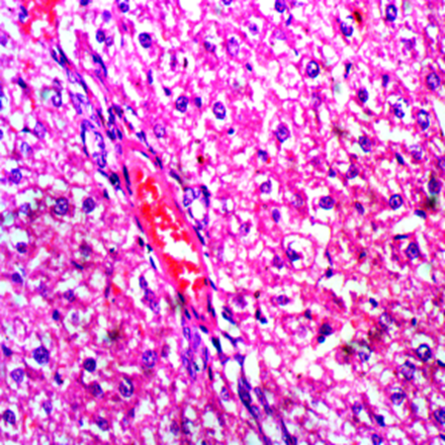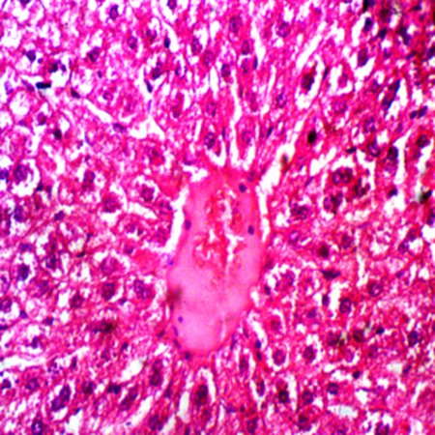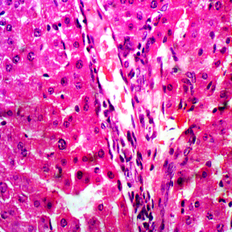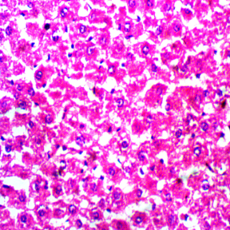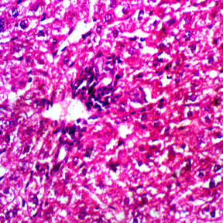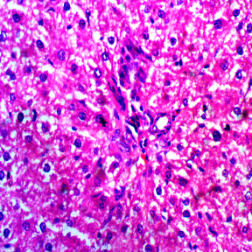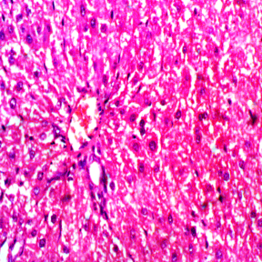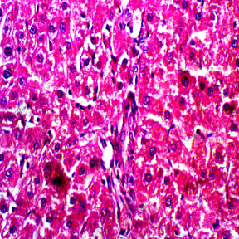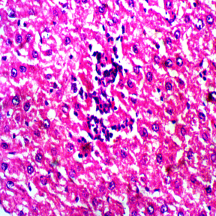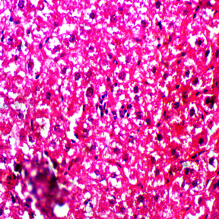
CV
BD
PV
HA
ALIMHEM
ALID
ALIDLEM
ALIMLEM
ALIMM
CN
KC
TNH
BNH
PV
HA
ALISLEM
ALIDHEM
ALIS
ALISHEM
Plate 1: Liver Photomicrographs (H & E x 400)
Legend: BD-Bile duct, BNH-Binucleate hepatocyte, CV- Central vein, HA-Hepatic arteriole, KC- Kupffer cell, PV-Portal venule,TNH- Trinucleate hepatocyte.CN-Control, ALIM- Mild acute liver injury without extract, ALIMLE-Mild acute liver injury with low dose extract, ALIMHE-Mild acute liver injury with high dose extract, ALID- Moderate acute liver injury without extract, ALIDLE-Moderate acute liver injury with low dose extract, ALIDHE-Mild acute liver injury with high dose extract, ALIS- Severe acute liver injury without extract, ALISLE-Severe acute liver injury with low dose extract and ALISHE-Severe acute liver injury with high dose extract.
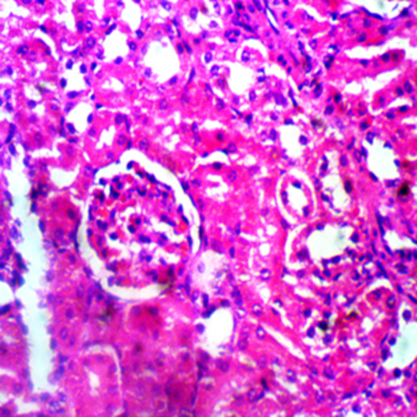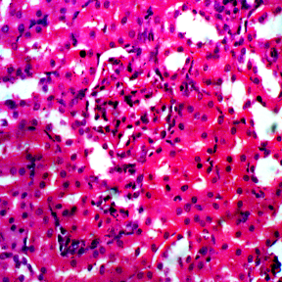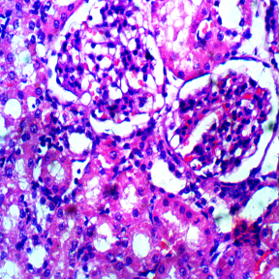
CN
ALIMM
ALIMLEM
ALIMHEM
ALIDLEM
BC
G
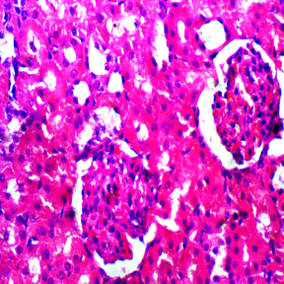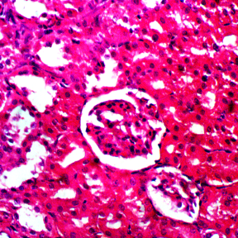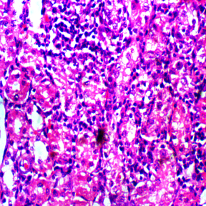
DCT
PCT
ALID
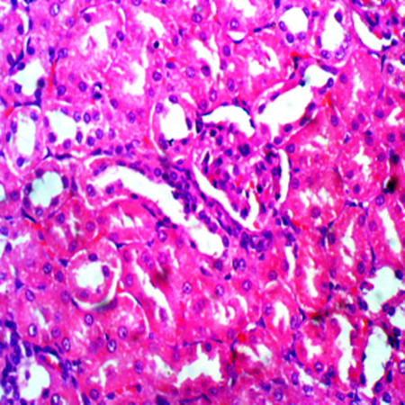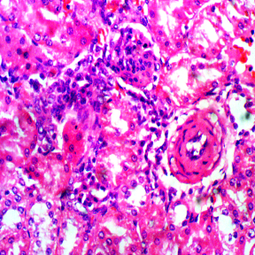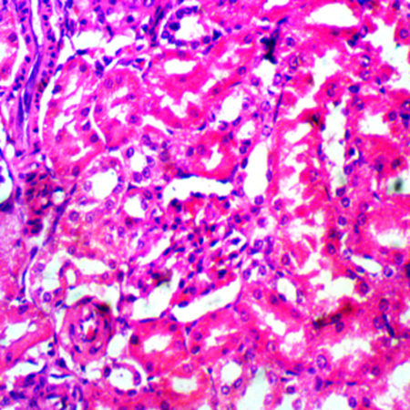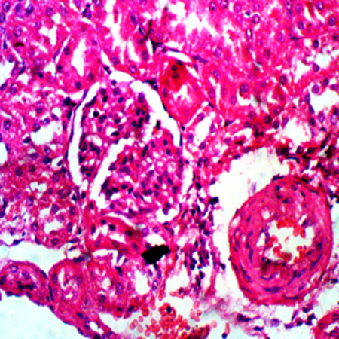
DG
DG
EA
AA
ALIDHEM
ALIS
ALISLEM
ALISHEM
Plate 2: Kidney: Photomicrographs (H & E x 400)
Legend: AA- Afferrent arteriole, BC-Bowans capsule,DCT-Distal convulated tubule, DG-Distorted glomerulus, EA- Efferent arteriole, G- Glomerulus, PCT- Proximal convulated tubule

Discussion.
The group that had the highest amount of carbon tetrachloride had the least weight gain this might be due to the severity of the injury. The initial response of a tissue or an organ to an acute insult known as inflammation is characterized by warmth, change in colour, swelling and loss of function. The swelling may affect particular organ(s) or the whole body. In this study, there was no appreciable difference either in the liver or kidney weights across the groups this might be due to the duration of the study. In fact, the standardized organ weight which is a parameter that corrects for differences in body weight was similar across the groups. This could infer that the injury occasioned by the administration of CCl₄ was more at the micro level rather than at macro level. One of the main functions of the liver is protein synthesis thus any process that negatively affects the hepatocyte (the main cell of the liver) will compromise protein synthesis. The mild liver injury group without extract had the least plasma protein level. However, its extract counterpart ie ALIMLE had a significantly higher level of plasma protein. Also, the plasma protein of the low extract but severely liver injured group (ALISLE) was significantly higher than that of the control group. Administration of the high dose of the extract did not appear to confer any additional benefit. It thus follows that post injury administration of the aqueous extract of C. reticulata at low dose is beneficent to the restoration of the protein synthesis ability of the liver and higher dose does not translate to additional benefit.
The plasma oncotic pressure that is responsible for retention of fluid within the intravascular space is a function of the albumin level of the plasma. Globulin, in form of the various types of immunoglobulins is responsible for the antibody component of the immune response system. The globulin fractions of the total plasma protein of the low extract groups were markedly higher than their non–extract groups this may imply that low dose of C. reticulata extract is immunogenic in essence it confers increased resistance to disease. This may offer a ray of hope in patient with chronic kidney or liver diseases who are very susceptible to infections due to compromised immune status. The globulin: albumin ratio is greater than one in all the groups without any significant difference. Since both fractions of the plasma protein have different functions, the implication of the value of this ratio is that the immunological status of the animals in this study was not compromised. This might be due to the duration of the study. The magnitude of, as well as the chronicity of exposure to injurious agents are key factors in the affectation of the immune status of a biological specie. In terms of distribution, the aspartate aminotransferase (AST) is found in liver, cardiac and skeletal muscles, kidney, brain, white and red blood cells [21,22] while alanine aminotransferase (ALT) occurs mainly in the liver [23]. Thus ALT is more specific for the liver and the elevation of its level in the blood is more predictive of liver pathology while that of AST is less specific. Alkaline phosphatase consists of some enzymes and is found in the bone, liver, small intestine, kidney, placenta and leukocytes [21,22]. Due to the fact that ALP has other sources than the liver, an elevated blood level may not connote liver pathology. However, it is still a reliable marker of liver and kidney diseases. The rise in the levels of the aminotransferases is a function of the severity of the damage to the liver and may thus be normal or as high as a ten-fold increase [24]. The liver enzymes namely alanine aminotransferase (ALT), aspartate aminotransferase (AST) and alkaline phosphatase (ALP) are synthesized by the hepatocytes within the cytosol. Thus in situations of insults to the liver, be of chemical or pathogens in origin, a rise in the levels of liver enzymes is indicative of necrosis of the hepatocytes. The ALT levels of all the groups except those of ALIM and ALISHE were higher than the control. However, the ALT level of the high extract dose with severe liver injury ie ALISHE was significantly lower than that of its corresponding control ie ALIS. Could this infer that that high dose of the aqueous extract of C. reticulata (tangerine) leaf was able to mitigate destruction of hepatocytes brought about by high dose chemical poisoning? If this postulation is in the affirmative, then the plant extract will be a good remedy against propagation of hepatic cellular damage due to ingestion of chemical. The AST level of the high extract dose with severe liver injury group (ALISHE) was similar to that of the general control ie CN and significantly lower than that of its low dose extract (ALISLE) counterpart. This pattern was also noticed in the results of alkaline phosphatase. Thus from the results of the liver enzymes as obtained in this study, high dose of the aqueous extract of C. reticulata (tangerine) was capable of arresting hepatocyte necrosis triggered by the administration of carbon tetrachloride.
Urea is the end product of protein metabolism though formed in the liver but largely excreted by the kidney. Thus its blood level is low in liver injury with considerable cellular damage and elevated in renal insufficiency. Normally, protein is filtered by the renal glomerulus but is reabsorbed from the filtrate in the renal tubules [25]. In renal insufficiency, both the glomerular filtration and tubular reabsorption of protein are adversely affected resulting in considerable loss of protein through urine that is proteinuria. In this scenario, the blood level of protein especially the albumin fraction will be low ie hypoproteinemia /hypoalbuminemia. In this study, there was no evidence of such as the protein levels of the liver injured groups that had the extract were similar to or slightly higher than that of the control. Thus it appears the extract of C. reticulata leaf was able to remediate the cellular injury caused by the administration of CCl_{4.} Although, no structural alteration of abnormality was seen in the histological sections of both the liver and kidney tissues obtained from the animals, this does not rule out the occurrence of pathologies in the course of the experiments.
.
Conclusion
Plants generally are of high medicinal and health values raging from preventive to therapeutics. Diseases of the liver from inflammatory to malignancy is of considerable burden globally. The ability of the aqueous extract of C. reticulata leaf to stem the tide of hepatic damage as evidenced by the results of the liver enzymes and restoration of protein synthesis, makes the plant a beneficial nutritional supplement. At low dose, the aqueous extract of C. reticulata leaf is immunogenic by up regulating globulin synthesis. Thus if C. reticulata leaf is incorporated into diets either as drink or additive, we may be able to reduce the incidence of liver diseases that are of chemical origin especially alcohol and drugs.

Disclaimer (Artificial intelligence)
Option 1:
Author(s) hereby declare that NO generative AI technologies such as Large Language Models (ChatGPT, manuscript.

REFERENCE
1.Devarbhavi H, Asrani SK, Arab JP, Nartey YA, Pose E, Kamath PS. Global burden of liver disease: 2023 update. J Hepatol. 2023;79(2):516-537.
2.Asrani SK, Devarbhavi H, Eaton J, Kamath PS. Burden of liver diseases in the world. J Hepatol
2019; 70:151–171.
3. Collaborators GBDC. The global, regional, and national burden of cirrhosis by cause in 195 countries and territories, 1990-2017: a systematic analysis for the Global Burden of Disease Study 2017. Lancet Gastroenterol Hepatol 2020; 5:245–266.
4. Huang DQ, Mathurin P, Cortez-Pinto H, Loomba R. Global epidemiology of alcohol-associated cirrhosis and HCC: trends, projections and risk factors. Nat Rev Gastroenterol Hepatol. 2023;20(1):37-49
5. Manthey J, et al. Global alcohol exposure between 1990 and 2017 and forecasts until 2030: a modelling study. Lancet. 2019; 393:2493–2502.
6. Bernal W, Auzinger G, Dhawan A, Wendon J. Acute liver failure. Lancet 2010; 376:190–201.
7. Lee WM. Acute liver failure in the United States. Semin Liver Dis 2003; 23:217–226.
8.Bower WA, Johns M, Margolis HS, Williams IT, Bell BP. Population-based surveillance for acute liver failure. Am J Gastroenterol 2007; 102:2459–2463.
9.Bretherick AD, Craig DG, Masterton G, Bates C, Davidson J, Martin K, et al. Acute liver failure in Scotland between 1992 and 2009; incidence, aetiology and outcome. QJM 2011; 104:945–956.
10. Bray F, Laversanne M, Sung H, Ferlay J, Siegel RL, Soerjomataram I, & Jemal, A. (2024). Global cancer statistics 2022: GLOBOCAN estimates of incidence and mortality worldwide for 36 cancers in 185 countries. CA: A Cancer Journal for Clinicians, 74(3), 229-263.

13.Francis A, Harhay MN, Ong ACM. et al. Chronic kidney disease and the global public health agenda: an international consensus. Nat Rev Nephrol 20 473–485 (2024). https://doi.org/10.1038/s41581-024-00820-6
14.Bosi, A. et al. Use of nephrotoxic medications in adults with chronic kidney disease in Swedish and US routine care. Clin. Kidney J. 15, 442–451 (2022).
15. Centers for Disease Control and Prevention. Chronic Kidney Disease in the United States,2021 (US Department of Health and Human Services, 2021).
16. Gummidi, B. et al. A systematic study of the prevalence and risk factors of CKD in Uddanam, India. Kidney Int. Rep. 5, 2246–2255 (2020).
17. Ajani R. S., & Ajayi, M. A. (2025). Mangifera indica (Mango) Leaf Extract as a Recipe for Chemical Induced Acute Liver Injury. Asian Journal of Medicine and Health. 23(4), 93–101.
18. Gruenbaum BF, Boyko M, Delgado B, et al. Cell-free DNA as a potential marker to predict carbon tetrachloride-induced acute liver injury in rats. Hepatol Int. 2013;7(2):721-727.
19.Frank D, Savir S, Gruenbaum BF, Melamed I, Grinshpun J, Kuts R, Knyazer B, Zlotnik A, Vinokur M, Boyko M. Inducing Acute Liver Injury in Rats via Carbon Tetrachloride (CCl4) Exposure Through an Orogastric Tube. J Vis Exp. 2020 Apr 28;(158):10.3791/60695.
20. National Academies Press (US); 2011. Available: https://www.ncbi.nlm.nih.gov/books/ NBK54050/doi: 10.17226/12910.
21. Lee TH, KimWR, Poterucha JJ. 2012.Evaluation of Elevated Liver Enzymes. Clinics in Liver Disease.2012: 16 (2); 183-198.
22 Schiff ER, Sorrell MF, Maddrey WC, editors. Schiff’s diseases of the liver. 10th edition. Philadelphia: Lippincott Williams & Wilkins; 2007.
23. Green R, Flamm S. AGA technical review on the evaluation of liver chemistry tests. Gastroenterology 2002; 123:1367–84,
24. Ellis G, Goldberg DM, Spooner RJ, et al. Serum enzyme tests in diseases of the liver and biliary tree. Am J Clin Pathol 1978; 70:248–58

25.Gounden V, Bhatt H, Jialal I. Renal Function Tests. [Updated 2024 Jul 27]. In: Stat Pearls [Internet]. Treasure Island (FL): Stat Pearls Publishing; 2025 Jan-. Available from: https://www.ncbi.nlm.nih.gov/books/NBK507821/

