**Original Research Article**

**Structural Symmetry Analysis of Mono Sodium L-glutamate Pentahydrate by Whole Powder Pattern Fitting Method: A Powder X-ray Line Diffraction Study**

ABSTRACT

|  |
| --- |
| The crystallographic bibliography of mono-sodium L-glutamate pentahydrate (MSLGPH) revealed a unique, unparalleled structural geometry using powder X-ray diffraction (XRD). The XRD analysis revealed the atomic structure of MSLGPH crystals, providing a detailed refinement of lattice parameters and crystal symmetry of the orientation. Crystallography revealed a dislocation density of 2.009 × 10⁻⁴ nm⁻², a crystallinity index of 1.98, a unit cell density of 1.48 g/cm³, and a specific surface area of 57.46 m²/g, contributing to a unique structural geometry.Rietveld refinement confirmed a unified 100 % crystalline phase using the whole powder pattern fitting (WPPF) method. The calculated lattice parameters are a= 6.224, b= 16.669, c= 5.992 Å; α= 98.77, β= 99.83, γ= 98.54° in a triclinic crystal system with lattice volume of 595.565 Å³ and crystal strain of 0.163 %. The strongest diffraction is distinct at 2θ= 20.364° (0-31) plane. Various models were used to estimate crystallite size, with the Scherrer equation exploring an average crystallite size of 70.55 nm for nano-size confirmation. |

***Keywords:*** MSLGPH, Structural geometry**,** Triclinic,WPPF,XRD.

**1.0 Introduction**

MSLGPH is a hydrated form of crystalline monosodium glutamate (MSG), a common flavor enhancer [1]. Its chemical formula is C5H8NNaO4. 5H2O, indicating that each MSG molecule is associated with five water molecules in its crystal symmetry [2]. The crystalline MSLGPH is significant in food science [2] and technology. The pentahydrate form influences its stability, solubility, and crystallinity in functional applications [3] performance.The crystallography of MSLGPH is important because it reveals crucial compound structure and functional properties [4]. Without understanding its crystal structure, one cannot optimize its use in food industries, ensuring quality control in production [5]. This phenomenon is vital for improving manufacturing processes, enhancing product stability, and potentially discovering new applications in food nanoscience and pharmaceuticals [6] exploration. Pointing out this drawback, studying its hydrated interactions within crystal structures and symmetry of MSLGPH, and exploring crystalline behavior with identification of class is the prime focus of this study.

**2.0 Materials and Methods**

A branded granular MSLGPH, which is commonly known as testing salt, was collected from the available local market in Mohammadpur [Chondrima model town, Road no# 05], Dhaka-1207, Bangladesh. The supplied sample was investigated only for research and development (R&D) purposes. It was dried for one and a half (1.50) hours at 80 °C in an oven [ED115, BINDER, USA] to eliminate moisture and other organic volatile impurity compounds.

**3.0 Characterization**

The geometrical characteristics of crystal symmetry and lattice parameters were analyzed by a multipurpose XRD instrument coated SmartLab SE [Rigaku, Japan] [7-8]. The typical X-rays produced by the copper ceramic X-ray tube [CuKα, λ= 1.54060 Å] had a voltage of 40.0 kV and a current of 50.0 mA [9], employed 2.0 kW. Data were obtained from 5 ° to 100 ° Bragg's angle with 0.01° step intervals. To explore the desired CuKα beam, a Ni-Kβ filter was added to the diffracted beam path to minimize Kβ-rays [10-11]. All experiments employed Bragg-Brentano (BB) para-focusing geometry. The analysis was performed in standard mode, with a 1D scan at a 10 °/min rate, and HPAD [hybrid pixel array detector] featured the Hypix-400 horizontal detector [12-13]. A horizontal theta-theta goniometer was employed, and both 2.5º solar slit boxes 1.0 and 2.0 were open. Data was characterized using SmartLab Studio II software with *ICDD PDF-5+* standard database [14-15]. The distance between atomic planes in a crystal system is represented by d-spacing (d) values computed by Bragg's law [16-17]. The average crystallite sizes were determined using various models [18-19]. Multiple studies have utilized different models for calculating crystallite size, and the related equations are listed below [20-21].

Bragg's law: $d=\frac{nλ}{2sinθ}$ (1)

Scherrer equation: $D_{s}=\frac{K λ}{β cos θ}$ (2)

Williamson-Hall method: $β_{total}\cos{θ}= \frac{kλ}{D }+4.ε \sin{θ}$ (3)

Monshi-Scherrer method: $ln\left(β\right)=ln\frac{1}{cos θ}+ln\frac{k λ}{D}$ (4)

Linear straight-line model: $cos θ=\frac{k λ}{D}×\frac{1}{β}$ (5)

Sahadat-Scherrer model: $cos θ=\frac{k λ}{D_{s-s}}×\frac{1}{FWHM}$ (6)

Size-strain plot model: ${(d_{hkl} β_{hkl}\cos{θ})}^{2}= \frac{kλ}{D}({d_{hkl}}^{2}β_{hkl}\cos{θ)+\frac{ε^{2}}{4}}$ (7)

Halder-Wagner method: ${\left(\frac{β_{hkl}}{d_{hkl}}\right)}^{2}= \left(\frac{1}{D}\right) \left(\frac{β_{hkl}}{d_{hkl}^{2}}\right)+ {\left(\frac{ε}{2}\right)}^{2}$ (8)

The quantitative analysis was performed using the whole powder pattern fitting (WPPF) method [22-23], considering pattern fitting factors or good fit (gof) values, and structural symmetry was explored using VESTA software [24-25].

**4.0 Result and Discussion**

***4.1 Crystallographic Phase Analysis***

The XRD pattern of the MSLGPH nanoparticles (NPs) was obtained. All the diffractions were identified as belonging to the Triclinic (anorthic) phase of MSLGPH, by ICDD data [Card No. 02-069-1324], as shown in Fig. 1(a). The observed diffraction broadening in the XRD pattern strongly indicates the presence of small nanocrystals in the samples, with no evidence of impurities. The analysis identified nine main diffractions at 2θ angles of 15.541, 20.364, 23.549, 25.609, 26.759, 28.045, 31.026, 35.894, and 46.592°, with corresponding crystallite sizes of 58.00, 88.50, 85.00, 63.90, 46.90, 61.20, 55.10, 65.90, and 110.40 nm, as shown in Table 1. These diffraction patterns are mainly associated with the MSLGPH phase, identified at the (101), (0-31), (1-21), (111), (050), (140), (-102), (1-61) and (003) planes, according to ICDD standard [Card No. 02-069-1324]. The corresponding d-spacing values of 0.56973, 0.43573, 0.37748, 0.34756, 0.33289, 0.31790, 0.28801, 0.24998, and 0.19477 nm closely match the standard ICDD data. The recorded intensities for these planes were 7779 (30.55 %), 25461 (100.0 %), 9721 (38.18 %), 18497 (72.65 %), 2936 (11.53 %), 5700 (22.39 %), 6531 (25.65 %), 2149 (8.44 %) and 2758 (10.83 %) counts per second (cps), with peak heights of 43092, 176530, 68926, 105698, 13671, 32237, 28197, 11061 and 20888 cps, as shown in Table 1. The increased intensity (I.) observed in the MSLGPH nanocrystals suggests a high crystallinity (47.50 %). The primary diffraction for the nanocrystal at 20.199 (0-31) in the ICDD data shifted right to 20.364 (0-31) in the experimental data, as shown in Fig. 1(b). A rightward shift in the 2θ value for the MSLGPH crystal indicates a reduction in the lattice spacing (d-spacing), according to Bragg's law revealed the compact lattice. This shift suggests structural changes within the crystal, such as strain, compression, or alterations in interatomic distances [26-27]. In crystallography, this shift may also point to variations in the sample's composition, defects, or interactions with external factors like temperature or pressure. A compact crystal lattice refers to a crystal structure where atoms, ions, or molecules are arranged in the most space-efficient way possible. This packing maximizes the number of nearest neighbors and minimizes the space between NPs [28-29].

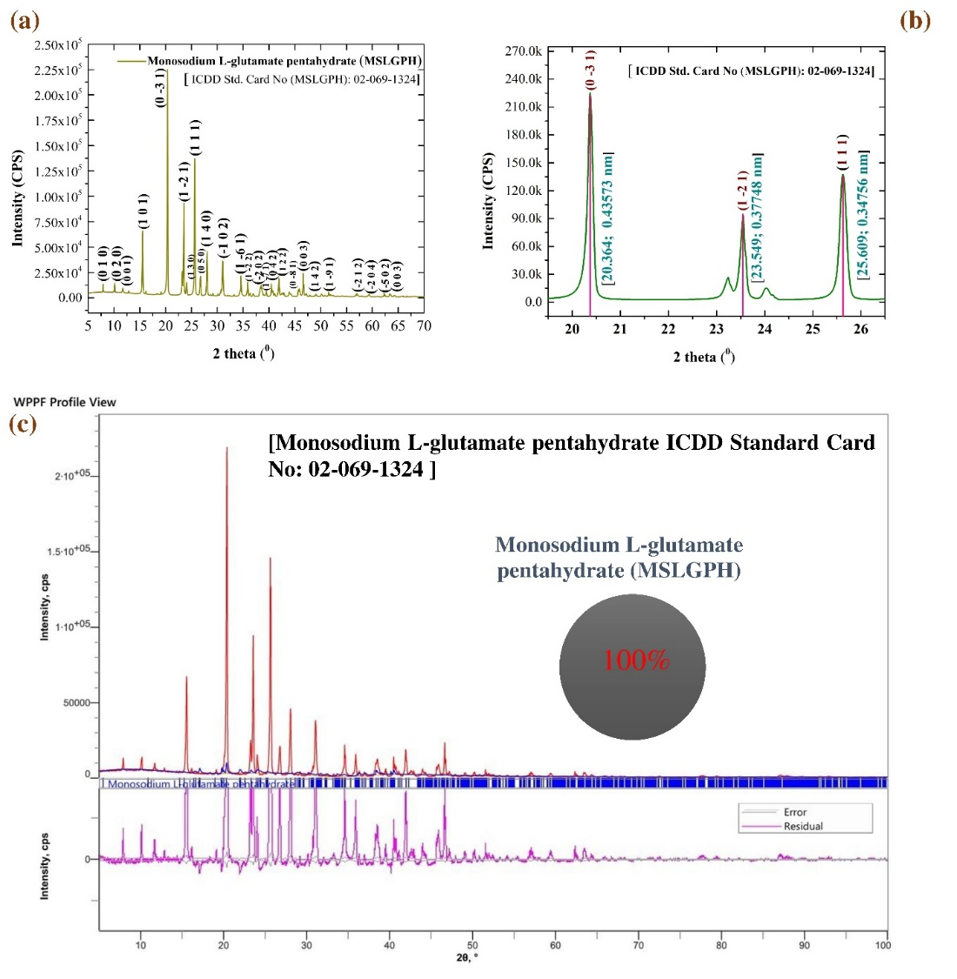

**Fig. 1** (a) X-ray diffraction pattern, (b) peak illustration, and (c) quantitative analysis in the WPPF method of investigated MSLGPH.

Fig. 1(c) depicts 100 % MSLGPH nanocrystals under different fitting conditions [Rwp: 59.51 %, Rp: 47.82 %, S: 8.8316, χ²: 77.9964]. The gof value is high, indicating some deviation of the fit against the standard ICDD. The calculated lattice parameters of the MSLGPH nanocrystals are a= 6.224, b= 16.669, and c= 5.992 Å; α= 98.77, β= 99.83, and γ= 98.54°, with a lattice volume of 595.565 Å³ and a lattice strain of 0.163 %. The lower lattice strain conformation the high mechanical properties. The crystallographic analysis revealed a dislocation density of 2.009 × 10⁻⁴ nm⁻², crystallinity index of 1.98, unit cell density of 1.48 g/cm³, and specific surface area of 57.46 m²/g, which explored and conformation of high crystallographic MSLGPH was observed [30]. The surface area of the crystals was increased, which suggests that the surface area-to-volume ratio is high for the more active side in photocatalytic species [31].

**Table 1.** Grain size calculation and crystallographic bibliography of MSLGPH.

|  |  |  |  |  |  |  |  |
| --- | --- | --- | --- | --- | --- | --- | --- |
| Grain size calculation of MSLGPH | | | | | | | |
| Diffraction angle (2Ɵ) | **Theta(Ɵ)** | **d-spacing d (±0.001) nm** | **Height (cps)** | | **FWHM**  **(radians)** | **Crystallite size D (±0.01) nm** | **Reflection** |
| 15.541 | 7.770 | 0.56973 | 43,092 | | 0.144 | 58.00 | (101) |
| 20.364 | 10.182 | 0.43573 | 1,76,530 | | 0.095 | 88.50 | (0-31) |
| 23.549 | 11.774 | 0.37748 | 68,926 | | 0.100 | 85.00 | (1-21) |
| 25.609 | 12.804 | 0.34756 | 1,05,698 | | 0.133 | 63.90 | (111) |
| 26.759 | 13.379 | 0.33289 | 13,671 | | 0.182 | 46.90 | (050) |
| 28.045 | 14.022 | 0.31790 | 32,237 | | 0.140 | 61.20 | (140) |
| 31.026 | 15.513 | 0.28801 | 28,197 | | 0.156 | 55.10 | (-102) |
| 35.894 | 17.947 | 0.24998 | 11,061 | | 0.132 | 65.90 | (1-61) |
| 46.592 | 23.296 | 0.19477 | 20,888 | | 0.082 | 110.40 | (003) |
| Simple peak indexing of MSLGPH | | | | | | | |
| 2Ɵ | **Ɵ** | **1000× Sin2Ɵ** | | | **Reflection** | **Remarks** | |
| 20.364 | 10.182 | 31.249 | | | (0-31) | 02+(-3)2+12=10 | |
| 23.549 | 11.774 | 41.637 | | | (1-21) | 12+ (-2)2+12=6 | |
| 25.609 | 12.804 | 49.113 | | | (111) | 12+12+12=3 | |
| Peak indexing from the d-spacing of MSLGPH | | | | | | | |
| 2Ɵ | **Ɵ** | **d (Å)** | **1000/d2** | | **Reflection** | **Remarks** | |
| 20.364 | 10.182 | 4.3573 | 52.670 | | (0-31) | 02+(-3)2+12=10 | |
| 23.549 | 11.774 | 3.7748 | 70.179 | | (1-21) | 12+ (-2)2+12=6 | |
| 25.609 | 12.804 | 3.4756 | 82.782 | | (111) | 12+12+12=3 | |
| Comparison of Experimental (Exp.) and Standard (Std.) Diffraction Data | | | | | | | |
| 2Ɵ | | **Interplanar distance (d) (Å)** | | | | **Norm. I. (%)** | |
| (Exp.) | (Std.) | (Exp.) | | (Std.) | | (Exp.) | (Std.) |
| 20.364 | 20.199 | 4.3573 | | 4.3925 | | 100.0 | 100.0 |
| 23.549 | 23.594 | 3.7748 | | 3.7676 | | 38.18 | 42.84 |
| 25.609 | 25.299 | 3.4756 | | 3.5175 | | 72.65 | 25.32 |
| Quantitative analysis of MSLGPH by WPPF | | | | | | | |
| Pattern fitting condition | | **Phase (%)** | **Crystallinity & Strain (%)** | | **Lattice volume, (Å³)** | **Lattice parameters** | |
| Rwp, % 59.51; Rp, % 47.82; S, 8.8316; χ², 77.9964. | | 100.0 | 47.50; 0.163 | | 595.565 | a= 6.224, b= 16.669, c= 5.992 Å; α= 98.77, β= 99.83, γ= 98.54° | |
| ICDD (PDF-5+) [Card No: 02-069-1324] | | | a:6.116Å b:16.511Å c: 6.007Å α:97.51° β:100.94° γ:98.20°; [Xtl Cell Z:1.00 c/a:0.982 a/b:0.370 c/b:0.364]; Space Group: P1(1); MolecularWt:518.38 g/mol. | | | | |

Diffraction peak indexing a lattice plane involves determining its Miller indices, a set of three integers (hkl) that describe the orientation of a plane within a crystal lattice. These indices are found by identifying the intercepts of the plane with the crystal axes, taking the reciprocals of these intercepts, and then reducing them to the smallest set of integers. This process allows for a standardized ICDD way to identify and differentiate between various crystal planes. Determine where the plane intersects the crystallographic axes (a, b, c). These intercepts are expressed as fractions of the lattice parameters [32]. The peak indexing by theta and d-spacing confirmed the interference of the characteristic X-ray in the MSLGPH nanocrystal.

***4.2 Estimation of Crystallite Size Using Models***

The average crystallite size of the MSLGPH crystal was found to be 70.55 nm using the Scherrer equation, while the Williamson-Hall plot gave a value of 89.47 nm. The Monshi-Scherrer method produced 78.32 nm, the Linear straight-line model resulted in 3785.76 nm, the Sahadat-Scherrer model gave 92.46 nm, the Size-strain plot model yielded 85.61 nm, and the Halder-Wagner method calculated 237.52 nm, as shown in Fig. 2. The calculated micro-strain from the Williamson-Hall plot model was 4.86472-4.

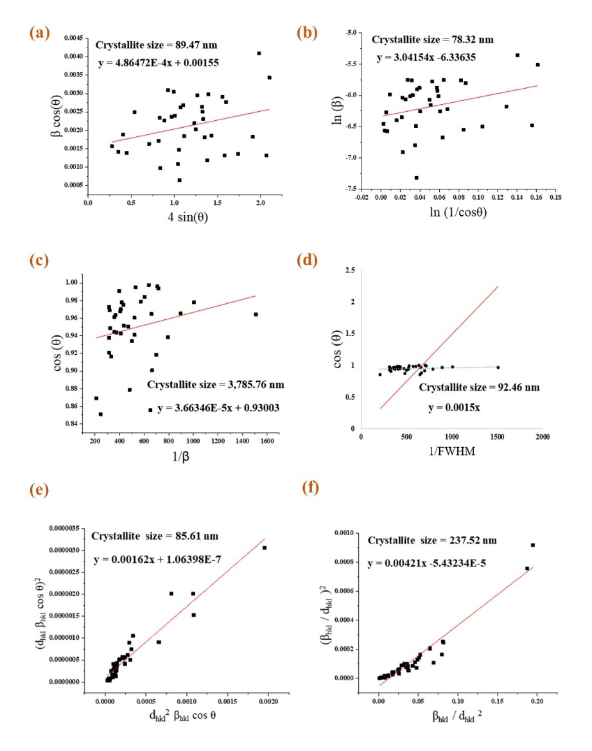

**Fig. 2.** Estimation of crystallite size using (a) Williamson-Hall plot, (b) Monshi-Scherrer method, (c) Linear straight-line model, (d) Sahadat-Scherrer model, (e) Size-strain plot model, (f) Halder-Wagner method for MSLGPH crystal.

The size-strain plot (SSP) method is a technique used to analyze XRD data to determine crystallite size and lattice strain in NPs. It assumes that the broadening of XRD peaks is caused by both the size of crystallites and lattice strain within the NPs [24]. The average size of the individual, coherently diffracting domains within the NPs. The deviation of the crystal lattice from its ideal structure, often due to defects or imperfections. The widening of diffraction peaks in an XRD pattern can be caused by both crystallite size and lattice strain. Mathematical functions are used to model the shape of XRD peaks. The size-strain plot method assumes that crystallite size broadening is best represented by a Lorentzian function, while strain broadening is better represented by a Gaussian function [24]. A graph is created with (d hkl β hkl cos θ)^2 on the y-axis and (d hkl^2 β hkl cos θ) on the x-axis, where: d hkl is the interplanar spacing for a specific crystallographic plane (hkl). β hkl is the full width at half maximum (FWHM) of the diffraction peak for the (hkl) plane. θ is the Bragg angle for the (hkl) peak [24]. A linear straight-line model is used when there's a consistent relationship between two variables, meaning a change in one variable results in a predictable, constant change in the other. This relationship is visually represented as a straight line on a graph, the value is higher and deviated [24].

***4.3 Structural Mechanism Analysis***

Structural symmetry, in a general sense, refers to a balance and uniformity in the arrangement of a structure's components, meaning that if you were to divide the structure along a central axis, the two halves would be mirror images of each other [33]. This concept applies to various fields, including engineering, architecture, and crystallography, where symmetry contributes to stability, simplifies design, and enhances aesthetics [34-35]. The structures shown in Fig. 3 were created using VESTA [visualization for electronic and structural analysis] software. The Triclinic structure was based on space group P1 (1) with unit cell edge lengths of a= 6.224 Å, b= 16.669 Å, and c= 5.992 Å, and angular parameters α= 98.77°, β= 99.83°, and γ= 98.54°. The crystal shape of the Triclinic was identical, and lattice parameters like axial and angular parameters depicted the atom distribution and volume. Symmetry operations (like reflections, rotations, etc.) can be applied to a structure to determine if it remains invariant (unchanged) [36-37].

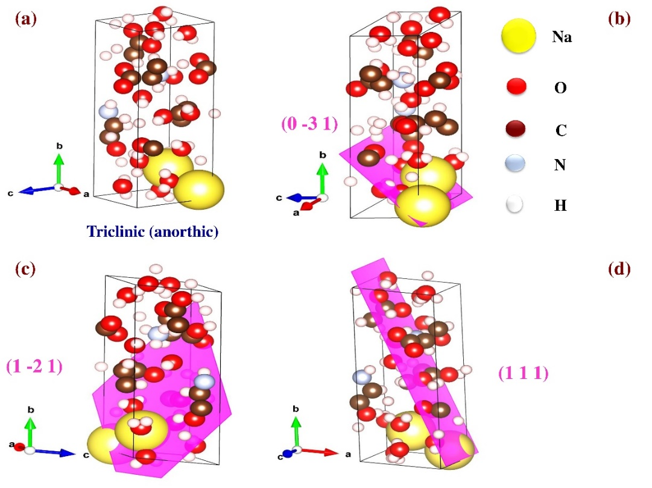

**Fig. 3.** (a) Structural symmetry of triclinic, (b) (0-31), (c) (1-21), and (d) (111) plane of MSLGPH.

The structural analysis of the edge and corner shows that the atoms were uniformly oriented in the uniform direction. Fig. 3 illustrates the crystal structure and predominant planes of the MSLGPH crystal where 3(a) depicts the ball-and-stick model, 3(b) (0-31), 3(c) (1-21) and 3(d) (111) plane in 3D space shows for crystal growth and orientation geometry of uniformly distributed atom onto the crystal plane. The planes (0-31), (1-21), and (111) were oriented in an identical direction, also observed on the predominant zone axis. In crystallography, a zone axis is a specific crystallographic direction within a crystal that is parallel to the intersection of two or more families of lattice planes [38-39]. It essentially represents a common direction shared by these planes. The zone axis is perpendicular to the Miller indices (hkl) of the planes within the zone, and this relationship is described by the Weiss zone law (uh + vk + wl = 0) [40-41]. MSG is primarily used as a flavor enhancer in the food industry. It intensifies the umami taste, which is a savory, meaty flavor, and can also reduce the need for salt while enhancing overall flavor. Beyond its use in various cuisines, MSG also finds applications in tobacco, medicine (for treating hepatic coma), and as a component in some instant ramen products [42].

**Conclusion**

The XRD analysis of MSLGPH revealed its crystallographic properties in detail. The study confirmed a fully crystalline triclinic structure with precise lattice parameters and crystal symmetry. Various crystallite size estimation methods were employed, with the Scherrer equation indicating an average size of 70.55 nm. We also determined other important crystallographic characteristics such as dislocation density, crystallinity index, unit cell density, and specific surface area of the nanocrystals. These findings contribute significantly to understanding the structural properties of MSLGPH and may aid in controlling its crystal growth for functional applications.

**Acknowledgement**

The authors heartily thank Dr. Shirin Akter Jahan, Principal Scientific Officer (PSO), BCSIR, Bangladesh, for using the software, PC, and other appliances.

**Data Availability**

The data is available on request.

**Disclaimer (Artificial intelligence)**

The author hereby declares that NO generative AI technologies such as Large Language Models (ChatGPT, COPILOT, etc.) and text-to-image generators have been used during the writing or editing of this manuscript.

**Reference**

[1]. Longden, Jonathan Paul. "A Method for the Quantitative Recovery of Mononucleotides from Fermentation Waste by Precipitation." Master's thesis, Lancaster University (United Kingdom), 2015.https://www.proquest.com/openview/35695461088e8f55a04e48395bae67a8/1?pqorigsite=gscholar&cbl=2026366&diss=y

[2]. Kashiwagi, Tatsuki, Chiaki Sano, Tetsuya Kawakita, and Nobuya Nagashima. "Monosodium L-glutamate pentahydrate." Crystal Structure Communications 51, no. 6 (1995): 1053-1056. <https://doi.org/10.1107/S0108270194014472>

[3]. Perea, C. G., C. F. Ihle, L. Dyer, and H. Estay. "Copper sulfide precipitation from alkaline monosodium glutamate solutions." Minerals Engineering 215 (2024): 108816. <https://doi.org/10.1016/j.mineng.2024.108816>

[4]. Alam, M. A., Shishir, M. K. H., Sarkar, D., Bishwas, R. K., & Jahan, S. A. (2025). X-ray line diffraction study of preferred oriented hexagonal zincite nanocrystals: A crystallographic investigation. Journal of Crystal Growth, 128230.

[5]. Ahashan, S. M., Sayeem, N. R., Meada, M. A. R., Naim, Z., Nahar, K., Mustak, M. H., ... & Alam, M. A. (2025). Understanding X-ray Crystallographic Diffraction of L-menthol by Rietveld Refinement: Insight into Structural Symmetry and Lattice Volume. Asian Journal of Applied Chemistry Research, 16(3), 69-82.

[6]. Devi, R., Gogoi, S., Barua, S., Dutta, H. S., Bordoloi, M., & Khan, R. (2019). Electrochemical detection of monosodium glutamate in foodstuffs based on Au@ MoS2/chitosan modified glassy carbon electrode. *Food chemistry*, *276*, 350-357.

[7]. Pandey, Akhilesh, Sandeep Dalal, Shankar Dutta, and Ambesh Dixit. "Structural characterization of polycrystalline thin films by X-ray diffraction techniques." Journal of Materials Science: Materials in Electronics 32 (2021): 1341-1368.

[8]. Bishwas, R. K., Alam, M. A., & Jahan, S. A. (2025). Crystallographic and morphological characterization of high-crystalline α-alumina nanoparticles: A comprehensive X-ray diffraction and transmission electron microscopy study. Chemical Physics Letters, 142245.

[9]. Rahaman, M. A., Islam, M. T., Aman, S., Rahman, M. M., Ahmad, A., Tama, R. T., ... & Alam, M. A. (2025). Crystallographic Phase Bibliography and Quantitative Phase Analysis of TiO2 Nanocrystals: A Rietveld Refinement Insight. Next Research, 100469.

[10]. Shishir, M. K. H., Islam, M. M., Islam, M. T., Rahaman, M. A., Mustak, M. H., Mostafa, M. G., & Alam, M. A. (2025). Crystallographic Benchmarking of Powder X-ray Line Diffraction Pattern Profiling of Monoclinic Sucrose Nanocrystal. Results in Surfaces and Interfaces, 100595.

[11]. Islam, M. T., Aman, S., Bayzid, T., Rahaman, M. A., Podder, U., Khan, G. M. A., & Alam, M. A. (2025). Crystal growth behavior of nanocrystal anatase TiO2: A Rietveld refinement in WPPF analysis. Chemistry of Inorganic Materials, 6, 100108.

[12]. Bayzid, T., Shishir, M. K. H., Akand, M. S., Sohage, M. S. P., Alam, M. A., Karim, M. M., ... & Khan, G. M. A. (2025). Crystallographic analysis of silk sericin-stabilized zinc oxide nanoparticles with enhanced antimicrobial and photocatalytic properties. Inorganic Chemistry Communications, 178, 114481.

[13]. Bishwas, R. K., Alam, M. A., & Jahan, S. A. (2025). Sustainable synthesis of nano-crystalline α-alumina from waste food packaging for efficient azithromycin removal. Journal of Industrial and Engineering Chemistry.

[14]. Rahaman, M. H., Rayhan, A., Khan, G. A., Alam, M. A., Alam, S. N., Islam, M. T., & Rahman, M. A. (2025). Hydrolytic degradation studies of bio-composites of poly (L-lactic acid)/Oligo (L-lactic acid) grafted and non-grafted microcrystalline cellulose. Next Materials, 8, 100615.

[15]. Aidid, A. R., Shishir, M. K. H., Rahaman, M. A., Islam, M. T., Mukta, M., & Alam, M. A. (2025). Powder X-ray line diffraction pattern profiling of anatase-quartz binary oxide: A crystallographic investigation. Next Materials, 8, 100571.

[16]. Islam, M. T., Rahaman, M. A., Ahmed, S., Khatun, M. T., Aman, S., Bayzid, T., ... & Alam, M. A. (2025). Effect of Isopropyl Peptization on Surface Particle Growth of Sol-Gel Derived Anatase: X-ray Crystallographic Analysis and Revealed on Transmission Electron Microscopy. South African Journal of Chemical Engineering.

[17]. Islam, M., Islam, M. T., Shishir, M. K. H., Rahaman, M. A., Ahmed, S., Sadia, S. I., & Alam, M. A. (2025). X-ray crystallographic structural Profiling of Polyvinyl Alcohol (PVA) caped Nickel Oxide Nanoparticle. Nano Trends, 10, 100106.

[18]. Ahmed, S., Shishir, M. K. H., Islam, M. T., Rahaman, M. A., Aman, S., Aidid, A. R., ... & Alam, M. A. (2025). Crystallinity integration of anatase (TiO2) nanocrystal by whole powder pattern fitting (WPPF) method: A Rietveld refinement study. Results in Materials, 26, 100673.

[19]. Alam, M. A., Ahmed, S., Bishwas, R. K., Sarkar, D., & Jahan, S. A. (2025). Crystal growth behavior interpret of co-precipitated derived nickel oxide (NiO) nanocrystals. Nano-Structures & Nano-Objects, 42, 101494.

[20]. Ahmed, S., Alam, M. A., Sadia, S. I., Bishwas, R. K., Hasanuzzaman, M., & Jahan, S. A. (2025). Stoichiometry low-temperature dynamics crystal growth interpret of zinc oxide hexagonal nanocrystals. Next Materials, 7, 100636.

[21]. Ray, G., Haque, I., Ahmed, T., Hasan, M. M., Salma, M. M., Hossain, M. K., ... & Akhtar, U. S. (2025). Synthesis of Carbon Capturing NaX Zeolite from Rice Husk Ash: Evaluation of Its Adsorption Properties. ACS Sustainable Resource Management, 2(4), 662-672.

[22]. Sachchu, M. M. H., Anik, F. K., Ahmed, S., Aman, S., Podder, U., Sayeem, N. R., ... & Alam, M. A. (2025). Crystallographic Investigation of PVA@ PLA Nanocomposite Film by X-ray Diffraction: Insight from High Resolution TEM. Journal of Engineering Research and Reports, 27(3), 310-327.

[23]. Alam, M. A., Sadia, S. I., Shishir, M. K. H., Bishwas, R. K., Ahmed, S., Al-Reza, S. M., & Jahan, S. A. (2025). Crystallinity integration and crystal growth behavior study of preferred oriented (111) cubic silver nanocrystal. Inorganic Chemistry Communications, 173, 113834.

[24]. Alam, M. A., Ahmed, S., Bishwas, R. K., Mostofa, S., & Jahan, S. A. (2025). X-ray crystallographic diffraction study by whole powder pattern fitting (WPPF) method: Refinement of crystalline nanostructure polymorphs TiO2. South African Journal of Chemical Engineering, 51, 68-77.

[25]. Sadia, S. I., Shishir, M. K. H., Ahmed, S., Aidid, A. R., Islam, M. M., Rana, M. M., ... & Alam, M. A. (2024). Crystallographic biography on nanocrystalline phase of polymorphs titanium dioxide (TiO2): A perspective static review. South African Journal of Chemical Engineering, 50(1), 51-64.

[26]. Al-Mahmud, M. R., Shishir, M. K. H., Ahmed, S., Tabassum, S., Sadia, S. I., Sachchu, M. M. H., ... & Alam, M. A. (2024). Stoichiometry crystallographic phase analysis and crystallinity integration of silver nanoparticles: A Rietveld refinement study. Journal of Crystal Growth, 643, 127815.

[27]. Sadia, S. I., Shishir, M. K. H., Ahmed, S., Alam, M. A., Al-Reza, S. M., Afrin, S., ... & Jahan, S. A. (2024). Green synthesis of crystalline silver nanoparticle by bio-mediated plant extract: A critical perspective analysis. Nano-Structures & Nano-Objects, 39, 101272.

[28]. Ahmed, S., Shishir, M. K. H., Sadia, S. I., Al-Reza, S. M., Sachchu, M. M. H., Aidid, A. R., ... & Alam, M. A. (2024). Crystallographic phase biographs of copper nanocrystalline material: A statistical perspective review. Nano-Structures & Nano-Objects, 39, 101275.[29].

[30]. Shishir, M. K. H., Afrin, S., Sachchu, M. M. H., Eva, T. N., Tabassum, S., Ahmed, S., ... & Alam, M. A. (2024). Crystalline Copper Nanomaterials for Advanced Ceramic: A Comprehensive Review for Functional Ceramic Coating Approaches. Asian Journal of Advanced Research and Reports, 18(8), 13-34.

[31]. Alam, M. A., Bishwas, R. K., Mostofa, S., & Jahan, S. A. (2024). Impact on preferred orientation and crystal strain behavior of nanocrystal anatase-TiO2 by X-ray diffraction technique. South African Journal of Chemical Engineering, 49, 348-352.

[32]. Alam, M. A., Bishwas, R. K., Mostofa, S., & Jahan, S. A. (2024). Crystallographic phase stability of nanocrystalline polymorphs TiO2 by tailoring hydrolysis pH. South African Journal of Chemical Engineering, 49(1), 73-85.

[33]. Alam, M. A., Bishwas, R. K., Mostofa, S., Sarkar, D., & Jahan, S. A. (2024). X-ray crystallography derived diffraction properties of cuprite crystal as revealed by transmission electron microscopy. Physics Open, 20, 100228.

[34]. Shishir, M. K. H., Sadia, S. I., Ahmed, S., Aidid, A. R., Rana, M. M., Hasan, M. M., ... & Alam, M. A. (2024). Transmission electron microscopic and X-ray diffraction based study of crystallographic bibliography demonstrated on silver, copper and titanium nanocrystals: state of the art statical review. Asian Journal of Applied Chemistry Research, 15(3), 1-19.

[35]. Ahamed, M. S., Ali, M. S., Ahmed, S., Sadia, S. I., Islam, M. R., Rahaman, M. A., & Alam, M. A. (2024). Synthesis of silver nanomaterials capping by fruit-mediated extracts and antimicrobial activity: A critical review. International Research Journal of Pure and Applied Chemistry, 25(1), 45-60.

[36]. Kobir, M. M., Tabassum, S., Ahmed, S., Sadia, S. I., & Alam, M. A. Crystallographic benchmarking on diffraction pattern profiling of polymorphs-TiO2 by WPPF for Pigment and Acrylic paint, Archives Curr. Res. Int. 24 (1)(2024) 62–70.

[37]. Tabassum, M., Alam, M. A., Mostofa, S., Bishwas, R. K., Sarkar, D., & Jahan, S. A. (2024). Synthesis and crystallinity integration of copper nanoparticles by reaction medium. Journal of Crystal Growth, 626, 127486.

[38]. Alam, M. A., Bishwas, R. K., Mostofa, S., & Jahan, S. A. (2024). Low-temperature synthesis and crystal growth behavior of nanocrystal anatase-TiO2. Materials Letters, 354, 135396.

[39]. Alam, M. A., Tabassum, M., Mostofa, S., Bishwas, R. K., Sarkar, D., & Jahan, S. A. (2023). The effect of precursor concentration on the crystallinity synchronization of synthesized copper nanoparticles. Journal of Crystal Growth, 621, 127386.

[40]. Alam, M. A., Mobashsara, M. T., Sabrina, S. M., Bishwas, R. K. B., Debasish, D. S., & Shirin, S. A. J. (2023). One-pot low-temperature synthesis of high crystalline cu nanoparticles. Malaysian Journal of Science and Advanced Technology, 122-127.

[41]. Emelyanov, A. Y., Pertsev, N. A., Hoffmann-Eifert, S., Böttger, U., & Waser, R. (2002). Grain-boundary effect on the Curie-Weiss law of ferroelectric ceramics and polycrystalline thin films: Calculation by the method of effective medium. Journal of electroceramics, 9(1), 5-16.

[42]. Okazaki, T., Hara, M., Muravyev, N. V., & Koga, N. (2022). Thermally induced dehydration reactions of monosodium L-glutamate monohydrate: dehydration of solids accompanied by liquefaction. *Physical Chemistry Chemical Physics*, *24*(1), 129-141.