Original Research Article
PHYSICO AND CHEMICAL CHARACTERIZATION OF NFC AND CNC STRUCTURE

ABSTRACT

Aims: Investigate fully physical, chemical and morphological structure of the NFC and CNC produced in an industrial pilot plant to develop better applications for nanocelluloses.
Methodology: Chemical, physical and morphological structure characterization was performed through high-tech devices such as elemental analysis, carbohydrate content, metal content, electronic and atomic force microscopy, X-ray, FTIR, thermogravimetric analysis, zeta potential and fungal biodegradation.
Results: CNC presented a higher sulfation (0.9 %) than the NFC, what has promoted the higher zeta potential (-56.96 mV) for nanocrystals than for NFC (-26.86 mV). CNC showed cylindrical shape (85.48 nm length and 10.32 nm wide) while the NFC presented a more elongated shape (4.7 nm wide and length greater than 1μm). 3D profile of nanocelluloses shows the greatest morphological difference at the end of each production process, in which CNC are small rods with crystallinity (96.17 %) and NFC are elongated tubes with one of its dimensions at the nanoscale with higher content of amorphous areas and less crystallinity (79.30 %). The CNC presented a higher temperature of thermal degradation (375 °C) than the NFC (353 °C), and weight loss in the range of 300-400 °C for CNC than for NFC (200 -300 °C). FTIR spectra confirm the surface cellulosic polymers derivatives groups with emphasis on the peaks of 1205 cm⁻¹ which shows the vibration for the linked sulfated groups (S=O) present in CNC due to acid hydrolysis, and the band of NFC in 1608 cm⁻¹ indicating vibrations of carboxylic acids bonds, due to the presence of hemicellulose or oxidative treatments performed for the nanofibrils isolation. For both nanocelluloses types it occurred the degradation by a fungus of the genus Pleurotus sp., indicating no toxic potential.
Conclusion: The nanocelluloses can be applied in many areas considering their properties and safety features classified as biodegradable biopolymers.

Keywords: cellulose, nanofibers, nanocrystals, CNC, NFC.

1. INTRODUCTION

The discovery of a transparent lightweight material more rigid than some commercial materials such as steel has aroused the academic and business interest to studies and applications of the nanocellulose production. It is an abundant material originated from natural plant fibers that are renewable and biodegradable, it has a competitive advantage to fossil and industrial materials.
The increasing development of new technologies and the search for new sources of raw materials for industrial use have provided advances never expected before. Brazil currently occupies the position of the largest world's pulp producer. Cellulose stands out worldwide as a great polymer in numerous industrial sectors. The nanotechnology and the study of nanomaterials provide valuable findings, not only for the development of new products, but also to provide a more intelligent use of resources. Today there are countless sectors that employ products and by-products in the nanometer size range. Nanomaterials are particles whose at least one dimension range from 1 to 100 nm.
In this scenario, the biopolymers such as cellulose are highlighted for the replacement of materials derived from non-renewable sources. The nanocelluloses have a great use potential in innumerous materials, for this reason they deserve attention among the known nanomaterials. Nanocelluloses can be obtained by different methods and in different structures. Nanofibrillated cellulose (NFC) and nanocrystalline cellulose (CNC) are nanocelluloses derived from cellulosic nanofibers that run through mechanical defibrillation processes and action of different chemical agents, respectively. To obtain these cellulosic nanofibers there are many important factors as the individualization process of the cellulose microfibrils which are embedded in a matrix linked to hemicellulose and lignin complexes.
The applications of these nanostructures have attracted the attention of researchers and base industries. The great interest is mainly due to their intrinsic characteristics of high strength and rigidity combined to low weight and availability in the environment [45]. The use of CNC and NFC has a great potential in the manufacturing process of various products that require strength characteristics. Therefore, we aim, by conducting this study, to achieve a level of knowledge that allows the use this new biorefinery. By this way the main objective of this study is the morphological, physical and chemistry characterization of nanocelluloses CNC and NFC produced from industrial process.

2. material and methods

2.1 Material

NFC and CNC, both produced from a mix of woods, were used in this study. The nanocelluloses were supplied by the United States Department of Agriculture (USDA) - Forest Products Laboratory in solid state.

2.2 Methods

2.2.1 Chemical analysis

The chemical characterization was performed in the Pulp and Paper Laboratory of the Federal University of Viçosa. The following chemical analyzes were performed in triplicate: carbohydrate content (glucans, xylans, galactans, mannans, arabinans), gray, insoluble in HNO₃ (nitric acid) - (silica) and metals (Mg, K, Ca, Mn, Fe and Cu). The elemental composition of cellulosic materials is well known because of its high carbon content, carbon is the main component of these structures.
CNC and NFC elemental analysis was carried out in a CHNS equipment LECO. The percentage of carbon, hydrogen, nitrogen and sulfur were determined in the TruSpec CHNS Micro module and the oxygen percentage in the TruSpec Oxygen Add-On Module. Table 1 shows analytical procedures utilized.
Table 1. Performed analytical procedures

Parameters | Procedures
Carbohydrate content* | [42]
Ash content | [39]
Metals** | [39]
Elemental analysis***
* Glucans, xylans, galactans, mannans and arabinans.
** Magnesium, potassium, calcium, manganese, iron and copper.
*** Carbon, hydrogen, nitrogen and sulfur.

2.2.2 Transmission Electron Microscopy (TEM)

Transmission Electron Microscope Zeiss EM model 109-80 kV was used, in the Center for Microscopy and Microanalysis (NMM), in the Federal University of Viçosa (UFV). A suspension droplet was deposited on 300 mesh copper grids coated with Formvar (0.5% in chloroform). Acetate solution 2% uranyl was dripped onto the material to promote staining and allow the structures observation.

2.2.3 Scanning Electron Microscopy (SEM)

Nanocelluloses samples were directly mounted on "stubs" and metallized using the equipment Model FDU-010 (Balzers, Germany) coupled to a sputtering cathodic assembly. The material was observed in an electron microscope LEO 1430 VP model (Zeiss, Germany), in the NMM-UFV.

2.2.4 Atomic Force Microscopy (AFM)

AFM nanocelluloses in the studied samples were performed in the Department of Physics of the Federal University of Viçosa, Minas Gerais, Brazil. The topography of the NFC and CNC were studied using atomic force microscopy (AFM NT-MDT, Russia). AFM images were acquired on an intermittent contact mode in random areas of 5 × 5 µm ². Samples were analyzed at room temperature (25 ◦C).
2.2.5 X-Ray diffraction

X-ray diffraction in order to assess the cellulose crystallinity index (CI) given in percent, following procedures described in by previous authors [8,14]. We used the CNC and NFC samples that passed by grinding in a mill with a no cutting blade.
The X-ray diffraction was utilized to calculate the crystallinity index for the nanocelluloses samples; by using the X-radiation spreading through organized structures (crystals) it allows the morphological studies of materials by determining their structure and crystalline fraction [4]. The X-ray diffraction analyses were performed at room temperature in a diffractometer X-ray Diffraction System Model X 'Pert PRO (PANalytical) using Ni filter and Co-Ka radiation (λ = 1.78890 Å), angular variation of 5 -50 ° (2θ), speed of 3 ° / min, 40 kV voltage and 30 mA current.
The CI was calculated through the Origin 8.0 software [28] according to the method described by Segal et al. (1959), which utilizes the ratio between the maximum (2θ = 26.15 °) and the minimum (2θ = 20.91 °) intensity diffraction peak after a baseline correction

2.2.6 Thermogravimetric analysis (TG / DTG)

We used the apparatus DTG-60H, Shimadzu for the nanocelluloses thermogravimetric analysis. The analyzes were performed under an atmosphere of nitrogen gas at a constant flow rate of 50 ml.min-1, using about 1 mg of nanocrystals and cellulose nanofibrils milled in a grinder without cutting blades.
The thermogravimetric curves were obtained from 50 °C to the maximum temperature of 700 °C at a heating rate of 10 °C min⁻¹. The thermogravimetric curve (TG) was obtained for the evaluation of the weight loss versus the temperature curve and the first derivative of the weight loss (DTG).
The mass loss was calculated based on the TG curve in the following temperature ranges: temperature 100-200 °C, 200-300 °C, 300-400 °C, 400-500 °C and 500-600 °C. The initial maximum and final thermal degradation temperatures were measured considering the sample wet weight at room temperature and the absolutely dry mass in the temperature of 100 °C.

2.2.7 Zeta potential

Zeta potential of the studied nanocelluloses was determined by Dynamic Light Scattering technique (Dynamic Light Scattering - DSL) and measurement of the electrophoretic mobility, using the Zetasizer equipment, Nano Series from Malvern Instruments. 3 ml aliquots of each suspension sample of the NFC and CNC were taken and placed in a glass cuvette at 20 °C for measuring the zeta potential.

2.2.8 Fourier transform infrared (FT-IR)

A spectrophotometer with Fourier transforms infrared (FT-IR) to obtain the FTIR spectra. The obtained spectra can be classified in a mid-infrared range between 400 cm⁻¹ and 4000 cm⁻¹.
Solid samples were used in order to obtain the spectrum, obtaining from pressed KBr pellets (potassium bromide). According to Barbosa (2007), this technique consists in mixing the finely pulverized sample (1 to 2 mg) with KBr (200 mg) in an agate mortar. The mixture is placed in a proper accessory and compressed at approximately 1,575 x 105 kg.cm² under vacuum. By this way we obtain a translucent pellet with about 13 mm diameter and 2 mm thickness. After this preparation the pellet is placed under a holder for reading the FTIR spectrum.
2.2.9 Potential of biodegradability and mycelial growth rate in CNC and NFC
In order to evaluate the potential of biodegradability and in vitro growth, the mycelium of the Pleurotus fungus was used in culture media containing nanocelluloses. The fungal isolate is kept stored in tubes containing potato dextrose agar (PDA, Merck®) culture medium at 4 °C and is reactivated every six months. A 1 cm disc from the reactivated mycelia was transferred to the center of a Petri dish containing PDA, PDA +CNC and PDA+ NFC and incubated at 25 ° C.
The culture media containing only PDA is the control treatment, composed exclusively of PDA and characterized as the reference for assessing the growth parameter. The PDA+CNC culture media was composed of CNC nanocellulose+PDA and the PDA+NFC culture media was composed of NFC nanocellulose+PDA, maintaining the proportion of 1 g of nanocellulose in 60 ml PDA medium. The culture media were autoclaved at 121 °C for 15 minutes and after that an amount was poured in the Petri dishes. It was reserved for solidification during a period of 20 minutes and the above described inoculation process was performed three times for each culture medium.
Measurements in duplicate of the fungal colony diameter was taken every day for a period of 9 days in order to determine the mycelium growth rate, this period of time was enough for the total mycelial colonization of the plates containing different culture media
3. results and discussion

3.1 Chemical composition

3.1.1 Inorganic content

The timber inorganic components present are entirely present in the ash residue after burning the organic material [36]. Likewise, the inorganic components are present after completely burning the pulp or other materials, such as the here studied NFC and CNC. According [6,15] in the wood elements such as calcium, silicon, potassium, and chloride are mentioned as main metals and their occurrence is preferably in the form of salts. It should be noted that what is going to influence their concentration in the nanocelluloses inorganic composition are the extraction and purification processes to which the raw material to obtain the desired product.
Ash content in the cellulose nanocrystals was lower than in the nanofibrillated cellulose. The silica content and almost all the elements hereby studied that compose the nanocelluloses presented a similar composition. Noteworthy higher sodium content (Na) is present in the NFC than in the CNC. This high content probably reflects an oxidative treatment used for the cellulose nanofibrils separation and to facilitate the isolation as proposed [34].
Table 2. Results of the analysis of ash content, insoluble in HNO₃ (silica) and metals (Mg, K, Ca, Mn, Fe and Cu) for CNC and NFC

Content | Samples
Content | CNC | NFC
Ash (%) | 2.28 | 5.31
Insoluble in HNO₃ (Silica) (%) | 0.28 | 0.37
Na (ppm) | 7188 | 26350
K (ppm) | 212 | 714
Ca (ppm) | 107.2 | 1798
Fe (ppm) | 23.1 | 24.5
Mn (ppm) | 0.6 | 1.3
Mg (ppm) | 132 | 275
Cu (ppm) | 4.2 | 6.2

3.1.2 Carbohydrates content
Both nanocelluloses do not have lignin in their composition since their production is initiated using bleached pulp.
Bleached hardwood pulps [38] exhibited 74.7; 25; 0.1; 0.5 and 0.2 % content of glucose, xylose, arabinose, mannose and galactose, respectively. In the same study bleached softwood pulps showed 84.9; 7.4; 0.8; 6.6 and 0.4% of glucose, xylose, arabinose, mannose and galactose, respectively.
The chemical treatments such as acid hydrolysis and mercerization, which are usually performed for the CNC production, drastically changed the content of sugars such as xylose and mannose that are present in the hemicelluloses structure. Thus, high levels of sugars such as glucans (83.52%) and lower levels of galactans, xylans, mannans and arabinans were expected to CNC, since they are composed almost solely of crystalline cellulosic regions [29].
There is a clear reduction in the content of xylose type sugars for the softwoods while sugars such as mannose show an increase. This is due to the greater quantities of hemicellulose xylan type in hardwood whereas the mannan type are more significant in softwood [37]. This study found a high content of xylan type sugars (13.46%) components of the CNF hemicellulose chain. The presence of hemicellulose in the original pulp composition facilitates the mechanical disintegration process during the nanofibrillated pulp production since cellulose nanofibrils are originated due to the disintegration of the cellulosic fibers, especially those from their surfaces [19].
Xylan content did not significantly change [34] after the fiber’s oxidation using TEMPO reagent, also used in the nanocelluloses production. In the other hand the mannan content after oxidation showed difference by using the TEMPO reagent, probably due to these sugars dissolution after the C6 hydroxyl terminals oxidation. Thus, the carbohydrate content showed by this study is consistent since cellulose, the target polymer, must be preserved for the nanocelluloses extraction during the extraction and purification processes.
Table 3. Carbohydrate content in the CNC and NFC samples

Content | Samples
Content | CNC | NFC
Arabinans (%) | 0.02 | 0.02
Galactans (%) | - | 0.02
Glycans (%) | 83.52 | 58.74
Xylans (%) | 0.05 | 13.46
Mannan (%) | 0.17 | 0.16

3.1.3 Elemental analysis

Table 4 shows the elemental composition of the nanocelluloses characterized in this study.

Table 4. Analysis of samples of CNF and CNC

Samples | C (%) | H (%) | N (%) | S (%)
CNC | 43.9 | 6 | 0.2 | 0.9
NFC | 42.6 | 5.9 | 0.0 | 0.2

The content of elements such as carbon and hydrogen in the NFC and CNC composition are very similar and are in accordance to the values ​​found [40], evaluated by various reactants and acid hydrolysis time for the cellulose nanocrystals production. However, sulfur content in the NFC and CNC are more critical, since the nanocelluloses sulfation is a factor that directly influences the stability of the dispersions in aqueous solution. Furthermore, the nanocelluloses surface sulfation will also influence on the zeta potential, that measures the superficial charge of these nanomaterials.

Same sulfur content (0.9%) for CNC after 60 minutes reaction time during acid hydrolysis of cellulose polymer at 45 °C [41] was reported. Only traces of nitrogen were found in the elemental composition.

3.2 Nanostructure: TEM, SEM and AFM

In recent years the nanocelluloses have acquired a great prominence as biopolymers with differentiated characteristics. This is due mainly to the increasing demand of new sustainable material sources, since the requirements to produce durable and nondurable consumption goods becomes differentiated while using natural biopolymers instead of artificial polymers. Although some artificial polymers cannot be fully replaced nanocelluloses have intrinsic characteristics that enable their application in a wide range of products. The knowledge of their nanostructure is essential to their application.
Cellulose nanofibrils originate from the cellulosic fiber’s disintegration, especially the superficial disintegration, promoting the cell wall disruption and the subsequent exposure of the fibrils and microfibrils previously situated inside the fibers [34]. The elementary fibrils originate the nanofibrillated cellulose and both them generate the microfibrils [10] (Figure 1C).

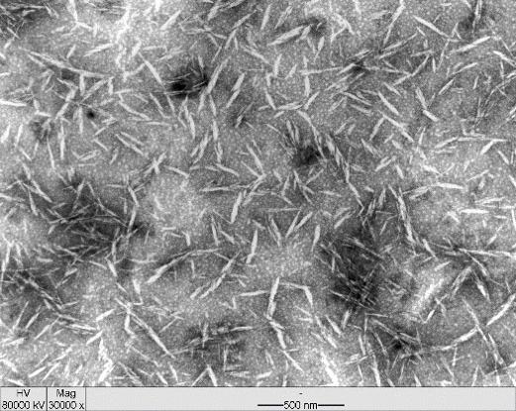  A | B
C | D
Figure 1. TEM Images: A) CNC, 30000x magnification - 500 nm and C) NFC, 50000x magnification - 200 nm. SEM images: B) CNC, 5000x magnification - 10 µm and D) NFC, 500x magnification - 100 µm.
TEM images shows that NFC presents a tubular nanostructure (Figure 1C). Its diameter fits in the nanometric scale and its length in the micrometer scale. The SEM images allow us to observe that the NFC has the capacity of forming rougher films (Figure 1D).
CNC are like small cylinders or rods (Figure 1A) which are crystalline in nature and isolated through the fiber’s via generally acid hydrolysis as in this study. The mechanism for obtaining nanocrystals by acid hydrolysis demonstrates that the action of the hydrolysis agents promotes extraction of the amorphous regions from the elementary cellulose fibrils, remaining only the crystalline regions [29]. The CNCs have both dimensions in the nanometric scale. The SEM images allow observing the formation of hard films (1B) due to their high crystallinity.

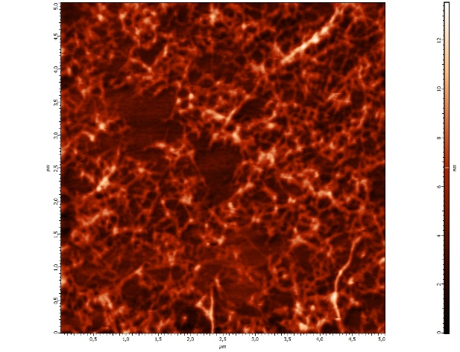  A | 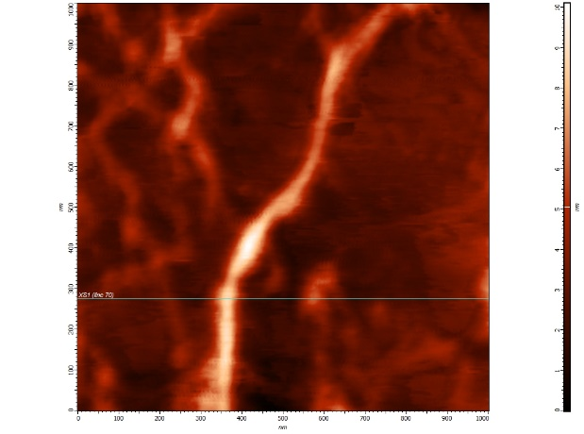  B
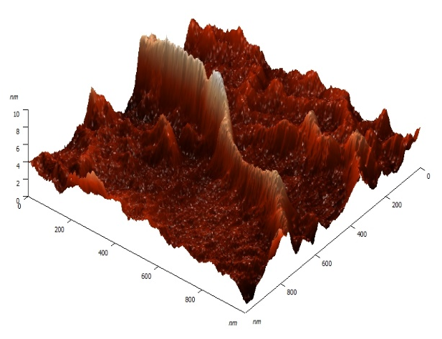  C | 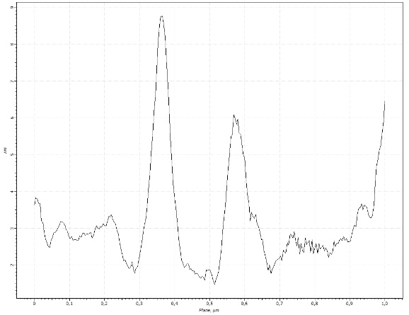  D
Figure 2. AFM Images of NFC, atomic force micrograph of scanning in the intermittent contact mode. A) General scanning of the area 5x5 μm², B) Scanning in 1x1 μm² (Detail of a cellulose nanofibril), C) 3D image of the nanofibrillated cellulose surface and D) Profile of the cellulose nanofibrils in the cut showed in B.
The atomic force microscopy enables the physical observation of the exact topography of these nanostructures. As the scanning is done the frequency of oscillation from valleys to peaks tips is designed according to the morphology of the studied nanocelluloses.
The nanofibrillated cellulose (Figure 2A) shows itself as a nano-network. This NFC network is formed due to the nanofibrils intertwining as their liaison active sites is exposed. A cellulose nanofibril, as mentioned above, has an elongated length and the diameter in the nanometer scale (Figure 2B and 2C). The use of AFM images allowed the 3D topographic mapping of the studied material (Figure 2C and 2D).
The nanofibrillated cellulose and the cellulose nanocrystal are cellulose polymers composed of glucose units that contain three free hydroxylic groups attached to carbons 2, 3 and 6, which are responsible for the intermolecular interactions. Successive structures can be formed by these interactions [17].

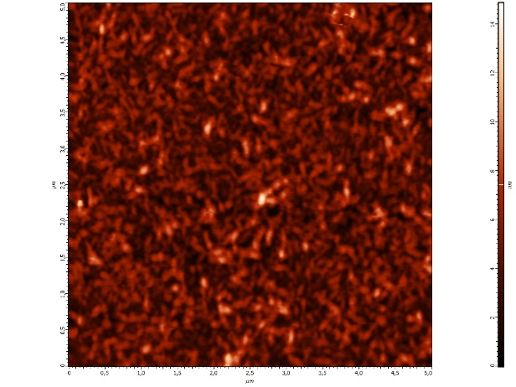  A | 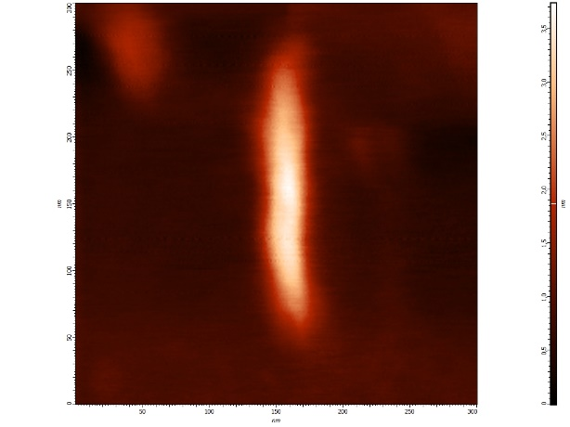  B
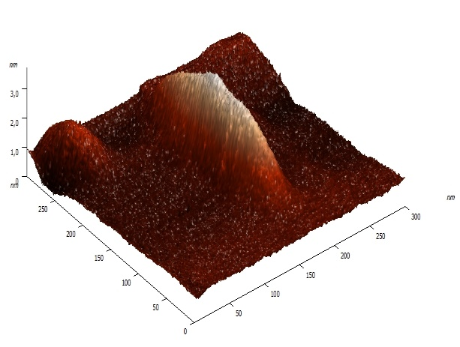  C | 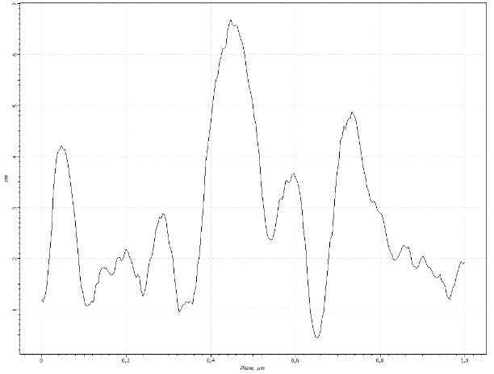  D
Figure 3. AFM images of CNC micrograph of Atomic Force Scan in intermittent contact mode. A) Scanning area 5x5 μm², B) Scanning area 1x1 μm² (isolated nanocrystal detailed), C) 3D surface image of the nanocrystal, D) Profile of cellulose nanocrystals in the study area.
The cellulose nanocrystals physical structure (Figure 3A) observed through AFM refers to a small cylinder whose dimensions (length and diameter) are in the nanometric scale. By tracing the CNC 3D profile (Figure 3C and 3D) we observe its format like small rods. When compared to the NFC the cellulose nanocrystals do not have a long length and their crystallinity index is high because it is the only crystalline region of the original polymer.

A | B
C
Figure 4. Histogram distribution of the nanoceluloses width and length according to the TEM images.
Using strong acid hydrolysis, it was obtained nanocrystals typically with 100-200 nm in length and 20-40 nm width [9]. The characterized nanocrystals have an average length of 85.48 nm (Figure 4A) and an average width of 10.32 nm (Figure 4B) as shown by the distributions. The NFC has an average width of 4.7 nm with their chains (Figure 4C), and length of several micrometers. The length of the nanofibrillated cellulose chains is several micrometers larger than their diameter [12].
Natural nanofibers have a very high elastic modulus compared to steel and this is particularly important for various industries [12]. Therefore, the knowledge of their physical and morphological structure is important to define their applications and their use.
3.3 X-ray diffraction

The Figure 5 shows the X-ray diffraction patterns concerning the nanocelluloses characterized in this study. Their crystallinity indices were calculated from the XRD patterns. As expected, the CNC crystallinity index is higher than the NFC crystallinity index, confirming the presence of amorphous regions in the structure of the elementary fibrils for NFC. The crystallinity index values ​​ for NFC (79.30%) and CNC (96.17%) in percentage according to the used methodology for its calculation after deconvolution of curves, shows CNC has much more rigid regions in your structure.
These results demonstrate that the crystallinity index is different for NFC and CNC mainly because their obtaining processes are also differentiated. The hydrolysis mechanisms using strong acids remove the amorphous regions, thereby increasing the crystalline regions frequency unlike nanofibrillated cellulose [29]. Thanks to this process the CNC crystallinity index will always higher than the NFC.
It is assumed that materials with higher crystallinity index are more resistant to thermal degradation, what could help to diversify the cellulose nanocrystals application. This hypothesis is based on studies that show that the amorphous regions of the cellulose are more susceptible to the heating effect and have lower thermal stability compared to the crystalline regions [5,7,11,18 and 25]
Figure 5. X-ray diffractograms of the CNC and NFC nanocelluloses.

3.4 Thermal analysis (TG / DTG)

The figure 6 depicts the thermogravimetric curve (TG / DTG) for the nanocelluloses, NFC and CNC. Thermogravimetric (TG) curves representing the weight loss in percentage, as a function of temperature, while the DTG curves corresponds to the first derivative of the TG curves and provide the mass change over time, that is recorded as a function of temperature.

Figure 6. TG/DTG nanocelluloses curves.
The thermal stability is essential for the use of nanocelluloses as effective reinforcing materials. The typical processing temperature of thermoplastic materials is above 200 °C thus the nanocelluloses which are increasingly used as reinforcing agents must be evaluated by their thermomechanical behavior [27,31].
Thermogravimetric degradation curves have similar behavior since NFC and CNC have a similar composition. However, there are components that change the maximum degradation temperature, such as the sulphate groups, which accelerate the cellulose nanocrystals degradation reactions [31]. Furthermore [26,43] the hemicellulose present in the NFC structure changes in the initial degradation temperature by decreasing its value.
The initial degradation temperature of the cellulose nanocrystals (288 °C) was greater than the NFC (245 °C) probably due to the crystalline structure of the CNC. Furthermore, the presence of hemicellulose in the NFC organic composition lower the degradation temperatures [43] (Table 5).

Table 5. Marked temperature peaks during the sample’s thermal degradation

Nanocelluloses | Thermal degradation intervals (ºC)
Nanocelluloses | Onset | Max | Endset
CNC | 288 | 332 | 375
NFC | 245 | 288 | 353

Almost all cellulose is completely pyrolyzed until 400 ºC [26]. It was observed a significant weight loss (56.37%) during the interval from 300 to 400 ºC in the cellulose nanocrystal’s degradation. The NFC maximum degradation (58.95%) was between 200 to 300 °C. Although the CNC sulfation occurred due to the acid hydrolysis process, the presence of these groups did not result in large destabilization for the CNC thermal degradation temperature. However, the presence of hemicellulose and amorphous structure in the NFC influenced the thermal degradation initiating at the lower temperature. The peak of weight loss for the cellulose is after the hemicellulose thermal degradation [20], because of the greater amount of energy required for the cellulose chain depolymerization and for breaking of their monomers. These results are consistently in accordance with the x-ray diffraction found for CNC and NFC.

Table 6. Temperature ranges for the NFC and CNC mass loss

Samples | Weight loss (%)
Samples | 100-200 °C | 200-300 °C | 300-400 °C | 400-500 °C | 500-600 °C
CNC  CNF | 0.91  1.14 | 10.95  58.95 | 56.37  17.07 | 16.53  12.64 | 3.84  4.70

3.5 Zeta potential
The average values ​​of the observed zeta potential for the CNC and NFC nanocelluloses were respectively -56.96 mV and -26.86 mV. While calculating the zeta potential of nanostructures such as nanocelluloses we should consider the direct influence of superficial charges that will affect severely their degree of dispersion or agglomeration. High zeta potential values ​​show higher dispersibility in water and lower zeta potential values ​​ indicate low dispersion stability [22].
CNC has a higher zeta potential value because of the hydrolysis with sulfuric acid. The cellulose hydrolysis with sulfuric acid induces the insertion of sulfate groups randomly distributed over the nanocrystal surface and leads to the creation of small nanoparticles with a surface presenting charge [22,30].
The different sizes of nanocrystals and cellulose nanofibrils (greater length of one than other) which can facilitate the intertwining within nanocelluloses is a factor that influences the difference in the zeta potential value. Furthermore, the presence of residual hemicelluloses can also cause changes while reading this parameter due to its bonding ability [41].
The results are quite consistent on the S content (%) found in this characterization, CNC showed higher sulfur content (Table 4) which increases the superficial charges [22].
3.6 FTIR
The figure 7 shows the CNF and CNC infrared spectra. The spectra are very similar because they are derived from the same base polymer, however there are some areas that can be differentiated due to the different obtaining processes.

Figure 7. NFC and CNC FTIR spectra.
The broad band in 3343 cm⁻¹ corresponds to the vibration of the OH groups bindings. In 2902 cm⁻¹ there is the of CH groups bindings vibration. These bands are characteristic of cellulosic materials and their values ​​are consistent [21,22,32].
Cellulose nanocrystals show remaining sulfated regions of their obtaining process through acid hydrolysis [22,30], unlike the nanofibrillated cellulose. These regions are in a range of 1205 cm⁻¹ due to the vibration of the S=O bond, which occurs due to esterification [22,27]. Sulfur-containing compounds in the form of sulfates (R-O-SO₂-OR’) may have asymmetric (1415-1370 cm⁻¹) and symmetric (1200-1185 cm-¹) vibrations [3] that fit to those found in this study for the CNC.
The band at 1608 cm⁻¹ for the NFC indicates carboxylic acid groups resented by C=O and C-O linkages. It can be noted that this band is very evident in the NFC spectra, while to the CNC it is barely prominent, what can be attributed to some residual hemicelluloses. The fact that band is wider for NFC may indicate the use of some oxidative treatment during the nanofibrillated celluloses production process such as TEMPO [34]. Thus, this result is consistent with the highest sodium concentrations in the inorganic composition of the NFC material. A carboxylic acid salt (RCOO⁻) may have symmetrical absorption bands 1650-1550 cm⁻¹ but also asymmetric absorption bands of 1440-1335 cm⁻¹ [3], these tracks confirm the suspicion of a COONa grouping.
Peaks at 1061 and 894 cm⁻¹ are associated with the vibrations of the bonds present in the cellulose polymer, C-O and C-H, which are present in the polymer chain [3] that has appeared in both spectra. These peaks growth for the CNC spectrum showed an increased percentage of the cellulosic material [27], probably due to the extraction of impurities during the hydrolysis, remaining only the crystalline regions of the initial cellulose polymer.
3.7 Mycelial growth rate of Pleurotus sp. fungus in different culture media containing NFC and CNC
The interest in replacing synthetic polymers by biodegradable polymers has been growing exponentially and they are now used as material in the production of sustainable packaging. Faced by the need of improving the environmental quality combined to worldwide research to increase and develop biodegradable packaging originated from renewable sources, nanocelluloses is an important and attractive biopolymer for these applications as showing hazard-free nature as nanoparticle material [44]. The most studied biological macromolecules for this purpose are proteins and polysaccharides, which are polymers capable of forming continuous matrices and that can be transformed into biodegradable films and coatings through different production techniques [24].

It is well known that polymers such as cellulose have in their chemical constitution elements such as C, H, N and O mostly. Some polymers show some traces or higher concentrations of S usually because of some chemical treatment. By the same was that the cellulose is considered a biodegradable polymer, the nanocelluloses NFC and CNC extracted from its structure are also biopolymers. The chemical constitution results of these nanomaterials are consistent with this statement.

The nanocelluloses characterized in this study have a great application potential in the manufacturing and mechanical strengthening of packaging. The figure 8 shows the biodegradability potential of NFC and CNC before the biological activity of a fungus belonging to the genus Pleurotus sp. on PDA for nine days of mycelial growth in Petri dishes. It can be observed that degradation showed a tendency (Figure 8) as the days have passed and that the cellulose nanocrystals are structures more resistant to the fungus growth when compared to the control and PDA+NFC. This trend was already expected due to their highly organized and crystalline structure, that difficult the mycelium access. The opposite is observed for the NFC that has an amorphous and more accessible structure proven due to the presence of hemicellulose and lower crystallinity index.

Figure 8. Measurement of the mycelial growth of Pleurotus sp. in a culture media containing PDA, PDA+CNC or PDA+NFC in its composition.

The biodegradation process consists of the physical or chemical modification caused by the action of microorganisms under stated conditions of heat, humidity, light, oxygen and the organic and mineral nutrients [1]. The polymeric materials biodegradation and biodeterioration are caused by microorganisms that colonize the surface of the material, forming biofilms and mycelial growth (Figure 9), which consist of microorganisms embedded in a biopolymer matrix and enzymes secreted by them that when in contact with the polymers cause structural and morphological changes [13].

Thus, the evaluation of this parameter shows that the NFC and CNC are easily degraded and do not exhibit toxicity to the growth of Pleurotus sp. (Table 7). Only a trend that was confirmed in the fourth and in the seventh day that the mycelial growth in CNC was lower than on the plates containing CNF. However, the growth monitoring shows homogeneity in mycelial growth rate.

Table 7. Mean values of the mycelial growth of Pleurotus sp. in culture media containing PDA, PDA+CNC and PDA+NFC in its composition

Samples | Growth days (cm)
Samples | 1 | 2 | 4 | 5 | 6 | 7 | 8 | 9 | 11
A | 1.00 ª | 1.17 ª | 2.15 ª | 3.10 ª | 4.56 ª | 5.93 ª | 7.17 ª | 8.00 ª | 8.00 ª
B | 1.00ª | 1.15ª | 1.77^{b} | 2.67ª | 3.74ª | 5.10^{b} | 6.20ª | 7.27ª | 8.00ª
C | 1.00ª | 1.13ª | 2.08ª | 3.30ª | 4.73ª | 6.40ª | 7.65ª | 8.00ª | 8.00ª
Different letters indicate that the Scott-Knott test at 5% significance showed a significant difference between the means. Four replicates per treatment. Treatments: A) (PDA), B) (PDA+CNC) and C) (PDA+NFC).

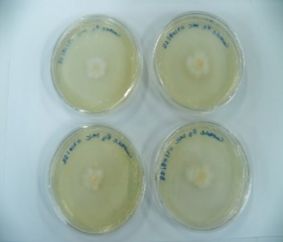
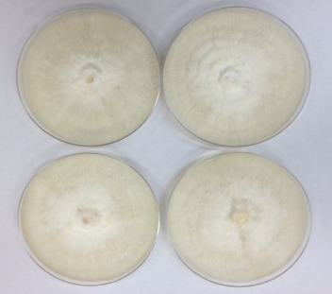
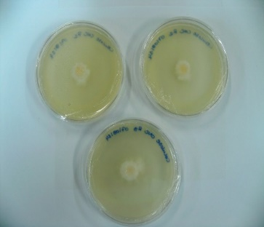
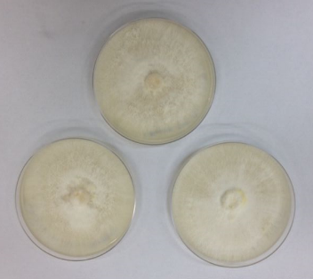
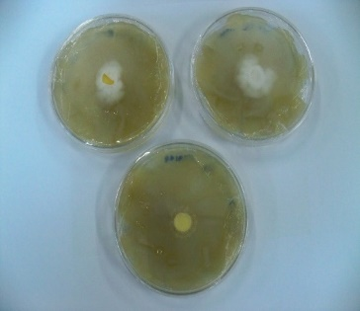
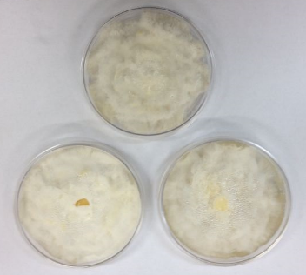
A
B
C
D
E
F

Figure 9. Mycelial growth monitoring in different culture media: a) and b) pda; c) and d) pda+cnc; e) and f) pda+nfc; beginning (left) and the end (right) of the colonization process.

4. Conclusion

NFC and CNC are materials with unique and differentiated morphology and properties. They are also material in the nanometer scale that have high rigidity and high sugar content in their composition due to their derivation from cellulose. They show modified superficial charges compared to the original polymer due to the extraction methods used in their production that allows their suspensions stability. Both nano structures can be applied to the confection of composites / nanocomposites, packaging and a range of thermoplastic materials since their degradation temperatures are above 200 °C. Finally, NFC and CNC have large numbers of active sites for intermolecular interactions, thus, allied to all these physico-chemical features they must be classified as biodegradable polymers.

COMPETING INTERESTS DISCLAIMER:
Authors have declared that they have no known competing financial interests OR non-financial interests OR personal relationships that could have appeared to influence the work reported in this paper.

Disclaimer (Artificial intelligence)

Author(s) hereby declares that NO generative AI technologies such as Large Language Models (ChatGPT, COPILOT, etc.) and text-to-image generators have been used during the writing or editing of this manuscript.

References

1. AMASS, W.; AMASS, A.; TIGHE, B. A review of biodegradable polymers: uses, current developments in the synthesis and characterization of biodegradable polyesters, blends of biodegradable polymers and recent advances in biodegradation studies. Polymeros, v. 47, p. 89-144, 1998.

2. ALEMDAR, A.; SAIN, M. Isolation and characterization of nanofibers from agricultural residues – wheat straw and soy hulls. Bioresour. Technol., v. 99, p. 1664–1671, 2008.

3. BARBOSA, L. C. A. Espectroscopia no infravermelho na caracterização de compostos orgânicos. Viçosa: Ed. UFV, 2007.
4. BAUMHARDT NETO, R. Raios X. In: TÉCNICAS de caracterização de polímeros.
São Paulo: Artliber, 2007. p. 41-60.

5. BASCH, A.; LEWIN, M. The influence of fine structure on the pyrolysis of cellulose I:
Vacuum pyrolysis., Journal of Polymer Science and Polymer Chemistry, v.11, p.
3071-3093, 1973.

6. BAXTER, L. L. et al. The behavior of inorganic material in biomass-fired power boilers: field and laboratory experiences. Fuel Processing Technology, v. 54, n. 1-3, p. 47-78, 1998.

7. BROIDO, A.; JAVIER-SON, A.C.; BARRALL, E.D. Molecular weight decrease in the
early pyrolysis of crystalline and amorphous cellulose. Journal of Applied Polymer
Science, v.17, p.3627-3635, 1973.

8. BROWNING, B. L. Methods of Wood Chemistry. New York: Interscience Publishers,
1967. v. 2, p. 385-823.

9. CAO, X., DING, B., YU, J., AL-DEYAB, S. S., Cellulose nanowhiskers extracted from TEMPO-oxidized jute fibers, Carbohydrate Polymers, 2010.

10. CARRASCO, G. C. Cellulose fibres, nanofibrils and microfibrils: The morphological sequence of MFC components from a plant physiology and fibre technology point of view. Nanoscale Research Letter, v. 6, n. 1, p. 417, 2011.

11. CHATTERJEE, P.K.; CONRAD, C.M. Kinetics of the pyrolysis of cotton celulose.
Textile Research, v.36, p.487-494, 1966.

12. DUFRESNE, A. Polysaccharide nano crystal reinforced nanocomposites. Canadian Journal of Chemistry, v. 86, p. 484–494, 2008.

13. FLEMMING, H. C. Role and levels of real time monitoring for successful anti-fouling strategies. Water Science Technology, v.47, n. 5, p. 1-8, 2003.

14. FENGEL, D.; WEGENER, G. Wood: chemistry, ultrastructure, reactions. New York: Gruyter, 1989. 613 p.

15. GALLIGAN, W. L.; STERN, H.; HOHENSCHU, P. Manganese distribution in wood by neutron activation analysis. Forest Products Journal, v. 15, n. 5, p. 185-189, 1965.

16. GOTHSCH, T., FINKE, J. H., BEINERT, S., LECHE, C., SCHUR, J., BUTTGENBACH, S., MULLER-GOYMANN, C., KWADE, A. Effect microchannel geometry on high-pressure dispersion and emulsification. Chemical Engineering Technology, v. 34, p.335-343, 2010.

17. HABIBI, Y., FOULON, L., AGUIÉ-BÉGHIN, V., MOLINARI, M., DOUILLARD, R. Langmuir–Blodgett films of cellulose nanocrystals: Preparation and characterization. Journal of Colloid and Interface Science, v.316, p. 388-397, 2007.

18. KIM, U.J.; EOM, S.H.; WADA, M. Thermal decomposition of native cellulose: Influence on crystallite size. Polymer Degradation and Stability, v. 95, p. 778-781, 2010.

19. IWAMOTO, S.; KENTARO, A.; YANO, H. The Effect of Hemicelluloses on Wood Pulp Nanofibrillation and Nanofiber Network Characteristics. Biomacromolecules, v. 9, p. 1022–1026, 2008.

20. LIAO, Y. F. Mechanism study of cellulose pyrolysis. Tese de Pós Doutorado, ZheJiang
University, HangZhou, China.

21. LIU, Y.; WANG, H.; YU, G.; YU, Q.; LI, B.; MU, X. A novel approach for the preparation of nanocrystalline celluloseby using phosphotungstic acid. Carbohydrate Polymers, v. 110, p. 415–422, 2014.

22. LU, Q.; TANG, L.; WANG, S.; HUANG, B.; CHEN, Y.; CHEN, X. An investigation on the characteristics of celulose nanocrystals from Pennisetum sínese. Biomass and Bioenergy, v. 70, p. 267-272, 2014.

23. LU, P.; HSIEH, Y. Preparation and properties of cellulose nanocrystals: rods, spheres, and network. Carbohydr. Polym, v. 82, p. 329–336, 2010.

24. MALLI, S.; GROSSMANN, M. V. E. Effects of yam starch films on storability and quality of fresh strawberries. Journal of Agricultural and Food Chemistry, v. 51, n. 24, p. 7055-7011, 2003.

25. MAJOR, W.D. The degradation of cellulose in oxygen and nitrogen at high temperatures, TAPPI , v.41, p.530-537,1958.

26. MORÁN, J. I.; ALVAREZ, V. A., CYRAS, V. P.; VÁZQUEZ, A. Extraction of cellulose and preparation of nanocellulose from sisal fibres. Cellulose, v. 15, p. 149–159, 2008.

27. NETO, W. P. F.; SILVÉRIO, H. A.; DANTAS, N. O.; PASQUINI, D. Extraction and characterization of cellulose nanocrystals from agro-industrial residue – Soy hulls. Industrial Crops and Products, v. 42, p. 480– 488, 2013.

28. ORIGINLAB CORPORATION. ORIGIN version 8.0. Northampton: OriginLab Corporation, 2007.

29. PÄÄKKÖ, M; ANKERFORS, M.; KOSONEN, H.; NYKANEN, A.; AHOLA, S.; OSTERBERG, M.; RUOKOLAINEN, J.; LAINE, J.; LARSSON, P. T.; IKKALA, O.; LINDSTROM, T. Enzymatic Hydrolysis Combined with Mechanical Shearing and High-Pressure Homogenization for Nanoscale Cellulose Fibrils and Strong Gels. Biomacromolecules, v. 8, n. 6, p. 1934-1941, 2007.

30. PODSIADLO, P.; CHOI, S.Y.; SHIM, B.; LEE, J.; CUDDIHY, M.; KOTOV, N.A. Molecularly engineered nanocomposites: layer-by-layer assembly of cellulose nanocrystals. Biomacromolecules, v. 6, n. 6, 2914-2918, 2005.

31. ROMAN, M., WINTER, W.T. Effect of sulfate groups from sulfuric acid hydrolysis on the thermal degradation behavior of bacterial cellulose. Biomacromolecules v. 5, p. 1671–1677, 2004.

32. REDDY, K.O.; GUDURI, B.R.; RAJULU, A.V. Structural characterization and tensile properties of borassus fruit fibers. J Appl Polym Sci, v. 114, n. 1, p .603-611, 2009.

33. SEGAL,L.; CREELY,J.J.; MARTIN,A.E.; CONRAD,C.M. An empirical method for estimating the degree of crystallinity of native cellulose using the X-ray diffractometer. Textile Res, v.29, p. 786-794, 1959.

34. SYVERUD, K.; CARRASCO, G.C.; TOLEDO, J.; TOLEDO, P.G. A comparative study of Eucalyptus and Pinus radiata pulp fibres as raw materials for production of cellulose nanofibrils. Carbohydrate Polymers, v. 84 p. 1033–1038, 2011

35. SIQUEIRA, G.; BRAS, J.; DUFRESNE, A. Cellulose whiskers versus microfibrils: Influence of the nature of the nanoparticle and its surface functionalization on the thermal and mechanical properties of nanocomposites. Biomacromolecules, v. 10, p. 425–432, 2009.

36. SIXTA, H. Handbook of Pulp. Wiley-VCH Verlag GmbH & Co, v. 1, 608 p., 2006.

37. SJOSTROM, E. Wood Chemistry, Fundamentals and Aplications. Second edition. Academic Press, San Diego, 1993.

38. SJOHOLM, E.; GUSTAFSSON, K.; BERTHOLD, F.; COLMSJO, A. Influence of the carbohydrate composition on the molecular weight distribution of kraft pulps. Carbohydrate Polymers, v. 41, p. 1–7, 2000.

39. TAPPI – TECHINICAL ASSOCIATION OF THE PULP AND PAPER INDUSTRY. Tappi Standard Methods, Atlanta: TAPPI 2002.

40. TEIXEIRA, E. M.; OLIVEIRA, C. R.; MATTOSO, L. H. C.; CORRÊA, A. C.; PALADIN, P. D. Nanofibras de algodão obtidas sob diferentes condições de hidrólise ácida. Polímeros, vol. 20, nº 4, p. 264-268, 2010.

41. TONOLI, G.H.D.; TEIXEIRA, E.M.; CORRÊA, A.C.; MARCONCINI, J.M.; CAIXETA, L.A.; PEREIRA-DA-SILVA, M.A.; MATTOSO, L.H.C. Cellulose micro/nanofibres from Eucalyptus kraft pulp: Preparation and properties. Carbohydrate Polymers, v. 89, p. 80– 88, 2012.

42. WALLIS, A. F. A.; WEARNE, R. H.; WRIGHT, P. J. Chemical analysis of polysaccharides in plantation eucalypt woods and pulps. Tappi Journal, v. 49, n. 4, p. 258-262, 1996.

43. YANG, H.; YAN, R.; CHEN, H.; LEE, D. H.; ZHENG, C. Characteristics of hemicellulose, cellulose and lignin pyrolysis. Fuel, v. 86, p. 1781-1788, 2007.

44. ORLU, H.; OLLOR, O.; EBOR, E. (2024). Antibacterial Effect of Nanoparticles Synthesized from Ficus exaseprata (Sandpaper Leaves). Asian Journal of Applied Chemistry Research. 15. 28-36. 10.9734/ajacr/2024/v15i1280.

45. RAJENDIRAN, N.; RUNGE, T.; BERGMAN, R.; NEPAL, P.; HOUTMAN, C. (2023). Techno-economic analysis and life cycle assessment of cellulose nanocrystals production from wood pulp. Bioresource Technology. 377. 128955. 10.1016/j.biortech.2023.128955.

