Original Research Article
Hemp as Bio Fiber Material for Paper Applications: Fiber Processing

ABSTRACT

Hemp known as Cannabis Sativa, has been cultivated as an agricultural crop centuries before the Common Area and has been used extensively during colonial times as a cash crop in Europe and America. During industrialization the agricultural production of hemp declined and came to an end in the U.S. with the 1937 Marijuana Tax Act.
In the 1990s Hemp production was reauthorized throughout the European Union and in the U.S. in 2014 with the Farm Bill.
Today hemp has been rediscovered as a new sustainable environmentally friendly fiber source for many products including paper making.
During this research project hemp fiber for paper manufacturing was produced from agricultural waste products with a KRK pressurized refiner at 60°C and processing the hemp stems of 0.75-inch (19.0 mm) with a refiner plates gap of 0.5 mm at 1800 rpm. To eliminate the hemp fibers stringing tendency fibers are screened using a Valley type screen with a 150 µm screen plate and a screen box with a 150 mesh (105 µm) for collecting the fibers. Final refining to adjust the dewatering properties of the hemp fibers was done with a Valley beater type machine.
The manufactured handsheets had a basis weight of 71.31 g/m² and a caliper of 255.6 μm.
Mechanical properties measured yielded for the Short Compression Strength Index, Burst Index and Tensile Index 0.45 kNm/g, 0.58 kPa*m³/g and 3.61mNm³/g respectively. Elongation was measured at 3.46% and a Tensile Energy Adsorption at 61.20 kJ/m².
Air permeance 108.00 cfm and smoothness was at 3070.00 cfm for the top surface and 3002.00 cfm for the bottom surface. Air resistance was measured at 62.80 seconds.
Optical properties of the handsheets were measured for Color at a value of 77.34 for the L*, 0.08 for a*, and 17.57 for the b* properties. Whiteness was at -63.17% and brightness at 28.73%.
Applying hemp at present time as a valid fiber source for paper production requires more research and development on laboratory and pilot scale installations to determine the full potential of the hemp fiber material and its industrial application potential.

Keywords: Biofiber, Fiber Material, Hemp, Papermaking, Paper Properties, Refining, Sustainability,

1. INTRODUCTION

The development of more sustainable modes of operation is of great interest to reduce energy and material consumtion and at the same time utilize more recycled materials to foster more sustainability and reduce the carbon foot print of industries, agricultural operations, and municipalities.
Paper is known as a sustainable material since its invention in ancient China during the Eastern Han dynasty (105 CE) by Cai Lun [1,2].
At present time every industry sector face increasing production costs due to increasing energy costs, implementation of stringent environmental laws, globalization and high competitiveness and pressure on profit margins [1,3-5].
Paper products became more favorable material in the packaging and retail industry to replace plastic- based packaging materials due to rising environmental concerns such as microplastic pollution. Today, consumers require more sustainable packaging solutions, and industry is required to shift to more sustainable and plastic free packaging solutions [5]. Paper based packaging materials have a more favorable environmental footprint and because of that, the demand for pulp and paper products is still growing, especially in the packaging industry [6].
Paper was introduced as packaging material in the late 1800’s and can be found today in almost every item that is shipped and or packaged in the food, beverage, pharmaceutical, and other industry sectors [5].
Recently Hemp was emerging as a new sustainable natural fiber resource in paper manufacturing since it was authorized to be used in the 1990s by the European Union [7,8,9]. In the U.S. Section 7606 of the 2014 Agricultural Act (the Farm Bill) changed the legal status of Hamp, allowing the growth by researchers at an institute of higher education, by the State Departments of Agriculture, or by farmers participating in a research program [10]. All growth operations still needed to be permitted and overseen by the State Department of Agriculture [11].
Industrial Hemp (Cannabis sativa L.) has a long history of utilization in Europe and America. It has been cultivated in the British Colonies in the Americas before 1619 [12] and played a significant role in European mercantilism and imperialism between the 17th and 20th centuries [13]. Because Hemp fibers are resistant to natural decay, they are a ideal fiber material for maritime applications [14] and therefore, hemp was a crucial material for shipping and trading, as well as naval warfare. Hemp was used to manufacture textile products, ropes, paper, uniform, tents, Canastota wagon covers, ship sails and ropes, ship charts, maps, and ship logs as well as currency [15,16,17].
Industrialization and the usage of steam ships resulted in a decreased need for sailcloth's and cordage in the 19th century [18]. Hemp fibers were still used for paper, cordage, rope, textiles, and clothes between the end of the 19th century till the Marijuana Tax Act was passed in 1937 [19] by the United States Congress. Hemp products were replaced by other fibers from cotton and wood [20]. Cotton was a less expensive and labor-intensive source of fibers than Hemp [21].
At present time the cultivation of industrial Hemp creates a new opportunity for many states in the United States in which the selling of CBD oils and the recreational marijuana uses is allowed, creating a opportunity of resurged usage of Hemp fibers into other products [23].
Today’s consumer demand for sustainable products forces manufacturers to look for more sustainable and eco-efficient raw material and additives in manufactured, such as straw and willow, to produce sustainable and eco-friendly products [24,25,26].
Implementing sustainable fiber material for paper production may not need a chemical pulping process such as the Kraft process to extract cellulosic fiber material from wood fiber sources and therefore fosters a more favorable environmental footprint [27].
The following manuscript describes a laboratory study focused on hemp fiber processing of the hemp biomass, left over from CBD oil production, with the goal to produce a TAPPI type handsheet. The study was performed at the State University of New York (SUNY), College of Environmental Science and Forestry (ESF), Chemical Engineering Departments Paper Engineering Program. The development included laboratory scale fiber material processing development and testing, for the future application of hemp fiber material in paper and board paper grades.

2. Material and Methods

The following materials and methods were used for the hemp fiber laboratory development.

2.1. Materials Used

Hemp stem material was sourced from Cornell University.

2.2. Mechanical Equipment Used
For this research, mechanical processing equipment as shown in Figure 1 a to d was used.
Figure 1a shows a TAPPI type Valley Beater, Figure 1b shows the Wiley Mill, Figure 1c shows a Sprout Bauer Laboratory Refiner (SBLR) with 30 kW installed power and a hand operated feeding screw. Figure 1d shows a Kumagai Riki Kogyo Co., Ltd. (KRK) pressurized chip laboratory refiner with 45 kW of installed power and Figure 1e shows Valley type screen having a 150 µm screen plate, and Figure 1f shows a screen box for collecting the processed fiber material lined with a 150 mesh (105 µm) sieve fabric.
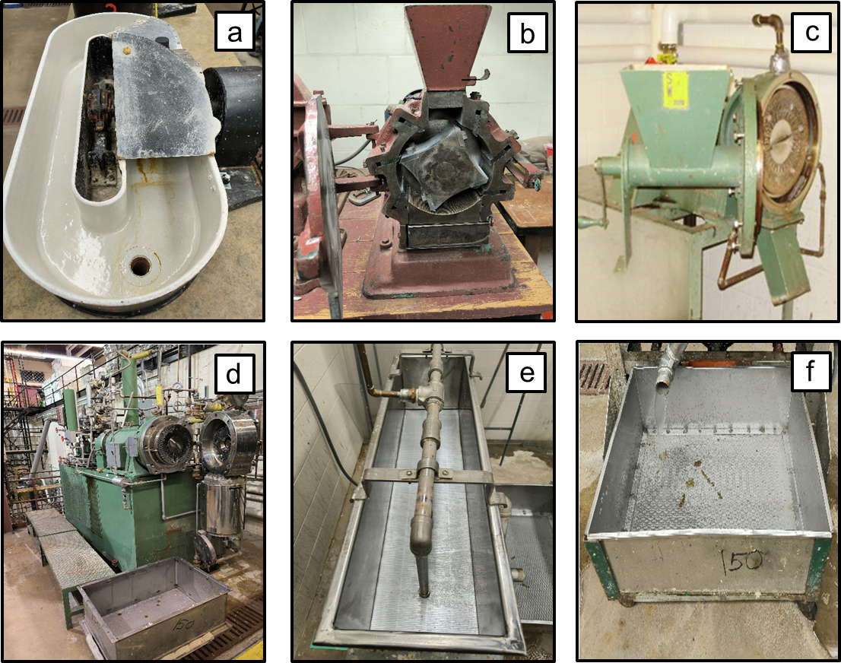
Fig. 1.: Processing Equipment

2.3. Testing Methods
In this study the following testing methods of the Technical Association of the Pulp and Paper Industry (TAPPI) and International Organization for Standardization (ISO) were used:
Beating of pulp (Valley beater method) in accordance with TAPPI test method T 200 sp-06 “Laboratory beating of pulp (Valley beater method)” [28].
Handsheets were prepared according to TAPPI test method T 205 sp-12, “Forming handsheets for physical tests of pulp” [29].
Physical testing of handsheets was performed in accordance with TAPPI test method T 220 sp-06, “Physical testing of pulp handsheets” [30].
Freeness of pulp was measured as Canadian Standard Freeness (CSF) according to TAPPI test method T 227 om-09 “Freeness of pulp (Canadian standard method)” [31]. Consistency of the pulp suspensions was measured with TAPPI T 240 om-07 “Consistency (concentration) of pulp suspensions” [32].
Screening of pulp was performed in accordance with TAPPI test method T 274 sp-08, “Laboratory screening of pulp (Master Screen-type instrument)” [33], the instrument used was a Valley type Screen with a 350 µm screen plate and a Voith Valley screen with 150µm screen plate.
Conditioning of the paper samples was done according to TAPPI test method T 402 sp-08, “Standard conditioning and testing atmospheres for paper, board, pulp handsheets, and related products” [34].
Burst Strength was measured in accordance with TAPPI test method T 403 om-02, “Bursting strength of paper” .
Basis weight was measured using TAPPI test method T 410 om-08. “Grammage of Paper and Paperboard (weight per unit area)” [36].
Thickness of the paper was measured with TAPPI test method T 411 om-10. “Thickness (caliper) of paper, paperboard, and combined board” [37].
Moisture content of pulp was determined by TAPPI test method T 412 om-06 “Moisture in pulp, paper and paperboard” [38].
The air resistance of Hemp paper handsheets was measured with T 460 om-06, “Air resistance of paper (Gurley method)” [39].
Opacity of the Hemp paper handsheets was measured in accordance with TAPPI test method T 519 om-06, Diffuse opacity of paper (d/0 paper backing) [40].
Brightness of Hemp paper handsheets was measured using TAPPI test method T 523 om-06, Diffuse brightness of paper, paperboard and pulp (d/0) [41].
Color of the Hemp paper handsheets was measured with TAPPI test method T 527 om-07, Color of paper and paperboard (d/0, C/2) [42].
Roughness (Smoothness) of Hemp paper handsheets was measured in accordance to TAPPI test method T 538 om-08, Roughness of Paper and Paperboard (Sheffield method) [43].
Air permeance of Hemp paper handsheets was measured using TAPPI test method T 547 om-07, Air permeance of paper and paperboard (Sheffield method) [44].
Whiteness of Hemp paper handsheets was measured according to TAPPI test method T 560 om-05, CIE whiteness and tint of paper and paperboard (d/0 geometry, C/2 illuminant / observer) [45].
The Hemp handsheets paper short compression strength was tested according to TAPPI test method T 826 pm-92. Short span compression strength of containerboard [46].

3.0 Result & Discussion

3.1. FIBER Processing

The following fiber processing equipment were used: a) TAPPI-type Valley Beater, b) A Wiley Mill, c) Sprout Bouer laboratory refiner, and d) KRK pressurized refiner was used to find the best way in producing hemp fibers suitable for papermaking from hemp stems. All hemp stems were soaked for 24 hours in a 5-gallon pail filled with 20°C tap water prior to processing.

3.2. Valley Beater
Approximately 500 g of Oven Dry (OD) Hemp stems were cut into approximately 0.5 inch (12.4 mm) long pieces to be processed with the Valley Beater into fiber material. The cut material was then soaked for 24 hours in tap water with a temperature of 20°C in a 5-gallon pail. After soaking some of the hemp stems were transferred to the running Valley Beater filled with 23 liters of 20°C tap water. It was imminent that the Valley Beater could not process and defiber the hem stems. Therefore, it was decided that the Valley Beater could not be used for initial hemp stem processing.

3.3. Wiley Mill
A Wiley Mill with a 0.08-inch (2.03 mm) screen was used was used to grind down the hemp stem fibers for fiber processing. 500 g OD Hemp stems were cut into approximately 1.5 inch (38.1 mm) long pieces before feeding them manually for processing in the Wiley Mill. The ground hemp stems were collected and put into a 1-gallon Zip-Lock bag for storage.

3.3.1. Handsheet making from Processed Hemp Fibers using a Wiley Mill
30 g Oven Dry (OD) hemp fibers were taken and diluted to a 0.3% hemp fiber water solution with a temperature of 20°C for measuring the freeness (CSF) and handsheet making having 20°C.
The freeness of the processed Hemp fibers was 600 ml, tested according to TAPPI test method T 227 om-09 [31]. From the processed Hemp fibers a handsheets with a targeted basis weight of 60 g/m² were manufactured, according to TAPPI test method T 205 sp-12 [29]. The produced handsheet was very weak and hard to form and it was almost impossible to be pick up from the sheet former. Therefore, it was decided to refine/beat the processed Hemp fibers with a Valley Beater according to TAPPI T 200 sp-06 [28] test method. Beating the Hemp fibers for 20 minutes resulted in a CSF content of 420 ml. The hand sheet forming did not improve. Therefore, it was decided that using the Wiley Mill and Valley Beater to produce fiber material from Hemp stems may not be the best method to as a laboratory refining process.

3.4. Production of Hemp Fibers with Laboratory Refiner

3.4.1. Sprout Bauer Laboratory Refiner
The SBLR has a manual operated feed auger with approximately 3.25-inch (82.5 mm) diameter with a 2.0-inch (50.8 mm) pitch. 500 g of Hemp stems were cut into approximately 1.5 inch (38.1 mm) long pieces to transfer them to the refiner plates with the feed auger. The SBLR was operated at a speed of 1800 rpm and a gap of 0.5 mm. Water flow to the feed auger was set at approximately 1-gallon (3.78 l) per minute at a temperature of 20°C. The discharged refined Hemp stems were collected in a screen box lined with a 150 mesh (105 µm) sieve. To get acceptable results in defiber Hemp stems 3 passes of the hemp stems material are needed and the produced hem fiber still contains large pieces of unrefined Hemp fiber material.

3.4.2. Kumagai Riki Kogyo Co., Ltd. (KRK) Pressurized Chip Laboratory Refiner
The KRK laboratory refiner has an 6-liter pressurized hopper from which an automatic operated feed auger with approximately 3.25-inch (82.5 mm) diameter with a 1.1-inch (30.0 mm) pitch feeds the material to the refining plates. 1000 g of Hemp stems were cut into approximately 0.75-inch (19.0 mm) long pieces to transfer them to the refiner plates with the feed auger. Two batches of 500 g each were placed into the feed hopper of the KRK. After closing the lid of the feed hopper lid water, the hopper was filled with water having a temperature of 60°C. The KRK was then operated at a speed of 3000 rpm and a gap of 0.5 mm, and the Hemp stems were refined and discharged into the receiving chamber of the KRK. After all Hemp stems were from the feed hopper passed through the KRK, the receiving hopper was emptied into a screen box lined with a 150 mesh (105 µm) sieve. The operation at 60°C gave acceptable defibered Hemp fibers from the hemp stems using only one pass through the KRK laboratory refiner. The solids content of the refined hemp fiber suspension collected in the screen box was 5.29% based on Oven Dry (OD) fiber content.

3.4.3. Screening of Processed Hemp fibers
Processed Hemp fibers with the SBLR and KRK laboratory refiner were diluted to 1.0 % and stirred with a laboratory mixer. Stirring revealed that the processed Hemp fibers from both refining processes created large, tangled fiber strings on the mixing impeller as shown in Figure 2.

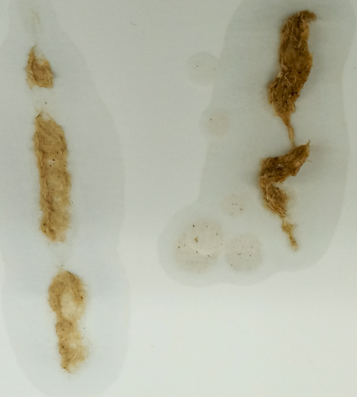
Fig. 2.: Hemp Strings attached to Stirrer

To eliminate the stringing tendency all refined Hemp fibers were screened using a Valley type screen with a 150 µm screen plate and a screen box for collecting the processed fiber material lined with a 150 mesh (105 µm) sieve fabric was used for further processing.
The usable fiber yield of the processed and refined and screened Hemp material was calculated at 81.5%. After screening the Hemp fibers were dewatered with a fabric to a 16.85% OD hemp fiber solids content and stored in a refrigerator at 41°F (5°C) prior to processing for handsheet making.

3.5. Handsheet making from Processed Hemp Fibers
From the processed Hemp fibers, produced with the Wiley Mill & Valley Beater and the KRK laboratory refiner, stored in a refrigerator at 41°F (5°C), 30 g Oven Dry (OD) fibers each were taken and diluted to a 0.3% hemp fiber water solution with a temperature of 20°C for measuring the freeness (CSF) and handsheet making having at 20°C.
The freeness of the processed KRK laboratory refiner Hemp fibers was 520 ml, tested according to TAPPI test method T 227 om-09 [31]. Handsheet with a target basis weight of 60 g/m² were manufactured according to TAPPI test method T 205 sp-12 [29]. The produced handsheet from the KRK laboratory refiner Hemp material was very weak and hard to form, like the Wilet Mill and Valley Beater Hemp fiber material as described in Section 3.3. Therefore, it was decided to refine/beat both the processed Hemp fibers with a Valley Beater according to TAPPI T 200 sp-06 [28] test method as well as produce handsheets with a targeted basis weight of 70 g/m². Beating the hemp fibers for 20 minutes resulted in a CSF content of 370 ml for the Wiley Mill processed fibers and a CSF of 80ml for the KRK processed fibers. Figure 3 displays the appearance of TAPPI handsheets made the handsheet type made with the KRK refiner processed fibers (Figure 3a) and the Whiley Mill/ Valley Beater processed fibers (Figure 3b), showing larger fiber materials present in the Whiley Mill/Valley Beater handsheets.

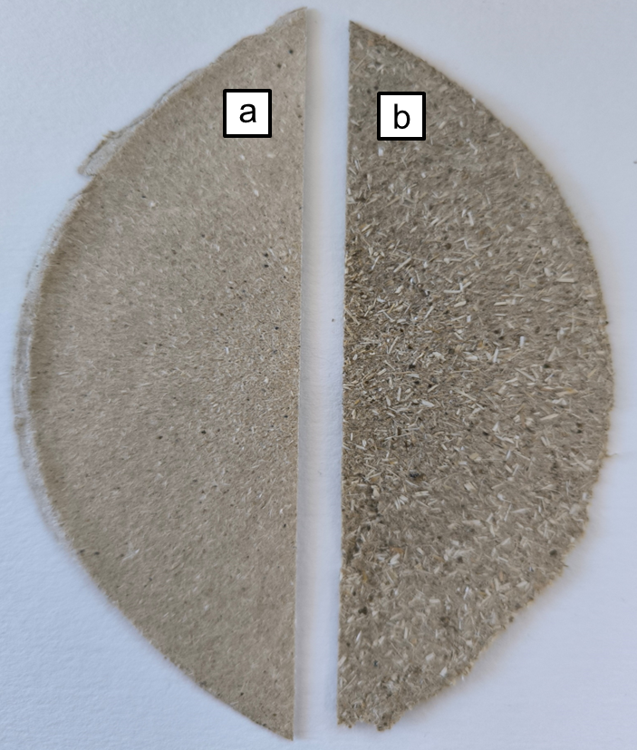
Fig. 3.: Hemp Hand sheets

3.6. Evaluation of Paper Properties
All tests performed for mechanical and optical paper properties were done in accordance to the in Section 2.3. referenced TAPPI methods. All results stayed in the precision statements for the referenced TAPPI methods.
From the suspension produced from the KRK refiner and Whiley Mill/Valley Beater processed Hemp fiber material as described in Section 3.3., fifteen handsheets with a targeted basis weight of 70 g/m² were made for the evaluation of mechanical-, surface- and optical paper properties.

3.6.1. Basis Weight and Caliper of TAPPI Hemp Handsheets
Figure 4 shows that handsheets made from the processed fiber material produced with the KRK refiner have a basis weight of 71.31 g/m² and a caliper of 255.6 μm, whereas the handsheets from the fiber suspension produced Whiley Mill/Valley Beater had a basis weight of 74.12 g/m² and a caliper of 571.40. μm.
The 1.04-fold higher basis weight can be explained with the difference of the produced fiber suspension of KRK refiner and Willey Mill/Valley Beater. The later required a higher amount of OD fiber material for the handsheet making process (see Figure 3a and 3b) due to the high fiber losses in the handsheet making process as well as the inconsistent fiber material size produced by the Whiley Mill/Valley Beater processing sequence. Tis resulted as well in a over 2.24-fold higher caliper which can be explained by the larger fiber material present in the Whiley Mill/Valley Beater fiber material as seen inf Figure 3a&b.

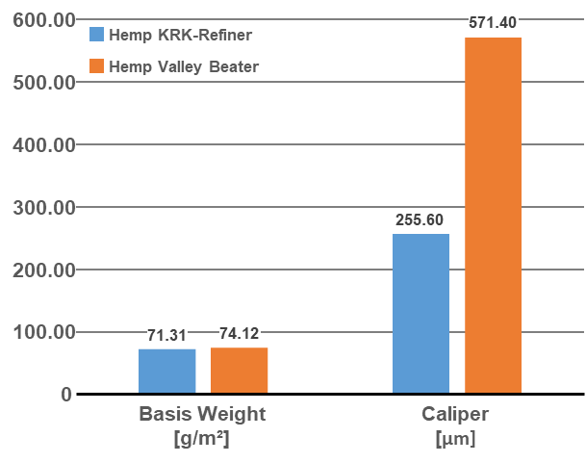
Fig. 4.: Basis Weight and Caliper of Hemp Handsheets

3.6.2. Mechanical Paper Properties of TAPPI Hemp Handsheets
Short Compression Strength Index (SCSI), Burst Index (BI) and Tear Index (TI) are shown in Figure 5. Handsheets made from the processed fiber material produced with the KRK refiner had a STIFFI Index of 0.45 kNm/g, a BI 0.58 kPa*m³/g and a TI of 3.61mNm³/g. Handsheets made from the fiber suspension produced with the Whiley Mill/Valley Beater had a STIFFI Index of 0.54 kNm/g, a BI 0.22 kPa*m³/g and a TI of 3.27mNm³/g.
The 1.2 fold higher STIFFI, the 2.64 and 1.21 fold lower Burst and Tear Index can be explained with the difference in the fiber material whereas the Willey Mill/Valley Beater fiber material consists of larger fibers compared to the KRK refiner fiber material as shown in figure 3a and 3b. Larger fiber material has an positive influence for STFFI and reduce the inter-fiber bonding lowering the Burst and Tear strength.

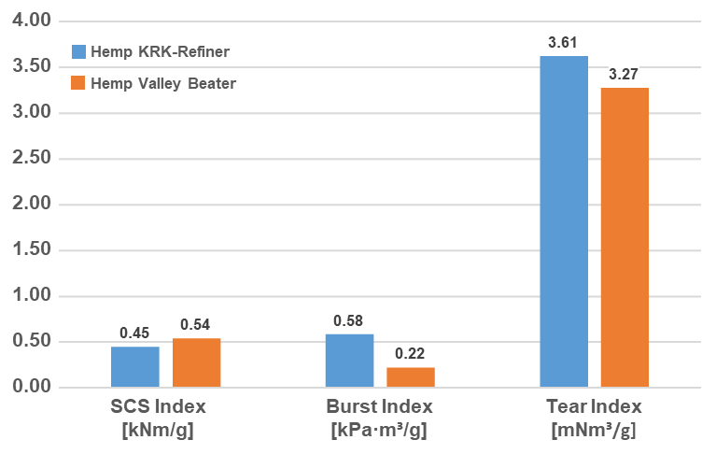
Fig. 5.: Mechanical Paper Properties of Hemp Handsheets

Tensile Index (TI), elongation (E) and Tensile Energy Absorption (TEA) (TI) are shown in Figure 6. Handsheets made from the processed fiber material produced with the KRK refiner had a TI of 3.61 Nm/g, E of 3.46% and a TEA of 61.20 kJ/m². Handsheets made from the fiber suspension produced with the Whiley Mill/Valley Beater had a TI of 3.27 Nm/g, E of 2.14% and a TEA of 57.30 kJ/m².
The 1.10-, 2.04-, and 1.07-fold lower values for the TI, E, and TEA respectively can be explained with the difference of the produced fiber suspension of KRK refiner and Willey Mill/Valley Beater, whereas the Willey Mill/Valley Beater fiber material consists of larger fibers compared to the KRK refiner fiber material as shown in figure 3a and 3b. Larger fiber material has an negative influence on the inter-fiber bonding capacity of the fiber material reducing subsequently the TI, E and TEA values.

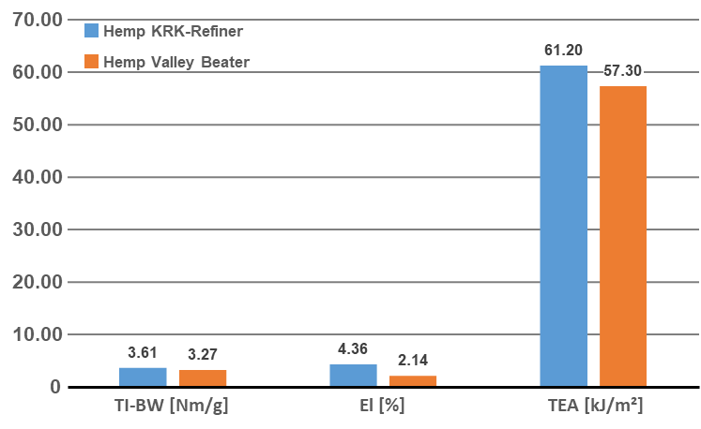

Fig. 6.: Mechanical Paper Properties of Hemp Handsheets

3.6.3. Surface Properties of TAPPI Hemp Handsheets
Figure 7 shows the surface properties of the laboratory manufactured handsheets made from processed fiber material produced with the KRK refiner and Willey Mill/Valley Beater. The air permeance of the handsheets measured with TAPPI T547 om-07 [44] revealed for the the KRK refiner handsheets a value of 108.00 cfm and the Whiley Mill/Valley Beater handsheets 2541.00 cfm, a 25.53-fold difference.
Smoothness (surface roughness) measured according to T 538 om-08 [43] resulted for the handsheets of the KRK refiner in a value of 3070.00 cfm for the top surface and 3002.00 cfm for the bottom surface. The Whiley Mill/Valley Beater handsheets smoothness was of 3097.00 cfm for the top surface and 3013 cfm for the bottom surface.
Smoothness properties had a less than 1% difference, because during the handsheet manufacturing process the top side is exposed to a plotter paper surface, and the bottom side is exposed to a polished metal disc during the handsheet manufacturing process which results in similar values
The air resistance measured according to TAPPI T 460 om-06 [39] revealed for the the KRK refiner handsheets a value of 62.80 seconds and the Whiley Mill/Valley Beater handsheets 1.30 seconds to push a volume of 100 ccm through the handsheet, representing a 47.92-fold difference in the resistance measurement.
The similar smoothness values can be explained with the handsheet manufacturing process, because both fiber materials were exposed during the manufacturing process to the same plotter paper with the same surface characteristics and the same pressure during the handsheet forming process which resulted in a similar surface characteristic.
The large difference in air permanence and air resistance can be explained with the difference of the produced fiber suspension of KRK refiner and Willey Mill/Valley Beater.
The later had larger fiber material present, as seen in Figure 3a and 3b, which resulted in a less dense handsheets and handsheets with hgher bulk for the Willey Mill/Valley Beater compared to the KRK refiner handhseets, allowing more air flow through the handsheet.

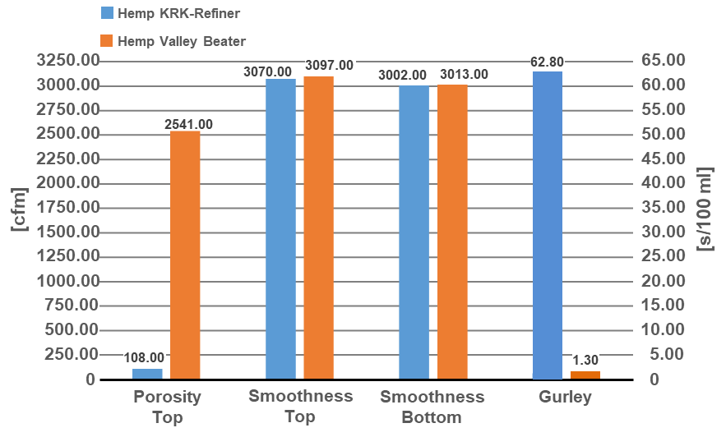
Fig. 7.: Air Resistance Properties of Hemp Handsheets

3.6.4. Optical Properties of TAPPI Hemp Handsheets
The optical handsheet properties of the handsheets produced from the KRK refiner and Willey Mill/Valley Beater pulp suspension are displayed in Figure 8. Optical properties were measured with a Technidyne Color Touch®X Spectrophotometer instrument which uses TAPPI Standards T 519 om-06 [40] to measure opacity, T 523 om-06 [41]. To measure brightness, T 527 om-07 [42] to measure color, and T 560 om-05 [45] to measure whiteness.
The manufactured hemp handsheets had no visible signs of dirt and a grayish white color with an opacity value of 100% for the KRK refiner pulp and 99.98% for the Willey Mill/Valley Beater pulp.
Color values of 77.34 and 66.31% for the L* value, 0.08 and 0.87 for a* value, and 17.57 and 17.29 for the b* value for the KRP refiner pulp and Willey Mill/Valley Beater pulp respectively.
Whiteness was measured at -63.17% for the KRK refiner pulp and -71.78 for the Willey Mill/Valley Beater pulp.
The brightness value reached 28.73% and 24.59%, for the KRP refiner pulp and Willey Mill/Valley Beater pulp respectively.
The measured optical properties of the handsheets manufactured with the KRK and Willey Mill/Valley Beater pulp suspension are very similar. Differences in the optical properties can be explained with the inconsistent fiber material size produced by the Whiley Mill/Valley Beater processing sequence requiring mor OD fiber material for the handsheet making process, which resulted in a different appearance of the handsheets as shown in Figure 3a and 3b.
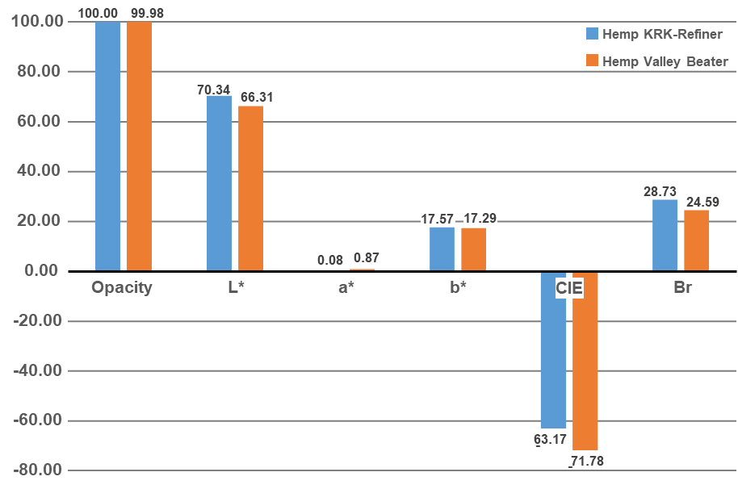
Fig. 8.: Optical Properties of Hemp Handsheets

4. Conclusion

Hemp known as Cannabis Sativa, has been cultivated as an agricultural crop centuries before the Common Area. Hemp has been used extensively during colonial times as a cash crop in Europe and America with applications such as sails and rope and maps for ships as well as fabric product for producing cloth and had a great impact to the European and American economy in pre- and past industrial times.
With industrialization, the agricultural production of hemp declined and came nearly to an end with 1937, the Marijuana Tax Act required registration and licensing of all Hemp growing and processing to restrict the production of marijuana.
In the 1990s Hemp production was reauthorized throughout the European Union and in the U.S. in 2014 with the Farm Bill, because of a new interest in natural resources and energy conservation.
Today hemp has been rediscovered as a new sustainable environmentally friendly fiber source for products like cordage, clothes, automobile industry, construction, composition materials, bioenergy sector, and future applications in paper making, beside the recreational marijuana and CBD oil production many applications which include which may include paper production.
During this research project hemp fiber for paper production could be produced. The most promising step is refining the hemp fibers with a KRK pressurized refiner at 60°C. Prior to refining it is suggested to cut the hemp stems in 0.75-inch (19.0 mm) long pieces and operate the refiner plates with a 0.5 mm gap at 1800 rpm.
It is suggested to reduce the stringing tendency of the hemp fibers, that all refined fibers are screened using a Valley type screen with a 150 µm screen plate and a screen box with a 150 mesh (105 µm) sieve fabric for collecting the processed fiber material followed by adjusting the final CSF with a Valley beater type machine to produce the desired fiber material for handsheet making.
The manufactured handsheets made from the preferred KRK refiner process had a basis weight of 71.31 g/m² and a caliper of 255.6 μm.

Mechanical properties measured yielded for the SCSI, BI and TI 0.45 kNm/g, 0.58 kPa*m³/g and 3.61mNm³/g respectively. TI was at 3.61 Nm/g, E-value at 3.46% and a TEA yielding 61.20 kJ/m².
Surface properties measured of the manufactured handsheets were for air permeance 108.00 cfm and for smoothness 3070.00 cfm for the top surface and 3002.00 cfm for the bottom surface.
The air resistance was measured at 62.80 seconds to push 100 ml volume through the handsheet.
Optical properties of the handsheets were measured for Color at a value of 77.34 for the L*, 0.08 for a*, and 17.57 for the b* properties. Whiteness was measured at -63.17% and brightness at 28.73%.
Applying hemp at present as a valid fiber source for paper production requires more research and development on laboratory and pilot scale installations to determine the full potential of the hemp fiber materials and its industrial application potential. Research should focus on the production of consistent fiber material allowing maximization of the mechanical and optical paper properties.

5. DISCLAIMER (ARTIFICIAL IMTELLIGENCE)

The author hereby declares that NO generative AI technologies such as Large Language Models (ChatGPT, COPILOT, etc.) and text-to-image generators have been used during writing or editing of manuscripts.

6. Competing interests

Author has declared that no competing interests exist. The products used for this research are commonly and predominantly use products in our area of research and country. There is absolutely no conflict of interest between the authors and producers of the products because we do not intend to use these products as an avenue for any litigation but for the advancement of knowledge. Also, the research was not funded by the producing company rather it was funded by personal efforts of the authors.

7. References

- Dölle K., Palmer K., Palumbo N., Neary B., Shick I., Rothwell I. Straw for Art Applications – a Paper Development Study. Journal of Engineering Research and Reports (JERR). 2022;22(1):33-88.
- Tschudin, P.F., (1999), „Vom Tapa-Kofer zur Papiermaschine: Technikgeschichte der besonderen Art“, Wochenblatt für Papierfabrikation, 23/24, 1541-1545.
- Doelle K. Lime in Papermaking – A Historic Review Paper. In: Thompson ML, Brisch JH., Editors, Lime: Building on the 100-Year Legacy of The ASTM Committee. 2012.
- Dölle K. Paper for Screen Printing Application – A Paper Development Study. Journal of Engineering Research and Reports (JERR). 2022;21(9):45-63.
- Dölle K. Moisture Transfer of Paper for Food Applications: A Laboratory Study. Journal of Engineering Research and Reports (JERR). 2022;25(11):177-185.
- Dölle K., Jeeva KNC. Aseptic Packaging Container Recovery – A Review. Journal of Materials Science Research and Reviews. 2022;10(1):38-51.
- Amaducci S, Scordia D, Liu FH, Zhang Q, Guo H, Testa G, Cosentino SL. Key Cultivation Techniques for Hemp in Europe and China. Industrial Crops and Products. 2015;68:2–16.
- Perez G. Nonwoody fibers and hemp in the paper industry. Invest.Tec.Papel.1993;20(76), 465-474.
- European Commission. Hemp. Accessed 9 June 2025. Available: https://agriculture.ec.europa.eu/farming/crop-productions-and-plant-based-products/hemp_en
- 2018 Farm Bill, Accessed 9 June, 2025. Available: https://www.usda.gov/farming-and-ranching/farm-bill
- The Pennsylvania State University, Industrial Hemp production, Accessed 6 June 2025. Available: https://extension.psu.edu/industrial-hemp-production
- Rovetto LJ, Aieta NV, Supercritical carbon dioxide extraction of cannabinoids from Cannabis sativa L., The Journal of Supercritical Fluids, 2017; 129:16-27.
- Borougerdi BJ. Cord of Empire, Exotic Intoxicant: Hemp and Culture in the Atlantic World, 1600-1900. The University of Texas at Arlington. 2014.
- Will III OH. The Forgotten History of Hemp Cultivation in America - Farm Collector. Farm
- Herer J. The Forgotten History of Hemp. Earth Island Journal. 1990;5(4):35–38.
- Malachowska M, Przybysz M, Dubowik M, Kucner M, Buzala K, Comparison of papermaking potential of wood and hemp cellulose pulps, Annals of Warsaw University of Life Sciences – SGGW, Forestry and Wood Technology, 2015; 91: 134-137.
- Prade T, Industrial Hemp (Cannabis sativa L.) – a High-Yielding Energy Crop, Diss. (sammanfattning/summary) Alnarp, Sweden: Sveriges lantbruksuniv., Acta Universitatis Agricultura, 2011.
- Crini G, Lichtfouse E, Chanet G, Morin-Crini N. Applications of Hemp in Textiles, Paper Industry, Insulation and Building Materials, Horticulture, Animal Nutrition, Food and Beverages, Nutraceuticals, Cosmetics and Hygiene, Medicine, Agrochemistry, Energy Production and Environment: A Review. Environmental Chemistry Letter. 2020;18 (5):1451–1476.
- United States Department of Agriculture, Economic Research Service. Industrial Hemp in the United States: Status and Market Potential. 2000. Accessed 2 June 2025. Available: https://www.ers.usda.gov/publications/pub-details?pubid=41757
- Gorbachev F. Industrial application of hemp fibers : history and future prospects of hemp as an alternative resource for pulp. Tampere University of Applied Sciences. 2021.
- Swenson B. Hemp & Flax in Colonial America. US History Museum Colonial Williamsburg CW Journal. 2015. Accessed 2 June, 2025, Available https://research.colonialwilliamsburg.org/foundation/journal/Winter15/hemp.cfm
- Radwan MM, ElSohly MA, Slade D, Ahmed SA, EI-Alfy WAT, Khan IA, Ross SA, Non-cannabinoid constituents from a high potency Cannabis sativa variety, Phytochemistry, 2008; 69(14):2627–2633.
- Crini G, Lichtfouse E, Chanet G, Morin-Crini N. Applications of Hemp in Textiles, Paper Industry, Insulation and Building Materials, Horticulture, Animal Nutrition, Food and Beverages, Nutraceuticals, Cosmetics and Hygiene, Medicine, Agrochemistry, Energy Production and Environment: A Review. Environmental Chemistry Letter. 2020;18 (5):1451–1476.
- Dölle K., Palmer K., Palumbo N., Neary B., Shick I., Rothwell I. Straw for Art Applications – a Paper Development Study. Journal of Engineering Research and Reports (JERR). 2022;22(1):33-48.
- Dölle K. Papermaking Using Willow (Salix dasiclados) as a Hardwood Source – A Handsheet and Pilot Paper Machine Study. Asian Journal of Chemical Sciences (AJCS). 2029;5(2):1-16.
- Hubbe MA, Rosencrance S. Advances in Papermaking Wet End Chemistry Application Technologies. TAPPI Press. 2018.
- Dölle, K. (2024). Reinventing Hemp as Bio Fiber Material for Industrial Applications: Past, Present and the Future. Advances in Research. 2024;25(2):98-112.
- TAPPI T 200 sp-06, Laboratory beating of pulp (Valley beater method)
- TAPPI T 205 sp-12, Forming handsheets for physical tests of pulp.
- TAPPI T 220 sp10, Physical testing of pulp handsheets.
- TAPPI T 227 om-09, Freeness of pulp was measured as Canadian Standard Freeness (CSF)
- TAPPI T 240 om-07, Consistency (concentration) of pulp suspensions
- TAPPI T 274 sp-08, Laboratory screening of pulp (Master Screen-type instrument)
- TAPPI T 402 sp-13, Standard conditioning and testing atmospheres for paper, board, pulp handsheets.
- TAPPI T 403 om-02, Bursting Strength of Paper
- TAPPI T 410 om-08, Grammage of Paper and Paperboard (weight per unit area).
- TAPPI T 411 om-10, Thickness (caliper) of paper, paperboard, and combined board.
- TAPPI T 412 om-06, Moisture in pulp, paper and paperboard.
- TAPPI T 460 om-02, Air resistance of paper (Gurly method)
- TAPPI T 519 om-06, Diffuse opacity of paper (d/0 paper backing)
- TAPPI T 523 om-06, Diffuse brightness of paper, paperboard and pulp (d/0)
- TAPPI T 527 om-07, Color of paper and paperboard (d/0, C/2)
- TAPPI T 538 om-08, Roughness of Paper and Paperboard (Sheffield method)
- TAPPI T 547 om-07, Air permeance of paper and paperboard (Sheffield method)
- TAPPI T 560 om-05, CIE whiteness and tint of paper and paperboard (d/0 geometry, C/2 illuminant / observer)
- TAPPI T 826 pm-92, Short span compression strength of containerboard.

