Geospatial Mapping and Monitoring of Sandbars in the Forcados River: Implications for Sustainable Blue Economy in the Niger Delta

Abstract
Understanding the spatiotemporal dynamics of sandbars along major river systems is vital for shoreline stability, sediment management, inland navigation, fisheries, aquaculture and coastal economy sustainability. This study investigates the mapping and monitoring of sandbars along the Forcados River in the Niger Delta, Nigeria, using geospatial tools and satellite imagery spanning 2003, 2013, and 2023. Utilizing high-resolution Landsat and Google Earth imagery, coupled with geospatial and morphometric analyses, the study identifies six major sandbars (SB1–SB6) and quantifies changes in their geometric, shape-based, and sedimentological parameters over the two-decade period. Results reveal consistent trends of lateral migration, expansion, accretion, and stabilization of sandbars, driven primarily by fluvial hydrodynamics, seasonal sediment flux, and upstream anthropogenic activities such as dredging and dam construction. The statistical relationship between length, width, and area yielded strong R² values (>0.96), indicating coherent geomorphic development across decades. Moran’s I spatial autocorrelation further highlighted a significant positive clustering (Moran's Index = 0.5147, p < 0.01) between sandbar locations and elevation. Grain size analysis based on the Folk and Ward method indicated predominantly medium to coarse sands with mesokurtic to leptokurtic distributions, suggesting moderate to high energy depositional environments. The findings contribute a geospatial database that supports riverine navigation planning, fisheries management, and aquaculture site suitability, while informing marine spatial planning and blue economy strategies. The study demonstrates the value of integrating remote sensing and spatial analysis for proactive river and coastal management, recommending sustained monitoring with drone photogrammetry and AI-enhanced tracking systems to build resilience in Nigeria’s coastal zones.

Keywords: Sandbar Evolution, Geospatial Analysis, Forcados River, Marine Blue Economy, Remote Sensing, Sediment Morphometry, Niger Delta

1. Introduction
Rivers are dynamic fluvial systems that transport sediments, reshape landscapes, and sustain biodiversity-rich habitats. In deltaic regions such as Nigeria's Niger Delta, these processes give rise to distinctive geomorphic features like sandbars, which are elongated deposits of sand or gravel formed by the interplay of current velocity, sediment load, river morphology, and flow regime [1]. Sandbars significantly influence river channel stability, navigation channels, aquatic habitats, and, in coastal deltas, serve as buffers against wave energy and storm surges [2], [3]. Monitoring their spatial and temporal dynamics is critical for effective river basin management, shoreline protection, and the sustainable growth of marine blue economies.
The Forcados River, a major distributary of the Niger River in southern Nigeria, flows through the ecologically and economically significant Niger Delta. This river experiences seasonal flooding, variable sedimentation, and anthropogenic pressures such as oil exploration, dredging, and dam-induced flow alterations upstream [4], [5], [6]. These processes contribute to the emergence, growth, and erosion of sandbars along its course. However, a paucity of integrated scientific studies exists on the long-term mapping and analysis of sandbars in the Forcados River system using modern geospatial and remote sensing tools, especially as they relate to broader sustainability goals like Nigeria’s marine blue economy agenda.
Sandbars play a dual role in river systems: while they offer ecological services such as fish breeding grounds and sediment filtration, they can also hinder navigation and infrastructure if not properly monitored [7], [8]. Their evolution is governed by sediment transport regimes, hydraulic conditions, and anthropogenic activities such as land reclamation and channelization [9]. Climate-induced hydrological variability has added new dimensions to sandbar dynamics, with irregular flood pluses and altered sediment budgets accelerating morphological transformations across tropical river systems [10],[11], [12]. The Niger Delta, as one of the world's largest and most complex deltas, presents a unique setting to study these interactions and develop models for sustainable sediment and ecosystem management.
The growing emphasis on blue economy frameworks centered on sustainable ocean-based economic activities has created a pressing need to monitor riverine and coastal morphologies using cutting-edge tools. In Nigeria, sandbars in estuarine and deltaic rivers like Forcados hold potential for fisheries enhancement, aquaculture siting, eco-tourism development, and even renewable energy projects such as tidal installations [13], [14]. Yet, these opportunities can only be realized through an evidence-based understanding of sedimentary processes and spatial dynamics across time. Traditional ground-based surveys of sandbars, while useful, are constrained by cost, accessibility, and temporal limitations. The advent of satellite remote sensing, object-based image analysis (OBIA), and machine learning has revolutionized the ability to detect, map, and monitor sandbars at scale [15], [16].
In recent years, researchers have successfully employed Landsat, Sentinel, and high-resolution Google Earth imagery to quantify shoreline change, fluvial morphodynamics, and sandbar evolution in diverse riverine settings [17],[18],[19],[20]. For instance, Lee et al. [18] demonstrated the feasibility of using SPOT imagery for delineating sandbar migration patterns in South Korea’s estuaries, while Ferreira et al. [21] used numerical models to simulate cross-shore sediment transport influenced by bar morphology. In the Niger Delta, few studies have applied a comparable multi-temporal, geospatially integrated framework to the analysis of sandbars in the Forcados River, despite its strategic importance for inland shipping, fisheries, and oil transport.
The primary aim of this study is to map and monitor the spatial evolution of sandbars along the Forcados River from 2003 to 2023 using remote sensing, GIS-based morphometric analysis, and statistical correlation techniques. Specifically, the study: (1) identifies and delineates sandbars using Landsat and Google Earth imagery across three epochs (2003, 2013, and 2023); (2) computes geometric and shape-based parameters (e.g., length, area, circularity, elongation ratio); (3) applies statistical correlation models to understand relationships between morphometric variables; (4) examines spatial autocorrelation using Moran’s I to evaluate clustering relative to elevation; and (5) assesses sediment characteristics using Folk and Ward [22] statistical parameters. These analyses are aimed at revealing the underlying processes shaping sandbar dynamics and their implications for environmental resilience and blue economy planning.
This study contributes methodologically by integrating morphometric parameters, spatial statistics, and grain size distribution into a unified geospatial monitoring approach. Practically, it provides actionable insights for environmental agencies, blue economy planners, and disaster risk managers in Nigeria and similar deltaic regions. By establishing a baseline of sandbar characteristics and evolution patterns, this research supports informed decision-making on dredging operations, inland navigation, habitat conservation, and estuarine development.
Moreover, this work aligns with the broader goals of the UN Sustainable Development Goal (SDG) 14 Life Below Water by fostering sustainable use of riverine and estuarine environments. It also provides a replicable framework for longitudinal monitoring of sedimentary features in other tropical deltas globally. In a rapidly changing climate and development context, proactive sandbar monitoring is not just a scientific necessity but a strategic imperative for coastal resilience and economic diversification.

2. Study Area
The Forcados River, a major distributary of the Niger River, serves as a key hydrological artery in the western Niger Delta of Nigeria. Emerging from a bifurcation of the Niger River near Onitsha, it courses southwest through the low-lying floodplains of Delta and Bayelsa States before discharging into the Atlantic Ocean. The river forms part of a complex fluvial system characterized by mangrove-lined estuaries, tidal creeks, levees, floodplains, and sandbars. Its strategic geographic position underpins its significance in transportation, oil and gas infrastructure, subsistence fisheries, and the provisioning of ecosystem services to millions of residents in the Niger Delta region [23],[24], [25].
This study specifically focuses on the segment of the Forcados River flowing through Sagbama Local Government Area (LGA) in Bayelsa State (Figure 1). This section exhibits pronounced fluvial-sediment interactions, notably the seasonal formation and transformation of sandbars. Hydrologically, this region is governed by the West African Monsoon, receiving over 2,500 mm of rainfall annually, with peak river discharge typically between July and September. These high-flow months significantly influence sediment transport, deposition, and subsequent reshaping of geomorphic features such as sandbars [10], [6].
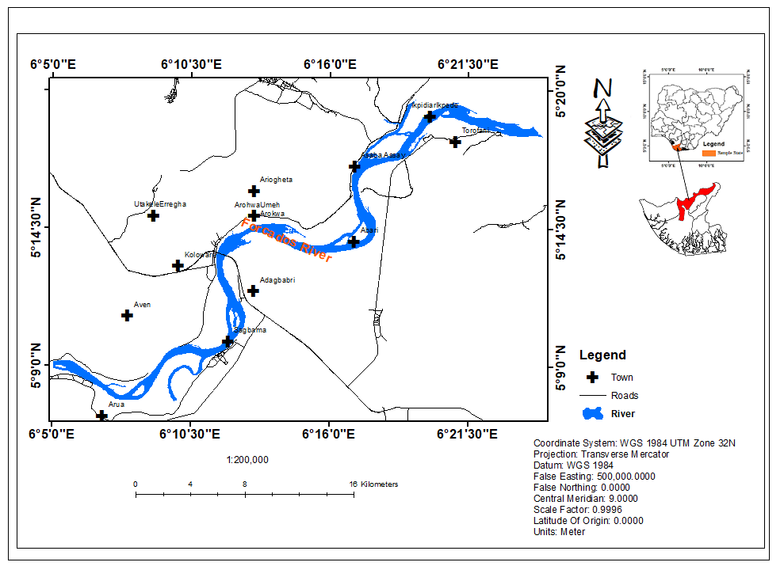
Figure 1: Location of study area
Geomorphologically, the area is characterized by a flat, low-elevation landscape composed of unconsolidated deltaic deposits primarily sands, silts, and clays laid down over time by the Niger River [26],[27],[28],[29]. Elevations generally do not exceed 10 meters above sea level. This low-relief terrain, in conjunction with an intricate drainage network, encourages lateral channel migration and overbank sedimentation. Consequently, the formation of mid-channel and lateral sandbars is common, especially following peak discharge periods when flow energy declines and suspended sediments settle out.
The Forcados River historically functioned as a critical inland navigation corridor, facilitating the transport of agricultural commodities and petroleum products. However, human interventions such as dam construction upstream, dredging activities, and oil infrastructure installations have significantly altered natural hydromorphological regimes [6], [30]. These interventions disrupt sediment continuity and modify depositional environments, leading to shifts in the locations, sizes, and stability of sandbars [9],[31]. These disruptions have cascading impacts on riverine ecosystems, estuarine biodiversity, and the livelihoods of dependent communities, underscoring the need for sustained monitoring and predictive modeling.
Ecologically, the sandbars of the Forcados River are not inert landforms but serve important biological and socio-economic roles. They provide spawning and nesting grounds for fish and avian species, support pioneer vegetation that stabilizes sediment, and host seasonal fishing activities. Badilla et al. [32] note that such estuarine sandbars often support distinct biotic communities, which are highly sensitive to hydrological alterations. In some cases, these sandbars evolve into vegetated semi-permanent islands, changing local flow regimes and supporting community-based resource use.
Socio-economically, the Forcados River corridor is central to Nigeria’s emerging blue economy a development framework promoting sustainable use of aquatic resources for economic growth, livelihood enhancement, and ecosystem integrity [13], [14], [33]. In this context, understanding sedimentary features like sandbars is critical. Properly mapped and managed, they can inform dredging operations, port development, aquaculture zoning, and biodiversity conservation initiatives key pillars of a sustainable blue economy.

3. Materials and Methods

3.1 Analytical Framework
The methodological design of this study integrates remote sensing data acquisition, image preprocessing, sandbar delineation, morphometric parameter extraction, spatial autocorrelation analysis, and sedimentological evaluation to achieve a comprehensive understanding of sandbar evolution along the Forcados River. The workflow involved three key phases: (i) satellite image processing and change detection, (ii) spatial and statistical analysis of sandbar morphometry, and (iii) field-based sediment sampling and granulometric interpretation. The study examined three epochs 2003, 2013, and 2023 to assess decadal-scale changes.

3.2 Data Sources
This research employed a blend of remotely sensed imagery, topographic datasets, and in-situ sediment data:
- Landsat 7 ETM+ (2003) and Landsat 8 OLI/TIRS (2013, 2023) data were downloaded from the United States Geological Survey (USGS) Earth Explorer portal. All images were cloud-free (<10%) and geometrically corrected.
- Google Earth Historical Imagery provided high-resolution visual confirmation and sandbar tracking across the 20-year span.
- Shuttle Radar Topography Mission (SRTM) 30m DEM was used for terrain and elevation analysis.
- Field sediment samples were collected in 2023 from six sandbar sites (SB1–SB6) and analyzed in accordance with the Folk and Ward [22] method.
The combination of temporal and spatial data sources enhanced both the robustness and granularity of the analysis.

3.3 Image Preprocessing and Classification
To extract sandbar features, all Landsat images were atmospherically corrected using the Dark Object Subtraction (DOS1) technique, and the bands were layer-stacked in ArcGIS 10.8. Radiometric corrections were applied to convert digital numbers into top-of-atmosphere reflectance. Water bodies and sandbars were distinguished using the Normalized Difference Water Index (NDWI) [34]. formulated as:
$\text{NDWI}=\frac{(G-NIR)}{(G+NIR)}$ Eq.1
Where G is the green band and NIR is the near-infrared band. NDWI values > 0.1 typically corresponded to open water, while < 0 indicated bare sand and vegetated bars. This spectral contrast facilitated unsupervised classification using the ISODATA algorithm. The resulting thematic layers were manually verified with Google Earth imagery and digitized polygons to delineate sandbars.

3.4 Sandbar Identification and Delineation
Six primary sandbars (SB1–SB6) were consistently detected across the study period, marked by their visibility in all three epochs and their locational persistence within the Forcados River channel. Each sandbar polygon was extracted and labeled, and its geometry recorded for morphometric analysis.
Manual digitization ensured higher boundary accuracy than automatic segmentation alone, as recommended by Blaschke [16], and Baatz & Schape [35]. The positional accuracy of extracted sandbars was cross-validated using historical imagery overlays, particularly during low water levels in the dry season when sandbars were exposed.

3.5 Morphometric Parameters Computation
Nine geometric and shape-based indices were calculated for each sandbar across 2003, 2013, and 2023 (Tables 1–3), following methods used in geomorphic studies [15]:
- Length (L): Longest axis of the sandbar
- Width (W): Maximum perpendicular distance to length
- Area (A): Total surface area
- Perimeter (P): Length of sandbar outline
- Aspect Ratio (AR) = $\frac{L}{W}$ Eq.2
- Elongation Ratio (ER) = $\frac{2\sqrt{\frac{A}{π}}}{L}$ Eq.3
- Circularity (C) = $\frac{4πA}{P^{2}}$ Eq.4
- Compactness (Com) = $\frac{P}{\sqrt{A}}$ Eq.5
- Form Factor (FF) = $\frac{A}{L^{2}}$ Eq.6
These indices helped characterize the shape evolution, complexity, and elongation behavior of each sandbar. For instance, increasing circularity and compactness often indicated stabilization and deposition, while decreasing elongation signaled lateral shifts.

3.6 Statistical and Correlation Analysis
A series of bivariate correlation analyses were performed to evaluate relationships among morphometric variables. Cross-plots were generated between:
- Length vs. Area
- Width vs. Area
- Length vs. Width
The coefficient of determination (R²) exceeded 0.96 in all cases, indicating strong linear relationships between these morphometric metrics and suggesting a predictable sandbar growth behavior. These high correlations also validated the integrity of spatial extraction and analytical consistency over time.

3.7 Spatial Autocorrelation (Moran’s I)
To assess whether sandbar locations exhibited spatial clustering in relation to elevation, Moran’s I spatial autocorrelation was applied using the Global Moran’s I statistic:
$I=\frac{n}{∑∑w_{ij}}⋅\frac{∑∑w_{ij}\left(x_{i}-\overset{ˉ}{x}\right)\left(x_{j}-\overset{ˉ}{x}\right)}{∑{\left(x_{i}-\overset{ˉ}{x}\right)}^{2}}$ Eq. 7
Where:
- $w_{ij}$ is the spatial weight between features i and j,
- $x$ is the attribute (elevation),
- $\overset{ˉ}{x}$ is the mean of attribute x,
- and n is the total number of features.
The results yielded a Moran’s I index of 0.5147, with a z-score of 15.45 and p < 0.001, indicating statistically significant spatial clustering. The clusters, revealing that sandbars tend to form in relatively lower-elevation depressions within the riverbed, enhancing their sediment-trapping capability.

3.8 Sediment Sampling and Grain Size Analysis
Field-based sediment samples were collected from each of the six sandbars using a hand auger at surface depths (0–10 cm). The samples were oven-dried at 105°C and sieved at half-phi intervals using a mechanical shaker. The cumulative grain size distributions were analyzed using the Folk and Ward [22] statistical method, computing the following parameters:
- Mean grain size (Mz): Indicates average grain diameter
- Sorting (σI): Degree of uniformity
- Skewness (SkI): Asymmetry of grain distribution
- Kurtosis (KG): Peakedness of grain curve
The grain size data show that most bars contained medium to coarse sands. For example, SB3 displayed fine sands, well-sorted, while SB5 and SB6 exhibited coarse sand with very leptokurtic curves, indicative of unidirectional energy conditions during deposition. These metrics offered insights into energy conditions and depositional environments.

3.9 Validation and Accuracy Assessment
To ensure the reliability of image-based sandbar detection, a visual validation was conducted by overlaying digitized polygons onto Google Earth historical imagery and field GPS waypoints. The positional accuracy achieved was within ±15 meters, which is acceptable for sandbar-scale geomorphological studies. Additionally, grain size laboratory results were cross-checked with in-situ textural observations and found to be consistent.

4. Results

4.1 Spatiotemporal Changes in Sandbar Geometry (2003–2023)
Over the 20-year observation period, significant changes were observed in the geometric dimensions and shape-based attributes of sandbars SB1–SB6 in the Forcados River within Sagbama LGA, Bayelsa State. Tables 1, 2, and 3 present comprehensive morphometric metrics for the years 2003, 2013, and 2023 respectively. These reveals both persistent and dynamic morphologic responses, likely driven by fluvial hydrodynamics, sediment flux variability, and anthropogenic alterations. In 2003 (Table 1), sandbars displayed an average length of 0.4168 km, with values ranging from 0.1123 km to 4.6751 km. The average area was 0.0154 km², while the width remained relatively narrow (mean of 0.0128 km). The aspect ratio and elongation ratio were high (mean AR = 24.53; ER = 4.87), indicating elongate features, many aligned parallel to the river’s primary flow direction. These sandbars typically formed mid-channel or adjacent to river bends.

Table 1: Sand Bar Geometry and Shape Metrics, Forcados River (2003), Bayelsa State, Nigeria
Parameter | Length (L) km | Area (A)  km² | Width (W) km | Perimeter (P) km | Aspect Ratio (AR) | Elongation Ratio (ER) | Circularity (C) | Compactness (Com) | Form Factor (FF)
Mini | 0.0377 | 0.0001 | 0.0018 | 0.0791 | 16.1971 | 4.0246 | 0.0517 | 0.0112 | 0.0170
Maxi | 3.4683 | 0.2284 | 0.0717 | 7.0683 | 58.8113 | 7.6689 | 0.1721 | 0.9968 | 0.0617
Mean | 0.6961 | 0.0297 | 0.0229 | 1.4379 | 27.2020 | 5.1133 | 0.1212 | 0.2028 | 0.0422
StDev | 0.8327 | 0.0515 | 0.0212 | 1.7002 | 11.9413 | 1.0490 | 0.0366 | 0.2398 | 0.0136

By 2013 (Table 2), notable shifts had occurred. The average length slightly declined to 0.3873 km, and the range narrowed (max = 3.9229 km). However, average area marginally increased to 0.0168 km², and maximum area nearly doubled to 0.4356 km². These metrics suggest sandbar fragmentation and lateral expansion. Morphometric indices such as circularity (mean C = 0.1212) and compactness (mean Com = 0.1129) increased slightly, implying more equant and stabilized bar shapes.
Table 2: Sand Bar Geometry and Shape Metrics, Forcados River (2013), Bayelsa State, Nigeria
Parameter | Length (L) km | Area (A)  km² | Width (W) km | Perimeter (P) km | Aspect Ratio (AR) | Elongation Ratio (ER) | Circularity (C) | Compactness (Com) | Form Factor (FF)
Mini | 0.0375 | 0.0001 | 0.0017 | 0.0784 | 15.5269 | 3.9404 | 0.0382 | 0.0111 | 0.0125
Maxi | 3.9229 | 0.4356 | 0.1110 | 8.0679 | 80.2343 | 8.9574 | 0.1787 | 1.1377 | 0.0644
Mean | 0.3873 | 0.0168 | 0.0129 | 0.8005 | 26.2700 | 5.0478 | 0.1212 | 0.1129 | 0.0421
StDev | 0.6485 | 0.0577 | 0.0195 | 1.3338 | 10.4465 | 0.8930 | 0.0302 | 0.1881 | 0.0112
In 2023 (Table 3), significant geometric expansion was observed. Average sandbar length rose to 0.6961 km, and maximum length, though lower than in 2003, remained considerable (3.4683 km). More notably, the mean area increased to 0.0297 km² almost double the 2003 value while the maximum reached 0.2284 km². This was accompanied by broader widths (mean = 0.0229 km) and increased perimeter lengths, reflecting bar growth in both longitudinal and lateral dimensions. The increase in compactness (mean Com = 0.2028) and form factor (mean FF = 0.0422) in 2023 denotes morphologic maturity and stabilization of sandbars, particularly those situated on the inner banks of meanders and river junctions. The consistency in circularity and the slightly higher kurtosis in sediment profiles support this evolution.

Table 3: Sand Bar Geometry and Shape Metrics, Forcados River (2023), Bayelsa State, Nigeria

Parameter | Length (L) km | Area (A)  km² | Width (W) km | Perimeter (P) km | Aspect Ratio (AR) | Elongation Ratio (ER) | Circularity (C) | Compactness (Com) | Form Factor (FF)
Mini | 0.0377 | 0.0001 | 0.0018 | 0.0791 | 16.1971 | 4.0246 | 0.0517 | 0.0112 | 0.0170
Maxi | 3.4683 | 0.2284 | 0.0717 | 7.0683 | 58.8113 | 7.6689 | 0.1721 | 0.9968 | 0.0617
Mean | 0.6961 | 0.0297 | 0.0229 | 1.4379 | 27.2020 | 5.1133 | 0.1212 | 0.2028 | 0.0422
StDev | 0.8327 | 0.0515 | 0.0212 | 1.7002 | 11.9413 | 1.0490 | 0.0366 | 0.2398 | 0.0136

4.2 Visual Tracking of Sandbar Migration and Accretion
Figures 2 and 3 map the evolution of the six sandbars from 2003 to 2023. Sandbar SB1, initially barely visible in 2003, became clearly emergent in 2013 and prominent by 2023. Similarly, SB2 exhibited a regrowth pattern declining in 2013 and expanding significantly by 2023, suggesting erosion followed by accretion. SB3 remained prominent throughout but shifted laterally downstream, indicating migratory behavior typical of mid-channel bars under variable discharge regimes.
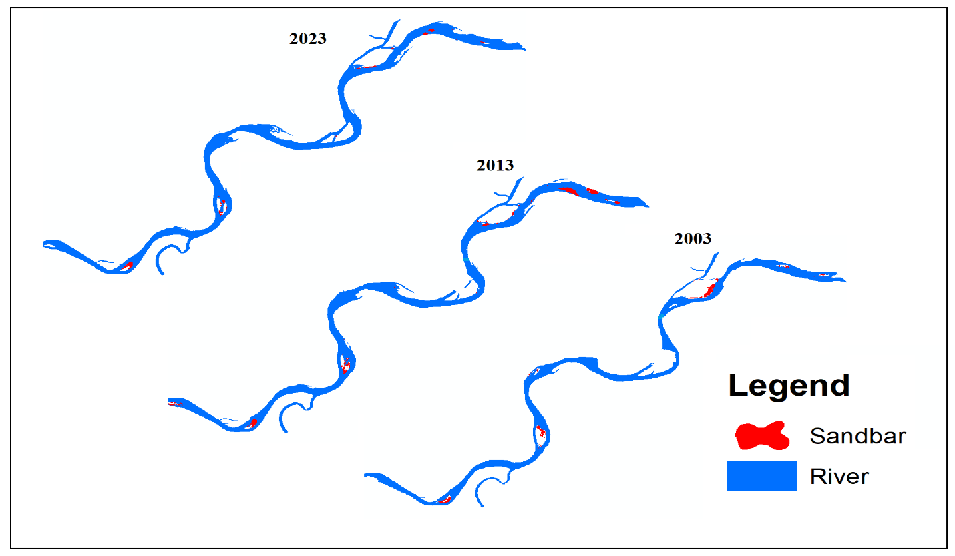
Figure 2: Sand Bars along River Forcados, Sagbama LGA (2003–2023) Bayelsa State, Nigeria
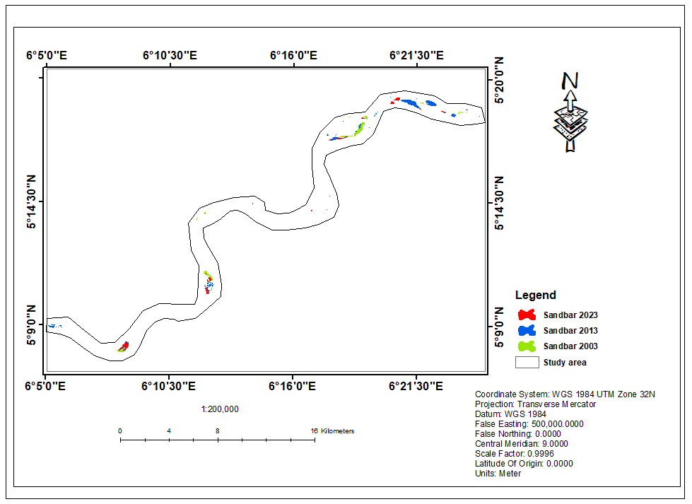
Figure 3: Spatial Distribution of Sand Bars, River Forcados (2003–2023) Bayelsa State, Nigeria
SB4 displayed a gradual increase in area and compactness, reflecting accretion. SB5, initially island-like, maintained its shape and became vegetated, while SB6 showed consistent linear expansion across all epochs. These trends are further summarized in Table 3, which classifies the evolutionary status of each sandbar based on temporal visibility and morphological shifts.
Google Earth imagery snapshots (Figure 4) provided temporal validation of these changes, with dry season exposures revealing the footprint expansion of SB1 and SB5 in particular. These visual cues correlated strongly with classification outputs from NDWI and polygon extraction layers.
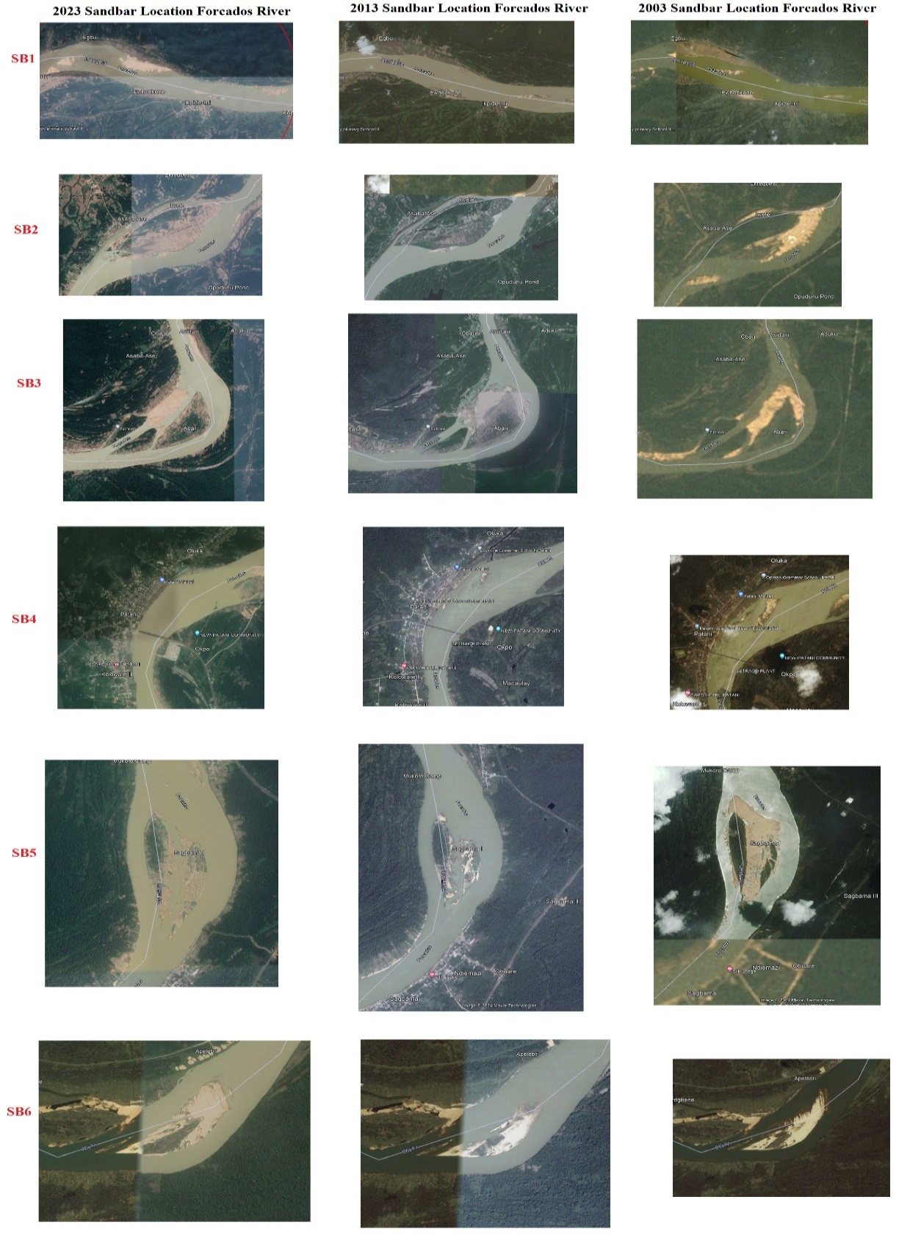
Figure 4: Google Earth Snapshot of Sand Bars, River Forcados (2003–2023) Bayelsa State, Nigeria

4.3 Morphometric Relationship Analysis
The geometric relationships between sandbar attributes were statistically significant. Figure 5 presents a cross-plot of sandbar length versus area, revealing a strong positive correlation with R² = 0.9695. This indicates that longer sandbars also tend to possess larger surface areas, a reflection of depositional continuity along flow axes.
Figure 5 plots width versus area, again showing a high correlation (R² = 0.9936), reinforcing the observation that both lateral and longitudinal expansions are synchronized in the development of these bars. Figure 5s length versus width cross-plot yields R² = 0.9909, confirming that sandbar geometry is governed by consistent depositional and flow-driven dynamics.
These high correlation values across all pairwise comparisons validate the classification methodology and reflect the physical behavior of fluvial sediment deposition under constant flow variability.

Figure 5: Cross plot between the length and area of all identified sand bars (R²=0.9695)

Figure 6: Cross plot between the width and area of all identified sand bars (R²=0.9936)

Figure 7: Cross plot between the length and width of all identified sand bars (R²=0.9909)

4.4 Spatial Autocorrelation with Elevation
Spatial clustering analysis using Moran’s I statistic further reveals the spatial distribution tendencies of sandbars. Table 4 shows the computed Global Moran’s Index = 0.5147, with a Z-score = 15.45 and p < 0.0001, indicating statistically significant clustering of sandbars relative to elevation.
Table 4: Spatial autocorrelation result between Sand bar and elevation in Forcados River, in Niger Delta
Global Moran’s | Summary
Moran's Index | 0.514699
Expected Index | -0.000994
Variance | 0.00114
Z-Score | 15.449795
p-value | 0

The expected index of -0.000994 and the narrow variance (0.00114) affirm the non-random distribution of sandbar locations. Figure 7 visually displays these clusters, which were concentrated in low-lying inner meander bends and braided sections of the river. This finding underscores the importance of microtopography in sandbar initiation and stabilization, where low elevation promotes sediment entrapment during high-discharge events.

4.5 Sedimentological Characteristics of Sandbars
Table 5 presents the granulometric statistics of surface sediments from the six sandbars, based on the Folk and Ward [22] method. The mean grain size across samples ranged from 0.4 mm to 2.37 mm, corresponding to coarse to fine sand classes. Most bars (SB1, SB2, SB5, SB6) were composed of coarse sand, while SB3 stood out with fine sand indicative of calmer depositional environments.
Sorting values (σI) ranged from 0.51 (well sorted) in SB3 to 0.94 (moderately sorted) in SB4. This variation reflects differences in depositional energy: well-sorted sands form under steady flow regimes, while moderate sorting suggests variable currents and sediment input.
Skewness ranged from -0.62 (strongly coarse-skewed) to +0.25 (fine-skewed), pointing to asymmetry in particle distributions. Coarse skewness in SB4 to SB6 suggests dominant deposition of larger particles, likely due to upstream sediment pulses. In contrast, the fine-skewed nature of SB1 and SB2 implies sorting under lower energy conditions.
Kurtosis values ranged from 1.03 to 1.57, with SB4–SB6 showing leptokurtic and very leptokurtic patterns. This peaked distribution supports the observation of bar crest formation under energetic flow regimes that favor uniform sediment layering.
These sedimentological results not only support the morphometric findings but also provide insights into sediment transport pathways and depositional environments. For example, the relatively homogeneous coarse sands in SB5 and SB6 may explain their structural resilience and persistence over time.
Table 5: Statistical parameter analysis of Grain size of sediment in sand bar location in River Forcados using Folk & Ward[22]
Code | MEAN | Interpretation | SORTING | Interpretation | SKEWNESS | Interpretation | KURTOSIS | Interpretation
SB1 | 1.22 | Medium Sand | 0.87 | Moderately Sorted | 0.25 | Fine Skewed | 1.07 | Mesokurtic
SB2 | 1.16 | Medium Sand | 0.85 | Moderately Sorted | 0.22 | Fine Skewed | 1.05 | Mesokurtic
SB3 | 2.37 | Fine Sand | 0.51 | Well Sorted | -0.21 | Coarse Skewed | 1.03 | Mesokurtic
SB4 | 0.4 | Coarse sand | 0.94 | Moderately Sorted | -0.52 | Coarse Skewed | 1.42 | Leptokurtic
SB5 | 0.71 | Coarse sand | 0.87 | Moderately Sorted | -0.60 | Coarse Skewed | 1.54 | Very Leptokurtic
SB6 | 0.60 | Coarse sand | 0.89 | Moderately Sorted | -0.62 | Coarse Skewed | 1.57 | Very Leptokurtic

4.6 Sandbar Evolution and Blue Economy Implications
The classification of sandbar evolution in Table 5 reveals varied developmental pathways. While SB1 and SB2 exhibit formation and regrowth, SB3 and SB4 show migration and accretion, and SB5 and SB6 represent stabilized sand-island structures. These divergent pathways illustrate the complex interplay between hydrology, sediment dynamics, and local geomorphology.
Such morphological behavior has implications for navigation, estuarine habitat health, and aquaculture zoning. For instance, the stabilization of SB5 opens possibilities for low-impact tourism or ecological restoration activities. Conversely, the lateral migration of SB3 signals potential hazards for riverine transport infrastructure.
Moreover, the morphological maturity observed in 2023, supported by increases in compactness, perimeter, and area, signals that these features are becoming semi-permanent fixtures in the riverine landscape. As such, they warrant inclusion in marine spatial planning frameworks, especially under Nigeria’s expanding blue economy agenda.

5. Discussion

5.1 Interpreting Morphometric Trends in Sandbar Evolution
The morphometric analysis presented in this study confirms that sandbars along the Forcados River exhibit discernible patterns of growth, migration, and stabilization over the 20-year observation period. The steady increase in average sandbar area from 0.0154 km² in 2003 to 0.0297 km² in 2023 (Tables 1–3) reflects a broader trend of sediment accretion and lateral expansion, likely influenced by sediment flux regulation, climate-driven hydrological variability, and morphological feedback mechanisms. Similar trends have been documented by Gijsman et al. [19] along curved estuarine shorelines and by Lee et al. [18] in the Nakdong River Estuary, where bar expansion was linked to altered hydrodynamics and sediment capture efficiency.
The Forcados River system, characterized by its relatively low gradient and high sediment load, provides a favorable setting for the formation of mid-channel and lateral bars. The rise in compactness and circularity indices (Table 3) by 2023 suggests a transition from transient to more stable bar formations. This finding echoes earlier research by Leuven et al. [36], who observed that topographic forcing in irregular estuaries governs bar geometry and longevity. The increasing values of the aspect ratio and elongation ratio are also consistent with the elongation and maturity of bars in high-discharge systems [1], [37].
Notably, the cross-plots (Figures 5–7) revealed near-perfect linear correlations (R² > 0.96) among sandbar length, width, and area, reinforcing the coherence and predictability of bar morphometry in this dynamic fluvial environment. These strong correlations mirror the outcomes of similar studies in tropical river deltas, such as those by Gu et al. [38] along the Mekong River, who attributed bar morphology to sediment supply, channel depth, and bankfull discharge frequency.

5.2 Spatial Clustering and Elevation Dependencies
The spatial clustering of sandbars, as revealed by the high and statistically significant Global Moran’s Index (0.5147; p < 0.001), underscores the role of elevation and localized channel topography in bar formation. Clustering patterns shown in Figure 7 correspond to zones with lower elevation and greater cross-sectional width, which enhance sediment deposition during the falling stage of seasonal floods. These findings support previous work by Petts [7] and Hickin & Nanson [8], who highlighted the importance of eddy zones and inner bank deposition in bar genesis.
The elevation-sandbar relationship is further strengthened by the positive skewness of sediment distributions in SB1 and SB2 (Table 5), suggesting finer sediments settle in areas with gentle slope gradients and low-energy backwaters. In contrast, SB4 to SB6 located in high-energy segments of the channel exhibited coarse skewness and very leptokurtic grain size curves, suggesting uniform grain sizes deposited under vigorous flows, typical of depositional lobes forming on channel margins [39].
This spatial distribution is relevant to riverine hazard mapping and sediment dredging strategies. Concentrated sandbar formation in low-lying clusters may indicate vulnerability zones where sediment congestion could hinder navigation or alter floodplain connectivity. A similar conclusion was reached by Miselis et al. [40], who linked bar clustering to sediment supply dynamics and foreshore slope on the U.S. Gulf Coast.

5.3 Sediment Characteristics and Depositional Environment
The sedimentological analysis revealed medium to coarse sand as the dominant grain size, with sorting values indicating moderately sorted to well-sorted sediments. These textural properties align with previous studies in deltaic rivers where high sediment load and variable discharge create dynamic depositional environments [22],[41]. In particular, SB3 exhibited finer grains and better sorting, suggesting deposition in a more stable, low-energy eddy zone, while SB4 to SB6 presented coarser grains with leptokurtic curves, typical of bar apex or mid-bar zones subject to recurrent inundation and peak flow energy [32].
These results align with sedimentological models of bar accretion described by Goldstein et al. [17], which emphasize the balance between sediment supply, bedform migration, and hydrodynamic energy. The persistent coarse-grained texture of SB5 and SB6 likely contributes to their morphologic resilience and ability to support vegetation colonization, consistent with findings by Taveneau et al. [42] and Paul & Harris [43] on vegetated sand-islands in tidal estuaries.
From a geotechnical standpoint, the uniformity in sediment texture suggests that these bars could support low-impact uses such as controlled aquaculture ponds or community-scale navigation aids. However, caution must be exercised as bar composition can vary seasonally and may not always offer mechanical stability for structural anchoring.

5.4 Sandbar Dynamics, Climate Drivers, and Anthropogenic Impacts
Hydrological variability, driven by seasonal rainfall and upstream dam regulation, exerts a profound influence on sandbar formation and transformation in the Forcados River. The increase in river area from 31.16 km² in 2003 to 46.71 km² in 2023 (Table 4) suggests increased floodplain inundation and lateral channel migration both of which create favorable conditions for sandbar nucleation. This aligns with the documented effects of dam operation and sediment retention upstream [31].
Climate-induced alterations in rainfall patterns and flood frequency in the Niger Delta may also be exacerbating bar formation. Eteh et al. [6] linked recent flood intensification in the Niger Delta to changing monsoonal dynamics and rising sea levels, which increase backwater effects and trap sediment in mid-channel bars. These hydroclimatic drivers, coupled with localized human pressures such as sand mining, dredging, and oil exploration, complicate sediment transport pathways and bar morphology [44], [14].
The anthropogenic alteration of the Forcados River is particularly evident in SB3 and SB4, which exhibit lateral migration and shape asymmetry across epochs. These may be responses to dredging operations or riverbank channelization near infrastructural nodes. Similar patterns were observed by Wang et al. [2] in the Lancang River, where extensive human interventions altered fluvial morphology and bar migration trajectories.

5.5 Contribution to Blue Economy and River Basin Management
The insights gained from this study have significant implications for Nigeria’s marine blue economy ambitions. The stable expansion and persistence of sandbars, particularly SB5 and SB6, provide opportunities for habitat restoration, mangrove expansion, and sustainable aquaculture zones. As observed in the Philippines and Senegal [32],[42], such sandbars can serve as ecological hotspots and microhabitats for estuarine biodiversity.
The potential use of sandbars for low-impact ecotourism, artisanal fishing bases, and inland docking stations must be approached with a rigorous understanding of their temporal variability and structural stability. The mapped sandbars can serve as natural buffers, reducing wave energy and enhancing bank stability, which are essential services for deltaic resilience under climate stress.
Moreover, by integrating remote sensing and spatial analytics, this research provides a replicable and scalable framework for long-term sandbar monitoring across Nigeria’s river systems. Such frameworks are critical for spatial zoning, flood risk modeling, inland shipping route optimization, and environmental impact assessments aligned with the Integrated Coastal Zone Management (ICZM) strategy [45], [46] [47].[48]

5.6 Comparison with Global Case Studies
Globally, sandbar mapping using satellite imagery has proven essential for understanding coastal and fluvial morphodynamics. Studies in the U.S. Missouri River [49], Curonian Spit in Lithuania [50], and the Rhine-Meuse Delta [51] have all demonstrated the critical role of sandbars in sediment redistribution, habitat connectivity, and shoreline stability. This study adds to the global evidence base by providing a longitudinal, sedimentologically informed mapping of sandbars in a tropical delta under significant hydrological and anthropogenic pressures.
The methodological combination of Landsat-derived indices, object-based segmentation, and morphometric profiling as demonstrated here can be replicated in other data-sparse regions. It also supports calls for the democratization of geospatial data for local environmental governance [16], [34]. Notably, the integration of satellite imagery with field-based sediment analysis allows for more robust interpretations than remote sensing alone strength of this study.

5.7 Limitations and Methodological Considerations
Despite its comprehensive approach, the study is not without limitations. First, the spatial resolution of Landsat imagery (30 m) may limit the detection of narrow or low-relief sandbars, potentially underestimating small-scale morphological variability. High-resolution drone imagery or commercial satellite data (e.g., SPOT, WorldView) could offer improved granularity for future studies. Secondly, hydrodynamic data (e.g., discharge, velocity) were not integrated due to unavailability; their inclusion would enhance modeling of bar migration processes.
The sediment analysis, though informative, was based on surface samples only. Subsurface coring could reveal depositional history and stratigraphy. Moreover, the study used three decadal time-points; seasonal analysis or higher temporal frequency would provide a more nuanced understanding of ephemeral and semi-permanent bar dynamics.
Nonetheless, the integration of satellite-derived morphometrics with field validation and spatial statistics presents a methodologically rigorous contribution to the literature on sandbar dynamics and blue economy planning in tropical riverine systems.

6. Implications for the Marine Blue Economy
The evolving spatial dynamics and geomorphic characteristics of sandbars along the Forcados River underscore their significance not just as fluvial features, but as foundational elements in the development of a sustainable marine blue economy in Nigeria’s Niger Delta. As evidenced by this study’s multi-decadal analysis, sandbars are increasingly transforming into semi-permanent geomorphological units expanding in area, stabilizing in form, and in some cases, supporting early-stage vegetation. These transitions signal opportunities for integrating sandbar landscapes into blue economy planning frameworks, particularly in the areas of environmental sustainability, fisheries development, ecotourism, and inland maritime logistics.
The blue economy, defined by the World Bank as the “sustainable use of ocean resources for economic growth, improved livelihoods, and jobs while preserving the health of ocean ecosystems,” requires localized frameworks that include not only offshore marine zones but also riverine and estuarine environments. The Forcados River, a key conduit linking inland Nigeria to the Atlantic, plays a strategic role in this context. The consistent formation and persistence of sandbars such as SB5 and SB6 present natural platforms that can be harnessed for low-impact, sustainable activities, especially if managed with ecological sensitivity.
One of the primary opportunities lies in leveraging stabilized sandbars as ecological habitats and biodiversity hotspots. The granulometric data from this study (Table 5) confirm the dominance of well-graded, coarse sediments, which are conducive to the establishment of pioneer vegetation species such as Cyperus and Ipomoea that often precede mangrove colonization. These vegetated sandbars can enhance carbon sequestration, promote sediment stabilization, and serve as nursery grounds for juvenile fish and crustaceans, echoing similar ecosystem services observed in estuarine sandbars in Asia and West Africa [32], [13].
Furthermore, sandbars can be zoned for sustainable aquaculture development. Their proximity to navigable channels, relative isolation from urban pollution sources, and seasonal exposure during low flow periods make them suitable for cage farming of catfish, tilapia, and shellfish species that dominate local fisheries. However, such activities must be guided by environmental impact assessments and seasonal monitoring of bar stability to prevent unintended sediment disturbances.
The potential for inland navigation enhancement is another area where sandbars intersect with the blue economy. In the Forcados corridor, certain sandbars particularly SB3 and SB4 were observed to migrate laterally (Table 5), at times encroaching into mid-channel zones. If left unmonitored, such features can impede river navigation and increase dredging costs for inland shipping routes. A predictive monitoring system, informed by the methodology used in this study, could help forecast bar formation zones, enabling better planning for dredging schedules and navigational risk assessments. This aligns with national objectives to revitalize inland waterways for cargo transport, as championed by the Nigerian Inland Waterways Authority (NIWA).
Additionally, the presence of persistent sandbars opens avenues for community-based ecotourism and cultural tourism. Local communities, such as those in Toru-Orua and Aleibiri in Sagbama LGA, could develop canoe tours, birdwatching activities, and seasonal festivals centered around riverine ecology, with sandbars serving as natural platforms or stopover points. This type of engagement has been successfully piloted in deltaic communities in Senegal and Bangladesh [42], [9]. However, such interventions require investment in community capacity-building, environmental education, and the provision of safety and navigational infrastructure.
From a coastal resilience perspective, sandbars can also serve as natural buffers against erosion and storm surge, particularly in the lower reaches of the Forcados River closer to the Atlantic coastline. As sea-level rise and upstream hydrological changes continue to reshape deltaic environments, these features can absorb wave energy and reduce the erosive force on adjacent riverbanks. Strategic preservation of these bars through exclusion from sand mining zones and integration into riparian buffer planning could support shoreline protection goals under the Nigerian National Adaptation Strategy and Plan of Action for Climate Change (NASPA-CCN).
Moreover, the insights from this study directly support marine spatial planning (MSP), which is gaining momentum across Nigeria’s coastal states. Accurate mapping of sandbar locations and their evolutionary trends can inform zoning decisions, especially in identifying conservation areas, navigational corridors, and aquaculture clusters. This is particularly relevant to Bayelsa State’s Integrated Coastal Zone Management (ICZM) plan, where sediment management and delta stability are recognized as priority action areas.
At a policy level, the application of geospatial tools as demonstrated in this research offers a cost-effective and scalable method for long-term monitoring of sedimentary features critical to blue economy infrastructure. The integration of object-based image analysis (OBIA), statistical modeling (Moran’s I), and morphometric indices provides a replicable framework that can be adopted by government agencies such as the Nigerian Maritime Administration and Safety Agency (NIMASA), the Nigerian Hydrological Services Agency (NIHSA), and the Federal Ministry of Water Resources. These agencies can build geospatial dashboards that track sandbar evolution and issue alerts for potential navigation blockages, sediment congestion, or ecological shifts.

7. Conclusion and Recommendations
The spatiotemporal analysis of sandbar evolution along the Forcados River over a 20-year period has revealed critical insights into the geomorphic dynamics of this vital fluvial corridor in Nigeria’s Niger Delta. Through the integration of satellite remote sensing, morphometric analysis, statistical modeling, and sedimentological evaluation, the study identified six persistent sandbars (SB1–SB6) and traced their transformation from nascent features in 2003 to increasingly stable and expansive formations in 2023. The progressive increase in sandbar area, shape compactness, and width-to-length ratios underscores a trajectory of geomorphic maturity driven by a combination of natural sediment deposition processes and anthropogenic modifications to river flow regimes.
The application of Landsat imagery, supported by Google Earth historical snapshots, allowed for accurate temporal tracking of sandbar geometry and migration. The computed morphometric indices, including aspect ratio, elongation ratio, circularity, and form factor quantitatively demonstrated the shifting nature of sandbars from elongated, ephemeral features to more equant and compact formations, particularly in SB5 and SB6. These morphological transitions were further validated through high correlations (R² > 0.96) among sandbar dimensions, suggesting predictable growth and spatial coherence.
The spatial autocorrelation analysis using Global Moran’s I provided a statistically robust indication of clustering between sandbar locations and low-elevation zones, affirming the influence of microtopography and localized hydraulic energy on bar formation. Moreover, the sedimentological results revealed medium to coarse sand compositions, with well to moderately sorted textures and kurtosis values pointing to consistent deposition under varying energy regimes. These findings not only confirm the physical resilience of the sandbars but also highlight their potential to support ecological colonization and multifunctional use.
From a practical standpoint, the implications of these results are wide-ranging. The stabilized sandbars, particularly those with vegetated components, present opportunities for low-impact blue economy activities such as artisanal fisheries, aquaculture siting, and ecotourism. In contrast, the lateral migration of bars like SB3 and SB4 poses navigational risks that require continuous monitoring and adaptive dredging strategies. Importantly, the identification of geomorphologically stable sandbars can inform marine spatial planning (MSP) and integrated coastal zone management (ICZM) frameworks being developed in Bayelsa State and across the Niger Delta.
This study contributes to the growing body of knowledge on riverine sedimentary processes in tropical deltas and reinforces the utility of geospatial tools in long-term environmental monitoring. It builds upon earlier studies such as those by Eteh et al.,[6], Okpara & Offiong [4], Gijsman et al. [19], Akhter et al. [52] while offering a novel methodological integration of remote sensing, OBIA, spatial statistics, and granulometric evaluation. The outputs including maps, correlation plots, and cluster diagrams serve as replicable templates for deltaic river systems experiencing similar sedimentary dynamics.
Based on the insights derived from this study, several key recommendations are proposed to guide future research, policy, and sustainable development practices in the Niger Delta and other fluvial systems:
- Institutionalize Geospatial Sandbar Monitoring: Government agencies such as NIHSA, NIMASA, and the Nigerian Ministry of Environment should adopt the geospatial methodologies demonstrated in this study to develop sandbar monitoring dashboards. These platforms should integrate Landsat/Sentinel data with near-real-time visualization of bar formation, migration, and erosion hotspots.
- Incorporate Sandbar Dynamics into Blue Economy Zoning: The persistence and expansion of sandbars should inform the delineation of sustainable aquaculture zones, navigational corridors, and ecological buffer areas in coastal and riverine spatial plans. Stabilized sandbars can be zoned for low-impact livelihood activities, with seasonal monitoring to ensure ecological integrity.
- Deploy Drones and High-Resolution Imagery for Fine-Scale Mapping: While Landsat proved effective for long-term trend analysis, drone-based photogrammetry and commercial satellite imagery (e.g., PlanetScope, WorldView) should be used to capture high-resolution snapshots of small or ephemeral bars, particularly in narrow river sections.
- Integrate Hydrodynamic Modeling and Sediment Transport Analysis: Future research should incorporate flow velocity, discharge data, and sediment load measurements to simulate sandbar development under various hydrological scenarios. This will support predictive modeling under climate change and dam regulation conditions.
- Promote Community-Based Management of Sandbars: Local communities should be engaged in participatory mapping, monitoring, and sustainable use of sandbar features. Training programs and livelihood support mechanisms can align environmental stewardship with income generation through controlled fishing, ecotourism, and small-scale aquaculture.
- Establish Sediment Management Guidelines: The Nigerian government should develop a national sediment management policy that includes guidelines for dredging near sandbar zones, restrictions on sand mining in ecologically sensitive areas, and protocols for monitoring post-dredging bar regeneration.
- Develop Early-Warning Systems for Navigational Hazards: Given the migratory nature of certain sandbars, real-time warning systems using GPS and remote sensing data should be established to alert inland navigation operators of emerging hazards, particularly during peak sediment transport seasons.
In summary, this study reinforces the view that sandbars are not merely passive deposits but active agents in shaping river morphology, ecology, and economic potential. In a region as ecologically sensitive and economically strategic as the Niger Delta, their monitoring and sustainable utilization are imperative. By harnessing the power of geospatial technology, sediment science, and participatory governance, Nigeria can position sandbar systems as pillars of a resilient and inclusive blue economy.

Limitations and Future Work
This study’s accuracy was limited by Landsat’s 30 m resolution, decade-spaced imagery, lack of hydrological data, and reliance on surface sediment samples. These constraints reduced detection of small/seasonal sandbars, missed short-term changes, and prevented process-based and stratigraphic insights. The method was also untested beyond the Forcados River. Future work should apply higher-resolution, frequent multi-sensor data, integrate hydrodynamic modeling, include core sediment analyses, and test scalability across other Niger Delta rivers.

COMPETING INTERESTS
Authors have declared that they have no known competing financial interests OR non-financial interests OR personal relationships that could have appeared to influence the work reported in this paper.

Disclaimer (Artificial intelligence)
Author(s) hereby declare that NO generative AI technologies such as Large Language Models (ChatGPT, COPILOT, etc.) and text-to-image generators have been used during the writing or editing of this manuscript.

References

- Komar, P. D. (1996). Mechanics of coarse sediment transport. CRC Press.
- Wang, P., Fu, K., Huang, J., Duan, X., & Yang, Z. (2020). Morphological changes in the lower Lancang River due to extensive human activities. PeerJ, 8, e9471. https://doi.org/10.7717/peerj.9471
- Kuang, C., Han, X., Zhang, J., Zou, Q., & Dong, B. (2021). Morphodynamic evolution of a nourished beach with artificial sandbars: Field observations and numerical modeling. Journal of Marine Science and Engineering, 9(3), 245. https://doi.org/10.3390/jmse9030245
- Okpara, D., & Offiong, M. B. (2020). Morphodynamics of river and coastal transport of sediments in mega delta basin, Niger Delta Nigeria. IOP Conference Series: Earth and Environmental Science, 424, 012010. https://doi.org/10.1088/1755-1315/424/1/012010
- Eteh, D. R., Paaru, M., Egobueze, F. E. & Okpobiri, O. (2024). Utilizing machine learning and DSAS to analyze historical trends and forecast future shoreline changes along the River Niger, Niger Delta. Water Conservation Science and Engineering, 9, 91. https://doi.org/10.1007/s41101-024-00324-1
- Eteh, D. R., Japheth, B. R., Akajiaku, C. U., Osondu, I., Mene-Ejegi, O. O., Nwachukwu, E. M., Oriasi, M. D., Omietimi, E. J., & Ayo-Bali, A. E. (2025). Assessing the impact of climate change on flood patterns in downstream Nigeria using machine learning and geospatial techniques (2018–2024). Discover Geoscience, 3, 76. https://doi.org/10.1007/s44288-025-00178-7
- Petts, G. E. (1984). Sedimentation within a regulated river. Earth Surface Processes and Landforms, 9(2), 125–134.
- Hickin, E. J., & Nanson, G. C. (1984). Lateral migration rates of river bends. Journal of Hydraulic Engineering, 110(11), 1557–1567.
- Syvitski, J. P. M., Vörösmarty, C. J., Kettner, A. J., & Green, P. (2005). Impact of humans on the flux of terrestrial sediment to the global coastal ocean. Science, 308(5720), 376–380. https://doi.org/10.1126/science.1109454
- Massazza, G., Bacci, M., Descroix, L., Ibrahim, M. H., Fiorillo, E., Katiellou, G. L., ... & Sauzedde, E. (2021). Recent changes in hydroclimatic patterns over medium Niger River basins at the origin of the 2020 flood in Niamey (Niger). Water, 13(12), 1659. https://doi.org/10.3390/w13121659
- Okpobiri, O., Akajiaku, C. U., Eteh, D. R., & Moses, P. (2025). Using machine learning and GIS to monitor sandbars along the River Niger in the Niger Delta, Nigeria. International Journal of Environment and Climate Change, 15(2), 182–203. https://doi.org/10.9734/ijecc/2025/v15i24721
- Eteh, D. R., Egobueze, F. E., Paaru, M., Otutu, A. O., & Osondu, I. (2024). The impact of dam management and rainfall patterns on flooding in the Niger Delta: Using Sentinel-1 SAR data. Discover Water, 4, 123. https://doi.org/10.1007/s43832-024-00185-8
- Lawson, S. K., Udo, K., Tanaka, H., & Bamunawala, J. (2023). Littoral drift impoundment at a sandbar breakwater: Two case studies along the Bight of Benin Coast (Gulf of Guinea, West Africa). Journal of Marine Science and Engineering, 11(9), 1651. https://doi.org/10.3390/jmse11091651
- Malhi, Y., Franklin, J., Seddon, N., Solan, M., Turner, M. G., Field, C. B., & Knowlton, N. (2020). Climate change and ecosystems: Threats, opportunities and solutions. Philosophical Transactions of the Royal Society B, 375(1794), 20190104. https://doi.org/10.1098/rstb.2019.0104
- Janušaitė, R., Jukna, L., Jarmalavičius, D., Pupienis, D., & Žilinskas, G. (2021). A novel GIS-based approach for automated detection of nearshore sandbar morphological characteristics in optical satellite imagery. Remote Sensing, 13(11), 2233. https://doi.org/10.3390/rs13112233
- Blaschke, T. (2010). Object-based image analysis for remote sensing. ISPRS Journal of Photogrammetry and Remote Sensing, 65(1), 2–16. https://doi.org/10.1016/j.isprsjprs.2009.06.004
- Goldstein, E. B., Coco, G., & Plant, N. G. (2019). A review of machine learning applications to coastal sediment transport and morphodynamics. Earth-Science Reviews, 194, 97–108. https://doi.org/10.1016/j.earscirev.2019.03.003
- Lee, S. H., Hyun, C. U., & Kim, S. B. (2024). Assessing sandbar morphology in the Nakdong River Estuary using SPOT series satellite imagery. Marine Georesources & Geotechnology, 1–11. https://doi.org/10.1080/1064119X.2024.2378074
- Gijsman, R., Ruessink, G., Visscher, J., & Schlurmann, T. (2020). Observations on decadal sandbar behaviour along a large-scale curved shoreline. Earth Surface Processes and Landforms, 45, 145–162. https://doi.org/10.1002/esp.5041
- Jonathan, L. E., & Charles, A. U. (2025). Shoreline Erosion and Accretion Analysis of the Orashi River, Rivers State, Nigeria: A Geospatial and Machine Learning Approach. Asian Journal of Geographical Research, 8(2), 27–44. https://doi.org/10.9734/ajgr/2025/v8i2260
- Ferreira, A. M., Coelho, C., & Silva, P. A. (2024). Numerical evaluation of the impact of sandbars on cross-shore sediment transport and shoreline evolution. Journal of Environmental Management, 370, 122835. https://doi.org/10.1016/j.jenvman.2024.122835
- Folk, R. L., & Ward, W. C. (1957). Brazos River bar: A study in the significance of grain size parameters. Journal of Sedimentary Research, 27(1), 3–26.
- Etu-Efeotor, J. O., & Odigi, M. I. (1983). Water supply problems in the Eastern Niger Delta. Journal of Mining and Geology, 20(1–2), 183–193.
- Short, K. C., & Stauble, A. J. (1967). Outline geology of the Niger Delta. AAPG Bulletin, 51(5), 761–779.
- Bamiekumo, B. P., Akpobome, E. O., Kemebaradikumo, A. N., Mene-Ejegi, O. O., & Eteh, D. R. (2025). Machine learning-based flood extent mapping and damage assessment in Yenagoa, Bayelsa State, using Sentinel-1 and -2 imagery (2018–2022). Discovery Nature, 2(3), e2dn1041. https://doi.org/10.54905/disssi.v2i3.e2dn1041
- Weber, K. J., & Daukoru, E. M. (1975). Petroleum geology of the Niger Delta. In Proceedings of the 9th World Petroleum Congress (Vol. 2, pp. 210–221). Applied Science Publishers.
- Etu-Efeotor, J. O., & Akpokodje, E. G. (1990). Aquifer systems of the Niger Delta. Journal of Mining and Geology, 26(2), 279–285
- Abaye, E. O., Ayowei, A. H., Akajiaku, U. C., & Eteh, D. R. (2022). Implication of landscape changes using Google Earth historical imagery in Yenagoa, Bayelsa State, Nigeria. Sumerianz Journal of Scientific Research, 5(1), 20–31
- Imoni, O., & Jonathan, E. L. (2025). Data-driven assessment of soil heavy metal contamination in Joinkrama, Rivers State, Nigeria using pollution indices and multivariate analytics. Journal of Materials Science Research and Reviews, 8(3), 628–643. https://doi.org/10.9734/jmsrr/2025/v8i3429
- Jonathan, L. E., Winston, A. G., & Chukwuemeka, P. (2025). Machine learning and morphometric analysis for runoff dynamics: Enhancing flood management and catchment prioritization in Bayelsa, Nigeria. Journal of Computational Systems and Applications, 2(2), 1–16. https://doi.org/10.63623/kkx1m906
- Gupta, H., Kao, S. J., & Dai, M. (2012). The role of mega dams in reducing sediment fluxes: A case study of large Asian rivers. Journal of Hydrology, 464, 447–458.
- Badilla, M. J. G., Pabatang, S. J. T., Norberte, D. R., Mercado, R. L., Bulay, M. L., & Berame, J. S. (2023). Diversity index of species in sandbar present in estuarine ecosystem of Agusan River, Philippines: Its threat, management and conservation. International Journal of Biology, 23(2), 47–59.
- Jonathan EL, Imoni O, Chukwuemeka P, Eteh DR. (2025) Impact of oil spills on mangrove ecosystem degradation in the Niger Delta using remote sensing and machine learning. Journal of Geography and Cartography. 2025; 8(2): 11707. https://doi.org/10.24294/jgc11707
- McFeeters, S. K. (1996). The use of the Normalized Difference Water Index (NDWI) in the delineation of open water features. International Journal of Remote Sensing, 17(7), 1425–1432. https://doi.org/10.1080/01431169608948714
- Baatz, M., & Schape, A. (2000). Multiresolution segmentation: An optimization approach for high quality multi-scale image segmentation. In J. Strobl, T. Blaschke, & G. Griesbner (Eds.), Angewandte Geographische Informations-Verarbeitung XII (pp. 12–23). Wichmann Verlag.
- Leuven, J., Haas, T., Braat, L., & Kleinhans, M. G. (2018). Topographic forcing of tidal sandbar patterns for irregular estuary planforms. Earth Surface Processes and Landforms, 43, 172–186. https://doi.org/10.1002/esp.4184

- Knighton, D. (1998). Fluvial forms and processes: A new perspective. Routledge
- Miselis, J. L., Flocks, J. G., Zeigler, S., Passeri, D., Smith, D. R., Bourque, J., ... & Yanchis, K. (2021). Impacts of sediment removal from and placement in coastal barrier island systems. U.S. Geological Survey Open-File Report 2021–1062, 94 pp. https://doi.org/10.3133/ofr20211062
- Sun, X., Liu, Y., & Liu, Z. (2017). Influences of grain size distribution on the erosion and stability of riverbeds. Journal of Mountain Science, 14(3), 446–459. https://doi.org/10.1007/s11629-016-4041-4
- Miselis, J. L., Flocks, J. G., Zeigler, S., Passeri, D., Smith, D. R., Bourque, J., ... & Yanchis, K. (2021). Impacts of sediment removal from and placement in coastal barrier island systems. U.S. Geological Survey Open-File Report 2021–1062, 94 pp. https://doi.org/10.3133/ofr20211062
- Islam, M., Yamaguchi, Y., & Ogawa, K. (2001). Suspended sediment in the Ganges and Brahmaputra Rivers in Bangladesh: Observation from TM and AVHRR data. Hydrological Processes, 15, 493–509. https://doi.org/10.1002/hyp.165

- Taveneau, A., Almar, R., Bergsma, E. W. J., Cissé, C. O. T., Sy, B. A., & Ndour, A. (2024). Monitoring temporal sandbar and shoreline changes at Saint Louis, Senegal using Sentinel-2 imagery (2015–2022). Remote Sensing, 16(19), 3551. https://doi.org/10.3390/rs16193551
- Paul, M. H., Purkis, S. J., & Ellis, J. (2011). Analyzing spatial patterns in modern carbonate sand bodies from Great Bahama Bank. Journal of Sedimentary Research, 81(3), 185–206. https://doi.org/10.2110/jsr.2011.21
- Kondolf, G. M. (1997). Hungry water: Effects of dams and gravel mining on river channels. Environmental Management, 21(4), 533–551. https://doi.org/10.1007/s002679900048
- Afolabi, M., & Darby, S. (2022). Spatial and temporal variations in shoreline changes of the Niger Delta during 1986–2019. Coasts, 2(3), 203–220.
- Rowland, E. D., Lolade, A. A., Nicholas, D. O., Opukumo, A. W., & Omonefe, F. (2022). The Environmental Impact of Shoreline Changes and Land Use/Land Cover Change Detection in the Niger Delta Region using Geospatial Technology. Journal of Asian Scientific Research, 12(4), 237.

- Akajiaku, U. C., Ohimain, E. I., Olodiama, E. B., Eteh, D. R., Winston, A. G., Chukwuemeka, P., Otutu, A. O., Bamiekumo, B. P., & Imoni, O. (2025). Identifying suitable dam sites using geospatial data and machine learning: A case study of the Katsina-Ala River in Benue State, Nigeria. Earth Science Informatics, 18, 497. https://doi.org/10.1007/s12145-025-01974-y

- Rahman, M., Islam, R., Bushra, F., Hossain, I., & Sobnam, M. (2025). Brahmaputra riverbank morphodynamic changes: A multi-temporal geospatial assessment of erosional processes in northern Bangladesh. Progress in Disaster Science, 27, 100452. https://doi.org/10.1016/j.pdisas.2025.100452
- Sweeney, M., Fischer, B., Wermers, K., & Cowman, T. (2018). Eolian and fluvial modification of Missouri River sandbars deposited by the 2011 flood, USA. Geomorphology, 327, 22–34. https://doi.org/10.1016/j.geomorph.2018.10.018
- Janušaitė, R., Karaliūnas, V., & Bevainis, L. (2019). Application of remote sensing methods in research of nearshore sandbars, Curonian Spit, Lithuania. Baltic Journal of Modern Computing, 7(4). https://doi.org/10.22364/bjmc.2019.7.4.08
- Cox, J. R., Huismans, Y., Leuven, J., et al. (2021). Anthropogenic effects on the contemporary sediment budget of the lower Rhine-Meuse Delta channel network. ESS Open Archive. https://doi.org/10.31223/X5D69N
- Akhter, S., Rahman, M. M., & Monir, M. M. (2025). Flood susceptibility analysis to sustainable development using MCDA and support vector machine models by GIS in the selected area of the Teesta River floodplain, Bangladesh. HydroResearch, 8, 127–138. https://doi.org/10.1016/j.hydres.2024.10.004

